Design and Development of a low cost 3-DOF Delta Robot for industrial Application: A Comprehensive Analysis

Abstract— The design, construction, and testing of a low-cost, 3D-printed Delta robot with an integrated color sensor system are presented in this thesis. An extremely effective parallel kinematic mechanism, the Delta robot has become rather popular in a number of industrial applications, such as pick-and-place, assembly, and packaging. However, the cost of traditional Delta robots may be too high for small and medium-sized businesses (SMEs). This research attempts to offer SMEs looking to automate processes involving lightweight items a workable solution by utilizing the benefits of 3D printing and color detection. Compared to commercially available models, the 3D-printed Delta robot is more affordable, and its integrated color sensor system improves its ability to precisely recognize and manipulate objects. The following important areas are examined in the thesis: The mobility of the Delta robot is mathematically modeled in order to comprehend its workspace and performance attributes. the process of 3D printing, material, and component selection to maximize weight, price, and structural integrity. The incorporation of a color sensor system to provide the robot the ability to recognize and find items with accuracy based on color. creating and putting into practice a control algorithm to guarantee accurate and dependable robot operation.
The built Delta robot will undergo testing and validation in order to evaluate its performance in a variety of industrial applications. The results of this study show how inexpensive, 3D-printed Delta robots have the potential to transform industrial automation by opening up robotics to a larger spectrum of industries. The robot's skills are further increased by the incorporation of color sensor technology, which enables it to carry out activities that were previously beyond its capabilities.
Keywords—Printed Circuit Board (PCB), small and medium-sized businesses (SMEs), Degree of Freedom (DOF), Polyethylene terephthalate glycol (PETG), Polylactic Acid (PLA), Programmable logic controller (PLC)

Introduction
Applications for industrial robotics include pick-and-place, painting, assembling, product inspection, quality control, and testing. The first industrial robot that complied with ISO standards was created by Griffith P. Taylor in 1937, and it was featured in Meccano Magazine's March 1938 issue. Devol and Joseph F. Engelberger's 1956 animation was the first to develop a robot. Victor Scheinman of Stanford University came up with the idea for the Stanford arm in 1969. It is a six-axis articulated robot that runs entirely on electricity and is intended to replace an arm. An altogether new idea for assembly robots was presented in 1981 by Sankyo Seiki, Pentel, and NEC with the introduction of the SCARA robot.

The delta robot was developed in the early 1980s by a research team led by Professor Reymond Clavel to facilitate quick manipulation of light and small objects. Over time, the delta robot has developed into one of the most effective pick-and-place systems for commercial application.[1] US 20110259138 A1 is the patent for the particular kind of ball joint used in the delta robot [2]. It explains how the arms may move without creating friction as well as the substance that was used to make the socket. R. Clavel[3] describes the fundamental design and functionality of the delta robot. The delta robot's forward and inverse geometric kinematic models, as well as its velocity and acceleration kinematics, were created by André Olsson [4].

The adoption of energy-efficient solutions has become a major challenge for robotics and computer-integrated production in recent years, particularly in the context of Industry 4.0. This trend is being driven by both economic factors and initiatives to mitigate climate change. The industrial sector accounts for a significant portion of the world's energy consumption (37% in 2017), so it is inevitable that sustainable manufacturing will play a key role in the growth plans of the European Union. Furthermore, businesses have just lately benefited from the incorporation of 3D printing technology into manufacturing lines. With the use of this technology, new manufacturing paradigms are possible, particularly for small and medium-sized businesses. These paradigms include flexible production and reasonably priced customized goods that can be ordered on demand. Numerous methods have been investigated in this regard to improve robotic and mechatronic systems energy performance. Designing robots with lightweight arms and parts recovering energy that would otherwise be lost (for example, by replacing conventional drives with regenerative ones and placing manipulators in the best possible positions in relation to the necessary task are some potential solutions for optimizing energy efficiency. Other strategies for lowering torque and power consumption depend on the manipulators' courses and trajectories being planned as optimally as possible, the coordination of multi-robot systems and cycle time optimization [5].
The kinematic model for the acceleration and velocity of the delta robot was created by Alain Codourey. For the Delta robot, M. Lopez, E. Castillo, G. Garcia, and A. Bashir have developed the inverse, direct, and intermediate Jacobians. The complicated kinematic equations generated by parallel robots make it challenging to determine their workspaces. The answer to this problem is crucial for trajectory planning and robot design. Therefore, it is essential to develop some effective tools that will enable them to decide on the size and form of their workplace. Additionally, the method for choosing a workspace ought to be straightforward enough to be used with robot CAD. The attainable workspace of a planar 2-DOF closed-loop manipulator was examined by Bajpai and Roth [6].

Gosselin and Angeles used geometric considerations to assess and maximize the workspace of spherical and planar 3-DOF parallel manipulators. Geometrical methods for figuring out the workspaces of planar 3-RPR parallel manipulators were presented by Merlet et al.[7] A geometric method for calculating the constant-orientation workspace of 6-PRR S parallel manipulators was proposed by Bonev and Ryu. Passionately, this thesis research builds on these technological developments by providing a fresh solution: a low-cost, 3D printed prototype Delta Robot with an integrated color sensor system. Giving SMEs and cost-conscious businesses a workable approach to use robotics for pick-and-place jobs is the goal[8].

Based on Delta technology, Pierrot suggested a new distinctive family of four DoF parallel Delta robots considering an articulated (and not rigid) movable platform with embedded joints—the H4-family—with four independent kinematic chains with an H-shaped end-effector, with the hope that such designs would improve the maximum range of motion in rotation.[9] The most frequent mechanism in this family is the H4 robot where, in contrast to the original Delta robot concept, four kinematic chains connected to the traveling plate through revolute joints are operated by four angular motors. [10]The gripper may rotate due to an extra gear-based amplification mechanism. Extensive research and testing of this and likewise model I4 have shown that none of these designs is optimum for extremely rapid pick-and-place operations and that problems may arise from greatly varying Jacobian condition number, risk of singular configurations, self-collisions, and short service-life of prismatic joints for the I4. Later, these designs were reviewed and improved, and a prototype was developed with a superior actuator arrangement and only revolute joints on its articulated traveling plate—the Par4[11]. The first commercially available version of the high-speed pick-and-place parallel manipulator employing the Par4 architecture (Adept Quattro), was free of any singular postures within its workspace and the preliminary prototype succeeded in achieving high speeds (more than 4 m/s) and high accelerations (more than 15 g).

Serial-parallel hybrid and fully-parallel designs with Schoenflies motion are discussed more in detail in. Regarding further research and development activities, during the last decades, extensive research on dimensional synthesis, workspace and singular configurations, kinematics, dynamics, control, vibrations, position accuracy, calibration, stiffness, optimization, gravity compensation, and mechanical design of Delta robots has been conducted[12]. Refer, for example to for an overview of the main contributions.

As mentioned, Delta robots are typically used in applications where the robot picks up products in groups and arranges them in a container or assembly pattern.[13] Deltas can now distinguish and select from a variety of size, color, and shape options, as well as pick and place objects based on a programmed pattern. The packaging industry, as well as the medical and pharmaceutical industries, benefit from Delta robots’ high speed. It is also used in surgery due to its stiffness. Additionally, high-precision assembly operations in a clean room for electronic components are possible. A Delta robot’s structure can also be used to create haptic controllers and, recently, the technology was adapted for use with 3D printers.[14, 15] These printers are faster, can be built for less than $200, and perform well in comparison to traditional Cartesian printers. 3D printing challenges and the analysis of the contribution of key process parameters in printing results and quality is discussed in; there are a wide variety of uses for 3D printing, ranging from mechanical components and human implants to musical instruments and personal protection equipment, such as COVID-19 protection.

This effort intends to combine the cost and flexibility of 3D printing with the intelligence of color detection to give a feasible alternative for automating procedures involving lightweight products[16]. In the next chapters, we will look at the design, development, and evaluation of this innovative robotic system and speculate on how it can revolutionize industrial automation. Through this initiative, we seek to advance the ongoing advancement of automation and robotics, making these technologies more adaptable and inclusive enough to satisfy the diverse needs of modern industry[17].

Methodology
This work proposes a delta robot designed using SolidWorks 2020 Software, actuated using commercial or research-based elements. The robot is fabricated using manual tools and machining techniques, and then assembled, integrated, and programmed. It can perform fast pick and place operations, distinguish between white and black colors, and sort objects using an RGB sensor. The project aims to demonstrate industrial robot operations and provide insights for designing, construction, and performance analysis of robots used in various industrial operations, such as material conveying, sorting, and loading.

Mathematical Modeling
Delta robot is constructed on the basis of inverse and forward kinematics which led the robot to work on a specified workspace.
- Forward kinematics: joint angles to position of the end effector
- Inverse kinematics: (desired) position of the end effector to required joint angles

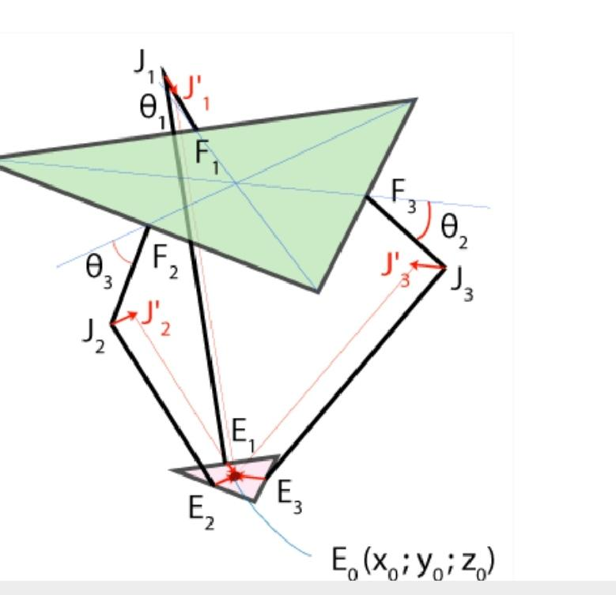
Inverse Kinematics

Fig. 1. Inverse Kinematics Geometry
The intersection of the two circles can be defined by
(y_{J1}-y²_{F1}) + (z_{J1}-z²_{F1})= r²_{f} (1)
And (y_{J1}-y_{E1’}) + (z_{j1}-z²_{E1’}) = r²_{e}-x²₀ (2)
Now solving for z_{J1} and y_{J1}, we get θ_{1,} θ₂ and θ₃ can be similarly derived as well.

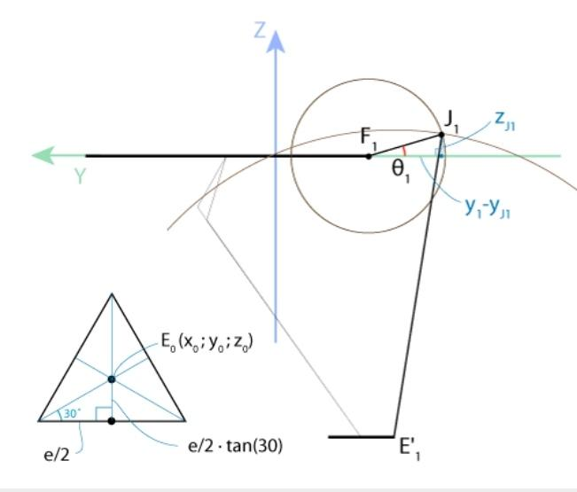
Forward Kinematics

Fig. 2. Forward Kinematics Geometry
For given θ_{1,}θ₂,θ₃, we can determine E₀ (x₀, y₀, z₀)
for given θ₁, θ₂, θ₃ we must know the coordinates of J₁, J₂, J₃
Then we moved J₁, J₂, J₃ to J’₁, J’₂, J’₃ using transition then we must compute the intersection of the three spheres centered at J’₁, J’₂, J’₃
And the intersection point is E₀(x₀, y₀, z₀)
(x-x_{j})²+(y-y_{j})²+(z-z_{j})²=r²_{e} (3)
x = a₁z+b₁ (4)
y=a₂z+b₂ (5)
Now we can substitute (4) and (5) in equation (3), thus we get,
(a₁²+a₂²+1) z² + 2(a₁+a₂(b₂-y₁)-z₁) z+(b₁²+(b₂-y₁)²+ z₁²-r_{e}²) = 0
By solving the last equation and calculate x and y from equations (4) and (5), we get the value of x, y and z which denotes the movement of the arms along x, y and z axis.

Work Volume Calculation
According to the calculation from the above equation, we found our designed Delta Robot specification,

The base radius (f) = 225 mm
Bicep length(r_{f}) = 62.2 mm
Forearm length (r_{e}) = 240 mm
End effector radius (e) = 102 mm
Base to floor distance (b) = 295 mm
by solving the equation (1) and (2) we find the value of
Z_{f1} =44mm
Now, θ₁= sin⁻¹ (Z_{f1}/r_{f}) = 50.24 (angle limitation from (-50.24 to 95.8))
θ₂= 61.08 (angle limitation from -59.64 to 107.65)
θ₃=61.08 (angle limitation from -59.64 to 107.65)
and for these θ₁, θ₂, θ₃ and solving the forward kinematics, we have found the intersecting points of the three spheres at E₀(0, 0, -234.61)
By solving the last equation and calculate x and y from equations (4) and (5)
x = -48.949 to 48.949 mm, y = -48.949 to 48.949 mm
z = -283.559 to -185.661 mm Now,
x = 69.224 mm = a
y = 69.224 mm = b
z = 338.933mm = c
So, the workspace volume = abc = 1.624X10⁶ mm³

System Overview
The system categorized into two segments and they are :

- Electrical Unit: Servo controller and PCB.
- Mechanical Unit: Base, Bicep, Forearm, End effector, Gripper.
A number of essential parts and elements are included in the overall configuration for delta robot, and they all work together to provide industrial support with better accuracy and precision and also saves a lot of time.

Main components
- SPSM Power Supply (DC)
- Blu-tooth HC 05 Module
- Microcontroller (Arduino AT mega 2560)
- Servomotor
- Relay
- Motor driver
- Transistor
- Capacitor
- Broker MQTT
- RGB sensor

Block Diagram of Control and power supply unit:

The voltage regulator, which ensures a steady voltage supply to the CPU, is powered by the DC power source. The microcontroller is in charge of controlling the robot's movement and functions as the brain of the system. The end-effector's location and orientation are determined by the information it receives from the infrared sensor. Subsequently, the microcontroller generates output signals that are used by the relay to drive the servomotors. Our system will be able to connect to the internet and share data with other devices because it has a Wi-fi module installed. The resistors, transistors, and capacitors will all be used to control and amplify the signals as needed.

Dc power Microcontroller Wi-fi Module
Relay Servomotor (Capacitor, Transistor,
Resistor) IR Sensor

Design and Construction

The elements of Delta robot fall roughly in following categories which should be considered for design construction for designing these components some considerations should be taken:

- Minimal size and shape due to cost and motor load capacity.
- Material selection based on market availability, cost.

- 3D Printing Prototype of Delta Robot Material Selection

- Base: Robust, rigid material suitable for robot weight and carrying goods. Carbon fiber-reinforced nylon and PETG are preferred.
- PETG: High Impact Resistance, Chemical Resistance, Excellent Dimensional Stability, Ease of Fabrication, Low Shrinkage.
- Arms: Lightweight yet sturdy for accurate movements. Carbon fiber-reinforced nylon or PLA reinforced with carbon fiber suitable.
- PLA: Biodegradable, easy of 3D printing, rigidity and strength, non-toxic, low odor.
- Forearm: Three stainless steel arms, six mm in
diameter, connected to the end effector through ball joint constraints.
- Joints and end-effectors: High-durability materials like PLA are used for withstand repeated movements and stresses.

- Mechanical System Design

The mechanical unit consists of a base, bicep, forearm, end effector, and gripper. It supports the project's weight, holds
the arm structure, and connects to the gripper compressor. The gripper is used to pick and place objects from the belt conveyor.

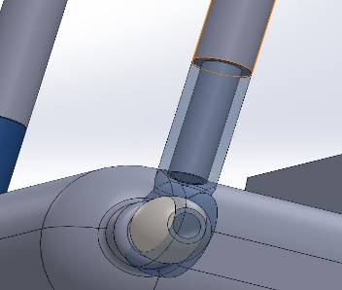
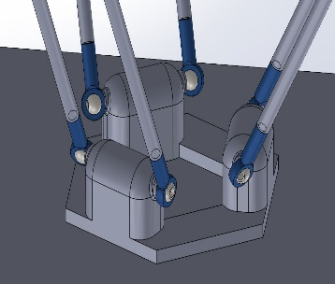

Fig. 3. End effector Fig. 4. Ball Joint

The end effector arrangement and the ball joint configuration is designed in Solidworks which is shown in Fig. 4 and Fig. 5.

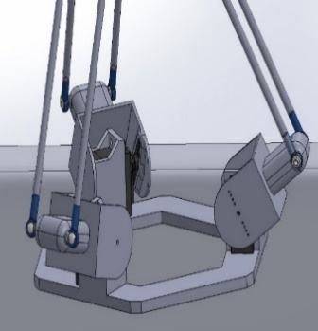
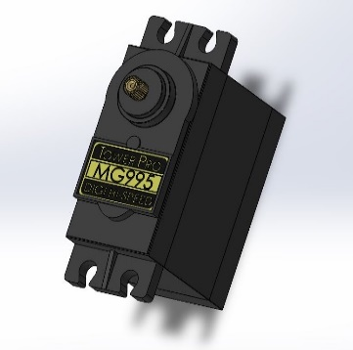

Fig. 5. Servo Motor Fig. 6. Solid State drive

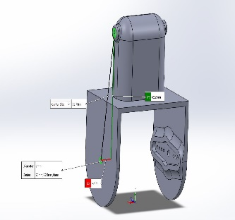
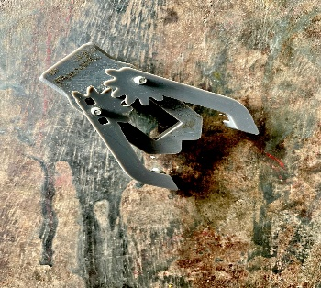

Fig. 7. Gripper Fig. 8. Solid State drive

Mechanical system design involves creating subassemblies and mechanisms like the base, arms which is shown in the Fig. 9 structure, gripper, and end effector. The base

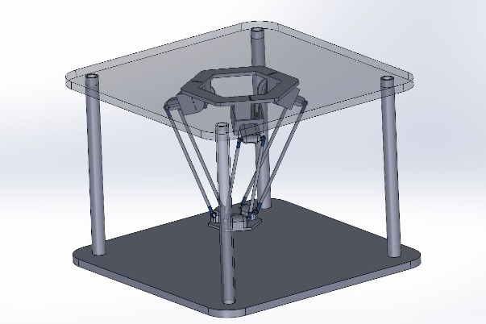
Fixed Structure
Base
Bicep

Forearm

Ball joint
End effector
Servo motor assembly
Servo motor

Fig. 9. Mechanical Components of Delta Robot
supports the Arduino, while the arm structure holds the travelling plate. The end effector holds the gripper and forearms, connected through ball joints for movement.
- Electronic system design
The electronic system of delta robot consist of many components like microcontroller, servomotors, PCB, sensors to integrate the total electronic system that enhance the performance of delta robot to pick and place an object by detecting the colour.
Servomotor: These are crucial for Delta Robot's precise movements, enabling efficient pick-and-place operations with three degrees of freedom (3DOF). They provide kinematic flexibility and real-time feedback, enabling closed-loop control and continuous movement adjustments.
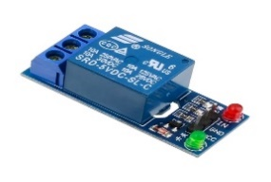
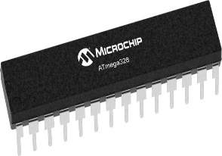

Fig: 10. ATmega-328 Fig. 11. Solid State Relay
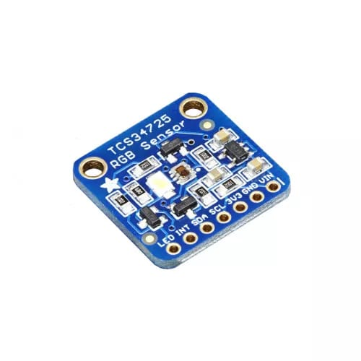
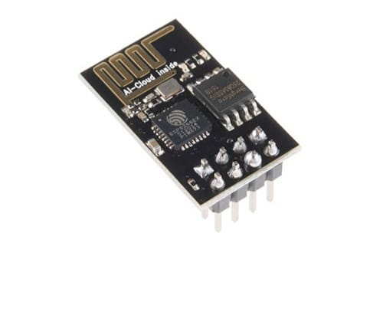

Fig. 12. Wi-fi Module Fig. 13. RGB Sensor
Microcontroller: Adruino ATmega 328 used for processing power, memory, and peripheral compatibility.
Wi-fi Module: The ESP8266 is a cost-effective Wi-Fi module that integrates into Delta robot control systems, providing motor control, sensor readings, and wireless communication, and also serving as an IoT gateway.
Solid State Relay: A 5V solid-state relay is a crucial component in delta robot control systems, enabling efficient switching of high-current loads like motors using a low-voltage microcontroller signal.
Feedback loop: Built-in encoders or sensors provide real-time position and speed feedback, enabling closed-loop Control.
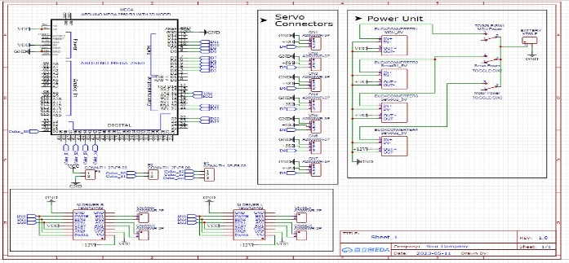
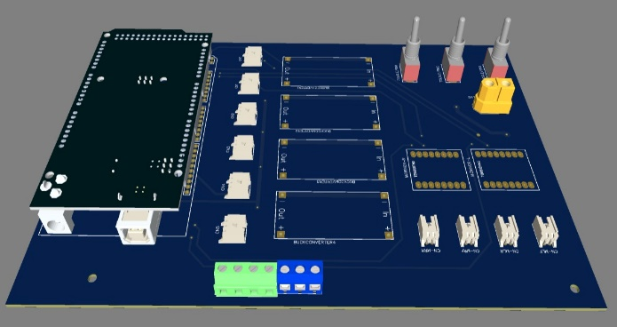
Fig. 14. Basic Schematic layout of PCB

Fig. 15. Component layout of PCB
PCB Design: A Printed Circuit Board (PCB) is a printed material with electrically conductive tracks, used to connect electronic components to create a functional circuit.
- Experimental Setup
All the essential parts and elements are included in the overall configuration for industrial operation of the delta robot and they all work together to make the system efficient. The base is attached to a fixed structure which holds the delta robot. Then the bicep and the forearm are connected to the end-effector which carry the gripper that identifies the correct object and place it aside. The whole system functions through the microprocessor which is mounted over the base in the fixed structure.
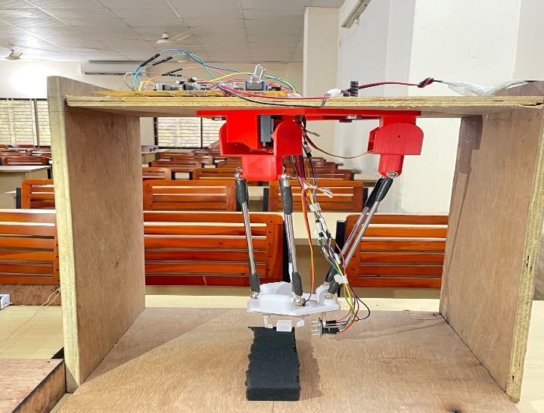
Fig. 16. Experimental Setup
- Cost analysis of component
No. | Delta Robot Components
No. | Conventional delta Robot | Cost (Dollar) | Low-Cost Delta Robot | Cost  (BDT)
1. | Structural-components (aluminum or steel frame) | 2000 | Servo MG995 Gear | 2750
2. | Linear guides and bearing | 500-2000 | Arduino Uno R3 | 1000
3. | Joints and actuators (servomotor, Gear box, encoders) | 2000-5000 | SMPS power supply | 800
4. | PLC Controller | 500-2000 | DC Gear Motor | 600
 | Total | 9000 | Total | 15150

The above data makes it clear that this delta robot costs too much for a 3D printed delta robot when compared to a traditional delta robot. Remarkably, bulk production can lower costs significantly, making the overall more affordable. Now a days, delta robot costs 200 dollar to make an prototype model which isn’t suitable for industry use.

Result & Discussion

Experimental Data & Graph

The delta robot is an affordable, robust, and under-actuated automaton designed for industrial use. Made with locally available materials and manual labor, it is precise and versatile. The robot's mass balance is accurate, and it can be easily manufactured using low-cost materials and rapid prototyping techniques. Experimentally validated, it is the fastest in industrial automation for pick and place, but its limitations, such as payload capacity and available space, need to be understood. Several test were done in order to calculate the performance of the delta robot such as Gripper test and the movement along the X, Y & Z axis.

Gripper Test

Tests to assess the payload, Maximum Or minimum time to select & place objects, gripper closing & opening time and graspable range showed that:

- Maximum payload of 500g can be grasped.
- Maximum object placement time: 10 seconds.
- Minimum object placement time: 4 seconds.
- Gripper's hand can be closed or opened in less than two seconds.
- Objects ranging from 2 to 9 cm can be held effectively.
- Specifications of the object
Object | Shape of the object | Weight | Time required for pick and place
Black | L=3 cm | 20gm | 3 seconds
White | L=3 cm | 20gm | 3 seconds

Movement analysis along the Axis

From Fig. 17. there seems to be a cyclical pattern in the X axis values, peaking at 0.2142 and 2.9988 seconds. This implies a periodic behavior. They return to the same values at 0.8568 and 2.3562 seconds, indicating the cycle repeats about every 0.64 seconds. Angles and time appear positively correlated, as both values rise and fall in sync. This suggests the X axis motion may be angle-dependent.

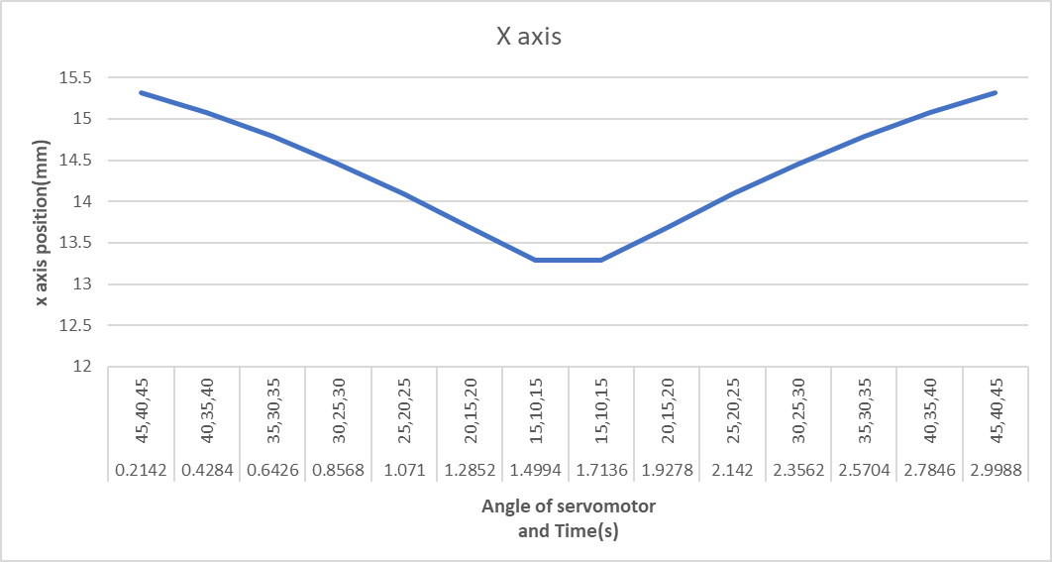
Fig. 17. Movement along X axis of Delta robot
Fig. 18. Depicts the time values are noticeably spread out with a range of 2.7846 seconds, which could suggest a broad timing for events or actions. The average time is 1.6065 seconds, indicating a mid-point around which time data tend to cluster. There's an observable cyclical pattern in Y values: first they decrease from 8.843 to 7.67, then they increase back to 8.843. It might suggest a recurring pattern or process.
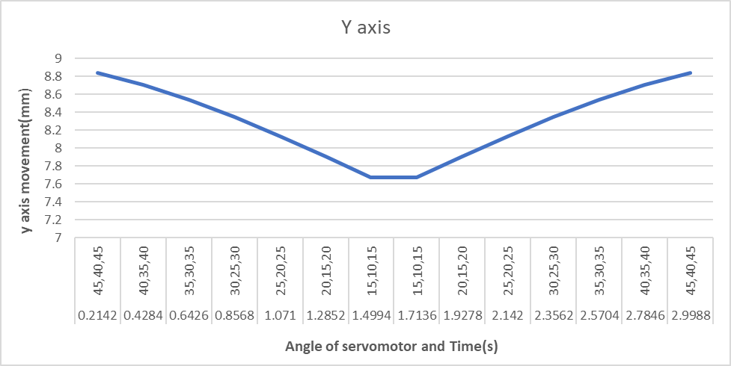
Fig. 18. Movement along Y axis of Delta robot
In Fig. 19. the average time interval appears to be short at 1.61 seconds, suggesting high frequency data collection. The Z axis has a negative average value of -328.49, indicating the data is centered below the 0 point on this axis. There's a repeating pattern in Z axis values, hinting at periodic or cyclic behavior in the data.
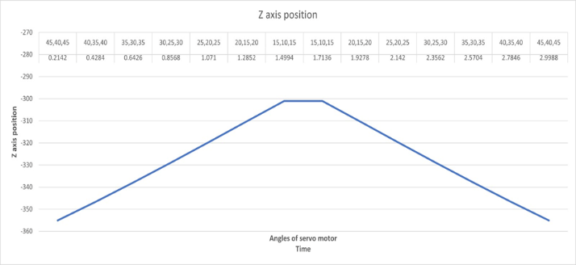
Fig. 19. Movement along Z axis of Delta robot

Performance Analysis

From the above test, the performance of the robot can be easily described. As we can see from the graph that the robot can pick and place object within 3 minutes while the experimental analysis shows the clear evidence. It can perform between X, Y and Z axis which takes least time to perform. Moreover, delta robot performance depends on some factor which includes the robot's link lengths, actuator type and power, joint configuration, payload capacity, workspace size, speed and acceleration, and repeatability and accuracy are all crucial factors in determining its performance. Longer links increase workspace size but may reduce speed and accuracy. Electric and pneumatic actuators offer high power and speed, while revolute and prismatic joints provide rotational and linear motion. As we developed our model by 3D printed technology, it can be compared with the conventional delta robot’s pick and place time.[18]
- Performance Evaluation
Result | 15% speed | 20% speed | 40% speed
Error (XYZ) | 3mm | 3mm | 4mm
Percentage | 1.32% | 1.32% | 1.37%

The testing results are implemented once the Delta robot's structure is constructed and its programming is finished. Students can assess the mathematical model and get practice for program testing with this experiment.

Conclusion

The creation of a three-degree-of-freedom delta robot for industry and education is markedly advanced by this endeavor. The robot's structure was initially meticulously designed and constructed using SolidWorks, allowing the parts to be seen in relation to one another. The robot's mechanical soundness, operating stress tolerance, and structural strength were then verified using ANSYS and Inventor Professional structure analysis. One of the best aspects of the project is its cost-effectiveness. Using inexpensive, locally accessible components, the team was able to build a robot that is not only functional but also attainable by a larger audience. It can identify an object taking approximately 3 seconds to pick and place.Moreover, error was found 1.3% on the oprational forearm that used for pick and place.It also reduces overall cost estimation by adjusting 3D printed materials for it’s base and end effector configuration. This is a crucial component for educational institutions that wish to teach students about automation and robotics.The programming and interface of the robot are noteworthy achievements. These characteristics point to an advanced control system that enables the delta robot to move precisely and cooperatively. Such synchronization is crucial for industrial pick-and-place jobs where precise timing and collaboration are critical. The delta robot receives extra capability that enables it to grasp and manipulate objects with the addition of a gripper mechanism that operates using a servo motor as an actuator. The robot can handle things using this function, allowing it to be used for activities other than just moving. To sum up, our work has successfully created a synchronized, flexible, and reasonably priced delta robot with a variety of potential applications.

References

1. Pranav, M., A. Mukilan, and C.S. Ganesh, A novel design of delta robot. Int. J. Multidiscip. Res. Mod. Educ.(IJMRME) II, 2016.
2. Hombach, C. and F. Böttcher, Delta robot having special arrangement of the ball joints. 2014, Google Patents.
3. Clavel, R. A fast robot with parallel geometry. in Proc. of the Int. Symp. on Industrial Robot, Switzerland, 1988. 1988.
4. Olsson, A., Modeling and control of a Delta-3 robot. MSc Theses, 2009.
5. Carabin, G., L. Scalera, T. Wongratanaphisan, and R. Vidoni, An energy-efficient approach for 3D printing with a Linear Delta Robot equipped with optimal springs. Robotics and Computer-Integrated Manufacturing, 2021. 67: p. 102045.
6. Vasques, C.M. and F.A. Figueiredo, The 3D-Printed Low-Cost Delta Robot Óscar: Technology Overview and Benchmarking. Engineering Proceedings, 2021. 11(1): p. 43.
7. Bonev, I.A. and J. Ryu, A geometrical method for computing the constant-orientation workspace of 6-PRRS parallel manipulators. Mechanism and machine theory, 2001. 36(1): p. 1-13.
8. Bonev, I.A. and C.M. Gosselin, Analytical determination of the workspace of symmetrical spherical parallel mechanisms. IEEE Transactions on Robotics, 2006. 22(5): p. 1011-1017.
9. Bai, P., J. Mei, T. Huang, and D.G. Chetwynd, Kinematic calibration of Delta robot using distance measurements. Proceedings of the Institution of Mechanical Engineers, Part C: Journal of Mechanical Engineering Science, 2016. 230(3): p. 414-424.
10. Uzunovic, T., E. Golubovic, E.A. Baran, and A. Sabanovic. Configuration space control of a parallel Delta robot with a neural network based inverse kinematics. in 2013 8th International Conference on Electrical and Electronics Engineering (ELECO). 2013. IEEE.
11. Codourey, A. Dynamic modelling and mass matrix evaluation of the DELTA parallel robot for axes decoupling control. in Proceedings of IEEE/RSJ international conference on intelligent robots and systems. IROS'96. 1996. IEEE.
12. López, M., E. Castillo, G. García, and A. Bashir, Delta robot: inverse, direct, and intermediate Jacobians. Proceedings of the institution of mechanical engineers, Part C: Journal of mechanical engineering science, 2006. 220(1): p. 103-109.
13. Bajpai, A. and B. Roth, Workspace and mobility of a closed-loop manipulator. The International Journal of Robotics Research, 1986. 5(2): p. 131-142.
14. Gosselin, C. and J. Angeles, The optimum kinematic design of a planar three-degree-of-freedom parallel manipulator. 1988.
15. Merlet, J.-P., C.M. Gosselin, and N. Mouly, Workspaces of planar parallel manipulators. Mechanism and Machine Theory, 1998. 33(1-2): p. 7-20.
16. Lin, J., C.-H. Luo, and K.-H. Lin, Design and implementation of a new delta parallel robot in robotics competitions. International Journal of Advanced Robotic Systems, 2015. 12(10): p. 153.
17. Zrazhevskiy, A., et al. Improving the accuracy of designing a delta robot for 3D printing. in Journal of Physics: Conference Series. 2021. IOP Publishing.
18. Joochim, C., S. Kaewkorn, and A. Kunapinun. Development of pick and place delta robot. in International Conference on Interactive Collaborative Learning. 2020.

