Experimental Analysis of Energy Losses in Stepped Spillways
with the Channel slopes between 8.9º and 26.6º.

ABSTRACT
Stepped spillways are structures built across dams to lessen the kinetic energy that could potentially create dangerous scour at the natural riverbed below the spillway. These structures utilize their stepped design to manage the energy in floodwaters. Numerous studies have indicated the damaging effects of the kinetic energy from falling water on the riverbed beneath the structure, particularly with channel slopes exceeding 26.6 degrees. However, only a few studies have examined the energy loss caused by stepped spillways with channel slopes between 26.6 degree and 8.9 degree. There is hence a knowledge gap in the design requirements for stepped spillways within these specific channel slopes. Additionally, the current model used to predict energy dissipation in stepped spillways across all slope angles incorporates a parameter known as the friction factor, f, which poses challenges in the estimation and often requires subjective assessment by those who design stepped spillways. This research aims to offer design guidelines for stepped spillways that feature varying slopes of 26.6 degrees and 8.9 degrees as well as to substitute the problematic friction factor, f. In a large facility, air-water flow experiments utilizing phase-detection intrusive probes were conducted in transitional and skimming flows on a stepped spillway with a channel slope of 26.6 degrees. This paper introduces a model for evaluating energy losses in stepped spillways with slopes of 26.6 degrees and 8.9 degrees. Regarding energy dissipation, the outcomes from the new model correlated well with the measured data, displaying high correlation coefficients between 0.79 and 1.00. All the findings were consistent. The model is user-friendly and provides superior results compared to the previous model.
Keywords: Stepped Spillway, Energy Dissipation, Nappe Flow, Skimming Flow

LIST OF SYMBOLS
The following symbols are used in this report:
d_{w} - equivalent clear water flow depth (m);
d_{c} - critical flow depth (m) ;
g - gravity constant (m/s²);
H_{dam} - dam height (m);
H_{max} - maximum upstream head (m) above chute toe:
H_{max} = H_{dam} + 1.5×d_{c};
H_{res} - residual head (m);
$\frac{∆H}{H_{max}}$ - Rate of energy dissipation (-)
h - Vertical step height (m);
l - Horizontal step length (m);
q_{w} - water discharge per unit width (m²/s);
Re - Reynolds number defined in terms of the hydraulic diameter:
Re = ρ_{w}×U_{w}×D_{H}/μ_{w};
U_{avg} - mean flow velocity (m/s): U_{avg} = q_{w}/d_{w};
W - Channel width (m);
ΔH - total head loss (m): ∆H = H_{max} – H_{res};
θ - Angle between pseudo-bottom formed by the step edges and the horizontal;

Subscript
c - Critical flow conditions;
max - maximum value;
w - Water properties.

INTRODUCTION
Stepped Spillway is an advanced technique for managing water flow, designed as a hydraulic structure positioned across dams, reservoirs, and other water-holding systems to control the water flow in a calculated and secure manner (Chanson H. 1997a). These spillways are created with a sequence of steps or cascades along their front face, allowing water to cascade down in a systematic way, which lessens the flow velocity and minimizes the risk of erosion. The primary goal of a stepped spillway is to dissipate the kinetic energy of the flowing water, making it one of the most effective designs for controlling water flow (Thorwarth, J. 2008, Peyras L, et al. 1992).

Stepped spillways can be constructed from concrete or stone, depending on the surrounding environmental conditions and specific design needs. Concrete is typically favored for its strength, while rocks may be utilized in more natural or rural environments (Rajaratnam N, 1990). They present an aesthetically pleasing form that resembles natural waterfalls. This feature can enhance the visual appeal of the dam or reservoir in some instances, making it a more attractive destination for visitors and tourists. They utilize gravity and natural aeration, making them advantageous for agricultural uses such as irrigation and wastewater management (Ozueigbo, O. Agunwamba, J. 2025, Sorensen, M. 1985).

Ozueigbo O and Agunwamba J. (2023) indicate that the steps of the stepped spillway are designed to be steep enough to break the water flow into smaller streams, yet gentle enough to prevent excessive turbulence. The stepped configuration (including its dimensions, gradient, and quantity) is a crucial factor in the design of spillways. As water falls over the steps down the spillway, the increasing boundary layer that initiates at the chute's crest will reach the free surface, allowing air to be mixed into the flow (Fig 1). The introduced air further decreases energy levels and aids in erosion prevention (Ohtsu I, et al 2004, Ozueigbo, O, and Agunwamba J 2022).

Unlike traditional spillways with smooth surfaces that facilitate water flow, stepped spillways feature tiered surfaces where water cascades over successive steps (Chanson, H., Carosi, G. 2007). This design mimics natural waterfalls or the steps found in hilly landscapes, effectively slowing down water flow and significantly diminishing its erosive energy; this decrease in velocity, along with considerable energy dissipation, not only allows for smaller basins at the spillway's end but also results in reduced maintenance costs, fewer repairs, and prevents erosive damage at the base of the structure and in the natural river channel below (Chamani, R., Rajaratnam, N. 1994, Stefan, F., Chanson, H., 2014, Ozueigbo, O. 2022).
Stepped spillways serve as a practical and efficient design utilized in various hydraulic structures for water flow management (Essery S, Horner W, 2005). They offer numerous benefits such as energy dissipation, decreased erosion, and reduced maintenance requirements, while also enhancing aesthetic appeal. As the demand for sustainable water management solutions continues to rise, stepped spillways are expected to gain greater acceptance in civil engineering projects (Thorwarth, J. and Koengeter, J. 2006, Youness, B. 2023).

Numerous researchers have examined the energy loss associated with stepped spillways that have channel slopes of 26.6 degrees and higher (Ozueigbo, O. 2025, Mozer, A., Sevam, H. 2024). However, only a few of these investigations have considered the energy losses in stepped spillways with channel slopes of 26.6 degrees and 8.9 degrees.
Consequently, there are knowledge gaps in the understanding of the guidelines and procedures for their design (Udai, J., Jabbar, H. 2024, Ozueigbo, O. 2025).

Moreover, the current models used for estimating energy dissipation in stepped spillways include a parameter known as the friction factor, f, which is difficult to estimate. As such, the primary aim of this study is to investigate energy dissipation in flat stepped spillways with a channel slope between 26.6 degrees and 8.9 degrees and to create a model that excludes the problematic friction factor, f, in estimating energy losses.

Stephenson, D. (1991), and Chanson, H. (1997b), categorized flows over stepped spillways into three distinct types, each exhibiting complex flow behavior influenced by both the discharge rates and step geometry: nappe, transition, and skimming flow regimes.
The nappe flow regime is characterized by low discharges and manifests as a free-falling sheet of water, cascading from one step to the next over a series of small free falls (Chanson, H. 1994) (Figure 2).
The transition flow is marked by characterized by moderate flow rates and notable amount of spray and turbulence near the free surface. (Degouite G, Peyras L, Royet P, 1992, Mojtaba, K., Azin, R. June 2023).
Lastly, the skimming flow regime is observed at high discharges and is recognized as a cohesive stream featuring large circulation vortices between the main flow and the steps (Chanson H, Toombes L. 2002a, Valentin, H., Daniel, V. 2025) (Figures 3 and 4).

The method of energy dissipation for each of these three flow regimes is unique and is estimated by (Chanson H, Toombes L, 2002b) in the following ways:

- Energy Dissipation at Nappe Flow Regime
In a nappe flow regime characterized by a fully developed hydraulic jump (Figure 1), the head loss at any given intermediate point is equivalent to the energy lost. The overall head loss, ∆H, along the spillway is equal to the maximum head available, Hmax, and the residual head, H_{res}, at the spillway's bottom (Chanson H. 1994, 1994a).
$$\frac{∆H}{H_{max}}=1-\frac{\frac{d_{1}}{d_{c}}+\frac{1}{2}{\left(\frac{d_{c}}{d_{1}}\right)}^{2}}{\frac{3}{2}+\frac{H_{dam}}{d_{c}}} ungated spillway (1)$$

$$\frac{∆H}{H_{max}} = 1 - \frac{\frac{d_{1}}{d_{c}} +\frac{1}{2}{\left(\frac{d_{c}}{d_{1}}\right)}^{2}}{\frac{H_{max} +H_{o}}{d_{c}}} gated spillway (2)$$

$$∆H=H_{max}-H_{res} (3)$$

In the study of open channel hydraulics, the residual energy in a nappe flow condition (often observed in freefall or weir flow scenarios) pertains to the energy that remains after the flow has traversed the crest and is in the descending jet (Chanson H, Toombes L. 1998).
The residual energy, H_{res}, comprises the velocity head and the residual pressure head. If the nappe is aerated and descends freely, the pressure head is minimal, leading to the residual energy being primarily attributed to velocity and potential energy. Therefore, for a freely tumbling nappe, the total residual energy at a particular point downstream can be approximated as
$$H_{res}={v_{1}^{2}}/{2g}+d_{1} (4)$$
And is dissipated at the toe of the spillway by a hydraulic jump in the dissipation basin.
For an un-gated spillway, the maximum head available and the dam height are related by:
$$H_{max}=H_{dam}+1.5d_{c} (5)$$
For a gated spillway, the maximum head available and the dam height are related by:
$$H_{max}=H_{dam}+H_{o} (6)$$
where H_{dam} is the dam height and H₀ is the reservoir free surface elevation above the spillway crest.
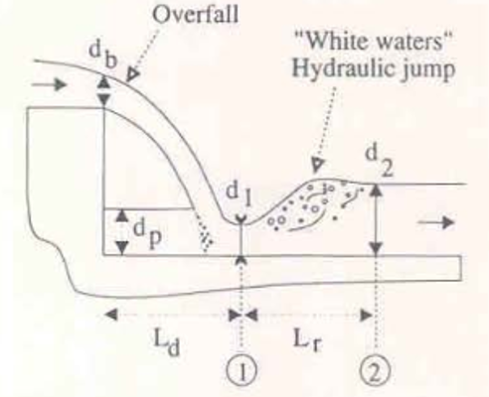

Figure 1: Nappe flow regime (Flow at a drop structure) Chanson (1994)

- Energy Dissipation at the Skimming Flow Regime
The energy dissipated happened to preserve the steady depression vortices. If constant flow conditions are reached downstream of the spillway, the energy loss could be estimated as follows (Chanson H., 1994, 1994a). (Figure 3):

Eq (6) is expressed for spillway slope with θ = 52 (degrees). Friction factor, f = 0.3 and f = 1.30 denote the average flow resistance on smooth spillways and stepped spillways, respectively (Figure 4),
$$\frac{∆H}{H_{max}}=1- \frac{\left(\frac{d_{w}}{d_{c}}\right)\cos{θ}+\frac{1}{2}{\left(\frac{d_{c}}{d_{w}}\right)}^{2}}{\frac{H_{dam}}{d_{c}}+\frac{3}{2}} (6)$$

$$\frac{∆H}{H_{max}}=1-\frac{{\left(\frac{f}{8sinθ}\right)}^{1/3}cosθ+\frac{E}{2}{\left(\frac{f}{8sinθ}\right)}^{{-2}/3}}{\frac{H_{dam}}{d_{c}}+\frac{3}{2}} (7)$$
Where $∆H$ is the total head loss calculated as $∆H= H_{max}-H_{res}$; H_{dam} is the dam height, $H_{max}$ is the maximum height estimated as $H_{max}=H_{dam}+1.5d_{c}$; $H_{res}$ is the residual head estimated as $H_{res}=\frac{U_{avg}^{2}}{2g}+d_{w}\cos{θ }$; ${∆H}/{H_{max}}$ is the rate of energy dissipation, $Q_{w}$ is the total water flow, b is the width of the channel, $q_{w}$ is the unit flow, $q_{w}={Q_{w}}/b$ ; d_{c} is the critical depth estimated as $d_{c}={{\left(q_{w}^{2}\right)}^{1/3}}/g$ ; U_{avg} is the average velocity estimated as $U_{avg}={q_{w}}/{d_{w}}$; d_{w} is the clear water depth estimated as $d_{w}=\int_{y_{0}}^{y_{90}}{\left(1-C\right)dy}$ ; θ is the dam slope in degrees, and the total head loss may be rewritten in terms of the friction factor, f, the spillway slope, θ, in degree.

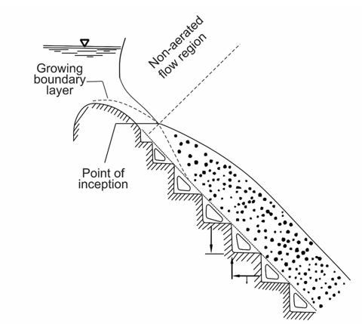

Figure 2. Skimming flow regime - Chanson, H. (1994b), Sorensen (1985)

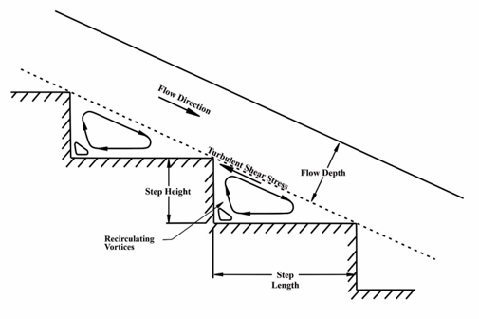

Figure 3: Skimming flow regime with uniform flow conditions

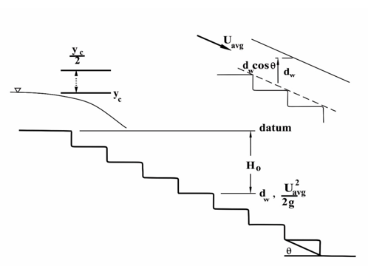

Figure 4: Arrangement of the spillway with the definition of the variables

2. material and methods
The authors’ carefully selected eleven studies that focused on the horizontal stepped spillways, which featured minimum step heights of 3 cm, consistent Froude numbers, and high dimensionless discharges that corresponded to Reynolds numbers that ranged from 1×10⁵ to 1×10⁶.
These studies utilized large-scale experimental setups to reduce the impact of scale effects on air-water flow dynamics in high-velocity free-surface flows (Maria, D., Marcelo, C., 2020).
The large scale of the experimental facilities aimed to reduce scale effects that could impact the fine air-water flow dynamics present in high-velocity free-surface flows.
Scale effects refer to minor distortions that arise from neglecting secondary forces like viscous forces and surface tension in stepped spillway models. While these forces are typically considered negligible in most open-channel applications, they gain significance in highly air-entrained flows, such as those found in stepped spillways, and thus cannot be overlooked.
Ignoring these factors can lead to erroneous data interpretations. Previous researches by Boes (2000), Chanson (2002), Boes and Hager (2003a), and Takahashi et al. (2008) has extensively documented the scale effects related to stepped spillway modeling.
Such effects are most commonly associated with scales smaller than 10:1.
Chanson (2001, 2002) suggests that a model scale of 10:1 or larger is advisable, while Boes and Hager (2003a) recommend achieving a minimum Reynolds number of 10⁵ and a minimum Weber number of 100. Takahashi et al. (2006) and Carosi, G., Chanson, H. (2005) emphasize the necessity of satisfying Froude, Reynolds, and Morton's similarity conditions when simulating strongly air-entrained flows, noting that this is achievable only at full scale.
Today, there is no consensus among researchers regarding the parameters to mitigate scale effects in physical stepped spillway models, some insights are available (Maria, D., Marcelo, C. 2020, Abbasi, S. et al. 2024).

The application of traditional mono-phase flow measurement tools in high-velocity air-water flows is impractical due to the complex three-dimensional nature of air-water flows, which contain large volumes of air (Maria, D., Marcelo, C., 2020).
Given the significant air entrainment at the air-water interface, using instruments like Dall Tube flow meters, V-notches for flow rates, Prandtl-Pitot devices for flow velocities, or point gauges for clear water flow depth to evaluate air-water flow characteristics proves impracticable (Ozueigbo, O., Agunwamba, J. 2023).

The scholars used conductivity phase-detection intrusive probes and optical fiber probes to assess the characteristics of air-water flow at each step edge downstream of the air-entrainment inception point.
The double-tip conductivity probes that they used featured sensors with the diameters of
Ø = 0.13 mm and 0.25 mm and were sampled over a duration of 45 seconds at a frequency of 20 kHz per sensor. The sensors were separated longitudinally and the cross-correlation analysis of the signals yielded the local time-averaged interfacial velocity.
The operation of the conductivity probe relied on the difference in resistivity between air and water, which generates an instantaneous voltage signal (Ozueigbo, O. 2020).
This threshold technique processes signals from a single sensor to compute a) the time-averaged local air concentration or void fraction C, b) the frequency of voltage fluctuations between air and water (or vice versa), referred to as bubble count rate F, and c) the sizes of the air bubble and water droplet chords.

The discharges had transition and skimming flow rates of 0.035 ≤ q_{w} ≤ 0.234 m²/s for the spillways with θ = 8.9º and 0.02 ≤ q_{w} ≤ 0.249 m²/s for θ = 26.6º, with Reynolds numbers of 1.4 x 10⁵ ≤ Re ≤ 9.3x 10⁵ and 8.1x 10⁴ ≤ Re ≤ 9.9 x 10⁵.

b) The Pearson Correlation Coefficient is a widely-used statistical method for assessing the reliability of the created model. This coefficient ranges from -1 to +1, indicating the nature of the correlation: -1 signifies a strong negative correlation, 0 indicates no correlation at all, and +1 reflects a strong positive correlation.
To compute Pearson's correlation coefficient manually, the formula is as follows (Stephanie Glen 2020):
$$r=\frac{n\sum{xy-\sum{x\sum{y}}}}{\sqrt{\left(n{\sum{x}}^{2}-{\left(\sum{x}\right)}^{2}\right)\left(n\sum{y^{2}}-{\left(\sum{y}\right)}^{2}\right)}} (8)$$
Where:
- x and y are the values of the two variables.
- n is the number of paired data points.
- ∑x is the sum of all x values.
- ∑y is the sum of all y values
- ∑x² is the sum of the squares of x values.
- ∑y² is the sum of the squares of y values.
- ∑xy is the sum of the product of corresponding x and y values.

- Formulation of the Models
In modeling, it is essential to identify the parameter values that best align with the model of the system being described (Agunwamba, 2007; Ozueigbo, O. 2020).
Utilizing the least squares method, the optimal curve fitted for this research was as follows:
$\frac{∆H}{H_{max}}={\left\lfloor α_{0}\frac{Nh}{d_{c}}\right\rfloor }^{α_{1}}N^{α_{2}}h^{α_{3}}θ^{α_{4}}$ (9)

Where
$\frac{∆H}{H_{max}}$ is the energy loss ratio (-),
H_{max} is the maximum available height (m),
N is the number of spillway steps (-),
h is the height of the spillway steps (cm),
$θ$ is the spillway channel slope (degree),
d_{c} is the critical depth (m)’
α_{o} is a constant (-),
α₁, α₂, α₃, and α₄ are coefficients (-),

A segment of the collected data sets was utilized along with multiple regression analysis to solve Equation (9). This process produced values for the constant α_{o} and the coefficients α₁, α₂, α₃, and α₄, which were later substituted in (9) to create the models presented in equations (10) through (17).

- Model Verification
The authors utilized the remaining data sets, referred to as verification data sets, to evaluate the effectiveness of the models (interpolation).

3. RESULTS
The Developed Models for the Transition/Skimming Flow Regime.
The discharges had transition and skimming flow rates of 0.035 ≤ q_{w} ≤ 0.234 m²/s for the spillways with θ = 8.9º and 0.02 ≤ q_{w} ≤ 0.249 m²/s for θ = 26.6º, with Reynolds numbers of 1.4 x 10⁵ ≤ Re ≤ 9.3 x 10⁵ and 8.1 x 10⁴ ≤ Re ≤ 9.9 x 10⁵ respectively.

${∆H}/{H_{max}}= {\left(0.79{Nh}/{d_{c}}\right)}^{0.36}N^{-0.09}h^{-0.24}θ^{-0.09}$ For 𝜽 = 26.6º, N = 10, h (cm) = 10 (10)
${∆H}/{H_{max}}= {\left(0.42{Nh}/{d_{c}}\right)}^{0.36}N^{-0.09}h^{-0.24}θ^{-0.09}$ For 𝜽 = 26.6º, N = 10, h (cm) = 5 (11)
${∆H}/{H_{max}}= {\left(0.52{Nh}/{d_{c}}\right)}^{0.36}N^{-0.09}h^{-0.24}θ^{-0.09}$ For 𝜽 = 21.8º, N = 20, h (cm) = 5 (12)
${∆H}/{H_{max}}= {\left(0.45{Nh}/{d_{c}}\right)}^{0.36}N^{-0.09}h^{-0.24}θ^{-0.09}$ For 𝜽 = 18.4º, N = 40, h (cm) = 3/6 (13)
${∆H}/{H_{max}}= {\left(0.35{Nh}/{d_{c}}\right)}^{0.36}N^{-0.09}h^{-0.24}θ^{-0.09}$ For 𝜽 = 15.9º, N = 18, h (cm) = 5 (14)
${∆H}/{H_{max}}= {\left(0.57{Nh}/{d_{c}}\right)}^{0.36}N^{-0.09}h^{-0.24}θ^{-0.09}$ For 𝜽 = 14.6º, N = 13, h (cm) = 10 (15)
${∆H}/{H_{max}}= {\left(0.37{Nh}/{d_{c}}\right)}^{0.36}N^{-0.09}h^{-0.24}θ^{-0.09}$ For 𝜽 = 14.6º, N = 26, h (cm) = 5 (16)
${∆H}/{H_{max}}= {\left(0.30{Nh}/{d_{c}}\right)}^{0.36}N^{-0.09}h^{-0.24}θ^{-0.09}$ For 𝜽 = 8.9º, N = 10, h (cm) = 3/6 (17)

The authors then used this developed model with its variants, Eq (10) through Eq (17), to predict the rates of energy dissipation and displayed them vis-à-vis the measured data sets in Figure 5 through Figure 12.

${∆H}/{H_{max}}= {\left(0.79{Nh}/{d_{c}}\right)}^{0.36}N^{-0.09}h^{-0.24}θ^{-0.09}$ (10)
The equation is valid for 𝜽 of 26.6°, Nh/d_{c} between 5.0 and 10.0, N between 5 and 20, d_{c}/h between 0.80 and 3.30, h (cm) between 5 and 10. Spearman coefficient is 0.97.
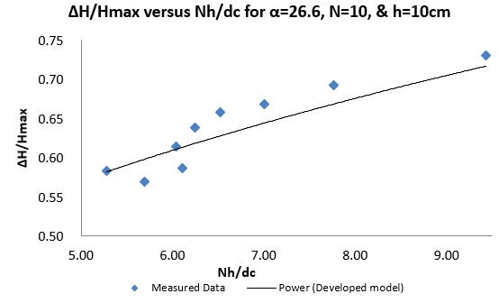

Figure 5: ∆H/Hmax versus Nh/dc between 5.00 and 9.50, q_{w} = (0.073 - 0.249) m²/s & Re = (2.92 x 10⁵ - 9.96 x 10⁵), flow rate d_{c}/h of (0.82 - 1.85).

${∆H}/{H_{max}}= {\left(0.42{Nh}/{d_{c}}\right)}^{0.36}N^{-0.09}h^{-0.24}θ^{-0.09}$ (11)
The model is valid for 𝜽 = 26.6º, N = 20, h (cm) = 5, Nh/d_{c} between 4.00 and 10.00, q_{w} = (0.020 - 0.227) m²/s & Re = (8.0 x 10⁴ - 9.08 x 10⁵), flow rate d_{c}/h, of (0.69 - 3.30).

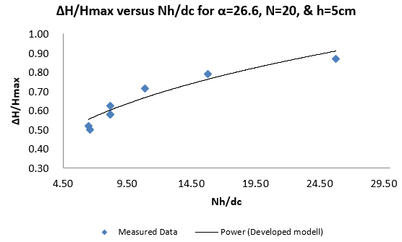

Figure 6: ∆H/Hmax versus Nh/dc between and 27.00, q_{w} = (0.020 - 0.227) m²/s & Re = (8.0 x 10⁴ - 9.08 x 10⁵), flow rate d_{c}/h, of (0.69 - 3.30).

${∆H}/{H_{max}}= {\left(0.52{Nh}/{d_{c}}\right)}^{0.36}N^{-0.09}h^{-0.24}θ^{-0.09}$ (12)
The model is valid for 𝜽 = 21.8º, N = 20, h (cm) = 5, Nh/d_{c} between 5.50 and 11.00, q_{w} = (0.059 - 0.158) m²/s, Re = (2.36 x 10⁵ - 6.32 x 10⁵), and flow rate, d_{c}/h, of (0.80 - 1.85).
The figure shows that the measured data sets compare well with those of the developed model data sets with Spearman coefficient of 0.95.
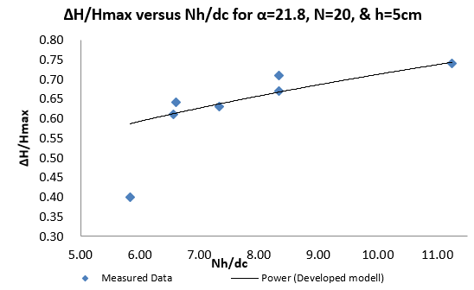

Figure 7: ∆H/Hmax versus Nh/d_{c} between 5.80 and 11.25, q_{w} = (0.059 - 0.158) m²/s, Re = (2.36 x 10⁵ - 6.32 x 10⁵), flow rate, d_{c}/h, of (0.80 - 1.85).

${∆H}/{H_{max}}= {\left(0.45{Nh}/{d_{c}}\right)}^{0.36}N^{-0.09}h^{-0.24}θ^{-0.09}$ (13)
The model is valid for 𝜽 = 18.4º, N = 40, h (cm) = 6, Nh/d_{c} between 21.00 and 30.00, q_{w} = (0.059 - 0.158) m²/s, Re = (2.36 x 10⁵ - 6.32 x 10⁵), flow rate, d_{c}/h, of (0.80 - 1.85).
The figure shows that the measured data sets compare well with those of the developed model data sets with Spearman coefficient of 0.95

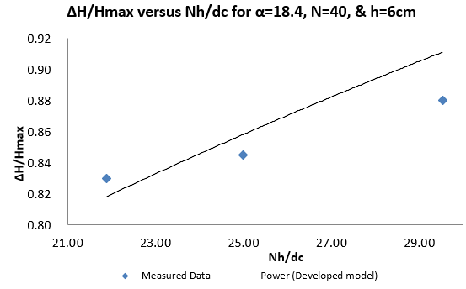

Figure 8: ∆H/Hmax versus Nh/d_{c} between 21.80 and 29.50, q_{w} = (0.059 - 0.158) m²/s, Re = (2.36 x 10⁵ - 6.32 x 10⁵), flow rate, d_{c}/h, of (0.80 - 1.85).

${∆H}/{H_{max}}= {\left(0.35{Nh}/{d_{c}}\right)}^{0.36}N^{-0.09}h^{-0.24}θ^{-0.09}$ (14)
The model is valid for 𝜽 = 15.9º, N = 18, h (cm) = 5, Nh/d_{c} between 4.00 and 11.00, q_{w} = (0.021 - 0.220)m²/s, Re = (8.4 x 10³ - 8.8 x 10⁵), & flow rate, d_{c}/h, of (0.60 - 3.20).
The figure shows that the measured data sets compare well with those of the developed model data sets with Spearman coefficient of 0.79.
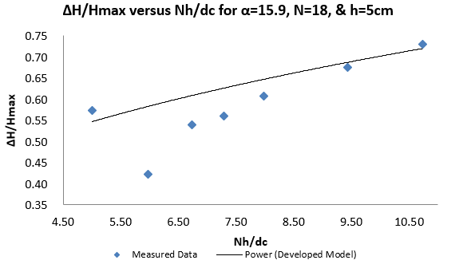

Figure 9: ∆H/Hmax versus Nh/d_{c} between 5.00 and 10.80, q_{w} = (0.021 - 0.220) m²/s, Re = (8.4 x 10³ - 8.8 x 10⁵), & flow rate, d_{c}/h of (0.60 - 3.20).

${∆H}/{H_{max}}= {\left(0.57{Nh}/{d_{c}}\right)}^{0.36}N^{-0.09}h^{-0.24}θ^{-0.09}$ (15)
The model is valid for 𝜽 = 14.6º, N = 13, h (cm) = 10, Nh/d_{c} between 6.20 and 8.00, q_{w} = (0.05 - 0.234) m²/s, Re = (2.0 x 10⁵ - 9.36 x 10⁵), & flow rate, d_{c}/h, of (1.27 - 3.55).
The figure shows that the measured data sets compare well with those of the developed model data sets with Spearman coefficient of 1.00.

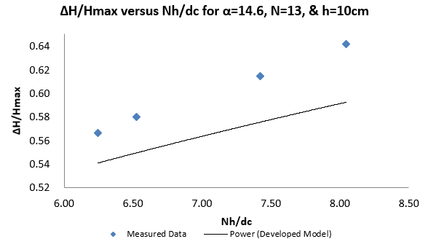

Figure 10: ∆H/Hmax versus Nh/d_{c} between 6.25 and 8.00, q_{w} = (0.05 - 0.234) m²/s, Re = (2.0 x 10⁵ - 9.36 x 10⁵), & flow rate, d_{c}/h, of (1.27 - 3.55).

${∆H}/{H_{max}}= {\left(0.37{Nh}/{d_{c}}\right)}^{0.36}N^{-0.09}h^{-0.24}θ^{-0.09}$ (16)
The model is valid for 𝜽 = 14.6º, N = 26, h (cm) = 5, Nh/d_{c} between 7.00 and 17.00, q_{w} =0.05 - 0.234) m²/s, Re = (2.0 x 10⁵ - 9.36 x 10⁵), & flow rate, d_{c}/h, of (1.27 - 3.55).
The figure shows that the measured data sets compare well with those of the developed model data sets with Spearman coefficient of 1.00.
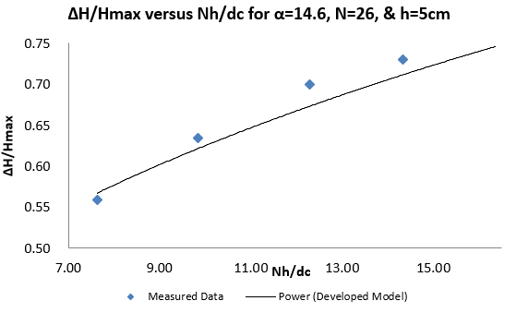

Figure 11: ∆H/Hmax versus Nh/d_{c} between 7.60 and 17.50, q_{w} =0.05 - 0.234) m²/s, Re = (2.0 x 10⁵ - 9.36 x 10⁵), & flow rate, d_{c}/h, of (1.27 - 3.55).

${∆H}/{H_{max}}= {\left(0.30{Nh}/{d_{c}}\right)}^{0.36}N^{-0.09}h^{-0.24}θ^{-0.09}$ (17)
The model is valid for 𝜽 = 8.9º, N = 21, h (cm) = 3/6, Nh/dc between 5.00 and 12.00, q_{w} = (0.035 - 0.234) m²/s, Re = (1.40 x 10⁵ - 9.36 x 10⁵), & flow rate, d_{c}/h, of (1.0 - 3.55).
The figure shows that the measured data sets compare well with those of the developed model data sets with Spearman coefficient of 1.00.

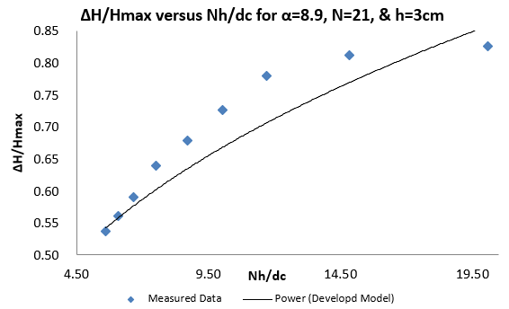

Figure 12: ∆H/Hmax versus Nh/d_{c} between 5.60 and 20.10, q_{w} = (0.035 - 0.234) m²/s, Re = (1.40 x 10⁵ - 9.36 x 10⁵), & flow rate, dc/h, of (1.0 - 3.55).

4. Discussions
Figures 5 through 12 illustrate the rates of energy loss as a function of the ratio of dam height to critical depth, based on the collected data and the established analytical formulas from Eq (10) to Eq (17). The results from the proposed model with its variants, as outlined in Eq (10) to Eq (17), show a strong correlation with the measured datasets regarding energy dissipation, with Spearman coefficients ranging from 0.79 to 1.0. The model is user-friendly. From Figures 5 to 12, it can be observed that energy losses for a specific discharge consistently increase with higher dam heights, which aligns with the findings of (Chanson 2001). The distribution of dimensionless energy dissipation rates across all measured datasets corresponds well with the various flow regimes. In Figures 5 to 12, the measured datasets in both transitional and skimming flows align closely with the datasets produced from Eq (10) to Eq (17), exhibiting Spearman correlations between 0.79 and 1.00.

5. Conclusion
The data presented illustrates the rates of energy loss as related to the ratio of dam height to critical depth for both the observed measurements and the experimental model developed. The distribution of both the actual and estimated data reveals a similar traditional concave shape, which aligns with prior findings. Across all the observed datasets, the outcomes from the proposed model with its variants—regarding the dimensionless distribution of energy loss rates—align closely with the measured results across the various flow conditions, exhibiting Spearman Correlation Coefficients between 0.79 and 1.00. There is a strong agreement between the observed and the estimated data. The model with its variants is straightforward, ease to use, and yields reliable results. As dam height increases, the energy losses for specific discharges rise consistently, which agrees with the current observations.

5. Design Example

Question: What is the rate of energy dissipated at the toe of a stepped spillway with a channel width of 50 cm, slope of 8.9º, step number of 21, and height of 0.05 m discharging a flow of 0.018 m³/s using each of the above-developed models and reproduced for convenience?

DISCLAIMER (ARTIFICIAL
Option 1:
Author(s) hereby declare that NO generative AI technologies such as Large Language Models (ChatGPT, COPILOT, etc) and text-to-image generators have been used during writing or editing of this manuscript.

REFERENCE
Agunwamba, J. (2007). “Engineering Mathematical Analysis. Enugu: De – Adroit Innovation 2007”; pp 479-510 and 674-675.
Abbasi, S., Seifollahi, M (2024). “Design Optimatimation of concrete gravity dams using grasshopper optimization combined with wavelet functions”. Turkish Journal of Hydraulic, Vol(Cilt): 8, Number (Sayi): Page (Sayfa). 01-15, (2024)
Boes. R., Hager, W. (2003a). “Two‐phase flow characteristics of stepped spillways”. J. Hydraul. Eng. ASCE. 129(9): 661‐670.
Boes, M. (2000). “Scale effects in modeling two‐phase stepped spillway flow”. In Proc. Intl. Workshop on Hydraulics of Stepped Spillways, Minor HE and Hager WH, eds. Steenwijk, The Netherlands: A. A. Balkema. 2000:53‐60.
Carosi, G., Chanson, H. (2005). “Air-water time and length scales in skimming flow on a stepped spillway. Application to the spray characterization”. Report No. CH59/06, Division of Civil Engineering, the University of Queensland, Brisbane, Australia, July; 2006.
Chamani, R., Rajaratnam, N. (1994). “Jet Flow on Stepped Spillways. J. Hydraul. Engg. ASCE 120(2):254–259”.
Chanson, H., Carosi, G. (2007). “Advanced post-processing and correlation analyses in high-velocity air– water flows”. Environ Fluid Mech. 2007; 7(6):495–508.
Chanson, H., Toombes, L. (2002a). “Air–water flows down stepped chutes: turbulence and flow structure observations”. Int J Multiph Flow. 28(11):1737–1761.
Chanson, H., Toombes, L. (2002b). “Energy dissipation and air entrainment in stepped storm waterway: experimental study”. J Irrig Drain Eng ASCE. 128(5):305–315.
Chanson H, Toombes L (1998). “Supercritical Flow at an Abrupt Drop: Flow Patterns and Aeration”. Can. J. Civil Eng. 25(5):956–966.
Chanson, H. (1994). “Comparison of energy dissipation between nappe and skimming flow regimes on stepped chutes”. Journal of Recherches Hydraulicques, Vol 32, 1994, Vol 2
Chanson, H. (2001). “The hydraulics of stepped chutes and spillways”. Balkema, isse.:418
Chanson H. (1997a). “Air bubble entrainment in open channels. Flow structure and bubble size distributions”. Int J Multiph Flow. 1997a; 23(1):193–203
Chanson, H. (2002). Air–water flow measurements with intrusive phase-detection probes. Can we improve their interpretation? J Hydraul Eng ASCE.128(3):252–255,
Chanson, H. (1997b). “Measuring air–water interface area in supercritical open channel flow”. Water Res.;31(6):1414–1420
Chanson, H. (1994a). Hydraulics of skimming flows over stepped channels and spillways. Journal of Hydraulic Research, 32(3): 445-460.
Chanson, H. (1994b). “Comparison of energy dissipation between nappe and skimming flow regimes on stepped chutes”. Journal of Hydraulic Research, 32(2): 213-218
Degouite, G., Peyras, L., Royet, P. (1992). Skimming Flow in Stepped Spillways - Discussion. Jl of Hyd. Engrg., ASCE. 118(1): 111-114.
Essery ITS, Horner MW (2005). “The hydraulic design of stepped spillways”. Rep. 33, Construction Industry Research and Information Assoc., London, U.K; 1971.
Maria, D., Marcelo, C. (February 2020). “Uso consciente De Agua em predios publicos, estudos analiticos, planejamento e gestao - estudo de caso.” Revista Gestão & Sustentabilidade Ambiental 9:905; DOI: 10.19177/rgsa.v9e02020905-920
Mojtaba, K., Azin, R. (June 2023). “Study of the Effect of the Location of a Continuous Porous Obstacle on the Bottom of a Stepped Spillway on the Characteristics of the Flow. DOI: 10.30495/wej.2023.28972.2338
Mozer, A., Sevam, H. (2024). “Investigating the Influence of Vegetation Height on the Air Concentration of Supercritical Aerated Flows” Water 16(21) DOI:10.3390/w16213136 License CC BY 4.0
Ohtsu, I., Yasuda, Y., Takahashi, M. (2004) “Flow characteristics of skimming flows in stepped channels”. J Hydraulic Eng ASCE 130(9):860–869”
Ozueigbo, O. (2025). “Three New Approaches to Estimating Energy Losses in Stepped Spillways with the Channel Slope of 8.9º”. Journal of Engineering Research and Reports 27 (3):173-85. https://doi.org/10.9734/jerr/2025/v27i31426

Ozueigbo, O., Agunwamba, J. (2025). “New Energy Loss Expression for Stepped Spillways with Channel Slopes 26.6° and Below”. Journal of Civil, Construction and Environmental Engineering, Vol. 10, No. 1, pp. 16-26, https://doi.org/10.11648/j.jccee.20251001.12

Ozueigbo, O. (2025). “Analytic Determination of the Roller Length of a Hydraulic Jump in an Open Channel Flow Using a Bouncing Ball”. Journal of Engineering Research and Reports Volume 27, Issue 1, Page 123-139, 2025; Article no.JERR.127641 ISSN: 2582-2926, DOI:

Ozueigbo, O., Agunwamba, J. (2023). “New Equations for Rate of Energy Dissipation of a Stepped Spillway with Slope less than Critical and Specific Step Height”. Journal of Engineering Research and Technology VOLUME 10(2):49 – 57 DOI: 10.33976/JERT.10.2/2023/2
Ozueigbo, O., Agunwamba, J. (2023). “Two New Equations for Energy Dissipation down a Stepped Spillway with Channel Slopes between 3.4° and 26.6°”. In book: Techniques and Innovation in Engineering Research Vol. 8. DOI: 10.9734/bpi/taier/v8/3589C

Ozueigbo, O., Agunwamba, J. (2022). “New Equations for Energy Dissipation down a Stepped Spillway”. Journal of Engineering Research and Reports 23(4): 1-14, 2022; Article no.JERR.90654 ISSN: 2582-2926, DOI: 10.9734/JERR/2022/v23i417602.
Ozueigbo, O. (2022). “New Equations for Energy Dissipation for Spillways with Slope of 30 Degrees and Height of 0.305m”. Journal of Engineering Research and Reports. DOI: 10.9734/JERR/2022/v22i1217580
Ozueigbo, O. (2020). “Using a Ball that Bounces Down a Flight of Stairs to Determine Energy Dissipation in Stepped Spillway with a Fully Developed Hydraulic Jump”. Journal of Engineering Research and Reports, DOI: 10.9734/jerr/2022/v23i417604

Peyras, L. Royet, P., Degoutte, G. (1992). “Flow and Energy Dissipation over Stepped Gabion Weirs”. Jl of Hyd. Engrg. ASCE; 118(5):707-717.
Rajaratnam, N. (1990). "Skimming flow in stepped spillways”. J. Hydr. Engrg., ASCE; 116(4):587-591
Sorensen, M. (1985). “Stepped spillway hydraulic model investigation”. Journal of Hydraulic Engineering, 111(12): 1461-1472.
Stefan, F., Chanson, H. (2014). “Aeration and air–water mass transfer on stepped chutes with embankment dam slopes”. Environ Fluid Mech; DOI 10.1007/s10652-014-9376-x
Stephanie, G. (2020). "Alpha Level (Significance Level): What is it?" From StatisticsHowTo.com: Elementary Statistics for the rest of us! https://www.statisticshowto.com/probability-and-statistics/statistics-definitions/what-is-an-alpha-level/
Stephenson, D. (Sept 1991). "Energy Dissipation down Stepped Spillways". International Water Power & Dam Construction, pp. 27-30.
Takahashi, M., Yasuda, Y., and Ohtsu, I. (2008). “Flow Patterns and Energy Dissipation over Various Stepped Chutes”. Jl of Irrigation and Drainage Engineering, ASCE, Vol. 134, No. 1, pp. 114-116.
Thorwarth, J. (2008). "Hydraulisches Verhalten der Treppengerinne mit eingetieften Stufen –Selbstinduzierte Abflussinstationaritäten und Energiedissipation." ("Hydraulics of Pooled stepped Spillways – Self-induced Unsteady Flow and Energy Dissipation.") Ph.D. thesis, University of Aachen, Germany (in German).
Thorwarth, J. and Koengeter, J. (2006). "Physical Model Test on a Stepped Chute with
Pooled Steps – Investigation of Flow Resistance and Flow Instabilities." In: Recent
Developments on Hydraulic Structures: From Hybrid Modelling to Operation and Repairs; Cuidad Guayana, Venezuela, October 2006 [International symposium on Hydraulic Structures/Ed. by Arturo MARCANO et al., Caracas, Venezuela: Venezuelan Society of Hydraulic Engineering, pp. 477-486 (ISBN 980-12-2177-1)
Udai, J., Jabbar, H. (2024). “Investigation of the impact of roughness on the flow characteristic of a broad-crest weir”. Water Practice and Technelogy, DOI: 10.2166/wpt.2024.180 License: CC By 4.0
Valentin, H., Daniel, V. (2025). “The unspoken value of water infrastructure” Renewable and Sustainable Energy Reviews 220:115378
DOI: 10.1016/j.rser.2025.115378
Youness, B. (2023). Climate Variability and Water Resources in the Souss-Massa Region: A Study of Rainfall Patterns,

