Research on UFLS of Power System with Wind Power and Thermostatically controlled Resources Participating in Frequency Regulation

Abstract—Against the backdrop of continuously increasing renewable energy penetration, the large-scale integration of wind power has significantly altered the output characteristics of generation units. The growing volatility of wind power output exacerbates the complexity of frequency regulation, potentially rendering traditional under frequency load shedding (UFLS) strategies inadequate. Investigating methods that leverage the frequency regulation capabilities of doubly-fed induction generators (DFIGs) and coordinated demand-side load clusters to participate in UFLS holds significant research value for enhancing power system frequency stability, reducing load curtailment, and improving power supply reliability. Therefore, this paper proposes an optimized UFLS strategy considering large-scale wind power integration. The frequency response models of wind turbines and thermostatically controlled loads (TCLs) in grid frequency regulation are analyzed, and the configuration principles for implementing UFLS in power systems are elaborated. A simulation model incorporating both wind turbines and TCLs in frequency regulation is developed, and UFLS simulations are conducted based on the operational conditions of a regional power grid. The results demonstrate that the participation of wind power and TCLs in frequency regulation not only ensures grid security but also significantly reduces load curtailment.
Keywords—doubly-fed induction generators, thermostatically controlled loads; under frequency load shedding

1.Introduction
In the development of modern power systems, the proportion of wind power-dominated renewable energy capacity continues to rise, driving a fundamental transformation in power generation and supply structures. However, the strong stochasticity and weak inertia of renewable energy generation pose new challenges to power system frequency stability, exacerbating power transmission imbalances ^{[1]}. When an active power deficit occurs in the power system, the primary frequency regulation capability alone becomes insufficient to meet the demand for active power support. Wind turbines must also leverage their flexible power control capabilities to actively participate in grid frequency regulation, thereby improving frequency stability. To prevent grid frequency collapse, wind turbines should cooperate in primary frequency regulation and under-frequency load shedding. Meanwhile, the advancement of smart grids provides the necessary hardware infrastructure for thermostatically controlled loads to participate in frequency control. The frequency response characteristics of loads play a critical role in power system security and stability and should not be overlooked.
UFLS represents a key research focus in power system stability studies, with extensive scholarly investigations yielding a wealth of theoretical and practical advancements ^{[2]}. In the field of traditional under frequency load shedding (UFLS) strategy optimization, Reference [3] proposed a semi-adaptive UFLS control scheme that determines the amount of load to be shed based on both the rate of change of frequency (RoCoF) and frequency deviation. Meanwhile, Reference [4] established a framework based on the Wide Area Measurement System (WAMS), which evaluates the load to be shed using a load-shedding contribution factor to determine the optimal locations and corresponding load-shedding capacities. Subsequently, the amount of load shedding is dynamically adjusted according to the gradient of the RoCoF. In the context of wind turbine participation in UFLS, reference [5] analyzed scenarios with substantial wind power providing frequency support by investigating the impact of virtual inertia on the RoCoF, leading to optimized UFLS setting adjustments. Reference [6] developed a UFLS strategy tailored for power systems with high wind power penetration. This strategy improves the accuracy of equivalent system inertia constant estimation while reducing the probability of over-shedding. Reference [7] proposed an adaptive UFLS strategy incorporating virtual inertia and primary frequency regulation control, using doubly-fed induction generators as a case study. Compared with conventional UFLS methods, this approach more accurately reflects grid frequency characteristics and requires less load shedding. Reference [8] conducts a comprehensive analysis of a significant number of clustered thermostatically controlled loads within microgrids. The study proposes an emergency control strategy that takes into account the advanced response of thermostatically controlled loads, working in synergy with the traditional under frequency load shedding rectification action.
Under the new situation of increasing wind power penetration and more demand-side loads responding to frequency changes, existing UFLS research schemes can no longer meet the requirements [15-17]. Therefore, this paper establishes a grid frequency response model involving both wind turbines and thermostatically controlled loads, and theoretically analyzes the impact of their joint participation in frequency regulation on the UFLS process. Then, a power deficit assessment method and a total load-shedding calculation method are proposed, based on which a UFLS implementation strategy is formulated. Finally, case studies are conducted to verify the effectiveness of the proposed UFLS strategy.

2.Principles of Wind Turbines and Thermostatically Controlled Loads Participating in Grid Frequency Regulation

Conventional System Frequency Response Model
In 1990, P.M. Anderson proposed a conventional system frequency response (SFR) model ^{[9]}, which employs a low-order transfer function to simulate the active power balance capability between generation and load sides in power systems, as illustrated in Fig. 1. The frequency response transfer functions of conventional thermal power units are given by:

In the equation: ΔP_{D} represents the active power variation of conventional thermal power units for frequency regulation; K_{m} denotes the mechanical power gain factor; F_{H} signifies the high-pressure cylinder power contribution coefficient of the prime mover; T_{R} indicates the reheating time constant; R stands for the primary frequency regulation droop coefficient; and Δf corresponds to the system center frequency deviation.
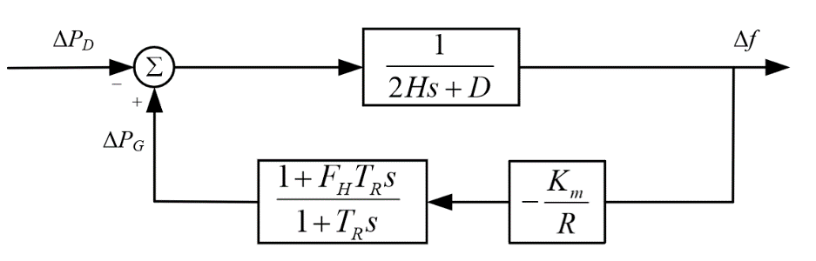
Fig. 1. Conventional system frequency response model.
The rotor motion equation is expressed by Equation (2):

In the equation: ΔP denotes the total active power modulation magnitude of the power system; H signifies the equivalent inertia time constant of the system; D stands for the equivalent damping coefficient of the system; and s corresponds to the frequency-domain operator.

Frequency Regulation Control Method for Wind Turbines with Variable Wind Speeds
The frequency regulation capability of wind turbines is influenced by factors such as wind speed, rotor speed, and their inherent reserve coefficients, resulting in varying frequency regulation capacities under different wind speeds and operating conditions. Moreover, the operational state of wind turbines under different working conditions also affects the wind-storage frequency regulation strategy [18-20]. Considering the characteristics and applicable ranges of different frequency regulation methods for wind turbines, wind speed intervals are classified, and control methods for wind turbine frequency regulation under different operating conditions are formulated.
2.2.1 Evaluation of Wind Turbine Operating Regions
When using overspeed de-loading control, wind turbines can simultaneously utilize rotor kinetic energy and reserve power for frequency regulation, providing fast response. However, it is limited by rotational speed constraints and is unsuitable for high-wind-speed conditions. Pitch angle control, while applicable across a broader range of wind speeds, involves mechanical adjustments ^{[10]}. Due to the high inertia of the pitch system, its response is slower. Additionally, frequent pitch angle changes increase mechanical wear. Conventional single-frequency control methods for wind turbines only allow limited participation in frequency regulation ^{[11]}. Therefore, a coordinated control approach combining virtual inertia control, overspeed de-loading control, and pitch angle de-loading control is often adopted to meet frequency regulation requirements under different wind speed conditions.
As shown in Figure 2, the operating range of the doubly-fed induction generator wind turbine is divided into three regions based on its operational characteristics: low wind speed region, medium wind speed region, and high wind speed region.
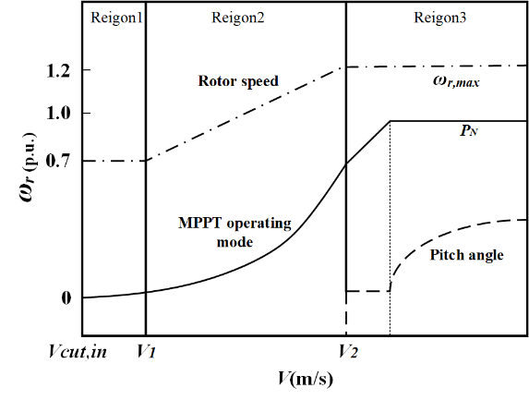
Fig. 2. Operating curve of WTG.
The frequency coordinated control strategy for wind turbines proposed in this chapter divides the operating range into three wind speed regions based on rotor speed characteristics: region 1 with lower rotor speeds is defined as the low wind speed region, where the wind turbine outputs relatively small active power; region 2 operating at optimal speed is classified as the medium wind speed region, following the maximum power point tracking curve; region 3 reaching maximum rotor speed is designated as the high wind speed region, where the rotor operates at constant speed. Corresponding operational control strategies are developed according to the characteristics of each wind speed region.
2.2.2 Integrated Frequency Regulation Control Strategy for Wind Turbines
A．In the low-wind-speed region
In region I, the wind turbine operates at low wind speeds and rotor speeds, resulting in low levels of both active power output and rotor kinetic energy. Under these conditions, the turbine cannot respond to frequency regulation demands by releasing rotational kinetic energy through speed reduction. If the wind turbine were to increase its active power output in response to system frequency deviations, the resulting decrease in rotor speed could easily lead to turbine stall. Therefore, to ensure stable operation, wind turbines operating in this region do not implement deloading reserves nor participate in frequency regulation.
B．In the middle-wind-speed region
In Region II, as wind speed and turbine rotor speed increase, the blade pitch angle remains at 0° during MPPT operation. The wind turbine's frequency control strategy combines inertial control and rotor over-speed control: on one hand, it converts and releases the stored rotational kinetic energy of the rotor into active power; on the other hand, it releases the reserved capacity maintained by over-speed control.
When the wind turbine adopts over-speed de-loading control, its power variation curve is shown in Figure 3. Here, P_{a} represents the initial maximum power operating point, P_{b} denotes the active power after the turbine is de-loaded by d_{b}%, and P_{c} indicates the operating point when the turbine participates in frequency regulation.

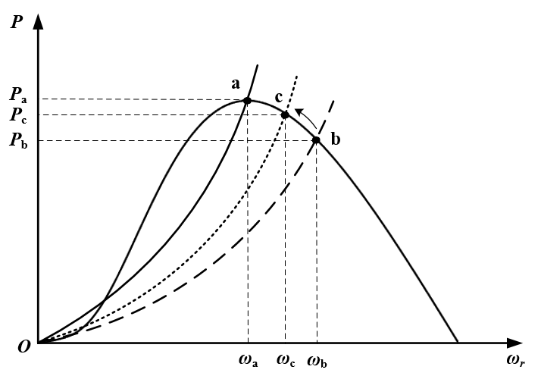
Fig. 3. Deloaded power and frequency regulation curves of wind turbine.
During the frequency regulation process, the rotor speed of the wind turbine gradually decreases, causing the operating point to shift upward from point b to a new power equilibrium point c, thereby increasing the active power output of the unit. As the frequency regulation progresses and the grid frequency gradually returns to normal, the wind turbine reverts to the de-loaded operating point b. The calculation formula for the new operating point P_{c} after wind power participates in frequency regulation can be expressed as:

Where k₁ is the active power increment coefficient under rotor over-speed control.
The deloading percentage corresponding to P_{c} is shown as:

The performance co-efficient of the wind turbine corresponding to P_{c} is written as:

Accordingly, the operating power reference of the P_{c} is calculated as:

The wind turbine rotor speed reference corresponding to P_{c} is calculated according to:


The total active power increment ΔP_{wind} is expressed as:

C．In the high-wind-speed region
In the high-wind-speed region, the rotor speed of the wind turbine reaches its maximum limit. Thus rotor over-speed control would not work for achieving the deloading operation of the wind turbine. Therefore, in the high wind speed region, the wind turbine frequency control strategy adopts combined inertia control and pitch angle control.
Figure 4 shows the power variation curve of the wind turbine when pitch angle control is applied. P_{d} represents the initial maximum power operating point, with a corresponding pitch angle of β₀. While maintaining the rotor speed at ω_{r,max}, the pitch angle is increased from β₀ to β₁, reducing the wind turbine's output power from P_{d} to P_{e}. Point e denotes the power operating point after a d_{e}% deloading. By adjusting the pitch angle, the wind turbine increases active power output, releasing the reserved standby capacity, and ultimately achieves stable operation at point f.
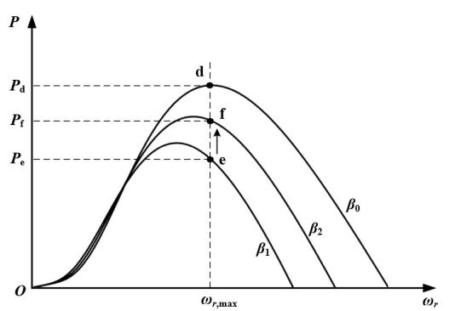
Fig. 4. Wind turbine pitch angle deloading frequency regulation curve.
When the wind turbine operates in the high wind speed region, the rotor speed remains constant at ω_{r,max}. If the incoming wind speed is steady, the tip-speed ratio stays unchanged. However, as the wind speed increases, the tip-speed ratio gradually decreases. Under a given tip-speed ratio, the relationship between the power coefficient and the pitch angle can be approximated as linear and expressed using a first-order function:

Where k is the proportionality coefficient.
According to the wind speed range classification in this study, wind turbines operate in two modes: maximum power tracking and constant power regulation. By employing pitch angle compensation control, the setpoint of the pitch angle for turbines operating in the high wind speed region can be determined. Typically, the boundary between the maximum power tracking zone and the constant-speed zone corresponds to an active power output of 0.75 p.u. To prevent abrupt changes in the pitch angle due to wind speed fluctuations, a compensation mechanism can be designed for the pitch angle, as expressed in Equation (12):

Where β_{off} represents the pitch angle compensation term, P_{ref} denotes the active power reference value.
Furthermore, the auxiliary frequency control module establishes the functional relationship between the system frequency deviation and the pitch angle deviation, which is expressed as:

where k₂ is the scale factor of pitch angle control.
When the system frequency deviates beyond the permissible operating range, the pitch angle control system reduces the pitch angle to increase the active power output of the wind turbine, driving the system to a new stable operating point (e.g., point f in Figure 4). At this new equilibrium, the wind power coefficient and active power output are given by Equations (14) and (15), respectively:


Thus the active power increment from the pitch angle adjustment is demonstrated as:


Thermostatically Controlled Load Aggregation Model Considering User Comfort
TCLs play a crucial role in power system frequency regulation, peak shaving, and renewable energy integration. Their effective control requires the establishment of reasonable mathematical and physical models. When grid frequency drops, the aggregated response capability of smart appliances can provide essential frequency support to the grid ^{[12]}. The key to developing an aggregation model lies in comprehensively considering user comfort constraints and response delay limitations to accurately assess the actual regulation potential of the load population. In this study, the primary TCLs considered are air conditioners and water heaters, with a focus on their ability to compensate for power deficits by adjusting power output. Active load power adjustments inevitably involve operational state interruptions, which may impact user experience. Therefore, a load comfort index is introduced to quantify the degree of deviation from the rated operating range, defined as follows:

In the equation, P represents the current state of household, D_{set} is the setting value for load demand, R_{LD} represents the setting range for load demand.
Taking the cooling mode of the air conditioner as an example, the operation state of the air conditioner is related to the indoor temperature. When the indoor temperature exceeds the upper limit set point, the air conditioner is turned on. When the indoor temperature is below the lower limit set point, the air conditioner is turned off. If the indoor temperature is within the set range, the previous operating state is maintained. The operation state of the air conditioner is described by:
(18)
In the equation: S_{t,AC} is the operating state of the air conditioner at time t (1 indicates the air conditioner is on, 0 indicates the air conditioner is off), T_{L,AC} is the lower limit of the indoor temperature for the air conditioner, T_{H,AC} is the upper limit of the indoor temperature for the air conditioner, T_{t,AC} is the indoor temperature at time t.
The definition of user comfort is given by:
(19)
The operation of the water heater is related to its water temperature. When the water temperature exceeds the upper limit set point, the water heater is turned off. When the water temperature is below the lower limit set point, the water heater is turned on. If the water temperature is within the set range, the previous operating state is maintained. The operation state of the water heater is described by:
(20)
In the equation: S_{t,WH} is the operating state of the water heater at time t (1 indicates the water heater is on, 0 indicates the water heater is off), T_{L,WH} is the lower limit of the water heater temperature, T_{H,WH} is the upper limit of the water heater temperature, T_{t,WH} is the water heater temperature at time t.
The definition of user comfort can be defined as:
(21)
The purpose of establishing the aggregation model is to investigate the response capabilities provided by a smart load group based on direct load control. This model needs to consider constraints related to the impact of comfort and response delay. The definition of user comfort is established, followed by ranking users based on their comfort levels. The response is then carried out in the order of comfort levels, simultaneously defining the aggregation model for the loads. Controllable loads include air conditioners and water heaters, both falling under the category of temperature-controlled loads. Utilizing the response power of temperature-controlled loads to compensate for the power deficit in the system requires interrupting loads to initiate the response. The aggregation model for loads is given by:
(22)
In the equation, P_{DR} represents the reducible load amount, P_{WH,i} is the operating power of the i-th water heater, P_{AC,k} is the operating power of the k-th air conditioner, S_{WH,i} and S_{AC,k} respectively indicate the operating states of the i-th water heater and the k-th air conditioner, where 0 denotes closed and 1 denotes open.

Coordinated Frequency Response Model of Wind Turbines and Thermostatically Controlled Loads
Based on the aforementioned content, an improved power system frequency response model incorporating primary frequency regulation of conventional generators, wind turbine participation, thermostatically controlled load response, and under frequency load shedding actions is illustrated in Figure 5.
Fig. 5. Improved power system frequency response model.
In Figure 5, ΔP_{short} represents the initial power deficit of the system, ΔP_{m} denotes the active power increment from the frequency regulation response of conventional thermal power units, ΔP_{shed} indicates the load shedding amount due to under frequency conditions, ΔP_{DR} stands for the active power adjustment from thermostatically controlled loads, ΔP_{wind} represents the active power contribution from wind turbines, Δf is the system frequency deviation.

3. Under Frequency Load Shedding Implementation Scheme for Power Systems

3.1 Basic Principles of UFLS Schemes
To ensure economic efficiency and fully utilize the system's spinning reserve capacity, the frequency setting step between successive stages of UFLS should preferably be 0.2 Hz, with the basic number of stages typically ranging from 3 to 8. For the actual grid conditions in this study, 4 stages are implemented, with their respective actuation frequency thresholds set at 49.4 Hz, 49.2 Hz, 49.0 Hz, and 48.8 Hz. Each stage has an actuation delay of 0.2 s, and the load shedding ratio (ξ) for each stage is configured as 20%, 25%, 25%, and 30% of the power deficit, respectively. Considering the priority response of TCLs, the TCL cluster's actuation threshold is set at 49.6 Hz, and its active power contribution to frequency regulation is dynamically adjusted based on the magnitude of the power deficit.
In the practical implementation of UFLS, the load shedding locations and allocation of shedding amounts can be determined using the load shedding sensitivity method proposed in paper [13]. Based on this approach, the load shedding amount at the i-th node in the power grid can be calculated as:
(23)
Where P_{shed,i} is the total load to be shed in the i-th stage, S_{n} is the sensitivity factor of the load node, which depends on the electrical distance between the load node and the disturbance source, N is the total number of load nodes.

3.2 Impact of Coordinated Frequency Regulation by Wind Turbine and TCLs on UFLS Process
Figure 6 details the dynamic process of coordinated participation of wind power and TCLs in under frequency load shedding. When a power disturbance occurs in the system, wind power participates in UFLS through its power compensation mechanism. The control center rationally allocates frequency regulation tasks to regional TCL clusters based on the disturbance severity and operational characteristics of each region's TCLs, then stores the control commands in smart meter devices.
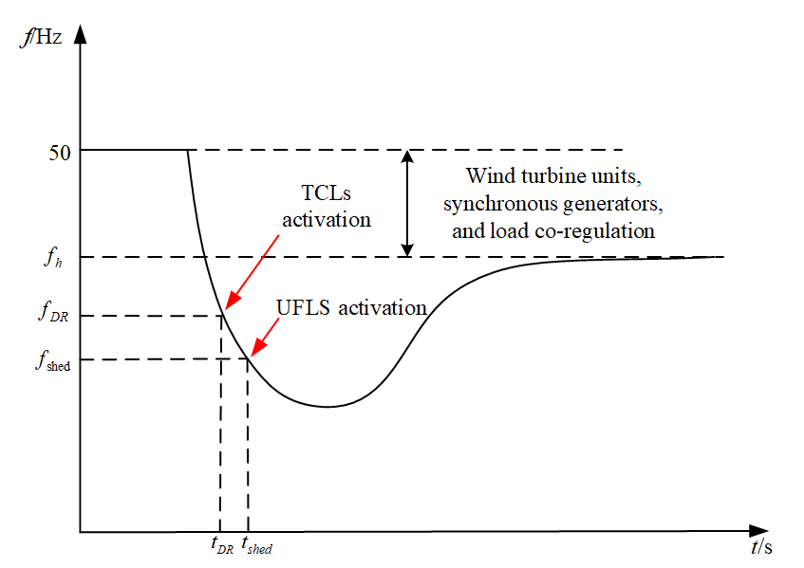
Fig. 6. Dynamic process of UFLS.
After the implementation of UFLS in the power system, let f_{h} denote the steady-state system frequency (as shown in Figure 6). When f_{h} drops below the rated frequency, the resulting active power deficit is ΔP_{h}. With wind turbines participating in frequency regulation, the system's power-frequency characteristic is described as follows:
(24)
Where K_{load}、K_{wind}、K_{G} represent the equivalent regulation coefficients of the load, wind turbines, and synchronous generators, respectively. Let P_{LN} denote the system load under steady-state operation, and the total load shedding amount ΔP_{shed,∑} of under frequency load shedding is given by:
(25)
Where .
This paper proposes an optimized load shedding strategy by setting higher activation frequencies and utilizing TCLs as priority response resources to achieve preemptive load reduction. The implementation approach is as follows: When the system frequency drops to a predefined threshold f_{DR} (indicating frequency regulation demand), the dispatch center issues control signals to load aggregators based on power deficit prediction. Upon receiving the signals, each load aggregator determines the actual TCL response capacity by evaluating both the total required load shedding amount and the maximum adcjustable capacity of the TCLs cluster. Two specific scenarios are considered:
Scenario 1: if the calculated total load shedding requirement does not exceed the adjustable capacity of the TCL cluster, each TCL cluster can respond to grid demand according to its available capacity using an optimized UFLS strategy. The response ratio of each cluster is determined by Equation (26):
(26)
In the equation, represents the active power curtailed by the n-th TCL cluster at time t; denotes the maximum curtailable active power of the n-th TCL cluster at time t. Under this scenario, the entire power deficit is compensated by the TCL clusters, eliminating the need to shed other types of loads.
Scenario 2: when the total required load shedding exceeds the maximum adjustable capacity of the TCL clusters, Each TCL cluster contributes its maximum curtailable power to mitigate the power deficit. If the system frequency continues to decline below a predefined threshold f_{shed}, the control center recalculates the remaining power deficit and activates UFLS protection devices.
Considering the two scenarios described above, the total load shedding amount in the power system is calculated as:
(27)
The specific implementation process of UFLS is illustrated in the figure below:
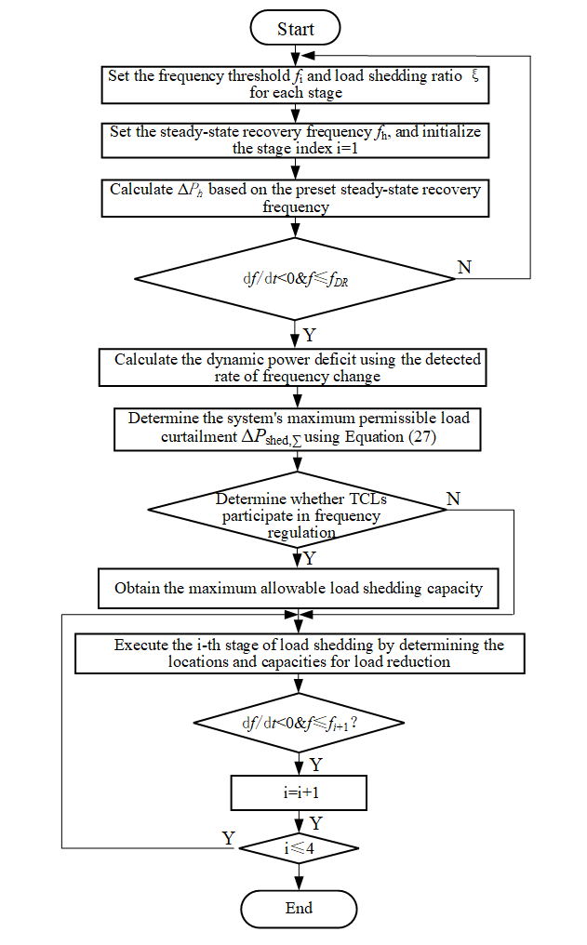
Fig. 7. Flowchart of the proposed UFLS implementation strategy.

4. Case Study Simulation and Analysis
The test system shown in Figure 8 is implemented in MATLAB/Simulink to validate the effectiveness of the proposed strategy. In this system, the synchronous generators at buses 30, 32, 36, and 37 are replaced with wind farms, achieving a wind power penetration rate of 32.3%. Additionally, thermostatically controlled load clusters managed by load aggregators are deployed at the nodes marked in red. During the simulation, a disturbance is introduced by disconnecting the generator (with an output of 920 MW) at bus 35 at t=5s.
Fig. 8. IEEE 39-bus system topology and distribution of TCLs.

4.1 The impact of the improved UFLS scheme in the low wind speed range
In the simulation model, the wind speed was set to 6 m/s. Due to the rotor speed constraints of wind turbines, they were unable to participate in system frequency regulation. Consequently, thermostatically controlled loads were prioritized to provide active power support and undertake the UFLS task. The simulation results are illustrated in Figure 9.
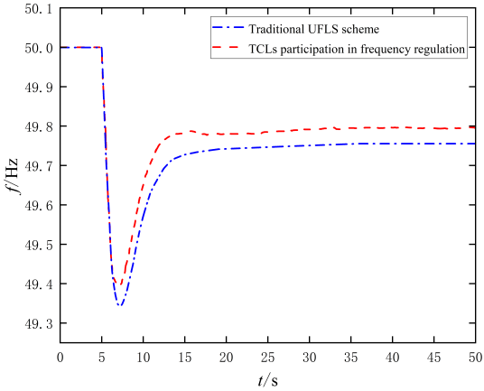
Fig. 9. Simulation results of UFLS in the low wind speed region.
As illustrated in Figure 9, when an active power deficit occurs, the logic control center calculates the required active power output of the thermostatically controlled load cluster based on the system frequency deviation and rate of change of frequency. The TCLs compensate for part of the power deficit, effectively mitigating the rapid frequency decline and significantly improving the frequency recovery speed. Specifically, without TCLs participation in frequency regulation, the system frequency nadir drops to 49.34 Hz, while with TCLs support, it increases to 49.38 Hz. Similarly, the steady-state frequency improves from 49.75 Hz (without TCLs) to 49.80 Hz (with TCLs), meeting the technical requirements for UFLS.
TABLE I. Load Shedding and Frequency Response Under Low Wind Speed Conditions
Simulation Scenarios | without TCLs | with TCLs
ΔP_{shed,∑} (MW) | 574.41 | 418.08
f_{min} (Hz) | 49.34 | 49.38
f∞ (Hz) | 49.75 | 49.80
The data in Table 1 shows that the participation of thermostatically controlled loads in system frequency response reduces the load shedding requirement by 156.33 MW, significantly decreasing the total curtailed load. By participating in grid frequency regulation, TCLs not only enhance system security but also improve economic efficiency. This approach alleviates the impact of under frequency load shedding on consumer-side demand and ensures power supply reliability for end-users.

4.2 The impact of the improved UFLS scheme in the middle wind speed range
In the simulation model with a constant wind speed setting of 8 m/s, a comparative analysis was conducted between two frequency regulation control strategies: Scheme 1 employs wind turbines participating in frequency regulation through synthetic inertia control combined with rotor over-speed control, while Scheme 2 adopts a coordinated frequency regulation strategy incorporating both wind power and thermostatically controlled loads. The comparative results of these two schemes are illustrated in Figure 10.
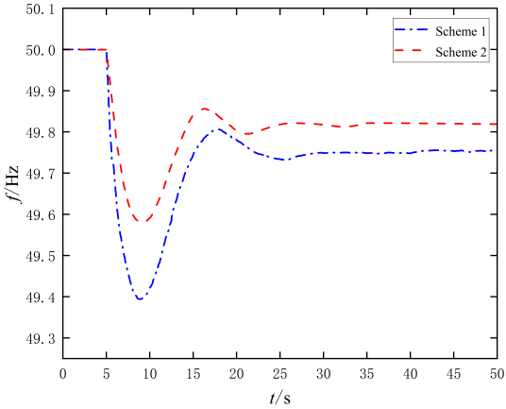
(a) System frequency response
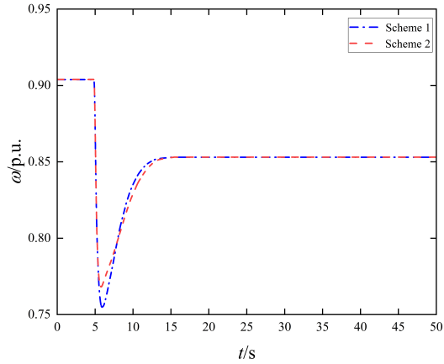
(b) Rotor speed
Fig. 10. Simulation results of UFLS in the middle wind speed region.
As shown in Figure 10, when active power deficit occurs, the rotor speed rapidly decreases in the initial stage of frequency regulation, providing short-term power support and effectively mitigating system frequency variations. When considering the joint participation of wind power and load in frequency response, since thermostatically controlled loads are prioritized for load shedding, the minimum rotor speed is higher compared to scenarios where wind turbines alone participate in frequency response, thereby facilitating the recovery of the wind turbine rotor speed.
TABLE Ⅱ. Load Shedding and Frequency Response Under middle Wind Speed Conditions
Simulation Scenarios | Scheme 1 | Scheme 2
ΔP_{shed,∑} (MW) | 530.67 | 392.03
f_{min} (Hz) | 49.39 | 49.59
f∞ (Hz) | 49.78 | 49.82

The data in the table demonstrates that the joint frequency regulation control strategy involving wind power and TCLs effectively reduces load shedding requirements and enhances system frequency stability. By comparing the data of Scheme 1 with Figure 9 and Table 1, it can be observed that when wind power participates in UFLS, it compensates for part of the power deficit. As a result, the required load shedding decreases from 574.41 MW to 530.67 MW, and the frequency nadir rises from 49.34 Hz to 49.39 Hz, effectively mitigating frequency decline.

4.3 The impact of the improved UFLS scheme in the high wind speed range
The simulation model, with wind speed set at 12 m/s, compares two frequency regulation strategies: Scheme 1 employs wind turbines participating in frequency regulation through combined inertia control and pitch angle control, while Scheme 2 implements a coordinated frequency regulation strategy incorporating both wind power and TCLs. The comparative results of these two schemes are presented in Figure 11.
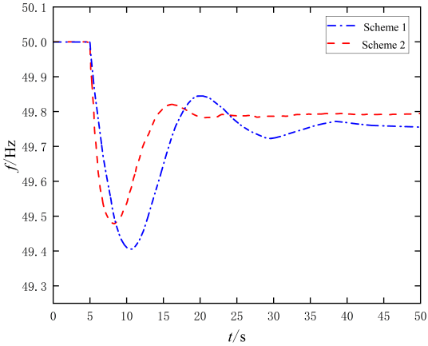
(a) System frequency response
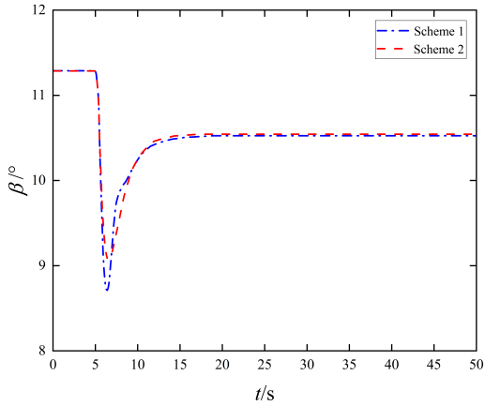

(b) Pitch angle
Fig. 11. Simulation results of UFLS in the high wind speed region.
As shown in Figure 11, under high wind speed conditions, pitch angle control exhibits relatively slow response speed when participating in frequency regulation, while the thermostatically controlled load cluster demonstrates faster response capability. When a sudden frequency drop occurs in the system, the TCL cluster rapidly engages in the load shedding process. Simultaneously, wind turbines increase active power output by reducing pitch angles. As the frequency regulation process progresses, wind turbines maintain system frequency stability through combined inertia control and pitch angle control.
TABLE Ⅲ. Load Shedding and Frequency Response Under high Wind Speed Conditions
Simulation Scenarios | Scheme 1 | Scheme 2
ΔP_{shed,∑} (MW) | 533.04 | 363.39
f_{min} (Hz) | 49.42 | 49.48
f∞ (Hz) | 49.77 | 49.80
The above analysis demonstrates that the coordinated frequency regulation strategy effectively combines the stable reserve capacity advantage of pitch angle control with the fast-response characteristics of thermostatically controlled loads. This integrated approach significantly improves upon the regulation performance achieved by wind turbines alone, thereby enhancing overall system frequency stability.

5.conclusion
This paper proposes a coordinated frequency regulation strategy combining wind power and TCLs. Simulation analysis verifies the effectiveness of the proposed control method, which provides a novel approach for joint frequency regulation by wind farms and TCLs in large-scale wind power integration scenarios. The main conclusions are as follows:
When the system experiences active power deficit, wind turbine participation in frequency regulation outperforms scenarios without wind turbines or flexible loads in mitigating rapid frequency declines. Furthermore, joint participation of wind turbines and flexible loads demonstrates superior frequency support capability compared to wind-only participation, effectively preventing severe frequency drops during low-frequency events. Furthermore, the under-frequency load shedding calculation under this coordinated regulation scheme meets the steady-state frequency recovery requirements specified in technical standards while significantly reducing the required load shedding amount. This effectively minimizes the impact on consumer-side loads during UFLS implementation. The proposed strategy successfully achieves a balanced optimization between maintaining system frequency stability, improving the economic efficiency of load shedding, and ensuring power supply reliability.

References
- Wang Yun, Zou Runmin, Liu Fang, Zhang Lingjun, Liu Qianyi. A review of wind speed and wind power forecasting with deep neural networks[J]. Applied Energy,2021,304.
- Aparicio N, Villalba S A, Belenguer E, et al. Automatic under-frequency load shedding mal-operation in power systems with high wind power penetration [J]. Mathematics and Computers in Simulation,2018,146：200-209.
- Tofis Yiannis, Timotheou Stelios, Kyriakides Elias. Minimal load shedding using the swing equation[J]. IEEE Transactions on Power Systems, 2017, 32(3):2466-2467.
- Banijamali, S.S., Amraee, T.: Semi-adaptive setting of under frequency load shedding relays considering credible generation outage scenarios. IEEE Trans. Power Delivery 34(3), 1098–1108 (2019).
- Aparicio, N., Villalba, S.A., Belenguer, E., et al.: Automatic underfrequency load shedding mal-operation in power systems with high wind power penetration. Math. Comput. Simul. 146, 200–209 (2018).
- Li, S., Tang, F., Shao, Y., Liao, Q.: Adaptive under-frequency load shedding scheme in system integrated with high wind power penetration: Impacts and improvements. Energies 10(9), 1331 (2017).
- Li, S., Lyu, X., Zhong, H., et al.: Adaptive under-frequency load shedding strategy of power grid with large-scale DFIG wind turbines participating in frequency regulation. Autom. Electr. Power Syst. 43(15), 109–120 (2019).
- M. Saeed Misaghian, R. Li and D. Flynn, “Fast Frequency Response Provision from Commercial Demand Response, from Scheduling to Stability in Power Systems,” The 9th Renewable Power Generation Conference (RPG Dublin Online 2021), Online Conference, 2021, pp. 306-311.
- Anderson P M, Mirheydar M. A low-order system frequency response model [J]. IEEE Transactions on Power Systems, 1990, 5(3):720-729.
- Mararakanye N, Bekker B. Renewable energy integration impacts within the context of generator type, penetration level and grid characteristics[J]. Renewable and Sustainable Energy Reviews, 2019, 108: 441-451.
- Yan Cheng, Tang Yi, Dai Jianfeng, Wang Chenggen, Wu Shengjun. Uncertainty modeling of wind power frequency regulation potential considering distributed characteristics of forecast errors[J]. Protection and Control of Modern Power Systems,2021,6(1).
- A. Rafinia, J. Moshtagh, and N. Rezaei, “Towards an enhanced power system sustainability: An MILP under-frequency load shedding scheme considering demand response resources.” Sustainable Cities and Society vol. 59, p. 102168, Aug. 2020.
- M. Vadillo, L. Sigrist and U. Rudez, “Design and comparison of UFLS schemes of isolated power systems based on frequency stability margin,” 2023 IEEE Belgrade PowerTech, Belgrade, Serbia, 2023, pp. 1-6.
- Alhelou, H. H., Golshan, M. E. H., Njenda, T. C., & Hatziargyriou, N. D. (2020). An overview of UFLS in conventional, modern, and future smart power systems: challenges and opportunities. Electric Power Systems Research, 179, 106054.
- Bustamante, S., López, G. J., & Cardona, H. A. (2023). UFLS and Smart Load for Frequency Regulation in Electrical Power System: A Review. IEEE Access, 11, 110967-110984.
- O’Malley, C., Badesa, L., Teng, F., & Strbac, G. (2021). Probabilistic scheduling of UFLS to secure credible contingencies in low inertia systems. IEEE Transactions on Power Systems, 37(4), 2693-2703.
- Madiba, T., Bansal, R. C., Justo, J. J., & Kusakana, K. (2017). Optimal control system of under frequency load shedding in microgrid system with renewable energy resources. Smart Energy Grid Design for Island Countries: Challenges and Opportunities, 71-96.
- Ning, J., Sun, L., Yuan, T., Lu, G., & Zeng, A. (2024, March). Research on Continuous Under Frequency Load Shedding Strategy Based on Temperature-Controlled Load Response. In 2024 6th Asia Energy and Electrical Engineering Symposium (AEEES) (pp. 781-787). IEEE.
- Mbungu, N. T., Madiba, T., Bansal, R. C., Bettayeb, M., Naidoo, R. M., Siti, M. W., & Adefarati, T. (2022). Economic optimal load management control of microgrid system using energy storage system. Journal of Energy Storage, 46, 103843.
- Ketabi, A., & Fini, M. H. (2014). An underfrequency load shedding scheme for hybrid and multiarea power systems. IEEE Transactions on Smart Grid, 6(1), 82-91.

