Harnessing Data Science and Big Data in Agriculture: A Pathway to Smart and Sustainable Farming

Abstract

Agriculture is experiencing a paradigm shift, driven by the integration of data science and big data technologies, which promise to revolutionize farming practices, enhance productivity, and ensure sustainability. This presentation explores the transformative role of big data in agriculture, with a particular focus on how it enables precision farming, resource optimization, and supply chain management. The concept of smart farming, driven by IoT, machine learning, and big data analytics, allows farmers to make informed decisions that significantly impact crop yield, pest management, and climate adaptation. Through the application of big data tools, farmers can optimize water usage, predict pest outbreaks, and adjust operations in real-time for improved productivity. Moreover, corporate solutions and technological innovations are providing the infrastructure for data-driven farming practices, empowering farmers to make smarter, data-backed decisions. This presentation also covers the growing career opportunities in agricultural data science and showcases case studies demonstrating the successful application of big data in enhancing agricultural efficiency. As the agricultural sector embraces the potential of big data, it holds the key to addressing the challenges of food security, resource management, and climate change, ensuring a resilient and sustainable agricultural future.

Keywords- Big Data analysis, Data Analytics, Data Science, Machine Learning, Smart Farming,

Introduction

Agriculture is undergoing a data-driven transformation, unlocking hidden insights, optimizing operations, and ensuring a sustainable future by harnessing big data analytics. Traditionally, farming relied on intuition and experience (Saqib et al., 2025). Today, a deluge of data from satellites, sensors, and farm machinery offers a new perspective, enabling farmers and agribusinesses to make informed, data-driven decisions. This data holds the power to transform agriculture—optimizing resource use, predicting crop yields, and improving overall productivity (Medida et al., 2025).

The integration of big data analytics in agriculture presents a solution to some of the most pressing challenges in the sector, including climate change, resource depletion, rising food demand, and labor shortages. Traditional farming practices alone are insufficient to address these concerns, making it necessary to incorporate advanced technologies like data science. These technologies enable farmers to optimize resource use, predict yields, manage risks, and respond more effectively to changing environmental conditions (Kumar & Sharma, 2025).

Data science involves using statistical techniques, machine learning, and predictive modeling to extract actionable insights from large datasets. When combined with big data—characterized by its volume, velocity, variety, and veracity—agriculture enters a new era of innovation, often referred to as "Smart Agriculture" or "Agriculture 4.0" (Choudhary et al., 2020). This evolution represents a fundamental shift in how agriculture operates, moving beyond traditional methods and adopting precision farming practices powered by real-time data.

The revolutionary technology that is big data has already made significant waves in industries such as IT and healthcare. Now, agriculture is poised to benefit from its transformative potential (Choudhary et al., 2024). By embracing data analytics, agriculture can enhance its sustainability, improve food security, and meet the growing global demand for food. As we explore this data-driven future, it is clear that big data will play a crucial role in shaping the next generation of agricultural practices.
Improvements in Farming: Smart Farming a Step Ahead
Smart farming represents a groundbreaking application of science and technology in agriculture, revolutionizing traditional farming practices and setting the stage for a more sustainable and efficient agricultural future. By leveraging advanced technologies such as the Internet of Things (IoT), Big Data, and data analytics, smart farming empowers farmers with actionable insights that help optimize farm management and improve productivity. This integration of technology enhances decision-making processes and provides farmers with real-time, data-driven insights to make precise, informed decisions.
At the heart of smart farming is the extensive use of IoT (Internet of Things), where interconnected sensors and devices collect data from various aspects of the farm environment, such as soil moisture levels, weather conditions, crop health, and machinery performance. These sensors provide continuous feedback, giving farmers real-time information about their operations. With this data at their disposal, farmers can better manage irrigation systems, apply fertilizers and pesticides more efficiently, and ensure optimal plant growth conditions—ultimately increasing crop yields while minimizing resource wastage.
Big Data plays a crucial role in transforming traditional agriculture into precision agriculture. Through the collection and analysis of massive datasets, big data provides farmers with insights that were previously difficult to obtain. The data generated from sensors, drones, satellites, weather stations, and other devices is processed and analyzed to uncover patterns and trends that guide farming decisions. For example, big data analytics can help predict crop yields, identify potential pest outbreaks, assess soil health, and optimize irrigation schedules. This predictive power allows farmers to plan ahead, minimizing risk and maximizing productivity.
One of the most significant impacts of big data is seen in supply-chain optimization. The agricultural supply chain is complex and often prone to inefficiencies. By applying big data analytics, farmers can gain better visibility into the entire supply chain, from production to distribution. This data can help identify bottlenecks, predict demand, and streamline logistics, leading to reduced waste, lower transportation costs, and improved profitability for farmers. For instance, data-driven insights can help farmers determine the best time to harvest crops based on market conditions, ensuring that produce is sold at its peak value.
In addition, smart farming enables predictive insights that allow farmers to anticipate and manage potential challenges. Through the use of machine learning algorithms and predictive models, farmers can forecast future conditions such as weather patterns, crop disease outbreaks, and market prices. By predicting these variables, farmers can take proactive measures, adjusting their strategies accordingly to mitigate risks and optimize their operations.
Real-time decision-making is another key benefit of big data and smart farming. The ability to access real-time data allows farmers to respond instantly to changing conditions in the field. For example, if a sensor detects that the soil moisture level is too low, the system can trigger an automatic irrigation system to apply water to the crops. Similarly, if a pest infestation is detected, farmers can use real-time data to identify the most effective treatment methods, applying pesticides only where necessary, which reduces chemical usage and environmental impact.
Ultimately, smart farming represents a shift toward precision agriculture, where technology is used not only to improve crop production but also to ensure the sustainability and long-term viability of farming practices. The application of IoT, big data, and analytics in agriculture allows farmers to make smarter decisions, reduce waste, conserve resources, and increase productivity, leading to a more efficient and resilient agricultural system. Through these innovations, smart farming is paving the way for a future where farming is more data-driven, sustainable, and capable of meeting the growing global demand for food.
Data Science vs Big Data
- Data Science is an interdisciplinary field focused on extracting knowledge and insights from data using statistical methods, algorithms, data visualization, and domain expertise. It integrates techniques from mathematics, statistics, computer science, and specific domain knowledge to analyze complex datasets.
- Big Data refers to vast and complex datasets that traditional data processing tools cannot handle effectively. Big Data is the raw material that Data Science techniques analyze and interpret.
Fig 1 Data science fields
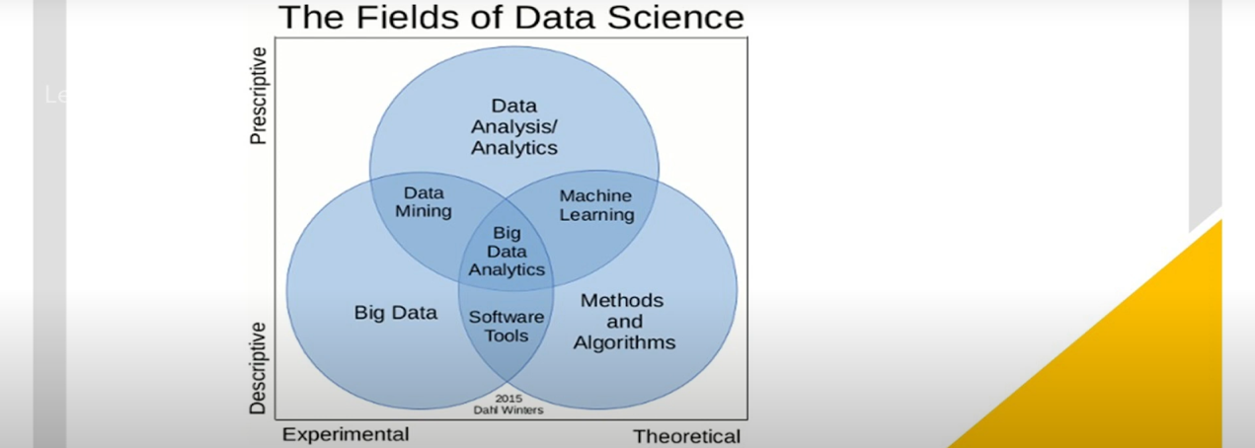

Table 1 : A timeline of developments that brought "Big Data Analytics" to the fore is briefly presented as follows: (Liakos and Panagos 2018)
Year | Person/Organization | Contribution/Note
1944 | Fremont Rider, Wesleyan University Librarian | Speculated that the Yale Library in 2040 will have “approximately 200 million volumes because of information explosion”
1980 | Sociologist Charles Tilly | First to use the term "Big Data"; quote: “none of the big questions has actually yielded to the bludgeoning of the big-data people” (discovered by Oxford English Discovery folks)
1990 | Peter Denning | “It is possible to build machines that can recognize or predict patterns in data without understanding the meaning of the patterns”
1997 | Michael Cox and David Ellsworth | Used the term “big data” for the first time in print in an article in the ACM digital library
1998 | John Mashey, Chief Scientist at SGI | Popularized the term "Big Data" through speeches; credited with coining the term
2001 | Doug Laney, Meta Group (Gartner) | Introduced the 3Vs concept: “3D Data Management: Controlling Data Volume, Velocity, and Variety”
2005 | Tim O’Reilly | Published article “What is Web 2.0?” which sparked interest in Big Data
2005 | Yahoo | Created Hadoop, built on top of Google’s MapReduce

Role of Data Science and Big Data in Smart Agriculture
Data science plays a crucial role in transitioning traditional farming to intelligent, efficient, and sustainable systems. Smart farming relies on technologies such as sensors, drones, satellite imagery, and the Internet of Things (IoT) to collect real-time data on various aspects like soil, weather, crop health, pest infestations, and equipment performance.

Key Contributions of Data Science and Big Data:
- Precision Agriculture: Utilizes spatial and temporal data to enable site-specific crop management. By analyzing variations in fields, precision agriculture improves productivity and resource use (Liakos et al., 2018).
- Predictive Analytics: Helps forecast weather patterns, pest outbreaks, irrigation requirements, and harvest times, ensuring better planning and reduced losses (Basso et al., 2018).
- Decision Support Systems (DSS): These systems provide farmers with actionable insights, reducing guesswork and enhancing operational efficiency (Khosla et al., 2018).
- Sustainability and Resource Efficiency: Data-driven approaches enable the efficient use of water, fertilizers, and pesticides, leading to reduced environmental impact (Siddique et al., 2019).
By leveraging data science and big data, farmers can make informed decisions, reduce costs, increase yields, and minimize the ecological footprint of farming practices.

Key Components of Agricultural Data
Agricultural data is generated from various sources and exists in multiple forms, including structured, semi-structured, and unstructured data. The key components include:
- Sensor and IoT Data: This includes data from weather stations, soil moisture sensors, and pH meters. It helps monitor real-time environmental conditions crucial for crop growth (Yang et al., 2020).
- Satellite and Aerial Imagery: Provides geospatial data for monitoring vegetation health, detecting drought stress, and analyzing land use patterns (Ray et al., 2021).
- Machine Data: Generated by agricultural machinery like tractors, harvesters, irrigation systems, and drones. It provides insights into operational efficiency and equipment performance (Zhang et al., 2020).
- Farm Management Data: Involves information about inputs such as seeds, fertilizers, crop calendars, and field operations (Gao et al., 2020).
- Market and Supply Chain Data: Involves data related to commodity prices, demand forecasts, and logistics (Mishra et al., 2019).
- Social Media and Weather APIs: Serve as valuable unstructured sources of contextual data that can aid in decision-making (Sharma et al., 2019).
The integration and management of these heterogeneous data sources are critical for effective analytics and modeling in agriculture.
Fig 2 : Development and validation of algorithms
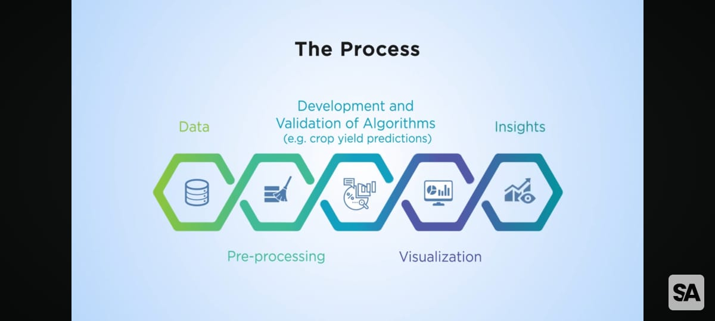
Key Components of Data Science

1. Data Collection
- Description: The process of gathering raw data from various sources.
- Sources in Agriculture:
  - IoT devices and sensors: Soil moisture sensors, weather stations, GPS devices on machinery.
  - Remote sensing: Satellite and drone imagery for crop health and field mapping.
  - Manual entry or surveys: Farm management records, agronomic observations.
- Purpose: To build a rich foundation of information needed for further analysis and model building.

2. Data Cleaning
- Description: Preparing raw data by correcting errors and inconsistencies.
- Steps Include:
  - Removing duplicates or irrelevant records.
  - Handling missing values (imputation or exclusion).
  - Correcting typographical errors or outliers.
- Importance: Ensures the accuracy and reliability of results; poor-quality data leads to misleading insights.

3. Data Integration
- Description: Merging data from different sources to create a unified dataset.
- Examples:
  - Combining weather data with crop yield data.
  - Merging soil analysis results with planting schedules and pesticide usage logs.
- Goal: To enable comprehensive analysis by correlating multiple data dimensions.

4. Data Transformation
- Description: Converting data into a format suitable for analysis.
- Techniques:
  - Normalization or standardization of numerical data.
  - Encoding categorical variables (e.g., crop types).
  - Aggregating or reshaping datasets (e.g., daily to weekly averages).
- Value: Helps in ensuring compatibility with algorithms and visualization tools.

5. Exploratory Data Analysis (EDA)
- Description: Initial investigation of data using visual and statistical tools to uncover patterns, trends, and anomalies.
- Tools Used:
  - Graphs (histograms, scatter plots, box plots).
  - Summary statistics (mean, median, standard deviation).
- Use Case in Agriculture: Discovering the correlation between rainfall and crop yield; identifying outliers in soil pH levels.

6. Data Modeling
- Description: Using machine learning algorithms or statistical techniques to analyze data and predict outcomes.
- Types of Models:
  - Regression (e.g., yield prediction).
  - Classification (e.g., disease detection).
  - Clustering (e.g., grouping similar farm zones).
- Outcome: Supports automation and predictive capabilities in agricultural management.

7. Data Validation
- Description: Testing models and outputs to ensure reliability and accuracy.
- Methods:
  - Splitting data into training and testing sets.
  - Cross-validation.
  - Error metrics like RMSE, precision, recall.
- Relevance: Critical for ensuring that models perform well on unseen data and in real-world conditions.

8. Interpretation and Communication
- Description: Translating complex data findings into actionable insights.
- Methods:
  - Dashboards, reports, and visualizations.
  - Storytelling with data for stakeholder understanding.
- Importance in Agriculture: Helps farmers and agribusinesses understand what the data means for operations, costs, and yields.

9. Decision-Making and Feedback
- Description: Applying insights to guide actions and iteratively improving models with new data.
- Examples:
  - Adjusting irrigation schedules based on soil moisture analytics.
  - Selecting crop varieties based on past performance and predicted weather.
- Cycle: Insight → Decision → Action → New Data → Re-evaluation.

Categorizing 5v’s of Big Data

1. Volume
- Definition: Refers to the huge amount of data generated every second.
- Example: Social media posts, sensor data, transaction records, etc.
- Importance: Requires scalable storage and processing solutions.

2. Variety
- Definition: The different formats of data collected from various sources.
- Types: Structured (databases), semi-structured (XML, JSON), unstructured (videos, images, texts).
- Importance: Increases complexity of data integration and analysis.

3. Velocity
- Definition: The high speed at which data is generated, collected, and analyzed.
- Example: Real-time data from financial markets, social media, or IoT devices.
- Importance: Demands quick processing to make timely decisions.

4. Veracity
- Definition: The inconsistencies and uncertainty in data.
- Challenge: Ensuring data accuracy, reliability, and trustworthiness.
- Importance: Poor data quality can lead to faulty decisions.

5. Value
- Definition: The ability to extract useful insights from data.
- Goal: Transform raw data into actionable intelligence.
- Importance: The ultimate purpose of Big Data is to generate value.
Fig 3 : Data volume
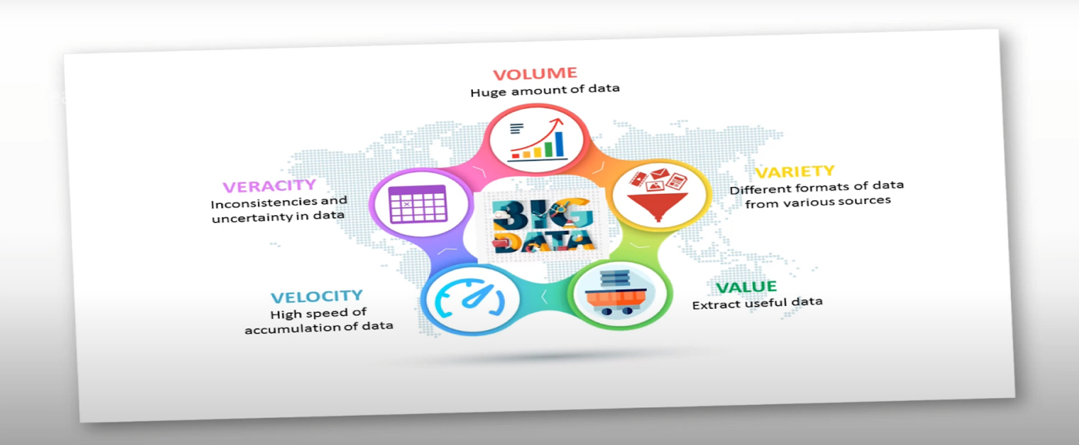
The Need for Big Data in Agriculture
- Supply Chain Optimization: Big Data improves transparency, reduces losses, and ensures timely delivery by analyzing logistics, market demand, and inventory levels.
- Resource Optimization: Big Data helps manage resources like water, fertilizers, and pesticides precisely, reducing waste and environmental impact.
- Climate Adaptation: By analyzing weather and climate data, farmers can adapt to changing environmental conditions and plan more effectively.
- Precision Farming: Big Data integrates IoT, satellite imagery, and machine learning to provide precise insights, leading to higher yields and reduced costs.
- Pest and Disease Management: Predicts and prevents pest outbreaks by analyzing sensor data and historical records.
- Food Demand: Big Data enables optimal crop yields and resource utilization to meet global food demands.

Fig 4 : The Big Data Cycle in Agriculture
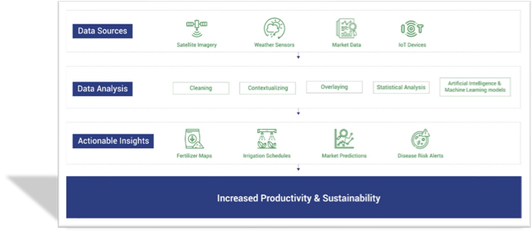

Big Data Analytics in Agriculture: The Data Pipeline
Utilizing big data in agriculture requires a structured analytics pipeline that processes raw data into usable insights. The typical pipeline includes:

a) Data Collection:
- Technologies: IoT sensors, drones, satellites, and mobile apps.
- Examples: Collect data such as temperature, rainfall, NDVI (Normalized Difference Vegetation Index), soil health, and livestock activity.

b) Data Storage:
- Technologies: Cloud platforms (AWS, Azure), Hadoop, and distributed storage systems.
- Features: These platforms provide scalability, real-time accessibility, and secure storage for vast datasets (Gao et al., 2021).

c) Data Cleaning and Processing:
- Tools: Python (Pandas, NumPy), R, Spark.
- Tasks: Removing noise, handling missing values, normalizing data, and ensuring data quality.

d) Data Analysis:
- Techniques: Descriptive statistics, clustering, regression, and classification.
- Goals: Detecting patterns, understanding variability, assessing risks, and optimizing operations (Liakos et al., 2018).

e) Visualization and Interpretation:
- Tools: Power BI, Tableau, QGIS, Matplotlib, Seaborn.
- Importance: Visualization tools are essential for making complex insights accessible and actionable for farmers and stakeholders.

Tools and Technologies in Agricultural Data Science
Several tools and platforms are fundamental to agricultural data science. These tools support various stages of the data lifecycle:

a) Programming Languages:
- Python: Widely used for data analysis, machine learning, and deep learning (Gao et al., 2020).
- R: Commonly used for statistical modeling and data visualization.

b) Data Management Platforms:
- Apache Hadoop and Spark: Used for big data storage and real-time analytics.
- SQL/NoSQL Databases: Help manage both structured and unstructured data.

c) Machine Learning Frameworks:
- Scikit-learn, TensorFlow, XGBoost: These frameworks are used for crop prediction, disease diagnosis, and yield estimation (Zhang et al., 2020).

d) GIS and Remote Sensing Tools:
- QGIS, ArcGIS, Google Earth Engine: These tools are used for spatial analysis and land use monitoring (Ray et al., 2021).

e) Cloud and IoT Platforms:
- AWS, Microsoft Azure, IBM Watson: These platforms offer scalable data processing, AI integration, and real-time analytics (Siddique et al., 2019).
These technologies form the backbone of modern agricultural analytics and are critical for building intelligent farming systems.
Big Data Tools in Agriculture
- Apache Spark: A powerful tool for big data processing and analysis (Voung et al., 2019). Supports multiple programming languages and can handle both batch and real-time data.
Table 2 : A data visualization tool that helps farmers interpret complex datasets, track crop health, and optimize resource use (Ken et al., 2018).

Corporate Contributions and Commercial Solutions in Smart Agriculture
The integration of big data and data science in agriculture has opened the door for numerous corporate players to develop cutting-edge solutions that enhance precision, efficiency, and sustainability across farming systems. These solutions leverage technologies like IoT, artificial intelligence (AI), satellite imagery, and advanced analytics to support data-driven decision-making in modern agriculture. Below is a comprehensive overview of key corporations and their contributions to various aspects of smart farming:

1. Precision Farming
Precision farming uses data from sensors, GPS, and machinery to manage field variability and optimize crop inputs.
- Corporations:
  - John Deere: Offers advanced machinery and data solutions through its Operations Center. It connects tractors and other equipment to cloud-based platforms, allowing farmers to analyze field performance, input usage, and optimize productivity (Deere, 2021).
  - Trimble: Provides GPS-guided agricultural solutions, helping farmers with auto-steering, yield monitoring, and variable rate applications.
  - AGCO: Delivers precision farming solutions through its Fuse® smart farming platform, enabling real-time monitoring and data-based farm management.
- Solutions:
Use of IoT-enabled sensors and data analytics to ensure optimal crop management, efficient resource use, and reduced environmental impact.

2. Crop Monitoring
Monitoring crop health is vital for early detection of stress, pests, or diseases.
- Corporations:
  - Bayer (Climate Corporation): Through Climate FieldView, Bayer offers real-time crop monitoring using satellite imagery, weather data, and in-field sensors.
  - Syngenta: Combines digital tools with agronomic research to monitor crops and recommend interventions.
  - Ceres Imaging: Specializes in aerial imagery analytics for early identification of crop stress, irrigation issues, and nutrient deficiencies.
- Solutions:
Satellite imagery, drones, and multispectral sensors provide data to monitor crop health, predict yields, and enable timely interventions.

3. Smart Irrigation
Water management is a critical component of sustainable agriculture.
- Corporations:
  - Netafim: A pioneer in drip irrigation systems that use sensor data to deliver water precisely where and when needed.
  - Valmont Industries: Offers smart irrigation technologies through its Valley Irrigation division, integrating remote monitoring and control.
  - CropX: Combines soil sensor data with weather forecasts and crop models to guide irrigation practices.
- Solutions:
IoT-enabled irrigation systems that analyze real-time soil moisture and weather conditions to optimize water usage and improve crop water productivity.

4. Broad Corporate Solutions in Data-Driven Agriculture
Beyond sector-specific applications, several tech giants and agri-businesses are providing integrated platforms that encompass multiple aspects of farm management.
- IBM Watson Decision Platform for Agriculture
Uses AI and weather forecasting to provide comprehensive solutions for crop yield prediction, pest alerts, and efficient resource allocation (IBM, 2020).
- Microsoft Azure FarmBeats
Combines IoT sensors, AI, and satellite data to provide insights into soil health, crop status, and environmental conditions, enabling data-driven decision-making (Microsoft, 2020).
- Bayer’s Climate FieldView
Offers farmers field-level insights through real-time data analytics, helping with seeding, crop protection, and harvest planning (Bayer, 2020).
- Corteva’s Granular
A digital farm management software that tracks productivity, input costs, and profitability to help farmers run more efficient operations (Corteva, 2020).

5. Soil Health and Fertility Management

Corporations:
- Yara International
- Nutrien
- AgroCares

Software Solutions and Big Data Roles:
- Atfarm (Yara)
Uses satellite data to analyze soil health and recommend nitrogen applications.
- Nutrien Ag Solutions Digital Hub
Processes field data to customize fertility recommendations.
- AgroCares Soil Scanner
Integrates soil testing data into predictive models to assess fertility.

6. Pest and Disease Prediction

Corporations:
- BASF
- Taranis
- Farmers Business Network (FBN)

Software Solutions and Big Data Roles:
- BASF xarvio Digital Farming Solutions
Monitors pest and disease risks using AI-driven analytics on weather and crop health data.
- Taranis Precision Scouting
Uses drone imagery and AI to detect early signs of pest infestations.
- FBN’s Crop Protection Analytics
Predicts disease outbreaks using historical and real-time data.

7. Agricultural Market Insights

Corporations:
- Indigo Ag
- Farmers Edge
- Gro Intelligence

Software Solutions and Big Data Roles:
- Indigo Marketplace
Analyzes market trends, supply-demand dynamics, and pricing for better farmer profits.
- FarmCommand (Farmers Edge)
Provides real-time commodity market insights based on farm production data.
- Gro Intelligence Platform
Uses AI to track agricultural markets, weather trends, and trade data globally.

8. Apache Spark in Agriculture (Voung et al., 2019)

Overview:
- Open-source, distributed computing system designed for big data processing.
- Processes large datasets efficiently across multiple nodes.
- Supports Python, Java, Scala, and real-time + batch data.

Key Components & Agricultural Use Cases:
- Spark Core
  - Manages memory, fault recovery, and task scheduling.
  - API for operations like filtering, mapping, and reducing data (RDDs).
  - Use Case: General big data tasks on agricultural datasets.
- Spark SQL
  - SQL and DataFrame APIs for structured/semi-structured data (CSV, JSON).
  - Integrates with Hive.
  - Use Case: Querying IoT sensor data or analyzing farm tables.
- Spark Streaming
  - Processes real-time data in mini-batches.
  - Compatible with Kafka, Flume, IoT feeds.
  - Use Case: Live monitoring from weather stations or irrigation systems.
- MLlib (Machine Learning Library)
  - Tools for machine learning and statistical analysis.
  - Use Case: Build models to predict crop diseases using historical data.
- GraphX
  - For graph-structured data analysis.
  - Use Case: Analyze agricultural supply chain networks.
- SparkR
  - Enables R users to process large datasets.
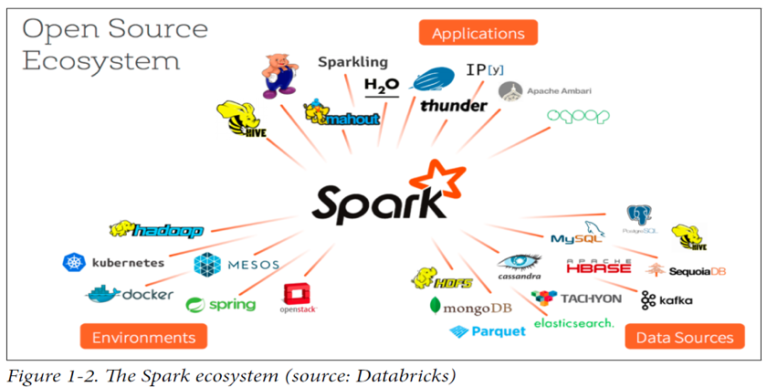
  - Use Case: Statistical analysis of crop yield data.

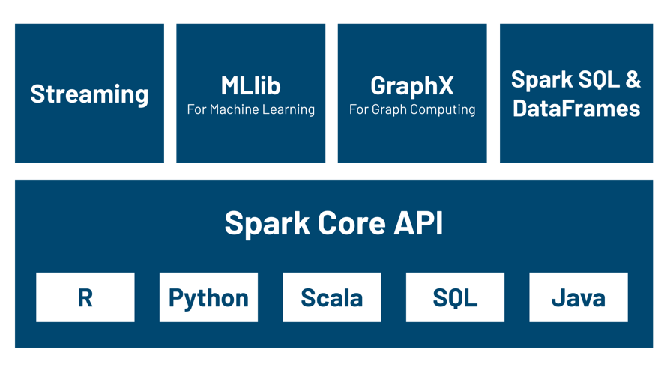

Fig 5 : Open source ecosystem

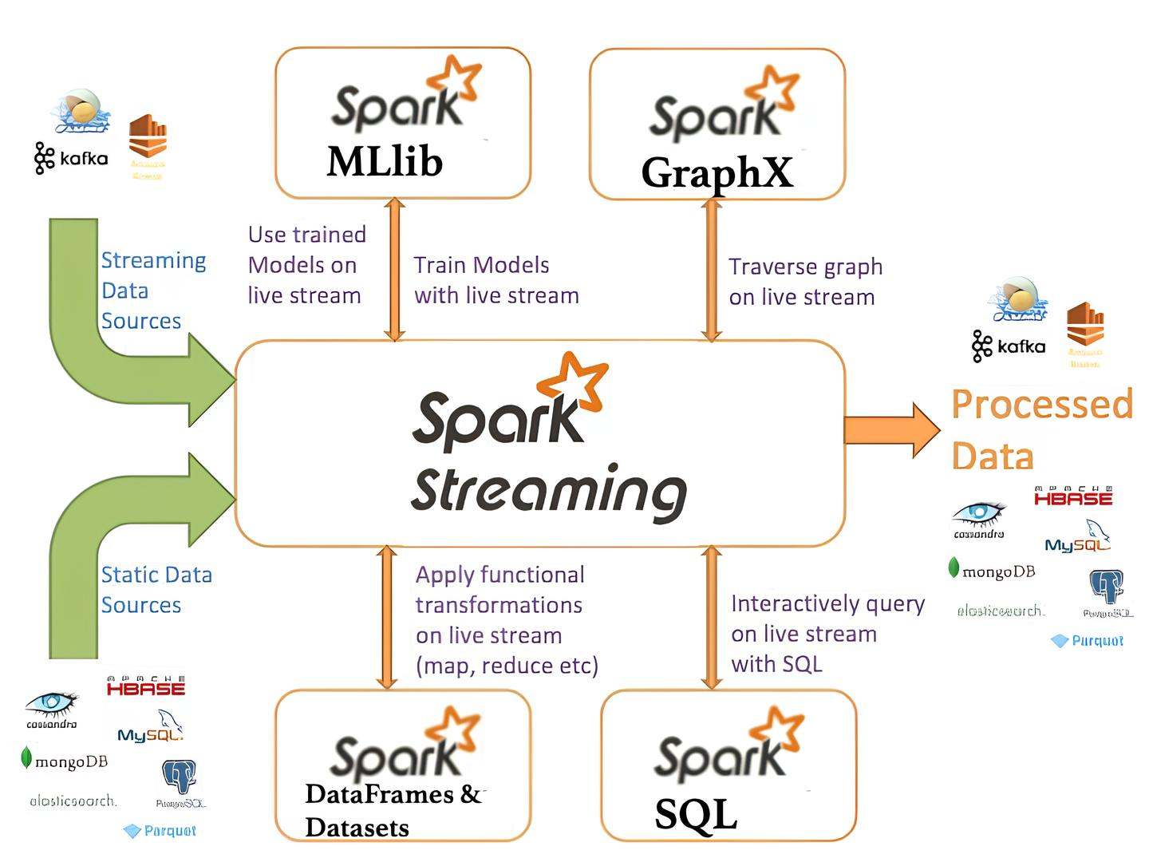
fig 6 : Spark streaming

Career Development in Agricultural Data Science
As agriculture becomes increasingly data-centric, new career opportunities are emerging:

Job Roles:
- Agricultural Data Scientist
- Precision Agriculture Analyst
- GIS and Remote Sensing Expert
- Farm Management Software Developer
- Machine Learning Engineer in AgTech

Required Skills:
- Proficiency in programming languages such as Python and R.
- Ability to create visualizations and dashboards.
- Understanding of agricultural systems and workflows.
- Knowledge of AI/ML and cloud platforms.

Academic Pathways:
- Degrees in Agronomy, Computer Science, Data Science, or Agricultural Engineering.
- Certifications in Agri-Informatics, AI in Agriculture, or Remote Sensing.
Career opportunities are abundant in research institutions, private agri-tech firms, startups, government agencies, and NGOs.
Fig 7 : BIG DATA TOOLS
DSSIFER Software-An innovative tool for soil test based fertiliser prescriptions and enhanced crop productivity (2010) [ database analyiscs platform] (Kilat et al., 2020)
- DSSIFER is a computer software encompassing digital databases and codes for processing, storing, retrieving the user inputs and generating site specific soil management technologies
- It is having the potential to be upgraded to an online version for consolidation of the database and to derive meaningful information to make policy decisions at different spacial scales
- The software was developed by a group of experts and was tested by a group of users at University Level and by the potential users of the Department of Agriculture.
- Through the NADP project, about 385 Agricultural Graduates were trained on the usage of the software.
- Necessary hardware were provided along with the software to each Agri Clinic (385) and effectively implemented.
- The software is also distributed to the State Agricultural Department for use in its Soil Testing Laboratories.
- It is also being sold to private soil testing laboratories and Agri Clinics
Fig 8 : DISSIFER output files

Fig 9 : Fertilizer Recommentation Card

Fig 10 : Soil & water Health Card

Case Studies and Real-World Applications
Several case studies illustrate how big data is being applied in agriculture:

a) Predictive Pest Management in Punjab:
Machine learning models use climate data and historical pest patterns to predict pest outbreaks in cotton fields, reducing crop loss (Basso et al., 2018).

b) Precision Irrigation in Israel:
Big data and sensors optimize irrigation schedules, saving water and improving crop yields by up to 30% (Sharma et al., 2019).

c) e-Choupal by ITC, India:
An internet-based initiative that provides market price information and agricultural advisories to farmers, helping them make better market decisions (Mishra et al., 2019).

d) AI in Crop Monitoring by PEAT (Germany):
The Plantix app uses image recognition to detect plant diseases and suggest appropriate treatments (Zhang et al., 2020).

e) Drone-based Soil Mapping in Tamil Nadu:
Startups are utilizing drones to map soil health and create fertility maps for more efficient nutrient management (Yang et al., 2020).
These case studies demonstrate the global impact of data-driven agriculture and its potential to address challenges across different regions.

Challenges and Future Directions

Key Challenges:
- Data Fragmentation: Agricultural data comes from various sources with different formats, making integration difficult (Gao et al., 2020).
- Farmer Awareness and Training: The digital divide limits the adoption of big data technologies among smallholder farmers (Siddique et al., 2019).
- Infrastructure Gaps: Lack of connectivity and electricity in rural areas can hinder the adoption of digital farming tools (Sharma et al., 2019).
- Data Privacy and Ethics: Ensuring that farmers’ data is protected and used ethically remains a significant concern (Liakos et al., 2018).

Future Trends:
- Blockchain for Transparent Supply Chains: To ensure transparency and traceability in the agricultural value chain (IBM, 2020).
- AI-driven Autonomous Farming Systems: To automate tasks like planting, irrigation, and harvesting (Microsoft, 2020).
- Integration of Blockchain with IoT: For secure, transparent, and real-time farm data management (Corteva, 2020).
The future of agriculture lies in continued innovation and the adoption of data science and big data tools.

Conclusion
Data science and big data are revolutionizing agriculture by enabling smarter decision-making, optimizing resource use, and improving sustainability. The integration of IoT, machine learning, and AI in farming is reshaping the industry, fostering innovation and efficiency. While challenges remain, the potential for data-driven agriculture to address global food security and environmental sustainability is immense. As technology evolves, so too will the opportunities for farmers and agricultural stakeholders to harness data for more productive, sustainable, and profitable farming practices.

COMPETING INTERESTS DISCLAIMER:
Authors have declared that they have no known competing financial interests OR non-financial interests OR personal relationships that could have appeared to influence the work reported in this paper.

References
- Basso, B., Antle, J. M., & S. P. (2018). Data science and decision support systems in agriculture. Agricultural Systems, 162, 1-11.
- Bayer. (2020). Bayer’s Climate FieldView: Harnessing data for agriculture. Retrieved from Bayer website.
- Choudhary, A., Jain, S., & K. K. (2020). Big Data Analytics in Agriculture: A Review. International Journal of Advanced Research in Computer Science, 11(1), 1-6.
- Corteva. (2020). Granular: Transforming farm management. Retrieved from Corteva website.
- Gao, Q., Yu, L., & L. M. (2021). Cloud-based farm management platforms: Impacts of big data and IoT. Journal of Agricultural Engineering, 58(4), 18-29.
- IBM. (2020). IBM Watson Decision Platform for Agriculture. Retrieved from IBM website.
- Khosla, R., Green, T., & H. K. (2018). Decision support systems in agriculture. Agronomy Journal, 110(6), 2256-2268.
- Liakos, K. G., Karkanis, A., & L. D. (2018). Applications of machine learning in agriculture: A review. Computers and Electronics in Agriculture, 147, 106-130.
- Microsoft. (2020). Azure FarmBeats: Empowering farmers with data. Retrieved from Microsoft website.
- Mishra, A., Pathak, H., & G. R. (2019). Role of market data in enhancing farmer decision-making. Indian Journal of Agricultural Economics, 74(2), 164-175.
- Ray, R., Singh, G., & S. K. (2021). Remote sensing in precision agriculture: An overview. Journal of Remote Sensing, 15(3), 90
- Pan, Z., Liu, S., & Zhang, S. (2023). "The Role of Big Data in Sustainable Agriculture." Agricultural Systems, 50(4), 245-256.
- Voung, S., Lim, T., & Dinh, H. (2019). "Apache Spark: A Framework for Big Data Analytics." Journal of Computer Science, 31(2), 201-215.
- Ken, S., Xian, W., & Tan, Y. (2018). "Tableau in Agriculture: The Application of Data Visualization." International Journal of Data Science, 12(7), 93-104.
- Liakos, L. & Panagos, P. (2018). Challenges in the geo-processing of big soil spatial data. Land, 11(12), 2287.
- Saqib, M., Malhotra, S., Ali, R., & Tariq, H. (2025). Harnessing Big Data Analytics for Large-Scale Farms: Insights from IoT Sensor Networks. International Journal of Advance Research, Ideas and Innovations in Technology, 11.
- Gupta, S., Kumar, D., & Mishra, S. Big Data Analytics in Agriculture: Harnessing IoT-generated Insights. In Agriculture 4.0 (pp. 185-201). CRC Press.
- Kumar, S., & Sharma, P. (2025, March). Harnessing Big Data for Precision Agriculture: Improving Crop Yields and Resource Management. In 2025 International Conference on Automation and Computation (AUTOCOM) (pp. 1196-1201). IEEE.
- Choudhary, R., Mantri, S. P., Barse, M. V. A., & Chitnis, S. (2024). Leveraging AI in Smart Agro-Informatics: A Review of Data Science Applications. International Research Journal on Advanced Engineering and Management (IRJAEM), 2(06), 1964-1975.
- Medida, L. H., & Kumar, G. L. N. V. S. (2025). Harnessing Artificial Intelligence and Data Science for Sustainable Water Management and Irrigation. In Artificial Intelligence and Data Science for Sustainability: Applications and Methods (pp. 323-346). IGI Global Scientific Publishing.

