Original Research Article

Antagonistic potential of Native Papaya rhizospheric microflora against Root rot disease incited by Fusarium solani in Papaya (Carica papaya L.)

Abstract
Aims: This study explores the battle of rhizospheric microbes against Fusarium solani-induced root rot in papaya under the agro-ecological conditions of Bihar. This study aims to isolate and identify rhizobacteria with antagonistic activities against soil-borne fungi.
Background: However, there is limited understanding of the specific mechanisms by which rhizomicro flora inhibit these pathogens and the diversity of rhizospheric species involved.
Methodology: The research, conducted during the 2022-23 period at ICAR-AICRP on Fruits experimental field & Fruit Pathology Laboratory in RPCAU Pusa (Bihar) India. The investigation began with the isolation of 48 distinct rhizospheric microbes (38 bacterial and 10 fungal) isolates were antagonistically assessed against Fusarium solani in vitro. Further scrutiny identified 07 best bacterial isolates with over 85% antagonistic potential.
Findings: Notably, as per results highlighted that significantly remarkable efficacy of inhibition was exhibited by isolate RB-34 (93.85%), which was at par with RB-29 (91.00%) followed by RB-25 (89.30%), RB-32 (86.48%), RB-15 (83.96), RB-24(80.70%) and RB-13 (79.39%) as compared to check. Significantly least percent inhibition was recorded by RB-33 (59.89%) over control against Fusarium solani, showcasing its potential for combating root rot. This experiment was conducted under controlled laboratory condition and statistically, carried out using completely randomized design (CRD and FCRD). One way ANOVA was used with the help of Past 4.0 software to statistically analyze the data obtained by the experiments.
Conclusion and Recommendation: The promising isolates RB-34 exhibited highest antagonistic efficacy i.e. 93.85% against fusarium solani mycelial growh. Therefore it showcased in this research offer a beacon of hope for farmers grappling with pathogen-induced root rot, paving the way for ecologically sound and effective disease management practices. These findings enhance our understanding of rhizospherical biodiversity and their potential as biocontrol agents in sustainable agriculture.
Keywords: Fusarium solani, Papaya root rot, antagonistic, rhizomicro flora.
- Introduction
Papaya (Carica papaya L.) is refers as the "Fruit of the angles", it belongs to the family Caricaceae. Five of the 21 species in the Carica genus-the C. papaya, C. chilensis, C. goudotiana, C. monoica, and C. pubescens produce edible fruits (Saran et al., 2016). Being a rich source of carbohydrates, minerals, vitamins (carotene, thiamine, riboflavin), and ascorbic acid, it is widely used as food, medicine, and industrial input (Aradhya et al., 1999). Papaya contains alkaloids such as carpaine, which have several industrial applications, as well as proteolytic enzymes like pectin (Jiao et al., 2022). In recent decades, Papaya production and cultivation area have increased, making India the world's largest Papaya producer. Currently, India’s Papaya production is estimated at 5.51 million tons, with a total cropped area of 0.126 million hectares and an average productivity of 43.7 tons per hectare, making India a world leader in papaya with 42.6% of global contribution (Ministry of Agriculture and Farmers Welfare, Govt. of India, 2024-25).One of the limiting factors to papaya cultivation is disease. Roberts and Trujillo, (1998) were the first to report root rot in Papaya caused by Phytophthora nicotianae. Subsequently, Rodriguez et al. (2001) identified Pythium aphanidermatum as the main cause behind root rot in Tabasco, Mexico and the United States. In India, Bihar, Papaya root rot disease was noticed for the first time in 2011-2012, with an unknown etiology. Fusarium solani (Mart.) Sacc. was identified as the cause of papaya root rot under agro-ecological conditions in Bihar (Singh and Kumar, 2015). In recent years, this disease has become a serious threat to papaya crops, leading to 90-95% crop failure and the gradual collapse of entire plantations, resulting in heavy losses for growers. This devastating disease has led to significant losses for growers and all Papaya varieties are highly susceptible to this disease. The disease appears to affect the crop throughout the year and at all stages of plant growth, with its development being particularly fast after periods of rain (Singh and Kumar, 2015). Not only in Bihar but Root rot in papaya, instigated by Fusarium solani, has emerged as a critical issue on a global scale, severely impacting papaya farming both in India and beyond. With an extensive host range, this pathogen dwells in the soil for long duration, which undermines crop rotation techniques and continually threatens successive papaya crops (Smith et al., 2021). Contrary to chemical methods, biological control offers an eco-friendlier solution. Traditional fungicides, although somewhat effective against Fusarium solani, carry the potential for environmental harm, including water pollution and damage to non-target organisms. In contrast, biological control agents often display specificity towards the pathogen with minimal environmental impact (Srivastava and Singh, 2022). Their capacity to establish a symbiotic relationship with papaya plants and maintain their presence in the rhizosphere equips them with a sustainable biocontrol impact. This makes them beneficial tools to minimize root rot (Mehta et al., 2023). This research aims to fill the knowledge gap by isolating and identifying rhizobacteria from soils, which have not been extensively studied. This study helps to reduce the usage of chemical pesticides and fertilizers and establish sustainable agriculture practices by describing their dual roles as PGPR and BCAs. The primary objective of this study is to isolate and identify rhizomicro flora from soil that demonstrate strong antagonistic activity against serious root rot pathogens and significant capacities to promote plant growth and development. This research seeks to enhance our understanding of the biodiversity and functional capabilities of rhizobacteria in soils, contributing to more sustainable and effective agricultural practices. Therefore, with this perspective in view, the overall prime concern of the present study was to isolate rhizomicrbes from the rhizosphere of papaya plants that could be used to developing a successful biological management plan for the root rot disease of papaya.
2. Material and methods
All the material and experimental methods used for execution of the study were conducted in Fruit Pathology Laboratory, Department of Plant Pathology and Nematology, Post Graduate College of Agriculture and Department of Microbiology, College of Basic Science and Humanities of Dr RPCAU Pusa (Samastipur), Bihar, India during the year 2021-2023. The general laboratory techniques given by Aneja (2003) and Rangaswami and Mahadevan (1999) used to prepare the media, sterilization of equipment, isolation, to keep and maintenance the pure culture.
2.1. Collection of disease sample, Isolation, identification and maintenance of pathogen
Diseased Samples were taken from the root portion of unhealthy Papaya plant. The collected samples were brought to the laboratory, washed under running water in order to remove dirt and dust, and then kept in the refrigerator for further study. The collected diseased samples were sliced into small (5–6 mm) pieces, surface sterilized with 0.1% HgCl₂, and then washed three times with sterile distilled water and plated onto potato dextrose agar (PDA) that has been subjected to streptomycin at 0.05 g litre⁻¹. The incubation of the plates took place at 28 °C for five days. The isolated pathogen were identified microscopically and pure cultures were preserved
2.2. Pathogenicity test of causal organism
To establish Pathogenicity test of causal organism following methodology of Nair et al. (2022). Disease free Papaya seedlings were used for conducting Koch postulates to establish pathogenicity of F. solani on Papaya the pots were sterilized using 70% v/v ethanol before use and were planted in 6 L pots containing sterilized soil, sand and FYM (3:3:1) and allowed for hardening. The pathogen inoculum was mass multiplied in MSM (Maize sand medium) The maize sand media was prepared by mixing coarse crushed maize grain (after soaking in water for 24 hrs.) 100 g, sand 50 g, distilled water 50 mL in polythene bag and sterilized at 15 psi for 2 hrs for 2 successive days. 4-5 bits of a recently developed pathogen were implanted into sterilized sand maize meal, where they were then incubated for 15–18 days at 25–28°C. Three plants were inoculated by placing 25 g of culture 2–3 cm beneath the surface of the surrounding roots. Remaining 3 plants were used as control. Then plants were daily watered and maintained for observing the symptoms for proving Koch`s postulates. After 21-30 days symptoms of root rot found in inoculated plants and Re-isolation of pathogen was done from root parts of diseased plants. Reisolated pathogen was identified as F. solani (Fig. 2).
2.4. Collection, Isolation and purification of rhizospheric soil microflora (fungal and bacterial)
Rhizospherical microflora were isolated and purified using serial dilution technique of Krassilnikov, 1950. Soil samples were randomly collected from the rhizosphere of different healthy Papaya plants (at a depth of 15–30 cm surrounding the roots). Before sent to lab for processing samples were desiccated, completely homogenizing and passed through a 2 mm sieve. 1g of rhizospheric soil was thoroughly mixed with 10 mL of sterile distilled water, serially dilutions were then prepared by mixing 1 mL of previous solution with 9 mL of sterile distilled water, and so on, until dilution 10⁻⁶ . For isolation of fungal soil microflora 10⁻³ and 10⁻⁴ dilution were used, while for bacterial soil microflora 10⁻⁵ and 10⁻⁶ dilutions were used. For obtaining fungal colonies from rhizospheric sample, 1 mL desired dilution was taken after vigorous shaking and poured into Petri plates, then sterile molten Trichoderma Selective Media (TSM), Rose Bengal Agar (RBA) and Potato Dextrose Agar media (PDA) were poured into the plates, separately. For obtaining bacterial colonies from rhizospheric samples, same methodology was repeated where plates were seeded with 1 mL of desired dilutions and sterile molten LB Agar, NA media, KB Agar, MacConkey Agar, Malachite Green, Pikovskaya media and Aleksandrow agar, separately. The plates were incubated for 5–6 days (for fungus) and 2 days (for bacteria) at a temperature at 28 ± 2 °C. After appearance of growth in isolation medium, single colonies were carefully picked up and sub cultured further (Fig. 1, 2). Purification of rhizospheric bacterial colonies was streaked onto new Petri dishes by Single spore isolation, and fungal isolates purified by single Hyphal tip method.
2.5. In vitro evaluation of antagonistic effect of different rhizospheric microflora isolates
2.5.1. The antagonism assay
The dual culture method or confrontation assay was applied to investigate the antagonistic potential of rhizospheric isolates against the pathogen by using protocol of (Morton and Stroube, 1955). A seven-day-old pathogen culture's mycelial disc (8 mm) was taken out and middle of a Petri plate that has been planted with sterile PDA medium. On the other side, a 5day old pure culture of rhizospheric bacterial isolate was placed as a border. In case of fungal isolates a mycelial disc (8 mm) was cut out from a 7 days old pathogen culture and placed 2 cm away from the periphery on one side of the Petri plate seeded with sterilized PDA medium. On the other side, a 5 days old pure culture of fungal isolate was placed. Plates that contained solely causal pathogen of root rot disease were used as a control. Each treatment was maintained in three replications. At a temperature of 25 ± 1 °C, all of the plates were incubated. The experiment was maintained until there was absolutely no more growth of the pathogen observed in the confrontation assay plates and also when the pathogen achieved maximum growth in the check. On 3rd, 5th and 10th day, the pathogen's radial growth on plates was recorded. According to McKinney (1923), the percentage of the pathogen's inhibition was calculated by comparing the pathogen's growth (after inhibition) with that of the check.
Percentage Growth Inhibition = | (C−T) | ×100
Percentage Growth Inhibition = | C | ×100

Where,
C = Radial growth of pathogen (mm) in check
T = Radial growth of pathogen (mm) in treatment

2.6. Statistical analysis
All the experiments were conducted under controlled laboratory condition and statistically, carried out using completely randomized design (CRD and FCRD). One way ANOVA was used with the help of Past 4.0 software to statistically analyze the data obtained by the experiments.
3. RESULTS AND DISCUSSION
3.1. Symptomatology
Symptoms of Papaya root rot caused by Fusarium solani were observed during the seedling stage. Once the infection occurred, the disease primarily affected young, tender seedlings. The symptoms initially appeared as yellowing of leaves, followed by root rot and eventual wilting of the entire plant. Depending on the conducive environmental conditions, the plant would wilt and die either within a few days (4-6) or a few weeks (3-4) after infection. The youngest infected leaves exhibited pale yellow symptoms and drooping, leading to irreversible wilting. The root tips and wounds showed signs of water-soaking and necrosis. The secondary and tertiary root systems were destroyed, ultimately resulting in the death of the plant (Fig. 1). The findings are in corroboration with the observations described by various workers on various crops. Majumdar et. al. (2007) reported that various plantations of Aloe barbadensis showed root rot caused by Fusarium solani with light to dark brown discoloration of root. Several infected plants could be easily uprooted, their secondary roots were completely lost and the main root started rotting and turned blackish in colour. Prasad et al. (2008) conducted a study on rose-scented geranium (Pelargonium graveolens) in Uttarakhand, investigating the root rot and wilt complex caused by Fusarium solani .The affected plants exhibited distinct symptoms, including yellowing, stunting, defoliation and drooping of leaves and branches. Additionally, severe root rotting and lesions were observed on the stem, below the soil line. Kalita et al. (2012) observed a dry root rot, characterized by greyish-white mycelial growth, particularly associated with Fusarium solani. This disease was more prevalent in nurseries established during the rainy or spring seasons, with low-lying beds lacking proper drainage being especially susceptible to infection. Several researchers (Singh and Kumar 2015; Kumar and Singh, 2016; Gupta et al., 2019; Gupta et al., 2020) also reported similar symptoms of root rot in Papaya plants. The disease progressed with the yellowing of leaves, followed by root rotting and ultimately resulted in the wilting of the entire Papaya plant. Under favorable environmental conditions, the Papaya plants succumbed to the disease within a short span of 4-6 days.
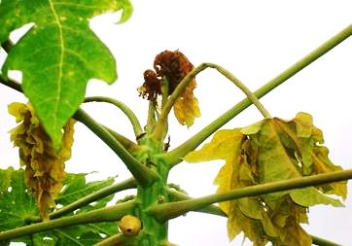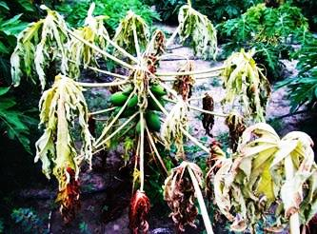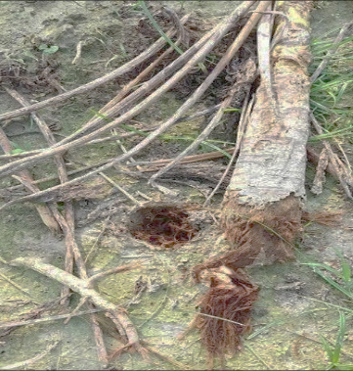
- (B) (C)
Figure 1. Root rot disease of Papaya: Typical Symptoms (A) Youngest infected leaves initially showed pale yellow symptoms, (B) Complete plant wilting, (C) Root tips and wounds were water soaked and necrotic. Secondary and tertiary root system destroyed & ultimately causing death of plant.

3.2. Isolation and characterization of the causal organism Fusarium solani
The pathogen Fusarium solani was isolated and cultural and morphological characteristics were studied. For confirmation of pathogen the pathogenicity test was performed. It was found that the causal organism Fusarium solani produced macroconidia, microconidia and chlamydospores were produced in orange-colored structures sporodochia. Macroconidia were fusiform, slightly curved, pointed at tip, mostly 3 septate present, and basal cells were pedicillate. Microconidia were mostly non septate, ellipsoidal, straight or curved. Chlamydospores ranged in shape from globose to subglobose and produced in chains, intercalary to lateral, hyaline, and variable in size. Fungus colonies on PDA were white, fluffy, and reverse brownish vinaceous. (Figure 2, Table 1) Similar findings were reported by Singh and Kumar, 2015; Kumar and Singh, 2016; Gupta et al., 2019; Gupta et al., 2020.
Table 1. Morphological characterization of Fusarium solani causing Papaya root rot.
Morphological Parameters | Size (LxW) | Shape | Septation | Colour
Microconidia | 3-10 µm x 1-3 µm | Round to oval shaped | 0-1 Septa | Hyaline
Macroconidia | 14-20 µm x 3-5 µm | Sickle shaped to sickle shape with blunt end | 2-5 Septa | Hyaline
Chlamydospores | 12-21 µm x 3-5 µm | Thick walled, rough, globose to oval shape. | Terminal intercalary or middle position | Hyaline

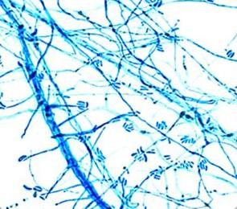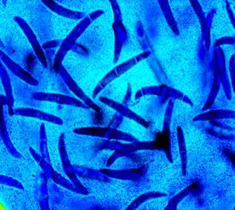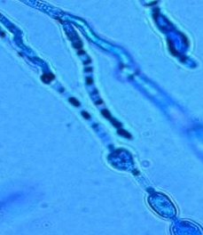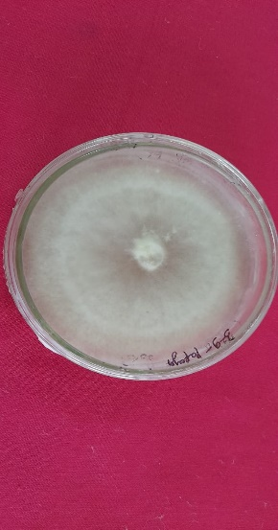
- (B) (C) (D)
Figure 2. Microscopic view of (A) Microconidia, (B) Macroconidia, (C) Chlamydospores and pure culture of fusarium solani
3.3. Pathogenicity test
The Pathogenicity test was conducted at Experimental field, RPCAU, Pusa. After 21-30 days of inoculation, the treated plants showed symptoms, but the control plants were symptomless. Later, the infected parts of inoculated plants were transferred to PDA media for re-isolating the pathogen. The re-isolated and original pathogens were similar in cultural and morphological characters; thus, Koch postulates were proved and pathogenicity was established. In a study conducted by Siddaramaiah et al. (1982) in Dharwad, they were able to demonstrate the pathogenicity of Fusarium solani on Tulsi (Ocimum sanctum) for the first time. These findings were further supported by Farrag et al. (2013), who isolated several pathogenic fungi from cucumber seed samples collected from commercial markets in Egypt. Among the isolated fungi, Fusarium oxysporum and Fusarium solani were the most common, with Fusarium oxysporum identified as the causative agent of damping off in cucumbers based on pathogenicity tests. Another study, conducted by Correia et al. (2013), also confirmed pathogenicity using the wound method. They introduced mycelial plugs of each isolate into shallow wounds (0.4 cm in diameter) at the center of each plant stem, which were then wrapped with parafilm and placed in a greenhouse. After 2 weeks, seedlings showed reddish-brown necrotic lesions in their stems. The pathogen was successfully re-isolated from symptomatic plants, fulfilling Koch's postulates.
3.4. Antagonistic effect of different rhizospheric microflora isolates against Fusarium solani
In this study it was found that total 48 rhizospheric isolates(38 bacterial and 10 fungal) were tested in vitro for their antagonistic activity against Fusarium solani. Percent inhibition over control was calculated on 10th day. As per results highlighted that significantly higher percent inhibition was exhibited by isolate RB-34 (93.85%), which was at par with RB-29 (91.00%) followed by RB-25 (89.30%), RB-32 (86.48%), RB-15 (83.96), RB-24(80.70%) and RB-13 (79.39%) as compared to check. Significantly least percent inhibition was recorded by RB-33 (59.89%). (Table 2, Fig. 3, 4). Additionally among fungal isolates RF-5 (40.00%) followed by RF-2 (33.72%) as compared to check. Significantly least percent inhibition was exhibited by RF-9(14.55%). (Table 3, Fig. 5). The results are consistent with the research of Thangavelu et al. (2001), where they conducted an experiment using 11 strains of Psuedomonas fluorescens isolated from the rhizospheric region of banana. These strains were tested against Fusarium oxysporum f.sp. cubensein vitro and strain Pf10 demonstrated the highest effectiveness in inhibiting the pathogen's mycelial growth. Another study by Thangavelu and Mustaffa (2012) identified a rhizospheric strain, Trichoderma viride NRCB1, among thirty-seven isolates, which was capable of reducing Fusarium wilt by up to 75–80 percent. Similarly, Xue and colleagues, (2015) reported that Bacillus amyloliquefaciens (strain NJN-6), isolated from the rhizosphere of a healthy banana plant along with a bio-organic treatment, significantly decreased the disease incidence by 68.5%, leading to doubled yield. Additionally, Chand (2020) found that Trichoderma asperellum 1 exhibited the highest inhibition rate of 64.82% over the control, followed by Trichoderma asperellum 2 with 62.70% inhibition. On the other hand, Aspergillus flavus showed the least inhibition (35%), and Penicillium chrysogenum exhibited 22.62% inhibition compared to the control. In a study by Win and colleagues (2021), Trichoderma spp. was isolated from the rhizosphere soil of a healthy banana plant grown in a disease-contaminated plot. The selected strain, identified as Trichoderma asperellum, showed remarkable suppression of Fusarium oxysporum f. sp. cubense growth, reducing it by 65-74%.

Isolate | 3rd day | 5th day | 10th day
RB-34 | 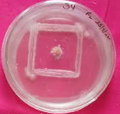 | 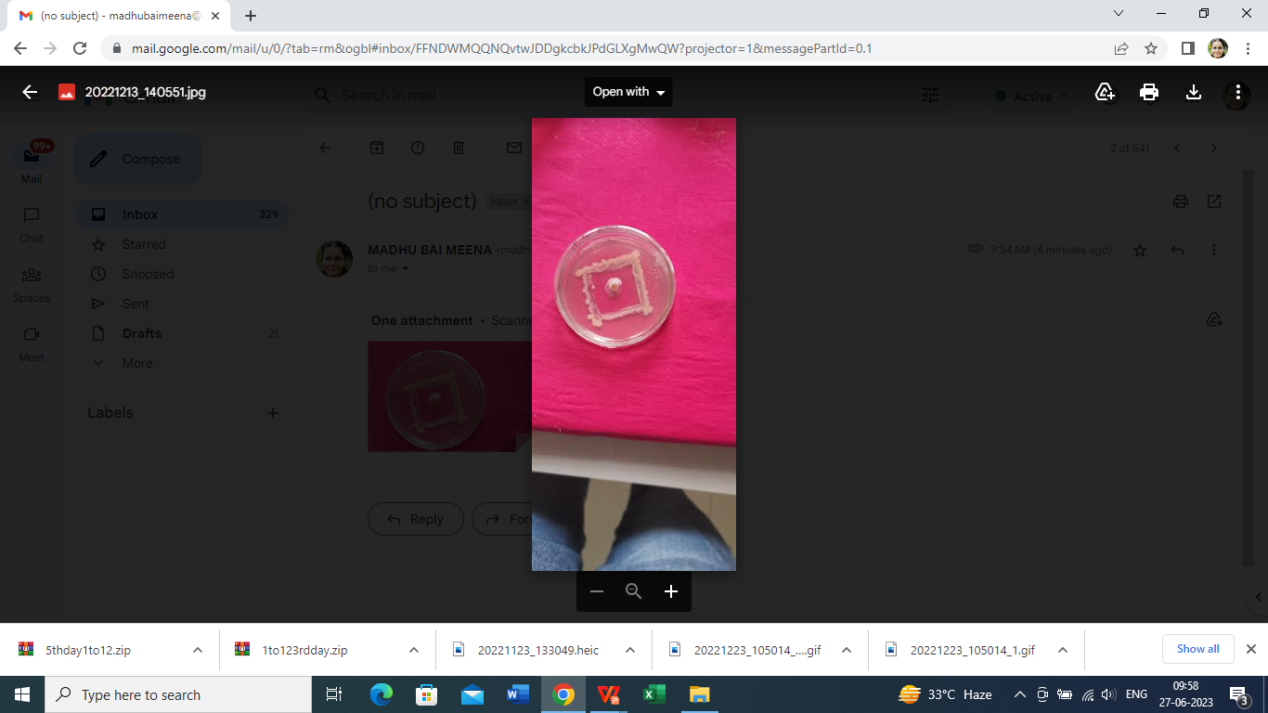 | 
RB-29 | 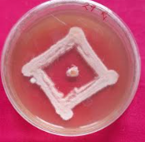 | 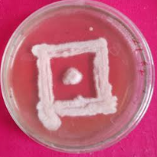 | 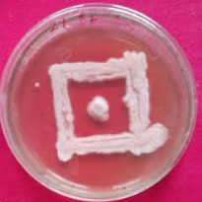
RB-25 | 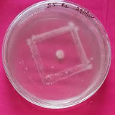 | 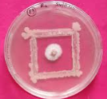 | 
RB-32 | 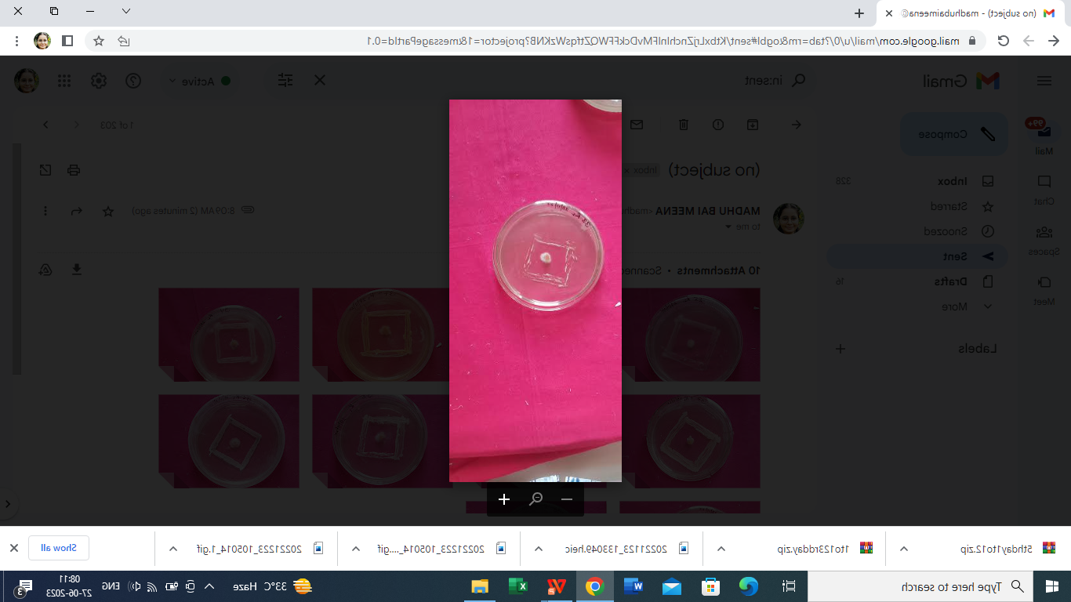 | 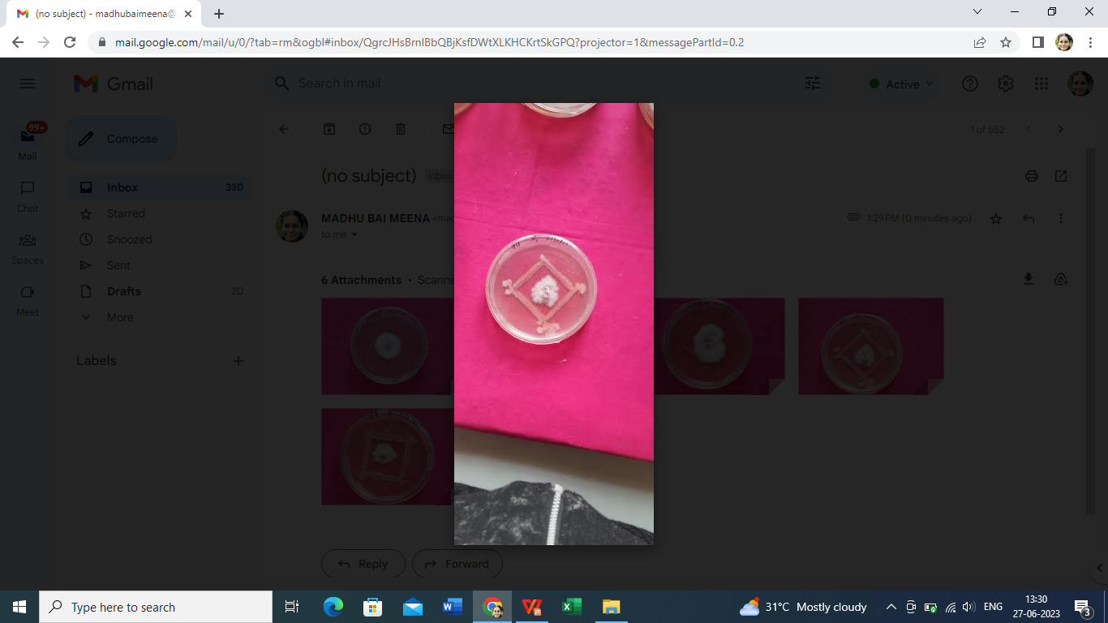 | 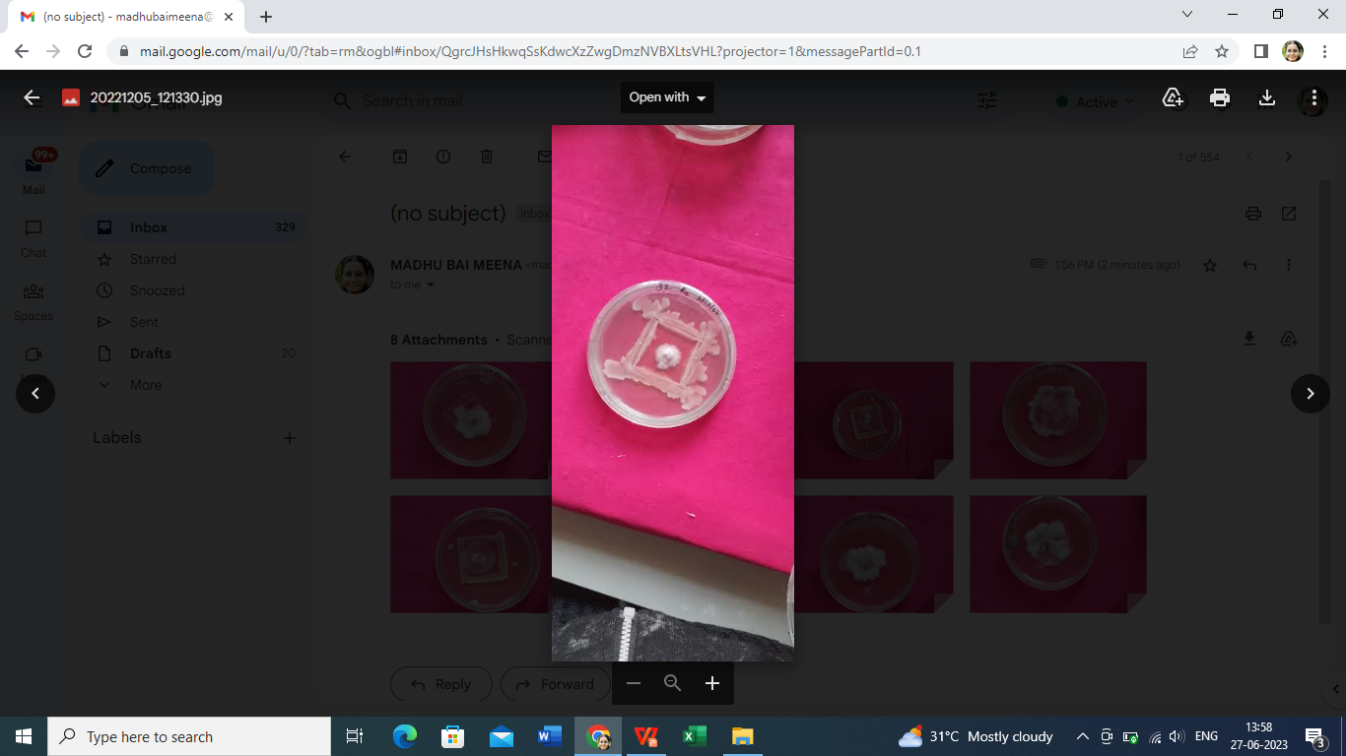
RB-15 | 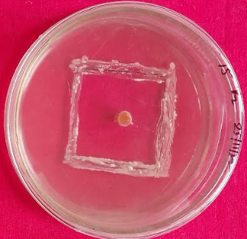 | 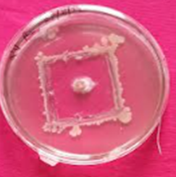 | 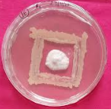
RB-24 | 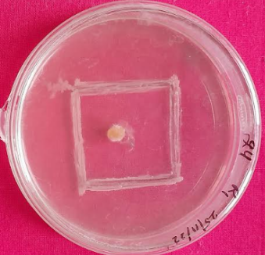 | 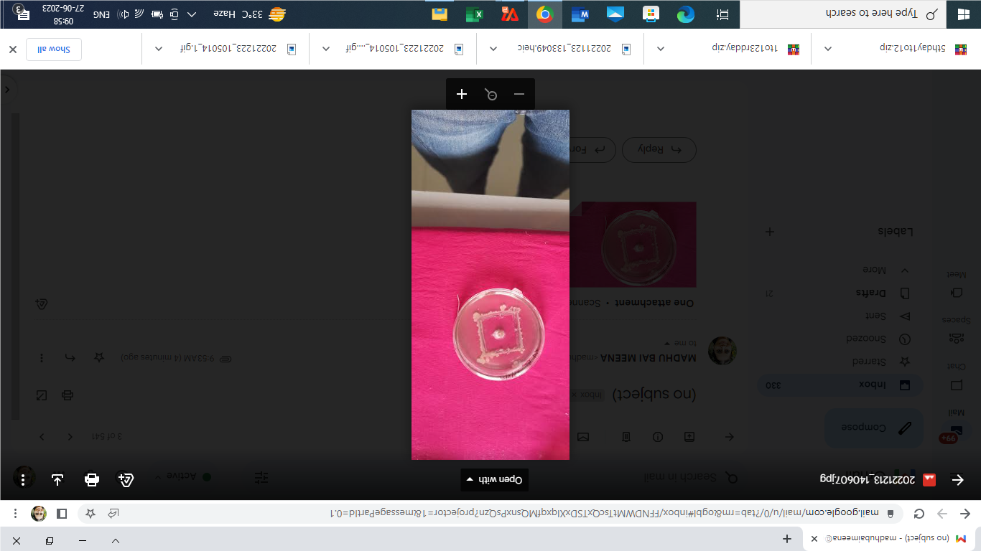 | 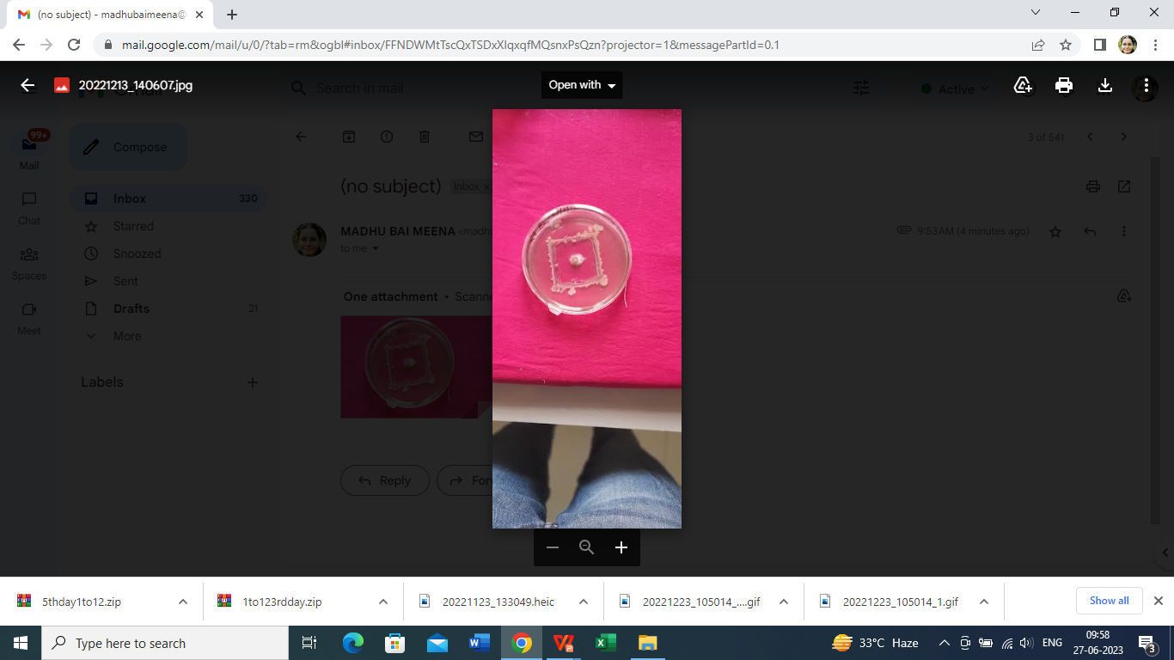
RB-13 | 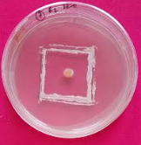 | 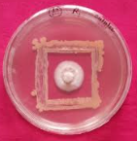
CHECK | 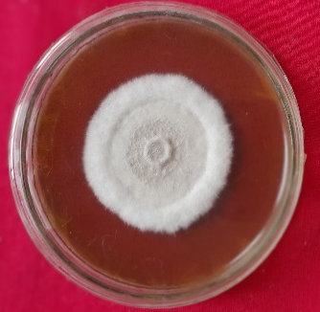 | 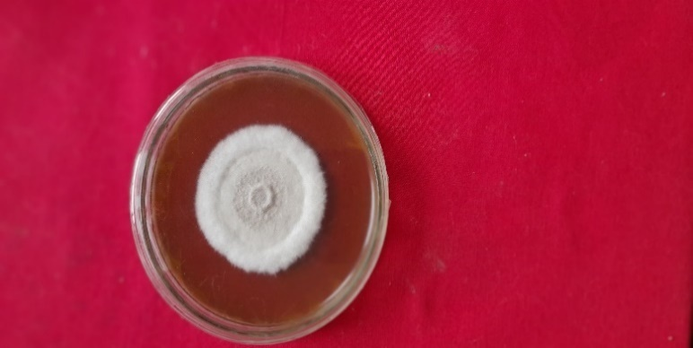
Figure 3. Antagonistic effect of different potential rhizospheric bacterial isolates against Fusarium solani

Table 2. Antagonistic effect of different rhizospheric bacterial isolates against Fusarium solani causing root rot of Papaya

Sl. No. | Treatments | Radial growth of Fusarium solani (mm) * |  |  | Inhibition over control (%)**
Sl. No. | Treatments | 3rd day | 5th day | 10th day | Inhibition over control (%)**
1 | RB-1 | 10.53 | 13.67 | 25.87 | 71.26
2 | RB-2 | 10.47 | 15.87 | 24.20 | 73.11
3 | RB-3 | 10.20 | 15.00 | 19.03 | 78.85
4 | RB-4 | 10.67 | 15.00 | 28.30 | 68.56
5 | RB-5 | 7.70 | 14.20 | 27.37 | 69.59
6 | RB-6 | 9.00 | 12.33 | 25.67 | 71.48
7 | RB-7 | 9.00 | 10.80 | 21.87 | 75.70
8 | RB-8 | 8.37 | 10.87 | 19.00 | 78.89
9 | RB-9 | 6.60 | 11.03 | 26.87 | 70.15
10 | RB-10 | 9.00 | 12.03 | 23.33 | 74.07
11 | RB-11 | 10.17 | 12.50 | 23.27 | 74.15
12 | RB-12 | 10.73 | 14.00 | 24.37 | 72.93
13 | RB-13 | 6.53 | 10.00 | 18.37 | 79.59
14 | RB-14 | 9.57 | 11.40 | 25.00 | 72.22
15 | RB-15 | 5.67 | 9.40 | 14.43 | 83.96
16 | RB-16 | 9.53 | 14.70 | 20.50 | 77.22
17 | RB-17 | 5.53 | 11.83 | 23.03 | 74.41
18 | RB-18 | 9.70 | 19.33 | 32.20 | 64.22
19 | RB-19 | 10.20 | 15.00 | 22.67 | 74.81
20 | RB-20 | 6.67 | 12.43 | 25.50 | 71.67
21 | RB-21 | 7.37 | 13.33 | 24.77 | 72.48
22 | RB-22 | 8.33 | 17.00 | 24.37 | 72.93
23 | RB-23 | 5.83 | 13.17 | 25.53 | 71.63
24 | RB-24 | 7.10 | 12.10 | 17.37 | 80.70
25 | RB-25 | 4.97 | 7.27 | 9.63 | 89.30
26 | RB-26 | 6.50 | 12.57 | 24.73 | 72.52
27 | RB-27 | 8.57 | 14.73 | 20.33 | 77.41
28 | RB-28 | 8.00 | 20.77 | 32.33 | 64.07
29 | RB-29 | 5.97 | 7.07 | 8.10 | 91.00
30 | RB-30 | 7.17 | 12.57 | 24.47 | 72.81
31 | RB-31 | 7.43 | 16.03 | 22.03 | 75.52
32 | RB-32 | 7.50 | 10.47 | 12.17 | 86.48
33 | RB-33 | 11.67 | 21.97 | 36.10 | 59.89
34 | RB-34 | 3.77 | 4.33 | 5.53 | 93.85
35 | RB-35 | 8.67 | 18.00 | 22.77 | 74.70
36 | RB-36 | 7.00 | 10.50 | 24.67 | 72.59
37 | RB-37 | 9.50 | 12.40 | 26.27 | 70.81
38 | RB-38 | 8.50 | 16.77 | 24.70 | 72.56
39 | Control | 15.33 | 23.50 | 90.00 | 0.00
SE(m) ± |  | 0.22 | 0.28 | 0.38 | 0.43
C.D. at 5% |  | 0.63 | 0.78 | 1.09 | 1.21
C.V. (%) |  | 4.63 | 3.59 | 2.76 | 1.02
* Mean of three replications; RB- Rhizobacteria; Digit- Isolate number;
** Percent inhibition over control calculated on 10th day

Table 3. Antagonistic effect of different rhizospheric fungal isolates against Fusarium solani causing root rot of Papaya

Sl. No | Treatments | Radial growth of Fusarium solani (mm)* |  |  | Inhibition over control (%)**
 |  | 3rd day | 5th day | 10th day | Inhibition over control (%)**
1 | RF-1 | 13.33 | 26.60 | 44.46 | 25.88
2 | RF-2 | 14.93 | 24.23 | 39.76 | 33.72
3 | RF-3 | 12.66 | 23.40 | 48.46 | 19.22
4 | RF-4 | 14.00 | 23.46 | 49.76 | 17.05
5 | RF-5 | 12.50 | 26.70 | 36.00 | 40.00
6 | RF-6 | 10.33 | 27.33 | 47.76 | 20.38
7 | RF-7 | 10.00 | 22.23 | 45.16 | 24.72
8 | RF-8 | 9.00 | 22.26 | 50.73 | 15.44
9 | RF-9 | 14.60 | 28.36 | 51.26 | 14.55
10 | RF-10 | 13.83 | 25.16 | 45.00 | 25.00
11 | Control | 13.60 | 20.63 | 60.00 | 0.00
SE(m) ± |  | 0.31 | 0.51 | 0.39 | 0.52
C.D. at 5% |  | 0.91 | 1.47 | 1.15 | 1.55
C.V. (%) |  | 4.29 | 3.53 | 1.44 | 4.27
* Mean of three replications; R- Rhizospheric; F- Fungus; Digit- Isolate Number;
** Percent inhibition over control calculated on 10th day
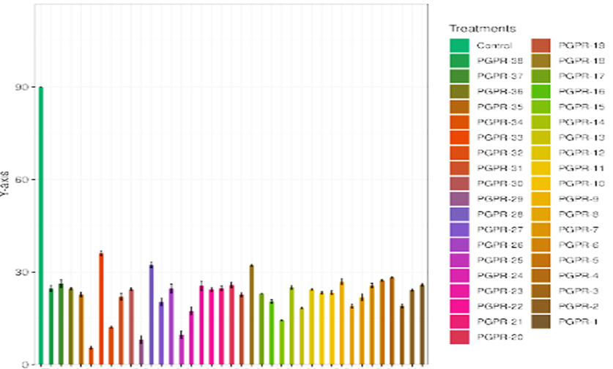
Inhibition (%)
Treatments (x- axis)

Figure 4. Antagonistic effect of rhizospheric bacterial isolates against Fusarium solani
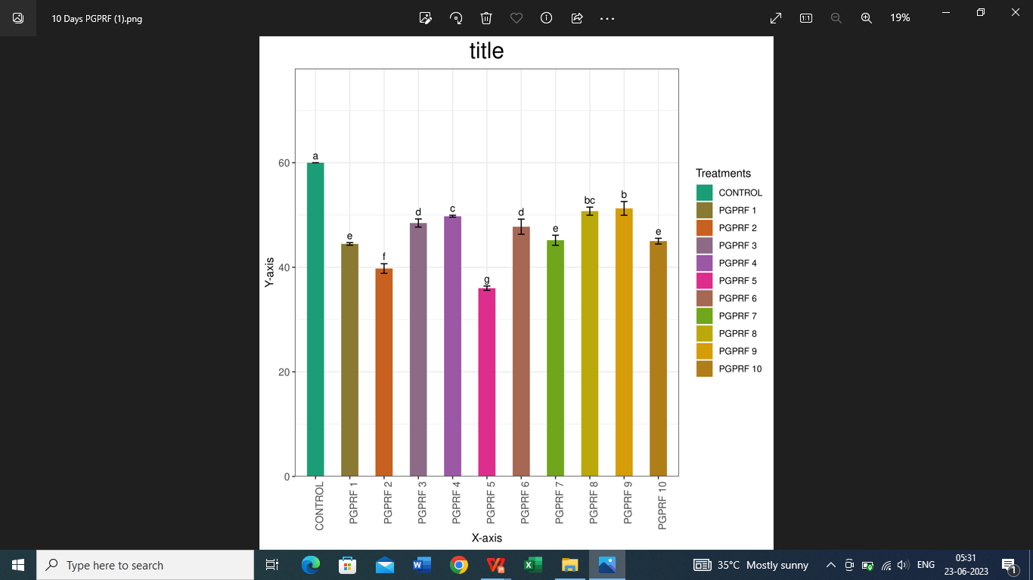
Inhibition (%)
Treatments (x-axis)
Figure 5. Antagonistic effect of different potential rhizospheric fungal isolates against Fusarium solani

4. Conclusion
Biological control has become an integral part of IDM programmes for sustainable management of the plant pathogens in near future. The findings reveal that the antagonistic potential of fungal and bacterial isolates isolated from rhizosphere of different healthy Papaya plants are successfully mitigated root rot disease incited by Fusarium solani in laboratory condition. Consequently, this study concludes that significantly higher percent inhibition was exhibited by isolate RB-34 (93.85%),Additionally among fungal isolates RF-5 (40.00%) as compared to check. Lastly, the evaluated promising isolates could be tested under in vivo conditions for practical application and efficacy. All the selected promising bacterial strains, namely RB-25, RB-29, RB-32, and RB-34, can be used to prepare effective biocontrol consortia against Fusarium solani, the pathogen causing root rot in Papaya. Further, an in-depth study of the various modes of action exhibited by these selected bacterial isolates, which possess promising biocontrol potential, could be conducted to enhance their involvement in IDM strategies against the pathogen.
Disclaimer
Author(s) hereby declare that NO generative AI technologies such as Large Language Models (ChatGPT, COPILOT, etc) and text-to-image generators have been used during writing or editing of this manuscript.

Referances
Aneja, K.R. 2003. Experiments in Microbiology, Plant Pathology and Tissue Culture. Wishwa Prakashan, New Delhi (A division of Wiley Eastern Ltd.). 471
Aradhya MK, Manshardt RM, Zee F, Morden CW (1999) A phylogenetic analysis of the genus Carica L. (Caricaceae) based on restriction fragment length variation in a cpDNA intergenic spacer region. Genet Res Crop Evol 46:579–586
Chand, G. (2020). Diseases of Cucurbits and Their Management: Integrated Approaches. Diseases of Fruits and Vegetable Crops: Recent Management Approaches, 314.
Correia, K. C., Souza, B. O., Câmara, M. P. S., and Michereff, S. J. (2013). First report of stem rot of Papaya caused by Fusarium solani species complex in Brazil. Plant Disease, 97(1), 140-140.
Farrag, E. S. H., Moharam, M. H. A. and Ziedan, E. H. (2013). Effect of plant extracts on morphological and pathological potential of seed-borne fungi on cucumber seeds. International Journal of Agricultural Technology. 9(1):141-149.
Gupta, A. K., Choudhary, R., Bashyal, B. M., Rawat, K., Singh, D., & Solanki, I. S. (2019). First report of root and stem rot disease on Papaya caused by Fusarium falciforme in India. Plant disease, 103(10), 2676.
Gupta, P. K., Chitara, M. K., & Singh, S. K. (2020). Antagonism of Native and Commercial Trichoderma spp. against Fusarium solani Isolates Causing Root Rot of Papaya (Carica papaya L.). Int. J. Curr. Microbiol. App. Sci, 9(2), 1260-1269.
Jiao, M., Liu, C., Prieto, M. A., Lu, X., Wu, W., Sun, J. & Li, N. (2022). Biological Functions and Utilization of Different Part of the Papaya: A Review. Food Reviews International, 1-24.
Kalita, H. Borah, T. R., Gopi, R., Helim, R. and Das, B. (2012). A new record of patchouli wilts from Sikkim, Himalayas. Journal of Mycology and Plant Pathology.
Kumar R, Singh SK (2016). Growth characteristic of Fusarium solani causing root rot of Papaya (Carica papayaL.)- A new threat in an agroecological condition of Bihar. New Agriculturist.2015; 26(2): 307-310
Majumdar VL, Bhatnagar K, Sharma H, Verma OP. (2007). Three new diseases of Aloe barbadensis L.J. Mycol. Pl. Pathol 37(1):124–125

Mckinney, H.H. 1923. Influence of soil temperature and moisture on infection of wheat seedling by Halminthosporium sativum. J. Agric. Res., 26: 195 – 210
Mehta, S., Sharma, A., and Kumar, P. (2023). Rhizospheric Bacteria in Sustainable Biocontrol: A Case Study on Fusarium solani. Biological Control, 67, 25-31.
Ministry of Agriculture and Farmers Welfare, Govt. of India, (2021-22), https://agricoop.nic.in/
Morton, D. J. and Stroube, W. H. 1955. Antagonistic and stimulating effects of soil micro-organisms upon Sclerotium. Phytopathology. 45: 417-420
Nair, R., Singh, S., and Gupta, S. (2022). Plant Defense Mechanisms: Activation by Beneficial Microbes. Journal of Plant Physiology, 249, 153-162.
Prasad, D., Singh, K. P., and Kumar, J. (2008). Root rot and wilt complex of rose-scented Geranium (Pelargonium graveolens) in Uttarakhand. Indian Phytopathology, 61(3), 365.
Prince Kumar Gupta, Manoj Kumar Chitara and Sanjay Kumar Singh. 2020. Antagonism of Native and Commercial Trichoderma spp. against Fusarium solani Isolates Causing Root Rot of Papaya (Carica PapayaL.). Int.J.Curr.Microbiol.App.Sci. 9(02): 1260-1269.
Rangaswami G., Mahadevan A., (1999). Diseases of crop plants in india, 4th Ed., Twenty first printing, ISBN 978-81-203-1247-3
Roberts, P. D and Trujillo, E. (1998). First report of Phytophthora nicotianae causing leaf blight, fruit rot, and root rot of Papaya in American Samoa. Plant Disease82(6):712
Rodriguez, A. G., Fernandez, P. S. P., Geraldo, V. J. A. and Landa, H. L. (2001). Pythium aphanidermatum causing collar rot on Papaya in Baja California Sur, Mexico. Plant Disease. 85(4): 444.
Saran, P. L., Solanki, I. S., & Choudhary, R. (2016). Papaya: biology, cultivation, Production and Uses. CRC Press.
Siddaramaiah, A.L., Kulkarni, S. and Hegde, R.K. (1982). An unrecorded fungus on tulsi (Ocimum sanctum). Indian Phytopath. 35: 695
Srivastava, S.,and Singh, P. (2022). Biological Control of Plant Pathogens: An Environmentally Friendly Approach. Environmental Science and Technology, 56(3), 125-133.
Thangavelu, R. and Mustaffa, M. M. 2012. Current Advances in the
Fusarium Wilt Disease Management in Banana with Emphasis on
Biological Control, Plant Pathology, Dr. Christian Joseph Cumagun
(Ed.), ISBN: 978-953-51-0489-6.
Thangavelu, R., Sundararaju, P., Sathiamoorthy, S., Raghuchander, T., Velazhahan, R.,Nakkeeran, S. and Palaniswami, A. (2001). Status of Fusarium wilt of banana in India. In: Banana Fusarium Wilt Management: Towards Sustainable Cultivation.
Molina, A.B., N.H. Nikmasdek, K.W. Liew (eds), INIBAP-ASPNET, Los Banos,
Laguna, Philippines, pp: 58-63
Win, T. T., Bo, B., Malec, P., Khan, S., & Fu, P. (2021). Newly isolated strain of Trichoderma asperellum from disease suppressive soil is a potential bio-control agent to suppress Fusarium soil borne fungal phytopathogens. Journal of Plant Pathology, 103, 549-561.
Xue, C., Ryan Penton, C., Shen, Z., Zhang, R., Huang, Q., Li, R., et al. (2015). Manipulating the banana rhizosphere microbiome for biological control of Panama disease. Sci. Rep. 5:11124
Singh, S. K., & KUMAR, R. (2015). Etiology, symptomatology and molecular characterization of Papaya root rot–A new and serious threat. Indian Phytopathology, 68(3), 348-349.
Smith, R. J., Patel, V., and Kumar, A. (2021). Fusarium solani in Papaya: Understanding its Survival Mechanisms in Soil. Journal of Plant Pathology, 103(1), 27-34.

