Virtual Screening and Identification of Novel Polyketide Synthase 13 of Mycobacterium tuberculosis Inhibitors: A modelling approach using the pharmacophore method combined with virtual screening

ABSTRACT
Tuberculosis, a communicable disease provoked by the bacillus Mycobacterium tuberculosis, is one of the leading causes of death worldwide. Every year millions of people are contaminated by the disease and more than a million lose their lives. One of the major causes is the emergence of multi-resistant and ultra-resistant strains for which conventional treatment strategies are ineffective. Current challenges consist to find new therapeutic molecules capable of neutralizing these resistant strains. It is possible to destroy these strains by circumventing the resistance mechanism or by using new therapeutic targets. Pks13 is a recent target that is responsible of the final step in the synthesis of mycolic acids, elements ensuring the permeability and integrity of the Mtb cell wall. Therefore, Pks13 inhibition is a promising track for the discovery and development of new effective anti-tuberculosis. Research on Pks13 inhibitors revealed that benzofuran derivatives were among the molecules capable of inhibit Pks13. Thus, from on the computer-aided rational design method, a virtual library of 28,350 new benzofuran analogues was designed and then filtered by Lipinski's rule of five. After filtering, the reduced-size library obtained which contains 5,194 benzofuran analogues was screened using the Pks13 inhibition PH4. At the end of the screening, the predicted activity of the molecules retained by PH4 was evaluated by the equation: ${pIC}_{50}^{exp}=-0.2182×∆∆G_{com}+7.0853 ; R^{2}=0.98$, QSAR model illustrating the linear correlation between the experimental inhibition potential (${pIC}_{50}^{exp}$) and the Gibbs free energy relative to a reference ligand ($∆∆G_{com}$) in aqueous medium. Analogues with predicted inhibitory activity higher than TAM2 (most active ligand in the training set) and an excellent pharmacokinetic profile were identified. Among these new analogues, the most active has a predicted activity 96 times higher than that of TAM2.
Keywords : Tuberculosis, Mycobacterium tuberculosis, Polyketide Synthase 13, benzofuran, QSAR, pharmacophore, in silico screening ,ADME-Related properties.

1. INTRODUCTION
In 2023, among the causes of death of people in worldwide, the tuberculosis is of them one. In the same year, out of 10.8 million people infected, this disease killed 1.25 million people according to the World Health Organization [1]. This infectious and contagious disease is caused by a mycobacterium called Mycobacterium tuberculosis [2]. Tuberculosis frequently attacks the lungs (pulmonary tuberculosis), but other organs can be affected by the tuberculous bacillus (extrapulmonary tuberculosis) [3]. The pulmonary form represents the usual source of contamination [3]. Transmission is essentially interhuman and is done airborne [4]. Efforts are consented as part of the fight against tuberculosis in terms of diagnosis, prevention and curative treatments. According to the WHO, these efforts allowed of save 79 million lives since 2000 [1]. Despite this, the statistical data regarding mortality and incidence rates are always alarming. In 2022, tuberculosis was responsible of the deaths of 1.3 million people out of 10.6 million infected people [5]. All age groups are affected by this pathology. In 2022, 55% of people who developed the disease were men, 33% women and 12% children (aged 0 to 14) [5].
Tuberculosis is one of the main causes of mortality in people living with HIV [1]. In 2023, out of 1.25 million deaths caused by tuberculosis, 161,000 presented HIV infection [1].
Resistant or multidrug-resistant tuberculosis is a threat to health security and provoke a crisis at the level public health. In 2022, 410,000 people developed resistant or multi-resistant tuberculosis [5]. To face the resurgence of tuberculosis, it is necessary or even urgent, to find new therapeutic strategies capable of destroying strains resistant to current treatments. Drugs that target cell wall synthesis have historically been effective in treatment infections due to bacteria and fungi [6]. Most of the compounds that constitute the mycobacterial envelope are essential for the survival of the tuberculous bacillus and play a preponderant role in the pathogenicity of the bacterium. Among these compounds we have long chain fatty acids called mycolic acids [7]. These acids having a waxy nature are specific to the genus Mycobacterium. Disruption of mycolic acid biosynthesis has been a strategy exploited in the current therapeutic arsenal [6]. Two antituberculous (isoniazid and ethionamide) important in current treatment target InhA [6]. This enzyme is one of the fatty synthase II acid involved in the elongation of the long chain (C40-C60), components of fatty acid of mycolic acids [6]. Like the antituberculous agents that target the cell wall are effective, research is moving towards new molecules that inhibit these enzymes or other enzymes involved in the biosynthesis of mycolic acids [8]. Identify as the enzyme responsible for the last step of the mycolic acids synthesis, polyketide synthase 13 (Pks13) is involved in the condensation reaction of two fatty acid chains into a α-alkyl β-ketoacyl [9, 10]. This latter is the direct precursor of mycolates. Pks13 possesses catalytic domains required for this condensation: an acyl transferase domain, a ketosynthase domain, acyl carrier protein (ACP) domains and a thioesterase (TE) domain [9]. The TE domain is a domain that has dual functions [10,11]. It initially behaves as a hydrolase by breaking the thioester bond and forming an ester bond between mycolic β-ketoesters and the hydroxyl group of the Ser1533 residue of the TE domain [10,11]. Finally, it manifests as an acyltransferase for the formation of trehalose monomycolate (TMM) which is subsequently transported and bound to arabinogalactan [10,11]. The thioesterase domain of Pks13 (Pks13-TE) has been revealed as a therapeutic target for the development of anti-tuberculosis drugs [12,13]. Thus, Pks13 becomes an essential element for the survival of Mycobacterium tuberculosis. Therefore, it represents an important target to find future anti-tuberculosis agents. Several compounds including benzofurans have been reported as Pks13-TE inhibitors [14]. The results obtained on this series of Pks13 inhibitory molecules open up avenues for the search for anti-tuberculosis drugs [14]. The development of therapeutic molecules is a very difficult, long and expensive task which know to many failures [15-18]. Several techniques including computer-aided drug design are used for the discovery and development of these molecules. Today, this approach has attracted considerable attention and has been recognized as indispensable in the drug discovery process [19]. This method permit accelerate drug discovery by reducing the time and financial means necessary to identify avenues for drug marketing. Computer-aided rational design has been used for drug discovery such as nelfinavir, imatinib, and zanamivir [20].
In this work, our objective is to propose new benzofuran analogues as potential anti-tuberculosis drug candidates with an excellent pharmacokinetic profile, based on computer-aided rational design techniques. To reach it, we screened a virtual library composed of benzofuran analogues using the Pks13 inhibition pharmacophore model obtained in our previous study [21]. Then, the predicted activity of the analogues retained by PH4 was evaluated from the equation of the QSAR model in aqueous medium elaborated in our recent work [21]. Finally, the predicted pharmacokinetic profile of the best designed analogues was calculated.

2. MATERIALS AND METHODS
2.1. Model building
From the crystallographic structure of the reference complex (Pks13-TAM1) containing the training set inhibitor, TAM1 [21] bound to Pks13 (Protein Data Bank entry code 5V3X at 1.94 Å resolution [14]), the molecular models of the different Pks13-TAMx complexes (E:I), of the Pks13 enzyme alone (E) and of the free inhibitors (I) were obtained using insightII, a molecular modeling software [22].The structures of the E and E:I complexes were taken at an appropriate physiologically relevant pH of 7 with capped neutral N- and C-terminal residues and all protonated and ionized residues charged. Crystallographic water molecules were not included in the model. The inhibitors were built into the crystallographic structure of the reference complex by in situ modification of the R-groups that derive from the scaffold of benzofuran compounds. An exhaustive conformational search on all rotatable bonds of the replacing functional group, coupled with a careful stepwise simulation of the modified ligand and the active site residues of Pk13 located within 5Å of the ligand were used to find the resulting low energy conformations of the modified ligand. This technical has been previously used successfully for the modeling of virus, bacteria, and protozoal protease inhibitor complexes and for the design of peptidomimetic, hydroxynaphthoic, and thymidine-based inhibitors [23-29].

2.2. Molecular Mechanics
Modeling of ligands, of the Pks13 and of complexes E:I was performed by the molecular mechanics (MM) method as already detailed [30]. The optimization of the ligand models, the Pks13 enzyme and their complexes was done with the atomic and charge parameters of the CFF97 force field. To account for the proteins shielding effect, the dielectric constant was kept at 4 in all MM calculations. In the geometry minimization process, the molecular structure is gradually relaxed through a sufficient number of steepest descent steps followed by iterative conjugate gradient cycles whose convergence criterion for the average gradient is 0.01 kcal.mol⁻¹. Å⁻¹.
2.3. Conformational search
The conformations of the free inhibitor were obtained from their conformations in the E:I complexes by progressive relaxation towards the nearest local energy minimum as previously explained [23, 24, 30]. On all so-called rotatable bonds (except for those in the rings), a Monte Carlo search was done (for 50,000 iterations) for low energy conformations using Discovery Studio [31]. Unique stable conformations numbering 200 were generated for each inhibitor by randomly varying the torsion angles of the last retained conformer by ± 15◦ at 5000 k before energy minimization. Over the minimization, a dielectric constant equal to 80 was used in order to approximately account for the dielectric screening effect of hydration on the generated conformers. The conformer with lowest total energy was selected and then minimized again for a dielectric constant fixed at 4.
2.4. Solvation Free Gibbs Energies
The electrostatic component of solvation Gibbs free energy [32] which also includes the effects of ionic strength through solving the nonlinear Poisson-Boltzmann equation [33,34] was evaluated by the DelPhi module of Discovery Studio [31] as previously described [23]. This program considers the solvent as a continuous medium of high dielectric constant (80) and the solute as a cavity of low dielectric constant (4) with boundaries related to the molecular surface of the solute, which encloses the atomic charges of the solute. The numerical resolution of the molecular electrostatic potential and the reaction field around the solute is done with the finite difference method. With the Delphi module, the calculations were performed on a cubic grid (235 × 235 × 235) for the E:I and free E complexes, and on a grid (65 × 65 × 65) for free I. Full Coulombic boundary conditions were applied. Two subsequent focusing steps led to a similar final resolution of approximately 0.3 Å per grid unit at 70% solute grid filling. Two subsequent focusing steps resulted in a similar final resolution of approximately 0.3 Å per grid unit at 70% filling of the grid by solute. A physiological ionic strength set at 0.145 mol.dm^{–3}, partial atomic charges and radii defined on all CFF force field parameters [31], and a probe sphere radius of 1.4 Å were used. The calculation of the electrostatic component of the Poisson-Boltzmann solvation Gibbs free energy was performed in the same way that the reaction field energy [35–37].
2.5. Calculation of the Entropic contribution
The change in vibrational entropy when the inhibitor binds to the enzyme was assessed by normal mode analysis of the inhibitor vibrations via the simplified method of Fischer et al [38]. In this approach, vibrational analyses of the inhibitor bound to the active site of a “frozen” enzyme and the low-energy conformer of the free inhibitor are carried out for fully optimized structures.

2.6. Calculation of Binding Affinity
The calculation of binding affinity in GFE complex formation has been wholly described previously [23, 24, 30].

2.7. Interaction Energy
The calculation of MM interaction energy (Eint) between receptor residues and the inhibitor was done with a protocol of Discovery Studio [31] as previously explained [24, 30].

2.8. Pharmacophore Generation
In this work, we did not generate a new pharmacophore model of Pks13 inhibition, but we used the one designed in our previous work on Pks13 inhibitors [21]. We recall that the procedure for elaboration PH4 is the same as that described previously [39].

2.9. ADME Properties
Predicted pharmacokinetic properties of inhibitors were calculated using the QikProp program [40] which is based on the methods of Jorgensen [41-43]. This program allows calculate of pharmacokinetic properties such as octanol/water partitioning coefficient, aqueous solubility, blood/brain partition coefficient, Caco-2 cell permeability, serum protein binding, number of probable metabolic reactions, and other descriptors related to adsorption, distribution, metabolism and excretion (ADME properties) of the inhibitors. According to the methods used, the experimental results of more than 710 compounds were correlated with calculated physicochemical descriptors, and this made it possible to accurately predict the pharmacokinetic profile of the new molecules considered. Drug likeness (#Stars), the number of property descriptors out of 24 selected descriptors calculated by QikProp [40], located outside the range of values ​​determined for 95% of known drugs, was exploited as an additional compound selection filter linked to ADME.

2.10. Virtual Library Generation
The design of the virtual library was done as previously described [30]. Analogue model building was carried out with the Discovery Studio software [31]. The analogues library was enumerated by attaching the R groups (fragments, building blocks) to the scaffold of benzofuran derivatives using the Enumerate Library from Ligands protocol of the Discovery Studio program [31].

2.11. Pharmacophore-Based Library Searching
The pharmacophore model (PH4) resulting from the conformations of TAMs bound at the Pks13 active site was a tool that served for library search and in silico screening as previously described [39]. The designed virtual library was refined by the ligand pharmacophore mapping protocol of Discovery Studio [31]. In the process, the geometry of each conformer of the analogs generated was optimized using the CFF force field for up to 500 energy minimization steps and then aligned and mapped to the pharmacophore model to retain the top-ranked overlaps.

2.13. Inhibitory Potency Prediction
The conformer with best mapping on the PH4 in each cluster of the focused library subset was selected for ∆∆G_{com} calculation and ${IC}_{50}^{pre}$ evaluation by the complexation QSAR model as explained previously [39].

3. RESULTS
3.1. Virtual Library and In Silico Screening of news Inhibitors of Pks13
The application of the in silico screening technique of a virtual library designed by the combinatorial approach can provide excellent results, as demonstrated by recent our study on the design of Pks13 inhibitors [21].

3.2. Virtual Library
The previous study on the design of Pks13 inhibitors [21] was helpful in choosing fragments for the design of a new virtual library containing benzofuran analogues. Substitutions made at positions R₁, R₂, R₃ and R₄ of the benzofuran derivatives scaffold led to the elaboration of a virtual library of the size of: R₁ x R₂ x R₃ x R₄ = 50 x 7 x 27 x 3 = 28,350 analogues. The R-groups used to build this virtual library by the so-called combinatorial approach are listed in Table 1. To design drug analogues and orally administrable, Lipinski's rule of five was applied to the 28,350 molecules in the virtual library. This first filtering phase allowed to obtain a reduced virtual library containing 5,194 compounds, or approximately 18% of the initial size. Subsequently this latter has been submitted to in silico screening in order to identify effective analogues against Pks13.

Table1. R₁, R₂, R₃ and R₄ groups used in the design of the initial diversity virtual library of benzofuran analogues
R-groups*
1 | 2 | 3 | 4
5 | 6 | 7 | 8
9 | 10 | 11 | 12
13 | 14 | 15 | 16
17 | 18 | 19 | 20
21 | 22 | 23 | 24
25 | 26 | 27 | 28
29 | 30 | 31 | 32
33 | 34 | 35 | 36
37 | 38 | 39 | 40
41 | 42 | 43 | 44
45 | 46 | 47 | 48
49 | 50 | 51 | 52
53 | 54 | 55 | 56
57 | 58 | 59 | 60
61 | 62 | 63 | 64
65 | 66 | 67 | 68
69 | 70 | 71 | 72
73 | 74 | 75 | 76
77 | 78 | 79 | 80
81 | 82 | 83 | 84
85 | 86 | 87
*R₁-groups : 1 – 50 ; R₂-groups : 77 – 84 ; R₃-groups : 50 – 77 ; R₄-groups : 85 – 87

3.3. In silico screening of the virtual library
Screening of the reduced virtual library (5,194 molecules) was performed using the 3D-QSAR model of Pks13 inhibition pharmacophore obtained in the previous study [21]. After screening, 135 analogues aligning at least at four functionalities of the pharmacophe model were selected. The variation of the free enthalpy of complexation compared to the reference ligand (TAM2) as well as its components of these molecules were evaluate The predicted activity of these compounds was also expressed through the equation of the solvated medium built complexation QSAR model in the previous study [21]. Following these calculations, 64 molecules were retained and their predicted activities are recorded in Table 2.

3.4. Substituents of novel Pks13 inhibitors
The individual occurrence frequency of each fragment of the R-groups of the 135 hits which come from the screening by the PH4 model of Pks13 inhibition is presented in Figure 1. It also allows examining the results of in silico screening of the virtual library in order to identify fragments likely to improve the activity of new benzofuran analogues. Position R₁ has been more occupied by fragments such as: No.17(frequency : 13), 1(12), 42(12), 41(10), 43(10), and 37(8). Five fragments are more observed at the position R₂: 79(48), 78(28), 80(24), 82(14) and 81(13). At position R₃, the substituents of largest occurrence are: 76(28), 77(10), 54(8), 62(7) and 65(7). The substituent 85(113) appears more at the R₄ position. We note that most of these fragments allowed us to have new molecules more active than TAM2 (table 2).

Table 2. Relative GFE value calculated and components of 64 analogues benzofuran retained by in silico screening of the combinatorial library. The molecules numbering concatenates the index of each fragment R₁ to R₄ with the fragment numbers taken from table 1.
Nº | Designed  analogues | ∆∆H_{MM} ª | ∆∆G_{sol} ^{b} | ∆∆TS_{vib} ^{c} | ∆∆G_{com} ^{d} | $${IC}_{50}^{pre e}$$
Nº | Designed  analogues | (kcal.mol⁻¹) | (kcal.mol⁻¹) | (kcal.mol⁻¹) | (kcal.mol⁻¹) | (nM)
Ref | TAM2 | 0.00 | 0.00 | 0,00 | 0.00 | 120.00^{f}
1 | TAM-1-78-65-86 | -7.73 | 5.32 | -1.04 | -1.37 | 41.36
2 | TAM-17-78-54-86 | -9.97 | 6.19 | -4.36 | 0.57 | 109.66
3 | TAM-18-78-59-85 | -10.45 | 4.37 | 1.58 | -7.66 | 1.75
4 | TAM-25-78-65-85 | -9.08 | 2.78 | 1.33 | -7.64 | 1.77
5 | TAM-41-78-60-85 | -10.14 | 2.78 | 0.62 | -7.98 | 1.49
6 | TAM-42-78-54-85 | -8.88 | 2.91 | 0.93 | -6.89 | 2.58
7 | TAM-42-78-74-85 | -10.87 | 2.34 | -0.25 | -8.28 | 1.28
8 | TAM-43-78-54-85 | -6.95 | 2.17 | -0.58 | -4.19 | 10.00
9 | TAM-43-78-59-85 | -8.78 | 4.45 | 0.36 | -4.68 | 7.82
10 | TAM-47-78-76-87 | -10.48 | 2.56 | 0.24 | -8.15 | 1.37
11 | TAM-1-79-54-85 | -5.64 | 3.10 | 1.72 | -4.26 | 9.64
12 | TAM-49-78-75-85 | -9.11 | 2.37 | -0.44 | -6.31 | 3.46
13 | TAM-2-79-76-85 | -11.32 | 3.72 | -0.29 | -7.31 | 2.09
14 | TAM-1-79-72-85 | -5.25 | 4.29 | -2.01 | 1.04 | 138.86
15 | TAM-1-79-52-86 | -17.12 | 7.70 | -2.04 | -7.39 | 2.01
16 | TAM-4-79-62-85 | -10.80 | 5.05 | -0.72 | -5.03 | 6.55
17 | TAM-4-79-51-85 | -11.28 | 3.87 | -1.35 | -6.06 | 3.92
18 | TAM-4-79-59-87 | -6.70 | 4.84 | -2.22 | 0.35 | 98.02
19 | TAM-9-79-54-85 | -6.35 | 3.11 | 3.04 | -6.28 | 3.49
20 | TAM-7-79-76-85 | -12.11 | 3.97 | 0.01 | -8.16 | 1.36
21 | TAM-12-79-65-87 | -7.03 | 4.22 | -0.06 | -2.76 | 20.54
22 | TAM-17-79-66-85 | -3.94 | 3.31 | 0.26 | -0.89 | 52.56
23 | TAM-17-79-66-87 | -2.13 | 3.87 | -0.36 | 2.10 | 235.60
24 | TAM-19-79-77-87 | -14.74 | 5.72 | -2.67 | -6.35 | 3.39
25 | TAM-23-79-76-85 | -11.03 | 3.96 | 0.86 | -7.93 | 1.53
26 | TAM-26-79-76-85 | -12.27 | 3.85 | -2.08 | -6.34 | 3.39
27 | TAM-26-79-54-85 | -9.65 | 3.57 | 0.40 | -6.49 | 3.16
28 | TAM-25-79-54-86 | -11.08 | 8.16 | -0.32 | -2.60 | 22.27
29 | TAM-28-79-76-85 | -10.41 | 3.88 | -0.45 | -6.08 | 3.87
30 | TAM-33-79-65-85 | -8.80 | 3.37 | 0.31 | -5.74 | 4.59
31 | TAM-33-79-73-87 | -2.09 | 2.58 | -1.76 | 2.25 | 254.68
32 | TAM-37-79-76-85 | -13.30 | 4.04 | -1.82 | -7.44 | 1.96
33 | TAM-41-79-60-85 | -9.92 | 4.44 | -0.10 | -5.38 | 5.50
34 | TAM-38-79-67-85 | -8.90 | 3.83 | 1.25 | -6.32 | 3.43
35 | TAM-41-79-51-85 | -10.26 | 3.62 | -0.97 | -5.66 | 4.78
36 | TAM-41-79-76-85 | -7.54 | 2.77 | 1.20 | -5.98 | 4.08
37 | TAM-42-79-56-85 | -7.21 | 3.03 | 0.82 | -5.01 | 6.63
38 | TAM-41-79-77-86 | -10.28 | 4.29 | -1.36 | -4.64 | 8.00
39 | TAM-43-79-76-85 | -9.52 | 2.94 | -0.03 | -6.55 | 3.05
40 | TAM-43-79-60-85 | -10.44 | 4.57 | -2.42 | -3.45 | 14.49
41 | TAM-43-79-71-85 | -12.68 | 5.20 | -0.42 | -7.06 | 2.37
42 | TAM-47-79-59-85 | -10.98 | 4.72 | 0.33 | -6.59 | 3.00
43 | TAM-48-79-74-86 | -9.11 | 2.89 | 1.44 | -7.66 | 1.75
44 | TAM-49-79-73-87 | -6.97 | 4.12 | 1.35 | -4.20 | 9.96
45 | TAM-1-80-72-85 | -7.09 | 4.49 | 1.43 | -4.03 | 10.86
46 | TAM-1-80-74-85 | -9.98 | 2.80 | 1.15 | -8.32 | 1.25
47 | TAM-50-79-73-87 | -8.45 | 4.69 | 1.91 | -5.67 | 4.76
48 | TAM-4-80-76-87 | -9.94 | 4.14 | -0.18 | -5.62 | 4.89
49 | TAM-17-80-55-85 | -8.64 | 3.92 | 1.11 | -5.83 | 4.39
50 | TAM-17-80-55-87 | -11.25 | 4.62 | 1.10 | -7.73 | 1.69
51 | TAM-17-80-76-87 | -11.39 | 4.46 | 0.72 | -7.65 | 1.76
52 | TAM-25-80-54-87 | -7.29 | 4.69 | 0.29 | -2.88 | 19.31
53 | TAM-41-80-72-85 | -7.33 | 3.78 | -0.43 | -3.12 | 17.17
54 | TAM-42-80-72-85 | -10.18 | 4.57 | -0.87 | -4.74 | 7.60
55 | TAM-1-81-76-85 | -10.97 | 3.28 | -1.07 | -6.62 | 2.95
56 | TAM-17-81-62-85 | -10.95 | 4.56 | 0.55 | -6.94 | 2.52
57 | TAM-41-81-59-85 | -8.33 | 4.20 | 2.29 | -6.42 | 3.26
58 | TAM-43-84-54-85 | -7.98 | 3.36 | 1.80 | -6.42 | 3.26
59 | TAM-42-84-75-85 | -11.01 | 3.93 | -0.50 | -6.58 | 3.01
60 | TAM-4-82-65-85 | -9.59 | 3.73 | 1.49 | -7.35 | 2.05
61 | TAM-17-82-57-85 | -11.68 | 5.59 | 1.61 | -7.70 | 1.71
62 | TAM-43-82-65-85 | -10.19 | 3.61 | 1.70 | -8.28 | 1.28
63 | TAM-41-82-73-87 | -7.64 | 4.18 | 2.39 | -5.85 | 4.35
64 | TAM-17-82-73-86 | -3.51 | 3.53 | -0.05 | 0.08 | 85.43
ª ΔΔH_{MM} is the relative enthalpic contribution to the GFE change of the Pks13-TAM complex formation ΔΔG_{com} ; ^{b} ΔΔG_{sol} is the relative solvation GFE contribution to ; ^{c} ΔΔTS_{vib} is the relative (vibrational) entropic contribution to ΔΔG_{com} ; ^{d} ΔΔG_{com} is the relative Gibbs free energy (GFE) change related to the enzyme–inhibitor Pks13-TAM complex formation ${∆∆G}_{com}={∆∆H}_{MM}+{∆∆G}_{sol}-{∆∆TS}_{vib}$; ^{e} ${IC}_{50}^{pre}$ is the predicted inhibition potency towards Pks13; ^{f} Experimental value ${IC}_{50}^{exp}$ is given for the reference inhibitor TAM2 instead of the predicted value.

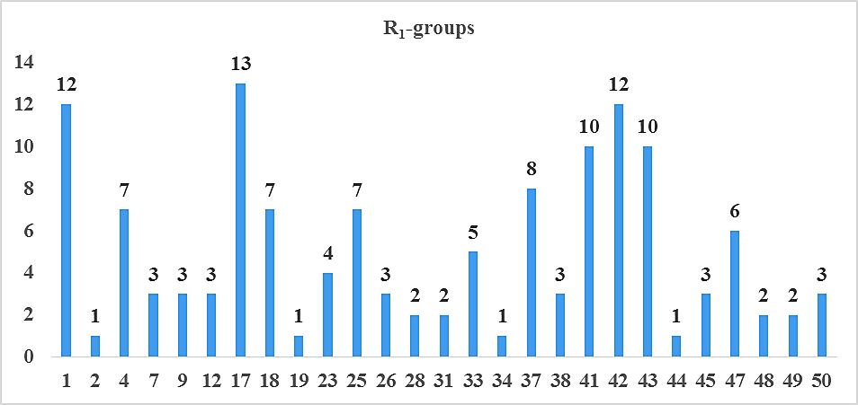 | 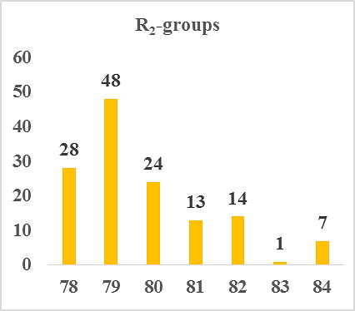
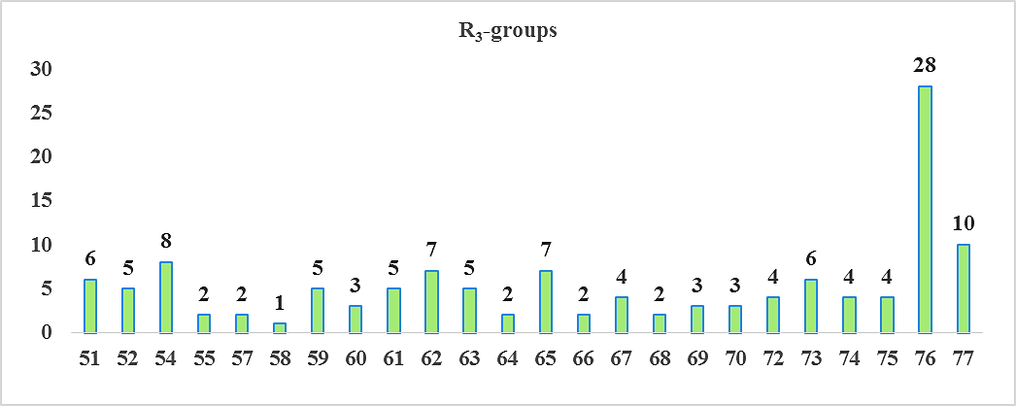 | 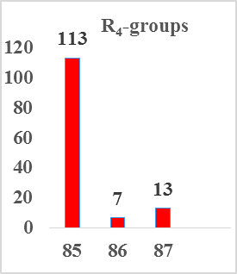
Figure 1. Histograms of frequency of occurrence of individual R-groups in the 135 best-retained analogues mapping to features of the PH4. For the structures of the substituents see table 1.

3.5. Pharmacokenetic Profile of novels benzofuran analogues

In this work, the pharmacokinetic descriptors of the best designed benzofuran analogues and drugs used in the treatment of tuberculosis or in clinical trials were calculated with the QikProp program. The analysis of these values ​​presented in table 3, shows that for our new benzofuran analogues, no violation of descriptors is observed [40]. Indeed, the novel designed analogues display favorable #stars descriptor values ​​equal to zero for all molecules except one. Drug likeness of our new analogues is better compared to some molecules used in the treatment of tuberculosis such as Pyrazinamide, Ethambutol, Isoniazid, Bedaquiline. Moreover, fourteen designed benzofuran analogues have a percentage oral absorption (%HOA) greater than or equal to 80%. The other six analogues have an oral absorption percentage between 67% and 79%. These values ​​are higher than or equal to those of certain drugs used in anti-tuberculosis therapies (Rifampicin, Isoniazid, Pyrazinamide, Ethambutol). All these ADME properties indicate that our new benzofuran analogues can be considered as potential drug candidates. Thus, in the process of discovery and development new anti-tuberculosis drugs, these analogues can constitute an excellent starting point for the pharmaceutical industry.

Table 3. Predicted ADME-related properties of 6 best designed benzofuran analogs and known antitubercular agents either in clinical use or currently undergoing clinical testing computed by QikProp [40]
TAMxª | #Stars^{b} | Mw^{c}  [g.mol⁻¹] | S_{mol}^{d}  [Å²] | S_{mol,hfo}^{e}  [Å²] | V_{mol}^{f}  [Å³] | RotB^{g} | HBdon^{h} | HBacc^{i} | logP_{o/w}^{j} | logS_{wat}^{k} | logK_{HSA}^{l} | logB/B^{m} | BIP_{caco}^{n}  [nm.s⁻¹] | #metaº | ${IC}_{50}^{Pre}$ ^{p}  [nM] | HOA^{q} | %HOA^{r}
TAM-1-80-74-85 | 0 | 461.60 | 834.03 | 523.99 | 1544.22 | 10 | 3 | 6.75 | 4.88 | -5.84 | 0.92 | -0.69 | 313.85 | 6 | 1.25 | 3 | 100
TAM-42-78-74-85 | 0 | 467.56 | 792.14 | 495.65 | 1492.53 | 11 | 3 | 7 | 4.08 | -4.88 | 0.72 | -1.19 | 112.39 | 8 | 1.28 | 3 | 87.53
TAM-43-82-65-85 | 0 | 484.59 | 785.45 | 470.38 | 1500.66 | 10 | 5 | 8.95 | 2.55 | -2.89 | 0.34 | -0.67 | 29.58 | 8 | 1.28 | 2 | 68.19
TAM-7-79-76-85 | 0 | 482.58 | 818.51 | 520.85 | 1509.43 | 9 | 4 | 9.9 | 2.93 | -4.67 | 0.28 | -1.06 | 133.23 | 7 | 1.36 | 2 | 82.15
TAM-47-78-76-87 | 0 | 481.59 | 808.44 | 537.01 | 1525.89 | 10 | 2 | 9.4 | 3.54 | -4.61 | 0.45 | -1.03 | 142.57 | 5 | 1.37 | 3 | 86.2
TAM-41-78-60-85 | 0 | 481.59 | 812.97 | 506.95 | 1523.46 | 10 | 3 | 7.95 | 4.14 | -5.10 | 0.67 | -0.84 | 214.31 | 8 | 1.49 | 3 | 92.90
TAM-23-79-76-85 | 0 | 483.56 | 815.47 | 524.97 | 1499.16 | 9 | 4 | 10.9 | 2.45 | -4.34 | 0.09 | -1.1 | 122.48 | 7 | 1.53 | 2 | 78.68
TAM-17-80-55-87 | 0 | 487.64 | 862.57 | 547.18 | 1599.93 | 10 | 3 | 8.5 | 4.37 | -5.77 | 0.75 | -0.93 | 205.3 | 6 | 1.69 | 3 | 93.93
TAM-17-82-57-85 | 0 | 478.59 | 824.23 | 472.52 | 1524.54 | 10 | 4 | 9.45 | 3.11 | -4.73 | 0.35 | -1.32 | 88.68 | 7 | 1.71 | 2 | 80.01
TAM-18-78-59-85 | 0 | 493.60 | 833.77 | 531.42 | 1557.40 | 10 | 3 | 8.95 | 3.74 | -5.14 | 0.57 | -1.14 | 124.90 | 8 | 1.75 | 3 | 86.39
TAM-48-79-74-86 | 0 | 493.61 | 836.88 | 545.58 | 1567.92 | 12 | 5 | 7 | 3.93 | -5.10 | 0.68 | -1.57 | 67.97 | 7 | 1.75 | 2 | 82.74
TAM-17-80-76-87 | 0 | 478.59 | 815.90 | 476.21 | 1511.74 | 10 | 3 | 10.9 | 2.73 | -4.23 | 0.12 | -1.15 | 121.13 | 4 | 1.76 | 3 | 80.21
TAM-25-78-65-85 | 0 | 481.59 | 830.84 | 509.37 | 1533.13 | 9 | 3 | 9.45 | 3.02 | -3.87 | 0.46 | -0.52 | 44.73 | 8 | 1.77 | 2 | 74.17
TAM-37-79-76-85 | 0 | 469.54 | 787.21 | 445.62 | 1444.01 | 9 | 4 | 10.9 | 2.00 | -3.91 | -0.03 | -1.33 | 72.7 | 6 | 1.96 | 3 | 71.99
TAM-1-79-52-86 | 0 | 474.60 | 836.69 | 478.88 | 1534.32 | 10 | 4 | 7 | 4.18 | -5.63 | 0.76 | -1.24 | 111.19 | 6 | 2.01 | 3 | 88.05
TAM-4-82-65-85 | 0 | 495.62 | 822.22 | 490.48 | 1555.82 | 10 | 5 | 9.7 | 2.58 | -3.28 | 0.34 | -0.76 | 27.56 | 8 | 2.05 | 2 | 67.80
TAM-2-79-76-85 | 0 | 466.58 | 805.36 | 517.87 | 1490.63 | 8 | 3 | 9.15 | 3.45 | -4.93 | 0.46 | -0.73 | 219.03 | 6 | 2.09 | 3 | 89.03
TAM-43-79-71-85 | 0 | 469.54 | 781.22 | 429.37 | 1442.87 | 9 | 4 | 9.45 | 2.54 | -4.2 | 0.21 | -1.32 | 69.97 | 8 | 2.37 | 2 | 74.86
TAM-17-81-62-85 | 0 | 492.62 | 839.98 | 540.35 | 1577.44 | 8 | 3 | 7.75 | 4.63 | -5.95 | 0.92 | -0.62 | 276.90 | 6 | 2.52 | 3 | 100
TAM-42-78-54-85 | 1 | 467.56 | 781.98 | 477.47 | 1464.91 | 9 | 3 | 7 | 3.885 | -5.031 | 0.73 | -1.10 | 103.38 | 8 | 2.58 | 3 | 85.75
Rifampicine | 1 | 137 | 314 | 0.0 | 480 * | 2 | 3 | 4.5 | -0.7 | 0 | -0.8 | -0.8 | 267.5 | 2 | - | 2 | 67
Isoniazid | 4 | 123.1 * | 300 | 0.0 | 443 * | 1 | 2 | 5 | -0.6 | -0.5 | -0.8 | -0.7 | 298.4 | 4 | - | 2 | 67
Ethambutol | 2 | 204.3 | 476 | 395.8 | 806 | 11 | 4 | 6.4 | -0.2 | 0.6 | -0.8 | 0.0 | 107.8 | 4 | - | 2 | 62
Pyrazinamide | 10 | 823.0 * | 1090* | 850.0 * | 2300* | 25 * | 6 | 20.3 * | 3.0 | -3.1 | -0.3 | -2.7 | 38.2 | 11 * | - | 1 | 34
Gatifloxacin | 0 | 375.4 | 598 | 355.7 | 1093 | 2 | 1 | 6.8 | 0.5 | -4.0 | 0 | -0.6 | 17.0 | 1 | - | 2 | 52
Moxifloxacin | 0 | 401.4 | 642 | 395.6 | 1168 | 2 | 1 | 6.8 | 1.0 | -4.7 | 0.2 | -0.6 | 20.9 | 1 | - | 2 | 56
Rifapentine | 10 | 877.0* | 1025* | 844.9* | 2333* | 24* | 6 | 20.9* | 3.6 | -2.2 | -0.2 | -1.5 | 224.40 | 13 | - | 1 | 51
Bedaquiline | 4 | 555.5 | 787 | 213.7 | 1532 | 9 | 1 | 3.8 | 7.6* | -6.9 | 1.7 | 0.4 | 1562.2 | 5 | - | 1 | 100
Delamanid | 2 | 534.5 | 796 | 284.4 | 1470 | 7 | 0 | 6.0 | 5.8 | -7.6 | 1.0 | -1.0 | 590.9 | 2 | - | 1 | 85
Linezolid | 0 | 337.4 | 555 | 337.2 | 996 | 2 | 1 | 8.7 | 0.6 | -2.0 | -0.7 | -0.5 | 507.0 | 2 | - | 3 | 79
Sutezolid | 1 | 353.4 | 594 | 330.6 | 1047 | 2 | 1 | 7.5 | 1.3 | -3.4 | -0.4 | -0.4 | 449.3 | 0 | - | 3 | 82
Ofloxacin | 1 | 361.4 | 581 | 337.0 | 1044 | 1 | 0 | 7.3 | -0.4 | -2.8 | -0.5 | -0.4 | 25.9 | 1 | - | 2 | 50
Amikacin | 14 | 585.6 | 739 | 350.3 | 1500 | 22* | 17* | 26.9* | -7.9* | -0.2 | -2.1 | -3.5 | 0 | 14* | - | 1 | 0
Kanamycin | 10 | 484.5 | 656 | 258.9 | 1291 | 17* | 15* | 227* | -6.7* | 2.0 | -1.4 | -3.1 | 0 | 12* | - | 1 | 0
Imipenem | 0 | 299.3 | 487 | 259.1 | 880 | 8 | 3 | 7.2 | 1.0 | -1.8 | -0.7 | -1.4 | 35.0 | 3 | - | 3 | 61
Amoxicillin | 2 | 365.4 | 561 | 164.6 | 1033 | 6 | 4,25 | 8.0 | -2.5 | -0.8 | -1.1 | -1.5 | 1.0 | 5 | - | 1 | 12
Clavulanate | 0 | 199.2 | 397 | 184.6 | 630 | 4 | 2 | 6.5 | -0.8 | 0.3 | -1.3 | -1.3 | 13.3 | 2 | - | 2 | 42
ª designed benzofuran analogs and known antituberculotic agents, Table 2 ; ^{b} drug likeness, number of property descriptors (24 out of the full list of 49 descriptors of QikProp, ver. 3.7, release 14) that fall outside of the range of values for 95% of known drugs; ^{c} molar mass in [g.mol ⁻¹ ] (range for 95% of drugs: 130–725 g.mol ⁻¹ ) [40] ; ^{d} total solvent-accessible molecular surface, in [Å² ] (probe radius 1.4 Å) (range for 95% of drugs: 300–1000 Å 2 ); ^{e} hydrophobic portion of the solvent-accessible molecular surface, in [Å² ] (probe radius 1.4 Å) (range for 95% of drugs: 0–750 Å 2 ); ^{f} total volume of molecule enclosed by solvent-accessible molecular surface, in [Å³ ] (probe radius 1.4 Å) (range for 95% of drugs: 500–2000 Å³ ); ^{g} number of non-trivial (not CX3), non-hindered (not alkene, amide, small ring) rotatable bonds (range for 95% of drugs: 0–15); ^{h} estimated number of hydrogen bonds that would be donated by the solute to water molecules in an aqueous solution. Values are averages taken over several configurations, so they can assume non-integer values (range for 95% of drugs: 0.0–6.0); ^{i} estimated the number of hydrogen bonds that would be accepted by the solute from water molecules in an aqueous solution. Values are averages taken over a number of configurations, so they can assume non-integer values (range for 95% of drugs: 2.0–20.0) ; ^{j} logarithm of partitioning coefficient between n-octanol and water phases (range for 95% of drugs : −2 to 6.5) ; ^{k} logarithm of predicted aqueous solubility, logS. S in [mol·dm^{–3}] is the concentration of the solute in a saturated solution that is in equilibrium with the crystalline solid (range for 95% of drugs: −6.0 to 0.5); ^{l} logarithm of predicted binding constant to human serum albumin (range for 95% of drugs: −1.5 to 1.5); ^{m} logarithm of predicted brain/blood partition coefficient (range for 95% of drugs: −3.0 to 1.2); ^{n} predicted apparent Caco-2 cell membrane permeability in Boehringer-Ingelheim scale in [nm s ⁻¹ ] (range for 95% of drugs: < 25 poor, > 500 nm s ⁻¹ great); º number of likely metabolic reactions (range for 95% of drugs: 1–8); ^{p} predicted constants ${IC}_{50}^{pre}$ , ${IC}_{50}^{pre}$ was predicted from computed ${∆∆G}_{com}$ using the regression Equation (B) shown in (Table 3) ; ^{q} human oral absorption (1 = low, 2 = medium, 3 = high); ^{r} percentage of human oral absorption in gastrointestinal tract (<25% = poor, >80% = high); * star in any column indicates that the property descriptor value of the compound falls outside the range of values for 95% of known drugs.

4. DISCUSSION

Figure 2 shows the mapping of the Pks13 inhibition pharmacophore with TAM2 (most active ligand of training set) and the best designed analogues. We find that the novel benzofuran analogues align well with the PH4 model of Pk13 inhibition. Indeed, all molecule that aligns perfectly with the PH4 model is considered active. As for Figure 3, it illustrates the different interactions between residues within the active site of Pk13 and TAM2, and the four best designed analogues. With the new fragments that allowed design of the four analogues, new interactions were observed with the residues of the active site of Pks13. Among these interactions, we can cite: hydrogen bonds with catalytic residues (Ser1533, His1699), Asn1640, Tyr1663 and Gln1633, Pi-Akyl interactions with residues Trp1579, Tyr1582, Tyr1637 and van der Waals interactions with Val1562, His1699 and Trp1579 (see Figure 3). To quantify the established interactions between the novel analogues and the active site residues of Pks13, we calculated the interaction energy individual contribution of the active site residues (see diagram in Figure 4). After analysis this diagram, we find that the interaction energy of the Ser1533 residue is stabilizing at more than 2 kcal.mol⁻¹ for the new analogues than in the case of TAM2. The level of interaction energy contribution in of the Val562 residue is more than 2 times greater (more than 2.8 kcal.mol-1) with the new benzofuran analogues than with TAM2. In addition, fragments 1, 7, 42, 43, 65, 74, 76, 78, 79, 80, 82 and 85 (see Table 1) used in the design of the new analogues allowed to amplify the interactions between certain residues Trp1579, His1699, Tyr1674, Ala1667, Tyr1663, Ile1643, Tyr1582, Gln1633 and the new analogues (Figure 4).
All these observations noted in terms of contribution in interaction energy justify the predicted activity of the new analoguesTAM-1-80-74-85 (${IC}_{50}^{exp}=1.25 nM),$TAM-42-78-74-85 (${IC}_{50}^{exp}=1.28 nM)$, TAM-43-82-65-85 (${IC}_{50}^{exp}=1.28 nM)$ and TAM-7-79-76-85 (${IC}_{50}^{exp}=1.36 nM)$ compared to TAM2 (${IC}_{50}^{exp}=120 nM)$.

TAM2 (${IC}_{50}^{exp}=120 nM)$ | TAM-1-80-74-85 (${IC}_{50}^{exp}=1.25 nM)$
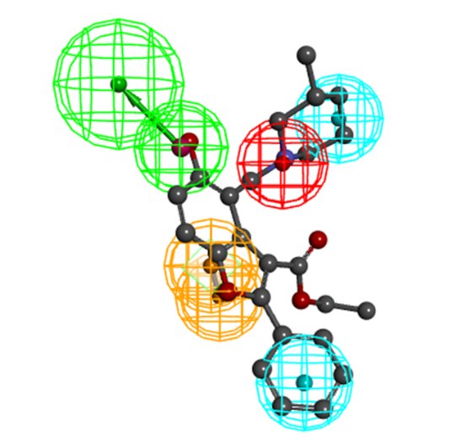 | 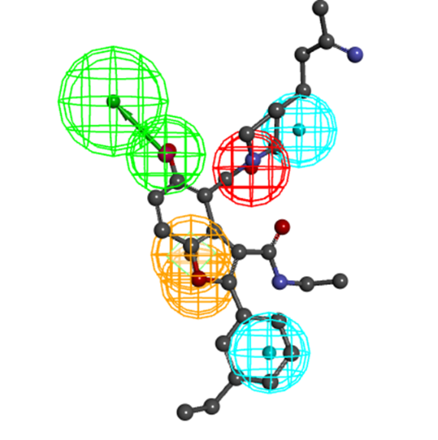
TAM-42-78-74-85 (${IC}_{50}^{exp}=1.28 nM)$ | TAM-43-82-65-85 (${IC}_{50}^{exp}=1.28 nM)$
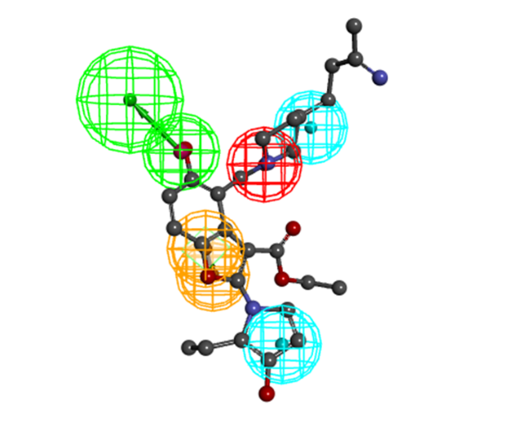 | 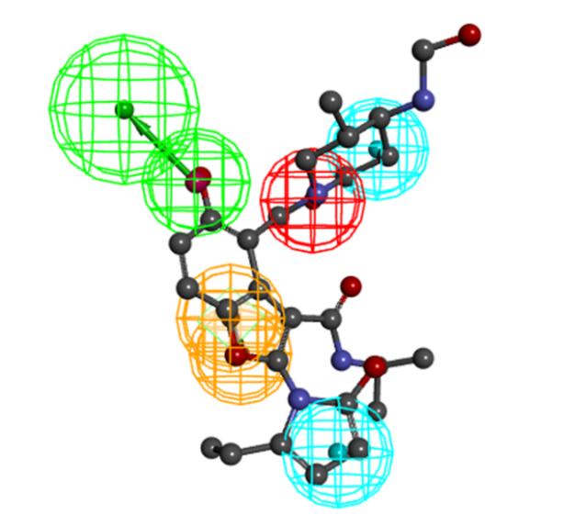
TAM-7-79-76-85 (${IC}_{50}^{exp}=1.36 nM)$
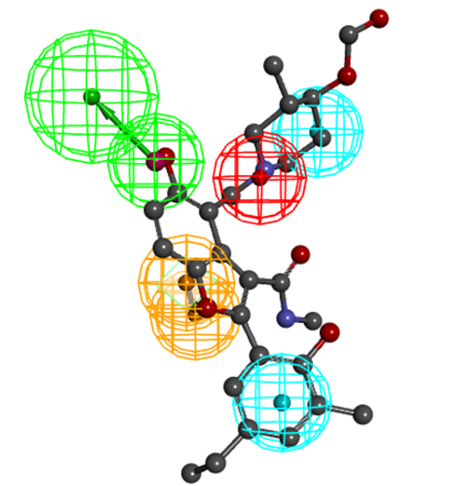
Figure 2. Mapping of analogues TAM2; TAM-1-80-74-85; TAM-42-78-74-85; TAM-43-82-65-85; TAM-7-79-76-85 to Pks13 inhibition pharmacophore.

TAM2 (${IC}_{50}^{exp}=120 nM)$ | TAM-1-80-74-85 (${IC}_{50}^{exp}=1.25 nM)$
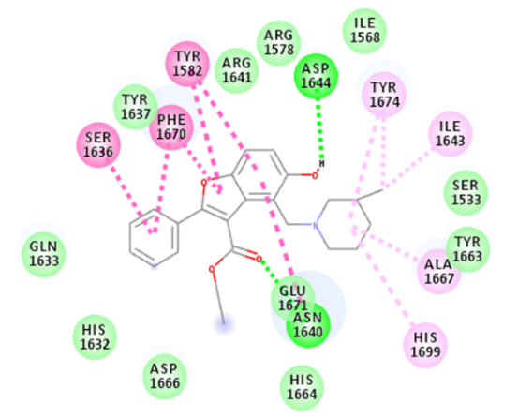 | 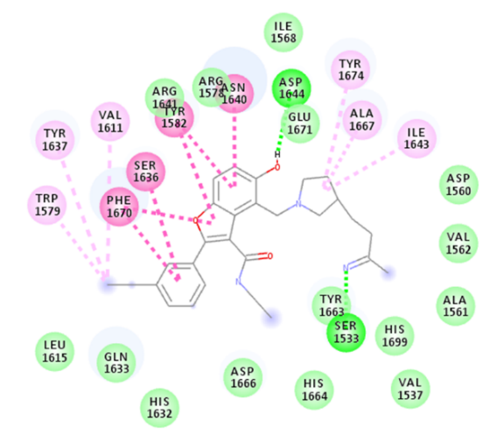
TAM-42-78-74-85 (${IC}_{50}^{exp}=1.28 nM)$ | TAM-43-82-65-85 (${IC}_{50}^{exp}=1.28 nM)$
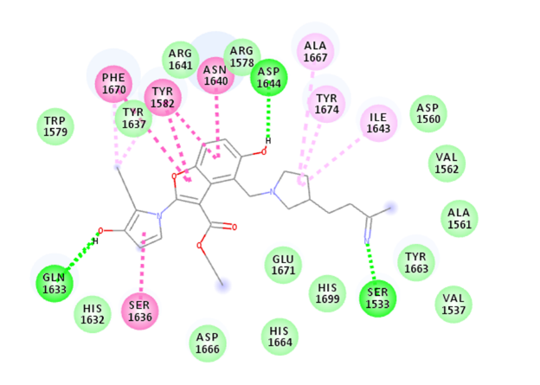 | 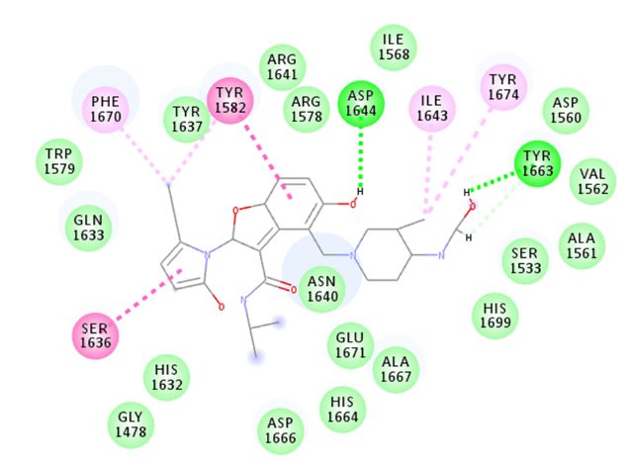
TAM-7-79-76-85 (${IC}_{50}^{exp}=1.36 nM)$ | van der Waals  Carbon Hydrogen Hond  Conventional Hydrogen Hond  Pi-Pi stacked  Pi-Pi-T-shaped  Amide-Pi-stacked  Pi-Akyl  Akyl
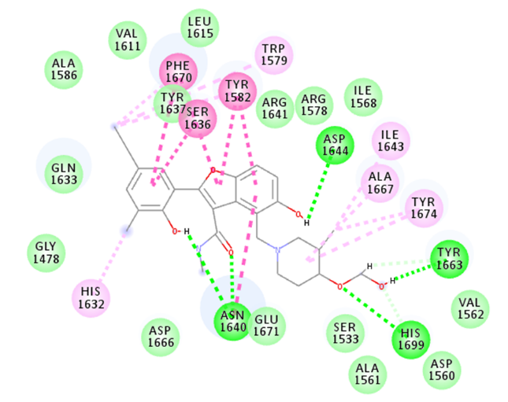
Figure 3. 2D schematic interaction diagram of the analogues TAM2; TAM-1-80-74-85; TAM-42-78-74-85; TAM-43-82-65-85; TAM-7-79-76-85.

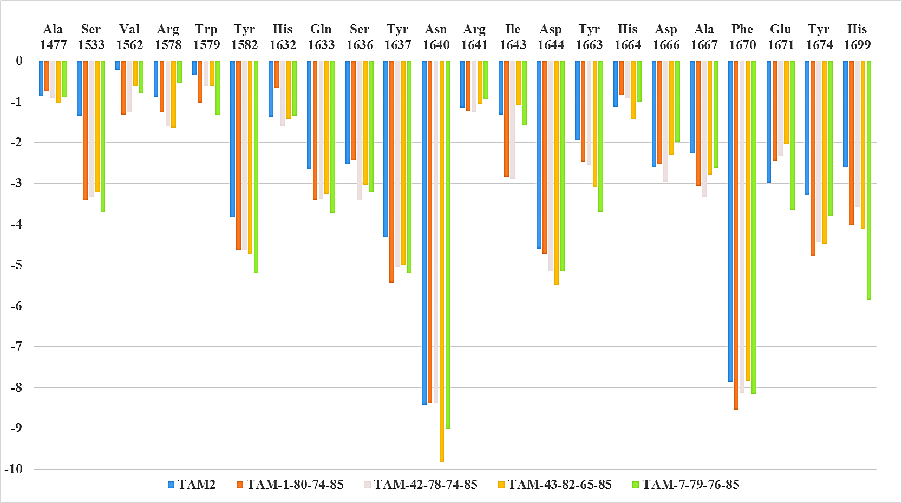
Figure 4. Molecular mechanics intermolecular interaction energy E_{int} breakdown to residue contributions, in [kcal.mol ⁻¹] shown for the best five designed novels benzofuran analogues (the color coding refers to ligands and is given in the legend).

5. CONCULSION
Our study was dedicated to the in silico design of new and more effective Pks13 of Mtb inhibitors based on the structural information of benzofuran derivatives. Thus, we opted for the combinatorial approach to design a virtual library from the substitutions made at position R₁, R₂, R₃ and R₄ of the skeleton of TAM2 (the most active ligand in the training set). A total of 87 fragments of which 50 for position R₁, 7 for R₂, 27 for R₃ and 3 at position R₄ were used to construct a virtual library of 28,350 molecules. This virtual library was purified using Lipinski's rule and we obtained a reduced-size library with 5,194 molecules. This latter was screened from the Pks13 inhibition pharmacophore elaborated in the previous work. At the end in silico screening of the reduced virtual library, 135 molecules aligning at least four PH4 functionalities were selected. The Gibbs free energy and its components of these new molecules were calculated. The predicted inhibitory activity of these molecules was also evaluated through the QSAR equation in aqueous medium obtained in our previous study on benzofuran derivatives. Following these calculations, twenty best analogues were identified and their pharmacokinetic profile is compared to that of certain anti-tuberculosis molecules used in the treatment of tuberculosis. Among these molecules, an analysis of the fixation mode aimed at justifying the predicted activity of the new analogues was made from the four most effective analogues such as: TAM-1-80-74-85 (${IC}_{50}^{exp}=1.25 nM),$TAM-42-78-74-85 (${IC}_{50}^{exp}=1.28 nM)$, TAM-43-82-65-85 (${IC}_{50}^{exp}=1.28 nM)$ and TAM-7-79-76-85 (${IC}_{50}^{exp}=1.36 nM)$. The most active of the designed analogues, TAM-1-80-74-85 (${IC}_{50}^{exp}=1.25 nM)$, has a predicted inhibitory activity 96 times higher than that of TAM2 (the most active molecule in the training set). Considering the quality of their predicted inhibitory activity and the excellent pharmacokinetic profile of these new inhibitors (TAM-1-80-74-85, TAM-42-78-74-85, TAM-43-82-65-85 and TAM-7-79-76-85), we suggest their synthesis and biological testing. Furthermore, the Pks13 inhibition pharmacophore model can be further used to screen a virtual library of existing drugs in order to increase the number of Mtb Pks13 inhibitors. Furthermore, the Pks13 inhibition pharmacophore model can be yet used to screen a virtual library of existing drugs in order to increase the number of Pks13 inhibitors.

ABBREVIATIONS
ADME : Absorption, Distribution, Metabolism, and Excretion
2D : Two-Dimensional
3D : Three-Dimensional
Eint : MM Enzyme–Inhibitor Interaction Energy per Residue
${∆∆G}_{com}$ : Relative Complexation GFE
GFE: Gibbs Free Energy
${∆∆G}_{sol}$ : Relative Solvation GFE
${∆∆TS}_{vib}$ : Relative Entropic GFE
${∆∆H}_{MM}$: Enthalpy Component of GFE
${IC}_{50}$ : Half-Maximal Inhibitory Concentration
MM : Molecular Mechanics
PDB : Protein Data Bank
PH4 : Pharmacophore
Pks : Polyketide Synthase
QSAR : Quantitative Structure-Activity Relationships
TE : Thioesterase

REFERENCES
[1] World Health Organization. Global tuberculosis report; 2024. Available:https://www.who.int.
[2] OMS. Tuberculosis. Fact sheet. Consulté en juillet 2016. http://www.who.int/mediacentre/factsheets/fs104/en/.
[3] Aubry, P. (2014) Actualités sur la tuberculose. Bulletin de la Société de Pathologie Exotique, 107, 127-128.
[4] Huchon, G. Tuberculose : infection et maladie. EMC - Pneumol. 2012, 9, 1–22.
[5] World Health Organization. Global tuberculosis report; 2023. Available:https://www.who.int.
[6] Wilson C, Ray P, Zuccotto F, Hernandez J, Aggarwal A, Mackenzie C, et al. Optimization of TAM16, a benzofuran that inhibits the thioesterase activity of Pks13; Evaluation toward a Preclinical Candidate for a Novel Antituberculosis Clinical Target.J. Med.Chem. 2022;65:409−423. Available:https://doi.org/10.1021/acs.jmedchem.1c01586.
[7] Marrakchi H, Lanéelle MA, Daffé M.Mycolic acids: Structures, biosynthesis,and beyond. Chemistry&Biology. 2014;21(1):67-85.Available:https://doi.org/10.1016/j.chembiol.2013. 11.011.
[8] North,E.J.;Jackson,M.;Lee,R.E. New approaches to target the mycolic acid biosynthesis pathway for the development of tuberculosis therapeutics. Curr. Pharm. Des. 2014, 20, 4357−4378.
[9] Portevin D, De Sousa-D'Auria C, Houssin C, Grimaldi M, Chami M, Daffé M, et al. A polyketide synthase catalyzes the last condensation step of mycolic acid biosynthesis in mycobacteria and related organisms. The Proceeding of the National Academy of sciences. U.S.A. 2004;101(1):314-319. Available:https://doi.org/10.1073/pnas.0305439101.
[10] Gavalda S, Bardou F, Laval F, Bon C, Malaga W, Chalut C, et al. The polyketide synthase Pks13 catalyzes a novel mechanism of lipid transfer in mycobacteria. Chemistry & Biology. 2014;21(12): 1660-1669. Available:https://doi.org/10.1016/j.chembiol.2014.10.011
[11] Zhao, G. et al. The structure-based virtual screening of non-benzofuran inhibitors against M. tuberculosis Pks13-TE for antituberculosis phenotypic discovery. New J. Chem. 45, 1286–1300 (2021).
[12] Ioerger TR, O'Malley T, Liao R, Guinn KM, Hickey MJ, Mohaideen N, et al. Identification of new drug targets and resistance mechanisms in Mycobacterium tuberculosis. PLoS One. 2013;8(9):1-13.Available:https://doi.org/10.1371/journal.pone.0075245.
[13] Jeffrey North, E., Jackson, M. & E Lee, R. New approaches to target the mycolic acid biosynthesis pathway for the development of tuberculosis therapeutics. Curr. Pharm. Des. 20, 4357–4378 (2014).
[14] Aggarwal A, Parai MK, Shetty N, Wallis D,Woolhiser L, Hastings C, et al. Development of a novel lead that targets M. tuberculosis polyketide synthase.13.2017;170(2):249-259. Available:https://doi.org/10.1016/j.cell.2017.06.025.
[15] Shaker, B., Ahmad, S., Lee, J., Jung, C. & Na, D. In silico methods and tools for drug discovery. Comput. Biol. Med. 137, 104851(2021).
[16] Wahedi, H. M., Ahmad, S. & Abbasi, S. W. Stilbene-based natural compounds as promising drug candidates against COVID-19. J. Biomol. Struct. Dyn. https:// doi. org/ 10. 1080/ 07391 102. 2020. 17627 43 (2020).
[17] Hassan-Baig, M. et al. Computer aided drug design: Success and limitations. Curr. Pharm. Des. 22, 572–581 (2016).
[18] Ahmad, S., Waheed, Y., Ismail, S., Abbasi, S. W. & Najmi, M. H. A computational study to disclose potential drugs and vaccine ensemble for COVID-19 conundrum. J. Mol. Liq. 324, 114734 (2021).
[19] Yu, W. & MacKerell, A. D. Computer-aided drug design methods. In Antibiotics 85–106 (Springer, 2017).
[20] Talele, T. T., Khedkar, S. A. & Rigby, A. C. Successful applications of computer aided drug discovery: Moving drugs from concept to the clinic. Curr. Top. Med. Chem. 10, 127–141 (2010).
[21] Djako A. M. B., M. Keita ,Y. Bibila Mayaya Bisseyou , A. Esmel and E. Megnassan. Computer-assisted Design of Novel Polyketide Synthase 13 of Mycobacterium tuberculosis Inhibitors Using Molecular Modeling and Virtual Screening. Journal of Pharmaceutical Research International. 12.2022; 34(56):12-41. Available: doi: 10.9734/JPRI/2022/v34i567250.
[22] Accelrys Inc. Insight-II and Discover Molecular Modeling and Simulation Package, Release 2005; Accelrys Inc.:San Diego, CA, USA; 2005.
[23] Frecer, V.; Miertus, S.; Tossi, A.; Romeo, D. Rational design of inhibitors for drug resistant HIV-1 aspartic protease mutants. Drug Des. Disc. 1998, 15, 211–231.
[24] Frecer, V.; Berti, F.; Benedetti, F.; Miertus, S. Design of peptidomimetic inhibitors of aspartic protease of HIV-1 containing–PheΨPro– core and displaying favourable ADME-related properties. J. Mol. Graph. Model. 2008, 27, 376–387.
[25] V. Frecer, M. Kabelac, P. De Nardi, S. Pricl, S. Miertus, J. Mol. Graph. Model. 2004, 22, 209–220.
[26] L. C. Owono Owono, M. Keita, E. Megnassan, V. Frecer, S. Miertus, Tuberc. Res. Treat. 2013, 670836
[27] B. Dali, M. Keita, E. Megnassan, V. Frecer, S. Miertus, Chem.Biol. Drug. Des. 2012, 79(4), 411–430.
[28] J. S. Freundlich, F. Wang, H. C. Tsai, M. Kuo, H. M. Shieh, J. W. Anderson, L. J. Nkrumah, J. C. Valderramos, M. Yu, T. R. Santha Kumar, S. G. Valderramos, W. R. Jacobs Jr., G. A. Schiehser, D. P. Jacobus, D. A. Fidock, J. C. Sacchettini, J. Biol. Chem. 2007,
282(35), 25436–25444.
[29] H. M. Berman, J. Westbrook, Z. Feng, G. Gilliland, T. N. Bhat, H. Weissig, I. N. Shindyalov, P. E. Bourne, Nucleic Acids Res. 2000, 28, 235–42.
[30] Frecer, V.; Seneci, P.; Miertus, S. Computer-assisted combinatorial design of bicyclic thymidine analogs as inhibitors of Mycobacterium tuberculosis thymidine monophosphate kinase. J. Comput. Aidded Mol. Des. 2011, 25, 31–49.
[31] Discovery Studio molecular modeling and simulation program, version 2.5, Accelrys, Inc., San Diego, CA, California. USA ;2009.
[32] Frecer, V.; Majekova, M.; Miertus, S. Approximate methods for solvent effect calculations on biomolecules. J. Mol. Struct.THEOCHEM 1989, 52, 403–419.
[33] Adama Niaré, Abadê Ange-Boris N’guessan, Akassa Marius Bernard Djako, Georges Stéphane Dembélé, Mamadou Guy-Richard Koné, Yaya Yéo « QSAR, Pharmacophore and Molecular Docking Studies for the Design of Novel Arylamide-derived Inhibitors of Mycobacterium tuberculosis » Chemical Science International Journal, Volume 33, Issue 6, P. 212-224, 2024.
[34] Rocchia, W.; Sridharan, S.; Nicholls, A.; Alexov, E.; Chiabrera, A.; Honig, B. Rapid grid-based construction of the mo-lecular surface and the use of induced surface charge to calculate reaction field energies: Applications to the molecular systems and geometric objects. J. Comput. Chem. 2002, 23, 128–137.
[35] Böttcher, C.J.F. Theory of Electric Polarization; Elsevier: Amsterdam, The Netherlands, 1973.
[36] Miertus, S.; Scrocco, E.; Tomasi, J. Electrostatic interaction of a solute with a continuum. A direct utilizaion of ab initio molecular potentials for the prevision of solvent effects. Chem. Phys. 1981, 55, 117–129.
[37] Frecer, V.; Miertus, S. Polarizable continuum model of solvation for biopolymers. Int. J. Quant. Chem. 1992 , 42, 1449–1468.
[38] Fischer, S.; Smith, J.C.; Verma, C.S. Dissecting the vibrational entropy change on protein/ligand binding: Burial of a water molecule in bovine pancreatic trypsin inhibitor. J. Phys. Chem. B 2001, 105, 8050–8055.
[39] Adama Niaré., Alex, A.Y.Z., Bernard, D.A.M., Marius, K.S., Stéphane, D.S., Moise, K.A., Guy-Richard, K.M., Fagnidi, Y.K.H., & Doh, S. (2025). Study by Molecular Docking of the Interactions Between Dihydroorotate Dehydrogenase and a Series of Inhibitors of Pyrrole Derivatives for the Treatment of Malaria. Asian Journal of Chemical Sciences, 15 (1):92-110.
[40] QikProp, version 3.7, release 14, X Schrödinger, LLC. New York, NY; 2014.
[41] E.M. Duffy, W.L. Jorgensen, J. Am. Chem. Soc. 122 (2000) 2878–2888.
[42] Jorgensen W, Duffy E. Prediction of drug solubility from Monte Carlo simulations. Bioorganic & Medicinal Chemistry Letters. 2000;10(11):1155-1158. 00172-4 View Article
[43] Jorgensen W and Duffy E. Prediction of drug solubility from structure. Advanced Drug Delivery Reviews. 2002;54(3):355–366. 00008-X View Article.
[44] Adama Niaré., N’guessan, H., Dali, B., Megnassan, E. (2022). Computer-assisted design of hydroxamic acid derivatives inhibitors of M1 metallo aminopeptidase of Plasmodium falciparum with favorable pharmacokinetic profile. British Journal of Pharmaceutical Research International, 34(60), 21–44.
[45] Lipinski C, Lombardo F, Dominy B, Feeney P. Experimental and computational approaches to estimate solubility and permeability in drug discovery and development settings, Adv. Drug Deliv. Rev. 2001;46:3–26.

