Novel Potential Of Vitamin C And E On The Myelin, Oligodendrocyte And Inflammatory Markers Of Rohypnol Exposed Amygdala In Rats

Abstract
Rohypnol, scientifically known as flunitrazepam, is a potent benzodiazepine medication primarily prescribed for the treatment of severe insomnia and as a pre-anesthetic medication. However, its reputation has been tarnished by its misuse as a recreational drug and its association with drug-facilitated crimes, particularly sexual assault. However, its potent sedative effects can lead to memory impairment, loss of motor coordination, and respiratory depression, especially when combined with alcohol or other central nervous system depressants. This study aims to investigate and establish mechanism and novel potential of vitamin C and E on the myelin, oligodendrocytes and inflammatory markers of Rohypnol exposed Amygdala. Twenty five male adult Wistar rats were divided into five groups: the control group was exposed to normal atmospheric air, 1mg/kg of Rohypnol, 1mg/kg of Rohypnol+100mg/kg of vitamin C, 1mg/kg of Rohypnol+100mg/kg of vitamin E, 1mg/kg of Rohypnol+100mg/kg of vitamin C and E and the test groups were exposed for 28days. In the last three days of exposure, neurobehavioural tests were conducted. 24hours after the last exposure, the animals were anesthetized using chloroform vapour. The brains were harvested by making an occipitofrontal incision for biochemical and histological assessment. The fixation was done in 10% neutral buffered formalin for 48hrs following the brain mapping to isolate the brain tissue of interest. The Vitamin C and E-exposed rats showed significant (p<=0.05) progressive improvement in their behaviours including the oxidative stress markers when compared to the control, In conclusion, this study have shown that good antioxidants such as vitamin C and E are very much effective in reducing oxidative stress and thus, have great antioxidant ameliorative properties to the Rohypnol induced Amygdala of the wistar rats.

Keywords: Flunitrazepam Vitamin C and E (Rohypnol), Amygdala, Histoarchitecture, Benzodiazepine

Introduction
Despite its classification as a controlled substance in numerous countries, Nigeria included, studies have demonstrated that the misuse of Rohypnol by adolescents is a recurrent occurrence (Oluwole et al,. 2020), Animal and human studies have demonstrated that Benzodiazepines (BZDs) have several side effects, including drowsiness, dizziness, tiredness, mental confusion, headache, anxiety, lethargy, ataxia, postural hypotension, retrograde amnesia, accidents, tolerance, dependence, and increased frequency of falls (Keith and Rasmussen, 2014), The major pharmacological effect of Flunitrazepam (Rohypnol) as a Lipophilic drug is its enhancement of Gamma-aminobutyric acid (GABA) at the localized GABA receptors ( Hesse et al 2001) , Additionally, research shows a link to organ toxicity, a bad mental state, and problems with muscle control and psychomotor abilities. (Wick , 2013), suppression of hypothalamic-pituitary-testicular axis (Oluwole et al, 2020)
Pharmacotherapeutic interventions are available for individuals experiencing withdrawal symptoms or desiring cessation of their persistent benzodiazepine (BZD) utilization. Multiple alternative pharmacological treatments have been suggested to mitigate the severity of withdrawal, encompassing alpha-blockers (such as propranolol and clonidine), anticonvulsants (valproic acid, lamotrigine, carbamazepine, and phenobarbital), progesterone, baclofen, and trazodone. Nevertheless, the outcome of each of these investigations exhibited inconclusive findings, lacking statistically significant superiority over BZD therapy. Presently, the preferred course of treatment involves substituting the present short-acting BZD with a long-acting substitute, gradually decreasing the dosage to effectively wean the individual off BZD entirely. (Brett et al 2015)
Vitamin E is a fat-soluble vitamin that plays the role of antioxidant against oxidative stress, Antioxidants act in the following two ways: they prevent neuronal death due to oxidative stress (scavenging free radicals and, thus, preventing lipid peroxidation) and reduce the activation of transcription factors, (sen et al 2006)
There is growing evidence that Each tocopherol molecule can donate two electrons (Maria et al, 2021) before being “consumed”; the tocopherol molecule is then reduced to its previous state and can then be reused. Importantly, this reduction process is most likely carried out by ascorbic acid (Maria et al, 2021), which is why there are many studies reporting the antioxidant capacity of vitamin E linked to vitamin C (Behl, 2000). A combination of different antioxidants, therefore, may offer additional benefit ((Maria et al, 2021)) because antioxidants may together have different protective effects. Vitamin C is a nutrient of greatest importance for proper functioning of nervous system and its main role in the brain is its participation in the antioxidant defense. Apart from this role, it is involved in numerous non-oxidant processes like biosynthesis of collagen, carnitine, tyrosine and peptide hormones as well as of myelin. It plays the crucial role in neurotransmission and neuronal maturation and functions (Joanna et al, 2017)
The increasing evidence on the potential neuroprotective roles of vitamin E have been well documented in both in vivo and in vitro studies (Takahashi et al, 2016). In vivo, vitamin E and other endogenous antioxidants work in concert or synergistically by maintaining a reduced environment (Maria et al, 2021), The effects of vitamin E on microglial cells have been studied in the short term, most studies, in line with the idea that microglial activation is a harmful process, have shown that vitamin E suppresses inflammatory activation of microglia, thus providing some neuroprotection (Maria et al, 2021).
There is an emerging model of the role of specific brain structures in anxiety and their relation to the mechanism of action of benzodiazepine (BZD) anxiolytics. The presumption of this model is that there are structures in the brain, the activity of which mediate anxiety. Ben-zodiazepines are presumed to work via the BZD- GABA-C1- ionophore complex such as to enhance the inhibitory effects of GABA upon these anxiety-mediating structures ( Hesse et al 2001)
A number of such brain regions have been proposed as putative sites for the action of BZDs, including the nuclei of the raphe (Wise et al. 1972; Soubri 1986), the septo-hippocampal system (Gray 1982), and the amygdala (Scheel-Kruger and Petersen 1982; Costall et al. 1989). The amygdala is an almond-shaped structure that lies in the temporal lobe, The amygdala also functions in regulating anxiety, aggression, fear conditioning, emotional memory, and social cognition (Rajmohan et al 2007)
The Amygdala has been associated with many diseases, mainly neuropsychiatric. And various research suggests that amygdala neurofeedback may not only be therapeutic for this patient group but may also be used as a future adjunctive treatment (Nicholson et al 2017) Given the aforementioned information, this study evaluates the effect of vitamin C and E on rohypnol induced Amygdala integrity.
MATERIALS AND METHODS.
Location and Duration of the Study
This scientific investigation was carried out in Animal house of the Department of Human Anatomy, College of Health Sciences, Nnamdi Azikiwe University Nnewi Campus, Anambra State, Nigeria. The experimental animals were allowed to acclimatize for a period of 14days after which the test substances was administered for 28days; the entire experiment lasted for six weeks
Ethical Approval
All the animals were treated following the approval of the ethical committee with the number FBMS/EA/1020, College of Health Sciences, Nnamdi Azikiwe University, Nnewi Campus, in line with the “Guide for the Care and Use of Laboratory Animals” (NRC 2011).

Experimental Animals: Twenty five (25) male albino rats weighing 150-200g were procured from a laboratory at Nnamdi Azikiwe University Nnewi campus and housed at the animal house of the Department of Anatomy, College of Health Sciences Nnamdi Azikiwe University Nnewi, Anambra State. The rats were marked with various colors peculiar with each group, and were housed in plastic cages with iron net in standard condition (a controlled room temperature of about 25–28 ℃, a relative humidity of about 60–80%, and a photoperiodicity of 12 h day and night.). The rats were fed sufficiently with normal grower mesh produced by Premier Feed Mills Co. Limited (A subsidiary of Flour Mills Nigeria Plc). The animals were grouped into four; Group A represents the control group while Groups B, C and D represents the test group. All rats were weighed prior to the commencement of administration and subsequently weighed weekly (once a week) using Melter’s Electronic weighing balance model PB303 (made by Monobloc in Switzerland).
Procurement of Drug: Rohypnol was produced and marketed by SWISS Pharma Nigeria LTD. No 5, Dopemu Road, Agege, Lagos state. Under the license of Global Healthcare Ltd, Basel Switzerland.
Experimental Design: The animals were grouped at random into four with five animals in each of the groups. The test animals were administered Rohypnol for 28days in graded doses of 1mg/kg, 100mg/kg and 100mg/kg Respectively while group A which is the control group received only distilled water.
List 1- The Groups and treatments provided
S/N | GROUP | WATER+RAT FEED | DURATION
1 | A (Control) |  | 28days
2 | B | 1mg/kg of Rohypnol | 28days
3 | C | 1mg/kg of Rohypnol+100mg/kg of Vitamin C | 28days
4 | D | 1mg/kg of Rohypnol +100mg/kg of Vitamin E | 28days
5 | E | 1mg/kg of Rohypnol +100mg/kg of Vitamin C and E | 28days

Biomedical analysis
The brain tissues were analysed for oxidative stress markers namely; malondialdehyde (MDA) for lipid peroxidation and superoxide dismutase (SOD) and reduced glutathione for antioxidants (GSH) at the Department of Biochemistry, Nnamdi Azikiwe University, Nnewi Campus. One gram of each animal brain tissue was added to 10 mL of 0.9% normal saline and homogenized at room temperature. After this, each of the samples was centrifuged at 3,000 rpm for 20 min at room temperature. The supernatants were separated and stored for further analyses.
Elevated Plus Maze Test
The elevated plus maze (EPM) test assessed anxietyrelated behaviour in the rats on day 27 of exposure. The EPM apparatus consists of a plus-shaped maze elevated above the floor with two oppositely positioned closed arms, two oppositely positioned open arms, and a centre area. This was a five-minute test that allowed the rats to freely explore the maze; their behaviours were recorded by means of a video camera mounted above the maze and analysed using a video tracking system. The entry in and time spent in the open arms were regarded as direct measures of anxiety (Frye 2007; Walf and Frye 2007).
Wire Suspension Test
The motor activities were assessed using the wire suspension test protocol on day 28 of exposure. The rat’s forepaws were suspended on a two-millimetre diameter metal bar that was 30 cm above a soft, flat surface. The longest time until the rats lost their grip and fell on the soft surface in three consecutive trials was measured and used to assess their motor function. Complete acquisition of the reflex was assumed when the rat was able to hang on the bar for 30 s (Moran et al. 1995).
Organ Collection: The rats were sacrificed after 28days of administration of Rohypnol in graded doses. The Amygdala were then harvested and put in a normal saline to maintain normal physiological conditions after which they were weighed and fixed in 10% formal saline for Histological processing.
Tissue Processing: After weighing the organs, a small part of the Amygdala tissues were cut out and immediately fixed in 10% formal saline in order to preserve the various constituents of the cells in their normal micro anatomical position and to prevent autolysis and putrefaction. After fixation the tissues were dehydrated to remove water and other substances. This was carried out in different percentages of alcohol 50%, 70% and 95% absolute. In each grade of alcohol, tissues were changed twice for two (2) hours, one (1) hour for each change. After dehydration, tissues were cleared in xylene for two (2) hours after which infiltration was done in molten paraffin wax at a temperature of 60oc for two (2) hours, each in two changes. When the paraffin wax cools, it sets as a hard block which allows for easy sectioning of the tissues. The tissue sections were produced by normal histochemical methods of dehydration, clearing, impregnation, embedding, sectioning and staining (with H&E). The micrographs of the relevant stained sections were subsequently taken with the aid of a light microscope.
Statistical Analysis: The data were analyzed using SPSS version 23. Values were represented as MEAN and SEM, Relative Organ weight (Brain) were analyzed using One way ANOVA, followed by Post Hoc LSD multiple comparison. Body weight was analyzed using Student dependent T-test. Values were considered significant at P<0.05.
Results
Amygdala Immunohistochemical Expression
Table 1: Findings obtained from this experiment in showed a non-significant (p>0.05) decrease in the TNFɑ test in Groups, 1mg/kg Rohypnol + 100mg/kg vitamin C, 1mg/kg Rohypnol + 100mg/kg vitamin E and 1mg/kg Rohypnol + 100mg/kg vitamin C and E, when compared to Group 1mg/kg Rohypnol that shows a significant (p<0.05) increase. In the Bcl-2 test, there was a (p>0.05) non-significant increase in Groups 1mg/kg Rohypnol + 100mg/kg vitamin C and 1mg/kg Rohypnol + 100mg/kg vitamin E, except Group 1mg/kg Rohypnol + 100mg/kg vitamin C and E, that showed significance increase (p<0.05), when compared to Group 1mg/kg Rohypnol that showed (p>0.05) non-significant decrease . In the MBP-test,there was a (p>0.05) non-significant increase in Groups 1mg/kg Rohypnol + 100mg/kg vitamin C, 1mg/kg Rohypnol + 100mg/kg vitamin E and 1mg/kg Rohypnol + 100mg/kg vitamin C and E, when compared to Group 1mg/kg Rohypnol that showed (p>0.05) non-significant decrease. In the Olig2-test, there was a (p>0.05) non-significant increase in Group 1mg/kg Rohypnol + 100mg/kg vitamin C, 1mg/kg Rohypnol + 100mg/kg vitamin E and 1mg/kg Rohypnol + 100mg/kg vitamin C and E, when compared to Group 1mg/kg Rohypnol that showed a (p>0.05) non-significant decrease.

Table 1: Amygdala Expression Count.
 | Groups | Mean ± SEM | p-value | F-value
TNFɑ  (µg/mL) | Group A | 34.20 ± 6.24 |  | 2.154
TNFɑ  (µg/mL) | Group B | 62.10 ± 8.76 | 0.202
TNFɑ  (µg/mL) | Group C | 45.38 ± 6.89 | 0.901
TNFɑ  (µg/mL) | Group D | 45.08 ± 6.14 | 0.885
TNFɑ  (µg/mL) | Group E | 38.10 ± 9.10 | 1.000
Bcl-2  (µg/mL) | Group A | 18.96 ± 3.31 |  | 6.386
Bcl-2  (µg/mL) | Group B | 16.51 ± 3.68 | 1.000
Bcl-2  (µg/mL) | Group C | 29.72 ± 3.23 | 0.266
Bcl-2  (µg/mL) | Group D | 40.85 ± 7.36 | 0.140
Bcl-2  (µg/mL) | Group E | 46.93 ± 3.51 | 0.001*
 | Group A | 6.20 ± 1.88 |  | 5.224
MBP  (µg/mL) | Group B | 0.73 ± 0.05 | 0.228
 | Group C | 24.22 ± 5.15 | 0.132
 | Group D | 12.38 ± 3.99 | 0.797
 | Group E | 11.96 ± 4.30 | 0.876
 | Group A | 9.40 ± 1.29 |  | 2.845
Olig2  (µg/mL) | Group B | 6.40 ± 1.86 | 0.838
 | Group C | 14.00 ± 2.02 | 0.513
 | Group D | 14.20 ± 1.88 | 0.415
 | Group E | 16.40 ± 4.04 | 0.667

Data were analyzed using One-way ANOVA, followed by Post HOC Turkey’s multiple comparison, and data was considered significant at P<0.05

Oxidative Stress Markers And Antioxidants Activity
Table 2 : Result showed a non-significant decrease in the MDA level in group 1mg/kg Rohypnol compared to the control (group A) (p=0.97), groups 1mg/kg Rohypnol + 100mg/kg vitamin C and 1mg/kg Rohypnol + 100mg/kg vitamin E (p=0.97, p=0.45) had a non-significant decrease while group 1mg/kg Rohypnol + 100mg/kg vitamin C and E (p=0.79) had non-significant increase compared to group 1mg/kg Rohypnol. The SOD level result showed a non-significant decrease in group 1mg/kg Rohypnol compared to control (p=0.95), groups 1mg/kg Rohypnol + 100mg/kg vitamin C, 1mg/kg Rohypnol + 100mg/kg vitamin E and 1mg/kg Rohypnol + 100mg/kg vitamin C and E (p=0.028, p=0.00, p= 0.00) had a significant decrease compared to group 1mg/kg Rohypnol. The GPx level result showed a non-significant increase in group 1mg/kg Rohypnol compared to control group (p=0.24), while groups 1mg/kg Rohypnol + 100mg/kg vitamin C and 1mg/kg Rohypnol + 100mg/kg vitamin E (p=0.53, p=0.33) had a non-significant increase and group 1mg/kg Rohypnol + 100mg/kg vitamin C and E (p=0.00) had a significant increase compared to group 1mg/kg Rohypnol The GSH result showed a non-significant increase in group 1mg/kg Rohypnol compared to control group (p=1.00), while groups 1mg/kg Rohypnol + 100mg/kg vitamin C and 1mg/kg Rohypnol + 100mg/kg vitamin E (p=0.83, p=1.00) had a non-significant decrease and group 1mg/kg Rohypnol + 100mg/kg vitamin C and E (p=0.52) had a non-significant increase compared to group 1mg/kg Rohypnol.

Table 2: Effect Of Vitamins C And E On Oxidative Stress Marker And Antioxidants Activity Following Rohypnol Induced Brain Dysfunction
 | Malondialdehyde level (um/L) | Superoxide Dismutase (U/ml) | Glutathione Peroxidase (Um/ml) | Reduced glutathione (Um/ml)
 | MEAN±SEM | MEAN±SEM | MEAN±SEM | MEAN±SEM
Group A (control) | 0.71±0.11 | 23.39±0.38 | 3.40±0.79 | 10.17±0.28
Group B (1mg/kg of Rohypnol) | 0.70±0.20ª | 23.34±0.04ª | 6.05±0.79 ª | 10.20±0.06 ª
Group C (1mg/kg of Rohypnol +100mg/kg of Vitamin C) | 0.69±0.01 ª | 20.87±0.81ª | 6.06±0.00 ª | 10.12±0.22 ª
Group D (1mg/kg of Rohypnol +100mg/kg of Vitamin E) | 0.58±0.01 ª | 11.14±0.93 ª | 8.15±0.26 ª | 10.17±0.08 ª
Group E (1mg/kg of Rohypnol +100mg/kg of Vitamin C & E) | 0.74±0.00 ª | 9.01±0.04 ª | 18.68±2.89* | 10.34±0.11 ª
F-value | 0.34 | 143.04 | 17.61 | 0.24
Data was analyzed using paired T-test, and values were considered significant at p<0.05. BWC: Body weight changes. (*= significant, a: not significant)

Bar Chart Showing The Effect Of Vitamin C And E On SOD, MDA, Gpx , And GSH Levels On Amygdala Induced Rohypnol.
Fig 1: Result showed a decrease in The SOD level in group 1mg/kg Rohypnol compared to the control (p=0.95), groups 1mg/kg Rohypnol + 100mg/kg vitamin C , 1mg/kg Rohypnol + 100mg/kg vitamin E, and 1mg/kg Rohypnol + 100mg/kg vitamin C and E (p=0.028, p=0.00, p= 0.00) had a decrease compared to group 1mg/kg Rohypnol. the MDA level result showed a decrease in group 1mg/kg Rohypnol compared to A (p=0.97), groups 1mg/kg Rohypnol + 100mg/kg vitamin C and 1mg/kg Rohypnol + 100mg/kg vitamin E (p=0.97, p=0.45) had a decrease while group 1mg/kg Rohypnol + 100mg/kg vitamin C and E (p=0.79) had an increase compared to group 1mg/kg Rohypnol The GPx level result showed an increase in group 1mg/kg Rohypnol compared to the control (p=0.24), while groups 1mg/kg Rohypnol + 100mg/kg vitamin C and 1mg/kg Rohypnol + 100mg/kg vitamin E (p=0.53, p=0.33) had an increase and group 1mg/kg Rohypnol + 100mg/kg vitamin C and E (p=0.00) had an increase compared to group 1mg/kg Rohypnol. The GSH result showed an increase in group 1mg/kg Rohypnol compared to the control (p=1.00), while groups 1mg/kg Rohypnol + 100mg/kg vitamin C and, 1mg/kg Rohypnol + 100mg/kg vitamin E (p=0.83, p=1.00) had a decrease and group 1mg/kg Rohypnol + 100mg/kg vitamin C and E (p=0.52) had an increase compared to group B.

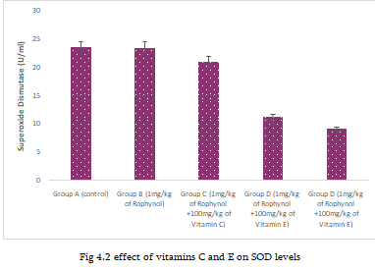  SOD | 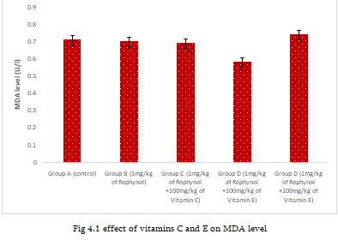  MDA
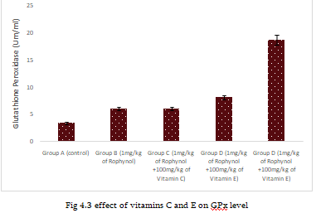  GPx | 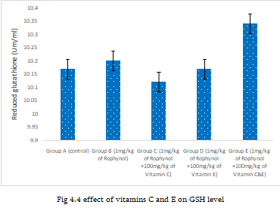
 | GSH

Fig 1: Bar chart showing the Effect of vitamin C and E on SOD, MDA, GPx , and GSH levels on Amygdala induced Rohypnol.
Effect Of Vitamin C And E On Motor Function Using Immobility Time Test Following Rohypnol Toxicity
Table 3: Result revealed a significant decrease in time following immobility time test at Day 1 in group 1mg/kg Rohypnol compared to control group (p=0.001), while groups 1mg/kg Rohypnol + 100mg/kg vitamin C, 1mg/kg Rohypnol + 100mg/kg vitamin E, and 1mg/kg Rohypnol + 100mg/kg vitamin C and E compared to 1mg/kg Rohypnol (p=0.001, p=0.012, p=0.002) showed a significant increase in the immobility time at Day 1. Day 2, the immobility time test using wire test showed a significant decrease in group 1mg/kg Rohypnol compared to control group (p=0.002), groups 1mg/kg Rohypnol + 100mg/kg vitamin C, 1mg/kg Rohypnol + 100mg/kg vitamin E, and 1mg/kg Rohypnol + 100mg/kg vitamin C and E showed a (p=0.002, p=0.010, p=0.002) showed a significant increase compared to group 1mg/kg Rohypnol. At day 3, the immobility time test using wire test showed a significant decrease in group 1mg/kg Rohypnol compared to control group (p=0.011), groups 1mg/kg Rohypnol + 100mg/kg vitamin C, 1mg/kg Rohypnol + 100mg/kg vitamin E, and 1mg/kg Rohypnol + 100mg/kg vitamin C and E showed a (p=0.012, p=0.013, p=0.014) showed a significant increase compared to group 1mg/kg Rohypnol

Table 3: Effect Of Vitamin C And E On Motor Function Using Immobility Time Test Following Rohypnol Toxicity
 | Time of immobility Day 1 (Seconds) | Time of immobility Day 2 (Seconds) | Time of immobility Day 3 (Seconds)
 | MEAN±SEM | MEAN±SEM | MEAN±SEM
Group A (control) | 263.50±10.50 | 214.00±5.00 | 203.00±9.00
Group B (1mg/kg of Rohypnol) | 149.50±38.50* | 159.50±25.50* | 172.50±8.50
Group C (1mg/kg of Rohypnol +100mg/kg of Vitamin C) | 199.50±9.50* | 236.50±31.50* | 212.00±3.50 *
Group D (1mg/kg of Rohypnol +100mg/kg of Vitamin E) | 227.00±31.00* | 258.00±8.00* | 207.50±5.00 *
Group E (1mg/kg of Rohypnol +100mg/kg of Vitamin C&E) | 247.00±7.00* | 186.00±52.00* | 218.00±6.00*
F-value | 1.40 | 1.36 | 0.62
Data was analyzed using ANOVA followed by multiple comparison using Fisher’s LSD, and values were considered significant at p<0.05. (*= significant, a: not significant).
The Effect of Vitamin C and E on exploratory time following Rohypnol toxicity
Table 4: Result showed a significant increase in exploratory time in control group compared to 1mg/kg Rohypnol (p=0.000), while groups 1mg/kg Rohypnol + 100mg/kg vitamin C, 1mg/kg Rohypnol + 100mg/kg vitamin E, and 1mg/kg Rohypnol + 100mg/kg vitamin C and E (p=0.000, p=0.001, p=0.002) had a significant decrease when compared to group 1mg/kg Rohypnol at day 1. At Day 2, a significant increase in exploratory time in-group A compared to 1mg/kg Rohypnol (p=0.000), while groups 1mg/kg Rohypnol + 100mg/kg vitamin C, 1mg/kg Rohypnol + 100mg/kg vitamin E, and 1mg/kg Rohypnol + 100mg/kg vitamin C and E (p=0.000, p=0.020, p=0.025) had a significant decrease when compared to group 1mg/kg Rohypnol. At day 3, a significant increase in exploratory time in control group compared to 1mg/kg Rohypnol (p=0.010), while groups 1mg/kg Rohypnol + 100mg/kg vitamin C, 1mg/kg Rohypnol + 100mg/kg vitamin E, and 1mg/kg Rohypnol + 100mg/kg vitamin C and E (p=0.010, p=0.021, p=0.005) had a significant decrease when compared to group 1mg/kg Rohypnol.

Table 4: Effect of Vitamin C and E on exploratory time following Rohypnol toxicity
 | Exploratory time Day 1 (Seconds) | Exploratory time Day 2 (Seconds) | Exploratory time Day 3 (Seconds)
 | MEAN±SEM | MEAN±SEM | MEAN±SEM
Group A (control) | 2.33±1.33 | 3.33±0.45 | 4.67±1.33
Group B (1mg/kg of Rohypnol) | 15.67±10.80* | 10.00±0.00* | 12.00±0.00*
Group C (1mg/kg of Rohypnol +100mg/kg of Vitamin C) | 3.00±2.00* | 5.10±0.10* | 6.20±0.00*
Group D (1mg/kg of Rohypnol +100mg/kg of Vitamin E) | 1.00±0.00* | 4.50±0.01* | 7.20±0.01 *
Group E (1mg/kg of Rohypnol +100mg/kg of Vitamin C&E) | 1.00±0.00* | 4.67±0.10* | 7.08±0.07*
F-value | 15.71 | 1.12 | 3.15
Data was analyzed using ANOVA followed by multiple comparison using Fisher’s LSD, and values were considered significant at p<0.05. (*= significant, a: not significant).

Bar Chart Showing The Effect Of Vitamin C And E On Motor Function Using Immobility Time Test And On Exploratory Time Following Rohypnol Toxicity
Fig 2: Result revealed a significant decrease in time following immobility time test at Day 1 in group 1mg/kg Rohypnol compared to the control (p=0.001), while groups 1mg/kg Rohypnol + 100mg/kg vitamin C, 1mg/kg Rohypnol + 100mg/kg vitamin E, and 1mg/kg Rohypnol + 100mg/kg vitamin C and E compared to 1mg/kg Rohypnol (p=0.001, p=0.012, p=0.002) showed a significant increase in the immobility time at Day 1. Day 2, the immobility time test using wire test showed a significant decrease in group 1mg/kg Rohypnol compared to the control (p=0.002), groups 1mg/kg Rohypnol + 100mg/kg vitamin C , 1mg/kg Rohypnol + 100mg/kg vitamin E, and 1mg/kg Rohypnol + 100mg/kg vitamin C and E showed a (p=0.002, p=0.010, p=0.002) showed a significant increase compared to group 1mg/kg Rohypnol. At day 3, the immobility time test using wire test showed a significant decrease in group 1mg/kg Rohypnol compared to the control (p=0.011), groups 1mg/kg Rohypnol + 100mg/kg vitamin C, 1mg/kg Rohypnol + 100mg/kg vitamin E, and 1mg/kg Rohypnol + 100mg/kg vitamin C and E showed a (p=0.012, p=0.013, p=0.014) showed a significant increase compared to group 1mg/kg Rohypnol
Result showed a significant increase in exploratory time in the control group compared to 1mg/kg Rohypnol (p=0.000), while groups 1mg/kg Rohypnol + 100mg/kg vitamin C, 1mg/kg Rohypnol + 100mg/kg vitamin E, and 1mg/kg Rohypnol + 100mg/kg vitamin C and E (p=0.000, p=0.001, p=0.002) had a significant decrease when compared to group 1mg/kg Rohypnol at day 1. At Day 2, a significant increase in exploratory time in control group compared to 1mg/kg Rohypnol (p=0.000), while groups 1mg/kg Rohypnol + 100mg/kg vitamin C, 1mg/kg Rohypnol + 100mg/kg vitamin E, and 1mg/kg Rohypnol + 100mg/kg vitamin C and E (p=0.000, p=0.020, p=0.025) had a significant decrease when compared to group 1mg/kg Rohypnol. At day 3, a significant increase in exploratory time in the control group compared to 1mg/kg Rohypnol E (p=0.010), while groups 1mg/kg Rohypnol + 100mg/kg vitamin C, 1mg/kg Rohypnol + 100mg/kg vitamin E, and 1mg/kg
Rohypnol + 100mg/kg vitamin C and E (p=0.010, p=0.021, p=0.005) had a significant decrease when compared to group 1mg/kg Rohypnol.
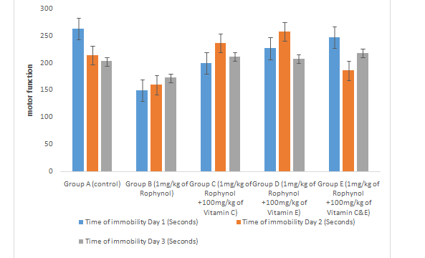  Bar chart showing the Effect Of Vitamin C And E On Motor Function Using Immobility Time Test Following Rohypnol Toxicity | 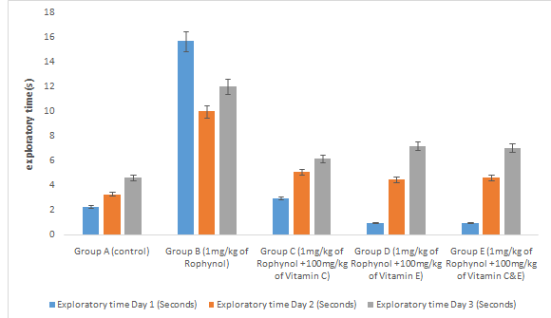  Bar chart showing the Effect of Vitamin C and E on exploratory time following Rohypnol toxicity
Fig 2: Bar chart showing the Effect of Vitamin C and E On Motor Function Using Immobility Time Test and on exploratory time following Rohypnol toxicity
Histopathological Findings
Amygdala Tumor Necrosis Factor Alpha (TNF-ɑ) Expression
Fig 3: The control group of Amygdala show an increase in the expression of tumor necrosis factor alpha (TNF-ɑ) on the amygdala region of the brain, that of 1mg/kg rohypnol Group of shows a decrease in the expression of tumor necrosis factor alpha (TNF-ɑ) , 1mg/kg Rohypnol + 100mg/kg vitamin C Group shows an increase in the expression of tumor necrosis factor alpha (TNF-ɑ), 1mg/kg Rohypnol + 100mg/kg vitamin E Group shows an increase in the expression of tumor necrosis factor alpha (TNF-ɑ), and 1mg/kg Rohypnol + 100mg/kg vitamin C and E Group of shows an increase in the expression of tumor necrosis factor alpha (TNF-ɑ) on the amygdala region of the brain.

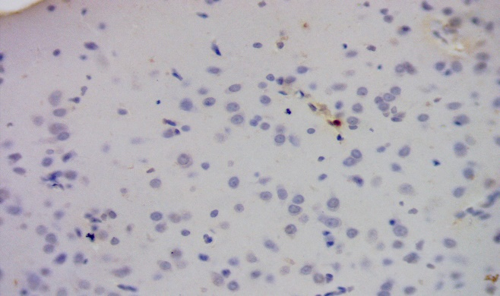  Control | 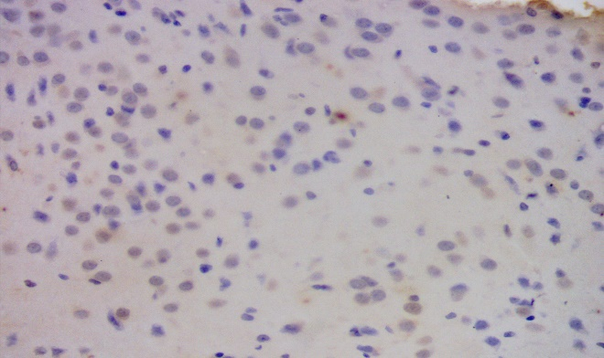  1mg/kg Rohypnol
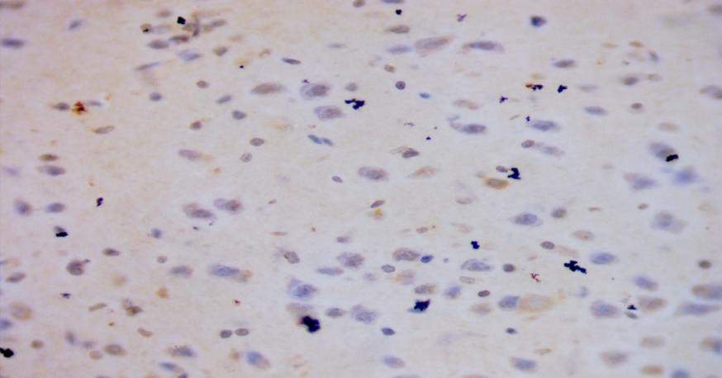  1mg/kg Rohypnol +100mg/kg Vitamin C | 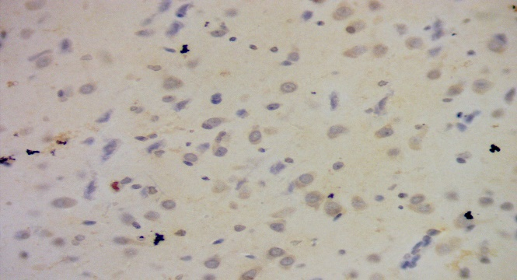  1mg/kg Rohypnol + 100mg/kg vitamin E
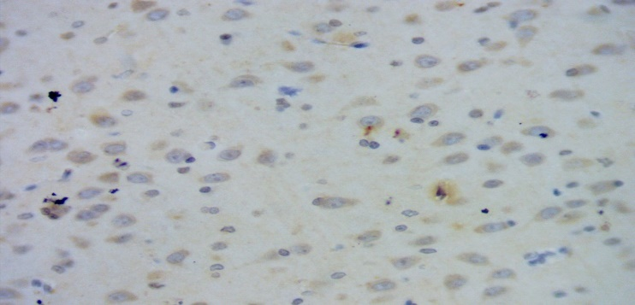
1mg/kg Rohypnol + 100mg/kg vitamin C and E
Fig 3: Amygdala Tumor Necrosis Factor Alpha (TNF-ɑ) Expression
Amygdala B-Cell Lymphoma 2 (Bcl-2) Expression
Fig 4 shows the control Group shows an increase in the expression of b-cell lymphoma 2 (BCL-2), 1mg/kg Rohypnol Group shows a decrease in the expression of b-cell lymphoma 2 (BCL-2), 1mg/kg Rohypnol + 100mg/kg vitamin C Group shows an inverse increase in the expression of b-cell lymphoma 2 (BCL-2), 1mg/kg Rohypnol + 100mg/kg vitamin E Group shows an inverse increase in the expression of b-cell lymphoma 2 (BCL-2), 1mg/kg Rohypnol + 100mg/kg vitamin C and E Group of Amygdala shows an inverse increase in the expression of b-cell lymphoma 2 (BCL-2) on the amygdala region of the brain.
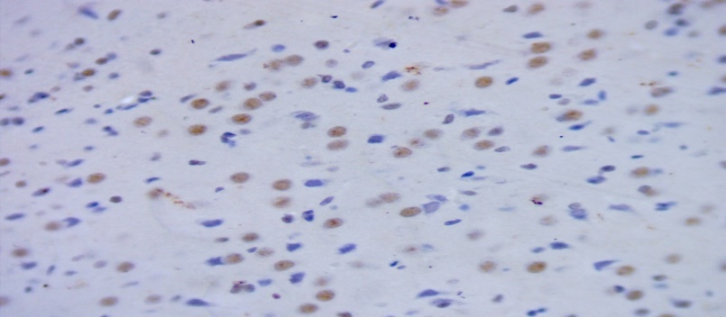  Control | 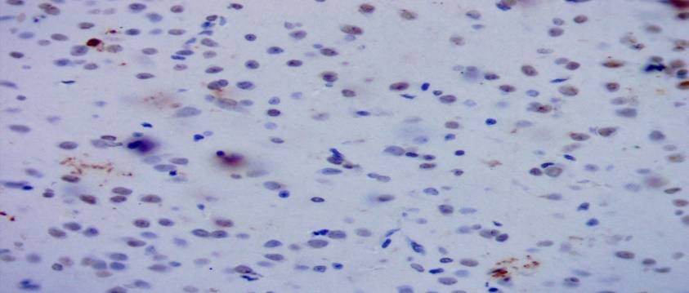  1mg/kg Rohypnol
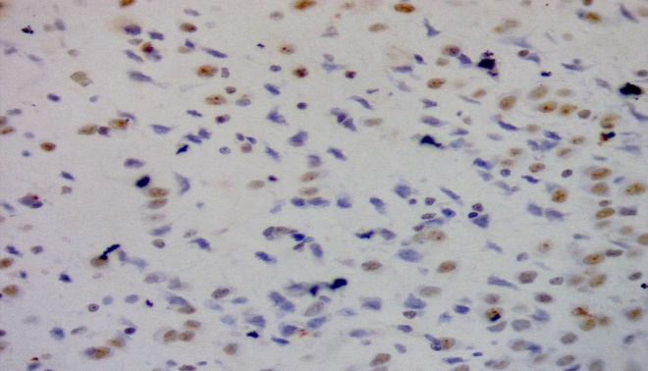  1mg/kg Rohypnol + 100mg/kg vitamin C  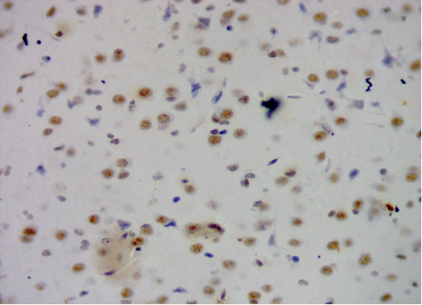  1mg/kg Rohypnol + 100mg/kg vitamin C and E  Fig 4: Amygdala B-Cell Lymphoma 2 (Bcl-2) Expression. | 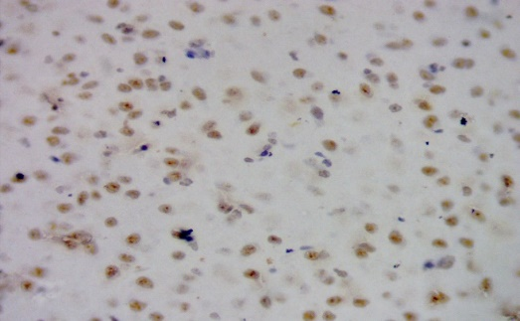  1mg/kg Rohypnol + 100mg/kg vitamin E

Amygdala Myelin Basic Protein (MBP) Expression
Fig 5 shows the Control Group shows an increase in the expression of myelin basic protein (MBP), 1mg/kg Rohypnol Group shows a decrease in the expression of myelin basic protein (MBP), 1mg/kg Rohypnol + 100mg/kg vitamin C Group shows an inverse increase in the expression of myelin basic protein (MBP), 1mg/kg Rohypnol + 100mg/kg vitamin E Group shows an inverse increase in the expression of myelin basic protein (MBP), 1mg/kg Rohypnol + 100mg/kg vitamin C and E Group shows an inverse increase in the expression of myelin basic protein (MBP) on the amygdala region of the brain

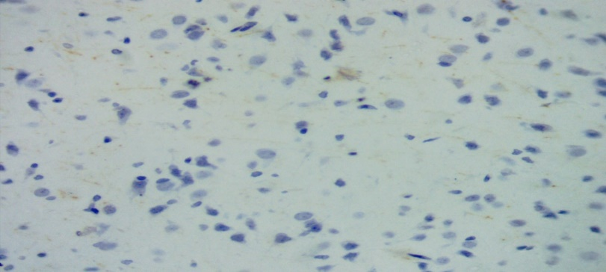  Control  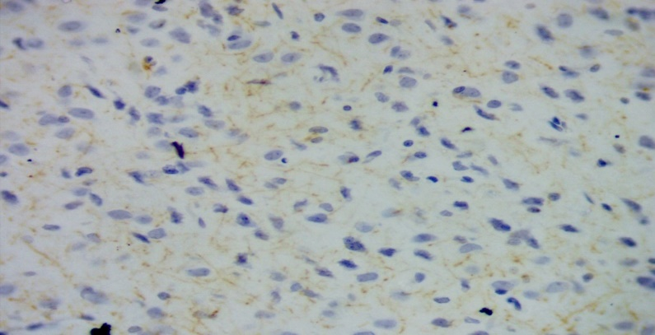  1mg/kg Rohypnol + 100mg/kg vitamin C | 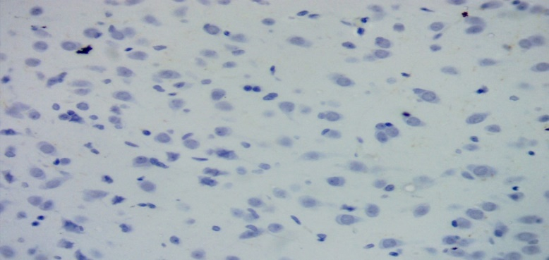 1mg/kg Rohypnol  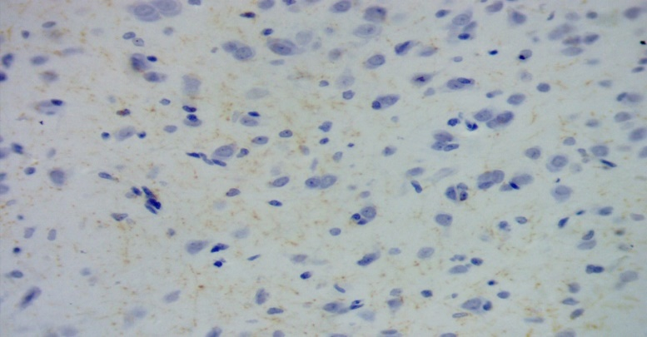 1mg/kg Rohypnol + 100mg/kg vitamin E
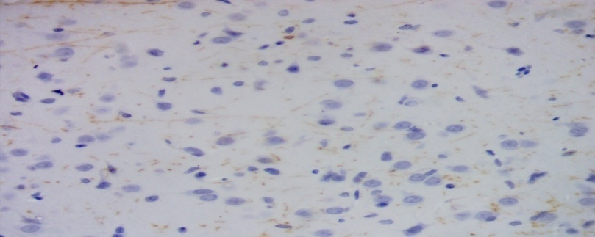
1mg/kg Rohypnol + 100mg/kg vitamin C and E
Fig 5 : Amygdala Myelin Basic Protein (MBP) Expression
Amygdala Oligodendrocyte Transcription Factor 2 (Olig2) Expression
Fig 6 shows the Control Group shows an increase in the expression of oligodendrocyte transcription factor 2 (olig2) , 1mg/kg Rohypnol Group shows a decrease in the expression of oligodendrocyte transcription factor 2 (olig2), 1mg/kg Rohypnol + 100mg/kg vitamin C Group shows an inverse increase in the expression of oligodendrocyte transcription factor 2 (olig2) , 1mg/kg Rohypnol + 100mg/kg vitamin E Group shows an inverse increase in the expression of oligodendrocyte transcription factor 2 (olig2), 1mg/kg Rohypnol + 100mg/kg vitamin C and E

Group shows an inverse increase in the expression of oligodendrocyte transcription factor 2 (olig2)
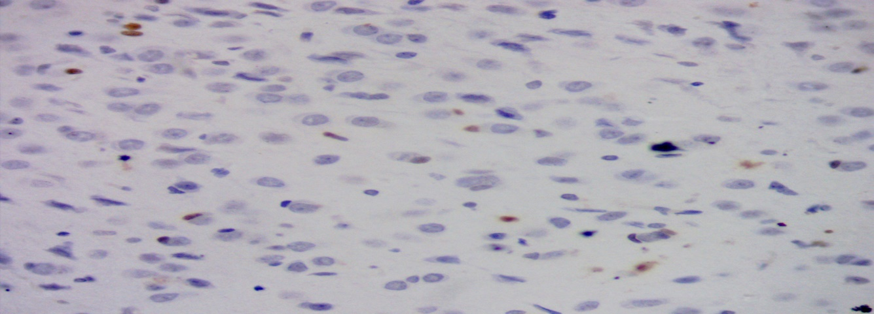 Control | 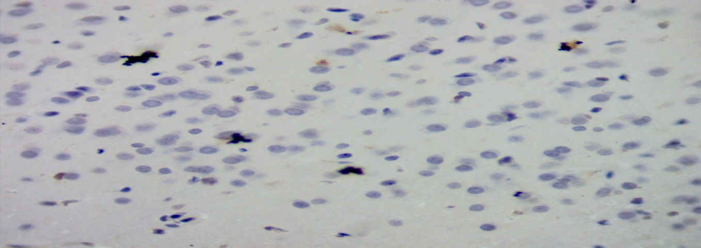 1mg/kg Rohypnol
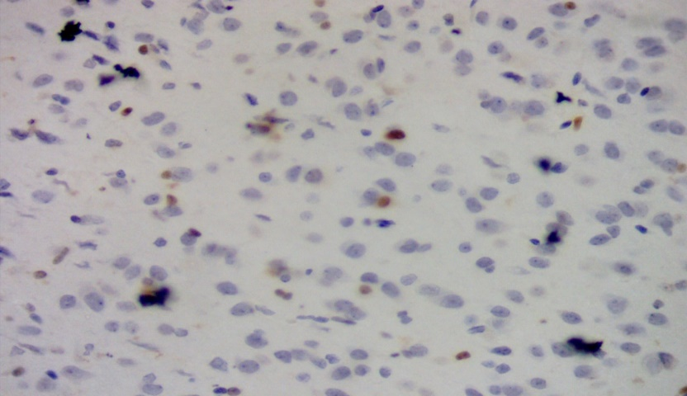 1mg/kg Rohypnol + 100mg/kg vitamin C  .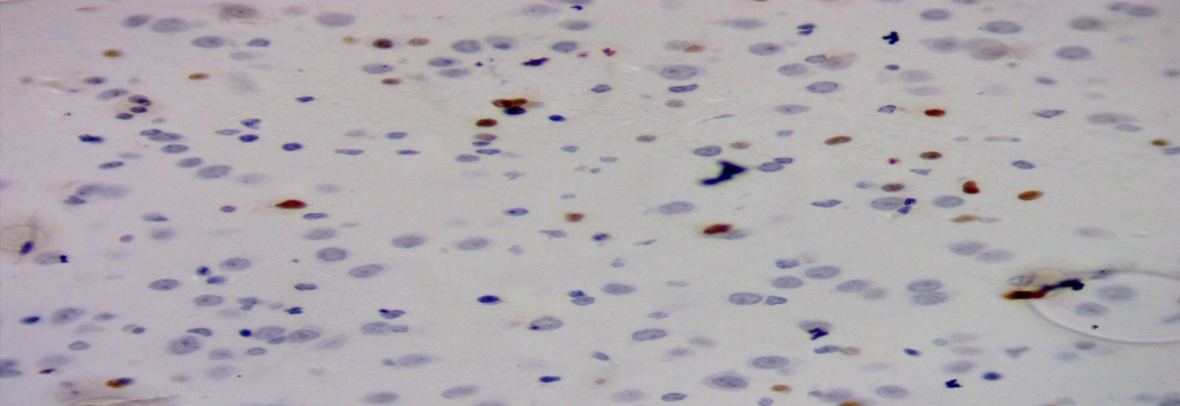 | 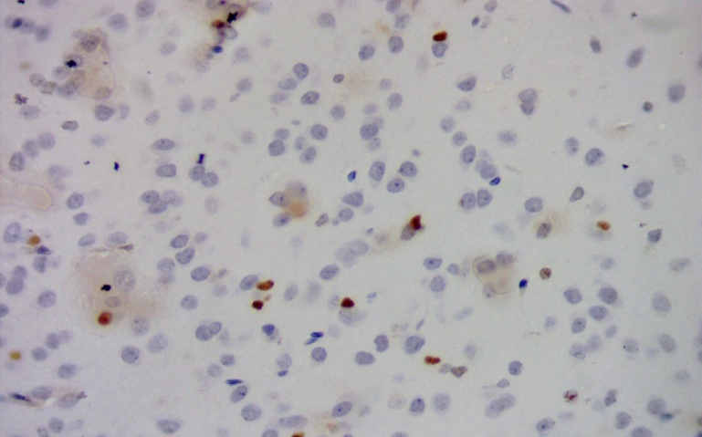 1mg/kg Rohypnol + 100mg/kg vitamin E Group  1mg/kg Rohypnol + 100mg/kg vitamin C and E

Fig 6: Amygdala Oligodendrocyte Transcription Factor 2 (Olig2) Expression

Discussion
Rohypnol is a central nervous system depressant in a class of drugs called benzodiazepines. Rohypnol was discovered at Roche as part of the benzodiazepine work led by Leo Sternbach ; the patent application was filed in 1962 and it was first marketed in 1974 (Erika et al., 2006).
It has been reported that vitamin C ameliorates organophosphate pesticide-induced hematological and bio- chemical alterations in humans and animals (Ambali et al., 2007, 2011b; Aly et al., 2010; Karmmon et al., 2011). This readily available, cheap and relatively non-toxic antioxidant possesses great benefit in the amelioration of toxic effects by most xenobiotics (Uchendu et al., 2012). Vitamin E is known to have been proven beneficial in some disease processes. It protects the body’s biological systems (Packer, 1991) by preventing lipid peroxidation (Evstigneeva et al., 1998).
Findings obtained from this experiment showed a non-significant decrease in the TNFɑ test in Groups C, D and E when compared to Group B that shows a significant increase. In the Bcl-2 test, there was a non-significant increase in Groups C and D, except Group E that showed significance increase, when compared to Group B that showed non-significant decrease. In the MBP-test, there was a non-significant increase in Groups C, D and E when compared to Group B that showed non-significant decrease. In the Olig2-test, there was a non-significant increase in Group C, D and E when compared to Group B that showed a non-significant decrease. This work is similar to the work of Osarobo et al., 2018 that reported Effects of Alcohol and Rohypnol Combination on the Liver Function of Adult Albino Rats showed that alcohol and rohypnol consumption caused significant increase in liver indicators as compared with control with an increase in weight by 1kg
Histological findings of amygdala tumor necrosis factor alpha (tnfɑ) expression for Group A showed an increase in the expression of tumor necrosis factor alpha (TNFɑ) on the amygdala region of the brain. For Group B shows a decrease in the expression of tumor necrosis factor alpha (TNFɑ) on the amygdala region of the brain. For Group C shows an increase in the expression of tumor necrosis factor alpha (TNFɑ) on the amygdala region of the brain.
Group D shows an increase in the expression of tumor necrosis factor alpha (TNFɑ) on the amygdala region of the brain. Group E shows an increase in the expression of tumor necrosis factor alpha (TNFɑ) on the amygdala region of the brain.
Histological findings of amygdala b-cell lymphoma 2 (bcl-2) expression for Group A shows an increase in the expression of b-cell lymphoma 2 (BCL-2) on the amygdala region of the brain. Group B shows a decrease in the expression of b-cell lymphoma 2 (BCL-2) on the amygdala region of the brain. Group C shows an inverse increase in the expression of b-cell lymphoma 2 (BCL-2) on the amygdala region of the brain. Group D shows an inverse increase in the expression of b-cell lymphoma 2 (BCL-2) on the amygdala region of the brain. For Group E shows an inverse increase in the expression of b-cell lymphoma 2 (BCL-2) on the amygdala region of the brain.
Histological findings of amygdale myelin basic protein (mbp) expression, Group A shows an increase in the expression of myelin basic protein (MBP) on the amygdala region of the brain. Group B shows a decrease in the expression of myelin basic protein (MBP) on the amygdala region of the brain.
Group C shows an inverse increase in the expression of myelin basic protein (MBP) on the amygdala region of the brain. Group D shows an inverse increase in the expression of myelin basic protein (MBP) on the amygdala region of the brain. Group E shows an inverse increase in the expression of myelin basic protein (MBP) on the amygdala region of the brain.
Histological findings of amygdala oligodendrocyte transcription factor 2 (olig2) expression Group A shows an increase in the expression of oligodendrocyte transcription factor 2 (olig2) on the amygdala region of the brain. Group B shows a decrease in the expression of oligodendrocyte transcription factor 2 (olig2) on the amygdala region of the brain. Group C shows an inverse increase in the expression of oligodendrocyte transcription factor 2 (olig2) on the amygdala region of the brain. Group D shows an inverse increase in the expression of oligodendrocyte transcription factor 2 (olig2) on the amygdala region of the brain. Group E shows an inverse increase in the expression of oligodendrocyte transcription factor 2 (olig2) on the amygdala region of the brain.
Conclusion
This study have shown that good antioxidants such as vitamin C and E are very much effective in reducing oxidative stress and thus, have great antioxidant ameliorative properties to the Rophynol induced substantia nigra of the wistar rats

COMPETING INTERESTS DISCLAIMER:

Authors have declared that they have no known competing financial interests OR non-financial interests OR personal relationships that could have appeared to influence the work reported in this paper.
References
Oluwole DT, Akhigbe RE, Ajayi AF. Rohypnol-induced sexual dysfunction is via suppression of hypothalamic-pituitary-testicular axis: an experimental study in rats. Andrologia. 2020;2020:e13931.
[Google Scholar]
Brett J., Murnion B. Management of benzodiazepine misuse and dependence. Aust. Prescr. 2015;38:152–155. Doi: 10.18773/austprescr.2015.055. [PMC free article] [PubMed] [CrossRef] [Google Scholar]
L. M. Hesse, K. Venkatakrishnan, L. L. Von Moltke, R. I. Shader, D. J. Greenblatt. CYP3A4 is the major CYP isoform mediating the in vitro hydroxylation and demethylation of flunitrazepam. Drug Metabolism & Disposition, Vol.29, No.2, 133–40, 2001
Nicholson A.A, Rabellino D, Densmore M, Frewen PA, Paret C, Kluetsch R, Schmahl C, Théberge J, Neufeld RW, McKinnon MC, Reiss J, Jetly R, Lanius RA. The neurobiology of emotion regulation in posttraumatic stress disorder: Amygdala downregulation via real-time fMRI neurofeedback. Hum Brain Mapp. 2017 Jan;38(1):541-560. [PMC free article] [PubMed]
Rajmohan V, Mohandas E. The limbic system. Indian J Psychiatry. 2007 Apr 49 (2):132-9.
Sen, C.K.; Khanna, S.; Roy, S. Tocotrienols: Vitamin E beyond tocopherols. Life Sci. 2006, 27, 2088–2098
Wick JY. The history of benzodiazepines. Consult Pharm. 2013; 28 (9):538–548.
[PubMed],
Goodman, Y.; Mattson, M.P. Secreted forms of β-amyloid precursor protein protect hippocampal neurons against amyloid β-peptide-induced oxidative injury. Exp. Neurol. 1994, 128, 1–12. [
Joanna Kocot, Dorota Luchowska-Kocot, Małgorzata Kiełczykowska, Irena Musik andJacek Kurzepa (2017) Does Vitamin C Influence Neurodegenerative Diseases and Psychiatric Disorders? Journals Nutrients Volume 9 Issue 7 10.3390/nu9070659.
Takahashi, T.; Nakaso, K.; Horikoshi, Y.; Hanaki, T.; Yamakawa, M.; Nakasone, M.; Kitagawa, Y.; Koike, T.; Matsura, T. Rice Bran Dietary Supplementation Improves Neurological Symptoms and Loss of Purkinje Cells in Vitamin E-Deficient Mice. Yonago Acta Med. 2016, 59, 188–195. [Google Scholar] [PubMed]
Gray JA (1982) The neuropsychology of anxiety. Oxford University Press, New York.
Wise CD, Berger BD, Stein L (1972) Benzodiazepines: Anxiety- reducing activity by reduction of serotonin turnover in the brain. Science 117: 18(~183
Soubrie P (1986) Reconciling the role of central serotonin neurons in human and animal behavior. Behav Brain Sci 9:319-364
Scheel-Kruger J, Petersen EN (1982) Anticonflict effect of the ben- zodiazepines mediated by a GABAergic mechanism in the amygdala. Eur J Pharmacol 82 : 115-116
Costall B, Kelly ME, Naylor RJ, Onaivi ES, Tyers MB (1989) Neuroanatomical sites of action of 5-HT3 receptor agonist and antagonist for alteration of aversive behavior in the mouse. Br J Pharmacol 96: 325-332
Maria Ester La Torre, Ines Villano ,Marcellino Monda, Antonietta Messina ,Giuseppe Cibelli ,Anna Valenzano , Daniela Pisanelli, Maria Antonietta Panaro, Nicola Tartaglia, Antonio Ambrosi , Marco Carotenuto 5ORCID,Vincenzo Monda, ,Giovanni Messina, andChiara Porro, 2017) Role of Vitamin E and the Orexin System in Neuroprotection, Brain Sci. 2021,Vol. 11(8), 1098; https://doi.org/10.3390/brainsci11081098
Erika, A. and Janos, F. Table of Selected Analogue Classes. Part III of Analogue-based Drug Discovery EdsJanosFischer, C. Robin Ganellin. John Wiley & Sons. . (2006), Pg. 537.

