### Original Research Article

### COMPARISION OF IMMEDIATE EFFECT OF TRIGGER POINT PRESSURE RELEASE VERSUS INSTRUMENT ASSISTED SOFT TISSUE MOBILIZATION ON GASTROCNEMIUS SOLEUS ON ANKLE MOBILITY AND PAIN IN RUNNERS WITH PLANTAR FASCIITIS

### 

**ABSTRACT**

* **Background and Objectives**: Instrument assisted soft tissue mobilization and Myofascial trigger point pressure release are found to be effective in treatment of plantar fasciitis. However which technique is more effective in improving ankle dorsiflexion range of motion and pain is unknown. The purpose of this study was to compare both the techniques and find out which one works better and give immediate effect on Pain and restricted ROM in runners with plantar fasciitis.
* **Methods:** 30 runners having plantar fasciitis were randomly allocated in two groups (A & B). Group A received Myofascial trigger point pressure release and Group B received Instrument assisted soft tissue mobilization Technique. The outcome measure such as Range of motion of ankle dorsiflexion and NPRS (Numerical pain rating scale) for pain was taken pre and post intervention in both groups.
* **Results:** The results of the study suggested that The ankle dorsiflexion ROM was significantly increased but reduction of pain (NPRS) was not significant in group-A. The ankle dorsiflexion ROM was significantly increased and pain (NPRS) was significantly reduced in group-B. But, while compared the post-test outcomes in between the groups the reduction of pain and ankle dorsiflexion ROM in group-B was better than group-A.
* **Interpretation and Conclusion**: The present study concludes that both treatment protocols were effective in improving ROM whereas IASTM was found more effective in improving pain as well as ROM as compared to Myofascial trigger point pressure release.

**Key words**: Plantar fasciitis, Instrument assisted soft tissue mobilization, Heel pain, Myofascial trigger point pressure release, Ankle dorsiflexion range of motion

INTRODUCTION

Heel pain is the broad term used to describe pain and discomfort which is experienced anywhere in and around the rear part of the foot. There are many causes of heel pain out of which biomechanical cause is the major one. Apart from bio mechanic causes, other causes are injury related, arthritic, infectious, neurologic, auto immune and other systemic causes. Most commonly known conditions are plantar fasciitis, Achilles Tendinopathy, Retro calcaneal bursitis and calcaneal spur.1 The normal biomechanics of foot and ankle has two parts: static and dynamic. The static includes bones, joint surface congruity, ligaments and fascia. The dynamic includes muscle function and arthrokinematicsof tarsal bones. The static mechanism which takes care for force attenuation within the foot comprises of windlass effect of plantar aponeurosis, the tensile strength of plantar ligaments, the beam effect of metatarsals and the joint congruity of tarsal and metatarsal bones.2The plantar fascia prevents the collapse of foot through its anatomical orientation and tensile strength.

The plantar aponeurosis extends from base of calcaneus proximally to phalanx distally. The tension generated by plantar fascia maintains the proximal longitudinal arch.3,4,5 The phases of gait cycle describes by Donatelli6 during stance are: heel contact, weight acceptance, mid stance, push off and propulsion and toe off. The gait cycle begins with the foot in a supinated position at heel strike. The subtalar joint then immediately pronates when going from heel strike to weight acceptance. This period of pronation results in the increased foot mobility needed to absorb ground reaction forces and adapt to uneven terrain.6The foot reaches maximum pronation at the end of the weight-acceptance phase, and the subtalar joint supinates the foot from midstance through toe-off. This supination movement transforms the foot into the rigid lever arm needed for propulsion.7 Plantar fasciitis is defined as an inflammatory condition of the plantar fascia at its insertion on the medial calcaneal tubercle which occurs as a result of overstress on plantar fascia. So it falls under the category of overuse injuries.8

Plantar fasciitis Is experienced and elite athletes in different sports.9 Plantar fasciitis accounts for nearly 10% of running injuries, but is also seen in the general population.10 The middle age people of 40 to 60 are more prone to plantar fasciitis11 Simons et al have stated that taut bands Myofascial/muscle trigger points (TrPs) in the gastrocnemius muscles may be involved in the development of plantar heel pain. TrPs are defined as hyperirritable areas associated within a taut band of a skeletal muscle that are painful on compression, contraction, or stretching of the muscles, and elicit a referred pain distant to the TrP.11 Active trigger points are those local and referred points which reproduce the pain reported by patient. It has also been found that thickness of taut band is more compared to surrounding muscle fibres which contributes to reduced muscle extensibility and restricts joint motion.12

Treatment strategies of Myofascial trigger points are hyper irritable areas within the taut band of skeletal muscle and fascia. They can be active or latent. Active MTrPs are painful at rest and during muscle contraction. Latent MTrPs gives pain when they are activated by direct pressure. The pain produced by MTrPs is local or referred. The term used to define the pain produced by MTrPs is Myofascial pain syndrome. They are very common cause of pain and dysfunction. The MTrPs are said to be associated with restricted ROM13. IASTM is an advanced technique used for soft tissue mobilization. The devices used are specially designed stainless steel tools with bevelled edges. The devises are contoured with concave and convex edges to target different body parts. Specific techniques are used to detect adhesions, fascial restrictions, scar tissues by using multi-dimensional strokes applied at an angle of 30-60 degrees. IASTM delivers controlled micro trauma to the area targeted. This result in local inflammation followed by initiation of healing. Thus it is used to treat variety of conditions.14 MTrP pressure release technique is based on barrier release concept. It was proposed by Travell and Simons. The pressure is ischaemic compression applied with thumb. When it is applied downward on trigger point it tends to lengthen the sarcomere and ultimately reduce muscle tension and increase joint range of motion.28 MTrP release causes reactive hyperaemia in trigger point. Direct pressure on sarcomere causes relaxation on involved muscle.15

METHODOLOGY

The subjects were randomly allocated into two groups of 15 each. Thirty pieces of paper were used. Out of thirty, on fifteen papers alphabet A was written and on rest fifteen alphabet B was written to identify the subjects falling into respective group. All thirty papers were folded and placed in a box. After shaking the box each subject was asked to withdraw a paper 15 subjects with letter A were enlisted under Group-A and were treated with MTrP pressure release technique and other 15 subjects with letter B were enlisted in Group-B and were treated with IASTM.

As the study includes human subjects’ ethical clearance is obtained from ethical committee of K.T.G. college of physiotherapy and K.T.G Hospital, Bangalore as per ethical guidelines for bio-medical research on human subjects, 2000 ICMR, New Delhi. All subjects fulfilling the inclusion criteria will be informed about the study and a written consent will be taken. All subjects fulfilling the inclusion criteria were informed and explained about the study. Once the subject agrees to participate in the study, an informed written consent (Annexure-1) was taken from the subjects.

#### Group-A: Trigger point pressure Release Technique

Subjects were screened and selected based on inclusion criteria i.e runners with heel pain. Subjects were later examined for presence of MTrP.

TrP diagnosis was done based on the following guidelines:

1. Presence of palpable taut band
2. Presence of hypersensitive area in the taut band
3. Local twitch response provoked by the snapping palpation of the taut band (4) reproduction of referred pain in response to compression.

The subjects were then explained about the procedure of entire study to the best of their understanding and informed written consent was taken.

After that initial Dorsiflexion Range of Motion of ankle and NPRS was taken and noted.

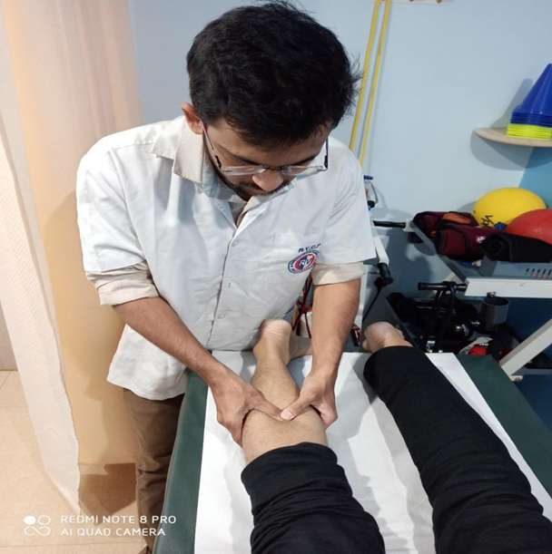

Figure: 1 Myofascial trigger point pressure release on gastrocnemius-soleus

#### Group-B IASTM:

The patient was treated with IASTM using Edge Mobility tool applied at gastrocnemius-soleus muscle with patient’s knee and ankle placed in relaxed position. The bevelled side of the tool was contacting the skin. The tool was held at 45 degrees to the patient’s skin. Sweeping strokes were applied parallel to the muscle fibre for 20 seconds and perpendicular for 20 seconds. The strokes were applied from proximal to distal and vice versa. Total duration is 4 minutes or as tolerated by the patient.16,17

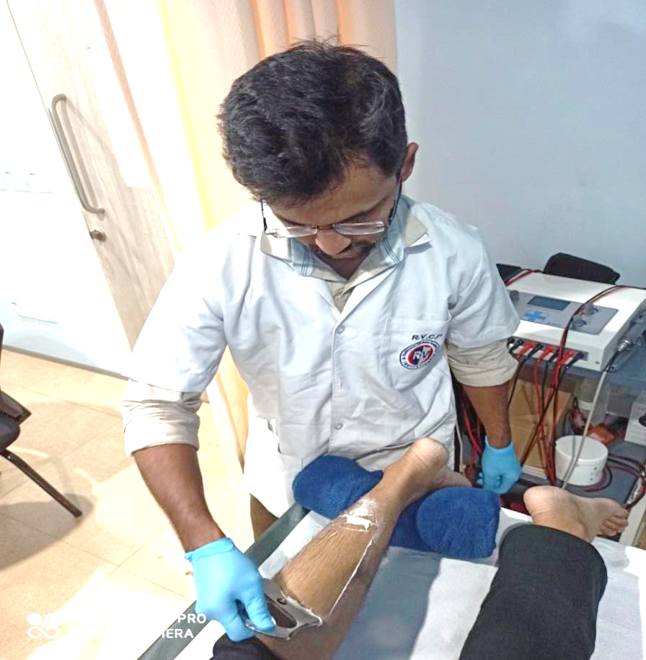 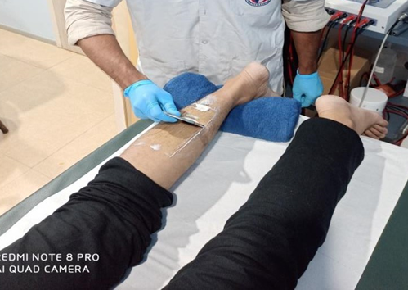

Figure:2 Instrument assisted soft tissue mobilization of calf

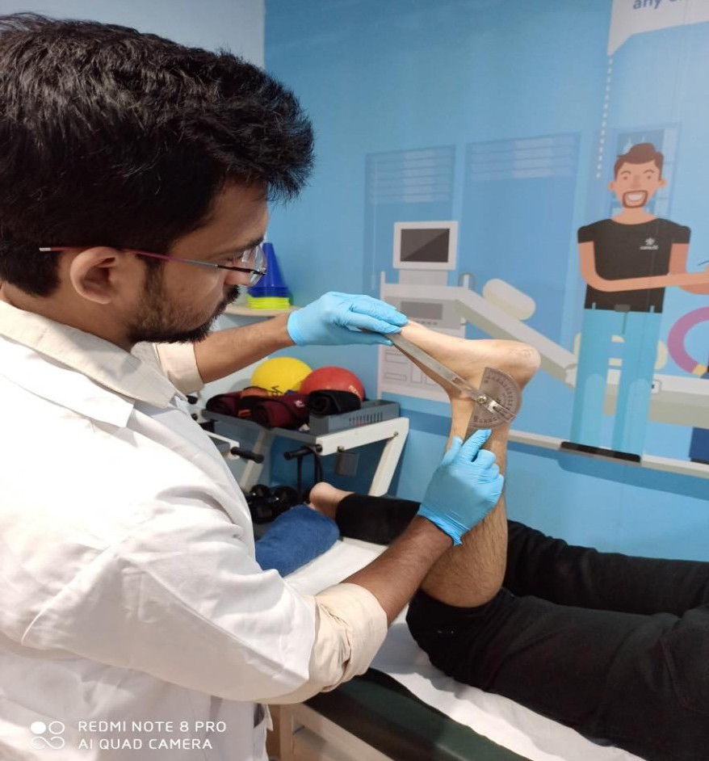

Figure:3 Measurement of ankle dorsiflexion ROM as an outcome measure

### OUTCOME MEASURES:

* NPRS
* ANKLE ROM

**FLOW CHART-1**

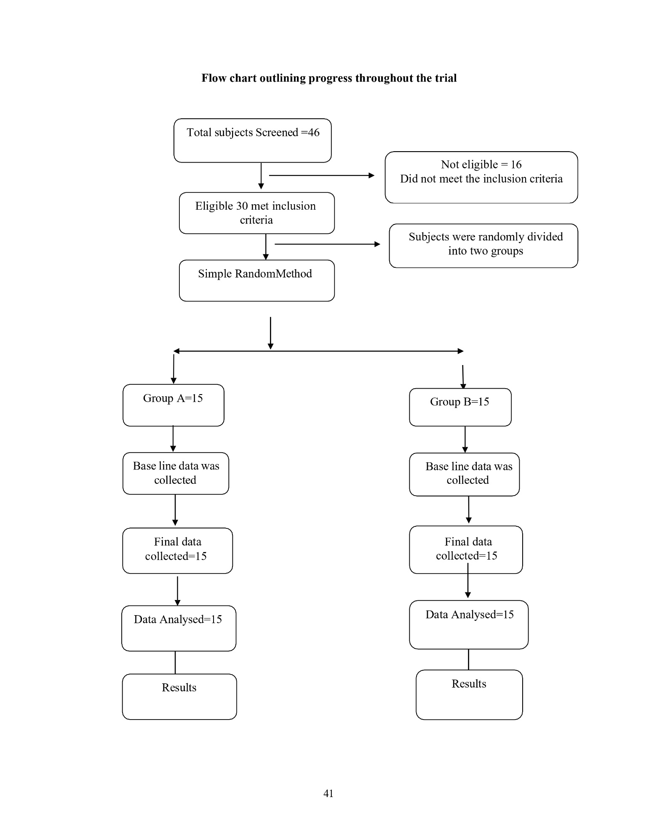

RESULT

Table-1: Range, mean and SD of age of the runners with planter fasciitis in both the groups.

|  |  |  |  |  |  |  |
| --- | --- | --- | --- | --- | --- | --- |
| **Sno** | **Variable** | **Group-A** | | **Group-B** | | **Unpaired t-test** |
| **Range** | **Mean ± SD** | **Range** | **Mean ± SD** |
| 1 | **Age in years** | 20-45 | 30.37±7.49 | 21-36 | 27.80±4.29 | t=1.282, p>0.05, NS |

NS-Not significant.ie.,p>0.05.

The table 2 presents the outcomes of age in years of the runners with plantar fasciitis in both the groups. In group-A, the subjects were ranging within the age of 20-45 with mean and SD of 30.37±7.49. In group-B,, the subjects were ranging within the age of 21-36 with mean and SD of 27.80±4.29.The unpaired t-test was carried to compare the means, which was found to be not significant at 5% level (ie., p>0.05). It revealed that the baseline characteristic of age was similar in both the groups.

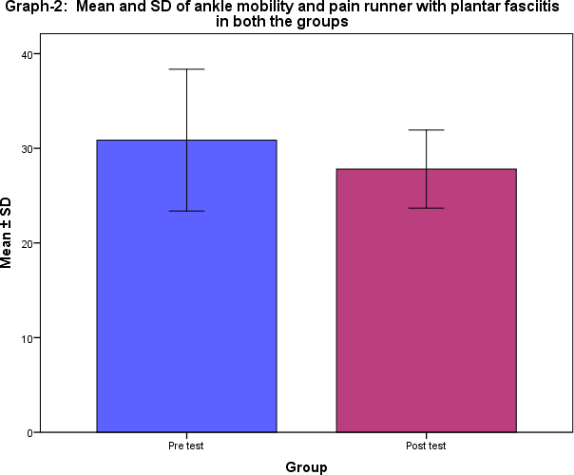graph 1-Mean and SD of ankle mobility and pain runner with plantar fasciitis in both the groups

Table-2: Range, mean and SD of outcome measures of runners with planter fasciitis in group-A.

|  |  |  |  |  |  |  |  |
| --- | --- | --- | --- | --- | --- | --- | --- |
| **Sno** | **Outcome measures** | **Group-A** | | | | Wilcoxon test/ t-test | **p-value** |
| **Pre test** | | **Post test** | |
| **Range** | **Mean ±SD** | **Range** | **Mean ±SD** |
| 1 | **NPRS** | 2-7 | 4.67±1.39 | 1-7 | 4.13 ± 1.64 | z=1.780NS | p>0.05 |
| 2 | **Ankle Dorsiflexion**  **ROM** | 17-26 | 20.93 ±2.84 | 20-27 | 23.60  ±2.09 | t=4.934* | p<0.001 |

Note; * denotes –Significant, NS-Not significant, z- Wilcoxon test., t-test.

The above table-3 shows the pre and post-test outcomes of NPRS and Ankle dorsiflexion among the runners with planter fasciitis in group-A. In pre-test, the NPRS was ranging within 2-7 with mean and SD of 4.67±1.39.. But in post-test, it was found to be decreased to the range 1-7 with mean and SD of. 4.13 ± 1.64. The non-parametric test for comparison of dependent outcomes, when the scores were ordinal, the Wilcoxon test was carried out and it was found to be significant ( p<0.001).

Regarding Ankle dorsiflexion ROM in pre-test, the scores were ranging within 177-26 with mean and SD of 20.93 ±2.84. But in post-test, the scores were found to be increased and it was ranging within 20-27 with mean and SD of 23.60 ±2.09. .Since, ankle dorsiflexion ROM are the measurable outcomes, the paired t-test was carried out to assess the statistical significance between pre and post-test sores and it was found to be significant (p<0.001).

It evidence the there is a no significant reduction in pain (NPRS) but significant increase in ankle dorsiflexion ROM among runners with planter fasciitis in group-A.

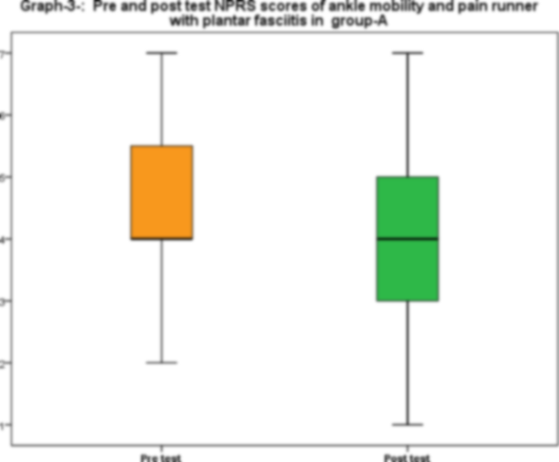 Graph 2-Pre and post test scores of ankle mobility and pain runner with plantar facilities in group A

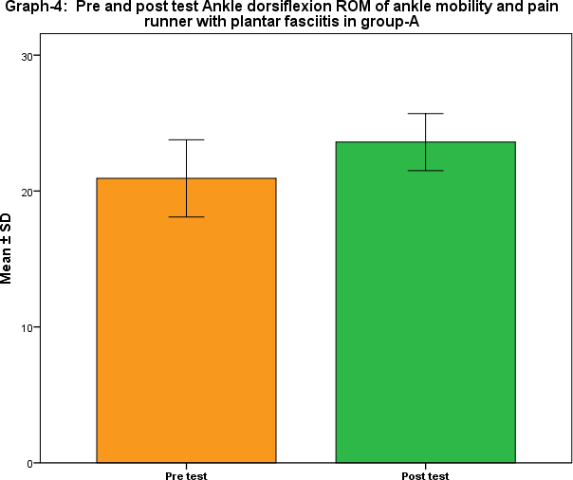

Graph 3- pre and post ankle dorsiflexion ROM of ankle mobility and pain runner with plantar facilities in group A

Table-3: Range, mean and SD of outcome measures of runners with planter fasciitis in group-B

| **Sno** | **Outcome measures** | **Group-B** | | | | Wilcoxon test/ t-test | **p-value** |
| --- | --- | --- | --- | --- | --- | --- | --- |
| **Pre test** | | **Post test** | |
| **Range** | **Mean ±SD** | **Range** | **Mean ±SD** |
| 1 | **NPRS** | 2-8 | 4.73±1.55 | 1-7 | 3.27 ± 1.62 | z=3.256* | p<0.001 |
| 2 | **Ankle**  **Dorsiflexion ROM** | 18-25 | 21.93±2.05 | 22-28 | 25.73 ±1.53 | t=7.466* | p<0.001 |

Note; * denotes –Significant, NS-Not significant, z- Wilcoxon test., t-test.

The above table-3 shows the pre and post-test outcomes of NPRS and Ankle dorsiflexion ROM among the runners with planter fasciitis in group-B.. In pre-test, the NPRS was ranging within 2-8 with mean and SD of 4.73±1.55. But, inpost-test, it was found to be decreased to the range 1-7 with mean and SD of. 3.27± 1.62. The non-parametric test for comparison of dependent outcomes, when the scores were ordinal, the Wilcoxon test was carried out and it was found to be significant ( p<0.001).

Regarding Ankle dorsiflexion ROM in pre-test, the scores were ranging within 18-25 with mean and SD of 21.93±2.05.But in post-test, the scores were found to be increased and it was ranging within 22-28 with mean and SD of 25.73 ±1.53. .Since, ankle dorsiflexion ROM are the measurable outcomes, the paired t-test was carried out to assess the statistical significance between pre and post test sores and it was found to be significant (p<0.001).

It evidence that there is a significant reduction in pain (NPRS) and increase in ankle dorsiflexion ROM among runners with planter fasciitis in group-B

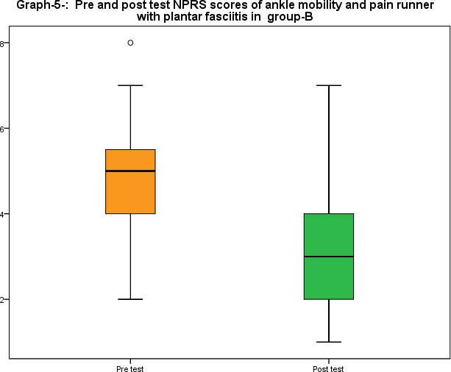

Graph 4- pre and post test NPRS scores of ankle mobility and pain runner with plantar facilities in group B

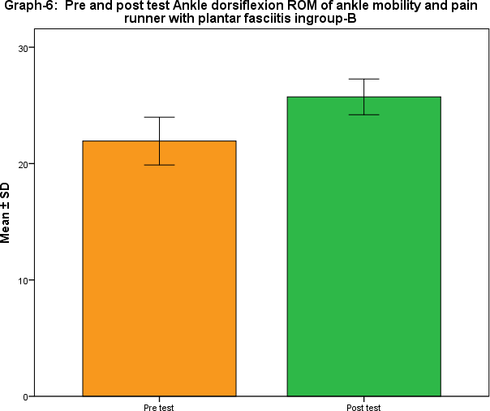Graph 5- pre and post test ankle of dorsiflexion of ankle and pain runner with plantar fasciitis in group B

Table-4: Comparison of pre and post test outcome measures of NPRS and ankle dorsiflexion ROM among runners with planter fasciitis in between the groups.

| **Sno** | **Outcome measures** | **Pre test** | | **Post test** | |
| --- | --- | --- | --- | --- | --- |
| **Group-A** | **Group-B** | **Group-A** | **Group-B** |
| **Mean ±SD** | **Mean ±SD** | **Mean ±SD** | **Mean ±SD** |
| 1 | **NPRS** | 4.67±1.39 | 4.73±1.55 | 4.13 ± 1.64 | 3.27 ± 1.62 |
| 2 | **Ankle**  **Dorsiflexion ROM** | 20.93 ±2.84 | 21.93±2.05 | 23.60 ±2.09 | 25.73 ±1.53 |
| **Between group comparisons:**  **Mann- Whitney U test/ t-test** | | * NPRS: z=0.892, p>0.05, NS * ROM: z=0.681, p>0.05, NS | | * NPRS: z=2.530, p<0.05, S * ROM : t=3.412 p<0.05, S | |

S-denotes significant (p<0.05); NS – not significant (p>0.05).

The above table-5 presents the outcomes of between group comparison of pre and post-test among runners with plantar fasciitis The pre-test scores of NPRS was 4.67±1.39 in group-A and

4.73±1.55 in group-B which was more are less same and it not significant(p>0.05) . Similarly, the pre-test mean and SD of ankle dorsiflexion ROM was 20.93 ±2.84 in group-A and 21.93±2.05 in group B were not statistically significant (p>0.05). It evidenced that initially before the intervention runners with plantar fasciitis were similar in NPRS and ankle dorsiflexion ROM in both the groups.

But, while comparison of post test scores of NPRS the mean and SD was 4.13 ± 1.64, in group-A , which was comparably less than the post-test mean and SD of ODI 3.27 ± 1.62 in group-B. The non-parametric test for independent outcomes when the scores were ordinal, Mann-Whitney U test was worked out and it was found to be statistically significant(i.e. p<0.05). Similarly, post test scores of ankle dorsiflexion ROM the mean and SD was 23.60 ±2.09, in group-A, which was comparably less than the post-test mean and SD of ankle dorsiflexion ROM 25.73 ±1.53 in group-B. The parametric test for independent outcomes when the scores were measurable, the unpaired t-test was worked out and it was found to be statistically significant(i.e.,p<0.05).

Its evident that there was significant difference in performance of trigger point pressure release technique administered in group-A and soft tissue mobilization administered in group-B among runners with plantar fasciitis

**DISCUSSION**

Plantar fasciitis is an inflammatory degenerative condition of the plantar fascia at its insertion on the medial calcaneal tubercle which occurs as a result of overstress on plantar fascia. Pain and restricted ankle range of motion are among the many features of the condition. The aim of the present study was to compare the immediate effectiveness of Myofascial trigger point pressure release technique and Instrument assisted soft tissue mobilization on Pain and Restricted ankle joint dorsiflexion ROM. The outcome measures used were NPRS for pain measurement and goniometry to evaluate ankle DF ROM. In study 30 subjects were randomly recruited based on inclusion criteria and who has active MTrP in gastrocnemius-soleus complex. 30 subjects were selected and randomly assigned in two groups: group A (n=15) and group B(n=15).Group-A received MTrP pressure release whereas Group- B received Instrument assisted soft tissue mobilization. The results showed that There was more or less same proportion of subjects found according to gender and it was found to be statistically not significant (χ2=0.600, DF=1) at 5% level i.e., p>0.05. It evidenced the baseline characteristic of gender is homogeneous in both the groups.

In group-A, the subjects were ranging within the age of 20-45 with mean and SD of 30.37±7.49. In group-B,, the subjects were ranging within the age of 21-36 with mean and SD of 27.80±4.29.The unpaired t-test was carried to compare the means, which was found to be not significant at 5% level (i.e., p>0.05). It revealed that the baseline characteristic of age was similar in both the groups. Thus there was no significance difference in age and gender of both groups. Group-A received MTrP release where the results showed that there was no significant reduction in pain (NPRS) but significant increase in ankle dorsiflexion ROM. In pre-test, the NPRS was ranging within 2-7 with mean and SD of 4.67±1.39. But in post-test, it was found to be decreased to the range 1-7 with mean and SD of. 4.13 ± 1.64. Regarding Ankle dorsiflexion ROM in pre-test, the scores were ranging within 17-26 with mean and SD of 20.93 ±2.84.But in post-test, the scores were found to be increased and it was ranging within 20-27 with mean and SD of 23.60 ±2.09

A previous study have recommended that taut band or muscle trigger point referred as MTrP in the calf leads to increased stiffness and decreased dorsiflexion ROM at ankle which is one of the major risk factor for plantar fasciitis. Previous studies and literature shows conflicting evidences for the physiotherapy management of plantar fasciitis. The most commonly used treatment such as stretching has mode evidence of effectiveness. Thus this study helped to find the effectiveness of MTrPs release in plantar fasciitis. Also studies after 2005 has recommended to involve ROM as an outcome to measure the effectiveness of treatment modality addressing MTrP. In present study we can see that MTrP is found to be effective in improving significant ankle DF ROM. A study done in 2018 to compare the effectiveness of Muscle Energy Technique and Myofascial trigger point release in chronic plantar fasciitis suggested that MTrP release is more effective then Muscle Energy Technique in addressing pain and tenderness. Group-B received IASTM where it is evident that there is a significant reduction in pain (NPRS) and increase in ankle dorsiflexion ROM. In pre-test, the NPRS was ranging within 2-8 with mean and SD of 4.73±1.55. But, in post-test, it was found to be decreased to the range 1-7 with mean and SD of. 3.27± 1.62.Regarding Ankle dorsiflexion ROM in pre-test, the scores were ranging within 18-25 with mean and SD of 21.93±2.05.But in post-test, the scores were found to be increased and it was ranging within 22-28 with mean and SD of 25.73 ±1.53. Previously a study was done to compare the effect of CMR and Graston technique to improve ankle DF ROM. The result were more or less same with both the techniques. However there was more significant increase in ROM with CMR. Also they did not consider this for plantar fasciitis which is done in current study. Previously a study done by Justin Stanek to compare the effectiveness of compressive Myofascial release and Graston technique for improving Ankle Dorsiflexion ROM showed that compressive Myofascial release increased ankle ROM after a single treatment session. And suggested that CMR should be considered to address Dorsiflexion deficit It is believed that joint stiffness occurs due to increase in muscle stiffness. And thus reduction in joint stiffness is secondary to reduction in muscle stiffness. The results from present study suggest that IASTM as well as MTrP pressure release contributes to improvement of joint ROM. It has been found that stretching reduces neuromuscular activity and maximal voluntary force production. These negative effects after stretching are presumed to be due to changes in neural properties such as increased stretch tolerance, reduced neural drive and lowered stretch reflex sensitivity. Whereas IASTM improves joint ROM without altering stretch tolerance. The results of the study suggest that The ankle dorsiflexion ROM was significantly increased but reduction of pain (NPRS) was not significant with MTrP pressure release.. The ankle dorsiflexion ROM was significantly increased and pain (NPRS) was significantly reduced with IASTM.. But, while compared the post-test outcomes in between the groups the reduction of pain and ankle dorsiflexion ROM with IASTM was better MTrP pressure release.

LIMITATION OF STUDY

1. No follow up was done after the single session so maintenance of the improved outcome could not be assessed
2. A larger sample size would have strengthened the study findings.
3. Ultrasonic studies can be conducted to study the physiological changes occurring at cellular level.

### RECOMMENDATION FOR FUTURE RESEARCH

1. Further studies can be carried out in different population with plantar fasciitis.
2. In further studies follow up of sustained effects can be studied.
3. Current techniques can be combined with other proved treatment modalities and combined effect can be studied in future.

##### CONCLUSION

The current study concludes that IASTM and MTrP pressure release are found to be effective in treatment of plantar fasciitis in marathon runners. However IASTM is more effective in improving ROM as well as pain. Whereas MTrP pressure release has significant effect on improving ankle dorsiflexion ROM alone. So based on goal the technique should be selected accordingly as an evidence based treatment.

REFERENCES

1. Edward Kwame Agyekum, Kaiyu Ma. Heel pain: A systemic review, Chinese journal of traumatology ; 2015; 164-169
2. Jay Hertel. Functional Anatomy, Pathomechanics, and Pathophysiology of Lateral Ankle Instability, Journal of Atheletic Training;2002;37(4):364-375
3. Viel E, Esnault M. The effect of increased tension in the plantar fascia: a biomechanical analysis. PhysiotherPract. 1989;5:69–73.
4. Fuller EA. The windlass mechanism of the foot: a mechanical model to explain pathology. J Am Podiatr Med Assoc. 2000;90:35-46.
5. Sarrafian SK. Functional characteristics of the foot and plantar aponeurosis under tibiotalar loading. Foot Ankle. 1987; 8:4-18.
6. Karr SD. Subcalcaneal heel pain. OrthopClin North Am. 1994;25:161– 175.
7. Norkin CC, Levangie PK. Joint Structure and Function.A Comprehensive Analysis. 4th ed. Philadelphia, PA: FA Davis; 2001.
8. Joshua Dubin. Evidence Based Treatment for Plantar Fasciitis - Review of Literature.Sports Therapy. 2007 Mar; 1-8.
9. Orchard J. Plantar fasciitis. BMJ.2012;345:e6603.
10. Kent Stuber, KevynKristmanson: Conservative therapy for Plantar Fasciitis: a narrative review of randomized controlled trials.The Journal of Canadian Chiropractic Association. 2006; 50(2): 118-133.
11. Simon J. Bartold. Plantar Heel Pain Syndrome: Overview and Management. Journal of Bodywork and Movement Therapies.2004; 8(1):214-226.
12. Corey A. Peacock, Darren D. Krein, Jose Antonio, Gabriel J. Sanders, Tobin A. Silver, Megan Colas. 2015. Comparing Acute Bouts of Sagittal Plane Progression Foam Rolling vs. Frontal Plane Progression Foam Rolling. Journal of Strength and Conditioning Research 29:8, 2310- 2315.
13. Shane McClinton, Bryan Heiderscheit, Thomas G. McPoil, Timothy W. Flynn. 2018. Physical therapist decision-making in managing plantar heel pain: cases from a pragmatic randomized clinical trial. Physiotherapy Theory and Practice 9, 1-25.
14. Bibhuti Sarkar, Anupam Kumar Mangalam, Pallavi Sahay. Efficacy of muscle energy technique as compared to myofascial trigger point release in chronic plantar fasciitis: A double blind Randomized clinical trial.IJHSR; 2018(6)128-134.
15. Romulo Renan-Ordine, Joshua A Cleland et al. Effectiveness of Myofascial Trigger Point Manual Therapy Combined With a Self-Stretching Protocol for the Management of Plantar Heel Pain: A Randomizes Controlled Trial. JOSPT; 2011(41)43-50.
16. VinodBabu,Lisa Michael Pereira et al. Effectiveness of instrumental assisted soft tissue mobilization technique with static stretching in subjects with plantar fasciitis, ijpjy; 2014:vol(3) 101-111.
17. Joseph et al. short term effects of instrument assisted soft tissue mobilization on painfree range of motion in a weightlifter with subacromial pain syndrome. IJSPT; 2017 Feb; 12(1) 144-1