Original Research Article

Impact of the Hospital Environment on Serum Cortisol Levels in Healthcare Professionals

ABSTRACT

Aims: This study investigates cortisol levels in healthcare workers to understand the implications of excessive stress on professional performance and quality of work.
Study design: This is an observational, longitudinal, and analytical study with a quasi-experimental component. The relationship between the work environment and cortisol levels was assessed through questionnaires and blood sample collections conducted at two different time points.
Place and Duration of Study: The research was conducted with professionals from a Hospital Assistance Association located in a municipality in western Santa Catarina, between September and October 2024.
Methodology: Serum cortisol levels were analyzed and compared with the reference values established by the Brazilian Society of Endocrinology and Metabology. These results were correlated with responses to specific questionnaires designed to assess the participants’ psycho-emotional health conditions.
Results: The findings indicate high cortisol levels among healthcare professionals, suggesting significant concerns regarding their mental and physical health.
Conclusion: The data suggest that extensive working hours, exhaustion, and high turnover in hospital sectors contribute to the increased susceptibility of healthcare workers to emotional and physical stress.

Keywords: Working Conditions; Cortisol; Endocrinology; Physiological Stress; Occupational Stress; Health Level; Mental Health; Healthcare Worker.

1. INTRODUCTION

Recently, mental health has become an increasing concern due to the rise of disorders such as anxiety, depression, and stress, particularly among healthcare workers. Studies indicate that, after the first year of the COVID-19 pandemic, there was a 25% increase in mental health issues among these professionals (Lima, 2020). The work environment in the hospital sector exposes workers daily to various risks, in addition to adverse organizational conditions, such as high turnover and inadequate rewards (Leite et al., 2016).

It is also understood that prolonged stress can lead to physiological imbalances, such as elevated levels of serum cortisol, predisposing workers to chronic diseases, such as hypertension and type II diabetes (Silva, 2020). Cortisol, often referred to as the stress hormone, is produced by the adrenal glands and is a corticosteroid that can cause several effects on the body, including metabolic changes and influencing the immune response (Santana et al., 2017).

There are both extrinsic and intrinsic factors that trigger stress, notably including the mental and physical health of the worker, their coping skills, considering their values and beliefs, along with excessive workloads and labor and family conflicts (Di Dalmazi et al., 2015). In this context, this study analyzed the results from serum cortisol measurements, associating them with the signs and symptoms related to stress among healthcare workers. Additionally, it aimed to comprehend how elevated cortisol levels can impact patient safety.

2. material and methods

2.1 Area of Study

The research was conducted with professionals from the Santo Expedito Hospital Assistance Association (AHSC), located in Ponte Serrada, Santa Catarina. Fifty percent of the workers from each sector of the institution were included, covering areas such as nursing, pharmacy, medicine, nutrition, psychology, physiotherapy, and social assistance. It is important to note that we initiated the research after its submission and approval by the Ethics Committee for Research Involving Human Beings (CEP). Currently, this hospital serves urgent and emergency patients, with beds in medical clinics, psychiatric clinics, and a palliative care unit, totaling approximately 67 accommodations, classifying it as a medium-sized hospital. The service schedule consists of 12 hours of work followed by 36 hours off, with two day teams and two-night teams.

Initially, participants were informed about the terms of the research, potential risks, and benefits. After their acceptance and the signing of the Informed Consent Form (TCLE), the professionals responded to two questionnaires. These were based on the forms applied by Dalri (2020) and Rizzini (2015), aimed at collecting sociodemographic and health information from the participants, as well as assessing their perception of stress in the workplace. The questionnaires were adapted for the better development of the present research. Subsequently, after the completed form was submitted to the researcher, the participants underwent the first blood collection for serum cortisol level testing, which was conducted by a third-party laboratory. After 30 days, a second blood collection was performed on the same participants, correlating the first collection at the beginning of their shift, that is, at the start of their workday, with the second collection, which was conducted at the end of their work shift.

2.2 Inclusion and Exclusion Factors

For the inclusion criteria, participants were selected based on being over 18 years of age, having completed vocational training or higher education, being in regular employment conditions with the hospital where the research was conducted, and having accepted and signed the proposed informed consent terms.

Conversely, the exclusion criteria encompassed participants who were on vacation or had returned from vacation within the last 30 days, as well as those on medical leave, certified absence, or any form of leave. Additionally, workers from the administrative sector and general services, along with professionals undergoing cortisol replacement therapy, were also excluded from this study.

In this research, two participants were excluded due to medical leave and discharge from the hospital under study.

2.3 Sample Collection

Sample collection was conducted between 07:00 and 09:00 in the morning and between 17:00 and 19:00 in the evening. Participants were instructed to fast for a minimum of four hours prior to sample collection and to abstain from physical exercise on the day preceding the examination.

The biological samples were stored in pre-labeled tubes (without anticoagulants) and transported in a temperature-controlled container maintained at 2°C to 6°C until delivery to the laboratory.

2.4 Clinical Analysis and Interpretation of Results

The analysis of samples was performed using chemiluminescent immunoassay techniques. Serum cortisol levels were compared to reference values established by the Brazilian Society of Endocrinology and Metabolism, utilizing normal ranges for samples collected between 07:00 and 09:00 (or up to two hours after the habitual waking time) of 5 to 23 µg/dL, and for those collected between 16:00 and 18:00 of 3 to 16 µg/dL (Brazilian Society of Endocrinology and Metabolism, 2019). The collection and clinical procedures were performed by an outsourced laboratory.

2.5 Interview and Administration of the Perceived Stress Scale Questionnaire

A data collection form was utilized to gather sociodemographic variables from the participants, including personal information such as sex, age, marital status, and professional experience, as well as lifestyle factors, current medications, and medical history concerning chronic conditions.

The interviews were conducted using two self-administered questionnaires in a designated room within the hospital, ensuring individual privacy and without time constraints on the participants for questionnaire completion. Present during the interviews were one of the researchers and the hospital's clinical psychologist.

The Worker Stress Inventory was adapted and standardized for the Brazilian population, intended to quantify workplace stressors experienced by respondents and their frequency in the professional environment. The inventory was developed based on theoretical constructs wherein stress is perceived by individuals as a detrimental experience stemming from the inability to manage sources of occupational pressure and stress.

2.6 Data Analysis

Initially, the data obtained from questionnaire responses and serum cortisol assays were systematically compiled into Excel® spreadsheets. Subsequently, descriptive statistical analyses of frequencies and inferential statistical analyses for correlation were conducted using Past 4.17® software, and the results were visually represented through various types of graphs to enhance interpretability and presentation.

3. results and discussion

3.1 Descriptive Analysis: Personal and Professional Characteristics of Healthcare Workers

The data pertaining to specific objective 1, which aimed to characterize the personal and professional profiles of participants working in the healthcare sector, were analyzed according to the following variables: gender, marital status, age range, type of employment contract, duration of work experience in the healthcare field, area of activity, return from the most recent vacation, engagement in night and/or weekend shifts, number of employment links, and working hours. These data are presented in the tables and figures below.

Table 1 presents a description of the sociodemographic profile of the participants.

Table 1. Distribution of Healthcare Professionals at AHSE According to Sociodemographic Data and Employment Links During the Analysis Period

Demographic Variables | Simple Frequency | Percentage (%)
Sex  Female  Male  Age  18 to 29 years  30 to 40 years  41 to 50 years  51 to 60 years  Marital Status  Single  Married  Separated  Number of Job  1 job  2 or more jobs  Type of Employment Contract | 29  2  17  6  6  2  10  17  4  24  7 | 93,6  6,4  54,9  19,3  19,3  6,5  32,3  54,8  12,9  77,4  22,6
Nurse  Nursing Technician  Physican  Pharmacist  Pharmacy Assistant  Nutritionist  Psychologist  Physiotherapist  Social Worker | 10  10  2  2  1  1  2  1  2 | 32,3  32,3  6,5  6,5  3,2  3,2  6,5  3,2  6,5
Source: Authors, 2024.

A total of 31 healthcare professionals were surveyed, of which 29 (93.60%) are female. This demonstrates that women dominate the workforce in healthcare, which may also be linked to historical and social factors that associate the idea of care with the female figure. However, the work environment in healthcare, with long hours and constant pressure, contributes to an increase in mental health disorders, such as depression. The overload of professional and family responsibilities, combined with a lack of adequate support, exacerbates stress, making women more vulnerable. A cross-sectional study conducted after the COVID-19 pandemic with healthcare professionals in hospitals in regions of China found a large percentage of health workers experiencing symptoms of depression, anxiety, insomnia, and distress, with the author highlighting that the group most affected was female nurses (Lai, J. et al., 2020).

Regarding the number of employment links, the results showed that 24 participants (77.4%) have only one employment link, while 22.6% have two or more employment links (Table 1). Among the reasons justifying participation in the secondary labor market, a study by Atherton et al. (2016) suggests that financial pressures are the main incentive for taking a second job. However, we must also consider that having multiple jobs directly affects emotional and social well-being, impairing quality of life and mental health.

Table 2 presents characteristics of healthcare professionals related to variables such as night work, vacation return, weekend work, and length of time in the healthcare field.

Table 2. Distribution of Healthcare Professionals at AHSE During the Analysis Period According to Work Variables

Demographic Variables | Simple Frequency | Percentage (%)
Work Variable  Yes  No  Total  Return from Vacation  Yes  No  Total  Weekend Work  Yes  No  Total  Length of Time in Healthcare  0 to 5 years  6 to 15 years  16 to 25 years  26 to 30 years  Total  Number of Work Sectors | 11  20  31  0  31  31  23  8  31  16  10  3  2  31 | 32,5  64,5  100  0  100  100  74,2  25,8  100  51,6  32,3  9,7  6,4  100
1 sector  2 sectors  3 or more sectors  Total | 22  5  4  31 | 71  16,1  12,9  100
Source: Authors, 2024.

Regarding night work, 11 participants (35.5%) reported that they engage in nighttime activities, while 20 (64.5%) stated that they do not work night shifts (Table 2). A study on night workers found that those who worked night shifts experienced sleep disturbances, along with higher anxiety scores indicative of poorer mental health (Reynolds, Amy C. et al., 2022).

Concerning the weekly work hours of healthcare professionals, 28 (90.3%) individuals work over 40 hours per week, while 3 of these professionals (9.7%) work fewer than 39 hours per week. According to COFEN Resolution No. 543/2017, which establishes norms for the working hours of nursing professionals, the maximum weekly working hours for nurses, nursing technicians, and nursing assistants is 40 hours.

In relation to how many healthcare professionals are following these guidelines, we noted that only three individuals adhered to the standards set forth by the Federal Nursing Council as mentioned in the resolution. The other 28 individuals work beyond the specified hours, often holding one or more jobs.

Table 3 presents the characteristics of healthcare professionals concerning health issues and whether they utilized continuous or occasional medications during the study period, highlighting the drug classes used.

Table 3. Percent Distribution of Healthcare Professionals at AHSE During the Analysis Period According to Health Problems and Medications Used

Variables | Simple Frequency | Percentage (%)
Health problems  1 concern related to health issues  2 concerns related to health issues  No problems/concerns regarding health  Total  Medications Used  1 medication  2 medications  3 or more medications  Does not use any medications  Total  Medications Class  Angiotensin II receptor antagonist  Hypnotic  Antibiotic  Supplementation  Potassium-sparing diuretic  Anticonvulsant/ neuropathic analgesic  Antidepressant  Contraceptive hormones  Thyroid hormone  Total | 8  1  22  31  13  0  2  16  31  1  1  1  1  1  1  1  5  6  3  21 | 25,8  3,2  71  100  42  0  6,4  51,6  100  3,23  3,23  3,23  3,23  3,23  3,23  3,23  16,13  19,35  9,65  67,74
Source: Authors, 2024.

Analyzing the medications taken during the study period, one of the most relevant findings is that among all the participants, five of them use medications that fall into the class of antidepressants. According to Caixeta, Silva, and Abreu (2021), the main reasons for healthcare professionals to excessively use psychoactive substances are related to factors they experience, such as stress, irritability directly linked to the work environment and exhausting work schedules (Table 3).

3.2 Descriptive Analysis: Serum Cortisol Dosage Data

Figure 1 presents the distribution of blood cortisol concentrations in three categories: low, normal, and high. It can be observed that 10% of the population has a low cortisol concentration, while the majority, representing 71%, falls within the normal range. On the other hand, 19% of individuals exhibit high cortisol concentrations. These data suggest that, under normal conditions, most of the population maintains cortisol levels within the standard range, while a smaller percentage displays levels outside of this interval, whether low or high.

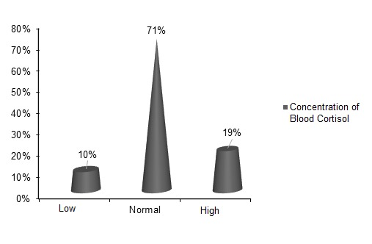

Fig. 1. Percentage distribution of blood cortisol concentrations from the first collection of health professionals at AHSE during the analysis period. Source: Authors, 2024.

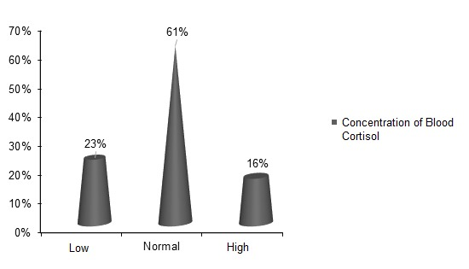

Fig. 2. Percentage distribution of blood cortisol concentrations from the second collection of healthcare professionals at AHSE during the analysis period. Source: Authors, 2024.

The image above (Figure 2) presents the data from the second collection of blood cortisol concentrations categorized into three levels: low, normal, and high. In this analysis, we observe that 23% of the population presents a low concentration of cortisol, while the majority, representing 61%, falls within the range considered normal. Conversely, 16% of individuals exhibit a high concentration of cortisol.
Thus, referencing a study conducted by Rosa (2016), which demonstrated that stress, anxiety, and depression are psychological stressors that significantly elevate cortisol levels. Over time, these issues have increasingly become prevalent in people's lives, particularly among healthcare professionals.
However, during the research, a greater number of professionals were found to have low cortisol levels, where these levels increased from 10% in the first collection to 23% in the second blood collection. According to Chabre et al. (2017), low cortisol levels can lead to cognitive problems, mental health issues, and behavioral complications. Studies indicate that patients with hypercortisolism report a lower quality of life compared to the general population, which can directly impact the physical and mental health of these individuals.
These changes may indicate variations in the hormonal profile of the studied population, possibly associated with factors such as fluctuations in environmental conditions, recent stress levels, or changes in daily habits between collections (Hirschle; Guedes-Gondim, 2020). The comparative analysis between the two collections provides a more detailed view of fluctuations in cortisol levels and aids in understanding how external and internal factors influence cortisol regulation in the body over time.

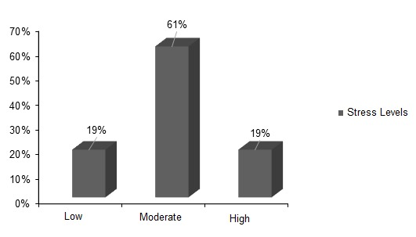

Fig. 3. Percentage distribution of concentrations concerning stress levels, related to the applied questionnaire: Stress Inventory, healthcare professionals from AHSE, during the analysis period. Source: Authors, 2024.

The stress inventory serves as a tool to identify and classify the impact of stressful situations in individuals' lives, allowing for an assessment of how stress can affect mental and physical health. The Stress Inventory (IE) is theoretically grounded in the definitions provided by Quick et al. (2003), where the author argues that stress is perceived by individuals as detrimental due to their inability to cope with sources of pressure in the work environment. Thus, occupational stress is understood through the identification of stressors experienced in the professional setting. The presence of a significant percentage of both low and high levels indicates the need for tailored interventions, where those with elevated levels may require stress management interventions, while those with low levels may be in less challenging situations or have developed effective coping mechanisms (Freitas; Mourão, 2020).

Occupational stress is not a recent phenomenon; since 1993, Holt has emphasized the relationship between the emergence of diseases linked to work-related stress, including the occurrence of gastric ulcers, hypertension, and depression, among others.
Figure 3 displays the stress levels of individuals classified into three categories: low, moderate, and high. It is observed that most participants, representing 61%, exhibit a moderate stress level, whereas 19% are categorized as low and high, respectively.

These results, when analyzed within the framework of a stress inventory, suggest that most of the population experiences a significant, yet not excessive, stress load, which may fall within normal limits for daily functioning. The distribution of stress levels reflects the reality of a population that, for the most part, faces constant pressures and challenges but still maintains a moderate level.

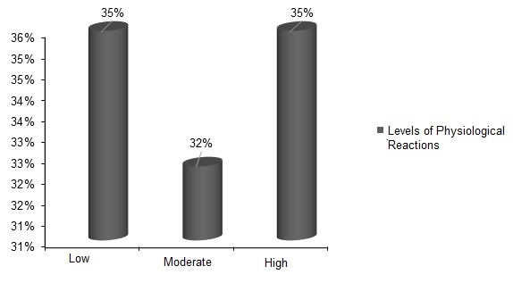

Fig. 4. Percentage distribution of concentrations regarding physiological responses related to the applied questionnaire: Physiological Reactions to Stress, healthcare professionals from AHSE, during the analysis period. Source: Authors, 2024.

Figure 4 presents the different levels of physiological reactions obtained from a administered questionnaire, which evaluated participants' physiological responses in three categories: Low, Moderate, and High.

We observe that both the Low and High levels accounted for 35% of responses, indicating a balanced distribution between low and high intensity of physiological reactions. The Moderate level, on the other hand, showed a lesser frequency of responses, totaling 32%. These data suggest that the majority of participants exhibit more extreme physiological reactions, both low and high, while a smaller portion displays moderate responses. This variation in levels may be associated with differing sensitivities or stress conditions of the participants during the questionnaire. Through these questionnaires, we were able to correlate statistics from several factors analyzed during work.

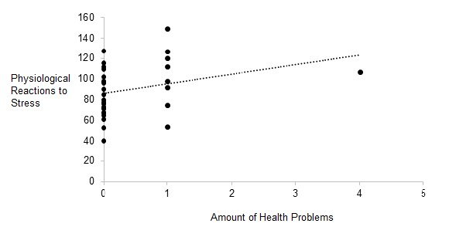

Fig. 5. Statistics related to Physiological Reactions in response to stress vs. Quantity of Health Problems among healthcare professionals from AHSE during the analysis period. Source: Authors, 2024.

Figure 5 illustrates a statistic concerning the relationship between the number of health problems and physiological reactions to stress. We can perceive a slight trend of increased physiological reactions as the number of health problems grows, supporting studies by Danielle McCarty (2020) on comorbidities and psychological stress. The author highlights how different health issues, both physical and mental, can burden the organism, intensifying the physiological response to stress. She analyzes how the presence of multiple chronic illnesses impairs the body's ability to adapt to these conditions, potentially leading to more intense physiological reactions.

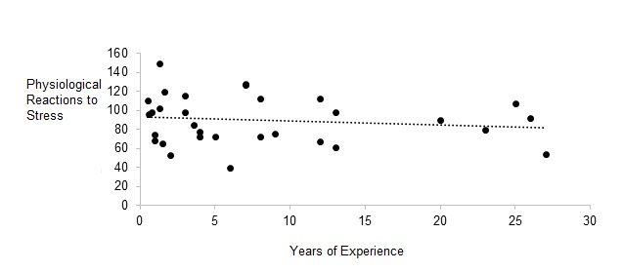

Fig. 6. Statistics related to Physiological Reactions in response to stress vs. Years of Experience among healthcare professionals from AHSE during the analysis period. Source: Authors, 2024.

Figure 6 presents the relationship between years of experience and physiological reactions to stress. The trend line indicates a slight reduction in physiological reactions with increased years of experience. However, due to data dispersion, it is not possible to ascertain that years of experience directly cause this decline in stress reactions, as other factors may influence individuals' physiological responses.

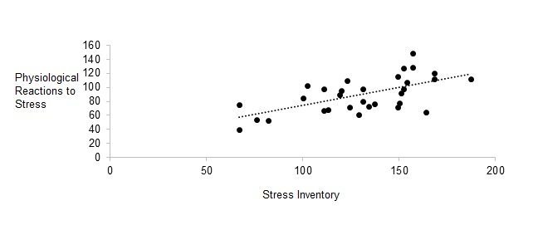

Fig. 7. Statistics related to Physiological Reactions (RF) in response to stress vs. Stress Inventory (IE) among healthcare professionals from AHSE during the analysis period. Source: Authors, 2024.

Figure 7 represents the relationship between the questionnaires applied, Physiological Reactions (RF) in response to stress and the Stress Inventory, revealing that the higher the levels reported by participants in the IE questionnaire, the greater their symptoms in the RF questionnaire. Despite these statistics and multiple efforts made, we have yet to establish a clear assertion between the obtained variables. The collected data exhibit inconsistent patterns that suggest the possibility of unknown factors influencing the results, compelling us to refrain from making premature hypotheses.

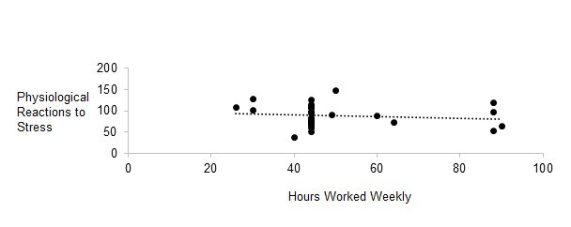

Fig. 8. Statistics related to Physiological Reactions in response to stress vs. Weekly Working Hours of healthcare professionals from AHSE during the analysis period. Source: Authors, 2024.

Thus, correlation assessments reveal that elevated levels of subjective stress (perceived stress – IE) may be associated with significant physiological alterations, such as increased blood pressure, exacerbated inflammatory responses, and hormonal dysfunctions (Mariotti, 2015). This predisposition to pathological conditions results from the constant modulation of the hypothalamic-pituitary-adrenal axis (Mbiydzenyuy; Qulu, 2024). In hospital environments, this situation can be exacerbated due to excessive demands, the need for quick decisions by healthcare professionals, and continuous exposure to adverse events, such as the suffering and death of patients.

Moreover, in addition to physical factors, psychosocial aspects, including the perception of neglect by superiors, professional insecurity, and poor working conditions, amplify the impact of stress (Shanker, 2019). This scenario can compromise physiological and mental homeostasis, predisposing individuals to burnout and disorders such as anxiety and depression. These disorders are often precursors to physiological manifestations, such as dermatitis, neuralgia, or hormonal disorders (Ota et al., 2014).

The relationship between high indices of IE and physiological dysfunctions reinforces the need for institutional strategies to mitigate occupational stress. The implementation of interventions, such as psychological support, optimization of working hours, and improvement of working conditions, can reduce adverse impacts on the mental and physical health of professionals, promoting not only individual well-being but also the safety and quality of care provided (Candeias et al., 2021).

4. Conclusion

Finally, the analysis of the data indicates a greater vulnerability of healthcare workers to emotional and physical stress, primarily due to excessive working hours and high turnover in hospital environments. These factors result in elevated cortisol levels, signaling an urgent need for attention to mental and physical health. Chronic stress, exacerbated by adverse working conditions, contributes to an increase in mental disorders, negatively affecting performance and the quality of care. It is essential to implement interventions that promote healthy work environments, prioritizing the mental health of professionals and aiming not only for their well-being but also for the efficiency of the healthcare system. The relationship between occupational stress and variables such as age, gender, and role is crucial to understanding the physical and psychological symptoms associated with it.

References

1. Atherton, A., Faria, J.R., Wheatley, D., Wu, D., & Wu, Z. (2016). The decision to moonlight: does second job holding by the self-employed and employed differ? Journal of Industrial Relations, 47(3), 279-299. https://doi.org/10.1111/irj.12135

2. Bardaquim, V. A., Santos, S. V. M., Dias, E. G., Dalri, R. C. M. B., Mendes, A. M. O. C., Gallani, M. C., et al. (2020). Stress and hair cortisol levels among nursing staff. Brazilian Journal of Nursing, 73(1), 1-7. https://doi.org/10.1590/0034-7167-2018-0953

3. Caixeta, A. C., Silva, R. C., & Abreu, C. R. C. (2021). Abusive use of psychotropic drugs by health professionals. JRG Journal of Academic Studies, 4(8), 188-200. https://doi.org/10.5281/zenodo.4627867

4. Candeias, A., Galindo, E., Sueck, M., Portelada, A., & Knietzsch, J. (2021). Psychological adjustment, quality of life and well-being in a German and Portuguese adult population during the COVID-19 pandemic crisis. Front. Psychol. 12: 674660.

5. Chabre, O., Goichot, B., Zenaty, D., & Bertherat, J. (2017). Epidemiology of primary and secondary adrenal insufficiency: Prevalence and incidence, acute adrenal insufficiency, long-term morbidity and mortality. Annales d’Endocrinologie, 78(6), 490-494. https://doi.org/10.1016/j.ando.2017.10.010

6. Federal Council of Nursing (COFEN). (2017). Resolution No. 543/2017, of May 12, 2017. Updates and establishes parameters for the Sizing of the Nursing Professional Framework. Brasilia: COFEN.

7. Quick, JC, Cooper, CL, Nelson, DL, Quick, JD, and Gavin, JH (2003). Stress, health and well-being at work. In J. Greenberg (Ed.), Organizational behavior: The state of the science (2nd ed., pp. 53-89). Lawrence Erlbaum Associates Publisher.

8. Freitas, A. F. S., & Mourão, L. (2020). Evidence of psychometric validity of the inventory of work stressors in oncology. Psychology Journal: Organizations and Work, 20(2), 974-983. https://doi.org/10.17652/rpot/2020.2.17451

9. Hirschle, A. L., & Guedes-Gondim, S. (2020). Stress and well-being at work: a literature review. Science & Public Health. 25. 2721-2736.

10. Holt, R. R. (1993). Occupational stress. In L. Goldberger & S. Breznitz (Eds.), Stress Handbook: Theoretical and Clinical Aspects (2nd ed.). New York: Free Press.

11. Lai, J., Ma, S., Wang, Y., Cai, Z., Hu, J., Wei, N., et al. (2020). Factors associated with mental health outcomes among healthcare workers exposed to coronavirus disease 2019. JAMA Network Open, 3(3), e203976. https://doi.org/10.1001/jamanetworkopen.2020.3976

12. Leite, H. D. C. S., Carvalho, M. T. R., Cariman, S. L. S., Araújo, E. R. M., Silva, N. C., & Carvalho, A. O. (2016). Occupational risk among health professionals of the Mobile Emergency Care Service – SAMU. Nursing in Focus, 7(3/4), 31-35. https://doi.org/10.21675/2357-707X.2016.v7.n3/4.912

13. Lima, R. C. (2020). Social distancing and isolation due to Covid-19 in Brazil: impacts on mental health. Physis: Journal of Public Health, 30(02), 1-10. https://doi.org/10.1590/S0103-73312020300214

14. Mariotti, A. (2015). The effects of chronic stress on health: New insights into the molecular mechanisms of brain–body communication. Future Science OA, 1(3), FSO23. https://doi.org/10.4155/fso.15.21

15. Mbiydzenyuy, N. E., & Qulu, L. (2024). Stress, hypothalamic-pituitary-adrenal axis, hypothalamic-pituitary-gonadal axis, and aggression. Metabolic Brain Disease, 39, 1613-1636. https://doi.org/10.1007/s11011-024-01393-w

16. McCarthy, D.J. (2020). The interactions of multiple chronic diseases and mental health disorders. Journal of Clinical Psychology. [in press].

17. Ota, K. T., Liu, RJ., Voleti, B., Maldonado-Aviles, J. G., Duric, V., Iwata, M., et al. (2014). REDD1 is essential for stress-induced synaptic loss and depressive-like behavior. Nat Med, 20, 531-535. https://doi.org/10.1038/nm.3513

18. Reynolds, A. C., Lechat, B., Melaku, Y. A., Samson, K., Brown, B. W. J., Crowther, M. E., et al. (2022). Shift work, clinically significant sleep disorders and mental health in a representative, cross-sectional sample of young working adults. Scientific Reports, 12(1), 16255. https://doi.org/10.1038/s41598-022-20308-2

19. Rizzini, M. A. S. S. (2015). The psychological impact of occupational stress on hospital nurses. Master's Dissertation, Federal University of Maranhão, Maranhão.

20. Rosa, T. G. (2016). Influence of stressors on increased plasma cortisol levels. University of Rio Verde (UniRV). [Course Completion Work].

21. Santana, J. S., Silva, J. L. L., Mello, G. M., Bortolazzo, P. A. A. B., Bento, L. C. S., & Souza, A. B. (2017). Stress assessment tool for nursing staff. Health Care Journal, 15(52), 61-65. https://doi.org/10.13037/ras.vol15n52.4424

22. Shanker, M. (2019). Assessing Job Stress Development of an Inventory and relationship with managers’ intention to stay. Journal of Organization and Human Behaviour, 8(1), 24-32.

23. Di Dalmazi, G. et al. (2015). Subclinical hypercortisolism: A state, a syndrome, or a disease? European Journal of Endocrinology, 173(4), 61–71.

24. Silva, R. P., Valente, G. S. C., & Camacho, A. C. L. F. (2020). Risk management in the health of nursing professionals in the hospital context. Brazilian Journal of Nursing, 73(6), e20190303. https://doi.org/10.1590/0034-7167-2019-0303

25. Brazilian Society of Endocrinology and Metabolism (SBEM). (2019). Manual of Endocrinology. Brasilia: SBEM.

