Case report

A Case Report on Sagliker Syndrome- A
Sequelae of Chronic Kidney Disease

.

Abstract:

Sagliker syndrome was first recognized in medical literature in the year 2004, taking into account the bizarre craniofacial malformities and systemic manifestations in patients with uncontrolled Secondary Hyperparathyroidism (SHPT) arising from Chronic Renal Failure (CRF). This syndrome describes the “uglifying” maxillofacial deformations and skeletal changes observed in subjects who have been under prolonged haemodialysis for end stage renal disease. Till date it remains an elusive entity and patients often go undiagnosed which significantly diminishes their quality of life and treatment outcomes. This case report aims at presenting a rare manifestation of the syndrome in a 22-year-old female patient, concentrating on a variety of clinical radiographical and biochemical findings.

Keywords: Chronic Renal Failure, Sagliker Syndrome, Secondary Hyper Parathyroidism, “uglifying” craniofacial malformities

INTRODUCTION

Sagliker syndrome (SS) is a rare disorder of the craniofacial skeleton that occurs as a manifestation of long term untreated secondary hyperparathyroidism (SHPT) arising from end stage kidney disease. The syndrome was first identified and described by Sagliker et. al (2004).[1]
Owing to the paucity of literature regarding SS and its fairly recent discovery, not much light has been shed about its incidence and prevalence in the population at large. Sagliker initially evaluated its incidence to be around 0.5%. [1] A study from Bulgaria [2] showed an incidence rate of 6.34% which was much higher compared to Sagliker’s own findings and a compilation of case studies and Iran [3]. Previous literature has simply mentioned its manifestations but details pertaining to its incidence, therapeutic response and prognosis remain to be explored.
The exact etiopathogenesis of SS remains undiscovered till date, however novel genetic studies have tapered the cause down to 4 probable detected missense mutations in the GNAS1 gene exons, which were observed in 40% of the reported cases.3 The pathophysiology is associated with SHPT, leading to hyperplasia and hypertrophy of the parathyroid gland cells, causing a progressive anomalous and unregulated increase in parathormone secretion resulting in decimated bone deformities. [1,4,5,6]
The clinical presentation of SS is diverse, depending upon the stage of detection and severity of SHPT. The striking features include a short stature, emaciated appearance with an abnormally large, disproportionate increase in the size of the skull. Sagliker used the term “severe degree of uglifying human appearance” to elaborate the craniofacial manifestations [1]. Patients with SS showed skull tomography with unique and peculiar irregularities and bone density changes. [1] Cephalometric analysis pointed out significantly larger maxillary protrusion angle, and Angle’s class II malocclusions, with soft tissue parameters following the same pattern.[12] Maxillary and mandibular radiographs exhibited significant bone destruction in the nasal septum and surrounding structures, with concomitant obliteration of sinuses. Dental abnormalities like irregularly shaped teeth, abnormally large interdental spaces causing derangement of occlusion were noted. Skeletal changes in the upper extremities like an upward curving of the third phalanges was also an intriguing clinical finding in most patients. [6,7] Patients usually suffered from depression owing to their facial deformities and general health status. [3,5] Biochemical analysis in literature points to a common discourse of serum Ca +2 levels ranging from 6-7 mg/dl, phosphate levels 7-8 mg/dl and spiking levels of Alkaline Phosphatase (ALP). The main diagnostic feature, is the radical unprecedented increase in the intact parathormone levels. [1,3]
In accordance with the aforementioned clinical radiographical and biochemical findings, we would like to discuss a case report of a patient that came to our institution presenting similar features.

CASE HISTORY
A 22-year-old female patient, from a semi-urban area, reported to the Department of Oral & Maxillofacial Pathology, complaining of a progressively enlarging painless swelling involving her upper jaw. Initially the swelling had developed in the peri-nasal area and frontal portion of her upper jaw. It gradually expanded over a period of 2 years, reaching its present dimensions. The lesion spanned from her upper teeth bearing segments up to the ears bilaterally. Her medical history revealed that she was under regular cycles (twice per week) of hemodialysis, for two years owing to her existing chronic kidney disease. She added that her father had succumbed to the same condition a couple of years ago. Her diagnosis was made around 5 years prior, and she had been receiving treatment ever since. She appeared emaciated, anxious and complained of frequent headaches, pruritus and persistent fatigue. The extra-oral examination revealed an abnormally large bilaterally symmetrical swelling spanning over the entire craniofacial skeleton. The lesion presented over the entire middle 3rd of face, involving whole of the anterior part of the maxilla and posteriorly up to the pre-auricular region on either side.
A frontal forward malformation of the upper jaw was noted, which caused an incompetence of her lips and an anterior open bite. Overlying skin appeared stretched out without any notable discolorations, or discharging sinuses. Concomitant obliteration of the nasolabial fold was persistent and the ala of nose was extended over the swelling spreading outwards, on both sides. A mild deviation of the nasal septum could also be appreciated [Fig 1-A,C].
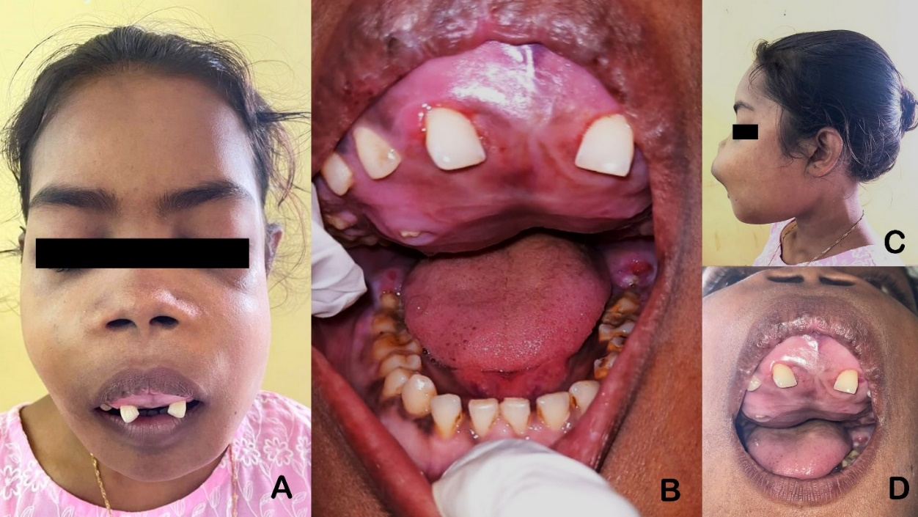
FIG-1 A, C- Extra-oral clinical photographs showing abnormal increase in size of the head, and an extensive swelling involving whole of maxilla causing an incompetence of the lips.
B, D- Intra-oral clinical photograph showing large swelling involving the hard palate and alveolus with widening of interdental spaces and occlusal discrepancies.

On palpation it was non tender, bony hard and without egg shell crackling and the skin was free from the underlying structures. The intra oral examination showed the presence of a large diffused bony hard swelling involving the entire maxilla, extending up to the posterior portion of the hard palate causing severe derangement of the regional teeth. The swelling was non-tender, non-compressible and non-pulsatile. Indentations of the opposing teeth could be appreciated on the mucosa covering the lesion in several areas [Fig 1-B,D].
The patient was suggested a profile of radiographic, routine hematological and biochemical examinations.
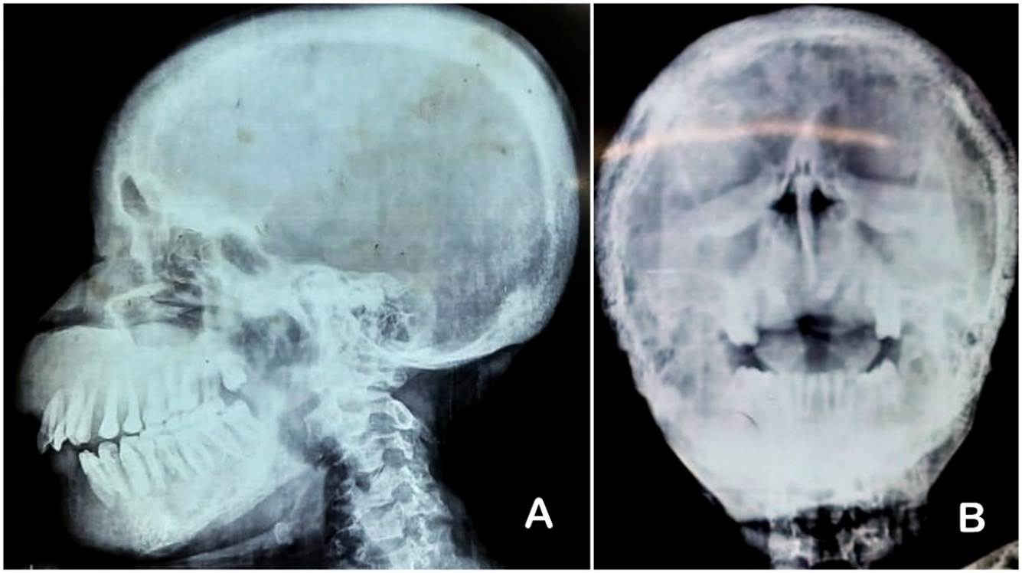
FIG 2 A- Lateral cephalogram demonstrating “salt and pepper appearance” of the skull and abnormal thickening of the calvarium.
B- P.N.S view radiograph showing opacification of the maxillary sinuses bilaterally.

A lateral cephalogram of the skull revealed an abnormal thickening of the calvarium extending from the frontal prominence up to the occiput [Fig 2-A]. A generalized grainy salt and pepper appearance of the skull bones was noted. A Para Nasal Sinus (P.N.S) radiograph showed a dense radio-opacity over both the maxillary sinuses which signaled to possible obliteration of the sinuses [Fig 2-B]. Similar grainy radio opacities were appreciated over the maxilla which was protuberant (around 1-1.5 cm from the upper incisors).
Routine hemograms revealed mild anemia (9.6 gm/dl of Hb).
Biochemical analysis showed calcium and phosphorus levels in blood to be 9.20 mg/dl and 5.50 mg/dl respectively. The intact parathormone levels were found to be greater than 2000 pg/ml. Blood urea levels were 73 mg/dl which was extremely high given the normal range and the creatinine levels were found to be 2.6 mg/dl which were a definite marker of Azotemia.
Owing to the established end stage CKD, the patient was suggested a fine needle biopsy of the kidneys. The linear soft tissue fragments from the kidneys exhibited renal tissue with 7-8 glomeruli of which 5 were completely sclerosed, the remaining relatively viable glomeruli showed segmental sclerosis with associated proliferation. Sections also revealed areas of multiple tubular atrophy and the interstitium had lymphocytic infiltrate. The arterioles showed focal hyalinized changes. The overall light microscopic features were corroborative to the diagnosis of Chronic sclerosing proliferative glomerulonephritis with moderate tubular atrophy and mild arteriosclerosis.
Based on the definitive clinical and biochemical manifestations and a potent history of chronic kidney disease, the final diagnosis was conducive with Sagliker Syndrome. A histopathological examination of the lesion was advised but a biopsy could not be conducted at the moment due to spiked levels of Parathormone. She was prescribed to continue her regime for hemodialysis and further surgical intervention was proposed but due to poor socioeconomic and dwindling health conditions she failed to resume her regular follow-ups.

DISCUSSION

Sagliker Syndrome is a unique manifestation in patients suffering from SHPT, due to end stage CKD undergoing regular dialysis in the absence of adequate control of parathormone and Alkaline Phosphatase levels. It leads to massive changes in the maxillofacial skeleton and a multitude of systemic complications that greatly affect the patient’s physical appearance and mental health status.[2] The disorder also causes significant deterioration of their quality of life.[3]
Patients undergoing regular cycles of hemodialysis as a consequence of chronic kidney disease often suffer from Secondary Hyperparathyroidism.⁷ This seems to have an increased incidence in developing countries and a considerable section of these cases go untreated [1] due to negligent approach in the protocols and their follow ups. The unregulated levels of Parathormone in circulation, plays a major role in the development of Sagliker Syndrome.[5]
The discourse on the signs and symptoms of SS are limited to a series of case reports which suggest that the predominant age of occurrence ranges between 2nd to 5th decades of life. [2,3,4] It has been observed that males and females are affected equally. This is also reflected in our case report as the study subject was a 22-year-old female.
Surveys dating to the first discovery of the syndrome suggest that patients suffering from Sagliker usually present with a stature that is peculiarly short, stunted and unlikely when compared to individuals of that age group. [1] The craniofacial abnormalities seen in our subject are also in accordance with reports. Literature reviews have suggested discrepancies of the maxillofacial skeleton and dental anomalies like abnormal increase in the size of the maxilla, causing the denture bearing arch to expand in radical proportions.[7,9] This entails the interdental spaces to increase causing occlusal disharmonies like anterior open bite and obstruction of the airways. Frontal bossing due to bony malformations is also a feature.[1] Several studies taking into account the psychological evaluation of the patients significantly pointed out that a number of them suffered from depression (46%) or anxiety disorder (23%).[3] The aforementioned clinical features were analogous with our own findings. X.H Chen et. al stated that patients manifested additional low-grade symptoms like persistent bone pain, pruritus, sudden weight loss and severe fatigue.[4] These were also complaints made by our study subject during her first formal inspections. Cardinal features of cephalometric studies in these patients exhibit a frontal forward malformation of the maxilla with a dramatic amplification of the maxillary protrusion angle.[12] Sagliker et. al pointed out that their skull radiographs had striking “salt and pepper” appearance.[1,9] These characteristic deformities were in tandem with our own observations. Several studies also suggested curving anomalies in the phalanges,[1,3,9,11] bowing deformity in the lower extremities which were not apparent in this instance.
Despite the various defining clinico-radiological attributes and a potent history of chronic kidney disease, the major predictive criteria to narrow down on the diagnosis remains to be the biochemical and hematological assays. As Sagliker is a direct outcome of uncontrolled secondary hyperparathyroidism, enormously elevated levels of intact parathormone in blood is the principal feature noted in almost all cases.[1,3,8,11] Concomitant spikes in the levels of calcium and phosphorus as a result of prolonged treatment with hemodialysis is consistently portrayed. Similar observations were obtained in our study.
Differential diagnoses that closely mimic the clinical and radiographical features of Sagliker include Polyostotic Fibrous Dysplasia and Paget’s disease, however the biochemical analyses provide a definite conclusion supporting Sagliker due to the tremendous increase in the levels of intact parathormone, which is not observed in these diseases. Another manifestation of Sagliker is the presence of several Brown’s tumor, although they were not diagnosed in the discussed case.
Studies regarding Sagliker Syndrome is still underway, although there are possibly thousands of people who suffer in silence because of its life altering manifestations. Most of these cases go undiagnosed due to the chronic negligence surrounding patients with end stage kidney diseases and also ignorance about the syndrome. Yet if an intervention is brought about at the early stages of its onset, one may expect a radical change in the clinical course and outcome of these cases. Patients undergoing hemodialysis for CRF, who do not receive proper medications or lack treatment for secondary hyperparathyroidism eventually present with these severe craniofacial anomalies, systemic manifestations alongside the devastating psychological problems. This is more common in developing countries due to the substandard healthcare structures.
This case report is an attempt to shed light on the variance and degree of diminished quality of life that the patients go through. Further studies and analysis of the epidemiology, clinical behaviors of this disease become mandatory, to bring forth a better understanding about the treatment modalities for best possible prognosis and outcomes.

Consent (where ever applicable)

All authors declare that ‘written informed consent was obtained from the patient (or other approved parties) for publication of this case report and accompanying images. A copy of the written consent is available for review by the Editorial office/Chief Editor/Editorial Board members of this journal."

References

- Sagliker Y, Balal M, Sagliker Ozkaynak P, et al. Sagliker syndrome: uglifying human face appearance in late and severe secondary hyperparathyroidism in chronic renal failure. Semin Nephrol. 2004;24(5):449-455. doi:10.1016/j.semnephrol.2004.06.021
- Cholakova R, Pechalova P, Kapon E. Sagliker syndrome: first four cases in Bulgaria. G Ital Nefrol. 2016 Jul-Aug;33(4):gin/33.4.2. English. PMID: 27545627.
- Mohebi-Nejad A, Gatmiri SM, Abooturabi SM, Hemayati R, Mahdavi-Mazdeh M. Diagnosis and treatment of Sagliker syndrome: a case series from Iran. Iran J Kidney Dis. 2014;8(1):76-80.
- Chen XH, Shen B, Zou J, et al. Clinical status of Sagliker syndrome: a case report and literature review. Ren Fail. 2014;36(5):800-803. doi:10.3109/0886022X.2014.890110
- Castro LB, Mendes R, Coelho FB, et al. Sagliker Syndrome: A Case Report on a Rare Case of Severe Renal Osteodystrophy Due to Untreated Secondary Hyperparathyroidism. World J Endoc Surg 2020;12(1):38–40.
- Yu Y, Zhu CF, Fu X, Xu H. Sagliker syndrome: A case report of a rare manifestation of uncontrolled secondary hyperparathyroidism in chronic renal failure. World J Clin Cases. 2019;7(22):3792-3799. doi:10.12998/wjcc.v7.i22.3792
- Pontes, Flávia Sirotheau Correa et al. “Oral and maxillofacial manifestations of chronic kidney disease-mineral and bone disorder: a multicenter retrospective study.” Oral surgery, oral medicine, oral pathology and oral radiology 125 1 (2018): 31-43 .
- Hricik DE, Chung-Park M, Sedor JR. Glomerulonephritis. N Engl J Med. 1998;339(13):888-899. doi:10.1056/NEJM199809243391306
- Hamrahian, M., Pitman, K. T., Csongrádi, É., Bain, J. H., Kanyicska, B., & Fülöp, T. (2012). Symmetrical craniofacial hypertrophy in patients with tertiary hyperparathyroidism and high‐dose cinacalcet exposure. Hemodialysis International, 16(4), 571-576.
- Lopes ML, Albuquerque AF, Germano AR, Queiroz LM, Miguel MC, da Silveira ÉJ. Severe maxillofacial renal osteodystrophy in two patients with chronic kidney disease. Oral Maxillofac Surg. 2015;19(3):321-327. doi:10.1007/s10006-015-0490-9
- Sagliker Y, Acharya V, Ling Z, et al. International study on Sagliker syndrome and uglifying human face appearance in severe and late secondary hyperparathyroidism in chronic kidney disease patients. J Ren Nutr. 2008;18(1):114-117. doi:10.1053/j.jrn.2007.10.023
- Mi, J. P., He, P., Shi, K., Feng, S. Y., Chen, X. Z., He, Q. Q., ... & Fan, Y. P. (2021). Cephalometric craniofacial features of patients with Sagliker syndrome: a primary analysis of our experience. Annals of Translational Medicine, 9(12).

