Original Research Article

Examining the Effects of Perceived Mate Availability on Intrasexual Competitiveness and Alcohol Consumption: Hidden Effects of Gender and Relationship Status

.
ABSTRACT

Aims: To investigate whether perceived mate availability influences intrasexual competitiveness and hypothetical alcohol consumption, and to examine the moderating role of gender and relationship status.
Study Design: Between-subjects, single-blind experimental design.
Place and Duration of Study: School of Psychology, University of Portsmouth, between March and June 2024.
Methodology: Ninety-two participants (52 females; aged 18–54, M = 26.34, SD = 7.12) were randomly assigned to read priming articles simulating either mate abundance or mate scarcity. Participants completed the Intrasexual Competition Scale (ICS) and an Alcohol Purchase Task (APT). Four dependent variables were generated from the APT: derived Q₀, derived α, observed intensity, and observed Omax. ANOVAs and MANOVAs were conducted to test the effects of priming condition, gender, and relationship status on these outcomes.
Results: No significant main effect of condition was found on intrasexual competitiveness. However, significant interaction effects emerged, particularly for females in romantic relationships, suggesting that relationship status moderates sensitivity to mate availability cues. For alcohol consumption, mate scarcity increased hypothetical demand (Q₀) and reduced price sensitivity (α), particularly among males in relationships. No significant effects were found for observed intensity or Omax overall, but significant interactions with gender and relationship status were present.
Conclusion: Mate availability cues influence hypothetical alcohol consumption, particularly among partnered males, supporting evolutionary models of risk-taking and mate signalling. The null effect on ICS underscores the need for improved manipulation checks and more sensitive measures of competitiveness. Cultural factors and socioeconomic variables should be considered in future studies to enhance generalisability.

Keywords: Mate availability, Intrasexual competition, Alcohol consumption, Alcohol purchase task, Relationship status, Evolutionary theory

1. INTRODUCTION

Alcohol is one of the most widely consumed recreational substances worldwide, second only to caffeine (Rajendram et al., 2006). In Europe, per capita consumption is among the highest globally, averaging more than three bottles of wine per week (WHO, 2019). Excessive alcohol use is a leading contributor to premature mortality, accounting for approximately 6.5% of all deaths in the European region (Rehm et al., 2009). Beyond mortality, alcohol misuse is associated with a wide range of health problems, including liver cirrhosis, pancreatitis, cancer, diabetes, and neurological and psychiatric disorders such as depression and suicide (Grønbæk, 2009; Rehm et al., 2003; Brady, 2006; Norström & Ramstedt, 2005). Social consequences are also significant, ranging from violence and vandalism to family conflict and financial instability (Klingemann & Gmel, 2001; Meloni & Laranjeira, 2004).

While the physical and social consequences of alcohol misuse are well documented, the motivational factors underlying alcohol use remain incompletely understood. One influential framework is the motivational model by Cox and Klinger (1988, 1990), which posits that drinking is driven by two orthogonal dimensions: valence (positive vs. negative reinforcement) and source (internal vs. external motivation). This yields four primary motives for alcohol use (Cooper, 1994). Closely related is expectancy theory, which assumes that individuals hold beliefs about the anticipated outcomes of alcohol consumption, influencing their drinking behaviour (Stacy et al., 1990). However, empirical findings related to expectancies are mixed, with inconsistent support for both positive and negative expectancy effects (Jones et al., 2001).

Moreover, there is growing recognition that some determinants of alcohol consumption may be implicit and not accessible through introspection (Cox & Klinger, 2004). These insights have prompted interest in alternative theoretical frameworks, including evolutionary psychology, which posits that behaviours, particularly those with fitness-related trade-offs, may be shaped by reproductive strategies rather than conscious deliberation.

According to sexual selection theory (Darwin, 1871; Trivers, 1972), traits that reduce survival can evolve if they enhance reproductive success. This applies especially to males, who, due to lower obligatory parental investment, have evolved traits and behaviours aimed at maximising mating opportunities (Emlen & Oring, 1977). For example, the peacock’s tail is maladaptive for survival but advantageous for mate attraction. In humans, men more often value physical attractiveness in mates, while women place greater importance on resource acquisition and stability (Buss & Barnes, 1986). This asymmetry has implications for intrasexual competition: males are more likely to display status or risk-taking behaviours to attract mates, while females often focus on physical appearance (Buss, 1988).

Initially, female aggression and competitiveness were thought to be by-products of male aggression due to shared genetics (Wallace, 1891). However, research now shows that intrasexual competition exists in both sexes, especially when access to mates or mate-relevant resources is limited (Rosvall, 2011). Under such conditions, women may also engage in competitive behaviours to secure reproductive opportunities.

Arnocky et al. (2014) demonstrated that perceived mate scarcity increases intrasexual competitiveness in both men and women, regardless of relationship status. Other work has linked intrasexual competition to mate retention behaviours (Arnocky et al., 2018). Additionally, individuals are often willing to accept long-term physical or psychological costs to improve short-term mating prospects. For example, intrasexual competition is a stronger predictor of body dissatisfaction and disordered eating than media exposure (Ferguson et al., 2011), and it also predicts anabolic steroid use among male bodybuilders (Harris et al., 2019).

Given these findings, alcohol use may also be interpreted within an evolutionary framework. Risk-taking, which includes impulsivity and alcohol consumption, is known to be associated with intrasexual competition (Baker & Maner, 2009). Furthermore, drinking games among university students have been identified as a form of competitive mating display, particularly for men (Hone et al., 2013; Hone & McCullough, 2015). Other research has found correlations between intrasexual competitiveness and hazardous alcohol use (Harris et al., 2019), though causality remains unclear and most studies rely on student samples.

This study addresses these gaps by examining whether perceived mate availability influences intrasexual competitiveness and hypothetical alcohol consumption in a broader, more demographically diverse sample. It also considers the moderating effects of gender and relationship status, two variables frequently implicated in both mating and alcohol use research (Pedersen et al., 2009). Alcohol demand is measured using the Alcohol Purchase Task (Murphy & MacKillop, 2006), which provides behavioural economic indices of consumption and price sensitivity.

The following hypotheses were tested: mate scarcity would increase intrasexual competitiveness; higher intrasexual competitiveness would be associated with increased alcohol consumption and reduced price sensitivity; and gender and relationship status would moderate these effects.

2. material and methods

2.1 Participants

A total of 129 participants completed the study. After applying exclusion criteria (see Section 2.5.1), the final sample included 92 participants (52 females), aged 18 to 54 years (M = 26.34, SD = 7.12). Participants were recruited online via Facebook, targeting individuals from the United Kingdom and Lithuania. Eligibility criteria included being 18 years or older and reporting any alcohol consumption. Participation was voluntary.
Table 1 presents the demographic characteristics by condition.
Condition (N) | Age (SD) | Gender (male/females) | Ethnic Background (white) | Relationship status (single) |  | *Drinking frequency (%)
Mate Abundance (N = 41) | 25.9 (5.44) | 20/21 | 80 % | 37 % | - 24 %  - 44 %  - 27 %  - 5 %
Mate Scarcity  (N = 51) | 26.69 (8.26) | 20/31 | 80 % | 39 % | - 27 %  - 43 %  - 26 %  - 4 %
Notes. *Drinking frequencies: 1. Monthly or less, 2. 2-4 times per month, 3. 2-3 times per week, 4. 4 or more times per week.

2.2 Design

This was a single-blind, between-subjects experimental study conducted online using the Gorilla platform. Participants were randomly assigned to one of two conditions: mate abundance or mate scarcity. The independent variables were condition, gender, and relationship status. The dependent variables included intrasexual competitiveness and alcohol consumption, operationalised through four indices. Ethical approval was granted by the University of Portsmouth Department of Psychology Ethics Committee.

2.3 Materials and Procedure

2.1.1 Demographics Questionnaire
Participants first completed a demographics questionnaire assessing age, gender, ethnicity, relationship status, and drinking frequency.

2.1.2 Priming Task
Participants were randomly allocated (1:1 ratio) to the mate abundance or mate scarcity condition. Each group read a brief fictitious article, adapted from Spielmann et al. (2009), designed to manipulate perceived mate availability. Articles in the abundance condition described favourable romantic prospects and high partner availability, while the scarcity condition emphasised limited opportunities and difficulty finding new partners. These manipulations have previously been validated and shown to affect intrasexual competition (Arnocky et al., 2014).

2.3.3 Intrasexual Competition Scale (ICS)
Participants then completed the 12-item ICS (Buunk & Fisher, 2009), which measures competitiveness toward same-sex individuals. Items were rated on a 7-point Likert scale (1 = not at all applicable to 7 = completely applicable). Example items include: "I can't stand it when I meet someone of the same sex who is more attractive than I am." A mean score was computed by averaging all item responses. Higher scores indicate stronger intrasexual competitiveness. The ICS has demonstrated good reliability in previous studies (e.g., α = 0.83; Harris et al., 2019).

2.3.4 Alcohol Purchase Task (APT)

Following the ICS, participants completed the APT (Murphy & MacKillop, 2006). This behavioural economic task measures hypothetical alcohol demand across increasing price points (£0 to £9 per drink). Participants imagined being at a bar with friends from 9 PM to 2 AM, where standard alcoholic drinks were available. They were asked how many drinks they would consume at each price point (e.g., "How many drinks would you purchase if each cost £1?").
The task generated four dependent variables: Derived Q₀: estimated consumption at zero price; Derived α: price sensitivity (elasticity); Observed Intensity: actual consumption at £0; Observed Omax: maximum monetary expenditure across prices.
The APT has demonstrated validity in both hypothetical and real settings (Amlung et al., 2012).

2.4 Data Analysis

2.4.1 Data Cleaning

Of the 129 initial participants, 37 were excluded: 3 provided non-binary or missing gender responses, 17 reported never drinking alcohol, 11 were removed due to poor-quality APT data (e.g., empty responses, bounce violations, or reversals from zero), 5 outliers were removed to meet assumptions of normality. This resulted in a final sample of 92 participants: 41 in the mate abundance condition and 51 in the mate scarcity condition.

2.4.2 ICS Analysis

Mean ICS scores were analysed using a three-way between-subjects ANOVA with condition, gender, and relationship status as factors. Levene’s test indicated no violations of variance homogeneity.

2.4.3 Alcohol Purchase Task Analysis

Demand curves were modelled using Hursh and Silberberg’s (2008) exponential equation:
ln(Q) = ln(Q₀) + k(e^(–α × Q₀ × C) – 1), where: Q = consumption at price C, Q₀ = baseline consumption (at or near zero price), α = price elasticity, k = constant (set to 2.3, reflecting a log consumption range of 10). Zero values were replaced with 0.01 to enable log transformation. Curve fitting and model comparisons were conducted using GraphPad Prism 9.2.0.

Additionally, observed intensity and Omax values were directly analysed. Observed intensity corresponded to the number of drinks at £0. Omax was calculated by multiplying each consumption response by the corresponding price and extracting the highest value. As these variables were positively correlated (r = 0.52, p = .001), a multivariate analysis of variance (MANOVA) was used to assess effects of condition, gender, and relationship status. Assumptions of multivariate normality and equality of variance were met (Box’s M and Levene’s tests non-significant).

All statistical analyses were conducted using IBM SPSS Statistics Version 26.0 and GraphPad Prism Version 9.2.0.

3. results

3.1 Intrasexual Competition Scale
A three-way ANOVA was conducted on ICS scores with condition, gender, and relationship status as between-subjects factors.
The main effect of condition on ICS score was not significant, F(1, 79) = 0.34, p = .56, ηp² = .001, which contradicts the original hypothesis. However, there was a significant main effect of gender, F(1, 79) = 4.68, p = .03, ηp² = .06, with males scoring higher on ICS than females. The main effect of relationship status was not significant, F(2, 79) = 1.42, p = .29, ηp² = .04.
There was a significant interaction between condition and relationship status, F(1, 79) = 4.90, p = .03, ηp² = .06. Pairwise comparisons indicated that, within the mate scarcity condition, participants in romantic relationships scored significantly higher on ICS than single participants.
The three-way interaction between condition, gender, and relationship status was not significant, F(1, 79) = 0.42, p = .52, ηp² = .001. However, post hoc analyses revealed that within the mate scarcity condition, females in relationships scored significantly higher on ICS than single females.
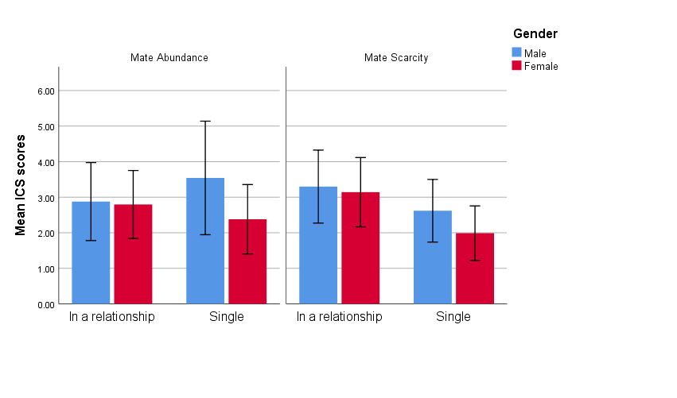
Note. Higher scores indicate stronger willingness to compete with same sex individuals.
Figure 1. Mean ICS scores (+/- 1 SD) of males and females based on relationship status for both conditions.
3.2 Alcohol Purchase Task
To analyse demand curves, data from the Alcohol Purchase Task were fitted using the exponential model described in the methodology. The model showed excellent fit in both conditions, with R² = .98 for the mate abundance group and R² = .99 for the mate scarcity group.

Participants in the mate abundance condition showed a mean Q₀ of 4.7 (SD = 0.79), while those in the mate scarcity condition had a higher mean Q₀ of 5.2 (SD = 1.07). Corresponding α values were 0.0063 (SD = 0.0043) for mate abundance and 0.0053 (SD = 0.0041) for mate scarcity. Statistical comparison of these curves revealed that the Q₀ estimates differed significantly between conditions, F(1, 21) = 7.60, p = .01, indicating greater hypothetical alcohol consumption at zero price under mate scarcity. The α estimates were also significantly different, F(1, 21) = 21.00, p = .001, with a steeper decline in consumption under mate abundance. These findings are consistent with the hypothesis that perceived mate scarcity increases alcohol demand and reduces price sensitivity.
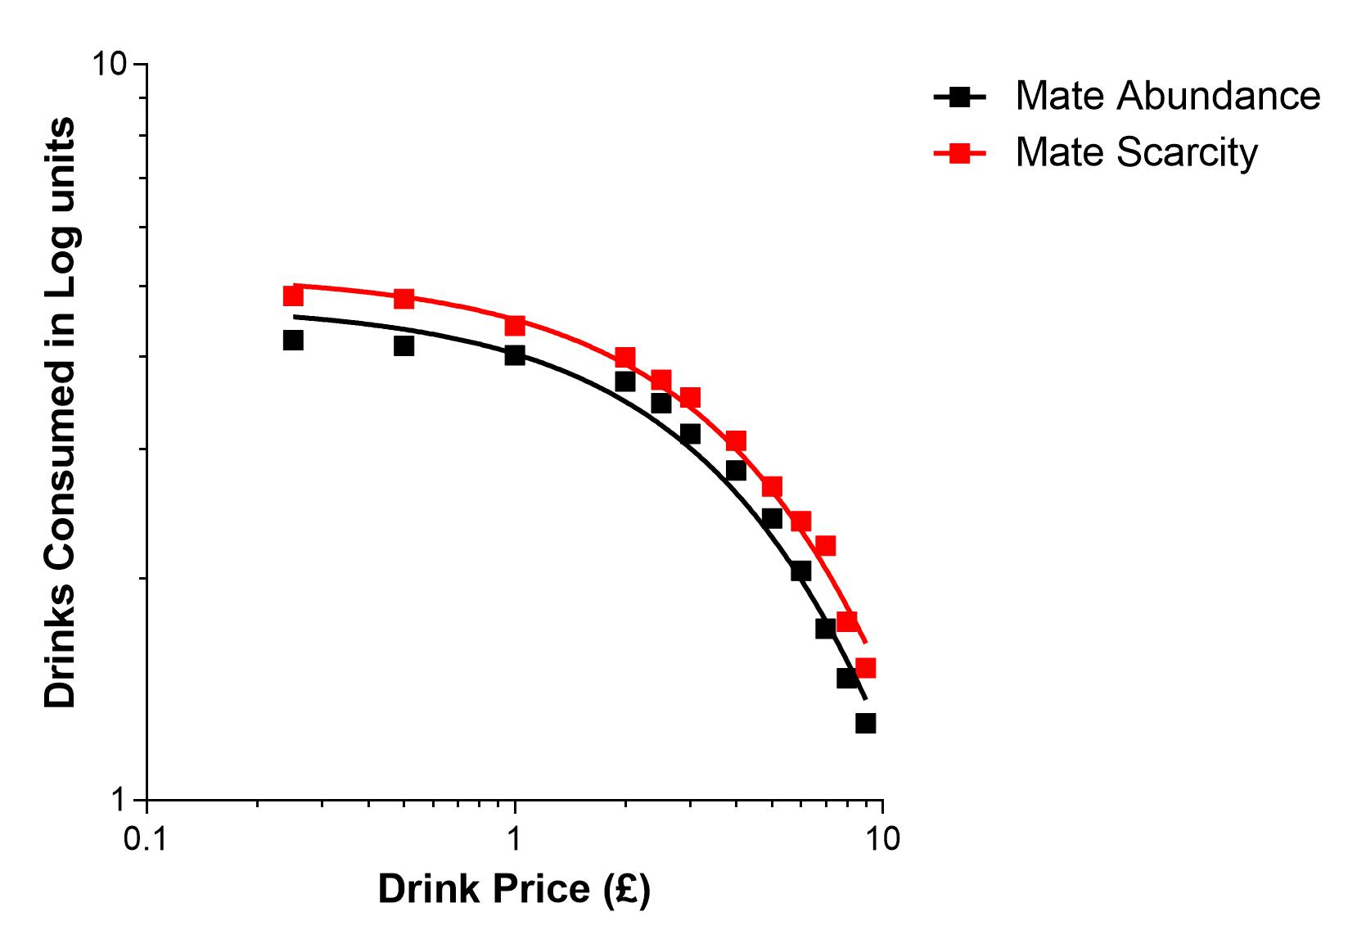
Figure 2. Demand curve (log consumption; price). Mean alcohol demand curve for both conditions.

Analysis of directly observed values (consumption at £0 and maximum expenditure) did not yield significant effects for condition, F(2, 78) = 0.19, p = .82, Wilks’ λ = .99, ηp² = .005, or gender, F(2, 78) = 1.73, p = .18, Wilks’ λ = .96, ηp² = .04. However, relationship status showed a marginally significant effect, F(4, 156) = 2.43, p = .05, Wilks’ λ = .87, ηp² = .06, with single participants tending to report higher alcohol-related outcomes compared to those in romantic relationships. Further pairwise comparisons revealed that this effect was significant only for maximum expenditure, while differences in consumption intensity were not statistically significant.

There was a significant interaction between condition and relationship status, F(2, 78) = 4.19, p = .02, Wilks’ λ = .90, ηp² = .06. Participants in relationships exposed to mate scarcity reported higher consumption intensity and maximum expenditure than those in the same relationship status group under mate abundance. The interaction between condition and gender was not significant, F(2, 78) = 1.27, p = .29, Wilks’ λ = .97, ηp² = .03. However, the three-way interaction among condition, gender, and relationship status was significant, F(2, 78) = 4.42, p = .02, Wilks’ λ = .90, ηp² = .10.

Further analysis showed that males in romantic relationships reported significantly higher consumption intensity and expenditure under mate scarcity compared to those under mate abundance. Additionally, single males in the mate abundance condition showed higher maximum expenditure than single males in the mate scarcity condition.
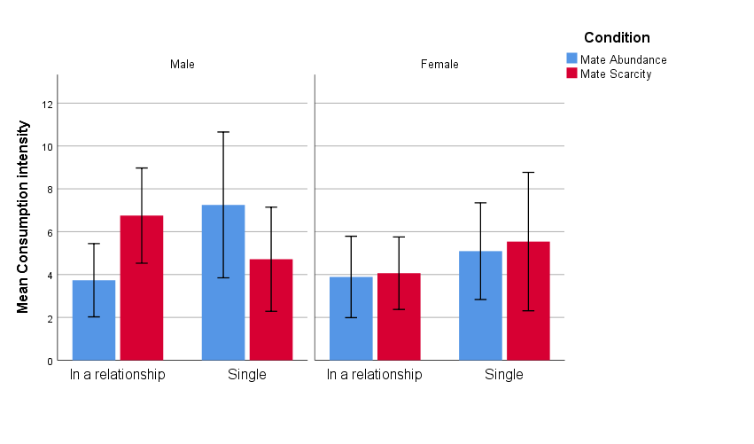
Figure 3. Mean consumption intensity values (+/- 1 SD) for both conditions separated by relationship status and filtered by gender.
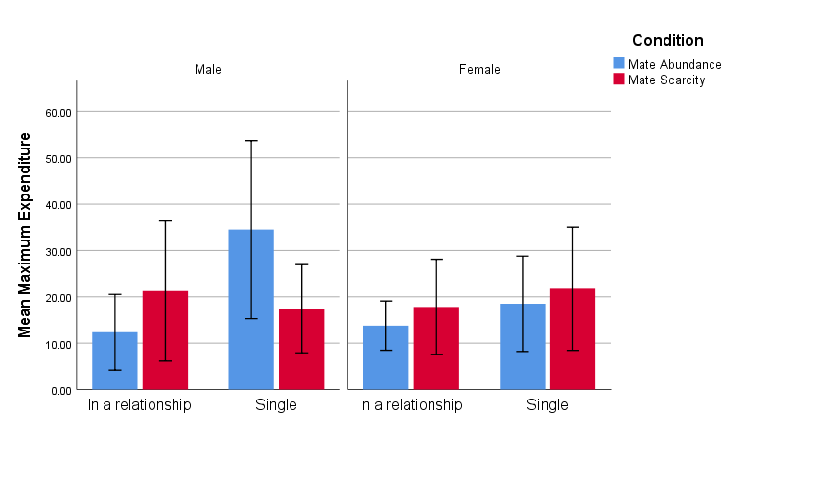
Figure 4. Mean maximum expenditure values (+/- 1 SD) for both conditions separated by relationship status and filtered by gender.
3.3 Awareness of Study Purpose
When asked to guess the purpose of the study, 15 participants (16%) provided responses that correctly or partially referenced intrasexual competition. The remaining 77 participants (84%) gave incorrect or unrelated responses. These results suggest that the priming manipulation was subtle enough to avoid demand characteristics for the majority of participants.

Discussion

This study aimed to replicate prior findings that perceived mate scarcity increases intrasexual competitiveness and to explore whether this manipulation also influences alcohol consumption behaviour. It additionally examined the moderating roles of gender and relationship status. The results provide partial support for the hypotheses, with significant findings emerging primarily in the domain of alcohol consumption rather than competitiveness.

Contrary to expectations and previous research (e.g., Arnocky et al., 2014), the manipulation of mate availability did not produce a significant main effect on intrasexual competitiveness. However, interaction effects suggest that relationship status moderates the response to mate availability cues. Specifically, individuals in romantic relationships, particularly females, reported higher competitiveness under mate scarcity compared to single participants. These findings suggest that the priming manipulation may differentially activate mating-related motives depending on one’s current relationship context. It is possible that partnered individuals experience heightened mate guarding or mate retention concerns when scarcity cues are present, especially if they perceive competition for their partner's attention.

The null main effect for competitiveness may reflect limitations in the sensitivity of the Intrasexual Competition Scale (ICS), which was designed to assess stable traits rather than transient states. It is also possible that the manipulation itself was insufficiently strong or that its effects decayed before measurement. The absence of a direct manipulation check limits the ability to draw firm conclusions in this regard.

By contrast, the alcohol-related outcomes provide stronger support for the hypothesised effects. Participants exposed to mate scarcity showed higher hypothetical alcohol consumption and reduced price sensitivity on the Alcohol Purchase Task (APT), as reflected in higher Q₀ and lower α values. These effects were particularly pronounced among males in romantic relationships, suggesting that alcohol demand may function as a form of costly signalling in mating-relevant contexts. This interpretation aligns with prior research linking risk-taking to status-driven behaviours (Griskevicius et al., 2007; Baker & Maner, 2009) and with the idea that alcohol use can serve social and strategic functions within mating dynamics.
Interestingly, no significant differences were observed in the directly reported values of observed Q₀ and Omax across the full sample. However, interaction effects emerged once again: participants in romantic relationships, especially males, showed greater consumption and spending under mate scarcity conditions. Single males, on the other hand, exhibited higher expenditure under mate abundance, a finding that runs counter to initial predictions. One possible interpretation is that single males exposed to abundance cues may perceive greater opportunities for short-term mating and respond with increased display behaviours, including willingness to spend on alcohol.

These findings raise the possibility that perceived mate availability interacts with mating strategy—conscious or unconscious—to influence economic decisions around alcohol. The results support the argument that alcohol consumption may, in some contexts, be shaped by mating motives and that behavioural economic tools such as the APT can effectively capture these subtle changes.

It is important to acknowledge that other mechanisms can be in play, including changes in self-esteem, testosterone levels, or anxiety, which were not directly measured. While speculative explanations based on these variables are theoretically grounded (e.g., Bernhardt et al., 1998; Nepomuceno & Stenstrom, 2021), they require empirical testing in future research. For example, measuring circulating testosterone or incorporating validated self-esteem and anxiety scales would allow for more robust conclusions about mediation effects.
Taken together, the results suggest that mating-related environmental cues can influence behavioural decision-making around alcohol, particularly among individuals in romantic relationships. These findings add to a growing body of research indicating that evolutionary motives extend beyond social cognition to affect consumption and health behaviours. They also highlight the importance of considering gender and relational context when interpreting these effects.

4.4 Limitations and Future Directions

This study has several limitations that should be considered. First, the absence of a manipulation check limits confidence in whether perceived mate availability was successfully altered, particularly given the null findings on intrasexual competitiveness (Arnocky et al., 2014). Future studies should directly assess participants’ perceptions post-priming.

Second, the Intrasexual Competition Scale may have lacked sensitivity to detect subtle, situational changes in competitiveness, particularly in older or more diverse samples. Prior research has shown the scale performs well in younger student populations (Buunk & Fisher, 2009), but further validation in broader samples is warranted.

Third, while participants were recruited from the UK and Lithuania, nationality and cultural background were not recorded or analysed. Cultural differences could have influenced both mating norms and drinking behaviours, and future studies should control for or compare across national contexts.

Fourth, socioeconomic variables such as income which may influence alcohol purchasing patterns and price sensitivity (Hursh & Silberberg, 2008) were not measured. Including these variables could clarify the interpretation of demand curve parameters.

Finally, random attention checks were not used in the present study which could have affected the quality of the data. inclusion of random attention checks should be considered. This could help ensure engagement in priming task and improve the quality of data.

4. Conclusion

This study investigated the effects of perceived mate availability on intrasexual competitiveness and alcohol-related decision-making. While no overall increase in competitiveness was observed, interaction effects suggest that relationship status, especially among females, may moderate responsiveness to mating cues. More robust effects were observed on hypothetical alcohol demand: mate scarcity increased estimated consumption and reduced price sensitivity, particularly among males in relationships. These findings partially support evolutionary models of mating-related behaviour and provide preliminary evidence that mating motives may influence economic decision-making around alcohol. Future research should incorporate manipulation checks, include cultural and socioeconomic variables, and use more sensitive measures to clarify these mechanisms.

References

Amlung, M. T., Acker, J., Stojek, M. K., Murphy, J. G., & Mackillop, J. (2012). Is Talk “Cheap”? An Initial Investigation of the Equivalence of Alcohol Purchase Task Performance for Hypothetical and Actual Rewards. Alcoholism: Clinical and Experimental Research, 36(4), 716–724. https://doi.org/10.1111/j.1530-0277.2011.01656.x

Arnocky, S., Ribout, A., Mirza, R. S., & Knack, J. M. (2014). Perceived mate availability influences intrasexual competition, jealousy and mate-guarding behavior. Journal of Evolutionary Psychology, 12(1), 45–64. https://doi.org/10.1556/JEP.12.2014.1.3

Arnocky, S., Albert, G., Carré, J. M., & Ortiz, T. L. (2018). Intrasexual competition mediates the relationship between men’s testosterone and mate retention behavior. Physiology and Behavior, 186(July 2017), 73–78. https://doi.org/10.1016/j.physbeh.2018.01.007
Baker, M. D., & Maner, J. K. (2009). Male risk-taking as a context-sensitive signaling device. Journal of Experimental Social Psychology, 45(5), 1136–1139. https://doi.org/10.1016/j.jesp.2009.06.006

Bartsch, L. A., King, K. A., Vidourek, R. A., & Merianos, A. L. (2017). Self-Esteem and Alcohol Use Among Youths. Journal of Child and Adolescent Substance Abuse, 26(5), 414–424. https://doi.org/10.1080/1067828X.2017.1322018

Bernhardt, P. C., Dabbs, J. M., Fielden, J. A., & Lutter, C. D. (1998). Testosterone changes during vicarious experiences of winning and losing among fans at sporting events.
Physiology and Behavior, 65(1), 59–62. https://doi.org/10.1016/S0031-9384(98)00147-4

Bertholet, N., Murphy, J. G., Daeppen, J. B., Gmel, G., & Gaume, J. (2015). The alcohol purchase task in young men from the general population. Drug and Alcohol Dependence, 146(1), 39–44. https://doi.org/10.1016/j.drugalcdep.2014.10.024

Bolles, R. C. (1967). Theory of Motivation. Harper & Row.
Brady, J. (2006). The association between alcohol misuse and suicidal behaviour. Alcohol and Alcoholism, 41(5), 473–478. https://doi.org/10.1093/alcalc/agl060

Buunk, A. P., & Fisher, M. (2009). Individual differences in intrasexual competition. Journal of Evolutionary Psychology, 7(1), 37–48. https://doi.org/10.1556/JEP.7.2009.1.5

Buunk, A. P., & Massar, K. (2012). Intrasexual competition among males: Competitive towards men, prosocial towards women. Personality and Individual Differences, 52(7), 818–821. https://doi.org/10.1016/j.paid.2012.01.010

Buss, D. M. (1988). The Evolution of Human Intrasexual Competition: Tactics of Mate Attraction. Journal of Personality and Social Psychology, 54(4), 616–628. https://doi.org/10.1037/0022-3514.54.4.616

Buss, D. M., & Barnes, M. (1986). Preferences in Human Mate Selection. Journal of Personality and Social Psychology, 50(3), 559–570. https://doi.org/10.1037/0022-3514.50.3.559

Buss, D. M., & Greiling, H. (1999). Adaptive Individual Differences. Journal of Personality, 67(2). https://doi.org/10.1111/1467-6494.00053

Cooper, M. L. (1994). Motivations for alcohol use among adolescents: Development and validation of a four-factor model. Psychological Assessment, 6(2), 117–128. https://doi.org/10.1037/1040-3590.6.2.117

Cox, W. M., & Klinger, E. (1988). A Motivational Model of Alcohol Use. Journal of Abnormal Psychology, 97(2), 168–180. https://doi.org/10.1037/0021-843X.97.2.168

Cox, W. M., & Klinger, E. (1990). Incentive motivation, affective change, and alcohol use: A model. In W. M. Cox (Ed.), Why people drink: Parameters of alcohol as a reinforcer. Psychology Press.

Cox, W. M., & Klinger, E. (2003). A Motivational Model of Alcohol Use: Determinants of Use and Change. Handbook of Motivational Counseling Concepts, Approaches, and Assessment (pp. 121–138). John Wiley & Sons, LTD. https://doi.org/10.1002/9780470713129.CH6

Darwin, C. (1871). The Descent of Man and Selection in Relation to Sex. John Murray Press.
Diulio, A. R., Silvestri, M. M., & Correia, C. J. (2014). The role of personality variables in drinking game participation. Addictive Behaviors, 39(7), 1159–1162. https://doi.org/10.1016/j.addbeh.2014.02.005

Emlen, S. T., & Oring, L. W. (1977). Ecology, sexual selection, and the evolution of mating systems. Science, 197(4300), 215–223. https://doi.org/10.1126/science.327542
Ferguson, C. J., Winegard, B., & Winegard, B. M. (2011). Who Is the Fairest One of All? How Evolution Guides Peer and Media Influences on Female Body Dissatisfaction. Review of General Psychology, 15(1), 11–28. https://doi.org/10.1037/a0022607

Fernandez, A. M., Muñoz-Reyes, J. A., & Dufey, M. (2014). BMI, age, Mate Value, and Intrasexual Competition in Chilean Women. Current Psychology, 33(4), 435–450. https://doi.org/10.1007/s12144-014-9221-x

Fernie, G., Cole, J. C., Goudie, A. J., & Field, M. (2010). Risk-taking but not response inhibition or delay discounting predict alcohol consumption in social drinkers. Drug and Alcohol Dependence, 112(1–2), 54–61. https://doi.org/10.1016/j.drugalcdep.2010.05.011

Griskevicius, V., Tybur, J. M., Sundie, J. M., Cialdini, R. B., Miller, G. F., & Kenrick, D. T. (2007). Blatant benevolence and conspicuous consumption: When romantic motives elicit strategic costly signals. Journal of Personality and Social Psychology, 93(1), 85–102. https://doi.org/10.1037/0022-3514.93.1.85

Grønbæk, M. (2009). The positive and negative health effects of alcohol- and the public health implications. Journal of Internal Medicine, 265(4), 407–420. https://doi.org/10.1111/j.1365-2796.2009.02082.x

Harris, M. A., Jones, C. R., & Brown, D. (2019). Survival of the drunkest: The relationship between intrasexual competition and excessive alcohol consumption by university students. Evolutionary Behavioral Sciences, 13(4), 394–401. https://doi.org/10.1037/ebs0000153

Harris, M., Dunn, M., & Alwyn, T. (2019). Intrasexual competition as a potential influence on anabolic-androgenic steroid use initiation. Journal of Health Psychology, 24(9), 1210–1220. https://doi.org/10.1177/1359105317692145

Herman, A. M., & Duka, T. (2019). Facets of impulsivity and alcohol use: What role do emotions play? Neuroscience and Biobehavioral Reviews, 106(August 2018), 202–216. https://doi.org/10.1016/j.neubiorev.2018.08.011

Hone, L. S. E., Carter, E. C., & McCullough, M. E. (2013). Drinking games as a venue for sexual competition. Evolutionary Psychology, 11(4), 889–906. https://doi.org/10.1177/147470491301100413

Hone, L. S. E., & McCullough, M. (2015). Sexually selected sex differences in competitiveness explain sex differences in changes in drinking game participation. Evolutionary Psychology : An International Journal of Evolutionary Approaches to Psychology and Behavior, 13(2), 397–410. https://doi.org/10.1177/147470491501300206

Hursh, S. R., & Silberberg, A. (2008). Economic Demand and Essential Value. Psychological Review, 115(1), 186–198. https://doi.org/10.1037/0033-295X.115.1.186

Jacobs, E. A., & Bickel, W. K. (1999). Modeling drug consumption in the clinic using simulation procedures: Demand for heroin and cigarettes in opioid-dependent outpatients. Experimental and Clinical Psychopharmacology, 7(4), 412–426. https://doi.org/10.1037/1064-1297.7.4.412

Jones, B. T., Corbin, W., & Fromme, K. (2001). A review of expectancy theory and alcohol consumption. Addiction, 96(1), 57–72. https://doi.org/10.1046/j.1360-0443.2001.961575.x
Klingemann, H., & Gmel, G. (2001). Introduction: Social consequences of alcohol — the forgotten dimension? Mapping the Social Consequences of Alcohol Consumption, 1–9. https://doi.org/10.1007/978-94-015-9725-8_1

Meda, S. A., Stevens, M. C., Potenza, M. N., Pittman, B., Gueorguieva, R., Andrews, M. M., Thomas, A. D., Muska, C., Hylton, J. L., & Pearlson, G. D. (2009). Investigating the behavioral and self-report constructs of impulsivity domains using principal component analysis. Behavioural Pharmacology, 20(5–6), 390–399. https://doi.org/10.1097/FBP.0b013e32833113a3

Meloni, J. N., & Laranjeira, R. (2004). The social and health burden of alcohol abuse. Revista Brasileira de Psiquiatria, 26(SUPPL.), 7–10. https://doi.org/10.1590/s1516-44462004000500003

Moeller, F. G., Barratt, E. S., Dougherty, D. M., Schmitz, J. M., & Swann, A. C. (2001). Psychiatric aspects of impulsivity. American Journal of Psychiatry, 158(11), 1783–1793. https://doi.org/10.1176/appi.ajp.158.11.1783

Morris, E. P., Stewart, S. H., & Ham, L. S. (2005). The relationship between social anxiety disorder and alcohol use disorders: A critical review. Clinical Psychology Review, 25(6), 734–760. https://doi.org/10.1016/j.cpr.2005.05.004

Murphy, J. G., & MacKillop, J. (2006). Relative reinforcing efficacy of alcohol among college student drinkers. Experimental and Clinical Psychopharmacology, 14(2), 219–227. https://doi.org/10.1037/1064-1297.14.2.219

Nepomuceno, M. V., & Stenstrom, E. (2021). Consumption on steroids: The effect of testosterone on preferences for conspicuous consumption and the moderating role of intrasexual competition. Journal of Behavioral Decision Making, 34(3), 457–475. https://doi.org/10.1002/bdm.2222

Norström, T., & Ramstedt, M. (2005). Mortality and population drinking: A review of the literature. Drug and Alcohol Review, 24(6), 537–547. https://doi.org/10.1080/09595230500293845

Otterbring, T., Ringler, C., Sirianni, N. J., & Gustafsson, A. (2018). The abercrombie & fitch effect: The impact of physical dominance on male customers’ status-signaling consumption. In Journal of Marketing Research, 55(1). https://doi.org/10.1509/jmr.15.0247

Pedersen, E. R., Lee, C. M., Larimer, M. E., & Neighbors, C. (2009). Gender and dating relationship status moderate the association between alcohol use and sex-related alcohol expectancies. Addictive Behaviors, 34(9), 786–789. https://doi.org/10.1016/j.addbeh.2009.04.015

Rajendram, R., Lewison, G., & Preedy, V. (2006). Worldwide Alcohol-related research and the disease burden. Alcohol and Alcoholism, 41(1), 99–106. https://doi.org/10.1093/alcalc/agh238

Rehm, J., Mathers, C., Popova, S., Thavorncharoensap, M., Teerawattananon, Y., & Patra, J. (2009). Global burden of disease and injury and economic cost attributable to alcohol use and alcohol-use disorders. The Lancet, 373(9682), 2223–2233. https://doi.org/10.1016/S0140-6736(09)60746-7
Rehm, J., Room, R., Graham, K., Monteiro, M., Gmel, G., & Sempos, C. T. (2003). The relationship of average volume of alcohol consumption and patterns of drinking to burden of disease: An overview. Addiction, 98(9), 1209–1228. https://doi.org/10.1046/j.1360-0443.2003.00467.x

Rosvall, K. A. (2011). Intrasexual competition in females: Evidence for sexual selection? Behavioral Ecology, 22(6), 1131–1140. https://doi.org/10.1093/beheco/arr106

Scheier, L. M., Botvin, G. J., Griffin, K. W., & Diaz, T. (2000). Dynamic Growth Models of Self-Esteem and Adolescent Alcohol Use. Journal of Early Adolescence, 20(2), 178–209. https://doi.org/10.1177/0272431600020002004

Snider, S. E., LaConte, S. M., & Bickel, W. K. (2016). Episodic Future Thinking: Expansion of the Temporal Window in Individuals with Alcohol Dependence. Alcoholism: Clinical and Experimental Research, 40(7), 1558–1566. https://doi.org/10.1111/acer.13112

Spielmann, S. S., MacDonald, G., & Wilson, A. E. (2009). On the rebound: Focusing on someone new helps anxiously attached individuals let go of ex-partners. Personality and Social Psychology Bulletin, 35(10), 1382–1394. https://doi.org/10.1177/0146167209341580

Stacy, A. W., Widaman, K. F., & Marlatt, G. A. (1990). Expectancy Models of Alcohol Use. Journal of Personality and Social Psychology, 58(5), 918–928. https://doi.org/10.1037/0022-3514.58.5.918

Stahre, M., Roeber, J., Kanny, D., Brewer, R. D., & Zhang, X. (2014). Contribution of excessive alcohol consumption to deaths and years of potential life lost in the United States. Preventing Chronic Disease, 11, 1–12. https://doi.org/10.5888/pcd11.130293

Stein, J. S., Koffarnus, M. N., Snider, S. E., Quisenberry, A. J., & Bickel, W. K. (2015). Identification and management of nonsystematic purchase task data: Toward best practice. Experimental and Clinical Psychopharmacology, 23(5), 377–386. https://doi.org/10.1037/pha0000020

Trivers, R. L. (1972). Parental investment and sexual selection. In B. Campbell (Ed.), Sexual selection and the descent of man (pp. 136-179). Aldine Publishing Company.

Tybur, J. M., Bryan, A. D., & Caldwell Hooper, A. E. (2012). An evolutionary perspective on health psychology: New approaches and applications. Evolutionary Psychology, 10(5), 855–867. https://doi.org/10.1177/147470491201000508

Wade, T. D., Keski‐Rahkonen, A., & Hudson, J. I. (2011). Epidemiology of eating disorders. Textbook of psychiatric epidemiology, 343-360. https://doi.org/10.1002/9780470976739.ch20

Wallace, A. R. (1891). Natural selection and tropical nature: Essays on descriptive and theoretical biology. Macmillan and Company.

World Health Organisation (2019). Status report on alcohol consumption, harm and policy responses in 30 European countries. https://www.euro.who.int/__data/assets/pdf_file/0019/411418/Alcohol-consumption-harm-policy-responses-30-European-countries-2019.pdf

Yuresak, A. M., Murphy, J. G., Clawson, A. H., Dennhardt, A. A., & MacKillop, J. (2013). Smokers report greater demand for alcohol on a behavioral economic purchase task. Journal of Studies on Alcohol and Drugs, 74(4), 626–634. https://doi.org/10.15288/jsad.2013.74.626

APPENDIX
Mate abundance article.
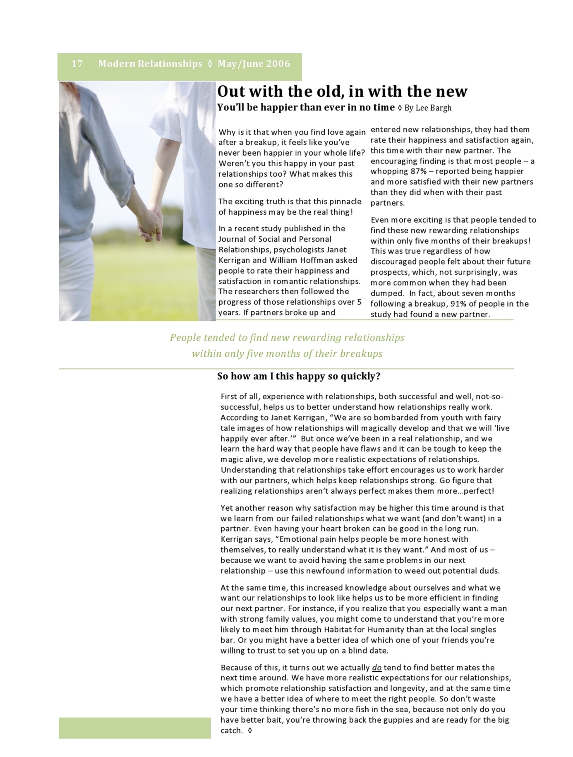
Mate scarcity article.
