Original Research Article

The influence of heat on the torque of prosthetic screws: an in vitro study

.
ABSTRACT
Aim: To evaluate whether applying heat to the implant surface can reduce the torque of the prosthetic screw. Study Design: Comparative in vitro experimental study. Place and Duration of Study: Department of Restorative Dentistry, School of Dentistry, Federal University of Minas Gerais between January 2023 and March 2025. Materials and Methods: In this in vitro study, a total of 40 implants were installed in bovine rib blocks, featuring Morse taper (MT) and external hexagon (EH) connections and they were divided into 4 groups: MT test (n =10), MT control (n=10), EH test (n=10) and EH control (n=10). Heat was applied at 47°C to the test groups prior to measuring the detorque of the prosthetic screws. The detorque value was also measured for the control groups. Data were analyzed using IBM SPSS Statistics (Version 26). Descriptive analysis, Shapiro-Wilk test for normality, and paired t-test were performed, with a significance level set at 5% (P=.05). Results: The results showed no significant differences in torque compared to the experimental group. Conclusion: The application of heat at 47ºC did not reduce the torque of prosthetic screws in dental implants.

Keywords: Torque; Thermal Conductivity; Implants; Biomechanics.

1. INTRODUCTION

Due the increasing use of dental implants in dentistry and the need to create a long-lasting system, mechanical challenges have become inevitable in the pursuit of the best treatment option.[1] Screw fractures and irreparable prosthetic component failures are the most recurrent complications.[2] Therefore, the problem goes beyond implants, as the removal and insertion of prosthetic components also present challenges for the clinician. Manufacturing defects or errors in the screw thread design may explain fractures of abutments or abutment screws.[3] Additionally, the interface design can significantly influence the stability of the connection between components. [4]
Some techniques are already used to remove those prosthetic screws. The use of ultrasound equipment or the creation of a channel using a high-speed handpiece in the prosthetic screw to obtain higher adherence as well as the use of rescue kits are some of them. [5,6] However, in certain situations these techniques may not be suitable or enough, since they can damage the internal configuration of the implant or generate too much heat in the bone structure.[7]
A study demonstrated that temperature variation may be a solution to minimize the prosthetic challenge regarding abutments removal, as it causes material expansion and reduces contact between the screw’s surface and the internal threads of the implant.[8] Beside that, it is a factor capable of reverting e reducing the torque, making easier to remove the screws.[9] This occurs due to the cooling process, which induces a decrease in plastic deformation as a result of the alteration of the crystalline slip plane, leading to a potential weakening of the metal.[10]
The cooling effect on different indexed implant screws was also evaluated in another study and it was confirmed that it reduces the preload and facilitates removal of screw’s fragments, but the effect is dependent on implant connection and its abutment.[11] Despite the promising results obtained by these studies on the effects of temperature reduction on detorque of prosthetic screws, there are still no data in dental literature which associate the direct application of heat, promoting temperature increase, for the removal of abutments.
Thermal conductivity is the heat transfer capacity of each material.[3] Some studies have already shown the entry of energy as a form of weakening bone-implant fixation, [12,13] but there is no study which correlates the gain of energy with the loosening and removal of prosthetic screws.
For this reason, studies evaluating the relation between heat application and torque as a form of solving those mechanical challenges involving prosthetic screws are needed. Knowing these interactions could provide alternatives to simplify the clinical routine of dentists, especially when it comes to removing stripped screws. Therefore, the aim of this study is to evaluate whether the heat application to the surface of the prosthetic screw can reduce its torque. The null hypothesis of this study is that heat doesn’t interfere with the torque value of the prosthetic screws.

2. MATERIAL AND METHODS

In this quantitative, experimental, in vitro study, a trained and calibrated examiner (K= 0,87) performed the laboratory analysis. It used bovine rib blocks due to its similarity in macroscopic structure to the human jawbone. Since the bovine ribs were obtained post-slaughter from the local food market, the study was not submitted to the animal ethics committee.[14] The bone segments underwent a cleaning process to remove soft tissue, and the dimensions were standardized (6 cm - length x 1.2 cm - width x 4 cm - height). The sample size calculation for mean comparison was performed.[15] A standard deviation of 2.84 Ncm was considered,[11] with a detectable difference between groups set at 3 Ncm in torque value. A 95% significance level and 80% test power were adopted, determining a sample size of 10 implants per group. Were used Morse taper (MT) and external hexagon (EH) connections, both implants type measuring 4.1 mm x 10 mm (Bionnovation, Juiz de Fora, Minas Gerais, Brazil) and they were divided de forma aleatória (randomização simples) into 4 groups: MT test (n =10), MT control (n=10), EH test (n=10) and EH control (n=10). The implant sites were prepared according to the manufacturer's protocol, using a 20:1 reduction handpiece. The implants were installed in an alternating manner, with one implant from the MT group and one from the EH group side by side in the bone block. The final position of the implants was at crest level. The bone segments were fixed in a bench vise to prevent movement during the tests (figure 1).[16]

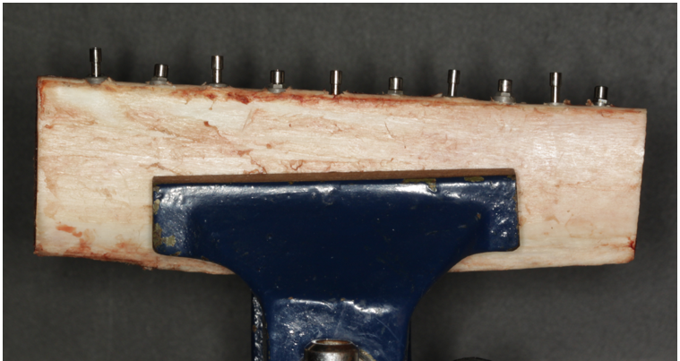
Fig. 1: External hexagon (EH) and Morse taper (MT) implants and prosthetic screws installed in bovine ribs.

Each connection (MT and EH) was divided into 2 subgroups: control group (without heat application) and test group (with heat applied at 47º C). Heat was applied to the prosthetic screws using a fine tip of an electric dropper, its temperature was measured with a digital thermometer (figure 2) adopting the temperature of 47º C considering that it’s the highest temperature supported by bone without damaging it.[17]
All the prosthetic screws were torqued according to instructions by the manufacturer with a calibrated digital torque meter (Lutron TQ - 8800): MT screws received a torque of 20 Ncm, while EH screws received a torque of 32 Ncm. In all groups, the torque was reapplied after 10 minutes using the digital torque meter to compensate for the effects caused by the settling phenomenon.[18] Each group had the detorque of the prosthetic screw measured using the digital torque meter. In the test group, the detorque was realized after the heat application for 60 seconds (figure 3), as in the control group it was realized without the heat application. All the values were recorded in a spreadsheet and transferred to the statistical analysis software.
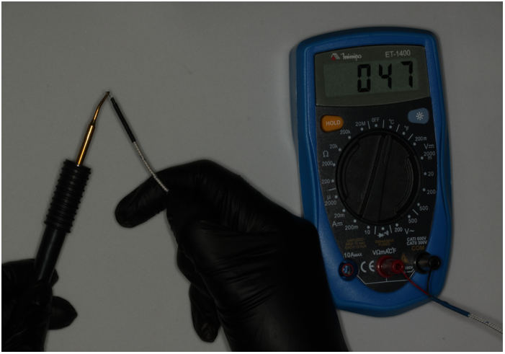
Fig. 2: Fine-point measurement of the electric dropper to ensure the temperature does not exceed 47°C.

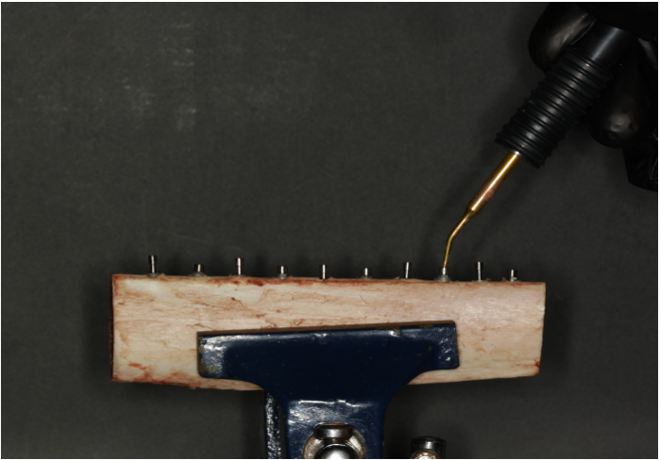
Fig. 3: Heat application for 60 seconds on the prosthetic screws belonging to the experimental group.
The data were analyzed using the IBM SPSS Statistics software (IBM SPSS Statistics for Windows, Version 26. Armonk, NY: IBM Corp). Descriptive analysis was performed to obtain the mean and standard deviation. The Shapiro-Wilk test was used to assess data normality. A paired t-test was applied to compare the groups. A significance level of 5% (P=.05) was adopted.
3. RESULTS AND DISCUSSION

No significant difference in detorque was observed between the control and test group, where heat of approximately 47°C was applied (table 1).
Table 1: Comparison of detorque values measured in the control group and the test group.
 | Detorque
 | Mean  (Ncm) | SD | *P
EH control (n=10) | 16,34 | 5,15
EH test (n=10) | 13,61 | 4,98 | 0,269
MT control (n=10) | 8,92 | 2,58
MT test (n=10) | 8,60 | 2,30 | 0,780
*Paired t-test.

The present study evaluated the effect of heat application on the detorque values of prosthetic screws, as well as the influence of the prosthetic connection on these values. The results showed that heat application aiming to decrease the torque of prosthetic screws did not show significant difference compared to the control group. Furthermore, the prosthetic connection also presents no significant difference regarding the detorque after heat application.
The literature presents studies with similar methodologies but different results, however, using the cooling technique. It has been proven screw cooling causes a decrease of plastic deformation due to the reduction in the crystalline slip plane, leading to metal weakening. [10]
Joda et al. (2013)[8] described the cryomechanical method, which consists in the tension release of an abutment screw after cooling it, facilitating its removal.[8] Besides that, it was established that there was no alteration in the implant-abutment interface, as intact osseointegration was confirmed after 10 years. Concerning the clinical applicability, a study demonstrated that approximately 20% of the cases involving stripped screws were removable through the cooling technique, thereby showing the practical relevance of thermal alteration.[11]
The effects on detorque values were evaluated using two types of prosthetic connections in the present study (MT and EH). No significant differences were observed in torque loss in any of the groups (control vs. test, MT vs. EH). Nevertheless, there is evidence in the literature which demonstrates that tapered connections are more favorable for initial torque maintenance.[19]
In the study of Srimurugan-Thayanithi et al. (2023)[11], verification and tightening of the prosthetic screws in both implant groups were performed after 10 minutes to ensure the torque. The same procedure was adopted in the present study to eliminate preload loss due to the difference between insertion and reverse torque values.[20,21] Preload occurs because the screw undergoes elastic deformation and elongates when tightened, thereby creating a tensile force.[22] As a result, the implant acts as a tensioned spring, generating a force that maintains fixation and contributes to implant-screw stability. [23]
The loosening provoked by temperature changes can occur due two main reasons: the creep behavior of materials and the relative movements caused by the difference in thermal expansion of the materials.[24] In mechanical engineering, the increase in temperature for removal of threaded components is already a well-established practice, and many studies have been performed to assess this effect.[25,26,27] However, the relationship between heat application and the torque of prosthetic screw has not yet been demonstrated in any scientific study. Therefore, research investigating this relationship is of great importance. This correlation has been explored only in the context of removing osseointegrated implants through limited thermal necrosis’ induction at the bone-implant interface.[12,13] As a consequence, it was verified that the heat generation on the internal surface of the implant collar can induce its removal with a force below 30 Ncm, without apparent bone loss or macroscopic bone necrosis.[28]
As discussed above, it is essential to consider the temperature threshold for transient changes in bone. Many studies have shown that the ideal temperature limit tolerable by bone is 47 °C.[17,29] Exceeding this temperature can lead to necrosis, enzyme inactivation, protein denaturation, bone resorption, hyperemia, and increased osteoclastic and osteoblastic activity in bone tissues. [30] Therefore, one limitation of this study is determining how much of the heat applied to the prosthetic screw is transferred to the individual's bone and whether all the applied temperature is effectively converted into heat within the bone. This limitation arises from the fact that temperature measurements were taken at the heat applicator instrument. Pure titanium, as well as titanium alloys, has low thermal conductivity compared to other metals.[31,32] So, considering the low thermal conductivity of titanium implants, a higher temperature could potentially be applied directly to the prosthetic screw, which might result in different outcomes. New studies should be conducted to find strategies for the removal of prosthetic components without damaging structures or interfering with the rehabilitative treatment.
Future in vitro studies should be conducted to analyze the effect of heating on different types of implants. However, since bone has a temperature threshold that must not be exceeded, applying heat at appropriate temperatures may sometimes not be sufficient to address this situation. Therefore, future research evaluating new strategies for prosthetic screw removal should be carried out to prevent alterations to the internal configuration of the implant or heating of the bone structure. This is important as implants are increasingly being used as treatment options but may be accompanied by some mechanical and biological complications.[33,34] These complications are associated with clinical practice and are therefore unfavorable for the success of rehabilitative treatment.[35,36]
This study presents advances in the literature as it is an in vitro study that ensures precision and control, in addition to comparing the two most clinically used types of implants. Investigating methods that facilitate the removal of prosthetic screws without damaging the implant platform or adjacent tissues is of utmost importance to ensure the success of the patient’s rehabilitative treatment and the overall treatment conducted by the clinician.
4. CONCLUSION
It was concluded that the application of heat (47ºC) did not have an influence on the removal of these components, either MT or EH implants.
DISCLAIMER (ARTIFICIAL INTELLIGENCE)
Author(s) hereby declare that NO generative AI technologies such as Large Language Models (ChatGPT, COPILOT, etc.) and text-to-image generators have been used during the writing or editing of this manuscript.

REFERENCES

[1] Solderer A, Al-Jazrawi A, Sahrmann P, Jung R, Attin T, Schmidlin PR. Removal of failed dental implants revisited: Questions and answers. Clin Exp Dent Res. 2019; 5(6):712-724.
[2] Mangano F, Macchi A, Caprioglio A, Sammons RL, Piattelli A, Mangano C. Survival and complication rates of fixed restorations supported by locking-taper implants: a prospective study with 1 to 10 years of follow-up. J Prosthodont. 2014; 23(6):434-44.
[3] Meisberger EW, Bakker SJ, Cune MS. Temperature rise during removal of fractured components out of the implant body: an in vitro study comparing two ultrasonic devices and five implant types. Int J Implant Dent. 2015 ;1(1):7.
[4] Balshi TJ, Hernandez RE, Pryszlak MC, Rangert B. A comparative study of one implant versus two replacing a single molar. Int J Oral Maxillofac Implants. 1996; 11(3):372-8.
[5] Luterbacher S, Fourmousis I, Lang NP, Brägger U. Fractured prosthetic abutments in osseointegrated implants: a technical complication to cope with. Clin Oral Implants Res. 2000; 11(2):163-70.
[6] Siamos G, Winkler S, Boberick KG. Relationship between implant preload and screw loosening on implant-supported prostheses. J Oral Implantol. 2002; 28(2):67-73.
[7] Huttula AS, Tordik PA, Imamura G, Eichmiller FC, McClanahan SB. The effect of ultrasonic post instrumentation on root surface temperature. J Endod. 2006; 32(11):1085-7.
[8] Joda T, Wittneben JG, Brägger U. A novel cryo-mechanical approach for the removal of blocked nonretrievable implant components. Int J Oral Maxillofac Implants. 2013; 28(1):e45-7.
[9] Sutter F, et al. The role of screws in implant system. Int J Oral Maxillofac Implants. 1994; 9: 51-52.
[10] Traini T, Di Iorio D, Caputi S, Degidi M, Iezzi G, Piattelli A. In vitro evaluation of thermomechanic coupling in conical implant-to-abutment joint. Implant Dent. 2007; 16(4):379-86.
[11] Srimurugan-Thayanithi N, Abou-Ayash S, Yilmaz B, Schimmel M, Brägger U. Effect of Abutment Cooling on Reverse Torque Values of Abutment Screws: An In Vitro Study. Int J Oral Maxillofac Implants. 2023; 38(1):94-100.
[12] Gungormus M, Erbasar GNH. Transient Heat Transfer in Dental Implants for Thermal Necrosis-Aided Implant Removal: A 3D Finite Element Analysis. J Oral Implantol. 2019; 45(3):196-201.
[13] Massei G, Serge SM. Thermo‐explantation. A novel approach to remove osseointegrated implants. European Cells and Materials. 2004; 7 (2):48.
[14] Loh CYY, Wang AYL, Tiong VTY, Athanassopoulos T, Loh M, Lim P, Kao HK. Animal models in plastic and reconstructive surgery simulation-a review. J Surg Res. 2018; 221:232-245.
[15] Lwanga SK, Lemeshow S. Sample size determination in health studies: a practical manual. World Health Organization, Geneva, 1991.
[16] Nova MFP, et al. Avaliação do torque para inserção, remoção e fratura de diferentes mini-implantes ortodônticos. Rev Dent Press Ortod Ortop Facial. 2008: 13 (5): 76-87.
[17] Bashutski JD, D'Silva NJ, Wang HL. Implant compression necrosis: current understanding and case report. J Periodontol. 2009; 80(4):700-4.
[18] Winkler S, Ring K, Ring JD, Boberick KG. Implant screw mechanics and the settling effect: overview. J Oral Implantol. 2003; 29(5):242-5.
[19] Pardal-Peláez B, Montero J. Preload loss of abutment screws after dynamic fatigue in single implant-supported restorations. A systematic review. J Clin Exp Dent. 2017; 9(11):e1355-e1361.
[20] Assunção WG, Barão VA, Delben JA, Gomes ÉA, Garcia IR Jr. Effect of unilateral misfit on preload of retention screws of implant-supported prostheses submitted to mechanical cycling. J Prosthodont Res. 2011; 55(1):12-8.
[21] Huang Y, Wang J. Mechanism of and factors associated with the loosening of the implant abutment screw: A review. J Esthet Restor Dent. 2019; 31(4):338-345.
[22] Byrne D, Jacobs S, O'Connell B, Houston F, Claffey N. Preloads generated with repeated tightening in three types of screws used in dental implant assemblies. J Prosthodont. 2006; 15(3):164-71.
[23] Jaarda MJ, Razzoog ME, Gratton DG. Geometric comparison of five interchangeable implant prosthetic retaining screws. J Prosthet Dent. 1995; 74(4):373-9.
[24] Hou S, Liao R, Li J. A Mathematical Model for Temperature Induced Loosening due to Radial Expansion of Rectangle Thread Bolted Joints. Advances in Mechanical Engineering. 2015;7(1).
[25] Sawa T, Takagi Y, Yamada K. Evaluation of the sealing performance in bolted flange connection under heat condition and internal pressure: the effect of scatter in bolt preloads. In: ASME 2006 pressure vessels and piping/icpvt-11 conference [Internet]; 23-27 jul 2006; Vancouver, BC, Canada]: ASMEDC; 2006.
[26] Sawa T, Ishimura M, Yamanaka H, Fukuba Y. Mechanism of rotational screw thread loosening in bolted joints under repeated temperature changes. In: ASME 2007 pressure vessels and piping conference [Internet]; 22-26 jul 2007; San Antonio, Texas, USA: ASMEDC; 2007.
[27] Yang X, Nassar SA, Wu Z. Thermo-Mechanical behavior of a stainless steel threaded fitting with a pre-compressed gasket. In: ASME 2008 pressure vessels and piping conference [Internet]; 27-31 jul 2008; Chicago, Illinois, USA: ASMEDC; 2008 .
[28] Cunliffe J, Barclay C. Removal of a dental implant: An unusual case report. Journal of Dental Implants. 2011: 1(1): 22-25.
[29] Eriksson A, Albrektsson T, Grane B, McQueen D. Thermal injury to bone. A vital-microscopic description of heat effects. Int J Oral Surg. 1982; 11(2):115-21.
[30] Calvo-Guirado JL, Delgado-Peña J, Maté-Sánchez JE, Mareque Bueno J, Delgado-Ruiz RA, Romanos GE. Novel hybrid drilling protocol: evaluation for the implant healing--thermal changes, crestal bone loss, and bone-to-implant contact. Clin Oral Implants Res. 2015; 26(7):753-60.
[31] Powell RW, Tye RP. The thermal and electrical conductivity of titanium and its alloys. J. Less-Common Met. 1961: 3 (3): 226-233.
[32] Hong SY, Markus I, Jeong WC. New cooling approach and tool life improvement in cryogenic machining of titanium alloy Ti-6Al-4V. IJMTM 2001; 41(15):2245-2260.
[33] Gbara A, Darwich K, Li L, Schmelzle R, Blake F. Long-term results of jaw reconstruction with microsurgical fibula grafts and dental implants. J Oral Maxillofac Surg. 2007; 65(5):1005-9.
[34] Wittneben JG, Millen C, Brägger U. Clinical performance of screw- versus cement-retained fixed implant-supported reconstructions--a systematic review. Int J Oral Maxillofac Implants. 2014;29 Suppl:84-98.
[35] Jung RE, Zembic A, Pjetursson BE, Zwahlen M, Thoma DS. Systematic review of the survival rate and the incidence of biological, technical, and aesthetic complications of single crowns on implants reported in longitudinal studies with a mean follow-up of 5 years. Clin Oral Implants Res. 2012; 23 Suppl 6:2-21.
[36] Sahin C, Ayyildiz S. Correlation between microleakage and screw loosening at implant-abutment connection. J Adv Prosthodont. 2014;6(1):35-8.

