**ANALYSIS OF ACTIVE METHODOLOGY IN THE MEDICINE COURSE AT A PUBLIC UNIVERSITY IN NORTHERN BRAZIL**

**ABSTRACT :** The globalization process has allowed greater access to knowledge and, as a result, learning methods have been changing over time. Currently, it is necessary to improve methodologies used in teaching, including in higher education institutions. The Problem-Based Learning (PBL) method aims to guide the student through a strategy to formulate self-knowledge, leading them to the adequate acquisition of skills that can be applied in their clinical reality, making their use practical. Therefore, the objective of this study is to report an educational experience in the teaching-learning process with PBL in the Medicine course at the Federal University of Northern Tocantins. Exploratory, prospective, quantitative study was carried out through the application of questionnaires to students to evaluate the active methodology, between May and July 2023. The data were subjected to statistical analysis, and it was observed that most students consider the PBL method superior when compared to the traditional teaching method.

**KEYWORDS:** Teaching Methods. Self-learning. Medicine.

**INTRODUCTION**

Globalization has significantly expanded access to knowledge, causing substantial changes in the ways of learning. Technological, social, economic and political transformations impose the need for new teaching methodologies, especially in higher education institutions, in order to monitor the evolution of students' perception of the teaching-learning process (DE OLIVEIRA GARCIA; DE OLIVEIRA; PLANTIER, 2019; JR, 2016).

Despite the proposed innovations, the traditional methodology, centered on the teacher, still predominates in undergraduate courses. In this model, the teacher is considered the main holder of knowledge, with knowledge being transmitted in a mechanistic way to students, who, in turn, assimilate it passively, without encouraging critical reflection (BEZERRA et al., 2020; PASQUALINI; LAVOURA, 2020). Although this approach may be somewhat effective, it fragments teaching and compromises the completeness of learning, especially in specific areas such as Medicine (JR, 2016). Furthermore, this method requires high didactic competence from the educator so that students can not only understand the theoretical contents, but also apply them efficiently in clinical practice (DA CRUZ et al., 2019).

Given this scenario, the Ministry of Health (MS) and the Ministry of Education and Culture (MEC) instituted Resolution No. 03, of June 20, 2014, which establishes the National Curricular Guidelines for undergraduate courses in Medicine. This regulation aims to train critical, reflective professionals committed to social reality, promoting student-centered teaching, with the teacher assuming the role of mediator in the educational process (ABREU, 2009; COTTA et al., 2012; EDUCAÇÃO, 2014). The aim is to improve the quality of health training and, indirectly, the assistance provided to the population (DE CASTRO, BARBOSA, MELLO; ALVES; LEMOS, 2014). However, it is observed that the adoption of active teaching-learning methodologies is still limited, especially in the north and northeast regions of Brazil (PAIVA et al., 2016; RICARDO; ABREU, 2009).

Among these methodologies, Problem-Based Learning (PBL) stands out, or *Problem-Based Learning (PBL)*, originally developed by McMaster University, in Canada. This pedagogical approach inserts students into problematizing contexts, stimulating logical reasoning, self-knowledge, communication and teamwork (DA SILVA, MAIA et al., 2020; DOS SANTOS, 1994). The PBL structure is based on seven stages, which involve reading and understanding problems, group discussion, formulating hypotheses, actively searching for information and synthesizing solutions (PINTO, 2022; QUEIROZ, 2012).

In the Brazilian context, the Federal University of Northern Tocantins (UFNT), through its Medicine course, established in 2015, adopts ABP as a teaching methodology with the aim of training technically qualified and humanistically sensitive doctors, committed to citizenship and the promotion of comprehensive health (CORDOVA; NUNES; MORON, 2018; UNIVERSIDADE FEDERAL DO TOCANTINS, 2018). However, there are still few investigations that address the application of this methodology in the Northern region of Brazil. Thus, with the purpose of contributing to the deepening of scientific knowledge on the subject, this research aims to analyze the educational experience in the teaching-learning process of the Medicine course at the Federal University of Northern Tocantins.

**METHODOLOGY**

This study integrates quantitative research, of a descriptive-analytical nature, with exploratory and evaluative purposes regarding the application of Problem-Based Learning (PBL) in tutoring meetings of the Medicine course at the Federal University of Northern Tocantins (UFNT). The target audience for the investigation was made up of one hundred and sixty-seven (n = 167) academics regularly enrolled and volunteers of the aforementioned course, on the Araguaína campus.

The sample included students from the first to the eighth periods, of both sexes, aged eighteen or over and with active and regular enrollment. Students who had dropped out of the course, who were in the internship period or who were away for health reasons were excluded from the research.

The research was approved by the Research Ethics Committee of the Hospital for Tropical Diseases of the Federal University of Tocantins (HDT-UFT), according to opinion number 6,088,887 (ANNEX I). All participants previously signed the Free and Informed Consent Form (TCLE), as provided for in current ethical regulations (APPENDIX I).

Data collection was carried out through the application of a questionnaire adapted from Moraes (2022) (ANNEX II), which allowed a quantitative and indirect analysis of the use of the ABP methodology in medical teaching. The instrument addressed aspects such as: prior knowledge of the method; anxiety levels regarding opening the case and self-directed study; prior preparation for the problem case; ease in identifying problems; performance in discussions to formulate hypotheses; ability to identify case objectives; coherence between proposed objectives and problems; perceived evolution between the first and last cases; study sources used; contribution of colleagues’ explanations; performance in group discussions; assertiveness in achieving objectives; importance attributed to the tutor's score in the acquisition of knowledge; relevance of the tutor's participation in the final considerations; perception of aptitude to carry out tests on the topics discussed; ease of applying knowledge in practical internships; and comparison of the effectiveness of PBL in relation to the traditional teaching method, both in the acquisition of theoretical knowledge and in its practical applicability.

The questionnaire was administered at the end of a tutorial meeting of each academic period, between the months of August and October 2023, with an individualized questionnaire being delivered to each participant by the responsible researchers. After collection, the data was organized and tabulated in Microsoft Excel® spreadsheets, with subsequent processing for comparison and inference purposes.

To facilitate data analysis, students were categorized according to their graduation phase: students from the first, second and third periods were grouped into the initial phase; those of the fourth, fifth and sixth periods, in the intermediate phase; and those of the seventh and eighth periods, in the conclusive phase. The statistical analyzes carried out were descriptive in nature, with the objective of identifying the distribution of responses per item among the sample participants.

Associations between variables were evaluated using Pearson's Chi-Square Test, adopting a significance level of 0.05. To carry out statistical analyses, the SAS® OnDemand for Academics software (SAS Institute Inc., 2015. Cary, NC, USA) was used.

**RESULTS**

A total of 167 questionnaires were administered to students of the Medicine course at the Federal University of Northern Tocantins (UFNT), regularly enrolled between the first and eighth period. Figure 1 shows the percentage distribution of completed questionnaires, according to the period studied by the participants.

It was observed that approximately 12% of the sample corresponded to students in the first period (n = 20), 14% in the second period (n = 24), 15% in the third period (n = 26), 8% in the fourth period (n = 13), 14% in the fifth period (n = 22), 11% in the sixth period (n = 18), 14% in the seventh period (n = 24) and 12% in the eighth period (n = 20). These data demonstrate a relatively balanced distribution between the different periods of graduation, which allows a representative analysis of students' perception regarding the application of the Problem-Based Learning (PBL) methodology in tutoring meetings.

**Figure 1.** Representation of the number of questionnaires applied according to the graduation period.

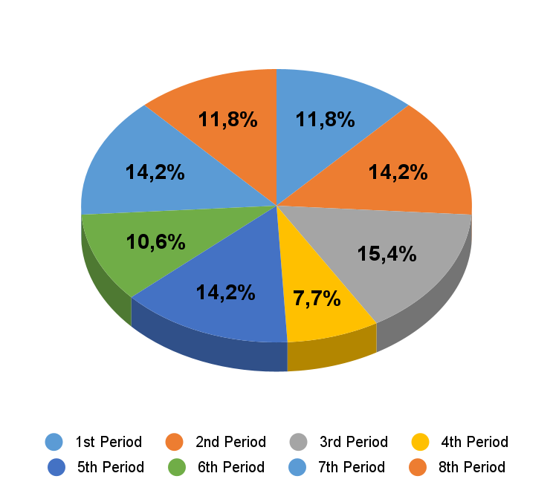

Source: AUTHOR (2025).

When analyzing the data, considering the sample as a whole, it was observed that, with regard to prior knowledge of the ABP methodology, the majority of students (63%) knew very little about the methodology and did not know how the method worked (figure 2), and a small portion knew it very well (5%) (p<0.001).

**Figure 2.** Prior knowledge of the ABP methodology before entering medical education.

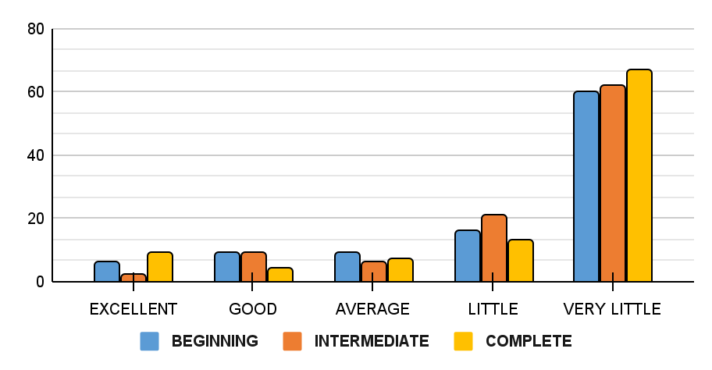

Source: AUTHOR (2025).

Regarding anxiety regarding the active methodology in opening the case and self-directed study, it was observed that 26.95% (figure 3) of sample considers themselves anxious during case opening (p=0.0014).

**Figure 3.** Anxiety level with the ABP method.

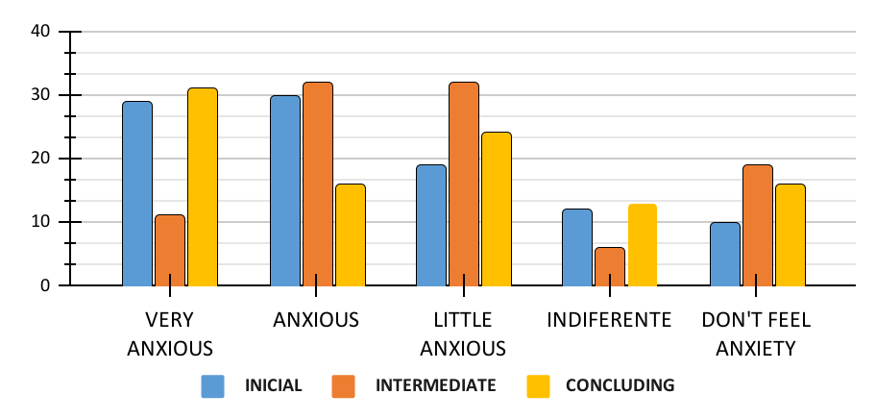

Source: AUTHOR (2025).

Regarding the development of the problem case, it was found that in relation to the preparation of the subject before the problem case, the majority of students (43.11%) considered it to be good preparation (p<0.001), 35.32% reported a good diversity of sources for acquiring knowledge (p<0.001), 47.3% showed regular ease in identifying problems (p<0.001), 42.51% reported good performance in raising hypotheses (p<0.001), 40.71% reported good ability to identify case objectives, 47.3% noted good agreement between the objectives defined by the group and the case objectives (p<0.001), 40.12% considered a good performance in their contribution to discussions (p<0.001), 31.3% described how to regulate the contribution of colleagues' explanations in discussions in the acquisition of knowledge (p=0.0007), 59.28% reported the group's frequency of achieving its objectives as good (p<0.001), 47.3% reported the group's assertiveness in relation to the case's objectives as good (p<0.001), 47.3% considered its progress in relation to PBL performance to be good (p<0.001). Regarding the role of the tutor, 31.54% of the sample considered the tutor's score at the closure of the case to be excellent in terms of knowledge acquisition (p=0.0004) and 68.26% reported the need for the tutor to act in the final considerations after closing the case as excellent (p<0.001).

Regarding the applicability of the knowledge acquired with the PBL, 38.92% considered their ability to carry out a knowledge test on the subject covered to be good (figure 4) (p<0.001) and 41.91% described the ease of applying knowledge as normal, right after the discussions, in the internships (p<0.001). When evaluating the comparison between the active methodology and the traditional teaching method, it was found that 30.54% considered the efficiency of the active methodology in acquiring theoretical knowledge to be good compared to the traditional method (p=0.0061) (figure 5) and 40.72% reported the superiority of the preparation provided by PBL to apply the knowledge acquired in the problem in everyday life as good (p<0.001).

**Figure 4.** Students' aptitude to perform in a post-tutorial knowledge test.

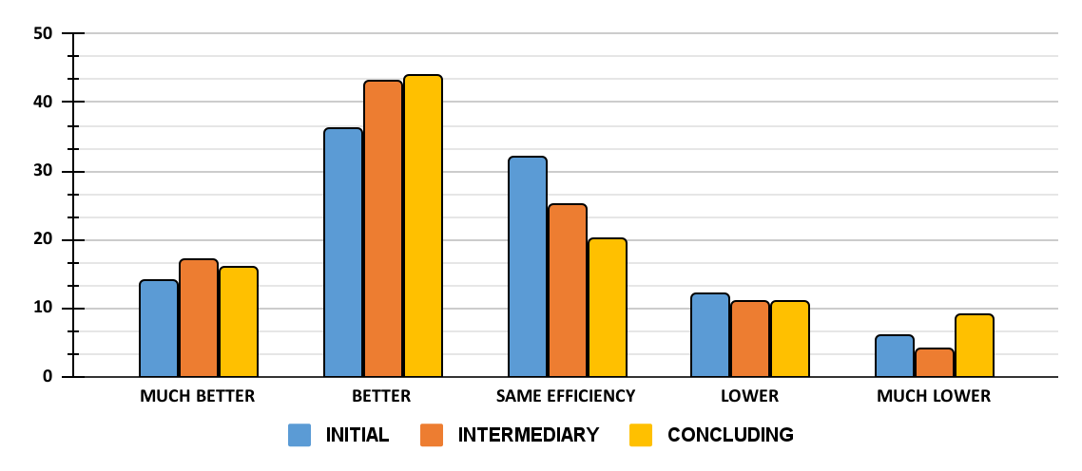

Source: AUTHOR (2025).

**Figure 5.** Efficacy of the ABP method compared to traditional methodology.

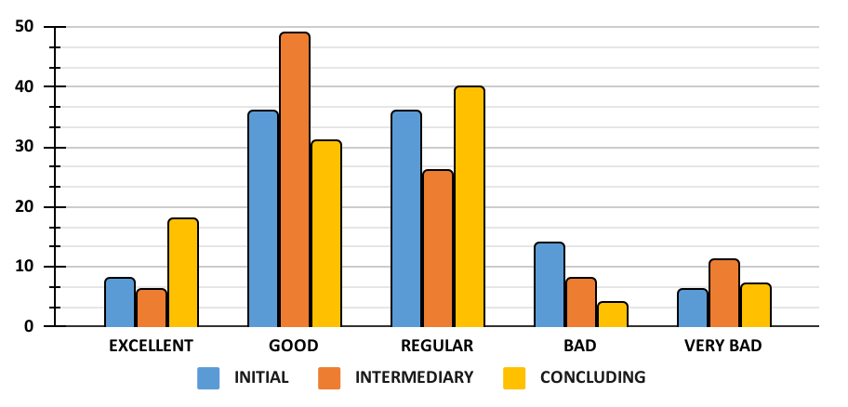

Source: AUTHOR (2025).

Table 1 shows data relating to the analysis of the sample as a whole and table 2 represents the analysis by periods (initial, intermediate, final). It is observed that in the latter, no statistical significance was verified, all analyzes showed a p value >0.05. In table 1 it is possible to see that the majority of students consider the ease of identifying problems and their ease of applying knowledge in internships after discussing the topic to be average. Furthermore, the vast majority of academics consider themselves to have a good performance in raising hypotheses, being able to identify and achieve the proposed study objectives and a good level of preparation in their study before discussing the case using different bibliographic sources. Furthermore, it was observed that, throughout the semester, students considered a good evolution in their general performance between the first and last cases.

**Table 1.** Data analysis considering the sample as a whole.

|  |  |  |  |  |
| --- | --- | --- | --- | --- |
|  | Assessment | n | % | p value |
| PRIOR KNOWLEDGE |  |  |  |  |
| 1) What is your level of knowledge about active methodology in medical education before having contact with it during your undergraduate studies? | roomy | 105 | 62,87 | p<0.001 |
| DEVELOPMENT |  |  |  |  |
| 2) What is your level of preparation on the subject to be covered before the discussion/class? | good | 72 | 43,11 | p<0.001 |
| 3) How easy was it to identify the Problems of the clinical case presented? | regular | 79 | 47,3 | p<0.001 |
| 4) How do you evaluate your performance in the discussion with your colleagues to raise Hypotheses? | good | 71 | 42,51 | p<0.001 |
| 5) How easy was it to identify the study objectives of the clinical case presented? | good | 68 | 40,71 | p<0.001 |
| 6) How much do you believe that the objectives defined by the group are in accordance with the clinical case presented? | good | 79 | 47,3 | p<0.001 |
| 7) If you have difficulty with unfamiliar terms, raise diagnostic hypotheses and discuss the problems, how do you consider their evolution between the first and last problems of the modules? | good | 79 | 47,3 | p<0.001 |
| 8) How often do you consider that you and the group achieve the objectives proposed by the tutor? | good | 99 | 59,28 | p<0.001 |
| 9) What is the diversity of sources used to acquire knowledge? | good | 59 | 35,32 | p<0.001 |
| 10) In discussions with colleagues, how much did their explanations add to your knowledge? | regular | 52 | 31,13 | p = 0.0007 |
| 11) How do you evaluate your performance in discussions with your colleagues? | good | 67 | 40,12 | p<0.001 |
| 12) How much do you consider the study objectives were achieved by the group? | good | 79 | 47,3 | p<0.001 |
| TUTOR |  |  |  |  |
| 13) How much did the tutor's scores after closing the case add to your knowledge? | excellent | 53 | 31,74 | p = 0.0004 |
| 14) How do you consider the need for the guardian to act in the final considerations after the case is closed? | excellent | 114 | 68,26 | p<0.001 |
| APPLICABILITY |  |  |  |  |
| 15) At the end of the discussion, how ready do you feel to take a knowledge test on the topic covered? | good | 65 | 38,92 | p<0.001 |
| 16) How easy is it to apply knowledge right after discussion during internships? | regular | 70 | 41,91 | p<0.001 |
| COMPARISON/EFFICIENCY |  |  |  |  |
| 17) Comparing with the traditional high school method, how do you consider the efficiency of the active PBL methodology in acquiring theoretical knowledge in medical graduation? | good | 51 | 30,54 | p = 0.0061 |
| 18) Compared to the traditional method, how much did learning through PBL make the group more prepared to apply the knowledge acquired in this problem in their daily lives? | good | 68 | 40,72 | p<0.001 |
| ANXIETY |  |  |  |  |
| 19) How anxious do you feel about the active methodology during case opening and self-directed study? | good | 45 | 26,95 | p = 0.0014 |

Source: AUTHOR (2025).

**Table 2.** Data analysis, considering the periods (initial, intermediate, final).

|  |  |  |  |
| --- | --- | --- | --- |
|  |  |  | p value |
| PRIOR KNOWLEDGE |  |  |  |
| 1) What is your level of knowledge about active methodology in medical education before having contact with it during your undergraduate studies? |  |  | p = 0.8168 |
| DEVELOPMENT |  |  |  |
| 2) What is your level of preparation on the subject to be covered before the discussion/class? |  |  | p = 0.2694 |
| 3) How easy was it to identify the Problems of the clinical case presented? |  |  | p = 0.3488 |
| 4) How do you evaluate your performance in the discussion with your colleagues to raise Hypotheses? |  |  | p = 0.9121 |
| 5) How easy was it to identify the study objectives of the clinical case presented? |  |  | p = 0.6477 |
| 6) How much do you believe that the objectives defined by the group are in accordance with the clinical case presented? |  |  | p = 0.3019 |
| 7) If you have difficulty with unfamiliar terms, raise diagnostic hypotheses and discuss the problems, how do you consider their evolution between the first and last problems of the modules? |  |  | p = 0.2825 |
| 8) How often do you consider that you and the group achieve the objectives proposed by the tutor? |  |  | p = 0.1965 |
| 9) What is the diversity of sources used to acquire knowledge? |  |  | p = 0.5035 |
| 10) In discussions with colleagues, how much did their explanations add to your knowledge? |  |  | p = 0.6798 |
| 11) How do you evaluate your performance in discussions with your colleagues? |  |  | p = 0.1084 |
| 12) How much do you consider the study objectives were achieved by the group? |  |  | p = 0.4570 |
| TUTOR |  |  |  |
| 13) How much did the tutor's scores after closing the case add to your knowledge? |  |  | p = 0.3409 |
| 14) How do you consider the need for the guardian to act in the final considerations after the case is closed? |  |  | p = 0.3113 |
| APPLICABILITY |  |  |  |
| 15) At the end of the discussion, how ready do you feel to take a knowledge test on the topic covered? |  |  | p = 0.0904 |
| 16) How easy is it to apply knowledge right after discussion during internships? |  |  | p = 0.2474 |
| COMPARISON/EFFICIENCY |  |  |  |
| 17) Comparing with the traditional high school method, how do you consider the efficiency of the active PBL methodology in acquiring theoretical knowledge in medical graduation? |  |  | p = 0.7682 |
| 18) Compared to the traditional method, how much did learning through PBL make the group more prepared to apply the knowledge acquired in this problem in their daily lives? |  |  | p = 0.9176 |
| ANXIETY |  |  |  |
| 19) How anxious you feel in relation to active methodology during case opening and self-directed study? |  |  | p = 0.0909 |

Source: AUTHOR (2025).

**DISCUSSION**

GALVAO et al., 2014, in a meta-analysis, compared the effects of learning based on the ABP method with the traditional method. The analysis included student impressions and compared group scores. The results showed that students using the ABP method performed better in intermediate and final academic tests compared to students using the traditional method. In the present study, students from the first to the eighth period of their medical degree participated by filling out a questionnaire on their personal perception of the active methodology. It was evidenced that the majority of students considered that the ABP method is more efficient when compared to the traditional teaching method in the acquisition of theoretical knowledge (p = 0.0061) and in the applicability of knowledge in daily practice (p<0.001). Furthermore, it was observed that the majority of participants had poor knowledge regarding the active methodology (p<0.001) and some anxiety when opening the problem case (p= 0.0014). Despite this, the majority of students in this study considered their performance in relation to the learning process to be good, in terms of subject preparation (p<0.001), diversity of sources (p<0.001), performance in the discussion to raise hypotheses (p<0.001), identifying objectives (p<0.001), agreement between the objectives raised by the group and those of the problem case (p<0.001), assertiveness in the objectives raised by the group (p<0.001), performance in discussions (p<0.001), evolution between problems (p<0.001). Furthermore, students considered the ease in identifying problems to be regular (p<0.001) and the contribution of their colleagues' explanations during the discussion (p= 0.0007).

BIJLI; SHANKARAPPA, 2012 investigated the opinion of 772 medical students about the effectiveness of the traditional method and ABP. In this study, the majority of students considered that the ABP method offers greater quality in terms of learning efficiency. Furthermore, the presence of the tutor at meetings was highlighted as crucial to facilitate communication and discussions during the learning process, which can contribute to better knowledge construction. This corroborates this research, in which the majority of students consider their ability to take a knowledge test on the subject covered to be good (p<0.001) and believe that their ability to apply the knowledge acquired in practice is fair (p<0.001). In this study, it was verified that the tutor's observations at the end of the case are essential, in the academics' perception, to complement knowledge (p=0.0004) and that the tutor's participation is necessary in the final considerations at the end of the case (p<0.001).

The article "Experimental Planning Factorial: A Brief Review" (OLIVEIRA et al., 2018) highlights the importance of factorial planning as a statistical tool for analyzing multiple variables in scientific research. This method, widely used in areas such as biotechnology and health sciences, allows the evaluation of interactions between complex factors — such as those involved in the implementation of PBL (Problem-Based Learning) — with fewer experiments and greater results. In the context of the study on active methodologies in medicine, factorial planning could be applied to analyze, for example, how variables such as class anxiety level, tutor preparation, and diversity of study sources interact to influence PBL results. In addition, the multivariate approach would reinforce the statistical robustness of the research, complementing the quantitative analysis already performed with tests such as the Chi-Square. The integration of these methodologies could thus improve the evaluation of educational disciplines, aligning with national guidelines that require critical and evidence-based medical training.

The presence of anxiety in students during case opening and self-directed study may be related to limited prior knowledge about PBL. Even so, the participants in this research evaluated the implementation of the ABP positively, according to the questions asked. Furthermore, it was observed that students feel prepared to apply the content in their daily lives.

In his study, DE LEON; BY QUADROS ONÓFRIO, 2015, argued that the adoption of a hybrid learning system (traditional and PBL) could be a promising strategy. This is because the ABP method promotes the development of skills and critical clinical reasoning independently, while the traditional method contributes to the acquisition of deeper knowledge on the topics covered. Therefore, the authors consider the possibility of combining methods to improve the effectiveness of applied teaching.

One of the limitations of this study is the sample number, since the number of students available for data collection was restricted to those enrolled in the institution where the research was carried out, which is limited. However, the data obtained allows us to infer that the active methodology, in the student's view, allows the acquisition of knowledge in a satisfactory way.

It is possible to see that ABP is an effective and satisfactory methodology for training future doctors. There was a general positive evaluation of the method and the majority of students consider the ABP method to be superior when compared to the traditional teaching method.

**CONCLUSION**

The results of this study suggest that the active methodology can promote a greater capacity for clinical reasoning, in addition to encouraging more active participation by the student, resulting in more engaged and reflective learning, thus favoring self-learning, as the student is primarily responsible for this process.

Although PBL has its flaws and limitations, such as the difficulty of adapting during the first periods of graduation, its adoption should not be abandoned. Instead, the methodology can evolve and adapt to maximize its advantages and minimize its weaknesses.

By adopting ABP, doctors in training not only have the possibility of acquiring broad knowledge, but they can also develop essential skills such as communication, problem solving and self-learning, fundamental attributes for medical professionalism.

**REFERENCES**

ABREU, J. R. P. DE. Current context of medical education: traditional and active methodologies: pedagogical needs of teachers and the structure of schools. 2009.

BEZERRA, K. K. S. et al. Active Methodologies in the Context of Medical Education in Brazil. **ID online REVISTA DE PSICOLOGIA**, v. 14, n. 51, p. 393–407, out. 2020.

BIJLI, N.; SHANKARAPPA, M. Indian medical students’ perspectives on problem-based learning experiences in the undergraduate curriculum: One size does not fit all. **Journal of Educational Evaluation for Health Professions**, v. 10, p. 11, out. 2012.

CORDOVA, C.; NUNES, E. M.; MORON, S.E. **PEDAGOGICAL PROJECT FOR THE MEDICINE COURSE AT THE ARAGUAÍNA CAMPUS**. , 2018.

COTTA, R. M. M. et al. Construction of collective portfolios in traditional curricula: an innovative teaching-learning proposal. **Science & Public Health**, v. 17, p. 787–796, 2012.

DA CRUZ, P. O. et al. Perception of the Effectiveness of Teaching Methods Used in a Medicine Course in Northeastern Brazil. **Brazilian Journal of Medical Education**, v. 43, n. 2, p. 40–47, out. 2019.

DA SILVA MAIA, H. A. A. et al. Prevalence of Depressive Symptoms in Medical Students with a Problem-Based Learning Curriculum. **Brazilian Journal of Medical Education**, v. 44, no. 3, 2020.

DE CASTRO BARBOSA MELLO, C.; ALVES, R. O.; LEMOS, S. M. A. Teaching and training methodologies in the health area: literature review. **CEFAC Magazine**, v. 16, n. 6, p. 2015–2028, out. 2014.

DE LEON, L. B.; DE QUADROS ONÓFRIO, F. Problem-Based Learning in Medical Undergraduate Studies – A Review of Current Literature. **Brazilian Journal of Medical Education**, v. 39, n. 4, p. 614–619, out. 2015.

DE OLIVEIRA GARCIA, M. B.; DE OLIVEIRA, M. M.; PLANTIER, A. P. Interactivity and Mediation in the Practice of Active Methodology: the Use of Peer Instruction and Technology in Medical Education. **Brazilian Journal of Medical Education**, v. 43, n. 1, p. 87–96, out. 2019.

De Oliveira, M., Lima, V. M., Yamashita, S. M. A., Alves, P. S., & Portella, A. C. (2018). Experimental planning factorial: a brief review. **International Journal of Advanced Engineering Research and Science**, 5(6), 264164.

DOS SANTOS, S. R. PROBLEM-BASED LEARNING (PBL). **Brazilian Journal of Medical Education**, v. 18, n. 3, p. 121–124, out. 1994.

EDUCAÇÃO, C. N. D. E. **RESOLUTION Nthe 3, OF JUNE 20, 2014 Establishes National Curricular Guidelines for the Undergraduate Medicine Course and provides other measures**. , 2014.

GALVAO, T. F. et al. Problem-Based Learning in Pharmaceutical Education: A Systematic Review and Meta-Analysis. **The Scientific World Journal**, v. 2014, pp. 1–7, 2014.

JR, V. C. Active methodology in medical education. **Medicine Magazine**, v. 95, n. 3, p. 113, out. 2016.

MORAES, S. R. C. D. E. **Analysis of Problem-Based Learning applied in specialization in ophthalmology**. , 2022.

PAIVA, M. R. F. et al. **ACTIVE TEACHING-LEARNING METHODOLOGIES: INTEGRATIVE REVIEW**. , 2016.

PASQUALINI, J. C.; LAVOURA, T. N. THE TRANSMISSION OF KNOWLEDGE UNDER DEBATE: IS HISTORICAL-CRITICAL PEDAGOGY REHABILITATING TRADITIONAL TEACHING? **Education in Magazine**, v. 36, 2020.

PINTO, M. M. C. G. PROBLEM-BASED LEARNING. **Gender and Interdisciplinary Magazine**, v. 3, n. 01, out. 2022.

QUEIROZ, A. PBL, PROBLEMS THAT BRING SOLUTIONS. **Psychology, Diversity and Health Magazine**, v. 1, n. 1, out. 2012.

RICARDO, J.; ABREU, P. DE. **ACTIVE TEACHING-LEARNING METHODOLOGIES: INTEGRATIVE REVIEW**, 2009.