Original Research Article
Assessment of dyeing potential of violet pigment produced by Streptomyces DP6

ABSTRACT

Introduction: Environmental pollution and hazardous waste, resulted from the use of synthetic dyes in industries, have sparked the interest of researchers and industries towards the discovery of eco-friendly, biodegradable, non-toxic natural colors. Among these natural safe colorants, microbial pigments hold considerable potential for use in various industries like textile, food, pharmaceutical etc. Streptomyces violaceoruber strain DP6 producing violet pigment was isolated, and characterized.
Material and Methods: Isolate DP6 was isolated from soil sample and pigment production was optimized. Pigment dyeing potential was assayed on silk and wood. Pigment was purified and characterized.
Results: For optimum pigment production, the isolate was grown in ISP5 medium, at an initial pH of 5.0-5.5, with 2% inoculum and at temperature of 30ºC under shaking conditions at 160 rpm for 10 days. The violet pigment was extractable in ethyl acetate and was highly sensitive to pH changes and sunlight. Further in the study, dyeing ability of the violet pigment produced under optimum conditions was assessed on wool and silk fabrics where the color yield was found to be better on wool as compared to silk. Additionally, mutagenicity tests revealed non-mutagenic nature of the tested pigment. Purification and characterization of the pigment suggested it may have an anthraquinone type structure having methoxy group.
Conclusions: The study results indicate that violet pigment from Streptomyces DP6 hold the potential to be exploited as safe dye for use in textile industry.

Keywords: Streptomyces DP6, violet pigment, dyeing ability, non-toxic

1. INTRODUCTION
The textile industry in India is the second largest sector after agriculture, generating huge employment opportunities for both types of skilled and unskilled labour. It offers employment to around forty five million people directly and around sixty million people indirectly in the country Colouring textile materials dates back to ancient times. Nowadays, the textile dyeing industry is facing challenges related to environmental issues. This industry is generating a substantial amount of contaminated water waste and also generating large amount of chemical waste (Kramar & Kostic, 2022; Islam et al., 2023). Dyed fabrics also contain toxic dye residues attached to the fabric and these chemicals can cause skin problems to consumers when they use dyed fabrics. Thus, use of these chemical or synthetic dyes in textile industry is posing significant threat to the environment and human health (Alihosseini et al., 2008; DeBritto et al, 2020).
Pigment production from natural sources is gaining importance worldwide due to safety concerns triggered by use of artificial synthetic dyes. Natural dyes are safer and environment friendly because of their better biodegradability. Microorganisms are well known for producing secondary metabolities including pigments antibiotics and enzymes (Kanwar et al., 2024; Etta et al., 2025; Sharma et al., 2025). However, pigments from microorgansims are less explored as compared to plants and animals (Sen et al., 2019). Microoroganisms belonging to the Genus Serratia, Streptomyces, Pseudomonas, Chromobacterium and Janthinobacterium are known to produce a variety of both extracellular as well as intracellular pigment (Agarwal et al., 2023). Biopigments chemically attach to textile materials and form bonds with functional groups of fabric fibres. Additionally, these pigments also possess good antimicrobial, anticancerous and antioxidative properties (Stankovic et al., 2014; Mumtaz et al., 2019; Venil et al. 2021). Nowadays, researchers are isolating pigment producing microbes and exploring their dyeing potential (Kumar et al., 2018; Galasso et al., 2017; Mazotto et al., 2021). To make earth sustainable, the best option is to replace the harmful chemical dyes with natural dyes produced by microorganisms.
Among microorganisms, actinobacteria, especially Streptomyces spp. produce many intensely pigmented molecules that cover the visible light spectrum. Ultramarine blue pigment actinorhodin and yellow pigment from Streptomyces coelicolor, red pigment rubrolone from Streptomyces echinoruber are examples of pigments reported from Streptomyces (Sarmiento-Tovar et al., 2022). The production of distinct cocktail of pigments by Streptomyces spp. has been employed as an important cultural characteristic in characterizing these microorganisms. Despite the multifarious potential of Streptomyces spp. in diverse fields, very few studies have been reported on the dyeing potential of pigments obtained from these organisms (Srinivasan et al., 2017; Hizbullah et al., 2018; Abou Elmaaty et al., 2020; Nuanjohn, et al., 2020). Therefore, the present study was carried out with the objective to assess the dyeing potential of violet pigment produced by an actinobacterium isolate (designated as DP6) on wool and silk fabrics. The isolate was identified as a strain of Streptomyces violaceoruber strain DP6.

2. MATERIALS AND METHODS
2.1 Isolation and characterization of DP6
Strain DP6 was isolated from a soil sample collected from Dalhousie, Himachal Pradesh, India (32.53° N, 75.98° E). The soil sample was serially diluted and spread onto Starch Casein Nitrate Agar (SCNA) plates containing cycloheximide (50 µg/ml) and nystatin, (25 µg/ml) (Sharma et al., 2011; Kaur et al., 2013). The plates were incubated at 28°C for a period of 7 to 21 days. The resulting actinobacterial colonies were then subcultured and pure actinobacterial cultures were preserved using glycerol suspension (20% v/v) and stored at -80°C.
The DP6 isolate, producing violet pigment, was characterized using cultural and morphological methods from the International Streptomyces Project. For analysing morphological features, DP6 was grown on SCNA media and incubated at 28°C. After 4 days the culture morphological features were studied using a light microscope. Additionally, DP6 was grown on various ISP media for studying cultural characteristics such as soluble pigments, sporulation, aerial and substrate mycelia color etc. Various biochemical tests, including casein, lipid, and starch hydrolysis, nitrate reduction, gelatin liquefaction, and hydrogen sulfide production, were performed. Citrate utilization and urea hydrolysis were also assessed. Finally, diaminopimelic acid isomers in the cell wall and sugar composition in the whole-cell hydrolysate were analysed.
2.2 Phylogenetic analysis/DNA sequence analysis
The genomic DNA of DP6 was extracted and amplified using primers: f27 (5ˈ-AGAGTTTGATCATGGCTCAG-3ˈ) and r1492 (5ˈ-TACGGCTACCTTGTTACGACTT-3ˈ) and the amplified product was sequenced. The sequenced 16S DNA was compared against sequences from the EzTaxon database using BLAST (Chun et al., 2007).Nearly complete DP6 sequence was aligned with downloaded sequences using the Clustal W program. Using the neighbor-joining method in MEGA 5 software, DP6 phylogenetic tree was constructed and bootstrap analysis was performed (Tamura et al., 2011). Finally, the 1401-bp sequence was deposited in GenBank with accession number JX683527.
2.3 Optimization of pigment production
For the development of inoculum, 50 ml of Glycerol Asparagine broth (ISP-5) having pH 7.0 was dispensed in 250 ml Erlenmeyer flasks and inoculated with 7 day old slant culture. For the pigment production, the same medium was inoculated with 48 hour old culture (1% v/v) and incubated at 28ºC on a rotary shaker (Scigenic biotech, Orbitek) at 180 rpm for 10 days. Various physical parameters viz. temperature, initial pH, fermentation time and agitation speed were studied to obtain the maximum yield of the extracellular pigment. Optimization of production was done by varying a single parameter at a time and keeping others constant. Pigment production was monitored by spectrophotometric measurements using a UV-Visible spectrophotometer (Shimadzu UV-1601, Japan).
2.4 Pigment sensitivity and extraction
The pH sensitivity of the pigment was checked by adjusting pH of culture supernatant from pH 2- 12 and absorbance spectra in the range of 300-700 nm was read by using UV-Visible spectrophotometer. The extent of photo-degradation under mercury light (ordinary tube light), UV-light and sun light was checked after 3 hour intervals until 9 hours.
For the extraction of pigment, 10 days old culture broth was centrifuged (10,000 rpm) for 20 min and pH of supernatant was adjusted to 3.0. The acidified supernatant was extracted with ethyl acetate in 2:1 ratio. Solvent containing pigment was dried on a rotary evaporator (Buchi, Switzerland) and re-dissolved in the water.
2.5 Mutagenicity testing
The study utilized strains TA98 (for frame-shift mutations) and TA100 (for base-pair substitution mutations), with 4-Nitro-o-phenylenediamine (NPD) and sodium azide serving as their respective diagnostic mutagens. The mutagenicity of the aqueous pigment extract was evaluated using Ames test. For the assay, 0.1 ml of the extract at varying concentrations (25, 50, 100, 250 μg/0.1 ml) and 100µl of bacterial suspension were mixed with 2 ml of top agar and spread on minimal agar plates (Rampal et al., 2017). These plates were incubated at 37°C for 48 hours. Negative controls (100µl bacterial culture + 100µl sterilized distilled water) and positive controls (20 μg/0.1 ml NPD for TA98 and 2.5 μg/0.1 ml sodium azide for TA100) were included. After 48 hours, the number of revertant his+ bacterial colonies was counted. The mutagenic potential of the pigment extract was determined by comparing the colony counts with those on control plates. The experiment was conducted in triplicate.
2.6 Fabric dyeing and color fastness testing
The fabrics were treated with 5g/L standard soap solution (SDC, Bradford) at 50°C for 30 min (Ndinchout et al., 2019). The material to liquor ratio was taken as 1:30. Fabrics was rinsed in cold water after washing and dried at room temperature. Pretreated samples were dyed for an hour at 100°C in an open bath beaker dyeing machine. Material to liquor ratio of the sample was 1:30. The pH of the dyeing bath was maintained upto 4.5 by using acetic acid. The dyed samples were thoroughly rinsed under running tap water. To improve washing fastness, soaping with standard soap solution (2 g/l) was done at 60ºC for 15 min. by using 1:30 material to liquor ratio.
Color fastness to washing was assessed by standard method of ISO CO6 C2S test (Bradford, 1990). Soap solution was made by adding 4 g/l ECE soap, 1 g/l Sodium perborate and 1 g/l sodium carbonate in 100 ml distilled water (pH 10) and heated at 60ºC for 30 min. Dyed fabrics were subjected to light fastness standard test method ISO 105/ BO2 using a xenon arc lamp.
2.7 Reflectance values
Data color UV spectrophotometer (Perkin Elemer, USA) was used to measure the color of a sample using the CIELAB color space The reflectance of the soaped samples was measured on a and relative color strengths (K/S values) will be calculated using Kubelka Munk equation formula:
K/S= [(1-R) ² /2R] - [(1-R) ²/2R]
R= Decimal fraction the reflectance of dyed fabric
K= Absorption coefficient
S= Scattering coefficient.

2.8 Purification and Characterization
DP6 pigment was purified using Toyopearl resin HW-40 (Tosoh Bioscience, Germany) and reverse phase-HPLC (1260 Infinity Agilent Technologies, United States). The mobile phase consisted of HPLC grade water and acetonitrile, with 0.1% and 0.12% trifluoroacetic acid as mobile phases A and B, respectively (Sharma et al., 2024). The injected sample peaks were monitored (UV detector set at 220 nm) and collected for further analysis. The colored peak (RT 19.8min) was collected, concentrated, redissolved and injected it onto HPLC to check its purity. ¹H NMR was performed to study the structure of the pigment. For NMR, AVANCE III Bruker spectrometer (Bruker, Germany) at 25 °C on 500 MHz was used, and the sample was dissolved in chloroform-d (99.8 atom% D, containing 0.1% (v/v) tetramethylsilane TMS.
3. RESULTS AND DISCUSSION
3.1 Identification of strain
The cultural characteristics of isolate DP6 were investigated on various ISP media. DP6 exhibited robust growth on all ISP media. However, no melanin pigment production was observed on Peptone Iron Agar (ISP-6) or Tyrosine Agar (ISP-7) media (Table 1). Notably, the maximum growth and violet pigment production occurred on Glycerol asparagine medium (ISP-5) (Fig. 1a). Microscopic examination revealed short, slightly spiral chains of spores with approximately 20-30 spores on the aerial mycelium (Fig. 1b).
Chemotaxonomic analysis revealed presence of LL-diaminopimelic acid as the characteristic diamino acid in the cell wall. No characteristic sugar was identified in the whole-cell hydrolysate. DP6 also produced various extracellular enzymes, including protease, amylase, lipase, urease and gelatinase. Nevertheless, it did not respond to cellulase. DP6 showed positive results citrate utilization and H₂S production (Table 2).

Table 1 Cultural characteristics of DP6 on different ISP media
Characteristic | ISP-1 | ISP-2 | ISP-3 | ISP-4 | ISP-5 | ISP-6 | ISP-7
Growth | Good | Good | Good | Good | Good | Good | Good
Color of aerial mycelium | White | Grey | Grey | Grey | Grey | Grey | Grey
Color of substrate mycelium | Blue | Violet | Violet | Violet | Violet | Light brown | Orange
Soluble pigment | Blue | None | None | Violet | Violet | None | None
Sporulation | White | Grey | Grey | Grey | Pink white | Grey | Grey
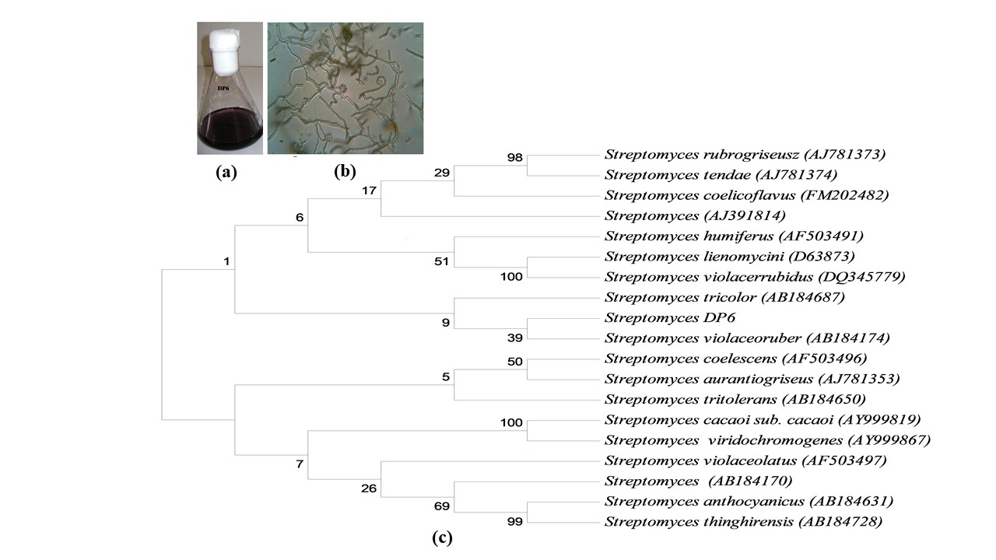
Fig. 1. Phylogenetic tree obtained by neighbor joining analysis of 16S rRNA gene sequences showing the relationship between DP6 and species belonging to the genus Streptomyces. (a) Inset showing violet pigment production by Streptomyces DP6 (b) Aerial mycelium of Streptomyces DP6 showing spiral spore chains (at 100X)

Table 2 Morphological, physiological and biochemical characteristics of Streptomyces DP6
Characteristic | Result
Spore mass | Pinkish white
Spore chain  Spores shape | Short/ slightly spiral  Round
Substrate mycelium | Violet
Aerial mycelium | Violet
Pigment | Violet
Sugar pattern | No sugar
Diaminopimelic acid | LL-DAP
Production of melanin pigment on :  Tyrosine agar medium  Peptone yeast extract agar medium | -  -
Production of hydrolytic enzymes:  Amylase  Protease  Cellulase  Lipase | +  +  -  +
Gelatinase | +
Urease  Pectinase | +  -
H₂S production | +
Citrate utilization  Indole  Growth Temperature | -  -  25ºC (20 to 35 ºC)

Based on morphological, cultural, and chemotaxonomic studies, strain DP6 was classified within the genus Streptomyces. This classification was further supported by 16S rRNA sequencing. DP6 sequence (1401 bp) exhibits 99-100% similarity with other Streptomyces spp. available at EzTaxon database. Notably, DP6 was most closely related (100%) to Streptomyces violaceoruber NBRC 12826 (T) (AB184174). A phylogenetic tree constructed using the neighbor-joining method to confirm its close relationship with other species (Fig. 1c). Further comparison between DP6 and S. violaceoruber revealed similarities in most cultural characteristics. However, S. violaceoruber lacked violet pigment production on ISP-5 medium. Additionally, DP6 exhibited differences in physiological traits, including H₂S production and urea hydrolysis, whereas S. violaceoruber did not produce H₂S or hydrolyze urea. Based on these findings, actinobacterium DP6 was identified as a strain of S. violaceoruber.
3.2 Optimization of pigment production
The production of violet pigment started on third day of incubation and continued to increase, and reached to its highest level at tenth day. The UV-VIS analysis of the samples obtained after every 24 h showed two constant peaks, one with λ_{max} 404 nm and another with λ_{max} 535 nm. To determine the effect of initial pH of the medium on production, fermentation was carried out over a range of pH 4.0- 8.0. The maximum pigment yield and growth (2.92 g/l) was achieved at pH 5.0 and pH 6.0, respectively (Fig. 2a). The quality of the pigment varied with change of pH. Pink to violet colored pigment with λ_{max} 404 and λ_{max} 535 was produced at acidic pH (4.0-6.0) but higher pH supported the production of blue pigment with λ_{max} 535 nm. In accordance to our results, Chatterjee et al. (2009) also reported the influence of initial pH of the fermentation medium on quality of the pigment produced by Monascus purpureus. They obtained more yellow pigment (λ_{max} 400 nm) at acidic pH (2.0- 4.0), whereas at higher pH (6.0- 8.0) the red pigment (λ_{max} 500 nm) was dominating. The orange fraction (λ_{max} 480 nm) maintained steadily irrespective of pH condition.
Temperature plays a vital role in cell metabolism, thus influencing pigment production (Chatterjee et al., 2009). The maximum pigment and biomass production (1.3 g/l) from Streptomyces DP6 was recorded at 30ºC and rate of production was reduced as the temperature increased. No pigment was produced at 40 ºC (Fig. 2b). Variation in temperature did not affect the color of the pigment. To check the influence of agitation on growth and pigment production, Streptomyces DP6 was grown at various agitation rates. The pigment yield and growth varied at different agitation rates (Fig. 3). The highest growth (1.3 g/l) and pigment production was obtained at 160 rpm and reduced thereafter with further increase in agitation. The highest levels of violacein (violet pigment) from Pseudoalteromonas luteoviolacea under static conditions and decrease in yield with the increase of agitation speed (Yang et al., 2007).

Fig. 2. Effect of pigment production and mycelial growth (a) Initial pH of medium (b) Incubation temperature

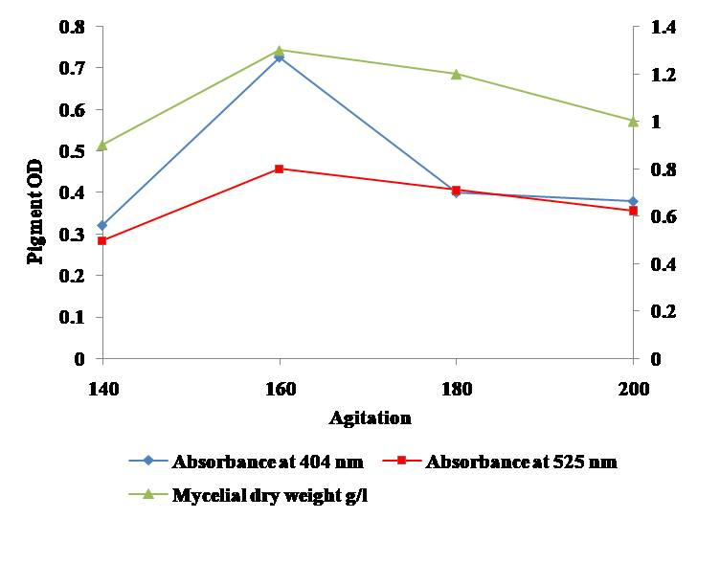
Fig. 3. Effect of agitation on the pigment production and mycelial growth
3.3 pH sensitivity and photochemical degradation of the pigment
The pigment isolated from Streptomyces DP6 was found to be very sensitive to pH change (Fig. S2). The color of the pigment changed according to the variation in the pH of the supernatant along with change in color as follows; at pH 2-6, pink (λ_{max} 532- 235 nm); pH 6, light violet (λ_{max} 535 nm); pH 7, violet (λ_{max} 575 nm); pH 8, pale blue (λ_{max} 579 nm); pH 10, blue (λ_{max} 591 nm) and pH 12, blue (λ_{max} 610 nm). Similar observation was reported for the anthocyanin pigments, widely used as food colorant, in that they are highly colored at pH values from 4-6 but almost colorless at high pH values (Carlsen & Stapelfeldt,1997) Similarly, the color of the pigment from Paecilomyces sinclairii was found to be dependent on pH of the solution; red at pH 3- 4 ( λ_{max} 500, 507 nm); violet at pH 5-7 ( λ_{max} 522, 526, 529 nm); pale violet at pH 8- 9 (λ_{max} 536, 537 nm) and pale pink at pH 10- 12 (λ_{max} 540, 541, 542 nm) (Cho et al., 2002).This might be possible because of the presence of different colored components present in the extract, concentrations of which vary at different pH values thus resulting in the corresponding shifts in absorption maxima. Due to this property of exhibiting different colors at different pH, the pigment from DP6 can be used as a pH indicator.
The photochemical degradation of pigment under mercury lamp, UV-light and sun light was checked spectrophotometrically after three hours intervals until 9 hours. It was observed that after three hours of irradiation, chromophore degradation under sun light began with corresponding shift of λ_{max} from initial 525 nm to 502 nm, whereas in case of mercury lamp and UV-light no significant change took place. On further exposure, pigment showed even higher degradation under sun-light and negligible change in case of mercury lamp and UV-light. Thus, it is concluded that pigment is highly sensitive to sun-light and comparatively stable when exposed to mercury lamp and UV-light. After 9 hours, the percent degradation under mercury lamp, UV-light and sun light were 12.1%, 8.4% and 22.0%, respectively. It would, therefore be suggested to protect the products colored with the pigment from intense sun light as much as possible or the pigment should be complexed with some light protective agent or mordant before use. Photochemical degradation of dye gardenia blue, phycocyanin and indigo dye has also been reported Dellamatrice, et al., 2017; Ali et al., 2011).
3.4 Dyeing potential analysis
Dyeing ability of the pigment extract was assayed by directly applying it on wool and silk fabrics. The pigment showed dyeing ability for both fabrics. Color yield was found to be better on wool as compared to silk because of amphoteric nature of wool. Similarly, Yosuf et al., also reported fabric depended varying dyeing capability of pigment from Serratia marcescens. Red and yellow pigment obtained from fungal strains Monascus purpureus and Penicillium purpurogenum, respectively, also showed dyeing potential for cotton and leather products when used in combination with ferrous sulphate as mordant (Velmurugan et al., 2009). Dyeing and printing efficiency of the brown pigment produced by a Streptomyces strain was also reported (Periyasamy et al., 2024). In another study, Abou Elmaaty et al. (2020) also evaluated the dyeing potential of orange pigment obtained from Streptomyces thingirensis on wool.
3.5 Washing and light fastness testing of the dyed fabrics
The results of fastness studies indicate very good washing fastness for both the dyed samples while light fastness was moderate to good (Table 3). The color fastness, including washing and light, of the dyed wool and silk samples was performed according to grey scale and presented in Table 4. The results indicted very good washing fastness for both the dyed samples with values ranging from 4-5 on grey scale. However, the results of light fastness for the samples indicate moderate to good values according to grey scale. Similar results were observed when wool fabrics was dyed with pigment from Streptomyces thingirensis Abou Elmaaty et al. (2020).
Table 3: Dyeing and fastness gradings of dyed fabrics
*SCA: Secondary Cellulose Acetate; BUC: Bleached Unmercerized cotton; N: Nylon; P: Polyester; A: Acrylic; WW: Worsted Wool
** Grade 5: Excellent; 4: Better; 3: Good; 2: Ok; 1: poor
Sample | Dyed Fabrics | Color Fastness | Washing Fastness |  |  |  |  |  | Light Fastness
 |  |  | SCA | BUC | N | P | A | WW
Wool |  | 2-3 | 4-5 | 4-5 | 5 | 5 | 4-5 | 4 | 3-4
Wool |  | 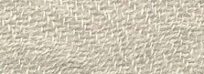 |  |  |  |  |  |  | 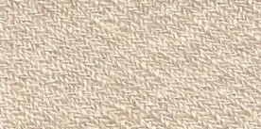
Silk | 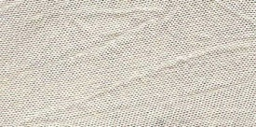 | 3 | 4-5 | 5 | 5 | 5 | 5 | 4 | 3
Silk |  | 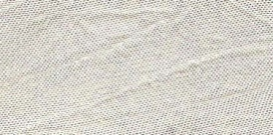 | 
3.6 Spectrophotometric K/S Analysis
The color properties of dyed wool and silk samples were quantified using the CIELAB system (Table 4). The color coordinates indicated the dyed wool was more deeply dyed than the silk at the given temperature, as indicated by greater chroma (C*). Dyed substrates were evaluated for K/S values by using spectrophotometer which showed higher K/S value for dyed wool as compared to silk (Fig. 4).

Table 4: Colorimetric data of dyed fabrics
D65 10 Deg | L* | a* | b* | C* | H | X | Y | Z | x | Y
Wool | 66.68 | 5.00 | 13.93 | 14.80 | 70.26 | 35.79 | 36.21 | 28.54 | 0.3560 | 0.3601
Silk | 79.57 | 2.25 | 7.42 | 7.75 | 73.14 | 53.90 | 55.93 | 52.27 | 0.3325 | 0.3450

L* - White/black a* - Red/Green b* - Blue/ yellow C* - Chroma H - Hue X,Y,Z,x,y: coordinates

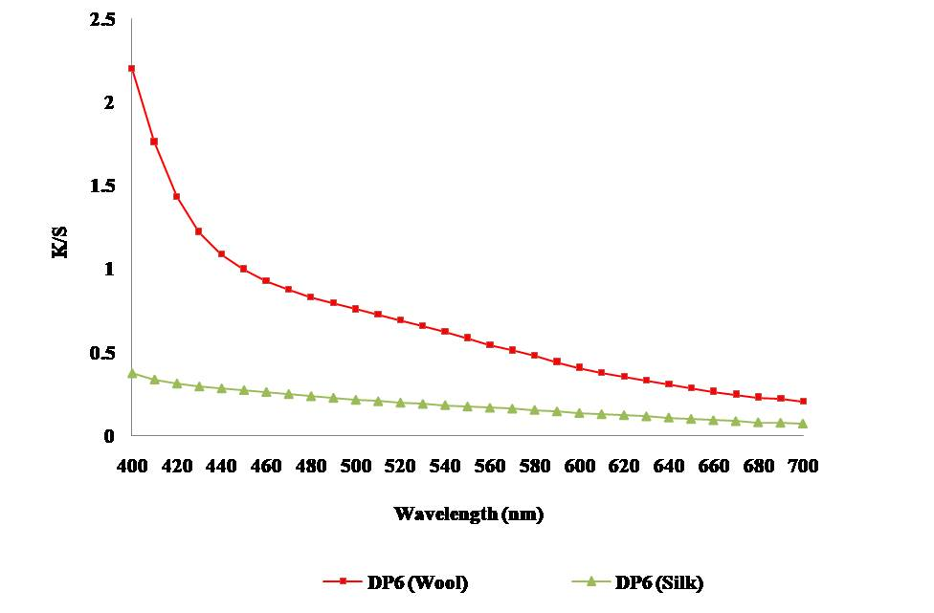
Fig. 4. K/S values of dyed fabrics

3.7 Toxicity testing of the pigment
Mutagenicity testing done by Ames test showed non mutagenic nature of the pigment at all the studied concentrations (25, 50, 100 and 200 µg/ 0.1ml) used in the experiment, as the number of revertant colonies in plates with pigment concentrations were found to be similar to that of spontaneous revertant colonies for TA98 as well as TA100 (Table 5). On contrary, most of the textile dyes are highly toxic and potentially carcinogenic and pose potential threat to the environmental as well as to human health (Periyasamy et al., 2024). Therefore, the non-mutagenic nature of the pigment point towards its promising potential to be used as a safe pigment/dye in the textile industries.

Table 5: Mutagenic Testing of DP6 Pigment

Treatment | Dose (µg) | No. of colonies
Treatment | Dose (µg) | TA98 | TA100
Spontaneousª |  | 26.0 ± 1.0 | 187.33± 2.0
Positive control (NPD)^{b} | 20 | 950.33 ± 2.5
Positive control^{b}  (Sodium azide) | 2.5 |  | 1115.33± 4.0
DP6 Pigment Extract^{c} | 25  50  100  250 | 22.33 ± 2.5  25 ± 1.6  24.0 ± 2.5  24.63 ± 1.5 | 187.66 ± 4.0  185.0 ± 4.5  186.66 ± 2.5  190.33 ± 7.6

Values are mean ± S.D
ªMean number of spontaneous revertants as determined in assays without pigment extract and standard mutagen
^{b}Mean number of revertants induced by reference mutagens: NPD (20 μg) and Sodium azide
^{c}Mean number of revertants induced by DP6 pigment extract at different concentrations

3.8 Purification and structure of pigment
The pigment culture filtrate was recovered using XAD-4 (5% v/v) resin, purified by size exclusion chromatography (Toyopearl resin HW-40) and reverse phase-HPLC. The HPLC purified peptide showed retention peak at 17.3 min (Fig. 4). . ¹H NMR showed the doublets at δ 7.14 and 7.38 respectively, and some multiplets of remaining aromatic protons are showed at δ 1.0-11.9 (Fig. 5). Proton NMR indicate presence of the singlet of methoxy group at δ 4.04. It is suggested that the DP6 pigment may be like an anthraquinone type structure with methoxy group. A structurally related compound to DP6, exhibiting antimicrobial and antiproliferative property, was previously isolated and reported from Streptomyces olivochromogenes (Balachandran et al., 2016).

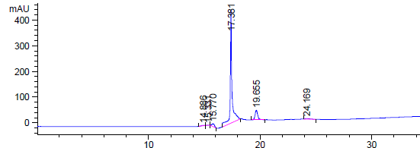

Fig. 4. RP-HPLC profile of the purified pigment

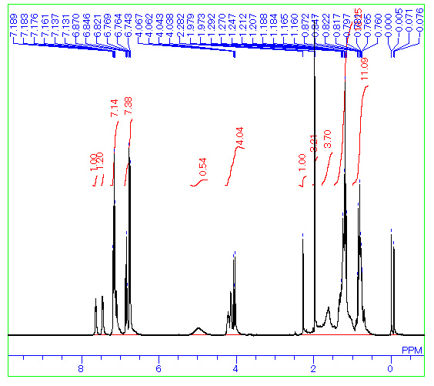

Fig. 5. ¹H NMR of the purified pigment

4. Conclusion
Textile industry is facing challenges related to environmental issues as it is generating a substantial amount of contaminated water and chemical waste. Microbial pigments can bring sustainability to the textile industry. Although most researchers have focused on evaluating pigmented compounds against biofilm-forming microorganisms, studies specifically examining Streptomyces pigments have been limited to antimicrobial activity and quorum sensing inhibitors. The results of current study indicate that the pigment from S. violaceoruber DP6 is suitable for dyeing wool and silk fabrics and can be used for dyeing fabrics in textile industry. Furthermore, the pigment could also be used as pH indicator due to its sensitivity towards pH changes.

REFERENCES
Abou Elmaaty, T., Kasem, A., Elsalamony, M. & Gamal, H. A. (2020) Green Approach for One Step Dyeing and Finishing of Wool Fabric with Natural Pigment Extracted from Streptomyces thinghirensis. Egyptian Journal of Chemistry, 63(6), 1999-2008. https://doi: 10.21608/ejchem
Agarwal, H., Bajpai, S., Mishra, A., Kohli, I., Varma, A., Fouillaud, M., Dufossé, L., & Joshi, N. C. (2023). Bacterial Pigments and Their Multifaceted Roles in Contemporary Biotechnology and Pharmacological Applications. Microorganisms, 11(3), 614. https://doi.org/10.3390/microorganisms11030614
Ali, M. A., Keera, A. A., Helmy, M. S., Abd El-Nasser, H. N., Ahmed, K. A. & El-Hennawi H. M. (2011) Selection of pigment (melanin) production in Streptomyces and their application in printing and dyeing of wool fabrics. Research Journal of Chemical Sciences, 1, 22-28.
Alihosseini, F., Ju, K. S., Lango, J., Hammock, B. D. & Sun, G. (2008) Antibacterial colorants: characterization of prodiginines and their applications on textile materials. Biotechnology Progress, 24,742-747. https://doi: 10.1021/bp070481r
Balachandran, C., Duraipandiyan, V., Arun, Y., Sangeetha, B., Emi, N., Al-Dhabi, N. A., Ignacimuthu, S., Inaguma, Y., Okamoto, A. & Perumal, P. T. (2016). Isolation and characterization of 2-hydroxy-9,10-anthraquinone from Streptomyces olivochromogenes (ERINLG-261) with antimicrobial and antiproliferative properties. Revista Brasileira de Farmacognosia, 26(3), 285-295. https://doi.org/10.1016/j.bjp.2015.12.003.
Carlsen, C. & Stapelfeldt, H. (1997). Light sensitivity of elderberry extract quantum yields for photodegradation in aqueous solution. Food Chemistry, 60:383-387. https://doi:10.1016/j.foodres.2018.02.035
Chatterjee, S., Maity, S., Chattopadhyay, P., Sarkar, A., Laskar, S., Sen, S. K. (2009) Characterization of red pigment from Monascus in submerged cultured pigment from Monascus purpureus. Journal of Applied Sciences Research, 40, 132-138.
Cho, Y. J., Park, J. P., Hwang, H. J., Kim, S. W., Choi, J. W. & Yun, J. W. (2002). Production of red pigment by submerged culture of Paecilomyces sinclairii. Letters in Applied Microbiology. 35, 195-202. https://doi:10.1046/j.1472-765x.2002.01168.x.
Chun, J., Lee, J. H., Jung Y, Kim, M., Kim, S. & Lim, Y.W. (2007). EzTaxon: a web-based tool for the identification of prokaryotes based on 16S ribosomal RNA gene sequences. International Journal of Systematic and Evolutionary Microbiology, 57, 2259-2261. https://doi: 10.1099/ijs.0.64915-0.
DeBritto, S., Gajbar, T. D., Satapute, P., Sundaram, L., Lakshmikantha, R. Y., Jogaiah, S. & Ito, S. I. (2020). Isolation and characterization of nutrient dependent pyocyanin from Pseudomonas aeruginosa and its dye and agrochemical properties. Scientific Reports, 10(1), 1542. https://doi: 10.1038/s41598-020-58335-6
Dellamatrice, P. M., Silva-Stenico, M.E, Moraes, L. A., Fiore, M. F. & Monteiro, R. T. (2017). Degradation of textile dyes by cyanobacteria. Brazilian Journal of Microbiology, 48(1), 25-31. https://doi:10.1016/j.bjm.2016.09.012
Etta, K. K., Chetapalli, C., Muvva, V. & Kumbha, N. (2025).Taxonomic profile & antimicrobial potential of Brachybacterium conglomeratumVLCH–15 Isolated from Mangroves of Machilipatnam, Andhra Pradesh, India. Journal of Advances in Microbiology, 25 (2), 22-33. https://doi.org/10.9734/jamb/2025/v25i2898
Francis, F. J. (1989). Food colorants: anthocyanins. Critical Reviews in Food Science & Nutrition, 28(4), 273-314. https://doi: 10.1080/10408398909527503.
Galasso, C., Corinaldesi, C. & Sansone, C. (2017). Carotenoids from marine organisms: biological functions and industrial applications. Antioxidants (Basel), 6(4), 96. https://doi: 10.3390/antiox6040096
Hizbullah, U. M., Farouq, A. A. A., Baki, S., Dabai, M. U., Nafi’u, A., Nata’ala, M. K. & Mustapha, G. (2018). “Studies on Bio-Color Production by Pseudomonas Aeruginosa isolated from Soil”. Journal of Advances in Microbiology 12 (1):1-12. https://doi.org/10.9734/JAMB/2018/43068
Islam, T., Repon, M., Islam, T, Sarwar, Z. & Rahman, M. M. (2023). Impact of textile dyes on health and ecosystem: a review of structure, causes, and potential solutions. Environmental Science & Pollution Research International, 30, 9207-9242. https://doi:10.1007/s11356-022-24398-3
Kanwar, K., Sharma, D., Singh, H., Pal, M., Bandhu, R. & Azmi, W. (2024) In vitro effects of alginate lyase SG4+ produced by Paenibacillus lautus alone and combined with antibiotics on biofilm formation by mucoid Pseudomonas aeruginosa. Brazilian Journal of Microbiology, 5(2), 1189-1203. https://doi: 10.1007/s42770-024-01334-w
Kaur, T., Sharma, D., Kaur, A. & Manhas R. K. (2013) Antagonistic and plant growth promoting activities of endophytic and soil actinomycetes. Archives of Phytopathology and Plant Protection, 46, 1756-1768. https://doi:10.1080/03235408.2013.777169
Kramar, A., & Kostic, M. M. (2022). Bacterial Secondary Metabolites as Biopigments for Textile Dyeing. Textiles, 2(2), 252-264. https://doi.org/10.3390/textiles2020013
Kumar, A., Vishwakarma, H. S., Singh, J., Dwivedi, S. & Kumar, M. (2015). Microbial pigments: production and their applications in various industries. International Journal of Pharmaceutical Chemical and Biological Sciences, 5, 203–212.
Mazotto, A. M., De Ramos Silva, J., De Brito, L. A. A., Rocha ,N. U. & De Souza Soares, A. (2021). How can microbiology help to improve sustainability in the fashion industry? Environmental Technology & Innovation, 23, 101760. https://doi: 10.1016/j.eti.2021.101760
Mumtaz, R., Bashir, S., Numan, M., Shinwari, Z. K. & Ali, M. (2019). Pigments from soil bacteria and their therapeutic properties: a mini review. Current Microbiology, 76(6):783-790. https://doi: 10.1007/s00284-018-1557-2
Ndinchout, A. S., Chattopadhyay, D. P., Paul, M. F., Ascension, N. M., Kaur, V. & Kaur, S. (2019). Studies on dyeing and bacterial resistance of Dacryodes macrophylla extract on woollen fabric. Journal of Applied & Natural Science, 11(1), 205-210. https://doi.org/10.31018/jans.v11i1.1993
Nuanjohn, T., Suphrom, N., Nakaew, N., Pathom-Aree, W., Pensupa, N., Siangsuepchart, A., Dell, B., & Jumpathong, J. (2023). Actinomycins from Soil-Inhabiting Streptomyces as Sources of Antibacterial Pigments for Silk Dyeing. Molecules, 28(16), 5949. https://doi.org/10.3390/molecules28165949
Periyasamy, A. P. (2024). Recent advances in the remediation of textile-dye-containing wastewater: prioritizing human health and sustainable wastewater treatment. Sustainability, 16(2), 495. https://doi:10.3390/su16020495
Rampal, G., Singh, T. T., Arora, R., Vig, A. P. & Arora, S. (2017). Synergistic antimutagenic effect of isothiocyanates against varied mutagens, Food & Chemical Toxicology, 109, 879-887. https://doi: 10.1016/j.fct.2017.05.017
Sarmiento-Tovar, A. A., Silva, L., Sánchez-Suárez, J., & Diaz, L. (2022). Streptomyces-Derived Bioactive Pigments: Ecofriendly Source of Bioactive Compounds. Coatings, 12(12), 1858. https://doi.org/10.3390/coatings12121858
Sen, T., Barrow, C. J. & Deshmukh, S. K. (2019) Microbial pigments in the food industry-challenges and the way forward. Frontier in Nutrition, 6, 7. https://doi:10.3389/fnut.2019.00007
Sharma, B., Dangi, A. K. & Shukla, P. (2018) Contemporary enzyme based technologies for bioremediation: A review. Journal of Environmental Management, 15, 210:10-22. https://doi: 10.1016/j.jenvman.2017.12.075-22.
Sharma, D. (2024) Novel natural and synthetic anticandidal therapeutic peptides to combat drug-resistant infections. Medical Science Forum, 24, 12. https://doi:10.3390/ECA2023-16385.
Sharma, D., Kanwar, K., & Manhas R. K. (2025). Genomic analysis of Streptomyces amritsarensis MTCC 11845 and characterization of novel lanthipeptide 2A. Indian Journal of Experimental Biology, 63, 229-238 https://doi.org/10.56042/ijeb.v63i03.13585
Sharma, D., Kaur, T., Chadha, B. S. & Manhas, R. K. (2011). Antimicrobial activity of actinomycetes against multidrug resistant Staphylococcus aureus, E. coli and various other pathogens. Tropical Journal of Pharmaceutical Research, 10, 801-808. https://doi:10.4314/tjpr.v10i6.14
Sharma, D., Mayilraj, S., Manhas, R. K. (2014). Streptomyces amritsarensis sp. nov., exhibiting broad-spectrum antimicrobial activity. Antonie Van Leeuwenhoek 105(5):943-9. https://doi:10.1007/s10482-014-0151-2.
Srinivasan, M., Keziah, S. M, Hemalatha, M. & Devi, C. S. (2017). Pigment from Streptomyces bellus MSA1 isolated from marine sediments. IOP Conference Series: Material Science & Engineering, 263, https://022049.doi:10.1088/1757-899X/263/2/022049
Stankovic, N., Senerovic, L., Ilic-Tomic, T., Vasiljevic, B. & Nikodinovic-Runic, J. (2014) Properties and applications of undecylprodigiosin and other bacterial prodigiosins. Applied Microbiology & Biotechnology, 98(9), 3841-358. https://doi: 10.1007/s00253-014-5590-1
Tamura, K., Peterson, D., Peterson, N., Stecher, G., Nei, M. & Kumar, S. (2011) MEGA5: molecular evolutionary genetics analysis using maximum likelihood, evolutionary distance, and maximum parsimony methods. Molecular Biology and Evolution, 28, 2731-2739. https://doi:10.1093/molbev/msr121
Velmurugan, P., Chae, J., Lakshmanperumalsamy, P., Yun, B., Lee, K. & Oh, B. (2009). Assessment of the dyeing properties of pigments from five fungi and anti-bacterial activity of dyed cotton fabric and leather. Color Technology, 125, 334-341. https://doi:10.1111/j.1478-4408.2009.00215.x
Venil, C. K., Dufossé, L., Velmurugan, P., Malathi, M., & Lakshmanaperumalsamy, P. (2021). Extraction and Application of Pigment from Serratia marcescens SB08, an Insect Enteric Gut Bacterium, for Textile Dyeing. Textiles, 1(1), 21-36. https://doi.org/10.3390/textiles1010003
Yang, L. H., Xiong, H., Lee, O. O., Qi, S. H. & Qian, P. Y. (2007). Effect of agitation on violacein production in Pseudoalteromonas luteoviolacea isolated from a marine sponge. Letters in Applied Microbiology, 44(6), 625-30. https://doi:10.1111/j.1472-765X.2007.02125.x

