Assessment of Physicochemical Characteristics, Polymer Identification and total coliform counts in selected rivers in Ado-Ekiti, Nigeria

Abstract
Microplastics are any synthetic solid particles or polymeric materials with equivalent spherical diameter ranging from 1 µm to 5 mm. The presence of microplastics in water bodies is a global menace for humans and aquatic animals, its fragments act as surfaces for the attachment of microorganisms, toxins, antibiotics and as vectors for pollutants in the environment. This study investigated the physicochemical characteristics, polymer identification of microplastics and total coliform counts in selected rivers (Ureje, Emirin, Ogbese, Odo-ayo and Elemi) in Ado-Ekiti, Nigeria. Water samples were collected biweekly over a period of 24 months (from January, 2023 to December, 2024) from the rivers using composite sampling method. The physicochemical characteristics of the water samples, microplastics concentrations and the total coliform counts in the water samples were determined using standard methods. Polymer identification was done using fourier transform infrared spectroscopy (FTIR) and scanning electron microscope (SEM). The result of the physicochemical parameters showed that the mean value of pH ranged from 9.55 - 9.87, electrical conductivity (EC) ranged from 196.67 µs/cm - 416.81 µs/cm, the total dissolved solid (TDS) ranged from 130.00 ppm – 213.00 ppm, DO ranged from 6.95 mg/L -9.62 mg/L, the biological oxygen demand (BOD) ranged from 1.95 Mg/L - 3.09 Mg/L and turbidity ranged from 9.47 NTU to 13.71 NTU. River Emirin had the highest concentration of microplastics with the mean value of 6.15 particles/L while water samples from Odo-Ayo river had the least value of 4.69 particles/L. FTIR spectra showed that polyethylene, polypropylene and polyethylene terephthalate (PET) were the most commonly detected microplastics in the water samples. SEM-EDX also showed that carbon and nitrogen were the predominant elements in the morphology of the extracted microplastics from the water samples. The water samples from the rivers had high mean total coliform counts ranging from 3.80×10² CFU/100ml. to 4.40 ×10² CFU/100ml.The results obtained from this study revealed that the water samples from the rivers contain different types of microplastics and are of poor microbial qualities. Therefore, there should be public awareness on good methods of plastics wastes management and water from the rivers must be adequately treated before use.
Keywords: Microplastics, physicochemical characteristics, polymer identification, rivers, total coliform counts
Introduction
The presence of microplastics in water bodies is a global menace due to industrial discharge and poor method of plastic wastes disposal in the environment. These plastic wastes eventually find their ways into the rivers, oceans and sea where they undergo mechanical, photo of biological degradation into secondary microplastics. .Microplastics are any synthetic solid particles or polymeric matrix, with regular or irregular shape and with size ranging from 1 µm to 5 mm, of either primary or secondary manufacturing origin, that are insoluble in water (Stabnikova et al., 2021). The two main ways by which microplastics are formed and enter a body of water are through primary and secondary microplastics. The primary microplastics consist of manufactured raw plastic materials, such as virgin plastic pellets, scrubbers, and microbeads that enter the water bodies via runoff from land (Masura et al., 2015). The microplastic fragments which are undetectable to the naked eye act as surfaces for the attachment of microorganisms, toxins, antibiotics and also act as vectors for pollutants in the environment (Wang et al., 2021). Microplastics also affect microbial activity in water, potentially altering dissolved oxygen levels and disrupting the ecosystems. (Sushma et al., 2021)
Microplastics are environmental pollutants and contaminants with the potential for advice effects on the ecosystems and human health (Rajul et al., 2023). Microplastics contamination in river ecosystems can impair their long-term functioning, affect biological interactions, threaten water species, and even harm local communities that rely on these bodies of water for drinking (Rawintra et al., 2022). Microplastics interact with physicochemical parameters of water bodies such as turbidity, conductivity, total dissolve solids, temperature and pH of the rivers, influencing their distribution, properties, and the overall water quality (Eamrat et al., 2022). Fluctuations in these parameters can lead to altered microbial communities and increased pollution levels in water sources (Wenyu et al., 2024). For instance, high turbidity in water bodies increases the abundance of microplastics because the microplastic particles may be carried along with suspended particles. Poor water quality indicated by high (BOD) can link with higher microplastic abundance, suggesting that microplastic pollution increases more in areas with poor water quality. Temperature may affects the degradation and movement of microplastics, warmer temperatures possibly hasten degradation and changing the distribution of microplastics (Wenyu et al., 2024).
Several studies have been conducted on the abundance of microplastics pollution, for instance a research conducted by Idowu et al. (2024) in Osun river Nigeria revealed the abundance of microplastics in the river water samples at a maximum of 22,079 ± 134 particles/litre. Buwono et al. (2021) also investigated the abundance, types of microplastic particles found in the River and the relationship between water’s physicochemical properties and the presence of microplastics in Branta River, East Java, Indonesia, the authors found out that the total abundance of microplastics in this River’s waters ranged from 133 particles/m³ to 5467 particles/m3. Presently, there is limited research concerning studies on polymer identification of microplastics, physicochemical properties and faecal pollution (total coliform counts) in rivers in Nigeria, it is therefore, pertinent to investigate the physicochemical characteristics, polymer identification of microplastic and faecal pollution in selected Rivers in Ado-Ekiti, Nigeria.
MATERIALS AND METHODS
The study area
The study area is Ado- Ekiti, the capital of Ekiti- State in southwest Nigeria. The five rivers (Ureje, Emirin, Ogbese, Elemi and Odo-Ayo) are found in Ado-Ekiti which is located between latitude 7. 62⁰ north and longitude 5.22⁰ east of the Greenwich meridian with an estimated population of 557, 000 as at 2024 (WPR, 2023).
Collection of water samples
Water samples were collected from Ureje, Emirin, Ogbese, Elemi and Odo-Ayo rivers biweekly over a period of 24 months (from January, 2023 to December, 2024) using composite sampling method to collect a total of 191 water samples. On each sampling occasion, 10 litres of water was collected into a sterile containers, then placed in a cool box with icepacks and transported to the laboratory for microbiological investigation and other analysis.
Determination of physicochemical properties of the water samples
The physicochemical parameters assessed include pH, temperature, biological oxygen demand (BOD), turbidity, dissolved oxygen (DO), total dissolved solid and electrical conductivity. The pH, temperature, electrical conductivity (EC), total dissolved solids (TDS) and turbidity of the water samples were determined in-situ according to the method used by Olalemi et al. (2021). The dissolved Oxygen (DO) and Biochemical oxygen demand (BOD) were carried out by titrimetric method as desribed by Carvalho et al. (2021).
Extraction of microplastics from the water samples.
Extraction of microplastics was carried out according to Albert et al. (2019), the microplastics particles was extracted by sieving (6 litres) of each water sample with mesh 60 of 0.25mm pore size and the residue was flushed into glass beaker. The solids was subjected to wet peroxide oxidation in the presence of iron II (Fe (II)) catalyst and 30% hydrogen peroxide solution to digest the labile organic matter. The plastic debris remained unchanged, while the WPO mixture was then subjected to density separation in 95% ethanol to isolate the plastic debris through floatation. The floating solids was separated from the denser undigested mineral components using a density separator. The floating plastic debris was collected in the density separator using a customize 0.3mm filter and air-dried, the plastic materials were removed and weighed to determine the microplastics concentration.
Polymer identification of microplastics in the water samples from the rivers
Polymer identification was carried out by Fourier transform infrared spectroscopy (FTIR) analysis and scanning electron microscope (SEM) as described by Miserli et al. (2023). Infrared radiation from FTIR spectrometer was introduced to the extracted microplastics, the FTIR’s detector detected or measured the samples absorbance of infrared light at various wavelength to determine the materials molecular composition and structure. The resulting spectra were compared against a series of polymer spectral reference libraries to identify the microplastic polymer type.
The morphology of the extracted microplastics samples were also determined using scanning electron microscope (SEM). The samples was coated with 5 nm of chromium prior to analysis, SEM images were acquired using a Thermo Fisher Pharos Phenom G2 Field Emission Scanning Electron Microscope which was operated under high vacuum (0.1 Pa) with the accelerating voltage set at 15 kV. The surface chemical composition of the microplastic surface was also studied through Energy Dispersive Spectroscopy (EDS) analysis using the same equipment.
Determination of the total coliform counts in the water samples
The total coliform counts in the water samples was determined as described by Abu-Sini et al. (2023). 100ml of the water sample was filtered using membrane filter of pore size 0.25µm, this was placed aseptically on the prepared Endo agar plates. The plates were incubated at 37°C for 24hrs and observed for the presence of growth which appeared as pink to red colonies with greenish metallic sheen, the growth were counted and recorded as colony forming unit per 100ml (CFU/100ml).
Results and Discussion
Table 1 shows the physicochemical properties of the water samples from the rivers, the highest mean pH value (9.87) was obtained from Odo-Ayo river, while the least was obtained from river Emirin (9.55), this shows that pH of the rivers fall within the alkaline range (above the WHO standard for drinking water). The temperature also fall above the standard range of less than 25⁰C, the highest mean value of electrical conductivity (EC) 416.81µs/cm was obtained in the water samples from river Ureje, the least mean (EC) value was obtained from Odo-Ayo river 196.27µs/cm; the (EC) of the water samples from all the rivers ranged from 100 µs/cm -1027 µs/cm which is relatively high, some of these values were above the world health organization standard (WHO) for unpolluted rivers. The highest DO value of 9.62 mg/L was obtained in Ogbese river, the least value (5.95 mg/l) was obtained from Odo-Ayo river, The highest turbidity (13.71 NTU) was obtained from Ogbese river, the least value (9.47 NTU) was obtained from river Emirin. This result implies that most of the physicochemical parameters of the rivers were above the world health standard for drinking water, indicating that the water samples from the rivers are of poor quality. High values of physicochemical parameters like pH, biological oxygen demand (BOD), turbidity and temperature are indicators of poor water quality which can lead to increase in the quantity of microplastics in water bodies. For instance, high turbidity can increase the abundance of microplastics, as they can be transported along with suspended particles in the aquatic environment. Elevated dissolved Oxygen content (DO) indicates poor water quality due to the presence of high levels of organic matter, has also been correlated with higher microplastic concentrations. pH plays a significant role in the interactions between microplastics and their surrounding environment. It can influence the adsorption of organic pollutants and heavy metals onto microplastic surfaces by affecting their surface charge, thereby impacting their potential for biochemical degradation (Li et al., 2018). These suggest that microplastic pollution tends to be more severe in aquatic systems with poor water quality. This result is in agreement with Adewumi (2018) where the author observed high values of physicochemical parameters in selected rivers in Efon-Alaaye, Ekiti-State. Nigeria. High values of physicochemical properties of turbidity, conductivity total dissolved solid and biological oxygen demand was also observed in a study conducted by Rawintra et al. (2022) in an Urban canal of Thailand.

Table 1: Physicochemical Characteristics of the water samples from the rivers
Parameters | Ureje | Emirin | Ogbese | Elemi | Odo- Ayo
pH | 9.81±0.75(8.10-10.50) | 9.55±0.66  (8.00-11.00) | 9.70± 1.18(7.50-12.00) | 9.75 ± 0.87(7.00- 11.50) | 9.87±0.84(7.50-12.00)
Temp (⁰C) | 28.98± 2.13 (26.40-33.00) | 29.89 ±2,38(25.60-37.40) | 30.34 ± 1.15 (23.00-39.80) | 29.32±1.68 (23.00-39.80) | 29.15±2.00(25,30-36.70)
EC (µs/cm) | 416.81±21.28 (120.00-1027.00) | 382.12±57.74(100.00-727.00) | 280.35±3204(100.00-727.00) | 266.64±37.14(97.00-692.00) | 196.27±65.74 (97.00-401.00)
TDS (ppm) | 210.2±29.12 (99.00-474.00) | 213.00±31.09 (48.00-363.00) | 138.36± 14.28(51.00-365.00) | 148.36±60.32(51.00-365.00) | 130.00±64.06 (39.00-556.00)
DO (mg/L) | 6.55±3.16(2.40-18.50) | 6.32±1.95 (2.20-13.00) | 9.62± 2.77(1.20-20.00) | 6.64±2.57 (3.00-14.00) | 5.95±2.51(2.00-15.50)
BOD (mg/L) | 1.95±0.88(0.70-5.00) | 2.55±1.19(1.00-8.00) | 3.09±1.75 (0.50-13.00) | 2.30±1.11 (0.60-6.00) | 3.0± 0.92 (0.32-5.00)
Turbidity (NTU) | 10.19±9.31(1.63-40.00) | 9.47±6.62(1.00-35.10) | 13.71±7.13(0.50-57.40) | 11.94±8.19(1.00-31.00) | 13.01±9.05(0.70-36.00)
Values are presented as means± standard deviation (minimum-maximum), n=38
Key: Temp = temperature, EC= Electrical conductivity, TDS= total dissolved solid, DO= dissolved oxygen, BOD= biological oxygen demand.

Microplastics were detected in all the rivers (Figure 1). This implies contamination of the rivers under study with microplastics which may be due to indiscriminate disposal of plastics and other wastes in to the river bodies. This may pose health risks to aquatic animals and humans. Microplastics contaminate the environment and may acts as surfaces for the adsorption of harmful or toxic chemicals like pesticides, heavy metals and persistent organic pollutants. When ingested by aquatic animals like fishes, the toxins can enter the food chain and potentially affect human health (Wenjie et al., 2023). This result in line with Chidimma et al. (2024) where the authors observed microplastics concentration between 0.12g to 2.50g at the surface water of Otammiri River, Imo-State, Nigeria.

Figure 1: Levels of microplastics in the water samples from the rivers
The FTIR spectrum (Figure 2) revealed the presence of C-H asymmetric or symmetric stretch at 2918.5 and 2851 peaks which is found to be polyethylene and polypropylene, peak at 1736.9 indicate C=O stretching (carbonyl) group, this shows the presence of polyethylene terephthalate (PET), peaks 1,591 -1400 range is an indication of aromatic ring vibrations showing the presence of polystyrene microplastics, peaks at 1218-1006.4 indicate C-O stretching esters, this also shows the presence of PET microplastics. Figure 3, also shows the presence of O-H or N-H Stretch at peaks (3753-3652 cm⁻¹) indicating the presence of contaminant, peaks (2903, 2829 cm⁻¹) indicate C-H stretching which is found in polypropylene, polyethylene and polyvinyl chloride (PVC). Peak 2225 cm⁻¹ indicate the presence of nitrile (-C≡N) or alkyne (-C≡C) groups commonly found in Polyacrylonitrile (PAN). Peaks (1591, 1476 cm⁻¹) indicates C=C aromatic stretch found in polystyrene and PET. In addition, peaks at 2922 cm⁻¹ and 2856 cm⁻¹ suggest C-H stretching of aliphatic hydrocarbons found in Polyethylene and Polypropylene microplastics (figure 4), there is no strong peak at the triple bond region (25000 cm⁻¹-2000 cm⁻¹), peak 1640 cm⁻¹ at the double bond region indicates C=O (Carbonyl) Stretch, this suggests the presence of ester (-COO), ketone (C=O), or amide groups common in Polyethylene terephthalate (PET), Aromatic C=C peaks at 1444 cm⁻¹ and 1457 cm⁻¹ indicates C=C aromatics ring vibrations found in Polystyrene (PS) and PET. Polyethylene, polypropylene and polyethylene terephthalate were the most commonly extracted microplastics in the study area (figures 2-6). The morphology of the extracted microplastics as indicated by SEM-EDX showed that carbon and nitrogen were the predominant elements (Plates 2-5). This result is in agreement with Attah et al. (2023) where the authors observed FTIR spectrum of microplastics in Bonny and Calabar rivers in Nigeria with a typical pattern of polyethylene and polypropylene.

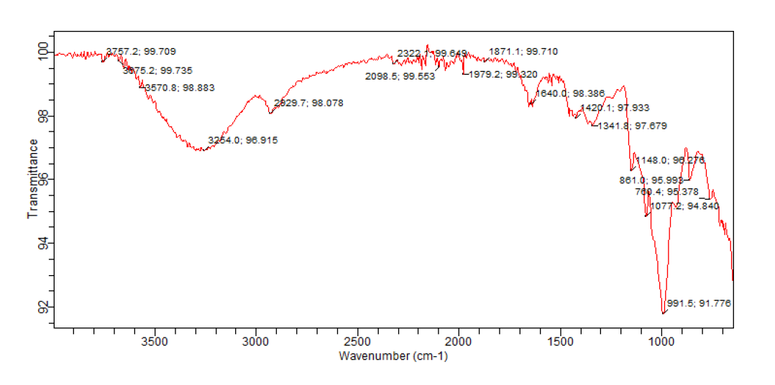
Figure 2: FTIR Spectra of Microplastics extracted from Water Samples of Emirin River
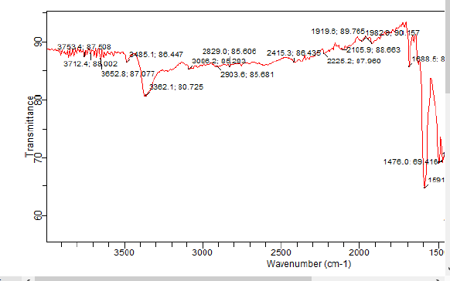
Figure 3: Spectra of Microplastics extracted from Water Samples of Ureje River
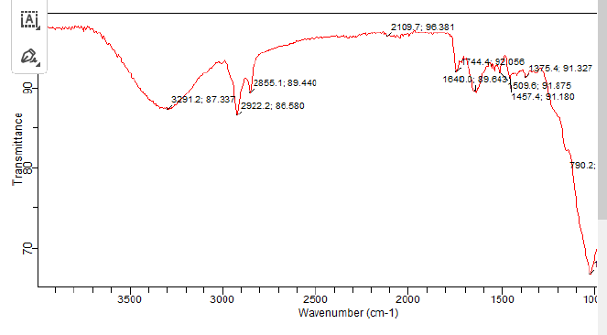 Figure 4: FTIR Spectra of Microplastics Extracted from Water Samples of Ogbese River

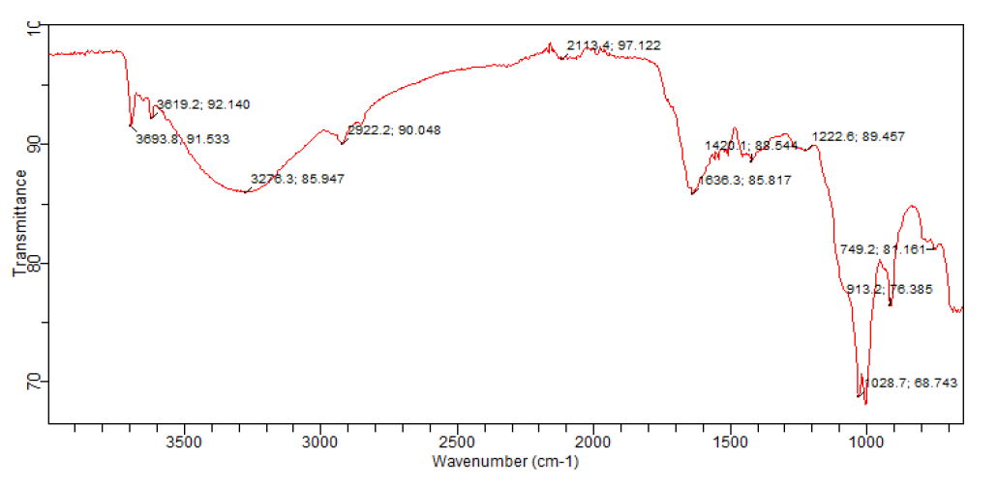 Figure 5: FTIR spectra of microplastics extracted from water samples of Odo-Ayo river

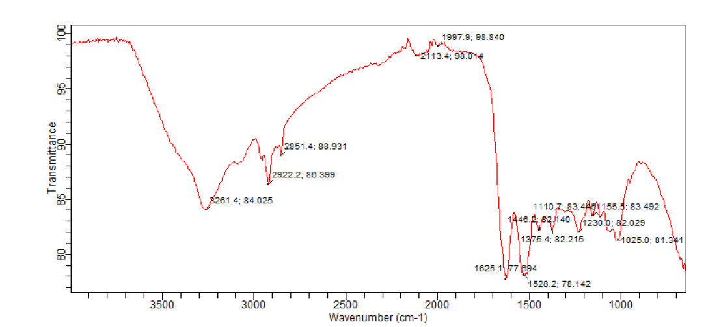 Figure 6: FTIR spectrum of microplastics extracted from water samples of Elemi river

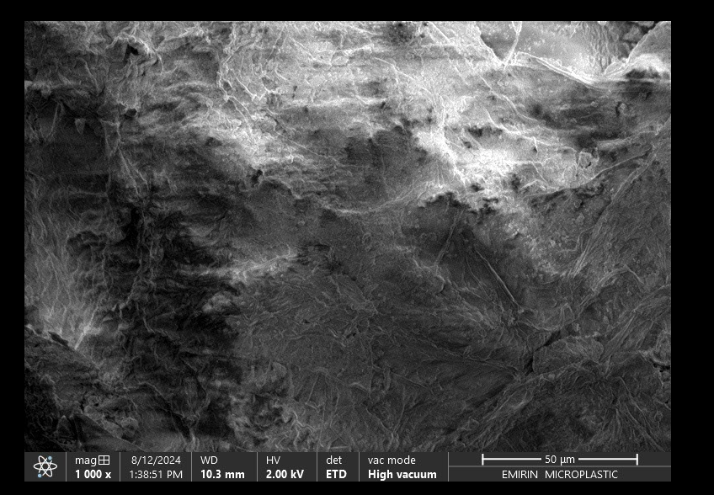
Plate 1: Photomicrograph of Microplastics from water samples of Emirin River
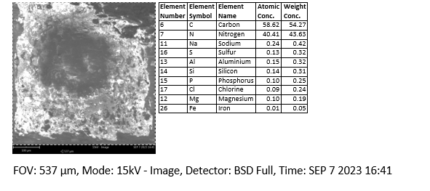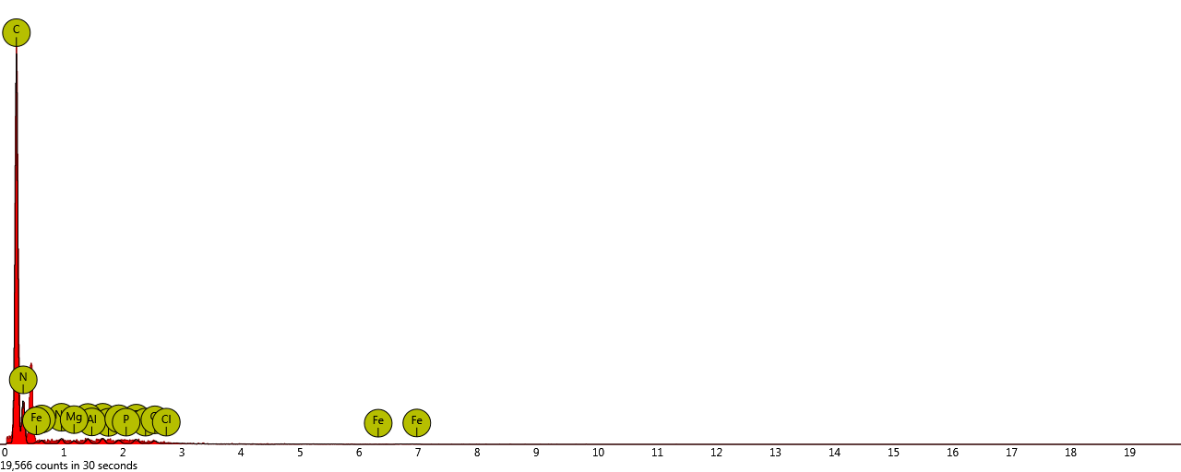
Plate 2: Photomicrograph of Microplastics from water samples of Ureje river
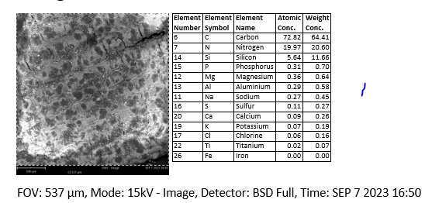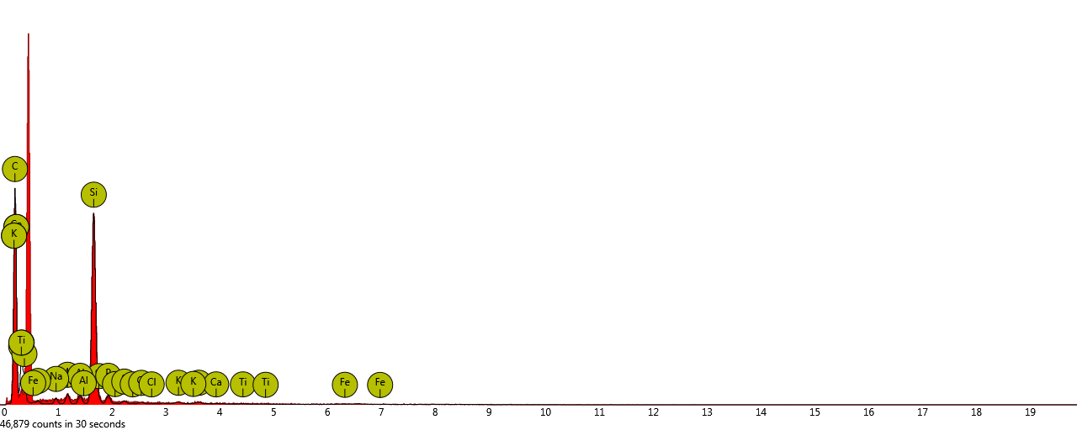
Plate 3: Photomicrograph of Microplastics from water samples of Ogbese river
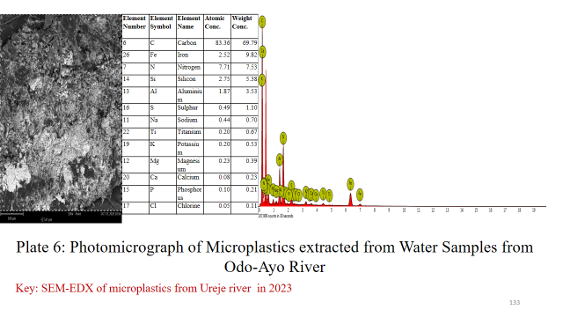
Plate 4: Photomicrograph of Microplastics from water samples of Odo-Ayo River
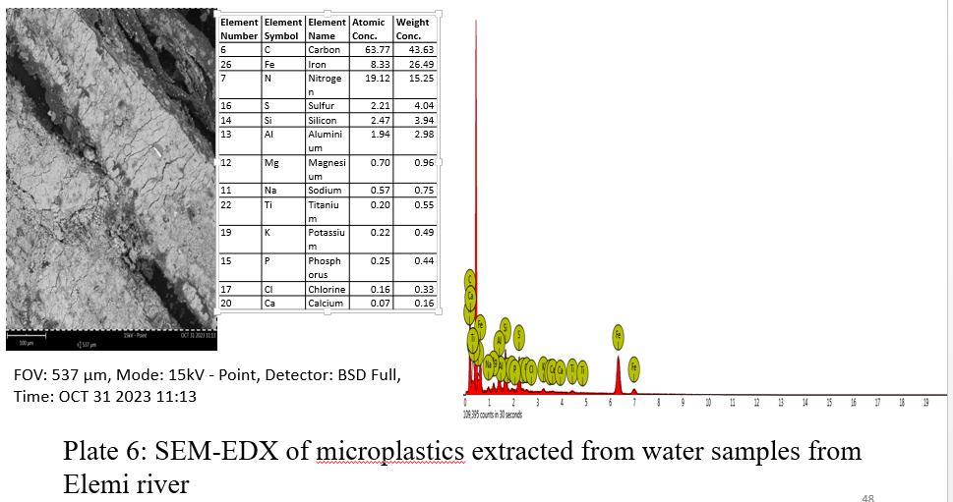
Plate 5: Photomicrograph of Microplastics from water samples of Elemi River
Emirin and Odo-Ayo rivers had the highest and the least mean coliform counts of 4.40×10² Cfu/100ml and 5.60×10² Cfu/100 ml respectively (Figure 7). The high total coliform counts implies faecal contamination of the rivers which may be as a result of pollution from faecal and plastic wastes and other human activities in and around the rivers. It also shows the presence of indicator organisms and other pathogenic bacteria in the water samples from the rivers, this is an indication that the rivers are of poor microbial qualities. This can pose significant health risks to humans, such health risks include outbreak of water borne diseases in the form of cholera, shigellosis and typhoid fever. This result is in agreement with Onaiwu et al. (2022) where the authors observed total coliform counts that ranged from 0.1 × 10² to 5.5 × 10² CFU/100ml in water samples from river Ogbese in Edo-State, Nigeria. It is also in line with Akrong et al.(2019), where the authors observed total coliform counts ranging from 2.0 × 10³ to 4.2 × 10³ CFU/100 ml in drinking water sources (stream) in communities surrounding Lake Bosomt in the Ashanti Region of Ghana.

Figure 7: The mean total coliform counts in the water samples from the rivers

Conclusion
The mean pH of the water samples ranged from 9.55- 9.87, the mean value of electrical conductivity (EC) ranged from 196.27 µs/cm- 416.81 µs/cm. The dissolved oxygen (DO) ranged from 5.95 mg/L - 9.62 mg/L. The mean value of turbidity ranged from 9.47 NTU - 13.71 NTU. This result implies that most of physicochemical parameters of the rivers were above the World Health Organization (WHO) standard for drinking water, indicating that the water samples from the rivers are of poor quality. River Emirin had the highest mean concentration of microplastics of 6.15 particles/litre while Odo-Ayo had the least concentration of 4.69 particles/litre, this implies contamination of the all the rivers with microplastics, this may pose health risks to aquatic animals and humans. Polyethylene, polypropylene and polyethylene terephthalate were the most commonly extracted microplastics in the study area. The morphology of the extracted microplastics as indicated by SEM-EDX showed that carbon and nitrogen were the predominant elements. Emirin and Odo-Ayo rivers had the highest and the least mean total coliform counts of 5.60×10² Cfu/100ml and 4.40×10² Cfu/100 ml respectively. The high total coliform counts implies faecal contamination of the rivers which is an indication that the rivers are of poor microbial qualities and may pose significant health risks to humans.
Findings from this study also show that pH, total dissolve solid, electrical conductivity and biological oxygen demand (BOD) have great influence on microplastics pollution. Concentration or levels of microplastics is also related to total coliform counts of the water samples, river Emirin had the. highest mean concentration of microplastics and also had the highest mean total coliform counts. Water samples from Odo-Ayo river also had the lowest mean concentration of microplastics and at the same time had the least mean total coliform counts. This shows that there is a relationship between the physicochemical properties of rivers, microplastics concentration and faecal pollution in the water bodies. Findings from this study suggests that there should be public awareness on good methods of plastics wastes management. Water from the rivers must be adequately treated before use.
ª

References
Abu-Sini, M. K., Maharmah, R. A., Abulebdah, D. H., & Al-Sabi, M. N. (2023). Isolation and Identification of Coliform Bacteria and Multidrug-resistant Escherichia coli from water intended for Drug compounding in community pharmacies in Jordan. Healthcare (Basel), 11(3), 1289-1299.
Akrong, M. O., Amu-Mensah, F. K., & Amu-Mensah, M. A. (2019). Seasonal analysis of bacteriological quality of drinking water sources in communities surrounding Lake Bosomt in the Ashanti Region of Ghana. Applied Water Science, 9(82).
Albert, A. K., Nur, H., Mohamed, N., Enya, H., Merel, K., Svenja, M. M., & Jennifer, D. F. (2019). Microplastics in Freshwaters and Drinking water{ Critical review and Assessment of data quality. Water Research, 155, 411-422.
Aliyu, O. A., Okunola, O. J., Awe, F. E., & Musa, A. A. (2023). Assessment of microplastics contamination in River water, Bottled water, sachet water and Branded table salt samples in Kaduna metropolis, Nigeria. Journal of Applied Sciences and Environmental Management, 27(6), 1105-1118.
Carvalho, A., Costa, R. N., Oliveira, C. M., Ricardo, J. N., & Bettencourt, d. S. (2021). Determination of dissolved oxygen in water by the Wrinkler method: Performance modelling and optimisation for environmental analysis. Microchemical, 165, 1061-1072.
Chidimma, A., Nduka-Chukwudi, O., Josephat, N., Mgbemena, I. E., Ethelbert, U., & Chukwudi, P. (2024). Assessment of Microplastic pollution in surface water and sediment of Otammiro River, Imo-State, Nigria. Journal of Advances in Biology and Biotechnology, 27(7), 296-317.
Eamrat, R., Taweesan, A., & Pussayanayin, T. (2022). Assess of Microplastics Distribution and Related Water Quality in an Urban Canal, Thailand. Pollution, 8(4), 1172-1184.
Idowu, G. A., Oriji, A. Y., Olorunfemi, K. O., Sunday, M. O., Sogbanmu, T. O., Bodunde, O. K., . . . Aiyesanmi, A. F. (2024). Why Nigeria should ban single-use plastics: Excessive microplastic pollution of the water, sediments and fish species in Osun River, Nigeria. Journal of Hazardous Materials Advances, 13, 100409.
Li, J., Liu, H., & Paul, C. J. (2018). Microplastics in freshwater systems: A review on occurrence, environmental effects and methods for microplastics detection. Water Research, 137, 362-374.
Miserli, K., Lykos, C., Kalampounnias, A. G., & Konstantinou, J. (2023). Screening of Microplastics in Aquaculture Systems (Fish, Mussel, and Water Samples) by FTIR, Scanning Electron Microscopy–Energy Dispersive Spectroscopy and Micro-Raman Spectroscopies. Applies Science, 13(17), 3162-3174.
Mohammad, A. (2020). Biodegradation of microplastics in Drinking water, A review. Sustainable Resources Management, 5(1), 01-17.
Olalemi, A. O., Ige, O. M., James, G. A., & Obasoro, F. I. (2021). Dectection of enteric bacteria in two groundwater sources and associated microbial health risks. Water Health, 19(2), 322-335.
Onaiwu, I. E., Benedicta, I. N., & Omoregbe, O. (2022). Antibiogram profiles and virulence factors associated with water borne gram-negative bacteria from Ogbese tiver, Edo-State, Nigeria. Journal of Pure and Applied Sciences, 8(2), 1132-1142.
Panelrajul, J., Ashish, G., Renuka, S., Uttra, C., Manu, P., Vishal, T., & Gaurav, P. (2023). Microplastic pollution: Understanding microbial degradation and strategies for pollutant reduction. Science of the Total Environment, 905.
Rajul, J., Ashish, G., Renuka, S., Uttra, C., Manu, P., Vishal, T., & Gaurav, P. (2023). Microplastic pollution: Understanding microbial degradation and strategies for pollutant reduction. Science of the Total Environment, 905, 1123-1134.
Rawintra, E., Achara, T., & Tatchai, P. (2022). Assessment of Microplastics Distribution and Related Water Quality in an Urban Canal, Thailand. Pollution, 8(4), 1172-1184.
Sushma, J., Vipul, D. B., & Rinku, K. (2021). Physicochemical parameter: An indicator of Water pollution. Environmental Reserve, 5(5), 423-430.
Wenjie, Y., Yang, L., & Diana, B. (2023). Microoransms and Microplastics: How Does it change the host-pathogen interaction and subsequent Immune response? International Journal of Molecular Science, 24(4), 4065.
Wenyu, Z., Jinfeng, J., Mengyue, L., TianZi, T., Lijun, W., & Shengwei, Z. (2024). Exploring correlations between microplastics , microorganisms and water quality in an urban drinking water source. Ecotoxicology and Environmental Safety, 275, 3262-3273.
WPR. (2023). Location of Ekiti-State. Retrieved from World population review: https//www.world population review.com

