Review Article

Soil Pollution and Remediation Strategies: New Approaches for Soil Quality Improvement

ABSTRACT
Soil pollution, characterized by the presence of harmful chemicals or substances in concentrations that adversely affect non-target organisms, is a growing environmental concern. The projected global population increase of 2 billion over the next 30 years has intensified the demand for agricultural productivity, leading to widespread soil degradation. Toxic metals, hydrocarbons, agrochemicals, and excess nutrients from industrial, agricultural, and urban activities contribute significantly to this issue. This creates a pressing conflict between the pursuit of immediate economic benefits and the need for sustainable soil management, emphasizing the urgency of adopting innovative remediation strategies. To combat soil pollution, emerging strategies such as phytoremediation, nanoremediation, biochar application, and electrokinetic remediation offer promising solutions. These approaches, whether applied individually or as part of integrated systems, address the limitations of traditional methods and aim to restore soil quality. Phytostabilization using endophytic bacterial strains by many studies has been reported to reduce heavy metal toxicity in soil while enhancing plant growth. Likewise, bioremediation techniques, including bioaugmentation (BA) and biostimulation (BS), have demonstrated significant efficacy in degrading petroleum hydrocarbons. These methods resulted enhanced germination of seeds and also increase microbial activity in contaminated soils. Nanotechnology also has emerged as a powerful tool for soil remediation where different magnetic nanoparticle systems can be effectively used to degrade hydrocarbons more efficiently than conventional methods. Similarly, biochar applications electrokinetic remediation, coupled with permeable reactive barriers, further aids in reducing pollutants and heavy metals. Thus, leveraging these advanced methodologies, along with interdisciplinary research and community involvement, offers scalable and adaptable solutions to diverse and evolving environmental challenges. By such innovative approaches, sustainable soil resource management can be achieved, ensuring the long-term health and productivity of vital ecosystems while balancing ecological preservation with economic growth.

Key words: Pollution, Contamination, Remediation, Biochar, Soil quality
- Introduction:
According to United Nations, on 15 November 2022, the world’s population reached 8 billion people, making world’s population count more than three times larger than it was in the mid-twentieth century. Furthermore, the global population is expected to increase by nearly 2 billion persons in the next 30 years, from the current 8 billion to 9.7 billion in 2050 and could peak at nearly 10.4 billion in the mid-2080s (United Nations, 2024). Such increasing trends in population has resulted in urbanization and industrialization along with requirement for increased agricultural production in the past few decades. From 2000 to 2019, global production of primary crops such as wheat, maize, sunflower, and rice has been reported to increase by 53%, reaching a record high of 9.4 billion tons (Tortajada & González-Gómez, 2022). This growth was primarily driven by the intensive use of pesticides, fertilizers, and expanded irrigation practices, along with contributions from conservation techniques and the expansion of cultivated land areas. However, the extensive use of agricultural inputs enhances crop production but has adverse effects on environmental quality (Bilias et al., 2021; Wang et al., 2022). Soil, as the foundation of crop production, provides essential support for plant nutrient uptake and plays a crucial role in maintaining agricultural sustainability. Nevertheless, the growing demand for agricultural outputs, driven by increasing population and resource exploitation, has created significant conflict between achieving immediate economic benefits and ensuring the sustainable management and conservation of soil resources. All these practices contribute significantly to soil degradation through the accumulation of potentially toxic metals, agrochemicals, and excess nutrients contaminating soil creating significant risks to natural ecosystems and human health.
Soil pollution is a critical environmental issue that poses significant threats to agricultural productivity, human health, and ecosystem stability. It occurs due to the accumulation of harmful substances such as heavy metals, pesticides, industrial waste, and excessive fertilizers, which degrade soil quality and disrupt its natural functions. With the global demand for food production and sustainable land use rising, addressing soil contamination has become imperative for ensuring long-term agricultural productivity and environmental health. Remediation strategies, including conventional and innovative approaches, aim to mitigate the impact of pollutants and restore soil quality. Emerging technologies, offer promising solutions for identifying, managing, and rehabilitating polluted soils. It is not only an environmental issue but also a socioeconomic one, threatening livelihoods, the quality of life, and long-term sustainable development. Addressing this challenge requires urgent soil conservation efforts, emphasizing sustainable agricultural practices, effective land management strategies, and the restoration of degraded soils. These actions are essential to balance the demands of a growing population with the need to preserve the planet’s natural ecosystems for future generations.
1.1 Definition:
Pollution refers to the introduction of substances, compounds, or forms of energy into the environment at levels that disrupt its natural functioning or pose significant risks to humans and other organisms that depend on or interact with that environment. “Soil pollution” can be defined as the presence of a chemical or substance out of place and/ or present at a higher-than-normal concentration that has adverse effects on any non-targeted organism (FAO and ITPS, 2015). The definition of polluted soils is now entrenched in this risk assessment process, although these definitions continue to evolve.
Pollution of soil is a frightening issue and has been identified as the third most important threat to soil functions in Europe and Eurasia, fourth in North Africa, fifth in Asia, seventh in the Northwest Pacific, eighth in North America, and ninth in sub-Saharan Africa and Latin America (FAO and ITPS, 2015). The presence of certain pollutants may also produce nutrient imbalances and soil acidification, two major issues in many parts of the world, as identified in the Status of the World’s Soil Resources Report (FAO and ITPS, 2015).
Healthy soil is foundational to human health. Healthy soil is needed to grow crops, provides food, and sustains populations. However, the contamination of soil by toxic substances may alter the health of soil leading towards its degradation and pollution. The terms "soil contamination" and "soil pollution" are often used interchangeably, but they have distinct definitions formalized by the Intergovernmental Technical Panel on Soils (ITPS) under the Global Soil Partnership (GSP) (FAO and ITPS, 2015). Soil contamination refers to an elevated concentration of a chemical or substance compared to its natural levels, which may not necessarily cause harm. Conversely, soil pollution is the presence of a chemical or substance in a location or at a concentration that exceeds natural levels and has harmful effects on non-target organisms.
1.2 Sources of soil Pollution:
Industrialization, mining, wars and intensification in agriculture have left a legacy of contaminated soils around the world. Soil pollution, can result from both intended and unintended activities. These activities can include the direct deposition of contaminants into the soil as well as complex environmental processes that can lead to indirect soil contamination through water or atmospheric deposition. The release of pollutants to the environment, usually originates from anthropogenic processes. Even if some elements and compounds occur naturally in soils, human interventions are the main drivers of soil pollution. Soil pollution can result from a single event or a series of events in a specific location where contaminants are introduced into the soil, with the source and nature of the pollution being readily identifiable. This type of pollution is referred to as point-source pollution, which is predominantly caused by human activities. Common examples include former industrial sites, improper waste and wastewater disposal, unregulated landfills, overuse of agrochemicals, and accidental spills. Additionally, mining and smelting practices conducted without adequate environmental safeguards contribute significantly to heavy metal contamination in many parts of the world (Mackay et al., 2013; Lu et al., 2015; Podolský et al., 2015; Strzebońska, Jarosz-Krzemińska, and Adamiec, 2017). Other examples of point-source pollution include aromatic hydrocarbons and toxic metals associated with oil products. Notable cases include leakage from tank installations in Greenland, which led to contamination levels exceeding Danish environmental quality standards (Fritt-Rasmussen et al., 2012), and accidental oil refinery storage tank leaks in Tehran, which resulted in similar pollution issues (Bayat et al., 2016). These instances illustrate the critical environmental and health risks posed by point-source soil pollution.
1.3 Diffuse pollution:
It refers to contamination spread over extensive areas without a distinct or easily identifiable source. It accumulates in the soil through complex processes of emission, transformation, and dilution in other media, such as air and water, before transferring to soil (FAO and ITPS, 2015). This type of pollution involves the movement of pollutants across interconnected air-soil-water systems, requiring comprehensive analyses of these compartments for proper assessment (Geissen et al., 2015). Tracking and delineating diffuse pollution is challenging due to its widespread nature and the lack of clarity regarding the fate of many contaminants in the environment (Grathwohl and Halm, 2003). Examples of diffuse pollution are diverse and include nuclear activities, uncontrolled waste disposal, contaminated effluents in catchment areas, and the application of sewage sludge. Additionally, agricultural practices such as pesticide and fertilizer use contribute to diffuse pollution by introducing heavy metals, persistent organic pollutants, excess nutrients, and agrochemicals into the environment, which are transported downstream via surface runoff or floods. Atmospheric deposition and soil erosion also play significant roles in spreading contaminants. Despite its substantial environmental and health impacts, the severity and scope of diffuse pollution remain difficult to quantify due to its complex dynamics and interactions across environmental compartments, highlighting the need for innovative monitoring and remediation strategies to address its far-reaching consequences.
All these sources can be broadly categorised to origin from the following source categories as-
Agricultural Activities: Excessive use of chemical fertilizers, pesticides, and herbicides leads to soil contamination.
Industrial Processes: Improper disposal of industrial waste, mining operations, and spills of hazardous chemicals introduce toxins into the soil.
Urbanization: Construction activities and improper waste management contribute to soil degradation.
Atmospheric Deposition: Pollutants from industrial emissions settle on the soil surface.
Natural Disasters: Events such as floods and volcanic eruptions can introduce pollutants into the soil.

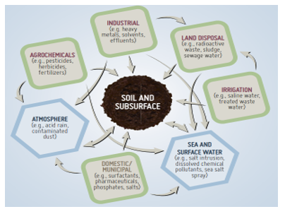
Image 1 : Potential interrelated pathways for soil-subsurface chemical contamination. (Source: Yaron et al., 2012)
- Impact of Soil Pollution
Soil pollution affects the ecosystem in various ways:
- Loss of Soil Fertility: Contaminants disrupt microbial activity, reduce nutrient availability, and degrade soil structure.
- Food Security: Polluted soils result in lower crop yields and contaminated food products.
- Water Contamination: Leaching of pollutants into groundwater impacts water quality.
- Biodiversity Loss: Soil organisms essential for nutrient cycling and ecosystem services are adversely affected.
- Human Health Risks: Exposure to soil contaminants through food, water, or direct contact leads to health issues such as cancer, neurological disorders, and developmental problems.
- Soil Pollution: From Detection to remediation
Soil pollution often cannot be directly assessed or visually perceived, making it a hidden danger. Therefore, it requires minute detection of soil pollution extents in soils. Detecting soil pollution involves various methods that assess the presence and concentrations of contaminants, helping determine the extent of pollution and its potential impact. The methods used in detection of soil pollution are-

Physical Analysis
Texture and Composition Analysis: Determines soil structure, which can influence contaminant movement.
Moisture Content: Assesses water-retaining capacity, influencing pollutant transport.
Chemical Analysis
pH Measurement: Helps identify acidic or alkaline conditions that affect contaminant solubility and bioavailability.
Heavy Metal Testing: Detects toxic metals like lead, cadmium, mercury, and arsenic.
Organic Pollutant Analysis: Uses gas chromatography (GC) or mass spectrometry (MS) to detect hydrocarbons, pesticides, and other organic compounds.
Fluoride and Nitrate Tests: Measures specific anions to assess pollution caused by fertilizers or industrial runoff.
Biological Methods
Microbial Assays: Evaluate changes in microbial activity or population diversity in polluted soil.
Bioindicators: Use plants or microorganisms sensitive to pollutants as markers of soil contamination.
Spectroscopic Methods
Atomic Absorption Spectroscopy (AAS): Measures metal concentrations in soil.
Fourier Transform Infrared (FTIR) Spectroscopy: Identifies organic pollutants.
X-Ray Fluorescence (XRF): Analyzes elemental composition and metal contamination in soils.
Chromatographic Techniques
Gas Chromatography-Mass Spectrometry (GC-MS): Detects volatile organic compounds (VOCs) and persistent organic pollutants (POPs).
High-Performance Liquid Chromatography (HPLC): Measures non-volatile organic contaminants like pesticides.
Immunoassays
Use antibodies to detect specific contaminants, such as herbicides, pesticides, or hydrocarbons.
Electrochemical Techniques
Ion-Selective Electrodes: Measure concentrations of specific ions like nitrates, ammonium, or fluoride.
Voltammetry: Detects metals and organic pollutants in soil.
Remote Sensing and Geospatial Techniques
Satellite Imaging: Detects large-scale changes in vegetation health and soil color, indicating potential pollution.
Geographic Information System (GIS): Maps and analyzes spatial distribution of soil pollutants.
Leachate Analysis
Simulates natural leaching processes to measure contaminants in water passing through soil.
Toxicity Testing
Evaluates the toxic effects of pollutants on soil organisms like earthworms or plants.
Molecular Techniques
Polymerase Chain Reaction (PCR): Identifies genetic markers of microorganisms affected by soil pollutants.
Metagenomics: Studies microbial communities to assess pollution-induced biodiversity changes.
Field Sensors
Real-time monitoring tools for detecting volatile compounds, hydrocarbons, and heavy metals.
These methods can be used independently or in combination, depending on the type of pollutants, the level of contamination, and the specific objectives of the soil pollution assessment.
- Remediation of Polluted Soils:
Remediation is the process that eliminates and/ or controls unacceptable risks in a safe and timely manner, and which maximizes the overall environmental, social and economic benefits of the remediation work. In other words, Soil remediation is the process that uses to remove, degrade contaminants/pollutants to achieve soil for vegetation and a healthy ecosystem. The remediation techniques or options may be traditionally classified as biological (Bioremediation using microorganisms to degrade organic pollutants) chemical (Use of chemical oxidants or stabilizers to neutralize contaminants) or physical (Soil excavation, soil washing, and thermal desorption), but the combination of this processes may offer the most effective remediation, in some cases.
Soil remediation treatments can be broadly categorized into in situ (treatment of undisturbed soils) and ex situ (treatment of excavated soils) methods, applied either on-site or at specialized treatment facilities. In situ treatments are advantageous because they cause minimal disruption to ongoing activities at the site or surrounding areas. This approach involves the circulation of air or water through the polluted soil, making it more suitable for permeable soils with uniform physical conditions and consistent pollution distribution. On the other hand, ex situ methods allow for better control and optimization of treatment conditions, offering higher efficiency in addressing contamination. These methods provide enhanced capabilities for managing variables such as temperature, pressure, and chemical exposure, which can help minimize the spread of pollutants during the remediation process. While ex situ techniques may involve higher costs and the logistical challenge of soil excavation and transport, they often yield superior outcomes in terms of pollutant removal and treatment precision methods have their distinct advantages and limitations, and the choice of approach depends on the site-specific conditions, the type and extent of contamination, and environmental and economic considerations.
However, in some cases, the traditional methods, often proven inadequate in addressing modern environmental challenges. Traditional remediation systems, such as excavation, thermal treatments, and chemical soil washing, are typically resource-intensive, expensive, and sometimes environmentally disruptive, often causing secondary pollution or requiring significant energy inputs. Moreover, these methods are not always effective for treating complex or mixed contaminant types, such as heavy metals combined with organic pollutants, or for addressing diffuse and large-scale pollution. With increasing industrialization, urbanization, and agricultural activities introducing diverse and persistent pollutants into the soil, there is a growing demand for sustainable, cost-effective, and eco-friendly solutions. Emerging technologies, such as nanotechnology, electrokinetic remediation, and advanced bioremediation techniques using genetically modified microbes, offer innovative ways to improve the efficiency, scalability, and sustainability of soil remediation. These approaches are designed to minimize environmental disruption, reduce waste generation, and address contaminants at the molecular level, making them essential for tackling the evolving complexities of soil pollution in a rapidly changing world. All these aspects have ultimately given rise to the needs for new approaches in soil pollution remediation for maintaining sustainability and to help improvement in the soil quality.
  - New Approaches in Soil Pollution Remediation
To address the challenges of traditional remediation methods, innovative solutions like nanotechnology, electrokinetic remediation, advanced bioremediation, and phytoremediation have gained significant traction due to their sustainability, cost-efficiency, and reduced environmental impact. The process can be defined as-
4.1.1 Phytoremediation
Phytoremediation is an innovative and eco-friendly approach to soil remediation that employs plants to extract, stabilize, or degrade contaminants. It leverages the natural abilities of certain plant species to accumulate heavy metals or degrade organic pollutants. For instance, hyperaccumulator plants like Brassica juncea (Indian mustard) are commonly used to absorb toxic metals such as cadmium, arsenic, and lead, while vetiver grass is effective in breaking down organic pollutants such as hydrocarbons. These plants not only clean the soil but also stabilize it by preventing erosion and enhancing soil structure through their root systems. One of the most significant advantages of phytoremediation is its cost-effectiveness compared to traditional remediation methods, as it relies on natural processes and requires minimal mechanical intervention. Furthermore, this technique is environmentally friendly, as it avoids the need for harsh chemicals and preserves soil ecology. Additionally, phytoremediation can improve soil health over time by enhancing organic matter content and microbial activity, contributing to long-term sustainability. Despite its slower pace compared to some other methods, phytoremediation remains an attractive solution for large-scale or low-contamination sites due to its affordability and dual benefits of remediation and ecosystem restoration.
4.1.2 Nanoremediation
Nanoremediation leverages advanced nanotechnology to address soil contamination, employing nanoparticles such as zero-valent iron (nZVI), titanium dioxide (TiO₂), and carbon-based nanomaterials to degrade, neutralize, or immobilize pollutants. These nanoparticles are characterized by their high reactivity, large surface area, and ability to interact directly with contaminants at the molecular level, making them particularly effective in targeting specific pollutants. For instance, nZVI is widely used to reduce and immobilize heavy metals like arsenic, chromium, and lead, while simultaneously breaking down organic pollutants such as chlorinated hydrocarbons into less harmful substances. Similarly, titanium dioxide nanoparticles act as photocatalysts under UV light to degrade persistent organic pollutants, such as pesticides and polycyclic aromatic hydrocarbons, into non-toxic end products.
One of the major advantages of nanoremediation is its high efficiency and targeted action. Unlike traditional methods, nanoparticles can be injected directly into contaminated zones, where they migrate through the soil matrix to interact with pollutants, even in low-permeability soils like clays. This precision reduces the need for extensive soil excavation or energy-intensive treatments, thereby lowering operational costs and minimizing environmental disruption. Additionally, the ability to design nanoparticles for specific contaminants allows for tailored remediation strategies, enhancing effectiveness across a range of soil pollution scenarios. However, despite its promising potential, nanoremediation is not without challenges, including concerns about the long-term environmental fate of nanoparticles and their potential ecological impacts. However, ongoing research into biodegradable and eco-friendly nanoparticles continues to address these limitations, making nanoremediation a sustainable and cutting-edge approach to restoring soil health. By offering scalable, efficient, and less invasive solutions, nanoremediation represents a significant advancement in the field of soil remediation, particularly for sites with complex or persistent contamination issues.
4.1.3 Biochar application
Biochar, a carbon-rich material derived from the pyrolysis of organic biomass under low oxygen conditions, has gained significant consideration as a sustainable tool for soil remediation. Its unique physicochemical properties, including a high surface area, porosity, and an abundance of functional groups, make it particularly effective in adsorbing and immobilizing a wide range of soil pollutants, such as heavy metals, organic contaminants, and excess nutrients. When applied to polluted soils, biochar interacts with contaminants, reducing their bioavailability and toxicity. For instance, biochar can adsorb heavy metals like lead (Pb), cadmium (Cd), and arsenic (As) by binding them to its surface through ion exchange, electrostatic interactions, and complexation. Similarly, it can trap organic pollutants, including pesticides and polycyclic aromatic hydrocarbons (PAHs), preventing their leaching into groundwater or uptake by plants. One of the key advantages of biochar is its ability to simultaneously remediate soil pollution and enhance soil fertility. By improving soil pH, biochar can counteract acidity often associated with contaminated sites, thereby creating a more favourable environment for plant growth. Its high water-holding capacity boosts soil moisture retention, reducing drought stress and promoting healthier vegetation. Furthermore, biochar supports microbial activity by providing a habitat for beneficial microorganisms, which play a critical role in nutrient cycling and organic matter decomposition. For example, mycorrhizal fungi and nitrogen-fixing bacteria thrive in biochar-amended soils, contributing to improved soil productivity.
In addition to its direct effects on contaminants, biochar can be tailored to target specific pollutants. Modified biochars, such as those impregnated with iron or calcium, enhance the sorption of particular contaminants, such as phosphates or heavy metals, further expanding its applicability. Moreover, biochar's long-term stability ensures that its remediation benefits persist over time, offering a sustainable solution for polluted soils. Though, despite its advantages, challenges such as the variability in biochar quality and potential unintended consequences, such as the release of adsorbed contaminants under certain conditions, require careful consideration. Nonetheless, biochar application remains a cost-effective, environmentally friendly, and multifunctional approach for restoring polluted soils while supporting sustainable agricultural practices. Its dual role as a remediation agent and soil amendment positions biochar as a pivotal innovation in the quest for soil health and environmental sustainability.
4.1.4 Electrokinetic Remediation
Electrokinetic remediation is an innovative and versatile soil remediation technique that applies a low-voltage electric field across contaminated soil to mobilize and extract pollutants. This method works by leveraging electrokinetic phenomena, such as electroosmosis, electrophoresis, and electromigration, to transport contaminants towards electrodes for removal. The electric field induces the movement of charged particles, including heavy metals, organic compounds, and salts, either in dissolved form or adsorbed to soil particles. As contaminants migrate towards the anode or cathode, they are either extracted or transformed through chemical reactions near the electrodes.One of the primary advantages of electrokinetic remediation is its effectiveness in fine-grained soils, such as clay and silty soils, where traditional methods often fail due to low permeability. It also performs well in sites with complex contamination, including mixtures of organic pollutants and heavy metals, by targeting different contaminants simultaneously. For instance, heavy metals like lead, arsenic, and chromium are transported through electromigration, while organic pollutants can be addressed using enhancements like surfactants or oxidizing agents added to the soilAnother key benefit of this method is its minimal disruption to the site. Unlike excavation or soil washing, electrokinetic remediation does not require large-scale soil removal, preserving the structural integrity of the site. It can be applied in situ, reducing the risk of spreading contaminants during the remediation process. Furthermore, this technique is energy-efficient compared to methods such as thermal treatments, making it a sustainable option for long-term environmental management. To enhance its efficiency, electrokinetic remediation can be combined with other remediation approaches, such as phytoremediation or chemical amendments, to target specific contaminants or improve soil conditions. For example, adding chelating agents can improve the mobility of certain metals, while oxidizing agents can break down organic compounds. However, challenges such as uneven contaminant migration due to soil heterogeneity and high energy costs for large-scale applications associated with such techniques require further optimization. However, its ability to effectively treat challenging contamination scenarios and its adaptability to different types of pollutants make electrokinetic remediation a promising solution for restoring polluted soils in a wide range of environmental contexts.
4.1.5 Microbial Augmentation
Microbial augmentation is a bioremediation strategy that involves the deliberate introduction of specific microorganisms or microbial consortia into contaminated soils to degrade pollutants and restore soil health. These microorganisms possess enzymatic pathways that allow them to metabolize or transform various contaminants, rendering them less harmful or completely inert. For example, Pseudomonas spp. is widely used for the degradation of hydrocarbons in oil-contaminated soils due to their ability to break down complex organic molecules into simpler, non-toxic compounds. Similarly, Bacillus spp. is effective in breaking down pesticides, reducing their persistence in the environment and preventing their accumulation in food chains. Microbial augmentation is advantageous because of its specificity. Microorganisms can be selected and tailored to target particular contaminants, ensuring efficient remediation. For instance, microorganisms capable of producing enzymes like dehalogenase or oxidase can degrade halogenated hydrocarbons and aromatic compounds, respectively. This specificity minimizes the risk of affecting non-target soil components or nearby ecosystems. Moreover, microbial augmentation is an eco-friendly and cost-effective alternative to chemical treatments, as it uses natural processes to detoxify soils without causing secondary pollution. Again, this approach has potential to enhance soil fertility. Many of the microorganisms used in microbial augmentation, such as nitrogen-fixing bacteria or phosphate-solubilizing microbes, not only degrade contaminants but also contribute to nutrient cycling, thereby improving soil productivity. For example, while breaking down hydrocarbons, Pseudomonas spp. also produce biosurfactants that enhance soil texture and microbial diversity, promoting a healthier soil ecosystem.
Nevertheless, microbial augmentation faces challenges, such as the need for favourable environmental conditions, including appropriate pH, temperature, and moisture levels, to support microbial activity. Additionally, the introduced microorganisms must compete with native microbial populations and adapt to the specific soil environment to achieve effective remediation. Advances in microbial genomics and synthetic biology are helping to overcome these limitations by engineering more robust microbial strains capable of thriving in diverse and challenging conditions. Microbial augmentation represents a promising and sustainable approach to soil remediation, offering a targeted and environmentally friendly solution to mitigate the effects of soil pollution while contributing to the restoration of soil health and productivity.
4.1.6 Soil Amendments
Soil amendments involve the addition of specific materials, such as gypsum, compost, lime, or biochar, to restore soil health and neutralize contaminants effectively. These materials act by altering the chemical, physical, and biological properties of the soil, making pollutants less bioavailable and mitigating their harmful effects. Gypsum, for instance, is widely used to address salinity issues and reduce the mobility of toxic heavy metals such as aluminum in acidic soils. By improving soil structure and porosity, gypsum also enhances water infiltration and reduces surface runoff, minimizing the risk of contaminant transport. Compost, a nutrient-rich organic amendment, is particularly effective for remediating soils polluted with organic contaminants and heavy metals. It improves the soil's organic matter content, promotes microbial activity, and fosters the development of a robust soil food web. Microorganisms in compost can break down complex organic pollutants like hydrocarbons and pesticides, while the humic substances in compost bind heavy metals, reducing their bioavailability to plants and soil organisms. Compost also enhances soil fertility, improving crop productivity in contaminated lands. Lime is another widely used amendment, particularly in acidic soils, as it raises pH levels and reduces the solubility of toxic elements such as aluminum and manganese. By neutralizing soil acidity, lime creates a more favorable environment for plant growth and nutrient availability. This is especially beneficial in mining areas or regions where industrial activities have led to acidification and the leaching of harmful elements.In addition to these traditional amendments, advanced materials like zeolites and engineered biochar are being explored for their enhanced contaminant adsorption capabilities. Soil amendments not only remediate pollution but also enhance water retention, improve aeration, and stabilize soil aggregates, contributing to long-term soil health and sustainability. By combining cost-effectiveness with environmental benefits, soil amendments represent a versatile and eco-friendly approach to restoring polluted soils while supporting agricultural productivity.
  - Integrated Remediation Approaches
Integrated remediation approaches combine multiple techniques to maximize efficiency and address diverse pollutants in complex environmental scenarios. By leveraging the strengths of different methods, these approaches enhance contaminant removal, improve soil health, and promote sustainability.
Phyto-Nanoremediation: represents a synergistic use of plants and nanoparticles to remediate polluted soils. Plants, known for their ability to extract, degrade, or stabilize contaminants, are paired with nanoparticles like zero-valent iron (ZVI) or titanium dioxide (TiO₂), which enhance the degradation or immobilization of pollutants. For example, plants with deep root systems can transport nanoparticles to contaminated zones, where they catalyze the breakdown of hydrocarbons or heavy metals. This combination improves the uptake of contaminants while ensuring minimal environmental disruption.
Bioelectrochemical Systems: integrate microbial degradation with electrokinetic techniques to achieve comprehensive remediation. In this method, microorganisms break down organic pollutants, while electrokinetic methods mobilize ions or contaminants in the soil matrix. BES are particularly effective for mixed pollution scenarios, such as areas contaminated with both heavy metals and organic compounds. The electric field enhances microbial activity by providing optimal conditions for electron transfer, thereby accelerating the degradation of pollutants like petroleum hydrocarbons or polycyclic aromatic hydrocarbons (PAHs).
Amendment-Bioremediation: pairs soil amendments, such as gypsum, lime, or biochar, with enhanced microbial activity. Soil amendments improve soil structure, neutralize toxic compounds, and create favorable conditions for microbial communities. When combined with bioremediation, this approach amplifies the breakdown of contaminants like pesticides or hydrocarbons. For instance, compost amendments not only enhance organic matter but also provide a habitat for microbes capable of degrading persistent organic pollutants.
These integrated approaches offer significant advantages over standalone remediation techniques. By addressing multiple pollutant types and leveraging natural processes, they reduce remediation costs, minimize environmental disruption, and improve soil functionality. Integrated strategies are especially valuable for large-scale, heterogeneous pollution sites, offering flexible, efficient, and eco-friendly solutions to contemporary soil pollution challenges.
- Emerging New Approaches for remediation of Polluted Soils and their effectiveness

  - Phytoremediation, Microbial Augmentation, Amendments and their integration:
The increasing complexity of soil pollution, driven by industrial, agricultural, and urban activities, necessitates innovative approaches to soil remediation. Emerging strategies like phytoremediation, microbial augmentation, and the use of soil amendments have shown significant promise in addressing persistent pollutants such as heavy metals, hydrocarbons, and agrochemicals. These methods emphasize eco-friendliness, cost-effectiveness, and sustainability by leveraging natural processes to detoxify and restore polluted soils. When integrated, such as combining phytoremediation with microbial augmentation or amendments, these techniques offer synergistic benefits, improving both remediation efficiency and soil health. These novel approaches are transforming soil management practices, ensuring effective remediation while minimizing environmental disruption.
Phytostabilization is a mode of action for phytoremediation in which plants immobilize metals in order to minimize the transportation and leaching of contaminants while allowing metal accumulation in their roots with only small amounts of pollutant heavy metals being translocated to the shoots (Dary et al., 2010; Karczewska et al., 2013). Considering the potentiality of combined use of plants and their associated microbes to remediate heavy metal-contaminated soil, Ahsan et al. (2018) studied the effect that augmentation of soil with plant growth-promoting endophytes has on the phytostabilization of chromium (Cr)-contaminated soil using three potential endophytic bacterial strains (Enterobacter sp. HU38, Microbacterium arborescens HU33, and Pantoea stewartii ASI11). They were inoculated individually as well as in combination to Leptochloa fusca and Brachiaria mutica vegetated in Cr-contaminated soil. The treatments details of the study were, A: uncontaminated soil; B: Cr @ 50 mg kg⁻¹ soil; C: Cr @50 mg kg⁻¹ soil+ Bacterial consortium; D: Cr @100 mg kg⁻¹ soil; E: Cr @100 mg kg⁻¹ soil + Bacterial consortium; F: Cr @200 mg kg⁻¹ soil; G: Cr @200 mg kg⁻¹ soil +Bacterial consortium.
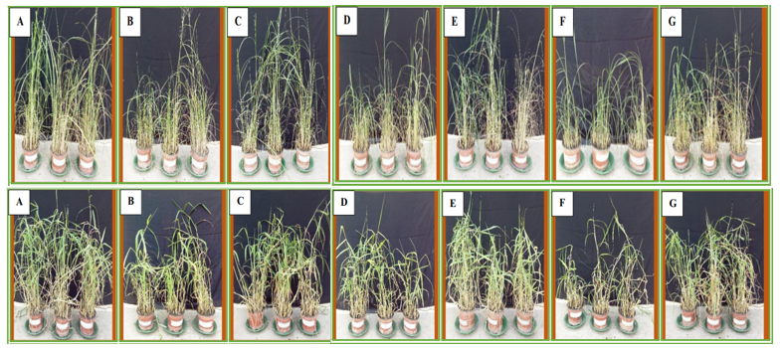
Fig. 1. Effect of endophytes augmentation on growth of Top: Leptochloa fusca and Bottom: Brachiaria mutica vegetated in Cr contaminated soil (Source: Ahsan et al, 2018)
Heavy metal contamination, such as chromium (Cr) in soil, has been reported to significantly inhibit plant growth and biomass production (Sessitsch et al. 2013, Khan et al. 2015), particularly at higher contamination levels. However, the study (Fig.1) highlights the potential of inoculated endophytic plant growth-promoting (PGP) bacteria to mitigate these inhibitory effects. Even though, a gradual decrease in growth and development as well as chlorophyll content of both plant species was observed with the increase in Cr concentration in soil as compared to the plants grown in uncontaminated soil, bacterial augmentation increased plant growth and chlorophyll content with maximum plant growth obtained with the application of all three bacterial strains together. Again, L. fusca and B. mutica augmented with bacterial consortium showed significant (p < 0.05) increase in root BCF (Bioconcentration factor) values (Table 1.) from 3.68 to 5.66 and 1.12 to 1.60; 2.26 to 3.17 and 0.78 to 1.13; and 1.84 to 2.47 and 0.77 to 1.07 at Cr contamination levels of 50, 100, and 200 mg kg⁻¹, respectively. Although bacterial augmentation increased BCF, most pronounced effect was observed when endophytes were used in consortium. The BCF values of roots were recorded to be > 1, and of shoots to be < 1. The high root BCF values along with low shoot BCF values confirm the phytostabilization potential of both plants.

Table 1. Bioconcentration factor of Leptochloa fusca and Brachiaria mutica plants grown in Cr-contaminated soil at different metal contamination levels (Ahsan et al, 2018)
Treatment | 50 mg Cr Kg⁻¹  Soil |  | 100 mg Cr Kg⁻¹ Soil |  | 200 mg Cr Kg⁻¹ Soil
Treatment | Roots | Shoots | Roots | Shoots | Roots | Shoots
Leptochloa fusca
Uninoculated | 3.68 | 0.46 | 2.26 | 0.32 | 1.84 | 0.18
Pantoea stewartii ASI11 | 4.18 | 0.5 | 2.45 | 0.34 | 2.06 | 0.19
Microbacterium arborescens HU33 | 4.12 | 0.54 | 2.41 | 0.37 | 2.03 | 0.2
Enterobacter sp. HU38 | 4.1 | 0.5 | 2.43 | 0.35 | 2.05 | 0.21
Consortium* | 5.66 | 0.68 | 3.17 | 0.46 | 2.47 | 0.24
Brachiaria mutica
Uninoculated | 1.12 | 0.42 | 0.78 | 0.33 | 0.77 | 0.22
Pantoea stewartii ASI11 | 1.24 | 0.46 | 0.81 | 0.36 | 0.84 | 0.23
Microbacterium arborescens HU33 | 1.2 | 0.44 | 0.84 | 0.35 | 0.86 | 0.22
Enterobacter sp. HU38 | 1.3 | 0.44 | 0.82 | 0.37 | 0.84 | 0.23
Consortium* | 1.6 | 0.54 | 1.13 | 0.41 | 1.07 | 0.26

These bacteria employ mechanisms like ACC deaminase activity, phosphate solubilization, nitrogen fixation, siderophore production, and phytohormone (IAA) synthesis to support plant growth in contaminated soils. ACC deaminase reduces ethylene levels by enzymatically hydrolysing ACC, alleviating metal-induced stress, while IAA enhances root elongation and nutrient absorption. Siderophores, as metal-chelating agents, improve chlorophyll biosynthesis by making iron more accessible to stressed plants. The findings emphasize that inoculated PGP bacteria significantly improve plant growth and development under heavy metal stress, presenting a sustainable and effective remediation strategy for contaminated soils. Plant’s ability to accumulate more Cr in roots is a natural toxicity response in which Cr becomes immobilized in the vacuoles of root cells.

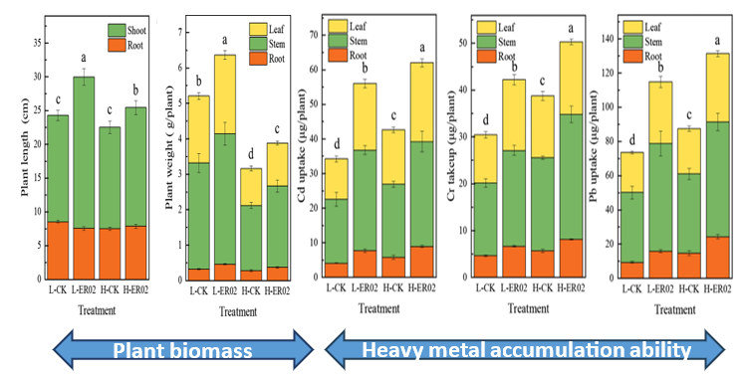
Fig. 2. Effect of endophyte inoculation on length, weight, Cd, Cr and Pb uptake of T. repens plants (Source: Liu et al., 2022)
Again, application of endophytes also showed a positive effect on the biochemical responses of Trifolium repens L. and could significantly improve rhizosphere ecological functioning in multi-heavy metal contamination, which provided clear strategies for regulating phytoremediation (Liu et al., 2022). Enhancing plant biomass and improving heavy metal accumulation ability are the two main methods to promote phytoremediation efficiency. In these regard, endophyte Pseudomonas putida (Fig. 2) could be suitable for microbial assisted phytoremediation because of its ability which is conducive to plant growth and HM concentration of its host plants (Fig. 1). Pseudomonas putida significantly increased plant biomass by 22.26–22.78% and phytoremediation of heavy metals Cd, Cr and Pb efficiency by 29.73–64.01%. The endophyte improved plant HM accumulation ability by facilitating metal solubility in rhizosphere soils with multi-metal contamination. Because of the improvement of plant biomass and HM enrichment, the total HM uptake and phytoremediation efficiency were extremely enhanced.
Bioremediation by natural attenuation (NA), bioaugmentation (BA), and biostimulation (BS) microcosmic experiment shows degradation rates for another major pollutant petroleum hydrocarbons in surface, middle, and deep soils as 99.87%, 96.04%, and 71.63% in the BA group; 99.75%, 95.73%, and 99.84% in the BS group; and 8.55%, 8.64%, and 9.84% in the NA group, respectively (Nong et al., 2023). Most of the petroleum hydrocarbon fractions were completely degraded by the end of remediation experiments (300 days) (Fig.3). The treatments comprised of (1) natural attenuation (NA) which is to study the biological depletion of petroleum hydrocarbons in contaminated soil by indigenous microbial communities by adding only sterile water; (2) bioaugmentation (BA) to study the effect of adding native dominant degrading bacteria on petroleum hydrocarbon degradation by supplementing the soil with 2% (w/v) dominant petroleum hydrocarbon–degrading strains, resulting in a soil density of 108 CFU g⁻¹; (3) biostimulation (BS) to study the effect of native microorganisms on the degradation of petroleum hydrocarbons when nutrients were added.
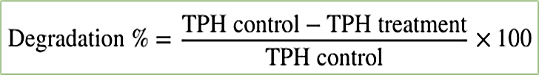
The TPH degradation percentage is obtained by-

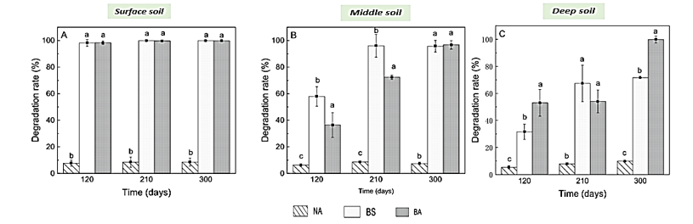
Fig. 3. Degradation % of petroleum hsydrocarbons in soils after bioremediation (Source: Nong et al., 2023)
The TPH degradation rate in the surface soil was>95% after 120 days of treatment, and most TPHs had been removed. TPH degradation rates in the middle and deep soil layers increased with time. After 300 days of treatment, TPH degradation rates in the middle soil exceeded 95.37% for BS and BA treatments; in the deep soil, the TPH degradation rate was 99.84% for the BS treatment group and only 71.63% for the BA group. Compared to NA, the TPH removal effect was significantly improved by feeding bacteria and adding nutrient salt, and addition of nutrient salts was shown to have superior effects compared to that of addition of bacteria (Suja et al., 2014). Overall, BS showed better degradation of long-chain alkanes (C27‒C36+) than that of short chain alkanes. Mung bean (Vigna radiata) seeds were selected as materials and germination percentages were used to assess soil toxicity after bioremediation. The germination rates (Fig.4) in BS and BA groups were > 72.5%. Compared with the NA group, the germination rates of bioremediation were significantly higher (Varjani et al., 2020). The germination rate increased with increasing soil depth, and the highest germination rate of 82.5% was observed in deeper soils. The results of this study demonstrated that BS should be the treatment of choice for the remediation of petroleum hydrocarbon–contaminated soils. This study obtained results that were similar to those of previous studies, where BS was more effective than BA.
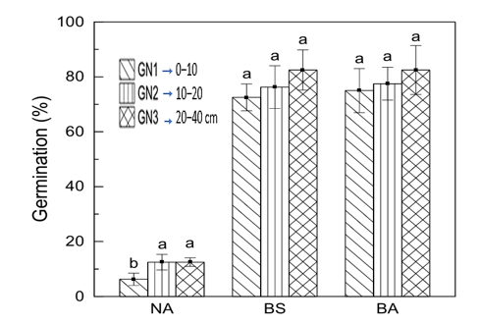
Fig. 4. Germination (%) of Mung beans in different soil layers for 300 days of microscopic treatment (Source: Nong et al., 2023)
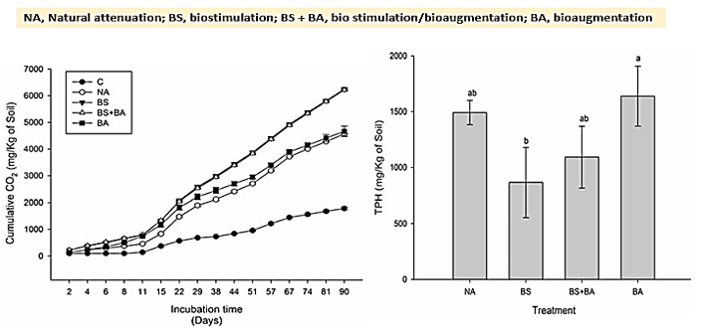
Fig. 5 Left: Cumulative CO₂ production determined by respirometry, right: Total petroleum hydrocarbons (TPHs) after 90 days of incubation in contaminated soil during 90 days of incubation at room temperature using different bioremediation strategies (Source: Giovanella et al., 2021)
Biostimulation and bioaugmentation techniques also has synergistic effect on soil microbial health. All the treatments revealed an increase in CO₂ production over the incubation period (Fig.5), indicating microbial metabolism in the microcosms when microbial consortium capable of detoxifying diesel oil were applied for bioremediation of soil contaminated with environmental pollutant through different bioremediation process (Giovanella et al., 2021). However, the soil without diesel oil addition (control) had the lowest respiration rate (~1.6 g of CO₂ per kg of soil), an expected result due to the low concentrations of carbon, nitrogen, and available phosphorus. Biostimulation (BS) and biostimulation/bioaugmentation (BS + BA) showed the highest respiratory rates, with CO₂ production of ~6.2 g/kg of soil, which indicates greater microbial activity in the treatments receiving nutrient addition. The TPH degradation was consistent with the data related to microbial soil respiration, with the BS and BS + BA treatments having the highest degradation rates relative to natural attenuation (41.9 and 26.7%, respectively).
When microbial augmentation is coupled with other remediation techniques, reports are evident in their effectiveness. Effective rhizoremediation pattern for removal of BDE-209 in pollution soils, through successive cultivation of rice and followed by ryegrass, with rice growth coupled with AMF inoculation and compost addition, while ryegrass growth coupled with AMF inoculation only was studied (Feng et al., 2019). The treatment combination were CK-Ry, dry control of ryegrass group; Ry, Ryegrass growth only; RyG, Ryegrass + G. mosseae; RyC, Ryegrass + compost; RyGC, Ryegrass + G. mosseae + compost; CK-Ri, sequential wetting-drying control of rice group; Ri, Rice growth only; RiG, Rice + G. mosseae; RiC, Rice + compost; RiGC Rice + G. mosseae + compost; NRS, Non-rhizosphere soil; RS, Rhizosphere soil. In general, the BDE-209 dissipation rates (as percentage removal of the initial amounts) in aged-contaminated soils (14.8%–53.3%) were higher than those in freshly-spiked soils (15.6%–28.0%) (Table 2).
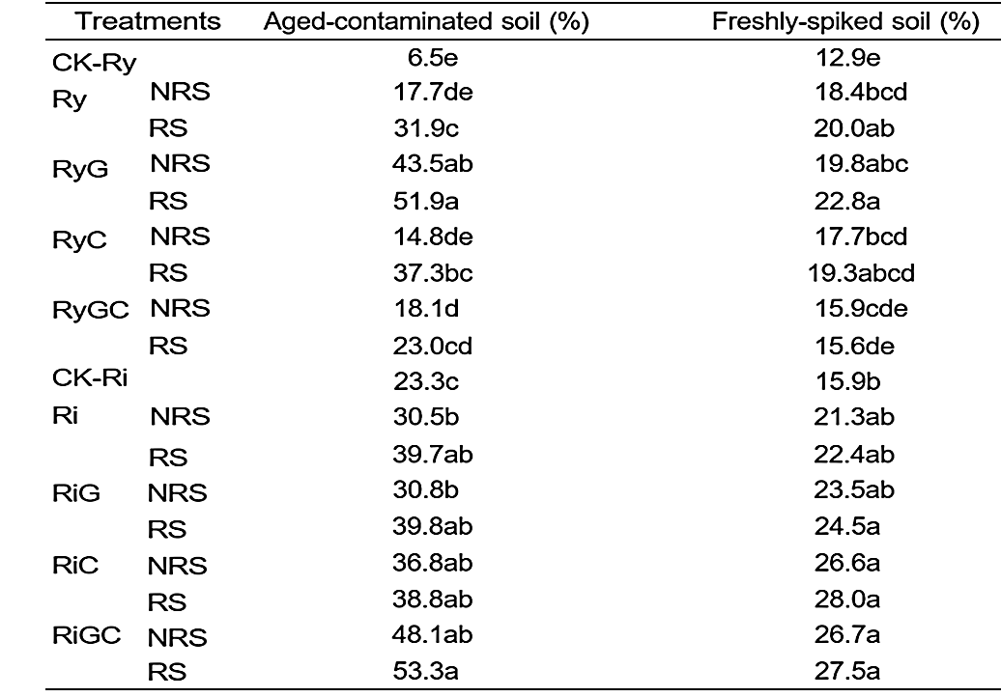
Table 2. The removal percentage of BDE-209 in rhizosphere (RS) and non-rhizosphere (NRS) of aged-contaminated and freshly-spiked soils of different treatments (Feng et al., 2019)

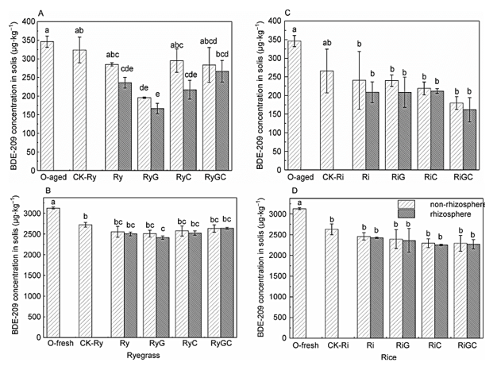
Fig. 6. The concentration of BDE-209 in soils of ryegrass (A and B) and rice (C and D) experiments (A and C: aged-contaminated soil; B and D: freshly-spiked soil). O-aged and O-fresh, original aged and freshly-spiked contaminated soil samples before the experiment commenced, respectively (Source: Feng et al., 2019)
Plants can enhance the dissipation of OCs by various processes, like immobilization, removal, and promotion of microbial degradation (Megharaj et al., 2011). In this study, the BDE-209 removal (Fig.6) was verified to be dependent on plant species, pollution condition and agronomic practices, and between rhizosphere and non-rhizosphere. By combining with G. mosseae inoculation and/or compost addition, the removal of BDE-209 in soils growing ryegrass or rice was greatly improved, with the effect regulated by the plant-microbial interactions that depended on plant species and pollution conditions.
5.2 Nano, Nano-Bio based and Biochar application approaches
The application of nano-sized materials for addressing environmental contamination is referred to as "nanoremediation." This innovative approach provides highly efficient, cost-effective, and rapid solutions for cleaning up contaminated sites. Nanoparticles such as zero-valent iron (ZVI), iron oxide, and silica have been extensively studied and utilized for their ability to degrade or immobilize pollutants. For instance, ZVI nanoparticles have demonstrated remarkable effectiveness in treating groundwater contamination, while iron oxide and silica nanoparticles are used for heavy metal adsorption and organic pollutant degradation. These materials' high reactivity and surface area make them particularly suitable for targeting complex contaminants efficiently.
Certain pollutants such as petroleum hydrocarbon etc. are very difficult to remove due to its complex components, high hydrophobicity, low volatility, low solubility, and high adsorption capacity in soil. The chemical oxidation method, on the other hand, is widely used in soil situ remediation because of its advantages of fast reaction speed, high efficiency, non-selectivity, and continuous availability in soil, especially activated PS oxidation technology in recent years. Fe₃O₄ magnetic nanoparticles (Fe₃O₄ MNPs) were assessed (Fig. 7) for their ability to enhance the activity of persulfate (PS) by Li et al. (2024). The methodology of preparation of nanoparticles are presented as-
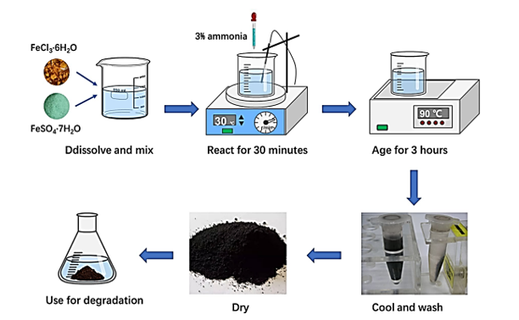
Fig. 7. Preparation procedures of Fe₃O₄ MNPs (Source: Li et al., 2024)
The hydrocarbon removal efficiency continuously increased with an increase in the PS dosages, then tended to be stable (Fig. 8), even decreased when the PS concentration was higher than 0.05 mol/L. As the driving force for the degradation of petroleum hydrocarbon, it is reasonable that higher PS dosages lead to higher petroleum hydrocarbon removal efficiency, for more generation of SO₄ ^{−·}. However, when PS dosages exceed a certain amount, activated SO₄ ⁻· reacts with excessive PS and OH⁻ in the solution, consuming SO₄ ^{−·} and inhibiting the increase of degradation rate of petroleum hydrocarbon. Considering both costs and efficiency, 0.05 mol/L would be the best choice of the PS dosages. As the PS dosages increased, the difference in degradation rate between the two systems decreased until the Fe³O⁴ MNPs/PS system reached a higher degradation rate, as shown in the small graph in Fig. 8.
The use of nano/biostimulation or nano/bioaugmentation treatments resulted in higher than 60% total n-alkane degradation, whereas 89.5% degradation was obtained by using nano/biostimulation + bioaugmentation.

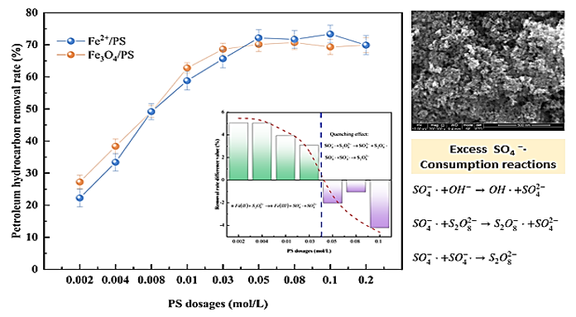
Fig. 8. Effect of initial PS dosages on petroleum hydrocarbon degradation by the Fe²⁺/PS and Fe₃O₄ MNPs/PS system (Source: Li et al., 2024)
Like nanoremediation, biochar application has gotten a lot of attention in the last 20 years since it is recognized as an environmentally acceptable and cost-effective way for degrading pollutants and reducing the threat of soil contamination. Biochar employs direct mechanisms such as ion exchange, precipitation, reduction, electrostatic attraction, and complexation to transform soil organic contaminants into non-toxic forms, thereby reducing their mobility and bioavailability. This, in turn, enhances soil health and supports agricultural productivity. Indirectly, biochar's porous structure provides a protective habitat and nourishment for microbes, boosting microbial activity in polluted soils. Additionally, its porous nature facilitates the biodegradation of organic contaminants, such as PAHs, which are broken down into non-toxic forms by PAH-degrading microbes in the soil (Haider et al., 2022).
Using biochar (BC) as a soil amendment to sequester carbon to mitigate climate change is well known. However, the implications of adding BC to agricultural soil for the environmental fate of pesticides remain unclear. In particular, the effect of biochars on desorption behavior of compounds is poorly understood. The influence of BC on pesticide chemical and biological accessibility using the herbicide isoproturon (IPU) was studied (Sopeña et al., 2012). The desorption (Table 3) of IPU from the biochar decreased significantly with increase in the doses of biochar. Also, desorption from 0% biochar was less as compared to high dose of biochar indicating the higher immobilization of IPU in the soil by biochar and compared to non-biochar applied soil.

Table 3. Percentages of IPU desorbed(D), Freundlich Desorption parameters (n_{des}) and Hysteresis Coefficients (H) from batch experiments with biochar-amended soils
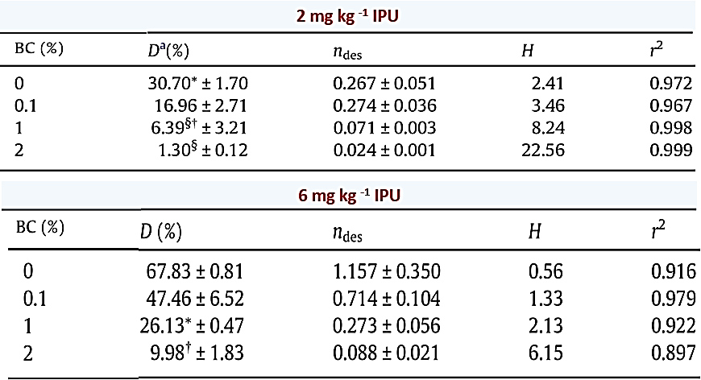
Similarly, biochar also contain potentiality in remediation crude oil contaminated soils. Crude oil contamination is a serious environmental threat to soil and plants growing in it. Biochar has the potential of biostimulation for remediation of crude oil-contaminated soil. The analysis of bio-stimulatory impact of biochar for remediating the crude oil contaminated soil (10%, and 15%), and growth of maize under glasshouse conditions was studied by Saeed et al. (2021). The treatment combinations used in the study were- To = Control without oil and biochar , T1 = Soil with 10% oil contamination, T2 = Soil with 15% oil contamination ,T3 = Soil with 1% biochar, T4 = Soil with 10% oil contamination and biochar, T5 = soil with 15% oil contamination and biochar. The results of soil analysis showed that the crude oil degradation efficiency of biochar was 34%. The soil enzymatic activities had shown 38.5% increase in fluorescein diacetate (FDA) hydrolysis and 55.6% increase in dehydrogenase activity in soil incubated with biochar in comparison to control (Fig. 9). Many researchers have acknowledged that the enzyme actions of soil are interrelated with the fertility of soil and biomass of microbes.
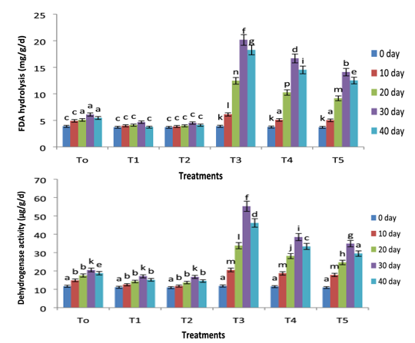
Fig. 9 . Variations in the fluorescein diacetate (FDA) hydrolysis and dehydrogenase activity of all treatments with remediation time (Source: Saeed et al., 2021)
Biochar incubation resulted in a 24.6% increase in chlorophyll content in the absence of oil, 16.4%, and 10% increase in chlorophyll at 10% and 15% level of oil as compared to the control one. Results of current research show that the fresh and dry biomass of plants was reduced in oil-contaminated soil (Fig. 10). More reduction was encountered at a 15% level of oil as compared to a 10% level of oil. Plants growing in oil-contaminated soil are documented to have a reduction in growth due to the accumulative impact of toxicity of hydrocarbons and inadequate aeration because of blockage of soil pores with crude oil (Pernar et al., 2006). Soil with a high level of oil has led to an increase in growth inhibition because of difficulty in the water and ion absorption. The possible justification of this fact that absorption of toxic contaminants by plants can change the structure of plasma membrane. A significant increase in plant fresh and dry biomass was recorded in biochar treated plants at 10% and 15% level of oil. It might be due to the increase in nutrient availability in the soils treated with biochar.
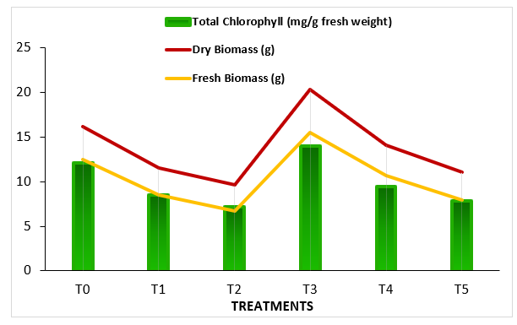
Fig. 10. Total chlorophyll, fresh and dry biomass of maize growing in hydrocarbon contaminated and biochar remediated soil (Source: Saeed et al., 2021)
5.3 Electrokinetic and Oxidation-Reduction Processes
The chemical reduction and advanced oxidation processes have been widely used individually in environmental pollution studies, however, very few studies have evaluated the combined reduction/oxidation approach for soil remediation. Removal of polychlorinated biphenyls (PCB) contaminated soils by means of chemical reduction and advanced oxidation processes using spiked sand and historically contaminated soil by using four synthetic nanoparticles (Fe₀, Fe/Ni, Fe₃O₄, Fe_{3-x}Ni_{x}O₄) (Rybnikova et al., 2016). These nanoparticles were tested firstly for reductive transformation of polychlorinated biphenyls (PCBs) and then employed as catalysts to promote chemical oxidation reactions (H₂O₂ or persulfate) (Fig 11 and 12).
In oxidation tests using synthesized nano-sized particles as catalysts, showed slightly higher degradation extents. H₂O₂ oxidation resulted in the degradation of 18, 19, 7, and 7 % of PCBs for Fe₀, Fe/Ni, Fe₃O₄, and Fe₃ − _{x}Ni_{x}O₄, respectively, after 48 h. Comparable degradation extents were observed in persulfate oxidation (13, 18, 8, and 10 % for Fe₀, Fe/ Ni, Fe₃O₄ and Fe_{3 − x}Ni_{x}O₄, respectively). It is worth noticing that magnetite nanoparticles, which did not show any reductive transformation capacity, showed 7–8 % of PCB degradation in direct oxidation.
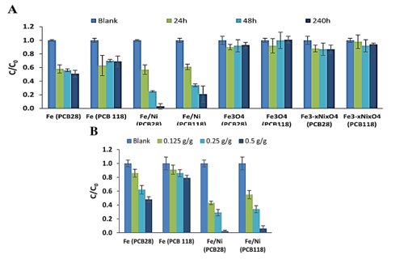
Fig. 11. A) Reductive transformation of PCB28 and PCB118 in spiked sand in the presence of different iron nanoparticles, B) Effect of nanoparticle dosage on efficiency of reductive transformation: L/S =1:1, pH=7.2±0.3, reaction time=48 h (Source: Rybnikova et al., 2016)
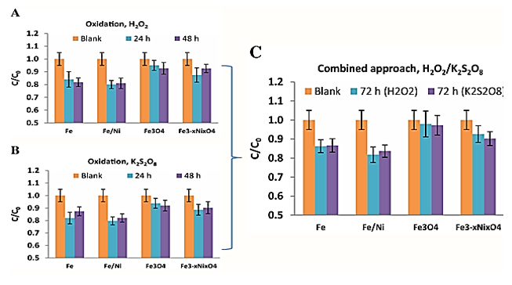
Fig. 12. Comparison of degradation efficiency of different nanoparticles in a, b direct oxidation and c combined approach (oxidant added at t=24h) (Source: (Source: Rybnikova et al., 2016)
In addition to oxidation-reduction methods, different electrokinetic methods are gaining attention in present times. Electrokinetic remediation is a well-known method for removing heavy metals from soil. It involves passing a low-density direct electric current through soil, transporting the contaminants between electrodes (anodes and cathodes) placed at appropriate distances. Electrokinetic remediation for contaminated soils aims to remove contaminants from low-permeability soils under the influence of a low-level direct current, with electroosmosis, electromigration, and electrophoresis as the primary transport mechanisms. The transport of contaminants towards the electrode of opposite charge increases when dissolved charged particles are in the interstitial fluid. The contaminants are then collected in the chambers of one of the electrodes and disposed of appropriately. Most hydrophobic organic particles are non-ionic and unaffected by an electrical field. A typical setup for electrokinetic remediation is presented in Fig. 13.
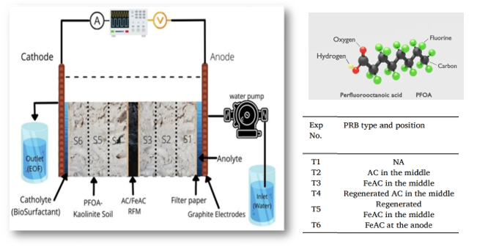
Fig. 13. Electrokinetic setup used in the soil remediation process (Source: Ganbat et al., 2024)
Coupling industrial iron slag waste and iron slag-activated carbon reactive filter media with electrokinetic for a single and mixture of heavy metals treatment (Fig. 14. A and B) also demonstrated positive effect in increasing the removal of heavy metals (Hamdi et al., 2024). Instead of using acid enhancement agents, the anolyte solution was recycled to neutralize the alkaline front at the cathode, reducing the operation cost and chemical use. Experiments were conducted for 2 and 3 weeks at 20 mA electric current. Copper removal increased from 3.11 % to 23 % when iron slag reactive filter media was coupled with electrokinetic. Copper removal increased to 70.14 % in the electrokinetic experiment with iron slag-activated carbon reactive filter media.

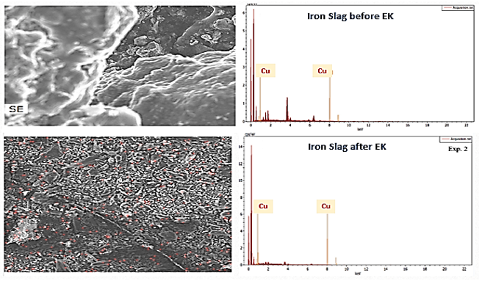
Fig. 14. A) SEM and EDM images of iron slag before and after EK treatment (Source: Hamdi et al., 2024)
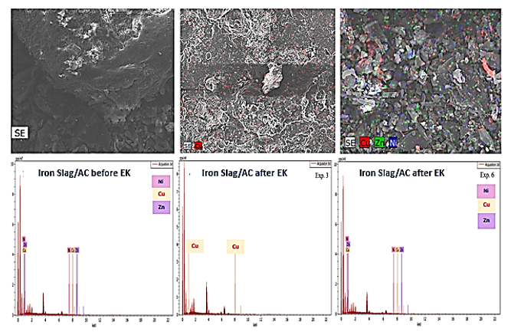
Fig. 14. B) SEM and EDS of iron slag/activated carbon before EK treatment (Left) and After EK treatment (Middle and Right)

Policy and Community Engagement
Regulatory Frameworks: Regulatory frameworks are essential for enforcing laws that prevent soil pollution and incentivizing remediation efforts. Policies like “polluter-pays” ensure industries bear responsibility for contamination while environmental quality standards guide remediation practices.
Community Involvement: Active involvement of local communities fosters shared responsibility for soil health. Awareness campaigns, workshops, and training empower people to identify pollution sources and implement sustainable remediation practices.
Research and Development: Investing in research drives innovation in soil remediation technologies. Collaborative efforts between academia, industry, and governments advance solutions like nanoremediation and biochar application s, ensuring scalability and accessibility.
- Conclusion
The need for effective soil remediation has become increasingly urgent due to escalating pollution from industrial, agricultural, and urban sources. While traditional remediation techniques have played a foundational role, their limitations necessitate the adoption of innovative approaches. Emerging technologies, such as nanoremediation, biochar application, microbial augmentation, and integrated systems, offer sustainable, cost-effective, and eco-friendly solutions. These methods not only mitigate pollution but also restore soil health and productivity. By leveraging interdisciplinary research and community engagement, the future of soil remediation lies in scalable and adaptable techniques capable of addressing diverse and evolving environmental challenges. The adoption of these methods is pivotal in ensuring soil sustainability, safeguarding ecosystems, and supporting agricultural and socio-economic resilience.
Disclaimer (Artificial Intelligence)
Author(s) hereby declare that no generative AI technologies such as Large Language models (Chat GPT, COPILOT, etc) and text to image generators have been used during writing or editing of this manuscript.
References:
Ahsan, M. T., Najam-ul-Haq, M., Saeed, A., Mustafa, T., & Afzal, M. (2018). Augmentation with potential endophytes enhances phytostabilization of Cr in contaminated soil. Environmental Science and Pollution Research, 25, 7021-7032.
Armishaw, R., Bardos, P., & Dunn, R. M. (1992). Review of Innovative Contaminated Soil Clean-up. Warren Spring Laboratory.
Bayat, J., Hashemi, S. H., Khoshbakht, K., & Deihimfard, R. (2016). Fingerprinting aliphatic hydrocarbon pollutants over agricultural lands surrounding Tehran oil refinery. Environmental monitoring and assessment, 188, 1-15.
Bilias, F., Nikoli, T., Kalderis, D., & Gasparatos, D. (2021). Towards a soil remediation strategy using biochar: Effects on soil chemical properties and bioavailability of potentially toxic elements. Toxics, 9(8), 184.
Bundschuh, J., Litter, M. I., Parvez, F., Román-Ross, G., Nicolli, H. B., Jean, J. S., Liu, C. W., Lopez, D., Cornejo,L., Cumbal, L.& Toujaguez, R. (2012). One century of arsenic exposure in Latin America: A review of history and occurrence from 14 countries. Science of the total Environment, 429, 2-35.
Dary M, Chamber-Perez, M.A., Palomares, A.J. & Pajuelo, E. (2010). In situ phytostabilisation of heavy metal polluted soils using Lupinus luteus inoculated with metal resistant plant-growth promoting rhizobacteria. J Hazard Mater 177(1-3):323–330.
FAO & ITPS. (2015). Status of the World’s Soil Resources (SWSR) - Main Report. Rome, Italy, ood and Agriculture Organization of the United Nations and Intergovernmental Technical Panel on Soils.
Feng, J., Shen, X., Chen, J., Shi, J., Xu, J., Tang, C., ... & He, Y. (2019). Improved rhizoremediation for decabromodiphenyl ether (BDE-209) in E-waste contaminated soils. Soil Ecology Letters, 1, 157-173.
Fritt-Rasmussen, J., Jensen, P. E., Christensen, R. H. B., & Dahllöf, I. (2012). Hydrocarbon and toxic metal contamination from tank installations in a northwest Greenlandic village. Water, Air, & Soil Pollution, 223, 4407-4416.
Ganbat, N., Altaee, A., Hamdi, F. M., Zhou, J., Chowdhury, M. H., Zaidi, S. J., ... & Tapas, M. J. (2024). PFOA remediation from kaolinite soil by electrokinetic process coupled with activated carbon/iron coated activated carbon-permeable reactive barrier. Journal of Contaminant Hydrology, 267, 104425.
Geissen, V., Mol, H., Klumpp, E., Umlauf, G., Nadal, M., van der Ploeg, M., van de Zee, S.E.A.T.M. & Ritsema, C. J. (2015). Emerging pollutants in the environment: a challenge for water resource management. International soil and water conservation research, 3(1), 57-65.
Giovanella, P., de Azevedo Duarte, L., Kita, D. M., de Oliveira, V. M., & Sette, L. D. (2021). Effect of biostimulation and bioaugmentation on hydrocarbon degradation and detoxification of diesel-contaminated soil: a microcosm study. Journal of Microbiology, 59, 634-643.
Grathwohl, P. & Halm, D., eds. 2003. INTEGRATED SOIL AND WATER PROTECTION: RISKS FROM DIFFUSE POLLUTION. Cluster meeting; 2nd, Innovative management of groundwater resources in Europe - training and RTD coordination; Sustainable management of soil and groundwater resources in urban areas. Conference papers / Umweltbundesamt, Wien. Paper presented at, 2003, Wien.
Haider, F. U., Wang, X., Zulfiqar, U., Farooq, M., Hussain, S., Mehmood, T., ... & Mustafa, A. (2022). Biochar application for remediation of organic toxic pollutants in contaminated soils; An update. Ecotoxicology and Environmental Safety, 248, 114322.
Hamdi, F. M., Altaee, A., Alsaka, L., Ibrar, I., Maryam, A. E., Zhou, J., ... & Hawari, A. H. (2024). Iron slag/activated carbon-electrokinetic system with anolyte recycling for single and mixture heavy metals remediation. Science of The Total Environment, 930, 172516.
Karczewska, A., Lewińska, K., & Gałka, B. (2013). Arsenic extractability and uptake by velvetgrass Holcus lanatus and ryegrass Lolium perenne in variously treated soils polluted by tailing spills. Journal of hazardous materials, 262, 1014-1021.
Khan, M. U., Sessitsch, A., Harris, M., Fatima, K., Imran, A., Arslan, M. & Afzal, M. (2015). Cr-resistant rhizo-and endophytic bacteria associated with Prosopis juliflora and their potential as phytoremediation enhancing agents in metal-degraded soils. Frontiers in Plant Science, 5, 755.
Li, Y. T., Sui, Q., Li, X., Liu, X. Y., Liu, H., Wang, Y. Q., & Du, W. Y. (2024). Remediation of diesel contaminated soil by using activated persulfate with Fe3O4 magnetic nanoparticles: effect and mechanisms. Environmental Science and Pollution Research, 1-13.
Liu, C., Song, Q., Ao, L., Zhang, N., An, H., Lin, H., & Dong, Y. (2022). Highly promoted phytoremediation with endophyte inoculation in multi-contaminated soil: plant biochemical and rhizosphere soil ecological functioning behavior. Environmental Science and Pollution Research, 29(59), 89063-89080.
Lu, Y., Song, S., Wang, R., Liu, Z., Meng, J., Sweetman, A. J., ... & Wang, T. (2015). Impacts of soil and water pollution on food safety and health risks in China. Environment international, 77, 5-15.
Mackay, A. K., Taylor, M. P., Munksgaard, N. C., Hudson-Edwards, K. A., & Burn-Nunes, L. (2013). Identification of environmental lead sources and pathways in a mining and smelting town: Mount Isa, Australia. Environmental Pollution, 180, 304-311.
Megharaj, M., Ramakrishnan, B., Venkateswarlu, K., Sethunathan, N. & Naidu, R., (2011). Bioremediation approaches for organic pollutants: a critical perspective. Environment International 37, 1362–1375.
Nong, J., Peng, P., Pan, J., Shen, T., & Xie, Q. (2023). Effect of Bioaugmentation and Biostimulation on Hydrocarbon Degradation and Bacterial Community Composition in Different Petroleum-Contaminated Soil Layers. Water, Air, & Soil Pollution, 234(3), 189.
Pernar, N., Baksic, D., Antonic, O., Grubesic, M., Tikvic, I., & Trupcevic, M. (2006). Oil residuals in lowland forest soil after pollution with crude oil. Water, air, and soil pollution, 177, 267-284.
Podolský, F., Ettler, V., Šebek, O., Ježek, J., Mihaljevič, M., Kříbek, B., ... & Nyambe, I. (2015). Mercury in soil profiles from metal mining and smelting areas in Namibia and Zambia: distribution and potential sources. Journal of soils and sediments, 15, 648-658.
Rybnikova, V., Usman, M., & Hanna, K. (2016). Removal of PCBs in contaminated soils by means of chemical reduction and advanced oxidation processes. Environmental Science and Pollution Research, 23, 17035-17048.
Saeed, M., Ilyas, N., Jayachandran, K., Gaffar, S., Arshad, M., Ahmad, M. S., ... & Hessini, K. (2021). Biostimulation potential of biochar for remediating the crude oil contaminated soil and plant growth. Saudi Journal of Biological Sciences, 28(5), 2667-2676.
Sessitsch, A., Kuffner, M., Kidd, P., Vangronsveld, J., Wenzel, W. W., Fallmann, K., & Puschenreiter, M. (2013). The role of plant-associated bacteria in the mobilization and phytoextraction of trace elements in contaminated soils. Soil Biology and Biochemistry, 60, 182-194.
Sopeña, F., Semple, K., Sohi, S., & Bending, G. (2012). Assessing the chemical and biological accessibility of the herbicide isoproturon in soil amended with biochar. Chemosphere, 88(1), 77-83.
Strzebońska, M., Jarosz-Krzemińska, E., & Adamiec, E. (2017). Assessing historical mining and smelting effects on heavy metal pollution of river systems over span of two decades. Water, Air, & Soil Pollution, 228, 1-11.
Suja, F., Rahim, F., Taha, M. R., Hambali, N., Razali, M. R., Khalid, A., & Hamzah, A. (2014). Effects of local microbial bioaugmentation and biostimulation on the bioremediation of total petroleum hydrocarbons (TPH) in crude oil contaminated soil based on laboratory and field observations. International Biodeterioration & Biodegradation, 90, 115-122.
Tortajada, C., & González-Gómez, F. (2022). Agricultural trade: Impacts on food security, groundwater and energy use. Current Opinion in Environmental Science & Health, 27, 100354.
United Nations (2024). World Population Prospects 2024: Summary of Results. UN DESA/POP/2024/TR/NO. 9. New York: United Nations.
Varjani, S., Upasani, V. N., & Pandey, A. (2020). Bioremediation of oily sludge polluted soil employing a novel strain of Pseudomonas aeruginosa and phytotoxicity of petroleum hydrocarbons for seed germination. Science of the Total Environment, 737, 139766.
Wang, C., Luo, D., Zhang, X., Huang, R., Cao, Y., Liu, G., ... & Wang, H. (2022). Biochar-based slow-release of fertilizers for sustainable agriculture: A mini review. Environmental Science and Ecotechnology, 10, 100167.
Yaron, B., Dror, I., & Berkowitz, B. (2012). Soil-subsurface change: chemical pollutant impacts. Springer Science & Business Media.

