Genotypic Divergence and Cluster Patterns in Broad Bean (Vicia faba L.): Implications for Genetic Improvement

Abstract:

Faba bean (Vicia faba L.) is an important grain legume with high protein content (approximately 25-30%) and has high nutritional value. It is mainly cultivated in winter for human consumption and as animal feed. According to FAOSTAT (2020), the total growing area of the broad bean reaches 2.5 million hectares and yields higher than 4.5 million tons. For genetic and biodiversity research, germplasm characterization, and the introduction of genetic variability in plant breeding, the faba bean’s genetic diversity is a crucial metric to understand. The present study aims to assess the genetic diversity among eighteen varied faba bean populations provided by the Indian Institute of Vegetable Research (IIVR), Varanasi, Uttar Pradesh. Qualitative and quantitative parameters were used to determine the genetic diversity of the studied population. By D2 analysis in this research, four clusters were analyzed, and D2 statistics were used to calculate intra and inter cluster D2 values. The mean D2 values of cluster elements were utilized as intra and inter cluster distance metrics. Cluster II with three genotypes had the most intra-cluster divergence (D2=3.073), followed by Cluster III with two genotypes (D2=2.984), Cluster I with five genotypes, and Cluster IV with eight genotypes had the lowest intra-cluster diversity (D2=2.978). The present study is the first step towards developing an efficient breeding program.
Keywords: Genetic diversity, Qualitative parameters, Quantitative parameters, Plant breeding, legume

Introduction
Faba bean (Vicia faba L., 2n = 2x = 12, 14) is a crop of grain and legumes, which grows from tropical to temperate zones (Faith, 2017). It was introduced into agriculture in the late Neolithic period (Cubero, 1974); it has been farmed since antiquity and is consumed as a green pod or dry seeds. It is additionally known as the bell bean, horse bean, broad bean, tic bean, and field bean. It is also called as kala Matar and bakala in India (Singh et al., 2013). It is a member of the Fabaceae family. It originated from the Middle East. It is also grown in parts of Australia and the South American continent, especially at high elevations in Mexico, Brazil, and the Andes. In terms of area and production, it is the 3rd foremost legume grain-feeding crop after soybean (Glycine max L.) and pea (Pisum sativum L.) (Mihailovic et al. 2005). Faba bean is an expedient vegetable legume crop due to its good source of energy, higher protein (20-45 %), and fibre content (Farag 2007). It contains carbohydrate (7.2 g/100g), fat (0.1 g/100g), calcium (50 mg/100g), vitamin C (12mg/100g), thiamine (0.08 mg/100g), iron (1.4 mg/100g) and some amount of other minerals (Singh, 2011), (Bond1966) and (Bora, 1998). Broad bean has a total area and production of 2.58 million hectares and 5.43 million tonnes worldwide (FAO, 2021). India ranks 22nd with a 0.31% share of exports. Gujarat ranks first in bean production (645.56 thousand tonnes), accounting for 28.35% of total bean production in the country, followed by Jharkhand and Tamil Nadu (NHB, 2020-21). Broad bean is mostly grown in the Indian states of Uttar Pradesh, Punjab, Haryana, Kashmir, Rajasthan, Karnataka, Madhya Pradesh, and Bihar.
Although its pods are used as vegetables, dry cotyledons are a cheap source of lysine protein. They are also regarded as a top source of levodopa (L-dopa), a substance used to treat Parkinson's disease and a precursor to dopamine (Tikka et al., 2003) and (Nisar et al.,2008). Globally, they are cultivated for food, feed, and forage; at present, they are grown in 58 countries. (Nisar et. al., 2008 and Ouji et. al., 2012)
Faba bean has proven its potential across the globe as a potential and nutrient-rich bean. Due to grown area and productivity of the faba bean being poor in India, (Dhakar, 2020) It continues to be categorized as a small, underutilized, less-used, and underexploited crop. Rainfed Faba Bean is grown in Jammu and Kashmir, Himachal Pradesh, Uttrakhand, and parts of South India. Faba bean production in the country is lower. (Singh et al., 2012).
Broad bean is a bushy annual herb that has a typical tap root with branched secondary roots and nodules due to Rhizobium leguminosarum bv. viciae, stem growth is indeterminate with 0.5 to 2 m tall coarse and upright stems, having pinnately compound leaves and alternate phyllotaxy. Its inflorescence is an axillary raceme. It is a self-pollinated crop but natural outcrossing was also done by insects/honeybees. (Jadhav et al., 2013, Jatav et al., 2022 and Lindemaran et. al., 2003)
It is a winter legume that grows best in chilly, damp environments and can withstand frost. Some hardier cultivars can endure temperatures as low as 4°C without suffering significant damage. The optimal temperature for manufacturing is 18 to 27°C. (Pardemir et. al., 2011 and Parmar et. al., 2003) It is a day-neutral plant that requires 650-1000 mm of yearly rainfall to thrive. Broad bean prefers medium-grained loamy soil with a pH of 6.5 to 8.0 and is more tolerant to acidic soil conditions than other leguminous crops.
Genetic diversity is required in the base population from which potential parents will be chosen as diverse parents for hybridization. (Patil et. al., 2011, Polovia et. al., 2010 and Sharifi et. al., 2014) The nature and degree of genetic diversity can be used to identify desirable parents from germplasm for a successful breeding program. It also aids in the selection of better parents, allowing for more effective and efficient germplasm use. The function of genetic heterogeneity in breeding for wide adaption is critical. The primary goal of a plant breeding program is to select desirable parents for an efficient hybridization program in terms of increasing variety and divergent groupings. Mahalanobis D2 approaches appear to be a solid multivariate analysis-based strategy that is a potent instrument for evaluating genetic divergence and acts as a good index of genetic variety. The degree of genetic diversity between any two populations is calculated across all of the traits under consideration. A high level of variability in several quantitative parameters among faba bean genotypes indicates a good opportunity for development. (Singh et al., 2013 Shivwashi et al., 2019)

Materials and Methods
The study was conducted during the rabi season at Babasaheb Bhimrao Ambedkar University, located at Vidya-Vihar, Rae Bareli Road, Lucknow-226025, Uttar Pradesh. The university's Horticulture Farm No. 1 is situated in the Gangetic alluvial plain of eastern Uttar Pradesh, precisely at 26° 50' North latitude and 80° 52' East longitude, with an elevation of 111 meters above mean sea level (MSL). The experimental field features a level landscape. This area falls within Uttar Pradesh's fifth agricultural climatic zone as classified by the Indian Council of Agricultural Research (ICAR)
The 18 faba bean accessions used in this study were all derived from the Indian Institute of Vegetable Research Institute Varanasi (Uttar Pradesh) (list 1)
list 1- Faba bean accessions (N=18)
1 | EC-841540 | 7 | EC-841587 | 13 | EC-841603
2 | EC-628934 | 8 | EC-591828 | 14 | EC-841617
3 | EC-841595 | 9 | EC-841577 | 15 | EC-628939
4 | EC-628940 | 10 | EC-841580 | 16 | EC-841579
5 | EC-1521 | 11 | EC-841563 | 17 | EC-628930
6 | EC-841532 | 12 | EC-841597 | 18 | EC-841571
The experiment was conducted using a Randomized
Block Design (RBD) in Lucknow during the Rabi season of the year 2022–2023. Eighteen genotypes of broad beans (Vicia faba L.) were planted under these conditions. Each genotype was replicated three times, resulting in a total of 54 experimental units (18 genotypes × 3 replications). Within each replication, the genotypes were randomized into 18 blocks, with one genotype per block. The spacing between plants within a row was set at 15 cm × 15 cm, while the spacing between rows was 45 cm × 45 cm. Phenotypic measurements: At maturity, eighteen guarded plants were used to measure the following agro-morphological traits: yield of seeds per plant (gm), germination percentage, number of branches per plant, days to 50% flowering, days to first fruit set, days to maturity, pods per plant, cluster per plant, length of the pod (cm), pod diameter (mm), number of seeds per pod, 100 seed weight (gm), yield of seeds per plant, yield of seeds per plant, and biochemical traits: TSS (Total Soluble Solids), Titratable acidity, Specific gravity Additionally, analysis of variance (ANOVA) and Pearson’s correlation coefficient were conducted using OPSTAT software (Sheoran et al., 1998). These statistical analyses provided further insights into the relationships among the measured agro-morphological and biochemical traits of the faba bean genotypes studied.

RESULTS AND DISCUSSION
Based on the D2 values, the 18 genotypes were categorized into four clusters (Table 1 and Fig. 1), highlighting significant variability across all studied traits, indicating substantial diversity within the germplasm. Cluster IV comprised the highest number of genotypes, totaling eight, followed by Cluster I, Cluster II, and Cluster III, which contained 5, 3, and 2 genotypes, respectively. The presence of eight genotypes in Cluster IV suggests a narrower genetic uniformity within this cluster. Inter-cluster distances ranged from 2.97 to 6.67 (Table 2). Cluster II, with three genotypes, exhibited the highest intra-cluster divergence (D2 = 3.073), followed by Cluster III with two genotypes (D2 = 2.984), Cluster I with five genotypes, and Cluster IV with eight genotypes, showing the lowest intra-cluster diversity (D2 = 2.978). Notably, genotypes EC-841577 and EC-628940 in Cluster II were identified as the most divergent. The maximum inter-cluster distance was observed between Cluster I and Cluster II, followed by Cluster III and Cluster IV. Interestingly, despite the geographic origin of the genotypes, they were distributed across different clusters, suggesting that geographical distance did not influence genetic divergence in this study. These findings align closely with previous research by Shivwanshi et al., (2019), Biswas et al., (2021), and Dhakar et al., (2020), who similarly observed clustering patterns based on faba bean traits and emphasized the importance of intra- and inter-cluster analyses for breeding programs. Moreover, cluster mean analysis for various traits revealed genetic diversity among the accessions, similar to findings in tomato where accessions were grouped into five clusters based on D2 values (Meena et al., 2019; Kale et al., 2003). This clustering pattern further underscores that geographic distribution did not correlate with genetic divergence. The observed phenotypic similarities within clusters may be attributed to selection pressures favoring specific traits across different locations, as noted in studies by Joshi et al., (2006) and Parashi et al. (2013). In summary, the clustering of genotypes based on D2 values highlights significant genetic diversity among the studied faba bean accessions, independent of their geographical origins. These insights are crucial for future breeding strategies aimed at enhancing faba bean varieties with improved agronomic and biochemical traits. Based on the findings of the current study, certain broad bean genotypes demonstrate superior traits such as germination percentage, pod length (cm), plant height (cm), days to flowering and maturity, number of pods per plant, seed yield, seed weight, among others, which are essential for genetic improvement in breeding programs. Specifically, genotypes EC-628940, EC-628934, and EC-841580 have shown notable performance in these traits. These genotypes are identified as promising candidates for further genetic enhancement through hybridization and selection processes. Their favorable attributes make them valuable contributors to the breeding objectives aimed at developing improved faba bean varieties with enhanced agronomic productivity and desirable biochemical characteristics.

Table no.1 Distribution of 18 genotypes of broad bean (Vicia faba L.) in a different cluster
Number of clusters | Number of genotypes | Genotypes
I | 5 | EC-841587, EC-841617, EC-628939, EC-841579, EC-628930
II | 3 | EC-628934, EC-628940, EC-841580
III | 2 | EC-841595, EC-841577
IV | 8 | EC-841540,EC-1521,EC-841532,EC-591828,EC-841563,EC-841597,EC-841603,EC-841571
Fig. no.1 Clustering Pattern of eighteen genotypes in broad bean (Vicia faba L.) on D2 statistics.
Table no.2 Inter and intra distance among three cluster
Clusters | I | II | III | IV
I | 2.978
II | 6.292 | 3.073
III | 4.965 | 6.677 | 2.984
IV | 3.316 | 4.594 | 5.853 | 2.978

Fig no.2 Inter and intra distance among four clusters in broad bean (Vicia faba L.)
Cluster |  | Germination % | Plant height (cm) | No. of branches/plant | Days to First Flowering | Days to 50 % Flowering | Days to first fruit set | Number of pods per plant | Days to maturity | Pod length | Pod diameter (mm) | Pod volume (ml) | Number of seeds per pod | Number of seeds per plant | 100 Seed Weight | Specific gravity | Titratable acidity | Total soluble solids | seed yield/plant (gm)
I | Mean | 62.51 | 80.56 | 4.89 | 54.17 | 58.12 | 21.64 | 7.75 | 122.04 | 6.26 | 15.82 | 27.48 | 2.52 | 21.27 | 81.90 | 1.06 | 0.53 | 7.18 | 14.96
 | ± SE | 14.95 | 10.99 | 0.47 | 3.31 | 3.63 | 2.81 | 1.98 | 5.17 | 0.41 | 1.57 | 2.97 | 0.17 | 9.13 | 4.79 | 0.16 | 0.04 | 1.47 | 4.44
II | Mean | 81.02 | 90.71 | 6.54 | 64.07 | 66.36 | 16.44 | 17.33 | 126.25 | 7.36 | 13.78 | 25.09 | 3.59 | 53.97 | 48.94 | 1.02 | 0.52 | 7.05 | 26.71
 | ± SE | 11.68 | 10.90 | 0.20 | 3.63 | 4.73 | 3.56 | 2.82 | 0.99 | 1.03 | 2.33 | 1.00 | 0.36 | 6.92 | 2.60 | 0.17 | 0.13 | 1.27 | 2.91
III | Mean | 74.38 | 91.23 | 5.94 | 52.45 | 54.99 | 18.93 | 10.84 | 115.60 | 8.61 | 17.42 | 50.08 | 2.38 | 33.98 | 84.94 | 0.91 | 0.47 | 7.67 | 19.58
 | ± SE | 4.95 | 12.25 | 0.08 | 5.23 | 6.90 | 4.51 | 2.28 | 4.48 | 1.10 | 1.48 | 7.08 | 0.70 | 9.99 | 35.87 | 0.11 | 0.11 | 0.31 | 3.26
IV | Mean | 72.41 | 79.52 | 4.84 | 61.53 | 63.90 | 20.77 | 11.74 | 124.11 | 6.51 | 14.33 | 27.21 | 3.04 | 25.35 | 46.98 | 0.91 | 0.50 | 6.77 | 13.90
 | ± SE | 8.40 | 5.28 | 0.88 | 3.45 | 3.17 | 3.25 | 3.40 | 6.26 | 0.41 | 0.92 | 3.27 | 0.47 | 7.42 | 4.44 | 0.13 | 0.09 | 1.15 | 3.52
Table no.3 Cluster mean by Mahabalanis D² method

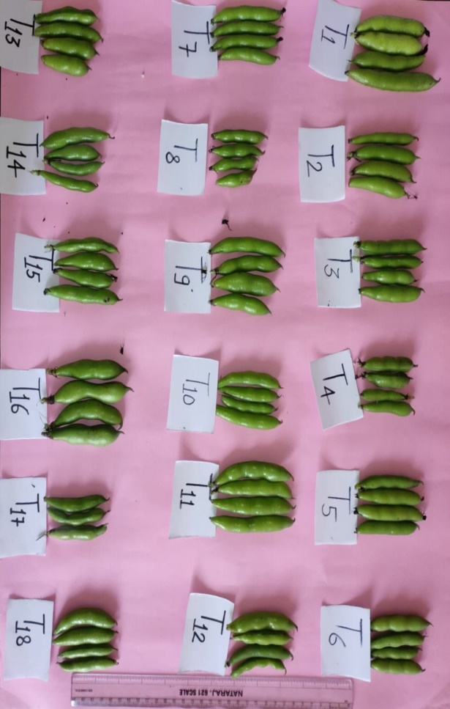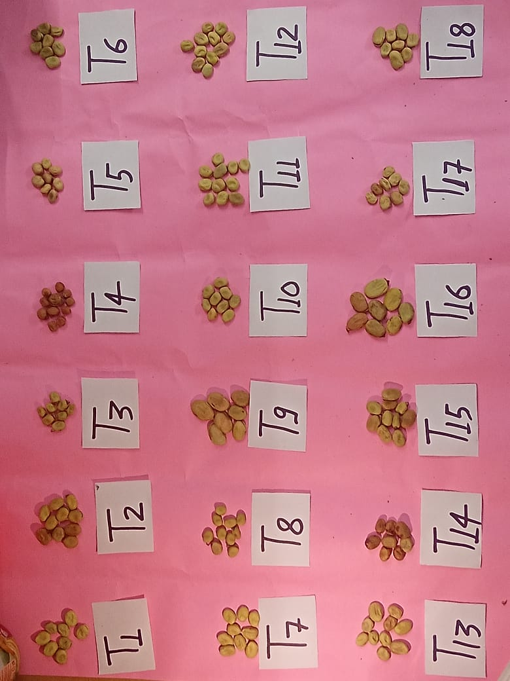
Fig no. 3 Diversity shows in genotypes pod
Fig no.4 Diversity shows in between genotypes seeds

References

Biswas, K., Sen, N., and Sinha, N. (2021). Assessment of genetic divergence through cluster analysis of chili varieties. Indian Academy of Sciences. 46: 52.

Bond, D.A. (1966). Yield and components of yield in diallel crosses between inbred lines of winter beans (Vicia faba L.). Journal Agricultural Science Cambridge. 57: 352-336.

Bora, G.C., Singh, S., Tomer, Y.S. and Singh, V.S.(1998). Stability analysis for earliness in fava bean (Vicia faba L.) genotypes. Annals Agricultural Research. 19: pp.390-392.

Chandrashekara, U. (2006). Tree species yielding edible fruit in the coffee-based home gardens of Kerala, India: their diversity, uses and management. Food security. 1: 361–370

Chaubey, B.K., Yadav, C.B., Kumar, K d Srivastava, R.K. (2012a). Genetic variability, Character association, and path coefficient analysis in faba bean. Journal of Food Leg. 25 (4): 348–350

Chaubey, B.K., Yadav, C.B., Kumar, K. and Srivastava, R.K. (2012). Genetic variability, character association, and path coefficient analysis in faba bean. Journal of Food Legumes. 25(4): 348- 350.

Chaubey, B.K., Yadav, C.B., Mishra, V. K., and Kumar, K. (2012b). Genetic Divergence Analysis in Faba Bean (Vicia Faba L.). Trends in Bioscieence. 5 (1): 64-67.

Chaudhari, A.K., Yadav, C.B., Prakash, H.P., Shrivastav S.P. and S., Hitaishi (2018). Genetic Variability, Heritability, Genetic Advance and Divergence in Fababean (Vicia faba L.). International Journal Current Microbiology Applied Science. 7(6): 1897-1907.

Cokkizgin, Alihan, Colkesen, Mustafa. (2013). Determination of the relationship between yield components in beans by using path coefficient analysis. Greener Journal of Agricultural Science.3(2): 85-89.

Cubero, J.I. (1974). Evolutionary trends in Vicia faba. Theoretical and Applied Genetics. 43: 59-65

Dahalanobis, P.C. (1936). Studies on generalized distance in Statistics. 2(1): 49-55.

Dhakar, M., Das,B., Sarkar, P., and Nath, V.(2020). Diversity in jackfruit (Artocarpus heterophyllus Lam.). insights into fruit characterization for the identification of superior genotypes, Plant Genetic Resources. Volume 18: pp. 307 - 315

Drazic, G. and Mihailovic, N.( 2005). Modification of cadmium toxicity in soybean seedlings by salicylic acid. Plant science. 168(2): pp.511-517.

Farag, S.T. (2007). Relative importance of genetic variance for improving broad bean plant Breed. 11(1): 301-315

Fatih E.A.Hamza(2017). Genetic variability, Heritability Genetic advance and correlation in faba bean(Vicia faba L.). International Journal Current Microbiology Applied Science. 6 (11): 1206-1214.

Henry, A. and Mathur, B.K. (2003). Varietal divergence in cowpea. In: Advances in Arid Legumes Research (eds. Henry, A., Kumar, D. and Singh, N.B.). Published by Indian Arid Legumes Society, Scientific Publishers (India). Jodhpur. pp. 67-70.

Jadhav, R.S. and Mohrir, M.N. (2013). Genetic divergence analysis in sesame (Sesamum indicum L.). Electronic Journal of Plant Breeding. 4(1): pp.1090-1092.

Jatav, V., Singh, D., and Singh, N. (2022) Principal component analysis in bitter gourd (momordica charantia L.). Bangladesh J. Bot. 51(1): 1-7.

Kahraman,F., Onder,M., and Ceyan. E.(2014). Cluster Analysis in Common Bean Genotypes (Phaseolus vulgaris L.) Turkish Journal of Agricultural and Natural Sciences. (1) 112-116.

Kale, N.Z., Kumar, P., Taha, A., R.K., Cowsik, S.M. and McLean, P. (2011). Metabolic and molecular action of Trigonella foenum-graecum (fenugreek) and trace metals in experimental diabetic tissues. Journal of biosciences. 36: pp.383-396.

Kale, R.K., Kumar, P., Taha, A., Sharma, D., and Baquer, N.Z.(2003). Anti-Diabetic Effect of Trigonella foenum graecum on Altered Membrane Functions in Alloxan Diabetic Rats. LIVER. 2: pp.2-5.

Kalia, P., and Pathania, N.K. (2007). Genetic variability and trait relationship for quantitative and quality characters in winter bean (Vicia faba L.). ISHS ActaHortic. 752: 405-409.

KanhaiyaLal; Yadav, C.B., Shiva Nath and Dwivedi, D.K.(2019). Correlation and Path Analysis in faba bean (Vicia faba L.). Trends in Biosciences. 12(11), Print: ISSN0974- 8431:779-787.

Kanhiya Lal; Yadav, C.V., Shiva Nath and Dwivedi, D.K. (2019). genetic variability and Diversiy in Fababean(Vicia faba L.). Trends in Biosciences. 12(11): 754-760.

Katiyar, R.P. and Singh, A.K. (1990). Path coefficient studies for yield and yield components in faba bean (Vicia faba L.). Fabis Newsletter, (26): pp.3-5.

Kujur, A., and Kurrey, V. (2017) Genetic Divergence Analysis in Khedha Bhaji (Amaranrhus dubius Mart.) Genotypes for Yield and its Component Characters. International Journal of Current Microbiology and Applied Sciences. 6(12): 2248-2253

Lindemann, W.C. and Glover, C.R. (2003). Nitrogen Fixation by Legumes. Guide A-129 Cooperative Extension Service. New Mexico State University. 3.

McGrath, J.M. and Quiros, C.F. (1992). Genetic diversity at isozyme and RFLP loci in Brassica campestris as related to crop type and geographical origin. Theoretical and applied genetics. 83: pp.783-790.

Nisar, A., Afzulpurkar, N., Mahaisavariya, B. and Tuantranont, A. (2008). MEMS-based micropumps in drug delivery and biomedical applications. Sensors and Actuators B: Chemical. 130(2): pp.917-942.

Noerwijati,K., and Shohilin,S. (2020). Cluster Analysis Based Selection in Seedling Population of Cassava Clones. Sarhad Journal of Agriculture. 37(2): 398-405.

Nusrat Perveen, N., Cholin, S., Hipparagi, K., and Peerjade, K. (2020). Diversity in Pomegranate (Punica granatum L.) Genotypes of India as Revealed by Principal Component Analysis and Cluster Analysis. Chemical Science Review and Letters Vol. 1: 223-233

Ojha, Vinay Sankar; ShivaNathaandSingh, Ranjeet. (2010). Genetic variability in chickpea(Cicer arietinum L.). Progressive Research. 5(2): 275-276.

Osman, A. A. M., Aziz, A. A. H. A. and Gailani, M. B. (2013). Correlation between seed yield and yield components in faba bean (Vicia faba L.). Advances in Environmental Bio. 7(1): 82-85

Ouji, A. El-Bok, S. Syed, N. H. Abdellaoui, R. Rouaissi, M. Flavell, A. J. El-Gazzah, M. (2012). Genetic diversity of faba bean (Vicia faba L.) populations revealed by sequence specific amplified polymorphism (SSAP) markers. Biotechnology. 11(9): 2162-2168.

Ouji, A.; Rouaissi, M.; Abdellaoui, R. and El-Gazzah, M. (2011). The use of reproductive vigor descriptors in studying genetic variability in Bibliography 91 nine Tunisian faba bean (Vicia faba L.) populations. African Journal Biotechnology. 10(6): 896-904.

P.N. and Yadav, C.B. (2013). Correlation and path coefficient analysis in Faba Bean (Vicia faba L.) under Irrigated Condition. Trends in Bioscience. 6(5): 576-578

Panikar ,P., Shrivatava, R., Nag ,S. and Kumar,N. (2018). Clustering analysis of soybean germplasm (Glycine max L. Merrill) The Pharma Innovation Journal. 7(4): 781-786.

Panse, V.G. and Sukhatme, P.V. (1967). Statistical methods for agricultural workers.3rd ED, ICAR, New Delhi.

Pardemir, O., and Ece, A. (2011). Determining relationship among plant characteristics related to plant seed yield of broad bean (Vicia faba L.) sown in winter and summer seasons in transitional climate areas of Turkey. Bulgarian Journal of Agricultural Science. 17(1): 73-82.

Parmar, L.D., Chauhan, R.M. and Tikka, S.B.S. (2003). Association analysis for grain yield and contributing characters in cowpea. In: Advances in Arid Legumes Research (eds. Henry, A., Kumar, D. and Singh, N.B.). Published by Indian Arid Legumes Society, Scientific Publishers (India), Jodhpur. pp. 50-53.

Parthasarathy, U., Saji, K., Jayarajan,K., and Parthasarathy, V. (2006). Biodiversity of Piper in South India – application of GIS and cluster analysis. Current Science Association. Vol. 91: pp. 652-658

Patel, K., , Parmar, D., and Adsul, H. (2019). Cluster analysis in cluster bean Cyamopsis Tetragonoloba [(L.) Taus] Green Farming Vol. (2):187-190.

Patil, S.S., Naik, M.R., Patil, A.B. and Ghodke, U.R. (2011). Genetic diversity in soybean. Legume Research-An International Journal. 34(1): pp.68-70.

POlivia, Pant S. C., Rawat, S. S., Rana, D. K., Singh, N. Indra Kumar. (2010). Correlation Coefficient and Genetic Divergence Analysis in Pea. Indian Journal of Horticulture. 67(4):125-127.

Pratap, V., Sharma, V. and Kamaluddin, G.S. ( 2021). Assessment of genetic variability and relationship between different quantitative traits in field pea (Pisum sativum var. arvense) Germplasm. Legume Research-An International Journal. 1: p.6.

Sadeghzadeh-Ahari, D., Hassandokht, M.R., Kashi, A.K., Amri, A. and Alizadeh, K.H. (2010). Genetic variability of some agronomic traits in the Iranian fenugreek landraces under drought stress and non-stress conditions. African Journal of Plant Science. 4(2): pp.012-020.

Sharifi, Peyman and Aminpana, Hashem. (2014) A study on the genetic variation in some of the faba bean genotypes using multivariate statistical techniques. Tropical Agriculture (Trinidad). 91(2): 87-97.

Sharma, S., and Singh, Y. (2018) Genetic divergence studies in cauliflower (Brassica oleracea L. var. botrytis) under mid hill conditions of Himachal Pradesh. Himachal Journal of Agricultural Research. 44(1-2): 50-53

Shivaramegowda, K., Krishnan, K., Kebbahalli, Y., Kumar, V., and Yashoda, P. (2016). Genotypic Variation among Okra (Abelmoschus esculentus (L.) Moench) Germplasms in South India. Korean Society of Breeding Science. 4: 234-241

Shivwanshi, R. and Babber, A. (2019). Genetic divergence analysis in chickpea germplasm Agricultural Research communication center. 42(5)

Sheoran O P, Tonk D S, Kaushik L S, Hasija R C and Pannu R S. 1998. Statistical software package for agricultural research workers. Recent Advances in Information Theory, Statistics and Computer Applications, pp.139–43. Hooda D S and Hasija R C (Eds). CCS Haryana Agricultural University, Hisar, Haryana, India.

Sikarvar, V.S., Sharma, R.N. and Payasi, D. (2006). Genetic Divergence Analysis for Seed Yield and its Components in Chickpea (Cicer arietinum L.). Indian Journal of Plant Genetic Resources. 19(2): pp.215-217.

Singh, A.K., Bharati, K.C., Mani bhushan, N. C., Pedpati and Anitha. (2013). An assessment of faba bean (Vicia faba L.) current status and prospects. Academic Journal. 8(50): 6634-6641.

Singh, D. and Mishra, V.K. (2008). Studies on genetic divergence in pea (Pisum sativum L.). The Agriculture Science Digest. 28(1): 21-23.

