Gastroprotective Effects of Methanol and Hexane Leaf Extracts of Saccharum spontaneum Against Aspirin-Induced Gastric Mucosal Injury in Rats: Histopathological and Mechanistic Insights

Abstract
Aspirin, a widely used non-steroidal anti-inflammatory drug (NSAID), is known to induce gastric mucosal injury upon prolonged use. This study investigates the gastroprotective potential of methanol (MESS) and hexane (HESS) leaf extracts of Saccharum spontaneum against aspirin-induced gastric lesions in albino rats. Gastric ulcers were induced via oral administration of aspirin (200 mg/kg body weight), with omeprazole (10 mg/kg) serving as the standard reference drug. Forty-nine rats were randomly assigned into seven groups (n=7): Group I (control), Group II (aspirin only), Group III (aspirin + omeprazole), Groups IV and V (aspirin + MESS at 200 and 400 mg/kg, respectively), and Groups VI and VII (aspirin + HESS at 200 and 400 mg/kg, respectively). Extracts were administered orally for 14 days post-ulcer induction. At the end of the treatment period, animals were sacrificed, and gastric tissues were collected for ulcer index evaluation and histopathological analysis. Administration of MESS and HESS at doses of 200 mg/kg and 400 mg/kg significantly lowered the mean ulcer index to 3.00 ± 1.41 and 2.50 ± 1.29 for MESS, and 2.75 ± 0.96 and 2.22 ± 0.82 for HESS, respectively, when compared to the aspirin-ulcerated group, which had a mean ulcer index of 5.88 ± 0.70. Histological examination revealed that aspirin caused extensive mucosal damage characterized by necrosis, hemorrhage, and inflammation. In contrast, treatment with S. spontaneum extracts preserved mucosal integrity with only mild epithelial abrasion and minimal inflammatory changes, with the HESS extract exhibiting better cytoprotection against gastric mucosal damage. These findings suggest that Saccharum spontaneum leaf extracts, especially the methanol fraction, exert a protective effect against NSAID-induced gastric mucosal injury, likely through mechanisms involving mucosal preservation and anti-inflammatory activity. Thus, S. spontaneum holds promise as a natural therapeutic agent for managing aspirin-induced gastric ulcers.
Keywords; Saccharum spontaneum, Gastric ulcer, Aspirin-induced injury, Histopathology, Gastroprotection, NSAIDs
Introduction
Gastric ulceration is a necrotizing mucosa lesion leading to inflammation and hemorrhage because of damage and perforation of the gastric mucosa (Sabiu et al., 2015). Gastrointestinal toxicity of non-steroidal anti-inflammatory drugs (NSAIDs), and toxic substances like alcohol use is the most common gastrointestinal disorder ever reported (Falsoni et al., 2022). Gastric ulceration is the most predominant gastrointestinal syndrome ever recognized and is responsible for approximately 15 deaths out of every 15,000 complications per year worldwide (Azhari et al., 2018). Gastric ulcers occur due to the difference between potentially destructive and defensive factors of the gastric mucosa (Aldossary 2021). One of the key contributing reasons to this stomach ulcer disorder is an NSAID (Wallace 2008), and complications are increasing risk factors, with a prior history of ulcer disease are more likely to experience problems (Sabiu et al., 2015). The pathological changes are characterized by erosion, bleeding, and exfoliation of the mucosa due to an imbalance between aggressive factors (Helicobacter pylori, acid pepsin, prostaglandin, mucus) and defensive factors (nitric oxide, growth factors, bicarbonate, and mucosal blood flow) (Karampour et al., 2019).
Aspirin has been reported to cause frequent and severe gastric mucosal injury both in vitro and in vivo (Fukui et al., 2012; Iwamoto et al., 2013), and it is one of the most highly consumed pharmaceutical products worldwide (Desborough and Keeling, 2017). This drug acts by inhibiting prostaglandin (PG) synthesis through irreversible inhibition of the enzyme cyclooxygenase (COX), which is responsible for catalyzing the conversion of arachidonic acid into endoperoxides (Vane and Botting, 2003). By interrupting PG synthesis, aspirin causes mucosal damage, increasing acid release and back-diffusion of H⁺ ions and resulting in collapse of the mucosal barrier (Hunt and Yuan, 2011). Thus, NSAIDs-induced ulcers remain a major adverse effect with a high morbidity and mortality that greatly limit their overall clinical efficacy (Drini 2017). Various anti-ulcer medications are currently offered to treat NSAID- induced gastric ulceration, including ranitidine, cimetidine, omeprazole, misoprostol, and esomeprazole. However, each of these drugs confers mild to severe side effects, such as GI discomfort, diarrhoea, central nervous system (CNS) disturbance, nephritis, hepatitis, granulocytopaenia, dry mouth, headache, and gynecomastia (Piper, 1995). Hence, there is a vital need for natural anti-ulcer therapies (Ahmad et al., 2013). Nowadays, increasing studies are being directed towards the use of natural products for developing drugs with minimal side effects. Saccharum spontaneum Linn is a perennial plant that belongs to the family Poaceae and it is widely distributed in Africa, Malaysia and Polynesia. It is commonly called wild sugar cane in English and Kibiya in Hausa. The plant is use medicinally in the treatment of several disorders including mental disturbances, dyspnoea, anaemia, diuretic, obesity, lithotriptic, purgative, tonic, aphrodisiac, dyspepsia, (Chopra et al., 1992; Yoganarashimhan, 2002), gynecological and respiratory troubles (Muhammad and Hefazat. 2011), and ulcer (Aiyeloja and Bello, 2006; Celestina et al., 2012). Thus, this study aims to evaluate the histopathological effects of Saccharum spontaneum leaf extracts on aspirin-induced gastric mucosal injury in rats.
Materials and methods
Plant Collection and Extraction
Fresh Saccharum spontaneum leaves were collected from Samaru, located in the Sabongari Local Government Area of Kaduna State, Nigeria. The plant material was authenticated at the Herbarium Unit of the Department of Botany, Ahmadu Bello University, Zaria, Nigeria, and assigned the voucher number 900111. The leaves were thoroughly washed, air-dried, and ground into a fine powder using a wooden mortar and pestle. The powdered sample was then stored in sealed plastic containers until further use.
Extraction of the dried leaf powder was carried out following the method described by Farnsworth (1988), using 95% methanol and n-hexane as solvents. One kilogram of the powdered material was subjected to extraction in 1500 mL of each solvent for 18 hours using a Soxhlet apparatus. The resulting extracts were concentrated under reduced pressure using a rotary evaporator at 40°C until completely dry. The methanol and hexane extracts were stored at 4°C and later reconstituted in distilled water prior to administration.
Experimental Animals
Forty-nine healthy adult male albino rats, each weighing approximately 250 g, were procured from the Animal House of the Faculty of Life Sciences, Kaduna State University, Kaduna, Nigeria. The animals were housed in appropriate cages and acclimatized to laboratory conditions for two weeks prior to the commencement of the experiment. Environmental conditions were maintained at a temperature of 25 °C with a 12-hour light/dark cycle. Throughout the study, the rats had unrestricted access to clean water and standard pelletized feed. All procedures were conducted in strict adherence to the ethical guidelines of the Organization for Economic Cooperation and Development (OECD) and were approved by the Animal Ethics Committee of Ahmadu Bello University, Zaria, Nigeria. Measures were taken to minimize animal discomfort and to ensure the use of the minimum number of animals required for statistically valid results.
Experimental design
The rats were randomly assigned into seven groups (n = 7). Gastric ulcers were induced in Groups II to VII via oral administration of aspirin at a dose of 200 mg/kg body weight. Treatments with plant extracts and the reference drug were administered following the dosage and protocol described by Berenguer et al. (2006) over a period of two weeks. Prior to ulcer induction, all animals were fasted for 48 hours. The chosen doses of Saccharum spontaneum extracts (200 mg/kg and 400 mg/kg) represent 4% and 8%, respectively, of the highest non-toxic dose (5000 mg/kg) determined from a preliminary acute toxicity study.
The experimental groups were as follows:
Group I (Control): Received distilled water only.
Group II (Aspirin only): Received aspirin (200 mg/kg) dissolved in distilled water.
Group III (Standard drug): Received omeprazole (10 mg/kg) and aspirin (200 mg/kg).
Group IV: Received methanol extract of Saccharum spontaneum (MESS) at 200 mg/kg and aspirin (200 mg/kg).
Group V: Received MESS at 400 mg/kg and aspirin (200 mg/kg).
Group VI: Received hexane extract of Saccharum spontaneum (HESS) at 200 mg/kg and aspirin (200 mg/kg).
Group VII: Received HESS at 400 mg/kg and aspirin (200 mg/kg).

Induction of gastric ulcer
The rats were housed in metabolic cages equipped with elevated wire mesh flooring to prevent coprophagy, which can interfere with effective gastric ulcer induction. Gastric ulcers were induced by administering aspirin orally at a dose of 200 mg/kg body weight, following the method described by Rao and Vijayakumar (2007). Four hours post-administration, the rats were anesthetized using chloroform and euthanized via cervical dislocation. The abdominal cavity was opened to expose and harvest the stomachs. Each stomach was carefully excised, opened along the greater curvature, and gently rinsed with normal saline to remove gastric contents and blood clots. The stomachs were then spread flat on a wax-coated board lined with filter paper, with the mucosal surface facing upward. Tissues were sectioned and processed for histopathological examination. Ulcer assessment was conducted on the glandular region of the stomach using a modified method by Magistretti et al. (1988).
Determination of Ulcer Index
Gastric mucosal lesions were evaluated using a scoring system based on the number and severity of lesions, as described by Magistretti et al. (1988). Lesions were examined in the glandular region of the stomach and graded using an arbitrary scale ranging from 0 to 6 points:
0 = no visible lesions, 1 = 1–3 small lesions, 2 = 1–3 large lesions, 3 = 1–3 thick lesions. 4 = more than 3 small lesions, 5 = more than 3 large lesions, and 6 = more than 3 thick lesions
The mean ulcer index (UI) for each group was determined by summing the individual lesion scores of all animals in the group and dividing by the total number of animals.
Preparation of Tissue for Histopathological Studies
Gastric tissue sections were collected from each experimental group and immediately fixed in 10% buffered formalin for 48 hours. The fixed tissues were then processed routinely, involving dehydration through a graded series of ethanol concentrations (70%, 95%, and 100%) using an automated tissue processor. Following dehydration, tissues were cleared with xylene and embedded in paraffin. Using a microtome, transverse sections of 5 μm thickness were cut and subsequently stained with hematoxylin and eosin (H&E) to assess microscopic gastric damage and possible regenerative changes. Prepared slides were examined under a light microscope at 100x magnification (Bancroft & Gamble, 2002).
Statistical Analysis
Numerical data were presented as mean ± standard error of the mean (SEM). Statistical analyses were performed using SPSS version 20.0 (Statistical Package for the Social Sciences, Inc., Chicago, IL, USA). One-way analysis of variance (ANOVA) was employed to assess differences among groups, followed by Duncan’s Multiple Range Test (DMRT) as a post hoc test for multiple comparisons. A p-value of less than 0.05 was considered statistically significant.
Ethical Approval
The study was approved by the Ahmadu Bello University Committee on Animal Use and Care, under reference number ABUCAUC/2016/124.

Results
Treatment with different doses of S. spontaneum resulted in a notable protective effect, as observed in the histological analysis. Rats in the control group exhibited intact mucosal epithelium and gastric glands, with no visible damage to the stomach mucosa (Plate 1). In contrast, aspirin administration caused significant gastric mucosal damage, characterized by submucosal edema, hemorrhagic injury, mucosal degradation, loss of epithelial cells, and inflammatory cell infiltration, along with ulceration, thinning, and detachment of the epithelial lining (Plate 2). Rats treated with the standard drug omeprazole showed only mild or rare signs of edema, hemorrhagic damage, epithelial cell loss, and leucocyte infiltration, which were not severe (p < 0.05) (Plate 3). Administration of S. spontaneum extracts provided notable protection against aspirin-induced ulceration, with histological features showing minimal superficial abnormalities in mucosal and submucosal morphology and a reduction in lesion severity (Plates 4, 5, 6, and 7). The higher dose of S. spontaneum (400 mg/kg) was particularly effective in safeguarding the gastric mucosa from the harmful effects of aspirin.
Table 1. Effect of oral administration of varying doses of methanol and hexane leaf extracts of S. spontaneum on gastric lesions induced by aspirin
Groups | Treatment | Dose (mg/kg) | Mean Ulcer Index (MUI)
I | Control | 10 | 0 ± 0.00^{d}
II | Aspirin | 200 | 5.88 ± 0.70ª
III | Omeprazole | 10 | 1.79 ± 0.58^{b}
IV | MESS | 200 | 3.00 ± 1.41^{c}
V  VI  VII | MESS  HESS  HESS | 400  200  400 | 2.50 ± 1.29^{c}  2.75 ± 0.96^{c}  2.22 ± 0.82^{b}
Values are mean ± SD of 7 rats per group. Mean values with different superscripts in the same column indicate significant differences (Duncan Multiple Range test; P≤ 0.05), and data were presented are mean± SD of 7 rats per group. MESS = Methanol extract of S. spontaneum, HESS = Hexane extract of S. spontaneum
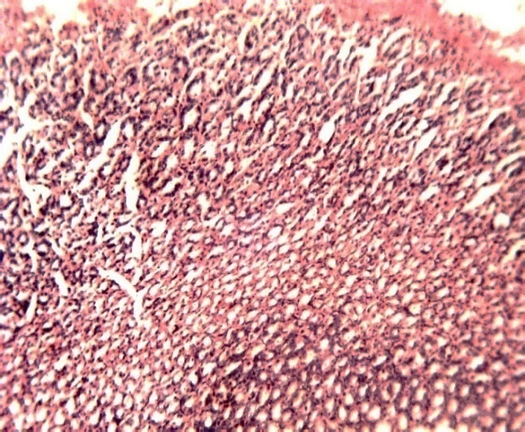
Plate 1: Photomicrograph of gastric mucosa of rats from group 1 indicating intact histological structure of the mucosa. H & E x100 magnification

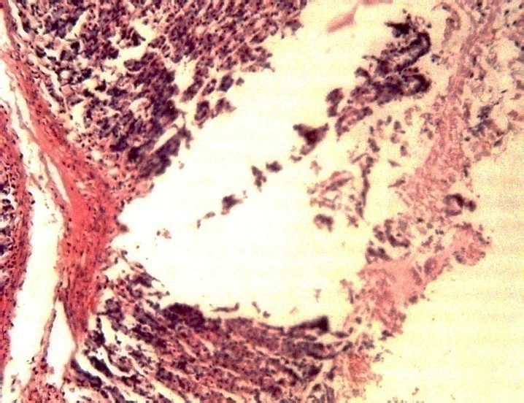
Plate 2: Photomicrograph of gastric mucosa of rats from group 2 showing deep ulceration, submucosa edema, mucosal necrosis, hemorrhagic injury, mucosa degradation, epithelial cell loss and inflammatory cell infiltration. H & E x100 magnification

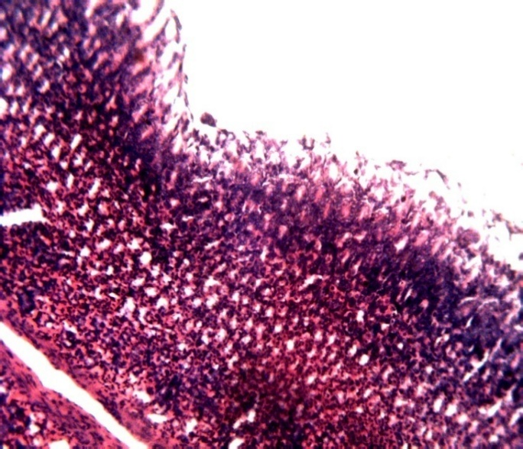
Plate 3: Photomicrograph of gastric mucosa of rats from group 3 showing mild blood vessels congestion and tissue infiltrations with no ulcer. H & E. x100 magnification

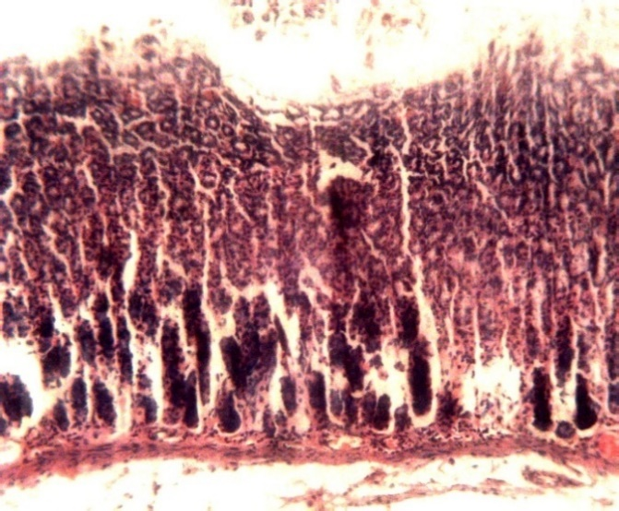
Plate 4: Photomicrograph of gastric mucosa of rats from group 4 showing mild superficial excoriation on lining epithelium, slight apical necrosis and mild haemorrhage. H & E. x100 magnification

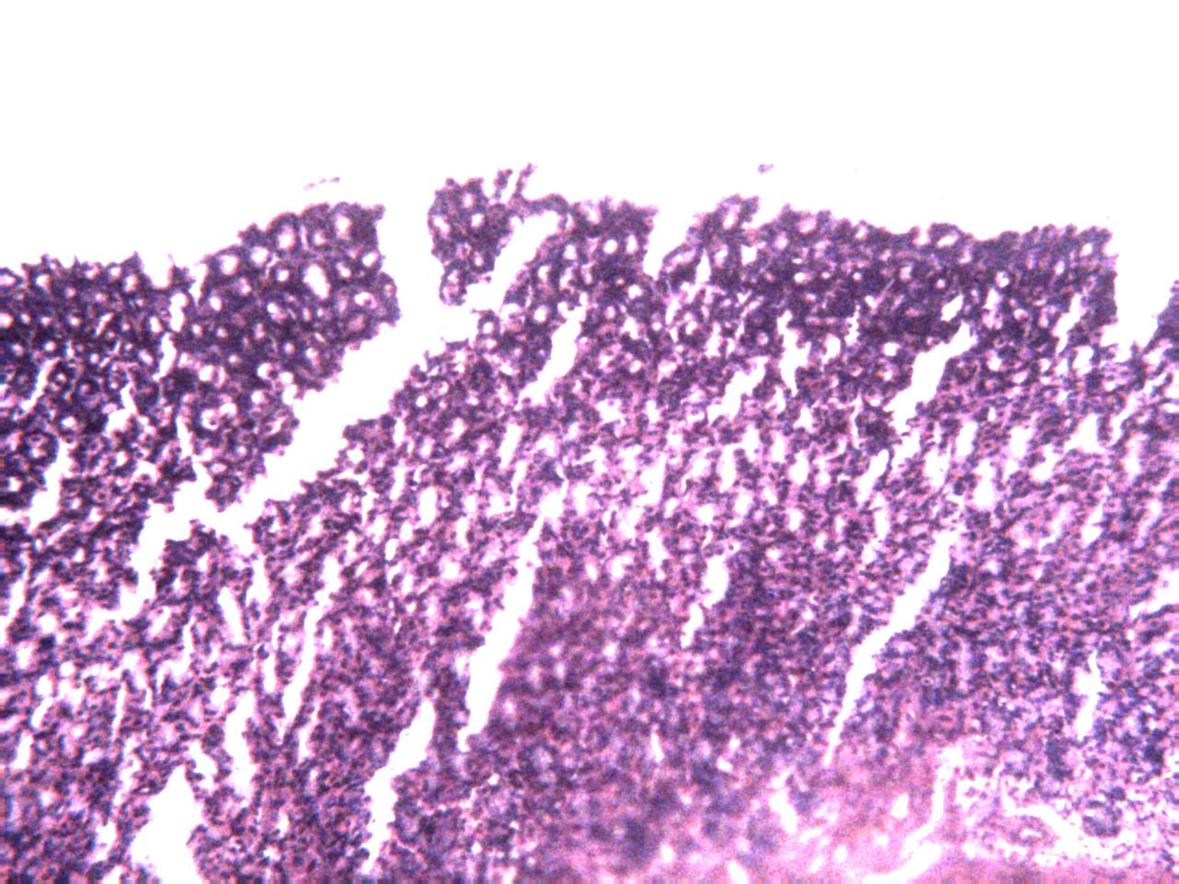
Plate 5: Photomicrograph of gastric mucosa of rats from group 5 showing slight mucosa epithelial changes. H & E magnification

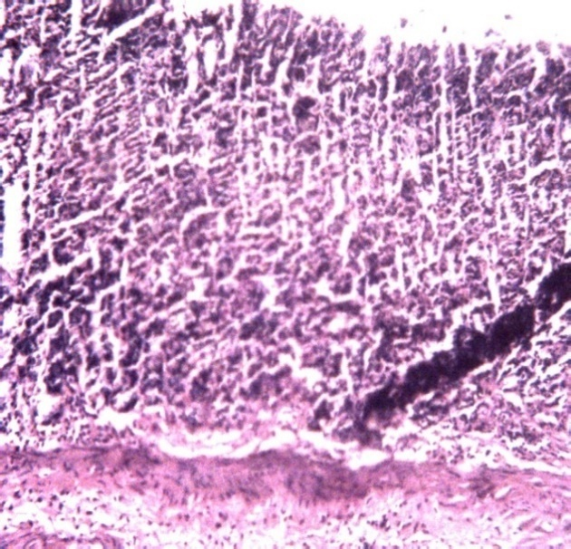
Plate 6: Photomicrograph of gastric mucosa of rats from group 6 showing slight mucosa epithelial change with no ulceration. H & E. x100 magnification

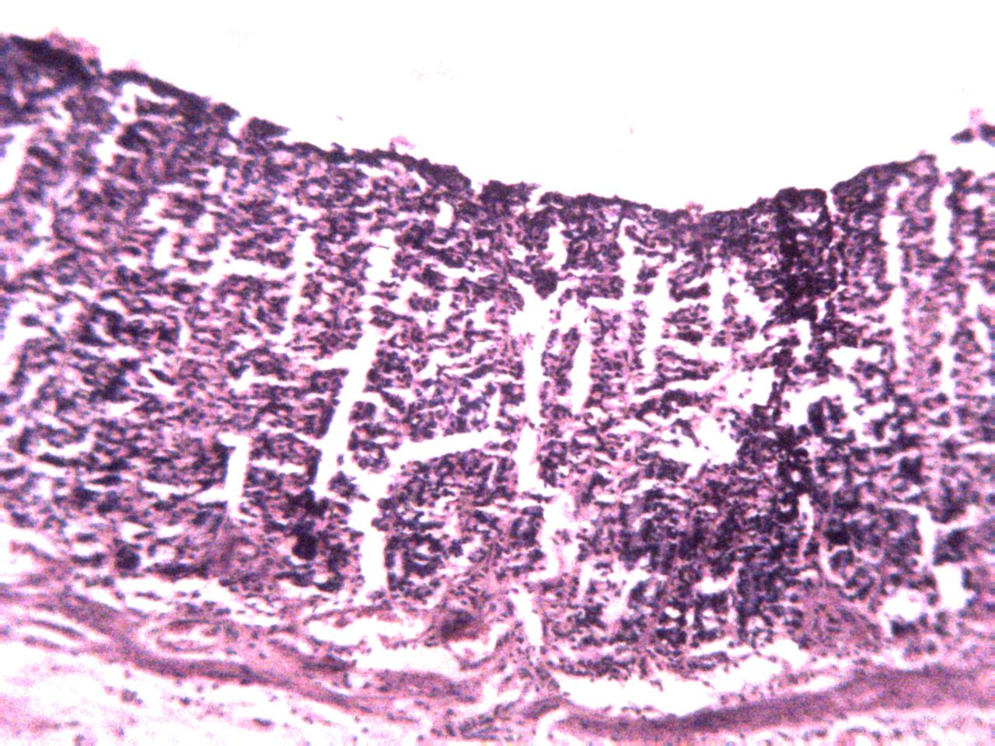
Plate 7: Photomicrograph of gastric mucosa of rats from group 7 showing moderate superficial abrasion of submucosal layer. H & E. x100 magnification

Discussion
Gastric mucosal integrity is normally maintained by defense mechanisms. Several studies have reported a strong association between gastric mucosal damage and aspirin intake. Gastrointestinal ulceration and localized mucosal inflammation are among the most serious gastrointestinal complications (Goldstein and Cryer, 2015). The present study demonstrated the protective effects of methanol and hexane leaf extracts of Saccharum spontaneum (MESS and HESS) against aspirin-induced gastric mucosal damage in albino rats. Histopathological findings revealed severe mucosal erosion, necrosis, hemorrhage, and inflammation in aspirin-treated rats, consistent with the known ulcerogenic effect of prolonged non-steroidal anti-inflammatory drug (NSAID) use, which disrupts gastric mucosal defense mechanisms. Ulcerated animals displayed typical histological alterations evidenced by the decrease of the mucosal thickness, erosion of the surface epithelial cells, loss of gastric mucosa integrity, submucosal edema, as well as infiltration of inflammatory cells, and thininng of the muscular layer (Tanka et al., 2013; Salah 2015; Majeed et al., 2015; Salga et al., 2017).
In contrast, rats treated with Saccharum spontaneum extracts, particularly the methanol fraction, exhibited reduced mucosal damage, with preservation of epithelial integrity and limited inflammation. These findings suggest a cytoprotective role for the plant extract, likely mediated by multiple bioactive phytochemicals present in the leaves.
NSAIDs like aspirin cause gastric mucosal injury in part through generation of reactive oxygen species (ROS), leading to oxidative stress and lipid peroxidation. Saccharum spontaneum is known to contain flavonoids, phenolic compounds, and saponins (Usman et al., 2025), phytochemicals with strong antioxidant properties. These compounds can neutralize free radicals, reduce oxidative stress, and protect gastric epithelial cells from peroxidative damage.
Aspirin-induced gastric injury involves upregulation of inflammatory mediators such as TNF-α, IL-1β, and COX-2 (Verma and Kumar 2018). The protective effect of the extracts may be due to inhibition of pro-inflammatory cytokines and enzymes, limiting tissue infiltration by neutrophils and reducing mucosal inflammation. This could explain the reduced histological signs of inflammation observed in treated groups. The hexane extract, in particular, may promote mucus secretion or enhance mucosal regeneration, contributing to improved barrier function and epithelial recovery. This aligns with observations of preserved or restored mucous layers and epithelial architecture.
Some plant-derived compounds can promote angiogenesis and cell proliferation, accelerating healing of gastric lesions (Majewska and Gendaszewska-Darmach 2011). The presence of these compounds in the plant as reported by Usman et al., 2025 could explain the more complete mucosal restoration. The hexane extract showed greater protective effects than the methanol extract, likely due to its higher content of non-polar bioactive compounds such as terpenoids, flavonoids, and fatty acids, which possess potent anti-inflammatory and antioxidant properties that contribute to enhanced mucosal defense and healing (Elwakeel et al., 2023). These compounds are well-documented for their gastroprotective effects, including free radical scavenging, cytokine modulation, and enhancement of prostaglandin synthesis, a key factor in mucosal defense (Biagi et al., 2019).

Conclusion
This study supports the therapeutic potential of Saccharum spontaneum in mitigating NSAID-induced gastric damage, with the hexane extract offering improved gastroprotection. The mechanisms are likely multifactorial, involving antioxidant, anti-inflammatory, and mucosal regenerative pathways. These findings warrant further biochemical and molecular analyses to identify specific active constituents and validate their roles in gastric protection.
References
Adhikary, B., Yadav, S. K., Roy, K., Bandyopadhyay, S. K., & Chattopadhyay, S. (2011). Black tea and the aflavins assist healing of indomethacin-induced gastric ulceration in mice by antioxidative action. Evidence-Based Complementary and Alternative Medicine, 2011, 1–11. https://doi.org/10.1155/2011/546560
Ahmad, A., Kumar, V., & Maurya, S. K. (2013). Natural antiulcer agents: A pharmacological review. International Journal of Research in Pharmaceutical and Biomedical Sciences, 4(2), 535–541.Science Publishing Corporation
Aiyeloja, A. A., & Bello, O. A. (2006). Ethnobotanical potentials of common herbs in Nigeria: A case study of Enugu State. Educational Research and Review, 1(1), 16–22.
Aldossary, S. A. (2021). Ameliorative effect of cannabidiol against gastric ulcer induced by diclofenac in rats. Journal of Pharmaceutical Research International, 23, 836–844. https://doi.org/10.9734/jpri/2021/v33i60b34686
Azhari, H., Underwood, F., King, J. A., Coward, S., Shah, S. C., Ng, S., Ho, G., Chan, C., Tang, W., & Kaplan, G. G. (2018). A36: The global incidence of peptic ulcer disease and its complications at the turn of the 21st century: A systematic review. Journal of the Canadian Association of Gastroenterology, 1(Suppl_2), 61–62. https://doi.org/10.1093/jcag/gwy009.036:contentReference[oaicite:14]{index=14}
Bancroft, J. D., & Gamble, M. N. (2002). Pigments and minerals. In Theory and Practice of Histological Techniques (pp. 258–256). Harcourt Publishers Limited.
Biagi, M., Governa, P., Miraldi, E., Magnano, A. R., & Giachetti, D. (2019). Phytochemical characterization and gastroprotective activity of Copaifera langsdorffii Desf. oleoresin and fruit methanolic extract. In XVI Congress of the Italian Society of Phytochemistry jointly with 2nd International Congress on Edible Medicinal and Aromatic Plants (ICEMAP 2019) (p. 14).
Celestina, A. O., Oguejiofor, U. M., Chinenye, U. J., & Anoka, N. A. (2012). Ethnobotanical studies of medicinal plants used in the management of peptic ulcer disease in Sokoto State, North Western Nigeria. International Research Journal of Pharmacy and Pharmacology, 2(9), 225–230.
Chopra, R. N., Nayar, S. L., & Chopra, I. C. (1992). Glossary of Indian medicinal plants. Publication and Information Directorate, CSIR.
Desborough, M. J. R., & Keeling, D. M. (2017). The aspirin story—from willow to wonder drug. British Journal of Haematology, 177(5), 674–683.
Drini, M. (2017). Peptic ulcer disease and non-steroidal anti-inflammatory drugs. Australian Prescriber, 40(3), 91–93.
Elwekeel, A., Hassan, M. H., Almutairi, E., AlHammad, M., Alwhbi, F., Abdel-Bakky, M. S., ... & Mohamed, E. I. (2023). Anti-inflammatory, anti-oxidant, GC-MS profiling and molecular docking analyses of non-polar extracts from five salsola species. Separations, 10(2), 72
Falsoni, R. M. P., Moraes, F. de S. A., Rezende, M. S. de, Silva, C. L. da, Andrade, T. U. de, Brasil, G. A., et al. (2022). Pretreatment with water kefir reduces the development of acidified ethanol-induced gastric ulcers. Brazilian Journal of Pharmaceutical Sciences, 58. https://doi.org/10.1590/s2175-97902022e191046
Farias-Silva, E., Cola, M., Calvo, T. R., Barbastefano, V., Ferreira, A. L., De Paula Michelatto, D., et al. (2007). Antioxidant activity of indigo and its preventive effect against ethanol-induced DNA damage in rat gastric mucosa. Planta Medica, 73(12), 1241–1246.
Fornai, M., Natale, G., Colucci, R., Tuccori, M., Carazzina, G., & Antonioli, L., et al. (Year). Mechanisms of protection by pantoprazole against NSAID-induced gastric mucosal damage. [Journal Name, Volume(Issue), Page Numbers].
Fukui, A., Naito, Y., Handa, O., Kugai, M., Tsuji, T., Yoriki, H., Qin, Y., Adachi, S., Higashimura, Y., & Mizushima, K. (2012). Acetyl salicylic acid induces damage to intestinal epithelial cells by oxidation-related modifications of ZO-1. American Journal of Physiology-Gastrointestinal and Liver Physiology, 303(9), G927–G936.
Goldstein, J. L., & Cryer, B. (2015). Gastrointestinal injury associated with NSAID use: A case study and review of risk factors and preventative strategies. Drug, Healthcare and Patient Safety, 7, 31–41.
Halabi, M. F., Shakir, R. M., Bardi, D. A., Al-Wajeeh, N. S., Ablat, A., Hassandarvish, P., Hajrezaie, M., Norazit, A., & Abdulla, M. A. (Year). Gastroprotective activity of ethyl-4-[(3,5-di-tert-butyl-2-hydroxybenzylidene) amino] benzoate against ethanol-induced gastric mucosal ulcer in rats. PLOS ONE, Volume(Issue), Page Numbers.
Handa, O., Naito, Y., Fukui, A., Omatsu, T., & Yoshikawa, T. (2014). The impact of non-steroidal anti-inflammatory drugs on the small intestinal epithelium. Journal of Clinical Biochemistry and Nutrition, 54, 2–6.
Hunt, R. H., & Yuan, Y. (2011). Acid-NSAID/aspirin interaction in peptic ulcer disease. Digestive Diseases, 29(5), 465–468.
Iwamoto, J., Saito, Y., Honda, A., & Matsuzaki, Y. (2013). Clinical features of gastroduodenal injury associated with long-term low-dose aspirin therapy. World Journal of Gastroenterology, 19(10), 1673–1682.
Karampour, N. S., Arzi, A., Rezaie, A., Pashmforoosh, M., & Kordi, F. (2019). Gastroprotective effect of zingerone on ethanol-induced gastric ulcers in rats. Medicina, 55(3), 64. https://doi.org/10.3390/medicina55030064
Khalid, M., & Siddiqui, H. H. (2011). Pharmacognostical evaluation and qualitative analysis of Saccharum spontaneum (L.) root. International Journal of Pharmaceutical Sciences and Drug Research, 3(4), 338–341.
Kuna, L., Jakab, J., Smolic, R., Raguz-Lucic, N., Vcev, A., & Smolic, M. (2019). Peptic ulcer disease: A brief review of conventional therapy and herbal treatment options. Journal of Clinical Medicine, 8(2), 179.
Laine, L., & Weinstein, W. M. (1988). Histology of alcoholic hemorrhagic gastritis: A prospective evaluation. Gastroenterology, 94(6), 1254–1262.
Majeed, W., Aslam, B., Javed, I., Khaliq, T., Muhammad, F., Ali, A., & Raza, A. (2015). Histopathological evaluation of gastroprotective effect of Berberis vulgaris (Zereshk) seeds against aspirin-induced ulcer in albino mice. Pakistan Journal of Pharmaceutical Sciences, 28, 1953–1958.
Majewska, I., & Gendaszewska-Darmach, E. (2011). Proangiogenic activity of plant extracts in accelerating wound healing—a new face of old phytomedicines. Acta Biochimica Polonica, 58(4), 449–460.
McManus, J. F. A. (1948). Histological and histochemical uses of periodic acid. Biotechnic and Histochemistry, 23(2), 99–108.
Melcarne, L., García-Iglesias, P., & Calvet, X. (2016). Management of NSAID-associated peptic ulcer disease. Expert Review of Gastroenterology & Hepatology, 10(6), 723–733.
Nalamachu, S. (2013). An overview of pain management: The clinical efficacy and value of treatment. American Journal of Managed Care, 19(14 Suppl), 261–266.
Piper, D. W. (1995). A comparative overview of the adverse effects of antiulcer drugs. Drug Safety, 12, 120–138.
Rami, A. B., Fouad, A. B., Al-Obaidi, M. M. J., Hadi, H. A., Ali, H. M., & Abdulla, M. A. (2013). In vivo antioxidant and antiulcer activity of Parkia speciosa ethanolic leaf extract against ethanol-induced gastric ulcer in rats. PLOS ONE, 8(7), e64751. https://doi.org/10.1371/journal.pone.0064751
Sabiu, S., Garuba, T., Sunmonu, T., Ajani, E., Sulyman, A., Nurain, I., & Balogun, A. (2015). Indomethacin-induced gastric ulceration in rats: Protective roles of Spondias mombin and Ficus exasperata. Toxicology Reports, 2, 261–267. https://doi.org/10.1016/j.toxrep.2015.01.002
Sagun, K., Roy, V. K., Kumar, R. S., Ibrahim, K. S., Parimelazhagan, T., Kumar, N. S., & Gurusubramanian, G. (2017). Antioxidant potential, anti-inflammatory activity and gastroprotective mechanisms of Mallotus roxburghianus (Muell.) against ethanol-induced gastric ulcers in Wistar albino rats. Journal of Functional Foods, 36, 448–458.
Salah, K. M. (2015). The postulated mechanism of the protective effect of ginger on the aspirin-induced gastric ulcer: Histological and immunohistochemical studies. Histology and Histopathology, 30(7), 855–864.
Salga, M. S., Ali, H. M., Abdulla, M. A., Abdelwahab, S. I., Taha, M. M. E., & Yagoub, U. (2017). Synthesis and gastroprotective activities of some zinc (II) complexes derived from Schiff bases against aspirin-induced ulceration. Arabian Journal of Chemistry, 10(10), 1578–1589.
Tanaka, T., Morito, K., Kinoshita, M., Ohmoto, M., Urikura, M., Satouchi, K., & Tokumura, A. (2013). Orally administered phosphatidic acids and lysophosphatidic acids ameliorate aspirin-induced stomach mucosal injury in mice. Digestive Diseases and Sciences, 58, 950–958.
Usman, B., Wulgo, A. M., Timta, M. H., Waziri, A., Maina, U. A., Abdulsalam, H., Jibril, I., & Idowu, A. (2025). Phytochemical screening and gastroprotective effect of aqueous leaf extract of Saccharum spontaneum in aspirin-induced mucosal ulceration in rats. Arid Zone Journal of Basic and Applied Research, 5(1), 15–26.
Vane, J. R., & Botting, R. M. (2003). The mechanism of action of aspirin. Thrombosis Research, 110, 255–258.
Wallace, J. L. (2001). Pathogenesis of NSAID-induced gastroduodenal mucosal injury. Best Practice & Research Clinical Gastroenterology, 15, 691–703.
Wallace, J. L. (2008). Prostaglandins, NSAIDs, and gastric mucosal protection: Why doesn’t the stomach digest itself? Physiological Reviews, 88, 1547–1565. https://doi.org/10.1152/physrev.00004.2008
Wang, Z., Hasegawa, J., Wang, X., Matsuda, A., Tokuda, T., Miura, N., & Watanabe, T. (2011). Protective effects of ginger against aspirin-induced gastric ulcers in rats. Yonago Acta Medica, 54, 11–19.
Yoganarashimhan, S. N. (2002). Medicinal plants of India (Vol. 2, pp. 474–475).
Zaghlool, S. S., Shehata, B. A., Abo-Seif, A. A., & Abd El-Latif, H. A. (2015). Protective effects of ginger and marshmallow extracts on indomethacin-induced peptic ulcer in rats. Journal of Natural Science, Biology and Medicine, 6(2), 421–428.
Zhang, W., Manda, E., & Qiu, M. (2012). Unusual causes of upper gastrointestinal bleeding: Review of Chinese literature. Intractable & Rare Diseases Research, 1, 18–22.

