In vitro efficacy of oyster spent mushroom substrate (SMS) extract against major soil borne fungal plant pathogens

ABSTRACT
Spent mushroom substrate (SMS), a by-product of the mushroom industry, is generated in large quantities after multiple cycles of mushroom cultivation. Rich in organic matter, SMS can pose environmental challenges if not properly managed. However, when effectively utilized, it holds potential as a nutrient-rich amendment for crops and may offer protection against various insect pests and plant diseases. This study aimed to evaluate the efficacy of Oyster mushroom SMS against major soil-borne fungal pathogens, Fusarium oxysporum, Rhizoctonia solani, and Sclerotium rolfsii. Both aqueous and methanolic extracts of SMS from three Oyster mushroom species (Pleurotus sapidus, P. ostreatus and P. sajor caju) were tested for their antifungal activity. Among the two types of extracts, aqueous extracts showed superior performance. The aqueous extract of Pleurotus sajor caju SMS demonstrated the highest inhibition against Fusarium oxysporum with 64.66% suppression of mycelial growth, followed by Pleurotus sapidus (58.80%) and Pleurotus ostreatus (57.22%).
Keywords: Spent mushroom substrate, Pleurotus spp., Fusarium oxysporum, Rhizoctonia solani and Sclerotium rolfsii.
- Introduction
Edible mushrooms, belonging to the phylum Basidiomycota, naturally grow on substrates such as tree trunks, fallen leaves, roots, and decaying wood (Stamets, 2000; Lindequist et al., 2005). For over two millennia, mushrooms have been consumed globally owing to their exceptional nutritional and therapeutic attributes. They contribute significantly to human health by providing digestible proteins, carbohydrates, dietary fiber, essential vitamins, minerals, and antioxidants (Acharya et al., 2017; Zhang et al., 2016). Given their multifaceted value, the advancement of mushroom cultivation is imperative to fulfill increasing global demand and reinforce sustainable agricultural practices.
Culturing mushrooms is an environmentally friendly process, utilizing residual materials from agriculture, poultry, and breweries (Mahato et al., 2022). Presently shiitake (Lentinula edodes), oyster (Pleurotus spp.), button (Agaricus bisporus) and milky mushrooms (Calocybe indica) contribute 22%, 19%, 18% and 15%, respectively, in terms of total mushroom production in the world (Singh et al., 2017). In India, there are five commercial mushroom varieties viz., white button mushroom, oyster, paddy straw (Volvariella volvacea), milky and shiitake.
Among all the varieties the Pleurotus spp. are a distinct group belonging to the order Agaricales and the family Tricholomataceae with different species including P.ostreatus, P.flabellatus, P.florida, P.sajor-caju ,P.sapidus, P.cystidiosus, P.eryngii, P.fossulatus, P.opuntiae, P.cornucopiae, P.yuccae, P.platypus, P.djamore, P.tuber-regium, P.australis, P.purpureoolivaceus, P.pupulinus, P.levis, P.columbinus, P.membra-naceus (Raman et al., 2021). Pleurotus spp. are commonly grown on lignocellulosic substrates (Sanchez, 2004). Agricultural byproducts like banana leaves, peanut hulls, corn leaves, mango fruits and seeds, sugarcane leaves, and wheat and rice straw are used as substrates for oyster mushroom production. P. sajor-caju, P. sapidus, P. ostreatus, and P. florida are cultivated using partially decomposed agricultural residues including wheat straw, maize straw, pea straw, jowar straw, bajra straw, kauri straw, gram seed husk, groundnut seed husk, sugarcane bagasse, cotton waste, and waste paper.
Spent mushroom substrate (SMS) is a byproduct after multiple mushroom cultivation cycles. According to Ma et al. (2014) and Economou et al. (2017), each kilogramme of mushrooms produces 5 kilogrammes of SMS. SMS contains carbon, nitrogen (0.4-13.7%), with a carbon-to-nitrogen ratio of 9:1 to 15:1 and essential cations (K+, Na+, Ca2+, Mg2+) and anions (Cl-, NO3-, SO42-) for plant growth. In addition, SMS may harbor beneficial microorganisms with potential antagonistic activity against phytopathogens.
The use of oyster mushroom substrates has shown promising results in managing a range of plant diseases, including bacterial wilt (Ralstonia solanacearum) in potatoes, stem rot in onions, damping-off (Phytophthora drechsleri) in cucumbers, damping-off (Rhizoctonia solani) in tomatoes, and late blight (Phytophthora capsici) in peppers. Disease resistance in plants can be enhanced through exposure to water extracts from spent mushroom substrate (Kang et al., 2017). Additionally, fungi isolated from spent oyster mushroom substrates have been effective in suppressing Fusarium oxysporum f. sp. lycopersici and Rhizoctonia solani (Verma et al., 2017). Bacterial isolates from these substrates have also demonstrated the ability to inhibit the in vitro growth of pathogens such as Colletotrichum musae and Fusarium solani.
The control of soil-borne pathogens like Fusarium, Sclerotium, and Rhizoctonia is largely attributed to soil microbial suppression facilitated by beneficial microorganisms supported by the organic matter in compost. The disease-suppressive effects of SMS composts result from intricate interactions among various microbial biocontrol mechanisms. As the focus shifts towards sustainable and eco-friendly plant disease management strategies, organic amendments—especially those derived from agricultural waste—are becoming vital tools for long-term soil health and disease control. This study aims to evaluate the in-vitro efficacy of water and methanolic extract of SMS derived from Pleurotus sapidus, P. ostreatus and P. sajor caju in controlling the phytopathogens Fusarium oxysporum, Rhizoctonia solani and Sclerotium rolfsii.
- Materials and Methods
  - Isolation of pathogen (Fusarium oxysporum, Rhizoctonia solani and Sclerotium rolfsii)
The Pathogens were collected from the Department of Plant Pathology, Assam Agricultural University, Jorhat.
  - Maintenance of fungal cultures
Obtained fungal cultures were maintained on sterilized Potato Dextrose Agar (PDA) slants in the refrigerator. To ensure the cultures remained in a viable and actively growing condition, periodic transfers were conducted onto fresh sterilized PDA slants.
  - Preparation of Extract from spent mushroom substrate using aqueous and organic solvents.
Dried SMS (3 days old) was finely ground using a mixer grinder and suspended in double-distilled water and methanol separately at a 1:10 ratio. The mixture was intermittently stirred for 48 hours, then filtered through muslin cloth and used for subsequent experiments (Elsakhawy and El-Rahem, 2020).
  - Agar Well Method
Agar well diffusion was carried out according to the protocol of Boyanova et al. (2005).
2.5 Calculation of per cent inhibition of mycelial growth
The experiment was laid out in a Completely Randomized Design (CRD) with five replications. The average colony diameter was measured, and the per cent inhibition of mycelial growth was calculated using the formula:
% MGI = (MGC-MGT)/MGC X 100
where, MGI= Mycelial Growth Inhibition,
MGC = Mycelial Growth in Control,
MGT = Mycelial Growth Inhibition in Treatment.
- Results
Air-dried SMS were incubated for 48 hours in different solvents—water (aqueous) and methanol (organic)—at a 1:10 ratio. The mixtures were then filtered through muslin cloth and used for subsequent in vitro efficacy evaluation against Fusarium oxysporum, Rhizoctonia solani, and Sclerotium rolfsii. In vitro evaluation of the oyster mushroom spent substrate extracts was performed using the agar well diffusion method. The results of the in vitro experiment are detailed in table 1 and 2.

Table 1: Per cent inhibition of growth in different treatment with Aqueous Extract (Fig 1)
Treatment with Aqueous Extract | Mycelial growth (cm) | Per cent inhibition over control (%)
T-1 (P. sapidus SMS + Fusarium oxysporum) | 3.70 | 58.80
T-2 (P. sapidus SMS+ Rhizoctonia solani) | 5.39 | 40.10
T-3 (P. sapidus SMS + Sclerotium rolfsii) | 5.44 | 39.50
T-4 (P. ostreatus SMS + Fusarium oxysporum) | 3.85 | 57.22
T-5 (P. ostreatus SMS+ Rhizoctonia solani) | 6.57 | 27.00
T-6 (P. ostreatus SMS+ Sclerotium rolfsii) | 6.66 | 26.00
T-7 (P. sajor caju SMS + Fusarium oxysporum) | 3.18 | 64.66
T-8 (P. sajor caju SMS + Rhizoctonia solani) | 6.51 | 27.66
T-9 (P. sajor caju SMS + Sclerotium rolfsii) | 5.04 | 44.00
T-10 Control: Water+ Fusarium oxysporum | 9.00 | 0.00
T-11 Control: Water+ Rhizoctonia solani | 9.00 | 0.00
T-12 Control: Water+ Sclerotium rolfsii | 9.00 | 0.00
SE(±d) | 0.201
CD | 0.409

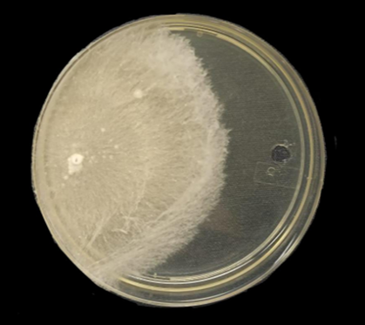
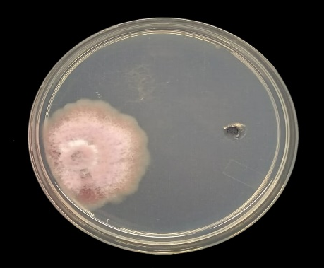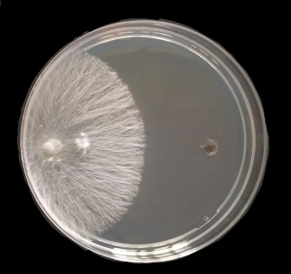
T3
T2
T1
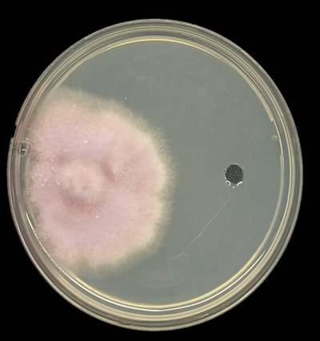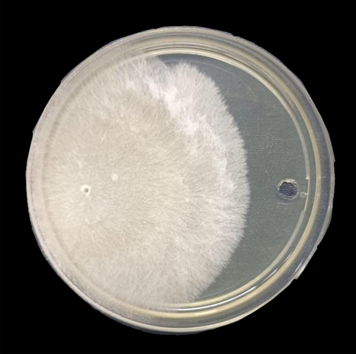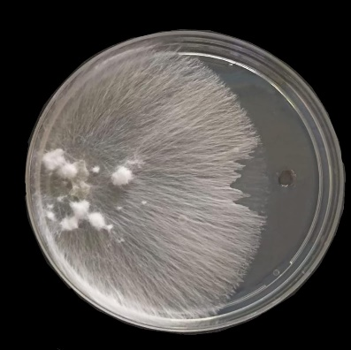
T6
T5
T4
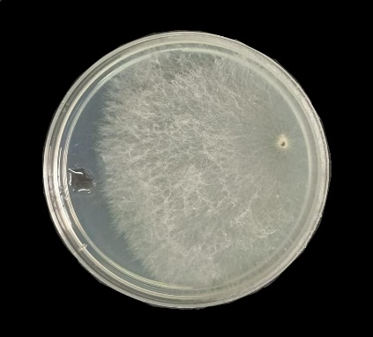
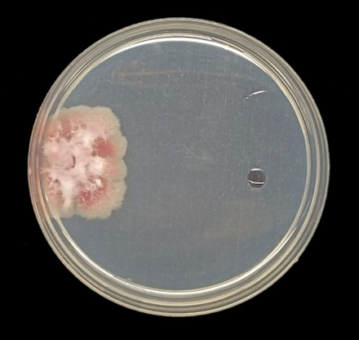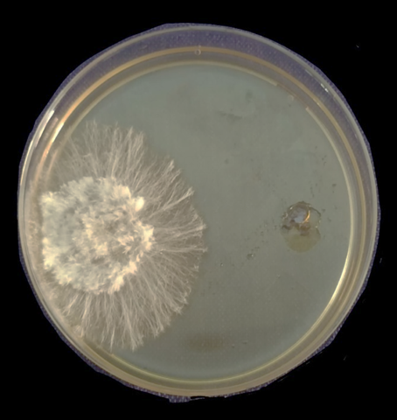
T9
T8
T7
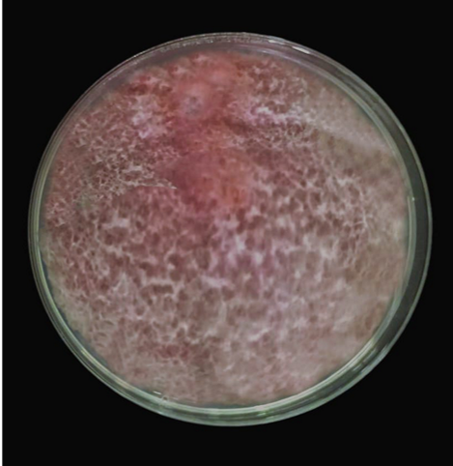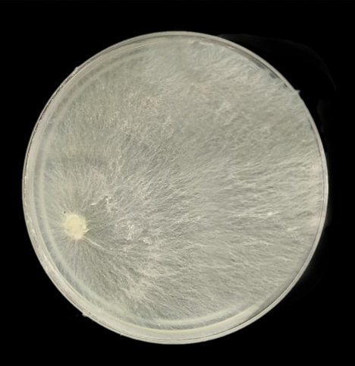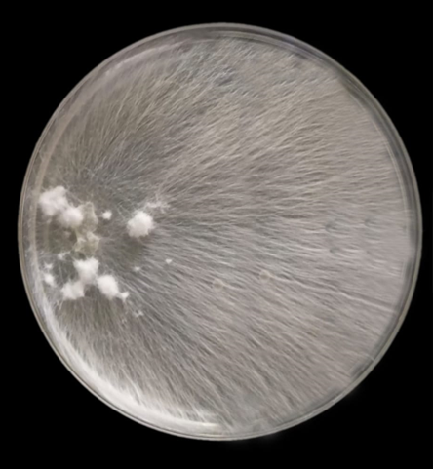
T12
T11
T10
Fig 1: In vitro evaluation of antagonistic activity of aqueous extracts of Oyster SMS against major soil borne plant pathogens. T-1: Aqueous extract of P. sapidus SMS + Fusarium oxysporum; T-2: Aqueous extract of P. sapidus SMS + Rhizoctonia solani; T-3: Aqueous extract of P. sapidus SMS + Sclerotium rolfsii; T-4: Aqueous extract of P. ostreatus SMS + Fusarium oxysporum; T-5 :Aqueous extract of P. ostreatus SMS + Rhizoctonia solani; T-6 : Aqueous extract of P. ostreatus SMS + Sclerotium rolfsii T-7: Aqueous extract of P. sajor caju SMS + Fusarium oxysporum; T-8: Aqueous extract of P. sajor caju SMS + Rhizoctonia solani; T-9: Aqueous extract of P. sajor caju SMS + Sclerotium rolfsii; T-10: Control: Water + Fusarium oxysporum; T-11: Control: Water + Rhizoctonia solani; T-12: Control: Water + Sclerotium rolfsii
Table 2: Per cent inhibition of growth in different treatment with Methanolic Extract (Fig 2)
Treatment with Methanolic Extract | Mycelial growth (cm) | Per cent inhibition over control (%)
T-1 (P. sapidus SMS + Fusarium oxysporum) | 4.87 | 45.80
T-2 (P. sapidus SMS + Rhizoctonia solani) | 6.42 | 28.66
T-3 (P. sapidus SMS + Sclerotium rolfsii) | 6.25 | 30.55
T-4 (P. ostreatus SMS + Fusarium oxysporum) | 5.19 | 42.33
T-5 (P. ostreatus SMS + Rhizoctonia solani) | 9.00 | 0.00
T-6 (P. ostreatus SMS + Sclerotium rolfsii) | 9.00 | 0.00
T-7 (P. sajor caju SMS + Fusarium oxysporum) | 5.30 | 41.11
T-8 (P. sajor caju SMS + Rhizoctonia solani) | 6.45 | 28.33
T-9 (P. sajor caju SMS + Sclerotium rolfsii) | 6.15 | 31.64
T-10 Control: Methanol+ Fusarium oxysporum | 9.00 | 0.00
T-11 Control: Methanol + Rhizoctonia solani | 9.00 | 0.00
T-12 Control: Methanol + Sclerotium rolfsii | 9.00 | 0.00
SE(±d) | 0.114
CD | 0.330

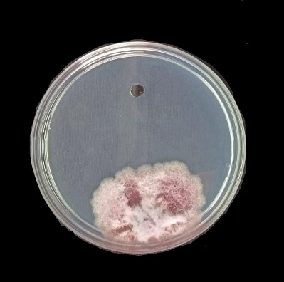
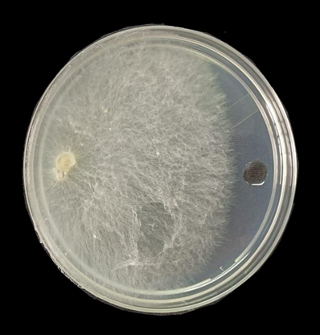
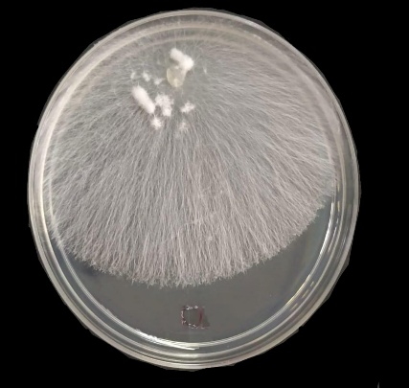
T3
T2
T1
T1
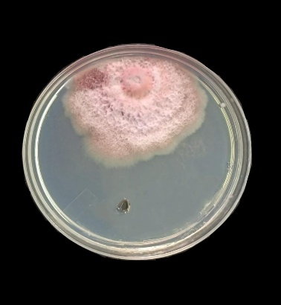
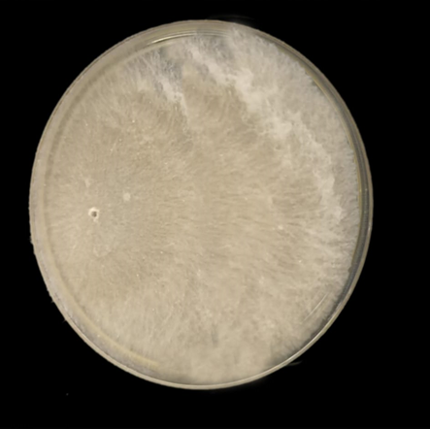
T6
T5
T4

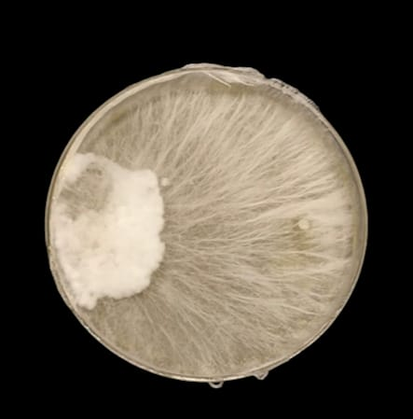

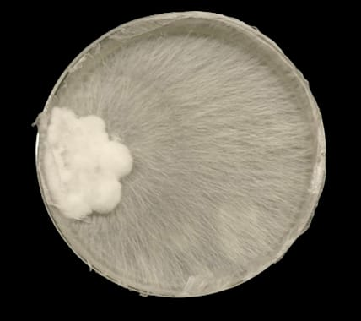
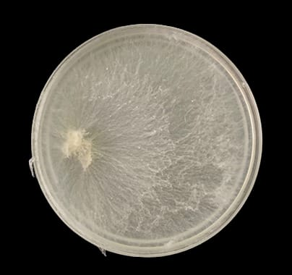
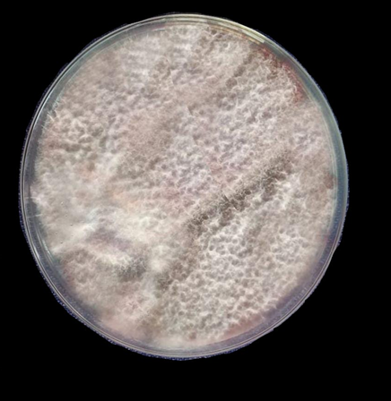
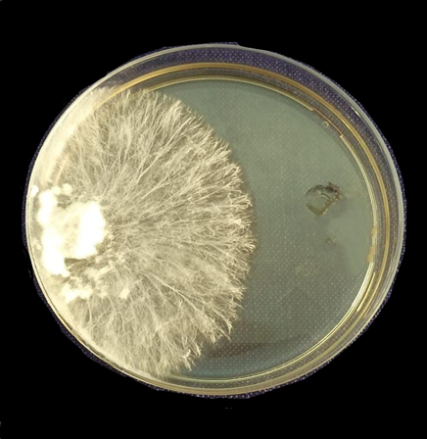
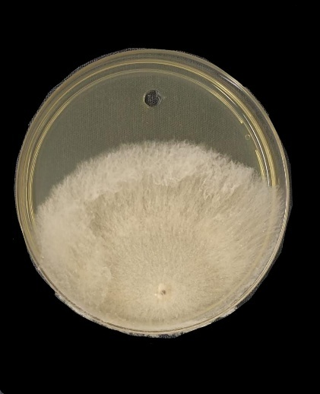
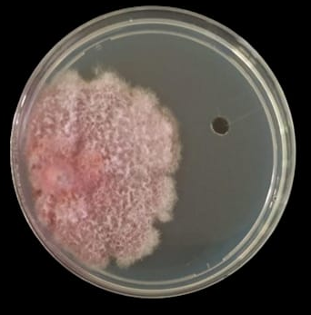
T12
T11
T10
T9
T8
T7

Fig 2: In vitro evaluation of antagonistic activity of methanolic extracts of Oyster SMS against major soil borne plant pathogens. T-1: Methanolic extract of P. sapidus SMS + Fusarium oxysporum; T-2: Methanolic extract of P. sapidus SMS + Rhizoctonia solani; T-3: Methanolic extract of P. sapidus SMS + Sclerotium rolfsii; T-4: Methanolic extract of P. ostreatus SMS + Fusarium oxysporum; T-5 : Methanolic extract of P. ostreatus SMS + Rhizoctonia solani; T-6 : Methanolic extract of P. ostreatus SMS + Sclerotium rolfsii T-7: Methanolic extract of P. sajor caju SMS + Fusarium oxysporum; T-8: Methanolic extract of P. sajor caju SMS + Rhizoctonia solani; T-9: Methanolic extract of P. sajor caju SMS + Sclerotium rolfsii; T-10: Control: Methanol + Fusarium oxysporum; T-11 :Control: Methanol + Rhizoctonia solani; T-12 : Control: Methanol + Sclerotium rolfsii
Aqueous extract of P. sajor caju SMS was found to be most effective one against Fusarium oxysporum with 64.66% inhibition, followed by aqueous extract of P. sapidus SMS against the same pathogen with 58.80% inhibition and aqueous extract of P. ostreatus SMS exhibited 57.22% inhibition against Fusarium oxysporum.
Methanolic extracts exhibited highest efficacy against Fusarium oxysporum obtained from P. sapidus, P. ostreatus and P. sajor caju spent mushroom substrates with 45.80%, 42.33% and 39.90%, respectively.
- Discussion
The aqueous extracts derived from various Oyster SMS demonstrated significant inhibition of three major soil-borne fungal pathogens: Fusarium oxysporum, Rhizoctonia solani, and Sclerotium rolfsii. Notably, the aqueous extract of P. sajor-caju SMS exhibited the highest efficacy against Fusarium oxysporum, achieving a 64.66% inhibition rate. This was followed by the aqueous extract of P. sapidus SMS, which showed a 58.80% inhibition rate against the same pathogen, and the aqueous extract of P. ostreatus SMS, which demonstrated a 57.22% inhibition rate. Furthermore, methanolic extracts displayed the highest efficacy against Fusarium oxysporum, with inhibition rates of 45.80%, 42.33%, and 39.90% for P. sapidus, P. ostreatus, and P.. sajor-caju SMS, respectively.
Yohalem et al. (1994) found that the anaerobically fermented aqueous extract of SMS demonstrated the highest efficacy in inhibiting the germination of Venturia inequalis conidia, which is the causal agent of apple scab. Conidial germination was shown to be significantly inhibited after an incubation period of 5 to 9 days, with ratios ranging from 2:1 to 4:1 of water to SMS (volume). Two bacterial taxa, namely pseudomonad and Bacillus, were reliably identified from the extract. Similarly, Yohalem et al. (1996) found that anaerobically fermented aqueous extracts from SMS, applied to McIntosh apple trees weekly from green-tip to petal-fall, then biweekly, moderately reduced apple scab (caused by Venturia inaequalis).
Mansour et al. (2011) used clarified compost tea made from SMS, route, and rice straw to control foliar and soil-borne diseases. In greenhouse trials, SMS compost tea significantly reduced root rot caused by Fusarium solani, Rhizoctonia solani, and Macrophomina phaseolinae during both pre- and post-emergence stages. Field applications of seed coating with compost tea also reduced disease incidence.
- Conclusion
The antifungal efficacy of both aqueous and methanolic extracts derived from three different varieties of Oyster mushrooms was assessed against the phytopathogen Fusarium oxysporum. Comparative analysis revealed that the aqueous extracts were generally more effective than their methanolic counterparts in suppressing the growth of the pathogen. Among the varieties tested, the aqueous extract of P. sajor-caju SMS demonstrated the highest inhibitory activity. This was followed by the aqueous extract of P. sapidus (SMS), which showed 58.80% inhibition, and P. ostreatus (SMS), which exhibited 57.22% inhibition of Fusarium oxysporum. These findings suggest that aqueous extracts, particularly from P. sajor-caju, hold substantial potential as eco-friendly biocontrol agents against Fusarium oxysporum and possibly other fungal phytopathogens.
CRediT authorship contribution statement
Pubali Bezbaruah, Devayani Sarmah: Investigation and Writing – original draft. Supriya Sharma, Apurba Das, Gunadhya Kumar Upamanya: Review & editing, Supervision, Conceptualization.
Ethical approval
This article does not contain any studies with human participants or animals by any of the authors.
Consent for publication
Written informed consent was obtained from all the authors for publication.
Declaration of competing interest
The authors declare no competing financial or non-financial interests.
Declaration of generative AI and AI-assisted technologies in the writing process
While preparing this work, we used Quillbot to improve the language. After using this tool/service, we reviewed and edited the content as needed and took full responsibility for the publication’s content.
Data availability
No new data has been generated to perform the study.
Reference
Acharya K, Das K, Paloi S, Dutta AK, Hembrom ME, Khatua S, Parihar A. Exploring a novel edible mushroom Ramaria subalpina: Chemical characterization and Antioxidant activity. Pharmacogn J. 2017; 9(1): 30-34.
Boyanova L, Gergova G, Nikolov R, Derejian S, Lazarova E, Katsarov N, Krastev Z. (2005). Activity of Bulgarian propolis against 94 Helicobacter pylori strains in vitro by agar-well diffusion, agar dilution and disc diffusion methods. J Med Microbiol. 2005; 54(5): 481-483.https://doi.org/10.1099/jmm.0.45880-0
Economou CN, Diamantopoulou PA, Philippoussis AN. Valorization of spent oyster mushroom substrate and laccase recovery through successive solid state cultivation of Pleurotus, Ganoderma and Lentinula strains. Appl Microbiol Biotechnol. 2017; 101(12):5213–5222
Elsakhawy T, Abd El-Rahem WT. Evaluation of spent mushroom substrate extract as a biofertilizer for growth improvement of rice (Oryza sativa L,). Egypt J Soil Sci. 2020; 60(1):31-42. https://doi.org/10.21608/ejss.2019.18835.1320
Kang DS, Min KJ, Kwak AM, Lee SY, Kang HW. Defense response and suppression of Phytophthora blight disease of pepper by water extract from spent mushroom substrate of Lentinula edodes. Plant Pathol J. 2017; 33(3):264. https://doi.org/10.5423/PPJ.OA.02.2017.0030
Lindequist U, Niedermeyer TH, Jülich WD. The pharmacological potential of mushrooms. Evidence‐Based Complementary and Alternative Medicine. 2005; 2(3):285-99. https://doi.org/10.1093/ecam/neh107
Ma Y, Wang Q, Sun X, Wang X, Su W, Song N. A study on recycling of spent mushroom substrate to prepare chars and activated carbon. Bioresources. 2014; 9(3):3939–3954.
Mahato D. Suppression of Plant Diseases by Exploiting Spent Mushroom Substrate. Biotica Research Today. 2022; 4(6):497-499
Manjit Singh MS, Shwet Kamal SK, Sharma VP. Status and trends in world mushroom production-I. Mushroom Res. 2017; 26(1): 1-20
Mansour FS, El-Sayed GA. Soil Amendment and Seed Treatments with Compost Tea as Alternative Fungicide for Controlling Root Rot Disease of Bean Plants. Egypt J Bìol pest control. 2011; 21(1).
Raman J, Jang KY, Oh YL, Oh M, Im JH, Lakshmanan H, Sabaratnam V. Cultivation and nutritional value of prominent Pleurotus spp.: an overview. Mycobiology. 2021; 49(1):1-4. https://doi.org/10.1080/12298093.2020.1835142
Sanchez C. Modern aspects of mushroom culture technology. App Microbiol Biotechnol. 2004; 64: 756-762.
Stamets P. Growing gourmet and medicinal mushrooms. Ten speed press; 2011.
Verma S, Kumar A, Singh J, Singh S, Rana RS. Antagonistic Effect of Trichoderma Spp. present in spent mushroom substrate against Rhizoctonia solani causing damping-off and root rot in tomato. Int J Agric Sci Res. 2017; 7:149-58.
Yohalem DS, Harris RF, Andrews JH. Aqueous extracts of spent mushroom substrate for foliar disease control. Compost Sci and Utilization. 1994; 2 (4): 67-74.
Yohalem DS, Nordheim EV, Andrews JH. The effect of water extracts of spent mushroom compost on apple scab in the field. Phytopathology. 1996;86(9):914-22.
Zhang JJ, Li Y, Zhou T, Ping XD, Zhang P, Sha Li, Hua-Bin L. Bioactivities and Health Benefits of Mushrooms Mainly from China Molecules. 2016; 21: 938- 944.

