Original Research Article

Simple Sequence Repeat (SSR) Marker-Based Parental Polymorphism Analysis between Improved Samba Mahsuri and Karuppunel for Grain Iron and Zinc Content in Rice (Oryza sativa L.)

ABSTRACT

Aim: The present study aimed to assess parental polymorphism between two genetically contrasting rice genotypes using microsatellite (SSR) markers, with a focus on identifying markers associated with grain micronutrient traits, particularly iron and zinc content.
Place and Duration of Study: The study was conducted at the Biotechnology Section, ICAR–Indian Institute of Rice Research (IIRR), Rajendranagar, Hyderabad, Telangana, India, during the period from August 2023 to September 2024.
Methodology: Genomic DNA was extracted from young leaf tissues of two contrasting parents, Improved Samba Mahsuri and Karuppunel, using the standard CTAB method. A total of 1,318 SSR (RM) markers covering all 12 rice chromosomes were used for PCR amplification. Amplicons were resolved by agarose gel electrophoresis, and polymorphic markers were identified based on the allele position between the two genotypes.
Results: Out of 1,318 SSR markers screened, 171 markers (13.0%) exhibited clear polymorphism between the two genotypes. Chromosome-wise polymorphism ranged from 9.0% (chromosome 7) to 18.2% (chromosome 1). Notably, several of the polymorphic markers identified in this study have been previously reported to be associated with iron and zinc content in rice, indicating their relevance for future trait mapping and breeding efforts.
Conclusion: The identified polymorphic SSR markers provide a valuable resource for the development of mapping populations and marker-assisted selection programs aimed at improving grain micronutrient content in rice. This study lays the foundation for future QTL mapping and biofortification efforts targeting iron and zinc efficiency in rice breeding.

Keywords: rice microsatellite markers, parental polymorphism, iron and zinc

1. INTRODUCTION
Rice (Oryza sativa L.) is a staple food for over 3.5 billion people globally, especially in Asia and Africa, where it serves as a primary source of daily caloric intake (Khush, 2005). While rice contributes significantly to global food security, its polished grains are inherently low in essential micronutrients, particularly iron (Fe) and zinc (Zn), which are vital for human health. Micronutrient malnutrition often termed "hidden hunger" affects more than two billion people worldwide, with iron and zinc deficiencies leading to conditions such as anemia, impaired immune function, stunted growth, and increased mortality in women and children (Bouis and Welch, 2010; Wessells and Brown, 2012). Therefore, improving the micronutrient content of rice grains through biofortification has emerged as a sustainable and cost-effective strategy to combat hidden hunger in resource-poor populations (Saltzman et al., 2013).
Conventional breeding approaches for enhancing grain Fe and Zn content are often hindered by the complex, quantitative inheritance of these traits and the strong influence of environmental factors (Anuradha et al., 2012). The integration of molecular marker technology into rice improvement programs has significantly enhanced the precision and efficiency of selection through marker-assisted selection (MAS) and quantitative trait loci (QTL) mapping (Collard and Mackill, 2008; Xu and Crouch, 2008). These approaches enable the identification of genomic regions associated with target traits and facilitate the rapid introgression of favorable alleles into elite genetic backgrounds.
Among the various molecular markers, Simple Sequence Repeats (SSRs), or microsatellites, are extensively used in rice genetics due to their high polymorphism, abundance, reproducibility, and co-dominant inheritance (McCouch et al., 2002; Temnykh et al., 2001). SSR markers have proven to be powerful tools for genome mapping, genetic diversity analysis, and the identification of QTLs linked to agronomic, grain quality, and micronutrient traits. Several SSR-based QTL mapping studies have identified loci associated with Fe and Zn concentration in rice grains, notably on chromosomes 1, 4, 7, and 11, highlighting their potential for marker-assisted biofortification (Stangoulis et al., 2007; Garcia-Oliveira et al., 2009; Swamy et al., 2016).
A prerequisite for any mapping population-based molecular breeding strategy is the assessment of parental polymorphism, which involves screening parental genotypes with a panel of markers to identify polymorphic loci. These markers are critical for the development of segregating populations such as F₂, backcrosses, or recombinant inbred lines (RILs), and serve as anchor points in linkage analysis and QTL detection (Dale Young, 1999; Xu, 2010). For Fe and Zn biofortification, selecting parents with contrasting mineral profiles and identifying associated polymorphic SSR markers greatly enhance the power of detecting trait-linked genomic regions.
In this context, the present study aimed to evaluate SSR-based parental polymorphism between two contrasting rice genotypes differing significantly in grain Fe and Zn concentrations. A set of SSR markers distributed across all 12 rice chromosomes was used to identify informative markers for further use in genetic linkage map construction and QTL mapping of micronutrient traits. The outcomes of this study will facilitate downstream applications in marker-assisted breeding for biofortified rice, contributing to the development of nutritionally superior cultivars for widespread cultivation and consumption.

2. MATERIAL AND METHODS
2.1 Plant Material
Two contrasting rice parents, Improved Samba Mahsuri (ISM) and Karuppunel, were selected for the parental polymorphism survey in this study. Improved Samba Mahsuri is a high-yielding, bacterial blight-resistant variety developed through marker-assisted selection (MAS) by the ICAR-Indian Institute of Rice Research (ICAR-IIRR), Hyderabad, in collaboration with the CSIR-Centre for Cellular and Molecular Biology (CCMB), Hyderabad (Sundaram et al., 2008). It is widely cultivated due to its fine, medium-slender grains, excellent cooking and eating quality, and stable yield potential ranging from 5.5 to 6.0 t/ha.
The other parent, Karuppunel, is a traditional rice landrace characterized by its high grain zinc concentration, making it a promising donor for micronutrient biofortification in rice. It was identified and characterized for its superior grain zinc content by Bollinedi et al., (2022). The contrasting traits of these two parents—particularly in terms of grain iron and zinc content, as well as agronomic and grain quality traits make them ideal for developing mapping populations aimed at identifying QTLs linked to micronutrient enrichment and other quality parameters.
Seeds of both parents were obtained from the Indian Institute of Rice Research (IIRR), Rajendranagar, Hyderabad. For DNA extraction, seeds were surface-sterilized and germinated in Petri dishes under controlled conditions. Leaf tissues were collected from 21-day-old seedlings and utilized for DNA isolation.

2.2 DNA Extraction
Young leaves from 21-day-old seedlings of both parental lines were harvested for genomic DNA extraction. The cetyltrimethylammonium bromide (CTAB) method was employed following the protocol of Doyle and Doyle (1987), with minor modifications. Approximately 100 mg of fresh leaf tissue was ground to a fine powder in liquid nitrogen and incubated in 1000 µL of preheated (65°C) CTAB extraction buffer containing 2% CTAB, 100 mM Tris-HCl (pH 8.0), 20 mM EDTA, 1.4 M NaCl, and 0.2% β-mercaptoethanol for 30 minutes at 65°C. The lysate was then extracted twice with an equal volume of chloroform:isoamyl alcohol (24:1), followed by centrifugation at 12,000 rpm for 10 minutes. The aqueous phase was transferred to a fresh tube and DNA was precipitated using chilled isopropanol. After centrifugation, the DNA pellet was washed with 70% ethanol, air-dried, and resuspended in TE buffer (10 mM Tris-HCl, 1 mM EDTA, pH 8.0). DNA quality was evaluated by electrophoresis on a 0.8% agarose gel, and concentrations were determined using a NanoDrop spectrophotometer. All DNA samples were diluted to a working concentration of 50 ng/µL for downstream PCR amplification
2.3 PCR Amplification
A total of 1318 Simple Sequence Repeat (SSR) markers spanning all 12 chromosomes of rice were employed to assess parental polymorphism. These markers, primarily from the RM series, were selected based on their broad genomic distribution and relevance to key agronomic and nutritional traits, especially iron and zinc content. PCR amplification was performed in 10 µL reaction volumes comprising 2.0 µL of genomic DNA (50 ng), 1.0 µL of 10 µM primer mix, 1.0 µL of 2.5 mM dNTPs, 3.0 µL of 10X PCR buffer, 0.75 µL of Taq DNA polymerase (1 U), and 2.25 µL of nuclease-free water. The PCR conditions included an initial denaturation at 94°C for 5 minutes, followed by 35 cycles of denaturation at 94°C for 30 seconds, annealing at 55–60°C (depending on primer melting temperature) for 30 seconds, and extension at 72°C for 1 minute, with a final extension at 72°C for 10 minutes.

2.4 Electrophoresis and Visualization
PCR products were resolved on 3% agarose gels, stained with ethidium bromide, and visualized under UV light. A 100 bp DNA ladder was used for size estimation. Markers showing distinct allelic bands between the two parents were recorded as polymorphic. Percentage Polymorphism was calculated by formula as below:
$$Percentage Polymorphism=\frac{Total Number of Markers Screened}{Number of Polymorphic Markers​} x 100$$
3. results and discussion
A parental polymorphism survey is crucial in QTL mapping as it ensures genetic variation for constructing a linkage map. In order to find polymorphic markers between parents, parental polymorphism studies between Improved samba mahsuri (ISM) and Karuppunel were carried out using 1318 Simple Sequence Repeat (SSR) markers covering all 12 chromosomes of the rice genome. Details of the polymorphic markers, % polymorphism, and total number of markers are provided in Figure 1 and Table 1. Figure 2 depicts the physical positions of polymorphic markers on each chromosome.
Out of 1318 markers 171 found to be polymorphic (Table 2) between parents. Product size of markers was in between 100 to 500 bp (Plate 1). The percentage of polymorphic markers per chromosome ranges from 9.0% (chromosome 7) to 18.2% (chromosome 1), with an overall polymorphism rate of 13.0 %. Notably, chromosomes 1 and 11 had the highest polymorphism percentages at 18.2% and 16.9%, respectively, while chromosomes 5 and 7 had the lowest at 9.2 % and 9.0 %. Interestingly, chromosomes that have a high total number of markers, like Chromosome 1, Chromosome 2, and Chromosome 3, showed a larger number of polymorphic markers. However, higher marker density does not always equate to greater genetic variation as observed in chromosome 6 and chromosome 7.

Table 1: Parental polymorphism studies between Improved samba mahsuri and Karuppunel

S. No | Chromosome | Total Markers | Polymorphic markers | % polymorphism
1 | chr1 | 231 | 42 | 18.2(highest)
2 | chr2 | 161 | 25 | 15.5
3 | chr3 | 120 | 13 | 10.8
4 | chr4 | 108 | 12 | 11.1
5 | chr5 | 87 | 8 | 9.2
6 | chr6 | 98 | 14 | 14.3
7 | chr7 | 134 | 12 | 9.0(lowest)
8 | chr8 | 72 | 11 | 15.3
9 | chr9 | 53 | 5 | 9.4
10 | chr10 | 89 | 9 | 10.1
11 | chr11 | 59 | 10 | 16.9
12 | chr12 | 106 | 10 | 9.4
 | Total | 1318 | 171 | 13.0

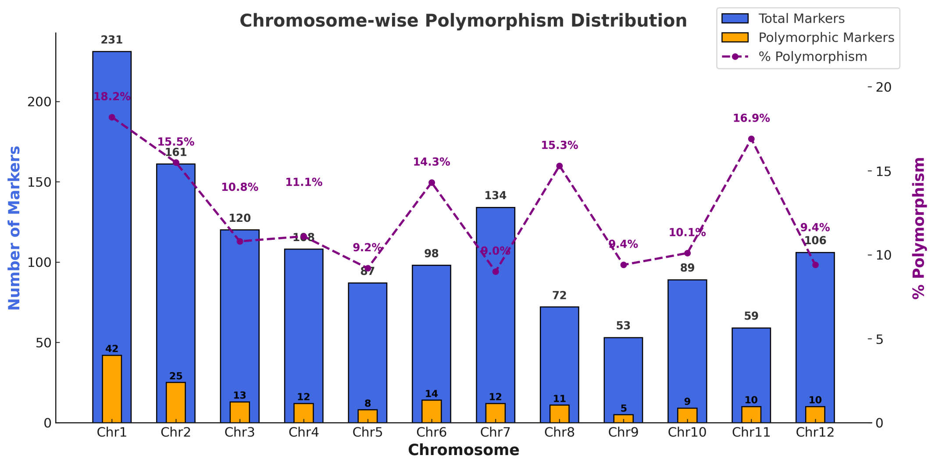
Figure 1: Chromosome-wise distribution of total and polymorphic SSR markers and their percentage polymorphism between Improved Samba Mahsuri and Karuppunel.

The polymorphism rate recorded in this study is in close agreement with previous reports. Bhargava et al. (2023) screened 816 SSR markers between rice genotypes 10–3 and Telangana Sona and identified 97 polymorphic markers (11.89%), with chromosome 6 showing the highest polymorphism at 30% and chromosome 5 the lowest at 3.49%. Similarly, Chandu et al. (2020) used 800 SSRs including 50 gene-specific markers linked to iron, zinc, and yield traits, of which 166 markers (20.75%) were polymorphic. Among them, 149 SSRs (19%) and 17 gene-specific markers (36%) exhibited distinct polymorphism. These polymorphic gene-specific markers represented key transporter gene families such as OsZIP, OsYSL, OsNRAMP, OsNAAT, OsFRO, and OsPDR, all of which play crucial roles in metal ion homeostasis in rice. Shivani et al. (2020) also reported 52 polymorphic markers out of 171 SSRs (30.4%) screened across rice genotypes, highlighting the variability in marker polymorphism depending on genetic background and marker type.
A notable highlight of the current investigation is the identification of 15 polymorphic SSR markers previously reported to be associated with grain iron and zinc content. These include RM13347 (Rathod et al., 2021), RM523 and RM489 (Watto et al., 2019), RM7 (Huang et al., 2012), RM551 (Islam et al., 2020), RM153 (Swamy et al., 2018), RM204 (Yu et al., 2015), RM340 (Xu et al., 2015), RM11, RM19, and RM247 (Hu et al., 2016), RM496 and RM591 (Kumar et al., 2014), RM332 and RM552 (Jeong et al., 2020). The presence of these trait-linked markers in the polymorphic set not only confirms their stability across diverse genetic backgrounds but also underscores their potential utility in downstream QTL mapping and marker-assisted breeding for grain micronutrient enhancement.
4. CONCLUSION
The parental polymorphism analysis between Improved Samba Mahsuri and Karuppunel revealed a moderate polymorphism rate of 13.0%, with 171 SSR markers displaying allelic variation across the rice genome. The identification of 15 previously reported trait-linked polymorphic markers associated with grain iron and zinc content provides a valuable resource for precise QTL detection and marker-assisted selection. These findings offer a solid foundation for developing biofortified rice varieties with improved nutritional quality and contribute significantly to efforts aimed at addressing micronutrient malnutrition through genetic improvement strategies.
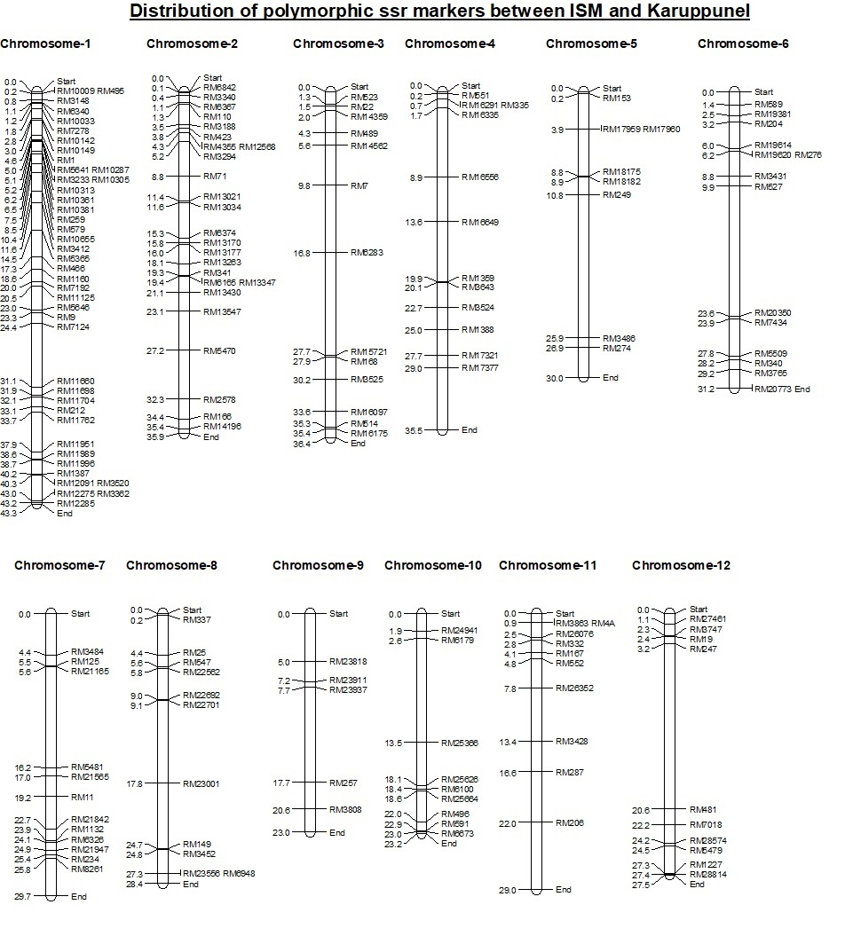
Figure 2: Chromosome wise physical distribution of polymorphic markers chromosome wise
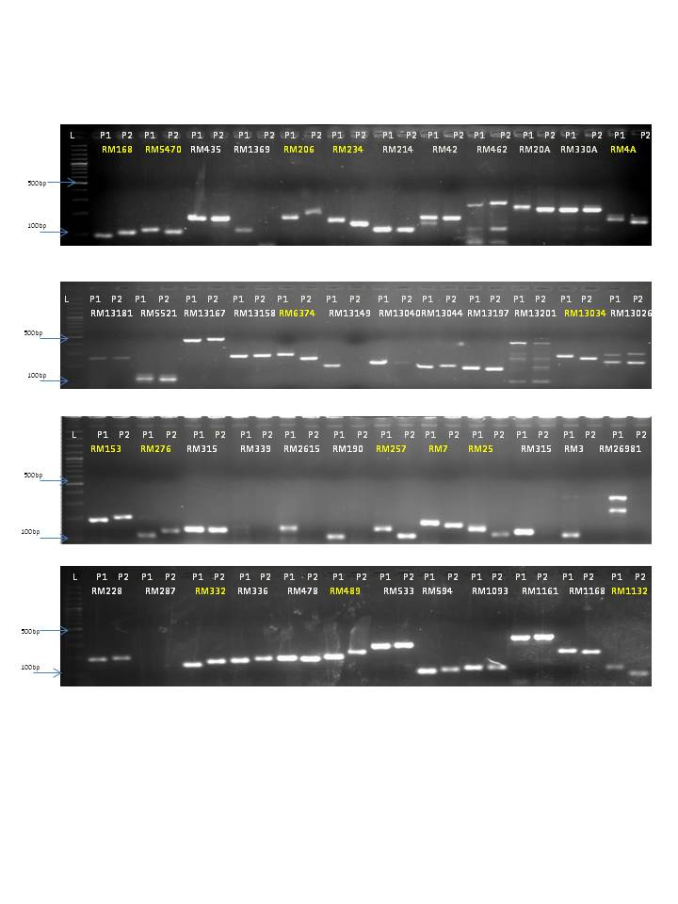
P1 : Improved samba mahsuri, P2 : Karuppunel, L: 100bp DNA ladder

Plate 1: Parental polymorphism studies between Improved samba mahsuri and Karuppunel using molecular markers.

Table 2: list of polymorphic markers with sequence.
S.No | Marker | Chr. No | Forward primer | Reverse primer
1 | RM10009 | 1 | GATGCTCCGGAATAACTAGATTGG | GGAATTACAGCTGTCTTGGAAGG
2 | RM495 | 1 | ATGATGATGGACGACGACAACG | TGAATCCAAGGTGCAGAGATGG
3 | RM3148 | 1 | GCTTTGGTATTTGCAGGTTCACG | CTATTGCTCGAACACTTTGCTTCTCC
4 | RM6340 | 1 | GCATGATGCAACGGAGATCG | CTTCCTCATCTCCCTCACCTTCC
5 | RM10033 | 1 | AGAGTGCGTAATAGCTCACTGATCG | ACCCAGGACGAACAAATCTAGGC
6 | RM7278 | 1 | GCTAGTCTGATGAATGCCGGTAGG | GCCATGTGGCAATCTGAGAGC
7 | RM10142 | 1 | CCCGTCACCAACTCACCATAGG | CTAAGCCACCCTTACCACCATCC
8 | RM10149 | 1 | AGAAGCCCGTGGAGTTTGTGG | AAACGAGCACTCGCGGAAGC
9 | RM1 | 1 | GCGAAAACACAATGCAAAAA | GCGTTGGTTGGACCTGAC
10 | RM5641 | 1 | GGCATGAGAGTCTGTGATGTTGG | TAGTACTGCTCCATCTGCCTTGG
11 | RM10287 | 1 | GTATTCCTTGCTGCTGCTGATGG | GACTGGAGATGTGATCGGAAACC
12 | RM3233 | 1 | GAAATTCGAAATGGAGGGAGAGC | GGTGAGTAAACAGTGGTGGTGAGC
13 | RM10305 | 1 | CAGGAACCAACCTTCTTCTTGACC | GTCAGACTCCGATCTGGGATGG
14 | RM10313 | 1 | ACTTACACAAGGCCGGGAAAGG | TGGTAGTGGTAACTCTACTCCGATGG
15 | RM10361 | 1 | CCTTGATCGGAAGTAGCTCAACG | GCCCTCAGAGCAGTAAGGAGAGG
16 | RM10381 | 1 | TGGAGATGGCAAAGAGGAATTGTGG | GAGAGTTCGCCGTCGCTTGG
17 | RM259 | 1 | GAAGTGCTCCCTAAACTTGTTGC | TTATGGAGGATGGATTCGAAGG
18 | RM579 | 1 | TTCCGAGTGGTTATGCAAATGG | TCGTGACCTGAGAAATTGTGTCC
19 | RM10655 | 1 | AGTACCGTTGAATCCGATATGC | TGGTTGAGGTGCTGAATTGG
20 | RM3412 | 1 | TGATGGATCTCTGAGGTGTAAAGAGC | TGCACTAATCTTTCTGCCACAGC
21 | RM5365 | 1 | CAAAGTTCGGATCATCTGTTCG | ACATATCAGGGAAAGCGTCAGG
22 | RM466 | 1 | CCTCACCATTGATCTCCATCACC | ACTTGCCCTCCTCTTCTCAACG
23 | RM1160 | 1 | CCAAGTTTCAGGGAAACCAACC | GCTTCTCCCTCTCTGCTTGACG
24 | RM7192 | 1 | CAACTACAACACGGACTACAAGATGC | ATTCAGATTGATTGGGCCTTCG
25 | RM11125 | 1 | CCAAGAACCCTAGCTCCCTCTCC | TCGACGAGATCCTCCTCGTAAACC
26 | RM5646 | 1 | ACGCGCACCAAGAGAGAAACG | CTCGGCAAGGAACTGGTCAGG
27 | RM9 | 1 | GGCCCTCATCACCTTCGTAGC | CGTCCTCCCTCTCCCTATCTCC
28 | RM7124 | 1 | ATCGGTTAAGCTGAAACCCC | AACCGTGAACACACACATGC
29 | RM11660 | 1 | AAACCGCCGTCCTCCTATTCG | CTTGAGCGCACCAACGAAATACC
30 | RM11698 | 1 | ATCAGCATCCCAAAGCTAGAACC | AACCGTATATTGAGGGAGCAAGC
31 | RM11704 | 1 | ACAGGGCTATGCAGACACAGTGC | AGCAAGCGAAGGGAAGTGACC
32 | RM212 | 1 | AAGGTCAAGGAAACAGGGACTGG | AGCCACGAATTCCACTTTCAGC
33 | RM11762 | 1 | AAGCGACAACTGAAGGAAACTCG | TTTGAAAGTCCACTGCCAAGTGC
34 | RM11951 | 1 | GAAACTCAACAAATCGCGAACG | CTAGGCCATTAGCCAAAGCATCC
35 | RM11989 | 1 | CAGTACGGACGTCTTCGTCAGG | CCGTACGTGCGTAGCTTCACG
36 | RM11996 | 1 | CCGTCGTCAATATTTCTACGACACC | GGCTTAAATTGCCACTGTTCAGG
37 | RM1387 | 1 | GCTACCATGCACGAAACAGAGACG | ACCAAATGTGGCTGGCTGATCG
38 | RM12091 | 1 | CTGCAAATGCACAGGAATCAGG | TCCTCTCGCCTTTCTTTCTCTCC
39 | RM3520 | 1 | CTGCAAATGCACAGGAATCAGG | TCCTCTCGCCTTTCTTTCTCTCC
40 | RM12275 | 1 | ATTGCGTGGGATATGGACTATGC | CCTCTTCAATTCCCTTCCTCTGC
41 | RM3362 | 1 | ATTGCGTGGGATATGGACTATGC | CCTCTTCAATTCCCTTCCTCTGC
S.No | Marker | Chr. No | Forward primer | Reverse primer
42 | RM12285 | 1 | CGACTGGAAGAAGGGATCATGG | CACACTACCAAGACTCCGCTATGG
43 | RM6842 | 2 | CCGTGCATCTCGCTACCTAACC | TGCACACACAACTTAGAGGAAGAAGG
44 | RM3340 | 2 | GAGAGAGACACCAAATGATCCATCC | ACTGATTTGGCCCTTGTTCTTGG
45 | RM6367 | 2 | GCAACCACGACATCAAAGAAACC | GGAGGTTAGTGCTTCGGAGTGG
46 | RM110 | 2 | AAATTCGAAGCCATCCACCAACG | GCCGACGAGGTCGAGTAGAAGG
47 | RM3188 | 2 | TTGCTGCTCAAGTGGTGAGAAGG | TCGATGGGTGAGCCTTTCTTGC
48 | RM423 | 2 | AGCACCCATGCCTTATGTTG | CCTTTTTCAGTAGCCCTCCC
49 | RM4355 | 2 | GGGATGAGAGTAGAAGGCACAAGG | GCTTAATGCCTTTGATCGTTGC
50 | RM12568 | 2 | TCTTCGAAACAAGCAGCTCTAGG | GATAGGTCGGATGTGTGATTTGG
51 | RM3294 | 2 | ATAGACGGATGGCACGAGATGC | ATGTGTTCAGTTCAGTGGTGAGTGG
52 | RM71 | 2 | CTAGAGGCGAAAACGAGATG | GGGTGGGCGAGGTAATAATG
53 | RM13021 | 2 | GATTCCACGTCAGGATCTTCTGG | GCTCACCAGTTGAGATTGAAAGG
54 | RM13034 | 2 | CAAACTTTAAACGGCCACTTCC | TCGGCATTATACTGGTCTTTGG
55 | RM6374 | 2 | TCACCAGACTCAACAAAGGATCG | TTCACCTTTCTTCTCCCTCATTCC
56 | RM13170 | 2 | GCCTCTTCACCCTCATCCTTCTCG | CGCCTGCCACCTTTATCTTGAACC
57 | RM13177 | 2 | AAGATTGCACACTGGTGTTCTCC | AGAAGAGCCGGTCTTTGTCTCC
58 | RM13263 | 2 | AAGATTGCACACTGGTGTTCTCC | AGAAGAGCCGGTCTTTGTCTCC
59 | RM341 | 2 | CAAGAAACCTCAATCCGAGC | CTCCTCCCGATCCCAATC
60 | RM6165 | 2 | TCCTTCTCCTTGAACAGCGACAGC | AGAGGCGAGAGGCATGGAGTGC
61 | RM13347 | 2 | TCCTTCTCCTTGAACAGCGACAGC | AGAGGCGAGAGGCATGGAGTGC
62 | RM13430 | 2 | CGCCTACATTCTTGTCTCAACC | GGAGAACTCTGCATTCTTATGAGG
63 | RM13547 | 2 | ACAGCCTCCTCCAGCTACAGACC | GGGATGACAAGATGGGTGAGG
64 | RM5470 | 2 | CGTGTATTGCATGGATTGTCTGG | CGGAACCCACAATTTCTTTCTGC
65 | RM2578 | 2 | TCCAGTTGGGCCAGGTGACG | ACTTGGTGGCTGTCATTGGTTGG
66 | RM166 | 2 | GGTCCTGGGTCAATAATTGGGTTACC | TTGCTGCATGATCCTAAACCGG
67 | RM14196 | 2 | ATCCTAGTGGATAAGGCACAGACTGG | CCCTTGCTCTTCCACCTCATCC
68 | RM523 | 3 | TGAATTCTTGCACATGGTCAGC | TGGGAGGTTTGCTAGGGTAATCC
69 | RM22 | 3 | GTTGACAAACAGGCCCTGAAACC | GTATGGTCTGGAGACGACGATCC
70 | RM14359 | 3 | CATCGAGATTGCCTGAGATAGTGC | TGAGCAGAAGGATGGGACTTAGG
71 | RM489 | 3 | GAACAGGGACACAATGATGAGG | GACGATCGGACACCTAATTACAGC
72 | RM14562 | 3 | TTGCCTGAAGAGAGACTAGACATGG | GCATGGTTTGCAGTTAAGATAGGG
73 | RM7 | 3 | TTCGCCATGAAGTCTCTCG | CCTCCCATCATTTCGTTGTT
74 | RM6283 | 3 | GATCAGGTGGTCGGTTCCTTACC | CCTGTTGGAGACTGAGCTGATGC
75 | RM15721 | 3 | CAGCCAAGCTCTCCAATTAAACC | TGTGCCTTCTGATCTGATGTTGC
76 | RM168 | 3 | TGTCGTCGAGGATTTGGAGATCG | GAATCAATCCACGGCACAGTCC
77 | RM3525 | 3 | CGCAAACGACACAAGTCATTACC | CTCAGCTCATCAAGACCTCAAGC
78 | RM16097 | 3 | CGCCTCGTAAGGTTGAGATCG | TGCCCTGTTCTTTCCATCTTGC
79 | RM514 | 3 | CTTCTCAGATTGATCTCCCATTCC | GGGAGAGAGGAAGAAGACAAGG
80 | RM16175 | 3 | AGCTTTGGTTTCTTGGCTTTGG | ATTAGCGTTGAACCCAAGTGTGG
81 | RM551 | 4 | CTTACTCCATTGGGCTGGAACC | TGTAGGGTGGTAAGAGATCCACTCC
82 | RM16291 | 4 | GTACACACCCACATCGAGAAGC | TCCATGGATATACGAGGAGATGC
83 | RM335 | 4 | GTACACACCCACATCGAGAAGC | TCCATGGATATACGAGGAGATGC
84 | RM16335 | 4 | AGCACGCGTGACATGAACTTCC | GAAGAGAGGCATGTGTTGTGTTGG
S.No | Marker | Chr. No | Forward primer | Reverse primer
85 | RM16556 | 4 | TTGGACCAGGAGATCAATGAAGG | GTGCGCACACTCTTCTATGTGC
86 | RM16649 | 4 | CTCCCTTCATGCGTAAGCTCTCC | GCAAACAGGATCCTCCACAAAGG
87 | RM1359 | 4 | CGACTTGCCAAAGGTCAACG | GATTCTACGGGCCACAAGTCC
88 | RM3643 | 4 | GCTAAGCTAATCTGACCGGATCTACG | GATGGGCCGATTAACAAATTCC
89 | RM3524 | 4 | CTGTCTCCGTCTTCCTCACTCG | TGGAGAAATCTCCCTTCCTGAGC
90 | RM1388 | 4 | GATCGTTGCTGCTTTCAATGAGG | AGTGTTTCACCTTGGACCCATGC
91 | RM17321 | 4 | AAAGACAACCGTGAGGCTAGTGG | CGATGATGTACATGGGCACTCC
92 | RM17377 | 4 | ATATTACTTCGACGCTGGATCAGG | GTCAGTTCGTCAGGCACAACG
93 | RM153 | 5 | CCTCGAGCATCATCATCAGTAGG | TCCTCTTCTTGCTTGCTTCTTCC
94 | RM17959 | 5 | AGAGATGGAAGTCTGGTGCTTTGG | TCAACATAGCTTCAGGGCACCTAGC
95 | RM17960 | 5 | CTAGGTTTGTGTCTCTTTGTGG | TCCATATGCATACTCCTACAGC
96 | RM18175 | 5 | AAAGTCACTCACACGCCGTACTCC | ACGAATGAGTCCGACCATGACC
97 | RM18182 | 5 | AGCCATGTAGCAACAGACCAGTTTCG | ACGGGCAGGCTTACTTTCTTCTGG
98 | RM249 | 5 | CAACTCCACTCCAGACTCAACTCC | GGTATGATGCCATGAAGGTCAGC
99 | RM3486 | 5 | GGAGGTCGGCACGTAGTAGAGG | GTCGGTACTATTCCTGCCATCG
100 | RM274 | 5 | CCTCGCTTATGAGAGCTTCG | CTTCTCCATCACTCCCATGG
101 | RM589 | 6 | GTGGCTTAACCACATGAGAAACTACC | TCACATCATTAGGTGGCAATCG
102 | RM19381 | 6 | AACGGGAGATCACAGGAATTTGC | GTGTTCGACTCGTCTCCATTTCG
103 | RM204 | 6 | CTAGCTAGCCATGCTCTCGTACC | CTGTGACTGACTTGGTCATAGGG
104 | RM19614 | 6 | ATGCTAGATCAGGGCAATCAACC | CTCCCTCCAACTACTGCCAAGC
105 | RM19620 | 6 | GCGACGAGGAAGAAGATTAGTTCG | GCGGCACTTCGAGCAGTACG
106 | RM276 | 6 | GTCCTCCATCGAGCAGTATCAGC | CTAGCAAGACATGGACCTCAACG
107 | RM3431 | 6 | AAGGGAACATTCTGGAAGACACG | ACACATTGCGTGTAGTGTGAAGC
108 | RM527 | 6 | CGGTTTGTACGTAAGTAGCATCAGG | TCCAATGCCAACAGCTATACTCG
109 | RM20350 | 6 | AGGCTTCTTGGAATGGAACTGC | GGGAATATACGTGGATGTGAGAGG
110 | RM7434 | 6 | AGGCTTCTTGGAATGGAACTGC | GGGAATATACGTGGATGTGAGAGG
111 | RM5509 | 6 | CCTGTCAATTGATGATCCATGC | TACCTTCCAGCAGAAAGAAGACG
112 | RM340 | 6 | GGGTAAATGGACAATCCTATGG | ACCCTATTCTGGAGTTCATCTGG
113 | RM3765 | 6 | ACACCATGACACCAAAGGAAGG | GGATGCTTCCAATCCTCTCACC
114 | RM20773 | 6 | TTGCCAATATTCCCTCCAGTGC | GTTGTGTTGGGACCTTGATTCG
115 | RM3484 | 7 | TCCGGTCGTCCTCATCGTATCC | GCCCTCTTGCTCCCACATCG
116 | RM125 | 7 | ATCAGCAGCCATGGCAGCGACC | AGGGGATCATGTGCCGAAGGCC
117 | RM21165 | 7 | AGTTGCTACTGGCAGTTTGTTTGG | CAAGGGTATGTGACCCTTATTGAGC
118 | RM5481 | 7 | CAAGTTTGGCAGCTAAATGTCTCC | GGTTGCACAGAGTAGTGATGTTTCG
119 | RM21565 | 7 | TATAGGTGGTAGCAACGCTGACG | GGTACCTCTCAAGCCAACAAGTATCC
120 | RM11 | 7 | TCTCCTCTTCCCCCGATC | ATAGCGGGCGAGGCTTAG
121 | RM21842 | 7 | GAACGGGAGGAGGAGTTGTAGG | GACTTCATTTCAACTCGACGATGG
122 | RM1132 | 7 | TCAAGGTCGACATGTTAGGTATGC | AACCCTATCACCTGAGAAACATCC
123 | RM6326 | 7 | CGATCTCTCTATCCTTCCTCTTCTCC | CAGATTGTTAGCAACCCGAATCC
124 | RM21947 | 7 | TTGGAACACACGAGAGATCAACC | CAACGTCTTCTTGCATTCCATCC
125 | RM234 | 7 | TTCAGCCAAGAACAGAACAGTGG | CTTCTCTTCATCCTCCTCCTTGG
126 | RM8261 | 7 | AGCTCGACGACTGGATGGTACG | GGTGCTTCTCCTGCAAACACG
127 | RM337 | 8 | GTAGGAAAGGAAGGGCAGAG | CGATAGATAGCTAGATGTGGCC
S.No | Marker | Chr. No | Forward primer | Reverse primer
128 | RM25 | 8 | GGAAAGAATGATCTTTTCATGG | CTACCATCAAAACCAATGTTC
129 | RM547 | 8 | TTGTCAAGATCATCCTCGTAGC | GTCATTCTGCAACCTGAGATCC
130 | RM22562 | 8 | GATCGGAGGAGGGAGGAAGACG | GTCGCATCCACTCATATTCCAAGC
131 | RM22692 | 8 | GAATAAATATGGGCTCCACACC | GACCATTAAGAGGTGAGCATATCG
132 | RM22701 | 8 | CCTCACGTCGTGCTCTCCAACC | CCTCGTCGCGTTCGTCAACC
133 | RM23001 | 8 | CAGTTCCTCTCCTCCACCACTTCG | TGGTGGACTGGAGGGCTACTGC
134 | RM149 | 8 | GGAAGCCTTTCCTCGTAACACG | GAACCTAGGCCGTGTTCTTTGC
135 | RM3452 | 8 | TGGACTTGGTCTCTCCAAACTCC | CAGTATGTGTTGGTGGGTCAAGC
136 | RM23556 | 8 | ACCATGATGGGCTAATGACG | TTCATCAGATATCAGCGACAGG
137 | RM6948 | 8 | ACCATGATGGGCTAATGACG | TTCATCAGATATCAGCGACAGG
138 | RM23818 | 9 | GATGATCGATTCAGGGTTCTTGG | CCTCAACTCATGGAGGCCTAACC
139 | RM23911 | 9 | TGCCTGCACTTATCTCTTGATGC | GATGAACCTAAAGGGCAGTTTCC
140 | RM23937 | 9 | CACATTGAAACCATCTGGGCTTGG | GAATGGACGGCTTCTCTGTGTTGC
141 | RM257 | 9 | CCGTGCAACTTAAATCCAAACAGG | GGAATCCTATATGAGCCAGTGATGG
142 | RM3808 | 9 | CAGTGGCGTGGAGAGAAATTTGG | CTCACCTGCGACAGCAAGATCG
143 | RM24941 | 10 | CGAATCTTGGAACACATCAACG | GGGAGGAGTGCTGTGAGAGG
144 | RM6179 | 10 | GCGCCGCCGAGATGATAAGC | AGCGGCATCTCGTCCATCTCC
145 | RM25366 | 10 | TCGGTCTCTGTGCCGTGATTAGG | CACCAGCGCAGCAACTAACATCC
146 | RM25626 | 10 | ATGCTCTCAAGTGTGTCAAGG | AACCTCTGGAGTATGTGTAGTGC
147 | RM6100 | 10 | TTCCCTGCAAGATTCTAGCTACACC | TGTTCGTCGACCAAGAACTCAGG
148 | RM25664 | 10 | CCAGCTGTTAATTAGCATGTGTGAGC | CAGCAAAGGCGTACGTATCTCG
149 | RM496 | 10 | GACATGCGAACAACGACATCC | CTATAGTTGTTGCACATGCGATCC
150 | RM591 | 10 | CTCATAGGTGGGTTAGTTTCTTGG | GCTGGTTTACAACTTGCTACTCTACC
151 | RM6673 | 10 | CCACCCGTCTCATGTTCTACTCG | ATGGAGATGATACACTCGCATCG
152 | RM3863 | 11 | CGATTGATCCCGTGCAAGTAGG | CATGCTAGTGCATTCTGCGTAGG
153 | RM4A | 11 | TTGACGAGGTCAGCACTGAC | AGGGTGTATCCGACTCATCG
154 | RM26076 | 11 | CCTTCTCTCTCCCACATCTCTAGC | CTAGTGAGTCCCACGTGTCAACC
155 | RM332 | 11 | GAAGGCGAAGGTGAAGAAGAAGC | CCTCCCTTGCATGATACCTTGG
156 | RM167 | 11 | CTCCGAGTCCGACCACAAGG | TCCAGCCCTTCCTATCATATTGC
157 | RM552 | 11 | CGCAGTTGTGGATTTCAGTGC | TCATGCTCAACGTTTGACTGTCC
158 | RM26352 | 11 | TCACTGGATCTAACCAAGCCTACC | CAATCGCACAGACAAACACAGC
159 | RM3428 | 11 | GCCATTGACACCAAATGATCACC | GGCATATAAGGTCCATGGTGAATTGG
160 | RM287 | 11 | GGCTACACCTACACGCGAGAACC | AGATGCATGGAATGCCTGTTTGG
161 | RM206 | 11 | ATCGATCCGTATGGGTTCTAGC | GTCCATGTAGCCAATCTTATGTGG
162 | RM27461 | 12 | ACGACCACCGTGTACGAAAGC | GATGAAGACGGATGAGGTGTTGC
163 | RM3747 | 12 | CTTGGTTTGGTTGTGTCCAAGC | GTTCTGATGAACAGGCCGTAGC
164 | RM19 | 12 | CAAAAACAGAGCAGATGAC | CTCAAGATGGACGCCAAGA
165 | RM247 | 12 | AAGGCGAACTGTCCTAGTGAAGC | CAGGATGTTCTTGCCAAGTTGC
166 | RM481 | 12 | TAGCTAGCCGATTGAATGGC | CTCCACCTCCTAGTTGTTC
167 | RM7018 | 12 | TTTCTCTCCACCCGTTCCTCACG | CAAGCATGGCCAAGTCATGTCG
168 | RM28574 | 12 | TAGTTTGGTGAAGTGGCATTGG | ATAGTAGGGCAAGGATTCAGAAGAGG
169 | RM5479 | 12 | CTCACCATAGCAATCTCCTGTGC | ACTTCGTTCACTTGCATCATGG
170 | RM1227 | 12 | CATCGACATGTGGACCACTCC | GCCTGAGACAAGTCCATGGTAGC
171 | RM28814 | 12 | CATCGACATGTGGACCACTCC | GCCTGAGACAAGTCCATGGTAGC

REFERENCES
Anuradha, K., Agarwal, S., Rao, Y. V., Rao, K. V., Viraktamath, B. C., & Sarla, N. (2012). Mapping QTLs and candidate genes for iron and zinc concentrations in unpolished rice of Madhukar× Swarna RILs. Gene, 508(2), 233-240.
Bhargava, K., Sreedhar, M., Vanisri, S., Rathod, R., Lakshmi, V. J., & Parimala, K. (2023). Parental Polymorphism Survey for Identifying Genes/QTLs for BPH Resistance in Assam Land Race 10-3. International Journal of Bio-resource and Stress Management, 14(6), 924-934.
Bollinedi, H., Neeraja, C. N., Chattopadhyay, K., Chandel, G., Shashidhar, H. E., Prakash, J., ... & Sundaram, R. M. (2022). Karuppunel: A promising donor for high zinc content in rice (Oryza sativa) grain. Indian J Agri Sci, 92(10), 1247-1252.
Bouis, H. E., & Welch, R. M. (2010). Biofortification—a sustainable agricultural strategy for reducing micronutrient malnutrition in the global south. Crop science, 50, S-20.
Chandu, G., Addanki, K. R., Balakrishnan, D., Mangrauthia, S. K., Sudhakar, P., Satya, A. K., & Neelamraju, S. (2020). SSR markers for grain iron zinc and yield-related traits polymorphic between Samba Mahsuri (BPT5204) and a wild rice Oryza rufipogon. Electronic Journal of Plant Breeding, 11(03), 841-847.
Collard, B. C., & Mackill, D. J. (2008). Marker-assisted selection: an approach for precision plant breeding in the twenty-first century. Philosophical Transactions of the Royal Society B: Biological Sciences, 363(1491), 557-572.
Dale Young, N. (1999). A cautiously optimistic vision for marker-assisted breeding. Molecular breeding, 5, 505-510.
Doyle, J. J., & Doyle, J. L. (1987). A rapid DNA isolation procedure for small quantities of fresh leaf tissue. Phytochemical bulletin.
Garcia‐Oliveira, A. L., Tan, L., Fu, Y., & Sun, C. (2009). Genetic identification of quantitative trait loci for contents of mineral nutrients in rice grain. Journal of integrative plant biology, 51(1), 84-92.
Hu, B. L., Huang, D. R., Xiao, Y. Q., Fan, Y. Y., Chen, D. Z., & Zhuang, J. Y. (2016). Mapping QTLs for mineral element contents in brown and milled rice using an Oryza sativa× O. rufipogon backcross inbred line population. Cereal Research Communications, 44(1), 57-68.
Huang, Y., Sun, C., Min, J., Chen, Y., Tong, C., & Bao, J. (2015). Association mapping of quantitative trait loci for mineral element contents in whole grain rice (Oryza sativa L.). Journal of Agricultural and Food Chemistry, 63(50), 10885-10892.
Islam, M. Z., Arifuzzaman, M., Banik, S., Hossain, M. A., Ferdous, J., Khalequzzaman, M., ... & Ali, M. P. (2020). Mapping QTLs underpin nutrition components in aromatic rice germplasm. PLoS One, 15(6), e0234395.
Jeong, O. Y., Lee, J. H., Jeong, E. G., Chun, A., Bombay, M., Banzon Ancheta, M., & Ahn, S. N. (2020). Analysis of QTL responsible for grain iron and zinc content in doubled haploid lines of rice (Oryza sativa) derived from an intra‐japonica cross. Plant Breeding, 139(2), 344-355.
Khush, G. S. (2005). What it will take to feed 5.0 billion rice consumers in 2030. Plant molecular biology, 59, 1-6.
Kumar, J., Jain, S., & Jain, R. K. (2014). Linkage mapping for grain iron and zinc content in F 2 population derived from the cross between PAU201 and Palman 579 in rice (Oryza sativa L.). Cereal Research Communications, 42(3), 389-400.
McCouch, S. R., Teytelman, L., Xu, Y., Lobos, K. B., Clare, K., Walton, M., ... & Stein, L. (2002). Development and mapping of 2240 new SSR markers for rice (Oryza sativa L.). DNA research, 9(6), 199-207.
Rathod, R., Suman, K., Madhubabu, P., Subbarao, L. V., Eswari, K. B., Chary, D. S., & Neeraja, C. N. (2021). Identification of genomic regions associated with grain zinc concentration in RILs derived from popular cultivar MTU1010 and BR2655 of rice. INDIAN JOURNAL OF GENETICS AND PLANT BREEDING, 81(04), 538-547.
Saltzman, A., Birol, E., Bouis, H. E., Boy, E., De Moura, F. F., Islam, Y., & Pfeiffer, W. H. (2013). Biofortification: progress toward a more nourishing future. Global food security, 2(1), 9-17.
Shivani, D., Suman, K., Madhubabu, P., Rathod, R., Cheralu, C., Shankar, V. G., & Neeraja, C. N. (2020). Parental polymorphism in iron-and zinc-rich rice varieties (Swarna and type 3) Using ssr markers.
Stangoulis, J. C., Huynh, B. L., Welch, R. M., Choi, E. Y., & Graham, R. D. (2007). Quantitative trait loci for phytate in rice grain and their relationship with grain micronutrient content. Euphytica, 154, 289-294.
Sundaram, R. M., Vishnupriya, M. R., Biradar, S. K., Laha, G. S., Reddy, G. A., Rani, N. S., ... & Sonti, R. V. (2008). Marker assisted introgression of bacterial blight resistance in Samba Mahsuri, an elite indica rice variety. Euphytica, 160, 411-422.
Swamy, B. M., Rahman, M. A., Inabangan-Asilo, M. A., Amparado, A., Manito, C., Chadha-Mohanty, P., ... & Slamet-Loedin, I. H. (2016). Advances in breeding for high grain zinc in rice. Rice, 9, 1-16.
Swamy, B. P. M., Kaladhar, K., Anuradha, K., Batchu, A. K., Longvah, T., & Sarla, N. (2018). QTL analysis for grain iron and zinc concentrations in two O. nivara derived backcross populations. Rice Science, 25(4), 197-207.
Temnykh, S., Park, W. D., Ayres, N., Cartinhour, S., Hauck, N., Lipovich, L., ... & McCOUCH, S. R. (2000). Mapping and genome organization of microsatellite sequences in rice (Oryza sativa L.). Theoretical and applied genetics, 100, 697-712.
Wattoo, Javed Iqbal, Sara Liaqat, Hira Mubeen, Muhammad Ashfaq, Muhammad Naveed Shahid, Amjad Farooq, Muhammad Sajjad, and Muhammad Arif. "Genetic mapping of grain nutritional profile in rice using Basmati derived segregating population revealed by SSRs." (2019): 929-935.
Wessells, K. R., & Brown, K. H. (2012). Estimating the global prevalence of zinc deficiency: results based on zinc availability in national food supplies and the prevalence of stunting. PloS one, 7(11), e50568.
Xu, Q., Zheng, T. Q., Hu, X., Cheng, L. R., Xu, J. L., Shi, Y. M., & Li, Z. K. (2015). Examining two sets of introgression lines in rice (Oryza sativa L.) reveals favorable alleles that improve grain Zn and Fe concentrations. PLoS One, 10(7), e0131846.
Xu, Y. (2010). Molecular plant breeding. Cabi.
Xu, Y., & Crouch, J. H. (2008). Marker‐assisted selection in plant breeding: From publications to practice. Crop science, 48(2), 391-407.
Yu, Y. H., Shao, Y. F., Liu, J., Fan, Y. Y., Sun, C. X., Cao, Z. Y., & Zhuang, J. Y. (2015). Mapping of quantitative trait loci for contents of macro-and microelements in milled rice (Oryza sativa L.). Journal of Agricultural and Food Chemistry, 63(35), 7813-7818.

