Allelopathic effect of common weeds on seed germination and early growth of aromatic rice.

Abstract
This study reveals that the allelopathic effect of aquous solution of wholw plant of commonly found four weeds, Acmella oleracea (L.) R.K. Jansen, Ageratum conyzoides L., Chromolaena odorata (L.) R.M.King & H.Rob. and Solanum nigrum L., which are from Asteraceae and solanaceae family respectively. On seed germination and early growth analysis of aromatic rice, we took four landraces, which are Radhunipagal, Kataribhog, Kalonunia, Lal-Badshabhog, each ware treated with above mentioned weed aquous solution with two different concentrations, (50mg/ml and 100 mg/ml) with a control treatment. All the study has been done under ideal laboratory condition. After five days of incubation, seed germination percentage and root, shoot length have been taken. As a result, germination is strongly inhibited for radhunipagal and Kataribhog, another two landraces also show a moderate inhibitory effect. As well as root, shoot growth also inhibited strongly at higher concentration in all four landraces.
Kew words: Allelopathic effect, aromatic rice, early growth, seed germination, weeds.

Introduction
Allelopathy is a branch of chemical ecology that studies how chemicals made by microbes or plants affect the growth and development of other plants in agricultural or natural environments (Einhellig, 1995). Allelopathy is a phenomenon of some plants by which plants release some chemical compounds, that positively or negatively affect the growth and population of neighboring plants (Koocheki et al., 2013). The neighboring plant’s growth may be positively or negatively impacted, Allelon, which means "to each other" or "mutual," and pathos, which means "to suffer" or "feel," are the two distinct Greek terms from which the word allelopathy is derived. Despite the fact that Austrian physicist Hans Molisch coined the term "allelopathie" in 1937, (Willis, 2007). Since ancient times, people have been aware of how plants interact chemically. Theophrastus, a Greek botanist, wrote in 300 B.C. about the detrimental effects of chickpeas on other plants. Later, Pliny, a Roman scholar, wrote in 1 A.D. that the walnut tree (Juglans spp.) inhibited the growth of neighbouring crops. Leaching from leaves or litter on the ground, root exudation, leaf volatilization, residue breakdown, and other processes in natural and agricultural systems are some of the ways that plant components release their allelochemicals (Rice, 1984). After being released, the allelochemicals can alter the rhizosphere's soil characteristics by affecting the microbial community or inhibit the germination, growth, and establishment of the nearby plants. (Weir et al., 2004). In general, allelochemicals can disrupt a plant's available sources of nutrients and cause allelopathic suppression of weeds to crops by preventing seed germination, shoot/root growth, nutrient uptake, or attacking a naturally occurring symbiotic relationship (Weston, 2000). Currently, crop performance suppressed by allelopathic weeds, so it has received more attention in order to control weeds in farming systems. Weeds may resist environmental stress and can alter seed properties with regard to seedlings, which allows them to grow faster than agricultural plants due to their quick reproduction techniques and ability to produce huge amounts of biomass in a short amount of time.(Qasem & Foy, 2001). Extracts of barnyard grass (Echinochloa crus-galli) could reduce the germination and seedling growth of field bean, corn and soybean (Bhowmik & Doll, 1983) and (Balyan et al., 1991). There are several common weeds are available which are found in rice germination bed and around rice field like Echinochloa colonum, Cyperus difformis, Physalis heterophylla, Jungle rice (Echinochloa colona (L.) and Cyperus difformis is considered to be a major weed in many crops (Raman et al., 2012) and can cause significant reduction in crop yields (Raman et al., 2012). It also revealed that a water-soluble extract of jungle rice might shorten the rice's radical and coleoptiles length (Galinato et al., 1999). A seed germination assay, specifically radical elongation, allows for rapid analysis of various compounds suspected being allelochemicals (Bogatek et al., 2006)

Materials and Methods
We took four plants to study their effect on seed germination and seedling growth of aromatic rice. They are as follow-
The herb species Acmella oleracea (L.) R.K. Jansen (synomym: Spilanthesacmella Murr.) belongs to the Asteraceae family and it is found in tropical and subtropical regions all over the world. Because it alleviates the symptoms of toothaches, A. oleracea is referred to as a toothache plant. Additionally, it has been utilized in Ayurvedic and traditional medicine to treat haemorrhoids, fever, rheumatism, headaches, and sore throats.
Ageratum conyzoides L. commonly known as Billy goat weed is an alien weed species native of Central America and Mexico (Negi et al., 2020). The herbaceous plant, which belongs to the Asteraceae family, is found in tropical and subtropical areas of the world, including India. Secondary metabolites such as alkaloids, flavonoids, phenolics, chromenes and essential oils have been identified from A. conyzoides, some of which are considered as Putative allelochemicals. Allelopathy is regarded as one of the reasons for imparting invasiveness by A. conyzoides. Water soluble phenolics as putative allelochemicals have been reported in number of studies in significant amount, deleteriously affected the early growth of rice, wheat, chickpea and pea.
Chromolaena odorata (L.) R.M.King & H.Rob. is a dominant, competitive shrub and the leaves contain a large amount of allelochemicals (Suwal 2010) which retard the growth of crop plants. The fresh tissue extract prepared from C. odorota had an inhibitory effect on the germination and seedling growth of Vigna unguiculata (Olasupo et al., 2016).
Solanaceae plants have the ability of allelopathy, and so that the species of plants control the behavior, form, and amount of allelopathic compounds (Mushtaq & Siddiqui, 2018). Sesquiterpenoid phytoalexins are abundant in the genera Withania, Solanum, Iochroma, Nicotiana, and Datura (Elakovich, 1987).The family's colloquial name, nightshade, comes from the deadly alkaloids found in some of its species. The enormous genus Solanum includes species that are found all over the planet. One of the most abundant species in the Solanaceae family, Solanum nigrum (L.) is a common and problematic annual weed in many parts of the world. Solanine, a glycoalkaloid that is toxic and present in most parts of the plant, with the largest amounts in the unripened berries, makes S. nigrum a common plant.
(Ismaiel & Salama, 2021). Although it is considered a rich source of one of the most popular plant poisons, it has also proven to be a pharmacologically prospective reservoir of phytochemicals.
Preparation of dry aqueous extract
For preparation of dry aqueous extract of Shoot, green leaves and stems of different four plant were collected from field and grounded to fine paste after air dry (10 day under shade). 20 g paste of each plant was soaked in 200 ml sterile distilled water in 1:10 w/v at room temperature for 48 hours. Whatman filter paper No. 1 was used to filter the contents after periodically shaking the soaked ingredients. The produced stock solution was diluted to a 50% concentration using distilled water, which was thought to have a 100% concentration. A distilled water treatment served as the control.
Seed Bioassay
In this experiment, four aromatic varieties of rice viz. Radhunipagal, Kataribhog, Kalonunia and Lal-Badshabhog were collected from Repositiory of Amarkanan Rural Socio environmental Welfare Society (ARSW Society situated at villege of Ranbahal – 86°36’E-87°47’E, with an altitude of 78 meter above sea level) and kept under two levels of extract concentrations treatment (50% and 100% concentration of extract) and distilled water as control. This experiment was carried out in the Department of Botany, Bankura Sammilani College under Bankura University, Bankura, West Bengal.
Thirty healthy, uniform sized seeds of each selected varieties were sterilized by 5% Sodium Hypochlorite, later washed with distilled water and were put in Petri dishes (with 9 cm diameter) with moistened filter paper (Whatman filter paper No.1) in three replicationsTo stop moisture from evaporating out of the Petri dishes, they were covered. The conditions for the germination test were a 12-hour light/dark cycle with a minimum temperature of 14°C and a maximum temperature of 28°C. Numbers of germinated seeds were recorded for upto 05 days. Germination percentage was determined by counting the number of germinated seeds every day divided by total number of tested seeds.

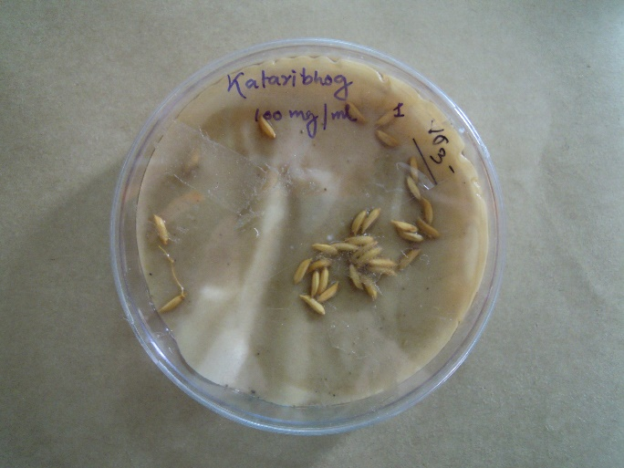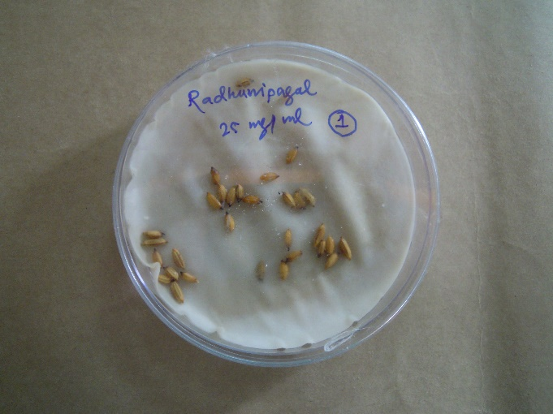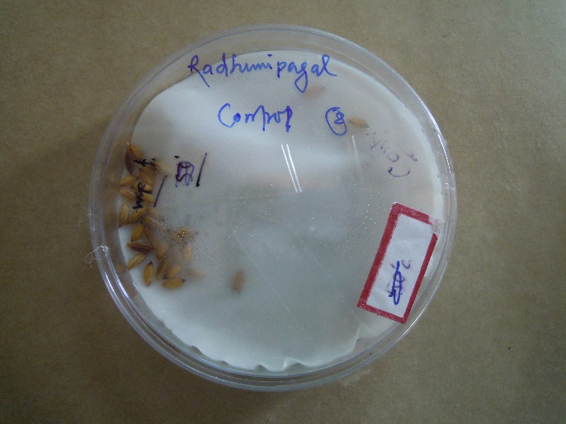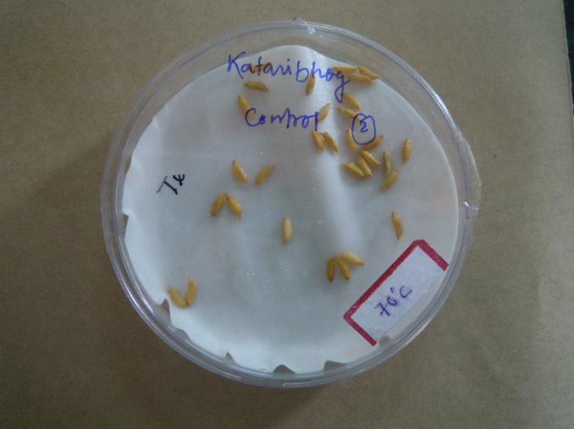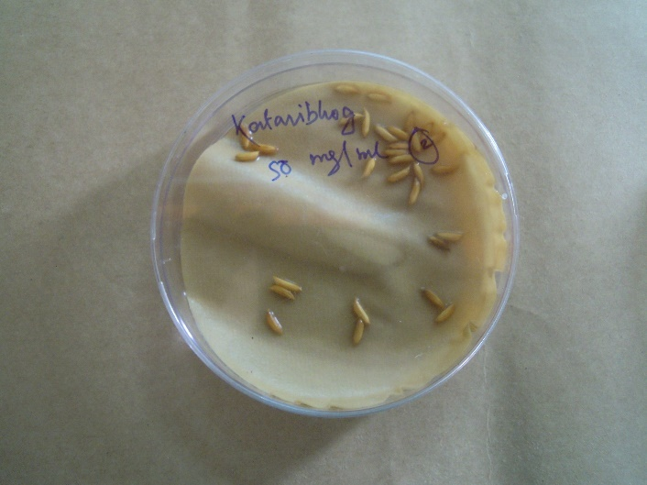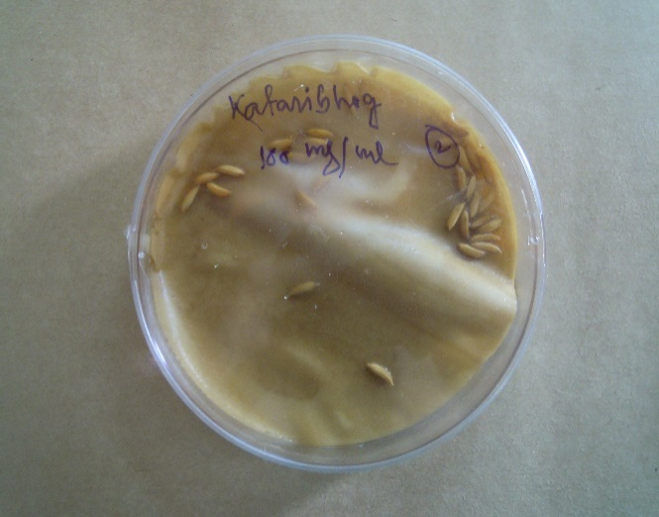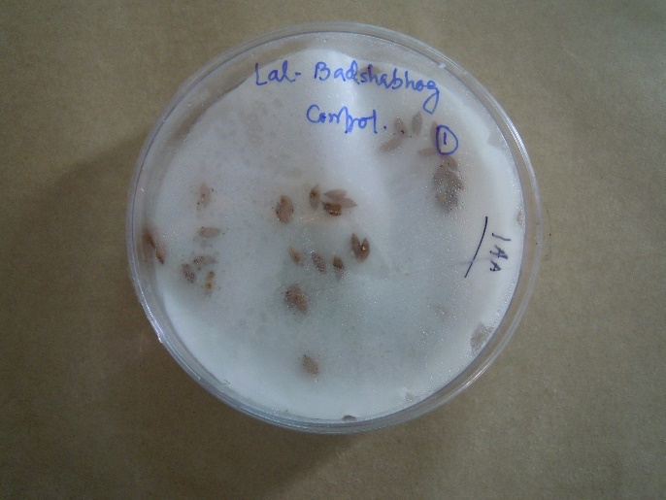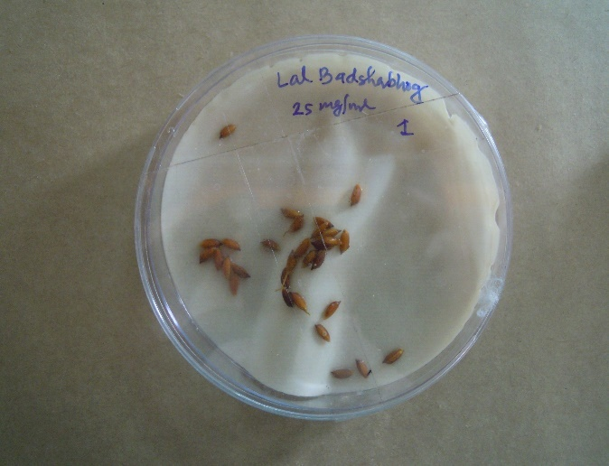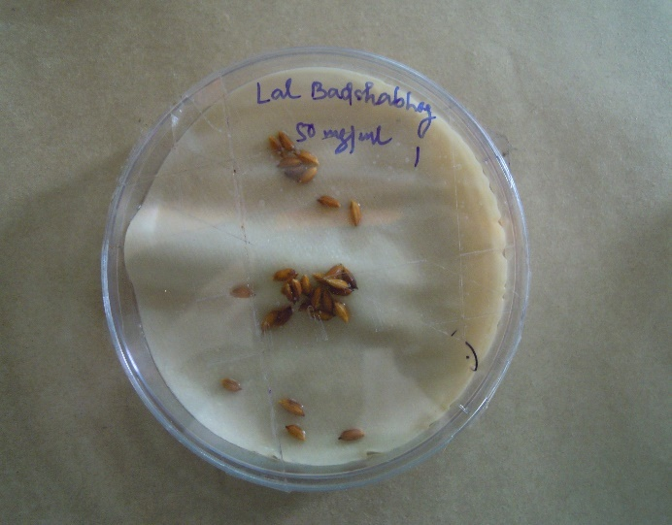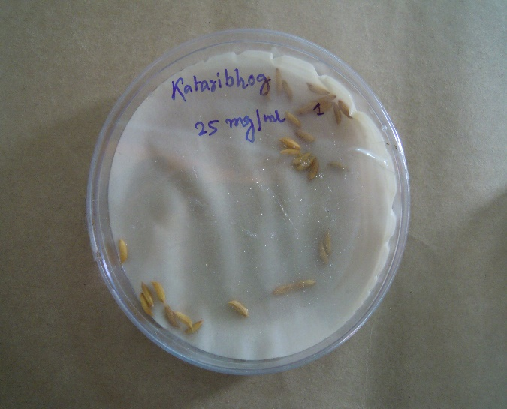
Fig 1-: Different seeds are treated with aqueous solution of plant extract along with a control treatment.

Result and Discussion
Treatment with Acmella oleracea
Acmella oleracea  Sample - 1 | Percentage of seed germination (%)
Acmella oleracea  Sample - 1 | Control | 50mg/ml | 100mg/ml
Radhunipagal | 100 | 3.33 | 0
Kataribhog | 100 | 20 | 0
Kalonunia | 90 | 80 | 20
Lal Badshabhog | 85 | 35 | 16.6
Table 1A. Germination percentage of different landraces under different concentration of dry aqueous extract of Acmella oleracea.

Acmella oleracea  Sample - 1 | Seedling growth
Acmella oleracea  Sample - 1 | Control |  | 50mg/ml |  | 100mg/ml
Acmella oleracea  Sample - 1 | Root length(mm) | Shoot length(mm) | Root length(mm) | Shoot length(mm) | Root length(mm) | Shoot length(mm)
Radhunipagal | 38 | 33.8 | 00 | 0.4 | 00 | 00
Kataribhog | 35.8 | 20.6 | 01 | 1.6 | 00 | 00
Kalonunia | 33 | 19.8 | 15.8 | 5.6 | 3.8 | 4.4
Lal Badshabhog | 42 | 19.8 | 22.6 | 12.8 | 2.6 | 03
Table 1B. Seedling growth of different landraces under different concentration of dry aqueous extract of Acmella oleracea.
Treatment with Ageratum conyzoides
Ageratum conyzoides Sample - 2 | Percentage of seed germination (%)
Ageratum conyzoides Sample - 2 | Control | 50mg/ml | 100mg/ml
Radhunipagal | 100 | 90 | 20
Kataribhog | 100 | 100 | 26.6
Kalonunia | 86.6 | 80 | 53.3
Lal Badshabhog | 80 | 65 | 20
Table 2A. Germination percentage of different landraces under different concentration of dry aqueous extract of Ageratum conyzoides.
Ageratum conyzoides  Sample - 2 | Seedling growth
Ageratum conyzoides  Sample - 2 | Control |  | 50mg/ml |  | 100mg/ml
Ageratum conyzoides  Sample - 2 | Root length(mm) | Shoot length(mm) | Root length(mm) | Shoot length(mm) | Root length(mm) | Shoot length(mm)
Radhunipagal | 38.4 | 25.6 | 19.4 | 7.2 | 3.2 | 2.8
Kataribhog | 33.2 | 8.8 | 26.6 | 6.8 | 0.4 | 3.6
Kalonunia | 39 | 15.4 | 21.6 | 09 | 18 | 5.4
Lal Badshabhog | 39 | 18 | 31 | 11.6 | 16.2 | 9.4
Table 2B. Seedling growth of different landraces under different concentration of dry aqueous extract of Ageratum conyzoides.
Treatment with Chromolaena odorata
C. odorata  Sample - 3 | Percentage of seed germination (%)
C. odorata  Sample - 3 | Control | 50mg/ml | 100mg/ml
Radhunipagal | 100 | 00 | 00
Kataribhog | 100 | 0 | 0
Kalonunia | 90 | 23.3 | 0
Lal Badshabhog | 86 | 21.3 | 0
Table 3A. Germination percentage of different landraces under different concentration of dry aqueous extract of Chromolaena odorata.
C. odorata  Sample - 3 | Seedling growth
C. odorata  Sample - 3 | Control |  | 50mg/ml |  | 100mg/ml
C. odorata  Sample - 3 | Root length(mm) | Shoot length(mm) | Root length(mm) | Shoot length(mm) | Root length(mm) | Shoot length(mm)
Radhunipagal | 39.6 | 15.2 | 0 | 0 | 0 | 0
Kataribhog | 46.8 | 12.4 | 0 | 0 | 0 | 0
Kalonunia | 33.3 | 19 | 6.4 | 04 | 0 | 0
Lal Badshabhog | 38 | 16 | 08 | 3.6 | 0 | 0
Table 3B. Seedling growth of different landraces under different concentration of dry aqueous extract of Chromolaena odorata.

Treatment with Solanum nigrum
Solanum nigrum  Sample - 4 | Percentage of seed germination (%)
Solanum nigrum  Sample - 4 | Control | 50mg/ml | 100mg/ml
Radhunipagal | 100 | 13.3 | 00
Kataribhog | 100 | 13 | 00
Kalonunia | 90 | 26 | 6.6
Lal Badshabhog | 80 | 33.3 | 3.3
Table 4A. Germination percentage of different landraces under different concentration of dry aqueous extract of Solanum nigrum
Solanum nigrum  Sample - 4 | Seedling growth
Solanum nigrum  Sample - 4 | Control |  | 50mg/ml |  | 100mg/ml
Solanum nigrum  Sample - 4 | Root length(mm) | Shoot length(mm) | Root length(mm) | Shoot length(mm) | Root length(mm) | Shoot length(mm)
Radhunipagal | 36.4 | 20.6 | 0.4 | 1.6 | 00 | 00
Kataribhog | 48.8 | 15.8 | 00 | 0.4 | 00 | 00
Kalonunia | 39 | 20.4 | 6.2 | 03 | 00 | 00
Lal Badshabhog | 42 | 24.8 | 11 | 05 | 00 | 00
Table 4B. Seedling growth of different landraces under different concentration of dry aqueous extract of Solanum nigrum.
Table 1A and 1B shows the percentage of seed germination and the root shoot length of different four varieties under three different treatment conditions (control, 50mg/ml and 100mg/ml dry aqueous extract of Acmella oleracea where, maximum root length was shown by Lal-Badshabhog with 42mm under control but it was inhibited up to 2.6mm with 100mg/ml treatment. Similarly maximum shoot length was shown by Radhunipagal, 33.8 mm under control and this length was reduced to 0.4mm and 0 mm respectively under 50mg/ml and 100mg/ml. maximum germination percentage decrease in Radhunipagal and Kataribhog, which wass 0% whereas germination percentage under control was shown 100% in both variety
Table 2A and 2B shows the percentage of seed germination and the root shoot length of different four varieties under three different treatment conditions (control, 50mg/ml and 100mg/ml dry aqueous extract of A. conizoides) where, maximum root length was shown by Lal-Badshabhog and Kaloonunia with 39 mm under control but it was reduced up to 18 mm and 16.2 respectively with 100mg/ml treatment. Similarly maximum shoot length was shown by Radhunipagal, 20.5 mm under control and this length was reduced to 3.2 mm under 100mg/ml. Maximum germination inhibition was seen in Radhunipagal under 100mg/ml treatment which was 20% whereas the contol was 100%.
Table 3A and 3B shows the percentage of seed germination and the root shoot length of different four varieties under three different treatment conditions (control, 50mg/ml and 100mg/ml dry aqueous extract of Chromolaena odorata) where, maximum root length was shown by Kataribhog with 46.8mm under control but it was reduced up to 0 mm with 100mg/ml treatment. Similarly maximum shoot length was shown by Kalonunia, 19mm under control and this length reduced to 0 mm under 100mg/ml. Maximum inhibition of germination percentage show in case of both Radhunipagal and kataribhog and Radhunipagal, which is 0%, whereas control treatment was shown 100% germination. Here Lal-Badshabhog shown better germination percentage under 50mg/ml but root and shoot length extremely reduced.
Table 4A and 4B shows the percentage of seed germination and the root shoot length of different four varieties under three different treatment conditions (control, 50mg/ml and 100mg/ml dry aqueous extract of S. nigram) where, maximum root length was shown by Lal-Badshabhog and Kaloonunia with 48.2 mm under control but it was reduced upto 0 mm with 100mg/ml treatment. Similarly maximum shoot length was shown by Radhunipagal, 38.4 mm under control and this length was reduced to 24.8 mm under 100mg/ml. Maximum inhibition of germination percentage was shown in case of both kataribhog and Radhunipagal, which was 0%.
Discussion
The findings of allelopathic research to far have been contradictory when considering the stimulatory or inhibitory effects of allelopathic plants (Yasmeen et al., 2013). Allelopathic activity varies from species to species and is dependent on concentration (Assaeed & Al-Doss, 1997). Furthermore, due to variations in their allelochemical diversity, Sundaramoorthy & Sen (1990) found that leachates derived from distinct plant sections of Tephrosia purpurea had a differential impact on the growth of different crops. High extract concentrations typically decrease seed germination and seedling growth in numerous allelopathic experiments (Rice, 1984; Synowiec & Nowicka-Połeć, 2016). According to Prinsloo and Du Plooy (2018), the allelopathic effect is contingent upon the test species' kind and concentration. For instance, these authors found that tomato seed germination was strongly decreased by high concentrations of Amaranthus extracts, whereas no such effect was seen at low quantities. The current study found that aqueous leaf and root extracts of two Lamiaceous species at low concentrations (0.5% and 1%) showed inhibitory effects on seed germination and the early growth parameters of rice seedlings, despite the fact that low concentrations of allelochemicals can have a stimulatory effect on target species (Lovett et al., 1989). Allelochemicals have been found to be more abundant in leaves than in other plant parts (Dorning & Cipollini, 2006). The majority of allelochemicals in nature are soluble in water (Turk et al., 2003), and practically all of them leak into the soil from plant portions above ground (Wetzel & Howe, 1999). Due to their direct touch, roots typically absorb allelochemicals from damp filter paper; they are also more impacted by varying concentrations than shoots (Ismail & Chong, 2002; Turk & Tawaha, 2003).
Effect of dry shoot aqueous extract on seed germination
Dry aqueous extract of four weeds with different two concentration 50mg/ml and 100mg/ml show effective inhibition of the percentage of germination on Radhunipagal and kataribhog, moderate inhibition on Lal- Badshabhog, and Kalonuniaat high aqueous concentration.
Effect of dry shoot aqueous extract on seedling growth (Root and Shoot length)
Growth of root and shoot also inhibited highly in case of Radhunipagal and Kataribhog with both treated concentrations of all the four weeds. Maximum root length shows Kaataribhog and Lal-Baadshabhog respectively under control condition and shoot length is maximum in Radhunipagal. Maximum root shoot length inhibition shows in C. odorata.
Conclusion
The aqueous extract of dry shoot of all four different weeds is effectively affect the germination percentage as well as the seedling growth and establishment. Although present study is insufficient to illustrate the complete effect of different allelochemicals of these four weeds on different rice landraces, therefore to study further may needs further evaluation on field condition and should be tested under natural condition.

References
- Koocheki A, Lalegani B and Hosseini S A. 2013. Ecological consequences of allelopathy. In Allelopathy: Current Trends and Future Applications pp. 23-38. Berlin, Heidelberg: Springer Berlin Heidelberg.
- Einhellig F A. 1995. Allelopathy: current status and future goals. Allelopathy: Organism, Process, and Applications. Inderjit K M M D, Einhelling F A. Symposium Series (Washington, DC, USA: ACS Symposium Series 582; American Chemical Society) pp. 1–24. doi: 10.1021/bk-1995-0582.ch001.
- Willis R J 2007. The history of allelopathy. (Dordrecht, The Netherlands: Springer Science & Business Media).
- Rice E L. 1984. Allelopathy. 2nd Edn (Orlando, FL: Academic Press, New York).
- Weir T L, Park S W and Vivanco J M. 2004. Biochemical and physiological mechanisms mediated by allelochemicals. Current Opinion in Plant Biology 7(4): 472–479. doi: 10.1016/j.pbi.2004.05.007.
- Weston L A. 2000. Are laboratory bioassays for allelopathy suitable for prediction of field responses? Journal of Chemical Ecology 26 (9): 2111-2118.
- Qasem J R, and Foy C L. 2001. Weed Allelopathy, Its Ecological Impacts and Future Prospects: A Review. Journal of Crop Production 4(2): 43–119. https://doi.org/10.1300/J144v04n02_02
- Bhowmik P C and Doll J D. 1983. Growth analysis of corn and soybean response to allelopathic effect of weed residues at various temperatures and photosynthetic photon flux dencities. Journal of chemical ecology 9: 1263–1280. https://doi.org/10.1007/BF00982228.
- Balyan R S, Malik R K, Panwar R S and Singh S. 1991. Competitive Ability of Winter Wheat Cultivars with Wild Oat (Avena ludoviciana). Weed Science 39(2): 154–158. https://doi.org/10.1017/s0043174500071393
- Raman A, Verulkar B S, Mandal P N, Variar M, Shukla D V, Dwivedi J, Singh N O, Swain P, Mall A, Robin S, Chandrababu R, Jain A, Ram T, Hittalmani S, Haefele S, Piepho H P and Kumar A. 2012. Drought yield index to select high yielding rice lines under different drought stress severities. Rice 5: 31-43. https://doi.org/10.1186/1939-8433-5-31.
- Galinato M Ignacio, Moody, Keith, Piggin C M and International Rice Research Institute. 1999. Upland rice weeds of south and southeast Asia. IRRI. ISBN: 9712201309.
- Bogatek R, Gniazdowska A, Zakrzewska W, Oracz K and Gawroński S W. 2006. Allelopathic effects of sunflower extracts on mustard seed germination and seedling growth. Biologia plantarum 50: 156-158, 2006 | DOI: 10.1007/s10535-005-0094-6.
- Negi B, Bargali S S, Bargali K and Khatri K. 2020. Allelopathic Interference of Ageratum conyzoides L. against Rice Varieties. Current Agriculture Research Journal 8(2): 69–76. DOI: http://dx.doi.org/10.12944/CARJ.8.2.01
- Suwal M M, Devkota A and Lekhak H D. 2010. Allelopathic effects of Chromolaena odorata (L.) King & Robinson on seed germination and seedlings growth of paddy and barnyard grass. Scientific world 8 (8): 73-75.
- Olasupo F O, Olumuyiwa Ilori C, Forster B P and Bado S. 2016. Mutagenic Effects of Gamma Radiation on Eight Accessions of Cowpea (Vigna unguiculata [L.] Walp.). American Journal of Plant Sciences 7(2): 339–351. https://doi.org/10.4236/ajps.2016.72034
- Mushtaq W and Siddiqui M B. 2018. Allelopathy in Solanaceae plants. Journal of Plant Protection Research 58 (1): 1–7. https://doi.org/10.24425/119113.
- Elakovich S D. 1987. Sesquiterpenes as Phytoalexins and Allelopathic Agents. ACS Symposium series 325: 93–108. https://doi.org/10.1021/bk-1987-0325.ch007
- Ismaiel S A and Salama H M. 2021. Allelopathic effects of black nightshade (Solanum nigrum L.) on germination, growth and yield of broad bean (vicia faba L.) and common bean (phaseolus vulgaris L.). Applied Ecology and Environmental Research 19(5): 3431–3441. https://doi.org/10.15666/aeer/1905_34313441
- Yasmeen A, Basra S M A, Farooq M, Rehman H, Hussain N and Athar H R. 2013. Exogenous application of moringa leaf extract modulates the antioxidant enzyme system to improve wheat performance under saline conditions. Plant Growth Regulation 69 (3): 225-233.
- Assaeed A M and Al-Doss A A. 1997. Allelopathic effects of Rhazya stricta on seed germination of some range plant species Annals of Agricultural Science 42 (1): 159-167.
- Sundaramoorthy S and Sen D N. 1990. Allelopathic effects of Tephrosia purpurea Pers. I. on germination and growth of some arid zone crops. Journal of the Indian Botanical Society 69 (3–4): 251-255.
- Rice E L. 1984. Allelopathy, 2nd. Academic Press, New York, 422.
- Synowiec A and Nowicka-Połeć A. 2016. Effect of aqueous extracts of selected medicinal plants on germination of windgrass [Apera spica-venti (L.) P. Beauv.] and lambs quarters (Chenopodium album L.) seeds. Acta Agrobotanica 69 (3): 1-9.
- Prinsloo G and Du Plooy C P. 2018. The allelopathic effects of Amaranthus on seed germination, growth and development of vegetables. Biological Agriculture & Horticulture 34 (4): 268-279.
- Lovett J V, Ryuntyu M Y and Liu D L. 1989. Allelopathy, chemical communication and plant defense. Journal of Chemical Ecology 15 (4): 1193-1202.
- Dorning M and Cipollini D. 2006. Leaf and root extracts of the invasive shrub, Lonicera maackii, inhibit seed germination of three herbs with no autotoxic effects. Plant Ecology 184 (2): 287-296.
- Turk M A, Shatnawi M K and Tawaha A M. 2003. Inhibitory effects of aqueous extracts of black mustard on germination and growth of alfalfa. Weed Biology and Management 3 (1): 37-40.
- Wetzel R G and Howe M J. 1999. High production in a herbaceous perennial plant achieved by continuous growth and synchronized population dynamics. Aquatic Botany 64 (2): 111-129.
- Ismail B S and Chong T V. 2002. Effects of aqueous extracts and decomposition of Mikania micrantha H. B. K. debris on selected agronomic crops. Weed Biology and Management 2 (1): 31-38. https://doi.org/10.1046/j.1445-6664.2002.00045.x.
- Turk M A and Tawaha A M. 2003. Allelopathic effect of black mustard (Brassica nigra L.) on germination and growth of wild oat (Avena fatua L.). Crop Protection 22 (4): 673-677. https://doi.org/10.1016/S0261-2194(02)00241-7.

