Original Research Article

"In Vitro Assessment of Biocontrol Agents and Essential Oils for Sustainable Management of Banded Leaf and Sheath Blight in Maize"

ABSTRACT
Maize (Zea mays L.) is a vital cereal crop globally and in India, where its productivity is often limited by biotic stresses such as banded leaf and sheath blight (BLSB), caused by Rhizoctonia solani f. sp. sasakii. In this study, BLSB-infected maize samples were collected from Kalyani, West Bengal, and the pathogen was isolated, morphologically and molecularly characterized. The Rs-01 isolate exhibited typical Rhizoctonia morphology and pathogenicity was confirmed through Koch’s postulates. Molecular identification using ITS sequencing further validated the identity of the pathogen, and a phylogenetic tree analysis placed the isolate firmly within the R. solani clade. In vitro evaluation of six fungal biocontrol agents revealed that Trichoderma harzianum (Th-02) showed the highest inhibition (92.59%) of pathogen growth, followed by other Trichoderma isolates. Additionally, the antifungal efficacy of eight essential oils was tested using the poison food technique. Tea tree, garlic, lemongrass, turmeric, and tulsi oils demonstrated complete (100%) inhibition of R. solani growth, while neem, aloe vera, and moringa oils exhibited comparatively lower antifungal activity. The findings suggest that selected Trichoderma isolates and specific essential oils hold strong potential for the eco-friendly management of BLSB in maize.
Keywords: Maize, Banded leaf and sheath blight, Rhizoctonia solani f. sp. sasakii, Eco-friendly

1. INTRODUCTION
Maize (Zea mays L.) is a globally important cereal crop, valued as a staple food, animal feed, and raw material for various industrial applications. In India, maize holds the third position among cereal crops after rice and wheat, playing a crucial role in food security and contributing significantly to the livelihoods of small and marginal farmers. It is grown across diverse agro-climatic regions, with key maize-producing states including Karnataka, Madhya Pradesh, Maharashtra, Rajasthan, and Bihar. Despite its importance, maize productivity in India is hampered by several biotic and abiotic stresses. Among the biotic stresses, diseases are a major limiting factor, with banded leaf and sheath blight (BLSB), caused by Rhizoctonia solani f. sp. sasakii Kühn, (Saxena, 2002; Singh and Shahi, 2012; Hooda et al., 2017) as a serious threat in many maize-growing regions. Banded leaf and sheath blight is a destructive disease that primarily affects the foliage and sheath, leading to reduced photosynthetic efficiency and significant yield losses, especially under warm and humid conditions favourable for pathogen growth. Hooda et al. (2017) reported banded leaf and sheath blight as the most destructive disease, capable of causing up to 100% economic loss. Its wide host range and sclerotia-based survival under adverse conditions make it highly destructive. Traditional management of BLSB often relies on the use of chemical fungicides; however, continuous use of synthetic chemicals poses environmental risks and contributes to the development of fungicide-resistant strains of the pathogen (Chaudhary et al., 2016). This has created a need for sustainable, eco-friendly alternatives for disease control. Biological control, employing antagonistic microorganisms and plant-derived products such as essential oils, presents a promising strategy for suppressing plant diseases. Biocontrol agents like beneficial fungi and bacteria, along with essential oils known for their broad-spectrum antimicrobial properties (Bhatt & Kumar, 2019). are being increasingly explored for managing plant pathogens. Therefore, the present study aims to assess the in vitro efficacy of selected biocontrol agents and essential oils against R. solani f. sp. sasakii, contributing to environmentally safe disease management practices for banded leaf and sheath blight in maize.
2. MATERIALS AND METHODS
2.1 Collection of banded leaf and sheath blight disease samples
The leaves and stems of maize plants severely showing typical banded leaf and sheath blight symptoms were collected from Kalyani, which were properly labelled and stored in a refrigerator to prevent secondary microbial invasion. The pathogen was isolated from the infected leaf tissues using the tissue isolation method and cultured on appropriate media. The cultures were then stored at 4°C for further use in laboratory experiments.
2.2 Isolation and Identification of the Pathogen
To isolate the fungus, 5 mm² sections of infected maize leaf and sheath tissues were washed thoroughly with sterile distilled water and surface-sterilized using 1% sodium hypochlorite (NaOCl) for 30 seconds. After three rinses in sterile distilled water, the samples were dried on sterile filter paper. The sterilized tissues were then placed on Potato Dextrose Agar (PDA) plates (Hi Media Pvt. Ltd., India) and sealed with Para film®. The plates were incubated at 25 ± 2 °C in the dark for 24–48 hours. Fungal colony development was observed every 2–3 days. Upon full colony growth, mycelial segments were transferred to fresh PDA plates. These pure cultures were maintained for further study and characterization.
2.3 Cultural and morphological studies
R. solani f. sp. sasakii culture on PDA after a five-day incubation period at 25°C, conducted an assessment on colony colour, pigmentation, and growth pattern. The data was recorded using a pre-calibrated Olympus CX21i LED compound microscope with an attached camera and Image view software.
2.4 Pathogenicity test
The pathogenicity of R. solani f. sp. sasakii was assessed using Koch's postulates on one-month-old seedlings of the susceptible maize cv. Kaveri 50, grown in plastic pots containing sterilized soil under glasshouse conditions. The obtained pure cultures of two isolates, 5-6 culture discs of 1 cm² were transferred to a conical flask containing 200 g soaked and sterilized sorghum seeds and incubated for another 15 days. The inoculation of fungus was performed with mass multiplied grain culture (2-4 grains) inserted between stalk and sheath at a second or third level from the soil. All the plants were covered with transparent plastic bags and incubated in an artificial inoculation chamber at 25 °C and 90 per cent relative humidity (RH). Plants were consistently monitored for the initiation and development of symptoms was recorded after 30-35 days of inoculation (Singh et al., 2019). Pathogenicity tests were repeated three times. Koch’s postulates were validated by re-isolating the pathogen, which was confirmed through micro- and macro-morphological characteristics.
2.5 Molecular identification.
2.5.1 DNA isolation
Genomic DNA was extracted from R. solani f. sp. sasakii using a modified CTAB method (Murray and Thompson, 1980). The fungus was cultured in potato dextrose broth (PDB) at 27 ± 1 °C for 7 days. Mycelial mats were ground to a fine powder using liquid nitrogen, then transferred to sterile tubes containing 15 mL of preheated 2× CTAB buffer (2–3% CTAB, 1.4 M NaCl, 20 mM EDTA, 100 mM Tris-HCl pH 8.0, and 0.17% β-mercaptoethanol). DNA purification involved extraction with ethanol and chloroform-isoamyl alcohol, followed by centrifugation. The supernatant was treated with 0.6 mL of cold isopropanol and incubated on ice for 30 minutes to precipitate DNA. After centrifugation, the pellet was washed with 70% ethanol, air-dried, and dissolved in 100 μL of TE buffer (Chandana et al., 2024).
2.5.2 PCR amplification
PCR amplification of genomic DNA was performed using universal ITS primers: ITS-1 forward (5’-TCCGTAGGTGAACCTGCGG-3’) and ITS-4 reverse (5’-TCCTCCGCTTATTGATATGC-3’) (White et al., 1990;), in a 30 μl reaction mixture containing 2 μl DNA template, 1.5 μl of each primer, 10 μl nuclease-free water, and 15 μl PCR master mix. Amplification was carried out in a thermal cycler (Wee32, Himedia-LA1060, India) with conditions: initial denaturation at 96 °C for 5 min; 35 cycles of 95 °C for 60 s, 55 °C for 60 s, 72 °C for 60 s; and a final extension at 72 °C for 5 min. PCR products were sequenced via the Sanger method (Biokart India Pvt. Ltd., Bengaluru). The ITS sequences were aligned and analyzed using MEGA11 software, and BLASTn was used to identify similarities with GenBank entries. An accession number was obtained, and a phylogenetic tree was constructed using MEGA11 (Tamura et al., 2021).
2.6 In vitro evaluation of biocontrol agents and essential oils against R. solani f. sp. sasakii
2.6.1 In Vitro evaluation of biocontrol agents against R. solani f. sp. sasakii
Six biocontrol agents were previously isolated and maintained in the AICRP Maize laboratory, Kalyani Centre, West Bengal, India (Table 1). Isolates of Trichoderma harzianum (Th-01, Th-02, Th-03 and Th-04), T. viride (Tv-01) and T. asperellum (Ta-01), were evaluated for their antagonistic activity against R. solani f. sp. sasakii using the dual culture technique. Each biocontrol agent and the pathogen were inoculated on opposite peripheral sides of a single Petri dish containing solidified Potato Dextrose Agar (PDA) medium. Three replications were conducted for each treatment, with a control treatment in which the pathogen and biocontrol agents were maintained separately. The inoculated plates were incubated at 27 ± 1ºC for five days. The colony diameters of the pathogen were measured in two perpendicular directions, and the average values were recorded. The percentage inhibition of the pathogen's growth was calculated using the formula provided by Vincent (1947).
$$Percent inhibition = \frac{C-T}{C} x100$$
Where,
C = colony diameter in control plates (mm)
T = colony diameter in treatment plates (mm)

Table 1. Details biocontrol agents
Sl. No. | Biocontrol agents | NCBI Accession Number
1. | Trichoderma harzianum (Th-01) | MZ562733
2. | Trichoderma harzianum (Th-02) | PQ306375
3. | Trichoderma harzianum (Th-03) | PQ557239
4. | Trichoderma harzianum (Th-04) | PQ557290
5. | Trichoderma viride (Tv-01) | PQ558472
6. | Trichoderma asperellum (Ta-01) | PQ558609

2.6.2 In vitro evaluation of essential oils against R. solani f. sp. sasakii
The antifungal activity of eight commercially available essential oils, viz., tea tree, garlic, lemongrass, turmeric, tulsi, neem, alovera, moringa (Naturalis Essence of Nature®, India) against R. solani was evaluated using the poison food technique. R. solani f. sp sasakii was initially cultured on Potato Dextrose Agar (PDA) and incubated at 25 ± 1 °C for 10 days. Each essential oil was incorporated into PDA to achieve a final concentration of 1%, and 20 ml of this medium was poured into sterile Petri dishes. A 0.5 cm mycelial disc from the 10-day-old culture was placed at the centre of each plate, followed by incubation at 25 ± 1 °C. Controls were maintained without essential oils, and all treatments were replicated thrice. Fungal growth was measured by recording colony diameter in two perpendicular directions and averaging the values. Growth inhibition was calculated using Vincent’s formula (1947).
3.6 STATISTICAL ANALYSIS
Data was subjected to analysis of variance (ANOVA). Data sets were analysed using OPSTAT software. Standard error and CD values at the 1 per cent level were derived for various data sets. Tukey's Range Test (DMRT) was used to compare the significant treatment means.

3. RESULTS
3.1 Collection and isolation of the pathogen
The maize plants in Kalyani, West Bengal, India, exhibited symptoms consistent with banded leaf and sheath blight (BLSB). These symptoms included irregular, water-soaked lesions on the lower leaves and sheaths, which later developed into characteristic tan to brown bands with concentric rings (Fig 1). The lesions expanded rapidly, often coalescing to cover large areas of the foliage and sheaths. Infected leaf and sheath samples were collected, and the pathogen was isolated on Potato Dextrose Agar (PDA) medium and incubated at 25 ± 2°C. Fungal colonies emerged within 24-48 hours, displaying typical Rhizoctonia sp. morphology, which is characterized by rapid growth and the formation of sclerotia. These colonies were sub-cultured onto fresh PDA plates to obtain pure fungal cultures.
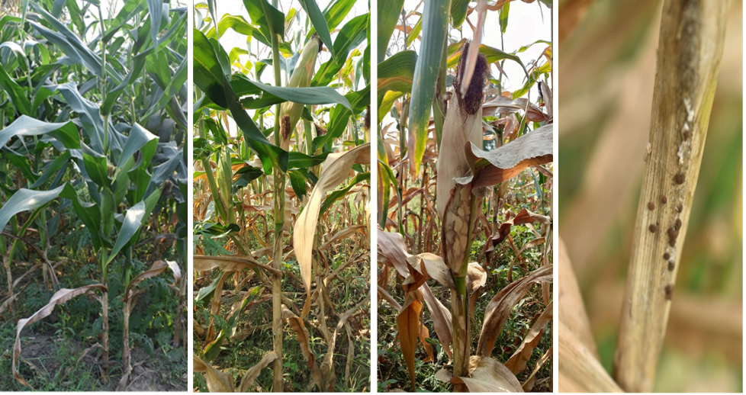
Fig. 1 Symptoms of banded leaf and sheath bight in maize
3.2 Cultural and morphological characterization
Isolated fungal culture Rs-01 was studied to examine for cultural characteristics. The nature of colony appearance on the PDA medium and the cultural characteristics were observed 5 days after incubation. The colony colour was white and the pigmentation of the colony was absent, exhibiting regular colony margins and a slightly fluffy colony texture (Fig. 2 a, b, c). The radial growth of the culture was profuse, with a diameter of 90 mm on the 3rd day after inoculation. Microscopically, R. solani f. sp. sasakii is characterized by vegetative hyphae. The hyphae typically have a diameter of 6-12 µm and exhibit branching at right angles, often with a slight constriction at the point of origin of the branch. Spores are absent, sclerotia are produced after 10-15 days of incubation (Fig. 2 d, e).
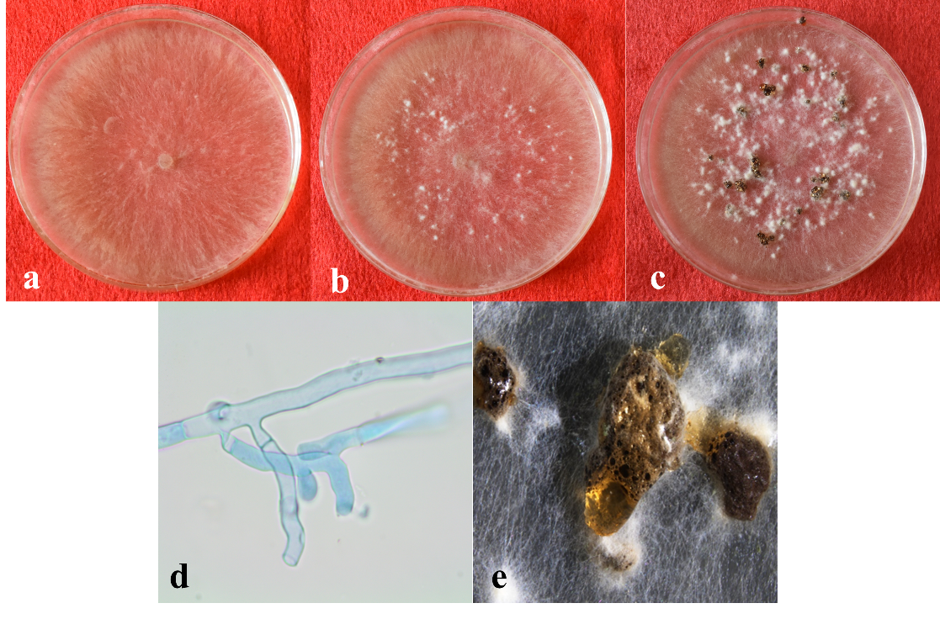
Fig. 2 Cultural and morphological characteristics of Rs-01. a) Cultural on PDA, b) initiation of sclerotia on culture plate, c) matured sclerotia, d) hyphal characteristics with right-angle branching, e) closer view of sclerotia
3.3 Pathogenicity test
The pathogenicity of the Rs-01 isolate was confirmed through Koch's postulates on one-month-old maize seedlings (cv. Kaveri 50). Seedlings were inoculated with a mass-multiplied culture of R. solani f. sp. sasakii grown on barley grains and developed characteristic banded leaf and sheath blight symptoms one week after inoculation. These symptoms resembled those observed in naturally infected field samples after 15 days (Fig. 3). The pathogen was successfully re-isolated from infected leaf tissues, and its cultural and microscopic characteristics matched those of the Rs-01 isolate, thereby fulfilling Koch’s postulates and confirming its pathogenicity. Control plants treated with sterile barley grains remained asymptomatic.
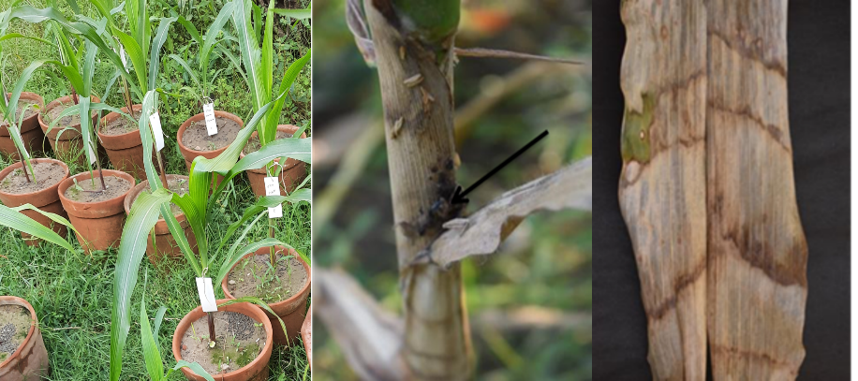
Fig.3 Pathogenicity test of Rs-01 on cv. Kaveri 50
3.4 Molecular Identification and Phylogenetic Analysis
Genomic DNA from the Rs-01 isolate was extracted using the CTAB method, and the ITS region was amplified via PCR using universal primers ITS 1 and ITS 4 (White et al., 1990). The amplified DNA fragment, approximately 600 bp in size, was sequenced, and the resulting sequence was analyzed using the NCBI BLASTn tool (www.blast.ncbi.nlm.nih.gov/Blast). Sequence comparison confirmed the identity of the isolate as Rhizoctonia solani, and the sequence was submitted to the NCBI GenBank, receiving the accession number OQ456383.
To determine the phylogenetic placement of the isolate, the ITS sequence was aligned with other R. solani sequences from the NCBI GenBank database. Athelia rolfsii was used as an outgroup for tree construction. A phylogenetic tree was generated using the Neighbor-Joining (NJ) method in MEGA version 11. Bootstrap analysis with 1,000 replicates was conducted to assess branch support. The resulting tree (Fig. 4) showed that the Rs-01 isolate clustered closely with other R. solani strains and the pathogenicity test shows that Rs-01 isolate infecting maize confirms its identity as R. solani f. sp. sasakii.
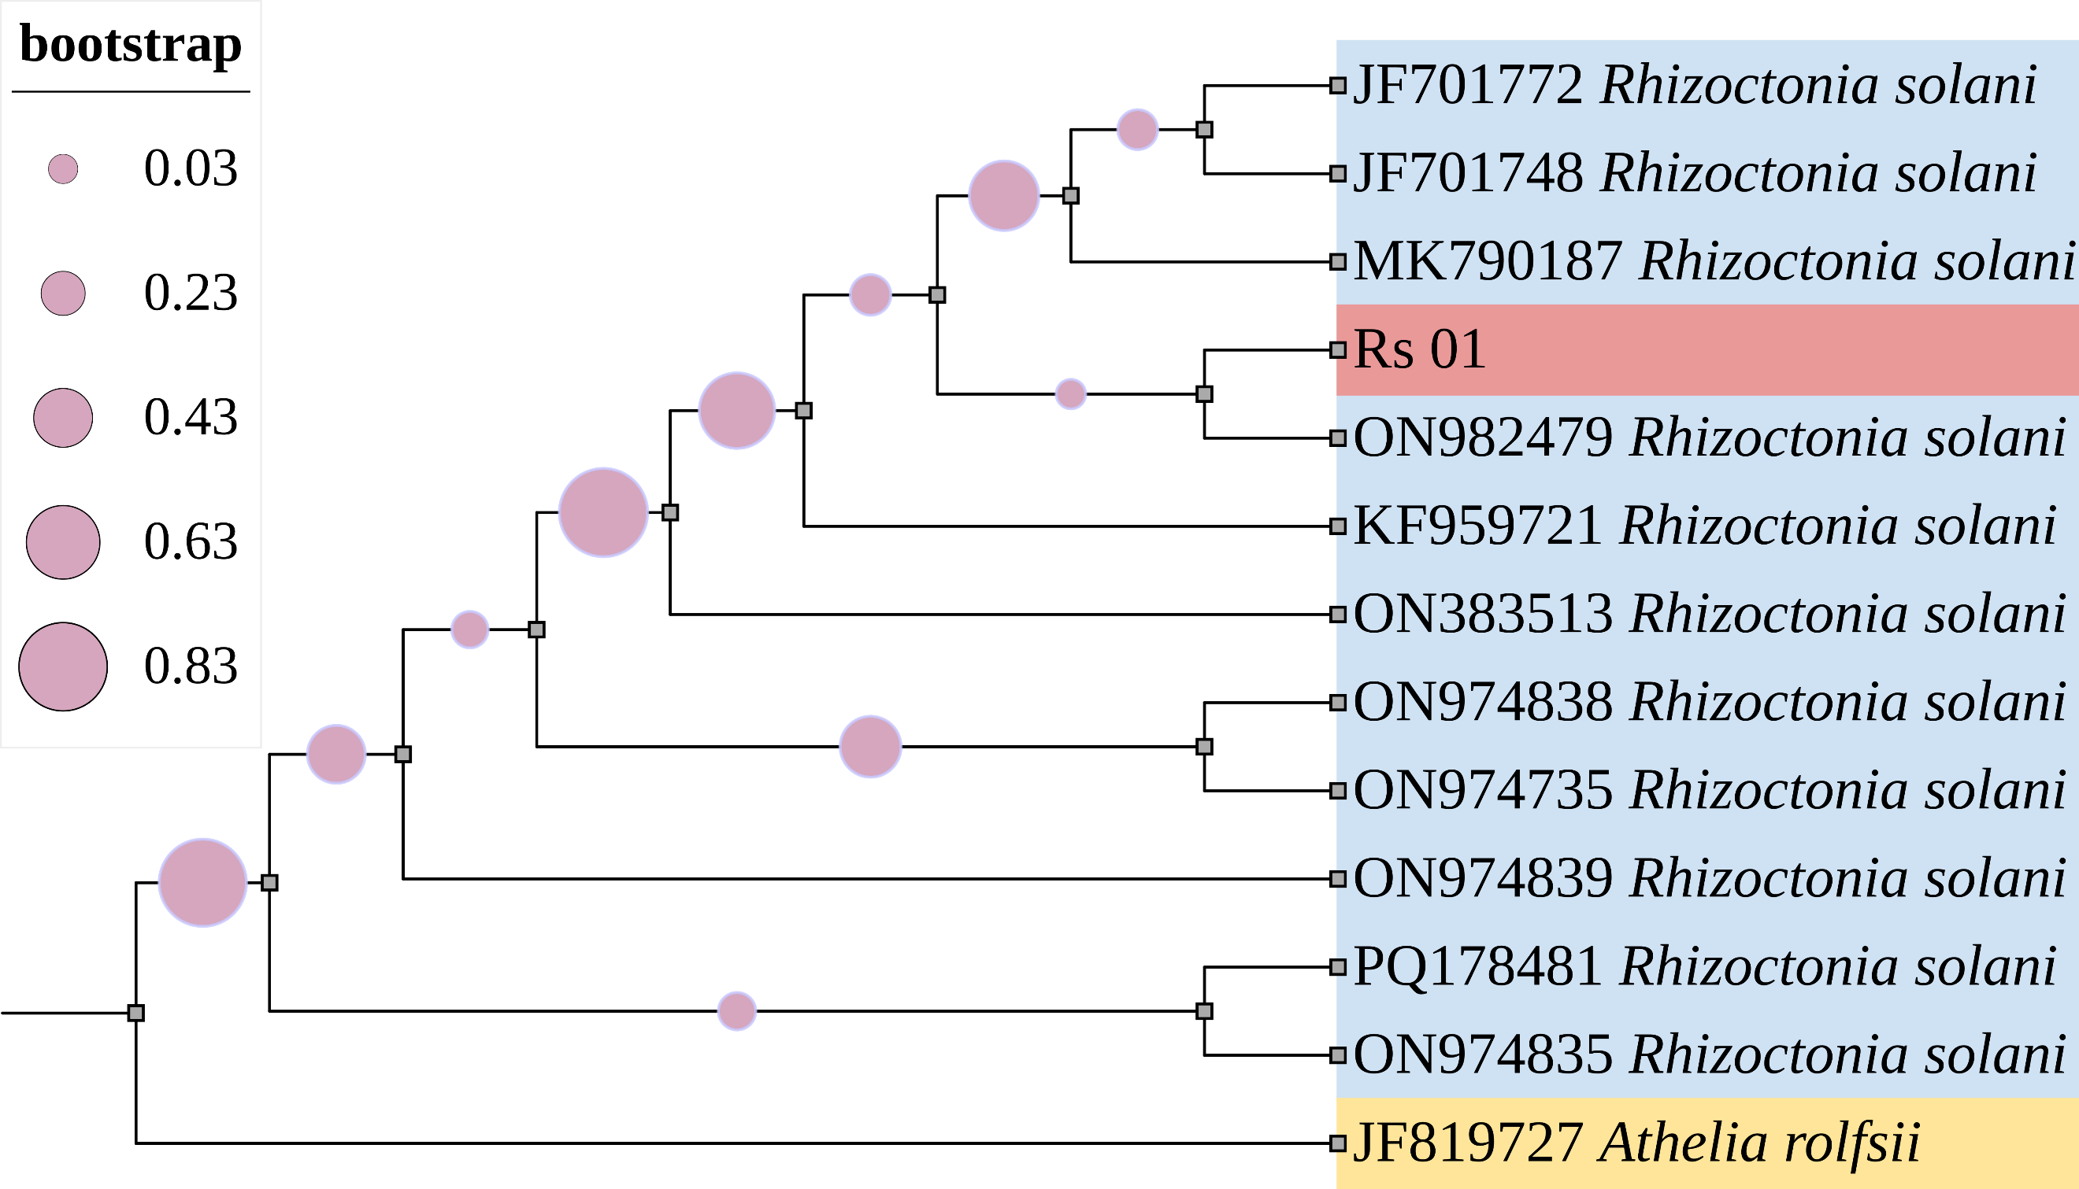
Fig 4. Phylogenetic tree was generated using the Neighbor-Joining (NJ) method in MEGA version 11 with 1,000 bootstrap replicates, Athelia rolfsi as outgroup
3.5 In vitro evaluation of biocontrol agents and essential oils against R. solani f. sp. sasakii
3.5.1 In vitro evaluation of biocontrol agents against R. solani f. sp. sasakii
A total of six biocontrol agents, previously isolated and maintained at the AICRP Maize Laboratory, Kalyani Centre, West Bengal, India, were assessed for their antagonistic potential against R. solani f. sp. sasakii using the dual culture technique. The evaluated isolates comprised T. harzianum (Th-01, Th-02, Th-03, Th-04), T. viride (Tv-01), and T. asperellum (Ta-01). The results revealed significant variations in the per cent inhibition of R. solani growth among the tested isolates (Fig. 5), among these, T. harzianum Th-02 demonstrated the highest per cent inhibition of mycelial growth (92.59%), followed by T. harzianum Th-01 and T. asperellum Ta-01 (88.89%), T. harzianum Th-03 (87.04%), T. viride Tv-01 (85.19%), and T. harzianum Th-04 (83.33%). The findings reveal differential antagonistic efficacy among the isolates, with T. harzianum Th-02 exhibiting the most pronounced inhibitory effect against R. solani f. sp. sasakii under in vitro conditions.
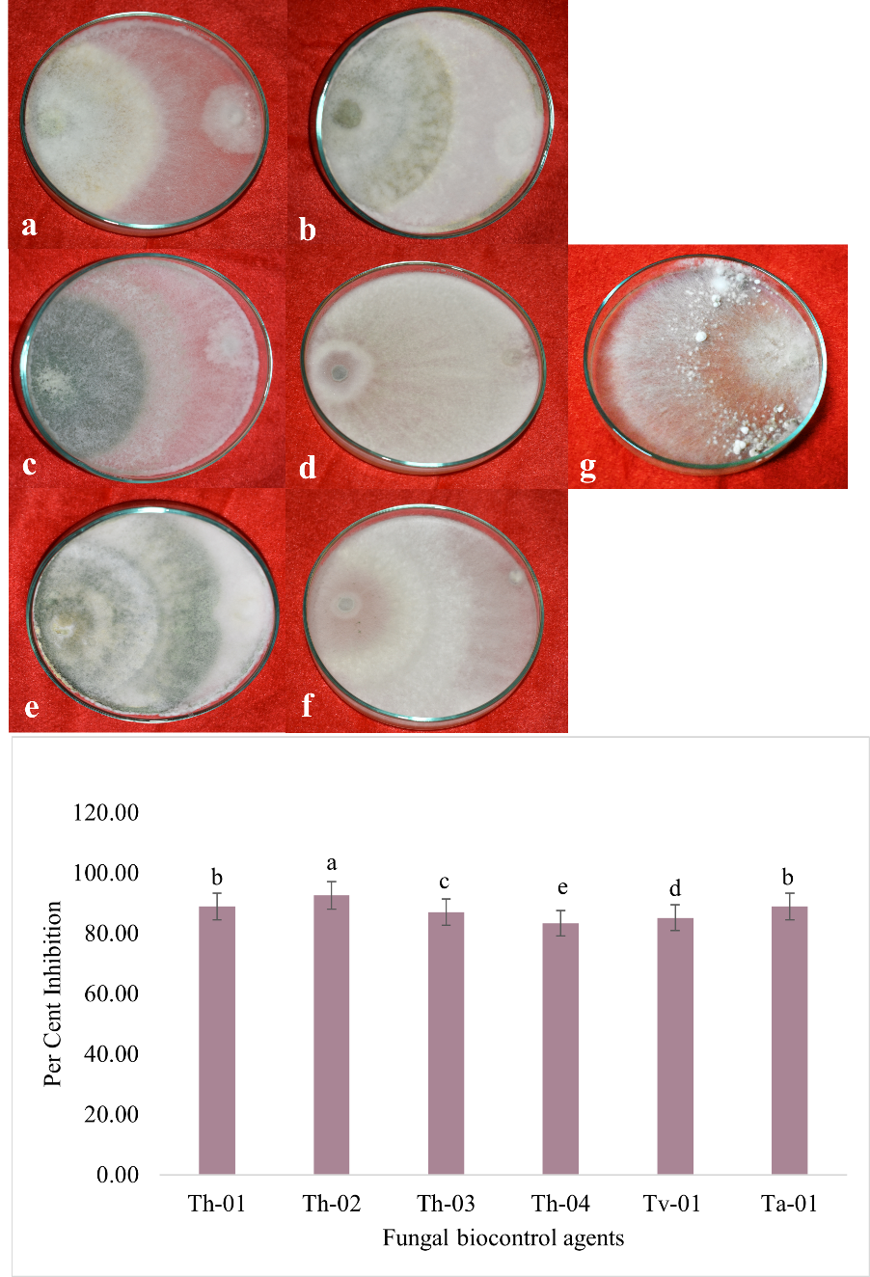
Fig. 5 In vitro evaluation of biocontrol agents against R. solani f. sp. sasakii. A. Dual culture technique with biocontrol agents: a) T. harzianum Th-01, b) T. harzianum Th-02, c) T. harzianum Th-03, d) T. harzianum Th-04, e) T. viride (Tv-01), f) T. asperellum (Ta-01) g) Control (Rs-01) B. Graphical representation of per cent inhibition of R. solani f. sp. sasakii aginst biocontrol agents
3.5.2 In vitro evaluation of essential oils against R. solani f. sp. sasakii
The antifungal activity of eight commercially available essential oils against R. solani f. sp. sasakii was evaluated under in vitro conditions using the poison food technique (Fig. 6). Among the tested oils, tea tree, garlic, lemongrass, turmeric, and tulsi exhibited complete mycelial growth inhibition, each recording 100 per cent inhibition, indicating statistically significant antifungal efficacy against R. solani f. sp. sasakii. In contrast, Neem oil showed moderate inhibition at 29.26 per cent, while aloe vera and moringa oils exhibited negligible antifungal activity, with per cent inhibitions of 0.37 and 0.74, respectively. The results demonstrate that tea tree, garlic, lemongrass, turmeric, and tulsi oils possess potent antifungal properties and may be considered as promising botanical alternatives for the management of R. solani f. sp. sasakii, whereas neem, aloe vera, and moringa oils were found to be significantly less effective under in vitro conditions.
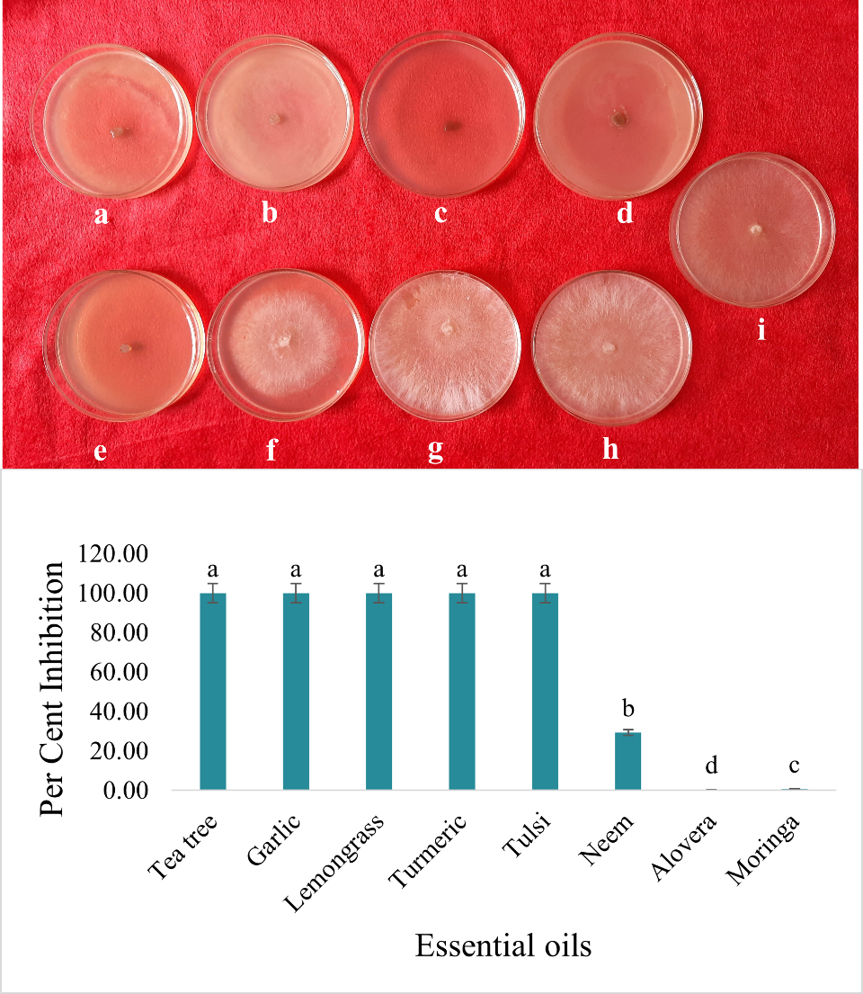
Fig. 6 In vitro evaluation of essential oils against R. solani f. sp. sasakii A. Mycelial growth on PDA with different essential oils: a) tea tree, b) garlic, c) lemongrass, d) turmeric, e) tulsi, f) Neem, g) alovera, h) moringa, i) control (Rs-01) B. Graphical representation of per cent inhibition of R. solani f. sp. sasakii with essential oils

4. DISCUSSION
The present study successfully isolated and characterized R. solani f. sp. sasakii from maize plants exhibiting typical BLSB symptoms in Kalyani, West Bengal, India. The symptoms and pathogen morphology observed were consistent with earlier reports describing BLSB disease in maize (Parveen et al. 2024). The isolated Rs-01 strain exhibited characteristic features of R. solani, such as right-angle branching hyphae with constrictions at the branch points and the eventual production of sclerotia, confirming morphological identification (Sneh et al., 1991). Pathogenicity tests validated the Koch’s postulates, as Rs-01 successfully induced typical BLSB symptoms in inoculated maize plants, corroborating previous findings that R. solani f. sp. sasakii is a primary causal agent of BLSB in maize (Hooda et al., 2017). Molecular identification using ITS sequencing further confirmed the identity of the isolate as R. solani, aligning with methods described by White et al. (1990) and supporting the use of ITS regions for accurate fungal identification (Gonzalez et al., 2001). The phylogenetic analysis placed the Rs-01 isolate within a well-supported clade of R. solani f. sp. sasakii isolates, further confirming its taxonomic position.
The evaluation of biocontrol agents revealed significant antagonistic effects of different Trichoderma spp. isolates against R. solani f. sp. sasakii, with T. harzianum Th-02 demonstrating the highest inhibition. These findings are in line with previous studies highlighting Trichoderma spp. as potent biocontrol agents against R. solani f. sp. sasakii through mechanisms such as mycoparasitism, antibiosis, and competition for nutrients and space (Harman et al., 2004). Particularly, T. harzianum has been widely recognized for producing hydrolytic enzymes like chitinases and glucanases that degrade the fungal cell wall (Benítez et al., 2004).
The assessment of essential oils provided revealed that tea tree, garlic, lemongrass, turmeric and tulsi oils completely inhibited the mycelial growth of R. solani f. sp. sasakii in vitro. These findings align with earlier reports demonstrating the antifungal efficacy of essential oils. For instance, tea tree oil has been shown to disrupt fungal cell membrane integrity (Carson et al., 2006), while garlic essential oil's high sulfur content exhibits potent antifungal properties (Ankri and Mirelman, 1999). Similarly, lemongrass oil, rich in citral, and turmeric oil, containing curcumin derivatives, have demonstrated strong antifungal activity against various plant pathogens. Tulsi (Ocimum sanctum) essential oil has also been reported to possess broad-spectrum antimicrobial activity (Prakash and Gupta, 2005). In contrast, neem oil, Aloe vera and moringa oils, however, showed minimal inhibitory effects, suggesting their limited utility against R. solani f. sp. sasakii under in vitro conditions. These results suggest that while certain botanical oils can serve as effective alternative strategies for the management of BLSB, not all natural products have uniform efficacy.
5. CONCLUSION
The present study successfully isolated and identified R. solani f. sp. sasakii as the causal agent of Banded Leaf and Sheath Blight (BLSB) in maize, confirmed through morphological, cultural, and molecular characterization. Trichoderma spp. exhibited significant antagonistic activity against the pathogen in vitro. Additionally, essential oils demonstrated strong antifungal efficacy, suggesting their potential as eco-friendly alternatives for disease management. These findings highlight the importance of integrating biocontrol agents and plant-based products into sustainable disease management strategies to reduce the reliance on chemical fungicides and promote healthier maize cultivation. Future investigations should focus on field validation of promising biocontrol agents and essential oils, along with exploring synergistic effects to develop integrated disease management strategies.
DISCLAIMER (ARTIFICIAL INTELLIGENCE)
Author(s) hereby declare that NO generative AI technologies such as Large Language Models (ChatGPT, COPILOT, etc.) and text-to-image generators have been used during the writing or editing of this manuscript.

REFERENCES
Ankri, S., & Mirelman, D. (1999). Antimicrobial properties of allicin from garlic. Microbes and Infection, 1(2), 125-129. https://doi.org/10.1016/S1286-4579(99)80003-3
Benítez, T., Rincón, A. M., Limón, M. C., & Codón, A. C. (2004). Biocontrol mechanisms of Trichoderma strains. International Microbiology, 7(4), 249-260.
Bhatt, B., & Kumar, P. (2019). Bioefficacy of fungicides, plant extracts and essential oils against Exserohilum turcicum (Pass.) Leonard and Suggs causing northern leaf blight of maize. Journal of Applied and Natural Science, 11(2), 257-262.
Carson, C. F., Hammer, K. A., & Riley, T. V. (2006). Melaleuca alternifolia (Tea Tree) Oil: a Review of Antimicrobial and Other Medicinal Properties. Clinical Microbiology Reviews, 19(1), 50-62. https://doi.org/10.1128/CMR.19.1.50-62.2006
Chandana, R., Poonacha, T. T., Chethan, D., Karan, R., Kruthika, R., Khan, F., Ashwini, K. S., Bevanur, A., Vani, Y., Ramesh, G. V., & Palanna, K. B. (2024). Neopestalotiopsis rosae, a novel pathogen causing leaf blight and crown rot of strawberries in India. Physiological and Molecular Plant Pathology, 133, 102377.
Chaudhary, S., Sagar, S., Tomar, A., Sengar, R. S., & Kumar, M. (2016). Banded leaf and sheath blight: A menacing disease of maize (Zea mays L.) and its management. Journal of Applied and Natural Science, 8(3), 1720-1730.
Gonzalez, D., Carling, D. E., Kuninaga, S., & Vilgalys, R. J. (2001). Ribosomal DNA systematics of Rhizoctonia solani and related taxa. Mycologia, 93(6), 1138-1150.
Harman, G. E., Howell, C. R., Viterbo, A., Chet, I., & Lorito, M. (2004). Trichoderma species — opportunistic, avirulent plant symbionts. Nature Reviews Microbiology, 2(1), 43-56.
Hooda, K. S., Khokhar, M. K., Parmar, H., Gogoi, R., Joshi, D., Sharma, S. S., & Yadav, O. P. (2017). Banded leaf and sheath blight of maize: historical perspectives, current status and future directions. Proceedings of the National Academy of Sciences, India Section B: Biological Sciences, 87, 1041-1052.
Koul, O., Walia, S., & Dhaliwal, G. S. (2004). Essential oils as green pesticides: potential and constraints. Biopesticides International, 1(1), 63-84.
Parveen, R., Chethan, D., Durga, Y., Biswas, M., & Debnath, S. (2024). Assessing the status of banded leaf and sheath blight disease of maize (Zea mays L.) caused by Rhizoctonia solani f. sp. sasakii in West Bengal, India. International Journal of Plant & Soil Science, 36(12), 488-495.
Prakash, P., & Gupta, N. (2005). Therapeutic uses of Ocimum sanctum Linn (tulsi) with a note on eugenol and its pharmacological actions: A short review. Indian Journal of Physiology and Pharmacology, 49(2), 125-131.
Saxena, S. C. (2002). Biointensive integrated disease management of banded leaf and sheath blight of maize. Asian Regional Maize Workshop, Bangkok, Thailand, 5-8.
Singh, A., & Shahi, J. P. (2012). Banded leaf and sheath blight: an emerging disease of maize (Zea mays L). Maydica, 57(3), 215-219.
Singh, S. K., Patel, M. B., Thakker, B. N., Hooda, K. S., & Barad, A. K. (2019). Rhizoctonia solani f. sp. Sasakii inciting banded leaf and sheath blight of maize and their management: an overview. International Journal of Current Microbiology and Applied Sciences, 8(7), 2858-2866.
Sneh, B., Burpee, L., & Ogoshi, A. (1991). Identification of Rhizoctonia species. APS Press.
Tamura, K., Stecher, G., & Kumar, S. (2021). MEGA11: Molecular evolutionary genetics analysis version 11. Molecular Biology and Evolution, 38(7), 3022-3027.
Vincent, J. M. (1947). Distortion of fungal hyphae in the presence of certain inhibitors. Nature, 159(4036), 239-241.
White, T. J., Bruns, T., Lee, S. J., & Taylor, J. (1990). Amplification and direct sequencing of fungal ribosomal RNA genes for phylogenetics. In Innis, M. A., Gelfand, D. H., Sninsky, J. J., & White, T. J. (Eds.), PCR Protocols: A Guide to Methods and Applications (pp. 315-322). Academic Press.

