Effect of Temperature on Maturation, Spawning and Pigmentation of Xiphophorus helleri (swordtail)

Abstract
This study assessed the impact of varying water temperatures on spawning, maturation, and pigmentation in Xiphophorus helleri (swordtail) over a period of sixty days. Four temperature treatments were set up at 21°C (T₀), 24°C (T₁), 27°C (T₂), and 30°C (T₃), with ten fish per tank using 25 liter aquarium. Continuous aeration and thermostatic control maintained stable conditions. The daily water exchange ensured cleanliness by removing leftover feed and excreta. Among the treatments, 27°C (T₂) showed the best reproductive performance. This temperature yielded the highest Gonadosomatic Index (GSI) for females (9.60±0.009) and males (7.83±0.008) as well as Hepatosomatic Index (HSI) values (1.47±0.008 for females). T₂ also had the best spawning rate (21.85±2.10) and fry production (30.00±0.816), along with the most advanced oocyte maturation stages (vitellogenic oocytes). In terms of skin pigmentation, carotenoid levels were also highest at 27°C (2.92±0.170), with the best survival rate observed at 95.00% for this treatment, though survival differences across treatments were statistically non-significant (p>0.05).
Keywords: Xiphophorus helleri, spawning rate, maturity stages, pigmentation, carotenoid content.
INTRODUCTION
Ornamental fish keeping is one of the most popular hobbies globally, second only to photography (Das et al., 2005). This practice dates back to 1805, with the first public aquarium opening in England in 1853. Ornamental fish farming involves cultivating visually appealing fishes in controlled environments, earning them the name "living jewels" (Pandeyet al., 2017). The hobby has also gained significant traction in India over the past 70 years (Raja, 2019). India boasts a rich biodiversity, harbouring more than 374 native freshwater ornamental fish species and roughly 700 indigenous marine decorative fish varieties.
Among these ornamental species, the swordtail (Xiphophorus helleri) stands out due to its various color patterns and ease of maintenance. The name swordtail perfectly captures its appearance due to its sword-like tail (caudal fin), especially in males. Numerous physiological and environmental factors regulate the annual reproductive cycle of fish (Bromageet al., 2001; Bye, 1984; Lam, 1983; Sumpter, 1990).Temperature plays a crucial role in the reproductive cycles of fish, influencing gonadal development, spawning, and regression (Wang et al., 2010 Pankhurst and Porter, 2003). Determining the optimal temperature for growth is critical for increasing the efficiency of varied fish production. The temperature can affect fish spawning in a number of ways. It might affect the location of ideal spawning conditions as well as the rate at which gametogenesis occurs. Since food intake and metabolic rate are related to temperature (Jobling, 1993), a drop in food consumption may limit energy expenditure in growth and reproduction indirectly (Kjesbu, 1994). Photoperiod and temperature appear to have the greatest influence on the reproductive cycle among environmental variables (Pankhurst and Porter, 2003; Taranger et al., 2010; Wang et al., 2010). Temperature is a vital environmental element since it affects other environmental variables and has a direct impact on all living species metabolism. Besides, aquaculture conditions can have a severe impact on fish's natural skin colouring (Lim et al., 2018), making commercialization difficult. Indeed, both exterior (biotic and abiotic) and internal (genetic, cellular, neurological, and hormonal) elements influence fish skin pigmentation (Pittman et al., 2013).
Carotenoids are the lipid soluble pigments exhibiting red, orange and yellow colours (determined by their polyene chain) that absorb the light in the 400–500 nm visible region of the electromagnetic spectrum (Goodwin, 1980). Carotenoids are de novo synthesized by plants, bacteria, algae and fungi. However, the animals including fish and crustaceans lack the ability to biosynthesize these compounds and therefore must obtain them through their diet (Matsuno, 2001). Carotenoids play diverse functions in different organisms including protection against reactive oxygen species, free radicals, UV radiation, act as accessory light harvesting pigments etc (Maoka, 2011; Caramujo et al., 2012). In fish, carotenoids play an important role in muscle pigmentation of food fishes, and skin colouration in ornamental fish besides being highly correlated with mating success, social dominance and antioxidant source (Bjerkeng, 2008; Maan and Sefc, 2013).

MATERIALS AND METHODS
Standardized and well aerated aquarium tank setups were used each with 25 L capacity. Brooders were distributed in 4 treatment groups with 6:4(F: M) ratio per tank following a completely randomized design (CRD). Maintaining optimal water quality parameters to minimize stress and ensure the health of the experimental subjects throughout the study.
Procurement and Acclimatization:
This study was carried over a span of sixty days. Laboratory grown fish was acclimatized under the experimental conditions for seven days prior to the commencement of the trail, during which they were fed a basal diet in granular form. The study comprised four treatment groups 21°C (T₀), 24°C (T₁), 27°C (T₂), and 30°C (T₃)) with four replicates per treatment and ten fish per replicate. A total of 160 fish, each with an average weight of 1g, were randomly selected for the trail. Throughout the study, the fish were provided with commercially available ornamental fish feed containing 32% crude protein, 10% moisture content, 4% crude fat, and 4% crude fiber.
Spawning Rate:
Spawning rate was calculated as the fraction of mature females spawning in each treatment.
Gonado-somatic Index (GSI)
For the calculation of GSI, the samples were weighed for their total body weight.This was followed by their dissection. GSI was calculated for both the sexes.Ovaries and testis were carefully removed in intact form. The weight of the fishand corresponding weight of gonad was measured to the nearest 0.001g using sensitive balance “Unibloc ATX224”. GSI was then calculated using the following formula (Desai, 1970; Biswas, 1993):
Gonado-somatic Index (GSI) = $\frac{weight of gonads (g)}{total weight of fish (g)} ×100$

Histological Analysis:
Histological studies involved fixing the gonads in 10% neutral buffer formalin, processing them through ethanol and xylene, embedding in paraffin, and staining with hematoxylin and eosin.
Total Mean Fry Production:
Fry production was recorded throughout the experimental period.
Hepato-somatic Index (HSI):
HSI was calculated using the formula;
$\frac{\text{liver weight}}{\text{body weight}}$x 100
Pigmentation Analysis:
Total carotenoid content in the fish skin was measured following Olson (1979).
Total carotenoid content (μg/g) = $\frac{Absorption at maximum wave length }{0.25 ×sample weight }$ × 10
Where, 10 = dilution factor
0.25= extinction coefficient.

Survival Percentage:
Survival rate was calculated as the percentage of fish surviving in each treatment.
Survival (%) = $\frac{Number of fishes survived }{Total number of fishes } ×100$

RESULTS
Gonado-Somatic Index (GSI) and Hepato-Somatic Index (HSI):
1. The GSI values were significantly higher in fish exposed to 24°C (T₁) and 27°C (T₂) compared to the control (21°C) and 30°C (T₃). Highest values for GSI were observed at 27°C (T₂), indicating optimal conditions for gonadal development. The HSI values followed a similar trend, with significant increases in T₁ (24°C) and T₂ (27°C) over the control, but a decline in T₃ (30°C), emphasising that while liver function improves with moderate temperature increase, excessive heat may impair hepatic function (Table 1.0)
2. Total Fry Production and Spawning Rate:
The total fry production was highest in T₂ (27°C) and significantly lower in the control and T₃ (30°C), indicating that 27°C is the most favourable temperature for reproductive output. Spawning rate also peaked at 27°C (T₂), with lower rates observed at the control, T₁ (24°C), and T₃ (30°C) suggesting that spawning frequency is optimal at 27°C, but decreases outside this temperature range (Table 2.0) .
3. Survival Rate:
Survival rate was seen to be highest at 24°C (T₁) and 27°C (T₂), with a significant decline at 30°C (T3). Fish in the control group also showed lower survival rates compared to T₁ and T₂, underlining that temperatures above 27°C or below 24°C increase mortality (Table 2.0) .
4. Carotenoid Content:
Carotenoid content in the skin of X. helleri was significantly higher in fish maintained at 24°C (T₁) and 27°C (T₂) in comparison to control and 30°C (T₃). The highest carotenoid concentration was observed in T₂ (27°C), thereby indicating enhanced pigmentation at this temperature. Hence, the data underscores that 27°C is the optimal temperature for maximizing reproductive performance, survival, and pigmentation in X.helleri, while temperatures outside this range can negatively impact these parameters (Table 3.0).

Treatments | GSI Female | GSI Male | Hepatosomatic index
T₀ | 5.21±0.129^{b} | 3.90±0.009^{b} | 1.25±0.0129^{b}
T₁ | 6.41±0.009^{c} | 5.31±0.009^{c} | 1.36±0.008^{c}
T₂ | 9.60±0.009^{d} | 7.83±0.008^{d} | 1.47±0.008^{d}
T₃ | 4.42±0.017ª | 3.22±0.17ª | 1.14±0.124ª
pvalue | p < 0.05 | P< 0.05 | P< 0.05

Table1:Mean±SE of the GSI of male and female X.helleri and HSI over the period of two months stocked at different temperatures
Treatments | Total fry production | Spawning rate | Survival
T₀ | 4.00±0.816ª | 2.07±2.39a (0.45±0.29) | 87.50±9.57ª
T₁ | 21.25±0.500^{c} | 12.50±0.00a (0.35±0.00) | 90.00±14.14ª
T₂ | 30.00±0.816^{d} | 21.85±2.10a (0.46±0.021) | 95.00±5.77ª
T₃ | 11.25±0.500^{b} | 6.22±2.39a (0.24±0.04) | 85.00±12.90a
pvalue | p < 0.05 | p > 0.05 | p > 0.05

Table 2: Mean ± SE of the Fry Production, spawning rate and survival of X. helleri over the period of two months stocked at different temperatures
Treatments | Initial Carotenoid | Final Carotenoid
T₀ | 1.90±0.009^{ab} | 1.71±0.022ª
T₁ | 1.89±0.008ª | 2.32±0.221^{b}
T₂ | 1.91±0.012^{b} | 2.92±0.170^{c}
T₃ | 1.89±0.015^{ab} | 1.68±0.032ª
P value | P< 0.05 | P< 0.05

Table 3: Mean ± SE of the Total Carotenoid Content of X. helleri over the period of two months stocked at different temperatures.
Histological Analysis: The ovarian stages in Xiphophorus helleri (swordtail) were separated into four stages (Fig.1 to Fig. 4.). Histologically Stage-II at 21℃ showed perinuclear oocytes encountered in major portion of ovary (Fig.1).The results showed Stage –III (Fig.2) at 24℃, in which Ovaries were dominated by late perinuclear oocytes (irregular in shape) and primary yolk vesicles, few secondary yolk vesicular oocytes were also present. A vitelline membrane consisting of Zona radiata and zona pellucida is evidently seen over the ooplasm (Fig. 3). Fully mature eggs with yolk globules; few pre vitellogenic oocytes begin to grow. Eccentric germinal vesicle were seen in Stage-IV at 27℃ (Fig. 3). The ovary also shows nests of oogonia and some oocytes in perinuclear stage (Stage- I at 30℃ (Fig. 4).
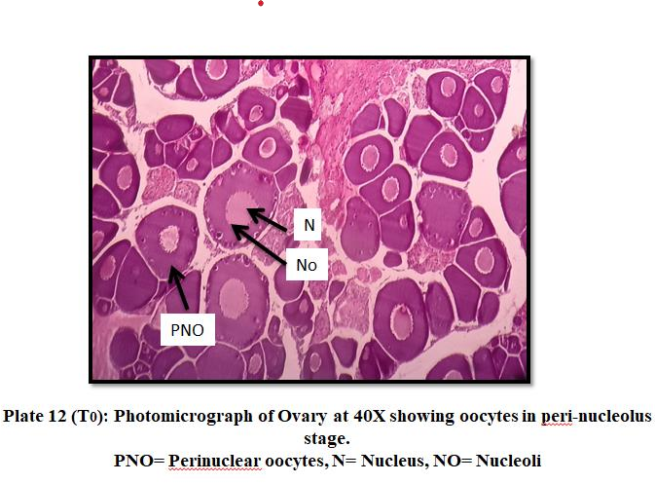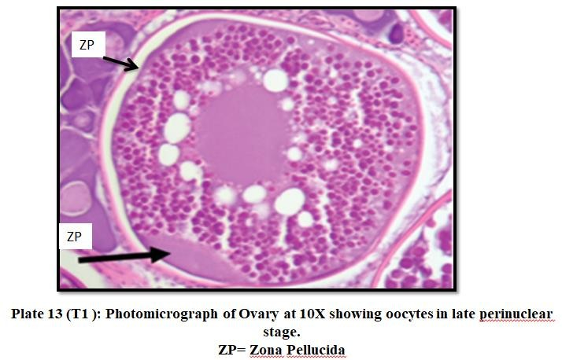
Fig.2: T1: Ovary at 10X, showing oocytes in Late Peri-nuclear stages
ZP: Zona Pellucida
Fig.1: T0: Ovary at 40X, showing oocytes in Peri-nucleolus stages
PNO: Peri-nucleolar, N: Nucleus, NO: Nucleolus

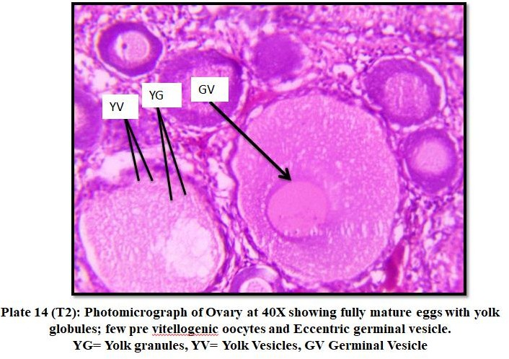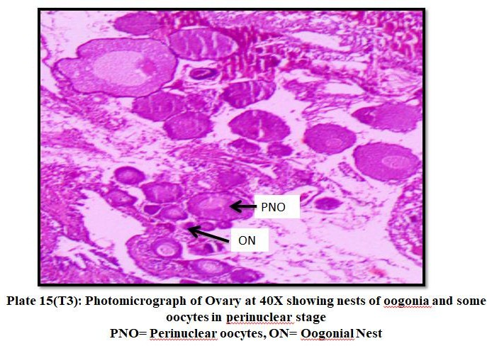
Fig. 4: T3: Ovary at 40X, showing nests of Oogonia and some oocytes in peri-nuclear stage
PNO: Peri-nucleolar, Oogonial nest=ON
Fig. 3: T2: Ovary at 40X, showing fully mature egg with yolk globules, pre vitellogenic oocytes and eccentric germinal vesicle. YG= Yolk Globules, YV= Yolk Vesicles, GV= Germinal Vesicle

DISCUSSION
The study meticulously examined the influence of temperature on the reproductive performance of Xiphophorus helleri, focusing on parameters such as the gonadosomatic index (GSI), hepatosomatic index (HSI), total fry production, spawning rate, and histological changes. The results revealed a significant temperature-dependent modulation of these factors. GSI initially increased from the control to T₂ (27°C), indicating enhanced gonadal development; however, beyond T₂, GSI exhibited a declining trend, suggesting the onset of stress-related effects at elevated temperatures, in line with the findings of Akhoundian et al. (2020) and Zhao et al. (2019).
Similarly, HSI peaked at T₁ (24°C) and T₂, reflecting an increase in liver size, potentially linked to enhanced vitellogenin production. This observation is consistent with studies by Kingdom and Allison (2011), Osoet al. (2011), and Ceket al. (2001), which report analogous trends in fish reproductive physiology. The decline in HSI at T₃ (30°C) suggested metabolic stress and reduced energy allocation towards hepatic development, corroborating earlier observations in Patagonotothen tesselata and Notopterus notopterus (Rae and Calvo, 1995; Kulkarni, 2013). Both the spawning rate and total fry production increased from the control to T₂ but decreased at T₃, indicating suboptimal reproductive conditions at extreme temperatures. These results resonate with studies on the temperature’s impact on the reproductive behaviours of species such as the silver pomfret (Pampus argenteus) and Japanese jack mackerel (Trachurus japonicus) (Dou et al., 2008).
Survival rates closely paralleled reproductive trends, with optimal levels observed at temperatures below 28°C, consistent with findings by Fonds et al. (1992), Buckel et al. (1995) and Duston et al. (2004). These results underscore the species sensitivity to thermal variations, which significantly affect stress responses and overall metabolic performance (Samaras et al., 2018).
Histological analysis revealed the evidence of active vitellogenesis up to T₂ (24°C), with maturing oocytes clearly visible (Plate 14), underscoring the critical role of temperature in gonadal maturation, as documented by Srisakultie and Wee (1988) and Chmilevskiy and Lavrova (1990, 1995). Furthermore, the study aligns with Barnabé’s (1994) findings regarding temperature’s direct impact on gonadotropin hormone (GtH) production and subsequent vitellogenesis. The observed trends of early maturation at lower temperatures (T₀) and degenerative changes at higher temperatures (T₃) highlight the dual regulatory role of temperature in reproductive potential in X. helleri, aligning with the conclusions of Jalabert and Zohar (1982), Barton (2002) and Mylonas et al. (2010).
Carotenoid concentrations in fish skin increased across all temperature treatments, reaching their highest levels at T2 (27°C), suggesting this temperature range is ideal for enhancing pigmentation in X. helleri. This observation aligns with the findings of Torrissen et al. (1989), who highlighted the role of temperature in modulating fish pigmentation, and Gouveia and Rema (2005), who reported optimal pigmentation levels between 26 and 30°C in Carassius auratus.
CONCLUSION
This study illuminates the profound impact temperature exerts on the reproductive performance, survival, and physiological attributes, including pigmentation of Xiphophorus helleri. These findings dissect the dynamics involved in the interplay between environmental factors most notably temperature and the dynamics of fish populations and aquaculture practices, emphasizing the imperative of maintaining optimal thermal conditions to ensure species health and productivity. The current study affirms that temperature is a pivotal factor in regulating spawning, maturation, and the enhancement of pigmentation in swordtails.
REFRENCES
Akhoundian, M., Salamat, N., Savari,A., Movahedinia, A. and Salari, M. A.2020. Influence of photoperiod and temperature manipulation on gonadaldevelopment and spawning in Caspian roach (Rutilusrutilus caspicus): Implications for artificial propagation. Aquaculture Research 51(4): 1623-1642.
Barnabe, G. 1994. Biological basis of fish culture .Aquaculture: Biology and ecology of cultured species. Ellis Horwood .New York, 227-372.
Biswas SP, Nasar SAK, Chatterjee K. Inter and intraspecific comparisons on some aspects of the reproductive biology of the two carps, Lebeo pangusia (Hamilton)andLabeodero(Hamilton).Arc.Biology(Bruxelles).1984; 95:11-27.
Bjerkeng, B., 2008. Carotenoids in aquaculture: fish and crustaceans, in: Britton,G., Liaaen-Jensen, S., Pfander, H. (Eds.), Carotenoids. Birkhäuser, Basel,pp. 237-254.
Bromage N, Porter M and Randall C 2001.The environmental regulation ofmaturationinfarmedfinfishwithspecialreferencetotheroleofphotoperiodandmelatonin.Aquaculture 197:63-98.
Buckel J A, Steinberg N D and Conover D O 1995. Effect of temperature, salinity and fish size on growth and consumption of juvenile bluefish. J. Fish Biol.47:696-706.
Bye, V. 1984. The role of environmental factors in the timing of reproductive cycle. InFish reproduction: Strategies and Tactics, (Potts, G. & Wootton,R.,Eds.), pp. 187-205. AcademicPress:London, UK.
Caramujo, M. J., De Carvalho, C. C., Silva, S. J., & Carman, K. R. 2012. Dietary carotenoids regulate astaxanthin content of copepods and modulate their susceptibility to UV light and copper toxicity. Marine Drugs, 10(5): 998-1018.
CekS,BromageN,RandallC,RanaK.Oogenesis, Hepatosomatic and Gonadosomatic Index, and Sex Ratio in Rosy Barb (Puntius conchonius).TurkishJ. Fish.Aquat.Sci 2001;1:33-41.
Chmilevskiy, D. A. 1995. Effect of reduced temperature on oogenesis in Tilapia, Oreochromis mossambicus.3.Impact on fish at age 30 and 60 days afterhatching.Journalof Ichthyology, 35(6):119-129.
Das,M.,Sarma,S.,&Das,A.K.2005.StatusofornamentalfishesofAssam.Fishing Chimes25(3):13-15.
Desai VR. 1970. Studies on the fishery and biology of Tor tor (Hamilton) fromriver Narmada. J Inland Fish.SOC.India.2:101-112.
Dou, S. Z., Yamada, Y., Okamura, A., Shinoda, A., Tanaka, S., & Tsukamoto, K.2008. Temperature influence on the spawning performance of artificially-matured Japanese eel, Anguilla japonica,incaptivity. Environmental biology of fishes, 82, 151-164.Sato, Y., & Godinho, H. P. 2003. Migratoryfishes of the São Francisco river. CAROLSFELD, J.; HARVEY, B.; ROSS,C,195-232.
Duston J, Astatkie T and Maclsaac P F 2004. Effect of body size on growth andfood conversion of juvenile striped bass reared at16-28°C in fresh and seawater.Aquaculture 234:589-600.
Fonds M, Cronie R, Vethaak A D and Van Der Puly P 1992.Metabolism, food consumption and growth of plaice (Pleuronectes platessa) and flounder(Platichthysflesus) inrelation to fish size and temperature. Netherlands J.SeaRes. 29:127-143.
Goodwin, T. 2012. The biochemistry of the carotenoids: volume I plants. Springer Science & Business Media.
Gouveia, L.andRema, P. 2005. Effect of microalgal biomass concentration and temperature on ornamental goldfish (Carassius auratus) skin pigmentation. Aquaculture Nutrition, 11(1): 19-23.
Jalabert, B., & Zohar, Y. 1982. Reproductive physiology in cichlid fishes, with particular reference to Tilapia and Sarotherodon.
JoblingM..RankinJ.C.,Jensen F.B..1993. Bioenergetics: feedintakeandenergy partitioning, Fish Ecophysiology, London Chapman&Hall (pg. 1-44).
Kingdom T, Allison ME.The Fecundity, Gonadosomatic and Hepatosomatic Indicies of Pellonula leonensis in The Lower Nun River, Niger Delta, Nigeria. Current Research Journal of Biologycal Sciences 2011; 3(2):175-179.
Kjesbu, O.S. 1994, Time of start of spawning in Atlantic cod (Gadus morhua) females in relation to vitellogenic oocyte diameter, temperature, fish length and condition. Journal of Fish Biology, 45:719-735.
Lim, L. C.and Wong, C. C. 1997. Use of the rotifer, Brachionus calyciflorus Pallas, in freshwater ornamental fish larviculture. Hydrobiologia, 358(1):269-273.
Maan,M.E.,&Sefc,K.M.2013,June.Colourvariationincichlidfish:developmentalmechanisms,selectivepressuresandevolutionaryconsequences. In Seminars in Cell & Developmental Biology (Vol. 24, No.6-7,pp. 516-528).Academic Press.
Matsuno, T. 2001. Carotenoids in sea urchins.Edible sea urchins: biology andecology.
OsoJA,IdowuEO,FagbuaroO,OlaniranTS,AyorindeBE.Fecundity,Condition Factor and Gonado-Somatic ~ 362 ~ International Journal ofFisheries and Aquatic Studies Index of Hepsetus Odoe ( African Pike ) in a Tropical Reservoir, Southwest Nigeria. World Journal of Fish and Marine Sci 2011;3(2):112-116.
Pankhurst, N. W. and Porter, M. J. R. 2003. Cold and dark or warm and light:variations on the theme of environmental control of reproduction. FishPhysiologyand Biochemistry28: 385–389.
Pandey, A., Kaur, V. I., Srivastava, A., Datta, S. N.and Singh, A. 2016. Effect offormulated feeds with different nutrient levels on growth and reproductive performance of molly, Poeciliasphenops (Valenciennes). Anima lNutrition and Feed Technology, 16(1): 61-70.
Pittman, K., Yúfera, M., Pavlidis, M.,Geffen, A.J., Koven, W., Ribeiro, L.,Zambonino-Infante,J.L.,Tandler,A.,2013.Fantasticallyplastic:fishlarvaeequipped for a newworld. Rev.Aquac. 5:S224-S267.
RaeGA,CalvoJ.1995. Annual Gonadal Cycle and Reproduction in Patagonotothen tessellate (Richardson1845) (Nototheniidae: Pisces)From The Beagle Channel, Argentina. Journal of Applied Ichthyology 11(12):60-70.
Raja, K., Aanand, P., Padmavathy, S., &Sampathkumar, J. S. 2019. Present and future market trends of Indian ornamental fish sector. International Journal of Fisheries and Aquatic Studies 7(2): 6-15.
Torrissen, O. J. 1986.Pigmentation of salmonids—a comparison of astaxanthin and canthaxanthinas pigment sources for rainbow trout. Aquaculture, 53(3-4):271-278.
Wang, L., Song, F., Zhu, W., Dong, J., Fu, J.and Dong, Z. 2018. Effects of temperature on body color of Malaysian red tilapia during overwintering.

