**Agro-morphological diversity of the ‘Folou’ or ‘Flado’ farmers' variety group of yams belonging to the D. alata species in Burkina Faso**

**Abstract**

The yams grown in Burkina Faso belong to the Folou or Flado farming group in the Gourounsi and Lobiri national languages, and can be found in several of the country's agrosystems. However, their agro-morphological diversity is not yet well established. The aim of this study is to determine the agro-morphological variability of yam cultivars belonging to this group. To this end, 14 quantitative traits selected from the yam descriptor were chosen to characterize the collection. The trial was conducted in a randomized Fisher block design with three replications. Work was carried out during the 2019-2020 and 2020 2021 wet seasons in the village of Onliassan in the Sissili province. The study revealed little differentiation between cultivars for all the traits studied. Only two traits showed a highly significant difference and one trait showed a significant difference. These are internode length (LE), tuber length (LTU) and number of tubers (NTU) respectively. There is therefore little agronomic variability among cultivars in this group. It is therefore necessary to develop initiatives to preserve this varietal group in view of its low diversity.

**Keywords: cultivars, folou or flado, agro-morphological diversity, Burkina Faso.**

**Introduction**

Although yam (Dioscorea sp) is grown in several provinces of Burkina Faso, its diversity is not yet well known. The first studies on yam diversity in Burkina Faso were carried out by Hamon (1988) and Zoundjihékpon (1993). According to Zoundjihékpon (1997), none of these studies has led to satisfactory results. The most recent diversity study was that of Tiama (2016) on Passoré yams.

In addition, the ethnobotanical study carried out by Sory (2019) established the geographical distribution of cultivated yams in Burkina Faso. The same study highlighted the existence of 27 yam cultivars divided into three farmers' varietal groups according to farmers' descriptions based on tuber and stem characteristics. Farmers' varieties, which form the basis of ex-situ collections, are recognized as useful gene reservoirs for breeding programs. These breeding programs need information on the spatial distribution and structuring of diversity. This involves a process of agromorphological characterization to determine actual varietal potential. A good knowledge of the forms of this traditional varietal diversity is therefore essential. The aim of this study is to determine the agromorphological variability of cultivars in the Folou or Flado varietal group, one of the farmers' groups of yams grown in Burkina Faso. To achieve this objective, we need to (i) evaluate the agro-morphological traits of this varietal group, (ii) assess the level and structure of agro-morphological variability and (iii) evaluate the effect of genotype-environment interaction on the traits studied.

1. Materials and methods

1.1. Plant material

The plant material comes from three provinces of Burkina Faso: Comoé, Noumbiel and Sissili. It comprises five cultivars from the “Folou or Flado” farming group in the Gourounsi or Lobiri national language.

1.2. Test site

The trials were conducted over two successive rainy seasons in 2019-2020 and 2020-2021. They were set up in June of each year in the village of Onliassan in the Sissili province (figure 1). This village is located in the southern zone of the province at UTM coordinates (longitude: 585305 and attitude: 1223498) with a rainfall of over 900 mm. The site's sandy-loam soil is ideal for yam cultivation. Rainfall for the 2019-2020 season was 1111mm in 69 rainy days, and for the 2020-2021 season was 986mm in 66 rainy days (figure 2).

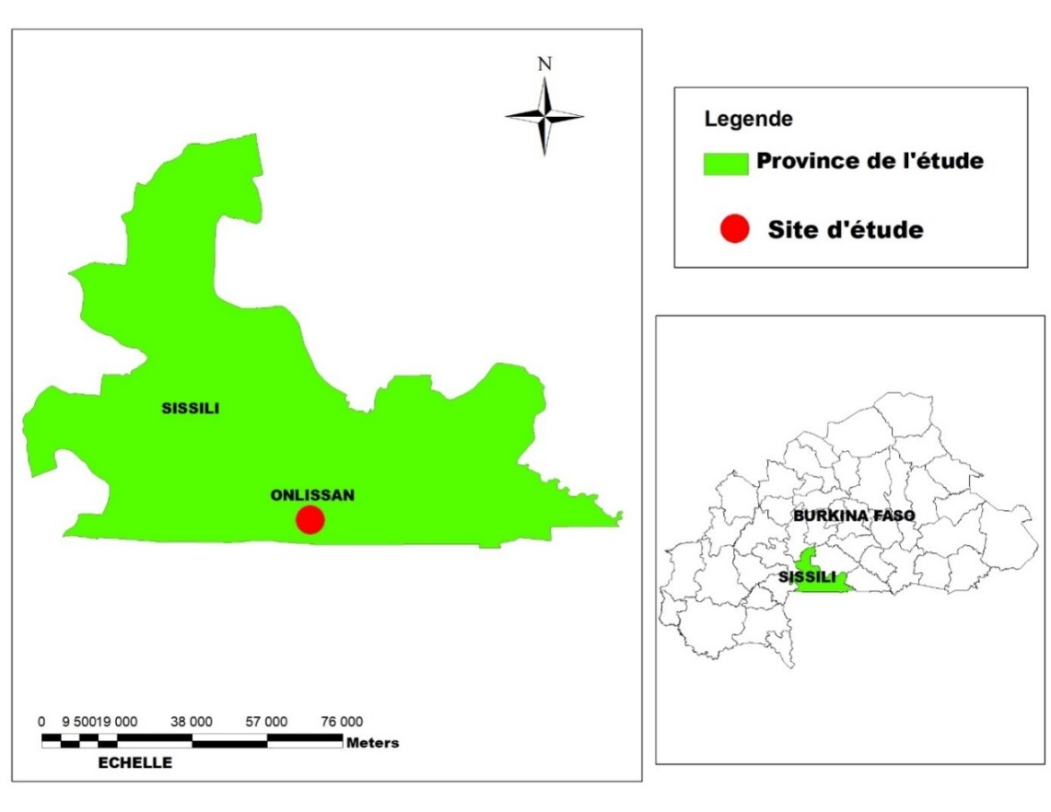

Figure 1: Geographical representation of the village of Onliassan

Figure 2: Rainfall in the village of Onliassan during the two campaigns (2019-2020 and 2020-2021).

1.3. Experimental setup

The trial was conducted in a randomized Fisher block design with three replications over two consecutive seasons. The aim was to study which traits are influenced by seasonal changes.

In fact, one cultivar was transplanted per line or elementary plot consisting of a ridge. On each elementary plot, the cultivar was represented by five distinct individuals spaced 50 cm apart. Replicates were spaced 2 m apart and ridges 0.5 m apart. Each replicate had five cultivars, including 25 individuals. A total of 75 individuals were studied for the whole trial.

1.4. Measured parameters

A total of 14 quantitative traits selected from the yam descriptor (IPGRI, 1994; 1997) were studied. The quantitative traits (Table I) were also studied in relation to the different stages of plant development.

At the juvenile stage, before the seedling rolls up on the stake, the number of days to emergence (NJL) and stem length (LTI) were recorded (14 days after emergence).

At the adult stage (60 days after emergence), leaf length (LF), blade length (LL), leaf width (LRF), number of main veins (NN), petiole length (LPE), internode length (LE) and stem diameter (DT) were recorded.

The number of tubers per foot (NTU), diameter (DTU), length (LTU) and average weight (PTU=Σ PTU /n) were recorded on tubers at harvest. Stem length, leaf length, flower and tuber length and tuber diameter variables were recorded in centimeters (cm). Tuber weight was estimated in kilograms (Kg).Tuber emergence and maturity dates were expressed in days after planting.

Table 1: Quantitative characteristics studied

|  |  |  |
| --- | --- | --- |
| Stages | Characteristics | Abbreviations |
| Juvenile (May-June) | Number of days to emergence | **NJL** |
| Stem length | **LTI (cm)** |
| Vegetative (July-August) | Stem diameter | **DTI (mm)** |
| Internode length | **LET (cm)** |
| Petiole length | **LPE (cm)** |
| Leaf blade length | **LLI (cm)** |
|  | Leaf width | **LRF (cm)** |
| Leaf length | **LOF (cm)** |
| Number of veins | **NNV** |
| Harvest (November-December) | Number of tubers | **NTU** |
| Tuber length | **LTU (cm)** |
| Tuber diameter | **DTU (mm)** |
| Average tuber weight PTU | **PTU (kg)** |

1.5. Data analysis

For all analyses, data from both seasons were used. The data collected were processed and analyzed using Excel spreadsheet software and R3.6.1, XLSTAT version 2016. Analyses of mean comparisons between cultivars were performed using R software. A two-factor analysis of variance (cultivars and seasons) was carried out for all cultivars in the collection, in order to determine which traits discriminate between cultivars, and to assess the effect of genotype-environment interaction on the quantitative traits studied. The Newman-Keuls test of comparison of means, estimated at the 5% threshold, was used to study the distribution of cultivars in the groups. Principal component analysis was performed to determine the main associations between variables and extract those most representative for cultivar grouping by hierarchical ascending classification (HAC) according to Ward's aggregation method using Euclidean distance. Finally, a discriminant factor analysis (DFA) was performed to characterize the groups derived from CAH. These analyses were performed using XLSTAT software, version 2016.

2. Results

2.1. Variation in quantitative traits studied

The results of the study of variation in quantitative traits are shown in Table II. The number of days corresponding to the emergence date since planting averaged 21.77 days after planting for the cultivars in this group. The minimum number of days for emergence was 15 days, with a standard deviation of 8.28 days. The cycle for all cultivars varied from 150 to 175 days, with an average cycle of 168 days. Internode length measured at the adult stage varied from 3 to 18 cm, with an average of 9.22 cm. Stem diameter ranged from 1.23 cm to 2.72 cm, with an average of 1.88 cm.

The number of main veins was only one modality, i.e. 7. Blade length varied from 6 to 18 cm, with an average of 8.76 cm. Width varied from 4 to 12.20 cm, with an average of 7.06 cm.

At harvest, tuber length ranged from 6.5 to 27 cm, with an average of 13.6 cm. Tuber diameter ranged from 2.53 to 9.92 cm, with an average of 5.79 cm. Average tuber weight was 0.45 kg, ranging from 0.02 to 1.55 kg.

Analysis of variance revealed very highly significant differences between cultivars for internode length (LE) alone, and highly significant differences for tuber length (LTU). It also revealed a significant difference between cultivars in this group for number of tubers (NTU).

Coefficients of variation ranged from 4.9% for cycle to 77.4% for tuber weight (PTU).

Table II: Variability of quantitative characteristics measured on cultivars of the Flado varietal group and results of analysis of variance.

|  |  |  |  |  |  |  |  |
| --- | --- | --- | --- | --- | --- | --- | --- |
| Variable | Minimum | Maximum | Moyenne | Standard deviation | F value | Pr(>F) | %cv |
| LE (cm) | 3,00 | 18,00 | 9,22 | 3,02 | 5,22 | 0,000 *** | 29,50 |
| DT (cm) | 1,23 | 2,72 | 1,88 | 0,25 | 0,05 | 1,00 ns | 14,00 |
| LPE (cm) | 2,50 | 10,00 | 5,26 | 1,66 | 1,62 | 0,18 ns | 31,10 |
| LF (cm) | 8,00 | 20,00 | 13,51 | 2,79 | 1,06 | 0,39 ns | 20,70 |
| LLI (cm) | 6,00 | 17,00 | 8,76 | 2,09 | 0,70 | 0,60 ns | 24,10 |
| LRF (cm) | 4,00 | 12,20 | 7,08 | 1,87 | 0,84 | 0,50 ns | 26,60 |
| Cycle(jours) | 150,00 | 175,00 | 168,23 | 8,28 | 1,49 | 0,21 ns | 4,90 |
| LTu (cm) | 6,50 | 27,00 | 13,60 | 4,97 | 4,82 | 0,001 ** | 33,20 |
| DTU (cm) | 2,53 | 9,92 | 5,79 | 1,75 | 1,75 | 0,15 ns | 29,60 |
| PTU (Kg) | 0,02 | 1,50 | 0,45 | 0,35 | 1,14 | 0,35 ns | 77,40 |
| NTU | 1,00 | 12,00 | 2,71 | 1,90 | 2,61 | 0,042 * | 67,00 |
| DLS (jours) | 15,00 | 40,00 | 21,77 | 8,28 | 1,49 | 0,21 ns | 37,50 |

*Legend: DLS: days to emergence (days); LE: internode length (cm); DT: stem diameter (mm); LPE: petiole length (cm); LLI: leaf blade length (cm); LRF: leaf width (cm); NTU: number of tubers; LTU: length of tuber(s); DTU: tuber diameter (mm); PTU: tuber weight;. *** : very highly significant, ** : highly significant, * : significant, ns : not significant*

2.2. Distribution of agromorphological variability

* According to geographical origin of cultivars

Table III shows the variation in quantitative characteristics of cultivars in the Flado varietal group. Analysis of variance shows that there is no significant variation in agronomic performance according to cultivar geographical origin for most traits. Only internode length showed a highly significant difference, and tuber length a significant difference between provenances. Cultivars from Noumbiel had long internodes, while those from Sissili produced the longest tubers.

Table III: Variation in quantitative characteristics of cultivars in the Flado varietal group by provenance and results of analysis of variance.

|  |  |  |  |  |
| --- | --- | --- | --- | --- |
| Characters | F | Pr > F | Geographical origin of cultivars | |
| Sissili | Noumbiel |
| LE (cm) | 7,504 | 0,008 *** | 8,278 a | 10,135 b |
| DT (cm) | 0,004 | 0,947 ns | 1,878 | 1,874 |
| LPE (cm) | 0,422 | 0,518 ns | 5,389 | 5,135 |
| LF (cm) | 0,534 | 0,467 ns | 13,750 | 13,270 |
| LL (cm) | 0,313 | 0,578 ns | 8,897 | 8,622 |
| LRF (cm) | 0,014 | 0,907 ns | 7,111 | 7,059 |
| Cycle(jours) | 0,218 | 0,642 ns | 168,694 | 167,784 |
| LTU (cm) | 6,600 | 0,012 * | 15,056 b | 12,176 a |
| DTU (cm) | 0,471 | 0,495 ns | 5,938 | 5,656 |
| PTU (Kg) | 2,728 | 0,103 ns | 0,523 | 0,388 |
| NTU | 0,105 | 0,747 ns | 2,639 | 2,784 |
| DLS (jours) | 0,218 | 0,642 ns | 21,306 | 22,216 |

*Legend : DLS : number of days to emergence (days) ; LE : internode length (cm) ; DT : stem diameter (mm) ; LPE : petiole length (cm) ; LLI : leaf blade length (cm) ; LRF : leaf width (cm) ; ; NTU : number of tubers ; LTU : length of tuber(s) ; DTU : tuber diameter (mm) ; PTU : tuber weight ;. *** : very highly significant, ** : highly significant, * : significant, ns : not significant*

* Depending on cultivar production season

Table IV shows the variation in quantitative characteristics of cultivars in the Flado varietal group by production season and the results of the analysis of variance. Analyses of variance showed that there was no significant variation in most of the quantitative traits studied between cultivars according to season.

However, for the characteristics cycle, duration of emergence after sowing and tuber diameter, there is a highly significant difference between cultivars depending on the season. It is significant for tuber length. In the first season, cultivars produced large, long tubers with a short cycle.

Table IV: Variation in quantitative characteristics of cultivars in the Flado varietal group by production season and results of analysis of variance.

|  |  |  |  |  |
| --- | --- | --- | --- | --- |
| Characters | F | Pr > F | Production campaign | |
| C1 | C2 |
| LE (cm) | 0,845 | 0,361ns | 8,889 | 9,541 |
| DT (cm) | 2,463 | 0,121ns | 1,923 | 1,830 |
| LPE (cm) | 1,078 | 0,303 ns | 5,056 | 5,459 |
| LF (cm) | 0,191 | 0,663 ns | 13,361 | 13,649 |
| LL (cm) | 0,013 | 0,909 ns | 8,786 | 8,730 |
| LRF (cm) | 2,760 | 0,101ns | 7,450 | 6,730 |
| Cycle (jours) | 162,713 | 0,000*** | 161,278 a | 175,000 b |
| LTU (cm) | 4,734 | 0,033* | 14,847 b | 12,378 a |
| DTU (cm) | 11,714 | 0,001*** | 6,457 b | 5,150 a |
| PTU (Kg) | 2,530 | 0,116 ns | 0,521 | 0,391 |
| NTU | 1,340 | 0,251ns | 2,972 | 2,459 |
| DLS (jours) | 162,713 | 0,000*** | 28,722 b | 15,000 a |

*Legend : DLS : number of days to emergence (days) ; LE : internode length (cm) ; DT : stem diameter (mm) ; LPE : petiole length (cm) ; LLI : leaf blade length (cm) ; LRF : leaf width (cm) ; ; NTU : number of tubers ; LTU : length of tuber(s) ; DTU : diameter of tuber (mm) ; PTU : weight of tuber;*** : very highly significant, ** : highly significant, * : significant, ns : not significant, C1 : campaign 1, C2 : campaign 2.*

2.3 Genotype-environment interactions

Table V shows the cultivar-environment interaction for the Flado group. A small number of parameters were influenced by seasonal variations. This analysis revealed a non-significant interaction between cultivars for all traits studied except tuber length, tuber diameter, leaf length and internode length.

Table V: Cultivar-environment interaction for the Flado varietal group

|  |  |  |  |  |  |  |
| --- | --- | --- | --- | --- | --- | --- |
|  | Genotypic effect | | Seasonal effect | | Interacting | |
| Caractères | F value | Pr(>F) | F value | Pr > F | F value | Pr(>F) |
| Cycle | 1,49 | 0,21ns | 40,725 | 0,000*** | 1,7986 | 0,140ns |
| DSL | 1,49 | 0,21ns | 40,725 | 0,000*** | 1,7986 | 0,140ns |
| DT | 0,05 | 1,00ns | 1,029 | 0,42ns | 0,6899 | 0,601ns |
| DTU | 1,75 | 0,15ns | 3,073 | 0,007** | 5,7546 | 0,000*** |
| LE | 5,22 | 0,000 *** | 3,257 | 0,005** | 2,0138 | 0,103ns |
| LF | 1,06 | 0,39ns | 1,705 | 0,12ns | 2,6081 | 0,043 * |
| LL | 0,70 | 0,60ns | 0,971 | 0,46ns | 1,0734 | 0,377ns |
| LPE | 1,62 | 0,18ns | 2,263 | 0,039* | 4,3923 | 0,003 ** |
| LRF | 0,84 | 0,50ns | 1,103 | 0,37ns | 2,2067 | 0,078ns |
| LTU | 4,82 | 0,001 *** | 4,317 | 0,000*** | 3,9002 | 0,006** |
| NTU | 2,61 | 0,0428 * | 2,405 | 0,029* | 1,1218 | 0,354ns |
| PTU | 1,14 | 0,35ns | 2,395 | 0,030* | 2,3096 | 0,067ns |

*Legend: DLS: number of days from emergence (days); LE: internode length (cm); DT: stem diameter (mm); LPE: petiole length (cm); LLI: leaf blade length (cm); LRF: leaf width (cm); NTU: number of tubers; LTU: length of tuber(s); DTU: tuber diameter (mm); PTU: tuber weight;. *** : very highly significant, ** : highly significant, * : significant, ns : not significant.*

2.4. Relationships between the quantitative characteristics studied

Table VI shows the correlations between the quantitative traits of the Flado varietal group. The correlation matrix estimated at the 5% threshold showed positive and significant values (≥ 0.60) between 14 pairs of characteristics, and negative and significant values between 13 pairs of variables. The strong positive correlations that were obtained between several pairs (Cycle; LTU; r = 0.81) (LF; LPE; r = 0.89), (LF; PTU; r = 0.83) and (DTU; LRF; r = 0.88), show that all cultivars with a long cycle have the largest tubers and leaves.

The correlation between the pairs LF; PTU (r= 0.83) and LF; LPE (r= 0.83) shows that cultivars with long leaves also have large tubers. The negative correlation between leaf length and number of tubers shows that cultivars with long leaves have few tubers.

Table VI: Correlations between quantitative characteristics of the Flado group

|  |  |  |  |  |  |  |  |  |  |  |  |  |
| --- | --- | --- | --- | --- | --- | --- | --- | --- | --- | --- | --- | --- |
| Variables | Cycle | DLS | DT | DTU | LE | LF | LL | LPE | LRF | LTU | NTU | PTU |
| Cycle | **1** |  |  |  |  |  |  |  |  |  |  |  |
| DLS | **-1,000** | **1** |  |  |  |  |  |  |  |  |  |  |
| DT | 0,050 | -0,050 | **1** |  |  |  |  |  |  |  |  |  |
| DTU | -0,786 | 0,786 | 0,249 | **1** |  |  |  |  |  |  |  |  |
| LE | -0,460 | 0,460 | -0,570 | -0,162 | **1** |  |  |  |  |  |  |  |
| LF | -0,142 | 0,142 | -0,746 | 0,225 | 0,015 | **1** |  |  |  |  |  |  |
| LL | -0,825 | 0,825 | -0,439 | 0,638 | 0,398 | 0,622 | **1** |  |  |  |  |  |
| LPE | 0,285 | -0,285 | -0,727 | -0,113 | -0,145 | **0,895** | 0,213 | **1** |  |  |  |  |
| LRF | -0,745 | 0,745 | -0,200 | **0,885** | 0,034 | 0,573 | 0,757 | 0,274 | **1** |  |  |  |
| LTU | 0,815 | -0,815 | -0,321 | -0,586 | -0,442 | 0,420 | -0,350 | 0,712 | -0,407 | **1** |  |  |
| NTU | 0,430 | -0,430 | 0,843 | -0,290 | -0,388 | **-0,914** | **-0,797** | -0,710 | -0,658 | -0,095 | **1** |  |
| PTU | -0,231 | 0,231 | -0,313 | 0,468 | -0,312 | 0,835 | 0,662 | 0,633 | 0,577 | 0,335 | -0,670 | **1** |

*Legend : DLS : number of days from emergence (days) ; LE : internode length (cm) ; DT : stem diameter (mm) ; LPE : petiole length (cm) ; LLI : leaf blade length (cm) ; LRF : leaf width (cm) ; ; NTU : number of tubers ; LTU : length of tuber(s) ; DTU : tuber diameter (mm) ; PTU : tuber weight ;. *** : very significant*

2.5. Structuring the agromorphological variability of cultivars

Table VII shows the matrix of eigenvalues and correlations between traits and principal axes after PCA for cultivars in the Flado varietal group. Figure 3 shows the association of quantitative traits on the axes (1x2) of the PCA

The projection of quantitative traits in the plane defined by axes 1 and 2 of the PCA (81.15% of total diversity) shows the most represented and discriminating variables within this varietal group. Axis 1, which explains 47.81% of the variability, is positively correlated with leaf length (LF), blade length (LL), duration of emergence after sowing (DLS), leaf width (LRF) and tuber weight (PTU). It is negatively correlated with cycle and number of tubers (NTU). It is the axis of earliness and size of vegetative organs. Axis 2, on the other hand, which accounts for 33.27% of total inertia, is positively correlated with petiole length and tuber length, and negatively with tuber diameter. This axis defines plants with long tubers and thin stems.

Figure3: Association of quantitative variables on the axes

Table VII: Eigenvalue matrix and correlations between variables and principal axes after PCA on Flado cultivar morphotypes.

|  |  |  |  |  |
| --- | --- | --- | --- | --- |
| Variables | F1 | F2 | F3 | F4 |
| Cycle | **-0,794** | 0,600 | -0,075 | -0,061 |
| DLS | **0,794** | -0,600 | 0,075 | 0,061 |
| DT | -0,486 | **-0,627** | -0,602 | 0,085 |
| DTU | **0,706** | -0,455 | -0,528 | -0,125 |
| LE | 0,323 | -0,220 | **0,920** | 0,034 |
| LF | **0,714** | 0,697 | -0,067 | -0,023 |
| LL | **0,957** | -0,072 | 0,069 | 0,272 |
| LPE | 0,352 | **0,913** | -0,055 | -0,200 |
| LRF | 0,892 | -0,131 | -0,296 | -0,315 |
| LTU | -0,324 | **0,925** | -0,151 | 0,133 |
| NTU | -**0,863** | -0,449 | -0,228 | 0,046 |
| PTU | **0,671** | 0,475 | -0,473 | 0,316 |
| Valeur propre | 5,745 | 3,992 | 1,898 | 0,365 |
| Variabilité (%) | 47,875 | 33,270 | 15,814 | 3,040 |
| % cumulé | 47,875 | 81,146 | 96,960 | 100,000 |

*Legend: DLS: number of days from emergence (days); LE: internode length (cm); DT: stem diameter (mm); LPE: petiole length (cm); LLI: leaf blade length (cm); LRF: leaf width (cm); NTU: number of tubers; LTU: length of tuber(s); DTU: tuber diameter (mm); PTU: tuber weight;*

Hierarchical ascending classification (figure 4) revealed a division of the five cultivars into three groups at a truncation level of 13%. Group I comprises three cultivars, two from Noumbiel province (Ala3 and Ala4_1) and one from Sissili province (Ala1). This group is characterized by cultivars with short internodes, short emergence time, medium leaves and medium tubers. Group II consists solely of a cultivar from the Sissili province (Ala2). This cultivar is characterized by long tubers and petioles. Group III is also made up of a cultivar from the Sissili province, characterized by the round shape of the tubers, i.e. short tubers, long internodes and long emergence times.

Characterization of the three CAH groups by discriminant factor analysis showed that traits related to tuber length (LTU), petiole length (LPE), cycle, leaf blade length (LL), post-sowing emergence time (DLS), tuber diameter (DTU), leaf length and width, number of tubers ( ) and average tuber weight (PTU) discriminate between cultivars in this varietal group.

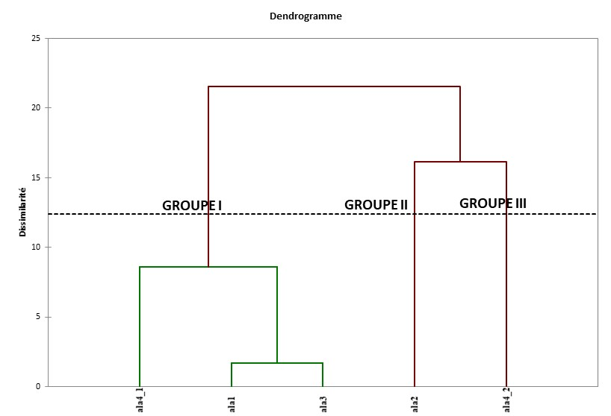

Figure 4: Dendrogram derived from the hierarchical ascending classification of the five Flado or folou cultivars.

List 1 : List of parameters for different groups

|  |  |  |  |  |
| --- | --- | --- | --- | --- |
| Parameters | Group 3 | Group 2 | Group 1 | Pr > F |
| Cycle | 158,750 a | 169,056 b | 168,856 b | 0,000 |
| DLS | 31,250 b | 20,944 a | 21,144 a | 0,000 |
| DT | 1,874 a | 1,862 a | 1,881 a | 0,225 |
| Dtu | 7,181 b | 5,991 ab | 5,668 a | 0,017 |
| LE | 10,750 a | 8,389 a | 9,286 a | 0,291 |
| LF | 13,750 b | 14,611 c | 13,100 a | 0,000 |
| LL | 9,750 b | 9,167 b | 8,468 a | 0,003 |
| Lpe | 5,000 a | 6,056 b | 5,036 a | 0,002 |
| LRF | 8,050 b | 7,500 ab | 6,931 a | 0,004 |
| Ltu | 8,000 a | 17,139 c | 12,668 b | 0,000 |
| Ntu | 2,000 a | 1,778 a | 3,103 b | 0,011 |
| PTu | 0,500 b | 0,593 b | 0,393 a | 0,002 |

*Legend: DLS: number of days from emergence (days); LE: internode length (cm); DT: stem diameter (mm); LPE: petiole length (cm); LLI: leaf blade length (cm); LRF: leaf width (cm); NTU: number of tubers; LTU: length of tuber(s); DTU: tuber diameter (mm); PTU: tuber weight;*

3. Discussion

Analysis of variance revealed little differentiation between cultivars for all the traits studied. Only two traits showed a highly significant difference and one significant difference. These are internode length (LE), tuber length (LTU) and number of tubers (NTU) respectively. There is therefore little agronomic variability among cultivars in this group. Existing agromorphological variability in this varietal group is therefore linked to morphological rather than agronomic traits. This may once again explain why growers have chosen to group them into a varietal group (Sory, 2019).

The performances of the cultivars in this varietal group, notably tuber dimensions such as tuber length (13 ,60 cm), tuber diameter (5.79cm); tuber number (2.71) and tuber weight (0.45 kg) are superior to those obtained by Tiama (2016) on Waogo in the Passoré. However, they are lower than those obtained by Adoukounou et al. (2014) on yams from Benin and by Ettien et al., (2009); Kouakou et al., (2012); Doumbia et al., 2014 on variety C8 and other yams of the same species in Côte d'Ivoire.

Means separation tests show that there is no significant variation in agronomic performance according to cultivar geographical origin for most traits. Less than 10% of the observed variability is attributable to the cultivar “provenance” factor. This could indicate that growers in Sissili and Noumbiel use the same planting material. It could also be explained by the species' reproductive system. In general, for vegetatively propagated plants, growers share clones.

Depending on the season, traits such as cycle, duration of emergence after sowing, tuber length and tuber diameter showed a significant difference. In the first season, the cultivars produced the longest and largest tubers during a short cycle. According to some authors, the yam development cycle is variable depending on the species and depends above all on climatic conditions (Cornet, 2015; Adifon et al., 2019). Tuber filling and ripening phases are variable, lasting between 80 and 150 days after the appearance of a fixed number of nodes on the stem. However, tuber yield is strongly influenced by environmental humidity, photoperiod and the number of leaves produced during the vegetative growth phase (Cornet, 2005).

Interaction analysis between the two factors (cultivars x seasons) reveals a non-significant interaction between cultivars for all traits studied, with the exception of tuber length, tuber diameter and internode length. This could indicate that these parameters are influenced by the environment.

The strong positive correlations obtained between cycle, tuber length, leaf length, leaf width and tuber diameter show that cultivars with a long cycle have the longest tubers and those with the largest tubers have the largest leaves. The negative correlation between leaf length and number of tubers shows that cultivars with long leaves have few tubers. The larger the leaves, the greater the photosynthesis capacity of the plant, since it has more leaf surface. This will encourage the production of more reserves in the form of tubers.

Knowledge of the relationships between traits is essential in defining breeding objectives. The strong positive correlations between traits, notably between tuber diameter, tuber weight, leaf length and internode length, are particularly important for the genetic improvement of yams. Indeed, given that it is the tubers that are consumed, the selection of high-yielding tuber varieties could be made by taking one of these traits into account. Variability is essential for varietal improvement. The variability observed in this study therefore offers opportunities for the selection of genotypes with high yield potential and/or organoleptic characteristics corresponding to people's needs.

**Conclusion**

The study assessed the agromorphological variability of cultivars in the Folou or Flado varietal group belonging to the D. alata species. It was found that there is little agronomic diversity within this group. In order to broaden the genetic base of this species in Burkina Faso, a hybridization study should therefore be initiated.

Analysis of the interaction between the two factors (cultivars x seasons) reveals a significant interaction between cultivars for very few of the traits studied. These were tuber length, tuber diameter and internode length. This suggests that the environment influences tuber production in cultivars of this varietal group.

**Références**

Adifon F. H., Yabi I., Vissoh P., Balogoun I., Dossou J., and Saïdou A., 2019. Ecology, cropping systems, and food uses of yams in tropical Africa: a bibliographic synthesis. Cah. Agri. Vol. 28, 11p.

Adoukonou-Sagbadja H., Missihoun A. A., Sedah P., Dagba R. A., Kinhoegbe G., Ahanhanzo C., and Agbangla C., 2014. Genetic variability of Dioscorea alata L. yam accessions introduced into Benin from the South Pacific Islands. Journal of Applied Biosciences 73:5966–5978.

Cornet D., 2015. Influence of early growth stages on plot yield variability of two yam species (Dioscorea spp.) cultivated in West Africa. PhD thesis, Institute of Life Sciences and Industries and the Environment (AgroParisTech), 174p.

Doumbia S., Koko L., and Aman A., 2014. Introduction and dissemination of the C18 yam variety in the central region of Côte d'Ivoire. Journal of Applied Biosciences 80:7121–7130.

Dumont R., Dansi A., Vernier P., and Zoundjihekpon J., 2005. Biodiversity and domestication of yams in West Africa. Traditional practices leading to Dioscorea rotundata. Reference collection. Montpellier: CIRAD. France.

Ettien d. J. B., koné b., kouadio k. K., kouadio n., yao k. A., giardin o., 2009. Mineral fertilization of ferralsols for yam production in the savannah zone.

Hamon P., 1988. Structure, genetic origin of cultivated yams of the Dioscorea cayenensis-rotundata complex and domestication of yams in West Africa. Works and documents, micropublished, IS8H 2-7099-0923-5, ORSTOM Documentary Fund.

Kouakou A.M., Zohouri G.P., Dibi K.E., N’Zué B., Fouabi., 2012. Emergence of a new yam variety of the species Dioscorea alata L., C18 in Côte D’Ivoire. Journal of Applied Biosciences 57: 4151-4158.

Sory S., 2019. Distribution, management and diversity of cultivated yams (Dioscorea sp) in Burkina Faso; Master of Research in Biosciences, option: Genetics, Joseph KI-ZERBO University, Burkina Faso, 83 pages.

Tiama D., 2016. Genetic diversity of Dioscorea sp yams from Burkina Faso: Yùyà du Passoré. Doctoral thesis, Ouagadougou University I Pr Joseph KI-Zerbo, UFR/SVT, Burkina Faso. 171 p.

Tiama D., Zoundjihekpon J., Sawadogo N., Nebie B., Bationo-Kando P., Sawadogo M., Zongo J.-D., 2016. Agro-morphological characterization of yams (Dioscorea sp) of Passoré in Burkina Faso. J. Appl. Environ. Biol. Sci., 6:1-1.

Zoundjihekpon J., 1993. Reproductive biology and genetics of cultivated yams of West Africa, Dioscorea cayenensis-rotundata. Doctoral thesis, National University of Côte d'Ivoire, 306 p.