**Morphological characterization of *Annona* (*Annona* spp.) genotypes**

**Abstract**

India is endowed with diverse agro-climatic conditions, allowing the cultivation of a wide range of tropical, subtropical and temperate fruit crops. The growing global demand for fruits has brought *Annona* species, once considered underutilized, into the spotlight. This surge in popularity can be attributed to their distinctive flavours, nutritional benefits and potential health-promoting properties. The present study, entitled "Morphological characterization of *Annona* (*Annona* spp.) genotypes" was conducted during 2022–2024 at the College of Horticulture, Bengaluru, University of Horticultural Sciences, Bagalkot. This study aimed to evaluate 11 *Annona* genotypes, selected through morphological and assessments. Fruit length, breadth, volume and average fruit weight of ranged from 6.76 to 23.00 cm, 6.50 to 13.31 cm, 110 to 783.33 ml and 119.70 to 1708.30 g with mean values of 9.77 cm, 8.26 cm, 311.51 ml and 371.35 g respectively. Pulp weight and pulp per cent ranged from 25.80 to 998.23 g and 19.22 to 88.49 per cent with mean values of 198.24 g and 46.65 per cent respectively. Traits such as total number of seeds per fruit, seed weight, seed per cent, pulp to seed ratio, thickness of rind, the number of fruits per tree, fruit yield (kg/plant) and shelf life showed highly significant differences. Several morphological traits exhibited significant positive correlations. A slightly higher phenotypic coefficient of variation was found for all the characters compared to the corresponding genotypic coefficient of variation. Hierarchical cluster analysis divided the populations into five distinct clusters. The significant variations in plant traits among the genotypes offer great chances to select the best ones for genetic improvement programmes.

**Keywords:** diversity; morphological characteristics; *Annona*.

**Introduction**

India's diverse agro-climatic conditions support the cultivation of various tropical, subtropical, and temperate fruit crops, which are vital to the agricultural economy. Fruit cultivation provides significant financial returns to farmers and boosts export revenues. Research and technological advancements have led to increased productivity, expanding both cultivated areas and overall fruit production.(Anuragi *et al*., 2016). The growing global demand for fruits has highlighted previously underutilized species like those in the Annona genus, due to their unique flavors, high nutritional value, and potential health benefits.

The genus *Annona* belongs to the family Annonaceae, one of the largest families of fruit-bearing trees and shrubs in tropical and subtropical regions, comprising over 135 genera and approximately 2,500 species (Escribano *et al*., 2007). This family is widely distributed across Asia, Africa and the Americas (Nakasone and Paul, 1998) with approximately 900 species occurring in the Neotropics (Chatrou *et al*., 2004). In India, custard apple (*Annona squamosa*) is cultivated over an area of 52.40 thousand hectares, with an annual production of 458 thousand metric tons (Anon., 2022–23). The major *Annona*-producing states in India include Maharashtra, Madhya Pradesh, Chhattisgarh, Gujarat, Andhra Pradesh, Odisha, Telangana and Karnataka.

The genus *Annona* was first documented in botanical literature during the sixteenth century, when several species with distinct morphological characteristics were identified. The name *Annona* is derived from the Latin term meaning "annual harvest" (Bapat *et al*., 2020). Several *Annona* species, including *A. cherimola* (cherimoya), *A. muricata* (soursop), *A. squamosa* (sugar apple), *A. reticulata* (bullock’s heart), *A. glabra* (pond apple) and the hybrid *A. cherimola* × *A. squamosa* (atemoya), are globally significant. While most *Annona* species likely originated in South America and the Antilles, *A. muricata* is believed to have originated in Africa. These species are now widely distributed, with soursop and sugar apple being the most cultivated in tropical regions. India is a secondary center of origin for *A. squamosa* (Anuragi *et al*., 2016). The chromosome number in *Annona* species varies, with most species having a diploid chromosome count of 2n = 2x = 14 or 16 (Nakasone and Paul, 1998; Folorunso and Modupe, 2007). However, *A. glabra* L. is an exception, as it is a tetraploid species with a chromosome count of 2n = 4x = 28 (De and Datta, 1990).

Ripe custard apple fruits are prized for their sweet, soft white flesh and are consumed fresh or used in juices, ice creams, and soft drinks. *Annona* plants contain medicinal alkaloids, with leaves used to treat sores, swelling, and anal prolapse, and roots used for dysentery, depression and spinal disorders. Extracts from the bark, leaves, and seeds exhibit anti-tumor activity (Roduan *et al*., 2019). The fruit contains 1-B, 17-dihydroxykauran-19-oic acid, which has shown anti-HIV activity (Wu *et al*., 1996). Compounds such as Annotemoyin-1, Annotemoyin-2, squamocin, and cholesteryl glucopyranoside were isolated from *A. squamosa* seeds. These compounds display strong antimicrobial and cytotoxic properties. *Annona* seeds, particularly from *A. muricata*, contain significant seed oil (Anuragi *et al*., 2016), suitable for industrial use. The fatty acid composition includes stearic acid (9.30%), oleic acid (37%), linoleic acid (10.90%) and isoricinoleic acid (9.80%) (Leal, 1990). The leaves, roots, bark, fruits, and seeds are rich in medicinal compounds. *Annona* plants are hardy, deciduous, and highly adaptable. They require minimal inputs and are resistant to major pests and diseases, making them ideal for sustainable cultivation (Pinto *et al*., 2005).

The genetic resources and diversity of outcrossing tropical tree species, including those of the *Annona* genus, are increasingly threatened by agricultural modernization and land-use changes. As a result, the genetic diversity of edible *Annona* species is primarily conserved *in situ*, either on farms, in orchards, or within natural populations (Anuragi *et al*., 2016). Historically, morphological traits have been valuable tools for assessing the genetic potential of germplasm. This approach has played a crucial role in developing high-yielding genotypes with improved fruit quality (Folorunso and Modupe, 2007). However, traditional morphological markers are highly influenced by environmental factors such as soil and climatic conditions, making them less reliable for consistent and accurate characterization (Kumar *et al*., 2014). To overcome these limitations, molecular markers provide a more precise and dependable method for analyzing genetic diversity. A comprehensive understanding of genetic variability in seedling progenies and the genetic superiority of hybrids is essential for crop improvement. This knowledge facilitates the development of improved genotypes with desirable agronomic traits.

**Materials and methods**

**Experimental material**

The experiment was conducted at Bioversity International, College of Horticulture, Bengaluru at Bioversity fruit block. A set of seven *Annona* spp. and five varieties were used in this experiment (Table 1). The plants have been planted at a spacing of 6m x 6m at Bioversity International, College of Horticulture, Bengaluru.

**Table 1. List of *Annona* spp.and varieties used in the study**

|  |  |
| --- | --- |
| **Sl. No.** | **Species/Varieties** |
| 1 | *Annona squamosa* L. |
| 2 | *Annona reticulata* L. |
| 3 | *Annona cherimola* M. |
| 4 | *Annona atemoya* L. |
| 5 | *Annona muricata* L. |
| 6 | *Annona glabra* L. |
| 7 | *Annona mucosa* L. |
| 8 | Balanagar |
| 9 | Arka Sahan |
| 10 | Red Sitaphal |
| 11 | Pink Mammoth |

|  |  |  |
| --- | --- | --- |
| Crop | : | Annona (*Annona* spp.) |
| Location | : | COH, Bengaluru |
| Number of genotypes | : | 11 |
| Experimental Design | : | RCBD |
| Spacing | : | 6 m x 6 m |
| Age of the plant | : | 10 years |

**Morphological characterization**

In this study, the morphological characteristics of three fruits from each *Annona* genotype were analysed and observations were recorded for 17 quantitative traits of fruit following the guidelines of the International Plant Genetic Resources Institute (IPGRI, 1999) for testing citrus plants for distinctiveness, uniformity and stability. Measurements of the fruit’s physical characteristics were conducted according to standards. Tree height was measured with the help of a standard wooden scale from the base of the tree, near the soil surface to the tallest point of the plant. Leaf length, breadth, petiole length, flower size, fruit length, breadth, diameter, thickness of rind measured by using scale. The weight of the fruit, pulp and seeds was measured using an electronic digital balance (CWS 6KE-scale tech [0.1 g to 3 kg]) and fruit volume by the water displacement method (cm3). Yield related parameters also measured by counting the number of fruits per tree and individual weight of fruit.

**Statistical analysis**

The data recorded on different morphological traits on the selected plants was analyzed for various statistical parameters such as mean, range, coefficients of variation, heritability, genetic advance and cluster analysis using multivariate statistical analysis. Panse and Sukhatme (1957) approach were used to do Analysis of Variance (ANOVA). Utilizing the mean values of plants that were selected at random, treatment effects were evaluated for significance.

**Results**

**Morphological characterization**

The per se performance of the morphological traits of surveyed 11 *Annona* genotypes is presented in Table 2. The estimates of variability for different metric attributes, i.e. range, coefficient of variation, heritability, genetic advance and genetic mean are represented in Table 2. The tree height, leaf length, leaf width, petiole length and flower size of ranged from 3.16 to 6.50 m, 13.50 to 21.83 cm, 4.50 to 8.00 cm, 0.66 to 2.50 cm and 4.33 to 8.83 cm respectively, with the highest tree height, leaf length, leaf width and flower size recorded in Arka Sahan and maximum petiole length in Red Sitaphal. The fruit length, breadth, volume and average fruit weight of ranged from 6.76 to 23.00 cm, 6.50 to 13.31 cm, 110 to 783.33 ml and 119.70 to 1708.30 g respectively, with the highest fruit length, fruit breadth, fruit volume and average fruit weight in genotype *A. muricata*. Pulp weight and pulp per cent ranged from 25.80 to 998.23 g and 19.22 to 88.49 per cent respectively with maximum pulp weight observed in *A. muricata* and pulp per cent in Arka Sahan. Total number of seeds per fruit, seed weight, seed per cent and pulp to seed ratio ranged from 20.33 to 206.00, 8.66 to 66.86 g, 2.34 to 20.64 per cent and 2.01 to 29.19 respectively, with the highest number of seeds per fruit, seed weight and seed per cent in in genotype *A. glabra* and maximum pulp to seed ratio observed in *A. muricata*.

The number of fruits per tree, fruit yield (kg/plant) and shelf life ranged from 39.33 to 128.33, 6.57 to 80.78 kg/plant and 3.66 to 6.66 days respectively, the maximum number of fruits per tree in genotype Balanagar, maximum fruit yield (kg/plant) in *A. muricata* and maximum shelf life observed in *A. atemoya* and *A. cherimola*. The thickness of rind ranged from 0.16 to 1.96 cm, highest rind thickness was recorded in *A. mucosa*.

**Genotypic and phenotypic coefficient of variation**

Variability plays a significant role in selecting desirable genotypes, which is assessed by determining the GCV and PCV (Table 2). Genotypic and phenotypic coefficients of variation are fundamental tools for assessing genetic variability within a population. Comparing their relative values provides insights into the extent of variability present. In this context, the genotypic coefficient of variation (GCV) and phenotypic coefficient of variation (PCV) were calculated. The results showed that PCV values slightly exceeded GCV values, highlighting the role of environmental factors in influencing the expression of traits under investigation.

According to the classification proposed by Sivasubramanium and Madhavamenon (1973), genotypic coefficient of variation (GCV) and phenotypic coefficient of variation (PCV) are grouped into three categories: low (below 10%), moderate (10-20%) and high (above 20%).

The highest GCV (142.16%) and PCV (146.38%) was observed for pulp weight, which is followed by average fruit weight (121.11% and 126.26%), number of seeds per fruit (96.34% and 99.88%), seed weight (84.25% and 91.80%), fruit volume (75.77% and 76.90%), thickness of rind (78.94% and 82.44%), pulp to seed ratio (77.24% and 95.80%), seed per cent (62.92% and 68.55%), fruit length (46.94% and 48.18%), number of fruits per plant (43.25% and 43.38%), pulp per cent (41.43% and 44.20%), petiole length (35.20% and 38.46%), tree height (24.25% and 27.09%), flower size (27.30% and 28.02%) and fruit breadth (24.40% and 25.70%). The moderate GCV and PCV were observed for leaf width (16.95% and 17.14%) which is followed by leaf length (16.29% and 16.47%).

**Table 2. Estimates of genetic variability characteristics for morpho-physical traits of *Annona* genotypes**

|  |  |  |  |  |  |  |  |  |
| --- | --- | --- | --- | --- | --- | --- | --- | --- |
| **Sl. No.** | **Traits** | **Range** | | **Mean** | **PCV (%)** | **GCV (%)** | **h2bs (%)** | **GA** |
| **Min.** | **Max.** |
| 1 | Tree height (m) | 3.16 | 6.50 | 4.56 | 27.09 | 24.25 | 0.80 | 44.71 |
| 2 | Leaf length (cm) | 13.50 | 21.83 | 16.83 | 16.47 | 16.29 | 0.97 | 33.20 |
| 3 | Leaf width (cm) | 4.50 | 8.00 | 6.39 | 17.14 | 16.95 | 0.97 | 34.55 |
| 4 | Petiole length (cm) | 0.66 | 2.50 | 1.60 | 38.46 | 35.20 | 0.83 | 66.36 |
| 5 | Flower size (cm) | 4.33 | 8.83 | 6.43 | 28.02 | 27.30 | 0.94 | 54.80 |
| 6 | Number of fruits per plant | 39.33 | 128.33 | 83.96 | 43.38 | 43.25 | 0.99 | 88.84 |
| 7 | Average fruit weight (g) | 119.70 | 1708.30 | 371.35 | 126.26 | 121.11 | 0.92 | 239.31 |
| 8 | Fruit length (cm) | 6.76 | 23.00 | 9.77 | 48.18 | 46.94 | 0.94 | 94.23 |
| 9 | Fruit breadth (cm) | 6.50 | 13.31 | 8.26 | 25.70 | 24.40 | 0.90 | 47.75 |
| 10 | Fruit volume (ml) | 110.00 | 783.33 | 311.51 | 76.90 | 75.77 | 0.97 | 153.81 |
| 11 | Thickness of rind (cm) | 0.16 | 1.96 | 0.59 | 82.44 | 78.94 | 0.91 | 155.74 |
| 12 | Pulp weight (g) | 25.80 | 998.23 | 198.24 | 146.38 | 142.16 | 0.94 | 284.43 |
| 13 | Pulp % | 19.22 | 88.49 | 46.65 | 44.20 | 41.43 | 0.87 | 79.98 |
| 14 | Seed weight (g) | 8.66 | 66.86 | 21.06 | 91.80 | 84.25 | 0.84 | 159.29 |
| 15 | Seed % | 2.34 | 20.64 | 7.44 | 68.55 | 62.92 | 0.84 | 118.97 |
| 16 | Number of seeds per fruit | 20.33 | 206.00 | 54.08 | 99.88 | 96.34 | 0.93 | 191.44 |
| 17 | Pulp to seed ratio | 2.01 | 29.19 | 9.03 | 95.80 | 77.24 | 0.65 | 128.29 |
| 18 | Shelf life (days) | 3.66 | 6.66 | 5.23 | 22.32 | 19.24 | 0.74 | 34.17 |
| 19 | Fruit yield (kg/plant) | 6.57 | 80.78 | 24.75 | 87.71 | 83.65 | 0.91 | 164.35 |

GCV: Genotypic coefficient of variation (%) PCV: Phenotypic coefficient of variation (%) h2bs: Heritability (broad sense) (%) GA: Genetic advance

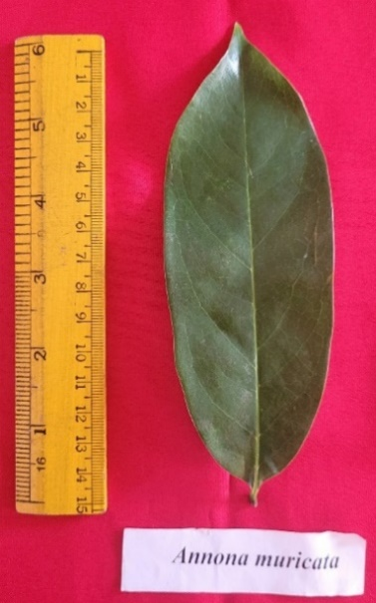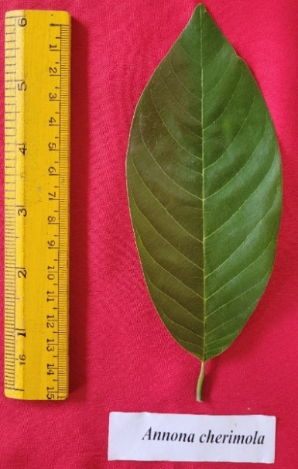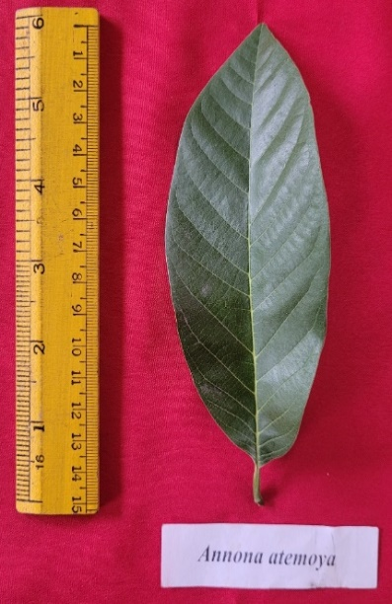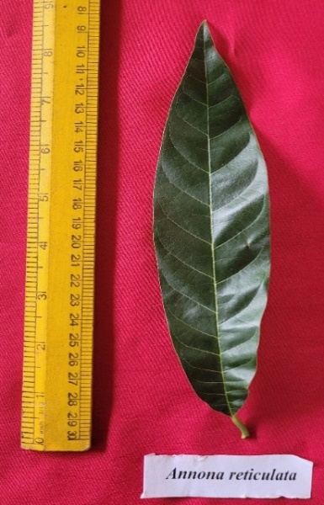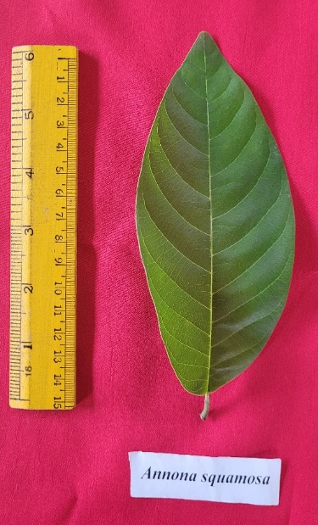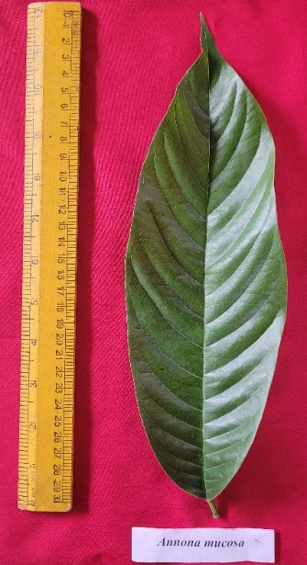

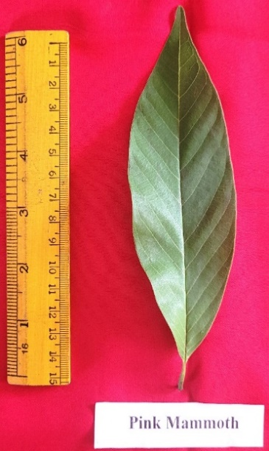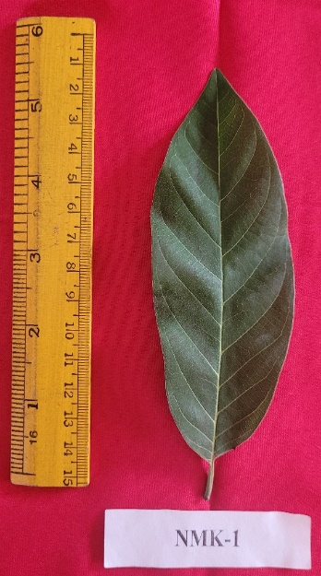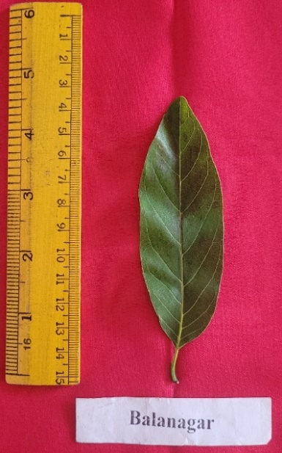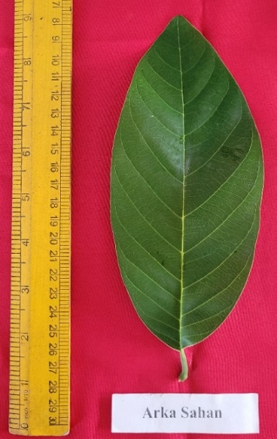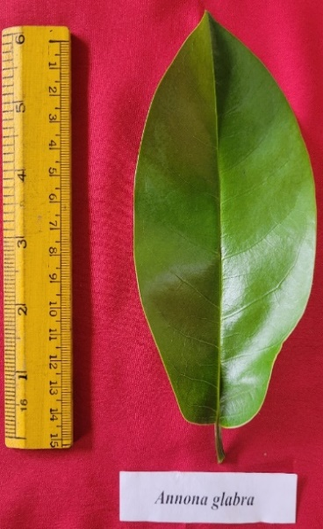***Annona squamosa Annona reticulata Annona atemoya Annona cherimola Annona muricata Annona mucosa***

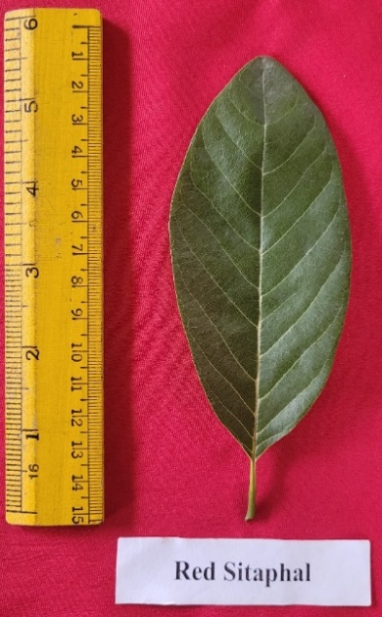***Annona glabra* Balanagar Arka Sahan Red Sitaphal Pink Mammoth NMK-1**

**Plate 1. Leaf morphological characters of *Annona* genotypes**

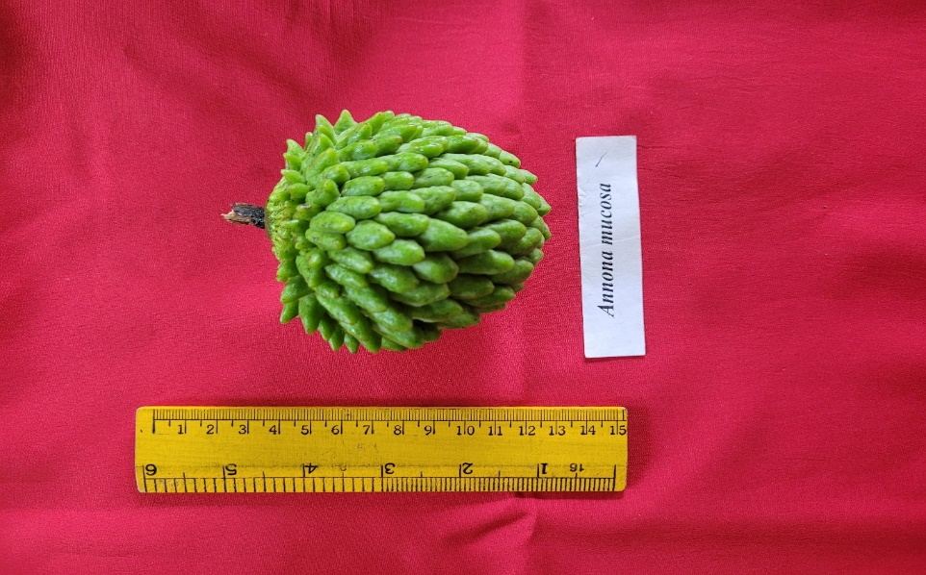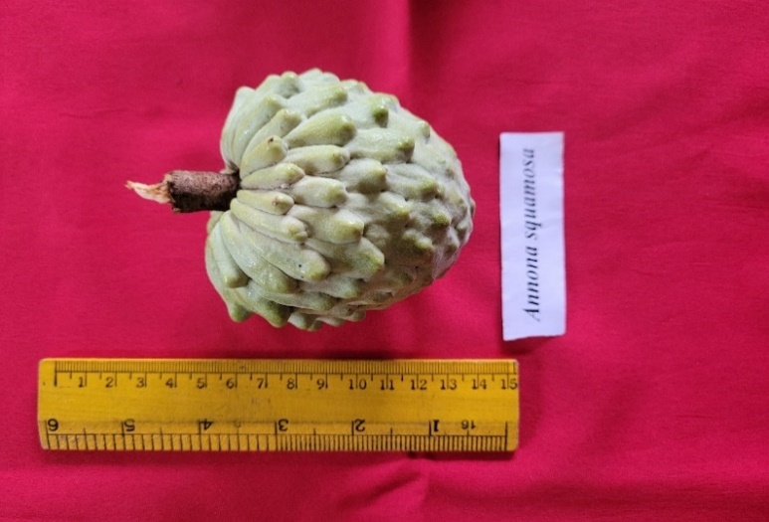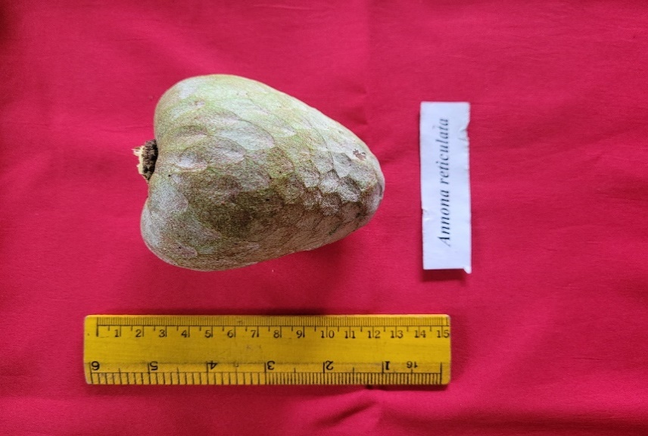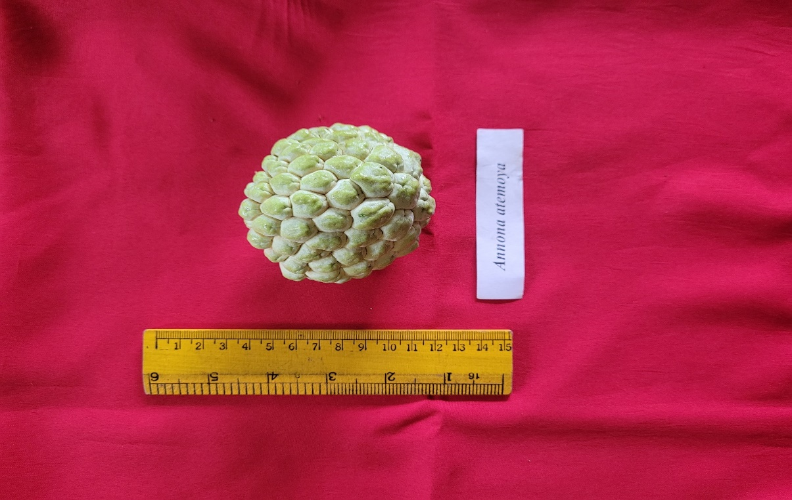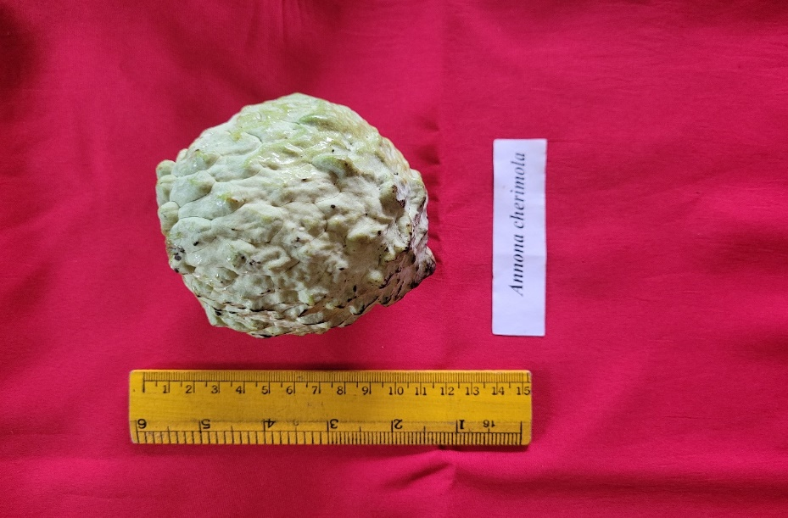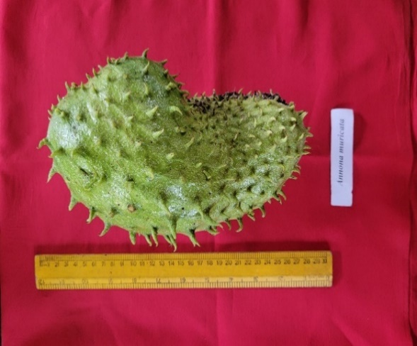***Annona squamosa Annona reticulata Annona atemoya Annona cherimola Annona muricata Annona mucosa***

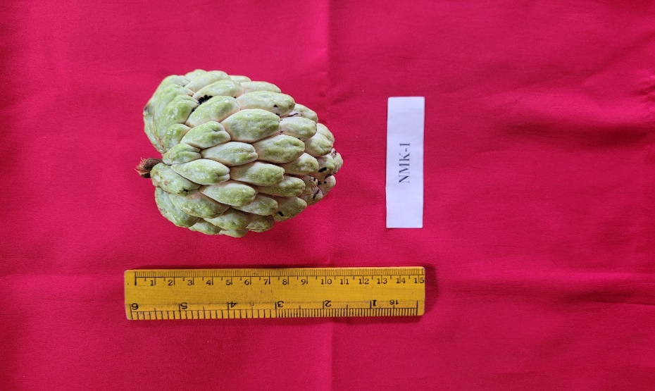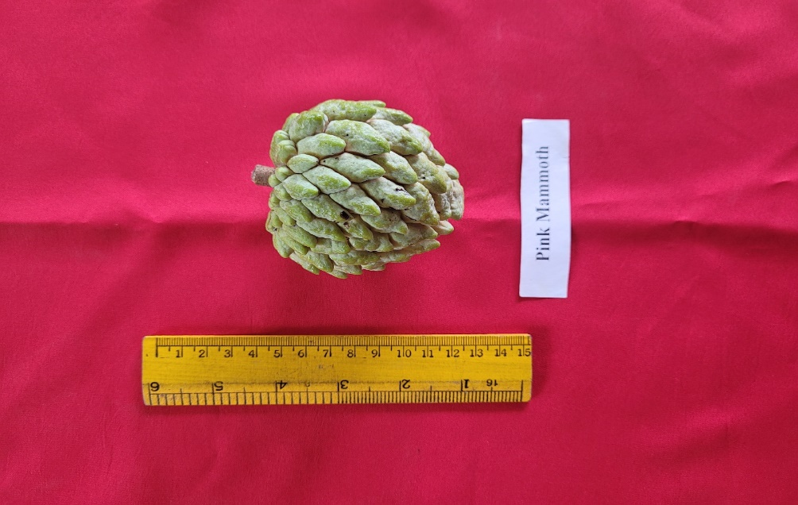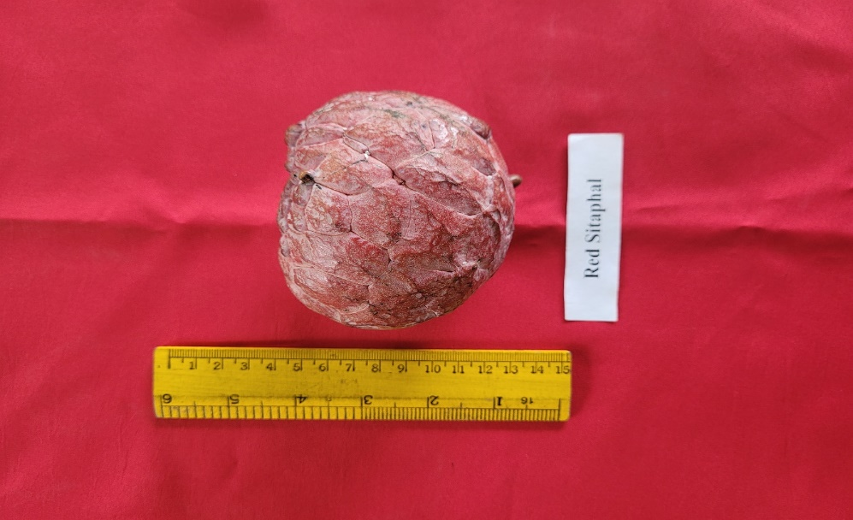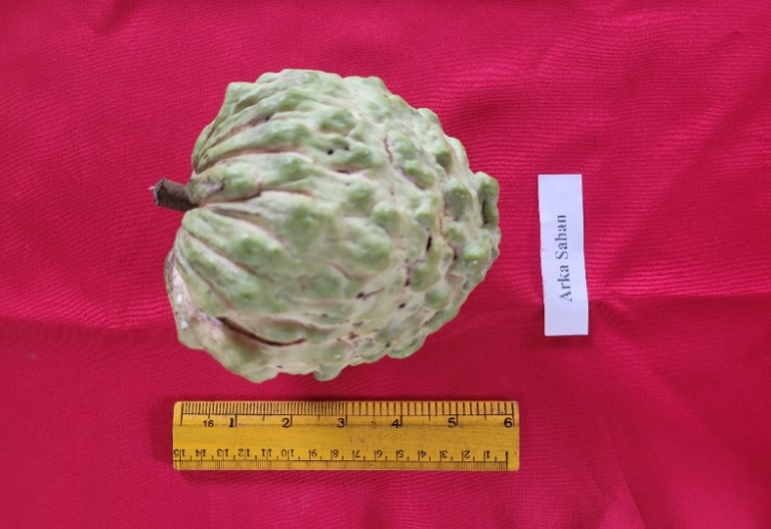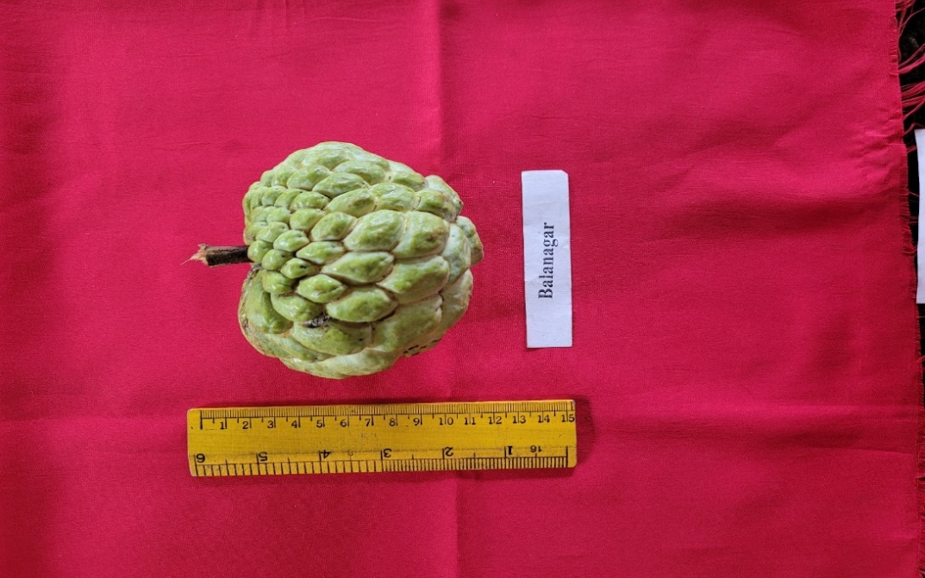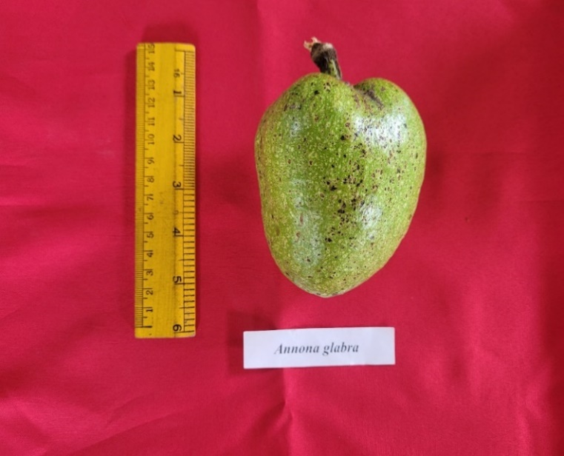

***Annona glabra* Balanagar Arka Sahan Red Sitaphal Pink Mammoth NMK-1**

**Plate 2. Fruit morphological characters of *Annona* genotypes**

**Correlation analysis**

Correlation coefficients are used to measure how strong a relationship is existed between two variables or correlation coefficient study is the measure of an association between two or more variables. The genotypic and phenotypic correlation studies were conducted to know the nature of the relationship existing between fruit yield and their component characters which are conferred in tables 3 and 4.

**Genotypic correlation coefficient**

Genotypic correlation coefficients for different growth yield and yield related characters among *Annona* genotypes are presented in Table 3.

1. **Fruit yield (kg/plant)**

At genotypic level, fruit yield per plant had a highly significant and positive correlation with tree height (0.592**), average fruit weight (0.927**), fruit length (0.947**), fruit breadth (0.910**), fruit volume (0.790**), pulp weight (0.891**) and pulp to seed ratio (0.979**), while it had significant positive correlation with flower size (0.368*) and seed weight (0.363*) and had non-significant positive correlation with leaf length (0.033), number of fruits per plant (0.01), thickness of rind (0.181), pulp percent (0.260), number of seeds per fruit (0.127) and shelf life (0.221), it had highly significant and negative correlation with petiole length (-0.711**), significant and negative correlation with leaf width (-0.339*) and seed per cent (-0.424*).

1. **Average fruit weight (g)**

Average fruit weight had found highly significant and positive correlation with fruit length (0.991**), fruit breadth (0.933**), fruit volume (0.811 **), pulp weight (0.986**), pulp to seed ratio (0.888**) and shelf life (0.911**) it had non-significant and negatively correlated with thickness of rind (-0.116) and seed percent (-0.341*).

1. **Pulp weight (g)**

Pulp weight had significant positive correlation with pulp percent (0.513*), seed weight (0.468*), non-significant positive correlation with number of seeds per fruit (0.168) and shelf life (0.149) it had non-significant negative correlation with seed percent (-0.365*).

1. **Seed weight (g)**

Seed weight had a strong significant and positive correlation with seed percent (0.619**), number of seeds per fruit (0.928**), while it had significant positive correlation with shelf life (0.345*) and pulp to seed ratio (0.356*).

**Table 3. Genotypic correlation coefficient for different growth, yield and yield related characters among *Annona* genotypes**

|  |  |  |  |  |  |  |  |  |  |  |  |  |  |  |  |  |  |  |  |
| --- | --- | --- | --- | --- | --- | --- | --- | --- | --- | --- | --- | --- | --- | --- | --- | --- | --- | --- | --- |
| **Traits** | **TH (m)** | **LL (cm)** | **LW (cm)** | **PL (cm)** | **FS (cm)** | **NF/P** | **AFW (g)** | **FL (cm)** | **FB (cm)** | **FV (ml)** | **TR (cm)** | **PW (g)** | **P (%)** | **SW (g)** | **S (%)** | **NOS/F** | **P/S** | **SL (days)** | **FY**  **(kg/P)** |
| **TH (m)** | 1 | 0.61** | 0.152 | -0.508* | 0.604** | -0.376* | 0.575** | 0.575** | 0.829** | 0.354* | 0.31 | 0.661** | 0.673** | 0.347* | -0.388* | 0.043 | 0.752** | 0.587** | 0.592** |
| **LL (cm)** |  | 1 | 0.217 | 0.159 | 0.3 | 0.022 | -0.02 | 0.004 | 0.174 | -0.186 | 0.058 | 0.102 | 0.521* | 0.118 | -0.05 | 0.012 | 0.139 | 0.035 | 0.033 |
| **LW (cm)** |  |  | 1 | 0.322* | 0.521* | -0.626** | -0.15 | -0.142 | 0.003 | -0.123 | -0.224 | -0.105 | 0.097 | 0.294 | 0.314 | 0.218 | -0.225 | -0.358* | -0.339* |
| **PL (cm)** |  |  |  | 1 | -0.124 | 0.031 | -0.593** | -0.537* | -0.649** | -0.248 | -0.352* | -0.568** | -0.366* | 0.095 | 0.717** | 0.23 | -0.772** | -0.72** | -0.711** |
| **FS (cm)** |  |  |  |  | 1 | -0.625** | 0.545* | 0.552* | 0.667** | 0.372* | -0.417* | 0.563** | 0.32* | 0.7** | 0.102 | 0.434* | 0.452* | 0.344* | 0.368* |
| **NF/P** |  |  |  |  |  | 1 | -0.423* | -0.387* | -0.42* | -0.235 | 0.466* | -0.46* | -0.378* | -0.531* | -0.13 | -0.326* | -0.387* | -0.062 | 0.01 |
| **AFW (g)** |  |  |  |  |  |  | 1 | 0.991** | 0.933** | 0.811** | -0.116 | 0.986** | 0.364* | 0.484* | -0.341* | 0.195 | 0.888** | 0.911** | 0.927** |
| **FL (cm)** |  |  |  |  |  |  |  | 1 | 0.944** | 0.839** | -0.064 | 0.951** | 0.293 | 0.598** | -0.213 | 0.335* | 0.97** | 0.933** | 0.947** |
| **FB (cm)** |  |  |  |  |  |  |  |  | 1 | 0.745** | 0.103 | 0.941** | 0.431* | 0.526* | -0.368* | 0.195 | 0.985** | 0.899** | 0.91** |
| **FV (ml)** |  |  |  |  |  |  |  |  |  | 1 | 0.073 | 0.761** | 0.058 | 0.558** | -0.011 | 0.336* | 0.673** | 0.781** | 0.79** |
| **TR (cm)** |  |  |  |  |  |  |  |  |  |  | 1 | -0.142 | -0.129 | -0.286 | -0.287 | -0.262 | -0.091 | 0.212 | 0.181 |
| **PW (g)** |  |  |  |  |  |  |  |  |  |  |  | 1 | 0.513* | 0.468* | -0.365* | 0.154 | 1.083 | 0.873** | 0.891** |
| **P (%)** |  |  |  |  |  |  |  |  |  |  |  |  | 1 | 0.223 | -0.213 | 0.041 | 0.621** | 0.248 | 0.26 |
| **SW (g)** |  |  |  |  |  |  |  |  |  |  |  |  |  | 1 | 0.619** | 0.928** | 0.356* | 0.345* | 0.363* |
| **S (%)** |  |  |  |  |  |  |  |  |  |  |  |  |  |  | 1 | 0.837** | -0.609** | -0.43* | -0.424* |
| **NOS/F** |  |  |  |  |  |  |  |  |  |  |  |  |  |  |  | 1 | -0.015 | 0.118 | 0.127 |
| **P/S** |  |  |  |  |  |  |  |  |  |  |  |  |  |  |  |  | 1 | 0.202 | 0.979** |
| **SL (days)** |  |  |  |  |  |  |  |  |  |  |  |  |  |  |  |  |  | 1 | 0.221 |
| **FY (kg/P)** |  |  |  |  |  |  |  |  |  |  |  |  |  |  |  |  |  |  | 1 |

TH- Tree height, LL- Leaf length, LW- Leaf width, PL- Petiole length, FS- Flower size, NF/P- Number of fruits /plant, AFW- Average fruit weight, FL- Fruit length, FB- Fruit breadth, FV- Fruit volume, TR- Thickness of rind, PW- Pulp weight, P%- Pulp percent, SW- Seed weight, S%- Seed percent, NOS/F- Number of seeds/fruit, P/S- Pulp to seed ratio, SL- Shelf life, FY- Fruit yield (kg/plant)

**Phenotypic correlation coefficient**

Phenotypic correlation coefficients for different growth, yield and yield related characters among *Annona* genotypes are presented in Table 4.

**1. Fruit yield (kg/plant)**

At phenotypic level, fruit yield per plant had a highly significant and positive correlation with average fruit weight (0.926**), fruit length (0.923**), fruit breadth (0.885**), fruit volume (0.759**), pulp weight (0.871**) and pulp to seed ratio (0.630**) while it had significant positive correlation with tree height (0.519*), flower size (0.349*) and seed weight (0.397*) and had non-significant positive correlation with leaf length (0.043), number of fruits per plant (0.01), thickness of rind (0.203), pulp percent (0.213), number of seeds per fruit (0.178) and shelf life (0.215), it had highly significant and negative correlation with petiole length (-0.589**), significant and negative correlation with seed percent (-0.381*)

**2. Average fruit weight (g)**

Average fruit weight had found highly significant and positive correlation with fruit length (0.973**), fruit breadth (0.901**), fruit volume (0.789**), pulp weight (0.969**), pulp to seed ratio (0.681**) and shelf life (0.91**) and significant positive correlated with seed weight (0.516*), non-significant and positive correlation with number of seeds per fruit (0.245) and pulp per cent (0.302), it had non-significant and negatively correlated with thickness of rind (-0.093) and seed percent (-0.300).

**3. Pulp weight (g)**

Pulp weight had a strong significant and positive correlation with pulp to seed ratio (0.763**) and shelf life (0.853**) while it had significant positive correlation with pulp percent (0.486*), seed weight (0.497*), non-significant positive correlation with number of seeds per fruit (0.197), it had non-significant negative correlation with seed percent (-0.316).

**4. Seed weight (g)**

Seed weight had a strong significant and positive correlation with seed percent (0.597**), number of seeds per fruit (0.913**), while it had significant positive correlation with shelf life (0.379*), non-significant positive correlation with pulp to seed ratio (0.071).

**Table 4. Phenotypic correlation coefficient for different growth, yield and yield related characters among *Annona* genotypes**

|  |  |  |  |  |  |  |  |  |  |  |  |  |  |  |  |  |  |  |  |
| --- | --- | --- | --- | --- | --- | --- | --- | --- | --- | --- | --- | --- | --- | --- | --- | --- | --- | --- | --- |
| **Traita** | **TH (m)** | **LL (cm)** | **LW (cm)** | **PL (cm)** | **FS (cm)** | **NF/P** | **AFW (g)** | **FL (cm)** | **FB (cm)** | **FV (ml)** | **TR (cm)** | **PW (g)** | **P %** | **SW (g)** | **S %** | **NOS/F** | **P/S** | **SL (days)** | **FY (kg/P)** |
| **TH (m)** | 1 | 0.521* | 0.155 | -0.398* | 0.537* | -0.342* | 0.513* | 0.504* | 0.74** | 0.313 | 0.252 | 0.563** | 0.524* | 0.287 | -0.319* | 0.034 | 0.487* | 0.514* | 0.519* |
| **LL (cm)** |  | 1 | 0.217 | 0.151 | 0.295 | 0.021 | -0.016 | 0.003 | 0.167 | -0.185 | 0.085 | 0.106 | 0.508* | 0.111 | -0.058 | 0.013 | 0.130 | 0.046 | 0.043 |
| **LW (cm)** |  |  | 1 | 0.301 | 0.511* | -0.622** | -0.146 | -0.140 | 0.010 | -0.120 | -0.194 | -0.106 | 0.082 | 0.253 | 0.270 | 0.204 | -0.162 | -0.338* | -0.321* |
| **PL (cm)** |  |  |  | 1 | -0.066 | 0.021 | -0.498* | -0.457* | -0.547* | -0.237 | -0.274 | -0.472* | -0.277 | 0.111 | 0.621** | 0.231 | -0.566** | -0.596** | -0.589** |
| **FS (cm)** |  |  |  |  | 1 | -0.61** | 0.506* | 0.519* | 0.626** | 0.348* | -0.373* | 0.530* | 0.288 | 0.608** | 0.077 | 0.403* | 0.386* | 0.326* | 0.349* |
| **NF/P** |  |  |  |  |  | 1 | -0.398* | -0.370* | -0.401* | -0.224 | 0.437* | -0.438* | -0.353* | -0.475* | -0.119 | -0.309 | -0.325* | -0.055 | 0.010 |
| **AFW (g)** |  |  |  |  |  |  | 1 | 0.973** | 0.901** | 0.789** | -0.093 | 0.969** | 0.302 | 0.516* | -0.300 | 0.245 | 0.681** | 0.910** | 0.926** |
| **FL (cm)** |  |  |  |  |  |  |  | 1 | 0.885** | 0.828** | -0.047 | 0.945** | 0.264 | 0.596** | -0.195 | 0.361* | 0.675** | 0.909** | 0.923** |
| **FB (cm)** |  |  |  |  |  |  |  |  | 1 | 0.697** | 0.132 | 0.871** | 0.340* | 0.477* | -0.342* | 0.204 | 0.679** | 0.875** | 0.885** |
| **FV (ml)** |  |  |  |  |  |  |  |  |  | 1 | 0.064 | 0.743** | 0.041 | 0.527* | -0.025 | 0.338* | 0.479* | 0.749** | 0.759** |
| **TR (cm)** |  |  |  |  |  |  |  |  |  |  | 1 | -0.119 | -0.091 | -0.253 | -0.284 | -0.233 | -0.047 | 0.233 | 0.203 |
| **PW (g)** |  |  |  |  |  |  |  |  |  |  |  | 1 | 0.486* | 0.497* | -0.316 | 0.197 | 0.763** | 0.853** | 0.871** |
| **P %** |  |  |  |  |  |  |  |  |  |  |  |  | 1 | 0.201 | -0.144 | 0.032 | 0.551* | 0.202 | 0.213 |
| **SW (g)** |  |  |  |  |  |  |  |  |  |  |  |  |  | 1 | 0.597** | 0.913** | 0.071 | 0.379* | 0.397* |
| **S %** |  |  |  |  |  |  |  |  |  |  |  |  |  |  | 1 | 0.765** | -0.508* | -0.388* | -0.381* |
| **NOS/F** |  |  |  |  |  |  |  |  |  |  |  |  |  |  |  | 1 | -0.136 | 0.168 | 0.178 |
| **P/S** |  |  |  |  |  |  |  |  |  |  |  |  |  |  |  |  | 1 | 0.011 | 0.630** |
| **SL (days)** |  |  |  |  |  |  |  |  |  |  |  |  |  |  |  |  |  | 1 | 0.215 |
| **FY (kg/P)** |  |  |  |  |  |  |  |  |  |  |  |  |  |  |  |  |  |  | 1 |

**UPGMA dendogram of 11 *Annona* genotypes based on morphological analysis**

Using 19 morphological characters data, a cluster dendrogram was generated with the neighbour joining clustering method (To construct Unweighted Neighbour Joining tree using R software) that clearly separated genotypes into five major clusters labelled as cluster-I, cluster-II, cluster-III, cluster-IV and cluster-V, respectively.

The dendrogram generated clustering showed that, cluster-I includes genotype of *A. muricata*. Cluster-II includes only one genotype *i.e*., *A. glabra* and cluster-III includes genotypes of *A. mucosa*. Cluster-IV includes genotype of Arka Sahan and Cluster V largest cluster with 7 genotypes. Further, cluster-V was sub divided into two groups i.e., sub-cluster 5.1 and sub-cluster 5.2. The sub-cluster 5.1 divided into two groups *viz*., 5.1.a (*A. reticulata*) and 5.1.b. (*A. atemoya* and *A. cherimola*). The sub cluster 5.2 divided into two sub clusters 5.2.a and 5.2.b. sub cluster 5.2.a includes genotypes like *A. squamosa* and sub cluster 5.2. b includes *Annona* genotypes like Balanagar, Red Sitaphal and Pink Mammoth (Fig. 1).

*Annona muricata*

*Annona glabra*

*Annona mucosa*

Arka Sahan

*Annona reticulata*

*Annona atemoya*

*Annona cherimola*

*Annona squamosa*

Balanagar

Red Sitaphal

Pink Mammoth

0

5

10

15

20

**Height**

**dist(di) hclust (*, "average")**

**Fig. 1. UPGMA cluster analysis of the studied *Annona* genotypes based on morphological characters**

**Discussion**

**Tree and flower characteristics of *Annona* genotypes**

Out of 11 genotypes, the maximum height was observed in Arka Sahan (6.50 m) which was followed by *A. mucosa* (6.00 m) and *A. muricata* (5.83 m), while genotype Red Sitaphal (3.16 m) recorded the minimum height. Thakur and Singh (1967) standardized pomological descriptions and classified various species of *Annona* in which they recorded similar observations. In their study, the height was 3.05 m, spread was 3.12 m in 10 years old plants of *A. atemoya* (interspecific hybrid). In *A. squamosa* var. Green, the height was 4.42 m, spread was 3.90 m and in *A. squamosa* var. Red the height was 2.74 m and spread was 2.59 m. The results are in confirmation with the findings of Hoque and Hossain (2012) and Ara *et al*. (2008) in pummelo. These variations is due to the genetic makeup and its interaction with the environmental factors.

The analysis of variance showed significant differences in flower size among species of *Annona*. The highest flower size was observed in Arka Sahan (8.83 cm) which was followed by *A. muricata* (8.50 cm) and *A. glabra* (8.50). Lowest were recorded in *A. squamosa* (4.33 cm). The results are in confirmation with the findings of Pinto *et al.* (2005) who reported that maximum flower size was observed in *A. muricata* compared to other *Annona* species. This variation is due to the genetic makeup of different species and varieties.

**Leaf characteristics of *Annona* genotypes**

The highest leaf length was observed in Arka Sahan (21.83 cm) which was followed by *A. reticulata* (21.16 cm). Lowest were recorded in Balanagar and NMK-1 (13.50 cm). Similar findings were reported by Awachare *et al.* (2018) in *A. reticulata* (12.30 cm), *A. atemoya* (11.40 cm), *A. glabra* (10.40 cm), *A. muricata* (14.40 cm), *A. squmosa* (12.20 cm) and *A. cherimola* (13.20 cm).

Out of 11 genotypes, the maximum leaf width was observed in Arka Sahan (8.00 cm) which was followed by *A. glabra* and *A. atemoya* (7.50 cm), while genotype Balanagar (4.50 cm) recorded the minimum leaf width. Similar results were reported by Awachare *et al.* (2018) in *A. reticulata* (3.20 cm), *A. atemoya* (4.80 cm), *A. glabra* (3.80 cm), *A. muricata* (3.20 cm), *A. squmosa* (3.10 cm) and *A. cherimola* (4.20 cm).

The data pertaining to the petiole length revealed that the maximum petiole length was recorded in Red Sitaphal (2.50 cm) followed by Pink Mammoth and *A. glabra* (2.33 cm). The minimum petiole length was recorded in *A. mucosa* (1.00 cm). Similar results were reported by Awachare *et al.* (2018) in *A. reticulata* (0.90 cm), *A. atemoya* (1.10 cm), *A. glabra* (1.30 cm), *A. muricata* (0.90 cm), *A. squmosa* (0.70 cm) and *A. cherimola* (1.20 cm).

**Fruit characteristics of *Annona* genotypes**

Maximum average fruit weight was recorded in *A. muricata* (1708.30) which was followed by Arka Sahan (450.93). Reduction in average fruit weight was observed in the Pink Mammoth (119.70). The present findings are in accordance with those reported by Da silva *et al.* (1999) who observed the average fruit weight in soursop (*A. muricata*) ranged from 369.00 g to 839.00 g. Fuentes (1999), Agustin (1999), Jalikop and Kumar (2000) reported the average fruit weight of Arka Sahan an interspecific hybrid was found to be 210.00 g.

From the data it was found that there was increase in fruit length in *A. muricata* (23.00) and *A. glabra* (11.16). The minimum fruit length was recorded in Balanagar (6.76). Similar results have been reported and values observed are consistent with those reported by Pinto *et al.* (2005) who found bullock heart fruits of 10 to 12 cm in length . Mathakar (2005) and Agustin *et al*. (2006), characterized for cherimoya cultivars using morphometric traits.

The maximum fruit breadth of 13.31 cm was observed in *A. muricata*, which was followed by *A. mucosa* (9.69), Arka Sahan (9.63) and *A. cherimola* (8.47). The minimum fruit breadth was noticed in *A. squamosa* and Balanagar (6.50). Similar results and values observed were consistent with those reported Morton and Miami (1987) who described species of *Annona* and found the fruit breadth of *A. muricata* was 15 cm. Mathakar (2005) evalvated 24 hybrids of *Annona* spp and observed that fruit breadth varied from 3.20 cm to 11.80 cm.

Maximum fruit volume was recorded in *A. muricata* (783.33) which was followed by Red Sitaphal(510.00). Reduction in fruit volume was observed in the *A. reticulata* (110.00).Similar results have been reported by Thakur and Singh (1967) and Jalikop and Kumar (2000).

Out of 11 genotypes, the maximum thickness of rind was observed in *A. mucosa* (1.96 cm) which was followed by *A. atemoya* (0.63 cm), while genotype *A. glabra* (0.16 cm) recorded the minimum thickness of rind.

Maximum number of fruits/plant was recorded in Balanagar (128.33) which was followed by *A. mucosa* (126.66). Reduction in number of fruits/plant was observed in the Arka Sahan (39.33). Morton and Miami (1987) reported that *A. squamosa* produced 50 fruits per plant while Shete *et al*. (1991) observed that in *A. squamosa*, number of fruits ranged from 27 to 49. Da Silva *et al*. (1999) reported that in *A. squamosa* in Brazil had 19.6 to 69.1 fruits per plant. Mathakar (2005) observed the number of fruit per tree ranged from 14 to 61.

The maximum fruit yield (kg/plant) of 80.78 was observed in *A. muricata*, which was followed by *A. mucosa* (45.34). The minimum fruit yield (kg/plant) was noticed in *A. squamosa* (6.57)and NMK-1 (7.45). Shete *et al*. (1991) reported that under Rahuri conditions in *A. squamosa*, the average yield per tree ranged from 4.26 kg to 8.70 kg. Similar findings were also reported by Anon (2003), Mathakar (2005) and Selvarajan (2008) reported highest fruit yield (kg/plant) *A. muricata* among the all *Annona* species.

**Pulp characteristics of *Annona* genotypes**

Out of 11 genotypes, the maximum pulp weight was observed in *A. muricata* (998.23) which was followed by Arka Sahan (398.46) while genotype Red Sitaphal (25.80) and Pink Mammoth (36.16) recorded the minimum pulp weight. Augustin (1999) observed the pulp weight in Cherimoya as 622.88 g. Mathakar (2005) reported that average pulp weight in Annona hybrids ranged from 88.80 g to 496.40 g.

The data pertaining to the pulp per cent revealed that the maximum pulp per cent was recorded in Arka Sahan (88.49) which was followed by NMK-1 (81.92). Minimum pulp per cent was recorded in Red Sitaphal (19.22). Similar results reported by Mathakar (2005) in Arka Sahan which had highest fruit pulp percentage whereas lowest in Washington. Findings analogous to this observation have also been reported by Jadhav (2008) who found pulp percentage (46.48 to 58.96 %) of evaluated *Annona* hybrids.

From the data it was found that there was increase in pulp to seed ratio in *A. muricata* (29.19) followed by NMK-1 (20.49). The minimum pulp to seed ratio was recorded in *A. glabra* (2.01) and Red Sitaphal (2.05).

**Seed characteristics of *Annona* genotypes**

Maximum number of seeds/fruit was recorded in *A. glabra* (206.00) which was followed by *A. muricata* (77.00) and minimum number of seeds/fruit was recorded in NMK-1 (12.33) and *A. atemoya* (20.33). The present findings are in accordance with those reported by Shete *et al.* (1991). The number of seed in *A. squamosa* reported ranged from 22 percent to 72 percent, Jalikop and Kumar (2000) reported that in Arka Sahan the number of seed were 9 per 100g of fruit.

Maximum seed weight was recorded in *A. glabra* (66.86 g) followed by *A. muricata* (42.56 g) and minimum seed weight was recorded in NMK-1 (5.80 g) and Pink Mammoth (98.66 g). Similar findings were reported by Mathakar (2005), Anon (2006) and Anon (2007).

The data pertaining to the seed per cent revealed that the maximum seed per cent was recorded in *A. glabra* (20.64) which was followed by Red Sitaphal (10.09). Minimum seed per cent was recorded in *A. muricata* (2.34). Findings similar to this observation have also been reported by Syed Hashmi and Pawar (2012) who observed that mean percent of custard apple ranged from 18.90 to 26.40 percent. Jadhav (2008) reported significant variation in seed percentage (6.72 to 11.79 %) of the evalvated Annona hybrids. Mathakar (2005) observed that it ranged from 3.33 to 6.13 per cent in custard apple hybrids.

**Genotypic and phenotypic coefficient of variation for morpho-physical traits of *Annona* genotypes**

The highest GCV (142.16%) and PCV (146.38%) was observed for pulp weight, which is followed by average fruit weight (121.11% and 126.26%), number of seeds per fruit (96.34% and 99.88%), seed weight (84.25% and 91.80%), fruit volume (75.77% and 76.90%), thickness of rind (78.94% and 82.44%), pulp to seed ratio (77.24% and 95.80%), seed per cent (62.92% and 68.55%), fruit length (46.94% and 48.18%), number of fruits per plant (43.25% and 43.38%), pulp per cent (41.43% and 44.20%), petiole length (35.20% and 38.46%), tree height (24.25% and 27.09%), flower size (27.30% and 28.02%) and fruit breadth (24.40% and 25.70%). The moderate GCV and PCV were observed for leaf width (16.95% and 17.14%) which is followed by leaf length (16.29% and 16.47%).

Similar findings were also reported earlier by Jagtap and Kokate (1991), Shete *et al*. (1991), George *et al*. (1999), Carvalho *et al*. (2000), Wang *et al*. (2001), Mariguele and Silva (2010), and Bhatnagar *et al*. (2012). Bhatnagar *et al*. (2012) reported the genotypic coefficient of variation percentage in fruit weight was (16.40%) whereas phenotypic coefficient of variation was (16.90%) which show that influence of environment on different genotypes is more than gene traits. Like wise the GCV of pulp weight of custard apple genotypes were (19.00%), whereas, PCV was found to be (19.30%). The studies show that both genotypic characters and phenotypic characters can be utilized for selection based on phenotypic characters in *Annona squmosa*.

**Correlation coefficient**

**Genotypic correlation coefficient**

At genotypic level, fruit yield per plant had a highly significant and positive correlation with tree height, average fruit weight, fruit length, fruit breadth, fruit volume, pulp weight and pulp to seed ratio, while it had significant positive correlation with flower size and seed weight and had non-significant positive correlation with leaf length, number of fruits per plant, thickness of rind, pulp percent, number of seeds per fruit and shelf life, it had highly significant and negative correlation with petiole length, significant and negative correlation with leaf width and seed per cent.

The present findings were in agreement with Mariguele and Silva (2010), Jagtap and Kokate (1991), George *et al*. (1999), Carvalho *et al*. (2000), Wang *et al*. (2001) and Bhatnagar *et al*.(2012). Mariguele and Silva (2010) reported positive correlations between the number of seeds and seed weight, as well as between the number of fruits and yield. The strongest direct effects were observed for pulp weight on fruit weight and for the average number and weight of fruits on fruit yield. Significant indirect effects included the influence of seed count and pericarp weight, mediated through pulp weight, on fruit weightand the impact of fruit length and width, mediated through average fruit weight, on yield in *Annona squamosa*.

**Phenotypic correlation coefficient**

At phenotypic level, fruit yield per plant had a highly significant and positive correlation with average fruit weight, fruit length, fruit breadth, fruit volume, pulp weight and pulp to seed ratio, while it had significant positive correlation with tree height, flower size and seed weight and had non-significant positive correlation with leaf length, number of fruits per plant, thickness of rind, pulp percent, number of seeds per fruit and shelf life, it had highly significant and negative correlation with petiole length, significant and negative correlation with seed percent.

The present findings were in agreement with Mariguele and Silva (2010), Jagtap and Kokate (1991), George *et al*. (1999), Carvalho *et al*. (2000), Wang *et al*. (2001) and Bhatnagar *et al*.(2012). Mariguele and Silva (2010) identified positive correlations between seed number and seed weight, as well as between fruit number and yield. The strongest direct effects were observed for pulp weight on fruit weight and for the average number and weight of fruits on yield. Key indirect effects included the influence of seed count and pericarp weight, mediated by pulp weight, on fruit weightand the effect of fruit length and width, mediated by average fruit weight, on yield in *Annona squamosa*.

**UPGMA dendogram of 11 *Annona* genotypes based on morphological analysis**

Using 19 morphological characters data, a cluster dendrogram was generated with the neighbour joining clustering method (To construct Unweighted Neighbour Joining tree using R software) that clearly separated genotypes into five major clusters labelled as cluster-I, cluster-II, cluster-III, cluster-IV and cluster-V, respectively.

These results are in general agreement with the findings of George *et al*. (2005), Liu and Liu (2000) and Mariguele and Silva (2010). Samsuzzaman *et al*. (2022) reported that based on the morphological characters 23 mango germplasms MIAkb001 to MIAkb0023 divided in cluster diagram. Cluster I obtained the highest number of genotypes (08) which was followed by cluster II (07), cluster IV (04), cluster V (03) and cluster III (1). The lowest number of genotypes (1) was observed in cluster III. Kaur *et al*. (2019) reported that in 46 pumelo accessions based on the qualitative and quantitave characters accessions are divided into five main clusters: Cluster I was the largest cluster comprising of 14 accessions while cluster II consisted of seven accessions, cluster III with ten accessions, cluster IV was smallest one with only two accessions while cluster V consisted of 13 accessions.

**Conclusion**

This comprehensive study on the genetic diversity of 11 *Annona* genotypes reveals significant morphological variation offering valuable insights for future breeding programmes. Our results demonstrate substantial genetic variability across key fruit traits, such as fruit size, fruit weight and pulp weight suggesting strong genetic control over these characteristics. High heritability and genetic gain estimates for morphological characters indicate a strong potential or improvement through targeted selection. Correlation analysis further highlights the potential for simultaneous enhancement of fruit size, quality and nutritional value in *Annona* breeding programmes. The clustering analyses underscore the genetic diversity within the *Annona* genotypes, dividing them into five distinct groups based on the 19 morphological characters identifying genotypes with superior traits for commercial and nutritional purposes. These findings not only enhance our understanding of *Annona* genetic diversity but also lay the groundwork for developing *Annona* varieties with improved fruit quality, disease resistance and adaptability.

**References**

Agustin J. A., 1999, Advances in research on genetic resources of cherimoya (*Annona cherimola* M.) in Michoacan State, *Acta Hort*., 497: 189-193.

Anonymous, 2006, Biennial report (2004-2005). XIII Group Workers Meeting. AICRP on Arid Zone Fruits, Central Institute for Arid Horticulture, Bikaner (Rajasthan), India.

Anonymous, 2007, A report on characterization and documentation of custard apple germplasm. AICRP on Arid Zone Fruits, Department of Horticulture, Mahatma Phule Krishi Vidyapeeth, Rahuri, (Maharashtra), India.

Anonymous, 2022-23, *Indian Horticulture Database*. *www.nhb.com*, 127-135.

Anuragi H., Dhadu H. L., Kumar S., Dhruve J. J., Parekh M. J. and Sakure A. A., 2016, Molecular diversity of Annona species and proximate fruit composition of selected genotypes, *3 Biotech*., 6:1-10.

Ara N., Bashar M. K., Uddin M. K. and Khalequzzaman, K. M., 2008, Evaluation of pummelo, *Citrus grandis* L. cultivars in northern area of Bangladesh, *J. Agric.* *Res.*, 46(1): 65-75.

Awachare C. M., Kurian R. M., Upreti K. K. and Laxman R. H., 2018, Morpho-physiological diversity in Annona species, *Sci Hortic*., 234: 58-62.

Bapat V. A., Jagtap U. B., Ghag S. B. and Ganapathi T. R., 2020, Molecular approaches for the improvement of under-researched tropical fruit trees: Jackfruit, Guava and Custard apple, *Int. J. Fruit Sci*., 20(3): 233-281.

Bhatnagar P., Singh J., Jain M. C. and Singh B., 2012, Evaluation of landraces of custard apple (*Annona squamosa* L.), *Plant archives*., 12(2):1045-1048.

Carvalho P. S. D., Bezerra J. E. F., Lederman I. E., Alves M. A. and Melo M. L. D., 2000, Performance of custard apple (*Annona squamosa* L.) genotypes in the Brazil, *Rev. Brazil Fruitcul*., 22(1): 27-30.

Chatrou L. W., Rainer H. and Maas P. J. M., 2004, Annonaceae flowering plants of the neotropics. Princeton University Press, Princeton, N.J. p. 18-20.

DaSilva J. F., Bezerra J. E. F., Lederman I. E., Tavares J. A. and DeMeloneto M. L., 1999, Conservation, characterization and evaluation of soursop (*Annona muricata* L.) germplasm under the semi-arid conditions of the Brazil, *Plant Gen. Resour. Newsltr*., 120: 25-29.

De B. and Datta P. C., 1990, Pharmacognostic evaluation of *Phyllanthus amarus*, *International Journal of Crude Drug Research.*, 28(2): 81-88.

Escribano P., Viruel M. A. and Hormaza J. I., 2007, Molecular analysis of genetic diversity and geographic origin within an *ex-situ* germplasm collection of cherimoya by using SSRs, *J. Am. Soc. Hortic. Sci*., 132(3): 357-367.

Folorunso A. E. and Modupe O. V., 2007, Comparative study on the biochemical properties of the fruits of some Annona species and their leaf architectural study, *Notulae Botanicae Horti Agrobotanici Cluj-Napoca*., 35 (1): 15-19.

Fuentes and Leon J., 1999, Production of cherimoya (*Annona cherimola* Mill.) in Ecuador, *Acta Hortic*., 497: 59-63.

George A. P., Broadely R. H. and Topp B. L., 1999, Breeding strategies for atemoya and cherimoya*. Proc. Ist Int. Symp. On cherimoya*. *Acta Hortic*., 497:255-260.

George A. P., Broadley R. H., Nissen R. J. and Hamill S., 2005, Breeding and selecting new varieties and rootstocks of custard apple (*Annona* spp. hybrids) in subtropical Australia, *Acta Hort*., 694: 37-41.

Hoque M. A. and Hossain M. M., 2012, Characterization of twenty Pummelo genotypes, *Ann. Bangladesh Agric*., 6(2): 105-121.

Jadhav S. B., 2008, Evaluation of Annona (*Annona* spp.) hybrids, *Ph. D. (Agri.) thesis.*, Mahatma Phule Krishi Vidyapeeth, Rahuri, (Maharashtra), India.

Jagtap K. B.and Kokate A. S., 1991, Promising custard apple (*Annona squamosa* L.) selections from Pemgiri (Sangamner) region in Ahmednagar district of Maharashta.

Jalikop S. H. and Kumar S. P., 2000, New fruit varieties for arid regions-pomegranate, ‘Ruby’ and custard apple ‘Arka Sahan’, *Indian Hort*., 45 (2):19-20.

Kaur S., Malik S. K., Choudhary R., Rohini M. R., Choudhury R. and Kumar R., 2019, Morphological characterization of pummelo germplasm collected from different parts of India, *Indian J Hortic.,* 76(1): 16-22.

Kumar M., Fougat R. S., Sharma A. K., Kulkarni K., Ramesh Mistry J. G., Sakure A. A. and Kumar S., 2014, Phenotypic and molecular characterization of selected species of Plantago with emphasis on *Plantago ovata*, *Aust. J. Crop Sci*., 8: 1639–1647.

Liu S. B. and Liu S. B., 2000, The performance of African Pride custard apple cultivar, *Fruits*., 3: 29-30.

Mariguele K. H. and Silva P. S. L., 2010, Relationship between fruit traits of custard apple trees (*Annona squamosa* L.), *Revista Ceres*., 57:476-479.

Mathakar T. D., 2005, Assessment of custard apple (*Annona squamosa* L.) hybrids, *M.Sc. (Agri.) Thesis*, Mahatma Phule Krishi Vidyapeeth, Rahuri (India).

Morton F. J. and Miami F. L., 1987, Sugar apple (*Annona squamosa*). Fruits of warm climates, 69-72.

Nakasone H. Y. and Paull R. E., 1998, Annonas crop production science in horticulture: Tropical fruits, CAB International. Wallingford, UK. p. 445.

Panse V. G. and Sukhatme D. V., 1957, Statistical methods for agricultural workers, *Indian Council of Agricultural Research Publication, New-Delhi*, 49(1):115.

Pinto A., Cordeiro M., de Andrade S., Ferreira F., Filgueiras H., Alves R. and Kinpara D., 2005, Annona species: International Centre for Underutilized Crops, University of Southampton, UK.

Roduan M. R. M., Abd Hamid R., Cheah Y. K. and Mohtarrudin N., 2019, Cytotoxicity, antitumor-promoting and antioxidant activities of *Annona muricata* *in vitro*, *J. Herb. Med*., 15:100219.

Samsuzzaman M., Alam M. S., Miah M. A. M., Sumi M. A. and Habib M. A., 2022, Evaluation and genetic diversity analysis of local mango germplasm, *Acta sci. Malays.,* 6(1): 23-27.

Selvarajan M., Jasmine J. A. and Mutha R., 2008, Evaluation of custard apple germplasm under rain fed vertisol conditions. In *Proc. National Seminar on Opportunities and Challenges of Arid Horticulture for Nutrition and Livelihood* (p. 18-24).

Shete M. B., Karale A. R., Keskar B. G. and Kale P. N., 1991, Seedling selection in the custard apple, *J. Maharashtra agric. Univ*., 16 (2): 271-173.

Shivasubramanian K. and Menon M. H., 1973, Genetic variability and heritability of qualitative characters in Indian mustard (*Brassica juncea*), *Indian J. Agri. Sci*., 38:820-825.

Syed I. H. and Pawar V. N., 2012, Studies on physical and chemical characteristics of custard apple fruit pulp from different locations, *J. Dairying,Foods & H.S*., 31(2): 117 120.

Thakur D. R. and Singh R. N., 1967, Pomological description and classification of some‘Ruby’ and custard apple ‘Arka Sahan’, *Indian Hort*., 45(2):19-20.

Wang J., Chen Y. and Luo S., 2001, Study on the effect of rootstocks on the growth and fruit quality of custard apple, *China Fruits*., 1: 23-24.

Wu Y. C., Hung Y. C., Chang F. R., Cosentino M., Wang H. K. and Lee K. H., 1996, Identification of Ent-16, 17-dihydroxykauran-19-oic acid as anti-HIV principle and isolation of the new diterpeniods Annona squamosins A and B from *Annona squamosa*, J. *Nat. Prod*., 59(6): 635-637.