Comparative Analysis of Soxhlet and Ultrasound-Assisted Extraction of Bioactive Components from Fig Leaves (lat. *Ficus carica*): Impact of the Method on Extraction Yield and Latex Preservation

.

ABSTRACT

|  |
| --- |
| This research investigates the efficiency of two methods for extracting bioactive compounds from fig leaves (Ficus carica) using different solvents. Dried fig leaves were used as extraction material. The focus is on Soxhlet extraction and Ultrasound-assisted extraction (UAE) methods. Also, two different solvents, methanol and ethanol, were used for extractions. Given that the enzyme ficin is one of the significant bioactive compounds in fig leaf latex, the aim was to explore and determine which method and solvent gives a higher extraction yield and better preservation of thermolabile components such as this enzyme. The results shows that Soxhlet extraction provides a higher total extract yield and requires a longer extraction time.  In this study, the highest yields of 12.3% were obtained using the methanol solvent using the Soxhlet method compared to ultrasonic extraction which showed a lower yield of 6.4%.  In contrast to that, ultrasound-assisted extraction (UAE) yields a higher-quality extract in a shorter extraction time. However, due to the high temperatures required for Soxhlet extraction, denaturation of ficin occurs, which leads to the formation of a dry extract without the presence of this enzyme. Ultrasound-assisted extraction (UAE) method does not require high temperatures, which enables the preservation of ficin and the formation of a mucilaginous extract due to the presence of enzymes. Due to the temperature sensitivity of bioactive compounds, the choice of extraction method significantly affects the stability and quality of the final extract. |

*Keywords: extraction, Ficus carica, Soxhlet extraction, Ultrasound-assisted extraction, ficin, extracion yield*

1. INTRODUCTION

Moraceae is an angiosperm plant family very rich in edible species characterised by milky latex in all parenchymatous tissue, unisexual flowers, anatropous ovules, and aggregated drupes or achenes. Ficus carica, or commonly known as fig, is a deciduous tree in the Moraceae family and is one of the oldest cultivated trees in the world, with both fresh and dry consumption. (Datwyler & Weiblen, 2004) Fig products are excellent examples of natural products that are widely used as a food source and a source of traditional medicine. Various studies on Ficus carica have confirmed the presence of different bioactive compounds such as phenolic compounds, phytosterols, organic acids, anthocyanin composition, triterpenoids, coumarins, and volatile compounds such as hydrocarbons, aliphatic alcohols. (Badgujar et al, 2014) .

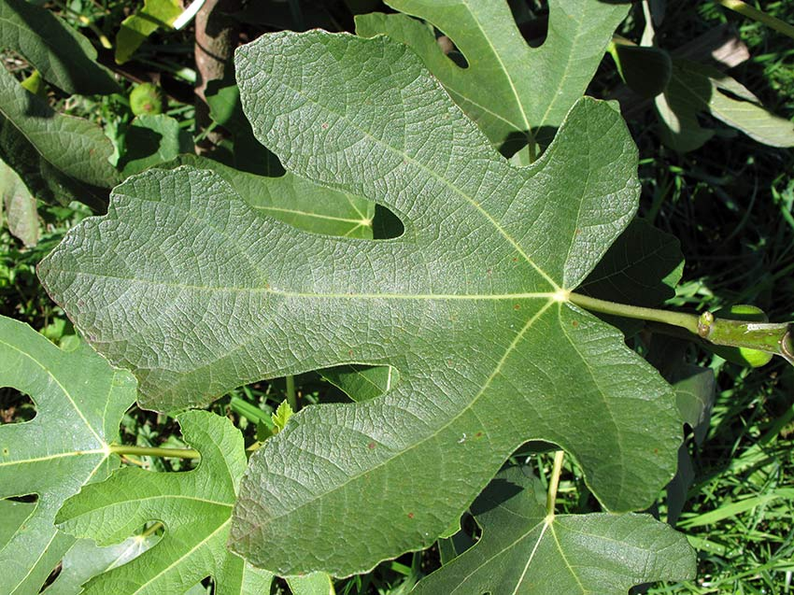

Figure 1. *Ficus carica*

In this study we have extracted compounds from Ficus carica leaves using different methods and solvents, including Soxhlet extraction and Ultrasound-assisted extraction.(Yu et al, 2023)

The qualitative and quantitative studies of bioactive compounds from plant materials mostly rely on the selection of proper extraction method. Extraction is the first step of any medicinal plant study, plays a significant and crucial role on the final result and outcome. (Azmir et al, 2013) Conventional techniques of phytochemical extraction with biological activities include maceration and Soxhlet extraction; these methods have been associated with high consumption of organic solvents that limit the application of bioactive extracts due to solvent toxicity. In addition, long-time extraction is required, which involves high energetic consumption causing an incremental cost. Thus far, the implementation of novel extraction technologies, using different mechanisms such as Ultrasound, Microwave energy, Supercritical fluids, and Accelerated solvent extraction has been promoted. The main objective of these methods is to reduce extraction time and energy consumption which is reflected in the lowering of the final cost. A common aspect of these technologies is that they are sustainable because they protect both the environment and consumers’ health and enhance the economic and innovatively competitiveness of industries. (Medina-Torres et al, 2017)

Soxhlet extraction is a type of atmospheric liquid extraction that employs solvents at their boiling temperature and low pressures (ambient pressure) to selectively extract target compounds. (Yu et al, 2023) Conversely, ultrasound-assisted extraction (UAE) utilizes mechanical energy generated by ultrasound waves including cavitation where small vacuum bubbles or voids form in the liquid and subsequently collapse near the solid sample.

To compare the efficieny of these extraction techniques, we conducted Soxhlet extraction and UAE using methanol and ethanol. The objective was to evaluate and determine which solvent yields better outcomes. It is only possible to conduct further separation, identification, and characterization of bioactive compounds after an appropriate extraction process. (Azmir et al, 2013)

Phytochemistry

Phytochemical research conducted on Ficus carica has led to the isolation of phytosterols, anthocyanins, amino acids, organic acid, fatty acids, phenolic components, hydrocarbons, aliphatic alcohols, volatile components, and several classes of secondary metabolites from its different parts. These phytochemicals are predominantly found in latex followed by leaves, fruit, and root. Furthermore, Ficus carica exibihts remarkable pharmacological properties such as antioxidant, anticancer, cytotoxic, anti-inflammatory, and hypolipidemic activities. (Chawla et. al, 2012)The organic acid profile of fig leaves is composed by six organic acids: oxalic, citric, malic, quinic, shikimic, and fumaric acids. (Oliveira et. al, 2009).

Flavonoids and phenolic compounds

The primary free flavonoid (non-glycosylated) in Ficus carica was found to be luteolin. Luteolin and quercetin are natural organic compounds that are present in fig leaves, but luteolin has a slightly higher flavonoid content than quercetin. (Vaya & Mahmood, 2006). Figure 2 shows their structure.

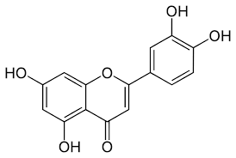 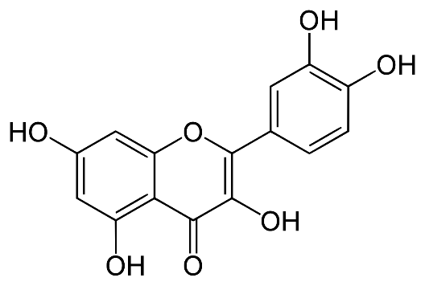 a) luteolin b) quercetin

Figure 2. Structures of luteolin and quercetin

(ChemBioDraw Ultra 14.0)

Luteolin (C15H10O6) is believed to have the potential to play a significant role in health, as it is considered to exhibit broad-ranging anti-inflammatory benefits (Jang et al, 2008), as well as anticarcinogenic, antimicrobial, antioxidant, and immunomodulatory effects.Cancer, hypertension, inflammation, and many other conditions have been treated with luteolin-rich food in traditional medicine. (Lin et. al, 2008)

Quercetin (C15H10O7), a chemical similar to the glycoside rutin, is frequently used therapeutically in allergic conditions, including asthma and high fever, eczema, and hives. Phenolic compounds are ubiquitously distributed in fruits, where they exert specific functions and are very important for sensory properties, i.e., flavor and color. Moreover, phenolic compounds have become popular among scientists and consumers for their health-promoting properties, mainly for their antioxidant property. (Badgujar et al, 2014)

Phytosterols are cholesterol-like molecules found in most plant foods, with the highest concentrations occurring in vegetable oils. Phytosterols are cholesterol-like molecules found in most plant foods, with the highest concentrations occurring in vegetable oils. They are absorbed only in trace amounts but inhibit the absorption of intestinal cholesterol, including recirculating endogenous biliary cholesterol, a key step in cholesterol elimination. (Ostlund, 2002) These compounds are involved in important cellular processes, such as the regulation of membrane fluidity, adaptation of membranes to temperature, and also participation in cellular differentiation and proliferation. (Bouvier et al, 2005) Studies have detected a new anthocyanin pigment from fig. With the help of proton and carbon NMR spectroscopy, they elucidated the structure of new anthocyanin named cyanidin-3-rhamnoglucoside designated as C3R. This compound inhibits the lipid peroxidation by producing peroxy radicals and malondialdehyde in a dose-dependent manner. (Solomon et al, 2006)

Enzymes compounds in latex

The latex of this plant is a rich source of hydrolytic enzymes. Ten proteolytic enzyme components have been reported from the latex. Two proteolytic enzyme components are characterized and designated as C and D components. Ficin S is an example of a sugar containing proteinase that has been well characterized from *Ficus* latex. *Ficus* latex is also reported to consist of several other enzymes namely rennin, protease, diastase, esterase, lipase, catalase, and peroxidase. In 2009, two independent studies demonstrated rennet-like milk clotting protease activity of latex. In addition, the latex of this plant has been reported to contain significant quantities of antioxidant enzymes such as polyphenol oxidase, catalase, peroxidase, superoxide dismutase, glutathione-*S*-tranferase, glutathione peroxidase, and glutathione reductase. (Hossein & Ilghar, [2011](https://www.tandfonline.com/doi/full/10.3109/13880209.2014.892515)) Younger parts of the fig tree (young shoots, buds, and leaves) contain the highest amounts of latex, as latex is their only defense mechanism. Figure 3 shows the presence of ficin in fig latex. Older parts of the plant have additional defense strategies such as high polyphenol concentrations and a harder and thicker bark, so they contain much less latex. (Rašković, 2015)

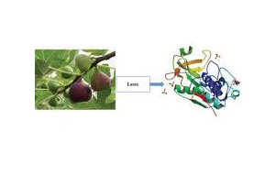

Figure 3. Ficin in fig latex

<https://www.sciencedirect.com/science/article/pii/S2666910221000715>

Pharmacological properties

Antimicrobal acivity

Latex of Ficus carica exhibited strong activities against microorganisms, including gram-positive bacteria, gram-negative bacteria, and yeast. These results revealed that capri fig latex had inhibition of the growth of all bacterial and yeast species represented in this chapter. The pharmacological properties are probably due to the high content of enzymes, flavonoids, and furanocoumarins from fig latex. (Mavlonov et. al, 2008)

Antiviral activity

The fig tree latex could be helpful in the treatment of bacterial and viral infections caused by strains resistant to conventional drugs. (Lazreg Aref et. al, 2011) Extracts of Ficus carica latex have been found to inhibit the replication of Herpes simplex type 1 (HSV-1), Echovirus type 11 (ECV-11), and adenovirus (ADV). Moreover, they have been found to act against several drug-resistant pathogens; among compounds isolated from Ficus carica, it is found that lupeol, α-amyrin, and luteolin could be used as promising inhibitors against SARS-CoV-2 main protease which plays a dynamic role in mediating viral replication and transcription. (Ay & Duran, 2018) The fig tree latex application on pox lesions showed continuous regression and shrinking of the nodules from the fourth day of treatment. (Abid & Ali, 2014)

Anticancer activity

Earlier studies have reported the antiproliferative effects of Ficus carica latex against cells derived from esophageal and stomach cancers separately. The overall knowledge suggests that fig latex could decrease tumor growth without adversely affecting hematological and histological factors. (Ghandehari & Fatemi, 2018) Latex of Ficus carica uses the different molecular mechanisms of action, including antiproliferative and anti-metastatic effects, along with significant effects on cell shape and fighting against side effects of oxidative stress of free radicals generated by the immune system cells. (Ghandehari & Fatemi, 2018) The phenolic compounds in fig latex are the main inhibitors of tumor growth, like protocatechuic acid derived from latex which is partially responsible for the induction of cell death and inhibition of invasion in these cell lines. The fig latex possesses a group of proteases such as ficin, caseinolytic, and gelatinolytic enzymes that induce apoptosis in cancer cells without causing any side effects on normal cells. (Ghandehari & Fatemi, 2018)

Anticoagulant acitvity

Ficin is is a heterogeneous group of proteases, a single polypeptide chain active at neutral pH while inactive at pH below 3.0. The procoagulant activity of Ficus carica crude extract could be explained by cysteine proteases FPI, FPII, and serine protease FPIII, which are types of ficin. Latex of Ficus carica can control its prominent coagulation stimulant nature caused by ficin (more than 5 isoenzymes) by fibrinolytic serine proteases. The anticoagulant property of the latex at a higher protein concentration suggested the presence of other anti-proteases and small peptides that may inhibit ficin. (Hamed et al, 2020) Ficin shortened the activated partial thromboplastin time and the prothrombin time of normal plasmas and plasmas deficient in coagulation factors; this showed that the hemostatic potency of Ficus proteases was based on the activation of human coagulation factor X (FX), which could explain the use of these latices as a local hemostatic agent in natural medicine. (Richter et al, 2002)

2. material and methods

The plant material was purchased in a specialized shop that sells high-quality medicinal plants. Every plant is carefully selected, ensuring that those seeking natural medicinal ingredients or pharmaceutical raw materials can rely on their purity and effectiveness. Among the many valuable products available, fig leaves have been obtained—an ingredient highly valued for its medicinal properties and rich phytochemical composition. Fig leaves, often overlooked in favor of the fruit, are an exceptional botanical material with a long tradition of use in medicine. Fig leaves contain numerous bioactive compounds traditionally used in folk medicine, which confirms their pharmacological value. Previous studies indicate the presence of highly valuable biomolecules with pronounced antidiabetic, antipyretic, antioxidant, and antilipidemic activity. Fig leaves may be an alternative source of phytochemicals such as organic acids, phenols, flavonoids, coumarins, and volatile compounds, with proven hypoglycemic, anti-inflammatory, and anticancer effects. Moreover, fig leaves represent a valuable source of secondary metabolites such as tannins, flavonoids, and hydrocarbons, which exhibit strong antioxidant properties. These compounds may have significant applications not only in therapy but also as functional ingredients in the food industry.(Shiraishi et al, 2023)

To extract the bioactive components of fig leaves, two extraction methods have been applied: Ultrasound-assisted extraction, and Soxhlet extraction. These techniques enabled a comparative analysis of their efficiency in isolating key compounds. By using methanol and ethanol as solvents, the extraction process maximized the recovery of phenolic compounds, flavonoids, and other pharmacologically significant components.

Ultrasound-assisted extraction enhanced the process by reducing extraction time, while Soxhlet extraction ensured exhaustive extraction through continuous solvent reflux. The extraction of natural products progresses through the following stages: (1) the solvent penetrates the solid matrix; (2) the solute dissolves in the solvents; (3) the solute is diffused out of the solid matrix; (4) the extracted solutes are collected. (Quing-Wen Zhag, 2018)

In addition to extraction method and solvent, several process parameters such as temperature, extraction time, particle size, and solid-to-liquid ratio also play a significant role in the recovery of bioactive compounds from fig leaves. (Zhao et. al, 2021)

High temperatures increase the solubility and diffusion. Temperatures that are too high, however, may cause solvents to be lost and bioactive components, leading to extracts of undesirable impurities and the decomposition of thermolabile components. The extraction efficiency increases with the increase in extraction duration in a certain time range. Increasing time will not affect the extraction after the equilibrium of the solute is reached inside and outside the solid material. (Quing-Wen Zhag, 2018)

The greater the solvent-to-solid ratio is, the higher the extraction yield is; however, a solvent-to-solid ratio that is too high will cause excessive solvent extraction and require a long time for concentration. (Quing-Wen Zhag, 2018) Different types of alcohol have different boiling points, so this can be used to separate them from each other and other organic compounds. The ethanol boiling point—also known as grain alcohol (C2H5OH)—at atmospheric pressure (14.7 psi, 1 bar absolute) is 173.1 F (78.37 C). (Helmenstine, 2024)

Methanol’s low boiling point (64.7°C) is another advantage, as it allows for easy removal of the solvent from temperature-sensitive reaction products. The low viscosity of methanol also aids in its use as a solvent for various chemical processes. Methanol is favored as a solvent due to its ready availability, affordability, and relatively low toxicity (when inhaled in moderate concentrations). (Marcus, 2009)

**2.1. Ultrasound-assisted extraction of bioactive compounds from *Ficus carica* leaves**

Ultrasound-assisted extraction (UAE) is a great method for isolating bioactive compounds from *Ficus carica* leaves, especially thermolabile compounds such as ficin present in latex, flavonoids, polyphenols, polysaccharides and others. (Alcántara et al, 2020) Ficin, a cysteine protease present in *Ficus carica* latex is denatured at elevated temperatures, therefore UAE allows the preservation of the enzymatic function of ficin. (Hegazy et al, 2023) This technique is based on the use of ultrasound waves in the frequency range of 20 kHz to 2 MHz for disruption of the plant matrix and improving the penetration of solvents. (Huang, 2025) The advantages of UAE include reduced processing times, lower temperatures, minimize dreagent consumption, and increased potency.(Wang et al, 2023) (Alcántara et al, 2020)

**2.1.1** **Detailed steps of exctraction and Solvent removal**

1. Extracts were prepared by mixing 2.5 grams of pulverized Ficus carica leaves with 50 mL of solvents (methanol and 96% ethanol). Plant material was pulverized to the degree of coarse powder (lat. Pulvis grossus) and sifted through the sieve. 2.5 grams of pulverized plant material were weighed and placed into two flat-bottomed flasks.
2. In one flask was added 50 mL of methanol and in the other 50 mL of 96% ethanol.
3. The flasks were sealed with parafilm to prevent evaporation and contamination during the extraction process. The samples were subjected to extraction in a Bandelin Sonorexultrasonic bath for 35 minutes at room temperature.
4. During the extraction, large amounts of energy are generated. To maintain the desired temperature, ice was used to cool the samples and prevent overheating. After completed extraction, the samples were filtered through filter paper (Macherey – Nagel MN 617 filter paper). The filtrates were collected in porcelain lab bowls. First 5 ml of filtrates were collected in a small lab beaker and discarded for further analysis.
5. Ethanol removal. A large laboratory beaker was filled halfway with water and heated to boiling. Once water vapor began to form, a porcelain lab bowl containing the filtrate was placed over the beaker. The ethanol evaporated from the extract due to the heat from the water vapor. After the ethanol was completely removed, the extract was carefully removed from the porcelain lab bowl, stored in paper, and then transferred to sterile cups for further use.
6. Methanol removal. The porcelain lab bowl containing the methanol extract filtrate was left overnight in a laboratory fume hood. As methanol evaporates at room temperature, it is completely removed from the extract. Once the methanol had evaporated, the extract was carefully removed from the porcelain lab bowl, stored in paper, and then transferred to sterile cups for further use.

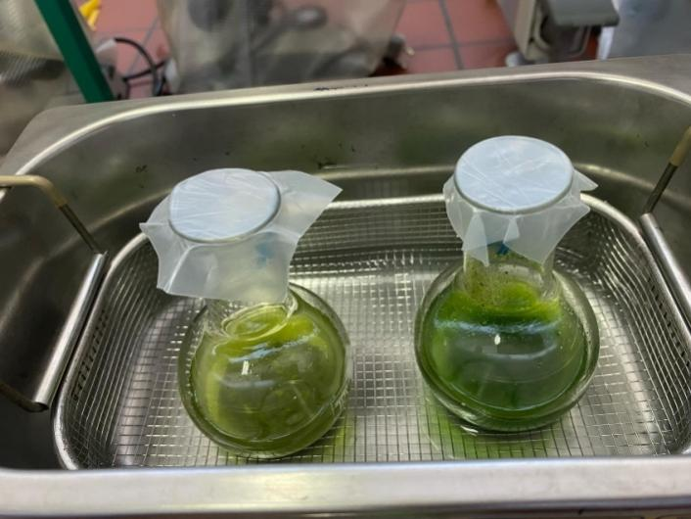

**Figure 4.** The samples were sealed with parafilm and subjected to extraction in a Bandelin Sonorex ultrasonic bath.

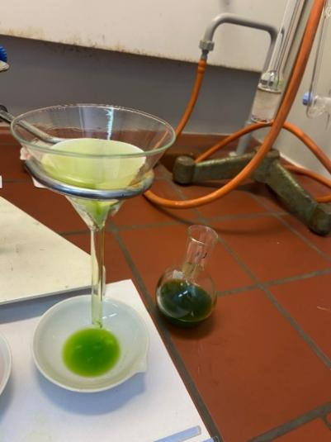

**Figure 5.** Filtration of extracts through filter paper (Macherey – Nagel MN 617 filter paper).

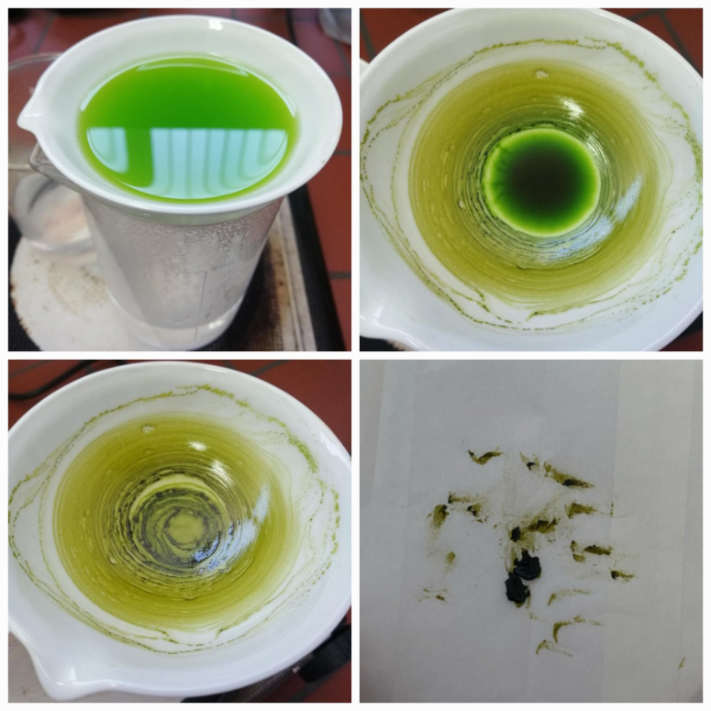

**Figure 6.** Ethanol removal.

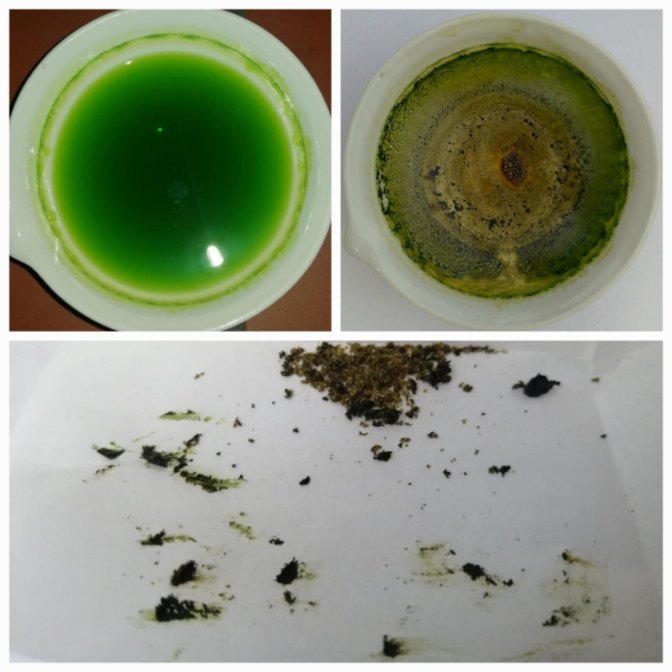

**Figure 7.** Methanol removal.

**2.2. Soxhlet extraction of bioactive compounds from fig leaves (*lat. Ficus carica*)**

Soxhlet extraction is a method that involves continuous extraction at elevated temperatures over a specified period. This technique is particularly suitable for extracting compounds with thermally stable active substances. However, it is important to note that the high temperatures and prolonged extraction times associated with Soxhlet extraction can increase the likelihood of thermal degradation of sensitive compounds.(Qing-Wen Zhang, 2018)

Ficus carica leaf latex contains enzymes and proteins that can denature at elevated temperatures. Studies have shown that ficin, a key protease in this latex, has a thermal denaturation temperature (Tₘ) around 72±1°C under standard conditions. However, the presence of co-solvents like trehalose has been found to significantly increase this denaturation temperature, enhancing the enzyme's thermal stability. Therefore, at temperatures above 72°C, especially without stabilizing agents, the enzymatic activity of ficin is likely to decrease due to denaturation.(Kamsagara Basavarajappa Devaraj, 2008)

The sample preparation began by weighing 10 grams of dried fig leaves, which were previously crushed to increase the extraction efficiency. The crushed leaves were carefully placed in filter paper, forming a thimble, which was sealed at the ends with cotton wool to prevent particles from washing into the extraction chamber. The prepared thimble was then placed in the extraction chamber of the Soxhlet apparatus. Methanol and ethanol, two solvents known for their ability to extract a wide range of bioactive compounds from plant materials, were used for the extraction. 150 mL of solvent was added to the apparatus through a funnel above the condenser, allowing it to flow freely into the lower flask. After adding the solvent, the flask was placed in a water bath. The solvent in the flask evaporated, condensed in the cooled condenser, and dripped back into the extraction chamber. This process was repeated many times, enabling continuous dissolution of the bioactive compounds in the solvent. [Figure 8.]After 6 hours of extraction, the alcoholic extract was transferred to a porcelain dish, and the solvent was removed by evaporation, which allowed for the concentration of bioactive compounds.

**2.2.1. Detailed steps of exctraction and Solvent removal**

1. The sample preparation began by weighing 10 grams of dried fig leaves, which were previously crushed to increase the extraction efficiency. The crushed leaves were carefully placed in filter paper, forming a thimble, which was sealed at the ends with cotton wool to prevent particles from washing into the extraction chamber. The prepared thimble was then placed in the extraction chamber of the Soxhlet apparatus.
2. Methanol and ethanol, two solvents known for their ability to extract a wide range of bioactive compounds from plant materials, were used for the extraction. 150 mL of solvent was added to the apparatus through a funnel above the condenser, allowing it to flow freely into the lower flask. After adding the solvent, the flask was placed in a water bath. The solvent in the flask evaporated, condensed in the cooled condenser, and dripped back into the extraction chamber. This process was repeated many times, enabling continuous dissolution of the bioactive compounds in the solvent.
3. After 6 hours of extraction, the alcoholic extract was transferred to a porcelain dish, and the solvent was removed by evaporation, which allowed for the concentration of bioactive compounds.
4. Ethanol removal. A large laboratory beaker was filled halfway with water and heated to boiling. Once water vapor began to form, a porcelain lab bowl containing the filtrate was placed over the beaker. The ethanol evaporated from the extract due to the heat from the water vapor. After the ethanol was completely removed, the dry fig extract was carefully removed from the porcelain lab bowl, stored in paper, and then transferred to sterile cups for further use.
5. Methanol removal. The porcelain lab bowl containing the methanol extract was left overnight in a laboratory fume hood. As methanol evaporates at room temperature, it is completely removed from the extract. Once the methanol had evaporated, the dry fig extract was carefully removed from the porcelain lab bowl, stored in paper, and then transferred to sterile cups for further use.

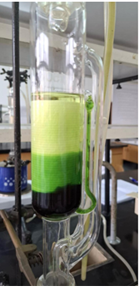

**Figure 8.** A depiction of a Soxhlet apparatus with an extraction chamber containing a paper thimble filled with plant material, while the solvent circulates through the system, enabling the continuous extraction of bioactive compounds

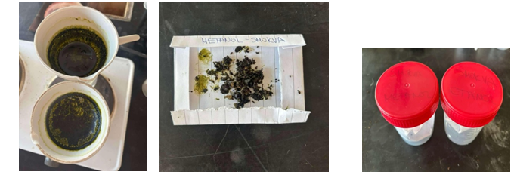

**Figure 9.**Shows solvent evaporation (methanol or 96% ethanol), obtaining dry extract, and packaging the dry extract into sterile bottles

3. results and discussion

The extraction yield is a measure of the solvent efficiency to extract specific components from the original material. It will give an idea about the extractability of the plant studied under different conditions. (Adam et. al, 2019)

The yield of extract (extractable components) expressed on dry weight basis was calculated from the following equation:

$$\text{Percentage yield=}\frac{\text{Weight of extract sample (g)}}{\text{Initial weight of sample (g)}}\text{×100\%}$$

Table 1 : The solvent to drug ratio used for extraction was 1:15.

|  |  |  |  |  |
| --- | --- | --- | --- | --- |
| **Extraction types** | **Extract sample** | **Initial weight of sample (g)** | **Weight of extract sample (g)** | **Precentage yield (%)** |
| **Ultrasonic extraction** | Methanol extract | 2.5 | 0.16 | 6.4 |
| Ethanol (96%) extract | 2.5 | 0.13 | 5.2 |
| **Soxhlet extraction** | Methanol extract | 10.0 | 1.23 | 12.3 |
| Ethanol (96%)extract | 10.0 | 1.21 | 12.1 |

Ficin is a proteolytic enzyme present in the latex of fig leaves (lat. *Ficus carica*). Ficin is thermolabile and denatures at elevated temperatures. Because of this temperature sensitivity, the extraction method significantly affects its stability and presence in the final extract.

We used organic solvents, specifically methanol (boiling point 64.7 °C) and ethanol (boiling point 78.37 °C) in Soxhlet extraction. Since the extraction takes place at temperatures close to or higher than 60 °C, latex is lost during the Soxhlet extraction process even before the drying process, which means that ficin, as the main protein component of the latex, is denatured and does not remain in the extract. As a result, the Soxhlet method produces a dry extract without the presence of ficin, regardless of whether methanol or ethanol is used.

Ultrasonic extraction does not involve elevated temperatures, which allows the preservation of sensitive components such as latex and ficin. After extraction, the solvent is removed in a way that minimizes temperature stress:

The methanol solvent was evaporated spontaneously overnight, resulting in a mucilaginous extract.

The ethanol solvent was removed by evaporation on a water bath, which allows for the preservation of the viscous structure of the extract.

Soxhlet extraction gave a higher percentage of extract but the quality was reduced due to the thermolability of the enzyme at elevated temperatures. The results show that both Soxhlet extraction and Ultrasound-assisted extraction yield higher when methanol was used as the solvent. The Soxhlet method gave a yield of 12.3% and Ultrasound-assisted extraction gave a yield of 6.4% when methanol was used as the solvent. Ultrasound-assisted extraction technique gave a lower yield but a higher preservation of enzyme activity.

Medium polar solvents (aqueous methanol, ethanol, acetone, chloroform, etc.) were more effective than low polar solvents (absolute organic solvents) in extracting polyphenols and other antioxidant compounds from fig. In this study, 50% (v/v) aqueous methanol extract of fig leaves had the highest polyphenol content and antioxidant capacity. (Nakilcioğlu-Taş, 2021).

4. Conclusion

Analyzing the obtained data, determined that the extract prepered by Soxhlet method gives a higher extraction yield. It can be concluded that the extract obtained by the Soxhlet method gives a larger amount of extract (larger quantity) with a longer extraction time, while Ultrasound-assisted extraction gives a higher quality and a shorter time required for extraction. Differences were also observed in the consistency of the extract itself. The extract obtained by the Soxhlet method was in dry form, as opposed to extract obtained by Ultrasound-assisted extraction, where due to the lack of heat treatment, during extraction and evaporation of the solvent, a mucous extract remains that retains ficin and other latex components.These findings confirm that the choice of extraction method is crucial for preserving the bioactive components of fig leaves, especially when the goal is to obtain an extract rich in proteolytic enzymes such as ficin.

In the future, research will focus on determining the antioxidant capacity of the extracted polyphenolic compounds.

References

1. Datwyler S., George D W. (2004). On the origin of the fig: phylogenetic relationships of Moraceae from ndhF sequences, 91(5):767-777. DOI: 10.3732/ajb.91.5.767

2. Badgujar, S. B., Patel, V. V., Bandivdekar, A. H., & Mahajan, R. T. (2014). Tradicional uses, phytochemistry and pharmacology of Ficus carica: A review. Pharmaceutical Biology,52 (11), 1487-1503. <https://doi.org/10.3109/13880209.2014.892515>

3.<https://www.google.com/search?vsrid=CLiczdu57durURACGAEiJDVlZmQxNjRmLTM1MzItNGM0OS1iODc0LTk1OGIxYWIxOTI1N>

4. Azmir J., Zaidul I.S.M, Rahman M.M, Sharif K.M, Mohamed A., Sahena F., Jahurul M.H.A., Ghafoor K., Norulaini N.A.N, Omar A.K.M. (2013) Techniques for extraction of bioactive compounds from plant materials: A review, Journal of Food Engineering 4, 117(4): 426-436 <https://doi.org/10.1016/j.jfoodeng.2013.01.014>

5. Medina-Torres, N., Ayora-Talavera, T., Espinosa-Andrews, H., Sánchez-Contreras, A., & Pacheco, N. (2017). Ultrasound Assisted Extraction for the Recovery of Phenolic Compounds from Vegetable Sources. Agronomy, 7(3), 47. DOI: <https://doi.org/10.3390/agronomy7030047>

6. Yu X, Tu X, Tao L, Daddam J, Li S, Hu F. (2023). Royal Jelly Fatty Acids: Chemical Composition, Extraction, Biological Activity, and Prospect, Journal of Functional Foods, 111, <https://doi.org/10.1016/j.jff.2023.105868>

7. Chawla, A., Kaur, R. and Sharma, A.K. (2012) Ficus carica Linn.: A review on its pharmacognostic, phytochemical and pharmacological aspects. International Journal of Pharmaceutical and Phytopharmacological Research, *1*(4), pp.215-232. DOI:

<https://www.researchgate.net/publication/236154374_Ficus_carica_Linn_A_Review_on_its_Pharmacognostic_Phytochemical_and_Pharmacological_Aspects>

8.Oliveira, A.P., Valentão, P., Pereira, J.A., Silva, B.M., Tavares, F. and Andrade, P.B., (2009). Ficus carica L.: Metabolic and biological screening. Food and Chemical Toxicology, 47(11),pp.28412846.[https://www.tandfonline.com/doi/full/10.3109/13880209.2014.892515#](https://www.tandfonline.com/doi/full/10.3109/13880209.2014.892515)

9. Vaya, J. and Mahmood, S. (2006) Flavonoid content in leaf extracts of the fig (Ficus carica L.), carob (Ceratonia siliqua L.) and pistachio (Pistacia lentiscus L.). *Biofactors*, 28(3‐4),pp.169-175 <https://iubmb.onlinelibrary.wiley.com/doi/abs/10.1002/biof.5520280303>

10. Jang, S., Kelley, K.W. and Johnson, R.W.(2008) Luteolin reduces IL-6 production in microglia by inhibiting JNK phosphorylation and activation of AP-1. Proceedings of the National Academy of Sciences, 105(21), pp.7534-7539.

<https://www.pnas.org/doi/abs/10.1073/pnas.0802865105>

11. Lin, Y., Shi, R., Wang, X. and Shen, H.M. (2008) Luteolin, a flavonoid with potential for cancer prevention and therapy. Current cancer drug targets, 8(7), pp.634-646. <https://www.ingentaconnect.com/content/ben/ccdt/2008/00000008/00000007/art00007>

12. Ostlund Jr, R.E. (2002) Phytosterols in human nutrition. Annual review of nutrition, 22(1), pp.533-549. <https://doi.org/10.1146/annurev.nutr.22.020702.075220>

13. Bouvier, F., Rahier, A. and Camara, B. (2005) Biogenesis, molecular regulation and function of plant isoprenoids. Progress in lipid research, 44(6), pp.357-429.<https://doi.org/10.1016/j.plipres.2005.09.003>

14. Solomon, A., Golubowicz, S., Yablowicz, Z., Grossman, S., Bergman, M., Gottlieb, H.E., Altman, A., Kerem, Z. and Flaishman, M.A. (2006) Antioxidant activities and anthocyanin content of fresh fruits of common fig (Ficus carica L.). Journal of agricultural and food chemistry, 54(20), pp.7717-7723. <https://pubs.acs.org/doi/abs/10.1021/jf060497h>

15. Hossein Tayefi-Nasrabadia, Ilghar Jafari-Navimipour (2011). Study of some biochemical properties and kinetic parameters of polyphenol oxidase from Ficus carica, doi:10.1016/j.clinbiochem.2011.08.625

16. Rašković Brankica, Lazić Jelena,Polović Natalija (2015) Characterisation of general proteolytic, milk clotting and antifungal activity of Ficus carica latex during fruit ripening, <https://doi.org/10.1002/jsfa.7126>

17. <https://www.sciencedirect.com/science/article/pii/S2666910221000715>

18. Mavlonov G, Ubaidullaeva K.A, Rakhmanov M, Abdurakhmonov, I.Y, & AbdukarimovA. (2008) Chitin-binding antifungal protein from Ficus carica latex.Chemistry of Natural Compounds, 44(2),216-219.

DOI:<https://www.researchgate.net/publication/225146348_Chitinbinding_antifungal_protein_from_Ficus_carica_latex>

19. Lazreg ArefH, Gaaliche B, Fekih A, Mars M, Aouni M, Pierre Chaumon J., & Said K. (2011). In vitro cytotoxic and antiviral activities of Ficus carica latex extracts. Natural Product Research, 25(3**),** 310–319. DOI: <https://doi.org/10.1080/14786419.2010.528758>

20. Ay, E., & Duran, N. (2018) Investigation of the antiviral activity of Ficus carica L. latex against HSV-2. International Conference on Advanced Materials and Systems (ICAMS), The National Research & Development Institute for Textiles and Leather-INCDTP. DOI:<https://icams.ro/icamsresurse/2018/proceedings/I_Advanced_Functional_Materials_Biomaterials_03.pdf>

21. Abid, T., & Ali, K.A. (2014). Proteolytic versus surgical removal: The therapeutic effect of fig tree latex (Ficus carica L) on cutaneous and diphtheric forms of avian pox in pigeons (Columba domestica). Iraqi Journal of Veterinary Sciences, 28(1),49–53 DOI: <http://dx.doi.org/10.33899/ijvs.2014.89471>

22. Ghandehari, F., & Fatemi, M. (2018). The effect of Ficus carica latex on 7, 12-dimethylbenz (a) anthracene-induced breast cancer in rats. Avicenna Journal of Phytomedicine, 8(4), 286 PMID: 30377588; PMCID: PMC6204144.

DOI: <https://pubmed.ncbi.nlm.nih.gov/30377588/>

23. Hamed, M.B., El-Badry, M.O., Kandil, E.I., Borai, I.H., & Fahmy, A.S. (2020). A contradictory action of procoagulant ficin by a fibrinolytic serine protease from Egyptian Ficus carica latex. Biotechnology Reports, 27, DOI: <https://doi.org/10.1016/j.btre.2020.e00492>

24. Richter, G., Schwarz, H.P., Dorner, F., & Turecek, P.L. (2002). Activation and inactivation of human factor X by proteases derived from Ficus carica. British Journal of Haematology, 119(4), 1042–1051 DOI: <https://doi.org/10.1046/j.1365-2141.2002.03954.x>

25. Shiraishi, C. S. H., Zbiss, Y., Roriz, C. L., Dias, M. I., Prieto, M. A., Calhelha, R. C., Alves, M. J., Heleno, S. A., V., d. C. M., Carocho, M., Abreu, R. M. V., & Barros, L. (2023). Fig Leaves (*Ficus carica* L.): Source of Bioactive Ingredients for Industrial Valorization. Processes*,*11(4), 1179 DOI:<https://doi.org/10.3390/pr11041179>

26. Qing-Wen Zhang, L.-G. L. &. W.-C. Y., (2018). Techniques for extraction and isolation of natural products : a comprehensive rewiev. Chinese Medicine, Volume 13.

27. Zhao C., Li S., Li C., Wang T., Tian Y., Li X. (2021). Flavonoids from Fig (Ficus carica Linn.) Leaves: The Development of a New Extraction Method and Identification by UPLC-QTOF-MS/MS. Bioactive Compounds from Natural Products: Separation, Characterization and Applications. 11(16), 7718 https://doi.org/10.3390/app11167718

28.Helmenstine, A.M. (2024) Boiling points of ethanol, methanol, and isopropyl alcohol. <https://www.thoughtco.com/boiling-point-of-alcohol-608491>. [2.03.2025].

29. Marcus, Y. and Glikberg, S. (2009)Recommended methods for the purification of solvents and tests for impurities: methanol and ethanol’, Pure and Applied Chemistry. <https://www.degruyter.com/document/doi/10.1351/pac198557060855/html>. [2.03.2025].

30. Alcántara C, Žugčić T, Abdelkebir R, García-Pérez JV, Jambrak AR, Lorenzo JM, Collado MC, Granato D, Barba FJ. (2020). Effects of Ultrasound-Assisted Extraction and Solvent on the Phenolic Profile, Bacterial Growth, and Anti-Inflammatory/Antioxidant Activities of Mediterranean Olive and FigLeaves Extracts. Molecules. 25(7):1718. <https://doi.org/10.3390/molecules25071718>.

31. Hegazy MM, Mekky RH, Afifi WM, Mostafa AE, Abbass HS. (2023). Composition and BiologicalActivities of Ficus carica Latex. In: Ramadan, M.F. (eds) Fig (Ficus carica): Production, Processing, and Properties. Springer, Cham. <https://doi.org/10.1007/978-3-031-16493-4_27>. [1.3.2025.]

32.Huang Z, Foo SC, Choo WS. (2025). A review on the extraction of polyphenolsfrompomegranatepeel for punicalaginpurification: techniques, applications, and future prospects. RSC. DOI: 10.1039/D4FB00304G [20.2.2025]

33. Wang W, Liu X, Wang L, Song G, Jiang W, Mu L, Li J. (2023). Ficus carica polysaccharide extraction via ultrasound-assistedtechnique: Structure characterization, antioxidant, hypoglycemic and immunomodulatoryactivities. UltrasonicsSonochemistry. 10:106680. <https://doi.org/10.1016/j.ultsonch.2023.106680>.

34. Kamsagara Basavarajappa Devaraj, P.R .K. V. P. (2008). Purification, characterization, and solvent- induced thermal stabilization of ficin from Ficus carica. Journal of Agricultural and Food Chemistry, 10 (12), Volume 23, pp. 11417-23.

35. Adam OAO, Abadi RSM, Ayoub SMH. (2019). The Effect of Extraction method and Solvents on yield and Antiooxidant Activity of Certain Sudanese Medicinal Plant Extracts. J Phytopharmacol ; 8(5) : 248-252.

36. Nakilcioğlu-Taş E., (2021). Influence of extraction solvents on the polyphenol contents, composition, and antioxidant capacities of fig (Ficus carica) seedsAn. Acad. Bras. Ciênc. 93 (1) 2021 DOI : <https://doi.org/10.1590/0001-3765202120190526> [04.05.2025]