Original Research Article
Spray drying process study for microencapsulation of phenolic compounds from Sarcocephalus latifolius (sm.) Bruce roots extracts based on two level factorial design

Abstract
Sarcocephalus latifolius (sm.) Bruce is a medicinal plant widely used in traditional herbal medicine to treat several diseases such as fever, pains, dental caries and malaria. In this research, various spray drying process operational parameters such as encapsulating agent to extract ratio (5 – 20 g/ g of extracts), feed suspension flow rate (200–800 mL/h), inlet air temperature (110 – 180°C), and inlet air flow rate (50 - 90 m³/h) were evaluated by screening process using two level factorial design (TLFD). Design-Expert software has been used to find out the significant variables in terms of obtaining high spray drying process yield, Encapsulation efficiency (EE) of polyphenols from S. latifolius roots and least moisture content of spray dried powders. The screening process indicated that encapsulating agent to extract ratio was the most significant and contributing factor affecting the results of spray drying process yield together with encapsulation efficiency of polyphenolic compounds (p < 0.05), while feed suspension flow rate exhibited the least significance and contribution (p > 0.05). Most interactions between the studied parameters were insignificant.
Keywords: Spray drying, Factorial design, microencapsulation, encapsulation efficiency, Sarcocephalus latifolius
- Introduction
Nowadays, herbal goods are sold as powders (dry and comminuted herbs or dried and liquid plant extracts) and liquid preparations (teas, tinctures). Both tablets and capsules are forms of dried extracts (Banker & Rhodes, 2002). In the Rubiaceae family, the genus Sarcocephalus (syn. Nauclea) comprises tropical evergreen trees or shrubs. They are indigenous to Africa and Asia (Gidado et al., 2005), and they are found in large numbers in West African woods and tropical forests (Benin, Burkina Faso, Cameroon, Democratic Republic of Congo, Ghana and Nigeria) (Lamidi et al., 1995). A little tree with several stems, Sarcocephalus latifolius (Sm.) E.A. Bruce (also known as Nauclea latifolia Smith) has glossy, rounded-ovate leaves, an intriguing blossom, and enormous red ball fruit (Haudecoeur et al., 2018). According to Arise et al. (2012), it is also referred to as African peach, Pin cushion tree, and Scille maritime.
The effect of different operating parameters (solid-to-liquid ratio, solvent polarity, irradiation time and microwave irradiation power) on the extraction of phenolic compounds from Sarcocephalus latifolius (sm.) Bruce roots and extraction optimization has been investigated (Touoze et al., 2023).
Spray drying is a process that is widely used to produce powders because it has several advantages over other drying methods used in the chemical and food industries (convective, freeze, or drum-drying). These advantages include the ability to produce powders of a specific particle size and moisture content, as well as being managed in continuous operation, having short production times, cost effectiveness, and handling flexibility (Keshani et al., 2015; Medina-Torres et al. 2019). The stability of biologically active molecules is improved with microencapsulation by spray drying, providing protection against oxygen, water, or any agent that affects their stability (da Rosa et al., 2013; Desai & Park, 2005). The wall material largely determines the durability of microcapsules and the effectiveness of spray drying (Liu et al., 2004, 2001; Zbicinski et al., 2002). Moreover, the quality of final product is influenced by variables related to the spray drying process, such as feed solid content, inlet and outlet air temperatures, feed flow rate, inlet drying air flow rate and atomizer type (Fazaeli et al., 2012). Products with a low moisture content (less than 5%) are more stable when packaged and stored (Sinija et al., 2008). According to reports, the herbal medicine has an impact on the liquid feed composition and spray-drying working conditions. As a result, one of the biggest issues facing the phytomedicine sector is the lengthy period required to develop new products for the manufacturing of medicinal dried extracts.
In the current study, spray drying technology has been applied as the method of microencapsulation of phenolic compounds of extracts from S. latifolius (sm.) Bruce roots. Two level factorial design (TLFD) has been applied for screening of the most significant and effective parameters on the spray drying microencapsulation of extracts. To the best of our knowledge, till now there is no data available in the literature to report a depth assessment of different spray drying variables, namely encapsulating agent to extract ratio (5 – 20 g/ g of extracts), feed suspension flow rate (500–700 mL/h), inlet air temperature (110 – 180°C), and inlet air flow rate (50 - 90 m³/h) using TLFD. In addition, evaluations of most significant factors on the drying process yield, moisture content of spray dried powders and Encapsulation efficiency (EE) of polyphenols from S. latifolius (sm.) Bruce roots extracts using TLFD have also been aimed for the first time. Hence, this research is aimed to accomplish a screening process on the above parameters using TLFD and to evaluate the most significant and effective factors on the spray drying microencapsulation of S. latifolius (sm.) Bruce roots extracts.
2. Materials and methods
2.1 Microwave assisted hydro-ethanolic extraction of S. latifolius roots
The roots of S. latifolius had been collected in close proximity of Bini, Cameroon (7°42.1695'N, 13°54.0631'E, at an elevation of 1128 m above sea level) at Ngaoundere University in October 2022. Dr. Fawa Guidawa has taxonomically verified and validated the plant. A specimen with the reference number 5285/SRF/Cam has been placed in the national herbarium in Yaoundé.
Based on the findings of our earlier research, the microwave assisted extraction method was chosen (Touoze et al., 2023). As a result, the root powders were extracted using the Touoze et al. (2023) method in a microwave chemical reactor OLT-CR-1 model. Using a solution of ethanol:distilled water (70:30 v/v), a suspension of a solid to liquid ratio of 1:15 was prepared for 80 s irradiation time. The extract solutions were then filtered through Whatman filter paper. The obtained liquid extracts were then concentrated with a rotary evaporator (Heidolph, Laborota 4002, Germany) at 60°C before being freeze-dried (freeze dryer Scientz-10ND, China) until completely dried. The dried extracts with Total phenolic content of 69.68±3.98 mg gallic acid equivalents per 100 mg dry extract were obtained.
2.2. Encapsulating agent production: Dextrinization of sweet potato (Ipomoea batatas Lam.) starch
The sweet potato root tubers of were collected at the farm of Institute of Research for Agricultural Development (IRAD) at Ngaoundere. Starch was extracted following the technique described by Tsatsop et al. (2024). Native starch had the following properties: 2.04% solubility, 30.02% amylose content, and 6.15% moisture content (wet basis). subsequently dextrin has been made from sweet potato starch using the pyrodextrinization process Tsatsop et al. (2025) described. Before being placed in sealed plastic bags and kept in a desiccator for a later microencapsulation application with S. latifolius (Sm.) Bruce roots extract, the resulting product was mashed in a porcelain mortar and sieved through a 100 µm mesh. Per DSC examination, the pyrodextrin's properties included a glass transition temperature (Tg) of 139°C and a solubility of 97.24% at 25°C.
2.3. Screening of spray drying process parameters of extracts from the roots of S. latifolius (Sm.) Bruce
Two level factorial design (TLFD) was conducted based on high and low levels of variables selected from preliminary assay namely: encapsulating agent to extract ratio (5 – 20 g/ g of extracts), feed suspension flow rate (500–700 mL/h), inlet air temperature (110 – 180°C), and inlet air flow rate (50 - 90 m³/h). Dextrinized starch produced from sweet potato has been used as encapsulating agent for spray drying during this investigation (Table 1). Spray drying of feed extracts was performed in a co-current small scale spray dryer (TFS-2LS SS304, TEFIC BIOTECH CO. LIMIDED, Xian, China), with two- fluid nozzle with internal orifice of 0.7 mm. With the help of Design Expert Software version 13, 16 experiments were defined and conducted.
Table 1. Level of experimental factors of spray drying process of polyphenolic compounds from the root’s extracts of S. latifolius (Sm.) Bruce
 |  |  | Level
Independent variables | Unit | Code | -1 | +1
Encapsulating agent to extract ratio | g/ g of extracts | A | 5 | 20
Feed suspension flow rate | mL/h | B | 200 | 800
Inlet air temperature | °C | C | 110 | 180
Inlet air flow rate | m³/h | D | 50 | 90
Responses (dependent variables) which have been evaluated during the study were: Process yield (Y₁), Moisture content (Y₂), Encapsulation efficiency (EE) of polyphenols (Y₃).
2.3.1 Preparation of the feed suspension for spray drying process
About x g of sweet potato dextrins (encapsulating agent) was introduced in 100 mL of distilled water, the mixture was added to a glass Erlenmeyer that contained 1 g of dried S. latifolius root extract while being continuously magnetically stirred. This process was repeated until the final liquid feed concentration (x% dextrins and 1% extract) was achieved. Before the spray drying procedure, each homogenous suspension was sonicated for five minutes in an ultrasonic bath (VWR USC 200TH, VWR International, Malaysia). The pressure in chamber were kept constant during the all experiments at 6 bars. The outlet air temperatures used ranged from 85-90°C. The feed suspension flow rate of sample, inlet air temperature, air inlet flow rate and Encapsulating agent to extract ratio were varied from according to experimental design (Table 2). The spray-dried extracts were removed from the cyclone and collector, put in airtight containers, and stored in a desiccator with silica gel at room temperature in the dark.
2.3.2 Process yield of spray drying of S. latifolius roots extracts
The process drying yield was determined by the ratio of the mass of microcapsules obtained after each spray-drying experiment with the initial mass of solids in the liquid feed suspension.
2.3.3 Moisture content of spray dried microcapsules of S. latifolius roots extracts
The AOAC method was used to determine the moisture content of the spray-dried microcapsules sample (AOAC, 2012). A sample of powder weighing approximately 1.0 g was dried in a vacuum oven at 70°C until it reached a constant weight. The samples were characterized in triplicate, and the mean value of the results was recorded.
2.3.4 Encapsulation efficiency of polyphenols of S. latifolius roots extracts
The encapsulation efficiency (EE) of polyphenols was calculated, in accordance with Navarro-Flores et al. (2020). Using the Folin-Ciocalteu reagent, the surface phenolic content and the total phenolic content were ascertained. About 200 mg of microcapsules were dissolved in 2 mL of a 50:8:42 v/v/v methanol/acetic acid/water solution.
The mixture was centrifuged for 5 min at 4000 rpm after being vortexed for 1 min and then sonicated for 20 min at 25°C. The phenolic compounds content in the supernatant was measured after it was collected. The same procedure was applied for determination of the surface phenolic compound content with ethanol/methanol (1:1 v/v) as solvent. The encapsulation efficiency was calculated using the following equation (Eq. 1):
$EE of polyphenols=\frac{({PC}_{total}-{PC}_{surface})}{{PC}_{total}}×100$ (1)
where PC_{total}: the total phenolic compound (mg gallic acid/g) and PC_{surface}: the surface phenolic compound (mg gallic acid/g).
2.4 Statistical analysis
The analysis of variance (ANOVA) was used to determine the p-value and significance of the model in the experiment. For designing the experiment Design Expert software (Version 13) was used.
3. Results and discussion
The screening of four different spray drying process parameters, namely encapsulating agent to extract ratio, feed suspension flow rate, inlet air temperature and inlet air flow rate was accomplished using TLFD. The screening process exhibited that encapsulating agent to extract ratio was the most contributing and significant factor affecting all responses of the process, including process yield, moisture content and Encapsulation efficiency of polyphenolic compounds of roots extract of S. latifolius (African peach). While, feed suspension flow rate was insignificant to obtain high process yield and Encapsulation efficiency of polyphenolic compounds. Other spray drying operational parameters such as encapsulating agent to extract ratio, inlet air temperature and inlet air flow rate also displayed a significant contribution based on their effects and p-values < 0.05.
3.1 Effect of spray drying process variables on spray drying process yield
One of the most important aspects of the cost and efficiency of the spray drying process is process drying yield (Muzaffar et al., 2015). The spray drying process variables influences on the process yield of spray drying of S. latifolius roots extracts are displayed in Table 3 and Figs. 1A-F. Fig. 1A displays the expected and actual results. The results show a strong correlation with the predictions. Concisely, there was no discernible distinction between the expected and experimental values. Pareto charts (Fig. 1B) also provide a clear description of the interactions and main effects of the factors. Whereas orange denotes the positive impact of things, blue indicates the negative. The percentages of factors contribution have been displayed in Table 3. It can be observed that the effects of encapsulating agent to extract ratio (A), inlet air flow rate (D), the interactions AB (encapsulating agent to extract ratio - feed suspension flow rate), AC (encapsulating agent to extract ratio - inlet air temperature), AD (encapsulating agent to extract ratio - inlet air flow rate) and CD (inlet air temperature - inlet air flow rate) are very significant (p < 0.05) on the spray drying process yield. However, the influence of feed suspension flow rate and inlet air temperature were not significant in achieving high process yield (p > 0.05). Effect of encapsulating agent to extract ratio on process yield (Y₁) exhibited the highest contribution of 67.83%, followed by interaction AC (16.47%), CD (6.48%), AD (2.71%) and AB (2.41%).
Table 2. Spray drying process variables and two-level factorial design (TLFD) with studied responses.
 | Encapsulating agent to extract ratio | Feed suspension flow rate | Inlet air temperature | Inlet air flow rate | Process yield | Moisture content | Encapsulation efficiency (EE) of polyphenols
Run | g/ g of extracts | mL/h | °C | m³/h | % | % | %
1 | 5 | 200 | 110 | 50 | 59.69 | 3.84 | 52.35
2 | 20 | 200 | 110 | 50 | 61.94 | 3.59 | 54.79
3 | 5 | 800 | 110 | 50 | 58.48 | 3.45 | 51.25
4 | 20 | 800 | 110 | 50 | 66.94 | 4.89 | 61.46
5 | 5 | 200 | 180 | 50 | 43.44 | 2.48 | 38.30
6 | 20 | 200 | 180 | 50 | 66.94 | 2.21 | 61.02
7 | 5 | 800 | 180 | 50 | 35.43 | 2.85 | 39.44
8 | 20 | 800 | 180 | 50 | 75.19 | 2.71 | 71.91
9 | 5 | 200 | 110 | 90 | 42.69 | 3.58 | 40.33
10 | 20 | 200 | 110 | 90 | 58.69 | 3.44 | 50.98
11 | 5 | 800 | 110 | 90 | 41.19 | 3.12 | 37.87
12 | 20 | 800 | 110 | 90 | 61.36 | 4.74 | 55.29
13 | 5 | 200 | 180 | 90 | 45.19 | 2.41 | 38.99
14 | 20 | 200 | 180 | 90 | 78.44 | 2.23 | 72.93
15 | 5 | 800 | 180 | 90 | 34.97 | 2.87 | 32.78
16 | 20 | 800 | 180 | 90 | 76.44 | 2.74 | 70.46
As it can be seen, increasing in the level of encapsulating agent to extract ratio (A) and inlet air temperature (C) resulted in increasing the of spray drying process yield with positive effects. However, raising the level of inlet air flow rate (D) resulted a decrease in the process yield. And the feed suspension flow rate (B) does not a significant effect on the process yield. In this vein, encapsulating agent to extract ratio showed the most significant effect (Fig. 1B and 1C). Increasing the amount of feed carrier agent reduced the feed's radial speed, which might have increased the drying yield (Bazaria & Kumar, 2016).
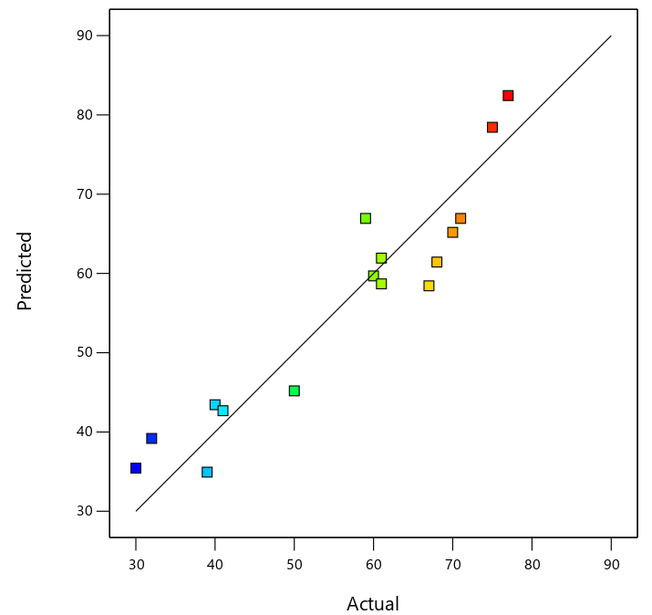  A | 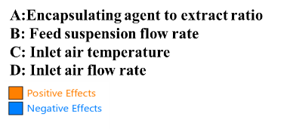  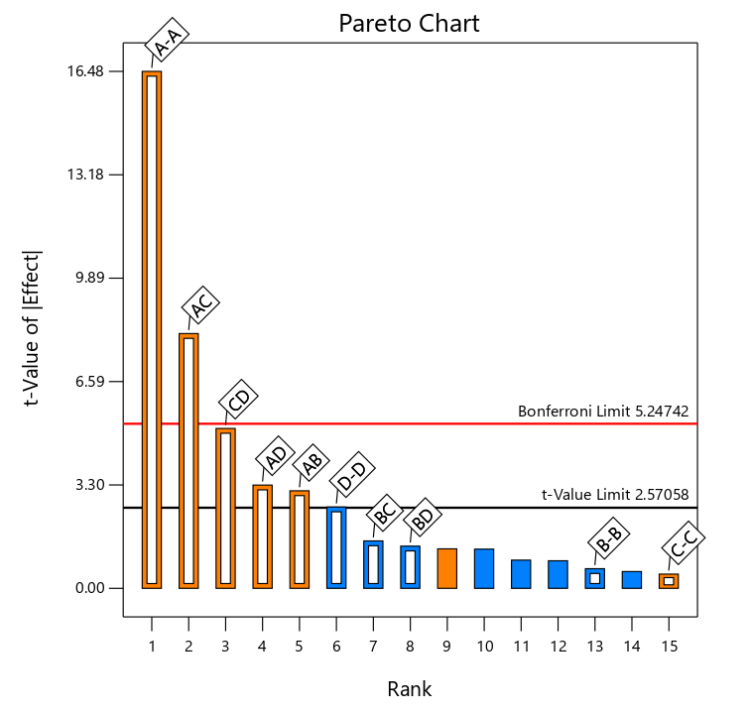  B
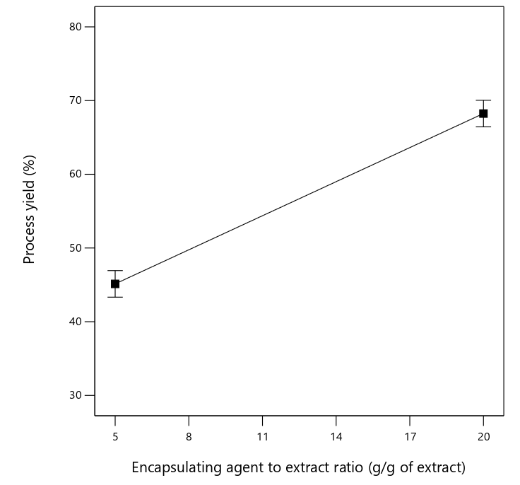  C | 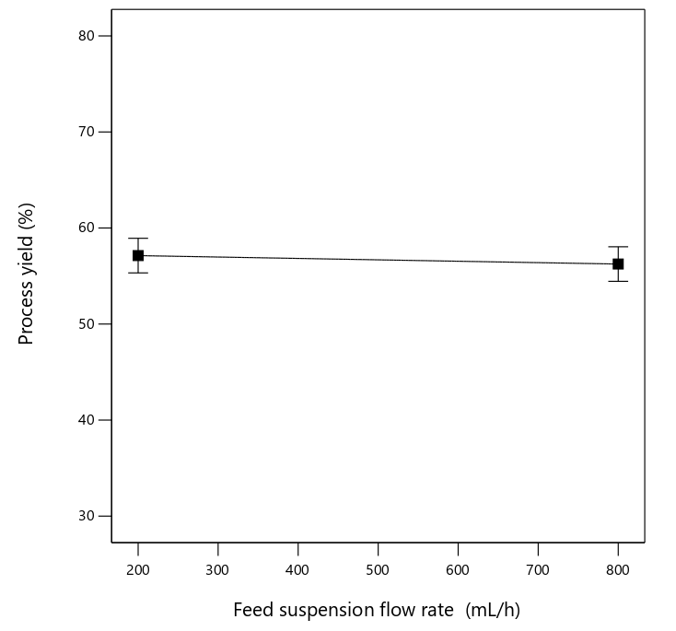  D
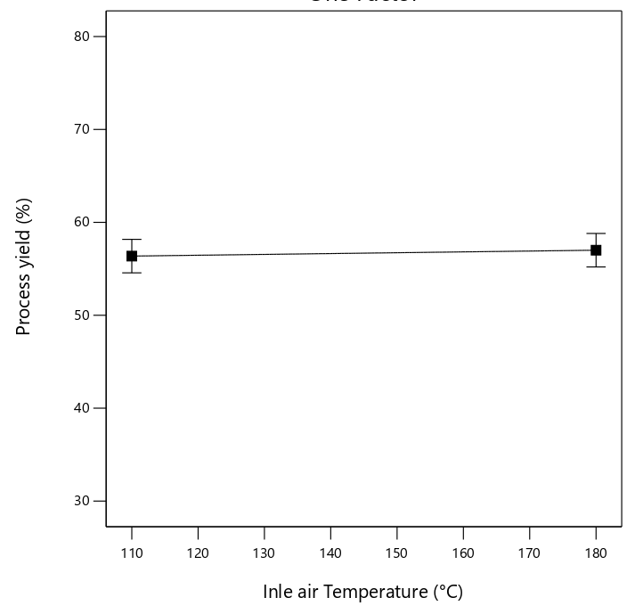  E | 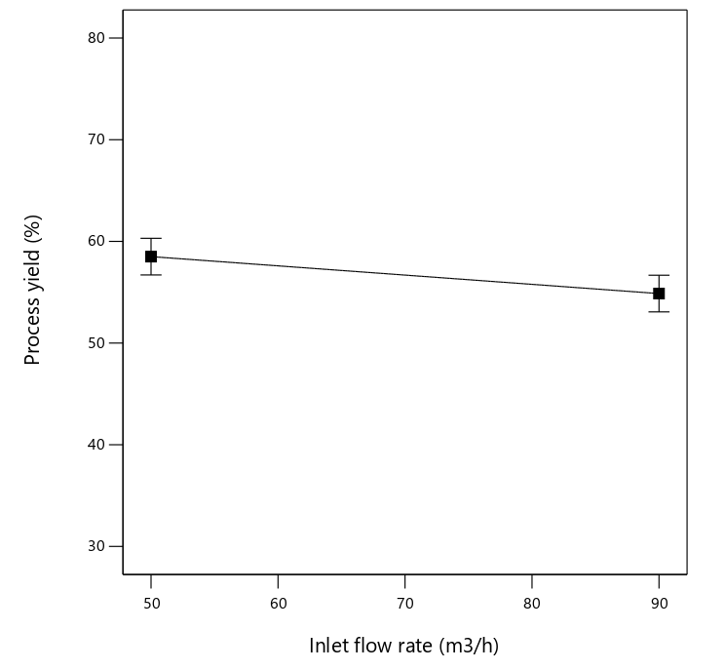  F
Fig. 1. (A) Actual vs predicted result, (B) Pareto chart for process yield, (C) effect of encapsulating agent to extract ratio, (D) effect of feed suspension flow rate, (E) effect of inlet air temperature, (F) effect of inlet air flow rate, on spray drying process yield.
There is a strong link between this result's contribution trend and the earlier research. In fact, the process yield is generally increasing as the encapsulating content increased in suspension formulation to be spray dried. Increasing process yield with increasing carrier agent concentration was observed for tamarind juice (Cynthia et al., 2015), raisin juice (Papadakis et al., 2006), orange juice (Goula & Adamopoulos, 2010), pomegranate juice (Vardin & Yasar, 2012), black mulberry juice (Fazaeli et al., 2012b), persimmon pulp (Du et al., 2014), sugarcane juice (Avila et al., 2015) and sucrose solutions (Jayasundera et al., 2011). The primary cause of this is because a mixture with a higher carrier has a higher glass transition temperature. Lower yield at low carrier material content was also explained by Masters (1991) in relation to feed density.
Table 3. Spray drying process variables and their contribution percentage.
 | Y₁: Process yield |  | Y₂: Moisture content |  | Y₃: Encapsulation efficiency of polyphenolic compounds
Spray drying process parameter | Contribution (%) | P-value | Contribution (%) | P-value | Contribution (%) | P-value
A | 67.83 | <0.0001 | 2.42 | 0.0022 | 67.81 | <0.0001
B | 0.09 | 0.5589 | 8.21 | <0.0001 | 0.28 | 0.2256
C | 0.05 | 0.6708 | 65.66 | <0.0001 | 1.12 | 0.0357
D | 1.68 | 0.0487 | 0.50 | 0.0592 | 2.30 | 0.0082
AB | 2.41 | 0.0266 | 8.40 | <0.0001 | 1.90 | 0.0126
AC | 16.47 | 0.0005 | 7.32 | 0.0001 | 17.91 | <0.0001
AD | 2.71 | 0.0217 | 0.09 | 0.3480 | 2.45 | 0.0072
BC | 0.57 | 0.1914 | 0.005 | 0.8221 | 0.04 | -
BD | 0.45 | 0.2366 | 0.000 | - | 1.44 | 0.0221
CD | 6.48 | 0.0038 | 0.50 | - | 3.84 | 0.0025
A = Encapsulating agent to extract ratio, B= Feed suspension flow rate, C = Inlet air temperature, D = Inlet air flow rate.
3.2 Effect of spray drying process variables on moisture content of spray dried S. latifolius roots extracts
The powder made by spray-drying had moisture contents that were typically less than 5% (Table 2, making it microbiologically safe and long-term storage-friendly. Furthermore, the lower moisture contents of spray-dried powders restrict the water's capacity to function as a plasticizer, which impacts the powder's caking during storage (Santana et al., 2017).
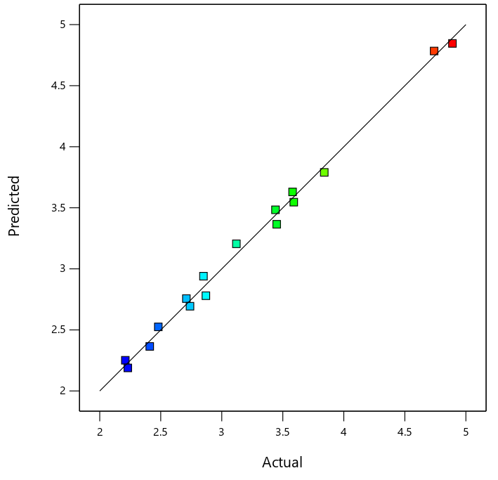  A | 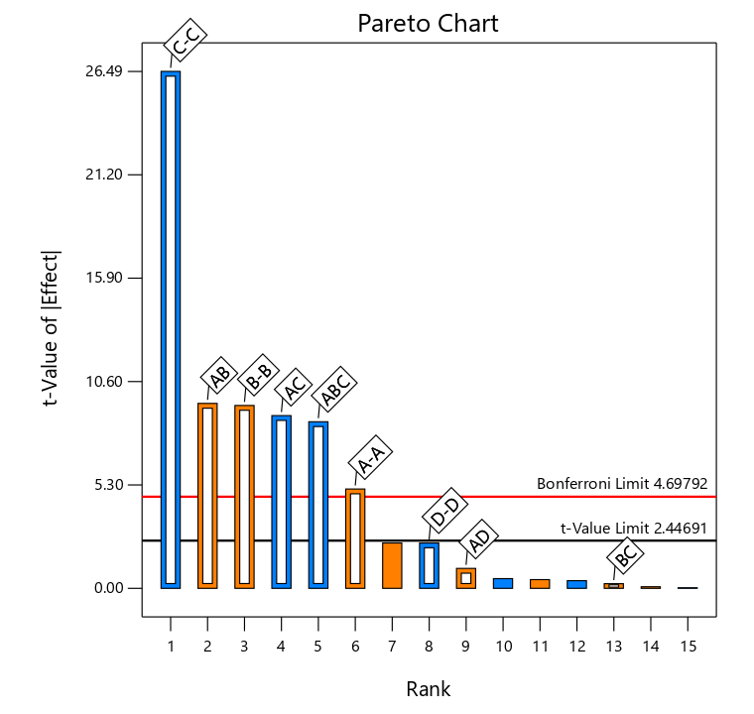  B
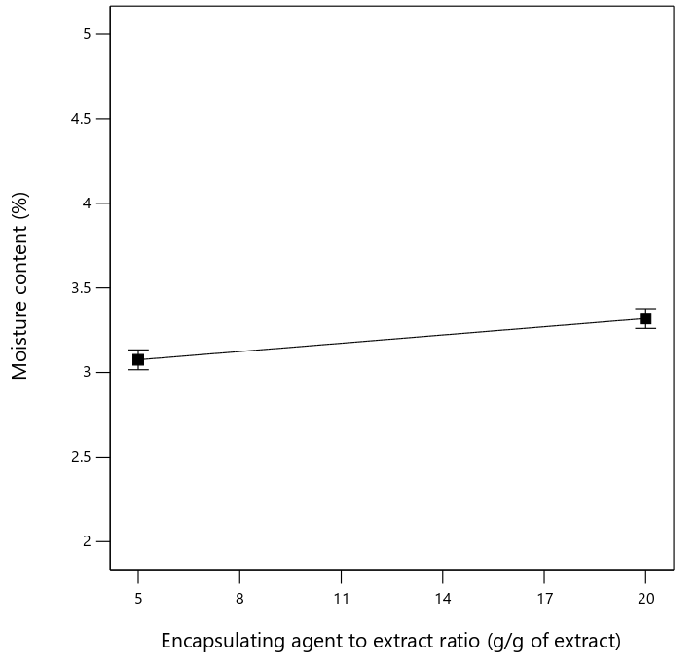  C | 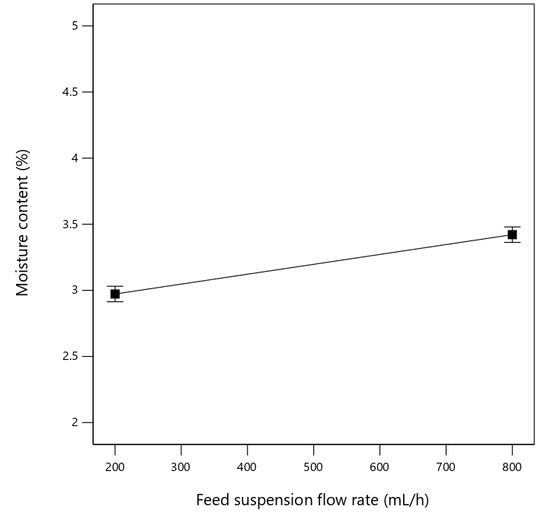  D
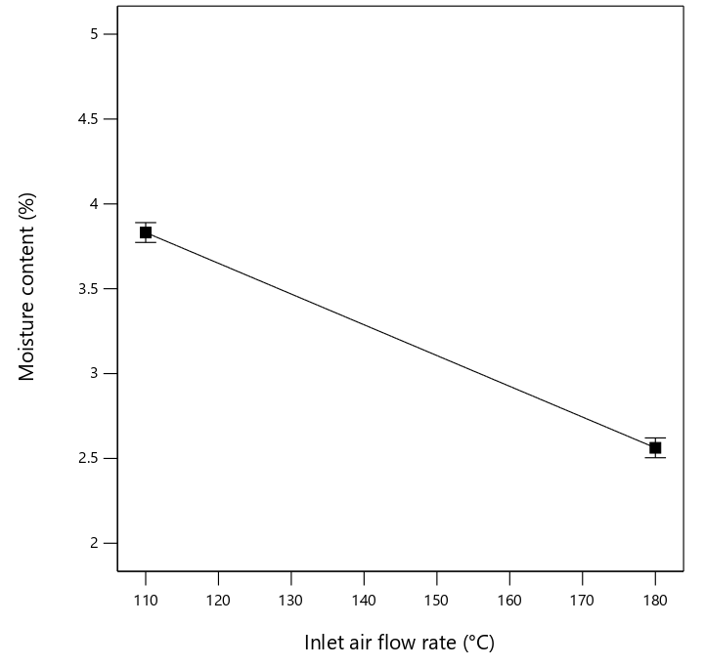  E | 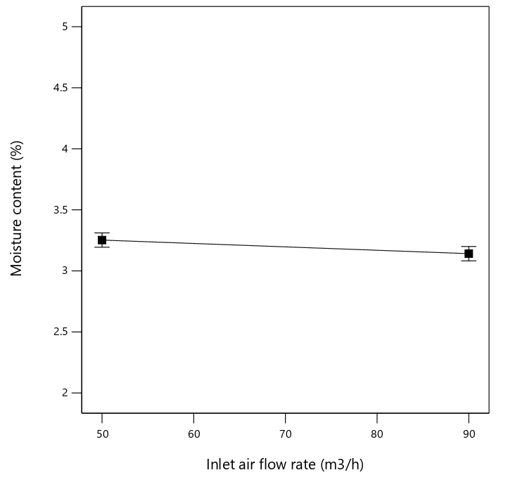  F
Fig. 2. (A) Actual vs predicted result, (B) Pareto chart for moisture content of spray dried extracts, (C) effect of encapsulating agent to extract ratio, (D) effect of feed suspension flow rate, (E) effect of inlet air temperature, (F) effect of inlet air flow rate, on moisture content of spray dried microcapsules extracts.
The spray drying process variables influences on the moisture content of spray dried powders of S. latifolius roots extracts are displayed in Table 2 and Figs. 2A-F. As it can be seen, increasing in the level of encapsulating agent to extract ratio (A) and feed suspension flow rate (B) resulted in increasing the of moisture content with positive effects. However, increasing in the level of inlet air temperature (C) and inlet air flow rate (D) resulted in decreasing the of moisture content. The percentages of contribution of different studied parameters have been displayed in Table 3. It can be observed that the direct effects of encapsulating agent to extract ratio (A), feed suspension flow rate (B), inlet air temperature (C), the interactions AB (encapsulating agent to extract ratio - feed suspension flow rate) and AC (encapsulating agent to extract ratio - inlet air temperature) were very significant (p < 0.05) on the moisture content of powders. Effect of inlet air temperature (C) on moisture content (Y₂) exhibited the highest contribution of 67.83%, followed by feed suspension flow rate (B) (8.21%) and encapsulating agent to extract ratio (A) (2.42%), followed by interaction AB (8.43%) and AC (7.32%).
According to a review of the literature, the moisture content of spray dried product dropped as the amount of wall material in the air flow rate increased. Similar results were found for tamarind (Bhusari et al., 2014), watermelon juice (Quek et al., 2007), black mulberry (Fazaeli et al., 2012a), Rhamnus purshiana (Gallo et al., 2011), gac (Kha et al., 2010), and pineapple juice (Abadio et al., 2004). The amount of free water available for evaporation decreased as the carrier material's content increased. A smaller droplet and a bigger drying surface area are the outcomes of increasing the feed flow rate. A larger area shortens the water's diffusion path in the droplets and improves heat and mass transfer efficiency. Consequently, the moisture content of the finished powders reduces as the atomization speed or pressure increases. This phenomenon was documented for nopal mucilage (Leon-Martínez et al., 2010) and sugarcane powder (Avila et al., 2015).
The moisture content of spray dried product is typically negatively impacted by feed flow rate. The droplets that form have a larger size and have a shorter contact time with the drying air due to the increased flow rate. As a result of less efficient heat transfer, there is less water evaporation in the droplet (Tonon et al., 2008). For tamarind (Muzaffar & Kumar, 2015), carrot-celery (Khalilian Movahhed & Mohebbi, 2016), orange (Chegini & Ghobadian, 2007), and acai (Tonon et al., 2008), the moisture content increased as the feed flow rate increased.
A greater inlet air temperature increases heat transfer and provides the drying medium with more energy. On the other hand, applying extremely high temperatures could result in the immediate creation of a crust on the particle's surface, which would hinder the diffusion of water. As a result, selecting the drying temperature requires caution. The moisture content of spray dried product often decreases as the inlet temperature (and consequently the output temperature) rises (Avila et al., 2015; Goula & Adamopoulos, 2010; Moghaddam, Pero, & Askari, 2017; Quek et al., 2007).
3.3 Effect of spray drying process variables on Encapsulation efficiency (EE) of polyphenols of S. latifolius roots extracts
The spray drying process variables influences on the Encapsulation efficiency (EE) of polyphenols of S. latifolius roots extracts are displayed in Table 2 and Figs. 3A-F. The percentages of contribution of different studied parameters have been displayed in Table 3. It can be observed that the direct effects of encapsulating agent to extract ratio (A), inlet air temperature (C) and inlet air flow rate (D), the interactions AC (encapsulating agent to extract ratio - inlet air temperature), AD (encapsulating agent to extract ratio - inlet air flow rate) and CD (inlet air temperature - inlet air flow rate) were very significant (p < 0.05) on the Encapsulation efficiency (EE) of polyphenols of S. latifolius roots extracts. Linear effect of encapsulating agent to extract ratio (A) on Encapsulation efficiency (EE) of polyphenols (Y₃) exhibited the highest contribution of 67.81%, followed by inlet air flow rate (D) (2.30%) and inlet air temperature (C) (1.12%), followed by interaction AD (2.45%) and CD (3.84%). An increasing in the level of encapsulating agent to extract ratio (A) and inlet air temperature (C) resulted in increasing the of Encapsulation efficiency (EE) of polyphenols with positive effects. However, increasing in the level feed suspension flow rate (B) and inlet air flow rate (D) resulted in slightly decreasing the of Encapsulation efficiency (EE) of polyphenols.
By decreasing the amount of time it takes for a semi-permeable crust to form around the droplets during spray drying, Di Giorgio et al. (2019) claimed that raising the drying temperature (inlet air temperature) can further increase encapsulation efficiency by limiting the amount of core material that diffuses to the particle surface during the drying process. Furthermore, a number of microencapsulate systems created using the same method showed similar encapsulation efficiency (Kalajahi & Ghandiha, 2022; Ozdemir et al., 2012; Mahdi et al. 2020; Rehman et al., 2019).
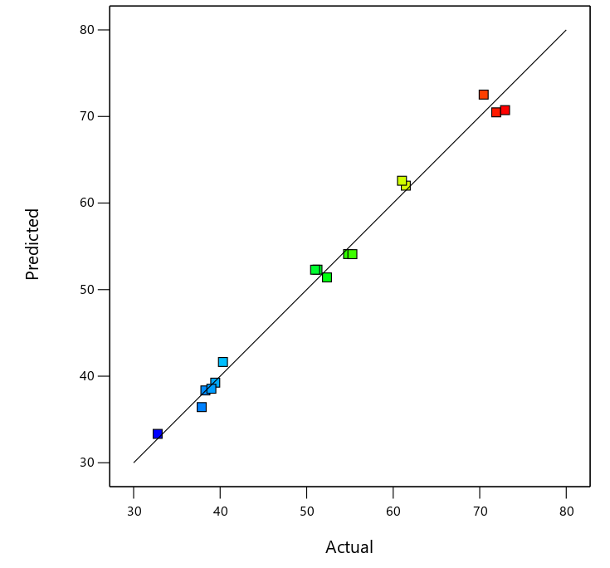  A | 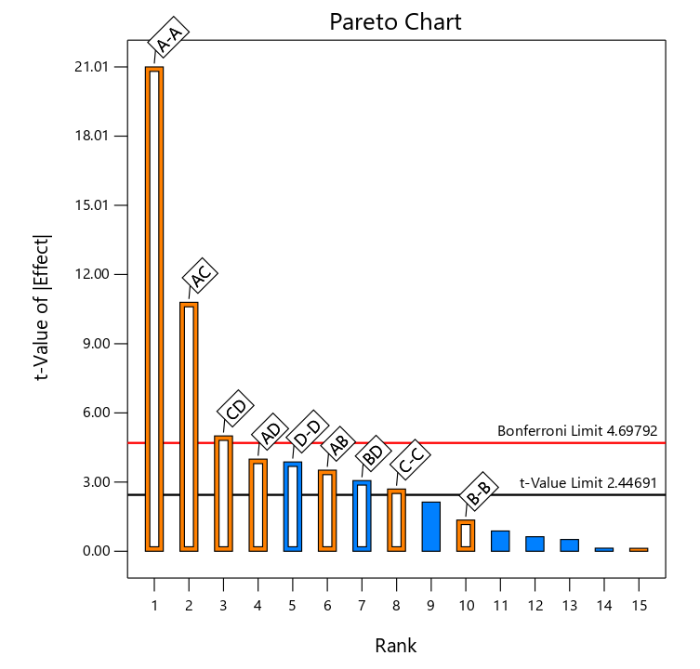  B
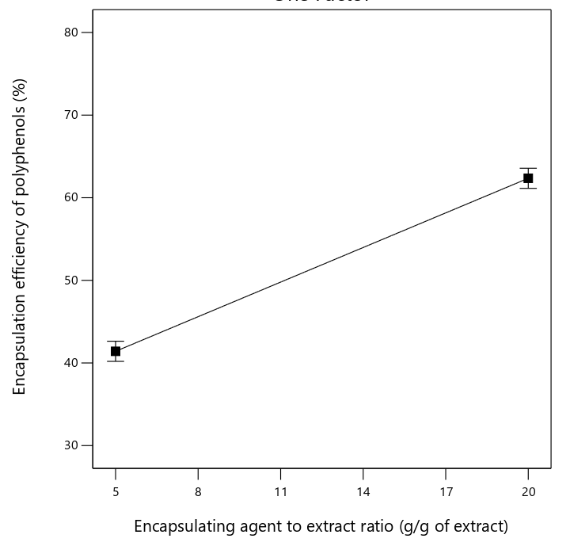  C | 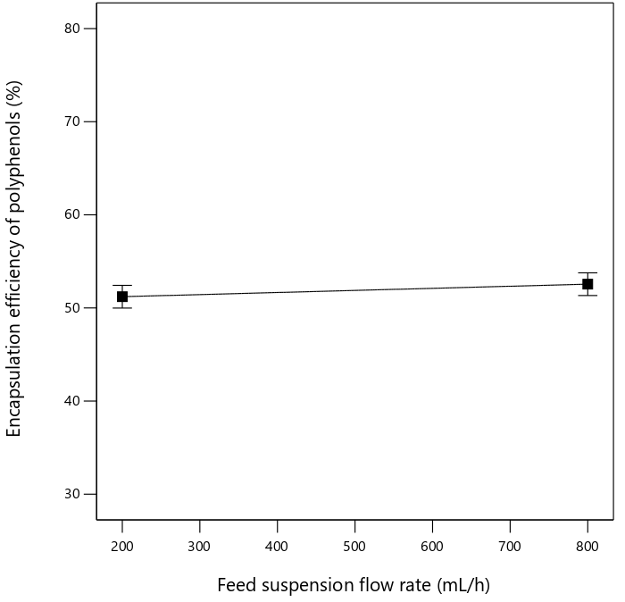  D
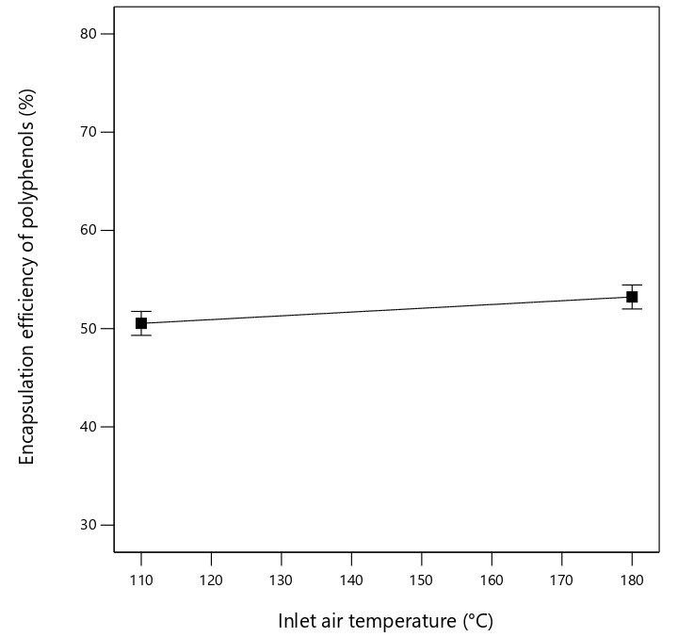  E | 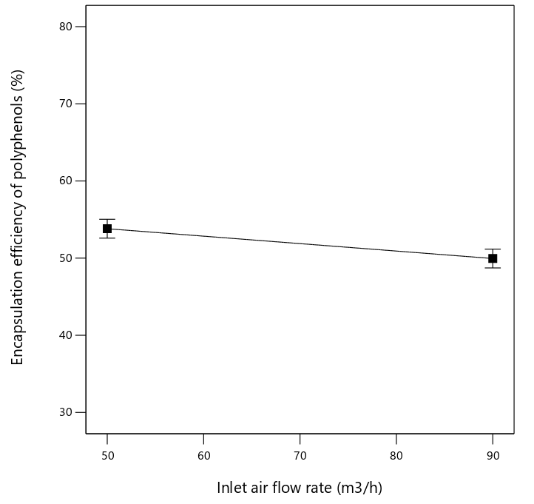  F
Fig. 3. (A) Actual vs predicted result, (B) Pareto chart for Encapsulation efficiency of polyphenolic compounds of roots extract of African peach, (C) effect of encapsulating agent to extract ratio, (D) effect of feed suspension flow rate, (E) effect of inlet air temperature, (F) effect of inlet air flow rate, on Encapsulation efficiency of polyphenolic compounds of roots extract of African peach.
The encapsulation efficiency of polyphenols was strongly impacted by the encapsulating agent content (dextrin) (p < 0.05); an increase in dextrin content generally results in an increase in polyphenol encapsulation efficiency (Fig. 3B, 3C). The effectiveness of the total solids content on encapsulation efficiency was the cause of this phenomena (Mehran et al., 2020).
4. Conclusion
This work aimed to screen using two-level factorial design, four different parameters of spray drying process including encapsulating agent to extract ratio, feed suspension flow rate, inlet air temperature and inlet air flow rate. Each variable was evaluated to find out the most significant and contributing factor in achieving high spray drying process yield, Encapsulation efficiency of polyphenolic compounds of roots extract of African peach and less moisture content in spray dried powders. Results indicated that encapsulating agent to extract ratio was the most significant and contributing factor affecting the results of spray drying process yield together with encapsulation efficiency of polyphenolic compounds (p < 0.05), while feed suspension flow rate exhibited the least significance and contribution (p > 0.05) on these responses. The results also found that the moisture content of powders can be reduced by enhancing the inlet air temperature and inlet air flow rate parameters within an appropriate level. More research is needed to study the optimization of microencapsulation of phenolic compounds from S. latifolius (sm.) roots extract for best application in food and pharmaceutical formulations.
Abbreviations
AOAC: Association of Official Agricultural Chemists; PC: Phenolic Compounds; EE: Encapsulation Efficiency; GAE: Gallic Acid Equivalent; ANOVA: Analyze of variance.
Declarations

Ethics approval and consent to participate: Not applicable.
References
Abadio, F., Domingues, A., Borges, S., & Oliveira, V. (2004). Physical properties of
powdered pineapple (Ananas comosus) juice effect of malt dextrin concentration and atomization speed. Journal of Food Engineering, 64, 285-287.
AOAC (2012). Official method of analysis of the association of the analytical chemists. Gaithersberg, MD: Author.
Arise, R.O., Akintola, A.A., Olarinoye, J.B., Balogun, E.A., (2012). Effects of Nauclea latifolia stem on lipid profile and some enzymes of rat liver and kidney. International Journal of Pharmacology, 10, 23–39.
Avila, E. L., Rodríguez, M. C., Velasquez, H. J. C. (2015). Influence of maltodextrin and spray drying process conditions on sugarcane juice powder quality. Revista Facultad Nacional de Agronomía, Medellín, 68, 7509-7520.
Banker, G.S., Rhodes, C.T., (2002à. Modern Pharmaceutics, fourth ed. Marcel Dekker, New York, NY
Bazaria B., Kumar P., (2016). Optimization of spray drying parameters for beetroot juice powder using response surface methodology (RSM). Journal of the Saudi Society of Agricultural Sciences 17(4):408–415. https://doi.org/10.1016/j.jssas.2016.09.007.
Bhusari, S., Muzaffar, K., & Kumar, P. (2014). Effect of carrier agents on physical and microstructural properties of spray dried tamarind pulp powder. Powder Technology, 266, 354-364.
Chegini, G., Ghobadian, B. (2007). Spray dryer parameters for fruit juice drying. World Journal of Agricultural Sciences, 3, 230-236.
Cynthia, S., Bosco, J. D., Bhol, S. (2015). Physical and structural properties of sprayndried tamarind (Tamarindus indica L.) pulp extract powder with encapsulating hydrocolloids. International Journal of Food Properties, 18, 1793-1800.
da Rosa, C.G., Borges, C.D., Zambiazi, R.C., Nunes, M.R., Benvenutti, E.V., Luz, S.Rd., Rutz, J.K., (2013). Microencapsulation of gallic acid in chitosan, β-cyclodextrin and xanthan. Industrial Crops and Products, 46, 138–146.
Desai, K.G.H., Park, H.J., (2005). Encapsulation of vitamin C in tripolyphosphate crosslinked chitosan microspheres by spray drying. Journal of Microencapsulaion, 22 (2), 179–192.
Di Giorgio L., Salgado P.R., Mauri A.N., (2019). Encapsulation of fish oil in soybean protein particles by emulsification and spray drying. Food Hydrocolloids., 87:891–901.
Du, J., Ge, Z.-Z., Xu, Z., Zou, B., Zhang, Y., & Li, C.-M. (2014). Comparison of the efficiency of five different drying carriers on the spray drying of persimmon pulp powders. Drying Technology, 32, 1157-1166.
Fazaeli, M., Djomeh, Z.E., Ashtari, A.K., Omid, M., (2012a). Effect of spray drying conditions and feed composition on the physical properties of black mulberry juice powder. Food Bioproducion Process., 90(4):667-75.
Fazaeli, M., Emam-Djomeh, Z., Kalbasi-Ashtari, A., Omid, M. (2012b). Effect of process conditions and carrier concentration for improving drying yield and other quality attributes of spray dried black mulberry (Morus nigra) juice. International Journal of Food Engineering, 8, 1-20.
Gallo, L., Llabot, J. M., Allemandi, D., Bucala, V., Pina, J. (2011). Influence of spray drying operating conditions on Rhamnus purshiana (Cascara sagrada) extract powder physical properties. Powder Technology, 208, 205-214.
Gidado, A., Ameh, D.A., Atawodi, S.E., (2005). Effect of Nauclea latifolia leaves aqueous extracts on blood glucose levels of normal and alloxan-induced diabetic rats. African Journal of Biotechnology, 4, 91–93.
Goula, A. M., Adamopoulos, K. G. (2010). A new technique for spray drying orange juice concentrate. Innovative Food Science & Emerging Technologies, 11, 342-351.
Haudecoeur, R., Peuchmaur, M., Pérès, B., Rome, M., Taïwe, G.S., Boumendjel, A., Boucherle, B., (2018). Traditional uses, phytochemistry and pharmacological properties of African Nauclea species: a review. Journal of Ethnopharmacology. 212, 106–136.
Jayasundera, M., Adhikari, B., Adhikari, R., & Aldred, P. (2011). The effect of protein types and low molecular weight surfactants on spray drying of sugar-rich foods. Food Hydrocolloids, 25, 459-469.
Keshani, S., Daud, W.R.W., Nourouzi, M.M., Namvar, F., Ghasemi, M., (2015). Spray drying: an overview on wall deposition, process and modeling. Journal of Food Engineering, 146, 152–162.
Kha, T. C., Nguyen, M. H., & Roach, P. D. (2010). Effects of spray drying conditions on the physicochemical and antioxidant properties of the Gac (Momordica cochinchinensis) fruit aril powder. Journal of Food Engineering, 98, 385-392.
Khalilian Movahhed, M., Mohebbi, M. (2016). Spray drying and process optimization of carrot-celery juice. Journal of Food Processing and Preservation, 40, 212-225.
Lamidi, M.E., Oliver, R., Faurel, L., Debrauwer, L., Nze, E., Balandsard, G., 1995.
Leon-Martínez, F., Mendez-Lagunas, L., Rodríguez-Ramírez, J. (2010). Spray drying of nopal mucilage (Opuntia ficus-indica): Effects on powder properties and characterization. Carbohydrate Polymers, 81, 864-870.
Liu, Z.Q., Zhou, J.H., Zeng, Y.L., Ouyang, X.L., (2004). The enhancement and encapsulation of Agaricus bisporus flavor. Journal of Food Engineering, 65 (3), 391–396.
Mahdi, A.A., Mohammed, J.K., Al-Ansi, W., Ghaleb, A.D.S., Al-Maqtari, Q.A., Ma, M., et al.. (2020). Microencapsulation of fingered citron extract with gum Arabic, modified starch, whey protein, and maltodextrin using spray drying. International Journal of Biological Macromolecules.,152:1125–1134.
Masters, K. (1991). Spray drying handbook. Essex, UK: Longman Scientific and Technical.
Medina-Torresa, L., Núñez-Ramírez, D.M., Calderasc, F., González-Laredod, R.F., R. Minjares-Fuentese, M.A. Valadez-Garcíaf, M.J. Bernad-Bernada, O. Manero (2019). Microencapsulation of gallic acid by spray drying with aloe vera mucilage (Aloe barbadensis miller) as wall material Industrial Crops & Products 138, 111461.
Mehran, M., Masoum, S., Memarzadeh, M. (2020). Microencapsulation of Mentha spicata essential oil by spray drying: Optimization, characterization, release kinetics of essential oil from microcapsules in food models. Industrial Crops & Products; 154.
Moghaddam, A. D., Pero, M., Askari, G. R. (2017). Optimizing spray drying conditions of sour cherry juice based on physicochemical properties, using response surface methodology (RSM). Journal of Food Science and Technology, 54, 174-184.
Muzaffar, K., Kumar, P. (2015). Parameter optimization for spray drying of tamarind pulp using response surface methodology. Powder Technology, 279:179–184.
Navarro-Flores, M.J., Ventura-Canseco, L.M.C., Meza-Gordillo, R., Ayora-Talavera, TdR, Abud-Archila M. (2020). Spray drying encapsulation of a native plant extract rich in phenolic compounds with combinations of maltodextrin and non-conventional wall materials. Journal of Food Science and Technology, 57(11):4111–4122.
Papadakis, S. E., Gardeli, C., Tzia, C. (2006). Spray drying of raisin juice concentrate. Drying Technology, 24, 173-180.
Ozdemir, N., Bayrak, A., Tat, T., Altay F., Kiralan, M., Kurt, A. (2012). Microencapsulation of basil essential oil: Utilization of gum arabic/whey protein isolate/maltodextrin combinations for encapsulation efficiency and in vitro release. Journal of Food Measurements Characteristic, 15:1865–1876.
Quek, S. Y., Chok, N. K., & Swedlund, P. (2007). The physicochemical properties of spray-dried watermelon powders. Chemical Engineering and Processing: Process Intensification, 46, 386-392.
Rehman, A., Ahmad, T., Aadil, R.M., Spotti, M.J., Bakry, A.M., Khan. I.M., et al.. Pectin polymers as wall materials for the nano-encapsulation of bioactive compounds. Trends Food Sci Technology, 2019;90:35–46.
Santana, A. A., Martin, L. G. P., de Oliveira, R. A., Kurozawa, L. E., & Park, K. J. (2017). Spray drying of babassu coconut milk using different carrier agents. Drying Technology, 35, 76-87.
Sinija, V.R., Mishra, H.N. (2008). Moisture sorption isotherms and heat of sorption of instant (soluble) green tea powder and green tea granules. Journal of Food Engineering; 86(4):494-500.
Tonon, R. V., Brabet, C., Hubinger, M. D. (2008). Influence of process conditions on the physicochemical properties of açai (Euterpe oleraceae Mart.) powder produced by spray drying. Journal of Food Engineering, 88, 411-418.
Touoze, A.S.Z, Toze, F.A., Tsatsop, T.R.K., Kamdem, W.A.F., Ngassoum, M.B., Kenmogne, S.B. (2023). Study of the Effect of Different Operating Parameters on the Microwave - Assisted Extraction of Phenolic Compound from the Roots of Sarcocephalus latifolius (sm.) Bruce. Ijsrm. Human, 24(2):31-45.
Tsatsop, T.R.K., Djiobie, G.E.T., Panyoo, E.A., Chendjou, S.M.S., Oladimeji, A.O., Nguimbou, R.M., Ngassoum, M.B. (2024). Process optimization in the pyroconversion of native sweet potato starch: structural and functional characterization of pyrodextrin. Discover Food., 4:68.
Tsatsop, T.R.K., Djiobie, G.E.T., Nkenmogne, I.E.K., Chendjou, S.M.S., Nguimbou, R.M., Ngassoum, M.B. (2025). Development of hydrocolloid mixtures from pyrodextrinized sweet potato starch and mucilage of Triumfetta cordifolia: Physicochemical characterization of formulated wall materials. Journal of Molecular Liquid, 422 : 127177.
Vardin, H., Yasar, M. (2012). Optimisation of pomegranate (Punica Granatum L.) juice spray-drying as affected by temperature and maltodextrin content. International Journal of Food science & Technology, 47, 167-176.
Zbicinski, I., Delag, A., Strumillo, C., Adamiec, J., 2002. Advanced experimental analysis of drying kinetics in spray drying. Chemical Engineering Journal, 86 (1), 207–216.
Kalajahi, S.E.M., Ghandiha, S. (2022). Optimization of spray drying parameters for encapsulation of Nettle (Urtica dioica L.) extract. LWT - Food Science and Technology,158:113149.

