**Incidental Discovery of Cholecystohepatic Duct during Laparoscopic Cholecystectomy: Do we clip it? Case Report and Literature Review.**

**Abstract:**

Cholecystohepatic bile duct (CHD) is a rare peculiar anatomical variation of clinical significance. It is defined as a network of bile ducts located in the perihepatic connective tissue of the gallbladder fossa that is usually responsible for the biliary drainage of a sector, segment, or limited area of the liver, connecting directly to the extrahepatic bile duct, cystic duct, or gallbladder.

We report the case of type III accessory subvesical bile duct that was detected incidentally during laparoscopic cholecystectomy. Intraoperative cholangiogram confirmed an aberrant communication with the biliary tree that was clipped and transected. Patient experienced a transient hyperbilirubinemia that was resolved spontaneously without any sequelae.

CHD is an unusual surgical finding whose injury can cause prolonged bile leakage, leading to delay in post-operative recovery. Careful critical view of safety method during dissection can aid in better identification and hence avoidance of evitable complications.

**Keywords:**

Cholecystohepatic duct (CHD); Biliary Anomaly; Laparoscopic Cholecystectomy; Hyperbilirubinemia.

**Introduction:**

Cholecystohepatic duct (CHD) is a rare anatomical variations of extra-hepatic biliary apparatus. Its injury can lead to prolonged bile leakage and post-operative complications [1]

Herein, we report the case of an accessory bile duct that was incidentally detected during laparoscopic cholecystectomy and was successfully managed with favorable.

**Case presentation**

A 42 years old male patient presented with a one-month history of colicky abdominal pain located at the right upper quadrant radiating to the back and associated with nausea. Pain was mainly postprandial increased with fatty meals and was relieved by painkillers. Clinical Examination revealed RUQ tenderness with absent Murphy sign. Blood tests including CBC, liver function, amylase, lipase, liver and kidney functions were all normal ranges. Ultrasound scan demonstrated mild GB thickness with variable in size stones, largest measuring 2x1.5 cm.

Laparoscopic cholecystectomy was indicated, Critical view of safety was achieved and Callot’s triangle was identified exposing both cystic duct and cystic artery. During dissection a 4 mm tubular structure was unexpectedly noticed connecting the liver parenchyma to the gall bladder entering just above its neck (Fig 1,2). An Intraoperative cholangiogram was performed through aspiration needle punctured at the level of infundibulum to clearly view the accessory duct and map its relation to biliary system (Fig 3). No direct communication to the common bile duct nor the cystic duct was visualized. Assessment of both the cystic and common bile ducts had no anatomical anomalies or stones. clips were applied over the cholecystohepatic duct, the cystic duct and the cystic artery. Procedure was completed in the usual fashion and a drain was placed in the area.

Postoperative course was uneventful and only marked with transient abnormal increase in bilirubin levels up to 50 mmol/L (total and direct) and liver functions. Drain output was serous and minimal that was eventually removed. Follow up Ultrasound revealed no collection or intrahepatic biliary radical dilatation. MRCP was done on the third day post-operative: Subvesical bile duct (type III cholecystohepatic duct) sectional duct draining mainly the anterior inferior aspect of the right hepatic lobe collecting drainage of segment V and partially VI of the liver with sideway communication directed to join the gallbladder (fig 4).

At the fourth post-operative day there was marked decrease in bilirubin levels. Drain was removed and the patient was discharged in a good medical condition. Follow up after 1 year, patient had no complaint with unremarkable US and LFTS.

**Discussion**

Laparoscopic cholecystectomy is a common keyhole procedure that is usually performed to treat gallbladder pathology [2]. Gallbladder anatomy has several vascular and biliary variations that could affect surgery and its outcome [3,4]. Cholecystohepatic duct was first introduced to literature in 1945 by Neuhof et al. [5]. It was described as an anomaly that caused the hepatic ducts to drain a certain area of the liver into the gallbladder. And that should be differentiated from the term “cystohepatic duct” which is defined as those ducts which drain variable portion of the right lobe into the cystic duct. So the term cholecystohepatic duct is much more appropriate [6].

Although there is variability in the literature Schnelldorfer described four types of subvesical bile ducts [1]

1. **segmental/sectorial subvesical bile duct**
   * variant bile duct with a superficial course along the gallbladder fossa
   * this is a normal bile duct in segment 5 or 8 that courses near the gallbladder without contacting it
   * drains into the right anterior sector duct (RASD) or right posterior sector duct (RPSD)
2. **accessory subvesical bile duct**
   * additional duct usually arising from segment 5 or 8, coursing superficially along the gallbladder fossa and draining into the common bile duct (or rarely into the cystic duct)
3. **cholecystohepatic bile duct**
   * (often segment 5) bile duct that connects the [gallbladder](https://radiopaedia.org/articles/gallbladder?lang=us) to a larger biliary sectorial duct
4. **aberrant subvesical bile duct**
   * a mesh of small bile ducts in the liver parenchyma of the gallbladder fossa draining into small intrahepatic bile ducts

CHD is an anatomical variant of the biliary system that facilitate bile drainage from the liver. This duct is distinct from the more commonly recognized bile duct of Luschka, which is a smaller, often vestigial duct located near the gallbladder bed. These terms are not to be confused with the *subvesical ducts* (of Luschka) running in the gallbladder plate but not draining into the gallbladder (Fig 5).

In 1863 Luschka first described small bile ducts lying in the gallbladder fossa [7], either as blind ducts emerging from the right lobe of the liver, or ducts running subserosally to join one of the main biliary channels later. He stated that he did not believe that these ducts entered the gallbladder lumen, thereby differing from true cholecystohepatic ducts [8].

Cystohepatic and cholecystohepatic ducts may occur in the presence of normal common hepatic and common bile ducts [9]. The hepatic territory drained by these ducts is variable. In the series of Champetier and colleaguesthe majority were segmental or subsegmental ducts. Cholecystohepatic duct is typically a thicker-walled bile duct, approximately 3 mm in diameter, that courses through the gallbladder fossa or the posterior gallbladder wall. It usually drains into the cystic duct or the right hepatic duct. In some cases, it may serve as the sole drainage pathway for bile from the intrahepatic to the extrahepatic biliary system, particularly in infants with congenital biliary anomalies [10].

Cholecystohepatic duct is clinically significant due to its potential propensity to cause complications. If this duct is inadvertently injured or divided during surgery, it can lead to bile leakage, a condition that may result in postoperative bile peritonitis. Therefore, it is crucial for surgeons to be aware of this anatomical variant to prevent such consequences. In our case the anatomy of the duct was well visualized during dissection and the intraoperative cholangiogram established its sectorial nature. The decision of clipping the duct may have been rushed and if there was adequate facilities proper probing of the duct and injection of the dye inside it would have helped us to determine the exact nature of the duct and would have prevented the sudden increase in the liver function tests. We were lucky that there were intercommunicating bile ducts between this sector of the liver to the other parts, which explains the transient rise of bilirubin levels post-operatively that was mostly due to stasis secondary sudden closure of the cholecystohepatic duct [11,12].

Imaging techniques, particularly cholangiography, are essential for identifying the cholecystohepatic duct during surgery. Intraoperative cholangiography can help delineate the ductal anatomy and assessment of its drainage allowing for better decision to safe removal of the gallbladder with reduced risk of injury to this variant duct.

**Conclusion**

Cholecystohepatic duct is a rare congenital anomaly of the extrahepatic biliary apparatus. Careful surgical technique and understanding the anatomy and potential variations can aid to prevent evitable complications. In case of any suspicion intraoperative cholangiogram is recommended. We report this unusual anatomic entity to increase its awareness and to highlight that in some cases clipping is a valid therapeutic option.

**References**

1 - Schnelldorfer T., Sarr M.G., Adams D.B. What is the duct of luschka? A systematic review. J. Gastrointest. Surg. 2012;16:656–662.

2 - Neuhof H, Bloomfield S. The surgical significance of an anomalous cholecystohepatic duct. Ann Surg. 1945;122:260–5.

3 - Balija M., Huis M., Szeda F., Bubnjar J., Stullhofer M. Laparoscopic cholecystectomy-accessory bile ducts. Acta Med. Croatica. 2003;57(2):105–109.

4 - Salah Termos,Alrashidi M1, Alrushaidan S 2, Alqudeimat Y1, AlBader MSB 1, Almojil K1 and Alkhalil AM1 Strawberry Gallbladder: A Distinctive Type of Cholesterolosis Case Report and Literature Review, Ann Med Clin Cas Rept, 2024; 1(2): 1

5 - Neuhof H, Bloomfield S. The surgical significance of an anomalous cholecystohepatic duct. Ann Surg. 1945;122:260–5.

6. - Champetier J, Létoublon C, Alnaasan I, et al. The cystohepatic ducts: surgical implications. Surg Radiol Anat. 1991;13:203–11.

7- Luschka H. H Lauppschen, Buchhandlung; Tubingen: 1863. DieAnatomie des Menschlichen Bauches; p. 255

8 - Jamshidi M, Obermeyer RJ, Garcia G, Hashmi M. Post-laparoscopic cholecystectomy bile leak secondary to an accessory duct of Luschka. Int Surg. 1999;84:86–8

9- Champetier J, Letoublon C, Alnaason I, Charvin B. The cystohepatic ducts: surgical implications. Surg Radiol Anat. 1991;13:203–11.

10- Lien H.H., Huang C.S., Shi M.Y., Chen D.F et al Management of bile leakage after laparoscopic cholecystectomy based on etiological classification. Surg.Today. 2004;34:326–330.

11- Hussain J, Alrashed AM, Alkhadher T, Wood S**.** Gall stone ileus: Unfamiliar cause of bowel obstruction. Case report and literature review. Int J Surg Case Rep. 2018; 49:44-50.

12- B. Doumenc, M. Boutros, R. Degremont. Biliary leakage from gallbladder bed after cholecystectomy Luschka or hepatocystic duct. Morphologie Vol 100, issue 328, March 2016:36-40.

**Figure Legend**

Figure 1: CVS, Posterior surface. CHD (blue arrow), CD and clipped CA (black arrows).

Your text here

sa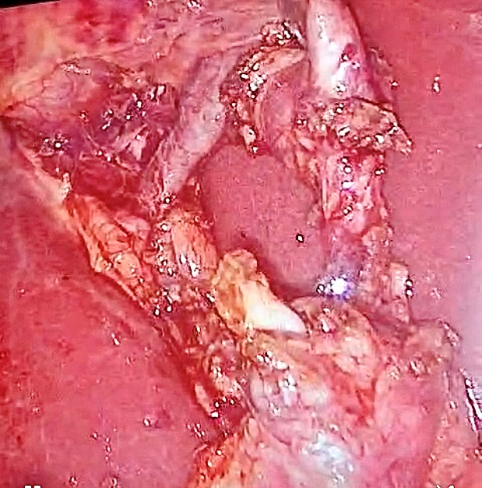

Figure 2: CVS, Anterior surface. CHD (blue arrow), CD (black arrow)

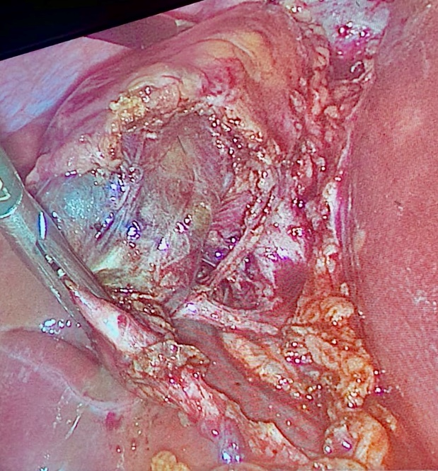

Figure 3:IOC, CHD joining the posterior right hepatic duct (Arrow).

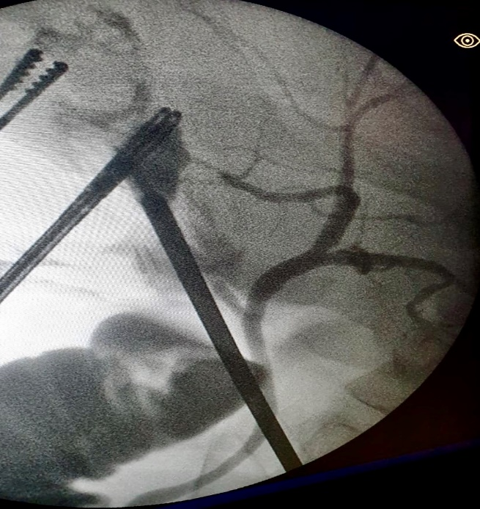

Figure 4: MRCP and coronal MRI cut showing interupted CHD due to clipping (Arrow)

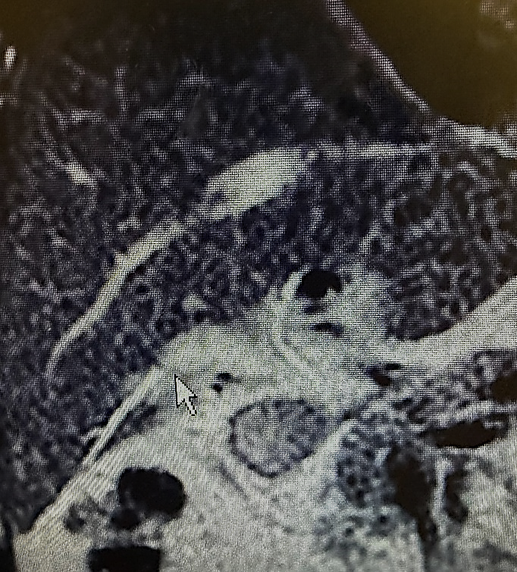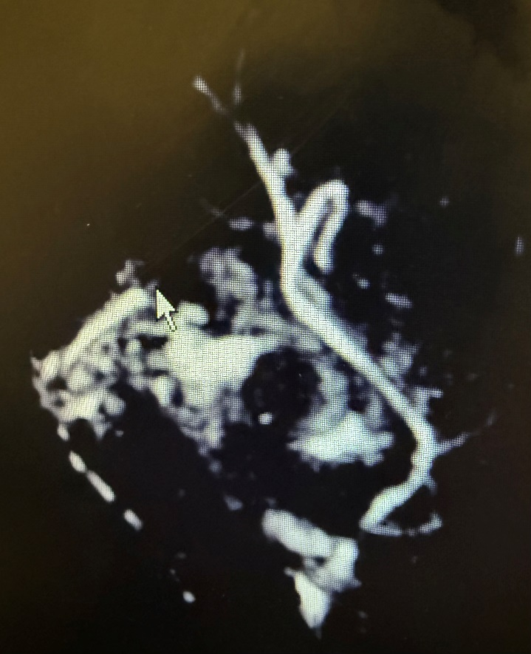

Figure 5: Anatomic difference between CHD and Duct of Luschka [12]

