Original Research Article

EXAMINING THE MODERATING ROLE OF MINDFULNESS IN THE RELATIONSHIP BETWEEN WORKPLACE STRESSORS AND SUBJECTIVE WELL-BEING

.
ABSTRACT

Aims: This study examined the impact of workplace stressors on employees’ subjective well-being and evaluated the mediating role of coping strategies and the moderating role of mindfulness within this relationship.
Study Design: A cross-sectional quantitative survey design was employed.
Place and Duration of Study: The study was conducted in Lithuania between January and April 2025.
Methodology: A total of 181 employees from various professional sectors participated in an online questionnaire survey. Standardised instruments were used to measure workplace stress, coping strategies, mindfulness, and subjective well-being. Data were analysed using multiple regression, mediation, and moderation models via the PROCESS macro.
Results: Workplace stressors were significantly associated with lower subjective well-being. Coping strategies partially mediated this relationship: problem-solving and social support were positively associated with well-being, while avoidant coping and emotional venting were negatively associated. Mindfulness moderated the relationship between stress and coping, reducing reliance on avoidant strategies and attenuating increases in problem-focused and support-seeking coping under stress.
Conclusion: The findings suggest that workplace stress negatively affects well-being, but this effect is shaped by the type of coping strategies used and moderated by mindfulness. Interventions promoting adaptive coping and cultivating mindfulness may buffer employees against the psychological costs of occupational stress.

Keywords: Workplace stress, Subjective well-being, Mindfulness, Coping strategies, Mediation, Moderation

1. INTRODUCTION

Workplace stress has become an increasingly pressing concern in organisational psychology, with extensive evidence linking job-related stressors to adverse psychological, physiological, and behavioural outcomes. Stress arises when the demands of one’s work environment exceed an individual’s coping resources, leading to emotional strain and, over time, detrimental consequences for health and performance. Common workplace stressors include excessive workload, lack of autonomy, interpersonal conflict, and limited managerial support. Prolonged exposure to such stressors has been associated with burnout, cardiovascular issues, reduced job satisfaction, and higher employee turnover (Ganster & Rosen, 2013; Cooper & Cartwright, 1997; Siegrist, 1996).

Subjective well-being (SWB), which encompasses individuals’ cognitive and emotional evaluations of their life satisfaction, mood, and sense of purpose, has emerged as a key outcome influenced by workplace conditions. Numerous studies have confirmed a negative association between perceived workplace stress and subjective well-being (van der Doef & Maes, 1999; Stansfeld & Candy, 2006; Hirschle & Gondim, 2020). However, individuals differ in how strongly they are affected by stress, and psychological factors may either buffer or exacerbate these effects.

Two such psychological mechanisms are coping strategies and mindfulness. Coping strategies refer to the behavioural and cognitive efforts people use to manage stress (Lazarus & Folkman, 1984). Research suggests that adaptive coping strategies, such as problem-solving and seeking social support, are positively associated with well-being, while maladaptive strategies, such as avoidance or emotional discharge, tend to be linked to poorer outcomes (Carver et al., 1989; Taylor & Stanton, 2007; Budimir et al., 2021). Accordingly, coping strategies are often conceptualised as mediators in the relationship between stress and well-being.

Mindfulness, defined as a present-moment, non-judgmental awareness of one’s thoughts, feelings, and experiences, has also gained attention as a protective psychological resource. The Five Facet Mindfulness model identifies mindfulness as a multidimensional construct comprising observing, describing, acting with awareness, non-judging of inner experience, and non-reactivity to internal stimuli (Baer et al., 2006; Brown & Ryan, 2003). These qualities are believed to enhance emotional regulation and cognitive flexibility, which may, in turn, influence how individuals cope with stress.

Although the individual effects of stress, coping, and mindfulness are well established, less is known about how mindfulness may interact with stress to shape coping strategies, and how these coping responses ultimately relate to well-being. The present study seeks to address this gap by testing a model in which workplace stressors predict subjective well-being through coping strategies, with mindfulness moderating the relationship between stress and coping. Specifically, the study hypothesises that workplace stressors are negatively associated with subjective well-being, that coping strategies mediate this relationship, and that mindfulness moderates the relationship between workplace stressors and coping responses.

By examining these interrelated processes, this study contributes to the literature on occupational health by providing empirical insights into how psychological resources, such as mindfulness, shape the stress–coping–well-being pathway. The findings may inform evidence-based interventions aimed at enhancing employee resilience and promoting psychological well-being in high-stress work environments.

2. material and methods

2.1 Design

This study employed a cross-sectional quantitative survey design to explore the relationship between workplace stressors and employees’ subjective well-being, with coping strategies examined as mediators and mindfulness as a moderator.

2.2 Participants and Procedure

The study sample consisted of 181 full-time employees working in various organisations across Lithuania. The participants ranged in age from 21 to 61 years, with a mean age of 44.5 years (SD = 11.0). The sample included 141 women (78%) and 40 men (22%). Recruitment was conducted through professional networks, online platforms, and internal communications within organisations. Inclusion criteria required participants to be over 18 years old and employed for a minimum of six months at their current workplace. Participation was voluntary and anonymous.

The data were collected via an online questionnaire administered between January and April 2025. Before participating, all respondents provided informed consent electronically. The survey took approximately 15–20 minutes to complete and no incentives were offered.

2.3 Measures

2.3.1 Workplace Stressors:
Work-related stressors were measured using a 14-item scale developed by Cooper and Cartwright (2018), covering domains such as workload, time pressure, interpersonal tensions, and role clarity. Responses were rated on a 5-point Likert scale (1 = strongly disagree, 5 = strongly agree). Internal consistency for the scale was acceptable (Cronbach’s α = 0.83).

2.3.2 Subjective Well-Being:

Subjective well-being was measured using the BBC Subjective Well-being Scale (BBC-SWB), which consists of 24 items covering three domains: psychological well-being, physical health, and social relationships. Participants responded on a 5-point Likert scale ranging from 1 (not at all) to 5 (very much so). Item 4, assessing negative emotional states (e.g., anxiety, depression), was reverse-coded. A total well-being score was computed by summing all items, with higher scores indicating greater subjective well-being. The composite measure demonstrated strong internal consistency (Cronbach’s α = 0.88; Stewart-Brown et al., 2011).

2.3.3 Coping Strategies:

Coping was measured using the Brief COPE Inventory (Carver, 1997), which includes both adaptive strategies (e.g., active coping, planning, seeking support) and maladaptive strategies (e.g., avoidance, denial). Participants rated 28 items on a 4-point scale (1 = I haven’t been doing this at all, 4 = I’ve been doing this a lot).

2.3.4 Mindfulness:

Trait mindfulness was measured using the Five Facet Mindfulness Questionnaire – Short Form (FFMQ-SF) (Baer et al., 2006). The 24-item scale assesses observing, describing, acting with awareness, nonjudging, and nonreactivity. Responses were scored on a 5-point scale (1 = never or very rarely true, 5 = very often or always true). The scale demonstrated good internal consistency (α = .87).

2.4 Data Analysis

Data were analysed using IBM SPSS and PROCESS macro (v4.0) for mediation and moderation analysis. Descriptive statistics and Cronbach’s alpha coefficients were first computed to assess internal consistency. Pearson correlation analyses were conducted to test associations between variables.

To test mediation, Model 4 of the PROCESS macro was used, examining whether coping strategies mediated the relationship between workplace stress and subjective well-being. To test moderation, Model 1 was employed to assess whether mindfulness moderated the link between stressors and coping. For all analyses, bootstrapping (5000 samples) was applied to estimate indirect effects with 95% confidence intervals.

2.5 Ethical Considerations

The study followed ethical guidelines outlined by the Declaration of Helsinki. Participants were informed about the aim of the study, the voluntary nature of participation, and the anonymity of their responses. Ethical approval was obtained from the Social Sciences Ethics Committee at Vilnius University.

3. results

3.1 Descriptive Statistics

Descriptive statistics for the main study variables are presented in Table 1. The mean perceived workplace stress score was 115.42 (SD = 11.61), which is moderately high relative to the scale midpoint of 105, indicating that participants reported moderately high levels of job-related stress. The mean score for subjective well-being was 85.04 (SD = 12.97), suggesting average to moderately positive levels of emotional and psychological well-being among the sample.
Participants also demonstrated relatively high levels of dispositional mindfulness, with a mean score of 124.84 (SD = 14.83). The average coping score was 79.59 (SD = 10.48), reflecting a broad engagement with a variety of coping strategies.
A breakdown of stress subscales is shown in Figure 1, which highlights differences across specific workplace stress dimensions (e.g., job demands, relationships, and supervisor support). Similarly, Figure 2 illustrates the relative use of different coping strategies, such as problem-solving, avoidance, emotional discharge, and seeking social support.

Table 1. Descriptive measures
Scale | Mean (M) | Standard Deviation (SD)
Workplace stress | 115.42 | 11.61
Subjective well-being | 85.04 | 12.97
Mindfulness | 124.84 | 14.83
Coping strategy usage | 79.59 | 10.48
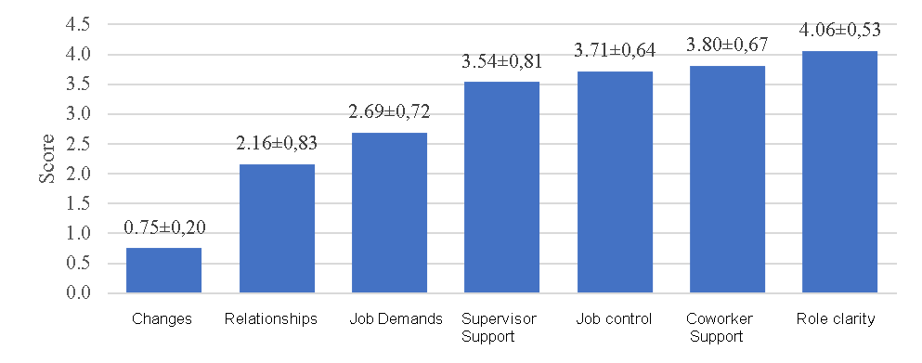
Figure 1. Stress subscales scores

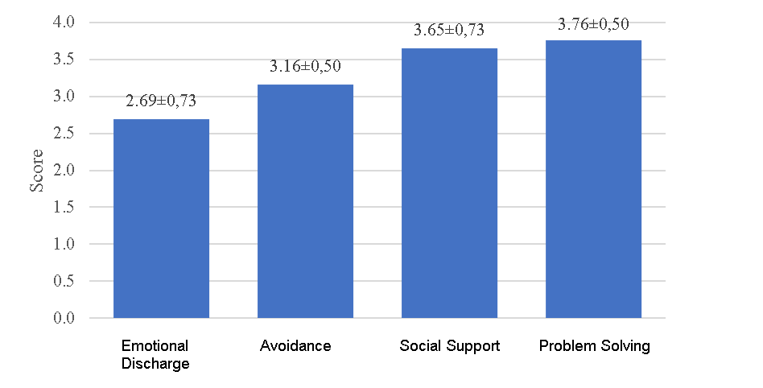
Figure 2. Coping strategies scores

3.2 Correlation Analysis

Bivariate Pearson correlations among all variables were computed and are presented in Table 2. The results show a significant negative correlation between workplace stress and subjective well-being (r = –.45, p < .001), and a positive correlation between stress and avoidant coping strategies (r = .41, p < .001). Subjective well-being was positively correlated with mindfulness (r = .48, p < .001) and adaptive coping (problem-solving, social support), and negatively correlated with emotional discharge and avoidant strategies. These correlations support the conceptual model linking stress to lower well-being, mediated by coping and moderated by mindfulness.

Table 2. Pearson correlations among all variables.
Variables |  | Work Stress | Subjective well-being | Mindfulness | Coping strategies
Work Stress | r | 1
Work Stress | p
Subjective well-being | r | 0.200** | 1
Subjective well-being | p | 0.000
Mindfulness | r | -0.090 | 0.604** | 1
Mindfulness | p | 0.082 | 0.000
Coping strategies | r | 0.396** | 0.220** | 0.009 | 1
Coping strategies | p | 0.000 | 0.000 | 0.861
** - correlation significant, when p<0,01

3.3 Mediation Analysis

To investigate whether coping strategies mediated the relationship between workplace stress and subjective well-being, a multiple regression analysis was conducted using PROCESS Model 4. Workplace stress was entered as the predictor, each coping strategy (social support, problem-solving, emotional discharge, and avoidance) as potential mediators, and subjective well-being as the outcome variable.

The overall model was statistically significant and demonstrated a good fit: R = 0.662, R² = 0.439, Adjusted R² = 0.428, p < .001, Durbin–Watson = 2.017 (see Table 3).

Regression coefficients revealed that coping strategies had distinct effects on subjective well-being (see Table 4). Greater use of social support was positively associated with subjective well-being (β = 0.216, p < .001), as was problem-solving (β = 0.318, p < .001). In contrast, emotional discharge (β = –0.355, p < .001) and avoidant coping (β = –0.172, p = .001) were both negatively associated with well-being.

Table 3. Results of model fit testing for the effect of coping strategies on subjective well-being
R | R² | Adjusted R² | p | Durbin–Watson statistic
0.530 | 0.281 | 0.273 | 0.000 | 1.886

Table 4. Results of the coefficient calculations for the model examining the effect of coping strategies on subjective well-being
 | Unstandardized Coefficients |  | Standardized Coefficient | p | VIF
 | B | SE | β | p | VIF
Constant | 42.865 | 5.183 |  | 0.000
Social Support | 0.641 | 0.159 | 0.216 | 0.000 | 1.480
Problem-Solving | 1.376 | 0.212 | 0.318 | 0.000 | 1.232
Emotional Discharge | -1.057 | 0.150 | -0.355 | 0.000 | 1.304
Avoidance | -0.747 | 0.225 | -0.172 | 0.001 | 1.380

3.4 Moderation Analysis

To examine whether mindfulness moderates the relationship between workplace stress and coping strategies, four separate moderation models were tested using PROCESS Model 1. Each coping strategy—social support, problem-solving, avoidant coping, and emotional discharge—was entered as a dependent variable, with workplace stress as the predictor and mindfulness as the moderator.
A significant interaction was found between workplace stress and mindfulness in predicting social support coping (β = –0.14, SE = 0.06, p = .013), indicating that individuals with higher levels of mindfulness were less likely to increase reliance on social support under stress. The regression results are shown in Table 5, and the interaction is illustrated in Figure 3.

Table 5. Results of the Coefficient Analysis for the Moderating Effect of Mindfulness on the Relationship Between Workplace Stress and Social Support Coping
Variable | Coefficient | t-statistic | Significance (p) | Confidence Interval
 |  |  |  | Lower Bound | Upper Bound
Constant | -63.1208 | -4.0904 | 0.0001 | -93.4646 | -32.7771
Workplace Stress | 0.7610 | 5.6798 | 0.0000 | 0.4976 | 1.0245
Mindfulness | 0.5469 | 4.5511 | 0.0000 | 0.3106 | 0.7832
Interaction (Stress × Mindfulness) | -0.0049 | -4.7249 | 0.0000 | -0.0070 | -0.0029

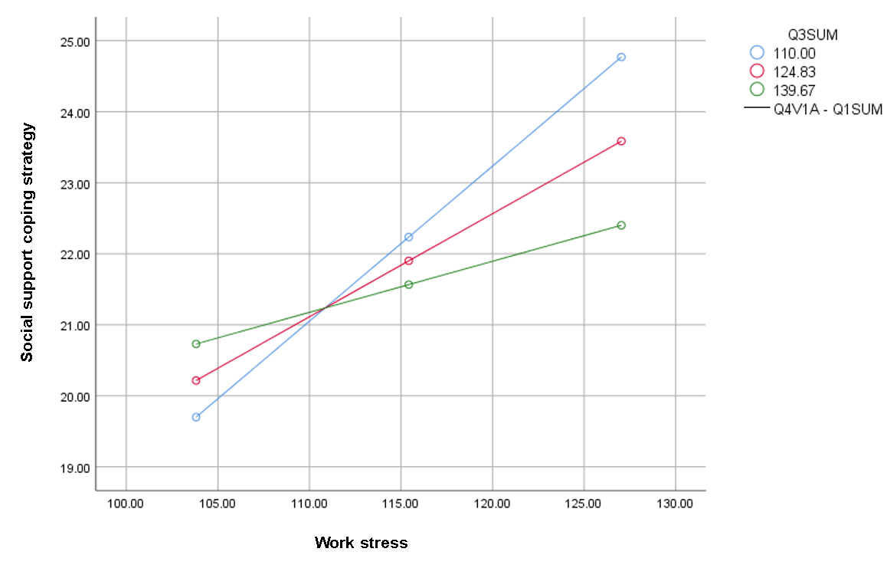
Figure 3. The Moderating Effect of Mindfulness on the Relationship Between Workplace Stress and Social Support Coping

For problem-solving, the interaction was similarly significant (β = –0.14, SE = 0.06, p = .014), suggesting that stress-related increases in problem-solving were dampened among individuals with higher mindfulness. See Table 6 for model coefficients and Figure 4 for the interaction plot.

Table 6. Results of the Coefficient Analysis for the Moderating Effect of Mindfulness on the Relationship Between Workplace Stress and Problem-Solving Coping
Variable | Coefficient | t-statistic | Significance (p) | Confidence Interval
 |  |  |  | Lower Bound | Upper Bound
Constant | -35.8625 | -3.2818 | 0.0011 | -57.3506 | -14.3744
Workplace Stress | 0.4731 | 4.9858 | 0.0000 | 0.2865 | 0.6596
Mindfulness | 0.4068 | 4.7805 | 0.0000 | 0.2395 | 0.5741
Interaction (Stress × Mindfulness) | -0.0033 | -4.4112 | 0.0000 | -0.0047 | -0.0018

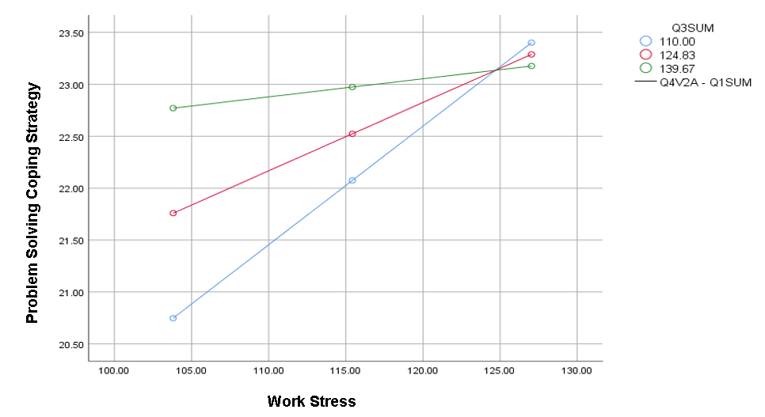
Figure 4. The Moderating Effect of Mindfulness on the Relationship Between Workplace Stress and Problem-Solving Coping

Mindfulness also significantly moderated the relationship between workplace stress and avoidant coping (β = –0.17, SE = 0.06, p < .01). Specifically, individuals with higher levels of mindfulness were less likely to respond to increased stress with avoidant behaviours. A Johnson–Neyman analysis revealed that this relationship became statistically non-significant when mindfulness scores exceeded 142.2, suggesting a protective threshold beyond which stress no longer predicted avoidant coping. Full results are presented in Table 7 and the interaction is depicted in Figure 5.

Table 7. Results of the Coefficient Analysis for the Moderating Effect of Mindfulness on the Relationship Between Workplace Stress and Avoidant Coping
Variable | Coefficient | t-statistic | Significance (p) | Confidence Interval
 |  |  |  | Lower Bound | Upper Bound
Constant | 29.4871 | -2.6896 | 0.0075 | -51.0456 | -7.9286
Workplace Stress | 0.4021 | 4.2242 | 0.0000 | 0.2149 | 0.5893
Mindfulness | 0.3167 | 3.7089 | 0.0002 | 0.1488 | 0.4845
Interaction (Stress × Mindfulness) | -0.0026 | -3.5073 | 0.0005 | -0.0041 | -0.0011

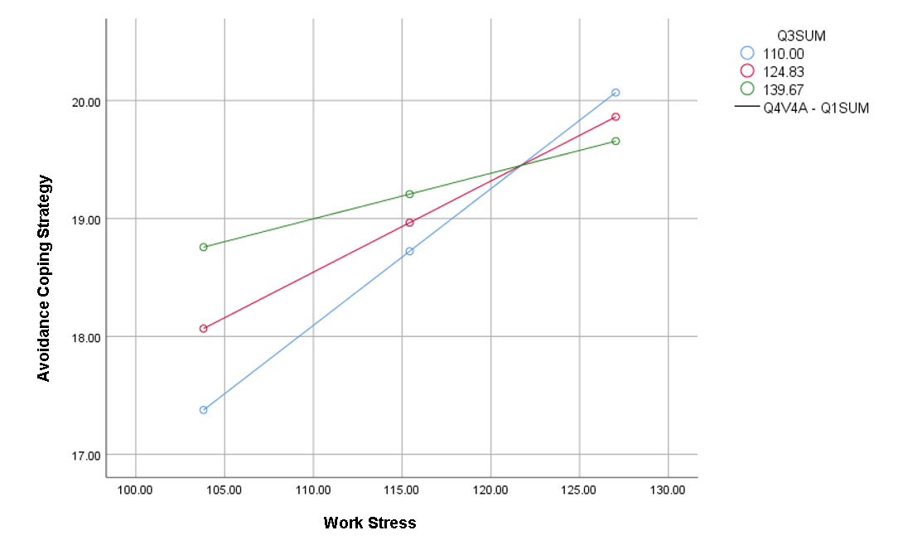
Figure 5. The Moderating Effect of Mindfulness on the Relationship Between Workplace Stress and Avoidant Coping

No significant interaction was found for emotional discharge coping (β = –0.11, SE = 0.06, p = .07); therefore, this model is not reported further.

4. Discussion

This study examined how workplace stressors affect employees’ subjective well-being and investigated the psychological processes that may explain this relationship. Specifically, the study tested whether coping strategies mediate, and whether mindfulness moderates, the link between perceived stress and well-being outcomes. The findings support a model in which both environmental demands and individual psychological resources interact to influence employee well-being.

Consistent with previous research, workplace stressors were significantly and negatively associated with subjective well-being (Stansfeld & Candy, 2006; Hirschle & Gondim, 2020). This finding reinforces a large body of evidence suggesting that job-related stress, particularly stemming from interpersonal conflict, workload, or poor role clarity, can undermine employees’ emotional and psychological functioning. High stress levels have previously been linked to reduced job satisfaction, increased burnout, and lower life satisfaction (Fortes-Ferreira et al., 2016), and the current study supports these conclusions in a Lithuanian workplace context.

Analysis of coping strategies revealed clear distinctions between adaptive and maladaptive responses. Problem-solving and seeking social support were positively associated with subjective well-being, suggesting that employees who actively address stressors or reach out for assistance fare better emotionally. In contrast, avoidant coping and emotional venting were both negatively associated with well-being. These results are in line with prior findings (Budimir et al., 2021; Rodrigues et al., 2023), which have emphasised the risks of maladaptive strategies that offer only short-term emotional relief without resolving the root causes of stress.

Among the coping styles assessed, only avoidant coping significantly mediated the relationship between stress and well-being. This implies that the use of avoidant strategies partially explains how stress leads to reduced psychological health. The finding supports the transactional model of stress (Lazarus & Folkman, 1984), which posits that individuals’ appraisals and coping responses play a central role in determining stress outcomes. Avoidance, while offering temporary emotional protection, may lead to the accumulation of unresolved issues and persistent distress.

The results also confirmed the hypothesised moderating role of mindfulness in the stress–coping relationship. Individuals with higher levels of mindfulness were less likely to increase their use of avoidant coping in response to stress, and they also showed weaker stress-related increases in problem-solving and social support seeking. These findings suggest that mindfulness may enhance emotional regulation and cognitive flexibility, allowing individuals to respond to stress with greater composure and intentionality. These results align with previous work (Weinstein et al., 2016; de Bruin et al., 2020) demonstrating that mindfulness can buffer stress reactivity and promote more effective behavioural responses.

Taken together, the findings highlight the importance of both coping styles and mindfulness in understanding how workplace stress affects well-being. While maladaptive coping may amplify the negative effects of stress, mindfulness appears to dampen this impact by shaping the individual’s coping profile. These results support the view that resilience is not only a matter of external conditions but is also influenced by internal psychological capacities.

4.1 Practical Implications

The findings of this study have meaningful implications for organisations aiming to protect and enhance employee well-being. The significant associations between stress, coping strategies, and well-being outcomes suggest that interventions targeting both external stressors and internal coping resources may be particularly effective. Specifically, promoting adaptive coping behaviours, such as problem-solving and support-seeking, may support employees’ resilience in high-stress environments.

In addition, the moderating role of mindfulness highlights its value as a psychological resource that can buffer stress reactivity and reduce reliance on maladaptive coping. Organisations may benefit from incorporating mindfulness-based interventions into their employee support systems. Programmes such as Mindfulness-Based Stress Reduction (MBSR) or brief, workplace-adapted mindfulness sessions could help reduce avoidant responses to stress and foster a more emotionally regulated and engaged workforce. These findings may be of interest to occupational health professionals, HR departments, and policy makers seeking cost-effective and scalable well-being strategies.

4.2 Limitations and Future Research

Despite its contributions, this study is not without limitations. First, the cross-sectional design prevents conclusions about causality. While the observed relationships are consistent with theoretical models, longitudinal or experimental studies would be needed to confirm the direction of effects. Second, the use of self-report measures may introduce biases such as social desirability or common method variance, which could inflate associations between variables.

The sample was also limited to a specific population, potentially affecting the generalisability of the findings. Future research should explore these mechanisms across diverse occupational groups, industries, and cultural contexts. In addition, while mindfulness was shown to moderate coping responses, the underlying mechanisms, such as emotion regulation or attentional control, were not directly measured. Future work could explore these mediating pathways using mixed-methods or experimental approaches. Investigating the effectiveness of targeted mindfulness training on coping behaviours and well-being outcomes would also provide valuable practical insights.

4. Conclusion

This study demonstrated that workplace stress negatively impacts employees’ subjective well-being and that coping strategies play a critical role in shaping this relationship. While avoidant coping partially mediated the link between stress and reduced well-being, adaptive strategies like problem-solving and social support were directly associated with better outcomes. Importantly, mindfulness emerged as a protective factor, moderating both maladaptive and adaptive coping responses. These findings highlight the value of addressing both environmental stressors and individual coping capacity in workplace well-being initiatives. Future research should build on these results by using longitudinal designs and testing targeted mindfulness-based interventions in diverse organizational settings.

References

Baer, R. A., Smith, G. T., Hopkins, J., Krietemeyer, J., & Toney, L. (2006). Using self-report assessment methods to explore facets of mindfulness. Assessment, 13(1), 27–45. https://doi.org/10.1177/1073191105283504

Brown, K. W., & Ryan, R. M. (2003). The benefits of being present: Mindfulness and its role in psychological well-being. Journal of Personality and Social Psychology, 84(4), 822–848. https://doi.org/10.1037/0022-3514.84.4.822

Budimir, S., Probst, T., & Pieh, C. (2021). Coping strategies and mental health during COVID-19 lockdown. Journal of Mental Health, 30(2), 156–163. https://doi.org/10.1080/09638237.2021.1875412

Carver, C. S. (1997). You want to measure coping but your protocol’s too long: Consider the Brief COPE. International Journal of Behavioral Medicine, 4(1), 92–100. https://doi.org/10.1207/s15327558ijbm0401_6

Carver, C. S., Scheier, M. F., & Weintraub, J. K. (1989). Assessing coping strategies: A theoretically based approach. Journal of Personality and Social Psychology, 56(2), 267–283. https://doi.org/10.1037/0022-3514.56.2.267

Cooper, C. L., & Cartwright, S. (1997). An intervention strategy for workplace stress. Journal of Psychosomatic Research, 43(1), 7–16. https://doi.org/10.1016/S0022-3999(97)00069-4

de Bruin, E. I., Formsma, A. R., Frijstein, G., & Bögels, S. M. (2020). Mindful2Work: Effects of combined physical exercise, yoga, and mindfulness meditations for stress relief in employees. Mindfulness, 11, 1191–1202. https://doi.org/10.1007/s12671-020-01337-2

Fortes-Ferreira, L., Peiró, J. M., González-Romá, V., & Wall, T. D. (2016). Decent working conditions and employee well-being: A multilevel perspective. Work & Stress, 30(1), 1–10.

Ganster, D. C., & Rosen, C. C. (2013). Work stress and employee health: A multidisciplinary review. Journal of Management, 39(5), 1085–1122. https://doi.org/10.1177/0149206313475815

Hirschle, C., & Gondim, S. M. G. (2020). Psychological well-being and perceived stress in the workplace: A meta-analytic approach. Journal of Managerial Psychology, 35(4), 297–313. https://doi.org/10.1108/JMP-06-2019-0445

Lazarus, R. S., & Folkman, S. (1984). Stress, appraisal, and coping. Springer Publishing Company.

Rodrigues, D. L., Silva, C. S. E., Monteiro, L. A., & Vagos, P. (2023). Adaptive and maladaptive coping strategies: A meta-analysis of their relationship with well-being. Psychological Reports, 126(1), 138–161. https://doi.org/10.1177/00332941221115128

Siegrist, J. (1996). Adverse health effects of high-effort/low-reward conditions. Journal of Occupational Health Psychology, 1(1), 27–41. https://doi.org/10.1037/1076-8998.1.1.27

Stansfeld, S., & Candy, B. (2006). Psychosocial work environment and mental health: A meta-analytic review. Scandinavian Journal of Work, Environment & Health, 32(6), 443–462. https://doi.org/10.5271/sjweh.1050

Taylor, S. E., & Stanton, A. L. (2007). Coping resources, coping processes, and mental health. Annual Review of Clinical Psychology, 3, 377–401. https://doi.org/10.1146/annurev.clinpsy.3.022806.091520

van der Doef, M., & Maes, S. (1999). The Job Demand–Control(-Support) model and psychological well-being: A review of 20 years of empirical research. Work & Stress, 13(2), 87–114. https://doi.org/10.1080/026783799296084

Weinstein, N., Brown, K. W., & Ryan, R. M. (2016). A multi-method examination of the effects of mindfulness on stress attribution, coping, and emotional well-being. Journal of Research in Personality, 65, 130–138. https://doi.org/10.1016/j.jrp.2016.09.001

