Crosstalk of the neuronal microenvironment in the pathophysiology of Alzheimer's disease and prospective intervention strategies advancing mitochondrial dynamics: A comprehensive review

Abstract
Mitochondria play a fundamental role in cell bioenergetics and respiratory processes, both of which are necessary for the myriad of metabolic responses that sustain cellular vitality. Mitochondrial dysfunction in neuronal cells facilitates the generation of reactive oxygen species, which are simply known as ROS, by a cellular irregularity called oxidative stress when there is an imbalance between the production of ROS and the body’s capacity to neutralize them. Thus, a reduction in the energy supply in the form of ATP can lead to damage to cellular components such as DNA, RNA, proteins, and lipids. Mitochondrial dynamics, including fission and fusion, can also be affected by this cellular occurrence. Alzheimer’s disease, a neurodegenerative disease that begins with the assembly of pathogenic proteins and neurofibrillary tangles or NFTs, highlights significant oxidative stress across the body, which is incidentally linked to the vulnerable regions of the brain affected by the condition. AD shows oxidative harm at levels that are distant from those of coercive controls, inferring the involvement of additional factors (biological or genetic). Practically harmful mitochondria, which seem more useful in generating reactive oxygen species known (ROS) but less productive in generating energy storehouses such as ATP, are early and recognizable indicators of diseases that damage mainly the hippocampus area in the brain, in which new memories form.
Keywords: AD, fission, fusion, mitochondrial features, oxidative imbalance, ROS, treatment strategies.

1. Introduction
The most prevalent type of dementia, or neurodegenerative disease, is Alzheimer's disease, which is distinguished by a gradual and subtle deterioration in cognitive function [1,2]. Histopathological findings reveal that consecutive neuritic plaques consisting of β-amyloid proteins and intraneuronal NFTs, commonly known as primary biomarkers of AD and consists of hyperphosphorylated tau protein, have severe impacts on AD patients [1,3]. AD influences myriads of individuals worldwide by disrupting their daily functions and quality of life; therefore, this progressive disease is currently a concurrent issue [4].
There are two main hypotheses that are believed to be the cause of AD. According to one hypothesis, “cholinergic functional impairment is a critical biomarker for AD, whereas others propose that changes in the synthesis and processing of amyloid β-peptide serve as the primary trigger [5,6]. Mitochondrial dysfunction can be caused by excessive ROS, imperfect mitophagy, and damage to the mitochondrial respiratory chain, such as the electron transport chain (ETC) located at the inner mitochondrial membrane (IMM), which consists of five complexes [7,8]. When the largest protein complex (complex I), also known as NADH dehydrogenase, is damaged by neurotoxins such as rotenone and 6-hydroxydopamine, it can lead to oxidative stress and mitochondrial dysfunction [9,10]. Extensive research has revealed that neurons in the AD brain exhibit Ca2+ dyshomeostasis and mitochondrial dysfunction. Mitochondria, the cardinal metabolic centers of cells, are critical to cellular proliferation, and abnormalities in mitochondrial dynamics usually precede many AD disorders, such as memory loss or dementia [11,12].
Mitochondrial dysfunction causes lower ATP production, Ca²⁺ dysregulation of homeostasis, and excessive ROS generation. ROS are unavoidable physiological by-products that act as a double-edged sword in the organic framework (nucleic acids, proteins, lipids, and etc) [13]. ROS can capacitate signaling molecules under strict conditions but can harm the organic framework when displayed in abundance since they have oxidized. Elevated lipid contents in neuronal cell membranes increase the susceptibility of the brain to oxidative stress. Therefore, tight regulation of ROS overproduction is mandatory to preserve cellular structural compatibility and normal brain functions [14,15]. However, excessive ROS can lead to problems with normal cellular signaling and disturb metabolism in the nervous system [16]. Progressive disintegration of mitochondrial movement, which facilitates ROS arrangement, has been connected to maturation and Alzheimer's disease. Due to ROS overproduction, NFTs (abnormal filaments of the hyperphosphorylated tau protein) twist each other, forming paired helical filaments (PHFs) that accumulate in various locations of neuron cells, such as axons and dendrites [15,17]. Some defects in axonal transport, mitochondrial dynamics and oxidative stress can lead to synaptic loss, such as the accumulation of tau and Aβ peptides at synaptic sites [18]. In addition to loss of synapses, Aβ plays a vital role in neurotoxicity and neuronal metabolic functions, resulting in the accumulation of denser insoluble plaques in the hippocampus, amygdala, or cerebral cortex, and leading to cognitive impairment [19,20].
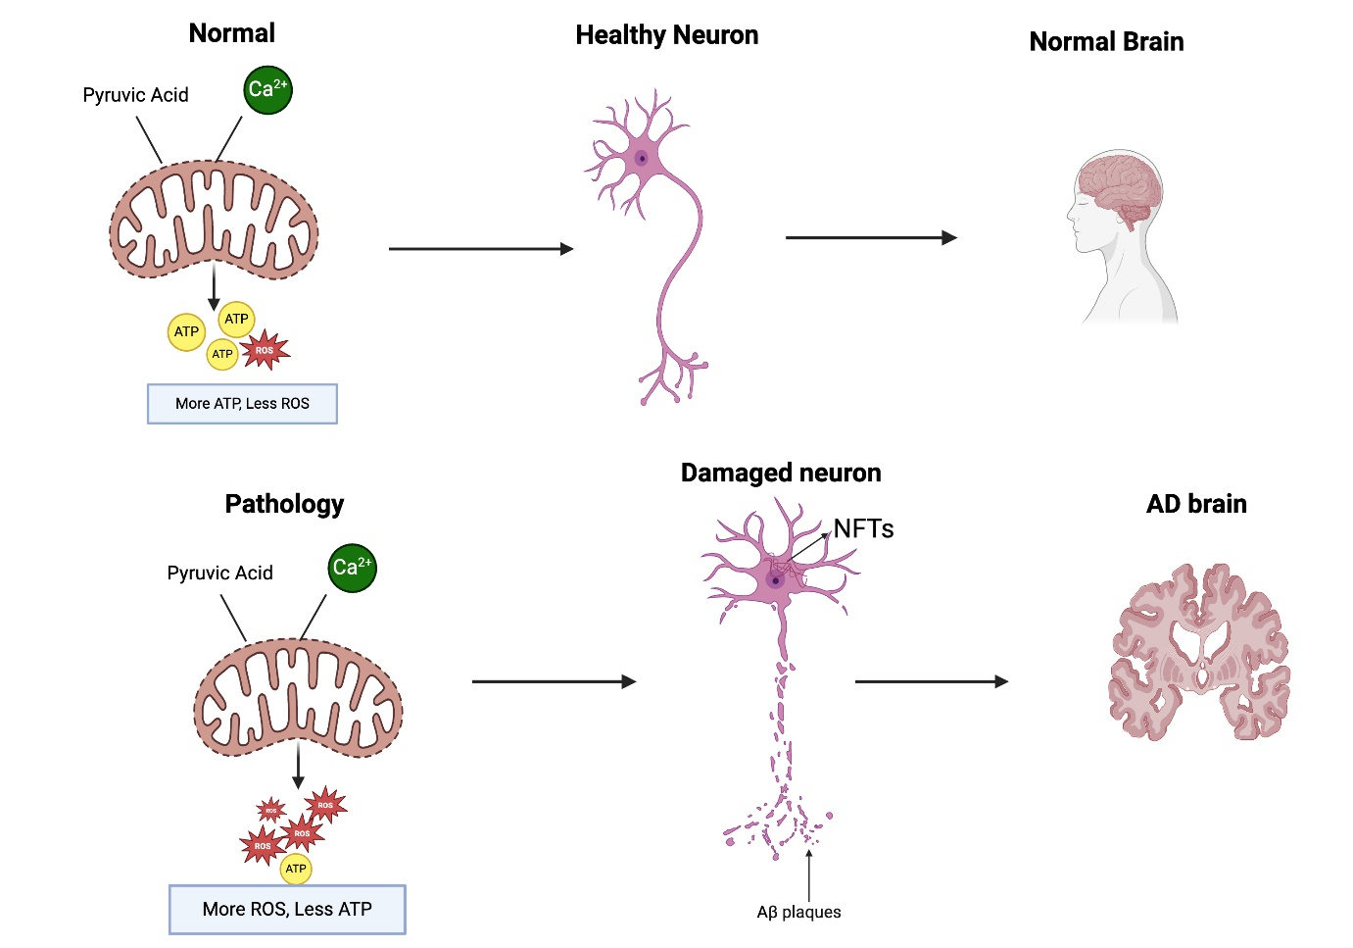
Figure 1: Comparison of the pathophysiology of the brain and neurons in the (a) healthy brain and (b) AD brain.
Here, we survey discoveries that elucidate the role of mitochondrial damage and the generation of ROS in AD pathogenesis, as well as provide a setting for display and potential treatments. We propose that expanding mitochondrial work could be considered fundamentally helpful in the treatment of AD.

2. ROS-mediated oxidation of biomolecules and AD pathogenesis
In neurons, reactive oxygen species (ROS) can oxidize various biomolecules, including proteins, lipids, and nucleic acids, leading to cellular damage and dysfunction. To start with ROS-mediated oxidized lipid biomolecules, there is now an amazing body of research showing that AD fundamentally expands lipid peroxidation (LPO). ROS can cause lipid peroxidation, attacking lipid biomolecules by means of a chemical reaction called “free radical chain reaction.” The most broadly explored lipid biomolecules in AD are susceptible aldehydes such as 4-hydroxynonal (HNE), which is a toxic aldehyde that is produced when polyunsaturated fatty acids (PUFAs) are oxidized; and is a key product of lipid peroxidation in cells, MDA (malondialdehyde), and acrolein, as well as chemically stable isoprostanes, which are responsible for posttranscriptional alterations in nucleic acids and proteins resulting in genotoxicity and neuronal cell death [21]. There are direct influences of lipid oxidation on AD progression very specifically in some ways. Membrane disruption and synaptic dysfunction occur because LP primarily targets PUFAs in neuronal membranes, leading to membrane instability and altered fluidity. As a result, the functions of neurotransmitter receptors and ion channels can be affected, promoting AD pathogenesis. In addition, MDA forms cross-links with DNA and proteins, leading to oxidative DNA damage and impaired gene expression. Moreover, an increase in the aggregation of amyloid-beta (Aβ) by modified fats and sphingolipids due to LPs that are responsible for AD. LP can also exacerbate AD pathogenesis by activating microglia and astrocytes, damaging the blood-brain barrier (BBB), and allowing peripheral immune cells and toxins to enter the brain.
On the other hand, protein carbonyls (e.g., phosphocreatine kinase and glutamine synthetase enzymes) and 3-nitrotyrosine are the two most commonly explored indicators of protein oxidation by ROS. 3-Nitrotyrosine is a prospective oxidative stress biomarker that is produced when reactive peroxynitrite molecules nitrate protein-bound and free tyrosine residues. Protein nitration at the subcellular level causes conformational changes that disrupt the cytoskeleton of neuronal cells and lead to neurodegeneration [22]. Changes in glutamine synthetase (GS) activity and gene expression, as well as excitotoxicity, have been observed in a variety of neurological diseases, including Alzheimer's disease and Parkinson's [23].
Another type of ROS-mediated oxidatively modified biomolecule is nucleic acids such as DNA and RNA. Recent research has demonstrated that RNAs are susceptible to oxidative damage, and that the oxidized molecule has the ability to break the RNA strand, resulting in cell disintegration and cell death, as well as the genesis and progression of neurodegenerative illnesses [24]. Mainly, the mRNA of the amyloid precursor protein (APP) gene changes the process of gene transcription and translation via oxidation, which leads to changes in the amino acid sequence of the APP protein. The mutant APP protein results in the production of more Aβ fragments through pathological β- and γ-hydrolysis pathways, forming plaques, and initiates the pathological process of AD [24].

3. Different cellular malfunctions in the mitochondria of neurons promote AD via oxidized ROS
Unstable oxygen species are unavoidable byproducts of the digestive system that have a dual impact on the structural and functional homeostasis of mitochondria in neuronal cells [13,25]. Whereas they can play crucial roles in carefully controlled situations, such as signaling, they can also cause cell harm when delivered in abundance since they can oxidize all major biomolecules, including proteins, fats, and nucleic acids [26]. Oxidative stretch is caused by an imbalance between the generation and collection of ROS. Cellular damage during maturation and neurodegenerative infections is caused by ROS [27]. In Alzheimer's disease, ROS-induced Aβ protein buildup leads to lysosome layer breakdown and neuronal passage.

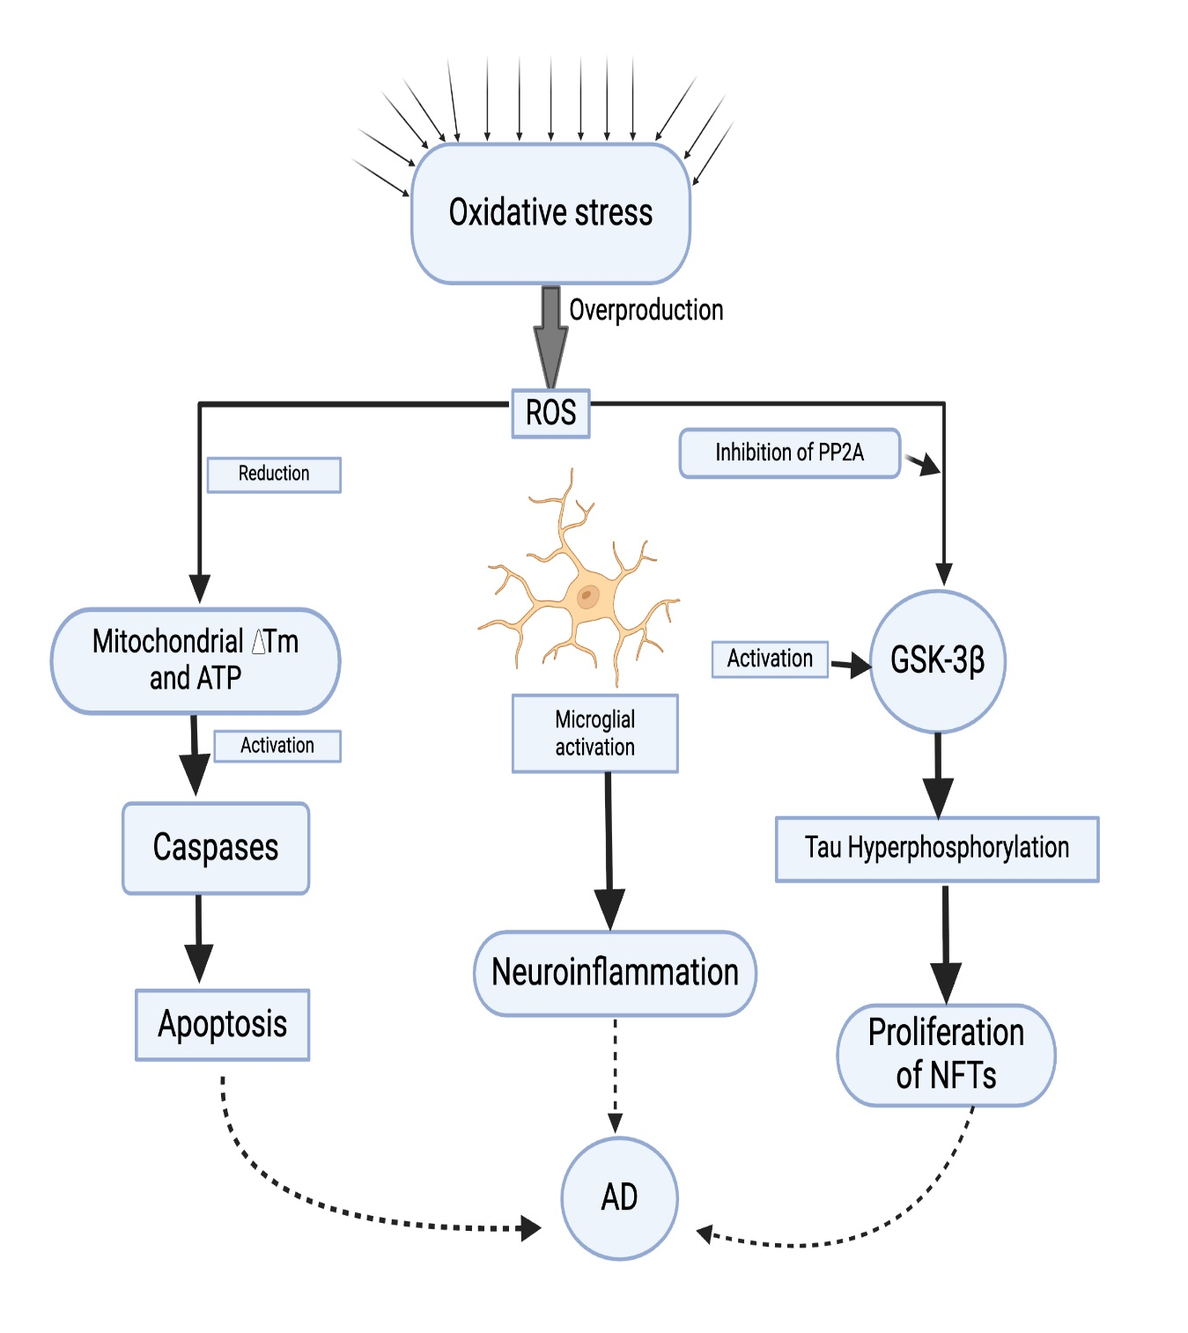

Figure 2: The figure illustrates how ROS-induced mitochondrial defects contribute to Alzheimer's disease. Reactive oxygen production or a defective antioxidant system alters the redox balance in cells, causing an imbalance in the abundance of ROS-producing oxidants. Therefore, these large amounts of oxidized species reduce mitochondrial membrane eventuality (ΔTm) and ATP by negatively influencing potency, disrupting mitochondrial functions, and normalizing the process of mitophagy. Reactive oxygen species increase caspase activity and induce apoptosis. Caspases are activated by ROS, and apoptosis is induced as a surplus of ROS inhibits PP2A and activates GSK-3β, resulting in hyperphosphorylation of the tau protein by activating GSK-3 (beta) and eventually a buildup in NFTs.

4. Common biomarkers of mitochondrial abnormalities and its quantifiable relationship with AD pathogenesis:

Clinical and experimental research has demonstrated a quantitative correlation between AD and abnormalities of the mitochondria. This is a brief summary of the main conclusions that demonstrate how mitochondrial dysfunction causes AD and how these alterations are quantifiable:

4.1 Reduction in the Neuromodulator (ATP) or Mitochondrial Bioenergetics
The alternative term of mitochondria is the cell's powerhouse since mitochondrial ATP generation via a metabolic process known as oxidative phosphorylation is essential for cellular activities. The ETC of mitochondria is made up of five enzyme complexes located in the inner mitochondrial membrane (IMM). ATP synthase (complex V) converts ADP and inorganic phosphate into ATP when the ETC generates an electric charge across the IMM. According to several investigations, all five complexes are impaired in various AD brain regions [28]. Decreased neuromodulator or energy levels, which are linked to an excess of ROS and are unable to sustain cellular energy, are primarily indicative of mitochondrial dysfunction in AD. Astrocytes, glial cells, and neurons need a high energy supply using a significant amount of ATP. Moreover, since the brain CNS does not reserve ATP from glucose or fat, energy must be generated by brain cells to control normal neuronal activity [29]. However, the availability of these energy forms can be reduced by damaged or aged mitochondria, which excessively release free radicals in AD. These bioenergetics reductions can be measured by using PET scans using [18F]-FDG that show reduced glucose metabolism in cells with chronic disease promotion. Specifically, oxidative damage to mitochondrial ATP synthase gene-encoding subunits lowers the levels of the corresponding protein, which reduces ATP production, damages susceptible genes of nuclear DNA, and causes functional loss [30].

4.2 Apoptotic mechanism
Mitochondria possess some core intrinsic apoptotic pathways. It is evident that several elements of the mitochondrial pathway are activated or changed in the AD brain [31], even if it is still debatable whether apoptosis plays a significant role in neurodegeneration in AD patients. Interestingly, apoptosis cannot always result from the activation of these molecules since the activation of caspase-3 by cleavage is linked to the development of NFTs and Tau cleavage in AD [32].

4.3 Reduced mitophagy and mitochondrial elements in AD
Mitochondria are energetic, with standard changes in shape, estimate, amount, and position. The capacity of mitochondria to separate, interface, and relocate across the cytoplasm accounts for their different shapes. The two unmistakable, firmly directed antagonistic forms, combination (fusion) and parting (division), which can be defined as fission, make up the majority of these forms, which are collectively implied as mitochondrial flow [33,34,35].
These forms are fundamental to mitochondrial science and quality control [35]. The steady parting and combination events that occur in mitochondria, which control their shape and conveyance, make them highly energetic organelles [36]. The forms of mitochondrial fission and fusion are regulated by dynamin-like protein 1 (DLP1, also called DRP1), OPA1, [37], mitofusin-1 & 2 (Mfn1, 2), and other mitochondrial parting proteins, including Fis1 [37,38]. DLP1 is drawn to the outer surface and shows as patches amid fission. OPA1 is situated in the inward mitochondrial film, although Fis1, Mff, Mfn1, and Mfn2 are mitochondrial transmembrane proteins found in the outer locale [39]. Later studies revealed a significant number of changes in the AD brain, supporting the inclusion of altered mitochondrial elements in AD [40,41,42]. The DRP1 protein is interatomic with Aβ monomers and oligomers, as is the phosphorylated Tau protein in the AD brain [41]. However, its effect on mitochondrial elements is obscure. Although greater numbers of mitochondria are regularly caused by restrained parting or expanded combination, additional broadened mitochondria observed in the brains of a fusion-deficient gene knockout mouse model [43]. It is clear that separate division is adequate to actuate several of the detrimental impacts observed in AD, including increased oxidative push, which causes auxiliary harm to mitochondria in AD [44].
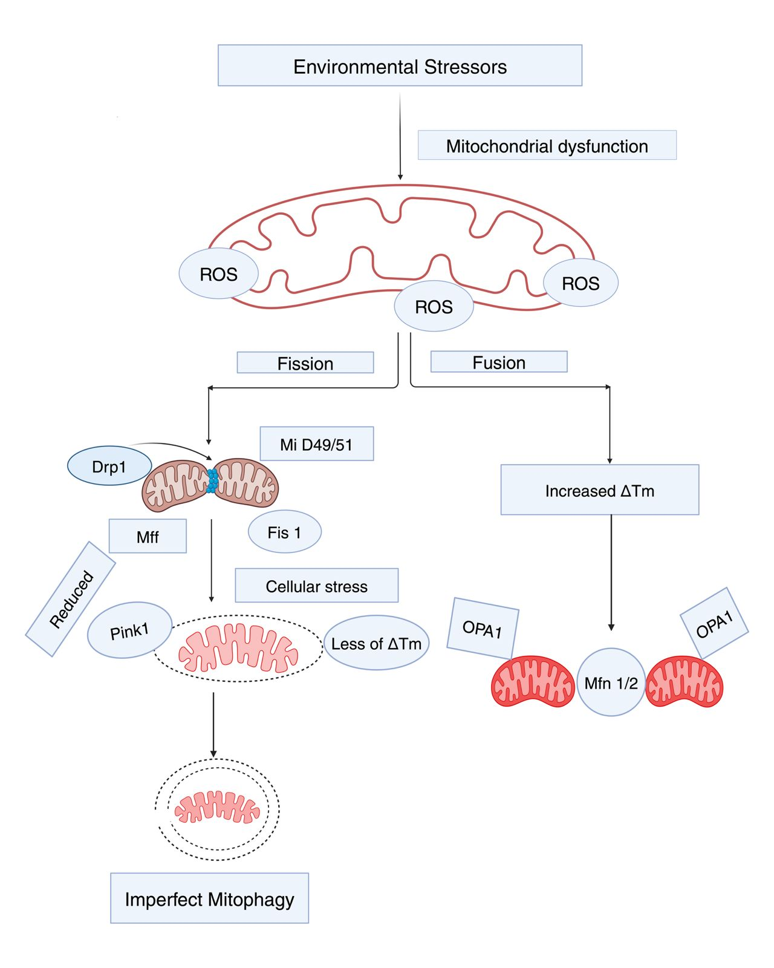
Figure 3: Breakdown of mitophagy medium and mitochondrial functions (fission and fusion) as shown in the above schematic figure. Since mitochondria are dynamic, several changes in their size, quality, and position frequently occur to control their external surface. Mitochondrial breaks are controlled by DRP1, which is activated by Mff, Fis1, and mitochondrial dynamic protein (MiD49/51). On the other hand, (Mfn 1, 2); as well as OPA1; regulate mitochondrial fusion. This facilitates the exchange of materials such as matrix factors and damaged mitochondrial DNA and promotes equilibrium in bioenergetic compartments (e.g., mitochondrial membrane eventuality ∆Tm). To maintain quality control, these fission/fusion processes use mitophagy mechanisms. When mitochondria are injured by cellular stress, they endure sustained depolarization of their inner membrane, resulting in the loss of ∆Tm. This loss stabilizes PINK1 at the exterior membrane and initiates mitophagy. Owing to an excessive ROS burden on neurons, fission/fusion balance is disturbed, resulting in poor mitophagy.

5. ROS-induced mitochondrial [Ca²⁺] dyshomeostasis in AD
Cellular Ca²⁺ homeostasis is largely maintained by mitochondria, and Ca²⁺ regulates a number of critical neuronal functions, including metabolic functions, neurotransmission, gene expression, and cell death. The permeability transition is a rise in the permeability of the IMM to neurotransmitters and soluble items, mediated by the voltage dependent, high-conductance PT pore (mPTP), which requires a permissive calcium matrix leading to open depolarizing channels of [Ca²⁺] release; and termination of OXPHOX, resulting in rupture of the OMM. Therefore, cytochrome C and other apoptogenic proteins are released, accompanied by persistent opening of the mPTP.
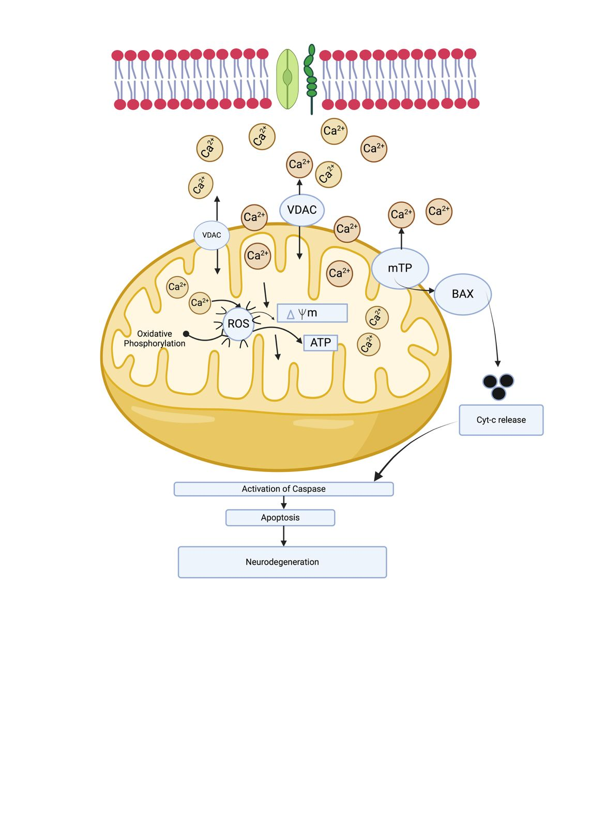
Figure 4: Illustration of mitochondrial Ca2+ dysregulation in AD patients. Mitochondria function as modulators, buffers, and sensors in intracellular Ca2+ signaling (Rizzuto et al., 2012). ROS overproduction occurs when excessive calcium ions are stored in mitochondria, inhibiting ATP synthesis. Therefore, the mPTP is opened, and Cyt-C is released, which activates caspases and causes cell death.
In addition, after ischemic and traumatic brain harm, as well as in a number of neurodegenerative illnesses [45,46], mitochondrial Ca²⁺ overburden and subsequent disruption are basic cause of apoptosis. Broken mitochondria contribute to calcium dyshomeogenesis via a decreased capacity to buffer calcium or by specifically influencing the ER [Ca²⁺] channels [47].

6. Techniques for improving mitochondrial function in Alzheimer's disease
A previous investigation revealed that strategies capable of targeting mitochondrial work are required to diminish the course of AD. An investigation of the effects of these strategies should be coordinated to create a helpful intervention that can target ROS and prevent mitochondrial fracture to reduce mitochondrial damage and subsequent synaptic harm as AD progresses. Work out is a brilliant way to diminish ROS and promote mitochondrial well-being. The impacts of physical action on mitochondrial work will be explored in depth.

6.1 Impacts of exercise and nutrition on oxidative push and mitochondrial function
One of the best ways to keep our body in great well-being and our brain working ordinarily is to work out. Moreover, an adjusted caloric count and normal work out can move forward a number of components of mitochondrial work. In this respect, considering people and rat models has illustrated the preferences of work-out and calorie limitations in postponing the maturing handle and progressing mitochondrial work [48,49]. Numerous benefits of working out for people with AD have been reported in other studies [50,51]. These benefits include the progression of the bloodstream to the brain, increased hippocampal thickness, increased neurogenesis, and improved cognitive work (such as thinking, perceiving, learning, and decision-making), which are indications of diminished neuropsychiatric and slower disorders. To maintain a solid antioxidant status, it may be best to devourerate satisfactory sums of vitamins and minerals and to utilize characteristic nourishments high in cancer prevention agents, such as natural products and vegetables. Vitamin C-rich nourishment can aid in diminishing ROS. The most frequently utilized antioxidant in clinical and research facilities is vitamin C, which can be given at diverse concentrations, intensely or chronically, alone or in combination with other cancer prevention agents [52]. In both cell and rodent models [53], vitamin C diminishes the level of receptive oxygen species (ROS) and impairs mitochondrial well-being.

6.2 Potential therapeutic approaches to mitigate abnormal mitochondrial biogenesis
Innovative pharmaceutical approaches, antioxidant treatment, and the ability to moderate the nearby ROS era in mitochondria to reduce worldwide ROS levels are ways to advance mitochondrial work. Various biochemical factors, such as coenzyme Q10, idebenone, amino acid compounds, mitochondrial supplements, Mito-VitE, sulforaphane, synthetic-dyes, curcumin, and organic fatty acids, which act on PGC-1α and actuate mitochondrial biogenesis, are among these substances [54]. A few laboratories have utilized in vitro and in vivo models of AD to survey these mitochondrion-targeted drugs. These substances have the benefits of protecting mitochondrial flow, reducing ROS, and increasing bioenergetics.

Peroxisome proliferator-activated receptor gamma coactivator 1-alpha (PGC-1α) is the primary regulator of mitochondrial biogenesis. It has been demonstrated that PGC-1α expression is decreased in AD mouse models and postmortem human brains. Therapeutic feasibility of these techniques is supported by some preclinical evidence. For instance, genetic overexpression of PGC-1α in transgenic AD animal models has been demonstrated to increase mitochondrial dynamics with reduced generation of Aβ through BACE1 suppression. Hence, pharmaceutical activators such as bezafibrate, metformin, and others that enhance mitochondrial biogenesis can do so. CoQ10, an important component of the ETC, prevents oxidative stress and neurodegenerative diseases in neuronal cells by maintaining mitochondrial ∆Tm, accelerating ATP amalgamation, and reducing ROS production [55]. In addition, it increases mitochondrial mass and bioenergetic work while protecting the phospholipid layer and mitochondrial layer proteins from free radical harm [56]. In other investigations, taking CoQ10 as a customary premise significantly improved the activity of antioxidant proteins and diminished irritation [57]. An analog of CoQ10 with greater adequacy and a more promising pharmacokinetic profile is idebenone. In those with dissimilar visual acuity, idebenone can prevent vision misfortune (leber hereditary optic neuropathy) by expanding the mitochondrial ETC [58], and it is better than vitamin C. A source of high-energy phosphate released during anaerobic digestion is phosphocreatine, which is produced in mitochondria when creatine and phosphate mix. Creatine therefore serves as an intracellular ATP buffer and a vitality carrier to transfer high vitality phosphates from the mitochondrial sites of production to the cytoplasmic sites of use. The tissues with the most elevated concentration of creatine are those with high vitality necessities, like the brain and muscles [59]. Research has demonstrated that people with mitochondrial damage have lower sums of phosphocreatine in their muscle tissue. Moreover, a few people with disrupted mitochondria may be able to work out more easily after receiving creatine monohydrate. Comparable benefits of creatine supplementation have been illustrated in neurological sickness, such as Parkinson’s disease, heart infection, and ALS. A substance called MitoQ targets the mitochondria and progresses their defense against oxidative harm. Mitoquinone mesylate, with its lipophilic cation moiety, allows specific collection of ubiquinone, which is then converted into a synthetic antioxidant called ubiquinol when ETC complex II activated. In animal models, MitoQ, a water-soluble supplement that can be utilized orally and crosses the blood brain boundary [60], has been shown to have defensive effects against changes in mitochondria caused by oxidative push [61]. Additionally, in a mouse model of AD, MitoQ decreased neuropathology and cognitive disability [62]. In accordance with Xing et al. (2019), MitoQ treatment actuates cAMP reaction element-binding protein (CREB), which affects mitochondrial function. This investigation highlights the antioxidant and mitochondria-protecting properties of MitoQ in an assortment of obsessive ailments, including AD.

These therapeutic approaches improve early-stage AD by activating PGC-1α, reducing oxidative stress, modulating mitochondrial fission/fusion, and maintaining a healthy mitochondrial network through neuronal connectivity and mitophagy enhancers like urolithin A or NAD+ precursors. In late-stage AD (moderate to severe), PGC-1α activation with NAD+ boosters can reduce neurotoxicity and increase neuronal survival. Mitophagy enhancers may improve non-neuronal cell function (astrocytes, microglia) to support remaining neurons in the brain, potentially improving motor and cognitive functions, as well as neuroinflammations.

7. Systematic way to reduce irregular mitochondrial breaks

7.1 Mdivi-1 (an inhibitor of mitochondrial division)
A number of Drp1 (dynamin-related protein-1) inhibitors have been created over the past 20 years; these include DDQ, P110, dynasore, and mitochondrial division inhibitor 1 (Mdivi- 1). Some positive impacts of these inhibitors have been examined in both mouse models and cell societies. In combination with increased mitochondrial biogenesis and increased levels of synaptic proteins, quinazolinone which is subordinate to Mdivi-1 and was first found to be a particular inhibitor of DRP1, induces neuroprotection in models of AD, PD, and other neurodegenerative sicknesses [63]. In any case, whether Mdivi-1 can diminish Drp1 and cause mitochondrial fission has recently been investigated. In this study, the researchers observed no restorative effect of the inhibitor on the morphology of mitochondria in mammalian cells. To guarantee the safety and viability of Mdivi-1 in people, an advanced comprehensive investigation into its atomic targets may be beneficial, as it is being explored in clinical trials, while preclinical studies are encouraging, but there are some concerns regarding the potential off-target effects of Mdivi-1, as some investigations suggest that it might also affect other cellular pathways in addition to Drp1.

7.2 Involvement of (DDQ) in the inhibition of mitochondrial fission

DDQ is a pharmaceutical substance that has been utilized to assess mitochondrial fragmentation in AD. With respect to the mRNA and protein associated with mitochondrial fragility and AD-related synaptic dysregulation, this drug has shown promising outcomes. Moreover, DDQ hinders Aβ associations, increases the levels of combination proteins (Mfn1 and Mfn2), and diminishes mitochondrial fission. One of the unique characteristics of DDQ is its capacity to tie to the dynamic official locales of both Drp1 and Aβ, anticipating that Aβ and Drp1 will not shape complexes.

8. Options for Advancing Mitochondrial Fusion through Medication
Targeting the mitochondrial fusion apparatus, which comprises Mfn1, Mfn2, and OPA1, via restorative media can improve mitochondrial well-being by rebalancing and optimizing combination control. It has been shown that medicines that increase mitochondrial fusion can hinder the passage of apoptotic cardiac cells in vivo. In rats, mitochondrial fusion and cardiac work progress when the modern drug SAMβA affects the association between Mfn1 and βIIPKC. The small chemical “benzyl-guanidine-pyridine-15,” also known as BGP-15, is another interesting substance that influences OPA1 movement, and it can reduce the production of ROS. Hydrazone-M1, an extramitochondrial fusion activator, was discharged in 2012. In this context, the organization of the fusion promoter M1 hinders cytochrome c discharge and diverts cell passage [64].

Conclusion
The serious neurodegenerative ailment of AD has led to noteworthy advances in understanding its cause. As proven scales, mitochondria are key players in the pathophysiology of AD, contributing to modified flow, mitophagy, disturbance of Ca²+ homeostasis, expanded generation of ROS and oxidative harm, and enactment of the neurotoxin called mPTP, which causes harm to AD. Although inquiries about medicines focused on mitochondria in AD are progressing, unused helpful strategies that halt or delay the movement of this hopeless ailment must be created as soon as possible. We evaluated novel approaches to address altered pathways, such as abnormal mitophagy, oxidative push, OXPHOS brokendown, misfolded protein accumulation, and changes in mitochondrial elements, to improve Alzheimer’s disease. Because current sedate conveyance methods have advanced, delivering mitochondrially focused AD therapeutics and bringing them from preclinical laboratories to clinical studies are still challenging. In any case, we believe that examining mitochondrial kinetics and increasing mitochondrial pharmacology holds extraordinary potential as a therapeutic approach for the treatment of AD patients. Variations from the norm in mitochondrial elements, resulting from a lack of hereditary, metabolic changes, or natural presentation, decrease the flexibility of mitochondria to the advancing requests of cells. This approach is anticipated to have particularly inconvenient results for neurons.

Competing interest
The author declares that they have no competing interests.

Data Availability
The author confirms that the data supporting the findings of this review study are available within the article. Raw data that support the findings of this study are available from the corresponding author, upon reasonable request.

Ethics and Consent to Participate declarations: not applicable

References

[1] F. S. Trigo, N. C. Pinto, and M. V. Pato, “Long-Term Insomnia Treatment with Benzodiazepines and Alzheimer’s Disease: A Systematic Review,” no. Dm, pp. 1–17, 2025, doi: 10.3390/neurosci6010011.
[2] M. M. Vroom and J.-C. Dodart, “Active Immunotherapy for the Prevention of Alzheimer’s and Parkinson’s Disease,” Vaccines, vol. 12, no. 9, p. 973, 2024, doi: 10.3390/vaccines12090973.
[3] C. A. Lane, J. Hardy, and J. M. Schott, “Alzheimer’s disease,” Eur. J. Neurol., vol. 25, no. 1, pp. 59–70, 2018, doi: 10.1111/ene.13439.
[4] R. Fleming, J. Zeisel, and K. Bennet, “World Alzheimer Report 2020,” vol. I, 2020.
[5] Z. Breijyeh and R. Karaman, “Comprehensive Review on Alzheimer’s Disease: Causes and Treatment,” Molecules, vol. 25, no. 24, 2020, doi: 10.3390/MOLECULES25245789.
[6] R. A. Armstrong, “Risk factors for Alzheimer’s disease,” Folia Neuropathol., vol. 57, no. 2, pp. 87–105, 2019, doi: 10.5114/fn.2019.85929.
[7] Q. Zheng et al., “Ameliorating Mitochondrial Dysfunction of Neurons by Biomimetic Targeting Nanoparticles Mediated Mitochondrial Biogenesis to Boost the Therapy of Parkinson’s Disease,” Adv. Sci., vol. 10, no. 22, pp. 1–18, 2023, doi: 10.1002/advs.202300758.
[8] J. Nunnari and A. Suomalainen, “Mitochondria: In sickness and in health,” Cell, vol. 148, no. 6, pp. 1145–1159, 2012, doi: 10.1016/j.cell.2012.02.035.
[9] V. Kravchuk, O. Petrova, D. Kampjut, A. Wojciechowska-Bason, Z. Breese, and L. Sazanov, “Author Correction: A universal coupling mechanism of respiratory complex I (Nature, (2022), 609, 7928, (808-814), 10.1038/s41586-022-05199-7),” Nature, vol. 611, no. 7936, p. E9, 2022, doi: 10.1038/s41586-022-05457-8.
[10] C. A. Gautier, O. Corti, and A. Brice, “Mitochondrial dysfunctions in Parkinson’s disease,” Rev. Neurol. (Paris)., vol. 170, no. 5, pp. 339–343, 2014, doi: 10.1016/j.neurol.2013.06.003.
[11] S. U. Nabi et al., “Mechanisms of Mitochondrial Malfunction in Alzheimer’s Disease: New Therapeutic Hope,” Oxid. Med. Cell. Longev., vol. 2022, 2022, doi: 10.1155/2022/4759963.
[12] R. H. Swerdlow and S. M. Khan, “A ‘mitochondrial cascade hypothesis’ for sporadic Alzheimer’s disease,” Med. Hypotheses, vol. 63, no. 1, pp. 8–20, 2004, doi: 10.1016/j.mehy.2003.12.045.
[13] M. D. Ferrer, A. Sureda, A. Mestre, J. A. Tur, and A. Pons, “The double edge of reactive oxygen species as damaging and signaling molecules in HL60 cell culture,” Cell. Physiol. Biochem., vol. 25, no. 2–3, pp. 241–252, 2010, doi: 10.1159/000276558.
[14] V. Castelli et al., “Neuronal cells rearrangement during aging and neurodegenerative disease: Metabolism, oxidative stress and organelles dynamic,” Front. Mol. Neurosci., vol. 12, no. May, pp. 1–13, 2019, doi: 10.3389/fnmol.2019.00132.
[15] V. Castelli et al., “Diet and Brain Health: Which Role for Polyphenols?,” Curr. Pharm. Des., vol. 24, no. 2, pp. 227–238, 2017, doi: 10.2174/1381612824666171213100449.
[16] D. R. Green, L. Galluzzi, and G. Kroemer, “Mitochondria and the autophagy-inflammation-cell death axis in organismal aging,” Science (80-. )., vol. 333, no. 6046, pp. 1109–1112, 2011, doi: 10.1126/science.1201940.
[17] A. Metaxas and S. J. Kempf, “Neurofibrillary tangles in Alzheimer’s disease: Elucidation of the molecular mechanism by immunohistochemistry and tau protein phospho-proteomics,” Neural Regen. Res., vol. 11, no. 10, pp. 1579–1581, 2016, doi: 10.4103/1673-5374.193234.
[18] C. R. Overk and E. Masliah, “Pathogenesis of synaptic degeneration in Alzheimer’s disease and Lewy body disease,” Biochem. Pharmacol., vol. 88, no. 4, pp. 508–516, 2014, doi: 10.1016/j.bcp.2014.01.015.
[19] R. A. Armstrong, “The molecular biology of senile plaques and neurofibrillary tangles in Alzheimer’s disease,” Folia Neuropathol., vol. 47, no. 4, pp. 289–299, 2009.
[20] G. F. Chen et al., “Amyloid beta: Structure, biology and structure-based therapeutic development,” Acta Pharmacol. Sin., vol. 38, no. 9, pp. 1205–1235, 2017, doi: 10.1038/aps.2017.28.
[21] O. V. Taso, A. Philippou, A. Moustogiannis, E. Zevolis, and M. Koutsilieris, “Lipid peroxidation products and their role in neurodegenerative diseases,” Ann. Res. Hosp., vol. 3, no. 4, pp. 2–2, 2019, doi: 10.21037/arh.2018.12.02.
[22] M. Bandookwala and P. Sengupta, “3-Nitrotyrosine: a versatile oxidative stress biomarker for major neurodegenerative diseases,” Int. J. Neurosci., vol. 130, no. 10, pp. 1047–1062, 2020, doi: 10.1080/00207454.2020.1713776.

[23] A. R. Jayakumar and M. D. Norenberg, “Glutamine Synthetase: Role in Neurological Disorders,” Adv. Neurobiol., vol. 13, pp. 327–350, 2016, doi: 10.1007/978-3-319-45096-4_13.
[24] Z. Liu et al., “Role of RNA oxidation in neurodegenerative diseases,” Int. J. Mol. Sci., vol. 21, no. 14, pp. 1–14, 2020, doi: 10.3390/ijms21145022.
[25] H. Sies and D. P. Jones, “Reactive oxygen species (ROS) as pleiotropic physiological signalling agents,” Nat. Rev. Mol. Cell Biol., vol. 21, no. 7, pp. 363–383, 2020, doi: 10.1038/s41580-020-0230-3.
[26] M. Arimon, S. Takeda, K. L. Post, S. Svirsky, B. T. Hyman, and O. Berezovska, “Oxidative stress and lipid peroxidation are upstream of amyloid pathology,” Neurobiol. Dis., vol. 84, no. 2014, pp. 109–119, 2015, doi: 10.1016/j.nbd.2015.06.013.
[27] M. Valko, D. Leibfritz, J. Moncol, M. T. D. Cronin, M. Mazur, and J. Telser, “Free radicals and antioxidants in normal physiological functions and human disease,” Int. J. Biochem. Cell Biol., vol. 39, no. 1, pp. 44–84, 2007, doi: 10.1016/j.biocel.2006.07.001.
[28] W. S. Liang et al., “Alzheimer’s disease is associated with reduced expression of energy metabolism genes in posterior cingulate neurons,” Proc. Natl. Acad. Sci. U. S. A., vol. 105, no. 11, pp. 4441–4446, 2008, doi: 10.1073/pnas.0709259105.
[29] N. Khatri and H. Y. Man, “Synaptic activity and bioenergy homeostasis: Implications in brain trauma and neurodegenerative diseases,” Front. Neurol., vol. 4 DEC, no. December, pp. 1–11, 2013, doi: 10.3389/fneur.2013.00199.
[30] T. Reed et al., “Redox proteomic identification of 4-Hydroxy-2-nonenal-modified brain proteins in amnestic mild cognitive impairment: Insight into the role of lipid peroxidation in the progression and pathogenesis of Alzheimer’s disease,” Neurobiol. Dis., vol. 30, no. 1, pp. 107–120, 2008, doi: 10.1016/j.nbd.2007.12.007.
[31] A. K. Raina et al., “Abortive apoptosis in Alzheimer’s disease,” Acta Neuropathol., vol. 101, no. 4, pp. 305–310, 2001, doi: 10.1007/s004010100378.
[32] J. Avila, “Alzheimer disease: Caspases first,” Nat. Rev. Neurol., vol. 6, no. 11, pp. 587–588, 2010, doi: 10.1038/nrneurol.2010.157.
[33] K. Palikaras, E. Lionaki, and N. Tavernarakis, “Mechanisms of mitophagy in cellular homeostasis, physiology and pathology,” Nat. Cell Biol., vol. 20, no. 9, pp. 1013–1022, 2018, doi: 10.1038/s41556-018-0176-2.
[34] P. H. Reddy, “Defective Autophagy and Mitophagy in Alzheimer ’ s Disease,” Cells, 2019.
[35] R. J. Youle and A. M. Van Der Bliek, “Mitochondrial fission, fusion, and stress,” Science (80-. )., vol. 337, no. 6098, pp. 1062–1065, 2012, doi: 10.1126/science.1219855.
[36] S. A. Detmer and D. C. Chan, “Functions and dysfunctions of mitochondrial dynamics,” Nat. Rev. Mol. Cell Biol., vol. 8, no. 11, pp. 870–879, 2007, doi: 10.1038/nrm2275.
[37] D. C. Chan, “Mitochondria: Dynamic Organelles in Disease, Aging, and Development,” Cell, vol. 125, no. 7, pp. 1241–1252, 2006, doi: 10.1016/j.cell.2006.06.010.
[38] A. B. Knott, G. Perkins, R. Schwarzenbacher, and E. Bossy-Wetzel, “Mitochondrial fragmentation in neurodegeneration,” Nat. Rev. Neurosci., vol. 9, no. 7, pp. 505–518, 2008, doi: 10.1038/nrn2417.
[39] H. Chen, A. Chomyn, and D. C. Chan, “Disruption of fusion results in mitochondrial heterogeneity and dysfunction,” J. Biol. Chem., vol. 280, no. 28, pp. 26185–26192, 2005, doi: 10.1074/jbc.M503062200.
[40] M. Manczak, M. J. Calkins, and P. H. Reddy, “Impaired mitochondrial dynamics and abnormal interaction of amyloid beta with mitochondrial protein Drp1 in neurons from patients with Alzheimer’s disease: Implications for neuronal damage,” Hum. Mol. Genet., vol. 20, no. 13, pp. 2495–2509, 2011, doi: 10.1093/hmg/ddr139.
[41] X. Wang, B. Su, H. Fujioka, and X. Zhu, “Dynamin-like protein 1 reduction underlies mitochondrial morphology and distribution abnormalities in fibroblasts from sporadic Alzheimer’s disease patients,” Am. J. Pathol., vol. 173, no. 2, pp. 470–482, 2008, doi: 10.2353/ajpath.2008.071208.
[42] S. Wang, J. Song, M. Tan, K. M. Albers, and J. Jia, “Mitochondrial fission proteins in peripheral blood lymphocytes are potential biomarkers for Alzheimer’s disease,” Eur. J. Neurol., vol. 19, no. 7, pp. 1015–1022, 2012, doi: 10.1111/j.1468-1331.2012.03670.x.
[43] H. Chen, J. M. McCaffery, and D. C. Chan, “Mitochondrial Fusion Protects against Neurodegeneration in the Cerebellum,” Cell, vol. 130, no. 3, pp. 548–562, 2007, doi: 10.1016/j.cell.2007.06.026.
[44] T. Yu, J. L. Robotham, and Y. Yoon, “Increased production of reactive oxygen species in hyperglycemic conditions requires dynamic change of mitochondrial morphology,” Proc. Natl. Acad. Sci. U. S. A., vol. 103, no. 8, pp. 2653–2658, 2006, doi: 10.1073/pnas.0511154103.
[45] G. E. Gibson, A. Starkov, J. P. Blass, R. R. Ratan, and M. F. Beal, “Cause and consequence: Mitochondrial dysfunction initiates and propagates neuronal dysfunction, neuronal death and behavioral abnormalities in age-associated neurodegenerative diseases,” Biochim. Biophys. Acta - Mol. Basis Dis., vol. 1802, no. 1, pp. 122–134, 2010, doi: 10.1016/j.bbadis.2009.08.010.
[46] L. Cortes, J. Malva, A. C. Rego, and C. F. Pereira, “Calcium signaling in aging and neurodegenerative diseases 2019,” Int. J. Mol. Sci., vol. 21, no. 3, 2020, doi: 10.3390/ijms21031125.
[47] G. E. Gibson et al., “Deficits in the mitochondrial enzyme α-ketoglutarate dehydrogenase lead to Alzheimer’s disease-like calcium dysregulation,” Neurobiol. Aging, vol. 33, no. 6, pp. 1121.e13-1121.e24, 2012, doi: 10.1016/j.neurobiolaging.2011.11.003.
[48] E. Barbieri et al., “The pleiotropic effect of physical exercise on mitochondrial dynamics in aging skeletal muscle,” Oxid. Med. Cell. Longev., vol. 2015, 2015, doi: 10.1155/2015/917085.
[49] C. Lundby and R. A. Jacobs, “Adaptations of skeletal muscle mitochondria to exercise training,” Exp. Physiol., vol. 101, no. 1, pp. 17–22, 2016, doi: 10.1113/EP085319.
[50] B. M. Brown, J. J. Peiffer, and R. N. Martins, “Multiple effects of physical activity on molecular and cognitive signs of brain aging: Can exercise slow neurodegeneration and delay Alzheimer’s disease?,” Mol. Psychiatry, vol. 18, no. 8, pp. 864–874, 2013, doi: 10.1038/mp.2012.162.
[51] S. P. Cass, “Alzheimer’s disease and exercise: A literature review,” Curr. Sports Med. Rep., vol. 16, no. 1, pp. 19–22, 2017, doi: 10.1249/JSR.0000000000000332.
[52] A. C. Carr and S. Maggini, “Vitamin C and immune function,” Nutrients, vol. 9, no. 11, pp. 1–25, 2017, doi: 10.3390/nu9111211.
[53] W. Peng, S. Xu, J. Zhang, and Y. Zhang, “Vitamin C Attenuates Sodium Fluoride-Induced Mitochondrial Oxidative Stress and Apoptosis via Sirt1-SOD2 Pathway in F9 Cells,” Biol. Trace Elem. Res., vol. 191, no. 1, pp. 189–198, 2019, doi: 10.1007/s12011-018-1599-0.
[54] M. P. Murphy and R. C. Hartley, “Mitochondria as a therapeutic target for common pathologies,” Nat. Rev. Drug Discov., vol. 17, no. 12, pp. 865–886, 2018, doi: 10.1038/nrd.2018.174.
[55] S. McCarthy, M. Somayajulu, M. Sikorska, H. Borowy-Borowski, and S. Pandey, “Paraquat induces oxidative stress and neuronal cell death; Neuroprotection by water-soluble Coenzyme Q10,” Toxicol. Appl. Pharmacol., vol. 201, no. 1, pp. 21–31, 2004, doi: 10.1016/j.taap.2004.04.019.
[56] U. Singh, S. Devaraj, and I. Jialal, “Coenzyme Q10 supplementation and heart failure,” Nutr. Rev., vol. 65, no. 6, pp. 286–293, 2007, doi: 10.1301/nr.2007.jun.286-293.
[57] F. M. Sohet et al., “Coenzyme Q10 supplementation lowers hepatic oxidative stress and inflammation associated with diet-induced obesity in mice,” Biochem. Pharmacol., vol. 78, no. 11, pp. 1391–1400, 2009, doi: 10.1016/j.bcp.2009.07.008.
[58] T. Klopstock et al., “A randomized placebo-controlled trial of idebenone in Leber’s hereditary optic neuropathy,” Brain, vol. 134, no. 9, pp. 2677–2686, 2011, doi: 10.1093/brain/awr170.
[59] S. Parikh, R. Saneto, M. J. Falk, I. Anselm, B. H. Cohen, and R. Haas, “A modern approach to the treatment of mitochondrial disease,” Curr. Treat. Options Neurol., vol. 11, no. 6, pp. 414–430, 2009, doi: 10.1007/s11940-009-0046-0.
[60] S. Rodriguez-Cuenca et al., “Consequences of long-term oral administration of the mitochondria-targeted antioxidant MitoQ to wild-type mice,” Free Radic. Biol. Med., vol. 48, no. 1, pp. 161–172, 2010, doi: 10.1016/j.freeradbiomed.2009.10.039.
[61] V. J. Adlam et al., “Targeting an antioxidant to mitochondria decreases cardiac ischemia‐reperfusion injury,” FASEB J., vol. 19, no. 9, pp. 1088–1095, 2005, doi: 10.1096/fj.05-3718com.
[62] D. D. McManus, J. Gore, J. Yarzebski, F. Spencer, D. Lessard, and R. J. Goldberg, “Recent trends in the incidence, treatment, and outcomes of patients with STEMI and NSTEMI,” Am. J. Med., vol. 124, no. 1, pp. 40–47, 2011, doi: 10.1016/j.amjmed.2010.07.023.
[63] S. Bido, F. N. Soria, R. Z. Fan, E. Bezard, and K. Tieu, “Mitochondrial division inhibitor-1 is neuroprotective in the A53T-α-synuclein rat model of Parkinson’s disease,” Sci. Rep., vol. 7, no. 1, pp. 1–13, 2017, doi: 10.1038/s41598-017-07181-0.
[64] D. Wang et al., “A small molecule promotes mitochondrial fusion in mammalian cells,” Angew. Chemie - Int. Ed., vol. 51, no. 37, pp. 9302–9305, 2012, doi: 10.1002/anie.201204589.

