Case report

ENDODONTIC MANAGEMENT OF MAXILLARY MOLARS WITH UNCOMMON INTRARADICULAR ANATOMY

ABSTRACT
Endodontic treatment is aimed at preventing apical periodontitis and facilitating bone healing. A comprehensive understanding of root canal morphology and its variations is crucial for achieving a successful treatment outcome. Accurate diagnosis and effective management of cases exhibiting atypical root canal morphology can be enhanced through the assessment of periapical radiographs from various angles, the application of advanced magnification techniques, and the utilization of Cone Beam Computed Tomography (CBCT) scanning. The occurrence of two palatal canals in the maxillary first and second molars constitutes a rare finding. This case report documents two instances of maxillary molars exhibiting two palatal canals.
KEYWORDS: Anatomic Variation, Maxillary First Molar, Palatal Root, Root Canal Anatomy, Root canal treatment, Palatal canal, instrument retrieval

INTRODUCTION
Endodontic treatment is challenging and unpredictable on account of the intricate and complex variations in root canal anatomy. The presence of deviations from normal anatomy further adds to this challenge. Reasons for the failure of root canal treatment and a retreatment rate as high as 19% are attributed to the inability to identify presence of additional canals. Therefore, root canal variations should be identified before treatment, and related skills need to be refined to address these variations appropriately.(Lin et al., 2025).
More than 95% of the maxillary first molars have three roots—mesiobuccal, distobuccal, and palatal. The mesiobuccal root has the highest anatomical variations and has two or more canals in 56.8% of cases. In contrast, the palatal root has the lowest variability, with a single canal in 99% and a single apical foramen in 98.8% of cases(Sung et al., 2021)
Buhrley et al reported the prevalence of a second mesiobuccal canal by traditional visual techniques to be 17.2%, but with the use of magnifying aids, such as operating microscope the findings increased to 62.5%. Stropko, in an 8-year study, found a second mesiobuccal canal in 73.2% of teeth treated endodontically by traditional means. Of these, the second mesiobuccal canal occurred as a separate canal in 54.9% of cases seen (Buhrley et al., 2002; Kumar et al., 2012). Stone and Stroner first proposed the palatal root variations of maxillary molars. According to Qun et al, the incidence of palatal root variation in maxillary molars is only 1.4%. (Chen et al., 2022; Qun et al., 2009). The incidence of a maxillary first molar with two separate canals in the palatal root is less than 1%(Cleghorn et al,2006).Two canals in a single palatal root may present as one of the following types:
- Two separate orifices, two separate orifices and two separate foramina;
- Two separate palatal roots, each with one orifice, one canal and one
- One palatal root, one orifice, one orifice, a bifurcated canal and two foramina.(Shetty et al., 2012)
These extra canals must be identified and debrided to prevent endodontic failure. Even when the frequency of radicular anatomy abnormality is extremely low, dentists must consider the possibility that a tooth has extra root canals or even extra roots.(Kumar et al., 2012)

Case Presentation

CASE 1
A 70 year old male patient presented to the department of conservative dentistry and endodontics with chief complaint of sensitivity and intermittent pain food impaction in his maxillary left second molar region. On clinical evaluation, severe attrition was noted on 27(left maxillary second molar). Thermal and electric pulp tests were non-responsive. A preoperative radiograph was taken which revealed periodontal ligament widening and coronal radiolucency involving pulp(FIG 1). The clinical diagnosis was pulp necrosis with chronic apical abscess
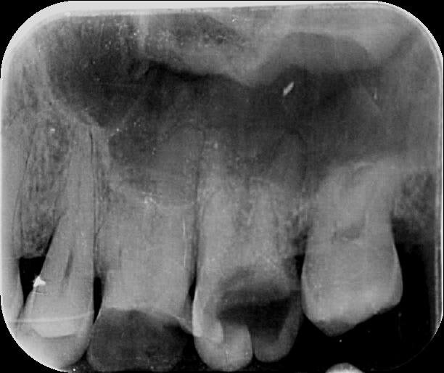
FIG 1:Preoperative radiograph of 17
On radiographic examination of 27, atypical anatomy of the roots was observed and a CBCT(FIG 2) was taken for confirmation.Local anaesthesia was administered and the operating field was isolated with rubber dam(COLTENE). Caries was excavated ,followed by pre-endodontic buildup with composite(FIG 3) . Access opening was done. Exploration of pulp chamber revealed one mesiobuccal, one distobuccal and two palatal canals under magnification(3.5x) .The working length radiograph was taken using the bisecting angle technique(FIG 4).
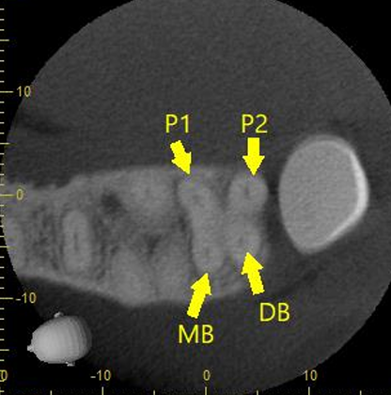
FIG 2:CBCT Image shows 2 palatal canals
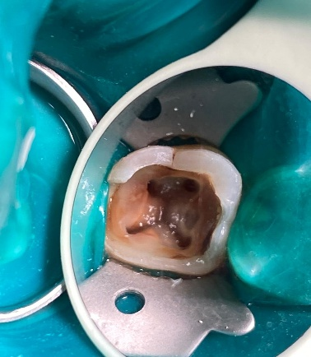
Fig 3: Pulp chamber with 4 root canals
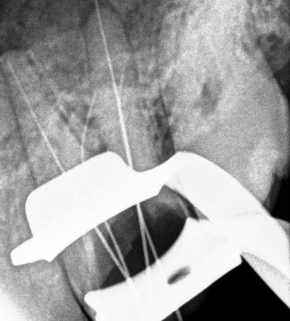
FIG 4: Working length determination
Initial instrumentation was performed with size 10 and 15 k files under irrigation with 2.5 % sodium hypochlorite. Root canal was prepared using crown down technique with Jizai rotary files. Further cleaning and shaping was completed using rotary files (JIZAI,MANI,Japan) with 2.5 % sodium hypochlorite irrigation ,followed by final rinse of 17% ethylene diamine tetraacetic acid (EDTA) and 5.25% sodium hypochlorite. The root canals were dried with sterile paper points . Pre-obturation radiograph was taken with the master cones and obturation was done with gutta-percha using cold lateral condensation technique(FIG 5). Permanent restoration was complete with composite.
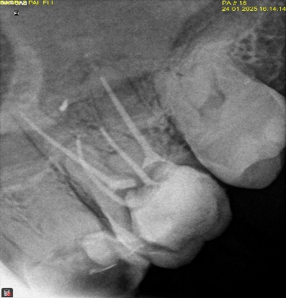
FIG 5:POST OBTURATION RADIOGRAPH
CASE 2
A 35 year old female patient presented to the department with chief complaint of intermittent pain and food impaction in her maxillary right first molar. On deeper clinical and radiographic evaluation, a gross proximal carious lesion was noted on 16(maxillary right first molar), and tooth was tender on percussion(FIG 6). Cold test demonstrated lingering pain for 50 seconds. The clinical diagnosis was symptomatic irreversible pulpitis with symptomatic apical periodontitis.
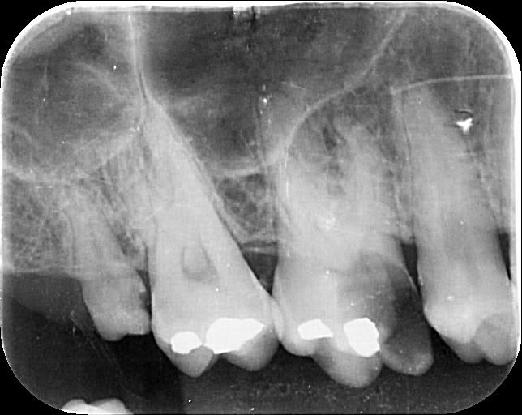
FIG 6: Preoperative Radiograph

Local anaesthesia was administered and the operating field was isolated with rubber dam(COLTENE). Caries was excavated ,followed by pre-endodontic buildup with composite. Access opening was done. Initial exploration of pulp chamber revealed two mesiobuccal, one distobuccal and one palatal canal. The pulp chamber was refined with ultrasonic tips and further exploration of pulpal floor with dental loupes(3.5x) revealed second palatal canal . The working length radiograph was taken using the bisecting angle technique.. During preparation, instrument got separated in the coronal third ,almost 2 mm from the canal orifice in MB2 canal(FIG 7).
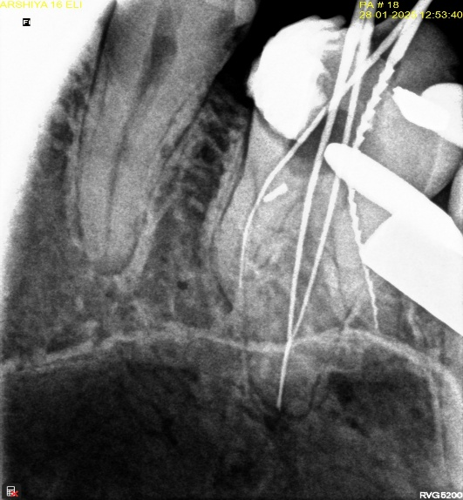
FIG 7 Working length radiograph with 2 palatal canals and fractrured instrument in MB2
Further cleaning and shaping was completed with rotary files (JIZAI, MANI, Japan) after establishing glide path with manual files. The canals were prepared to size 30/4% (MB1), size 30/6% (Distobuccal and P1) and size 30/4% (P2). Pre-obturation radiograph was taken with the master cones,then irrigation was done with 2.5 % sodium hypochlorite ,followed by final rinse of 17% ethylene diamine tetraacetic acid (EDTA) and 5.25% sodium hypochlorite. The root canals were dried with sterile paper points . and finally, obturation of all canals except MB2 was done with gutta-percha using cold lateral condensation technique(FIG 8). Patient was recalled after one week.
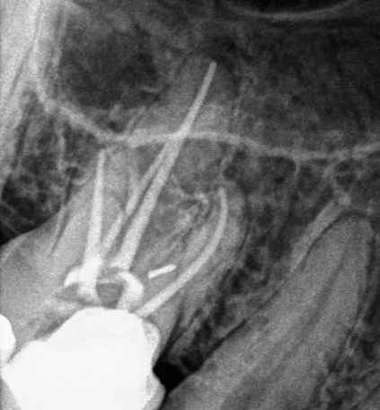
FIG 8: Post Obturation radiograph of 4 canals
The broken instrument was first successfully bypassed and size of the canal increased using k files. This created a staging platform for the placement of ultrasonic tips.The broken instrument was retrieved and canal was obturated(FIG 9,10).Access cavity was restored and later rehabilitated.

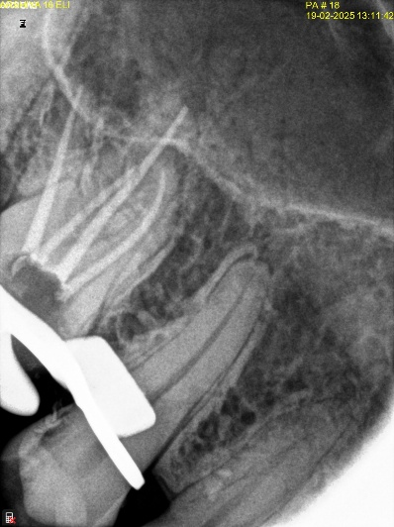
FIG 9: Radiograph after instrument retrieval from MB2
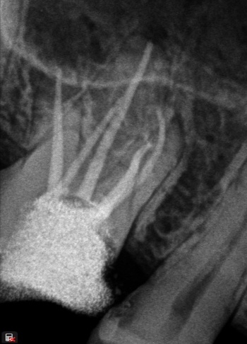
FIG 10: Post obturation Radiograph

DISCUSSION
This case reports outlines the non-surgical endodontic treatment of a maxillary molars exhibiting two palatal canals. Typically, the maxillary first molar is characterized by three roots and three to four root canals, making the presence of an additional palatal canal quite uncommon. Such cases underscore the complex endodontic anatomy of the maxillary first molar with dual canals in the palatal root. Dental practitioners can effectively identify and navigate these atypical configurations with a combination of magnification, illumination proper access cavity preparation and careful canal exploration. Additional imaging tools, such as preoperative Cone Beam Computed Tomography (CBCT), are valuable and mandatory diagnostic adjuncts.(Ali, 2020)
In case 1, two palatal canals have distinct orifices whereas in case 2 ,the 2 palatal canal seems to join at the apical third into a single exit.he traditional triangular access for maxillary molars was adapted to a trapezoidal shape to enhance visibility for identifying additional canals. A thorough evaluation of the preoperative radiograph and careful examination of the pulp chamber floor, aided by effective visualization and probing, enables the clinician to locate the canal orifices. The use of an endodontic explorer, magnifying loupes, and digital radiography proved essential for the identification and management of two canals located in the palatal and mesio-buccal roots. Meticulous evaluation of pulp chamber and floor for the potential presence of additional canals cannot be over emphasized preoperatively. It is crucial to identify and clean these extra canals to prevent endodontic mishaps. While the likelihood of encountering variations in radicular anatomy is generally low, practitioners must remain vigilant for the existence of supplementary canals or even additional roots.(Ali, 2020; Sung et al., 2021).
Instrument separation, is a frequent occurrence that can happen even among experienced endodontists, with studies indicating an incidence rate of 94.8% in endodontists compared to 85.1% in general dentists(Madarati et al., 2008). To enhance the longevity of the affected tooth, it is crucial to make every effort to either bypass or retrieve the broken instrument without much structural damage to tooth(Chauhan, 2024). In case 2, the initial attempts to bypass or retrieve the instrument were unsuccessful, and there was an additional risk of the instrument being lodged in other prepared canals during the retrieval process. Therefore, it was decided to obturate the remaining canals and defer the instrument retrieval to a subsequent appointment. During the follow-up session, the instrument was successfully bypassed, and removed with a combination of copious irrigation using EDTA and ultrasonic activation. Ultrasonic devices have demonstrated efficacy in the loosening and removal of various obstructions within root canals. The vibrational capabilities of endodontic instruments are useful and particularly recommended in cases where fractured segments are visible, enhancing the precision and effectiveness of the procedure.(Glii et al., 2023; Shiyakov & Vasileva, 2014)
Gaining access to the root canal is the initial step in the preparation process. Properly designed and executed access cavities can help avoid numerous potential complications during canal preparation and filling. The use of magnification tools, such as dental microscopes and loupes, enhances visualization and aids in identifying anatomical irregularities. In this particular case, 3.5x dental loupes are utilized for magnification and illumination. This increased magnification offers a much larger and clearer perspective of the treatment area. Such improved visualization enables clinicians to recognize subtle anatomical characteristics and differentiate between canal orifices more efficiently.(Manik et al,20)

CONCLUSION
A comprehensive understanding of tooth anatomy is essential for effective practice. Thorough evaluations should be performed during both clinical and radiographic examinations of patients. The palatal root of maxillary first molars is reported to have a prevalence of approximately 2% to 5.1%. Additionally, the utilization of endodontic microscopy and cone-beam computed tomography (CBCT) serves as valuable adjunctive techniques in endodontic treatment and the retrieval of instruments from the root canal. The decision to remove a fractured instrument is influenced by various factors, including the instrument’s position within the canal, the level of cleaning and shaping achieved at the time, and the length of the instrument. Nevertheless, it is always preferable to prevent instrument fracture within the canal through the implementation of proper techniques, rather than to confront the inherent challenges associated with retrieval.

CONSENT
All authors declare that ‘written informed consent was obtained from the patient (or other approved parties) for publication of this case report and accompanying images. A copy of the written consent is available for review by the Editorial office/Chief Editor/Editorial Board members of this journal

References
- Ali, M. (2020). Two Canals In Palatal Root Of Maxillary Molar: Case Series. Pakistan Journal Of Medicine And Dentistry. Https://Doi.Org/10.36283/PJMD9-1/020
- Buhrley, L. J., Barrows, M. J., Begole, E. A., & Wenckus, C. S. (2002). Effect Of Magnification On Locating The MB2 Canal In Maxillary Molars. Journal Of Endodontics, 28(4), 324–327. Https://Doi.Org/10.1097/00004770-200204000-00016
- Chauhan, D. (2024). Retrieval Of A Separated Instrument Using Combination Of Ultrasonics And Braiding Technique- A Case Report. International Journal For Multidisciplinary Research, 6(5). Https://Doi.Org/10.36948/Ijfmr.2024.V06i05.28392
- Chen, K., Ran, X., & Wang, Y. (2022). Endodontic Treatment Of The Maxillary First Molar With Palatal Canal Variations: A Case Report And Review Of Literature. World Journal Of Clinical Cases, 10(32), 12036–12044.
- Manik K, Ikhar A, Patel A, Chandak M, Bhopatkar J, Bhojwani PR, Rathod P, Manik Jr K. Diving Deep: Exploring Dual Palatal Canals In The Upper Second Molar. Cureus. 2024 May 28;16(5)
- Glii, W., Kikly, A., Brigui, F., Belguith, A. C., Zokkar, N., & Douki, N. (2023). Broken File Retrieval In The Lower Left Second Molar Using The Ultrasonic Technique. Mathews Journal Of Dentistry, 7(2). Https://Doi.Org/10.30654/MJD.10036
- Kumar, S. K., Sinha, S., Prabha, M. V., & Haragopal, S. (2012). Maxillary Molar With Two Palatal Canals. The Journal Of Contemporary Dental Practice, 13(6), 905–907. Https://Doi.Org/10.5005/Jp-Journals-10024-1251
- Lin, X., Xie, H., Ruan, S., Ma, X., Long, J., & Xie, F. (2025). Five-Canal Maxillary First Molar With Calcified MB2 And Low Bifurcation Of Distal Root Canals: A Case Report. Frontiers In Oral Health, 6. Https://Doi.Org/10.3389/Froh.2025.1511699
- Madarati, A. A., Watts, D. C., & Qualtrough, A. J. E. (2008). Opinions And Attitudes Of Endodontists And General Dental Practitioners In The UK Towards The Intracanal Fracture Of Endodontic Instruments: Part 1. International Endodontic Journal, 41(8), 693–701. Https://Doi.Org/10.1111/J.1365-2591.2008.01425.X
- Qun, L., Longxing, N., Qing, Y., Yuan, L., Jun, W., & Qingyue, D. (2009, April 1). A Case Of Asymmetric Maxillary Second Molar With Double Palatal Roots. | Ebscohost. Https://Openurl.Ebsco.Com/Contentitem/Gcd:43251665?Sid=Ebsco:Plink:Crawler&Id=Ebsco:Gcd:43251665
- Cleghorn BM, Christie WH, Dong CC. Root And Root Canal Morphology Of The Human Permanent Maxillary First Molar: A Literature Review. Journal Of Endodontics. 2006 Sep 1;32(9):813-21.
- Shetty, P. P., Astekar, M. S., Jain, A., & Pandya, M. (2012). Maxillary First Molar With Two Palatal Roots Located Under Dental Operating Microscope. Clinics And Practice, 2(1), E26. Https://Doi.Org/10.4081/Cp.2012.E26
- Shiyakov, K. K., & Vasileva, R. I. (2014). SUCCESS FOR REMOVING OR BYPASSING INSTRUMENTS FRACTURED BEYOND THE ROOT CANAL CURVE – 45 CLINICAL CASES. Journal Of IMAB - Annual Proceeding (Scientific Papers), 20(3), 567–571. Https://Doi.Org/10.5272/Jimab.2014203.567
- Sung, K.-H., Hwang, H.-K., & Jo, H.-H. (2021). Maxillary First Molars With Two Palatal Root Canals. Case Reports In Dentistry, 2021(1), 8885923. Https://Doi.Org/10.1155/2021/8885923

