Original Research Article
Seed Dormancy breaking in Nightshade (Solanum trilobatum L.)

Abstract
Nightshade (Solanum trilobatum L.) is one of the medicinal crops under Solanaceae family, often exhibits poor germination due to inherent seed dormancy. The present study was conducted to standardize the seed dormancy breaking treatments to improve the germination. The results clearly indicated that seeds treated with GA₃ @ 200 ppm for 6 h recorded maximum seed germination (84%) along with high speed of germination (5.5), seedling length (3.25 cm root length and 3.82 cm shoot length), dry matter production (4.94 mg seedlings⁻¹⁰) and vigour index (584) when compared to treatments viz., KNO₃ 1.0% for 12 h (64%) and thiourea 0.5% for 6 h (50%), while the control recorded 38% of germination. The increase in duration of soaking with GA₃ beyond 6 h. significantly reduced the seed germination with concomitant changes in seedling quality parameters. Hence, it could be concluded that breaking the seed dormancy through exogenous application of GA₃, KNO₃ and thiourea confirmed the presence of physiological dormancy in nightshade seeds and it could be effectively broken through soaking the seeds in GA₃ @ 200 ppm for 6 h.
Keywords: Solanum trilobatum, Dormancy, GA₃, KNO₃ and Thiourea
1. Introduction
Nightshade (Solanum trilobatum L.) is one of the medicinal plants belongs to the family Solanaceae. Traditionally, several medicinal plants such as aloe, kalmegh and ocimum (tulsi) etc., have specific analgesic and antibacterial properties. The nightshade plants are reported to possess several immunomodulatory, anti-diabetic, anti-ulcerogenic and hepatoprotective properties. The leaf extracts are used to heal snake poison and improve male fertility (Kumar et al., 2011). The entire plant decoction is used to treat acute and chronic bronchitis. According to cultivation, systematic cultivation of Solanum trilobatum L. is not practised anywhere, facing a range of difficulties in capitalising on their long-established advantages. Based on its ethnomedicinal importance, the plants have to be cultivated and conserved for the future generation. The mode of propagation of the crop Solanum trilobatum L. is mainly propagated through seeds which facilitates easy conservation practices. There are many numbers of literatures which detailed about the medicinal uses of the crop, but the resource related to the seed quality characteristics are limited. On persual of several literatures, it was reported that fresh seeds of nightshade have very low germination potential due to the prevalence of seed dormancy (Alagumanian et al., 2004) which might interfere the spread and distribution of plants. Seed dormancy is a biological mechanism that ensures seed germination at the appropriate time and under favorable conditions for the development and growth for the next generation. To ensure a uniform crop stand, it is highly essential to study the suitable seed dormancy breaking treatment to improve the seed germination.
2. MATERIALS AND METHODS
2.1 Experimental sit and Treatment details
The work has been carried out in the Department of Seed Science and Technology, Tamil Nadu Agricultural University, Coimbatore, in the year 2024-2025. The fully ripened berries were collected from ARS, Vaigai dam. The berries were graded based on their size and berries were surface sterilized with 2% sodium oxychloride (NaOCl) for 5 min and then treated with 80% ethanol for 5 min, followed by rinsing thrice with distilled water. Initial germination was low due to dormancy. The seeds were treated with different chemicals with different duration for breaking the seed dormancy. The treatment details are listed: T₀ – Control, T₁ - GA₃ 100 ppm, T₂ - GA₃ 200 ppm, T₃ - KNO₃ 0.5%, T₄ - KNO₃ 1.0%, T₅ - Thiourea 0.5%, T₆ - Thiourea 1.0% and duration of soaking: D₀ - 6 hrs, D₁ -12 hrs, D₂ -18 hrs. After the treatment, the seeds are shade dried at room temperature and subjected to the germination test in roll towel method. The seed quality parameters were estimated as per the ISTA (2019) protocol, such as Speed of germination, germination %, seedling length (cm), vigour Index and dry matter Production (mg/10 seedlings) were recorded.
Speed of germination = X₁/Y1+X₂-X₁/Y2+…+Xn- Xn-₁/Yn
Here X₁, X₂… Xn are the frequency of germinated seeds on the first, second and final day. While Y₁, Y₂ … Yn are the days from sowing to first, second and up to last day.
Germination (%) = Total number of seeds germinated/Total number of seeds sown × 100
Seedling length = Mean root length (cm)+ Mean shoot length (cm)
Vigour index= Germination (%) × Total seedling length (cm)
3. Statistical Analysis
The data were collected from the experiments has been carried out to analyse the statistical significance. The data were analysed by the method which is described by (Gomez and Gomez, 1984). The percent values were converted into angular transformation (arc sine) values wherever necessary. The critical difference (CD) value was calculated using 5% probability level.
4. Results and Discussions
Seed dormancy is considered as a component of growth arrest. It is characterized by a partial metabolic arrest that initiates and terminates under the direction of endogenous hormones. A balance in growth promotor and inhibitor regulates the mechanism behind seed dormancy. During seed maturation, the activity of growth promoter tends to decrease therefore seed dormancy is induced (Amen et al., 1968). Seed dormancy is defined as inability of viable seeds to germinate under favourable conditions (Bewley, 1997). Seed dormancy is a mechanism that limits the seed germination and growth of embryo. The level of seed dormancy is commonly regulated by an interaction between the development of seed under different growth phases and environmental conditions experienced by the parent plant.
Many of the medicinal plants remains non-domesticated because of their wild growth in nature (Pallavi et al., 2014). Due to non-domestication, systematic cultivation of many important medicinal plants is not practiced which results in extinction of several medicinal plants. For, effective cultivation of medicinal plants the seeds must be viable and non-dormant. Cultivation of dormant seeds results in poor germination and uneven crop stand. For uniform crop stand the seeds must be non-dormant for cultivation. In this present study, an attempt was made to standardize the suitable dormancy breaking treatment for germination improvement in the nightshade.
The freshly extracted seed was subjected for germination without any pretreatment, which records only 38% of germination. The minimum rate of germination percentage indicates the presence of dormancy. Freshly extracted seeds (dry seeds) were taken as control and the remaining seeds were treated with GA3, KNO3 and thiourea for breaking seed dormancy to improve germination. The duration of the treatment was carried out for 6, 12 and 18h at ambient temperature. After the pretreatment, the seeds were subjected for germination to observe seedling quality parameters viz., germination, speed of germination, seedling length and vigour index of the seedlings.
The growth potential and survival of seeds are the prime indicator of germination percentage which is irrespective of factors that leads to loss of viability in seed (Abdalla and Roberts 1969). Increasing the level of seed germination is the major objective in the successful seed production programme. One of the most important aspects of subjecting the seeds for germination test is mainly to determine the planting value of the seed for uniform crop establishment and to compare the test results between different seed lots.
In this present study, significant results were obtained among seed germination, the seeds treated with GA3 200 ppm @ 6h. improved the germination percentage (84%) when compared with control (38%) (Fig. 1). Seed treatment with GA3 100 ppm@6h resulted 72% of germination which is next to GA3 200 ppm for 6hrs (Fig. 2) (Table 1). Similar results were reported by Jayamani (2020) in black cumin.
The increase in seed germination through GA3 treatment is might be due to the enhanced stimulation of α-amylase synthesis and other hydrolyzing enzymes. The main role of hydrolyzing enzymes is the conversion of the complex starch molecules into simple sugars (Baskin et al., 1998, Finch‐Savage and Leubner‐Metzger 2006). Moreover, GA3 accelerates the vegetative growth and it weakens the endosperm layer which limits embryo growth and it mobilizes the endosperm food reserves (Bareke, 2018).





















Speed of germination have been used as an index of seed vigour and seedling growth rate. The time taken to the emergence of radicle from the seed coat is observed as speed of germination. It defines the ability of seed to produce seedlings within a short span of time under favourable conditions. Significant variations were observed in the speed of germination among different treatments and duration. Among various treatments, GA3 200 ppm for 6h. significantly improved the speed of germination (5.5) when compared with control (2.7) (Table 1). The increase in speed of germination is mainly due to the breakdown of complex food materials into simple sugars and release of energy into the growing tip of the radicle which triggers the speed of germination. The seeds which imbibe water but not germinated until the end of the germination test period are termed as fresh ungerminated seeds. The seeds were able to germinate after an appropriate treatment. The minimum number of fresh ungerminated seeds was recorded in GA3 200 ppm for 6h. (16%) when compared to control (54%) (Fig. 3) (Table 2)
700

600

500

400

300

200

100

0
T0
T1
T2
T3
Treatments
T4
T5
T6
6hr 12hr 18hr
Dry matter production and seedling length are the measure of the seed vigour index. It determines the physiological potential of germinating seeds. (Heydecker et al., 1973). In the present investigation the seeds treated with GA3 200 ppm for 6h. had significantly improved the seedling length (3.25 cm root length and 3.82 cm shoot length) when compared with control (2.19 cm root length and 3.08 cm shoot length) (Table 3) The seeds treated with GA3 200 ppm for 6h. has recorded maximum dry matter production (4.94 mg seedlings⁻¹⁰) when compared with control (2.66 mg seedlings⁻¹⁰) (Table 4). The physiological phenomenon of seedling vigour is determined by reserve metabolites, enzymatic activity and growth regulators. The vigour factor determines the germinability of the seed which is the ultimate expression of seed quality (Heydecker, 1972).
In the present study the maximum vigour index was recorded in the seeds treated with GA3 200 ppm for 6h. (584) when compared with control (200) (Table 4). The improvement in vigour index is might be due to the fact, seed treatment with GA3 regulates high water absorption which results in increased cell wall elasticity and it leads to the formation of the effective root system which is responsible for an increase in vigour index
The seeds treated with GA3 were significantly improved the germination percentage which ranged from 72% in 100 ppm to 84% ppm in 200 ppm, when the seeds were soaked for 6 h. The increased duration of soaking in GA3 significantly reduced the germination per cent with concomitant changes in seed quality parameters such as speed of germination, seedling length, dry matter production and vigour index. These findings are in conformity with Keerthana (2018) in Solanum nigrum.
The seeds treated with KNO3 had also significantly improved the germination but not more than GA3 treated seeds. The seeds treated with KNO3 1% for 12 h. had improved the germination of 64 per cent and other seedling quality parameters such as speed of germination (3.8), root length (2.81 cm), shoot length (3.36 cm), dry matter production (4.24 mg/10 seedlings) and vigour index (396). The findings were correlated with Gupta et al., (2011),
reported that the seeds of Hippophae salicifolia were treated with KNO3 @ 0.1% for 48 h. were significantly improved the seed germination and other quality parameters. The improvement in germination by KNO3 is mainly due to an increased level of oxygen by decreasing the supply of oxygen to the citric acid cycle. More amount of oxygen was dissolved in water which makes the availability of more oxygen for the embryo which improves the rate of germination (Bewley and Black, 2012). The results are in conformity with (Roberts and Lockett, 1978) noticed the improvement in germination percentage when the seeds of Solanum nigrum were treated with 0.2 % KNO3.
The seeds treated with thiourea showed slight improvement in seed germination and other seedling quality parameters. The results obtained from the seeds treated with thiourea 0.5% for 6 h. resulted in improved germination (50%), speed of germination (3.2), root length (2.53 cm), shoot length (3.19 cm), dry matter production (3.55 mg seedlings⁻¹⁰) and vigour index
(287). The improvement in seed germination is mainly due to the process of acidification and loosening of cell wall and erodes the seed coat which significantly improves the cell wall permeability for movement of water in the seeds (Ali et al., 2010). The germination and other quality parameters were decreased when the concentration and duration of soaking were increased. Similar results were reported by Pandey et al., (2000) in Aconitum sp and Gupta et al., (2011) in Hippophae salicifolia. However, the maximum seed germination was observed in seeds treated with GA3 200 ppm for 6 hrs soaking when compared with other growth regulators. The decrease in germination per cent were noted in GA3 100 ppm for 18 hrs recorded 62 per cent of germination and 48 per cent of germination was observed in KNO3 0.5% for 18 hrs and the seeds treated with thiourea 1.0% for 18 hrs recorded only 40 per cent of seed germination. The results clearly depict that optimizing the concentration and duration of seed dormancy breaking treatment is important for each and every species.
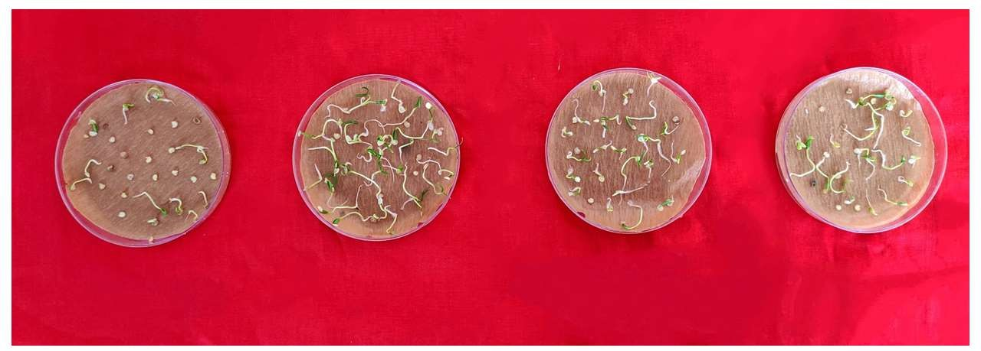

Figure 1. Effect of GA3, KNO₃ and Thiourea on seed germination in nightshade
Figure 2. Effect of different seed dormancy breaking treatment on seed germination (%) in nightshade
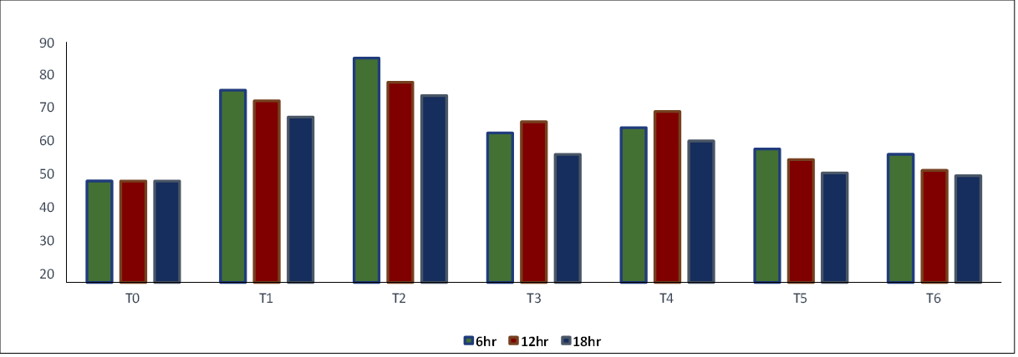
(T₀ – Control, T₁ - GA3 100 ppm, T₂ - GA3 200 ppm, T₃ - KNO₃ 0.5%, T₄ - KNO₃ 1.0%,
T₅ - Thiourea 0.5%, T₆ - Thiourea 1.0%: D₀ - 6 hrs, D₁ -12 hrs, D₂ -18 hrs)

Figure 3. Effect of different seed dormancy breaking treatment on fresh ungerminated seeds (%) in nightshade
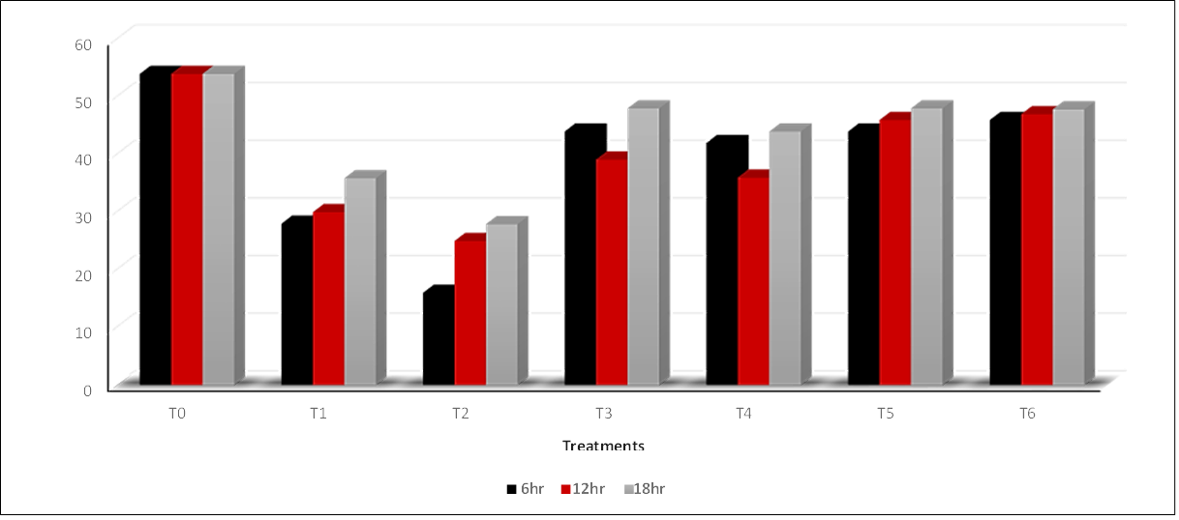
(T₀ – Control, T₁ - GA3 100 ppm, T₂ - GA3 200 ppm, T₃ - KNO₃ 0.5%, T₄ - KNO₃ 1.0%,
T₅ - Thiourea 0.5%, T₆ - Thiourea 1.0%: D₀ - 6 hrs, D₁ -12 hrs, D₂ -18 hrs)
Table 1. Effect of GA3, KNO₃ and Thiourea on seed germination (%) and speed of germination in nightshade (Solanum trilobatum L.)

Treatments (T) | Germination (%) |  |  |  | Speed of germination
Treatments (T) | Duration (D) |  |  | Mean | Duration (D) |  |  | Mean
Treatments (T) | 6 h | 12 h | 18h | Mean | 6 h | 12 h | 18h | Mean
T0 – Control | 38 (38.05) | 38 (38.05) | 38 (38.05) | 38 (38.05) | 2.7 | 2.7 | 2.7 | 2.7
T1- GA3 100 ppm | 72 (58.05) | 68 (55.55) | 62 (51.94) | 67 (55.21) | 4.4 | 4.2 | 4.0 | 4.2
T2- GA3 200 ppm | 84 (66.4) | 75 (60.00) | 70 (56.79) | 76 (61.12) | 5.5 | 4.6 | 4.5 | 4.8
T3- KNO3 0.5% | 56 (48.44) | 60 (50.76) | 48 (43.85) | 55 (47.74) | 3.5 | 3.7 | 3.2 | 3.4
T4- KNO3 1.0% | 58 (49.60) | 64 (53.13) | 53 (46.72) | 58 (49.82) | 3.6 | 3.8 | 3.4 | 3.6
T5 – Thiourea 0.5% | 50 (45.00) | 46 (42.70) | 41 (39.81) | 46 (42.55) | 3.2 | 3.1 | 3.0 | 3.1
T6- Thiourea 1.0% | 48 (43.85) | 42 (40.39) | 40 (39.23) | 43 (41.15) | 3.1 | 3.0 | 2.9 | 3.0
Mean | 58 (49.95) | 56 (48.69) | 50 (45.20) |  | 3.7 | 3.5 | 3.3
 | T | D | T×D |  | T | D | T×D
SEd | 0.82 | 0.54 | 1.43 |  | 0.07 | 0.04 | 0.13
CD(P=0.05) | 1.65 | 1.08 | 2.87 |  | 0.15 | 0.09 | 0.26
(Data in parentheses indicate arc-sine values)
Table 2. Effect of GA3, KNO3 and Thiourea on Fresh ungerminated seeds (FUG) in nightshade (Solanum trilobatum L.)

Treatments (T) | Duration (D) |  |  | Mean
Treatments (T) | 6 h | 12 h | 18h | Mean
T0 – Control | 54 (47.29) | 54 (47.29) | 54 (47.29) | 54 (47.29)
T1- GA3 100 ppm | 28 (32.40) | 30 (33.42) | 36 (36.84) | 31 (34.00)
T2- GA3 200 ppm | 16 (24.50) | 25 (30.40) | 28 (32.25) | 23 (28.50)
T3- KNO3 0.5% | 44 (41.44) | 39 (38.66) | 48 (43.45) | 44 (41.35)
T4- KNO3 1.0% | 42 (40.10) | 36 (37.02) | 44 (41.08) | 41 (39.60)
T5 – Thiourea 0.5% | 44 (41.55) | 46 (42.30) | 48 (43.51) | 46 (42.70)
T6- Thiourea 1.0% | 46 (42.70) | 47 (42.75) | 48 (43.31) | 47 (43.27)
Mean | 39 (38.43) | 40 (38.65) | 43 (41.31)
 | T | D | T×D
Sed | 0.50 | 0.33 | 0.87
CD(P=0.05) | 1.01 | 0.66 | 1.75
(Data in parentheses indicate arc-sine values)

Treatments (T) | Root length (cm) |  |  |  | Shoot length (cm)
Treatments (T) | Duration (D) |  |  | Mean | Duration (D) |  |  | Mean
Treatments (T) | 6 h | 12 h | 18h | Mean | 6 h | 12 h | 18h | Mean
T0 – Control | 2.19 | 2.19 | 2.19 | 2.19 | 3.08 | 3.08 | 3.08 | 3.08
T1- GA3 100 ppm | 2.75 | 2.36 | 2.20 | 2.43 | 3.54 | 3.43 | 3.18 | 3.35
T2- GA3 200 ppm | 3.25 | 2.89 | 2.70 | 2.94 | 3.82 | 3.52 | 3.26 | 3.53
T3- KNO3 0.5% | 2.63 | 2.73 | 2.33 | 2.56 | 3.22 | 3.23 | 3.16 | 3.21
T4- KNO3 1.0% | 2.66 | 2.81 | 2.44 | 2.63 | 3.24 | 3.36 | 3.20 | 3.26
T5 – Thiourea 0.5% | 2.53 | 2.39 | 2.29 | 2.40 | 3.19 | 3.24 | 3.11 | 3.18
T6- Thiourea 1.0% | 2.46 | 2.31 | 2.20 | 2.32 | 3.18 | 3.10 | 3.08 | 3.12
Mean | 2.63 | 2.52 | 2.37 |  | 3.32 | 3.27 | 3.15
 | T | D | T×D |  | T | D | T×D
SEd | 0.04 | 0.03 | 0.08 |  | 0.06 | 0.04 | 0.11
CD(P=0.05) | 0.09 | 0.06 | 0.16 |  | 0.12 | 0.08 | NS
Table 3. Effect of GA3, KNO₃ and Thiourea on root length and shoot length in nightshade (Solanum trilobatum L.)

Table 4. Effect of GA3, KNO3 and Thiourea on dry matter and vigour index in nightshade (Solanum trilobatum L.)
Treatments (T) | Dry matter (mg/10 seedlings) |  |  |  | Vigour index
Treatments (T) | Duration (D) |  |  | Mean | Duration (D) |  |  | Mean
Treatments (T) | 6 h | 12 h | 18h | Mean | 6 h | 12 h | 18h | Mean
T0 – Control | 2.66 | 2.66 | 2.66 | 2.66 | 2.66 | 200 | 200 | 200
T1- GA3 100 ppm | 4.69 | 4.18 | 3.84 | 4.23 | 4.69 | 440 | 394 | 334
T2- GA3 200 ppm | 4.94 | 4.56 | 4.18 | 4.56 | 4.94 | 584 | 482 | 418
T3- KNO3 0.5% | 3.96 | 3.97 | 3.45 | 3.79 | 3.96 | 326 | 359 | 264
T4- KNO3 1.0% | 3.64 | 4.24 | 3.31 | 3.73 | 3.64 | 342 | 396 | 298
T5 – Thiourea 0.5% | 3.55 | 3.14 | 3.05 | 3.24 | 3.55 | 287 | 259 | 221
T6- Thiourea 1.0% | 3.35 | 2.78 | 2.75 | 2.96 | 3.35 | 270 | 228 | 212
Mean | 3.82 | 3.64 | 3.31 |  | 3.82 | 350 | 331 | 278
 | T | D | T×D |  | T | D | T×D
SEd | 0.08 | 0.05 | 0.14 |  | 12.02 | 7.87 | 20.83
CD(P=0.05) | 0.16 | 0.10 | 0.28 |  | 24.03 | 15.73 | 41.62

5. Conclusion
The study concluded that, seeds treated with GA3 200 ppm for 6 h has reported improvement in germination percentage (84 per cent) when compared with control (38 per cent) and also improved other seedling quality parameters. The reduction in germination percentage with concomitant changes in seedling quality parameters was recorded when the duration of soaking was increased. Hence, it is revealed that optimizing the concentration and duration of seed dormancy breaking treatment is critical for each and every species. The seed germination was also improved when it is treated with KNO3 1% for 12 h. (64%) and thiourea 0.5% for 6 h. (50%). The results clearly indicated that breaking the seed dormancy through exogenous application of GA3, KNO3 and thiourea confirms the presence of physiological dormancy in nightshade (Solanum trilobatum L.) seeds.

Ethical issues: None.
References
- Abdalla, FH, and EH Roberts. 1969. "The effect of seed storage conditions on the growth and yield of barley, broad beans, and peas." Annals of Botany 33 (1):169-184.
- Alagumanian, S, V Saravana Perumal, R Balachandar, K Rameshkannan, and MV Rao. 2004. "Plant regeneration from leaf and stem explants of Solanum trilobatum L." Current Science 86 (11):1478-1480.
- Ali, Tavili, Pouzesh Hossein, Farajolahi Asghar, Zare Salman, and Zare Chahooki Mohammad Ali. 2010. "The effect of different treatments on improving seed germination characteristics in medicinal species of Descurainia sophia and Plantago ovata." African Journal of Biotechnology 9 (39):6588-6593.
- Amen, Ralph D. 1968. "A model of seed dormancy." The Botanical Review 34 (1):1-31.
- Bareke, TJAPAR. 2018. "Biology of seed development and germination physiology."
- Baskin, Jerry M, Xiaoying Nan, and Carol C Baskin. 1998. "A comparative study of seed dormancy and germination in an annual and a perennial species of Senna (Fabaceae)." Seed Science Research 8 (4):501-512.
- Bewley, J Derek, and Michael Black. 2012. Physiology and biochemistry of seeds in relation to germination: volume 2: viability, dormancy, and environmental control: Springer Science & Business Media.
- Bewley, J Derek. 1997. "Seed germination and dormancy." The plant cell 9 (7):1055.
- Finch‐Savage, William E, and Gerhard Leubner‐Metzger. 2006. "Seed dormancy and the control of germination." New phytologist 171 (3):501-523.
- Gomez, Kwanchai A, and Arturo A Gomez. 1984. Statistical procedures for agricultural research: John wiley & sons.
- Gupta, Sanjay Mohan, Pankaj Pandey, Atul Grover, and Zakwan Ahmed. 2011. "Breaking seed dormancy in Hippophae salicifolia, a high value medicinal plant." Physiology and Molecular Biology of Plants 17 (4):403-406.
- Heydecker, W. 1972. "Vigour." In Viability of seeds, 209-252. Springer.
- Heydecker, Walter, John Higgins, and RL Gulliver. 1973. "Accelerated germination by osmotic seed treatment." Nature 246 (5427):42-44.
- ISTA. 2019. "International Rules For Seed Testing bassersdorf (Switzerland)." International Seed Testing Association.
- Jayamani, S. 2020." Seed Technological studies in Black cumin (Nigella sativa)." M.Sc.(Ag) Thesis, Tamil Nadu Agricultural University, Coimbatore.
- Keerthana, S. 2018. "Seed Technological Studies in Black nightshade (Solanum nigrum L.)." M.Sc., (Ag.) Tamil Nadu Agricultural University, Coimbatore.
- Kumar, SR, Charles Lekhya Priya, and Kokati Venkata Bhaskara Rao. 2011. "Phytochemical composition, antimicrobial and hemolytic activity of Solanum trilobatum linn.".
- Pallavi, HM, K Vishwanath, BS Harish, Y Prashanth, and Thattimani Manjunath. 2014. "Seed treatments to break seed dormancy and Standardization of viability test procedure in Abrus precatorious." Journal of Medicinal Plants Research 8 (4):229-236.
- Pandey, H, SK Nandi, M Nadeem, and LMS Palni. 2000. "Chemical stimulation of seed germination in Aconitum heterophyllum Wall. and A. balfourii Stapf.: important Himalayan species of medicinal value." Seed Science and Technology 28 (1):39-48.
- Roberts, HA, and PATRICIA M Lockett. 1978. "Seed dormancy and field emergence in Solanum nigrum L." Weed Research 18 (4):231-241.

