Predicting the Effects of Climate Change on the Habitat Suitability of Long-Spurred Habenaria in Peninsular India

ABSTRACT
Endemic plant species are increasingly at risk due to global climate change and anthropogenic pressures, making the prediction of suitable habitats essential for their conservation. Habenaria longicorniculata is an endemic terrestrial orchid species of Peninsular India, currently facing threats due to climate change and anthropogenic activities. Predicting suitable habitats for such species is essential for effective conservation planning. In this study, species distribution modeling was performed using MaxEnt to assess the current and future habitat suitability of H. longicorniculata under various Shared Socioeconomic Pathways (SSPs). The model revealed high predictive accuracy, with an AUC value of 0.927 (±0.037). Results indicate a significant reduction in suitable habitat, projected to decline by 44.41% to 74.92% under future climate scenarios. Future distributions will likely become restricted to limited regions in Kerala, Tamil Nadu, and Karnataka. The Jackknife test revealed that bioclimatic variables Bio5 (max temperature of the warmest month) and Bio8 (mean temperature of the wettest quarter) are the most influential in determining species distribution. Overall, the study makes a significant contribution to species conservation and provides valuable input for future research and decision-making.

Keywords: Habenaria, MaxEnt, Climate Change, Decline, in-situ conservation.

1. INTRODUCTION

Global climate change has posed a severe threat to biological diversity (Kolanowska et al., 2017; Habibullah et al., 2021). These changes are directly impacting the distribution of plant species, particularly vulnerable and endemic plants with specific habitat needs, especially orchids (Tang et al., 2020). Orchids exhibit a complex lifecycle and are mutually dependent upon other biotic and abiotic factors, like mycorrhizal association, pollinators, and have a very specific habitat requirement for survival (Chandra et al., 2023). As a result, the majority of the species are currently under severe threat. Although various countries have enacted legislation to safeguard these unique species, effective conservation efforts must prioritize the protection and restoration of their microhabitats (Fay, 2018). Habitat suitability modeling serves as a valuable tool in biodiversity conservation, particularly for species with specialized ecological requirements such as orchids. Furthermore, habitat suitability models support in situ conservation planning by highlighting existing habitats that are crucial for the species’ persistence, enabling targeted protection and management of those areas. In the face of rapid environmental changes, especially due to climate change, such predictive modeling is critical for developing conservation strategies. Moreover, a few research can be found on the future habitat suitability due to the medicinal important or their invasiveness or on some particular geographical area, such as Anoectochilus elatus (Patil et al., 2020), Arundina graminifolia (Kolanowska & Konowalik, 2014), Changnienia amoena (Liu et al., 2024), Crepidium acuminatum (Boral & Moktan, 2024), Crepidium ridleyi (Usmadi et al., 2023), Cypripedium calceolus (Kolanowska & Jakubsha-Busse, 2020; Jakubsha-Busse et al., 2021; Krenova et al., 2023), Dactylorhiza hatagirea (Chandra et al., 2021; Wani et al., 2021; Shrestha et al., 2021), Dactylorhiza fuchsia, Dactylorhiza majalis, Gymnadenia conopsea and Platanthera bifolia (Štípková et al. (2017), Dendrobium moniliforme & Dendrobium nobile (Tang et al., 2020), Dendrophylax lindenii (Kolanowska, 2023), Epipactis helleborine (Kolanowska, 2013), Gymnosia orchidis (Li et al., 2024), Habenaria diphylla (Halagatti et al., 2024), Listera puberula, Neottianthe cucullata, Herminium monorchis, Cypripedium calceolus, Gymnadenia conopsea, and Liparis japonica (Wan et al. 2014), Neottia cordata (Tsiftsis et al., 2020), Orchis anthropophora, Orchis militaris, Orchis purpurea and Orchis simia (Evans et al., 2020), Paphiopedilum javanicum (Romadlon et al., 2021), Polystachya concreta (Kolanowska et al., 2020), Satyrium nepalense (Boral & Moktan, 2024), Spiranthes parksii (Wang et al., 2015), Traunsteinera globosa (Kolanowska, 2021), Vanda bicolor (Deb et al., 2017) & Vanilla borneensis (Deka et al., 2017). In contrast, only a handful of studies have been carried out to investigate the role of climate change in the distribution pattern of threatened/endemic orchids in India. For example, species distribution model was carried out for Cypripedium species (Chandra et al., 2023), Habenaria suaveolens (Jalal & Singh, 2017; Jalal et al., 2025), Habenaria longicornuculata (Sourabh & Uniyal, 2022) which provides current and future potential suitable habitats for the species, which in return will be helpful in the conservation process of the species.
Habenaria longicornuculata J. Graham is an endemic terrestrial orchid, commonly known as “long spurred Habenaria” due to the presence of a 10-15 cm long spur (Figure 1). The species was first reported from Maharashtra by John Graham in 1839. Later, the species was reported from other parts of the country like Andhra Pradesh, Odisha, Goa, Gujarat, Karnataka, Kerala, Maharashtra, Tamil Nadu, Jharkhand, Chhattishgarh, Madhya Pradesh and Rajasthan (Singh et al., 2019; Jalal, 2018; Purohit et al., 2020; Jalal, 2022). The species can be found growing on lateritic plateaus, grassy slopes, and gravelly soils at an elevation between 1000-1200 m. It is locally abundant in many parts of Peninsular India. According to Kumar et al. (2001), the overall population size in the Western Ghats exceeds 10,000 mature individuals. Jalal and Singh (2015) reported that the population size in Maharashtra is less than 5,000 mature individuals. Purohit et al. (2020) estimated a population size of less than 1,000 mature individuals in the Mount Abu Wildlife Sanctuary in Rajasthan. Rapid changes in the land use patterns across its habitat due to habitat fragmentation, developmental activities, grazing, rapid urbanization, forest fire, expansion of agricultural land, and anthropogenic activities are posing serious threats to its survival. Additionally, recent shifts in climate patterns, particularly in rainfall distribution and increased frequency of droughts, are adversely impacting its reproductive biology, including pollination efficiency and fruit setting. It is also known for its medicinal importance, leading to the illegal collection of tubers. Therefore, the present study aims at the following objectives: (1) distribution of the species in Peninsular India, (2) key environmental factors that play an important role in the distribution of species, (3) MaxEnt predicted distribution of species in India & (4) measure conservational steps to be taken care of for the protection of the species.

2. MATERIAL AND METHODS

2.1 Species Occurrence Record
The geographical locations of H. longicornuculata were obtained from both primary and secondary resources. The primary resources include field surveys from 2012 to 2024, while secondary occurrence records were gathered from different herbaria, viz., Western Regional Centre, Botanical Survey of India (BSI), Central National Herbarium (CAL), Calicut University Herbarium (CALI), Shivaji University, Kolhapur (SUK), Tropical Botanic Garden and Research Institute (TBGT), Kerala Forest Research Institute (KFRI), Southern Regional Centre, BSI (MH), Blatter Herbarium & online resources such as GBIF (GBIF.org (05 May 2025) GBIF Occurrence download https://doi.org/10.15468/dl.9bgrs7), iNaturalists. The geographical coordinates (latitude and longitude) of all recorded occurrences of H. longicorniculata were obtained using Google Earth Pro, particularly for locations where direct coordinate data were unavailable in the literature or herbarium records. Each occurrence point was carefully georeferenced based on locality descriptions, ensuring accuracy in spatial representation. The finalized coordinates were compiled and saved in CSV (Comma-Separated Values) format, which included essential fields such as species name, latitude, longitude, altitude (where available), and source reference. This format ensured compatibility with Geographic Information System (GIS) software for further analysis. A species distribution map was created using ArcGIS version 10.5 and the CSV file.

  - Bioclimatic Variables
Environmental variables (Bio1-Bio19) were obtained from the global WorldClim dataset version 2.1 (www.worldclim.org) at the spatial resolution of 30 arc seconds (Fick & Hijmans, 2017). The SRTM Digital Elevation Model (DEM) was obtained from the WorldClim archive and utilized to generate slope, aspect, and elevation variables. To identify land cover characteristics of the study area, soil type data and its physio-chemical parameters (pH, organic carbon (OCS) 0-05 cm, clay (0-05cm) were obtained from ISRIC (https://soilgrids.org) version 2.0 and Land Use and Land Cover (LULC) data for the study area were sourced from Copernicus Sentinel-2 imagery (2023) with an original spatial resolution of 10 meters. To ensure compatibility with other environmental predictor layers and to reduce computational complexity, the data were resampled to a 1-kilometer spatial resolution using the nearest neighbor interpolation method. A Pearson’s correlation study was conducted to prevent multicollinearity, which could lead to overfitting among environmental variables, and subsequently removed all the variables with a higher correlation (≥0.8) were removed. Subsequently, 16 bioclimatic variables were further used to run the model (Table 1).
For future climate change scenarios, a CMIP6 model, i.e., MIROC6 (Model for Interdisciplinary Research on Climate), was used, as the model performs best in the Indian region (Kumar & Sarathi, 2021; Paul et al., 2023; Konda & Vissa, 2023), which provides the most up-to-date and robust climate projections for future scenarios. Two Shared Socio-Economic Pathways (SSPs), i.e., SSP2-4.5 & SSP5-8.5, were used for the years 2030 (2020-2040), 2050 (2041-2060), 2070 (2061-2080), 2090 (2081-2100). These SSPs play a crucial role in climate change studies, enabling researchers to analyze potential socioeconomic conditions, assess their effects on greenhouse gas emissions, and determine their impact on future climate scenarios (Bhuyan et al., 2025).

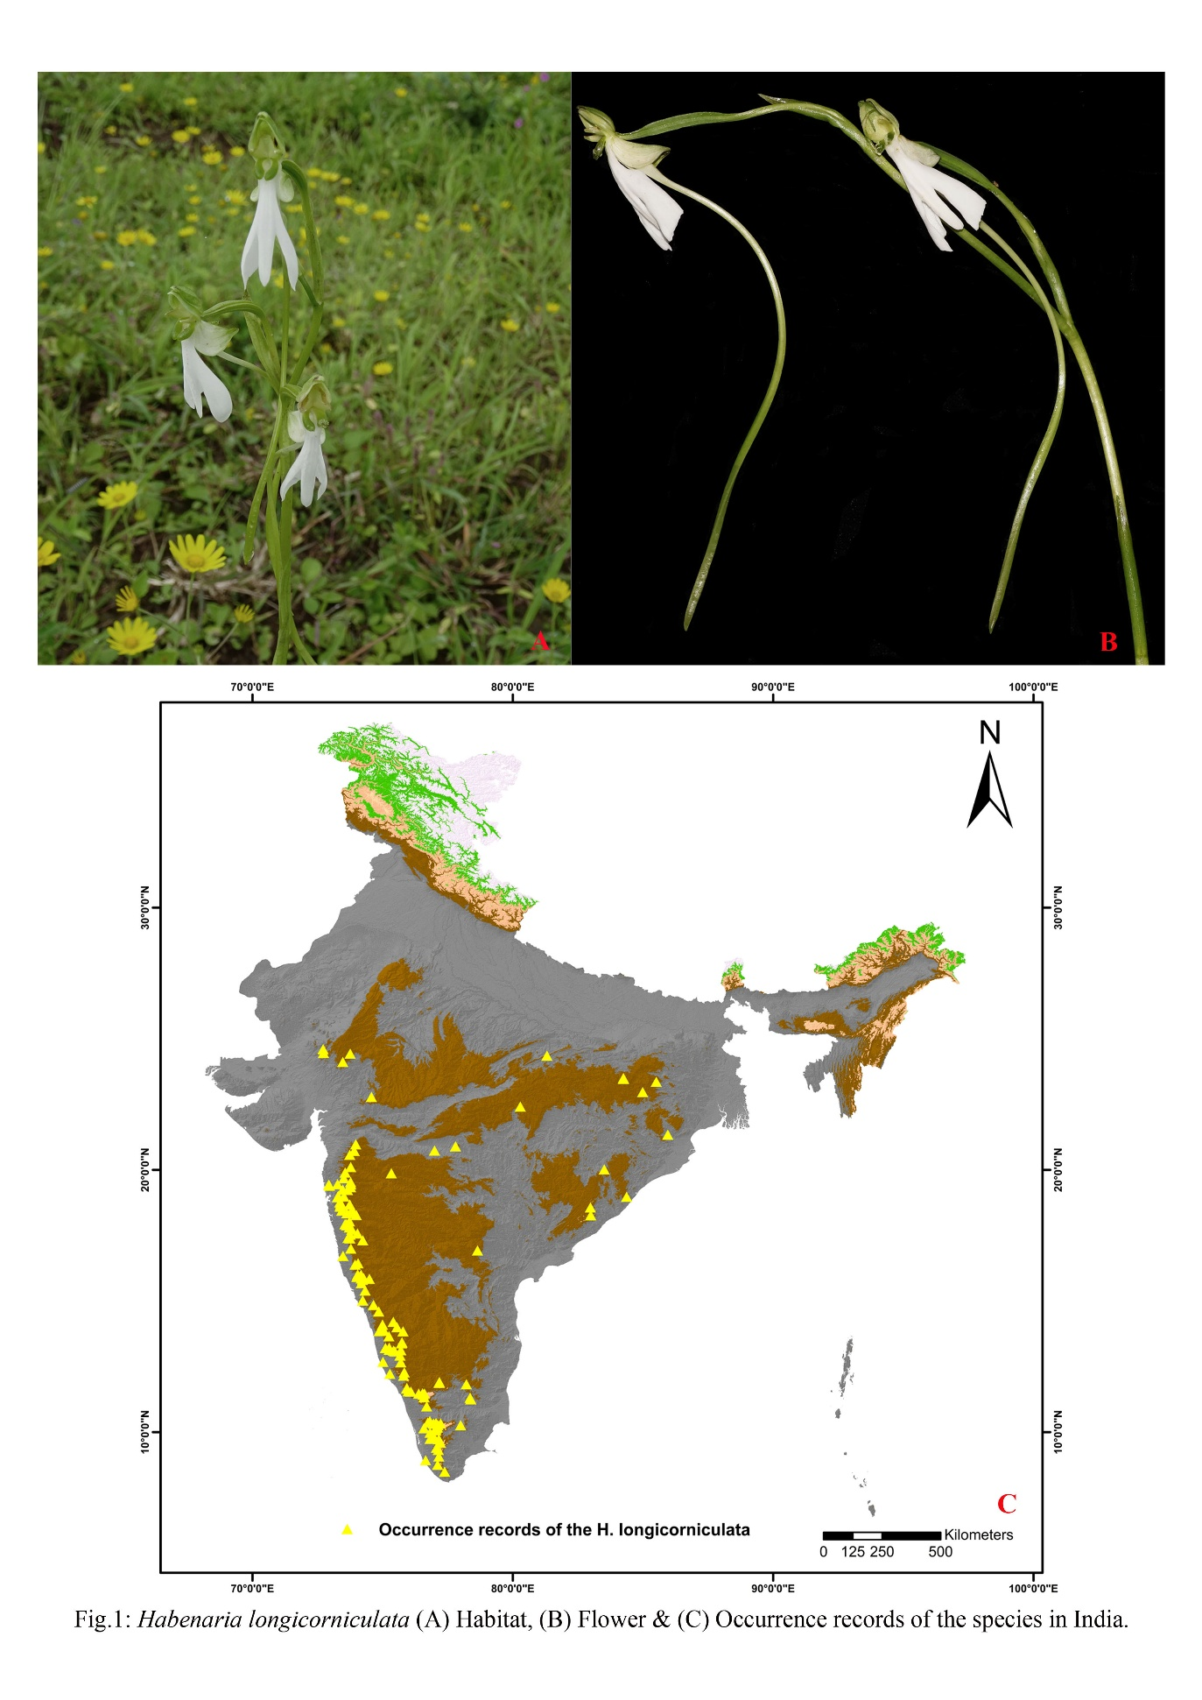
  - MaxEnt Model Building
The species distribution model was created using MaxEnt (3.4.4) with default settings. It is one of the most widely used models to predict the species distribution especially endangered species (Yuan et al., 2020) by using presence-only data and different environmental variables (Elith et al., 2011). It performs better than other models even when small datasets are applied. We used 10 replicates to cross-validate the model run with 10,000 background points selected randomly from the study area. The regularization multiplier value was set at 0.1 to reduce the model's overfitting and over-prediction with 500 iterations. The occurrence data were divided into 75% for training and 25% for testing, ensuring reliable model validation. A Jack-knife analysis was performed to determine variables that reduce the model reliability when omitted or vice versa (Phillips et al., 2006; Elith et al., 2011). Model performance was evaluated using the Area Under the Receiver Operating Curve (AUC), using the Receiver Operating Characteristic (ROC) analysis. The value of AUC decides the robustness of the model. The model is considered good at AUC (0.7-0.8), excellent at 0.8-1. AUC value close to 1 indicates a higher habitat suitability and a strong correlation between environmental variables and habitat classification, resulting in better model prediction (Elith et al., 2006; Ye et al., 2020; Wei et al., 2024). To create a potential distribution of the species, suitable habitat was manually classified under 4 categories: 0-0.6 means unsuitable, 0.6-0.7 means poorly Suitable, 0.7-0.8 means moderately suitable, and 0.8-1 means highly suitable, using ArcGIS 10.5.

3. results

The current distribution areas of H. longicornuculata were predicted using the MaxEnt model. The AUC value for the test and training was 0.944 & 0.946, respectively, along with a mean value of 0.927, with a standard deviation of 0.037 (Figure 2). This indicates the high performance and reliability of the model (Chandra et al., 2023). 16 bioclimatic factors were used to run the model. As determined by the Jackknife test, the key environmental variables that play an important role in the distribution of the species are Max Temperature of Warmest Month (Bio5), Mean Temperature of Wettest Quarter (Bio8), Annual Precipitation (Bio12), slope, and pH. All together they contribute 83.9% (Table 1).

Table 1: Dominant Environmental and Biophysical Variables

Code | Variable Description | Percent contribution
Bio5 | Max Temperature of Warmest Month | 41.7
Bio8 | Mean Temperature of Wettest Quarter | 14.5
Bio12 | Annual Precipitation | 12.5
Slope | Slope | 8.3
pH | pH | 6.9
Bio15 | Precipitation Seasonality (Coefficient of variation) | 4.9
LULC | Land Use Land Cover | 1.7
Bio1 | Annual Mean Temperature | 1.7
Bio19 | Precipitation of Coldest Quarter | 1.3
Bio2 | Mean Diurnal Range (Mean of monthly (max temp - min temp)) | 1.2
Bio6 | Min Temperature of Coldest Month | 1.1
Bio9 | Mean Temperature of Driest Quarter | 1.1
Bio18 | Precipitation of Warmest Quarter | 1.1
Bio14 | Precipitation of Driest Month | 1.1
Bio3 | Isothermality (Bio2 / (Bio7 × 100)) | 0.7
Aspect | Aspect | 0.1

The MaxEnt model predicted the current suitable habitat for H. longicornuculata in Peninsular India, identifying the Western Ghats (WGs) as a significant hotspot for the species. The total area was divided into four categories such as unsuitable, poorly suitable, moderately suitable, and highly suitable. Under current climatic conditions, the total area of suitable habitat comprises approximately 1.26% of the total study region, equating to 21,493 km². The area covers the entire Western Ghats along with some parts of the Aravali Range (Mount Abu, Rajasthan). Specifically, the highly suitable habitat was predicted to occupy 3,654 km², while moderately suitable and poorly suitable areas were estimated to cover 7,410 km² and 10,430 km², respectively (Figure 3). These results highlight the restricted distribution of the species, emphasizing the importance of preserving these critical areas for its conservation.
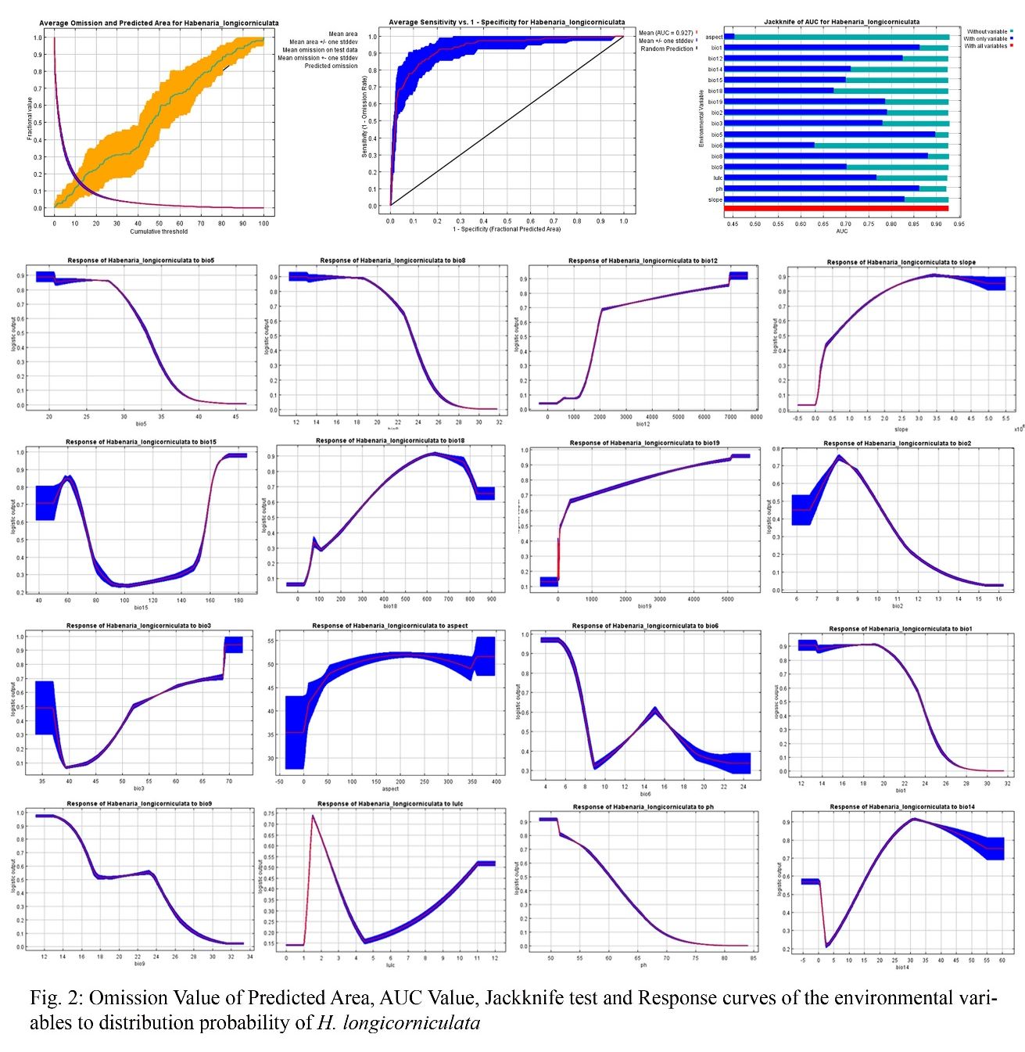

On the contrary, under the future climatic conditions, the total suitable area decreases subsequently. Under SSP2-4.5 scenarios, the predicted area decreases from 44.41 to 74.92%; whereas the highly suitable area decreases from 58.18 to 83.44% by 2030-2090 (Figure 4). In case of SSP5-8.5, the total predicted suitable area and highly suitable area decrease from 50.19% to 88.05%, and 61.16% to 92% by 2030-2090 (Figure 5). By the end of the century, the highly suitable habitat is expected to be reduced to less than 1,000 km². While the current distribution encompasses 21,493 km², the predicted future distribution will drastically contract to 5,390 km² and 2,567 km² under the SSP2-4.5 and SSP5-8.5 scenarios, respectively (Table 2). Consequently, the species' potential distribution range is expected to become highly restricted, with suitable habitats largely confined to the Western Ghats of Kerala and Tamil Nadu in the future. These findings underscore the vulnerability of H. longicorniculata to climate change and the need for targeted conservation efforts in these key areas.

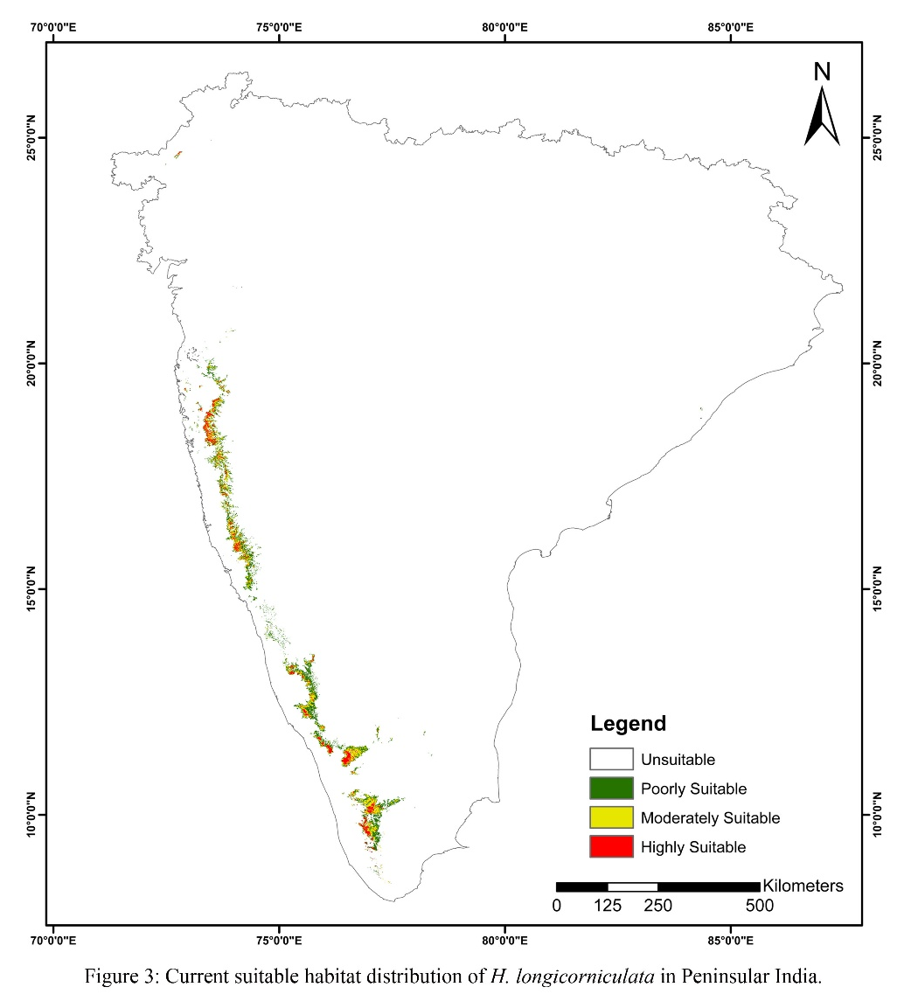

Table 2: Predicted Area of suitability of H. longicornuculata in Peninsular India under current and future climatic scenarios.

Predicted  Suitable area |  | SSP2-4.5 |  |  |  | SSP5-8.5
Predicted  Suitable area | Current | 2030 | 2050 | 2070 | 2090 | 2030 | 2050 | 2070 | 2090
Highly  Suitable Area (km²) | 3654 | 1528 | 994 | 697 | 605 | 1419 | 462 | 357 | 292
Moderately  Suitable Area (km²) | 7410 | 3806 | 2563 | 1945 | 1765 | 3417 | 1628 | 1120 | 938
Poor Suitable  Area (km²) | 10430 | 6611 | 4524 | 3514 | 3019 | 5868 | 3310 | 1769 | 1337
Total (km²) | 21493 | 11946 | 8081 | 6156 | 5390 | 10704 | 5399 | 3245 | 2567

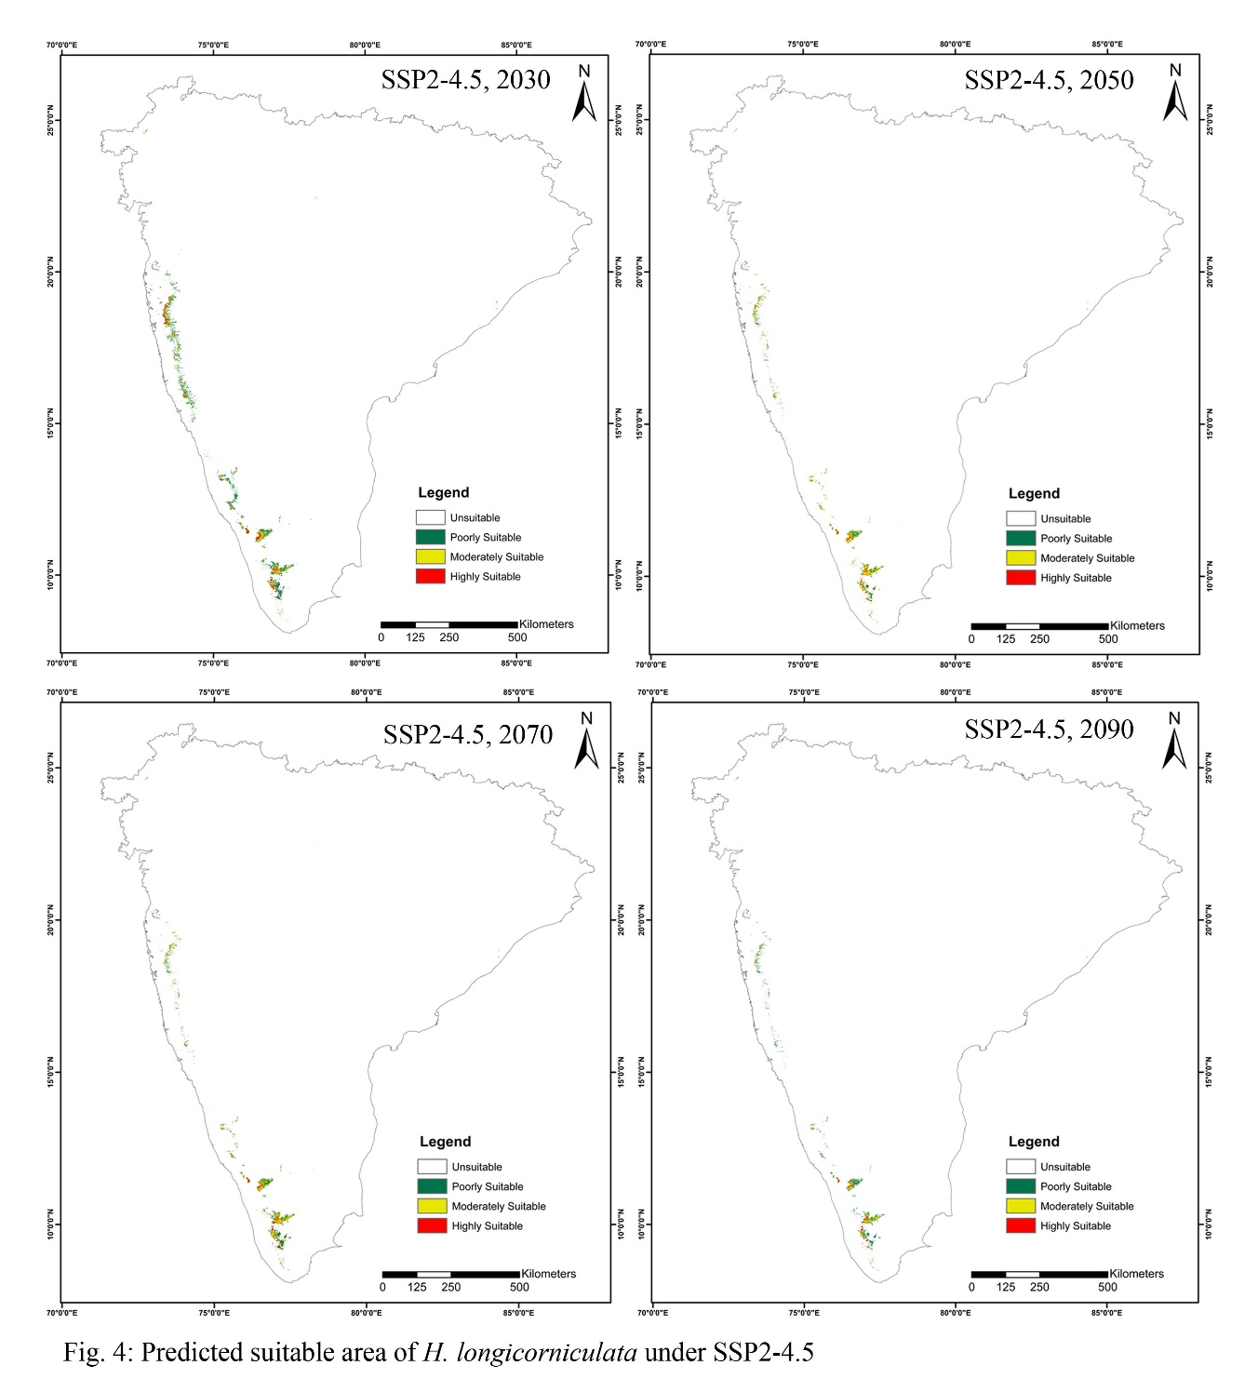

4. DISCUSSION

Habenaria longicornuculata is an endemic orchid distributed throughout Peninsular India; however, the majority of its occurrences are found in WGs. Also, a significant population recorded in the Sirohi of Rajasthan (Purohit, 2020). Belonging to the Orchidaceae family, the species is highly specific to its microhabitat and found growing in the rocky and gravelly areas in grasslands. Known for its distinctive long spur, nocturnal flower opening, and sweet scent emitted for pollination (Dangat & Gaurav, 2020), H. longicorniculata relies on Agrius convolvuli L. (Hawk Moth) as its primary pollinator (Dangat & Gaurav, 2020). The orchid species is known for its medicinal importance, such as the tubers being edible, and the paste is used externally to cure leukoderma (Roy et al., 2007; Purohit et al., 2020). The species also holds medicinal value, with edible tubers used in folk remedies, such as curing leukoderma and reducing scrotal enlargement (Subramani & Goraya, 2003; Roy et al., 2007; Purohit et al., 2020). However, these therapeutic uses have contributed to its population decline, compounded by threats such as habitat degradation, fragmentation, developmental activities, grazing, and trampling. Additionally, illegal harvesting of tubers and tourism, particularly in protected areas like the Mount Abu Wildlife Sanctuary, further exacerbate the species' vulnerability (Purohit et al., 2020). Thus, the species is listed in Appendix II of CITES and the Wildlife Protection Act, 1972, for conservation purposes.
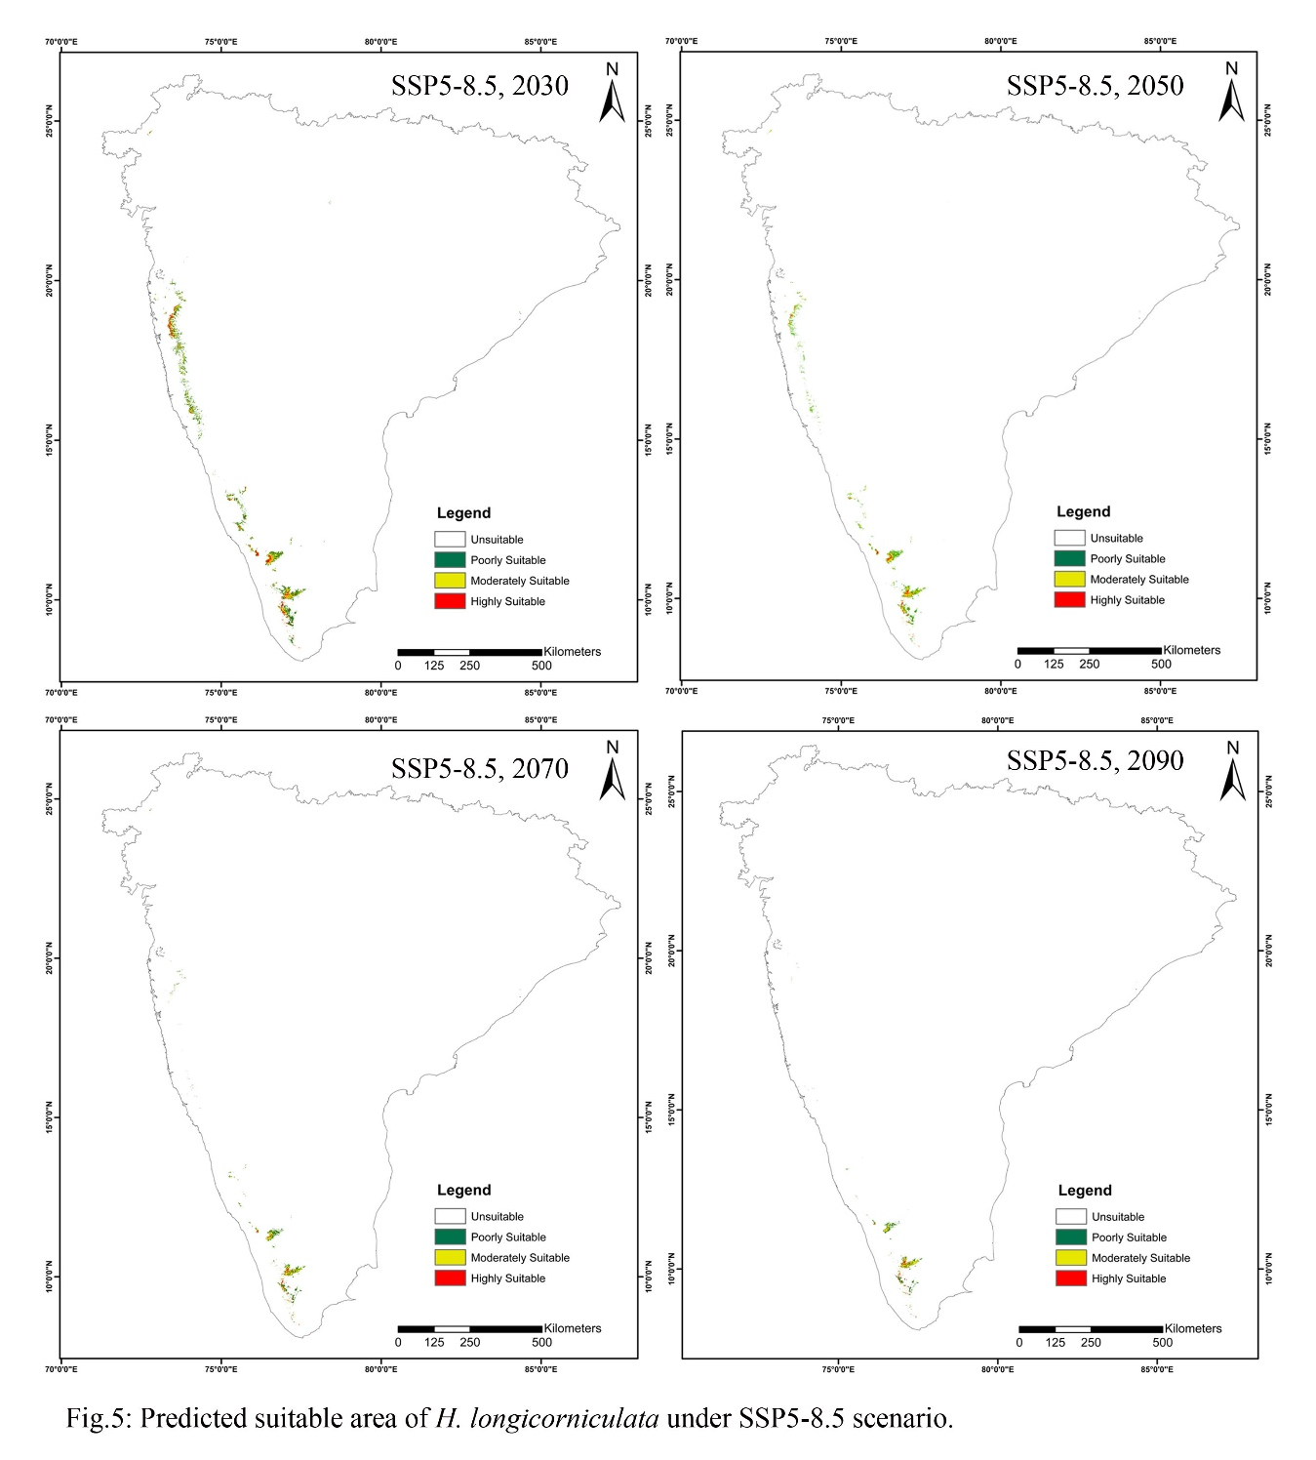
Recent efforts in propagation include successful protocorm development using Knudson C culture media in asymbiotic germination (Patil & Patil, 2017). However, further research is required on aspects such as population dynamics, life cycle studies, and protocol development for ex-situ conservation. Additionally, habitat management and in situ conservation strategies must be prioritized to protect existing populations.
We carried out the study to predict the potential distribution of the species in current and future scenarios using the MaxEnt model. The model was created using 141 occurrence records. Using Pearson’s correlation test (0.8), a total of 16 bioclimatic factors were used for the model run. The AUC (0.927) indicates the excellent performance of the model and had a high degree of fit between the actual suitable habitat & climatic variables (Wei et al., 2024). The model Jackknife test provides an insight into the key environmental variables that predict the distribution of the species. The results revealed that the Maximum Temperature of Warmest Month (Bio5), Mean Temperature of Wettest Quarter (Bio8), Annual Mean Temperature (Bio1), & pH were the major determining factors that contribute the most to the species distribution.
Under current climatic conditions, the predicted suitable habitat of H. longicorniculata spans approximately 21,493 km², which constitutes just 1.2% of the total study area. Of this, the highly suitable habitat is confined to 3,654 km² and is primarily located in Maharashtra (Pune, Raigad, Kolhapur, Sindhudurg), Karnataka (Chikmagalur, Kodagu), and Kerala (Wayanad, Kozhikode, Nilgiris, Idukki). In comparison, Sourabh & Uniyal (2022) estimated the current distribution of H. longicorniculata at 20,928 km², which is expected to decrease by 17% (to 17,339 km²) by 2050 under the A2a emission scenario. In our study, under the SSP2-4.5 scenario, the suitable area is predicted to decline from 11,946 km² to 5,390 km², while under the more severe SSP5-8.5 scenario, it is expected to shrink from 10,704 km² to 2,567 km². By 2090, the highly suitable area is predicted to become concentrated primarily in the WGs of Kerala (The Nilgiris, Idukki, Wayanad, Pathanamthitta) under both scenarios, indicating a drastic contraction of the species' suitable habitat. These results highlight the significant impact of climate change on the future distribution of H. longicorniculata, with a projected loss of >80% of its suitable habitat under both SSP2-4.5 and SSP5-8.5 scenarios. Its future distribution will likely be confined to less than 1,000 km², predominantly within the Western Ghats of Kerala and Tamil Nadu. This drastic decline in the suitable habitat of H. longicornuculata in the future climatic scenarios directly depends upon the climate change along with different anthropogenic pressures (Meza-Joya et al., 2023); which in the future may lead to its endangerment and will increase the risk of extinction (Wiens et al., 2016). Similar findings have been reported for other endemic and vulnerable plant species, where climate change has caused substantial habitat shrinkage. Chandra et al. (2023) documented a decline in suitable habitat for three Cypripedium species in the Western Himalayas under RCP 4.5 and RCP 8.5 scenarios, while the endemic species Habenaria suaveolens is predicted to experience a dramatic reduction in suitable habitat to less than 1,000 km² in the near future (Jalal et al., 2025). Studies on orchids globally have similarly reported habitat losses due to changing climatic conditions (Tang et al., 2020; Sourav & Uniyal, 2022; Pica et al., 2024). It is crucial to understand that the model was specifically designed to predict the species' fundamental niche, not its realized niche, which represents a significant limitation of the study. The actual niche of the species will likely differ from our model’s predictions (Chandra et al., 2023. The distribution of the species depends on both biotic and abiotic factors (Wang et al., 2023). However, while constructing the model, only a few bioclimatic factors were taken into consideration. Since other important factors like mycorrhizal association and pollination behavior were not taken into consideration, it may affect the accuracy in the prediction (Kuo et al., 2014; Xie et al., 2022). Nevertheless, the model provides valuable insights into the potential impacts of climate change on the future distribution of Habenaria longicorniculata and emphasizes the urgent need for targeted conservation strategies, including in situ conservation and habitat protection, to mitigate the predicted decline in suitable habitats

5. CONCLUSION

Habenaria longicorniculata is an endemic, terrestrial orchid species of high medicinal value, found primarily in Peninsular India. Owing to its narrow ecological niche, the species is particularly vulnerable to environmental changes. It exhibits specific habitat preferences, often occurring in rocky and gravelly grasslands with defined microclimatic and edaphic conditions. However, its distribution is increasingly threatened by a combination of biotic and abiotic stressors, including habitat loss, climate variability, overharvesting, grazing, and other anthropogenic pressures. We studied the species distribution modelling of the species using MaxEnt and predicted habitats suitable for the species. Our analysis identified several key environmental variables influencing the distribution of H. longicorniculata, with temperature, precipitation, slope, and soil pH emerging as the most significant predictors. These factors collectively determine the climatic and edaphic suitability for survival and reproduction. The current potential distribution, as predicted by the model, spans the entire Western Ghats (WGs), a global biodiversity hotspot, and extends to parts of the Aravalli Hills in Rajasthan, including Mount Abu. As the climatic scenario changes, the potential area changes drastically. Under both scenarios, suitable habitats are predicted to shrink dramatically and become largely restricted to the southern Western Ghats, particularly in Kerala (districts such as The Nilgiris, Wayanad, Idukki, and Pathanamthitta). This indicates a significant geographic shift and loss of ecological space for the species, reflecting its high vulnerability to climate change. This study can serve as a foundational reference for future research focused on species restoration, propagation protocols, and the integration of climate resilience into conservation strategies.

References
Bhuyan, A., Hazarika, S., Baidya, S., Sarma, K., Thakur, B., Prakash, A. & Devi, A. (2025). Assessing current and future potential habitat of Vatica lanceaefolia (Roxb.) Blume, a critically endangered tree species of Northeastern India. Theoretical and Applied Climatology, 156(2), pp.1-13.

Chandra, N., Singh, G., Rai, I.D., Mishra, A.P., Kazmi, M.Y., Pandey, A., Jalal, J.S., Costache, R., Almohamad, H., Al-Mutiry, M. & Abdo, H.G. (2023). Predicting distribution and range dynamics of three threatened Cypripedium species under climate change scenario in Western Himalaya. Forests, 14(3), p.633.
Deb, C.R., Jamir, N.S. & Kikon, Z.P. (2017). Distribution prediction model of a rare orchid species (Vanda bicolor Griff.) using small sample size. American Journal of Plant Sciences, 8(06), p.1388. https:// doi. org/ 10. 4236/ ajps. 2017.86094

Elith, J., H. Graham, C., P. Anderson, R., Dudík, M., Ferrier, S., Guisan, A., J. Hijmans, R., Huettmann, F., R. Leathwick, J., Lehmann, A. & Li, J. (2006). Novel methods improve prediction of species’ distributions from occurrence data. Ecography, 29(2), 129-151.

Elith, J., Phillips, S.J., Hastie, T., Dudík, M., Chee, Y.E. & Yates, C.J. (2011). A statistical explanation of MaxEnt for ecologists. Diversity and distributions, 17(1), 43-57.

Evans, A, Janssens, S, & Jacquemyn, H. (2020) Impact of climate change on the distribution of four closely related Orchis (Orchidaceae) species. Diversity 12(8), 312.

Fay, M.F. (2018). Orchid conservation: how can we meet the challenges in the twenty-first century? Botanical studies, 59,1-6.

Habibullah, M.S., Din, B.H., Tan, S.H. & Zahid, H. (2022). Impact of climate change on biodiversity loss: global evidence. Environmental Science and Pollution Research, 29(1), 1073-1086. https://doi.org/10.1007/s11356-021-15702-8.

Jakubska-Busse, A., Tsiftsis, S., Śliwiński, M., Křenová, Z., Djordjević, V., Steiu, C., Kolanowska, M., Efimov, P., Hennings, S., Lustyk, P. & Kreutz, K.C. (2021) How to protect natural habitats of rare terrestrial orchids effectively: a comparative case study of Cypripedium calceolus in different geographical regions of Europe. Plants, 10(2), 404. https://doi.org/10.3390/plants10020404

Jalal, J.S. (2018). Orchids of Maharashtra. Botanical Survey of India, Kolkata. pp 236.
Jalal, J.S. (2022). Wild Orchids of Goa. Botanical Survey of India, Kolkata. pp 171.
Kolanowska, M. (2013). Niche conservatism and the future potential range of Epipactis helleborine (Orchidaceae). PLoS ONE, 8, e77352, https://doi.org/10.1371/journal.pone.0077352.

Kolanowska, M., Jakubska-Busse, A. (2020) Is the lady’s-slipper orchid (Cypripedium calceolus) likely to shortly become extinct in Europe?—Insights based on ecological niche modelling. PLoS ONE, 15(1), e0228420.

Kolanowska, M. & Konowalik, K. (2014) Niche conservatism and future changes in the potential area coverage of Arundina graminifolia, an invasive orchid species from Southeast Asia. Biotropica 46(2),157–165.

Kolanowska, M., Rewicz, A. & Baranow, P. (2020) Ecological niche modeling of the pantropical orchid Polystachya concreta (Orchidaceae) and its response to climate change. Scientific Reports, 10(1),1–17.

Konda, G. & Vissa, N.K. (2023). Evaluation of CMIP6 models for simulations of surplus/deficit summer monsoon conditions over India. Climate Dynamics, 60(3), pp.1023-1042. https:// doi.org/10.1007/s00382-022-06367-1.

Kumar, P. & Sarthi, P.P. (2021). Intraseasonal variability of Indian Summer Monsoon Rainfall in CMIP6 models simulation. Theoretical and Applied Climatology, 145(1), 687-702.
Kuo, H. C., Chen, S. F., Fang, Y. P., Flanders, J., & Rossiter, S. J. (2014). Comparative range wide phylogeography of four endemic Taiwanese bat species. Molecular Ecology, 23(14), 3566–3586.

Meza-Joya, F.L., Morgan-Richards, M., Koot, E.M. & Trewick, S.A. (2023). Global warming leads to habitat loss and genetic erosion of alpine biodiversity. Journal of Biogeography, 50, 961–975.

Patil, A.R. & Patil, S.S. (2017). In Vitro Seed Germination and Protocorm Development in Terrestrial Orchid Habenaria longicorniculata J. Graham from Kolhapur District. International Journal of Researches in Biosciences, Agriculture and Technology, 5(3), 135-140.

Purohit, C.S., Kulloli, R.N., Maina, V., Kumar, R. & Kari, B. (2020). A little known orchid Habenaria longicorniculata (Orchidaceae) from Mount Abu wildlife sanctuary, Rajasthan and its IUCN status. Journal on New Biological Reports, 9(3), 299-305.

Roy, A.R., Patel, R.S., Patel, V.V. and Yadav, D.S. (2007). Medicinal orchids of Meghalaya. Journal of Orchid Society of India, 21, (1/2), 15-17.

Romadlon, M.A., Azzhara, F., Nugroho, G.D. & Pitoyo, A. (2021). Population, habitat characteristic, and modelling of endangered orchid, Paphiopedilum javanicum in Mt. Lawu, Java, Indonesia. Biodiversitas Journal of Biological Diversity, 22(4).

Shrestha, B., Tsiftsis, S., Chapagain, D.J., Khadka, C., Bhattarai, P., Kayastha Shrestha, N., Alicja Kolanowska, M. & Kindlmann, P. (2021). Suitability of habitats in Nepal for Dactylorhiza hatagirea now and under predicted future changes in climate. Plants, 10(3), p.467.
Singh, S.K., Agrawala, D.K., Jalal, J.S., Dash, S.S., Mao, A.A., and Singh, P. (2019). Orchids of India-a Pictorial Guide. Botanical Survey of India. Kolkata.
Sourabh, P. & Uniyal, P.L. (2022). Predicting Potential Habitat Distribution of Habenaria longicorniculata J. Graham in Western Ghats, India. Journal of Orchid Society of India, 36: 107-112.

Štípková, Z., Romportl, D., Černocká, V. & Kindlmann, P. (2017). Factors associated with the distributions of orchids in the Jeseníky Mountains, Czech Republic. European Journal of Environmental Sciences, 7(2), 135-145.

Subramani, S.P. & Goraya, G.S. (2003). Some folklore medicinal plants of Kolli Hills: record of a Natti Vaidyas Sammelan. Journal of Economic and Taxonomic Botany. 27(3) 665-678.

Tsiftsis, S., Djordjević, V. & Tsiripidis, I. (2019). Neottia cordata (Orchidaceae) at its southernmost distribution border in Europe: Threat status and effectiveness of Natura 2000 Network for its conservation. Journal for Nature Conservation, 48, 27-35.

Wani, I. A., Verma, S., Mushtaq, S., Alsahli, A. A., Alyemeni, M. N., Tariq, M., & Pant, S. (2021). Ecological analysis and environmental niche modelling of Dactylorhiza hatagirea (D. Don) Soo: A conservation approach for critically endangered medicinal orchid. Saudi Journal of Biological Sciences, 28(4), 2109-2122. https://doi.org/10.1016/j.sjbs.2021.01.054

Wang, H.H., Wonkka, C.L., Treglia, M.L., Grant, W.E., Smeins, F.E. & Rogers, W.E. (2015). Species distribution modelling for conservation of an endangered endemic orchid. AoB Plants, 7, p.plv039.

Wang, Z., Li, N., Xu, R., Ying, Z., Ruan, X., Wang, T., Liao, W. & Su, Y. (2024). Distribution model and prediction of the tree fern Alsophila costularis Baker (Cyatheaceae) in China. Ecology and Evolution, 14(6), p.e11594.

Wei, L., Wang, G., Xie, C., Gao, Z., Huang, Q., & Jim, C.Y. (2024). Predicting suitable habitat for the endangered tree Ormosia microphylla in China. Scientific Reports, 14(1), p.10330.

Wiens, J.J. (2016). Climate-related local extinctions are already widespread among plant and animal species. PLoS Biol. 14, e2001104.

Xie, C., Tian, E., Jim, C. Y., Liu, D., & Hu, Z. (2022). Effects of climate- change scenarios on the distribution patterns of Castanea henryi. Ecology and Evolution, 12(12), e9597. https://doi.org/10. 1002/ece3. 9597

Ye, X.Z., Zhao, G.H., Zhang, M.Z., Cui, X.Y., Fan, H.H. & Liu, B. (2020). Distribution pattern of endangered plant Semiliquidambar cathayensis (Hamamelidaceae) in response to climate change after the last interglacial period. Forests, 11(4), p.434.

Yuan, Y., Tang, X., Liu, S., & Zhang, J. (2020). The major factors influencing distribution of three species of Dendrobium: Analysis of potential ecologically suitable distributions. Journal of Applied Research on Medicinal and Aromatic Plants, 19, p.100275.

