Original Research Article

Effect of Herbicide and Intercropping System Based Weed Management Options on Weed Dynamics and Productivity of Fodder Sorghum (Sorghum bicolor L. Moench) under Semi-Arid Ecosystems

Abstract
Sorghum, known for its resilience and adaptability to various climates as a cereal crop, has also become important as a fodder crop due to its broad adaptability. However, it remains highly vulnerable to numerous weed species. In order to manage weeds, field experiment was designed during the Kharif season of 2021-22 at Instructional Farm, Rajasthan College of Agriculture, Udaipur to evaluate weed management in kharif fodder sorghum. The experiment was laid out in a Randomized Block Design (RBD) with twelve treatments replicated thrice. The treatment combinations are atrazine 50% WP @ 0.50 kg a.i ha⁻¹ as PE (T 1 ), metolachlor 50% EC @ 1.00 kg a.i ha -1 as PE (T 2 ), pyroxasulfone 85% w/w WG @ 0.1275 kg a.i ha -1 as PE (T 3 ), 2,4-D Na salt 80% WP @ 0.75 kg a.i. ha -1 as PoE at 20 DAS (T 4 ), T 1 + atrazine 50% WP @ 0.50 kg a.i. ha -1 as PoE (T 5 ), T 1 + 2,4-D Na salt 80% WP @ 0.75 kg a.i. ha -1 ha as PoE at 20 DAS (T 6 ), intercropping with cowpea (1:1 additive series) without herbicides (T 7 ), intercropping with cowpea (1:1 additive series) + pendimethalin 30% EC @ 0.75 kg a.i. ha -1 as PE (T 8 ), intercropping with blackgram (1:1 additive series) without herbicides (T 9 ), intercropping with blackgram (1:1 additive series) + pendimethalin 30% EC @ 0.75 kg a.i. ha -1 as PE (T 10 ), weed free (two hand weeding at 15 and 35 DAS) (T 11 ) and weedy check (T 12 ). The efficacy of the weed management using different treatments was evaluated among different weed flora, weed dry matter T₅ showed the most effective weed control, significantly reducing grass, sedge, and broad-leaved weed populations and dry matter by up to 74.87%. It maintained low weed indices (0.28%), nearly matching manual weeding, and improved fodder sorghum yield. Atrazine-based T₅ proves effective for managing diverse weeds in semi-arid conditions..
Keywords: Additive series, Resilience, Integrated weed Management, Weed flora, Weed Index
1. INTRODUCTION
India, which houses approximately 20% of the world’s livestock population and 17.5% of the global human population, faces significant challenges in meeting the growing demands for both food and fodder. Despite occupying only 2.3% of the world’s land area, India must support its ever-increasing population, with human numbers growing at 1.6% annually and livestock numbers at 0.66%. The pressure on limited land resources for food and fodder production is immense. Currently, only 4% of the country’s cultivable land is used for fodder crops, creating a severe shortage of green fodder (35.6%), dry crop residues (10.5%), and concentrate feed ingredients (44%). Given this imbalance, it becomes crucial to optimize the available land for fodder cultivation to meet the rising needs of both humans and animals.
In this context, sorghum (Sorghum bicolor L. Moench) emerges as a highly valuable crop for fodder production. Forage sorghum, when harvested at the 50% flowering stage, contains 9 to 10% crude protein, 65% neutral detergent fiber, 7 to 42% acid detergent fiber, 32% cellulose, and 21 to 23% hemicellulose on a dry matter basis (Kumar et al., 2012). Sorghum is extensively cultivated worldwide, with more than 90% of its production occurring in developing regions, particularly in Africa and Asia. For the 2023–2024 agricultural years, global sorghum production was estimated at around 62.09 million metric tonnes, with India ranking as the fourth-largest producer, contributing approximately 5.27 million metric tonnes, or 8% of the global supply (USDA, 2024). Sorghum’s resilience and adaptability to arid and semi-arid conditions make it particularly well-suited for regions like Rajasthan, which often experience water scarcity. Its drought tolerance, high biomass yield, and rapid growth rate make it an ideal choice for fodder in areas where other crops may struggle to thrive.
Sorghum is widely used for silage, hay, and direct grazing due to its excellent palatability and nutritional value, which is comparable to maize (Nicholas et al., 1998). Moreover, when included in the diets of lactating dairy cattle, sorghum has shown promising effects on strategic feed management, improving milk production and overall herd performance (Aydin et al., 1999). Given the significant livestock population in Rajasthan, including cattle, goats, and sheep, a steady supply of quality fodder is essential. However, the full potential of sorghum as a fodder crop is often hindered by weed competition, which reduces crop productivity. Globally, weeds are one of the main challenges hindering food production across agricultural systems (Monteiro & Santos, 2022). Weeds possess several traits that provide them with advantages over sorghum forage. It has been reported that the yield loss in sorghum caused by weeds can range from 15% to 97%, depending on the type and severity of the weed infestation (Thakur et al., 2016). Weeds compete with sorghum for water, nutrients, and light, which negatively affects the growth and yield of the crop. This issue is particularly pressing in semi-arid regions like Rajasthan, where the growing season is short, and water resources are limited. Effective weed management is, therefore, crucial to ensuring high sorghum yields and optimizing its potential as a fodder crop. By minimizing weed pressure, competition is reduced, allowing sorghum to grow efficiently and meet fodder demands.
To address this issue, this study investigates the effectiveness of various weed management strategies in kharif fodder sorghum cultivation. Intercropping enhances beneficial interactions between crops, improving yield stability, optimizing resource use, and naturally suppressing weed growth (Kadziuliene et al., 2009). Studies have shown that intercropping reduces weed density and biomass effectively (Amanullah et al., 2006; Banik et al., 2006; Carruthers et al., 1998; Poggio, 2005). Due to its ecological advantages, intercropping is increasingly integrated into weed management programs alongside chemical treatments, offering a sustainable approach to weed suppression while minimizing herbicide dependence and promoting agroecosystem health.The research evaluates different treatments and their influence on weed dynamics, sorghum growth, and overall yield. A range of methods, including pre-emergence (PE) and post-emergence (PoE) herbicides, integrated weed management practices such as intercropping with legumes like cowpea and blackgram, and traditional weed control methods like manual weeding, are examined.
These treatments are assessed for their impact on weed populations, sorghum dry matter production, and the overall weed index. The aim of the study is to identify sustainable and cost-effective weed management strategies that can enhance fodder sorghum yields, reduce competition from weeds, and improve overall crop efficiency. The findings of this research are expected to provide valuable insights into optimizing weed management practices for fodder sorghum cultivation, which could help to improve productivity, reduce competition from weeds, and support the growing livestock sector in India. Ultimately, this research aims to increase fodder availability, contributing to food security and livestock sustainability in India.

2. MATERIAL AND METHODS
2.1 Experimental Site and Climate
On the field based investigation carried out during the Kharif season of 2021-22 at Instructional Farm, Rajasthan College of Agriculture, Udaipur, Rajasthan, India.. The experimental site lies at an elevation of 581.13 meters above mean sea level, positioned at 24°35′ N latitude and 74°42′ E longitude. This area is classified under Agro-Climatic Zone IVa, characterized as the Sub-Humid Southern Plain and Aravalli Hill region of Rajasthan. The weather data for the 2021-22 kharif season was sourced from the Agro-meteorological Observatory within campus of Rajasthan College of agriculture MPUAT, Udaipur. The experimental site at Rajasthan College of Agriculture, Udaipur, experiences an average annual rainfall of approximately 600.8 mm, predominantly influenced by the south-west monsoon. During the crop growing season, a total of 432.7 mm of rainfall was recorded. Throughout the experimental period, maximum temperatures ranged from 30°C to 34.3°C, while minimum temperatures varied between 10.3°C and 22.3°C. Relative humidity levels fluctuated between 59.9% to 90.4% (maximum) and 25.2% to 79.1% (minimum). Daily sunshine duration ranged from 1.6 to 8.8 hours, and mean evaporation rates were observed between 3.7 and 6.3 mm. Details of the mean weekly meteorological parameters are shown in Fig.1. Soil health forms the backbone of successful crop production, playing a pivotal role in supporting plant growth, enhancing development, and ultimately shaping yield outcomes. The soil at the experimental site is characterized as clay loam in texture, offering a moderately alkaline reaction with a pH of 7.7 and electrical conductivity of 0.85 dS m⁻¹, indicating non-saline conditions. It contains 0.32% organic carbon, reflecting moderate fertility. The available nutrient status includes 274.14 kg ha⁻¹ of nitrogen, 22 kg ha⁻¹ of phosphorus (P₂O₅), and 316 kg ha⁻¹ of potassium (K₂O), suggesting a reasonably nutrient-rich profile conducive for sorghum cultivation.

Fig. 1: Detailed Mean weekly meteorological data during crop growing season

2.2 Experimental Design and Details
The experiment was carried out in a Randomized block Design with three replications.
Table 1: The experiment comprised twelve treatments combinations are given below
Treatments Details
T₁ | Atrazine 50% WP @ 0.50 kg a.i ha⁻¹ as pre- emergence (PE)
T₂ | Metolachlor 50% EC @ 1.00 kg a.i ha⁻¹ as PE
T₃ | Pyroxasulfone 85% w/w WG @ 0.1275 kg a.i ha⁻¹ as PE
T₄ | 2,4-D Na Salt 80% WP @ 0.75 kg a.i. ha⁻¹ as post- emergence (PoE) at 20 DAS
T₅ | T₁ + Atrazine 50% WP @ 0.50 kg a.i. ha⁻¹ as (PoE)
T₆ | T₁ + 2,4-D Na Salt 80% WP @ 0.75 kg a.i. ha⁻¹ ha as PoE at 20 DAS
T₇ | Intercropping with cowpea (1:1 additive series) without herbicides
T₈ | Intercropping with cowpea (1:1 additive series) + Pendimethalin 30% EC @ 0.75 kg a.i. ha⁻¹ as PE
T₉ | Intercropping with blackgram (1:1 additive series) without herbicides
T₁₀ | Intercropping with blackgram (1:1 additive series) + Pendimethalin 30% EC @ 0.75 kg a.i. ha⁻¹ as PE
T₁₁ | Weed free (Two hand weeding at 15 and 35 DAS)
T₁₂ | Weedy check

Table 2: Details of Herbicide Profiles
S. No. | Common name | Trade name | Chemical name
1. | Atrazine | Solaro 50 | 1-Chloro-3-ethylamino-5-isopropylamino-2,4,6-triazine
2. | Metolachlor | Amicus | 2-chloro-N-(2-ethyl-6-methylphenyl)-N-(1-methoxypropan-2-yl) acetamide.
3. | Pyroxasulfone | Momiji®  Pyroxasulfone 85% WG; | 3-{[5-(Difluoromethoxy)-1-methyl-3-(trifluoromethyl)-1H-pyrazol-4-yl]methanesulfonyl}-5,5-dimethyl-4,5-dihydro-1,2-oxazole
4. | 2,4-D Na Salt | Suspend | (2,4-Dichlorophenoxy)acetic acid
5. | Pendimethalin | Stomp 30 EC | N-(1-ethylpropyl)-2,6-dinitro-3,4-xylidine

2.3 Agronomical Practices
The experimental field was meticulously prepared to ensure optimal conditions for crop establishment. Initial tillage was carried out using a tractor-mounted disc plough, which helped in inverting the soil, burying weeds, and incorporating residual organic matter. The field was then kept fallow during the summer months, a practice that facilitated natural soil aeration and aided in the conservation of residual moisture, particularly important under the rainfed conditions typical of South-West Rajasthan. With the onset of the monsoon, the field underwent secondary tillage operations, including cross-harrowing to break down soil clods and enhance tilth, followed by planking to level the land and preserve soil moisture, ultimately creating a fine, well-structured seedbed conducive for uniform germination. Fertilization was done based on standard agronomic recommendations for sorghum, with a basal dose of 80 kg nitrogen, 40 kg phosphorus (P₂O₅), and 40 kg potassium (K₂O) per hectare. To support the nutrient demands of the intercropped legumes, additional phosphorus was applied. The cropping system involved sorghum intercropped with cowpea variety ‘Dollar’ and black gram variety ‘Kota Urd-3’ in a 1:1 additive series. This arrangement allowed for efficient use of resources, with an intra-row spacing of 5 cm to ensure proper plant density and minimize competition. Weed management included both chemical and manual methods. Pre-emergence and post-emergence herbicides were applied using a manually operated foot sprayer equipped with a flat fan nozzle, ensuring uniform application at a spray volume of 500 liters per hectare. In manually weeded plots, hand weeding was performed twice, at 15 and 35 days after sowing (DAS), to maintain a weed-free environment during critical crop growth stages. For pest control, two applications of Lambda-cyhalothrin 5% EC, a systemic insecticide, were conducted once a week for 3 weeks at key growth intervals to manage insect pressure effectively. Harvesting was performed at 107 DAS. To ensure accurate yield assessment and eliminate border effects, outer rows and a 0.5-meter buffer zone around each plot were excluded from data collection. This approach helped maintain the integrity of the experimental results and allowed for precise evaluation of treatment effects on sorghum and intercrop performance.

2.4 Observations to be recorded
Weed index: The Weed Index is a valuable indicator in sorghum weed management, as it quantifies yield losses due to weed interference and helps evaluate the effectiveness of various control strategies. By identifying treatments that minimize yield reduction, it supports informed decision-making for adopting the most efficient and economically viable weed control methods. Weed Index (fodder yield in comparison to weed free) was calculated by the following formula (Yadav and Mishra, 1982).
$Weed Index= \frac{X-Y}{X}$ × 100

Where, X = Average crop yield in control plot,
Y = Average crop yield in treated plot
2.7 Statistical Analysis
The data recorded during the experimental period were statistically analyzed using the Analysis of Variance (ANOVA) technique, following the methodology outlined by Fisher (1950). Treatment effects were evaluated, and the significance of differences among means was determined using the F-test at the 5% probability level. Wherever the F-value indicated statistical significance, further interpretation was carried out to assess treatment performance reliably. Correlation studies were conducted to determine the interrelationships between various traits, as outlined by Panse and Sukhatme (1985). Additionally, regression equations for the traits showing significant correlations were calculated and presented at relevant points.

3 RESULTS AND DISCUSSION
3.1 Weed flora
Kharif season crops are often challenged by a diverse spectrum of weed species, including grasses, broad-leaved weeds, and sedges.
Table 3: The predominant weed flora observed during the field investigation
S.No. | Botanical name | English name | Type of weed flora
1. | Commelina benghalensis L. | Day flower | Broad- leaved weeds
2. | Convolvulas arvensis (L.) | Hirankhuri | Broad-leaved weeds
3. | Cynodon dactylon (L.) Pear. | Bermuda grass | Grassy
4. | Dactyloctenium aegyptium | Egyptian crowfoot grass | Grassy
5. | Cyperus rotundus L. | Purple nutsedge | Sedge
6. | Amaranthus spp. | Amaranthus | Broad-leaved weed
7. | Digera arvensis (L.) | False amaranth | Broad-leaved weed
8. | Echinochloa spp. (L.) Link | Jungle rice | Grassy
9. | Digitaria sanguinalis | Crabgrass | Grassy
10. | Zizanopis miliacea | Giant cutgrass | Grassy

Images 1: Photoplates of the weed species taken during the study:
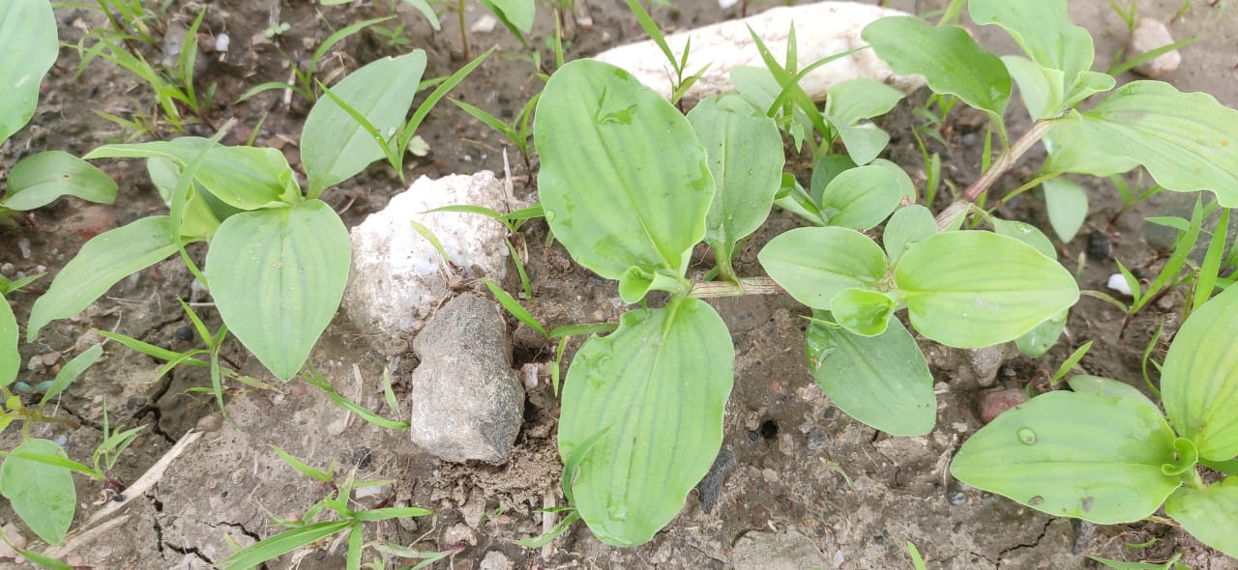 | 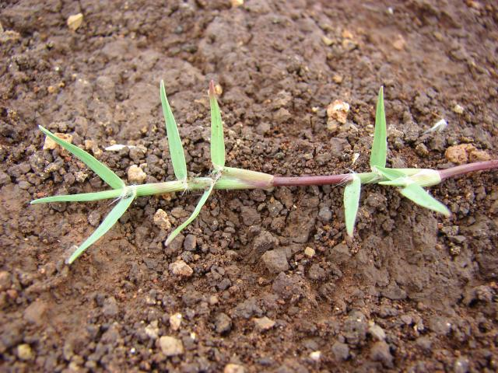
Commelina benghalensis L. | Cynodon dactylon (L.) Pear.
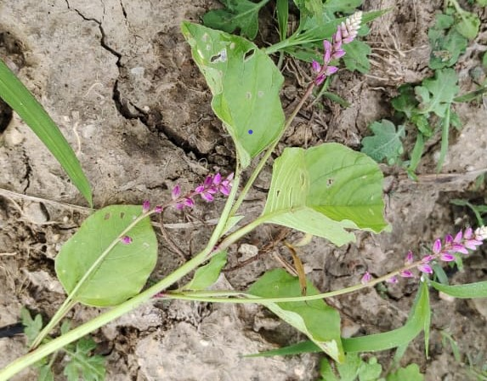 | 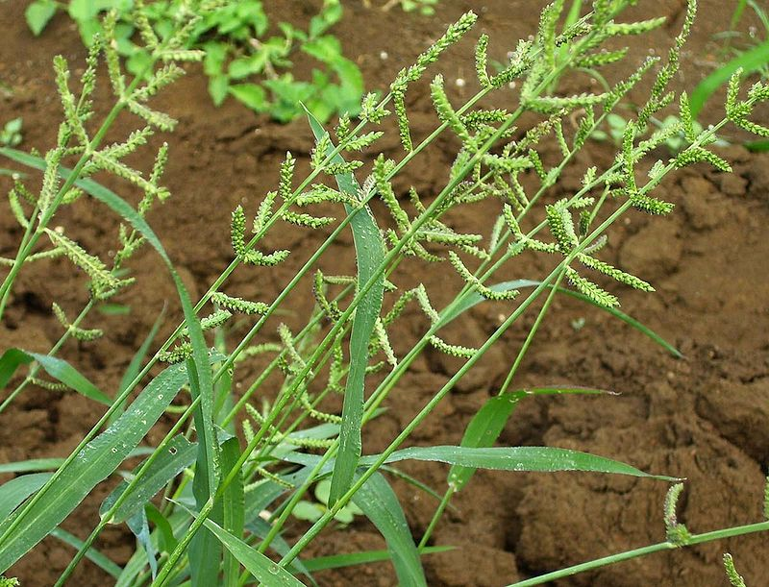
Digera arvensis L. | Echinochloa colonum
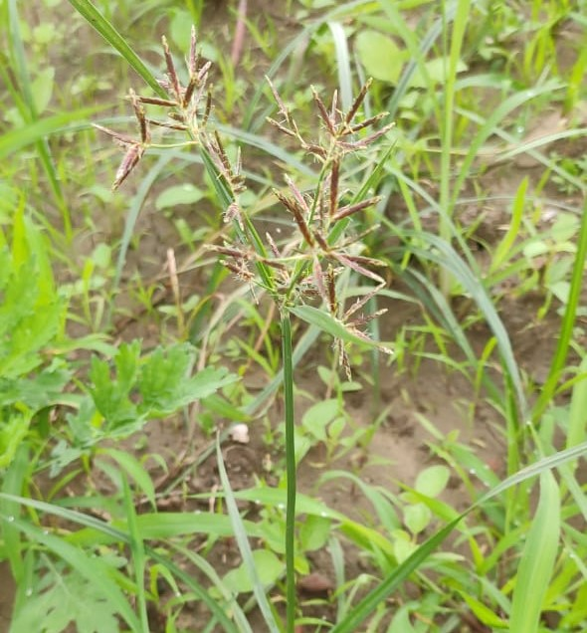 | 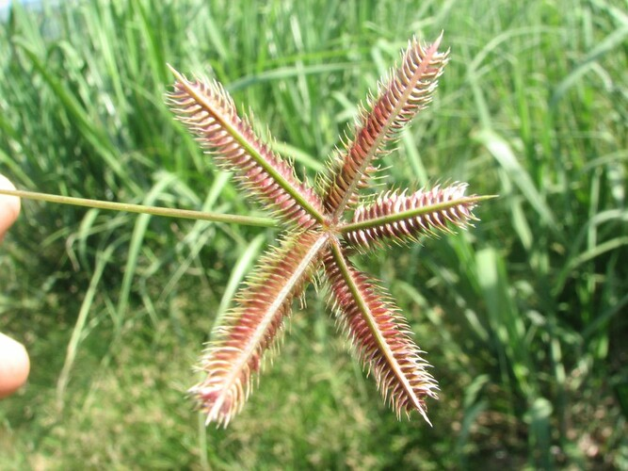
Cyperus rotundus L. | Dactyloctenium aegyptium
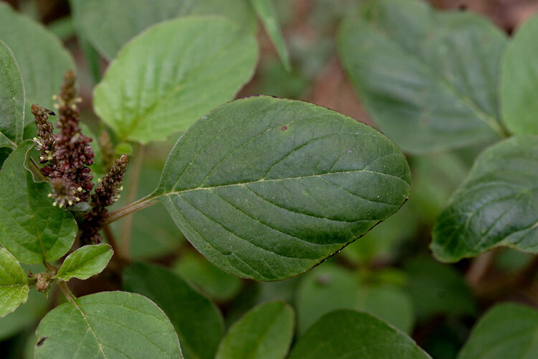 | 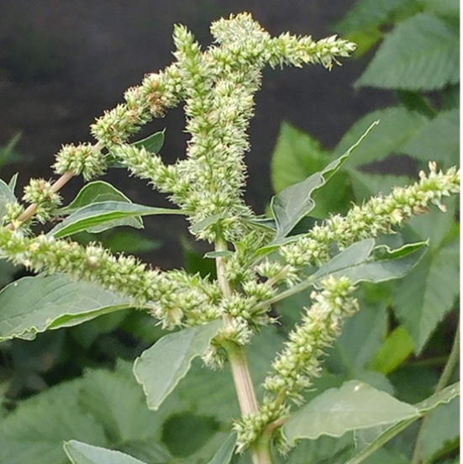
Amaranthus viridis | Amaranthus spinosus
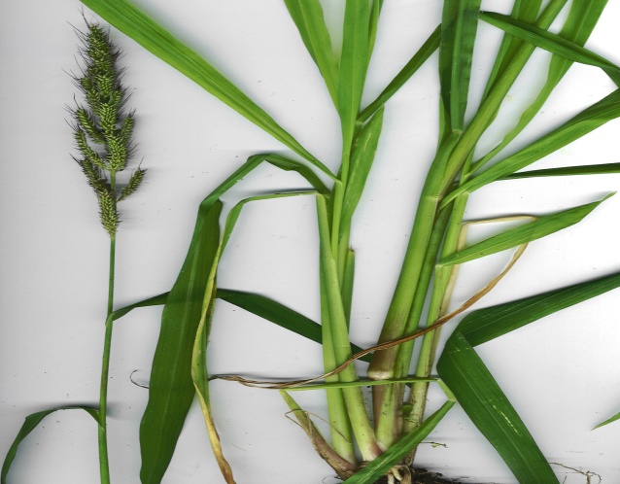 | 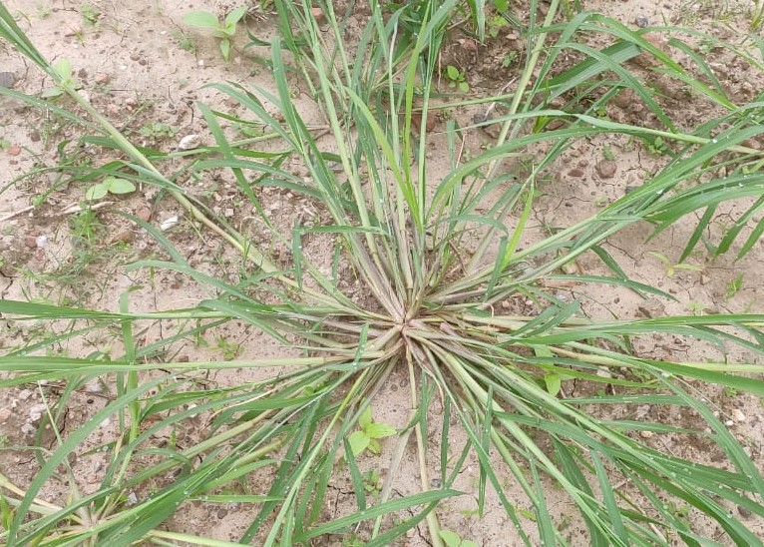
Echinochloa crusgalli | Digitaria sanguinalis
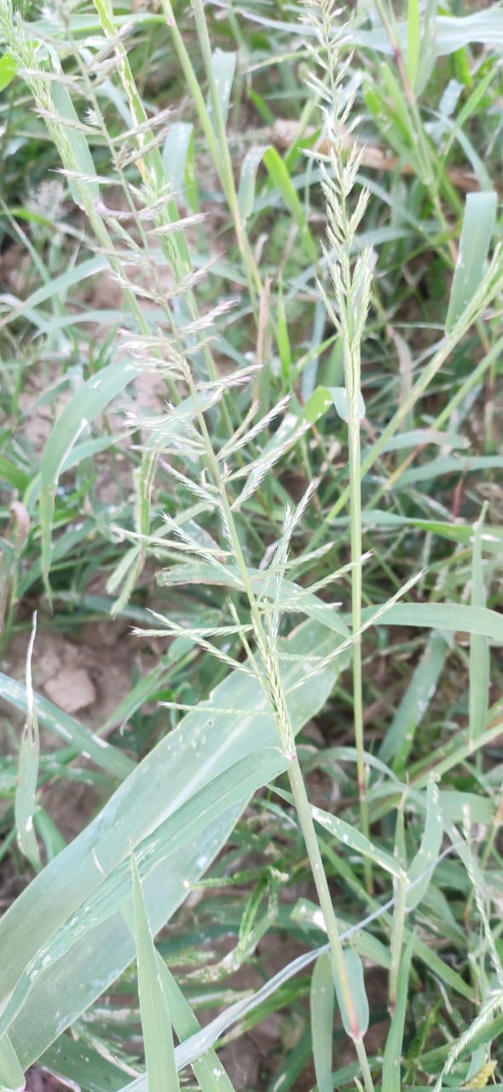 | 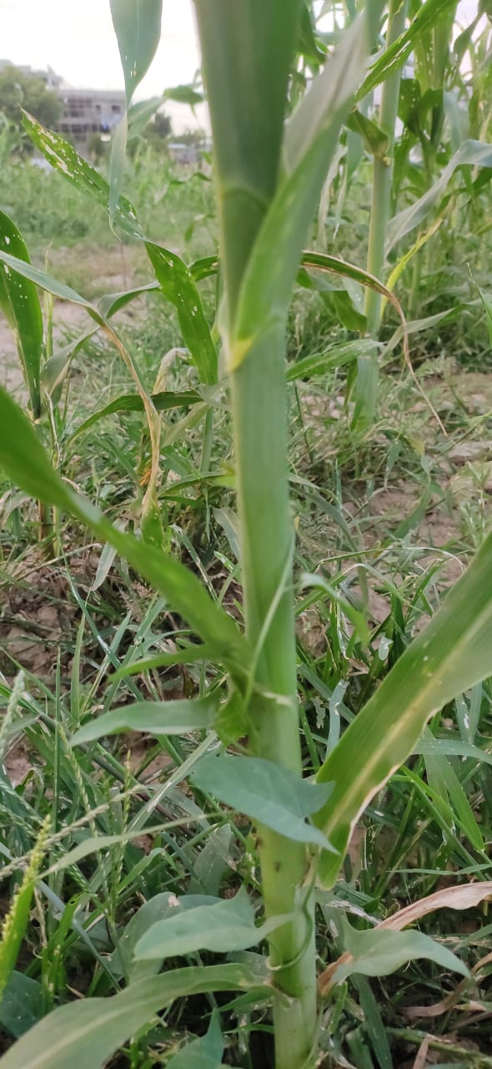
Dinebra retroflexa | Convolvulus arvensis L.

3.2 Weed population
All the weed management treatments significantly affected the grassy, sedges and broad leaved weeds at 20, 40 and at harvest days after pre- emergence spray (Table 1-6).
3.2.1 Grasses
The density of grassy weeds (no. m⁻²) observed at 20 days after pre-emergence (PE) herbicide application was significantly affected by the various weed management strategies employed,, showing notable improvement over the untreated control (weedy check). Among all treatments, the weed-free plots (T₁₁), maintained through manual hand weeding at 15 and 35 days after sowing (DAS), exhibited the lowest grass population due to continuous and complete removal of weeds. Although highly effective, this approach is labor-intensive, less feasible under labor-scarce conditions, and economically unsustainable concerns previously emphasized by Kolage et al. (2004) and Patel et al. (2006). Among herbicide-based treatments, T₅ recorded the minimum density of dominant grassy weeds such as Digitaria sanguinalis, Cynodon dactylon, and Echinochloa crus-galli. This superior control was attributed to the dual application of atrazine, which extended its residual effect and inhibited multiple flushes of weed emergence throughout the crop growth period. Treatment T₂ also suppressed grass populations effectively, although to a lesser extent than T₅, and was significantly better than T₄ and the weedy check. The data taken at 40 days after PE revealed significant differences in weed suppression across treatments, with notable reductions in specific weed species due to the efficacy of certain herbicidal strategies. T₂ was particularly effective in minimizing the population of Digitaria sanguinalis, Echinochloa colona, and Dactyloctenium aegyptium. These reductions were statistically comparable to T₁ and T₅ for D. sanguinalis, to T₃ for E. colona, and to T₅ for D. aegyptium. Similarly, the lowest density of Echinochloa crus-galli was recorded under T₂ and T₅, both of which were on par with T₁, suggesting their superior grass-suppressive potential. Treatment T₅ further demonstrated notable efficacy against Dinebra retroflexa, recording significantly lower counts than all other treatments. In terms of total grassy weed population, T₅ again outperformed all other management options, indicating the broad-spectrum pre- and post-emergence control provided by sequential atrazine applications. The evaluation of grassy weed populations at harvest under various herbicidal treatments revealed that T₅ consistently outperformed other treatments in reducing a wide spectrum of weed species. Notably, Zizaniopsis miliacea showed the highest population suppression under T₅, indicating strong efficacy of sequential atrazine application. Similarly, T₆ (a combination of atrazine as pre-emergence and 2,4-D Na salt as post-emergence) proved most effective in reducing Dactyloctenium aegyptium, significantly outperforming all other treatments. In terms of total grassy weed control, T₅ again emerged as the most effective, achieving a 56.62% reduction over the untreated control. While T₃ was statistically comparable for some grass species, T₅ consistently yielded the lowest overall grass density, highlighting its broad-spectrum efficacy.
3.2.2 Sedges
In the case of sedges at 20 days after PE, particularly Cyperus rotundus, T₅ achieved a substantial reduction of 48.58% over the control. At 40 days after PE, in Cyperus rotundus, T₅ achieved the most substantial control, with a 74.63% reduction compared to the untreated control, highlighting its effectiveness in targeting resilient perennial weeds. For Cyperus rotundus, a persistent sedge species, T₅ recorded the lowest population, reflecting a 62.39% reduction compared to the weedy check. This superior control underscores the herbicide's sustained activity throughout the growing season.
3.2.3 Broad- leaved weeds
. For broad-leaved at 20 days after PE weeds, including Commelina benghalensis, T₅ again proved most efficient, with a 35.33% reduction in total broad-leaved weed population compared to the weedy check. This broad-spectrum weed suppression is largely credited to the residual and systemic action of atrazine, applied at both early and later stages of crop development, effectively targeting multiple weed species during critical growth phases .Morever, atrazine, a herbicide from the triazine group, is widely used for controlling both monocot and dicot weeds. It is a selective herbicide typically applied before weed emergence (pre-emergence) to manage early weed growth. Atrazine accumulates in the chloroplasts of plants, disrupting photosynthesis by interfering with the electron transport near Photosystem II. This disruption hinders the plant’s ability to synthesize food, eventually leading to plant death due to starvation (Gupta, 2008). In the category of broad-leaved weeds at 40 days after PE, Commelina benghalensis and Convolvulus arvensis were most effectively suppressed by T₆, attributed to the combined action of atrazine (pre-emergence) and 2,4-D Na salt (post-emergence). Also, 2,4-D is classified as a selective systemic herbicide. EPA ( 2005) explains that 2,4-D kills plants by altering three key factors: it increases the plasticity of the plant’s cell walls, boosts protein production, and raises ethylene production within the plant. These changes lead to uncontrolled cell division and excessive growth, ultimately damaging plant tissues and resulting in the plant's death. Amaranthus spinosus was significantly reduced under T₂, with statistically similar suppression seen in T₃, T₅, and T₆. T₄, which involved post-emergence application of 2,4-D Na salt, was effective in reducing other broad-leaved weeds and was statistically comparable to T₅. The maximum overall reduction in broad-leaved weeds (2.86 m⁻²) was recorded under T₆, representing a 36.86% decrease relative to the weedy check, and was statistically at par with T₂ and T₅. The superior performance of treatments T₅ and T₆ can be attributed to their ability to control a broad spectrum of weeds grasses, sedges, and broad-leaved species through sequential or combined herbicide application, effectively reducing early competition and enhancing crop growth. Among broad-leaved weeds poplution at harvest , both Amaranthus viridis and Amaranthus spinosus populations were markedly reduced by T₅, with statistically similar results noted in T₂, T₄, T₆, and T₁₀ for A. viridis and T₁, T₂, T₄, T₆, and T₈ for A. spinosus. Interestingly, T₉, involving intercropping with black gram without herbicides, effectively suppressed Convolvulus arvensis, and was statistically on par with T₅, suggesting a competitive advantage conferred by legume intercropping. Moreover, T₆ showed the highest reduction in other broad-leaved species and recorded the maximum overall reduction in total broad-leaved weed population, at 37.20% over the weedy check, performing statistically at par with T₄ and T₅. The consistent superiority of T₅ and T₆ across multiple weed types can be attributed to their dual-phase control strategy, combining early-season suppression with sustained post-emergence activity. This integrated approach not only limits weed emergence but also minimizes competition throughout the crop growth period, thereby enhancing sorghum productivity.
3.3 Weed dry matter
3.3.1 Grasses
The data on dry matter species wise is illustrated from table 7 to 13. The effectiveness of various weed management strategies was further confirmed by their impact on dry matter accumulation of dominant weed species. Among grasses, Treatment T₅ consistently recorded the lowest dry matter accumulation for Digitaria sanguinalis, Cynodon dactylon, and Echinochloa crus-galli. These reductions were statistically comparable to those achieved by T₂, T₃, and T₆ in D. sanguinalis; T₂, T₃, T₆, and T₈ in C. dactylon; and T₂, T₃, T₆, T₇, and T₈ in E. crusgalli, indicating a broad efficacy across herbicide combinations. For total grass dry matter, T₂ recorded the lowest values, statistically at par with T₅, suggesting both treatments are highly effective in suppressing grassy weed biomass during critical crop growth stages. Additionally, T₁₀ also showed significant suppression of other minor grass species, showcasing the contribution of diverse approaches. In case of dry matter accumulation of weed species at 40 days after PE reveals that among the grassy weeds like Digitaria sanguinalis, Echinochloa crusgalli, Echinochloa colona, and Dactyloctenium aegyptium. Treatment T₂ achieved the lowest dry matter accumulation, indicating high suppression efficacy. Specifically, T₂ was statistically comparable to T₁ and T₉ for E. crusgalli, and on par with T₃, T₅, and T₆ in controlling D. aegyptium, reinforcing its broad-spectrum control. Furthermore, T₅ proved particularly effective in reducing biomass of Dinebra retroflexa, with its performance statistically at par with T₂ and T₆. The lowest accumulation of miscellaneous grassy weeds was observed under T₁₀, which also performed similarly to T₁, T₃, T₇, T₈, and T₉, suggesting the importance of diverse treatment strategies.
When considering total grass dry matter, T₅ again stood out by recording significantly lower accumulation compared to the untreated control. This result was statistically on par with T₁, T₂, T₃, T₆, and T₈, showcasing its consistent effectiveness across multiple weed categories. The effectiveness of various weed management treatments was found evident at harvest from their impact on dry matter accumulation across different weed categories. The minimum dry matter accumulation of Zizanopsis miliacea was observed under Treatment T₅, with performance statistically comparable to T₃ and T₈, reflecting its robust suppressive action. For Dactyloctenium aegyptium, the lowest biomass was recorded under T₆, followed closely by T₅, indicating both treatments' effective control of this species. In the case of other grasses, T₃ showed the most significant reduction in dry matter accumulation, statistically at par with T₁, reinforcing its potential in grass weed suppression. When considering total grass biomass, T₅ again emerged as the most effective, outperforming all other treatments and being statistically similar to T₃. The percent reduction in total grassy weed dry matter due to T₅ was 64.76%, compared to 58.71% for T₃, relative to the weedy check, reflecting its superior efficiency
3.3.2 Sedges
Assessment of dry matter accumulation of Cyperus rotundus, notoriously resilient sedge at 20 days after PE, T₅ once again achieved the lowest dry matter accumulation, closely followed by T₆. These treatments reduced sedge biomass by 88.88% and 83.33%, respectively, over the weedy control, highlighting their superior and consistent suppression potential throughout the growing season. At 40 days after PE , T₅ recorded the lowest dry matter accumulation, achieving a 65.07% reduction over the weedy check. This was closely followed by T₂ and T₃, with reductions of 56.46% and 60.00%, respectively, highlighting their strong potential in sedge suppression. At harvest, agin T₅ recorded the lowest dry matter accumulation, statistically comparable with T₂, T₃, and T₆. Notably, the dry matter reduction in this species by T₅ reached 74.87%, underscoring its high herbicidal efficacy.
3.3.3 Broad- leaved weeds
In terms of broad-leaved weed species, at 20 days after PE , dry matter of Commelina benghalensis was most effectively reduced by T₂ and T₅, which were statistically on par with T₁, T₃, and T₆. Similarly, Digera arvensis recorded significantly lower biomass under T₅, which was comparable with T₆. Total broad-leaved weed biomass was minimized under T₅, with T₆ and T₈ also showing comparable effectiveness, and all three were statistically superior to the rest of the treatments. Overall, the outstanding performance of T₅ can be attributed to its dual-mode action providing early and extended control through sequential herbicide application. This approach effectively limits weed growth, reduces competition for resources, and ultimately contributes to improved crop performance. The high efficacy of T₆ and T₂ further highlights the advantage of combining or sequencing herbicides with complementary modes of action for broader and more sustained weed suppression
At 40 days after PE, dry matter accumulation in broad-leaved weeds, again showed that T₅ was also highly effective in minimizing biomass accumulation in Amaranthus viridis, Amaranthus spinosus, and Convolvulus arvensis. Its performance was statistically similar to that of T₁, T₂, T₄, and T₁₀ for A. viridis; T₂, T₄, and T₆ for C. arvensis; and T₄ and T₆ for A. spinosus. Furthermore, T₄ was notably efficient in reducing dry matter accumulation in miscellaneous broad-leaved weeds, with effects statistically at par with T₃, T₅, T₆, T₇, and T₉. Overall, T₅ demonstrated the lowest total dry matter accumulation of broad-leaved weeds, significantly outperforming most other treatments. It was statistically on par with T₄ and T₆, indicating its consistency across weed categories. The percent reduction in total broad-leaved weed biomass was 61.59% under T₅, compared to 59.35% and 55.32% for T₄ and T₆, respectively, when compared to the weedy check. These results collectively affirm that T₅, involving the application of Atrazine 50% WP and likely a follow-up post-emergent herbicide, delivered the most comprehensive and consistent weed suppression across all major weed groups grasses, sedges, and broad-leaved species making it the most effective and reliable treatment under the tested conditions. The dry matter accumulation of the entire weed species follows a similar trend to that of the weed population at each observation stage.
3.6 Weed Index
The minimum weed index was observed in the weed-free plots managed through two manual hand weedings at 15 and 35 days after sowing (DAS), indicating the highest crop productivity due to complete weed suppression. Among the herbicidal treatments, the lowest weed index of 0.28% was recorded under the application of atrazine 50% WP (T₅), which was statistically comparable with T₁ (0.37%) and T₂ (0.35%). The reduced weed index under these treatments reflects their effectiveness in minimizing weed competition, thereby maximizing sorghum yield The Fig. 2 represents effect of weed management on weed index.
3.7 Productivity
The data on green fodder yield presented in table 13. and fig 7. show that green fodder yield was significantly influenced by weed management. Significantly maximum green fodder yield (69620 kg ha⁻¹) was obtained in T₁₁ and it was superior over rest of the treatments. Among weed control treatments, higher green fodder yield was recorded under T₅ and it was also superior over rest of the treatment. The increase in green fodder yield due to application of T₅ was 54.66, 41.49, 82.11, 209.39, 93.28, 126.77, 96.48, 130.70 and 106.74 per cent in comparison to T₁, T₂, T₃, T₄, T₆, T₇, T₈, T₉ and T₁₀, respectively. This outcome was attributed to a weed-free environment maintained until harvest, which minimized competition for essential growth resources such as light, space, water, and nutrients. According to Dhar et al. (2006), cultural methods of weed control are also effective in managing weeds without harming the environment. It is a well-established fact that minimizing crop-weed competition during critical growth stages plays a key role in enhancing yield formation by ensuring better access to vital resources for the crop.Dry fodder yield presented in table. 14 and fig. 7. reveal that higher dry fodder yield (20710 kg ha⁻¹) was obtained under T₁₁ which was significantly superior over rest of the treatments. Among weed control treatments, higher dry fodder yield was recorded under T₅. The per cent increase in dry fodder yield due to T₅ was 13.8, 10.66, 29.26, 121.82, 32.5, 58.71, 42.28, 64.52 and 42.96 in comparison to T₁, T₂, T₃, T₄, T₆, T₇, T₈, T₉ and T₁₀, respectively. The increase in dry fodder yield could be attributed to the direct impact of different weed control measures, which effectively suppressed weed growth. This reduction in crop-weed competition likely enhanced the crop’s ability to accumulate dry matter and absorb nutrients more efficiently.
3.5 Pearson Correlation Coefficient
It reveals a strong positive relationship between weed population and dry matter. Specifically, for grassy weeds, the correlation between weed population and dry matter is significant at 20 days after post-emergence (PE) (r = 0.961**), 40 days after PE (r = 0.890**), and at harvest (r = 0.954**). For sedges, the correlation at 20 days after PE (r = 0.935**), 40 days after PE (r = 0.827**), and at harvest (r = 0.936**) also shows a strong positive relationship. Similarly, for broad-leaved weeds, the correlation at 20 days after PE (r = 0.846**), 40 days after PE (r = 0.923**), and at harvest (r = 0.894**) remains strong. These trends were consistent across all weed species, with correlations at 20 days after PE (r = 0.986**), 40 days after PE (r = 0.928**), and at harvest (r = 0.969**) indicating a strong association between weed population and dry matter.

Table 4: Effect of weed management on weed population (grasses and sedges) at 20 days after PE
Treatments | Weed population (No.m⁻²)
Treatments | Grasses |  |  |  |  | Sedges
Treatments | Digitaria sanguinalis | Cynodon dactylon | Echinocloa crusgalli | Other grasses | Total grasses | Cyperus rotundus
T₁ | 3.34(1.94) | 2.33(1.68) | 2.00(1.5) | 3.33(1.95 | 11.0(3.38) | 7.00(2.68)
T₂ | 2.33(1.64) | 1.00(1.22) | 1.33(1.34) | 3.33(1.93) | 8.00(2.89) | 4.33(2.16)
T₃ | 3.00(1.86) | 1.00(1.17) | 0.67(1.05) | 3.33(1.95) | 8.00(2.91) | 3.00(1.86)
T₄ | 3.67(2.04) | 3.33(1.90) | 3.00(1.87) | 8.33(2.97) | 18.33(4.34) | 8.00(2.92)
T₅ | 1.33(1.34) | 0.67(1.05) | 0.67(1.00) | 3.33(1.94) | 6.00 (2.53) | 2.33(1.64)
T₆ | 3.00 (1.79) | 1.00(1.22) | 1.33(1.35) | 4.34(2.17) | 9.67(3.16) | 3.00 (1.87)
T₇ | 3.33(1.94) | 1.67(1.46) | 2.00(1.58) | 5.00(2.30) | 12.00(3.50) | 6.00 (2.54)
T₈ | 3.33(1.94) | 1.33(1.34) | 1.67(1.46) | 3.67(2.02) | 10.00 (3.21) | 6.33(2.60)
T₉ | 4.67(2.27) | 3.00(1.87) | 2.67(1.77) | 3.33(1.95) | 13.67 (3.76) | 3.33(1.95)
T₁₀ | 3.67(2.04) | 2.67(1.77) | 2.67(1.76) | 3.67(2.04) | 12.67(3.62) | 4.00 (2.12)
T₁₁ | 0.00 (0.71) | 0.00 (0.71) | 0.00(0.71) | 0.00(0.71) | 0.00(0.71) | 0.00(0.71)
T₁₂ | 6.67(2.67) | 5.33(2.41) | 3.33(1.96) | 9.33(3.13) | 24.67 (5.02) | 9.67 (3.19)
SEm+ | 0.17 | 0.15 | 0.13 | 0.16 | 0.20 | 0.19
CD(P=0.05) | 0.50 | 0.45 | 0.38 | 0.46 | 0.60 | 0.55

Note: Figures in parenthesis are transformed values i.e., √(X+0.5) and *original value

Table 5: Effect of weed management on weed population (broad- leaved) at 20 days after PE
Treatments | Weed population (No.m⁻²)
Treatments | Broad-leaved
Treatments | Commelina benghalensis | Digera arvensis | Other broad-leaved | Total broad-leaved
T₁ | 3.00*1.87) | 1.67 (1.46) | 4.33 (1.95) | 9.67(3.13)
T₂ | 0.67 (1.05) | 0.33 (0.88) | 8.00 (2.90) | 9.00(3.08)
T₃ | 0.67(1.05) | 0.33 (0.88) | 8.67 (3.03) | 9.67 (3.18)
T₄ | 5.00(2.35) | 3.00 (1.87) | 12.00 (3.53) | 20.00 (4.53)
T₅ | 0.33 (0.88) | 0.33 (0.88) | 8.00 (2.90) | 8.67 (3.02)
T₆ | 0.67 (1.05) | 0.33 (0.88) | 7.67 (2.85) | 9.00 (3.07)
T₇ | 1.67 (1.46) | 1.33 (1.35) | 10.34 (3.29) | 13.33(3.72)
T₈ | 0.66 (1.08) | 0.66 (1.08) | 11.01 (3.39) | 12.33 (3.58)
T₉ | 3.67 (2.04) | 2.67 (1.77) | 11.00 (3.35) | 17.33 (4.21)
T₁₀ | 3.33 (1.95) | 2.33 (1.68) | 8.34 (2.96) | 14.00 (3.80)
T₁₁ | 0.00(0.71) | 0.00 (0.71) | 0.00 (0.71) | 0.00 (0.71)
T₁₂ | 5.33 (2.41) | 4.00 (2.12) | 12.00 (3.53) | 21.33(4.67)
SEm+ | 0.12 | 0.10 | 0.25 | 0.16
CD(P=0.05) | 0.35 | 0.30 | 0.74 | 0.47
Note: Figures in parenthesis are transformed values i.e., √(X+0.5) and*original value

Treatments | Weed population (No.m⁻²)
Treatments | Grasses
Treatments | Digitaria sanguinalis | Echinocloa  crusgalli | Echinocloa  colonum | Dactylopteium  aegyptium | Dinebra retroflexa | Other  grasses | Total grasses
T₁ | 0.33* (0.91) | 0.67(1.05) | 5.00(2.35) | 2.00(1.58) | 11.67(3.49) | 1.11(1.22 | 20.7(4.61)
T₂ | 0.30 (0.89) | 0.33(0. | 0.00(0.71) | 0.89(1.14) | 3.33(1.94) | 4.49(2.21 | 9.34(3.11)
T₃ | 0.60(1.05) | 6.00(2.5) | 0.33(0.88) | 1.67(1.46) | 14.67(3.88) | 1.73(1.38 | 25.00(5.04)
T₄ | 1.50 (1.41) | 8.33(2.9) | 18.33(4.34) | 8.00(2.91) | 18.00(4.30) | 2.67(1.76 | 56.83(7.57)
T₅ | 0.33 (0.91) | 0.33(0.8) | 0.66(1.08) | 1.67(1.22) | 0.00(0.71) | 1.67(1.45 | 3.99(2.11)
T₆ | 0.67 (1.08) | 6.67(2.67) | 1.00(1.22) | 2.00(1.58) | 1.00(1.22) | 4.0(2.12) | 15.33(3.98)
T₇ | 1.00(1.22) | 8.33(2.97) | 2.00(1.58) | 2.67(1.77) | 6.67(2.66) | 3.34(1.9) | 24.00 (4.95)
T₈ | 1.00(1.22) | 5.00(2.5) | 2.00(1.58) | 2.33(1.68) | 3.67(2.04) | 3.00(1.86 | 17.00(4.18)
T₉ | 1.25(1.32) | 2.00(1.58) | 2.67(1.76) | 2.67(1.77) | 3.67(2.02) | 5.42(2.43 | 17.67(4.25)
T₁₀ | 1.33(1.35) | 2.33(1.68) | 2.33(1.64) | 5.33(2.41) | 3.33(1.95) | 3.00(1.8) | 17.67(4.26)
T₁₁ | 0.00(0.71) | 0.00(0.71) | 0.00(0.71) | 0.00(0.71) | 0.00(0.71) | 0.00(0.7) | 0.00(0.7)
T₁₂ | 6.00 (2.55) | 18.00(4.3) | 25.33(5.08) | 13.33(3.72) | 18.67(4.38) | 6.33(2.60 | 87.67(9.39)
SEm+ | 0.03 | 0.10 | 0.12 | 0.11 | 0.12 | 0.19 | 0.15
CD(P=0.05) | 0.09 | 0.31 | 0.34 | 0.31 | 0.36 | 0.55 | 0.45
Table 6: Effect of weed management on weed population (grasses) at 40 days after PE
Note: Figures in parenthesis are transformed values i.e., √(X+0.5) and *original value

Table 7: Effect of weed management on weed population (broad- leaved and sedges) at 40 days after PE
Treatments | Weed population (No.m⁻²)
Treatments | Broad- leaved |  |  |  |  |  |  | Sedges
Treatments | Amaranthus spinosus | Amaranthus viridis | Commelina benghalensis | Convolvulus arvensis | Other  broad-leaved | Total broad-leaved |  | Cyperus  rotundus
T₁ | 3.00*(1.86) | 2.67(1.77) | 1.67(1.46) | 2.00(1.58) | 3.00 (1.86) | 12.33(3.58) |  | 2.67(1.76)
T₂ | 1.33(1.29) | 1.67(1.46) | 1.00(1.22) | 1.33(1.35) | 3.00(1.84) | 8.33(2.95) |  | 1.33(1.29)
T₃ | 2.33(1.68) | 1.33(1.27) | 1.00(1.22) | 1.33(1.34) | 4.67(2.26) | 10.6(3.34) |  | 1.00(1.22)
T₄ | 4.00(2.10) | 3.00(1.87) | 1.33(1.34) | 1.00(1.17) | 1.00(1.17) | 10.33(3.28) |  | 12.67(3.62)
T₅ | 1.33(1.34) | 1.33(1.34) | 2.33(1.68) | 1.00(1.22) | 2.00(1.56) | 8.00(2.92) |  | 0.67(1.05)
T₆ | 2.33(1.68) | 1.33(1.34) | 0.64(1.07) | 0.67(1.00) | 2.69(1.78) | 7.67(2.86) |  | 2.00(1.58)
T₇ | 3.67(2.02) | 2.33(1.68) | 2.00(1.58) | 1.67(1.46) | 4.00(2.11) | 13.6(3.76) |  | 5.6(2.47)
T₈ | 3.00(1.86) | 2.33(1.66) | 1.00(1.22) | 1.67(1.46) | 3.67(2.02) | 11.67(3.49) |  | 3.67(2.02)
T₉ | 4.00(2.12) | 2.66(1.77) | 2.67(1.77) | 2.33(1.66) | 4.11(2.15) | 15.78(4.03) |  | 4.67(2.27)
T₁₀ | 3.33(1.95) | 2.33(1.68) | 1.67(1.46) | 1.97(1.57) | 2.69(1.78) | 12.00(3.53) |  | 5.00(2.29)
T₁₁ | 0.00(0.71) | 0.00(0.71) | 0.00(0.71) | 0.00(0.71) | 0.00(0.71) | 0.00(0.71) |  | 0.00(0.71)
T₁₂ | 4.33(2.20) | 4.00(2.12) | 3.67(2.02) | 3.00(1.86) | 5.00(2.34) | 20.00(4.53) |  | 16.67(4.14)
SEm+ | 0.16 | 0.14 | 0.09 | 0.14 | 0.16 | 0.13 |  | 0.17
CD(P=0.05) | 0.47 | 0.42 | 0.26 | 0.42 | 0.47 | 0.38 |  | 0.50

Note: Figures in parenthesis are transformed values i.e., √(X+0.5) and*original value

Table 8:. Effect of weed management on weed population (grasses and sedges) at harvest

Treatments | Weed population (No.m⁻²)
Treatments | Grasses |  |  |  |  | Sedges
Treatments | Zizanopis miliacea | Dactylotecium aegypticum | Other grasses | Total grasses |  | Cyperus rotundus
T₁ | 4.00*(2.12) | 2.33(1.68) | 3.33(1.94) | 9.67(3.19) |  | 3.67(2.04)
T₂ | 2.00(1.58) | 2.00(1.58) | 7.00((2.73) | 11.00(3.38) |  | 2.33(1.68)
T₃ | 2.00(1.58) | 5.0 (2.34) | 1.67(1.25) | 8.67(3.00) |  | 1.00(1.22)
T₄ | 4.00(2.12) | 4.00(2.12) | 5.67(2.43) | 13.67(3.75) |  | 2.67(1.77)
T₅ | 1.33(1.34) | 2.33(1.68) | 1.00(1.22) | 4.67(2.26) |  | 0.33(0.88)
T₆ | 2.67(1.77) | 1.33(1.34) | 6.67(2.67) | 10.67(3.34) |  | 1.33(1.34)
T₇ | 3.33(1.94) | 4.33(2.20) | 9.67(3.19) | 17.33(4.22) |  | 2.33(1.68)
T₈ | 2.33(1.64) | 2.00(1.58) | 10.00(3.24) | 14.33(3.85) |  | 2.00(1.58)
T₉ | 4.33(2.16) | 4.0 (2.12) | 11.33(3.44) | 19.67(4.49) |  | 2.33(1.68)
T₁₀ | 2.33(1.68) | 2.00(1.58) | 10.67(3.34) | 15.00(3.94) |  | 2.67(1.77)
T₁₁ | 0.00(0.71) | 0.0 (0.71) | 0.00(0.71) | 0.00(0.71) |  | 0.00(0.71)
T₁₂ | 9.00(3.08) | 5.00(2.34) | 12.67(3.62) | 26.67(5.21) |  | 4.67(2.34)
SEm+ | 0.13 | 0.08 | 0.22 | 0.15 |  | 0.10
CD(P=0.05) | 0.39 | 0.23 | 0.64 | 0.43 |  | 0.30

Note: Figures in parenthesis are transformed values i.e., √(X +0.5) and *original value

Table 9: Effect of weed management on weed population (broad- leaved) at harvest
Treatments | Weed population (No.m⁻²)
Treatments | Broad- leaved
Treatments | Amaranthus viridis | Convolvulus arvensis | Amaranthus spinosus | Other  broad-leaved | Total  broad-leaved
T₁ | 2.00*(1.58) | 5.00(2.34) | 3.33(1.95) | 4.00(2.11) | 14.3(3.85)
T₂ | 1.67(1.46) | 5.67(2.45) | 3.33(1.95) | 4.33(2.19) | 15.00(3.93)
T₃ | 3.67(2.04) | 6.00(2.53) | 4.00(2.12) | 4.33(2.20) | 18.00(4.29)
T₄ | 1.33(1.34) | 4.33(2.16) | 2.67(1.78) | 3.00(1.87) | 11.33(3.43)
T₅ | 1.00(1.17) | 3.33(1.94) | 2.33(1.64) | 6.00(2.55) | 12.67(3.62)
T₆ | 1.67(1.44) | 4.00(2.12) | 3.33(1.95) | 2.17(1.63) | 11.17(3.41)
T₇ | 4.33(2.19) | 5.33(2.41) | 4.00(2.12) | 4.00(2.11) | 17.67(4.26)
T₈ | 2.17(1.63) | 4.67(2.26) | 3.00(1.87) | 6.50(2.64) | 16.33(4.10)
T₉ | 3.50(2.00) | 2.00(1.58) | 3.67(2.02) | 6.83(2.71) | 16.00(4.06)
T₁₀ | 2.00(1.56) | 6.00(2.54) | 4.00(2.11) | 3.33(1.94) | 15.33(3.97)
T₁₁ | 0.00(0.71) | 0.00(0.71) | 0.00(0.71) | 0.00(0.71) | 0.00(0.71)
T₁₂ | 6.33(2.61) | 8.33(2.96) | 6.00(2.55) | 8.33(2.96) | 29.00(5.43)
SEm+ | 0.14 | 0.18 | 0.12 | 0.12 | 0.12
CD(P=0.05) | 0.40 | 0.52 | 0.34 | 0.34 | 0.36
Note: Figures in parenthesis are transformed values i.e., √(X +0.5) and *original value

Table 10: Effect of weed management on weed dry matter (grasses and sedges) at 20 days after PE
Treatments | Weed dry matter (g m⁻²)
 | Grasses |  |  |  |  |  | Sedges
 | Digitaria sanguinalis | Cynodon dactylon | Echinooa crusgalli | Other grasses | Total grasses |  | Cyperus  rotundus
T1 | 4.50 | 5.47 | 4.33 | 4.97 | 19.27 |  | 5.53
T2 | 3.23 | 1.37 | 1.60 | 6.03 | 12.23 |  | 3.57
T3 | 3.50 | 1.13 | 1.60 | 7.40 | 13.63 |  | 3.20
T4 | 8.40 | 7.30 | 7.17 | 15.33 | 38.20 |  | 8.33
T5 | 2.27 | 0.93 | 1.43 | 7.70 | 12.33 |  | 1.00
T6 | 3.67 | 1.17 | 1.70 | 9.83 | 16.37 |  | 1.50
T7 | 4.90 | 2.37 | 2.00 | 13.03 | 22.30 |  | 3.57
T8 | 5.33 | 1.47 | 2.08 | 8.33 | 17.22 |  | 3.77
T9 | 20.07 | 4.37 | 7.13 | 0.67 | 32.23 |  | 3.27
T10 | 15.73 | 4.37 | 5.93 | 0.63 | 26.67 |  | 3.47
T11 | 0.00 | 0.00 | 0.00 | 0.00 | 0.00 |  | 0.00
T12 | 22.07 | 9.60 | 7.53 | 1.39 | 40.60 |  | 9.00
SEm+ | 0.50 | 0.29 | 0.29 | 0.66 | 0.73 |  | 0.33
CD (P=0.05) | 1.46 | 0.85 | 0.86 | 1.94 | 2.15 |  | 0.96

Table 11: Effect of weed management on weed dry matter (broad-leaved) at 20 days after PE

Treatments | Weed dry matter (gm⁻²)
Treatments | Broad- leaved
Treatments | Commelina benghalensis | Digera arvensis | Other broad-leaved | Total broad-leaved
T1 | 1.63 | 4.97 | 6.03 | 12.63
T2 | 1.37 | 2.80 | 8.67 | 12.83
T3 | 1.63 | 4.00 | 7.47 | 13.10
T4 | 5.00 | 6.43 | 4.13 | 15.57
T5 | 1.37 | 2.67 | 6.75 | 10.78
T6 | 2.00 | 2.80 | 6.97 | 11.77
T7 | 3.77 | 4.43 | 9.17 | 17.37
T8 | 3.77 | 4.13 | 4.07 | 11.97
T9 | 4.17 | 5.47 | 4.33 | 13.97
T10 | 4.17 | 4.87 | 4.70 | 13.73
T11 | 0.00 | 0.00 | 0.00 | 0.00
T12 | 8.23 | 6.70 | 2.43 | 17.37
SEm+ | 0.24 | 0.33 | 0.40 | 0.49
CD (P=0.05) | 0.70 | 0.96 | 1.18 | 1.44

Table 12: Effect of weed management on weed dry matter (grasses) at 40 days after PE

Treatments | Weed dry matter (g m⁻²)
Treatments | Grasses
Treatments | Digitaria sanguinalis | Echinocloa crusgalli | Echinocloa colonum | Dactylopteium aegyptium | Dinebra retroflexa | Others grasses | Total grasses
T1 | 2.93 | 3.20 | 5.20 | 2.33 | 3.27 | 2.47 | 19.40
T2 | 1.67 | 3.10 | 1.17 | 1.57 | 2.27 | 9.00 | 18.77
T3 | 5.33 | 4.67 | 2.20 | 1.67 | 4.00 | 1.60 | 19.47
T4 | 5.87 | 6.10 | 6.10 | 4.20 | 4.33 | 8.87 | 35.47
T5 | 3.00 | 3.10 | 2.20 | 1.60 | 1.67 | 6.93 | 18.50
T6 | 4.67 | 5.00 | 3.23 | 2.03 | 2.00 | 3.22 | 20.15
T7 | 5.07 | 5.50 | 3.60 | 3.00 | 3.27 | 1.40 | 21.84
T8 | 4.70 | 4.53 | 3.27 | 2.47 | 2.83 | 1.26 | 19.06
T9 | 5.33 | 3.83 | 4.37 | 3.33 | 3.33 | 1.20 | 21.40
T10 | 5.20 | 4.33 | 4.13 | 3.33 | 3.47 | 0.97 | 21.43
T11 | 0.00 | 0.00 | 0.00 | 0.00 | 0.00 | 0.00 | 0.00
T12 | 7.47 | 9.87 | 6.17 | 5.33 | 4.80 | 7.50 | 41.13
SEm+ | 0.30 | 0.33 | 0.29 | 0.22 | 0.26 | 0.32 | 0.80
CD (P=0.05) | 0.89 | 0.96 | 0.85 | 0.64 | 0.76 | 0.93 | 2.36

Table 13: Effect of weed management on weed dry matter (broad-leaved and sedges) at 40 days after PE

Treatments | Weed dry matter (g m⁻²)
 | Broad-leaved |  |  |  |  |  |  | Sedges
 | Amaranthus spinosus | Amaranthus viridis | Commelina benghalensis | Convolvulus arvensis | Others broad-leaved | Total broad-leaved |  | Cyperus  rotundus
T1 | 3.07 | 1.67 | 4.33 | 3.00 | 1.37 | 13.43 |  | 3.33
T2 | 1.87 | 2.83 | 2.73 | 1.83 | 1.87 | 11.13 |  | 2.83
T3 | 2.50 | 1.67 | 2.53 | 1.83 | 4.47 | 13.00 |  | 2.60
T4 | 4.33 | 1.67 | 2.17 | 1.50 | 1.43 | 11.10 |  | 4.70
T5 | 1.80 | 1.33 | 2.67 | 1.67 | 2.70 | 10.17 |  | 2.27
T6 | 2.00 | 1.83 | 1.67 | 0.40 | 2.73 | 8.63 |  | 3.33
T7 | 4.00 | 1.57 | 3.67 | 2.00 | 2.47 | 13.70 |  | 3.33
T8 | 3.50 | 2.33 | 2.17 | 1.83 | 4.23 | 14.07 |  | 3.37
T9 | 2.50 | 2.17 | 4.33 | 3.13 | 3.00 | 15.13 |  | 4.70
T10 | 3.67 | 2.33 | 2.67 | 2.33 | 0.67 | 11.67 |  | 4.43
T11 | 0.00 | 0.00 | 0.00 | 0.00 | 0.00 | 0.00 |  | 0.00
T12 | 7.00 | 6.33 | 5.37 | 4.67 | 7.63 | 31.00 |  | 6.50
SEm+ | 0.27 | 0.21 | 0.23 | 0.17 | 0.17 | 0.34 |  | 0.23
CD (P=0.05) | 0.78 | 0.61 | 0.67 | 0.51 | 0.49 | 1.01 |  | 0.68

Table 14: Effect of weed management on weed dry matter (grasses and sedges) at harvest

Treatments | Weed dry matter (g m⁻²)
Treatments | Grasses |  |  |  |  | Sedges
Treatments | Zizanopis miliacea | Dactylotecium aegypticum | Other grasses | Total grasses |  | Cyperus  rotundus
T1 | 3.60 | 3.87 | 2.50 | 9.97 |  | 4.33
T2 | 3.67 | 2.33 | 4.17 | 10.17 |  | 2.17
T3 | 2.67 | 4.67 | 1.33 | 8.67 |  | 1.77
T4 | 3.83 | 4.93 | 3.17 | 11.93 |  | 4.67
T5 | 1.83 | 1.17 | 4.40 | 7.40 |  | 1.55
T6 | 3.33 | 1.07 | 5.33 | 9.73 |  | 1.83
T7 | 3.33 | 4.33 | 4.83 | 12.50 |  | 3.17
T8 | 2.67 | 3.17 | 8.00 | 13.83 |  | 2.33
T9 | 4.50 | 3.90 | 5.33 | 13.73 |  | 3.83
T10 | 2.70 | 3.00 | 9.00 | 14.70 |  | 3.77
T11 | 0.00 | 0.00 | 0.00 | 0.00 |  | 0.00
T12 | 6.13 | 6.00 | 8.87 | 21.00 |  | 6.17
SEm+ | 0.29 | 0.22 | 0.40 | 0.58 |  | 0.25
CD (P=0.05) | 0.86 | 0.65 | 1.17 | 1.69 |  | 0.73

Table 15: Effect of weed management on weed dry matter (broad- leaved) at harvest

Treatments | Weed dry matter (g m⁻²)
Treatments | Broad-leaved
Treatments | Amaranthus viridis | Convolvulus arvensis | Amaranthus spinosus | Other broad-leaved | Total broad-leaved
T1 | 2.33 | 3.07 | 2.30 | 2.86 | 10.56
T2 | 2.30 | 2.50 | 2.17 | 2.51 | 9.47
T3 | 3.17 | 3.37 | 2.17 | 2.22 | 10.92
T4 | 2.23 | 2.33 | 2.03 | 1.57 | 8.17
T5 | 1.77 | 2.17 | 1.57 | 2.22 | 7.72
T6 | 2.63 | 2.50 | 1.67 | 2.18 | 8.98
T7 | 3.67 | 4.17 | 2.33 | 2.02 | 12.18
T8 | 2.63 | 3.80 | 2.83 | 2.58 | 11.84
T9 | 3.07 | 5.50 | 5.87 | 1.69 | 16.13
T10 | 2.20 | 3.50 | 3.67 | 7.08 | 16.45
T11 | 0.00 | 0.00 | 0.00 | 0.00 | 0.00
T12 | 5.30 | 5.83 | 5.97 | 3.00 | 20.10
SEm+ | 0.23 | 0.27 | 0.18 | 0.26 | 0.51
CD (P=0.05) | 0.68 | 0.79 | 0.51 | 0.76 | 1.48

Table 16: Effect of weed management on Green fodder yield (kg ha⁻¹) and Dry fodder yield

Treatments | Green fodder yield  (kg ha⁻¹) | Dry fodder yield  (kg ha⁻¹)
T₁ | 42990 | 13040
T₂ | 46990 | 13410
T₃ | 36510 | 11480
T₄ | 21490 | 6690
T₅ | 66490 | 14840
T₆ | 34400 | 11200
T₇ | 29320 | 9350
T₈ | 33840 | 10430
T₉ | 28820 | 9020
T₁₀ | 32160 | 10380
T₁₁ | 69620 | 20710
T₁₂ | 8990 | 2880
SEm+ | 42990 | 13040
CD (P=0.05) | 6.09 | 1.81

Fig. 2: Effect of weed management on WI

Fig. 3: Effect of weed management on weed dry matter (g m⁻²) at 20 days after PE

Fig. 4: Effect of weed management on weed dry matter (g m⁻²) at 40 days after PE

Fig. 5: Effect of weed management on weed dry matter (g m⁻²) at harvest

Fig. 6: Effect of weed management on total (grasses, sedges and broad- leaved) weed dry matter (g m⁻²)

Fig. 7: Effect of weed management on green fodder yield and dry fodder yield (kg ha⁻¹)

4. CONCLUSION
The study underscores the vital importance of effective weed management in improving the productivity of fodder sorghum during the Kharif season, particularly in weed-prone and resource-limited areas like Rajasthan. Weed-free conditions maintained up to harvest produced the highest green and dry fodder yield confirming the significant impact of complete weed control. Among the herbicide-based treatments, the sequential application of T₅ proved most effective in reducing weed density and dry matter accumulation. This treatment also delivered the highest green and dry fodder yield among herbicide options, demonstrating its efficacy against a broad spectrum of grassy, sedge, and broad-leaved weeds. The combination of herbicides with different modes of action in T₅ provided extended residual activity, ensuring prolonged weed suppression during critical growth stages. While manual weeding T₁₁ achieved superior control, its labor-intensive and time-consuming nature limits its practical application, especially for large-scale or low-resource farming systems. In contrast, herbicide-based strategies like T₅ offer scalable, cost-effective, and efficient weed management solutions. Based on these findings, T₅ can be recommended as a reliable and sustainable weed management practice that not only boosts fodder yield but also contributes to narrowing the fodder demand-supply gap, ultimately promoting more resilient and productive agricultural systems in semi-arid regions.
REFERENCES
Amanullah, M.M., Alagesan, A., Vaiyapui, K., Sathyamoorthi, K. and Pazhanivelan, S. 2006. Effect of intercropping and organic manures on weed control and performance of cassava (Manihot esculenta Cranz). Journal of Agronomy 5(4): 589-595.
Aydin, G., Grant, R.J. and O’Rear, J. 1999. Brown midrib sorghum in diets for lactating cows. Journal of Dairy Science 82(10): 2127-2135.
Banik, P., Midya, A., Sarkar, B.K. and Ghose, S.S. 2006. Wheat and chickpea intercropping systems in an additive experiment: Advantages and weed smothering. European Journal of Agronomy 24(4): 325-332.
Carruthers, K., Fe. Q., Cloutier, D. and Smith, D.L. 1998. Intercropping corn with soybean, lupin and forages: Weed control by intercrops combined with inter row cultivation. European Journal of Agronomy 8(3-4): 225-238.
Dhar, S., Das, S.K., Kumar, S. and Tripathi, S.B. 2006. Response of fodder sorghum to different weed management technique and nitrogen levels. Indian Journal of Agronomy 51: 310-313.
EPA. 2005. Prevention, Pesticides, and Toxic Substances. Reregistration eligibility decision for 2,4D. Crop Protection pp- 8-10.
Fisher, R.A. 1950. Statistical methods for research workers, Oliver and Boyd, Edinburgh, London.
Gupta, O.P. 2008. Fuctional features of some currently used herbicides. Third Revised Edition, Modern Weed Management pp- 245.
Kadziuliene, Z., Sarunaite, L., Dereikyte, I., Maiksteniene, S., Arlauskiene, A., Masilionyte, L., Cenuleviciene, R. and Zekaite, V. 2009. Qualitative effects of pea and spring cereals intercrop in the organic farming systems. Agronomy Research 7(2): 606-611.
Kolage, A.K., Shinde, S.H. and Bhilare, R.L. 2004. Weed management in kharif maize. Journal of Maharashtra Agriculture University 29: 110-111.
Kumar, S., Agrawal, R.K., Dixit, A.K., Rai, A.K. and Rai, S.K. 2012. Forage crops and their management. Indian Grassland and Fodder Research Institute, Jhansi, Uttar Pradesh, India. pp- 3-6.
Monteiro A, and Santos S. 2022. Sustainable approach to weed management: The role of precision weed management. Agronomy, 12(1). https://doi.org/10.3390/agronomy12010118.
Nicholas, S.W., Froetschel, M.A., Amos, H.E. and Ely, L.O. 1998. Effects of fibre from tropical corn and forage sorghum silages on intake, digestion and performance of lactating dairy cows. Journal of Dairy Science 81(9): 2383-2393.
Panse, V.G. and Sukhatme, P.V. 1985. Statistical method for agriculture workers, ICAR, New Delhi.
Patel, V.J., Upadhyay, P.N., Zala, S.V. and Patel, B.D. 2006. Residual effect of herbicide applied as alone and mixture to kharif maize on succeeding rabi oat and mustard. Indian Journal of Weed Science 38: 258-262.
Poggio, S.L. 2005. Structure of weed communities occurring in monoculture and intercropping of field pea and barley. Journal of Agriculture Ecosystem and Environment 109: 48-58.
Thakur, N.S., Kushwaha, B.B., Girothia, O.P., Sinha, N.K. and Mishra, J.S. 2016. Effect of integrated weed management on growth and yields of rainy season sorghum (Sorghum bicolor). Indian Journal of Agronomy 61(2): 217-222.
USDA. 2024. International Production Assessment Division, United States Department of Agriculture (Website: https://ipad.fas.usda.gov retrieved on dated 15-04-2025).
Yadav, J.P. and Mishra, M.R.C. 1982. Navaen Prayogic Krishi, Kanti Prakashan, Etawa.

