Influence of integrated weed management and nitrogen levels on nutrient dynamics, yield, and quality of sesame (sesamum indicum l.) Under semi-arid conditions

Abstract
A field experiment was conducted during the kharif season, to evaluate the effect of integrated weed-management practices and nitrogen levels on nutrient content, uptake, nitrogen-use efficiency, and seed quality of sesame. The trial followed a factorial randomized block design comprising seven weed-management strategies and three nitrogen rates (0, 20, and 40 kg N ha⁻¹). Results revealed that the application of imazethapyr at 0.15 kg ha⁻¹ fb one hand-weeding at 30 DAS significantly improved crop growth parameters, nutrient content (N, P, K), and seed yield (855 kg ha⁻¹), while also minimizing nutrient depletion by weeds. This treatment was statistically on par with two hand-weedings at 20 and 40 DAS. Nitrogen application up to 40 kg ha⁻¹ significantly increased total nutrient uptake (N: 50.44 kg ha⁻¹, P: 9.76 kg ha⁻¹, K: 83.74 kg ha⁻¹), seed protein (17.31%), and oil content (43.39%). However, it also led to higher nutrient removal by weeds under sub-optimal weed control. The findings suggest that combining effective weed suppression strategies with moderate nitrogen application enhances yield, quality, and nutrient-use efficiency in sesame under semi-arid, loamy-sandy soils.
Keywords: Integrated weed-management, Nitrogen levels, Sesame
Introduction
Sesame (Sesamum indicum L.) is one of the most ancient and drought-tolerant oilseed crops grown in India, valued for its high-quality oil and adaptability to low-input conditions. Despite its resilience, sesame yields remain considerably below potential, largely due to imbalanced nutrient supply and unchecked weed competition (Meena et al., 2017). Among the essential nutrients, nitrogen (N) plays a pivotal role in enhancing vegetative growth, leaf development, and seed yield. However, nutrient-use efficiency (NUE) in sesame is often poor under traditional systems, where neither fertiliser management nor weed control is optimised (Kumar et al., 2020b). Sesame is a valuable oilseed crop commonly grown under rainfed conditions, which makes it highly susceptible to drought stress (Pandey et al., 2022). Its performance is greatly influenced by various environmental factors and nutrient management strategies. While nitrogen is not specifically addressed in some studies, research has highlighted the importance of other nutrients, such as potassium, in helping sesame withstand drought stress (Pandey et al., 2022).
Studies have shown that sesame benefits from improved nutrient management. For example, the application of boron (B) at different growth stages has been found to significantly enhance seed yield, nutrient uptake, antioxidant activity, and potential oil content (Dhaliwal et al., 2021). This indicates that proper nutrient management, including nitrogen, could potentially boost sesame productivity and quality, especially in semi-arid conditions.
Weeds are a major competitor for nutrients, especially during the early growth phase of sesame. Without effective control, they significantly reduce nutrient uptake by the crop, leading to nutrient losses and poor economic returns (Sujithra et al., 2018). Hand-weeding, although effective, is labour-intensive and less feasible under current labour shortages. Chemical weed control, particularly pre-emergence herbicides like alachlor and imazethapyr, offer timely and cost-effective alternatives, and when combined with a single hand-weeding, may optimise both weed suppression and nutrient availability (Ghosh & Pal, 2017). While many studies have reported on weed control efficacy and yield response, few have explored the interactive effect of weed-management strategies and nitrogen levels on nutrient uptake, nutrient content, and nitrogen-use efficiency (NUE) in sesame. Furthermore, understanding how these factors impact economic returns is essential for recommending feasible, resource-efficient production packages, especially in semi-arid regions with light-textured soils.
The critical period of weed interference prevention (CPWC) plays a key role in ensuring optimal productivity in sesame crops. According to Lins et al. (2019), the CPWC can vary among different sesame cultivars. For instance, BRS Seda requires weed control for 52-67 days, while CNPA G2 needs control for 34-52 days, depending on the acceptable yield loss threshold. This emphasizes the importance of effective weed management during these critical windows to achieve the highest possible sesame yields. Although not directly related to weed control, Nassiri-Mahallati and Jahan (2020) highlight the significance of water management in sesame cultivation, particularly in arid environments. They found that the use of eco-friendly inputs such as superabsorbent polymers and humic acid can improve sesame growth, especially when water is limited. In summary, while the information provided does not offer a detailed approach to integrated weed management in sesame, it underscores the need for timely weed control and proper soil fertility management to maximize sesame yield and quality.
Given this background, the present investigation was undertaken to assess the effect of weed-management treatments and their combinations and nitrogen rates on nutrient content, nutrient uptake, nitrogen-use efficiency, and economic profitability of sesame grown under loamy-sandy soils of Rajasthan.
Materials and methods
A field study was undertaken during the kharif season of 2018 at the Agronomy Farm of MJRP College of Agriculture and Research, located in Achrol, Jaipur (Rajasthan). The experimental site is part of agro-climatic zone IIIa and features a loamy-sandy soil texture with moderate fertility. The trial followed a factorial randomized block design (FRBD) comprising seven weed-management strategies and three nitrogen application rates, replicated three times. The weed-management treatments included: (i) untreated control (weedy check), (ii) single hand-weeding at 20 days after sowing (DAS), (iii) two hand-weedings at 20 and 40 DAS, (iv) pre-emergence application of alachlor at 1.5 kg a.i. ha⁻¹, (v) alachlor at 1.5 kg a.i. ha⁻¹ followed by (fb) one hand-weeding at 30 DAS, (vi) pre-emergence imazethapyr at 0.15 kg a.i. ha⁻¹, and (vii) imazethapyr at 0.15 kg a.i. ha⁻¹ fb one hand-weeding at 30 DAS. These were evaluated in combination with three nitrogen levels: 0, 20, and 40 kg N ha⁻¹.
Nitrogen was applied in the form of urea, and full doses were incorporated into the soil before sowing. The application rate of urea was as per nitrogen treatment. The sesame variety RT-127 was used for the experiment and applied at 3 kg ha⁻¹ in a 4.0 m x 3.0 m plot area. Standard agronomic practices were followed throughout the season, with irrigation, pest management, and thinning performed as needed.
For nutrient analysis, the representative samples of grain and stalk were drawn at the time of threshing. Samples were then sun dried to remove any excess moisture present on the surface then oven dried at 60°C ± 5°C followed by grinding using electrical grinder stainless steel Willey mill and were analyzed for their N, P and K concentrations. Similar procedure was applied for weed samples, and their nutrient depletion was computed using the equation,
N/P/K depletion (kg ha⁻¹) = $\frac{Nutrient concentration in weed \left(\%\right)×weed dry weight (kg {ha}^{-1})}{100}$
Crop and weed data were subjected to analysis of variance (ANOVA) for FRBD as given by Gomez and Gomez (1984).
Result and discussion
Growth and yield parameters
The effect of weed management and nitrogen rate on dry matter accumulation, number of capsules plant⁻¹, grain yield, stalk yield, and harvest index are presented in Table 1. Among the treatments, pre-emergence application of imazethapyr at 0.15 kg ha⁻¹ fb one hand-weeding at 30 DAS recorded the highest values for all observed parameters. This treatment produced the greatest dry matter at 50 DAS (118.14 g) and harvest (141.51 g), the maximum number of capsules plant⁻¹ (60.85), highest grain yield (855 kg ha⁻¹), and stalk yield (2977 kg ha⁻¹), and achieved the highest harvest index (22.42%). It was statistically at par with two hand-weeding at 20 and 40 DAS, which also showed superior performance. All weed-control treatments significantly outperformed the weedy check across parameters. The superior performance of imazethapyr + HW and two hand-weedings can be attributed to their ability to maintain a weed-free environment during the critical early growth stages, which improves light interception, reduces competition for nutrients and water, and enhances photosynthetic efficiency (Sujithra et al., 2020; Ghosh & Pal, 2017). Similar results were reported by Kumar et al. (2019), who observed improved nutrient uptake and yield in sesame under integrated weed management due to prolonged weed-free periods. Efficient weed control also contributes to better nutrient uptake, supporting greater dry matter accumulation and improved capsule development
Nitrogen application also had a positive and significant effect on sesame performance (Table 1). Application of 40 kg N ha⁻¹ resulted in the highest dry matter accumulation, number of capsules plant⁻¹ (53.33), grain yield (787 kg ha⁻¹), and stalk yield (2882 kg ha⁻¹), showing clear improvement over 20 kg and 0 kg N levels. However, harvest index was not significantly influenced by nitrogen application. Higher nitrogen application enhanced dry matter production, capsule formation, and yield parameters, likely due to increased chlorophyll content and enzymatic activity that stimulate vegetative growth and reproductive organ development. This is consistent with findings by Singh et al. (2021) and Alkhatib et al. (2020), who noted that sesame responds positively to nitrogen up to moderate levels, beyond which diminishing returns are observed. The non-significant effect of nitrogen on harvest index suggests that both grain and biomass increased proportionally, a trend noted in similar studies by El-Damarany and Hassan (2017).
Nutrient content and removal in weeds
The influence of weed-management practices and nitrogen rate on nitrogen (N), phosphorus (P), and potassium (K) content in weed biomass is presented in Fig. 1. All weed-control treatments significantly increased nutrient content in weeds compared to the weedy check. Among the treatments, imazethapyr at 0.15 kg ha⁻¹ fb HW at 30 DAS and two hand-weeding at 20 and 40 DAS showed the highest N content in weeds (1.887% and 1.853%, respectively), significantly greater than other treatments. Similar trends were observed for P and K content, where these treatments, along with alachlor 1.5 kg ha⁻¹ fb HW at 30 DAS, consistently recorded higher P and K content in weed biomass. The elevated nutrient content with these treatments likely reflects greater weed biomass recovery and delayed senescence under partially suppressed but still active weed communities, particularly for species that thrive under low-to-moderate competition. Nitrogen application also significantly influenced nutrient concentration in weeds. Increasing N from 0 to 20 kg ha⁻¹ significantly enhanced N and K content in weeds but further increase to 40 kg N ha⁻¹ did not yield a statistically significant rise. In contrast, P content increased consistently and significantly with each nitrogen level, reaching its peak (0.414%) at 40 kg N ha⁻¹, which was 91.7% higher than control. These results are in line with earlier research showing that nitrogen fertilisation not only promotes crop growth but also stimulates nutrient uptake by co-occurring weed flora due to improved root activity and overall nutrient cycling (Bagavathiammal et al., 2020; Patel et al., 2018). Higher nutrient concentrations in weed tissues under N-fertilised and partially weed-suppressed plots underscore the dual role of N in boosting both crop and weed nutrient status. This highlights the importance of integrating precise nutrient management with timely weed control to avoid unintended nutrient capture by weeds, which can reduce nutrient-use efficiency (Verma et al., 2022). Additionally, weed species like Echinochloa and Amaranthus, often dominant in sesame fields, are known to be highly responsive to applied nitrogen and phosphorus, especially under sub-optimal control conditions (Choudhary & Yadav, 2019).
In terms of nutrient removal which is presented in Fig.2, the lowest depletion of all three nutrients was recorded under imazethapyr at 1.5 kg ha⁻¹ fb HW at 30 DAS, which removed only 9.16, 1.80 and 8.00 kg NPK ha⁻¹ respectively, representing a 71–76% reduction over the unweeded control. This treatment remained at par with two HW at 20 and 40 DAS and alachlor at 1.5 kg ha⁻¹ fb HW at 30 DAS. These reductions are attributed to early and sustained weed suppression, which minimizes nutrient uptake by competing species and improves nutrient retention for the crop (Kumar et al., 2020a; Prasad and Bhan, 2017). Increasing nitrogen rates, however, significantly enhanced nutrient depletion by weeds. At 40 kg N ha⁻¹, weeds extracted the highest nutrient amounts (18.82 kg N, 4.04 kg P, and 16.06 kg K ha⁻¹), showing increases of up to 50% over the unfertilised plots. The higher N availability benefits both crop and weed growth, especially under less effective weed-control conditions. These findings reinforce the need to balance fertiliser input with weed management to avoid unintended nutrient losses and reduced nutrient-use efficiency (Bhullar et al., 2022; Yadav & Sondhia, 2016).
Nutrient content and uptake in sesame
The nutrient content and uptake of N, P, K in sesame were significantly influenced by both weed management and nitrogen rates (Table 2 and 3). Among all treatments, imazethapyr at 0.15 kg ha⁻¹ fb HW at 30 DAS recorded the highest concentrations of nitrogen (2.92% in seed, 1.14 % in stover), phosphorus (0.73 % in seed, 0.16 % in stover), and potassium (1.65 % in seed, 2.52 % in stover). These values were statistically superior to most other treatments and were closely followed by two hand-weeding at 20 and 40 DAS and alachlor at 1.5 kg ha⁻¹ fb HW at 30 DAS. Improved nutrient concentration in reproductive and vegetative parts under these treatments can be attributed to efficient weed suppression, which minimised nutrient competition and enhanced nutrient uptake and translocation to the crop (Kole et al., 2018; Kumar et al., 2020b). These improvements translated into significantly higher total nutrient uptake under effective weed control. W₇ recorded the maximum uptake of N (57.54 kg ha⁻¹), P (11.38 kg ha⁻¹), and K (89.82 kg ha⁻¹), followed by W₃ and W₅. This trend indicates that timely weed management not only boosts crop yield but also improves nutrient acquisition efficiency, a key factor in nutrient budgeting and soil fertility management. Similar results were observed by Verma et al. (2022) and Choudhary et al. (2019).
Nutrient content and uptake increased significantly with rising nitrogen application (Table 2 and 3). The 40 kg N ha⁻¹ rate (N₃) recorded the highest nutrient concentration in both seed (2.77% N, 0.690% P, 1.579% K) and stover (1.05% N, 0.150% P, 2.451% K), as well as the highest total uptake values for nitrogen (50.44 kg ha⁻¹), phosphorus (9.76 kg ha⁻¹), and potassium (83.74 kg ha⁻¹). The incremental gains in nutrient uptake with increasing N rate reflect nitrogen’s role in promoting vegetative growth, enzymatic activity, and efficient translocation of absorbed nutrients. These results align with the findings of Rathore et al. (2021) and Mahapatra et al. (2020), who reported enhanced nutrient uptake and distribution in sesame and other dryland crops with moderate nitrogen application.
Protein and oil content
Seed quality in terms of protein and oil content was significantly influenced by both weed-management and nitrogen rates (Table 3). The highest protein (18.28%) and oil content (45.50%) were recorded under imazethapyr at 0.15 kg ha⁻¹ fb hand-weeding at 30 DAS (W₇), followed closely by two hand-weedings (W₃) and alachlor at 1.5 kg ha⁻¹ fb HW (W₅). These treatments were significantly superior to the weedy check and other less intensive methods. The enhancement in seed quality under these treatments is attributed to improved nutrient availability and reduced competition from weeds, which supports greater protein synthesis and lipid accumulation in the developing seeds. This finding is in accordance with El-Damarany (2017), who reported that effective weed control improves assimilate partitioning and enhances seed biochemical quality in sesame. Seed protein and oil content increased progressively with higher nitrogen application. The 40 kg N ha⁻¹ treatment (N₃) produced the highest protein content (17.31%) and oil content (43.39%), showing significant improvements over 0 and 20 kg N levels. Nitrogen enhances protein biosynthesis through its role in amino acid formation and enzyme activation and indirectly influences oil content by improving source-sink balance and assimilate transport. These results align with the findings of Ghosh et al. (2019) and Yadava et al. (2021), who observed that moderate nitrogen rates improve both seed protein and oil concentration in sesame.
Conclusion
The study highlights that integrated weed management, especially imazethapyr followed by hand-weeding, is highly effective in reducing weed competition and nutrient depletion while improving nutrient uptake, seed yield, and quality in sesame. Application of 40 kg N ha⁻¹ significantly enhanced nutrient accumulation and use efficiency without negatively affecting the harvest index. The synergistic approach of combining herbicidal control with hand-weeding and optimal nitrogen nutrition can be recommended for improving sesame productivity and resource-use efficiency in semi-arid agro-ecosystems
Acknowledgements
The author extends his gratitude to the MJRP College of Agriculture and Research, for providing the essential resources and support for this research. Additionally, the collaborative efforts of all contributing authors are acknowledged for their valuable contributions to this study, enhancing the quality of the forthcoming journal publication.
Competing interests
Authors have declared that no competing interests exist.
References
Alkhatib, M., Fadel, A., & Salman, S. (2020). Effect of graded nitrogen doses on growth and yield attributes of sesame grown on light soils. Asian Journal of Agricultural Research, 14(3), 89–95.
Bagavathiammal, S., Singh, M., & Haider, S. Z. (2020). Nutrient uptake pattern of dominant weeds under nitrogen and weed-management regimes in oilseed crops. Indian Journal of Weed Science, 52(1), 22–27.
Bhullar, M. S., Kaur, T., & Shergill, L. S. (2022). Managing nutrient loss through integrated weed control in dryland cropping systems. Field Crops Research, 288, 108707.
Choudhary, S. K. & Yadav, D. S. (2019). Effect of integrated weed management on weed growth and nutrient depletion in sesame. International Journal of Agriculture Sciences, 11(8), 8706–8709.
Dhaliwal, S. S., Abdelhadi, A. A., Verma, V., Shukla, A. K., Hossain, A., Gaber, A., Sandhu, P. S., Althobaiti, Y. S., Kaur, K., Behera, S. K., & Sharma, V. (2021). Assessment of Agroeconomic Indicators of Sesamum indicum L. as Influenced by Application of Boron at Different Levels and Plant Growth Stages. Molecules, 26(21), 6699.
El Naim, A. M., Ahmed, E. M., Abdullah, M., & Ibrahim, M. E. (2012). Weed management–induced delay of leaf senescence and its impact on yield components in sesame. International Journal of Agronomy and Plant Production, 3(5), 189–195.
El-Damarany, A. M. & Hassan, H. M. (2017). Effect of nitrogen levels on yield, yield components and some physiological traits of sesame cultivars. Plant Archives, 17(2), 1325–1330.
El-Damarany, A. M. (2017). Influence of weed management and fertilisation on biochemical composition of sesame (Sesamum indicum L.). Journal of Plant Production, 8(4), 457–462.
Ghosh, P. K., Das, A., & Nath, C. P. (2019). Nutrient management for oil quality and yield in oilseed crops: A review. Journal of Oilseed Brassica, 10(1), 1–8.
Ghosh, R. K. & Pal, S. K. (2017). Integrated weed management effects on nutrient uptake and productivity of sesame (Sesamum indicum L.). Journal of Crop and Weed, 13(2), 124–129.
GomezKA, Gomez AA (1984) Statistical procedures for agricultural research. John wiley & sons.
Kamani, B. J., Patel, P. M., Savaliya, S. G., & Jethva, C. M. (2022). Nitrogen fertilisation and weed interference effects on sesame yield under irrigated conditions. Research on Crops, 23(1), 45–51.
Kole, R. K., Banerjee, H., & Bhattacharyya, A. (2018). Effect of weed management practices on nutrient uptake and productivity of sesame (Sesamum indicum L.) under rainfed condition. International Journal of Current Microbiology and Applied Sciences, 7(6), 1751–1757.
Kumar, A., Yadav, D. S., & Sharma, S. K. (2019). Effect of integrated weed management practices on weed dynamics and productivity of sesame (Sesamum indicum L.). International Journal of Chemical Studies, 7(2), 1222–1226.
Kumar, V., Chhokar, R. S., & Jat, S. L. (2020a). Integrated weed and nutrient management for enhanced input-use efficiency in oilseeds. Indian Journal of Fertilisers, 16(11), 1162–1171.
Kumar, V., Yadav, R. K., & Sharma, H. P. (2020b). Effect of nitrogen and weed management on growth and yield attributes of sesame in semi-arid conditions. Indian Journal of Agronomy, 65(3), 357–361.
Lins, H. A., Souza, M. D. F., Barros Júnior, A. P., Albuquerque, J. R. T. D., Santos, M. G. D., & Silva, D. V. (2019). Weed interference periods in sesame crop. Ciência e Agrotecnologia, 43.
Mahapatra, B. S., Nath, C. P., & Mishra, J. S. (2020). Nutrient management strategies for enhancing resource-use efficiency in oilseed crops. Indian Journal of Agronomy, 65(Special Issue), 45–52.
Meena, R. S., Meena, H. N., Singh, D. K., & Kumar, S. (2017). Influence of weed and nutrient management on growth, nutrient uptake, and productivity of sesame under rainfed conditions. Legume Research, 40(5), 839–844.
Nassiri-Mahallati, M., & Jahan, M. (2020). Using the AquaCrop model to simulate sesame performance in response to superabsorbent polymer and humic acid application under limited irrigation conditions. International Journal of Biometeorology, 64(12), 2105–2117.
Pandey, B. B., Pasala, R., Kulasekaran, R., Qureshi, A. A., Gandi, S. L., & Guhey, A. (2022). Leaf potassium status for drought tolerance: The hunt for promising sesame (Sesamum indicum L.) accessions. Journal of Plant Nutrition, 45(18), 2774–2786.
Patel, R. K., Sharma, R. A., & Pandey, N. (2018). Influence of nitrogen and weed control measures on nutrient content and uptake by crop and weeds in sesame (Sesamum indicum L.). Journal of Applied and Natural Science, 10(1), 215–220.
Prasad, K. & Bhan, V. M. (2017). Nutrient depletion by weeds and strategies to reduce losses in oilseed crops. Journal of Agronomy and Crop Science, 203(3), 234–240.
Rathore, S. S., Shekhawat, K., & Yadav, R. S. (2021). Response of sesame to graded nitrogen levels and weed control methods in arid Rajasthan. Journal of Oilseeds Research, 38(2), 145–149.
Singh, B., Meena, R. K., & Verma, S. K. (2021). Nutrient uptake and productivity of sesame as influenced by nitrogen and zinc under rainfed conditions. Journal of Pharmacognosy and Phytochemistry, 10(1), 1446–1450.
Sujithra, P., Krishnan, P., Thirumurugan, K., & Vanangamudi, K. (2018). Impact of herbicide-based integrated weed management on weed dynamics and productivity of rainfed sesame. Journal of Crop and Weed, 14(1), 97–101.
Sujithra, P., Krishnan, P., Thirumurugan, K., & Vanangamudi, K. (2020). Impact of herbicide-based integrated weed management on weed dynamics and productivity of rainfed sesame. Journal of Crop and Weed, 16(3), 202–208.
Verma, S. K., Mishra, J. S., & Mahapatra, B. S. (2022). Nutrient dynamics and weed competitiveness in oilseeds as influenced by nitrogen levels and weed control strategies. Indian Journal of Agronomy, 67(3), 290–295.
Yadav, A. & Sondhia, S. (2016). Nutrient uptake by weeds under graded nitrogen and its impact on crop productivity. Indian Journal of Weed Science, 48(2), 136–139.
Yadava, D. K., Singh, N., Vasudev, S., & Chauhan, J. S. (2021). Nutrient and crop management strategies for improving oil content in sesame under dryland conditions. Agricultural Reviews, 42(3), 201–207.

Table 1. Effect of weed management and nitrogen rates on crop growth and yield attributes of sesame
Treatment | Dry matter accumulation (g) |  | Capsule plant⁻¹ | Seed yield  (kg ha⁻¹) | Stover yield  (kg ha⁻¹) | Harvest index  (%)
Treatment | 50 DAS | Harvest
Weed management
W₁ | 71.70 | 94.03 | 31.56 | 514 | 2098 | 19.61
W₂ | 94.78 | 107.24 | 48.63 | 706 | 2576 | 21.60
W₃ | 113.89 | 134.02 | 57.22 | 818 | 2933 | 21.81
W₄ | 86.02 | 105.94 | 40.20 | 636 | 2366 | 21.19
W₅ | 106.42 | 125.86 | 53.19 | 770 | 2808 | 21.52
W₆ | 92.20 | 117.43 | 44.70 | 670 | 2501 | 21.21
W₇ | 118.14 | 141.51 | 60.85 | 855 | 2977 | 22.42
SEm+ | 3.33 | 3.69 | 1.79 | 22 | 96 | 0.54
Cd (P = 0.05) | 9.50 | 10.53 | 5.12 | 64 | 275 | 1.54
Nitrogen rate
N₁ | 89.63 | 108.57 | 39.03 | 613 | 2275 | 21.14
N₂ | 98.17 | 118.90 | 49.80 | 729 | 2668 | 21.43
N₃ | 104.98 | 126.55 | 55.33 | 787 | 2882 | 21.14
SEm+ | 2.35 | 2.61 | 1.27 | 16 | 68 | 0.38
Cd (P = 0.05) | 6.72 | 7.45 | 3.62 | 45 | 194 | NS

Table 2. Effect of weed management and nitrogen rates on nutrient content (NPK) of sesame
Treatment | Nitrogen (%) |  | Phosphorus (%) |  | Potassium (%)
Treatment | Seed | Stover | Seed | Stover | Seed | Stover
Weed management
W₁ | 2.384 | 0.821 | 0.561 | 0.119 | 1.228 | 2.113
W₂ | 2.636 | 0.938 | 0.653 | 0.137 | 1.461 | 2.389
W₃ | 2.823 | 1.154 | 0.749 | 0.160 | 1.686 | 2.485
W₄ | 2.416 | 0.895 | 0.588 | 0.125 | 1.332 | 2.227
W₅ | 2.702 | 1.030 | 0.657 | 0.145 | 1.500 | 2.439
W₆ | 2.524 | 0.911 | 0.615 | 0.129 | 1.409 | 2.273
W₇ | 2.924 | 1.141 | 0.739 | 0.168 | 1.657 | 2.529
SEm+ | 0.073 | 0.029 | 0.021 | 0.004 | 0.043 | 0.070
Cd (P = 0.05) | 0.208 | 0.082 | 0.061 | 0.011 | 0.124 | 0.201
Nitrogen rate
N₁ | 2.461 | 0.899 | 0.597 | 0.126 | 1.375 | 2.247
N₂ | 2.659 | 1.005 | 0.669 | 0.144 | 1.449 | 2.355
N₃ | 2.769 | 1.049 | 0.690 | 0.150 | 1.579 | 2.451
SEm+ | 0.051 | 0.020 | 0.015 | 0.003 | 0.032 | 0.050
Cd (P = 0.05) | 0.147 | 0.058 | 0.043 | 0.007 | 0.090 | 0.142

Table 3. Effect of weed management and nitrogen rates on total nutrient uptake (NPK), protein and oil content of sesame
Treatment | Total N uptake  (kg ha⁻¹) | Total P uptake  (kg ha⁻¹) | Total N uptake  (kg ha⁻¹) | Protein content (%) | Oil content (%)
Weed management
W₁ | 28.80 | 5.22 | 50.70 | 14.90 | 38.22
W₂ | 41.58 | 8.05 | 72.31 | 16.48 | 40.70
W₃ | 53.17 | 10.36 | 87.00 | 17.64 | 44.30
W₄ | 35.29 | 6.41 | 62.14 | 15.10 | 38.85
W₅ | 47.06 | 9.16 | 80.32 | 16.89 | 43.14
W₆ | 38.31 | 7.17 | 66.57 | 15.78 | 40.37
W₇ | 57.54 | 11.38 | 89.82 | 18.28 | 45.50
SEm+ | 2.43 | 0.47 | 4.07 | 0.45 | 1.25
Cd (P = 0.05) | 6.95 | 1.33 | 11.62 | 1.30 | 3.58
Nitrogen rate
N₁ | 34.11 | 6.45 | 59.48 | 15.38 | 39.49
N₂ | 44.78 | 8.55 | 74.86 | 16.62 | 41.90
N₃ | 50.44 | 9.76 | 83.74 | 17.31 | 43.39
SEm+ | 1.72 | 0.33 | 2.88 | 0.32 | 0.88
Cd (P = 0.05) | 4.92 | 0.94 | 8.22 | 0.92 | 2.53

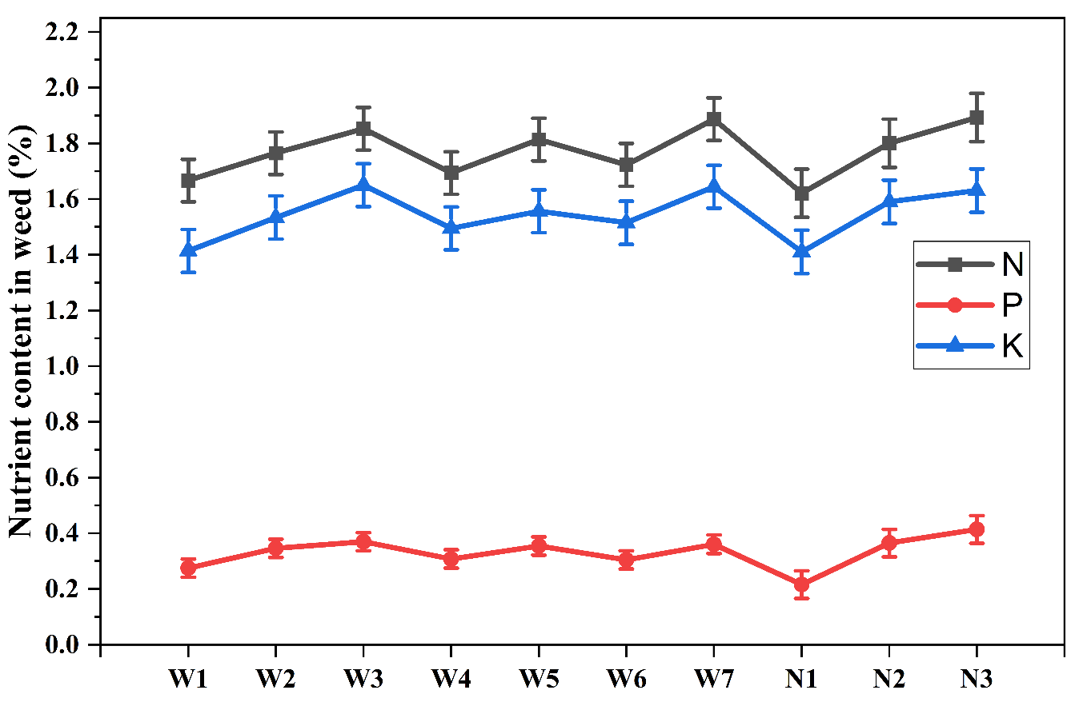

Fig. 1. Effect of weed management and nitrogen rate on nutrient (NPK) content in weed

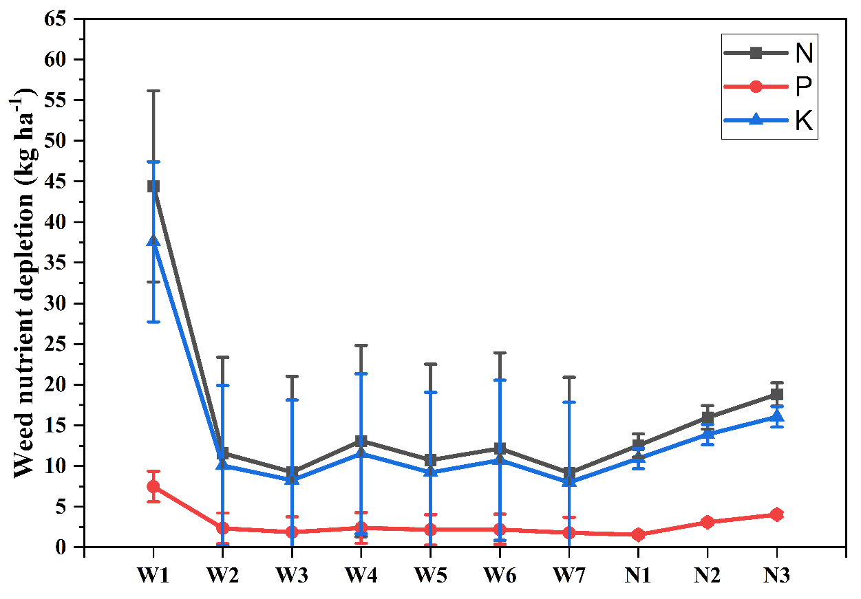

Fig. 2. Effect of weed management and nitrogen rate on nutrient depletion (NPK) by weed

