Original Research Article
Rice productivity, nutrients use efficiencies and water productivity on a biochar-amended soil in a typical lowland rice system in Benin

.
ABSTRACT

This study was conducted to evaluate the effects of soil amendment with corn cobs (CC) or rice husks (RH) biochars, under two irrigation regimes, on rice productivity, nutrients use efficiencies and irrigation water productivity (IWP) in a lowland rice system in Benin during the 2022 and 2023 growing cycles. A split-plot design in four replicates with two factors (irrigation regime and biochar amendment) was installed in the Koussin-Lélé rice production area in southern Benin. The results reveal that the combined use of CC or RH biochar (15 tons/ha) with chemical fertilizers significantly improved paddy rice yields by 19% compared to control (no use of biochar and use of chemical fertilisers). The AWD irrigation regime non-significantly improved paddy rice yields by 7% on average. The uptake of the three major nutrients (N, P and K) did not significantly vary with irrigation regime and biochar application. In the 2022 growing cycle, the combined use of CC or RH biochar and chemical fertilizers significantly reduced the apparent recovery rate by 42.07, 46.40 and 79.83%, and the agronomic N, P and K use efficiency by 39.91, 41.35 and 82.78%, respectively compared to control plots. In the 2023 growing cycle, the combined use of CC or RH biochar and chemical fertilizers increased apparent recovery rates by 29.09, 22.05 and 55.67% for N, P and K respectively, and their agronomic use efficiency by 40.36%. Soil amendment with CC or RH biochar significantly improved IWP by 18.5% on average compared to the control. AWD irrigation regime significantly improved IWP by 37% compared to the CF regime. Overall, the results of this study highlight the potential of : i) combining biochar amendment with the application of chemical fertilizers to significantly improve productivity and, ii) adopting the AWD irrigation regime without reducing yields in lowland rice systems in Benin.

Keywords: biochar, irrigation regime, paddy rice, yield, nutrients use efficiency, water productivity

1. INTRODUCTION

Rice ranks second in terms of cereal production after maize in Benin. National rice production has more than tripled in recent years thanks to Beninese government efforts, rising from 150,000 tonnes in 2012 to 525,014 tonnes in 2022 (MAEP, 2022). Despite this, only 54% of the consumption needs are covered (Olodo, 2021), the deficit being filled by massive imports from Asian countries. In order to reduce the loss of foreign currency linked to rice imports and ensure food security, rice has been included among the priority sectors selected to serve as leverage for Benin agricultural and economic development (MAEP, 2017). Although the country has significant natural resources (lowlands and flood plains) that are favourable to rice growing, the performance of this commodity chain is still well below consumer needs and state strategic expectations (Fall, 2016). To meet this challenge, rice production needs to be increased tenfold, not only by increasing the area under cultivation but also, and above all, by substantially improving yields. This increase will be more problematic than it has been over the last ten years, as the problem of land degradation has become more acute.

Benin soils, like most tropical soils, have low intrinsic fertility, with little assimilable P, low cation exchange capacity (CEC) and high Al saturation (Dabin, 1956). In addition, rainfall and high average temperatures, combined with farming practices such as deep tillage and failure to return crop residues to the soil accelerate mineralisation and the loss of soil organic matter (Igué et al., 2013). Indeed, the pedoclimate (temperature and humidity) determines the supply of vegetable matter as well as the decomposition rate of plant residues and organic matter in the soil (Sanchez et al., 1982). In Benin, rice-growing areas are over-exploited within an unfavourable pedoclimate context, where organic residues are not returned to the soil. This accelerates the decline in soil fertility, which constitutes a major constraint to improving rice productivity, and ultimately undermines food security and economic development in the region. Faced with this situation, the simplest solution proposed by agricultural research and advisory institutions is the use of chemical fertilisers. Despite this, average rice yields over the last fifteen years in Benin have remained low, at 2.4 tonnes/ha (Sossou, 2015).

In this context, the addition of biochar to soils is recognised as a way of simultaneously mitigating climate change by storing carbon (Lehmann et al., 2021), reducing ammonia emissions (Ferdous et al., 2023), and increasing agricultural production (Biederman and Harpole, 2013; Criscuoli, 2016; Djousse Kanouo, 2017). Highly weathered and acidic soils with low cation exchange capacity (CEC) and receiving few agricultural inputs, as found in tropical regions, give a positive response to biochar application in terms of yield (Jeffery et al., 2017). For example, based on pot experiments, Madari et al. (2006) found that rainfed rice was positively affected by the incorporation of eucalyptus biochar into the soil. According to these authors, rainfed rice had better initial vigour, more uniform development and much greater biomass accumulation (stem, leaf and seed). Biochar application also improved soil properties, reducing potential acidity and increasing P and K availability. Petter et al. (2012) reported a significant interaction between biochar and fertiliser on rice plant growth and biomass accumulation. Also, Asai et al. (2009) noted that the addition of biochar to soil resulted in higher grain yields on soils with low P availability and improved response to chemical fertiliser treatments. Given that biochar is alkaline in nature, its incorporation into the soil can stimulate the use and absorption of rice nutrients by raising the pH of acidic soils (Hossain et al., 2020). In addition, the changes induced in the physical properties of the soil, such as an increase in porosity and water retention or greater stability of aggregates, are usually presented as advantages (Schmidt et al., 2021). Biochar would promote water retention during drought phases and help prevent the risk of erosion during heavy precipitation (OFEV-OFAG-AGIR, 2023). For example, Haefele et al. (2011) found that on poor soil, where the crop was also suffering from water stress, the application of rice husk biochar increased yields by 16% to 35% compared to the control. Thus, in the current climate context, with increasing periods of drought, biochar offers an opportunity to improve adaptation to climate change through more water efficient use, particularly in lowland rice production.

While the positive effect of biochar on crop yield is often cited as an important co-benefit of its carbon sequestration, it should be noted that, however, some negative yield responses are also observed (Tisserant and Cherubini, 2019). Negative yield responses are mainly observed under alkaline soil conditions (Jeffery et al., 2017) that potentially limit P supply to plants (Lorenz and Lal, 2018). According to Lehmann et al. (2002), biochar could even limit N availability in deficient soils due to the high C/N ratio specific to biochar and, as a result, could reduce crop yields at least temporarily. In addition, Parker et al. (2021) did not see an improvement in water retention of biochar-amended structurally-poor tropical soils. Despite these risks and less favourable results, the controlled use of biochar as a soil improver may well result in higher and better crop yields (Melo et al., 2022). In general, in tropical soils, an average yield increase of 25% is observed, whereas biochar has little or no positive effects in temperate soils (Nelissen et al., 2015; Jeffery et al., 2017). In fact, the role of biochar in improving crop productivity depends on various factors such as the type and characteristics of soil, the climate conditions and the cultivated genotype (Bhattacharyya et al, 2024).

Considering all of the above, it is necessary to continue studies relating to the effect of adding biochar to the soil on crop productivity under field conditions, and in relation to the farming practices and crop varieties used in a given agro-ecological zone and on a given site. However, such research is rare in Africa. In Benin, the application of biochar to the soil as a soil amendment is not yet a tried and tested sustainable land management technology. There is little research on the quality of biochar, its effects on the physical, chemical and biological properties of soils and crop productivity. For example, Behoundja-Kotoko et al. (2022) reported that biochar combined with Mycotri increased the leaf area of plants and the mass of leaves and roots of greater nightshade. According to Dossa et al. (2021), among organic soil amendments, biochar combined with compost produced the best results for maize growth and yield variables, and was more stable in all environments. Tovihoudji et al. (2022) found that biochar combined with compost gave the best results in terms of cotton growth and yield in experiments both on station and in a farmer environment. Regarding rice specifically, to the best of our knowledge, no research has been carried out to determine the possible benefits of adding biochar to the soil in a typical lowland rice production system in sub-Saharan Africa and in Benin in particular. However, biochar application could help improve the efficiency of mineral fertiliser and water use in lowland rice production system. Furthermore, rice, mainly cultivated in lowlands and floodplains, is the main consumer of irrigation water in Benin. The conventional method of rice cultivation involves continuous flooding of plots/settlements, which is technically feasible and economically viable when irrigation water is abundant and cheap. In this method, irrigation water is used for evapotranspiration (ET) and infiltration-percolation (I&P). However, in reality, only ET represents the true water requirement for crop growth, and infiltration-percolation represents the inevitable losses (Rahman & Bulbul, 2014). However, rice can be grown under alternating wet and dry conditions without yield reduction (Rahman & Bulbul, 2014; Mote et al., 2022). Alternate wetting and drying (AWD) irrigation is a practice that addresses water scarcity in irrigated rice cultivation and could contribute to more sustainable and efficient use of water and energy. Its implementation uses a device designed to observe the water level in the rice field to determine the appropriate irrigation timing. This device involves installing a 10 cm diameter, 30 cm long perforated pipe (preferably PVC) 10 cm above and 20 cm below ground level. By using AWD, rice farmers can save 15–30% of irrigation water (Rahman & Bulbul, 2014; Mote et al., 2022). Thus, water productivity, i.e. the volume of irrigation water required to produce a certain quantity of rice, is increased compared to conventional cultivation based on continuous flooding (Feng et al., 2007; Rahman & Bulbul, 2014). Therefore, from the perspective of sustainable water resources management, it also seems relevant to study the potential of AWD irrigation practice to save water and energy without reducing yields in a typical lowland rice farming system in Benin.

This study was conducted to evaluate and compare rice growth and yield, and water productivity under treatments of soil amended with two types of biochar produced from rice husks and corn crops in a typical lowland rice system in Benin. A field experiment was carried out under different irrigation regimes to identify possible water-biochar interactive effects on nutrient uptake and nutrient use efficiency. We hypothesized that high quality biochar incorporated into the soil induces better productivity of lowland rice and that its interaction with water could increase the nutrient uptake and fertilizer use efficiency under an alternate wetting and drying (AWD) irrigation regime. The results could guide decision-makers in prioritizing actions in favour of the agroecological transition in order to sustainably ensure rice self-sufficiency, food security and economic development in Benin.

2. material and methods

2.1 Study site

The study was carried out in the Koussin-Lele rice production area in the municipality of Cove, in southern Benin. Located between latitudes 7°25' and 7°75' north and between longitudes 2°15' and 2°50' east, Cove covers 418 km² area, including 328 km² arable land and 1,200 hectares of lowland (Fig. 1). The rice production area includes the Koussin and Lélé sites located 4 km from each other. The experimental plots were set up at the Koussin site. The Cove municipality has a transitional climate between sub-equatorial and humid tropical (South Guinean type) with four seasons, including two dry seasons (July to August and December to March) and two rainy seasons (April to July and September to November). The average annual rainfall is 1100 mm. The temperature varies between 24 and 34 °C, with an average of 27 °C. The soils in the Koussin-Lele rice production area are hydromorphic and medium-humiferous according to the Commission for Pedology and Soil Mapping (1967) or, humic with gley (Gleysols) according to the World Reference Base for soil resources (2015). The physico-chemical characteristics of the soil on the experimental plots are shown in Table 1. The values shown are the mean with their standard deviation over the four blocks which constitute the experimental site. For all parameters, the estimated standard deviations were low, indicating homogeneity between the blocks.
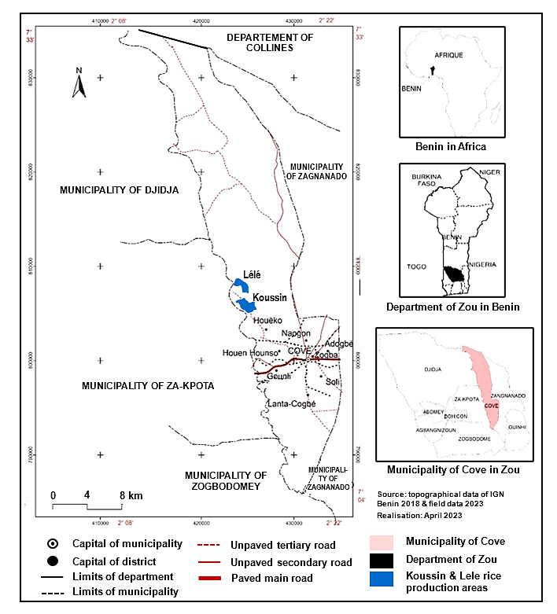

Figure 1. Map of Cove municipality, showing the Koussin-Lélé rice production areas

Table 1. Soil properties at the start of experiment

Parameters | Values*
Clay (%) | 12,44 ± 0,78
Silt (%) | 24,86 ± 1
Sand (%) | 62,7 ± 0,85
C (%) | 1,05 ± 0,04
N (%) | 0,1 ± 0,01
C/N | 10,64 ± 0,75
Organic matter (%) | 1,82 ± 0,07
pH_{water} (1/2.5) | 5,66 ± 0,25
pH_{KCl} (1/2,5) | 5,24 ± 0,13
P_{assimilable (}mg/kg) | 4,88 ± 0,4
Ca_{exchangeable (}meq/100g) | 6,82 ± 0,65
Mg_{exchangeable} (meq/100g) | 1,96 ± 0,07
K_{exchangeable} (meq/100g) | 0,29 ± 0,02
Na_{exchangeable}_meq/100g | 0,13 ± 0,01
∑cations (meq/100g) | 9,2 ± 0,65
Cation exchange capacity (CEC) (meq/100g) | 11,67 ± 0,21
Saturation rate (%) | 78,78 ± 4,78
* Values shown are the average over four blocks with their standard deviation
2.2 Inputs used

Aromatic rice (Oryza sativa L.) variety IR841 with a 120-day cycle and a potential yield of 8 t/ha was used for the experiment. Seeds were purchased from the Institut National des Recherches Agricoles du Bénin (INRAB). Two types of biochar produced from corn cobs and rice husks were used in the study. They were chosen because of their abundance and low valuation. Biochar was produced by slow pyrolysis in a pilot reacto. The kiln was used in internal heat transfer mode as a top-lit updraft kiln. Basic properties of the biochar used are presented in Table 2. Mineral fertilisers used were NPK complex (15-23-15) and urea (46%).

Table 2. Rice husk and corn cob biochar properties

Parameters | CC biochar | RH biochar
Bulk density (BD) (g/cm³) | 0.34 ± 0.02 | 0.45 ± 0.02
Particle density (PD)(g/cm³) | 1.62 ± 0.34 | 1.91 ± 0.03
Porosity (PO) (%) | 78.76 ± 3.4 | 76.65 ± 0.59
Mean particle diameter (MPD) (mm) | 0.28 ± 0.01 | 0.25 ± 0.01
Uniformity coefficient (UC) | 2.53 ± 0 | 2.32 ± 0
Water sorption by capillary rise (-0.7 hPa) (%) | 12.05 ± 0.98 | 10.43 ± 1.17
Water sorption by capillary rise (-2.1 hPa) (%) | 4.43 ± 0.47 | 2.96 ± 0.43
Moisture content (MC) (%) | 4.02 ± 0.55 | 5.62 ± 2.15
Electrical conductivity (EC) (dS/m) | 0.38 ± 0.05 | 0.56 ± 0.07
Ash content (AC) (%) | 16.89 ± 1.64 | 29.57 ± 2.69
Volatile matter (VM) (%) | 32.42 ± 2.33 | 25.85 ± 3.48
Fixed Carbon (FC) (%) | 48.64 ± 1.14 | 41.23 ± 6.13
Carbon (C) (%) | 66.55 ± 2.98 | 54.16 ± 2.79
Nitrogen (N) (%) | 0.72 ± 0.07 | 0.57 ± 0.1
Hydrogen (H) (%) | 1.57 ± 0.07 | 1.56 ± 0.16
Oxygen (O) (%) | 10.69 ± 1.88 | 8.95 ± 4.37
Molar ratio H/C | 0.28 ± 0.02 | 0.35 ± 0.05
Molar ratio O/C | 0.12 ± 0.03 | 0.13 ± 0.06
Ratio H/FC | 0.03 ± 0 | 0.04 ± 0.01
Ratio C/N | 93.25 ± 11.56 | 95.94 ± 10.74
Hydrogen potential (pH) | 9.23 ± 0.82 | 9.88 ± 0.74
Phosphorus (P) (%) | 1745 ± 174 | 1161 ± 147
Exchangeable Calcium (Ca²⁺) (cmol/kg) | 3.05 ± 0.83 | 3.31 ± 0.53
Exchangeable Potassium (K⁺) (cmol/kg) | 13.66 ± 2.28 | 19.09 ± 2.73
Exchangeable Sodium (Na⁺) (cmol/kg) | 2.09 ± 1.06 | 2.61 ± 0.52
Exchangeable Magnesium (Mg2⁺) (cmol/kg) | 1.01 ± 0.16 | 1.01 ± 0.17
Cation exchange capacity (CEC) (cmol/kg) | 22.55 ± 4.19 | 27.91a ± 5.06
Lead (Pb) (mg/kg) | <0. 000 | <0. 000
Cadmium (Cd) (mg/kg) | <0. 000 | <0. 000
Arsenic (As) (mg/kg) | <0. 000 | <0. 000
Mercury (Hg) (mg/kg) | <0. 000 | <0. 000
Values shown are the average with their standard deviation

2.3 Experimental design

The experiment was carried out twice in off-season during the long dry season of each year (november to march) for the 2022-2023 and 2023-2024 agricultural seasons. It was conducted in a split-plot design with four replications aimed at studying the effects of two irrigation regimes and two types of biochar, and their interactions on rice productivity and nutrient uptake. The main plots had the two irrigation regimes, that is the continuous flooding irrigation practice (CF) (control), and the alternate wetting and drying irrigation practice (AWD). Each main plot was divided into four subplots corresponding to the application of two types of biochar and a control: absolute control (no biochar and no chemical fertilizers, 0B0F), and treatments with chemical fertilizers + no biochar (0B), chemical fertilizers + 15 tons/ha of corn cob biochar (15CCB), chemical fertilizers + 15 ton/ha of rice husk biochar (15RHB). Thus, we had eight combinations or treatments. Each treatment was applied to a subplot of 25 m² (5 m x 5 m) in 4 replications, for a total of 32 subplots.

2.4 Farming practices

2.4.1 Ploughing-Sowing-Fertilizing-Weeding-Harvesting

For the first cropping cycle (november 2022 to march 2023), the soil of each plot was ploughed to 20 cm depth and harrowed manually using a hoe. Biochar was spread three days later on the surface of the 15CCB and 15RHB plots and incorporated into the top 20 cm of soil using a spade. Subsequently, the soil was levelled using a rake. Rice plants were grown in a nursery and transplanted after 21 days at 3-4 leaf stage. Two plants were placed in each seedling hole, with the holes spaced 20 cm x 20 cm apart. On each plot, NPK (15-15-15) and urea (46%N) mineral fertilisers were applied as soon as the plants began to establish, according to the doses and methods used by rice farmers, except for the full control (0B0F). Full dose of NPK (200 kg/ha) was applied 15 days after rice plants transplanting, while urea application was divided into two equal doses. A first application was performed 15 days after rice plant transplanting (beginning of tillering), and a second 45 days after transplanting (end of bolting and beginning of panicle initiation). Weeding was carried out before each fertilisers’ application and if necessary, depending on weeds state. This involved hand-pulling weeds whenever they appeared until the rice plants reached physiological maturity. Then, a bird hunt was organised to reduce the impact of granivorous birds’ attacks. A second cropping cycle (november 2023 to march 2024) was conducted using the same technical itinerary, with the exception of biochar adding, which was not repeated. The aim of repeating the experiment without biochar application is to determine the potential after-effects of a single biochar application on rice productivity and nutrient use efficiency in rice paddies.

2.4.2 Water management

Plots were irrigated by pumping water from the primary canal using a motor pump (Honda GX120, maximum flow: 37.2 m³/hour, total manometric height: 32 m, suction height: 7.5 m, pressure: 3.2 bar). Irrigation and drainage channels, each measuring 0.5 m wide and 0.5 m deep, were constructed between each block to ensure optimal conditions for controlling irrigation regimes. Each subplot was surrounded by a bund of 50 cm thickness and 50 cm height to ensure treatment independence. During the first fourteen days after transplanting (DAT), a 10 cm water height was maintained on the plots, regardless of the irrigation practice. On the fifteenth day, differentiation with the start of intermittent irrigation took place in AWD plots by supplementing them with a water layer of 5 cm height. In CF plots (farmers' irrigation practice), the water supplemented to a layer of 10 cm height. Then, the AWD plots were subjected to natural drying until the water level in the soil (monitored using a piezometer) fell to 15 cm depth, before being irrigated again till a water height of 5 cm on the soil surface was reached. The piezometers, made of PVC and 12.5 cm in diameter and 40 cm long, were installed to a depth of 25 cm below the soil surface in each subplot 15 days after transplanting. The 25 cm bottom of the pipe was perforated with 1 cm diameter holes, with a spacing of 2 cm vertically and around. The water level in the piezometer was measured throughout the growth cycle. In the farmers' irrigation practice, the 10 cm high layer of water was maintained until harvest except for fertilizers spreading and plot maintenance periods. One day before carrying out these operations, the plots were drained and then, the water layer was replenished two days after the end of operations.

2.5 Agronomic parameter measurements, nutrient use efficiency and irrigation water productivity

2.5.1 Soils and biochar sampling and analysis

Before the tests were installed and at harvest, composite soil samples were taken per block/replication from the 0-20 cm horizon. Each sample was taken from five different locations in each block (the four corners and the middle of the block). These elemental samples were mixed to make up the composite sample. Thus, three composite samples were taken per block, for a total of twelve samples. Then, they were sent to the laboratory for analysis of particle size distribution, C, N, P, pH, CEC and exchangeable bases (K⁺, Ca²⁺, Na⁺ and Mg²⁺). They were first air-dried under cover, then sieved (2 mm) before being grounded. Particle size was determined gravimetrically using a Robinson pipette and using a 50 µm sieve for the sand content (Gee and Or, 2002). pH was determined using a glass electrode pH meter at a 1/2.5 soil/solution ratio. Organic C content was determined by a method adapted from Walkley and Black (1934). Assimilable P was measured using a spectrophotometer (Thermo Scientific/Spectronic 200E) by the molybdenum-blue colorimetric method (Bray 1 method adapted by Tran Vinh An, 1976). Exchangeable bases (K⁺, Ca²⁺, Na⁺ and Mg²⁺) were determined by extraction with ammonium acetate buffered to pH 7.0 before reading with an atomic absorption spectrometer (AAS) (Tran Vinh An, 1976). Total nitrogen (N) was determined by Kjeldahl method (Tran Vinh An, 1976). Three samples of each type of biochar were also taken for chemical characterisation. Analyses were carried out on ash content, volatile matter content, organic C, N, P, K, Ca, Na, Mg, CEC, electrical conductivity and pH using the methods described above. At harvest, paddy grains and straw samples were collected from each subplot. They were analysed in the laboratory to determine nutrient concentrations (N, P and K) according to the methods described previously.

2.5.2 Growth parameters

Phenological parameters plant height and tiller number were measured for each subplot per bed at panicle initiation (PI), flowering (F), heading (H), and physiological maturity (PM), that is, at 30, 45, 60, 75 and 90 days after transplanting (DAT). These data were collected at six transplanting points randomly selected within the interpretable zone of each subplot, excluding border plants.

2.5.3 Yield parameters

For each subplot, at maturity, yield components (number of panicles, number of fertile grains per panicle, straw weight, weight of full and empty grains, weight of 1000 grains) were determined in a 1 m² yield square placed at random in each subplot. The number of fertile grains per panicle was recorded on six panicles from six randomly selected transplanting points in each yield square. Fertile grains were recorded after light finger pressure on the paddy. Grains were considered to be fertile (well filled) when the grain resisted pressure. Yields of paddy rice and straw were measured from a yield square placed on each subplot. Mature rice straw was cut, bundled and sun-dried in the field to reduce moisture content. Then, dried straw bales were threshed and winnowed. Paddy grains resulting from the winnowing were dried on the drying area of the rice production perimeter for 72 hours before being weighed to determine paddy rice yield. The straw obtained after threshing was also weighed to obtain the straw yield after drying for 72 hours on the drying area. Paddy rice and straw moisture content was determined from samples taken from each subplot, dried in an oven at 105°C for three days and then weighed.

2.5.4 Uptake, apparent recovery and agronomic use efficiency of nutrients

Total uptakes of nutrients N, P and K were determined from their tissue concentrations and grain and straw yields (Mote et al., 2022):

$$Nutrient uptake in grain\left(kg/ha\right)=\frac{Nutrient content\left(\%\right)×Grain yield\left(kg/ha\right)}{100}$$

$$Nutrient uptake in straw\left(kg/ha\right)=\frac{Nutrient content\left(\%\right)×Straw yield\left(kg/ha\right)}{100}$$

Apparent nutrients recovery was calculated from (Cabangon et al., 2004):

$$AR=\frac{U_{f}-U_{c}}{F_{ap}}×100$$

where AR (kg paddy rice/kg of N, P or K supplied) is defined as the increase in N, P or K uptake per unit of N, P or K fertiliser applied, U_{F} and U_{C} are the N, P or K uptake in the treatment where N, P and K fertiliser was applied and in the absolute control plot without fertiliser, F_{ap} is the amount of N, P or K in chemical fertiliser and biochar applied (kg/ha).
Agronomic nutrients use efficiencies (AUE) were determined from (Vanlauwe et al., 2011; Mutuku, 2020):

$$AUE=\frac{Y_{f}-Y_{C}}{F_{ap}}$$

where AUE (kg paddy rice/kg of N, P or K supplied) is defined as the increase in paddy rice yield per unit of N, P or K fertiliser applied, Y_{F} and Y_{C} are the paddy rice yields (kg/ha) in the treatment where N, P and K fertiliser was applied and in the absolute control plot without fertiliser, respectively, F_{ap} is the amount of N, P or K in chemical fertiliser and biochar applied (kg/ha).

2.5.5 Irrigation water volume and productivity

Irrigation water quantity supplied (IWQ, m³) to each plot was evaluated by:

$$IWQ=FR×T×N$$

with FR the flow rate (m³/s), T the irrigation time (s), and N the number of irrigations.

Irrigation water productivity (IWP, kg of grain/m³ of water) was used to express the additional crop yield or income for each unit volume of irrigation water used. IWP was determined by (Mote et al., 2022):

$$IWP\left(kg of grain/m^{3} of water\right)=\frac{Grain yield\left(kg/ha\right)}{Irrigation water applied\left(m^{3}/ha\right)}$$

2.6 Statistical analysis

R software (version 4.4.1, 2024) and RStudio development environment for Windows was used to carry out the statistical analyses. Data were first tested for normality and inequality of variance using the Quantile-Quantile plot and Levene's test respectively. Block was treated as random variable. Then, the sp.plot() function from the "agricolae" package was used to perform analysis of variance (ANOVA). Significant differences detected between treatment means were separated using LSD test at a significance level of 5%. Given the large number of agro-morphological variables studied, principal component analysis (PCA) was performed using the PCA() function from the "FactoMineR" package and prcomp(), fviz_pca_var() and fviz_pca_ind() functions from the "Factoextra" package (Evrard and Govaerts, 2023). The PCA allowed to reduce the number of variables, to group the most correlated and to determine those that contribute more significantly to the paddy rice yield.

3. results

3.1 Growth parameters​

3.1.1 Height of rice plants

Figure 2 shows the height of rice plants with time per treatment and growing cycle, with all curves having the same general shape. Independently of the growing cycle and irrigation regime, the soil amendment with corn cobs (CC) or rice husks (RH) biochar at a dose of 15 tons/ha (plots 15CCB and 15RHB) induced a higher plant height than the control plots 0B (no biochar and with chemical fertilisers). However, at maturity (90 days after transplanting), plant heights in the treatments based on the use of chemical fertilisers combined or not with the application of biochar (treatments 0B, 15CCB and 15RHB) did not significantly vary according to biochar application and irrigation regime (Table 3). Furthermore, the nature of the biochar applied and the irrigation-biochar interaction had no significant effect on rice plant growth, independently of the growing cycle. As expected, on the absolute control plots 0B0F (no biochar and no chemical fertiliser), the plants had significantly lower growth rates and heights at maturity than on the other plots, varying between 64.63 and 66.4 cm.

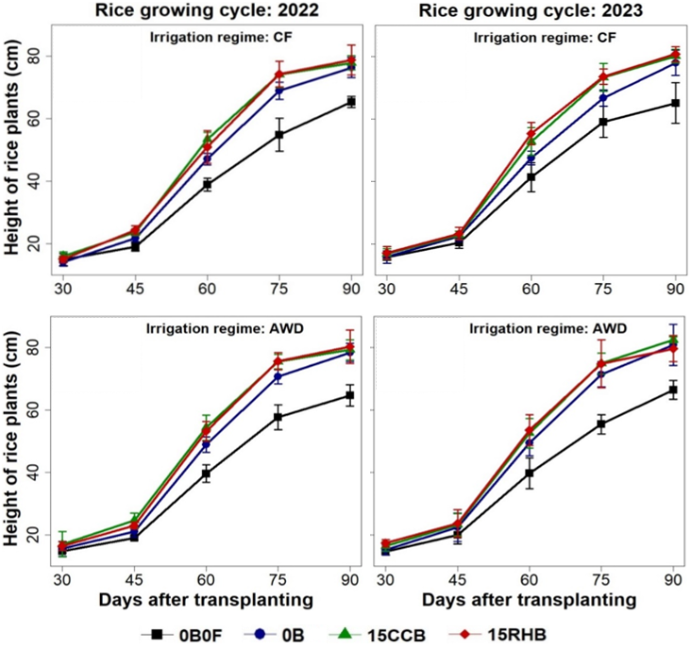
0B0F is absolute control corresponding to no use of biochar and chemical fertilizer, 0B is control corresponding to no use of biochar and use of chemical fertilisers (200 kg NPK + 100 kg Urea/ha), 15CCB corresponds to use of corn cobs biochar (15 tons/ha) and chemical fertilisers (200 kg NPK + 100 kg Urea/ha), 15RHB corresponds to use of rice husks biochar (15 tons/ha) and chemical fertilisers (200 kg NPK + 100 kg Urea/ha), CF is continuous flooding, AWD is alternating wetting-drying.

Figure 2. Rice plant growth in response to soil amendment with biochar and irrigation regime in a typical lowland rice system in Benin

3.1.2 Tillering rice plants

The average number of tillers per rice plant per treatment and growing cycle is presented in Table 3. Between treatments based on mineral fertilization combined or not with biochar application (treatments 0B, 15CCB and 15RHB), the average number of tillers per plant varied very significantly according to biochar application and irrigation regime. Thus, independently of the growing cycle and irrigation regime, the soil amendment with CC or RH biochar at a dose of 15 tons/ha induced plant tillering varying between 15 and 17 tillers/plant, which was on average 19% higher than on the control plots 0B. In addition, the tillering of rice plants under AWD irrigation regime was on average 10% higher than under CF irrigation regime. The nature of the biochar applied and the irrigation-biochar interaction had no significant effects on tillering, independently of the growth cycle. As expected, the 0B0F treatments (without biochar and without chemical fertilizers) induced the lowest tillering independently of the growing cycle and irrigation regime.

Table 3. Plant height and number of tillers per plant at maturity in response to soil amendment with biochar and irrigation regime in a typical lowland rice system in Benin

Irrigation | Biochar | Height (cm) |  | Number of tillers
 |  | 2022 | 2023 | 2022 | 2023
CF | 0B0F | 65.33 ± 0.55b | 65.1 ± 2.04b | 8.67 ± 0.3e | 8.71 ± 0.14e
CF | 0B | 76.31 ± 1.01a | 77.96 ± 1.25a | 12.75 ± 0.11d | 13 ± 0.25d
CF | 15CCB | 77.8 ± 0.71a | 80.1 ± 0.68a | 15.17 ± 0.22b | 14.79 ± 0.04bc
CF | 15RHB | 78.74 ± 1.51a | 80.72 ± 0.75a | 15.13 ± 0.08b | 15.33 ± 0.15b
AWD | 0B0F | 64.63 ± 1.09b | 66.4 ± 0.95b | 8.67 ± 0.25e | 8.92 ± 0.31e
AWD | 0B | 78.35 ± 0.93a | 80.76 ± 2.06a | 14 ± 0.1c | 14.25 ± 0.2c
AWD | 15CCB | 79.2 ± 1.03a | 82.45 ± 0.31a | 17.08 ± 0.22a | 16.75 ± 0.08a
AWD | 15RHB | 80.22 ± 1.67a | 79.6 ± 1.32a | 17.13 ± 0.14a | 17.04 ± 0.25a
0B0F is absolute control corresponding to no use of biochar and chemical fertilizer, 0B is control corresponding to no use of biochar and use of chemical fertilisers (200 kg NPK + 100 kg Urea/ha), 15CCB corresponds to use of corn cobs biochar (15 tons/ha) and chemical fertilisers (200 kg NPK + 100 kg Urea/ha), 15RHB corresponds to use of rice husks biochar (15 tons/ha) and chemical fertilisers (200 kg NPK + 100 kg Urea/ha), CF is continuous flooding, AWD is alternating wetting-drying. Values shown are the means with standard errors. Values in a column with similar letters indicate no significant difference between treatments (p < 0.05).

3.2 Yield parameters

3.2.1 Fertility of tillers and panicles, and 1000-grain weight

Tillers fertility rate (percentage of tillers bearing panicles), panicles fertility rate (percentage of grains filled) and 1000-grain weight are presented in Table 4. Whatever the growing season, variations between treatments based on mineral fertilization combined or not with biochar application (treatments 0B, 15CCB and 15RHB) are non-significant, ranging from 90.52 to 93.95%, 74.4 to 82.3% and 20.68 to 23.26 g, respectively, for tillers fertility rate, panicles fertility rate and 1000-grain weight. However, the soil amendment with CC or RH biochar at a dose of 15 tons/ha improved panicle fertility rate and 1000-grain weight by 4.54 and 6.88%, respectively, compared to the control. As expected, plants in the absolute control plots 0B0F (no chemical fertiliser and no biochar) had the lowest tillers fertility rates, panicles fertility rates and 1000-grain weights, ranging from 83,09 to 86,15%, 69.24 to 74.71% and 17.83 to 18.63 g, respectively.

Table 4. Tillers fertility rates and panicles fertility rates in response to soil amendment with biochar and irrigation regime in a typical lowland rice system in Benin

Irrigation | Biochar | Fertile tiller rate (%) |  | Fertility rate of panicles (%) |  | 1000-grain weight (g)
 |  | 2022 | 2023 | 2022 | 2023 | 2022 | 2023
CF | 0B0F | 84.13 ± 1.33b | 84.29 ± 1.75ab | 74.71 ± 0.51bc | 71.16 ± 1.79bc | 17.83 ± 0.41c | 18.27 ± 0.43c
CF | 0B | 93.17 ± 1.67a | 91.27 ± 1.62ab | 76.05 ± 1.21b | 76.24 ± 1.28abc | 20.68 ± 0.63ab | 21.4 ± 1.04ab
CF | 15CCB | 92.88 ± 0.63a | 91.74 ± 1.56ab | 78.54 ± 0.88ab | 80.92 ± 3.11a | 23.03 ± 0.34a | 22.89 ± 0.19a
CF | 15RHB | 92.83 ± 0.97a | 90.52 ± 1.47ab | 82.30 ± 1.59a | 79.17 ± 1.73abc | 21.55 ± 0.35a | 23.16 ± 0.6a
AWD | 0B0F | 86.15 ± 2.74ab | 83.09 ± 3.97b | 69.24 ± 0.26c | 70.59 ± 1.29c | 18.38 ± 0.3bc | 18.63 ± 0.44bc
AWD | 0B | 92.57 ± 1.3ab | 90.96 ± 1.23ab | 74.40 ± 1.13bc | 76.17 ± 1.89abc | 20.81 ± 0.45ab | 21.03 ± 0.4abc
AWD | 15CCB | 93.68 ± 1.47a | 93.78 ± 0.47a | 77.05 ± 1.60ab | 79.07 ± 0.72abc | 22.01 ± 0.65a | 22.09 ± 0.58a
AWD | 15RHB | 93.95 ± 1.68a | 92.93 ± 1.61ab | 76.34 ± 0.53b | 79.84 ± 1.61ab | 21.39 ± 0.78a | 23.26 ± 0.36a
0B0F is absolute control corresponding to no use of biochar and chemical fertilizer, 0B is control corresponding to no use of biochar and use of chemical fertilisers (200 kg NPK + 100 kg Urea/ha), 15CCB corresponds to use of corn cobs biochar (15 tons/ha) and chemical fertilisers (200 kg NPK + 100 kg Urea/ha), 15RHB corresponds to use of rice husks biochar (15 tons/ha) and chemical fertilisers (200 kg NPK + 100 kg Urea/ha), CF is continuous flooding, AWD is alternating wetting-drying. Values shown are the means with standard errors. Values in a column with similar letters indicate no significant difference between treatments (p < 0.05).

3.2.2 Paddy rice and rice straw yields

Figure 3 shows the paddy and straw yields obtained for the growing cycles 2022 and 2023 across the treatments. The paddy yields ranged from 1964.27 to 4592.11 kg/ha in 2022, and from 2082.88 to 5000.32 kg/ha in 2023. Regarding rice straw yields, they ranged from 4011.38 to 6510.45 kg/ha in 2022, and from 4123.95 to 7182.91 kg/ha in 2023. Independently of the growing cycle, paddy rice yields were significantly affected by the application of biochar. However, during the 2022 season, the increase in paddy rice yields induced by the soil amendment with RH biochar was not significant compared to the control. Generally, soil amendment with CC or RH biochar at a dose of 15 tons/ha improved paddy rice yield with 19% on average compared to the control. As expected, the mineral fertilization, whether combined with biochar application or not, significantly improved yields compared to the absolute control 0BOF (p < 0.01). Regarding the irrigation regime, paddy rice yields did not significantly vary, independently of the growth cycle. The irrigation-biochar interaction had no significant effect. However, the AWD irrigation regime improved paddy rice yields by 7% on average, though not statistically significant. Furthermore, independently of the growing cycle, straw yields did not vary significantly according to the irrigation regime and biochar application. Nevertheless, the soil amendment with CC or RH biochar at a dose of 15 tons/ha increased straw yields by 15% on average compared to the control. Regarding the irrigation regime, the AWD improved straw yields (non-significantly) by 4.5% on average.

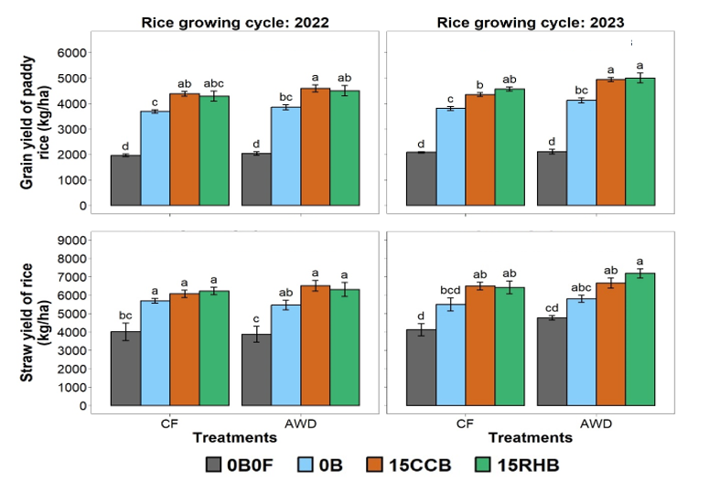
0B0F is absolute control corresponding to no use of biochar and chemical fertilizer, 0B is control corresponding to no use of biochar and use of chemical fertilisers (200 kg NPK + 100 kg Urea/ha), 15CCB corresponds to use of corn cobs biochar (15 tons/ha) and chemical fertilisers (200 kg NPK + 100 kg Urea/ha), 15RHB corresponds to use of rice husks biochar (15 tons/ha) and chemical fertilisers (200 kg NPK + 100 kg Urea/ha), CF is continuous flooding, AWD is alternating wetting-drying. For each season, bar graphs with similar letters indicate no significant difference between treatments. (p < 0.05).

Figure 3. Paddy rice and rice straw yields in response to biochar soil amendment and irrigation regime in a typical lowland rice system in Benin.

3.3 Absorption, apparent recovery and agronomic efficiency of use of nutrients N, P and K

As expected, the mineral fertilization combined or not with biochar application (treatments 0B, 15CCB and 15RHB) improved nutrient uptake very significantly (p < 0.01) compared to the absolute control plot 0B0F (no biochar and no mineral fertilisers) (Table 5). However, between treatments 0B, 15CCB and 15RHB, the uptake of the three nutrients did not vary significantly according to biochar application and irrigation regime (p > 0.05), independently of the growth cycle. It varied between 98.59 and 106.12 kg/ha, 20.68 and 24.55 kg/ha, 110.37 and 120.72 kg/ha for N, P and K respectively. Soil amendment with biochar at a rate of 15 tons/ha increased N, P and K uptake by 5.36, 8.63 and 6.97% respectively compared to the control (no biochar and with mineral fertilisers). The irrigation-biochar interaction had no significant effect on the uptake of these three nutrients (p > 0.05).

The apparent recovery rate and the agronomic efficiency of use of the three nutrients (N, P and K) showed trends in terms of variation that differed from the 1st to the 2nd growth cycle (Table 3). Independently of the growth cycle, these two parameters had values that varied significantly according to the application of biochar (p < 0.05) and not significantly according to the irrigation regime (p > 0.05). For the growth cycle 2022, soil amendment with biochar at a rate of 15 tons/ha significantly reduced the apparent recovery rates of N, P and K nutrients by 42.07, 46.4 and 79.83% and their agronomic use efficiencies by 39.91, 41.35 and 82.78% respectively. In contrast, for the growth cycle 2023, soil amendment with biochar at a rate of 15 tons/ha increased the apparent recovery rates of N, P and K nutrients by 29.09, 22.05 and 55.67% respectively, and agronomic use efficiencies by 40.36% on average for each of the three nutrients. Irrigation-biochar interaction and the type of biochar applied (CC or RH biochar) had no significant effect on these two parameters (p > 0.05), regardless of the growth cycle.

Table 5. Uptake, apparent recovery rate and agronomic efficiency of use of nutrients N, P and K in response to soil amendment with biochar and irrigation regime in a typical lowland rice system in Benin

Irrigation | Biochar | N |  | P |  | K
Irrigation | Biochar | 2022 | 2023 | 2022 | 2023 | 2022 | 2023
Nutrient uptake (kg/ha)
CF | 0B0F | 82.78 ± 1.49b | 81.78 ± 1.03b | 13.85 ± 1.1b | 15.1 ± 0.27c | 97.47 ± 1.56c | 96.8 ± 2.53b
CF | 0B | 99.06 ± 1.39a | 99.32 ± 1.29a | 21.35 ± 1.11a | 22.18 ± 1.37ab | 110.37 ± 1.05b | 111.96 ± 2.2a
CF | 15CCB | 103.7 ± 1.46a | 103.79 ± 1.66a | 22.29 ± 0.42a | 22.83 ± 0.39ab | 118.54 ± 1.89ab | 119.37 ± 2.42a
CF | 15RHB | 103.54 ± 1.7a | 104.27 ± 0.39a | 24.44 ± 1.08a | 24.68 ± 0.25a | 118.65 ± 1.81ab | 120.55 ± 2.81a
AWD | 0B0F | 82.75 ± 1.82b | 81.18 ± 0.95b | 13.45 ± 0.48b | 13.8 ± 0.9c | 98.85 ± 1.41c | 100.49 ± 1.9b
AWD | 0B | 98.59 ± 1.95a | 99.87 ± 0.77a | 21.86 ± 0.6a | 20.68 ± 0.34b | 112.64 ± 2.28ab | 112.07 ± 1.29a
AWD | 15CCB | 103.38 ± 0.89a | 105.39 ± 1.98a | 23.84 ± 0.35a | 22.13 ± 0.53ab | 120.64 ± 0.45a | 118.29 ± 1.56a
AWD | 15RHB | 106.12 ± 1.15a | 106.01 ± 2.22a | 24.55 ± 0.89a | 22.23 ± 0.75ab | 120.72 ± 0.96a | 119.63 ± 1.82a
Apparent nutrient recovery (%)
CF | 0B0F | NA | NA | NA | NA | NA | NA
CF | 0B | 22 ± 1.08a | 23.7 ± 1.95c | 47.8 ± 10.95ab | 45.13 ± 9.96c | 43.16 ± 8.48a | 50.75 ± 8.6c
CF | 15CCB | 13.12 ± 1.26b | 29.74 ± 2.69bc | 25.5 ± 2.86c | 49.28 ± 3.18bc | 7.37 ± 1.11b | 75.54 ± 5.91a
CF | 15RHB | 11.41 ± 1.61b | 30.39 ± 1.79ab | 25.31 ± 1.9c | 61.02 ± 2.22a | 10.35 ± 1.19b | 79.5 ± 12.82a
AWD | 0B0F | NA | NA | NA | NA | NA | NA
AWD | 0B | 21.41 ± 3.15a | 25.25 ± 2.3c | 53.61 ± 2.57a | 43.82 ± 7.62c | 46.17 ± 9.21a | 38.75 ± 10.53d
AWD | 15CCB | 12.93 ± 1.39b | 32.71 ± 2.12a | 31.38 ± 2.14bc | 53.09 ± 2.62ab | 7.63 ± 0.56b | 59.56 ± 10.69bc
AWD | 15RHB | 12.84 ± 0.43b | 33.54 ± 2.28a | 26.53 ± 1.39c | 53.73 ± 5.17ab | 10.69 ± 0.73b | 64.07 ± 7.15b
Agronomic efficiency of nutrient use (kg paddy rice/kg of N, P or K supplied)
CF | 0B0F | NA | NA | NA | NA | NA | NA
CF | 0B | 23.29 ± 0.98a | 23.24 ± 0.71e | 109.8 ± 4.63a | 109.57 ± 3.33e | 57.68 ± 2.43a | 57.56 ± 1.75e
CF | 15CCB | 15.13 ± 0.48b | 30.62 ± 0.95cd | 72.88 ± 2.3b | 144.38 ± 4.47cd | 8.45 ± 0.27b | 75.84 ± 2.35cd
CF | 15RHB | 12.76 ± 1.17b | 33.52 ± 1.28bc | 55.44 ± 5.09b | 158.04 ± 6.05bc | 11.34 ± 1.04b | 83.02 ± 3.18bc
AWD | 0B0F | NA | NA | NA | NA | NA | NA
AWD | 0B | 24.46 ± 1.76a | 27.16 ± 2.34de | 115.32 ± 8.31a | 128.04 ± 11.04de | 60.58 ± 4.36a | 67.26 ± 5.8de
AWD | 15CCB | 16 ± 1.22b | 38.25 ± 2.34ab | 77.08 ± 5.85b | 180.32 ± 11.04ab | 8.93 ± 0.68b | 94.72 ± 5.8ab
AWD | 15RHB | 13.5 ± 0.98b | 39.08 ± 3.7a | 58.67 ± 4.28b | 184.26 ± 17.45a | 12 ± 0.88b | 96.79 ± 9.17a
0B0F is absolute control corresponding to no use of biochar and chemical fertilizer, 0B is control corresponding to no use of biochar and use of chemical fertilisers (200 kg NPK + 100 kg Urea/ha), 15CCB corresponds to use of corn cobs biochar (15 tons/ha) and chemical fertilisers (200 kg NPK + 100 kg Urea/ha), 15RHB corresponds to use of rice husks biochar (15 tons/ha) and chemical fertilisers (200 kg NPK + 100 kg Urea/ha), CF is continuous flooding, AWD is Alternating wetting-drying. Values shown are the means with standard errors. Values in a column with similar letters indicate no significant difference between treatments (p < 0.05).

3.4 Water supply and productivity of irrigation water

The amount of water applied during each growing cycle was 1685 and 2140 m³/ha (168.5 and 214.0 mm, respectively) on average under the AWD and CF irrigation regimes respectively. Thus, the AWD regime enabled water savings by 27% on average. Figure 4 shows the variations in irrigation water productivity (IWP) according to biochar application and irrigation regime, with IWP ranging from 1 to 2.5 on average. Independently of the growing cycle, the difference in IWP between the irrigation regime was very highly significant (p < 0.001). The nature of the biochar applied had no significant effects on the IWP while the irrigation-biochar interaction did. Thus, in the CF regime, the soil amendment with CC or RH biochar at a dose of 15 tons/ha improved non-significantly IWP compared to the control 0B, while in the AWD regime, this improvement was significant. Overall, the soil amendment with CC or RH biochar at a dose of 15 tons/ha improved IWP by 18.5% on average compared to the control 0B. Regarding the irrigation regime, the AWD regime improved IWP by 37% on average.

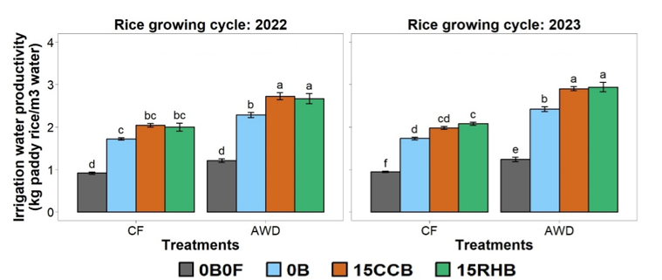
0B0F is absolute control corresponding to no use of biochar and chemical fertilizer, 0B is control corresponding to no use of biochar and use of chemical fertilisers (200 kg NPK + 100 kg Urea/ha), 15CCB corresponds to use of corn cobs biochar (15 tons/ha) and chemical fertilisers (200 kg NPK + 100 kg Urea/ha), 15RHB corresponds to use of rice husks biochar (15 tons/ha) and chemical fertilisers (200 kg NPK + 100 kg Urea/ha), CF is continuous flooding, AWD is alternating wetting-drying. For each season, bar graphs with similar letters indicate no significant difference between treatments. (p < 0.05).

Figure 4. Irrigation water productivity in response to biochar soil amendment and irrigation regime in a typical lowland rice system in Benin.

3.5 Correlation analysis of the different parameters studied

The correlation circles of the variables from the principal component analysis (PCA) show that the axis Dim1 explained 49.9% and 44.2% of the variability for the growing cycles 2022 and 2023, respectively (Fig. 5). Independently of the growing cycle, the first two components (Dim1 and Dim2) explain around 60% of the total variability. For the growing cycle 2022, the variables that contributed significantly (p<0.05) and positively to the first principal component were, in descending order: number of tillers per plant at 90 DAT (NbStem90D) (r = 0.90), number of panicles per plant at 90 DAT (NbPan90D) (r = 0.89), K uptake (Kuptake) (r = 0.85), paddy rice yield (YieldDryPaddy) (r = 0.79), N uptake (Nuptake) (r = 0.69), straw yield (YieldDryStraw) (r = 0.61), P uptake (Puptake) (r = 0.59), irrigation water productivity (IWP) (r = 0.58), 1000-grain weight (Mass100Gr ) (r = 0.46), panicle fertility rate (PanFert) (r = 0.44) and plant height at 90 DAT (High90D) (r = 0.43). On the other hand, the apparent recovery rate of P (APR) (r = -0.73), N (ANR) (r = -0.82) and K (AKR) (r = -0.83) and the agronomic efficiencies of use of P (APUE) (r = -0.86), N (ANUE) (r = -0.87) and K (AKUE) (r = -0.96) contributed significantly (p<0.05) and negatively to this same component. For the growth cycle 2023, the variables that contributed significantly (p<0.05) and positively to the first principal component were, in descending order: paddy rice yield (YieldDryPaddy) (r = 0.96), agronomic efficiencies of use of P (APUE) (r = 0.93), K (AKUE) (r = 0.93) and N (ANUE) (r = 0.93), number of tillers per plant at 90 DAT (NbStem90D) (r = 0.92), irrigation water productivity (IWP) (r = 0.79), N uptake (Nuptake) (r = 0.74), number of panicles per plant at 90 DAT (NbPan90D) (r = 0.72), apparent recovery rate of N (ANR) (r = 0.70), straw yield (YieldDryStraw) (r = 0.63), K uptake (Kuptake) (r = 0.56), 1000-grain weight (Mass100Gr ) (r = 0.55), tillers fertility rate (StemFert) (r = 0.43) and panicle fertility rate (PanFert) (r = 0.41).

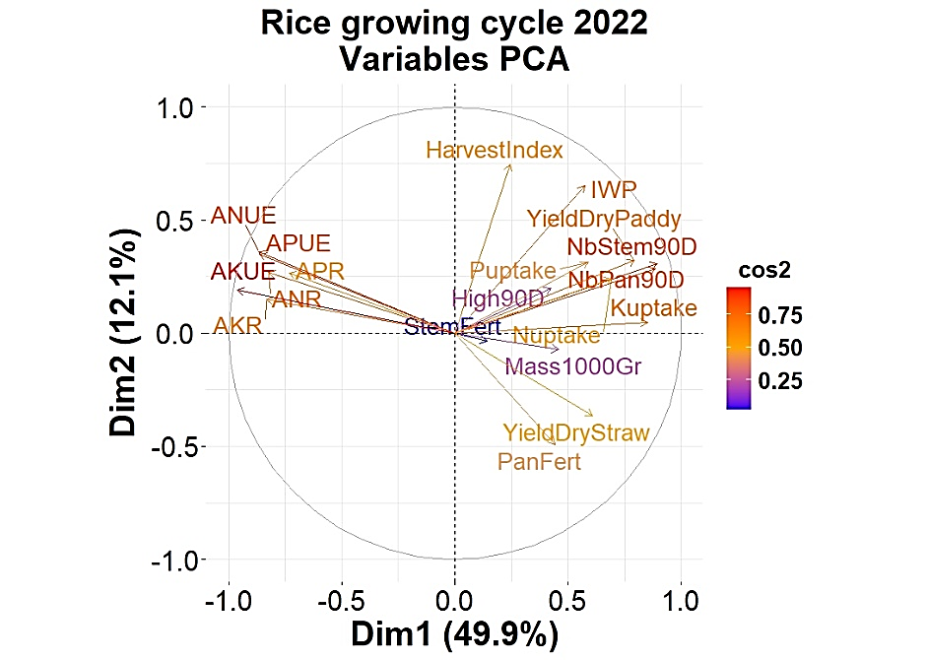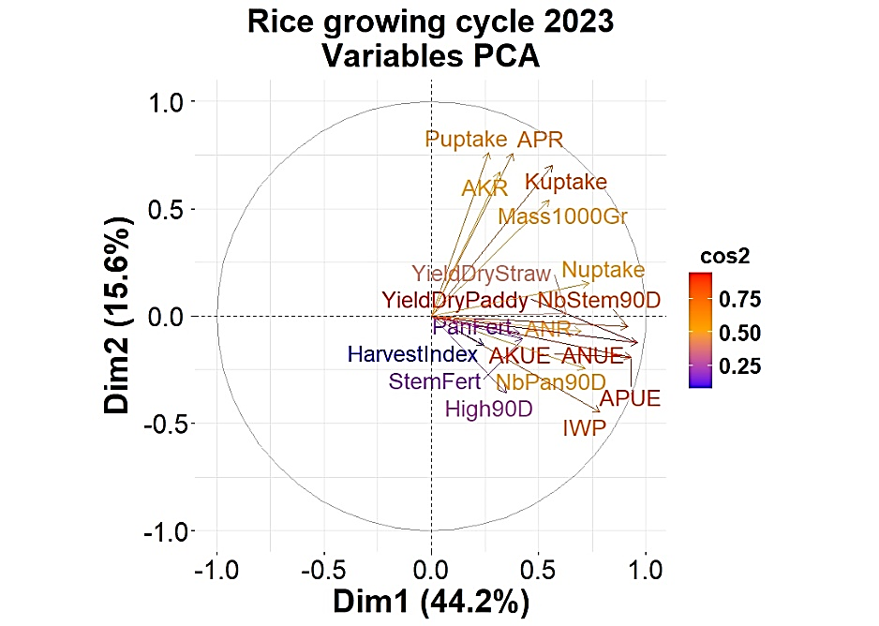
NbStem90D is number of tillers per plant at 90 days after transplanting (DAT), NbPan90D is number of panicles per plant at 90 DAT, High90D is plant height at 90 DAT, StemFert is tiller fertility rate, PanFert is panicle fertility rate, Mass100Gr is 1000-grain weight, YieldDryPaddy is dry paddy rice yield, YieldDryStraw is dry straw yield, Nsorption is N uptake, Psorption is P uptake, Ksorption is K uptake, IWP is irrigation water productivity, ANR is apparent recovery of N, APR is apparent recovery of P, AKR is apparent recovery of K, agronomic efficiencies of N use (ANUE), agronomic efficiencies of P use (APUE), agronomic efficiencies of K use (AKUE), HarvestIndex is harvest index. cos2 is the cosine squared of the angle between the variable and the axis under consideration and reflects the quality of the representation of the variables on the Principal Component Analysis (PCA) graph: the smaller the angle between two variables, the closer the correlation is to 1, if the angle is right, the correlation is close to 0, if the angle is close to 180°, the correlation is close to -1, the closer the arrowhead is to the circle, the higher the quality of the representation of the variable on the factorial plane.

Figure 5. Correlation circles of agro-morphological variables/parameters in response to soil amendment with biochar and irrigation regime in a typical lowland rice farming system in Benin.

Furthermore, the graphs relating to the correlation circles of individuals (treatments or plots) clearly show biochar effect on the first principal component, independently of the growing cycle (Fig. 6). The plots amended with biochar are mainly represented on the right of the graph while the unamended plots are on the left side. On the other hand, the irrigation regime effect is not present on these first two principal components. As observed on the circle of correlations of the variables, the variables relating to the productivity parameters (paddy rice and straw yields) contribute significantly and positively to the first principal component. Consequently, the most productive plots are those located on the right of the graph of individuals, namely those amended with 15 tons/ha of biochar. Furthermore, the significant overlap of the ellipses surrounding the biochar-treated individuals/plots confirms that RH and CC biochar have the same effects on rice productivity in a typical lowland rice-growing system.

In summary, correlation analysis between agro-morphological parameters on the one hand and between treatments on the other shows that the number of tillers per plant at maturity, the number of panicles per plant at maturity, N uptake, agronomic efficiencies of N, P and K, and the rate of apparent recovery of N, P and K were the most important parameters (r² ≥ 0.70) determining the productivity of the lowland rice-growing system subjected to the AWD irrigation regime and soil amendment with biochar.

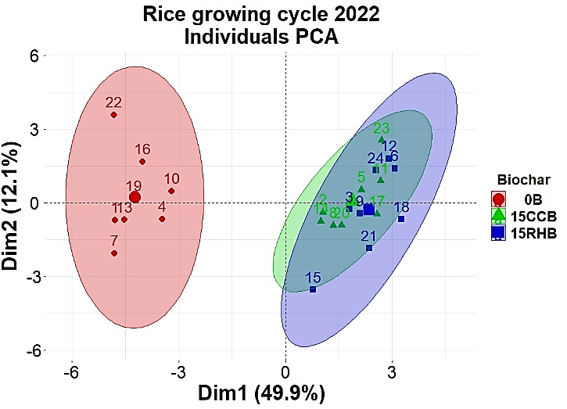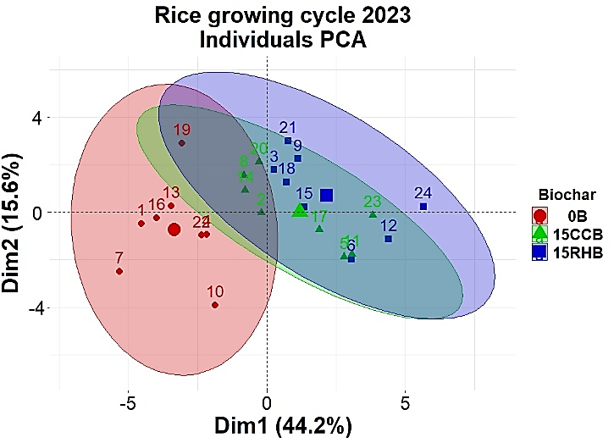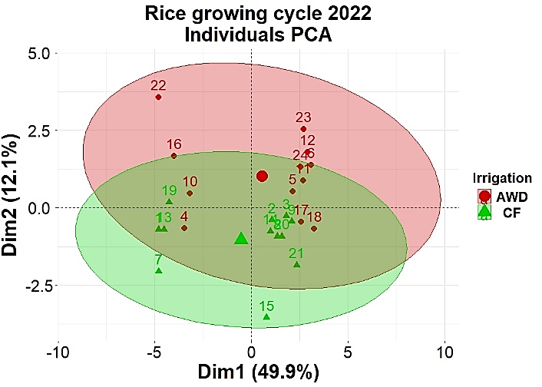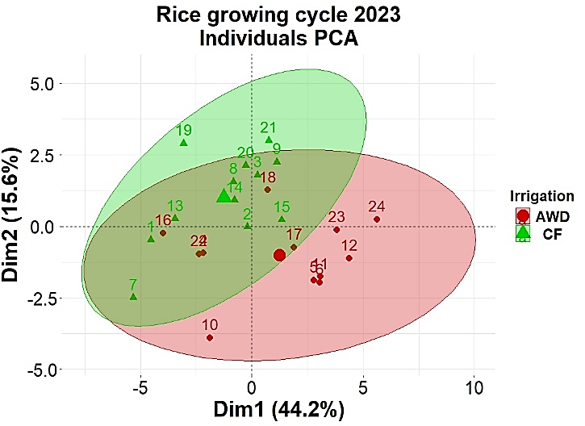
0B0F is absolute control corresponding to no use of biochar and chemical fertilizer, 0B is control corresponding to no use of biochar and use of chemical fertilisers (200 kg NPK + 100 kg Urea/ha), 15CCB corresponds to use of corn cobs biochar (15 tons/ha) and chemical fertilisers (200 kg NPK + 100 kg Urea/ha), 15RHB corresponds to use of rice husks biochar (15 tons/ha) and chemical fertilisers (200 kg NPK + 100 kg Urea/ha), CF is continuous flooding, AWD is alternating wetting-drying.

Figure 6. Correlation circles of individuals/factors in response to soil amendment with biochar and irrigation regime in a typical lowland rice farming system in Benin.

4. DISCUSSION

4.1 Rice plant growth

This study highlighted significant positive effects of soil amendment with biochar on rice plant tillering during both growth cycles. On the height of rice plants, non-significant positive effects were observed. Thus, soil amendment with biochar boosted rice plant growth, particularly in terms of tillering. This could be explained by the increase in soil pH and the increased availability of nutrients to plants following the addition of biochar. These results corroborate those of Diatta et al. (2020) who revealed that crop growth is positively influenced by organic amendments including biochars. Also, the results of Biedermann & Harpole (2013) confirmed that biochar application can have a beneficial effect on plant growth. However, Sagna et al. (2019) did not observe any significant difference in rice plant tillering between biochar-amended and non-amended plots. Furthermore, the study also revealed significant positive effects of AWD irrigation regime on tillering of rice plants during both growth cycles. These results corroborate those of Maragatham et al. (2010) who reported that the combined application of nitrogen in the form of urea (50%) and poultry manure (50%) induced a higher number of rice tillers compared to the application of 100% nitrogen in the form of urea in an AWD system. This could be explained by the fact that wetting and drying cycles enhance the air exchange between the soil and the atmosphere, which promotes oxygen availability for the root system (Tan et al., 2013). Under these conditions, the mineralization of soil organic matter is accelerated, thus producing more essential nutrients available to plants while inhibiting the mobilization of soil nitrogen, which promotes rice growth (Dong et al., 2012 ; Tan et al., 2013). However, our results are contrary to those obtained by Kumar et al. (2013) and Mote et al. (2017). These latter authors recorded 146 tillers/m² with CF regime while intermittent irrigation (AWD) induced significantly lower values (114 tillers/m²). Furthermore, the effects of AWD regime on rice plant height were not significant during both growth cycles. These results confirm those of Rezaei et al. (2009) who observed no significant difference in plant height between CF and AWD regime at 5 and 8 days intervals. Similar observations were reported by Azarpour et al. (2011) on loamy soil.

4.2 Rice yield components

Amending the soil with biochar had a beneficial but non-significant effect on the tillers fertility rate, panicles fertility rate and 1000-grain weight. This could be explained by the short duration of the study (two seasons) and by the intrinsic characteristics of biochar, which is an essentially carbon-based product and much less rich in N than other organic products (compost and manure). Indeed, several authors have linked the significant beneficial effects of organic amendments to a general improvement in soil N supply (Iqbal et al., 2019; Litardo et al., 2022). Haque et al. (2021) and Qui et al. (2024) reported significant beneficial effects of the combined chemical fertilisers and organic matter, on panicle length, number of grains per panicle, percentage of grains filled and 1000-grain weight compared to the application of chemical fertiliser alone. Regarding the irrigation regime, our study did not reveal significant beneficial effects of the AWD regime on fertile tillers rate, panicle fertility rate and 1000-grain weight. These results differ from those of Yang et al (2007) who observed that, in the AWD system, the incorporation of organic manure significantly increased the percentage of filled grains and the 1000-grain weight.

During both growing cycles, the greatest yields of paddy rice and rice straw were obtained on the biochar-amended plots without any significant effect of the biochar type (CC or RH). Our results corroborate those of Haefele et al. (2011) who reported that, on a poor and acidic soil as in our study, the chemical and physical improvements of the soil due to RH biochar amendment increased rice yields by 16–35%. In a study of lowland rice cultivation in China over two consecutive cycles, Zhang et al. (2012) showed that wheat straw biochar amendment at doses of 10, 20 and 40 tonnes/ha induced a significant positive effect on rice yield improvement of 10% in the first cycle and from 9.5% to 29% in the following cycle after biochar amendment This may be due to the relatively high availability of P and K nutrients to plants associated with the addition of biochar to the soil. Similar effects of biochar application on P and K availability have been previously reported (Yamato et al., 2006; Liu et al., 2016). According to Wang et al. (2013), RH biochar increases rice grain and straw yields, mainly by improving the root growth environment and promoting the uptake of N, P and K by plant tissues. Liu et al. (2016) reported that the application of rice straw biochar resulted in improved paddy rice grain yield (8.5-10.7% higher than the control), which could be attributed to increased availability of P and K nutrients.

Although the yield increases obtained in this study (19% on average compared to the control) are significant, they remain moderate compared to the yield increases of 200% or more reported by Major et al. (2010) in tests involving the application of woody biomass biochar. Indeed, it is difficult to compare results between different studies due to the diversity of biochars, soil types and soil fertility management practices used in the experiments (Liu et al., 2016). For example, the incorporation of biochar into acidic soils increases crop yields (Glaser et al., 2002), whereas on calcareous soil, yield improvement is not always obtained with the addition of biochar (Liang et al., 2014). Also, the effect of biochar amendment on cropping systems depends on the specific properties of the biochar used, which is strongly influenced by the feedstock and pyrolysis conditions (Liu et al., 2016 ; Biederman and Harpole, 2013). Biochars produced at high temperatures tend to be alkaline (Novak et al., 2009) and contain relatively few biologically active volatile compounds (Hale et al., 2012) that can limit crop growth (Liu et al., 2016). As a result, biochars produced at high temperatures are more effective in improving crop yields than biochars produced at low temperatures (Liu et al., 2016). The biochars used in our experiment were obtained at relatively high pyrolysis temperatures of 425°C on average.

The positive effects of biochar are attributed to various mechanisms, including the benefit of direct nutrients addition, improved nutrients availability, increased nutrients retention due to higher exchange capacity, improved soil physical characteristics, and positive effects on soil microbial fauna (Lehmann and Rondon, 2006; Haefele et al., 2011). However, on fertile soil, Haefele et al. (2011) noted that the high C/N ratio of RH biochar appears to limit N availability, thus slightly reducing rice grain yields in the first three seasons after application. This mechanism was also reported by Lehmann et al. (2003). In addition, Sagna et al. (2019) observed no significant difference in paddy rice yields between biochar-amended and unamended plots. This is likely one of the reasons why Asai et al. (2009) concluded that soil amendment with biochar has the potential to improve soil productivity for rice production but that its effect strongly depends on soil fertility and fertilizer management. Finally, the low yields observed in the absolute control plots (no mineral fertilizers and no biochar) can be explained by the low initial soil fertility level.

Regarding the irrigation regime, the AWD regime improved paddy rice yields by 7% on average. These results are similar to those of previous studies in Africa (Yameogo et al., 2021) and Asia (Yao et al., 2012; Liang et al., 2013) which reported that, despite the reduced water quantities applied, the water requirements of rice were covered and the paddy rice yield levels were maintained or even improved. Also, Carrijo et al. (2018) and Song et al. (2021) observed that paddy rice yield was not affected by the reduction in water quantities applied, provided that the soil remained moist. The performance of AWD irrigation regime is certainly linked to a better development of the rice plant root system with better soil aeration (Song et al., 2021). However, this greater development of the root system under AWD irrigation could have the disadvantage of a much greater mobilisation of heavy metals in the rice plant (Song et al., 2021).

4.3 Absorption, apparent recovery and agronomic efficiency of use of nutrients N, P and K

Determination of nutrients uptake, recovery and use efficiency parameters is important to differentiate genotypes/cultivars, crop management methods and practices based on their ability to assimilate nutrients for maximum dry biomass production. Thus, for this study, the soil amendment with CC or RH biochar improved non-significantly the uptake of major nutrients (N, P and K) in aboveground biomass (paddy grains + straw) compared to the control (no biochar and with mineral fertilizers). This improvement is probably due to the additional nutrient supply by the biochar (Liu et al., 2016), thus improving their availability in the rhizosphere, which led to an increase in their uptake by rice. Maragatham et al. (2010) reported better N uptake with the supply of 50% N as urea and 50% N as poultry manure compared to the control with 100 N as urea. Chew et al. (2022) showed that the combined application of biochar and chemical fertilisers improved the uptake of the main nutrients (N, P, K) in rice plants compared to the control. Indeed, the nutrients N, P and K are essential macronutrients for rice growth and biomass accumulation. They are also the main limiting nutrients in tropical soils. Therefore, increased uptake of these nutrients is probably a major factor contributing to increased biomass accumulation in rice plants from treatments based on soil amendment with biochar. Another study of Chew et al. (2020) indicated that the application of biochar-based fertiliser makes the potential of the root cell membrane negative (hyperpolarisation), thus favouring the uptake of N, P, K and Fe nutrients. Furthermore, the uptake of major nutrients was not significantly affected by the irrigation regime. This is in accordance with the results of Asai et al. (2009) who reported that the differences in N uptake between the CF and AWD regimes were not statistically significant at the 5% threshold. However, Rajesh and Thanunathan (2003) showed that the AWD regime induced better nutrient uptake due to increased root activity, as evidenced by the presence of longer roots and greater root volume, which in turn increased total dry matter production and nutrient uptake.

For the growing cycle 2022, soil amendment with biochar significantly decreased the values of apparent recovery rate and agronomic use efficiency of the three nutrients N, P and K compared to the control. The low recovery rates and nutrient use efficiencies in the plots amended with biochar (plots 15CCB and 15 RHB) are probably due to greater availability of these nutrients in the soil. In fact, amending the soil with biochar provided additional nutrients, so that the total quantities of N, P and K provided (fertiliser + biochar) in plots 15CCB and 15 RHB were 2.3, 2.4 and 8.2 times respectively those provided in plots 0B fertilised exclusively with mineral fertilisers. At the same time, the uptake of the three nutrients was similar in all these plots. Our results corroborate those obtained by Akassimadou et al. (2017), who reported a decrease in the apparent recovery rate and agronomic efficiency of P and K use when fertiliser doses applied increased. The same trends were observed by Devika et al. (2018). Their work on rice genotypes revealed that the highest nitrogen use efficiency was recorded at 0% of recommended nitrogen and the lowest value was recorded at 150% of recommended nitrogen for all genotypes. Conversely, for the growth cycle 2023 when no more biochar was applied, the plots amended the previous season with biochar had much higher apparent recovery rates and agronomic efficiencies of use of the three nutrients N, P and K compared to the control. Kotchi et al (2010), Zhang et al (2020) and Chew et al. (2022) reported similar results indicating that the combined application of chemical fertilizer and biochar can increase nutrient use efficiency and crop yield by acting as a slow-release fertilizer and altering soil nutrient dynamics. Indeed, biochar, which is chemically very stable, permanently modifies the physical and biological properties of the soil, producing positive after-effects on nutrients use efficiency for several years. However, several authors have concluded that the use efficiency of mineral and/or organic fertilisers varies according to genotype/cultivar, soil and climatic conditions and cropping practices (Sanginga and Woomer, 2009; Pypers, 2010; Devika et al., 2018).

4.4 Water supply and productivity of irrigation water

In this study, the AWD irrigation regime enabled water savings of 27% on average. This is in accordance with the observations of Bouman and Tuong (2007) in lowland rice-growing areas of China and the Philippines who reported that total water inputs (irrigation + rainfall) decreased by about 15-30% with the AWD regime, without significant impact on yield. Mote et al. (2017) reported water savings of 26.6-35.0% with AWD compared to CF regime in a lowland rice system in India. Irrigation water reductions of 20-50% in AWD regime without penalising yields were reported by Keisuke et al. (2007) and Zhao et al. (2010). The same trends were confirmed by Rajesus et al. (2009) who reported that the AWD regime reduced irrigation time by around 38% with similar yields, resulting in corresponding savings in irrigation water and pumping energy costs.

In addition, the AWD irrigation regime had very significant positive effects on irrigation water productivity (IWP), whatever the growing season. This is confirmed by the findings of Huan et al. (2008) and Maragatham et al. (2010). In the AWD regime, where the water level drops below the soil surface to a depth of 15 cm before reirrigation, the soil was always moist and water was available to the rice plant, which does not significantly affect yield (Lampayan et al., 2009). According to Bouman et al. (2007) and Kato and Okami (2010), irrigated rice has adapted to AWD irrigation conditions and has a semi-aquatic nature in its development process. In the AWD regime, water availability is adapted to the physiological water demand of the rice by rationally controlling water supply during key stages of rice growth, so that growth and biomass yield are not affected (Mao et al., 2001). However, the reported effect on yield varies considerably and detailed characterisations of hydrological conditions in AWD experiments are often lacking, so that generalisations are difficult to make (Mote et al., 2017).

5. CONCLUSION

Overall, soil amendment with biochar at a dose of 15 tons/ha had significant effects on plant tillering, paddy rice yield, irrigation water productivity and the agronomic efficiency of use of the three major nutrients (N, P and K). Although the irrigation regime had positive effects on most of the agro-morphological parameters studied, these effects were only significant for plant tillering and irrigation water productivity. The nature of the biochar applied (CC or RH biochar) and the irrigation-biochar interaction had no significant effects on any of the parameters studied, apart from the significant effect of the irrigation-biochar interaction on irrigation water productivity. This suggests that rice can be grown successfully by adopting an appropriate AWD irrigation regime without a significant decrease in yield. The results of this study also reveal the value of combining amendment with biochar and the application of inorganic fertilisers to significantly improve the productivity of lowland rice systems in Benin. However, with a view to making the modified system profitable, facilitating its adoption by farmers and reducing the quantities of mineral fertiliser used, it is important to determine the optimum doses of biochar and mineral fertilisers to apply in order to achieve sustainable and economically viable production.

Références

Akassimadou, F.E., Hien, M.P., Bouadou, O.F., Bolou, B.E., Bongoua, J.A., Ettien, J.B.D., & Yao-kouame, A. (2017). Efficiences des nutriments P et K en riziculture irriguée dans un bas-fond secondaire en zone de savane guinéenne de la Côte d’Ivoire. European Scientific Journal, ESJ, 13(36) : 432.
Asai, H., Samson, B.K., Stephan, H.M., Songyikhangsuthor, K., Homma, K., Kiyono, Y. et al. (2009). Biochar amendment techniques for upland rice production in Northern Laos: 1. Soil physical properties, leaf SPAD and grain yield. Field crops research, 111(1-2): 81-84.
Azarpour, E., Tarighi, F., Moradi, M., & Bozorgi, H.R. (2011). Evaluation effect of different nitrogen fertilizer rates under irrigation management in rice farming. World Applied Science Journal, 13(5): 1248-1252.
Behoundja-Kotoko, O., Somakou, F., Mamadou, N.T.D., Alagba, M., Agbede, R.D., & Baimey, H. (2022). Influence du Biochar et du Mycotri sur le développement de la grande morelle (Solanum macrocarpon L.) et la densité de population des nématodes à galles sous serre. Annales de l’Université de Parakou-Série Sciences Naturelles et Agronomie, 12(2) : 27-34.
Bhattacharyya, P.N., Sandilya, S.P., Sarma, B., Pandey, A.K., Dutta, J., Mahanta, K. et al. (2024). Biochar as Soil Amendment in Climate-Smart Agriculture: opportunities, future prospects, and challenges. Journal of Soil Science and Plant Nutrition, 24(1): 135-158.
Biederman, L.A., & Harpole, W.S. (2013). Biochar and its effects on plant productivity and nutrient cycling: a meta‐analysis. Global Change Biology Bioenergy 5: 202-214.
Bouman, B.A.M., Feng, L., Tuong, T.P., Lu, G., Wang, H., & Feng, Y. (2007). Exploring options to grow rice using less water in northern China using a modelling approach: II. Quantifying yield, water balance components, and water productivity. Agricultural Water Management, 88(1-3): 23-33.
Bouman, B.A.M. (2007). A conceptual framework for the improvement of crop water productivity at different spatial scales. Agricultural systems, 93(1-3): 43-60.
Cabangon, R.J., Tuong, T.P., Castillo, E.G., Bao, L.X., Lu, G., Wang, G. et al. (2004). Effect of irrigation method and N-fertilizer management on rice yield, water productivity and nutrient-use efficiencies in typical lowland rice conditions in China. Paddy and Water Environment, 2: 195-206.
Carrijo, D.R., Akbar, N., Reis, A.F., Li, C., Gaudin, A.C., Parikh, S.J. et al. (2018). Impacts of variable soil drying in alternate wetting and drying rice systems on yields, grain arsenic concentration and soil moisture dynamics. Field Crops Research, 222: 101-110.
Kumar, R., Kumar, R., & Prakash, O. (2019). Chapter-5 the impact of chemical fertilizers on our environment and ecosystem. Chief Ed, 35(69), 69-86.
Chew, J., Joseph, S., Chen, G., Zhang, Y., Zhu, L., Liu, M. et al. (2022). Biochar-based fertiliser enhances nutrient uptake and transport in rice seedlings. Science of the Total Environment, 826: 154174.
Chew, J., Zhu, L., Nielsen, S., Graber, E., Mitchell, D.R., Horvat, J. et al (2020). Biochar-based fertilizer: supercharging root membrane potential and biomass yield of rice. Science of the Total Environment, 713 : 136431.
Commission de Pédologie et de Cartographie des Sols (CPCS) (1967). Classification des sols. Laboratoire de Géologie et de Pédologie, Ecole Nationale Supérieure d’Agronomie, Grognon, France, 87 p.
Criscuoli, I. (2016). Stabilité du charbon végétal (biochar) dans le sol et impact sur la productivité et les cycles des nutriments des prairies alpines. Géochimie. Thèse de doctorat. Université Pierre et Marie Curie-Paris VI, 98p.
Dabin, B. (1956). Contribution à l'étude de la fertilité des terres de Barre. L'Agronomie Tropicale, 11(4): 490-506.
Devika, S., Ravichandran, V., & Boominathan, P. (2018). Physiological analyses of nitrogen use efficiency and yield traits of rice genotypes. Indian journal of plant physiology, 23: 100-110.
Diatta, A.A., Fike, J.H., Battaglia, M.L., Galbraith, J.M., & Baig, M.B. (2020). Effects of biochar on soil fertility and crop productivity in arid regions: a review. Arabian Journal of Geosciences, 13: 1-17.
Djousse Kanouo, B.M. (2017). Production et utilisation du biochar pour la restauration des sols rouges lessivés tropicaux. Thèse de doctorat. Université Laval, Canada. 118 p.
Dong, N.M., Brandt, K.K., Sørensen, J., Hung, N.N., Van Hach, C., Tan, P.S. et al. (2012). Effects of alternating wetting and drying versus continuous flooding on fertilizer nitrogen fate in rice fields in the Mekong Delta, Vietnam. Soil Biology and Biochemistry 47: 166-174.
Evrard, L., Govaerts, B. (2023). Analyses statistiques avec R. Manuel destiné aux étudiants du cours LBIRA2110 Biométrie mais en général à d’autres utilisateurs d’outils statistiques en science expérimentale. UCLouvain. https://bookdown.org/evraloui/lbira2110/
Fall, A.A. (2016). Synthèse des études sur l’état des lieux chaine de valeur riz en Afrique de l’Ouest : Benin, Burkina-Faso, Mali, Niger et Sénégal. Rapport Final ROPPA. 83 p.
Feng, L., Bouman, B.A.M., Tuong, T.P., Cabangon, R.J., Li, Y., Lu, G. et al. (2007). Exploring options to grow rice using less water in northern China using a modelling approach: I. Field experiments and model evaluation. Agricultural Water Management, 88(1-3) : 1-13.
Gee, G.W., & Or, D. (2002). Particle-Size Analysis. In J.H. Dane & G.C. Topp (Eds), Methods of Soil Analysis, Part 4: Physical Methods (pp. 255-293). Soil Science Society of America.
Glaser, B., Lehmann, J., & Zech, W. (2002). Ameliorating physical and chemical properties of highly weathered soils in the tropics with charcoal–a review. Biology and fertility of soils, 35 : 219-230.
Haefele, S.M., Konboon, Y., Wongboon, W., Amarante, S., Maarifat, A.A., Pfeiffer, E.M. et al. (2011). Effects and fate of biochar from rice residues in rice-based systems. Field Crops Research, 121(3) : 430-440.
Hale, S.E., Lehmann, J., Rutherford, D., Zimmerman, A.R., Bachmann, R.T., Shitumbanuma, V. et al. (2012). Quantifying the total and bioavailable polycyclic aromatic hydrocarbons and dioxins in biochars. Environmental science & technology 46: 2830-2838.
Haque, M.M., Datta, J., Ahmed, T., Ehsanullah, M., Karim, M.N., Akter, M.S. et al. (2021). Organic amendments boost soil fertility and rice productivity and reduce methane emissions from paddy fields under sub-tropical conditions. Sustainability, 13(6) : 3103.
Hossain, M.Z., Bahar, M.M., Sarkar, B., Donne, S.W., Ok, Y.S., Palansooriya, K.N. et al. (2020). Biochar and its importance on nutrient dynamics in soil and plant. Biochar, 2 : 379-420.
Huan, T.T.N., Khuong, T.Q., Van Hach, C., Tan, P.S., & Buresh, R. (2008). Effect of seeding rate and nitrogen management under two different water regimes on grain yield, water productivity and profitability of rice production. Omonrice, 16 : 81-88.
Igue, A.M., Saidou, A., Adjanohoun, A., Ezui, G., Attiogbe, P., Kpagbin, G. et al. (2013). Evaluation de la fertilité des sols au sud et centre du Bénin. Bulletin de la Recherche Agronomique du Bénin, 12-23.
Iqbal, A., He, L., Khan, A., Wei, S., Akhtar, K., Ali, I. et al. (2019). Organic manure coupled with inorganic fertilizer: An approach for the sustainable production of rice by improving soil properties and nitrogen use efficiency. Agronomy, 9(10) : 651.
Jeffery, S., Abalos, D., Prodana, M., Bastos, A.C., Van Groenigen, J.W., Hungate, B.A. et al. (2017). Biochar boosts tropical but not temperate crop yields. Environmental Research Letters, 12(5): 053001.
Kato, Y., & Okami, M. (2010). Root growth dynamics and stomatal behaviour of rice (Oryza sativa L.) grown under aerobic and flooded conditions. Field Crops Research, 117(1) : 9-17.
Keisuke, S., Yamaji, E., Sato, S., Budhiharto, P.S., & Mizoguchi, M. (2007). Sustainability of system of rice intensification: benefits of SRI focusing on effects of intermittent irrigation on yield increase and water savings. In: Proceeding of PAWEES 2007 6th international conference on sustainable rural development and management (pp 25–37), Seoul National University, Seoul, 18 October 2007.
Mote, K., Praveen Rao, V., Ramulu, V., Avil Kumar, K., & Uma Devi, M. (2017). Standardization of alternate wetting and drying (AWD) method of water management in low land rice (Oryza sativa (L.)). International Journal of Plant Production, 11(4) : 515-532.
Kotchi, V., Yao, K.A., & Diatta, S. (2010). Réponse de cinq variétés de riz à l’apport de phosphate naturel de Tilemsi (Mali) sur les sols acides de la région forestière humide de Man (Côte d’Ivoire). Journal of Applied Biosciences 31: 1895-1905.
Lampayan, R.M., Palis, F.G., Flor, R.B., Bouman, B.A., Quicho, E.D., De Dios, J.L. et al. (2009). Adoption and dissemination of “safe alternate wetting and drying” in pump irrigated rice areas in the Philippines. In 60th international executive council meeting of the international commission on irrigation and drainage (ICID), 5th Asian Regional Conference, 6-11 December 2009, New Delhi, India.
Lehmann, J., & Rondon, M. (2006). Biochar soil management on highly weathered soils in the humid tropics. Biological approaches to sustainable soil systems, 113(517): e530.
Lehmann, J., Cowie, A., Masiello, C.A., Kammann, C., Woolf, D., Amonette, J.E. et al. (2021). Biochar in climate change mitigation. Nature Geoscience, 14(12): 883-892.
Lehmann, J., da Silva Jr, J.P., Rondon, M., Cravo, M.D.S., Greenwood, J., Nehls, T. et al. (2002). Slash-and-char – a feasible alternative for soil fertility management in the central Amazon. In Proceedings of the 17th World Congress of Soil Science, pp. 1–12, Bangkok, Thailand.
Lehmann, J., Pereira da Silva, J., Steiner, C., Nehls, T., Zech, W., & Glaser, B. (2003). Nutrient availability and leaching in an archaeological Anthrosol and a Ferralsol of the Central Amazon basin: fertilizer, manure and charcoal amendments. Plant and soil, 249: 343-357.
Liang, F., Li, G.T., Lin, Q.M., & Zhao, X. R. (2014). Crop yield and soil properties in the first 3 years after biochar application to a calcareous soil. Journal of Integrative Agriculture, 13(3) : 525-532.
Liang, X.Q., Chen, Y.X., Nie, Z.Y., Ye, Y.S., Liu, J., Tian, G.M. et al. (2013). Mitigation of nutrient losses via surface runoff from rice cropping systems with alternate wetting and drying irrigation and site-specific nutrient management practices. Environmental Science and Pollution Research 20: 6980-6991.
Litardo, R.C.M., Bendezú, S.J.G., Zenteno, M.D.C., Pérez-Almeida, I.B., Parismoreno, L.L., & García, E.D.L. (2022). Effect of mineral and organic amendments on rice growth and yield in saline soils. Journal of the Saudi Society of Agricultural Sciences, 21(1) : 29-37.
Lorenz, K., & Lal, R. (2018). Carbon sequestration in agricultural ecosystems. eBook, Springer, 397 p.
Madari, B.E., Costa, A.R., Castro, L.M., Santos, J.L.S., Benites, V.M., Rocha, A.O., & Machado, P.L.O.A. (2006). Charcoal as a soil conditioner for upland rice (cultivar primavera): A prospective study. Embrapa Arroz e Feijão, 125(2).
Ministère de l’Agriculture, de l’Elevage et de la Pêche (MAEP). (2017). Plan Stratégique de Développement du Secteur Agricole (PSDSA) : Orientations stratégiques 2025 - Plan National d’Investissements Agricoles et de Sécurité Alimentaire et Nutritionnelle PNIASAN 2017 – 2021. Ministère de l’Agriculture, de l’Elevage et de la Pêche du Bénin, 132 p.
Ministère de l’Agriculture, de l’Elevage et de la Pêche (MAEP). (2022). Rapport de Performances du Secteur Agricole, Gestion 2022. Ministère de l’Agriculture, de l’Elevage et de la Pêche du Bénin, 125 p.
Major J, Rondon M, Molina D, Riha SJ, Lehmann J (2010). Maize yield and nutrition during 4 years after biochar application to a Colombian savanna oxisol. Plant and soil 333:117-128.
Mao, Z., Li, Y., Tuong, T.P., Molden, D., & Dong, B. (2001). Water-efficient irrigation regimes of rice in China. Paper presented at the International Rice Research Conference, 31 March-3 April 2000, Los Baños, Philippines.
Maragatham, N., Martin, G.J., & Poongodi, T. (2010). Effect of Nitrogen sources on Aerobic Rice production under various rice soil Eco systems. In Proceedings of 19th World Congress of Soil Science, Soil Solutions for a Changing World (Vol. 16). Brisbane, QLD.
Melo, L.C.A., Lehmann, J., Carneiro, J.S.D.S., & Camps-Arbestain, M. (2022). Biochar-based fertilizer effects on crop productivity: a meta-analysis. Plant and Soil, 472(1) : 45-58.
Mote, K., Rao, V.P., Ramulu, V., Kumar, K.A., & Devi, M.U. (2022). Performance of rice (Oryza sativa (L.)) under AWD irrigation practice - A brief review. Paddy and Water Environment 20: 1-21.
Mutuku, E.A. (2020). Maize production under conservation agriculture and integrated soil fertility management in the sub-humid and semi-arid regions of Kenya. Doctoral dissertation, Ghent University. 236p.
Nelissen, V., Ruysschaert, G., Manka’Abusi, D., D’Hose, T., De Beuf, K., Al-Barri, B. et al. (2015). Impact of a woody biochar on properties of a sandy loam soil and spring barley during a two-year field experiment. European Journal of Agronomy, 62 : 65-78.
Novak, J. M., Busscher, W.J., Laird, D.L., Ahmedna, M., Watts, D.W., & Niandou, M.A. (2009). Impact of biochar amendment on fertility of a southeastern coastal plain soil. Soil science, 174(2) : 105-112.
OFEV-OFAG-AGIR, (2023). Fiche technique: Utilisation de charbon végétal dans l’agriculture en Suisse – Risques et opportunités pour les sols et le climat. 15 p.
Olodo, E. (2021). Bénin: les achats de riz semi-blanchi ont atteint 90 milliards Fcfa sur le premier trimestre. Agence ECOFIN. https://www.agenceecofin.com/commerce/2506-89512-benin-les-achats-de-riz-semi-blanchi-ont-atteint-90-milliards-fcfa-sur-le-premier-trimestre
Petter, F.A., Madari, B.E., Silva, M.A.S.D., Carneiro, M.A.C., Carvalho, M.T.D.M., Marimon Júnior, B.H. et al. (2012). Soil fertility and upland rice yield after biochar application in the Cerrado. Pesquisa Agropecuária Brasileira, 47 : 699-706.
Pypers, P. (2010). Integrated soil fertility management: the TSBF definitions. In Seminar at UEA, 11th May 2010, Bukavu, DRC, 73 p.
Qui, N.V., Khoa, L.V., Phuong, N.M., Vien, D.M., Dung, T.V., Linh, T.B. et al. (2024). Effects of Rotating Rice with Upland Crops and Adding Organic Amendments, and of Related Soil Quality on Rice Yield in the Vietnamese Mekong Delta. Agronomy, 14(6) : 1185.
Rahman, M.R., & Bulbul, S.H. (2014). Effect of alternate wetting and drying (AWD) irrigation for Boro rice cultivation in Bangladesh. Agriculture, Forestry and Fisheries, 3(2) : 86-92.
Rajesh, V., & Thanunathan, K. (2003). Effect of seedling age, number and spacing on yield and nutrient uptake of traditional Kambam chamba rice. Journal of Ecobiology 15: 211-214
Rejesus, R.M., Palis, F.G., Lapitan, A.V., Chi, T.T.N., & Hossain, M. (2009). The impact of integrated pest management information dissemination methods on insecticide use and efficiency: evidence from rice producers in South Vietnam. Applied Economic Perspectives and Policy, 31(4) : 814-833.
Rezaei, M., Vahed, H.S., Amiri, E., Motamed, M.K., & Azarpour, E. (2009). The effects of irrigation and nitrogen management on yield and water productivity of rice. World Applied Sciences Journal, 7(2) : 203-210.
Sagna, Y.P., Diedhiou, S., Goudiaby, A.O.K., Diatta, Y., Diallo, M.D., & Ndoye, I. (2019). Effet des amendements organiques sur le développement du riz (Oryza sativa L.) dans les bas-fonds sulfato-acides en zone sud-soudanienne au Sénégal. Journal of Applied Biosciences, 144 : 14831-14841.
Sanchez, P.A., Couto, W., & Buol, S.W. (1982). The fertility capability soil classification system: interpretation, applicability and modification. Geoderma, 27(4) : 283-309.
Sanginga, N., & Woomer, P. (Eds.) (2009). Integrated soil fertility management in Africa: principles, practices and developpement process. TSBF-CIAT, Nairobi Kenya, 263 p.
Schmidt, H.P., Kammann, C., Hagemann, N., Leifeld, J., Bucheli, T.D., Sánchez Monedero, M. A., & Cayuela, M.L. (2021). Biochar in agriculture–A systematic review of 26 global meta‐analyses. GCB Bioenergy, 13(11) : 1708-1730.
Song, T., Das, D., Hu, Q., Yang, F., & Zhang, J. (2021). Alternate wetting and drying irrigation and phosphorus rates affect grain yield and quality and heavy metal accumulation in rice. Science of the Total Environment, 752 : 141862.
Song, T., Das, D., Zhu, F., Chen, X., Chen, M., Yang, F., & Zhang, J. (2021). Effect of alternate wetting and drying irrigation on the nutritional qualities of milled rice. Frontiers in plant science, 12 : 721160.
Sossou, C.H. (2015). Le financement de l’agriculture au Bénin : stratégies de gestion et d’adaptation des exploitations agricoles. (Thèse de doctorat en français). Université de Liège-Gembloux Agro-Bio Tech. Belgique, 181 p.
Tan, X., Shao, D., Liu, H., Yang, F., Xiao, C., & Yang, H. (2013). Effects of alternate wetting and drying irrigation on percolation and nitrogen leaching in paddy fields. Paddy and Water Environment, 11 : 381-395.
Tisserant, A., & Cherubini, F. (2019). Potentials, limitations, co-benefits, and trade-offs of biochar applications to soils for climate change mitigation. Land, 8(12) : 179.
Tovihoudji, G.P., Diogo, R.V.C., Abiola, W.A., Akoha, F.B., & Godau, T. (2022). Profitability and agronomic potential of cotton (Gossypium hirsutum L.) under biochar-compost-based amendments in three agroecological zones of northern Benin. Frontiers in Sustainable Food Systems, 6 : 1036133.
Tran Vinh An (1976). Recueil des méthodes d’analyses des sols. Principes, techniques et calculs. Version provisoire. Laboratoire d’Analyse des Sols et des Eaux PAP. Etude N°156. INRAB/MAEP/Bénin. 53 p.
Vanlauwe, B., Kihara, J., Chivenge, P., Pypers, P., Coe, R., & Six, J. (2011). Agronomic use efficiency of N fertilizer in maize-based systems in sub-Saharan Africa within the context of integrated soil fertility management. Plant and Soil, 339 : 35-50.
Wang WJ, Zhang XM, Ling GH (2013). Effects of biochar amendment on growth and yield of rice in cold water field. Journal of Anhui Agricultural Sciences 41: 6220-6221.
Yamato, M., Okimori, Y., Wibowo, I.F., Anshori, S., & Ogawa, M. (2006). Effects of the application of charred bark of Acacia mangium on the yield of maize, cowpea and peanut, and soil chemical properties in South Sumatra, Indonesia. Soil science and plant nutrition, 52(4) : 489-495.
Yameogo, P.L., Traore, A., & Bandaogo, A.A. (2021). Influence des modes de gestion de l’eau et de la fumure minérale sur quelques paramètres chimiques du sol et le rendement du riz à la Vallée du Kou au Burkina Faso. Journal of Applied Biosciences, 165 : 17099-17110.
Yang, J., Liu, K., Wang, Z., Du, Y., & Zhang, J. (2007). Water‐saving and high‐yielding irrigation for lowland rice by controlling limiting values of soil water potential. Journal of Integrative Plant Biology, 49(10) : 1445-1454.
Yao, F., Huang, J., Cui, K., Nie, L., Xiang, J., Liu, X., et al. (2012). Agronomic performance of high-yielding rice variety grown under alternate wetting and drying irrigation. Field crops research, 126 : 16-22.
Zhang, A., Bian, R., Pan, G., Cui, L., Hussain, Q., Li, L. et al. (2012). Effects of biochar amendment on soil quality, crop yield and greenhouse gas emission in a Chinese rice paddy: a field study of 2 consecutive rice growing cycles. Field Crops Research, 127 : 153-160.
Zhang, Q., Song, Y., Wu, Z., Yan, X., Gunina, A., Kuzyakov, Y., & Xiong, Z. (2020). Effects of six-year biochar amendment on soil aggregation, crop growth, and nitrogen and phosphorus use efficiencies in a rice-wheat rotation. Journal of Cleaner Production, 242 : 118435.

