Original Research Article
Spatial distribution and mapping of multi-nutrient deficiencies in paddy fields of north central laterites of Kerala, India

ABSTRACT

Abstract
Soil fertility assessment is crucial for sustainable crop production, particularly in intensive rice-growing regions. This study aimed to assess the spatial distribution of plant nutrients across the rice-growing areas of the north-central laterite of Kerala and generating soil fertility maps to understand potential constraints. The soil pH varied from 4.09 to 6.22, averaging 5.15, indicating an acidic nature. Electrical conductivity remained low (0.03–0.37 dS m⁻¹), ruling out salinity issues. Organic carbon content ranged from 0.42 to 3.00%, with a mean of 1.23%. Macronutrient analysis revealed low available nitrogen (56.45–169.34 kg ha⁻¹) and potassium (30.24–119.24 kg ha⁻¹) and mostly medium to high level of available phosphorus (2.59–89.88 kg ha⁻¹), while calcium (487.50–3318.75 mg kg⁻¹) was sufficient in all samples. 65.85% and 34.28% of samples were deficient in available magnesium and sulfur, respectively. Micronutrient assessment showed sufficient levels of available iron, copper, manganese, and zinc, while 62.85% samples were deficient in available boron. Nutrient index of nitrogen, phosphorous and potassium are categorised under low, medium and low classes, respectively. The study revealed the prevalence of widespread multi-nutrient deficiencies in these soils. These findings provide valuable insights for optimizing nutrient management strategies to improve soil health and sustain rice productivity in north central laterites of Kerala.
Keywords: North central laterite, macronutrients, multi-nutrient deficiencies, nutrient index, soil mapping

- INTRODUCTION
Soil fertility plays a pivotal role in determining crop productivity, and a thorough understanding of a soil’s fertility status is critical for the sustainable management of land resources. Nevertheless, intensive agricultural practices combined with poor soil management can severely deplete soil fertility. Continuous cropping to maximize yields significantly depletes the soil nutrient reserves. Moreover, the over-reliance on chemical fertilizers with little application of organic manures, minimal recycling of crop residues, soil erosion, uneven terrain, unregulated irrigation practices, and inappropriate cultural methods collectively accelerate the degradation of soil quality. Various soil properties considerably influence the availability of essential nutrients to plants. Therefore, investigating the relationship between the physico-chemical characteristics of soils and the availability of macro- and micronutrients is vital to understanding nutrient deficiencies. Assessing soil fertility status and addressing nutrient limitations through judicious external fertilization tailored to crop requirements is essential for maintaining soil health. One effective approach to evaluate soil fertility is the nutrient index method, which involves determining the available concentrations of nitrogen (N), phosphorus (P), and potassium (K) as indicators of soil fertility. Additionally, advancements in geospatial technologies have provided powerful tools for the development and management of soil resources.
In the current context, where land availability is diminishing while the population continues to rise, the demand for staple foods such as rice has increased significantly. Rice remains a fundamental dietary component for more than half of the global population. However, in Kerala, the area under paddy cultivation has witnessed a drastic decline of 78% from its peak levels recorded during 1975–76 (Agricultural Statistics, 2022–23). The humid tropical climate of Kerala, characterized by intense weathering, has resulted in the leaching of basic cations and the subsequent accumulation of sesquioxide in the upper layers of soil. Consequently, the soils are predominantly acidic, contain low-activity clays, and exhibit limited capacities to retain water and nutrients (Rajasekharan et al., 2014). These factors contribute to their relatively poor fertility status, necessitating strategic management interventions to achieve satisfactory crop yields. The situation is particularly concerning in the intensively cultivated rice-growing regions of Kerala’s lowland laterites, where nutrient depletion due to high crop nutrient uptake combined with insufficient replenishment is especially severe. Based on this context, it was hypothesized that continuous rice cultivation on lateritic soils could lead to significant nutrient leaching and the development of multiple nutrient deficiencies. Therefore, the present investigation was conducted with the objective of assessing the spatial distribution of plant nutrients across the rice-growing areas of the north-central laterite regions of Kerala and generating soil fertility maps for efficient soil fertility management techniques catered to this particular agro-ecological conditions.

2. material and methods
Geo-referenced soil samples were collected from different panchayats of Thrissur and Palakkad districts representing north central laterite (AEU-10). A total of 35 geo-referenced soil samples were collected at depth of 0-15 cm from intensively rice cultivating areas. Collected samples were shade-dried, processed and passed through 2 mm sieve and stored in properly labelled polythene covers. Soil pH and electrical conductivity (EC) were determined using a 1:2.5 soil-to-solution ratio, following the methodology given by Jackson (1958). Organic carbon content was assessed via the wet digestion method developed by Walkley and Black (1934). Available nitrogen levels were measured using the alkaline KMnO₄ method as described by Subbiah and Asija (1956). Available phosphorus was estimated employing Bray's extracting reagent, according to the procedure by Bray and Kurtz (1945). Available potassium, calcium, and magnesium were determined using a neutral normal ammonium acetate solution (Jackson, 1958). Micronutrient contents were analyzed using a 0.1M HCl extraction method (Lindsay and Norvell, 1978), while boron levels were estimated following the procedure by Wolf (1974). Soil test rating for interpretation of physico-chemical properties and available nutrients are given in the table 1 to 3. The Nutrient Index (NI) is calculated using the method developed by Ramamoorthy and Bajaj (1969) and represented in table.4. Equation for calculating nutrient index (NI) is provided below:

[(NL×1) + (NM×2) + (NH×3)​]
Nutrient Index (NI) =
TNS
Where, NL = Number of samples in low category
NM = Number of samples in medium category
NH = Number of samples in high category
TNS = Total number of samples
Statistical analysis: Descriptive and correlation analysis were done using KAU-GRAPES software and spatial nutrient variability maps were made using QGIS.
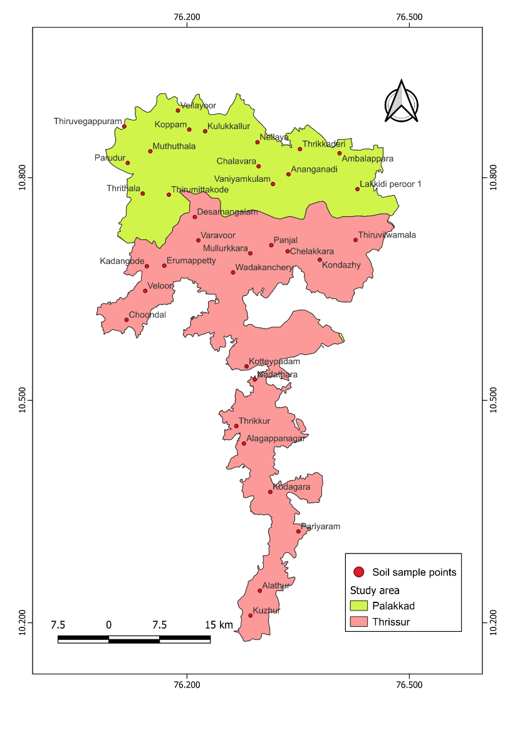
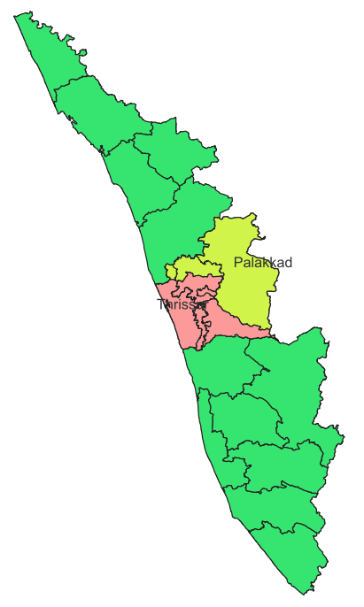

Fig. 1. Geographical location of study area

Table 1. Soil test rating for interpretation of pH in soil
Soil class | pH
Extremely acidic | <4.5
Very strongly acidic | 4.5-5.0
Strongly acidic | 5.1-5.5
Moderately acidic | 5.6-6.0
Slightly acidic | 6.1-6.5
Neutral | 6.6-7.3

Table 2. Soil test rating for interpretation of OC and available primary nutrients
Nutrient | Low | Medium | High
OC | <0.75% | 0.75-1.5% | >1.5%
N | <280 kg ha⁻¹ | 280-560 kg ha⁻¹ | >560 kg ha⁻¹
P | <10 kg ha⁻¹ | 10-24 kg ha₋₁ | >24 kg ha⁻¹
K | <115 kg ha⁻¹ | 115-275 kg ha⁻¹ | >275 kg ha⁻¹
Table 3. Soil test rating for interpretation of available secondary and micronutrients
Nutrient | Deficient | Sufficient
Ca | <300 mg kg⁻¹ | >300 mg kg⁻¹
Mg | <120 mg kg⁻¹ | >120 mg kg⁻¹
S | <5 mg kg⁻¹ | >5mg kg⁻¹
Fe | <5 mg kg⁻¹ | >5 mg kg⁻¹
Cu | <1 mg kg⁻¹ | >1 mg kg⁻¹
Mn | <1 mg kg⁻¹ | >1 mg kg⁻¹
Zn | <1 mg kg⁻¹ | >1 mg kg⁻¹
B | <0.5 mg kg⁻¹ | >0.5 mg kg⁻¹
Table 4. Soil test rating for interpretation of Nutrient Index (NI) in soil
Class | NI
Low | <1.66
Medium | 1.66-2.33
High | >2.33
3. results and discussion
The physico-chemical properties of laterite soils varied significantly across the studied area and represented in table.5.
Table 5. Physico-chemical properties of soils
Soil parameters | Range |  | Mean±SD
Soil parameters | Min | Max | Mean±SD
pH | 4.09 | 6.22 | 5.15±0.52
EC (dS m⁻¹) | 0.03 | 0.37 | 0.10±0.07
OC (%) | 0.42 | 3.00 | 1.23±0.54
N (kg ha⁻¹) | 56.45 | 169.34 | 92.11±24.14
P (kg ha⁻¹) | 2.59 | 89.88 | 22.01±17.61
K (kg ha⁻¹) | 30.24 | 119.84 | 65.02±25.38
Ca (mg kg⁻¹) | 487.50 | 3318.75 | 1053.84±512.11
Mg (mg kg⁻¹) | 25.94 | 651.56 | 118.63±107.04
S (mg kg⁻¹) | 1.18 | 56.98 | 12.53±12.66
Fe (mg kg⁻¹) | 5.75 | 375.63 | 100.78±85.34
Cu (mg kg⁻¹) | 1.28 | 9.58 | 4..48±2.06
Mn (mg kg⁻¹) | 0.63 | 115.63 | 26.09±29.24
Zn (mg kg⁻¹) | 1.50 | 11.13 | 3.93±2.13
B (mg kg⁻¹) | 0.002 | 1.07 | 0.41±0.25

3.1. Soil reaction (pH) and electrical conductivity (EC)
Soil pH ranges from 4.1 in Panjal to 6.2 in Wadakanchery, with an average of 5.16, reflecting an overall acidic nature. Frequency distribution analysis revealed that 11.43% of the samples were classified as extremely acidic, 31.43% as very strongly acidic, 42.86% as strongly acidic, 11.48% as moderately acidic, and 2.86% as slightly acidic (fig.2). In Kerala, hot and humid tropical climate with heavy rain fall accelerates intense weathering, leading to the leaching of essential base cations like calcium and magnesium. This process leaves behind iron and aluminum oxides, contributing to soil acidity (Rajasekharan et al., 2014). Additionally, the acidic nature of the parent material from which these soils originate further lowers the pH. Nair et al., (2019), also reported that high rainfall, leaching of bases, mineralization of organic matter, addition of acid-forming chemical fertilizers and inappropriate agriculture practices are the major reasons for soil acidification and its intensification in humid tropical soils of Peninsular India.

Fig. 2. Percentage Distribution of soil pH classes

​ The electrical conductivity of the soil remains low, ranging from 0.03 dS m⁻¹ in Desamangalam to 0.37 dS m⁻¹ in Wadakanchery, with an average of 0.10 dS m⁻¹(table.5). These values suggest that the soils in these regions do not face any salinity-related concerns. The consistently low EC levels across all samples can be attributed to the leaching of soluble salts, a common phenomenon in high-rainfall areas (Patil et al., 2017; Abiram et al., 2023).

3.2. Soil organic carbon (SOC)
The organic carbon content in the soil exhibits considerable variation, ranging from 0.42% in Muthuthala to 3.0% in Kuzhur, with an average of 1.24% (fig.3). This variation is primarily influenced by the incorporation of plant residues and farmyard manure into the surface soil layers. Among the collected samples, 20% were deficient in SOC, 57.14% were in medium, and 22.85% were high in SOC. Higher SOC recorded might be due to continuous incorporation of rice straw stubbles in the soil. These findings suggest that continuous application of crop residues and organic manures can effectively enhance soil carbon levels (Sudhir et al., 2006). In tropical paddy fields, soil organic carbon (SOC) accumulation is shaped by management practices such as flooding and organic amendments, which contribute to increasing SOC content. However, due to rapid decomposition rates in warm climates, the overall increase remains limited (Arai et al., 2024). Higher levels of organic carbon not only provide part of nitrogen requirement of the crop plants but also enhance nutrient and water retention capacity of soils and create favourable environment.

Fig. 3. Percentage distribution of SOC classes
3.3. Available primary nutrients
The available nitrogen content in the soil varies from 56.44 kg ha⁻¹ in Anangadi to 169.34 kg ha⁻¹ in Wadakanchery, with an average of 92.1 kg ha⁻¹. All collected soil samples exhibited low nitrogen levels (fig.4), indicating widespread nitrogen deficiency. Continuous and intensive cultivation of rice leading to high crop removal together with insufficient replenishment might be the reason for the high degree of nitrogen deficiency in soils. Additionally, this low level of available nitrogen content may be due to the presence of low to medium amount of organic matter in these soils. Available nitrogen showed a strong positive correlation with SOC (0.606***). These findings align with the results reported by Kumari et al., (2013). The nitrogen deficiency is because of its highly dynamic nature, particularly in its inorganic forms, which undergo various rapid transformations, including microbial immobilization, leaching, volatilization, and denitrification (Dal Molin et al., 2020; Ishii et al., 2011).

The available phosphorus (P) content in the soil varies widely, ranging from 2.59 kg ha⁻¹ in Muthuthala to 89.88 kg ha⁻¹ in Thirumittacode, with an average of 22.01 kg ha⁻¹. Among the collected soil samples, 17.14% were found to be low in available phosphorus, 54.28% and 28.57% were in medium and high classes, respectively (fig.4). This variability may be attributed to differences in soil formation processes and past phosphorus fertilization practices, as excessive application of phosphatic fertilizers can lead to phosphorus accumulation in soils. In soils with low available P, orthophosphate ions readily form complexes with aluminum (Al³⁺) and iron (Fe²⁺), making phosphorus less available for plant uptake. Furthermore, soils rich in manganese (Mn), iron (Fe), and aluminum (Al) have a high capacity to retain phosphorus, restricting its accessibility to plants (Afonso et al., 2020; Mitra et al, 2020). Consequently, nearly 80% of the applied phosphorus becomes unavailable to crops, as observed in south central laterites of Kerala (AEU 9) (Salvagioti et al., 2017). However, the addition of organic matter and its subsequent decomposition can enhance phosphorus availability in deficient soils by releasing it into the soil solution through mineralization (Yusran, 2018).
The availability of potassium in the soil varies between 30.4 kg ha⁻¹ in Veloor and 119.84 kg ha⁻¹ in Koppam, with an average of 65.02 kg ha⁻¹. Among the collected samples, 94.28% were found to be low in available potassium, while only 5.71% in medium level (fig.4). A significant correlation (0.432**) was observed between available potassium and soil organic carbon (table.6). The content of K in soil depends up on the soil properties, mineralogical composition, leaching, external K fertilization and crop removal. In general, the potassium status of Kerala soils is found to be low and the reason can be attributed to the tropical climate and predominance of kaolinitic clay mineral characterized by low K (Mini and Usha, 2015). Kavitha and Sujatha (2015) reported that the probable reason might be the leaching coupled with strong acidity which does not permit retention of potassium on the soil exchangeable complex. Rajasekharan et al. (2013) reported that the highly weathered and leached soils of Kerala developed under humid tropics do not have any significant amount of potassium bearing minerals. Additionally, low available K content can be attributed to low use of potassium fertilizers as suggested by Denis et al. (2017).

Fig. 4. Percentage distribution of available primary nutrients in soil
3.4. Available secondary nutrients
The available calcium content in the soil varies between 487.50 mg kg⁻¹ in Muthuthala and 3,318.75 mg kg⁻¹ in Thirumettacode, with an average value of 1,053.84 mg kg⁻¹. None of the collected soil samples exhibit calcium deficiency (fig.5). A significant positive correlation (0.436**) is observed between available calcium and soil pH. This might be due to the application of lime to reduce acidity in soil, thus releasing calcium later in time (Shamshuddin, 2006).

Available magnesium concentrations in the soil range from 25.93 mg kg⁻¹ in Alathur to 651.56 mg kg⁻¹ in Thirumettacode, with an average value of 118.63 mg kg⁻¹. Similar available magnesium levels have been reported in cultivated laterite soils by Jayaganesh et al (2011). 62.85% of collected samples showed deficiency in available Ca and 37.14% showed sufficiency (fig.5). Magnesium being a weak competitor of exchange sites with aluminium and calcium, appears to accumulate in soil solution and is subject to leaching loss in acid soils which might be the reason for lower magnesium levels in soils despite the high calcium content observed in the same areas. Similar findings were also reported by Natarajan et al. (2013).
Available sulfur levels exhibit considerable variation, ranging from 1.18 mg kg⁻¹ in Vaniyamkulam to 56.69 mg kg⁻¹ in Veloor, with an average of 12.53 mg kg⁻¹. Among the collected samples 34.28% of showed deficiency and 65.71% were in sufficient level (fig.5). Comparable findings were reported by Sahu et al (2022).

Fig. 5. Percentage distribution of available secondary nutrients in soil
3.5. Available micronutrients
Available iron content varies widely, ranging from 5.75 mg kg⁻¹ in Varavoor to 375.63 mg kg⁻¹ in Koppam, with an average of 100.78 mg kg⁻¹. All the samples analysed were sufficient in available iron (fig.6). It shows that laterite soils have inherent capacity to supply sufficient amount of available iron. Available copper concentrations vary from 1.28 mg kg⁻¹ in Alathur to 9.58 mg kg⁻¹ in Ambalapara, with a mean value of 4.48 mg kg⁻¹. All analysed soil samples exhibit sufficient available copper content (fig.6). The availability of copper in soil is primarily governed by factors such as soil organic matter (SOM), pH, and the overall concentration of available copper (Wu et al., 2010). Available manganese concentrations range from 0.625 mg kg⁻¹ in Alathur to 115.62 mg kg⁻¹ in Alagappanagar, with an average of 26.09 mg kg⁻¹. Among the collected samples, 5.71% are deficient, while 94.28% were adequate in available manganese content (fig.6). Available manganese exhibited a significant correlation with soil pH (0.598***). Laterite soils, which develop under intense weathering in tropical areas, undergo extensive leaching of soluble elements, leading to the accumulation of oxides, including manganese oxides and hydroxides (Heng Li and Wei Xu, 2024). The variation in available manganese content is largely influenced by the nature of the parent material and the degree of weathering. Available zinc concentrations range from 1.50 mg kg⁻¹ in Pariyaram to 11.12 mg kg⁻¹ in Wadakanchery, with an average of 3.92 mg kg⁻¹. Among the collected samples, none showed deficiency (fig.6). Available zinc exhibited a significant correlation with SOC (0.374*). Similarly, laterite soils used for arecanut cultivation also fall within this range (Bhat et al., 2012). Available boron levels vary from 0.09 mg kg⁻¹ in Alathur to 1.07 mg kg⁻¹ in Choondal, with an average of 1.07 mg kg⁻¹. Among the collected samples, 62.85% are deficient, while 37.14% samples were adequate in available boron content (fig.6). Its availability in soil is influenced by factors such as pH, SOC, soil type, temperature, moisture levels, and management practices like liming (Evans and Sparks, 1983). The low level of B might be due to leaching by high rainfall. Similar results were reported by Mini and Usha Mathew (2015).
Av. Fe Av. Cu Av. Mn Av. Zn Av. B

Fig. 6. Percentage distribution of available micronutrients in soil
3.6. Nutrient index of primary nutrients
The calculated nutrient index (NI) value for available nitrogen was 1.00, indicating a low fertility status (Ramamoorthy and Bajaj, 1969). All 35 soil samples were classified under low category, suggesting severe nitrogen deficiency across the study area. This needs to be corrected by practising integrated nutrient management, involving application of organic manures, legume-based cropping, and addition of slow-release nitrogenous fertilizers should be adopted to enhance nitrogen availability and minimise losses due to leaching or volatilisation. For available phosphorus, the NI value was 2.114, indicating an overall medium fertility status. Among the samples, 6 were low, 19 were medium, and 10 were high in available phosphorus. Though the situation is moderate, site-specific P fertilisation is advisable. In low P areas, phosphatic fertilizers along with organic amendments such as farmyard manure (FYM) or compost could be added to improve phosphorus availability. Moreover, practices like band placement of fertilizers and liming in acidic zones can reduce phosphorus fixation by Fe and Al oxides. Available potassium showed an NI value of 1.057, reflecting a low fertility status. Among the samples, 33 samples were low, and only 2 were medium, indicating widespread K deficiency. Since laterite soils are poor in exchangeable potassium, regular application of potassic is essential. Additionally, incorporating crop residue rich in potassium can improve K cycling. Avoiding K depletion through balanced fertilisation and crop rotation with deep-rooted crops that mobilise subsoil K can also help sustain long-term soil fertility.
Table 6. Correlation between macronutrients and pH, EC and OC
 | N | P | K | Ca | Mg | S
pH | -0.09 | 0.132 | 0.057 | 0.436** | 0.302 | -0.104
EC | 0.711*** | -0.241 | 0.463** | 0.22 | 0.109 | 0.523**
OC | 0.606*** | -0.375* | 0.432** | 0.096 | 0.062 | 0.334
Table 7. Correlation between micronutrients and pH, EC and OC
 | Fe | Cu | Mn | Zn | B
pH | -0.063 | 0.082 | 0.598*** | 0.012 | 0.209
EC | 0.587*** | 0.262 | 0.296 | 0.621*** | 0.238
OC | 0.326 | 0.33 | -0.004 | 0.374* | 0.035
3.7 Spatial variability of soil properties
Spatial variability of soil characteristics was mapped using QGIS software. The soil maps for pH, organic carbon, and macronutrients viz., N, P, K, Ca, Mg and S were prepared and presented in Fig.7 and Fig.8. The classes in which nutrients were present in north central laterite soils were shown in legend. As per categorization and availability of nutrients, the spatial distribution of each nutrient under low, medium and high classes were indicated by red, light orange and blue colour legends, respectively.
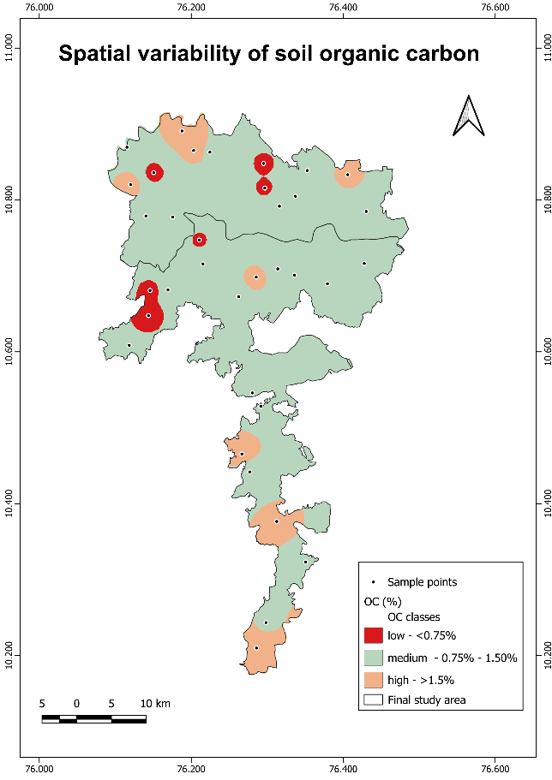
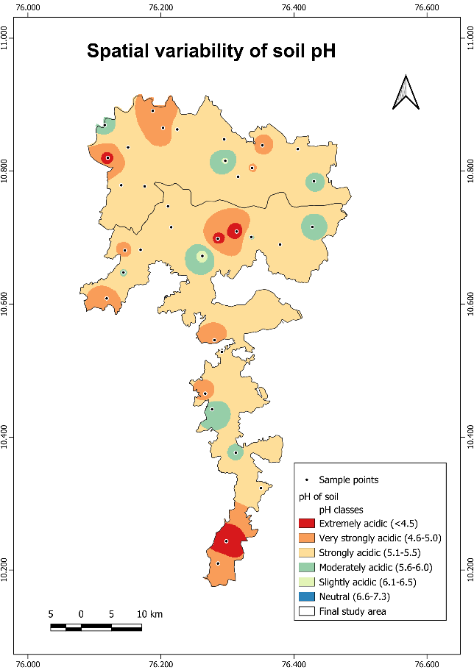

Fig. 7. Spatial variability of soil pH and soil organic carbon
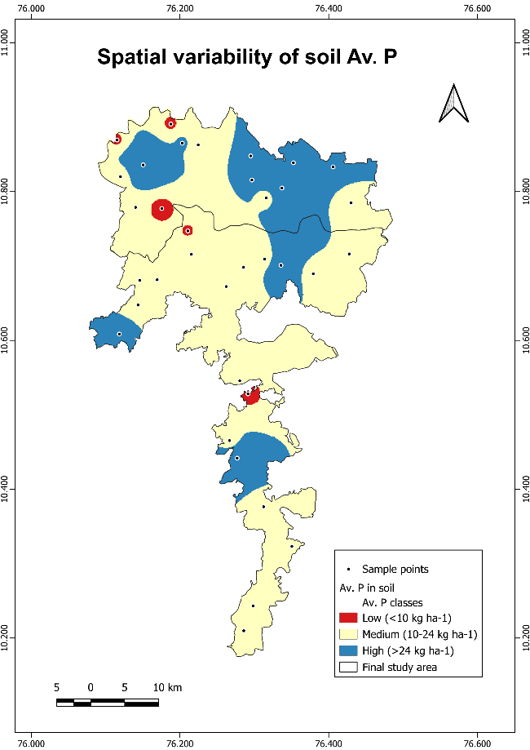
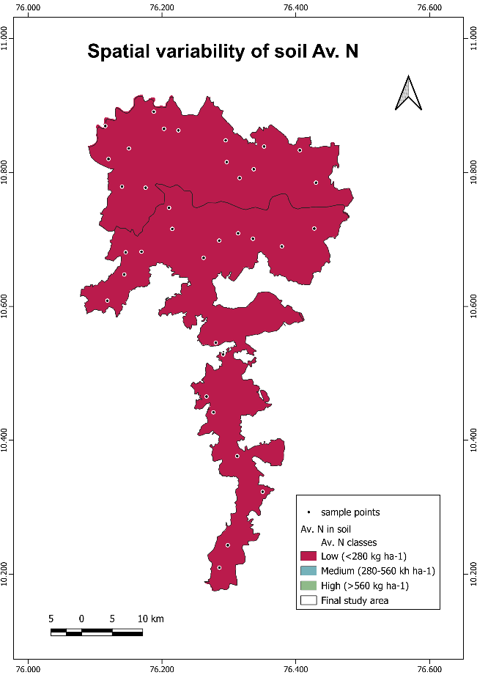
Spatial variability of Av. P in soil
Spatial variability of Av. N in soil

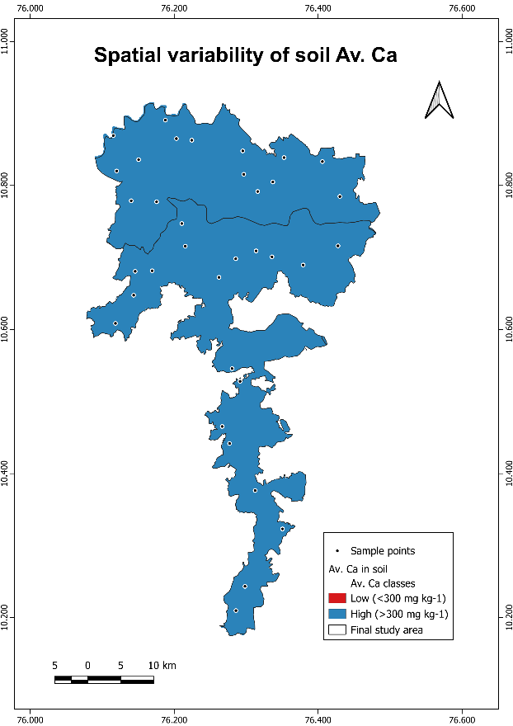
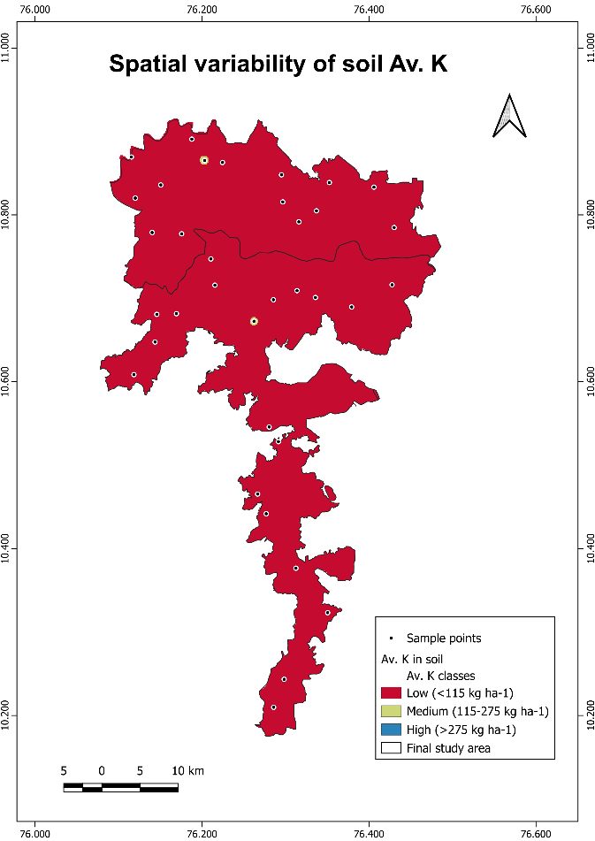
Spatial variability of Av. Ca in soil
Spatial variability of Av. K in soil
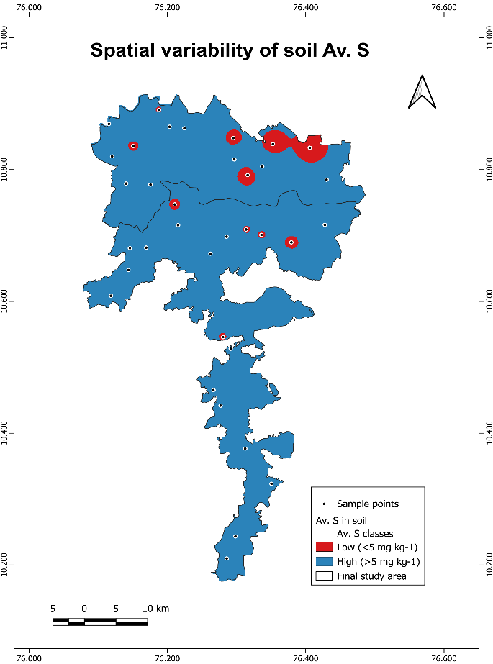
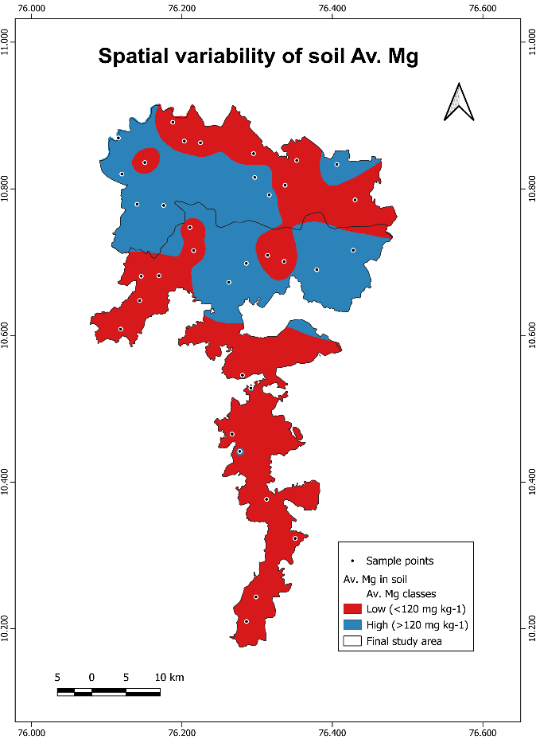
Spatial variability of Av. S in soil
Spatial variability of Av. Mg in soil
Fig. 8. Spatial variability of soil macronutrients
4. Conclusion

The study revealed the prevalence of widespread multi-nutrient deficiencies, including deficiency of available nitrogen, potassium, magnesium, sulfur, and boron, across the intensively rice-cultivated regions of the north-central laterites of Kerala. The findings of this study underscore the need to reassess the nutrient management practices currently employed by farmers to prevent soil-related problems such as nutrient imbalances and nutrient depletion. Balanced fertilization, including site-specific nutrient management, is essential to address macro and micronutrient deficiencies. Implementing these strategies will enhance soil health and support sustainable rice cultivation in Kerala. Spatial variability maps serve as valuable tools to identify nutrient deficiencies, monitor soil fertility trends over time, and support predictive planning for maintaining long-term soil health and productivity.

References
- Abhiram, M., Leno, N., Rani, B., Anil Kumar, K.S. and Rafeekher, M. 2023. Physical, chemical and biological properties of soils in Marayur Hills of Kerala, India. Pharma Innov. J., 12(2), pp.2887-2890.
- Afonso, S., Arrobas, M. and Rodrigues, M.Â. 2020. Soil and plant analyses to diagnose hop fields irregular growth. J. Soil Sci. Plant Nutr., 20(4), pp.1999-2013.
- Arai, M. and Wagai, R. 2024. Does rice paddy management increase soil organic carbon in warm temperate and tropical regions? Geoderma Reg., 36, p.e00738.
- Bhat, R., Sujatha, S. and Jose, C.T. 2012. Assessing soil fertility of a laterite soil in relation to yield of arecanut (Areca catechu L.) in humid tropics of India. Geoderma, 189, pp.91-97.
- Bray, R.H. and Kurtz, L.T. 1945. Determination of total organic carbon and available forms of phosphorus in soils. Soil Sci., 59, pp.39-45.
- Cassman, K.G., Peng, S. and Dobermann, A. 1997. Nutritional physiology of the rice plants and productivity decline of irrigated rice systems in the tropics. Soil Sci. Plant Nutr., 43 (1), pp.1101-1106.
- Dal Molin, S.J., Ernani, P.R. and Gerber, J.M. 2020. Soil acidification and nitrogen release following application of nitrogen fertilizers. Commun. Soil Sci. Plant Anal., 51(20), pp.2551-2558.
- Department of Economics and Statistics 2023. Agricultural Statistics 2022-23. Thiruvananthapuram.
- Evans, C.M. and Sparks, D.L. 1983. On the chemistry and mineralogy of boron in pure and mixed systems: A review. Commun. Soil Sci. Plant Anal., 14(9), pp.827-846.
- Gu, D., Andreev, K. and Dupre, M.E. 2021. Major trends in population growth around the world. China CDC Wkly., 3(28), pp.604.
- Ishii, S., Ikeda, S., Minamisawa, K. and Senoo, K. 2011. Nitrogen cycling in rice paddy environments: Past achievements and future challenges. Microbes Environ., 26(4), pp.282-292.
- Jackson, M.L. 1958. Soil Chemical Analysis. Prentice Hall of India, New Delhi, p.29.
- Jayaganesh, S., Venkatesan, S., Senthurpandian, V.K. and Poobathiraj, K. 2011. Vertical distribution of magnesium in the laterite soils of South India. Int. J. Soil Sci., 6(1), p.69.
- Kavitha C and Sujatha MP. Evaluation of soil fertility status in various agro-ecosystems of Thrissur District, Kerala, India. Inter. J. of Agric. Crop Sce. 2015;328-338.
- Kumari, S.L. 2012. Status Paper on Rice in Kerala. Directorate of Rice Research.
- Li, H. and Xu, W. 2024. Geological and Economic Assessment of Manganese Deposits. Int. J. Ecol. Environ. Sci., 6(2), pp.28-31.
- Lindsay, W.L. and Norvell, W.A. 1978. Development of DTPA soil test for Zn, Fe, Mn and Cu. Soil Sci. Soc. Am. J., 42, pp.421-428.
- Mini V and Usha Mathew. Soil based nutrient management plan for Onattukara sandy tract of Kerala. Asian J. of Soil Sci. 2015;10(1):99-103.
- Mitra, D., Anđelković, S., Panneerselvam, P., Senapati, A., Vasić, T., Ganeshamurthy, A.N., Chauhan, M., Uniyal, N., Mahakur, B. and Radha, T.K. 2020. Phosphate-solubilizing microbes and biocontrol agent for plant nutrition and protection: Current perspective. Commun. Soil Sci. Plant Anal., 51(5), pp.645-657.
- Naidu, L.G.K., Sidhu, G.S., Sarkar, D. and Ramamurthy, V. 2011. Emerging deficiency of potassium in soils and crops of India. Karnataka J. Agric. Sci., 24(1).
- Nair, K.M., Anil Kumar, K.S. Lalitha, M. et al. 2019. Surface soil and subsoil acidity in natural and managed land-use systems in the humid tropics of Peninsular India. Current Science. 116(7): 1201-1211.
- Natarajan P, Varghese JJ, Oommen M, Soumiya CS, Jyothi S, Kumar KVS et al. Fertility of soils of Kerala. In: Soil fertility assessment and information management for enhancing crop productivity in Kerala. Kerala State Planning Board, Thiruvananthapuram, Kerala 2013,204 227.
- Patil, P.L., Bidari, B.I., Hebbara, M., Katti, J., Dilvaranaik, S.A.M.I.R.K.H.A.N., Vishwanatha, S., Geetanjali, H.M. and Dasog, G.S. 2017. Identification of soil fertility constraints by GIS in Bedwatti sub-watershed under Northern Dry Zone of Karnataka for site-specific recommendations. J. Farm Sci., 30, pp.206-211.
- Rajasekharan P, Nair KM, Rajasree G, Sureshkumar P, Narayana kutty MC. Soil fertility assessment and information management for enhancing crop productivity in Kerala. Kerala state planning board, Government; 2013.
- Rajasekharan, P., Nair, K.M., John, K.S., Kumar, P.S., Kutty, M.N. and Nair, A.R. 2014. Soil fertility related constraints to crop production in Kerala. Indian J. Fertil., 10(11), pp.56-62.
- Rosolem, C.A. and Steiner, F. 2017. Effects of soil texture and rates of K input on potassium balance in tropical soil. Eur. J. Soil Sci., 68(5), pp.658-666.
- Sahu, M., Nisab, M.C. and Mondal, S. 2022. Availability of macronutrients and sulphur and their relationship with physico-chemical properties in lateritic soils of Birbhum district, West Bengal. Int. J. Econ. Plants, 9(3), pp.260-263.
- Salvagiotti, F., Prystupa, P., Ferraris, G., Couretot, L., Magnano, L., Dignani, D. and Gutierrez-Boem, F.H. 2017. N:P:S stoichiometry in grains and physiological attributes associated with grain yield in maize as affected by phosphorus and sulfur nutrition. Field Crops Res., 203, pp.128-138.
- Shamshuddin, J. 2006. Acid Sulfate Soils in Malaysia. Universiti Putra Malaysia Press, Serdang, Malaysia.
- Shukla, A.K., Behera, S.K., Prakash, C., Tripathi, A., Patra, A.K., Dwivedi, B.S., Trivedi, V., Rao, C.S., Chaudhari, S.K., Das, S. and Singh, A.K. 2021. Deficiency of phyto-available sulphur, zinc, boron, iron, copper and manganese in soils of India. Sci. Rep., 11(1), p.19760.
- Soil Survey Staff 1999. Soil Taxonomy: A Basic System of Soil Classification for Making and Interpreting Soil Surveys. Agriculture Handbook, 436, pp.336-337.
- Subbiah, B.V. and Asija, G.L. 1956. A rapid procedure for the estimation of available nitrogen in soils. Curr. Sci., 25, pp.259-260.
- Sudhir, K., Jose, G., Prakasha, H.C. and Gowda, J.N.A. 2006. Organic carbon status of a laterite and a red soil under long-term rice cultivation in Karnataka, India. In: Proc. 18th World Congr. Soil Sci., pp.9-15.
- Takkar, P.N., Chibba, I.M. and Mehta, S.K. 1989. Twenty Years of Coordinated Research on Micronutrients in Soil and Plants, 1967-87. IISS Bulletin 1, Indian Institute of Soil Science.
- Walkley, A. and Black, I.A. 1934. Estimation of soil organic carbon by chromic acid titration method. Soil Sci., 37, pp.29-38.
- Wolf, B. 1974. Improvement in the Azomethine-H method for the determination of boron. Commun. Soil Sci. Plant Anal., 5(1), pp.39-44.
- Wu, C., Luo, Y. and Zhang, L. 2010. Variability of copper availability in paddy fields in relation to selected soil properties in Southeast China. Geoderma, 156(3-4), pp.200-206.
- Yusran, F.H. 2018. The relationship between phosphate adsorption and soil organic carbon from organic matter addition. J. Trop. Soils, 15(1), pp.1-10

