Geoinformatic Analysis/Filtering Using GIS and RS of Sunderban Area

ABSTRACT
The Sentinel-2 datasets, topography data, have great potential and can be used for land use and land cover classification. The present search investigates the classification of satellite imagery by applying image processing and fusion methodologies.The present research envisages image analysis, classification techniques and clustered into groups. This study traces the trail of anastomosed channels, soil characteristics and land use through an integrated study of geology, satellite imagery and the use of RS/GIS Technologies. Various satellite imagery band fusion and manipulation techniques such as band overlaying, Normalised diferential vegetation Index (NDVI), Soil adujusted Vegetation Index (SAVI), Normalised differential Moisture Index, (NDMI), Modified Normalized Difference Water Index (MNDWI), density slice and spatial profiling. The results indicate the existence of various land profiles in Sunderbans. This technique will ensure the category of satellite images through classification by fusion techniques.
Keywords: GIS/RS, Fusion, Filtering; Sentinel Sensor, NDVI, geographic indices,
1.0.0 INTRODUCTION:
The image can be taken through the sensor by satellites and sent to the Earth’s surface. Satellites can use sensors to capture images that our human eyes can’t see; data can be captured remotely with the help of satellites.
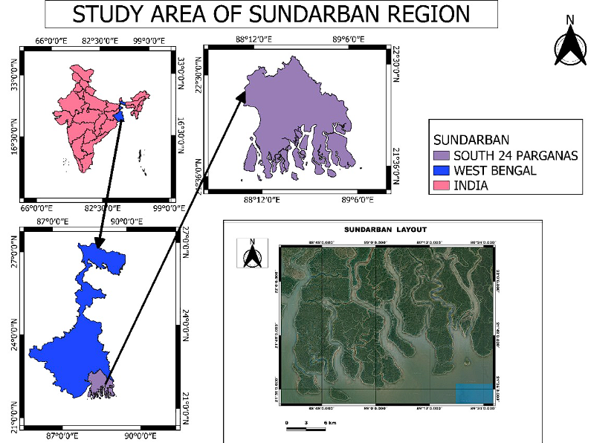
Fig 1: The Index map of the study area in the Sundarbans, West Bengal
Satellite images help our study, and it’s essential for scientists because they identify any geographical region. In modern times, satellite images are used in machine learning for analysis and algorithm making. A satellite image provides information through multi-temporal images ensuring accurate data over a large area. They are independent of sunlight and atmospheric conditions so are dependable sources of image detection in remote sensing, .(Asokan et al., 2020[1], Scarpetta et al, 2025[2]) .
Downloading and later analysing satellite images can reduce time and solving geospatial thematic problems can be easily solved. Landsat and Carto sat are both satellites used for earth observation. Landsat is used for mapping, agriculture, forestry, and more, while Carto sat is used for cartography, resource management, and defence forums.
Applications, satellite Remote sensing applications and processes include data fusion/ integration of multi-sensor data, Image segmentation/classification presentation of various features of earth such as Soil, Water, vegetation and rocks etc (Fig 2 a to d)
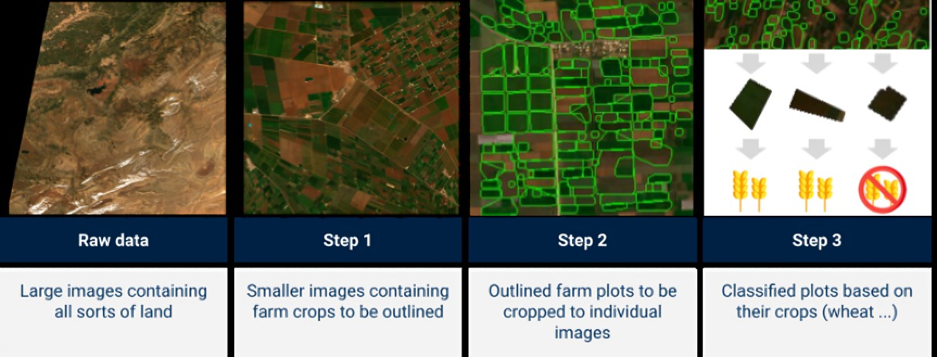
Fig 2 (a-d): (b) Satellite Image and its enhancement (c) Agricultural cartography map (d) Image segregation, Dritsas et al 2025[3], Delaney et al., 2025[4]
1.1.0 Study Area:
Indian Sunderbanshas houses 110 islands (54 reclaimed by settlements) comprising of area area of 9630 Km² (4260Km² in 56 forests as reserved forests) and within co-ordinates ( 21 °10′ E and 22 °30′ E Lat., and 88°15′ N and 89°40′ N long.) being approached through Gosaba and other seven major rivers, with creeks, alluvial plains, salt pans, mangrove swamps, dunes, estuaries and beaches. The southern islands are under erosion (Sagar, Jambu, Dalhousie, Namkhana,Lothian, Bhangaduani etc.) whereas the North eastern part of Sagar island , western fringe of Nayachar Island etc are depositional (Mishra et al, 2024[5], Mojid et al, 2025[6]).
India’s Sunder bans is in the lower deltaic reaches of South 24 Praganas of West Bengal, India. The India’s Sundarbans, (Mangrove forests) along the lower deltaic reaches of Bay of Bengal (BoB) was a part to birdfooted Ganga-Brahmaputra-Meghanna (GBM) delta, which was plentifull mangrove forests formed during active Indian summer monsoon (ISM) of the Holocene Epoch through natural sedimentation by sediments from Gangetic plains and longshore drifts and accompanied by intertidal segregation.
a.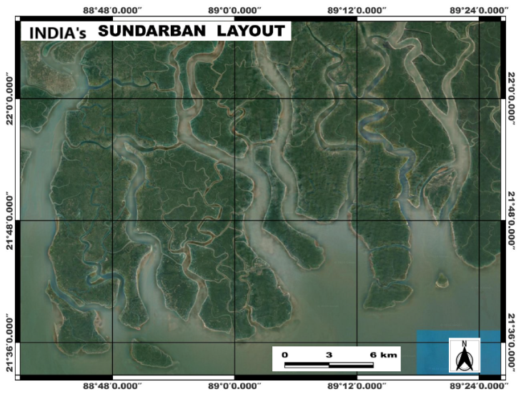b.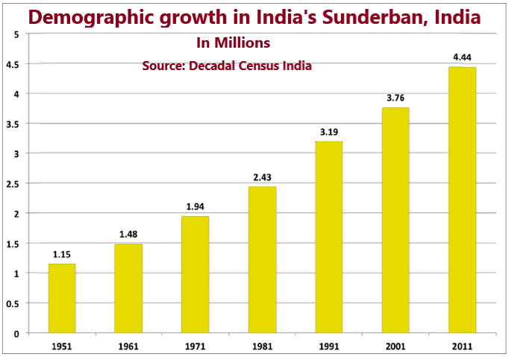
Fig 3 (a and b): (a)Indian Sunderbans considered for the study (NDVI, SAVI, Geological indices etc.), (b) Decadal population growth in Indian Sunderban areas
2.0.0 Literature Review:
Geographic Information Systems (GIS) and Remote Sensing (RS) play critical title role by enhances the ability to collect, analyse, and interpret spatial data, integrating them and for monitoring and managing wetlands. The data is used for continuous monitoring and mapping wetlands, water quality assessment, conservation initiatives to have sustainable management practices, alongwith biodiversity preservation (Ang et al, 2023[7], Chatrubhuja et al, 2024[8], Bar et al, 2025]9]).
The images received from the satellites are multitemporal and provide data or information for agriculture, geomorphology, oceanography, conservations, etc., with accuracy over a vast area Rivera et al., (2023)[10]; Mishra et al., 2023[11]. Satellite images delivers valuable data to understand and manage island environments. It has submissions ranges from monitoring coastal changes and vegetation cover to assessing the impact of climate change and mapping urban heat islands. These images are used to study various aspects of islands, including their geology, ecology, and social dynamics (Mishra et al, 2019[12], Chamine et al, 2021[13],Nanda et al, 2023[14], Mukherjee et al., 2024[15], Mishra et al. 2024,[16]Gui et al, 2025[17]).
The Normalised differential vegetation Index (NDVI) of Sunderban Island environment is studied to assess geospatial changes of Mangrove forests (MF) and Attribution, monitoring environmental sustainability and (Ghosh et al., 2016[18], Samanta et al, 2021,[19] Chanda et al, 2023[20], Mishra et al, 2024,[21] Mohammad et al, 2024[22], Majumdar et al., 2025[23])
The index, Soil-Adjusted Vegetation Index (SAVI) is used to lessen the effect of soil on growth of vegetation in low vegetative areas, using red and near-infrared reflectance data and a soil background correction factor. SAVI accurately asses the land cover or, soil reflectance that affect the NDVI of the area (Yeom et al, 2019[24], Chaves et al, 2020[24], Tran et al, 2022[25], Kanjin et al, 2024[26], Masdek et al, 2025[27]).
The Normalized Difference Moisture Index (NDMI) is applied to estimate the vegetation moisture contented, particularly in Sundarbans mangrove forests. NDMI investigates the differential values between near-infrared (NIR) and shortwave infrared (SWIR) reflectance, by sensing leaves moisture levels which assesses the luxuriance growth of mangroves under climate change scenarios (CC), water stress, and flooding (Haldar et al., 2024[29], Wei et al, 2025[30], Xia et al., 2025[31]).
The Modified Normalized Difference Water Index (MNDWI) is a valuable tool in RS, to develop water features, and overpower interference from MF vegetation and settlements. In the context of the Indian Sundarbans, MNDWI monitor water levels, water quality, and fetect spatial changes in mangrove forests particularly under high tidal fluctuations (Mondal et al, 2024[32], Dutta et al, 2025[33]) . .
Various Algorithms used considering GIS/RS data are Linear regression, Random Forest (RF), Support Vector Machine (SVM)Kernel, Neural Network (KNN), Decision Tree, Extreme Random Tree, K-Nearest Neighbor, Artificial Neural network (ANN), Extreme Random trees, Naïve Bayes etc. but found less studies (Roy et al, 2014[34], Ahmad et al, 2018[35], Rana et al., 2023[36], Hossain et al., 2024[37]), .
The use of remote sensing satellite image classification is the experimental survey, and comparative analysis is done using GIS code for an unsupervised image classification method and it is time saving and handy. The literature survey indicate that megeare reseraches have been done about the quality of growth of mangroves in Indian Sunderbans. The present search is an mere attempt to study the NDVI, NDMI, SAVI and geological indices in a small arbitrary area in Sunderban in India.
2.1.0 Methods and Methodology
GIS can use various methods to analysise satellite image, and filtering. The different software that is used Q-GIS. Arc-GIS, Erdas Imagine, etc. are used to identify various parameters.
2.1.1 Hardware/Software Used: QGIS is an popular GIS software, that can run on various hardware configurations. These powerful system performs the elementary tasks like viewing and editing maps. For more complex operations like raster processing and 3D visualization, higher-end hardware with more RAM and a dedicated GPU may be beneficial. ERDAS Imagine software used for analysing GIS/RS data and commonly applied by geographic imaging that save time, money, leverage present information use and expand image analysis competences, (Melesse et al, 2007[38], Dobesova et al, 2021[39], Sharma et al, 2024[40])
2.1.2 Objectives of study
The present study focuses on the High-frequency images received from Sentinel-2 constellations, which involve:
1. The procedure to acquire and analyze Sentinel-2 images of an arbitrary sample area in Indian Sundarbans and use these data to analyze the mangrove vegetation growth, distribution along the Bay of Bengal offshore along West Bengal coast.
2. The Normalized Difference Vegetation Index (NDVI), SAVI), NDMI, MNDWI indices of the area are calculated.
3. Planning and management of the analysis results for future implications.
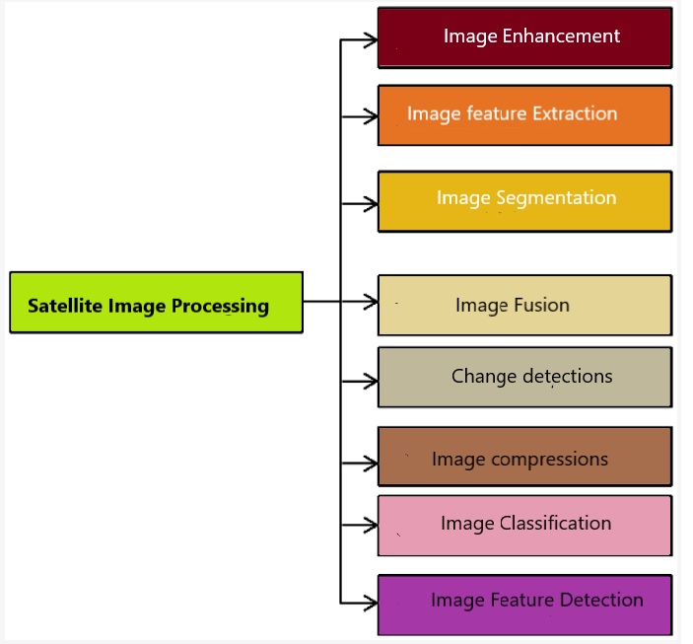

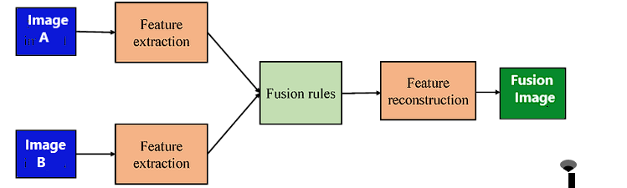
Fig 4( a-b):(a): The flow diagram involved in satellite image processing (b)Traditional fusion network involving feature extraction, fusion and feature rebuilding
2.1.3 Difference Sentinel 1 and Sentinel 2:
Sentinel-1 and Sentinel-2 are constellations of two polar-orbiting satellites. They both provide images for analysis. Each has its strengths and weaknesses based on its applications. They are of different orbiting periods (12 and 10 days) and provide diverse data. Sentinel 1 is vegetation sensitive, whereas Sentinel 2 is amicable with high resolution, clear pixel colour, and improved picture quality.
2.2.0 Sentinel 2 applications:
The high-resolution, good-quality Sentinel 2 images can be used to analysis: Flood detection, tillage practices mapping, marine survey, and natural disaster mapping. They have applications in monitoring climate change, forest cover, agricultural expanses, topology, LU/LC, iceberg assessment, surveillance of marine ships, oil spills, etc.
2.2.1 Data Acquisition:
These images were acquired from USGS of the Indian Sunderban area and georeferenced as per the Survey of India Toposheet of scale 1 : 50000 after georeferencing. The data was collected from the Sentinel-2A constellation. The sensor is a Sentinel-2A Satellite with a spatial resolution of 10m.
2.2.2 Data Preparation:
The machine learning method uses machine learning to analyse the images acquired from the Sentinel-2 constellation, which has 12 bands of various wavelengths (Table 1). Later, they are trained and compared to models to calculate the Normalized Difference Vegetation Index (NDVI), Lozano-Tello et al., 2023[41]
Table 1: The spectral bands for the various bands for the Sentinel - 2 band sensers.
Sentinel-2 bands | Sentinel-2A |  | Sentinel-2B
Sentinel-2 bands | Central wavelength (nm) | Band  width (nm) | Central wavelength (nm) | Bandwidth (nm) | Spatial resolution  (m)
Band 1 – Coastal aerosol | 442.7 | 21 | 442.2 | 21 | 60
Band 2 – Blue | 492.4 | 66 | 492.1 | 66 | 10
Band 3 – Green | 559.8 | 36 | 559.0 | 36 | 10
Band 4 – Red | 664.6 | 31 | 664.9 | 31 | 10
Band5– Vegetation red edge | 704.1 | 15 | 703.8 | 16 | 20
Band 6–Vegetation-red edge | 740.5 | 15 | 739.1 | 15 | 20
Band 7–Vegetation-red edge | 782.8 | 20 | 779.7 | 20 | 20
Band 8 – NIR | 832.8 | 106 | 832.9 | 106 | 10
Band 8A – Narrow NIR | 864.7 | 21 | 864.0 | 22 | 20
Band 9 – Water vapour | 945.1 | 20 | 943.2 | 21 | 60
Band 10 – SWIR –Cirrus | 1373.5 | 31 | 1376.9 | 30 | 60
Band 10 – SWIR –Cirrus | 1373.5 | 31 | 1376.9 | 30 | 60
Band 11 – SWIR | 1613.7 | 91 | 1610.4 | 94 | 20
Band 12 – SWIR | 2202.4 | 175 | 2185.7 | 185 | 20
Source: Wikipedia
3.0.0 Vegetation and Soil Indices
3.1.0 Normalised Difference Vegetation Index (NDVI)
The NDVI in RS is used to determine the spatial vegetation quantities, their health and greenness in an area. It measures the difference between near-infrared (NIR) and red light reflectance. The NDVI projects the vegetation health, and detect spatial changes for monitoring agriculture, forestry, and ecology of an area.
To determine the density of green on a patch of land, researchers must observe the distinct colours (wavelengths) of visible and near-infrared (NIR)sunlight reflected by the plants. The Normalized Difference Vegetation Index (NDVI) quantifies vegetation by measuring the difference between near-infrared, which vegetation strongly reflects, and red light (which vegetation absorbs). NDVI always ranges from -1 to +1.
The formula for NDVI is:-
NDVI=(NIR –RED)/(NIR+RED)
Where NIR = pixel values of near-infrared band; Red = pixel values from the red band
For greenness density and health, various NDVI values are assigned ranging from 0-1. The NDVI values are interpreted as ≤ 0 indicated water bodies or nonvegetative cover, between 0 to 0.3, it specifies barren/fallow areas with little to no vegetation cover, and 0.3 and 0.6 sparsly vegetative areas. The healthiest, dense and green vegetation in mid-latitudes are ≥0.82 (Fig 5)
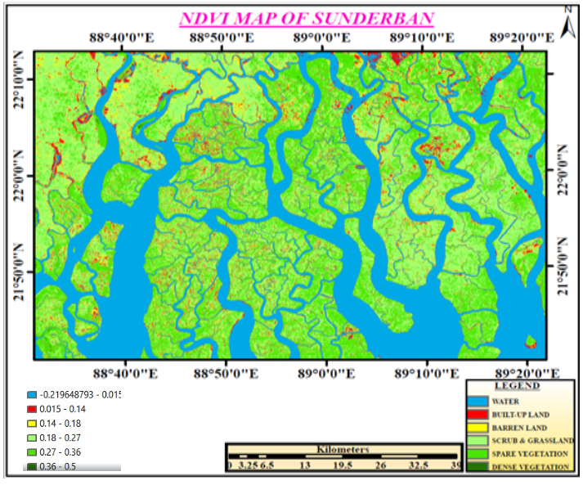
Fig 5: NDVI of the study area in Sundarbans with spare vegetation (sparse Mangroves)
3.1.1 Normalised Difference Moisture Index (NDMI):
The NDMI maps are prepared to know the moisture content observed within the Indian Sunderban anastomosed rivers, drainage channels, and mangrove forests, where the Geographic Information Systems (GIS) is used. Using the NDMI map, the judicious management and monitoring of the vibrant ecosystem under fluctuating sedimentary regimes and geo-bio-hydro Biome.
The NDMI map of the Sundarbans symbolises the vegetation index for the unique Sunderban wetlands (captured between NIR and Mid NIR) that infer the moisture content of the halophytic ecosystem under a fluvial-tidal saline ecosystem. The map shall also compute spatial changes in salinity and sediment changes in vegetative growth or decay caused by deforestation, urbanisation, river bank erosion, etc. By knowing the vegetative index, the prediction of floods in the area so that disaster preparedness can be planned and the conservation plan can be judicious management of the mangrove ecosystem.
The NDMI trends and disparities assign insights into drought stress, plant health, yield prediction and plan for water management for water management for drought mitigation. NDMI values ranges between -1 and 1. Moisture stress alarams by the values tending -1, while the +1 may indicate waterlogging that specifies agronomic state soil. Major portion of Islands in Indian Sunderbans are either vegetation or settlements (Fig 6).
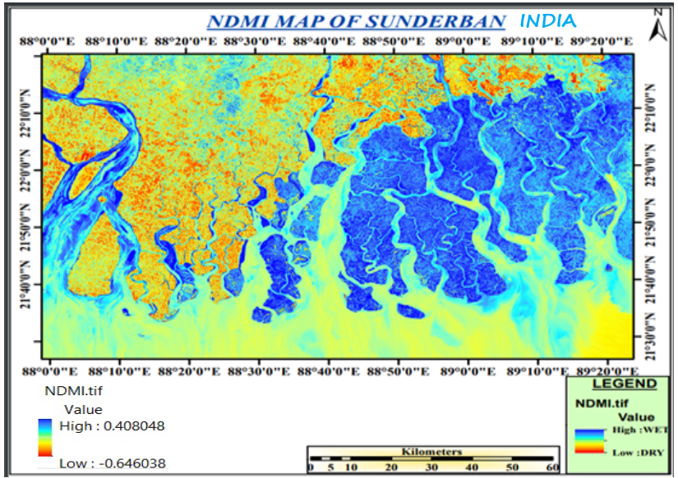
Fig 6: The NDMI map of Indian Sundarbans showing wet and dry areas
3.2.0 Soil-Adjusted Vegetation Index (SAVI)
The Soil-Adjusted Vegetation Index (SAVI) is a vegetation index that aims to minimise soil brightness influences using a soil brightness correction factor. This is often used in arid regions where vegetative cover is less.
Generally, in the visible spectrum (400-700 run), soil reflectance ranges from about 5% to 30%. However, in the near-infrared spectrum (700-2500 run), soil reflectance can be higher, ranging from about 10% to 50%
Soil-Adjusted Vegetation Index (SAVI) =
SAVI= ((NIR - Red) / (NIR + Red + L)) x (1 + L)
NIR = pixel values from the near-infrared band
Red = pixel values from the near-red band
L = amount of green vegetation cover
The resulting index (SAVI) is then visualised as bands using a specific colour map (RdYlGn) representing values between -1 and 1.The SAVI, a spectral index is used in remote sensing to evaluate vegetative cover that minimizes the background effects of soil on vegetation reflectance and transformed difference vegetation index (TDVI).
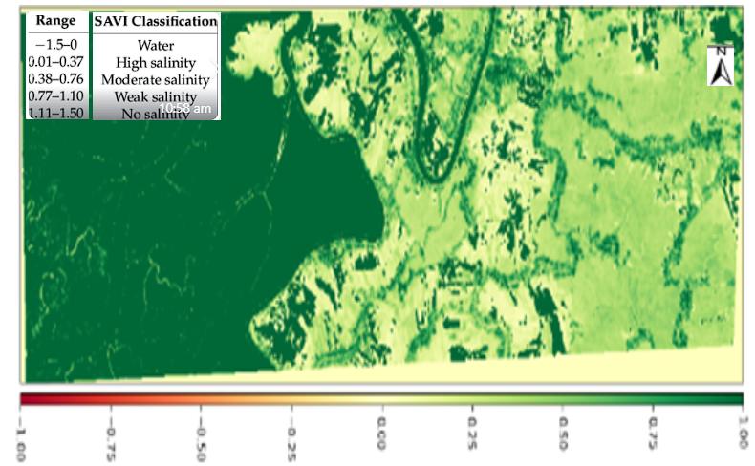
Fig 7: Separation of sea and in-landwater by feature extraction for NDVI method
The applications are in lands with sparse vegetation areas where soil brightness can have significant influence the NDVI. The index SAVI corrects the soil brightnessvalue by adopting a soil brightness correction factor (SBCF) (L), (typically set to 0.5), into the NDVI formula denominator.On an area with in vegetation, L is assigned value 1.0 and for moderate vegetative cover L=0.5 and greeny vegetative cover L=0. This index yields have range -1.0 and 1.0.
3.2.1 RS satellite image applied for surface water:
Satellite images help us monitor surface water like rivers and lakes. It covers large areas and takes pictures regularly, showing changes over time. This helps us track things like floods and droughts and monitor water quality. These images are accessible to many people and are especially useful in remote areas- satellite images can help us manage and protect our water resources.
3.3.0 Modified Normalized Difference Water Index (MNDWI):
Modified Normalized Difference Water Index (MNDWI) is a variant of the NDWI index used to detect waterbodies in satellite or aerial images. This index is more effective compared to the BDWI index as it reduces characteristics of built-up areas that often correlate with open water in other indices- It is calculated using the green and SW"IR channels-
3.3.1 Calculation of MNDWI
It is calculated using the formula: = (Green— StMR2) / (Green + St.uR2)
Where Green = pixel values from the green band
SIVIR = pixel values from the short-wave infrared band
The interpretation of MNDWI is a RS index , which is applied to detect and analyze water bodies shown in an satellite aimagery. It improves water features while overpowering noise from settlements or built-up land, svegetations, and soil. Water bodies in MNDWI exhibit (+) values, while soil, settlements and vegetation characteristically expressed with negative values.
3.4.0 Normalised Difference Moisture Index (NDMI)
NDMI is used to determine vegetation water content. It is calculated as a ratio between the NIR and SWIR values in a traditional fashion.The Normalized Difference Moisture Index (NDMI) detects moisture levels in vegetation using a combination of near-infrared (NIR) and short-wave infrared (SWIR) spectral bands. It is a reliable indicator of water stress in crops.
The NDMI is represented as a RS index which is used to estimate vegetation water contented and monitor drought situations. Calculation of SWIR is done by It is calculated by using the difference between near-infrared (NIR) and shortwave infrared (SWIR) reflectance bands and dividing it by the sum of those bands. NDMI values range from -1 to 1, with higher values generally indicating greater vegetation water content and lower values suggesting water stress.
3.4.1 Computation of MNDWI
It is calculated using the formula:
NDMI = (NIR - SWIR1)/(NIR + SWIR1)
Where NIR = pixel values from the near-infrared band
SWIR1 = pixel values from the short-wave infrared band -1
3.4.2 Application: The interpretation of NDMI values are bare soil (-1.0 to -0.8), for canopy cover least (-0.8 to -0.6), Very low (-0.6 to -0.4, dry tovery low (-0.4-0.2), Water stress for low/mid-low/High (-0.2 to 0), average canopy cover (0 to 0.2), Mid to High canopy cove or high/low water stress (0.2-0.4),No water stress with high canopy cover (0.4 to 0.6), very High canopy cover (0. 6to 0.8) and waterlogged areas with total canopy cover (0.8 to 1.0)•
3.4.3 NDMI is used when
- Regularly monitor water content in crops,
- Determine field/farm zones with water stress,
- Improve tree harvest logistics planning,
- Determine the combustibility levels in fire-prone areas.
The NDMI range between values -1 to +1. The colourwhite to pale brown, the lowest values indicate low vegetation water stress, and the highest ones (in blue) correspond to high water content. The water stress values varies to waterlogging when NDMI tends abnormally high showing water-logging areas.
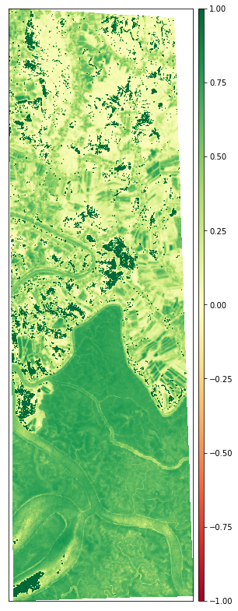
Fig 8: Normalised Difference Moisture Index (NDMI) for knowing water logistics.
3.5.0 Geological Indices: -
Geological indices, fusioned with mapped images provide intuitions about the structural history, stratigraphy, lithology, geo-chronology, and interpret the structure, mineralogy, paleontology, and proxies in the Earth's crust. co. Geological indices of an area are used to index minerals, determining metamorphism or geological processes such as lithological sequences, geological structures, folds, faults, depositions and earth’s dynamic occurances. Combined with ground trothing there is need for identifying the parent rock (protolith ), chemical reactions to solid minerals with other minerals to produce new minerals.
3.5.1 Clay Minerals:
Clay minerals are a group of hydrous aluminosilicate minerals essential to the Earth's crust. They are characterised by their small particle size (less than two micrometres) and layered crystal structure. Clay minerals play significant roles in various geological processes and can indicate specific environmental conditions. Several indices and methods are used to characterise and analyse clay minerals.
Clay Minerals Ratio = SWIR1 / SWIR2
SWIR1 = pixel values from the short-wave infrared one-band
SWIR2 = pixel values from the short-wave infrared two-band
3.5.2 Ferrous minerals:
Ferrous minerals are metallic minerals that contain iron and are magnetic. These minerals are essential components of the Earth's crust and have various geological and industrial significance. Understanding and analysing ferrous minerals involves several indices and methods commonly used in geology.
Ferrous Minerals Ratio = SWIR / NIR
SWIR= pixel values from the short-wave infrared band
NIR = pixel values from the near infrared band
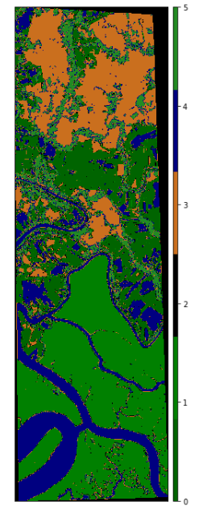
Fig 9: Imagery fusion of attributes like SWIR(1) and SWIR (2) for water body boundaries (Vegetation, minerals, soil and water)
Geological indices maps are formed to picturise and interpret several geological topographies and their properties in the Earth's crustsurface. These images are generated based on field samples, (including rock species) that measure geological structures, and GPS data are collected. Interpretation includes consideration of the relations between dissimilar geological units, processes, andstructures through map compilation, laboratory analysis, colouring and symbol assigning (Ashokan et al, 2020[42], Mishra et al. 2024[43]).
3.6.0 Fusion of bands satellite imageries:
Band fusion in Remote Sensing, is to syndicate data from various satellite sensors to generate images with boosted spectral and spatial resolution. This process adopts analysis of Earth's crust, lessening the strong points of multiple sensors. The high-resolution panchromatic information of lower-resolution multispectral data can produce images with enhanced spatial detail but the spectral information is retained.
The fusion of various bands has multiple fields like environment, agriculture, land use and land cover mapping, disasters etc. Other benefits are the Panchromatic data can be sharpened, and best use for vegetation monitoring, mineral mapping.
The Landsat and Sentinel-2, allows for the creation of a more consistent and comprehensive dataset, potentially bridging gaps in data availability or resolution (Gasmi et al. 2022[44],Wen et al., 2025[45]) . The Figure 10 (a and b) depict the fusion image of the study area with vegetation red edge and SWIR-Cirrus for chlorophyll absorption in vegetation.
a. 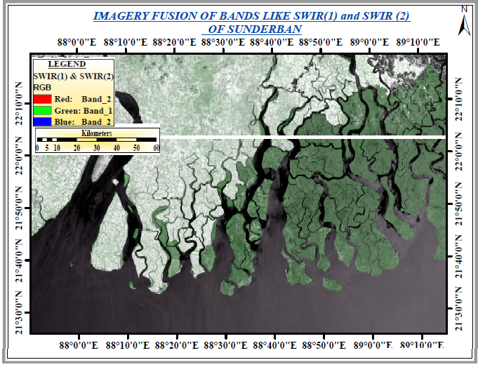
b.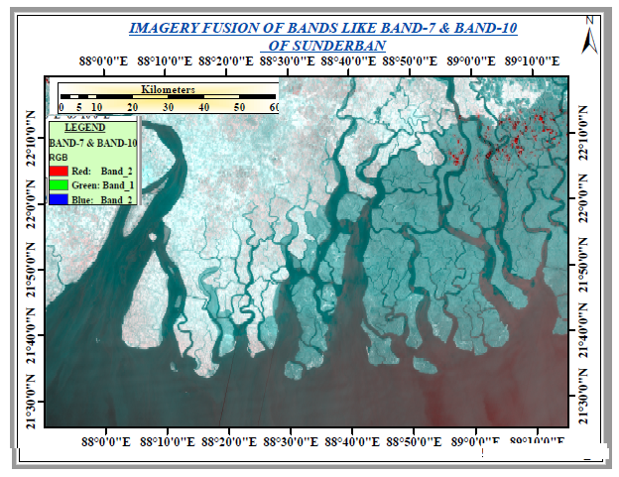
c. 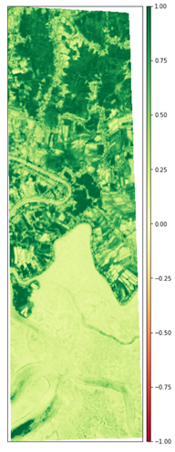
Fig 10 (a, b, and b):a. Fusion of SWIR 1 and SWIR 2 (b) Fusion of Band 7 and Band 10, (c.) Fusion of vegetation red EDGE and SWIR-Cirrus (For chlorophyll absorption in Vegetation.)

4.0.0 Discussion:
The NDVI, SAVI, NDMI, MNDWI and geographical indices maps of Indian Sunderbans the results perceived are:
The NDVI results infer that the ecosystem of Indian Sunderbans is deteriorating gradually degradation with decline in density, greenness and mangrove forest coverage since last 50years which need immediate attention and adequate strategic planning. Mostly coastal areas are denuding of mangroves whereas few areas showing increase in vegetationOn ground truthing it is observed that increased tourism, urbanisation, anthropogenic activities, habitation, increased crop areas over time and climate change impacts have aggravated the strategies. During the year 2015, 2020, and 2023, the NDVI values of Indian Sunderban were 0.872, 0.885 and 0.962 indicating improvement in Sunderban’s mangrove forests, Jana et al, 2022[46], Kanjin et al, 2024[27].
The SAVI image infer that the Indian Sunderbans there is depleting trend sweet water loving mangrove associates which is substituted by brackish water pure mangroves changing forest composition due to altering anostomasis in eenviornmental flow patterns indicating potential swing in the ecological sustainability, overall health and biodiversity of the mangrove forests. This change shall have impact on essential services on the blue carbon ecosystem like flora, fauna, aqua fauna, avifauna with coastal protection, and carbon sequestration.It is ascertained from India Sunderbans groundwater data, the underground aquifers are becoming more saline (about one ppt.) due to salinity intrusion particularly in islands like Gosaba, Namkhana, Pathar Pratima, Basanti, Kultali, Hingalganj, and Sagar Island Block, Bhadra et al, 2022[47], https://datacatalog.worldbank.org/search/dataset/0038270
NDMI map of India’s Sunderban can be interpreted about the moisture content and the greenness of vegetation of the mangrove ecosystem and the mangrove associates. The Ganga-Brahmputra-Meghana is the fastest growing bird footed delta of the globe and acknowledged for its anastomosed drainage system, diverse mangrove forests of ethenobotanical importance and IUCN redlisted habitats. The panaromic ecosystem is under threat climate change impacts, regional sea level rise, deforestation, salinityintrusion added by anthropogenic stresses (islam T. 2014[48], Sahana et al, 2022[49], Mishra et al, 2023[50],
It is ascertained from the geological indices map that the Indian Sunderbans area is dynamic and fluctuating landscape shaped by natural fluvial/aeolian forces and human stresses. Key geological features of the area include erosion, accretion, floods, tropical cyclones, sediment entry from Ganga Brahmaputra and Meghana delta, longshore drift and the impact of BoB cyclones and tidal surges on mangrove vegetation etc. The India Sundarbans is at a constant threat from land loss and gain. Erosions occur in the affecting sea-facing islands and accretion occurring on the northern side. Additionally, the region is characterized by a highly unstable geomorphology due to the interplay of erosion, accretion, and neo-tectonism.t The geological indices and informations alerted the researchers and policymakers provide clear view of the Sundarbans ecosystem in India, its vulnerabilities, greenness, ground water quality, that have negative impact on health and resilience of the unique ecosystem. The timely well judged pan and policy implementations can develop effective addressal to conservation and management strategies to protect this vital and unique ecosystem, (Ayikpia et al, 2025[51].
To attend to shoreline erosion/ accretional changes along the creeks and estuaries that is deteriorating Sunderban ecosystem it warrants to work on long or shortterm plans in the fragile fabric of Indian Sundarbans. It has become high time to ponder and monitor multiferous ecosystem services like protection ferry ghats, connecting iislands through structures, storm surges protection activities, prohibition for human trespass, carbon sequestration as ecosystem service supports.
4.5.0 Conclusion:
Satellite image analysis is crucial in various fields, such as environmental monitoring, urban planning, agriculture, disaster management, and defence intelligence. The Challenges in Satellite Image Processing become easier by overcoming noise, atmospheric effects, and varying spatial resolutions.For improved classification, anomaly detection, for spatial spectral details, disabling band gaps change detection fusion considered to be one of the best tool to sharpn the high resolution data along with generation of NDVI, SAVI, NDMI, MNDWI and geographical indices maps. On GIS studies on Indian Sunderban can be inferred that the fusion methods applied can be one of the best classification providing accuracy, time saving especially when dealing with ome metaheuristic methods to assign complexieties in weather, land, forests and water bodies.
The future Indian Sundarbans can be projected with declining mangrove associates, land loss/gain, more settlements and agricultural activities, tourism, Fishery, climate change threats. Salinity intruision,increased requency of BoB tropical cyclone, sedimentation with surged manmade activities that with deteriorated biodiversity of the Indian Sundarban.
4.6.0 Declarations
4.6.1 Ethics Approval: Not applicable.
4.6.2 Data availability: Data downloaded from Sentinel satellites, from public interaction during ground truthing, electronic media of Google Earth, USGS earth explorer,
4.6.3 Abbreviations: All abbreviations have expansions during their first use within the text.
4.6.4 Disclaimer (Artificial intelligence):
Option 1: Author(s) hereby declare that NO generative AI technologies such as Large Language Models (ChatGPT, COPILOT, etc.) and text-to-image generators have been used during the writing or editing of this manuscript.

Reference:
- Asokan, A., Anitha, J., Ciobanu, M., Gabor, A., Naaji, A., & Hemanth, D. J. Image Processing Techniques for Analysis of Satellite Images for Historical Maps Classification—An Overview. Applied Sci., (2020). 10(12), 4207. https://doi.org/10.3390/app10124207
- Scarpetta, M., De Palma, L., Di Nisio, A., Spadavecchia, M., Affuso, P., & Giaquinto, N. (2025). Optimizing Satellite Imagery Datasets for Enhanced Land/Water Segmentation. Sensors, 25(6), 1793. https://doi.org/10.3390/s25061793
- Dritsas, E., & Trigka, M. (2025). Remote Sensing and Geospatial Analysis in the Big Data Era: A Survey. Remote Sensing, 17(3), 550. https://doi.org/10.3390/rs17030550
- Delaney, B., Tansey, K., & Whelan, M. (2025). Satellite Remote Sensing Techniques and Limitations for Identifying Bare Soil. Remote Sensing, 17(4), 630. https://doi.org/10.3390/rs17040630
- Mishra SP., Paramanick S. Gosaba Island in Indian Sunderban: A Dystopia Allochthonous Ecosystem. Computer Research and Development 24(7), 2024
- Mojid, M. A., Mainuddin, M., Karim, F., & Wahid, S. M. (2025). Historical and Projected Future Hydrological Characteristics of the Mangrove Forest in the Ganges Delta—A Review. Water, 17(6), 838. https://doi.org/10.3390/w17060838
- Ang, M. L. E., Owen, J. R., Gibbins, C. N., Lèbre, É., Kemp, D., Saputra, M. R. U., Everingham, J.-A., & Lechner, A. M. (2023). Systematic Review of GIS and Remote Sensing Applications for Assessing the Socioeconomic Impacts of Mining. The J. of Env. & Dev., 32(3), 243-273. https://doi.org/10.1177/10704965231190126
- Chatrabhuj, Meshram, K., Mishra, U. et al. Integration of remote sensing data and GIS technologies in river management system. Discov Geosci 2, 67 (2024). https://doi.org/10.1007/s44288-024-00080-8
- Bar Subhadip, Remote Sensing and GIS Applications in Wetland Monitoring, Department of Fisheries Science, The Neotia University, Dept. of Fisheries Science, Conference: World Wetlands Day, February 2025, P-1
- Rivera A., Rolando J., Cabezas C., 11 authors Cabrera M., 2023, Satellite Image Using Image Processing and Machine Learning Techniques: applications to agriculture, environment and mining. Eur. Chem. Bull. 2023, 12 (1), 1718 – 1734DOI: 10.31838/ecb/2023.12.1.256
- Mishra, S. P., Mishra, A., Kumar, C., Mishra, S., & Nanda, R. (2023). Fretful Longevity of Upper Kolab Reservoir, Odisha by GIS Study. Journal of Scientific Research and Reports, 29(3), 36–52. https://doi.org/10.9734/jsrr/2023/v29i31735
- Mishra S. P., Nayak Shakti Pr, Mishra Saswat, Siddique Mohammed, Ch. Sethi Ku., 2019, GIS And Auto Desk Modelling For Satellite Cities around Bhubaneswar, International Journal of Innovative Technology and Exploring Engineering (IJITEE) ISSN: 2278-3075, Volume-8 (11), September 2019, PP- 297-306
- Chaminé, H.I., Pereira, A.J.S.C., Teodoro, A.C. et al. Remote sensing and GIS applications in earth and environmental systems sciences. SN Appl. Sci. 3, 870 (2021). https://doi.org/10.1007/s42452-021-04855-3
- Nanda RN., Mishra S.P., Siba Prasad Mishra, Barik K.K., Sethi K.C., (2023). Review of Episodic Voyage of Engineering Surveying and Cartography in India. Current J. of Applied Sci. and Tech. 42(12):32-48:10.9734/CJAST/2023/v42i124109
- Mukherjee A, Kumari M, Mishra VN. Assessing post-monsoon seasonal soil loss over Un-Gauged Stations of the Dwarkeswar and Shilabati Rivers, West Bengal. India Earth. 2024;5(1):45–71.
- Mishra SP., Bauri Bhumika, 2024, Geo-sustainability Challenges and Remediation Strategies: A GIS-based Assessment of Sripur Coalmine Areas, West Bengal, India. 2024, Advances in Research 25(5):97-119, DOI: 10.9734/air/2024/v25i51142
- Gui R., Song W., Lv Juan, Lu. Y., Liu H.,,Feng T. Linghu S., Digital Elevation Model-Driven River Channel Boundary Monitoring Using the Natural Breaks (Jenks) Method. Remote Sens. 2025, 17(6), 1092; https://doi.org/10.3390/rs17061092
- Ghosh, M. K., Kumar, L., & Roy, C. (2016). Mapping Long-Term Changes in Mangrove Species Composition and Distribution in the Sundarbans. Forests, 7(12), 305. https://doi.org/10.3390/f7120305
- Samanta, S., Hazra, S., Mondal, PP., Chanda, A., Giri, S., et. Al. (2021). Assessment and Attribution of Mangrove Forest Changes in the Indian Sundarbans from 2000 to 2020. Remote Sensing, 13(24), 4957. https://doi.org/10.3390/rs13244957
- Chanda, A., & Akhand, A. (2023). Challenges towards the Sustainability and Enhancement of the Indian Sundarban Mangrove’s Blue Carbon Stock. Life, 13(8), 1787. https://doi.org/10.3390/life13081787
- Mishra Sibaprasad, Saswat Mohapatra, Saswat Mishra, (2024). Quest for Mangroves in Anthropocene, South Odisha Coast. Afr.J.Bio.Sc.6.12(2024), 2712-2731, https://doi.org/10.48047/AFJBS.6.12.2024.2712-2731
- Mohammed, SF., Khan, A., Ahammed, S., Saimun, MSR., Bhuiyan, MS., Srivastava, SK., Mukul, SA., Arfin-Khan, MAS. (2024). Assessing Vulnerability to Cyclone Hazards in the World’s Largest Mangrove Forest, The Sundarbans: A Geospatial Analysis. Forests, 15(10), 1722. https://doi.org/10.3390/f15101722
- Majumdar, MSM., Matsui, K. Understanding the Contribution of the Green Climate Fund (GCF) in Mangrove Forest Conservation: A Case Study on Sundarbans MF. Bangladesh. Sustainability, (2025). 17(8), 3583. https://doi.org/10.3390/su17083583
- Yeom, J., Jung, J., Chang, A., Ashapure, A., Maeda, M., Maeda, A., & Landivar, J. (2019). Comparison of Vegetation Indices Derived from UAV Data for Differentiation of Tillage Effects in Agriculture. Remote Sensing, 11(13), 1548. https://doi.org/10.3390/rs11131548
- Chaves, ED., Picoli , MCA., Sanches, I. (2020). Recent Applications of Landsat 8/OLI and Sentinel-2/MSI for Land Use and Land Cover Mapping: A Systematic Review. Remote Sensing, 12(18), 3062. https://doi.org/10.3390/rs12183062
- Tran, T. V., Reef, R., & Zhu, X. (2022). A Review of Spectral Indices for Mangrove Remote Sensing. Remote Sensing, 14(19), 4868. https://doi.org/10.3390/rs14194868
- Kanjin K., Alam BM. Assessing changes in land cover, NDVI, and LST in the Sundarbans mangrove forest in Bangladesh and India: A GIS and remote sensing approach. Remote Sensing Applications: Society and Env, 36, 101289, doi.org/10.1016/j.rsase.2024.101289
- Msadek, J., Tlili, A., Chouikhi, F., Ragkos, A., & Tarhouni, M. (2025). Assessing the Impacts of Climate Change Scenarios on Soil-Adjusted Vegetation Index in North African Arid Montane Rangeland: Case of Toujane Region. Climate, 13(3), 59. https://doi.org/10.3390/cli13030059
- Halder, B., and P. Pereira. 2024. “Climate Change Impacts Assessment on Bangladesh Mangrove Forest Using High-Resolution Datasets and Google Earth Engine.” Journal of Coastal Conservation 28 (1): 24. https://doi.org/10.1007/s11852-023-01020-3.
- Wei, S., Zhang, H., & Ling, J. (2025). A review of mangrove degradation assessment using remote sensing: advances, challenges, and opportunities. GIScience & Remote Sensing, 62(1). https://doi.org/10.1080/15481603.2025.2491920
- Xia, Q., Qin, C.-Z., Li, H., Huang, C., & Su, F.-Z. (2018). Mapping Mangrove Forests Based on Multi-Tidal High-Resolution Satellite Imagery. Remote Sensing, 10(9), 1343. https://doi.org/10.3390/rs10091343
- Mondal, B. K., Mahata, S., Basu, T., Das, R., Patra, R., Abdelrahman, K., Fnais, M. S., & Praharaj, S. (2024). Analysis of the Post-Cyclonic Physical Flood Susceptibility and Changes of Mangrove Forest Area Using Multi-Criteria Decision-Making Process and Geospatial Analysis in Indian Sundarbans. Atmosphere, 15(4), 432. https://doi.org/10.3390/atmos15040432
- Dutta, A., Karmakar, S., Das, S., Banerjee, M., Ray, R., Hasher, F. F. B., Mishra, V. N., & Zhran, M. (2025). Modeling the River Health and Environmental Scenario of the Decaying Saraswati River, West Bengal, India, Using Advanced Remote Sensing and GIS. Water, 17(7), 965. https://doi.org/10.3390/w17070965
- Roy, M.; Routaray, D.; Ghosh, S.; Ghosh, A. Ensemble of Multilayer Perceptrons for Change Detection in Remotely Sensed Images. IEEE Geosci. Remote Sens. Lett. 2014, 11, 49–53.
- Ahmad I., Basheri M., Iqbal M. J., and Rahim A., Performance comparison of support vector machine, random forest, and extreme learning machine for intrusion detection, IEEE Access. (2018) 6, 33789, https://doi.org/10.1109/access.2018.2841987, 2-s2.0-85047829926.
- Rana, S.S.; Habib, S.A.; Sharifee, M.N.H.; Sultana, N.; Rahman, S.H. Flood risk mapping of the flood-prone Rangpur division of Bangladesh using remote sensing and multi-criteria analysis. Nat. Hazards Res. 2023, 4, 20–31
- . Hossain A K., Masiero M., Pirotti, F. Land cover change across 45 years in the world’s largest mangrove forest (Sundarbans): the contribution of remote sensing in forest monitoring. European Journal of Remote Sensing. 2024, 57(1), 1-17, https://doi.org/10.1080/22797254.2022.2097450
- Melesse, A. M., Weng, Q., Thenkabail, P. S., & Senay, G. B. (2007). Remote Sensing Sensors and Applications in Environmental Resources Mapping and Modelling. Sensors, 7(12), 3209-3241. https://doi.org/10.3390/s7123209
- Dobesova, Z. (2021). Cognition of Graphical Notation for Processing Data in ERDAS IMAGINE. ISPRS International Journal of Geo-Information, 10(7), 486. https://doi.org/10.3390/ijgi10070486
- Sharma, S.; Beslity, J.O.; Rustad, L.; Shelby, L.J.; Manos, P.T.; Khanal, P.; Reinmann, A.B.; Khanal, C. Remote Sensing and GIS in Natural Resource Management: Comparing Tools and Emphasizing the Importance of In-Situ Data. Remote Sens. 2024, 16, 4161.
- Lozano-Tello, A., Siesto, G., Fernández-Sellers, M., & Caballero-Mancera, A. (2023). Evaluation of the Use of the 12 Bands vs. NDVI from Sentinel-2 Images for Crop Identification. Sensors, 23(16), 7132. https://doi.org/10.3390/s23167132
- Lozano-Tello, A., Siesto, G., Fernández-Sellers, M., & Caballero-Mancera, A. (2023). Evaluation of the Use of the 12 Bands vs. NDVI from Sentinel-2 Images for Crop Identification. Sensors, 23(16), 7132. https://doi.org/10.3390/s23167132
- Mishra SP., Bauri Bhumika, 2024, Geo-sustainability Challenges and Remediation Strategies: A GIS-based Assessment of Sripur Coalmine Areas, West Bengal, India. September 2024Advances in Research 25(5):97-119, DOI: 10.9734/air/2024/v25i51142
- Gasmi, A., Gomez, C., Chehbouni, A., Dhiba, D., & Elfil, H. (2022). Satellite Multi-Sensor Data Fusion for Soil Clay Mapping Based on the Spectral Index and Spectral Bands Approaches. Remote Sensing, 14(5), 1103. https://doi.org/10.3390/rs14051103
- Wen, T. H., & Teo, T. A. (2025). An object-based spectral and elevation feature fusion framework for landslide mapping using time-series Landsat-8 imagery. Geomatics, Natural Hazards and Risk, 16(1). https://doi.org/10.1080/19475705.2025.2471014
- Jana A., Bhunia GS., Vegetation Cover Analysis Based on NDVI in Moushuni Island, Sundarban, India . 2022, Int. J. for Research in Applied Sci. & Eng. Tech. (IJRASET)
- 10 (V), 2669-2677, https://doi.org/10.22214/ijraset.2022.42883
- Bhadra T., Banerjee S., Ghosh S., Saha A., Mukherjee K., Sardar R., Roy S., Das R., Monitoring The Mangroves Of Indian Sundarbans Using Geospatial Techniques. The Int. Archives of the Photogrammetry, RS, and Spatial Inf. Sci., XLVIII-1/W2-2023 ISPRS Geospatial Week 2023, 2–7 September 2023, Cairo, Egypt
- Islam T. Vegetation Changes Of Sundarbans Based On Landsat Imagery Analysis Between 1975 And 2006. 2014, Landscape & Env., 8(1):1-9
- Sahana, M., Areendran, G. & Sajjad, H. Assessment of suitable habitat of mangrove species for prioritizing restoration in coastal ecosystem of Sundarban Biosphere Reserve, India. Sci Rep 12, 20997 (2022),https://doi.org/10.1038/s41598-022-24953-5
- Mishra SP, Chakraborty T., Barik KK., 2023, Geomorphologic Changes and Ethnobotany Losses of Indian Sundarbans in Anthropocene. Current Journal of Applied Science and Technology, 42(41), 28-47, DOI: 10.9734/CJAT/2023/v42i414265.
- Ayikpa, K. J., Jofack Sokeng, V.-C., Ballo, A. B., Gouton, P., & Kouamé, K. F. (2025). Multi-Source Satellite Imagery and Machine Learning for Detecting Geological Formations in Cameroon’s Western Highlands. Signals, 6(1), 12. https://doi.org/10.3390/signals6010012

