Enhancing Dragon Fruit Growth: The Efficacy of Nano Urea as an Alternative to Conventional Urea in Subtropical Conditions

ABSTRACT
Among the recent technologies, nano fertilizers are an emerging innovation, which has the potential to offer sustainable solutions to enhance the efficient use of nutrients and growth of plants. Nano urea is one of them, increasing nitrogen availability to crops by more than 80%, leading to greater use of fertilizer efficiency and crop output. The present investigation was carried out to depict the best treatment combination of urea, and nano urea for vegetative growth of dragon fruit. There was a significant increase in vegetative growth by nano urea regarding various growth characteristics. Results suggested that nano urea was beneficial and resulted very close to the recommended dose of fertilizers (RDF). Among the treatments under study, the foliar application of Urea @ 2% combined with Nano urea @ 6ml/L may be recommended for dragon fruit growth, since it produced maximum vegetative growth of dragon fruit in terms of plant length, number of primary branches, number of segments of main stem, number of areoles, stem thickness, stem circumference, number of spines, distance between two areoles, arch height and chlorophyll content at subtropical Lucknow condition.
Keywords: Dragon fruit, Nano urea, Urea, Vegetative growth.
INTRODUCTION
Dragon fruit (Hylocereus spp.) is a cactus plant belonging to the family Cactaceae, having a chromosome no. 2n=22 is emerging as a supercrop even for marginal land owing to its health and medicinal benefits worldwide. It is popular with various names in different areas (Pitaya, Night Blooming Cereus, Strawberry Pear, Queen of Night, Jesus in the Cradle, Honorable Queen, Belle of Night). It originated in Mexico and Central and South America (Britton and Rose, 1963; Morton, 1987: Mizrahi et al., 1997) and is now cultivated in China, Australia, Hawaii, Indonesia, Guatemala, Israel, Taiwan, Malaysia, Vietnam and Thailand. In India, it is mainly grown in parts of Maharashtra, Karnataka and Gujarat, West Bengal, Uttar Pradesh (Maji et al., 2021). Following types are primarily popular in India, all with leathery, slightly leafy skin: Hylocereus undatus— white flesh with pink skin, Hylocereus polyrhizus– red flesh with pink skin, Hylocereus costaricencis – with violet red flesh and pink skin and Hylocereus (Selenicerus) megalanthus –white flesh with yellow skin (Hunt, 2006; Hamidah et al., 2017). The taste of this fruit is delicately sweet but crispy, and it looks alluring with its green scales and pink skin. It is rich in nutrient content, especially vitamin C, phosphorus, calcium as well as its antioxidant properties (Morton, 1987). Consumers can make value-added goods from the pulp of dragon fruit, wine. Pectin is rich in fruit peel, and according to various methods, fruit peel can produce 7.5% of pectin (Thirugnanasambandham et al., 2014). It is a good source of minerals, glucose, fructose, dietary fiber and vitamins (Rao and Sasanka, 2015) and well-known for its rich vitamin C, phosphorus, calcium as well as anti-oxidant contents (Morton, 1987) along with B group vitamins (LeBellec et al., 2006). Whereas, seeds contain 50% of essential fatty acids namely, Linoleic acid and Linolenic acid (Sonawane, 2017). Regular consumption of dragon fruit greatly controls the asthma, cough, cholesterol, helps in preventing cancer, boosts immune power.
Although dragon fruit is well responsive to nutrient management. Judicious application of fertilizers and manures is necessary for higher fruit yield with better quality (Nangare et al., 2020; Singh et al., 2022). Nano urea is bioavailable to plants because of its desirable particle size about 20-50 nm and more surface area about (10000 times over 1mm urea prill) and number of particles (55000, nitrogen particles over 1mm urea prill). Hence, nano urea increases its availability to crops by more than 80% resulting in higher nutrient use efficiency (Anon., 2005) as stated by IFFCO. Nano urea is responsible for influencing both qualitative as well as quantitative aspects of dragon fruit. Keeping these facts in view a field experiment was conducted to assess the efficiency of nano urea along with urea on the growth of dragon fruit plants.
MATERIALS AND METHODS
The experiment was carried out at dragon fruit orchard, Department of Horticulture, Babasaheb Bhimrao Ambedkar University, Lucknow (Uttar Pradesh), India (26°55′N latitudes and 80°54′E, 123 m above MSL) in the subtropical climate of central Uttar Pradesh) during 2022-23. Soil was sandy loam with uniform fertility having pH of 8.1. There were 10 treatments- Control (T₀), RDF 100% (T₁), 2% N₂ through Urea (T₂), 1.5% N₂ through Urea (T₃), 6ml/l Nano Urea (T₄), 4 ml/l Nano Urea(T₅), 2% N₂ through Urea + 6 ml/l Nano Urea (T₆), 2% N₂ through Urea + 4 ml/l Nano Urea(T₇), 1.5% N₂ through Urea + 6 ml/l Nano Urea (T₈), 1.5% N₂ through Urea + 4 ml/l Nano Urea(T₉) which were laid out in Randomized Block Design with 3 replications. There were 30 poles each having 4 plants planted at 4 m x 2 m spacing. The base area of 1 m radius was cleaned for fertilizer and irrigation management. Plants along with new growth are tied up with pole regularly for better support.
Nano urea was collected from IFFCO Bhawan - 8, IFFCO State Office, Gokhle Marg, Lucknow (UP) which had desirable particle size about 20-50 nm and more surface area (10000 times over 1 mm urea prill) and several particles (55000, nitrogen particles over 1mm urea prill). Well-rotted FYM @ 16 kg/pole, Vermicompost @ 8 kg/pole and recommended dose of fertilizer @ 200g N₂, 225g P₂O₅, 137.5g K₂O/Pole (Nangare et al., 2020) were applied in two split doses first during November 2021 and second during February 2022 (end of winter). Chemical fertilizers, vermicompost and FYM were applied as soil application followed by irrigation whereas nano urea was applied twice as foliar spray as per treatment combination. Observations were recorded for its vegetative growth like plant length, number of primary branches, number of segments of main stem, number of areoles, stem thickness, stem circumference, number of spines, distance between two areoles, arch height and chlorophyll content using standard methods of biochemical analysis (Thimmaiah, 2009). To test the significance of variance in the data obtained from the various vegetative growth characters, the technique of analysis of variance was adopted as suggested by Panse and Sukhatme (1985) for Randomized Block Design (RBD). Significance of difference in the treatment effect was tested through ‘F’ test at 5% level of significance and critical difference (CD) was calculated, wherever the result was significant or not.
RESULTS AND DISCUSSION
Plant length
It was evident from Table 1 and Fig. 1 that there was a significant difference among the treatments at 30, 45, 60, 75, and 90 days after treatment (DAT). It was observed that an increase in plant length (7.09 cm) was recorded maximum at 45 days (from 30 DAT to 45 DAT) with T₆ treatment (2% N₂ through Urea + 6 ml/l Nano urea) followed by a 5.70cm increase in T₉ treatment (1.5% N₂ through Urea + 4 ml/l Nano urea). It was seen that a maximum increase (7.09 cm) in length at 45 DAT from 30 DAT was recorded under treatment T₆ (2% N₂ through Urea + 6 ml/l Nano urea) and at 60 DAT, it was maximum observed on T₆ (2% N₂ through urea + 6 ml/l Nano urea). Similarly, there was no specific pattern of increase since T₆ showed highest increase at 75 DAT from 60 DAT and continued to 90 DAT followed by T₂. It was also calculated that T₆ caused a maximum increase from 30 DAT to 90 DAT and control plants recorded minimum increase. However, at various stages of growth, the highest rate of increase in plant length was observed on increase at 75 DAT from 60 DAT. Overall, it was noticed that maximum total increase from 30 DAT to 90 DAT was recorded at T₆ and minimum increase was observed in untreated control. Kumar et al. (2020) also reported that nano fertilizers significantly increased plant growth and yield.
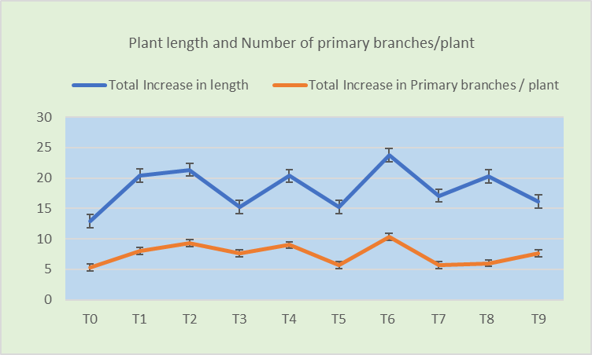
Fig.1. Effect of Urea and Nano-urea on increase of plant length and Number of primary branches / plant from 90 DAT
Number of primary branches/plant
It was seen that maximum (2.67) increase in number of branches was noticed under treatment T₂ (2% N₂ through Urea) and At 60 DAT (from 45 DAT to 60 DAT), it was found that maximum (3.00) increase in number of branches was under treatment T₃ (1.5% N₂ through Urea). It was evident from the above results (Table 1 and Fig. 2) that change in number of branches from 45 days to 60 days was non-significant (at 5% level of significance).
It was noticed that treatment T₆ (2% N₂ through Urea + 6 ml/l Nano urea) showed highest number of branches increase (3.66) followed by treatment T₁ (2.66) was recorded under treatment T₃ (from 60 DAT to 75 DAT) similarly, overall increase in number of branches from 30 to 90 DAT, maximum number of branches (10.33) was obtained with treatment T₆ (2% N₂ through Urea + 6 ml/l Nano urea)
Number of areoles/segments (three sides)
The number of areoles was counted on three sides of a segment and increase in a number of areoles was presented in Table 2. It showed that maximum increase in a number of areoles per segment was measured (6.67) under treatment T₂ (2% N₂ through Urea) at 45 DAT (from 30 DAT to 45 DAT). However at 60 DAT (from 45 DAT to 60 DAT), it was found that maximum increase (5.33) in number of areoles per segment was noticed under treatment T₁ (RDF).
At 90 DAT (from 75 DAT to 90 DAT), it was seen that treatment T₁ (RDF) caused highest increase in number of areoles/segment (5.33) data observed (Fig. 3) in total overall increase in number of areoles (Table 4) from 30 to 90 DAT, revealed that maximum increase in number of areoles/segment (18.00) was in treatment T₁ (RDF) and minimum increase was found in T₅ treatment (4 ml/l Nano urea).
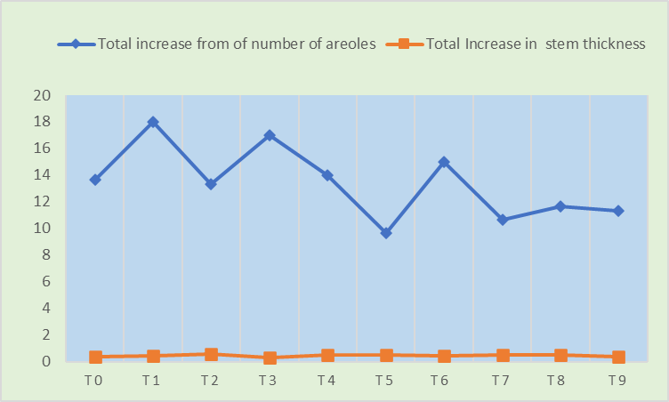
Fig.2. Effect of Urea and Nano-urea on increase of number of areoles per segment.and stem thickness.
Stem thickness
It was also observed (Table 2) that T₆ (2% N₂ through Urea + 6 ml/l Nano urea) caused maximum increase in stem thickness at 45 DAT and At 60 DAT (from 45 DAT to 60 DAT), it was found (Fig. 4) that maximum (0.26 cm) increase in stem thickness under treatment T₇ (2% N₂ through Urea + 4 ml/l Nano urea) and treatment T₅ (4 ml/l Nano urea) showed highest increase (0.34 cm) in stem thickness from 60 to 90 DAT. The maximum stem thickness was recorded at 90 DAT (4.55cm) under T₂ (2% N₂ through urea), which also showed the maximum increase in stem thickness. Law-Ogbomo and Law-Ogbomo (2009) reported that NPK fertilizer applications significantly increase plant stem girth in maize.
Number of spines per areoles
An increase in number of spines per areoles (0.16) was recorded maximum at 45 days (from 30 DAT to 60 DAT) with treatment T₄ (6ml/l Nano urea) (Table 3). Similarly, T₄ also showed

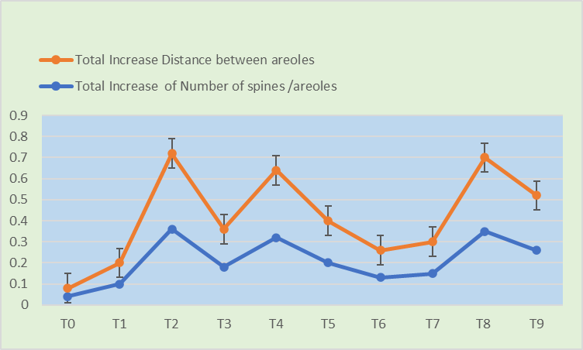
Fig.3. Effect of Urea and Nano-urea on distance of areole and number of spines per areole.
Distance between areoles (cm)
The variation in distance between areoles is presented in Table 3 and it showed that maximum increase in distance between areoles was measured (0.13cm) under treatment T₆ (2% N₂ through Urea + 6ml/l Nano urea) at 30 DAT to 60 DAT and at 75 DAT 90 DAT Maximum (0.07 cm) increase in distance between areoles was recorded under treatment T₇ (2% N₂ through Urea + 4ml/l Nano urea). The maximum distance between areoles was recorded at 90 DAT (3.63cm) under T₃ (1.5% N₂ through urea), however, T₆ (2% N₂ through Urea + 6ml/l Nano urea) showed the greatest increase in distance between areoles from 30 DAT to 90 DAT. Over-vegetative growth promotion was also reported by Maurya et al. (2023).
Conclusion
The study successfully demonstrated the potential of nano urea as a superior alternative to conventional urea in enhancing the vegetative growth of dragon fruit under subtropical conditions with slightly alkaline soil. The application of nano urea significantly improved various growth parameters, reflecting its efficacy in increasing nitrogen availability and fertilizer use efficiency. Among the different treatments evaluated, the combination of foliar application of Urea at 2% and Nano urea at 6ml/L was found to be the most effective, yielding the maximum vegetative growth. These findings suggest that nano urea, in conjunction with a reduced rate of conventional urea, can be recommended as an optimal fertilization strategy for dragon fruit cultivation, contributing to higher crop productivity and better soil health.
References
Anonymous (2005). Indian Farmers Fertilizer Cooperative Limited (IFFCO). https://www.iffco.in/en/nano-urea-liquid-fertilizer
Britton, N. L., & Rose, J. N. (1963). The Cactaceae: Descriptions and Illustrations of Plants of the Cactus Family (Vol. 2). The Carnegie Institution of Washington.
Hamidah, U., Chusnul, I., & Badri, A. (2017). Characterization of Dragon Fruit (Hylocereus spp.) and its Functional Properties. International Journal of Food Science and Nutrition, 2(4): 100-106.
Hunt, D. (2006). Cactus Family: The Complete Guide to the Cactus Family. Timber Press.
Kumar R, Pandey DS, Singh VP, Singh IP (2020). Nano-technology for better fertilizer use (Research experiences at Pantnagar). Res Bull, p 20
Law-Ogbomo KE, Law-Ogbomo JE (2009). The performance of Zea mays is influenced by NPK fertilizer application. Not Sci Biol 1(1): 59-62.
LeBellec, F., Wiart, C., & Vasseur, J. (2006). Hylocereusundatus: A Review of its Nutritional Properties and Health Benefits. Journal of Agricultural and Food Chemistry, 54(15): 5850-5855.
Maji, S., Meena. K. and Kumar, S. (2021). Influence of various lengths of stem cutting for successful propagation of Dragon fruit [Hyloceruscosturicensis (Web.) Briton and Rose]. Crop Research.56 (6): 313-316.
Maurya, A., Maji, S., Razauddin.,Mayaram., Rawat, A. and Meena, R.(2023). Studies on vegetative growth of dragon fruit [Hylocereus costaricensis (Web.) Britton and Rose] as Influenced by Nano Urea, Urea, FYM and Vermicompost. Environment and Ecology. 41 (1): 709-716
Mizrahi, Y., Nerd, A., & Oppenheim, A. (1997). Cactaceae: Hylocereus and Selenicereus—A New Generation of High-Quality Tropical Fruits. Horticultural Reviews, 19: 137-164.
Morton, J. (1987). Dragon Fruit. In Fruits of Warm Climates (pp. 279-283).
Nangare, D. D., Mehta, S. K., & Kale, P. B. (2020). Effect of Different Nutrient Management Practices on Growth and Yield of Dragon Fruit (Hylocereus spp.). Indian Journal of Horticulture, 77(3): 385-389.
Panse, V.G. and Sukhatme, P.V. (1995) Statistical Methods for Agricultural Workers. ICAR, New Delhi.
Rao, A. S., & Sasanka, R. (2015). Nutritional Evaluation of Dragon Fruit (Hylocereus spp.). International Journal of Science and Nature, 6(3): 317-320.
Singh, R., Maji, S., Razauddin, Mayaram and Meena, R.C. (2022). Response of Dragon Fruit [Hylocereus costaricensis (web.) Britton and Rose] on combined use of Chemical and Organic Nutrition Management. Indian Journal of Natural Sciences. 13 (74): 48746- 48750.
Sonawane, A. K. (2017). Nutritional and Medicinal Properties of Dragon Fruit. Research Journal of Pharmacognosy and Phytochemistry, 9(1): 227-229.
Thimmaiah, S. K. (2009). Standard Methods of Biochemical Analysis. Kalyani Publishers.
Thirugnanasambandham, K., Ranjitha, S. and Jayamurthy, P. (2014). Extraction and Characterization of Pectin from Dragon Fruit Peel (Hylocereus spp.). International Journal of Biological Macromolecules, 68: 223-227.

Treatment | Plant length (cm) at 30 DAT | Increase in length (cm) at (30-45 DAT) | Increase in length(cm) at (45-60DAT) | Increase in length (cm) at( 60-75 DAT) | Increase in length (cm) at (75-90 DAT) | Plant length (cm) at 90 DAT | Total Increase (cm)(from 30 days to 90 days) | Number of primary branches/plant at 30 DAT | Increase in Primary branches / plant at (30-45 DAT) | Increase in Primary branches / plant at(45-60 DAT) | Increase in Primary branches / plant at (60- 75 DAT) | Number of primary branches/ plant at 75-90 DAT | Increase in Primary branches / plant 90 DAT) | Total Increase (cm)(from 30 days to 90 days)
T₀ | 187.67 | 2.66 | 3.29 | 10.70 | 2.23 | 200.6 | 12.93 | 6.00 | 1.33 | 1.00 | 2.00 | 1.00 | 11.33 | 5.33
T₁ | 183.33 | 4.90 | 5.76 | 16.47 | 3.93 | 203.73 | 20.40 | 8.00 | 1.00 | 2.67 | 2.66 | 1.67 | 16.00 | 8.00
T₂ | 201.67 | 4.80 | 6.64 | 17.53 | 3.84 | 222.04 | 21.37 | 9.33 | 2.67 | 2.67 | 1.66 | 2.34 | 18.67 | 9.34
T₃ | 193.70 | 4.63 | 3.30 | 11.69 | 3.58 | 208.97 | 15.27 | 8.67 | 2.00 | 3.00 | 1.33 | 1.33 | 16.33 | 7.67
T₄ | 189.17 | 4.16 | 5.50 | 12.35 | 7.99 | 209.51 | 20.34 | 10.00 | 2.33 | 2.67 | 2.33 | 1.67 | 19.00 | 9.00
T₅ | 193.70 | 4.63 | 3.30 | 11.69 | 3.58 | 208.97 | 15.27 | 10.33 | 1.33 | 2.00 | 1.66 | 0.67 | 16.00 | 5.67
T₆ | 195.67 | 7.09 | 8.47 | 18.46 | 5.29 | 219.42 | 23.75 | 9.00 | 1.67 | 2.00 | 3.66 | 3.00 | 19.33 | 10.33
T₇ | 193.62 | 5.32 | 4.38 | 13.80 | 3.30 | 210.72 | 17.10 | 11.00 | 1.33 | 2.00 | 1.66 | 0.67 | 16.00 | 5.67
T₈ | 183.00 | 4.14 | 6.43 | 15.60 | 4.68 | 203.28 | 20.28 | 8.00 | 1.33 | 2.33 | 0.66 | 1.67 | 17.00 | 6.00
T₉ | 183.67 | 5.70 | 5.06 | 11.04 | 5.12 | 199.83 | 16.16 | 7.67 | 1.67 | 1.66 | 2.34 | 2.00 | 15.67 | 7.67
SEm () |  | 0.459 | 0.075 | 0.140 | 0.060 |  | 0.204 |  | 0.014 | 0.023 | 0.258 | 0.015 |  | 0.324
CD(P=0.05) |  | 1.374 | 0.226 | 0.419 | 0.180 |  | 0.610 |  | 0.042 | 0.069 | 0.772 | 0.045 |  | 0.969
Control (T₀), RDF 100% (T₁), 2% N₂ through Urea (T₂), 1.5% N₂ through Urea (T₃), 6ml/l Nano Urea (T₄), 4 ml/l Nano Urea(T₅), 2% N₂ through Urea + 6 ml/l Nano Urea (T₆), 2% N₂ through Urea + 4 ml/l Nano Urea(T₇), 1.5% N₂ through Urea + 6 ml/l Nano Urea (T₈), 1.5% N₂ through Urea + 4 ml/l Nano Urea(T₉) respectively

Table 1. Effect of Urea and Nano-urea on Increase of plant length,Number of primary branchesof dragon fruit

Treatment | Increase of number of areoles at 30 DAT | Increase of number of areoles at (30-45 DAT) | Increase of number of areoles at (45-60DAT) | Increase of number of areoles at( 60-75 DAT) | Increase of number of areoles at (75-90 DAT) | Increase of number of areoles at 90 DAT | Total increase from 30 days to 90 days) | Number of stem thickness at 30 DAT | Increase in stem thickness at (30-45 DAT) | Increase in stem thickness at(45-60 DAT) | Increase in stem thickness at (60- 75 DAT) | Number of stem thickness at 75-90 DAT | Increase in stem thickness 90 DAT) | Total Increase (cm)(from 30 days to 90 days)
T₀ | 45.00 | 3.33 | 3.34 | 4.66 | 2.34 | 58.67 | 13.67 | 3.83 | 0.04 | 0.10 | 0.13 | 0.07 | 4.17 | 0.34
T₁ | 44.33 | 3.67 | 5.33 | 3.67 | 5.33 | 62.33 | 18.00 | 3.90 | 0.10 | 0.10 | 0.20 | 0.03 | 4.33 | 0.43
T₂ | 39.33 | 6.67 | 3.33 | 2.34 | 1.00 | 52.67 | 13.34 | 3.97 | 0.06 | 0.20 | 0.20 | 0.09 | 4.52 | 0.55
T₃ | 40.00 | 5.67 | 5.33 | 3.33 | 2.67 | 57.00 | 17.00 | 4.60 | 0.07 | 0.07 | 0.13 | 0.07 | 4.93 | 0.33
T₄ | 45.00 | 3.00 | 4.00 | 5.00 | 2.00 | 59.00 | 14.00 | 3.90 | 0.07 | 0.17 | 0.17 | 0.10 | 4.40 | 0.50
T₅ | 44.67 | 0.33 | 2.00 | 4.33 | 3.00 | 54.33 | 9.66 | 3.43 | 0.03 | 0.13 | 0.23 | 0.07 | 3.90 | 0.47
T₆ | 34.00 | 2.00 | 3.00 | 6.00 | 4.00 | 49.00 | 15.00 | 4.33 | 0.20 | 0.07 | 0.10 | 0.06 | 4.76 | 0.43
T₇ | 40.33 | 3.67 | 3.00 | 2.00 | 2.00 | 51.00 | 10.67 | 4.20 | 0.01 | 0.26 | 0.17 | 0.05 | 4.68 | 0.48
T₈ | 57.00 | 0.33 | 2.67 | 5.00 | 3.67 | 68.67 | 11.67 | 3.67 | 0.07 | 0.10 | 0.20 | 0.10 | 4.13 | 0.47
T₉ | 44.00 | 2.00 | 2.67 | 4.33 | 2.33 | 55.33 | 11.33 | 3.90 | 0.13 | 0.07 | 0.10 | 0.07 | 4.27 | 0.37
SEm() |  | 0.028 | 0.050 | 0.043 | 0.044 |  | 0.152 |  | 0.002 | 0.003 | 0.003 | 0.001 |  | 0.007
CD(P=0.05) |  | 0.083 | 0.149 | 0.128 | 0.130 |  | 0.456 |  | 0.005 | 0.009 | 0.009 | 0.003 |  | 0.021
Control (T₀), RDF 100% (T₁), 2% N₂ through Urea (T₂), 1.5% N₂ through Urea (T₃), 6ml/l Nano Urea (T₄), 4 ml/l Nano Urea(T₅), 2% N₂ through Urea + 6 ml/l Nano Urea (T₆), 2% N₂ through Urea + 4 ml/l NanoUrea(T₇), 1.5% N₂ through Urea + 6 ml/l Nano Urea (T₈), 1.5% N₂ through Urea + 4 ml/l Nano Urea(T₉) respectively

Table 2. Effect of Urea and Nano urea on increase of number of areoles per segment and stem thickness of dragon fruit

Treatment | Increase Number of spines/areoles at 30 DAT | Increase Number of spines /areoles at (30-45 DAT) | Increase of Number of spines /areoles at (45-60DAT) | Increase of Number of spines /areoles at( 60-75 DAT) | Increase of Number of spines /areoles at (75-90 DAT) | Increase of Number of spines /areoles at 90 DAT | Increase in Number of spines /areoles (from 30 -90 days) | Distance between areoles at 30 DAT | Distance between areoles at (30-45 DAT) | Distance between areoles at(45-60 DAT) | Distance between areoles at (60- 75 DAT) | Distance between areoles at 75-90 DAT | Distance between areoles 90 DAT) | Distance between areoles)(from 30 days to 90 days)
T₀ | 3.34 | 0.01 | 0.01 | 0.03 | 0.01 | 3.38 | 0.04 | 3.02 | 0.04 | 0.01 | 0.03 | 0.01 | 3.10 | 0.04
T₁ | 3.02 | 0.02 | 0.03 | 0.07 | 0.03 | 3.12 | 0.10 | 2.84 | 0.02 | 0.03 | 0.01 | 0.03 | 2.94 | 0.10
T₂ | 4.23 | 0.11 | 0.22 | 0.25 | 0.11 | 4.59 | 0.36 | 3.07 | 0.04 | 0.02 | 0.05 | 0.07 | 3.24 | 0.36
T₃ | 3.88 | 0.04 | 0.09 | 0.18 | 0.00 | 4.06 | 0.18 | 3.55 | 0.02 | 0.01 | 0.05 | 0.01 | 3.63 | 0.18
T₄ | 3.43 | 0.16 | 0.26 | 0.31 | 0.01 | 3.75 | 0.32 | 2.78 | 0.10 | 0.02 | 0.02 | 0.01 | 2.94 | 0.32
T₅ | 4.16 | 0.10 | 0.13 | 0.19 | 0.01 | 4.36 | 0.20 | 2.37 | 0.04 | 0.02 | 0.01 | 0.02 | 2.46 | 0.20
T₆ | 3.61 | 0.05 | 0.10 | 0.02 | 0.11 | 3.74 | 0.13 | 2.90 | 0.13 | 0.07 | 0.01 | 0.01 | 3.13 | 0.13
T₇ | 4.09 | 0.08 | 0.11 | 0.12 | 0.03 | 4.24 | 0.15 | 3.02 | 0.04 | 0.01 | 0.07 | 0.04 | 3.18 | 0.15
T₈ | 3.37 | 0.12 | 0.17 | 0.14 | 0.21 | 3.72 | 0.35 | 2.40 | 0.07 | 0.02 | 0.04 | 0.00 | 2.53 | 0.35
T₉ | 3.77 | 0.04 | 0.14 | 0.24 | 0.02 | 4.03 | 0.26 | 2.52 | 0.04 | 0.01 | 0.05 | 0.02 | 2.64 | 0.26
SEm() |  | 0.002 | 0.002 | 0.002 | 0.001 |  | 0.003 |  | 0.001 | 0.000 | 0.001 | 0.000 |  | 0.002
CD(P=0.05) |  | 0.005 | 0.006 | 0.007 | 0.003 |  | 0.009 |  | 0.003 | 0.001 | 0.002 | 0.001 |  | 0.007
Control (T₀), RDF 100% (T₁), 2% N₂ through Urea (T₂), 1.5% N₂ through Urea (T₃), 6ml/l Nano Urea (T₄), 4 ml/l Nano Urea(T₅), 2% N₂ through Urea + 6 ml/l Nano Urea (T₆), 2% N₂ through Urea + 4 ml/l Nano Urea(T₇), 1.5% N₂ through Urea + 6 ml/l Nano Urea (T₈), 1.5% N₂ through Urea + 4 ml/l Nano Urea(T₉) respectively
Table 3. Effect of Urea and Nano urea on increase of number of spines per areoles and distance between areoles in dragon fruit

