***Original Research Article***

**Evaluation of the efficacy of novel insecticides against the rice gundhi bug, *Leptocorisa acuta* (Thun.) in the eastern region of Uttar Pradesh**

**Abstract**

The present investigation, entitled “**Evaluation of the effectiveness of novel insecticides against the rice gundhi bug, *Leptocorisa acuta* (Thun.) in the eastern region of Uttar Pradesh**” was conducted during Kharif 2022 at Students’ Instructional Farm, Acharya Narendra Deva University of Agriculture & Technology, Kumarganj, Ayodhya (U.P). The experiment was conducted in a Randomized Block Design with three replications and eight treatments on Rice var. ‘NDR-2065’. The field investigation was carried out to study the evaluation of certain insecticides against rice gundhi bug. It was observed that all treated plots were significantly outperformed over Control (Water Spray). However, among all the treatments minimum bug population was found in Thiamethoxam 25 g a.i./ha (0.52 nymphs/adults/hill) and statistically superior to all treatments followed by Fipronil 50 g a.i./ha (0.69 nymphs/adults/hill). Pymetrozine 100 g a.i./ha (0.74 nymphs/adults/hill) was the next best treatment which was at par with Acetameprid 20 g a.i./ha (0.83 nymphs/adults/hill). Azadirachitin 50 g a.i./ha (1.38 nymphs/adults/hill) was least effective treatment but significantly superior to control. Maximum reduction of bug population was observed in Thiamethoxam 25 g a.i./ha (82.6%) followed by Fipronil 50 g a.i./ha, Pymetrozine 100 g a.i./ha and Acetameprid 20 g a.i./ha, having 77.1, 75.3 and 72.3 per cent population reduction. Minimum pest population with the highest grain yield of rice (34.43 q/ha) recorded in treatment T3- Thiamethoxam 25 g a.i./ha followed by Fipronil 50 g a.i./ha recorded 33.27 q/ha yield. Maximum net return was recorded from Thiamethoxam 25 g a.i./ha (Rs. 13433). The benefit cost ratio of different insecticides revealed that Thiamethoxam 25 ga.i./ha (1:14.8) was the most economical treatment followed by Fipronil 50 g a.i./ha (1:4.7) and Acetamaprid 20 g a.i./ha (1:3.4).

**Keywords:** Rice**,** Gundhi bug, *Leptocorisa acuta*, Insecticides.

**Introduction**

Rice (*Oryza sativa* L.) serves as the primary staple food for over half of the global population, providing a significant source of daily caloric and protein intake (Khanjani, 2006). Approximately 90% of the world's rice cultivation and production is concentrated in Asia. Rice covers 12 percent of the world’s crop area of 165.3 m/ha and the cultivation of rice in more than 214 countries with global production is 787.3 m. ton. More than 90 per cent of world rice is produced and consumed in Asia. (FAO STAT, 2021). various factors contribute to the low productivity of rice, among which insect pests and diseases are the most significant constraints in India. The rice crop is susceptible to attacks by over 100 insect species, with approximately 20 known to cause substantial economic damage (Pathak, 1977) Key insect pests such as the stem borer (SB), leaf folder (LF), rice skipper (SKP), gall midge (GM), gundhi bug (GB), brown planthopper (BPH), white-backed planthopper (WBPH), and sheath mite (Sh.m) inflict considerable harm, leading to yield reductions. The rice gundhi bug, *Leptocorisa acuta* (Thunberg), is prevalent across all rice-growing environments, particularly in rainfed and upland ecosystems. It predominantly targets the flowering and milky stages of crop development. Currently, *L. acuta* is recognized as a significant pest, feeding on the sap of developing grains during the milky stage, resulting in chaffy and unmarketable grains. This pest not only diminishes grain quality but also causes quantitative losses. *L. acuta* (Hemiptera: Coreidae) is typically active during the flowering stage, which coincides with periods of rainfall and elevated humidity at the onset of the wet season (Reji and Chander, 2007). rice gundhi bug nymphs and adults feed on developing rice grains using their piercing-sucking mouthparts. They draw sap from parts like the peduncle, soft stems, and milky grains, which causes the grains to become chaffy. These bugs prefer to feed on younger plants, especially when the grains haven't fully developed their starch content. In India, around 15 different bug species are known to attack rice crops, with *Leptocorisa acuta* (Thunberg) being one of the most serious pests (Gupta *et al.,* 1993). Chemical methods are still seen as the main way to manage pests in rice farming. Using different types of insecticides, like granules and liquid sprays, has been shown to effectively control rice pests. careful use of insecticides, along with rotating chemicals that have different modes of action, is advised to help prevent insecticide resistance. In this regard, newer insecticides with varied mechanisms are likely to be important tools for resistance management. In recent years, specifically over the last five to six years in Uttar Pradesh, damage to rice crops caused by *Leptocorisa acuta* (Thunberg) has been steadily increasing. In light of this situation, the present study aimed to assess the effectiveness of new insecticide groups alongside traditional ones in controlling *L. acuta* in rice. The goal of this research was to manage gundhi bug infestations effectively and improve rice quality.

**Material and methods**

The research work was conducted at the student instructional farm, Acharya Narendra Deva University of Agriculture & Technology, Kumarganj, Ayodhya- 224229 (U.P.) in the Kharif season 2022. The experimental site is located 113 meters above sea level and is geographically located between 26.470 North and 82.120 East. The experiment was laid out with rice variety ‘NDR-2065’ in Randomized Block Design (RBD) with eight treatments including untreated control and three replications. The size of each plot was 4 x 3 m2 and all recommended package and practices were followed. Azadirachtin 0.15 EC @50g a.i (T1), Acetamaprid 20 SP @20g a.i (T2), Thiamethoxam 25WG 25g a.i/ha (T3), Fipronil 5 SC @50g a.i/ha (T4), Dinotefuron 20% SG @35g a.i/ha (T5), Pymetrozine 50% WG @100g a.i/ha (T6), Profenophos 50% EC @500g a.i/ha **(T7),** Control **(T8)** were tested to compare the efficacy against *Leptocorisa acuta* (Thun.)

**Result and Discussion**

The data presented in Table 1 and Fig. 1 indicate that all insecticides were significantly superior over control in reducing the population of gundhi bug recorded at 3th, 7th and 15th days after insecticidal applications. Thiamethoxam was found significantly superior (0.43,0.33,0.80) followed by Fipronil (0.60,0.57,0.90), Pymetrozine (0.67,0.60,0.97), Acetamaprid (0.80,0.70,1.00), Dinotefuron (0.93,0.90,1.07), Profenophos (1.00,0.90,1.13) and Azadirachtin (1.13,1.37,1.63) as compared to Control (2.97,3.07,3.00) on, 3th, 7th and 15th days respectively. The data for the efficacy of different treatments were presented in Table 1 and Figure 2 and evaluated based on per cent population reduction. all the treatments were significant. total Per cent population reduction of gundhi bug recorded after insecticidal applications. Thiamethoxam was found significantly superior (103.3%) followed by Fipronil (99.8%) as compared to other treatments i.e. Pymetrozine (91.7%), Acetamiprid (88.8%), Dinotefuron (87.6%), Profenophos (87.4%) and Malathion Azadirachtin (86.0%), respectively.

Similar findings have been reported by Sharma *et al.* (2019) and Shyamrao *et al.* (2020). The yields among the treatment were significant. The highest yield was recorded in Thiamethoxam (34.43 q/ha) followed by Fipronil (33.27 q/ha), Pymetrozine (30.57 q/ha), Acetamaprid (29.60 q/ha), Dinotefuron (29.20 q/ha), Profenophos (29.13 q/ha), Azadirachtin (28.67 q/ha) as compared to control (27.60 q/ha).

A successful explanation for these findings is that, upon entering the insect's body, the insecticides may have reached the synaptic sites and acted as acetylcholine mimics. By interacting with the enzyme acetylcholinesterase, they likely inhibited its function through the blockage of its active sites, which are essential for the hydrolysis of the natural substrate, acetylcholine. This enzymatic inhibition may have caused an accumulation of acetylcholine at the nerve endings, ultimately leading to symptoms such as restlessness, tremors, paralysis, and the eventual death of the targeted insect.

**Cost: Benefit ratio**

The economics is calculated by considering the profit increase over control of different treatments (Table 2). depicted that maximum net return was recorded from T3- Thiamethoxam 25 g a.i./ha (Rs. 13433) and the minimum in T1-Azadirachtin 50 g a.i./ha (Rs. 273). The benefit cost ratio of different insecticides revealed that T3- Thiamethoxam25 ga.i./ha (1:14.8) was the most economical treatment followed by T4- Fipronil 50 g a.i./ha (1:4.7), T2- Acetamaprid 20 g a.i./ha (1:3.4), T7- Profenophos500 a.i/ha (1:2.5), T6- Pymetrozine 100 g a.i./ha (1:1.8) and T5- Dinotefuron 35 g a.i./ha (1:1.2). Lowest benefit-cost ratio was recorded in T1-Azadirachtin 50 ga.i./ha (1:0.1).

Girish and Balikali (2015) reported that the treatment of thiamethoxam 25 WG @ 100 g/ha was recorded the highest gross returns of Rs. 89773.75 per ha in India. Thus, past workers’ findings are in agreement with present findings.

**Conclusion**

Rice gundhi bug, *Leptocorisa acuta* (Thunberg) is a serious pest of rice in india. Based on the study it can be concluded that apply two sprays of Thiamethoxam 25wg 25g a.i@/ha. or Fipronil 5sc @50g a.i/ha for effective management of rice gundhi bugs and to harvest higher grain and straw yield. The first spray should be given at the appearance of the pest and the remaining one spray at 15 days after the first spray.

**Acknowledgement**

The author extends heartfelt gratitude to the Head of the Department of Entomology at Acharya Narendra Deva University of Agriculture and Technology, Ayodhya (UP.) for their invaluable support and assistance.

**Conflict of interest:** None

**Reference:**

**Shyamrao, I. D., Raghuraman, M., Kumar, A., &Gajbhiye, R. (2020).** Population dynamics and management of gundhi bug, Leptocorisa acuta (Thunberg) in rice ecosystem. *Journal of Experimental Zoology India*, *23*(2).

**Sharma, K.R., Raju, S.V.S., Singh, K.N. and Roshan, D.R. (2019).** Effects of environmental factors on population dynamics of rice earhead bug and their management with newer Insecticide combinations and sole insecticide*. J. Bot*., 48(4): 973-979.

**FAOSTAT (2021).** Production/Yield Quantities of Rice, Paddy in World + (Total). Food and Agriculture Organization of the United Nations, 2021.

**Pathak, M. D. (1977).** Defense of the rice crop against insect pests.

**Reji, G., & Chander, S. (2007).** Thermal requirements for development of rice bug, Leptocorisa acuta (Thunb.) under variable temperature conditions. *Journal of Entomological Research*, *31*(3), 229-232.

**Gupta, S. P., Prakash, A., Rao, J., & Gupta, A. (1993).** Qualitative losses of paddy grains due to bugs in the farmers fields of coastal Orissa.

**Uthamasamy, S., & Karuppuchamy, P. (1988).** A note on the efficacy of new insecticides against rice pests.

**Dash, A. N., Sontakke, B. K., Mukherjee, S. K., Mishra, P. R., & Rath, L. K. (1996).** Efficacy of certain insecticides against major insect pests of rice. *Oryza*, *33*, 290-293.

**Girish, V. P., & Balikai, R. A. (2015).** Efficacy of botanicals, biopesticides and insecticide molecules against ear head bug, Leptocorisa acuta (Thunberg) in paddy and their effect on yield. *J Expt Zool India*, *18*(2), 943-946.

|  |  |  |  |  |  |  |  |  |  |  |  |
| --- | --- | --- | --- | --- | --- | --- | --- | --- | --- | --- | --- |
| **Tr.No.** | **Treatments** | **Dose** | **Gundhi Bug nymphs/adults/hill** | | | | | **Gundhi bug population reduction over control** | | | |
| **1 DBS** | **3 DAS** | **7 DAS** | **15 DAS** | **Overall mean** | **3 DAS** | **7 DAS** | **15 DAS** | **Overall mean** |
| T1 | Azadirachtin 0.15 EC | 50g a.i | 2.70  (1.79) | 1.13  (1.28) | 1.37  (1.36) | 1.63  (1.46) | 1.38  (1.37) | 61.8 | 55.5 | 45.6 | 54.3 |
| T2 | Acetamaprid 20 SP | 20g a.i | 2.63  (1.76) | 0.80  (1.14) | 0.70  (1.09) | 1.00  (1.22) | 0.83  (1.15) | 73.1 | 77.2 | 66.7 | 72.3 |
| T3 | Thiamethoxam 25 WG | 25g a.i | 2.47  (1.72) | 0.43  (0.96) | 0.33  (0.91) | 0.80  (1.14) | 0.52  (1.01) | 85.4 | 89.1 | 73.3 | 82.6 |
| T4 | Fipronil 5 SC | 50g a.i | 2.83  (1.82) | 0.60  (1.05) | 0.57  (1.03) | 0.90  (1.18) | 0.69  (1.09) | 79.8 | 81.5 | 70.0 | 77.1 |
| T5 | Dinotefuron 20% SG | 35g a.i | 2.87  (1.83) | 0.93  (1.20) | 0.90  (1.18) | 1.07  (1.25) | 0.97  (1.21) | 68.6 | 70.7 | 64.4 | 67.9 |
| T6 | Pymetrozine 50% WG | 100g a.i | 2.43  (1.71) | 0.67  (1.08) | 0.60  (1.05) | 0.97  (1.21) | 0.74  (1.11) | 77.6 | 80.5 | 67.8 | 75.3 |
| T7 | Profenophos 50% EC | 500g a.i | 2.63  (1.76) | 1.00  (1.22) | 0.90  (1.18) | 1.13  (1.28) | 1.01  (1.23) | 66.3 | 70.7 | 62.2 | 66.4 |
| T8 | Control (Water spray) | - | 2.77  (1.81) | 2.97  (1.86) | 3.07  (1.89) | 3.00  (1.87) | 3.01  (1.87) | 0.0 | 0.0 | 0.0 | 0.0 |
| **SEm±** | | | **-** | **0.03** | **0.04** | **0.03** | **0.03** | **-** | **-** | **-** | **-** |
| **CD at 5% level** | | | **NS** | **0.10** | **0.12** | **0.10** | **0.08** | **-** | **-** | **-** | **-** |

**Table 1 Efficacy of some insecticides against rice gundhi bug, *Leptocorisa acuta* during *Kharif* 2022**

**Table 2 Cost: Benefit ratio of different treatments for the management of rice gundhi bug during *Kharif* 2022**

|  |  |  |  |  |  |  |  |  |  |
| --- | --- | --- | --- | --- | --- | --- | --- | --- | --- |
| **S. No.** | **Treatments** | **Dose** | **Cost of treatments (Rs/ha)** | **Yield (q/ha)** | **Saved yield over control (q/ha)** | **Benefit due to treatment (Rs/ha)** | **Net profit** | **Cost: Benefit ratio** | **Rank** |
| T1 | Azadirachtin 0.15 EC | 50g a.i | 2010 | 28.67 | 1.07 | 2247 | 237 | 1: 0.1 | VII |
| T2 | Acetamaprid 20 SP | 20g a.i | 958 | 29.60 | 2.00 | 4200 | 3242 | 1: 3.4 | III |
| T3 | Thiamethoxam 25 WG | 25g a.i | 910 | 34.43 | 6.83 | 14343 | 13433 | 1: 14.8 | I |
| T4 | Fipronil 5 SC | 50g a.i | 2100 | 33.27 | 5.67 | 11907 | 9807 | 1: 4.7 | II |
| T5 | Dinotefuron 20% SG | 35g a.i | 1520 | 29.20 | 1.60 | 3360 | 1840 | 1: 1.2 | VI |
| T6 | Pymetrozine 50% WG | 100g a.i | 2250 | 30.57 | 2.97 | 6237 | 3987 | 1: 1.8 | V |
| T7 | Profenophos 50% EC | 500g a.i | 913 | 29.13 | 1.53 | 3213 | 2300 | 1: 2.5 | IV |
| T8 | Control (Water spray) | 500 L | - | 27.60 | - | - | - | - | - |

Price of Seed: Rs. 2100/q, Labour charges: Rs. 250/day/man, Sprayer Rent: Rs. 100/day

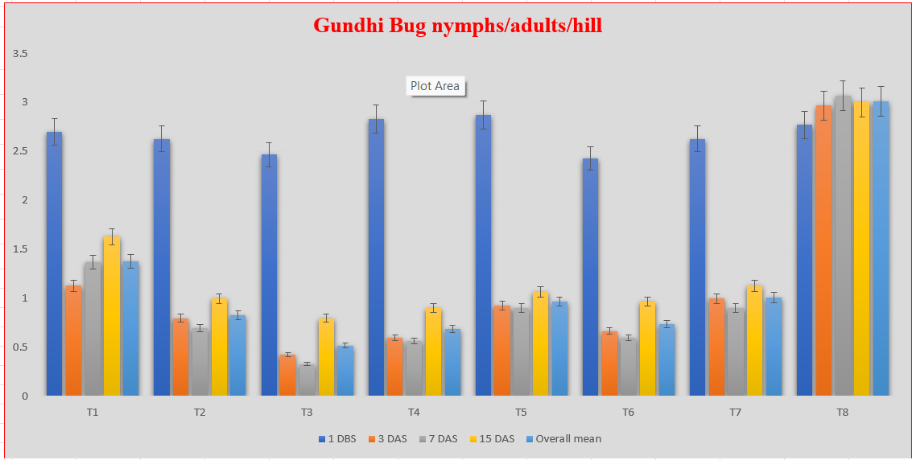

**(Error bar indicates standard error of means (±) at p≤0.05)**

**Figure 1 Efficacy of some insecticides against rice gundhi bug, *Leptocorisa acuta* during *Kharif* 2022**

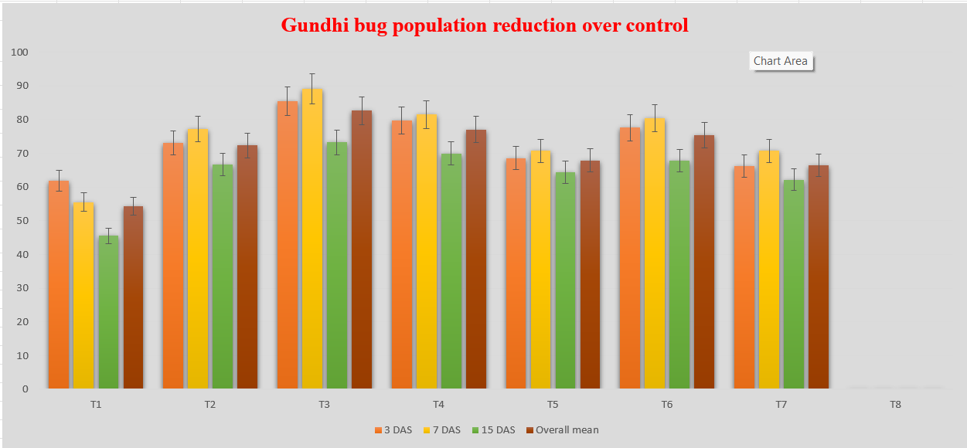

**(Error bar indicates standard error of means (±) at p≤0.05)**

**Figure 2 Efficacy of some insecticides against rice gundhi bug population reduction over control during *Kharif* 2022**