EFFECT OF BOROHUMATE AND DIATOMACEOUS EARTH ON GROUNDNUT GROWTH, YIELD AND QUALITY

ABSTRACT
Groundnut is one of the major crops cultivated in coastal areas, often without proper agricultural technology. By improving fertility management, groundnut production can be boosted and sustained. Silicon is a beneficial element whose importance to crops has increased due to extensive research. Furthermore, silicon mitigates salt stress and enhances pest resistance in plants. Boron is an essential nutrient for groundnut, as it plays a crucial role in pod setting and overall growth enhancement. The combined effect of these nutrients has not yet been extensively studied, particularly in groundnut cultivation in coastal areas. Therefore, this study aims to evaluate the combined effects of silicon and boron on groundnut grown in coastal soils. The study primarily focuses on key parameters such as growth, yield, and quality of groundnut. In order to study aim two field experiments were conducted in coastal village during December, 2020 - March, 2021 and July-October, 2021 using VRI 2 as test crop. The results of the study concluded that application of borohumate (BH) @ 1.5 kg B ha⁻¹ and diatomaceous earth (DE) @ 60 kg Si ha⁻¹ along with recommended dose of NPK recorded the highest growth characters (plant height, number of branches plant⁻¹ and dry matter production), yield characters (number of pods plant⁻¹, 100 pod weight, 100 kernel weight and shelling percentage), quality (protein and oil content) and yield of groundnut.
Keywords: Boron, silicon, borohumate, diatomaceous earth, groundnut, coastal saline soil
INTRODUCTION
Soil fertility is the most limiting factor for crop production in coastal soil. Coastal saline soils have specific soil constraints viz., light texture, poor exchange property, low nutrient and water retention capacity, low status of organic carbon and deficiency of both macro and micronutrients. These problems severely affect the productivity of crops in this region. Even the applied nutrients are leached to the lower layers due to poor physical properties, poor nutrient retention and low organic carbon content, which further aggravates the problem of nutrient deficiency. The coastal farmers are cultivating the lands by adopting traditional management practices and realizing very low yield of crops as compared to other regions.
Silicon (Si) is classified as a beneficial element. This element limits the effects of abiotic and biotic stresses in plants. In recent years, more research has been performed with regards to soil and foliar nutrition using silicon fertilizers, which brings unequivocal production beneﬁts, and at the same time, it is much cheaper and more convenient to use than soil fertilization especially in coastal salt affected soils. As a result, it improves the proﬁtability of many agriculture and horticulture crops. The positive effect of silicon observed, in the studies, results in many cases in which the susceptibility of plants to drought stress is reduced. Silicon has also a beneficial effect on limiting the adverse effects of other abiotic stresses; caused by salinity, heavy metals, high and low temperature, water ﬂooding, etc. (Sriramachandrasekharan et al., 2021).
The adequate silicon supply has potential to alleviate the salt stress and enhances the photosynthetic activity, enzyme activity and increase the concentration of soluble substance in xylem. Silicon strengthens the leaves and stem cell walls and making the plant stronger and rigid. Silica accumulation in plants leads to the production of phenolics and phytoalexins, which provides tolerant to the various plant pathogens. In groundnut, silica enhances the chlorophyll content as the way thick leaves and silica promotes antioxidant enzyme, which is insect repellant and eradicate termites and natural enemies for groundnut. The pod development was influenced by silica due to the less salinity stress, pest and disease attack and thereby increasing the yield of groundnut to their greater extent.
Boron (B) and silicon (Si) elements are similar in many chemical characteristics. Both are taken up by plant roots in the form of weak, undissociated acids. Boron concentration in plant tissues increased with increasing boron concentration in the nutrient solution, which leads to toxicity but was reduced by additional Si supply. Both silicon and boron applications correct to some extent the negative effects of salinity either on growth, yield and nutrients uptake by groundnut (Timotiwu et al., 2018 and Elayaraja and Jawahar, 2020).
MATERIALS AND METHODS
Location: The two field experiments were conducted in the coastal farmer’s field at Singarakuppam village, near Chidambaram, Cuddalore District, Tamil Nadu, India. The experimental site is geographically located at 11°24′N latitude, 79°44′E longitudes and altitude of 5.79 M above mean sea level (MSL) in the southern part of India and 15 km away from the Bay of Bengal Coast.
Experimental details:
Field 1: The first field experiment was carried out to find the effect of different levels and sources of silicon fertilizers on the growth, yield characters and yield of groundnut. The field experiment was conducted in the coastal farmer’s field at Singarakuppam village, near Chidambaram in Cuddalore district of Tamil Nadu during December, 2020 - March, 2021 using groundnut variety VRI 2 as test crop. The experimental soil was sandy in texture and taxonomically classified as Typic Ustipsamments with pH – 8.16, EC– 4.08 dSm⁻¹ and represented low status of organic carbon (2.21 g kg⁻¹). Regarding available nutrient status, it was low in alkaline KMnO₄-N (138.39 kg ha⁻¹), low in Olsen – P (9.11 kg ha⁻¹), medium in NH₄OAc-K (165.97 kg ha⁻¹) and low in available silicon content (28.05 mg kg⁻¹). The treatments involving various levels of silicon viz., 0, 20, 40, 60 and 80 kg ha⁻¹ as factor L and different sources of silicon like calcium silicate, silixol granules and diatomaceous earth as factor S. Fertilizer application was followed at the rate of 17:34:54 kg of N:P₂O₅:K₂O per hectare recommended for groundnut through urea, single super phosphate and muriate of potash, respectively was applied to all the plots. The experiment was conducted in a Factorial Randomized Block Design (FRBD) with three replications.
Field 2: To investigate the impact of boron and silicon on augmenting the nutrient content in coastal saline soil a field experiment was conducted at coastal farmer’s field during July-October, 2021 at Singarakuppam coastal village. The experimental soil was sandy in texture and taxonomically classified as Typic Ustipsamments with pH – 8.21, EC – 4.05 dSm⁻¹ and represented low status of organic carbon (2.32 g kg⁻¹). Regarding available nutrient status, it was low in alkaline KMnO₄-N (139.26 kg ha⁻¹), low in Olsen-P (9.22 kg ha⁻¹) and medium in NH₄OAc-K (164.63 kg ha⁻¹). The available B and Si content were 0.22 and 30.03 mg kg⁻¹, respectively. The treatments included were different levels of B as borohumate viz., control, 0.5, 1.0 and 1.5 kg B ha⁻¹ as factor B and different levels of Si as diatomaceous earth like control, 20, 40 and 60 kg Si ha⁻¹ as factor S. The experiment was studied in a Factorial Randomized Block Design (FRBD) with three replications, using groundnut variety VRI 2 as test crop.
The following parameters were analyzed based on the objectives of the study
Growth components
Plant height: The plant height (cm) was measured from ground level to the tip of the leaf at different critical stages like flowering, peg formation and at harvest stage.
Number of branches plant⁻¹: The total number of primary and secondary branches plant⁻¹ was counted from five randomly selected plants in each plot at flowering, peg formation and harvest stage.
Dry matter production (DMP): Five plants from each plot were collected from sample rows random at different stages and air-dried. The air-dried samples were oven-dried at 60 ± 5°C for 48 h. The oven dried plant samples were weighed and recorded. The dry matter production (DMP) was expressed in kg ha⁻¹.
Yield components
Number of pods plant⁻¹: The number of pods at harvest stage was counted and the mean number of pods per plant was recorded.
100 kernel weight: Hundred kernels were counted randomly from each replication was weighed. The mean weight was calculated and expressed in grams.
100 pod weight: Hundred pods were counted randomly from each replication were weighed. The mean weight was calculated and expressed in grams.
Yield
Pod yield: The pod yield from each plot was recorded at 14 per cent moisture content and expressed in kg ha⁻¹.
Kernel yield: The yield of the kernel was recorded plot wise and expressed in kg ha⁻¹.
Haulm yield: After stripping the pods, the plants were dried in sunlight to obtain constant weight and dry weight of haulm yield from each plot was recorded and expressed in kg ha⁻¹.
Shelling percentage: The shelling percentage was calculated as per the formula given below.
Shelling percentage $\frac{\text{Weight of kernel}}{\text{Weight of pod}}×\text{ 100}$
Quality parameters
Oil content: The oil content of the kernel was estimated using diethyl ether as extractant by Soxhlet’s apparatus and expressed in percent (Gupta and Varshaney, 1989).
Protein content: Nitrogen content of kernel was estimated as per the procedure outlined in micro Kjeldahl method and the crude protein content of kernel was calculated by multiplying the percent nitrogen content of kernel with 6.25 (Piper, 1966).
Statistical analysis: The data obtained from the field experiments were statistically analysed as suggested by Gomez and Gomez (1984). For significant results, the critical difference was worked at five per cent probability level.
RESULTS AND DISCUSSION
Field 1:
The influence of different levels and sources of silicon fertilizers on altering the growth, quality, yield and yield parameters of groundnut was statistically significant. The highest growth, quality, yield and yield parameters of groundnut recorded with the application of Si @ 80 kg ha⁻¹ (L₄). This treatment recorded a highest mean pod (1696 kg ha⁻¹), kernel (1224 kg ha⁻¹) and haulm yield (2357 kg ha⁻¹) of groundnut. However, this was on par with 60 kg Si ha⁻¹ (L₃) which recorded a comparable pod (1688 kg ha⁻¹), kernel (1218 kg ha⁻¹) and haulm yield (2348 kg ha⁻¹) of groundnut. This was followed by the treatments L₂ and L₁. The control (L₀) registered the lowest mean pod, kernel and haulm yield of groundnut. Of the various silicon sources evaluated, application of diatomaceous earth (S₃) was significantly superior in increasing the growth, quality, yield and yield parameters of groundnut. This was followed by the application of silixol granules (S₂) and calcium silicate (S₁).
Interaction effect revealed that equally efficient nature of 80 kg Si ha⁻¹ and 60 kg Si ha⁻¹ through diatomaceous earth application. Among the treatments the highest plant height (48.82cm), number of branches plant⁻¹ (9.75), DMP (4652 kg ha⁻¹), number of pods plant⁻¹ (27.12), 100 pod weight (84.13 g), 100 kernel weight (45.12 g), shelling percentage (73.15%), Protein yield (235.23 kg ha⁻¹) and oil content (498.73 kg ha⁻¹) of groundnut was recorded with application of silicon through diatomaceous earth @ 80 kg ha⁻¹ (L₄S₃) as compared to other treatments. The control registered the lowest growth, quality and yield parameters of groundnut.
The application of Si significantly increased all the growth characters of groundnut. This might be due to application of silicon, which improved the plant growth, through enhancement in various enzyme production and better nodulation. This observation was in accordance with Gangrong et al. (2010) and Kalaiyarasan et al. (2017). Furthermore, An adequate supply of plant nutrients enhanced the various metabolic activities, which in turn influenced the growth and yield attributing characters of groundnut. This was in conformity with findings of Moussa (2006), Marafin and Endres (2013) and Sahebi et al. (2015). That greater availability of nutrients from beneficial element of silicon sources which helped in the acceleration of photosynthetic activity and efficient utilization of light and translocation of assimilated products to sink (Rani et al., 1997).
Field 2:
The growth, quality, yield and yield parameters of groundnut were significantly influenced by the application of different levels of boron and silicon fertilizers.
Among the different levels of boron studied the application of borohumate @ 1.5 kg B ha⁻¹ (B₃) gives highest growth, quality, yield and yield parameters of groundnut. This was followed by the treatments B₂ and B₁. Among the different levels of silicon tried, diatomaceous earth @ 60 kg Si ha⁻¹ (S₃) recorded the highest growth, quality, yield and yield parameters of groundnut. This was followed by the treatments S₂ (DE @ 40 kg Si ha⁻¹), S₁ (DE @ 20 kg Si ha⁻¹) and S₀ (control).
Interaction effect of different levels of borohumate (BH) and diatomaceous earth (DE) was found to be significant. The highest plant height (54.36cm), number of branches plant⁻¹ (11.14), DMP (4915 kg ha⁻¹), number of pods plant⁻¹ (30.04), 100 pod weight (89.46 g) 100 kernel weight (49.16 g), shelling percentage (74.29 %), pod yield (2054 kg ha⁻¹), kernel yield (1526 kg ha⁻¹), haulm yield (2847 kg ha⁻¹), Protein yield (303.06 kg ha⁻¹) and oil yield (656.79 kg ha⁻¹) of groundnut with treatment combination of B₃S₃ (1.5 kg B ha⁻¹ + 60 kg Si ha⁻¹). This was followed by the treatment pairs viz., B₃S_{2,} B₃S₁ and B₃S₀. The control (B₀S₀) registered the lowest all the parameters of groundnut at harvest stage.
In the overall improvement in growth, quality, yield and yield parameters of groundnut due to combined application of borohumate @ 1.5 kg B ha⁻¹ along with diatomaceous earth @ 60 kg Si ha⁻¹ and recommended dose of NPK was positive effect. This could be attributed to the fact that the nutrients in the diatomaceous earth (DE) are released in the form of silicic acid gradually through the process of mineralization and enhance the boron availability in soil as well as maintaining optimal soil B levels over prolonged periods of crop growth. Some amount of the silicic acid binding with borohumate and maintain optimum boron level. Hence, silicon mitigates the boron toxicity. This was observed at B₃S₃ treatment, were the growth was increased slightly as compared to control instead of reduction in growth characters. The significant increase in growth and yield characters of groundnut shows that silicon applied treatments as well as alleviate boron toxicity under saline condition. The earlier reports of Kaya et al. (2011) support the present findings. The application of diatomaceous earth may act on alleviating the salt stress and enhance the relative water content in the cells, which may lead to increase protein and oil contents of groundnut (Khalaf et al. 2020). Further, boron encourages quick mobilization of water and sugar in the plant and resulted in higher protein and oil in groundnut. Similar results were earlier made by Ahmed et al. (2008).

CONCLUSION
The present investigation clearly concluded the beneficial role of boron and silicon fertilization for increasing groundnut production in coastal saline soil. Application of recommended dose of NPK (17:34:54 kg/ha) + borohumate @ 1.5 kg B ha⁻¹ and diatomaceous earth @ 60 kg Si ha⁻¹ through soil application was best treatment combination to be recommended for groundnut growers of coastal regions to realize the maximum net profit in groundnut yield. This treatment could sustain soil health as well as alleviating salinity stress on groundnut in coastal saline soil.
REFERENCES
Ahmed, A.H.H., Harb, E.M., Higazy, M.A. and Morgan, S.H. 2008. Effect of silicon and boron foliar application on wheat plants grown under saline soil conditions. Int. J. Agri. Res., 3(1): 1-26.
Elayaraja, D. and Jawahar, S. 2020. Effect of organics with boron and silicon fertilization on the yield of tomato and soil properties in coastal soil. Plant Arch., 20(1): 679-685.
Gangrong, S., Qinsheng, C., Caifeng, L. and Li. 2010. Silicon alleviates cadmium toxicity in peanut plants in relation to cadmium distribution and stimulation of antioxidant enzymes. Plant Growth Regul., 61: 45-52.
Gomez, K.A. and A.A. Gomez, 1984. Statistical Procedures for Agricultural Research. John Wiley and Sons, New York.
Gupta, A.K. and Varshaney, M.L. 1989. Practical manual for Agricultural Chemistry. Part II, Ist ed., Kalyani Publishers, New Delhi, pp. 35-37.
Kalaiyarasan, C., Jawahar, S., Suseendran, K. and Sriramachandrasekharan, M.V. 2017. Response of hybrid sunflower cv. Sunbred to integrated nutrient management practices. Int. J. Curr. Res. Aca. Rev., 5(8): 39-42.
Kaya, C., Levent Tuna, A., Guneri, M. and Ashraf, M. 2011. Mitigation effects of silicon on tomato plants bearing fruit grown at high boron levels. J. Plant Nutr., 34(13): 1985-1994.
Khalaf, A., Hassan, M. and Awny, A. 2020. Impact of foliar application of silicon and selenium on growth characters, yield, physicochemical characters, oil ingredients of peanut (Arachis hypogaea L.) variety Giza 6 under different planting dates. Asian J. Adv. Agrl. Res., 12(1): 21-28.
Marafin, A.C. and Endres, L. 2013. Silicon fertilization and nutrition in higher plants. Amazozonian J. Agric. Environ. Sci., 4: 380-387.
Moussa, H.R. 2006. Influence of exogenous application of silicon on physiological response of salt stressed maize (Zea mays L.). Intl. J. Agric. Biol., 8: 293-297.
Piper, C.S. 1966. Soil and plant analysis. Hans. Publishers, Bombay.
Rani, A.Y., Yadav, S.S. and Jain, P.K. 1997. The effect of silicon application on growth and yield of rice plants. Ann. Plant Physiol., 3: 20-24.
Sahebi, M., Hanafi, M.D., Azizi, P. and Mofrad, S. 2015. Importance of silica on biosilica formulations in plants. Bio. Med. Res., 12(1): 1-16.
Sriramachandrasekharan, M.V., Gokulapriya, N., Manivannan, R. and Prakash, M. 2021. Ameliorative role of silicon on osmoprotectants, antioxidant enzymes and growth of maize grown under alkaline stress. Silicon, 13(10): 1-9.
Timotiwu, P.B., Agustiansyah, Pramono, E., Voulina, W.A. 2018.The effects of foliar boron and silica through the leaves on soyabean growth and yield. J. Agrl Studies, 6(3): 34-48.
Table 1. Effect of different levels and sources of silicon fertilizers on the growth characters of groundnut (Field experiment – I)
L  S | Plant height (cm) |  |  |  |  |  | Number of branches plant⁻¹ |  |  |  |  |  |  | DMP
L  S | L₀ | L₁ | L₂ | L₃ | L₄ | Mean | L₀ | L₁ | L₂ | L₃ | L₄ |  | Mean | L₀ | L₁ | L₂ | L₃ | L₄ | Mean
S₁ | 37.01 | 41.46 | 43.35 | 44.87 | 45.07 | 42.99 | 7.04 | 7.91 | 8.43 | 8.91 | 8.95 |  | 8.24 | 3991 | 4117 | 4239 | 4367 | 4389 | 4220
S₂ | 37.24 | 43.23 | 45.09 | 46.75 | 46.98 | 44.45 | 7.07 | 8.31 | 8.86 | 9.29 | 9.34 |  | 8.57 | 3994 | 4244 | 4370 | 4504 | 4523 | 4327
S₃ | 37.13 | 45.04 | 46.55 | 48.53 | 48.82 | 45.88 | 7.02 | 8.79 | 9.24 | 9.69 | 9.75 |  | 8.89 | 3995 | 4378 | 4499 | 4640 | 4652 | 4432
Mean | 40.30 | 43.24 | 44.99 | 46.71 | 46.95 |  | 7.04 | 8.33 | 8.84 | 9.29 | 9.34 |  |  | 3993 | 4246 | 4369 | 4503 | 4521
 | SE_{D} |  |  |  | CD (p=0.05) |  | SE_{D} |  |  |  |  | CD (p=0.05) |  | SE_{D} |  |  | CD (p=0.05)
L | 0.28 |  |  |  | 0.58 |  | 0.04 |  |  |  |  | 0.09 |  | 12.11 |  |  | 25.01
S | 0.59 |  |  |  | 1.12 |  | 0.09 |  |  |  |  | 0.19 |  | 32.15 |  |  | 67.05
L × S | 0.65 |  |  |  | 1.24 |  | 0.14 |  |  |  |  | 0.29 |  | 47.06 |  |  | 98.11
L₀ - Control, L₁ - 20 kg Si ha⁻¹, L₂ - 40 kg Si ha⁻¹, L₃ - 60 kg Si ha⁻¹ and L₄ - 80 kg Si ha⁻¹
S₁ - Calcium silicate (Csi), S₂ - Silixol granules (SG) and S₃ = Diatomaceous earth (DE).

Table 2. Effect of different levels and sources of silicon fertilizers on the yield of groundnut (Field experiment – I)
L  S | Pod yield |  |  |  |  |  |  | Kernel yield |  |  |  |  |  | Haulm yield
L  S | L₀ | L₁ | L₂ | L₃ | L₄ |  | Mean | L₀ | L₁ | L₂ | L₃ | L₄ | Mean | L₀ | L₁ | L₂ | L₃ | L₄ | Mean
S₁ | 1473 | 1517 | 1584 | 1644 | 1648 |  | 1573 | 975 | 1039 | 1095 | 1158 | 1163 | 1086 | 2112 | 2156 | 2196 | 2278 | 2285 | 2205
S₂ | 1472 | 1572 | 1631 | 1689 | 1697 |  | 1612 | 979 | 1107 | 1167 | 1229 | 1236 | 1144 | 2116 | 2217 | 2267 | 2354 | 2362 | 2263
S₃ | 1476 | 1625 | 1676 | 1733 | 1743 |  | 1650 | 983 | 1146 | 1198 | 1265 | 1275 | 1174 | 2114 | 2279 | 2341 | 2413 | 2424 | 2314
Mean | 1473 | 1571 | 1630 | 1688 | 1696 |  |  | 979 | 1097 | 1153 | 1218 | 1224 |  | 2114 | 2217 | 2268 | 2348 | 2357
 | SE_{D} |  |  |  |  | CD (p=0.05) |  | SE_{D} |  |  |  | CD (p=0.05) |  | SE_{D} |  |  |  | CD (p=0.05)
L | 5.03 |  |  |  |  | 12.07 |  | 5.49 |  |  |  | 11.25 |  | 6.08 |  |  |  | 14.09
S | 10.06 |  |  |  |  | 22.15 |  | 7.08 |  |  |  | 14.51 |  | 13.09 |  |  |  | 28.12
L × S | 17.12 |  |  |  |  | 35.09 |  | 12.25 |  |  |  | 25.11 |  | 21.15 |  |  |  | 39.06

L₀ - Control, L₁ - 20 kg Si ha⁻¹, L₂ - 40 kg Si ha⁻¹, L₃ - 60 kg Si ha⁻¹ and L₄ - 80 kg Si ha⁻¹
S₁ - Calcium silicate (Csi), S₂ - Silixol granules (SG) and S₃ = Diatomaceous earth (DE).
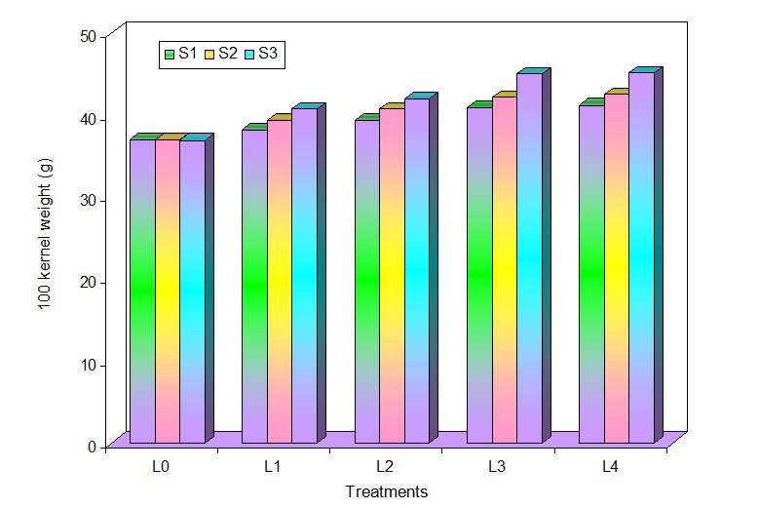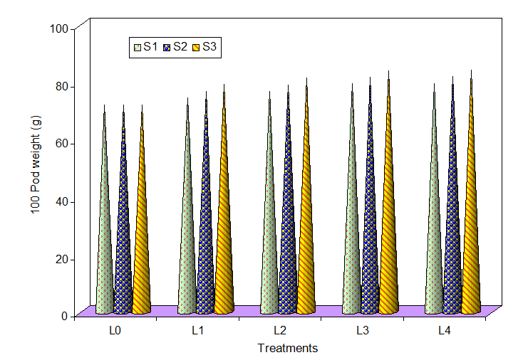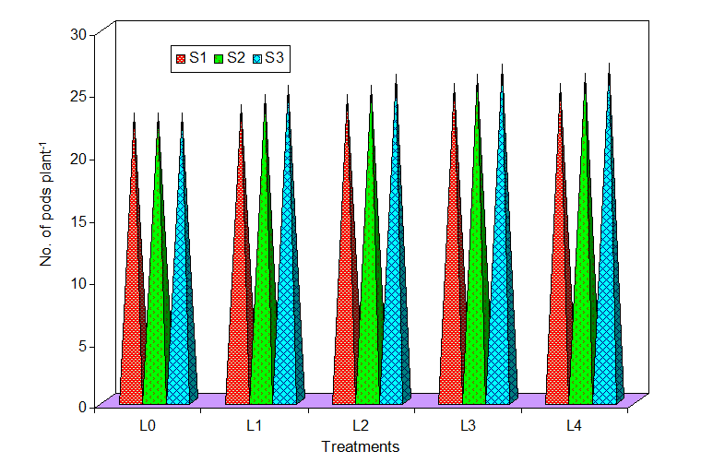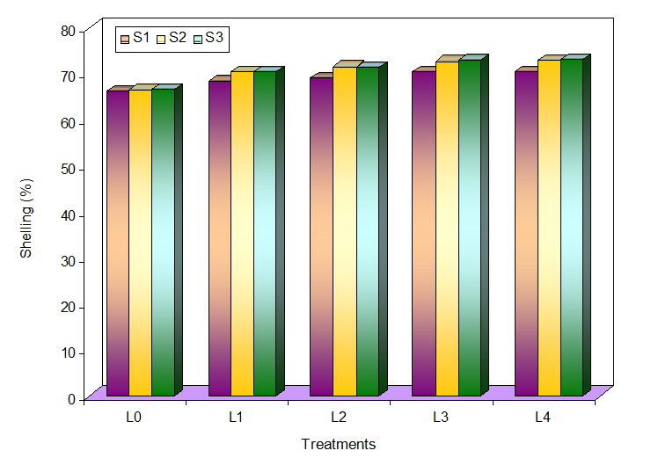

Fig 1. Effect of different levels and sources of silicon fertilizers on the yield characters of groundnut (Field experiment – I)
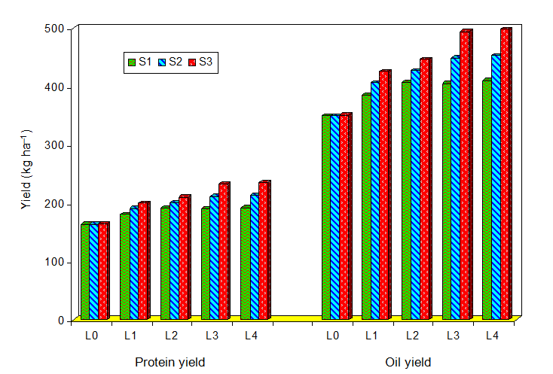

Fig 2. Effect of different levels and sources of silicon fertilizers on the quality characters of groundnut (Field experiment – I)
Table 3. Combined effect of different levels of boron and silicon fertilizer on the growth characters of groundnut
(Field experiment – II)
B  S | Plant height (cm) |  |  |  |  |  | Number of branches plant⁻¹ |  |  |  |  | DMP
B  S | B₀ | B₁ | B₂ | B₃ |  | Mean | B₀ | B₁ | B₂ | B₃ | Mean | B₀ | B₁ | B₂ | B₃ |  | Mean
S₀ | 37.19 | 43.53 | 46.29 | 48.32 |  | 43.83 | 7.84 | 8.20 | 8.75 | 9.38 | 8.54 | 3718 | 4130 | 4339 | 4572 |  | 4190
S₁ | 43.45 | 45.66 | 48.27 | 50.28 |  | 46.92 | 8.39 | 8.88 | 9.28 | 9.97 | 9.13 | 4326 | 4462 | 4535 | 4691 |  | 4504
S₂ | 45.79 | 47.84 | 50.20 | 52.37 |  | 49.05 | 8.88 | 9.42 | 9.87 | 10.59 | 9.69 | 4478 | 4574 | 4661 | 4806 |  | 4630
S₃ | 48.04 | 50.03 | 52.25 | 54.36 |  | 51.17 | 9.40 | 9.94 | 10.53 | 11.14 | 10.25 | 4602 | 4683 | 4795 | 4915 |  | 4749
Mean | 43.62 | 46.77 | 49.25 | 51.33 |  |  | 8.63 | 9.11 | 9.61 | 10.27 |  | 4281 | 4462 | 4583 | 4746
 | SE_{D} |  |  |  | CD (p=0.05) |  | SE_{D} |  |  | CD (p=0.05) |  | SE_{D} |  |  |  | CD (p=0.05)
B | 0.46 |  |  |  | 0.93 |  | 0.11 |  |  | 0.23 |  | 18.29 |  |  |  | 37.13
S | 0.46 |  |  |  | 0.93 |  | 0.11 |  |  | 0.23 |  | 18.29 |  |  |  | 37.13
B × S | 0.91 |  |  |  | 1.85 |  | 0.23 |  |  | 0.46 |  | 36.40 |  |  |  | 74.26
B₀ – Control, B₁ – 0.5 kg B ha⁻¹; B₂ –1.0 kg B ha⁻¹; B₃ –1.5 kg B ha⁻¹
S₀ – Control; S₁ – 20 kg Si ha⁻¹; S₂ – 40 kg Si ha⁻¹; S₃ – 60 kg Si ha⁻¹

Table 4. Combined effect of different levels of boron and silicon fertilizer on the yield of groundnut
(Field experiment – II)
B  S | Plant height (cm) |  |  |  |  |  | Number of branches plant⁻¹ |  |  |  |  | DMP
B  S | B₀ | B₁ | B₂ | B₃ |  | Mean | B₀ | B₁ | B₂ | B₃ | Mean | B₀ | B₁ | B₂ | B₃ |  | Mean
S₀ | 1643 | 1689 | 1785 | 1862 |  | 1745 | 1201 | 1239 | 1313 | 1375 | 1282 | 2220 | 2344 | 2448 | 2565 |  | 2394
S₁ | 1721 | 1762 | 1846 | 1921 |  | 1813 | 1261 | 1295 | 1361 | 1420 | 1334 | 2330 | 2439 | 2544 | 2653 |  | 2492
S₂ | 1783 | 1839 | 1913 | 1985 |  | 1880 | 1312 | 1355 | 1414 | 1471 | 1388 | 2441 | 2537 | 2645 | 2748 |  | 2593
S₃ | 1849 | 1918 | 1982 | 2054 |  | 1951 | 1363 | 1418 | 1470 | 1526 | 1444 | 2536 | 2639 | 2748 | 2847 |  | 2693
Mean | 1749 | 1802 | 1882 | 1956 |  |  | 1284 | 1327 | 1390 | 1448 |  | 2382 | 2490 | 2596 | 2703
 | SE_{D} |  |  |  | CD (p=0.05) |  | SE_{D} |  |  | CD (p=0.05) |  | SE_{D} |  |  |  | CD (p=0.05)
B | 14.34 |  |  |  | 29.12 |  | 8.15 |  |  | 16.62 |  | 20.37 |  |  |  | 41.56
S | 14.27 |  |  |  | 29.12 |  | 8.15 |  |  | 16.62 |  | 20.37 |  |  |  | 41.56
B × S | 28.54 |  |  |  | 58.23 |  | 16.29 |  |  | 33.24 |  | 40.74 |  |  |  | 83.11
B₀ – Control, B₁ – 0.5 kg B ha⁻¹; B₂ –1.0 kg B ha⁻¹; B₃ –1.5 kg B ha⁻¹
S₀ – Control; S₁ – 20 kg Si ha⁻¹; S₂ – 40 kg Si ha⁻¹; S₃ – 60 kg Si ha⁻¹

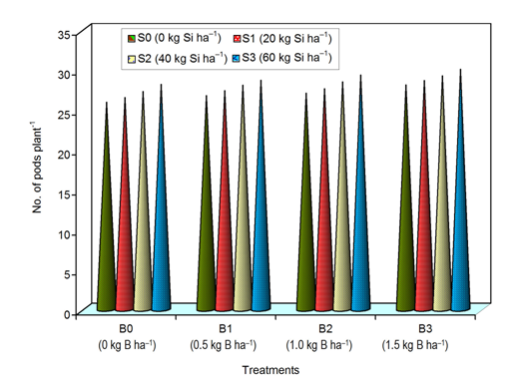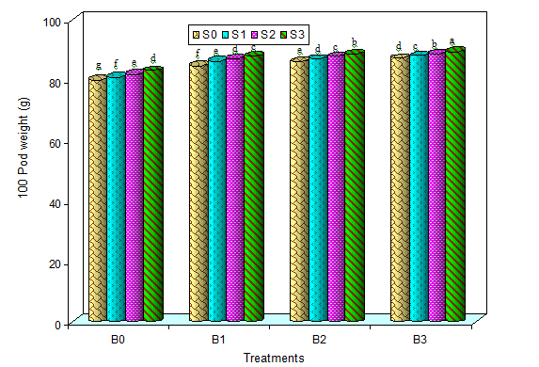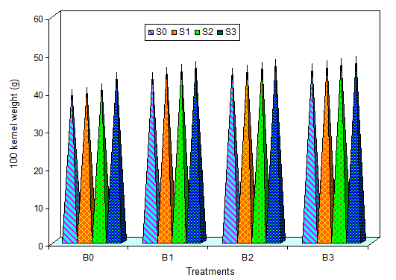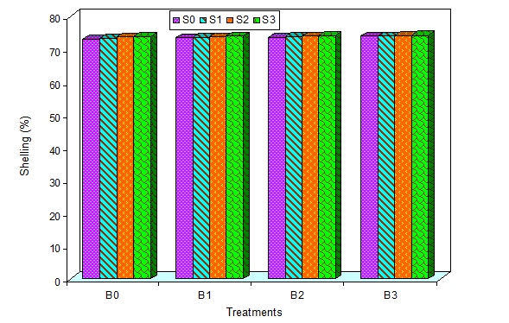
Fig 3. Effect of different levels and sources of silicon fertilizers on the yield characters of groundnut (Field experiment – II)
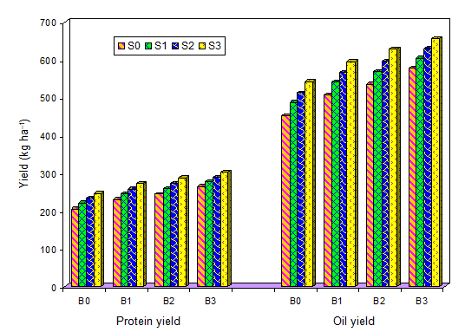
Fig 4. Effect of different levels and sources of silicon fertilizers on the quality characters of groundnut (Field experiment – II)

