Case report

CLINICAL ANALYSIS OF MYCOPLASMA PNEUMONIAE IN CHILDREN: A CASE SERIES

ABSTRACT
Mycoplasma pneumoniae is a common cause of community-acquired pneumonia in children, often presenting with varied clinical manifestations ranging from mild respiratory symptoms to severe pneumonia and extrapulmonary complications. Diagnosis of Mycoplasma pneumoniae is often challenging and controversial, due to limited understanding of its clinical presentation.
We included four cases of M pneumoniae, all of which were confirmed by a respiratory panel. Clinical manifestations include fever, persistent cough and with normal white blood cells, elevated CRP. Cold agglutination test was positive. Radiologic findings also account for pneumonia features. In all cases treatment response is obtained with macrolides and fluroquinolones.
Mycoplasma infections are mostly asymptomatic, but can lead to more serious complications. This condition also underdiagnosed due to its nonavailability of rapid and easy diagnostic methods. This case series emphasizes the importance of early detection and treatment can reduce complications , hospitalizations and improve patient outcomes.

KEYWORDS
Mycoplasma pneumoniae (MP), Respiratory panel ,fluroquinoles, parapneumonic effusion
INTRODUCTION
The smallest self-replicating biological system, Mycoplasma pneumoniae (MP), is frequently responsible for upper and lower respiratory tract infections, which can result in a variety of pulmonary and extra-pulmonary symptoms.¹ Mycoplasma pneumoniae pneumonia (MPP), also known as "walking pneumonia," is a mild, unusual illness with a range of clinical manifestations. Since it is a small rod without a cell wall, the Gram stain cannot see it. Serum-supplemented media can be used to isolate it. Nevertheless, isolation is typically not carried out in clinical laboratories because to its meticulous nature. Its growth is slow and necessitates specific cultural medium. For these reasons, it is not regularly cultivated. Since the organism is expelled from the respiratory system after several weeks of acute infection, isolation of the organism is not time-specific.³ Sore throat, hoarseness, fever, cough (may be purulent), headaches, coryza, earache, myalgias, chills, and general malaise are among the usual symptoms that appear over a period of days and last for weeks to months.⁴
In addition to respiratory tract infections, this organism can cause a variety of non-pulmonary symptoms, such as hemolytic anemia, polyarthritis, erythema multiforme, neurological, hepatic, and cardiac disorders. Of these non-pulmonary symptoms, neurological symptoms are believed to be the most prevalent. The stimulation of inflammatory cytokines is a part of M pneumoniae pathogenesis. Because of its gliding motion and particular tip organelles, M pneumoniae can burrow between cilia in the respiratory epithelium, causing the respiratory epithelial cells to slough off. ³
Effective treatment of M pneumoniae depends on an early and accurate diagnosis. In this case series, we discuss the clinical signs, diagnosis, and treatment of M. pneumoniae.

CASE SERIES
CASE 1
- A 10yr old male was admitted with complaints of cough for 7 days, wet cough. Child then started fever for 7 days, high grade, intermittent associated with chills and relieves on medication. It was associated with running nose and evaluated with necessary investigations and serum CRP was found to be elevated 182.9mg/L. Sputum culture and blood culture showed no growth of any microorganisms. Mantoux test was done, negative. He was provisionally diagnosed with a case of Right lower zone and mid zone pneumonia and was managed with IV Piperacillin +Tazobactam given for 3 days, IV Amikacin for 5 days, Oseltamivir for 5 days, nebulization, multivitamins, adequate hydration and other supportive care. Fever and cough are not controlled with the medications given and antibiotics upgraded to IV meropenem given for 7 days. In spite persistent fever and cough along with chest pain antibiotics was upgraded to Vancomycin given for 3 days. USG chest showed lung consolidation with stage of hepatization and mild pleural effusion on right side. Pulmonology consultation was sought and advise followed and Respiratory panel done, detected Mycoplasma pneumoniae and Rhinovirus. Child was started Clarithromycin given for 7 days. IV levofloxacin was started, given for 10 days Child became clinically better, chest pain improved. Repeated USG showed improvement in consolidation minimal pleural effusion on right side. The child became better with the treatment.

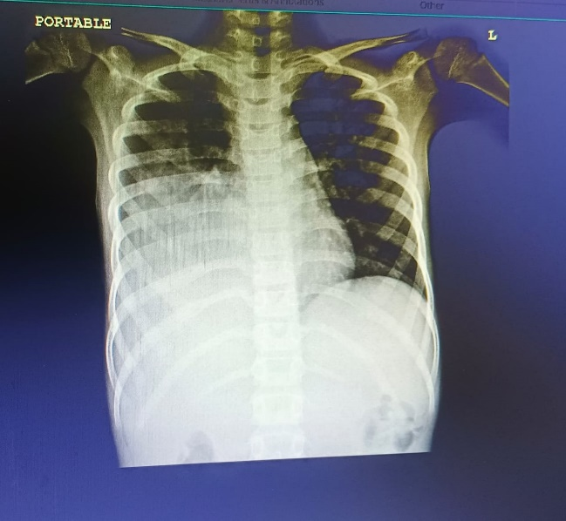
Fig 1. Chest x-ray showing right lower lobe pneumonia

CASE 2
- An 8yr old female child with fever, which was high grade, not relieving on medication, multiple spikes per day. Child had vomiting for 4 days, multiple episodes contained food. cough was dry type with throat pain. Child was evaluated with necessary investigations, serum CRP is elevated ,80.9mg/L and there was no bacterial growth in blood culture. In view of persistent fever respiratory panel was done and showed mycoplasma. He was provisionally diagnosed as case of Right lower zone pneumonia and was managed with IV Cefuroxime for 2 days then upgraded to IV Tazact given for 2 days, oseltamivir for 5 days, nebulization, multivitamins, adequate hydration and other supportive medications. USG chest showed consolidation with synpneumonic effusion. In view of synpneumonic effusion iv Tazact was changed to iv levofloxacin and clarithromycin given for 5 days. The child become symptomatically improved.

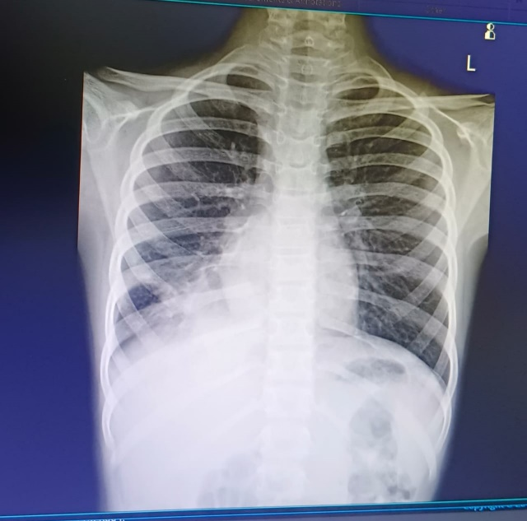
Fig 2. Chest x-ray showing right lower lobe pneumonia
CASE 3
- A 5yr old female baby was admitted with complaints low grade fever for 3 days and cough for 3 weeks and was evaluated with necessary investigations. She was provisionally diagnosed as case of LRTI and was managed with Clarithromycin for 4days, nebulization, multivitamins, adequate hydration and other supportive medications Respiratory panel taken showed corona virus NL63, mycoplasma and RSV-A+B. The child became better with the treatment.

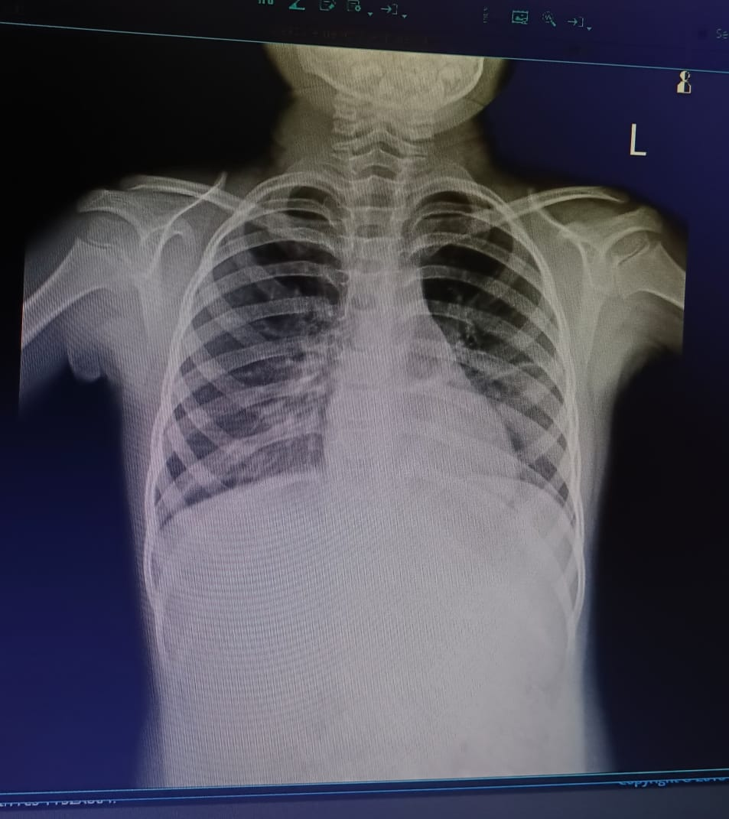
Fig 3. Chest x-ray showing left lower lobe pneumonia

CASE 4
- A 10 yr. old female child was admitted with complaints of fever for 5 days She was provisionally diagnosed as case of Left lower zone pneumonia and was managed with IV Cefuroxime for 2 days, Azithromycin for 5 days, nebulization, antipyretics, multivitamins, adequate hydration and other supportive medications In view of persistent fever, respiratory panel done showed Mycoplasma and human metapneumovirus. IV Cefuroxime was changed to IV Levofloxacin given for 7 days. The child became better with the treatment.

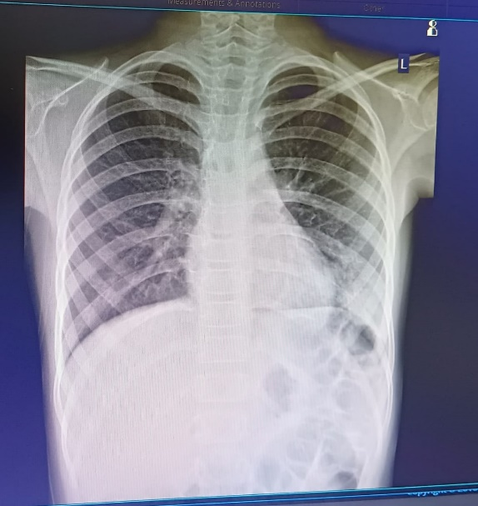
Fig 4. Chest x-ray showing left lower lobe pneumonia

DISCUSSION
The prevalence of MPP is underestimated, since most patients infected with MP usually are asymptomatic and rarely seek medical attention. MP is a common etiology for CAP. MPP is often called “walking pneumonia” because of its presumed benign nature. Fulminant MPP accounts for 0.5–2% of cases, commonly among healthy, young individuals. Pulmonary complications like parapneumonic effusions are rare and occur mainly in children or adolescents; most cases are unilateral, low-volume, and resolve with antimicrobial therapy. Diagnosing MPP is difficult especially since radiographic findings can be variable.
In the case report of Ateeq mubarik et al.. Pulmonary complications like parapneumonic effusions are rare and occur mainly in children or adolescents; most cases are unilateral, low-volume, and resolve with antimicrobial therapy, in our cases also presence of pleural effusions is found.⁶
Although blood culture is commonly used for detecting infections, it is not a reliable method for diagnosing Mycoplasma pneumoniae. In the case series of Hasina maredia et al.. Mycoplasma serologic results were collected, RT-PCR for M. pneumoniae would have provided further specificity. However, RT-PCR was performed for HSV to rule out the most likely alternative differential diagnosis. In our cases mycoplasma detected through respiratory panel.⁷
In case report of Bhimana Vaishnavi et al.. Chest X-ray showed right lung consolidation with pleural effusion There was decreased air entry in right hemithorax and trachea pushed to left side. Clinical diagnosis of right complicated pneumonia was made, that was similar to our cases.⁸
In the case report of Athira Unni et al the patient had positive cold agglutinin test and showed characteristic autopsy findings. Significant clinical findings are seen in those patients with consolidation. High index of suspicion is needed in diagnosing MP as radiographic findings can be variable and seen in other conditions too. The definitive diagnosis of MP is based on combination of clinical, radiographic, PCR
and serological findings. Due to its lack of a cell wall, MP cannot be identified on gram stain and due to the same reason, they are insensitive to beta-lactam antibiotics. In our cases also diagnosed by respiratory panel, serological test was positive for cold antibody. Initially, our cases were insensitive to beta-lactam treatment similar to their cases.⁹

CONCLUSION
Mycoplasma infections are mostly asymptomatic, but can lead to more serious complications. This condition also underdiagnosed due to its nonavailability of rapid and easy diagnostic methods. This case series highlights clinical manifestations of M Pneumonia, early detection and appropriate treatment can reduce complications, hospitalization and patient outcomes.
COMPETING INTERESTS DISCLAIMER:
Authors have declared that they have no known competing financial interests or non-financial interests or personal relationships that could have appeared to influence the work reported in this paper.
CONSENT
The author has obtained consent to conduct the study.
ETHICAL APPROVAL
It is not applicable

DISCLAIMER (ARTIFICIAL INTELLIGENCE):
Author(s) hereby declare that NO generative AI technologies such as Large Language Models (ChatGPT, COPILOT, etc.) and text-to-image generators have been used during the writing or editing of this manuscript.

REFERENCE
- Youn YS, Lee KY. Mycoplasma pneumoniae pneumonia in children. Korean journal of pediatrics. 2012 Feb 14;55(2):42.
- Bajantri B, Toolsie O, Venkatram S, Diaz-Fuentes G. Mycoplasma pneumoniae pneumonia: walking pneumonia can cripple the susceptible. Journal of Clinical Medicine Research. 2018 Oct 30;10(12):891.
- Rhim JW, Kang HM, Yang EA, Lee KY. Epidemiological relationship between Mycoplasma pneumoniae pneumonia and recurrent wheezing episode in children: an observational study at a single hospital in Korea. BMJ open. 2019 Apr 1;9(4):e026461.
- Sánchez-Vargas FM, Gómez-Duarte OG. Mycoplasma pneumoniae—an emerging extra-pulmonary pathogen. Clinical microbiology and infection. 2008 Feb 1;14(2):105-15.
- Kashyap S, Sarkar M. Mycoplasma pneumonia. Lung India. 2010 Apr 1;27(2):75-85.
- Mubarik A, Jupalli A, Iqbal AM, Mohammed SK, Muddassir S, Abdulmagid E. Mycoplasma pneumonia with hydropneumothorax: A case report. Respiratory medicine case reports. 2019 Jan 1;26:299-300.
- Maredia H, Eseonu A, Grossberg AL, Cohen BA. Recurrent Mycoplasma pneumoniae–associated reactive infectious mucocutaneous eruption responsive to systemic steroids: A case series. JAAD Case Reports. 2021 Mar 16;11:139.
- Vaishnavi B, Janakiraman L, Dhanalakshmi K. Rare presentation of mycoplasma pneumonia: a case report. International Journal of Contemporary Pediatrics. 2020 Sep;7(9):1928.
- Unni A, Hidayathulla PK, Kavitha KP, Paloth MN, Nair PR, Kumar J, Radhakrishnan C. A fulminant pneumonia due to Mycoplasma pneumoniae–Case report and literature review. IDCases. 2022 Jan 1;29:e01552.

