The Role of Soil in Carbon Sequestration: Implications for Climate Change Mitigation
Abstract
Soil, as the Earth's largest terrestrial carbon reservoir, plays a pivotal role in the global carbon cycle and presents a significant opportunity for mitigating climate change. This review synthesizes current knowledge on soil carbon sequestration, exploring its mechanisms, influencing factors, and potential for offsetting greenhouse gas emissions. We delve into various land management practices that enhance carbon storage in soils, including afforestation, no-till farming, and rotational grazing, while also addressing the uncertainties surrounding soil carbon dynamics and their response to climate change. The paper further examines the limitations and challenges associated with relying on soil carbon sequestration as a climate change mitigation strategy, emphasizing the need for comprehensive and integrated approaches that consider both biophysical and socioeconomic factors. Soils, serving as the largest terrestrial carbon sink, possess the capacity to substantially influence the global carbon cycle and climate regulation. Terrestrial ecosystems, with soils as their major component, absorb atmospheric carbon dioxide through photosynthesis, converting it into plant biomass and subsequently transferring a portion of this carbon into the soil. This intricate process of carbon sequestration in soils involves a multitude of complex interactions between biotic and abiotic factors. Soil organic matter, a heterogeneous mixture of plant and animal residues, microbial biomass, and their decomposition products, constitutes the primary form of carbon storage in soils. The dynamics of soil carbon are governed by the balance between carbon inputs from plant litter, root exudates, and organic amendments, and carbon outputs through decomposition, respiration, and erosion.

1. Introduction
Soils represent a substantial reservoir of terrestrial carbon, exerting considerable control over climate regulation through the intricate processes of greenhouse gas emission and sequestration, biogenic volatile organic compound release, and aerosol dynamics (Lal et al., 2021). The pressing need to address escalating concentrations of atmospheric greenhouse gases has amplified the importance of understanding the role of terrestrial ecosystems, particularly soils, in the global carbon cycle (Bardgett et al., 2008). Small changes in the amount of carbon stored in soil may have significant effects on the global carbon cycle, which in turn has repercussions on global change (Léopold et al., 2021). The importance of agricultural practices in mitigating climate change has been brought to light, with an emphasis on how they can affect soil carbon sequestration (Zhang et al., 2024). The soil's ability to hold carbon is essential to maintaining soil structure, supporting agricultural output, and sequestering carbon (Yadav & Malanson, 2007). Soils' dual role as both a source and sink of greenhouse gases underscores the importance of sustainable soil management practices in climate change mitigation strategies (Brevik, 2013).

- Soil's Role in Carbon Sequestration: An Overview

The global carbon cycle is significantly influenced by the capacity of soils to sequester carbon, which highlights the significance of soils in the fight against climate change. Terrestrial ecosystems, particularly soils, have absorbed about 30% of the carbon released by human activities between 1960 and 2008, highlighting their crucial function in reducing atmospheric carbon dioxide (Yan et al., 2014).
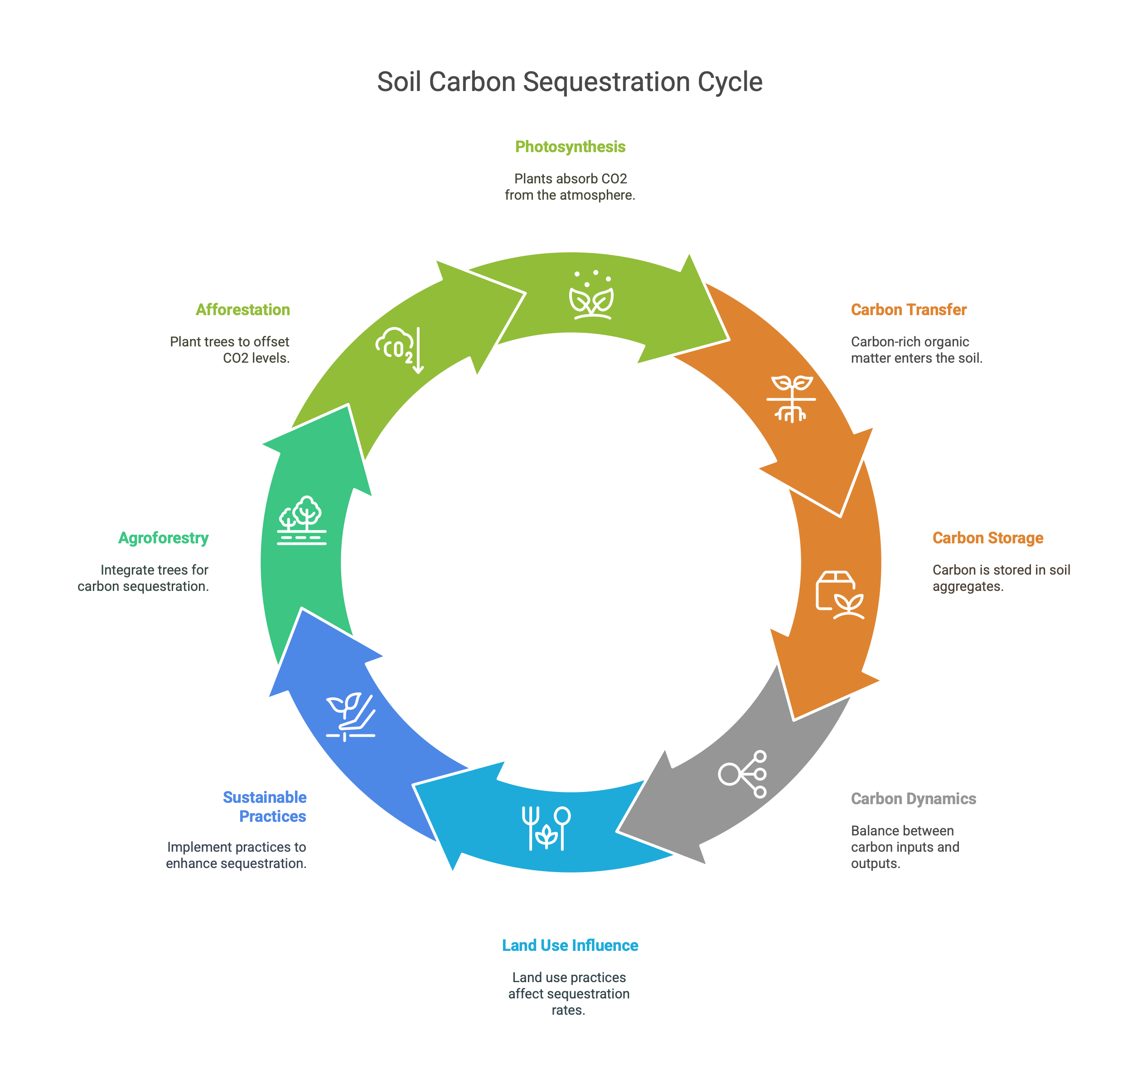
Fig 1. Soil carbon sequestration cycle
Soil carbon sequestration is essential for preserving soil health, enhancing agricultural productivity, and reducing the effects of climate change. Soil carbon sequestration encompasses a range of processes, including the conversion of atmospheric carbon dioxide into plant biomass through photosynthesis, the transfer of carbon-rich organic matter into the soil, and the long-term storage of carbon in soil aggregates and mineral associations (Katti et al., 2020). The dynamics between carbon inputs, such as plant debris and root exudates, and carbon outputs, such as microbial respiration and decomposition, determine the soil's capacity to sequester carbon. Also, the rate of carbon sequestration can be significantly influenced by land use practices, climate, soil type, and management strategies.
Agricultural soils, which make up a sizable portion of the world's land surface, are particularly well-suited to sequestering carbon and reducing greenhouse gas emissions. Altering land and soil management techniques can significantly lessen the detrimental effects of agriculture on soils and the environment (Keenor et al., 2021). Important advantages of adopting sustainable agricultural practices that increase carbon sequestration include increased soil fertility, better water retention, and decreased erosion. Agroforestry, which strategically integrates trees into agricultural landscapes, is becoming increasingly recognized for its potential to sequester carbon and provide additional environmental benefits (Zomer et al., 2016). Furthermore, afforestation initiatives on low-productivity agricultural lands have been suggested as a way to offset the rising concentration of atmospheric CO2, as the expansion of tree root systems, deposition of leaf litter, canopy shading, and discontinuation of nitrogen fertilizer application can all have an impact on the biogeochemical and hydrological characteristics of the soil.
3. Opportunities for Climate Change Mitigation
Several strategies can be implemented to enhance soil carbon sequestration and mitigate climate change. Agricultural practices such as no-till farming, cover cropping, and crop rotation can significantly increase carbon inputs into the soil while reducing carbon losses through erosion and decomposition. Furthermore, the adoption of integrated nutrient management strategies, including the use of organic amendments and biochar, can enhance soil fertility, promote plant growth, and sequester carbon in the soil (Alcántara et al., 2020). In addition to agricultural practices, land restoration and afforestation efforts can play a crucial role in sequestering carbon and restoring degraded ecosystems.
Peatlands, despite covering only a small fraction of the Earth's land surface, store a disproportionately large amount of soil carbon, underscoring their importance as carbon reservoirs. However, drainage of organic soils for agriculture and peat extraction has resulted in significant greenhouse gas emissions, highlighting the need for sustainable management practices to mitigate carbon losses (Tubiello et al., 2016). Modified agricultural practices, such as reduced tillage and the maintenance of soil cover, hold substantial promise for mitigating greenhouse gas emissions (Sanz-Cobeña et al., 2016). Furthermore, the implementation of strategies aimed at restoring degraded lands and promoting afforestation can contribute to carbon sequestration and biodiversity conservation.
4. Mechanisms of Soil Carbon Sequestration
The mechanisms governing soil carbon sequestration are multifaceted, encompassing physical, chemical, and biological processes that influence the stabilization and persistence of organic matter in soil (Peichl et al., 2014). One primary mechanism involves the formation of stable soil aggregates, where organic matter becomes physically protected from decomposition within the aggregate structure (Bhayal et al., 2018). The interactions between organic matter and soil minerals, such as clay minerals and iron oxides, also play a crucial role in carbon sequestration by forming organo-mineral complexes that are less susceptible to microbial degradation (Amundson & Biardeau, 2018). Furthermore, microbial communities in the soil contribute to carbon sequestration through the synthesis of recalcitrant organic compounds, such as humic substances, which resist decomposition and can persist in the soil for extended periods.
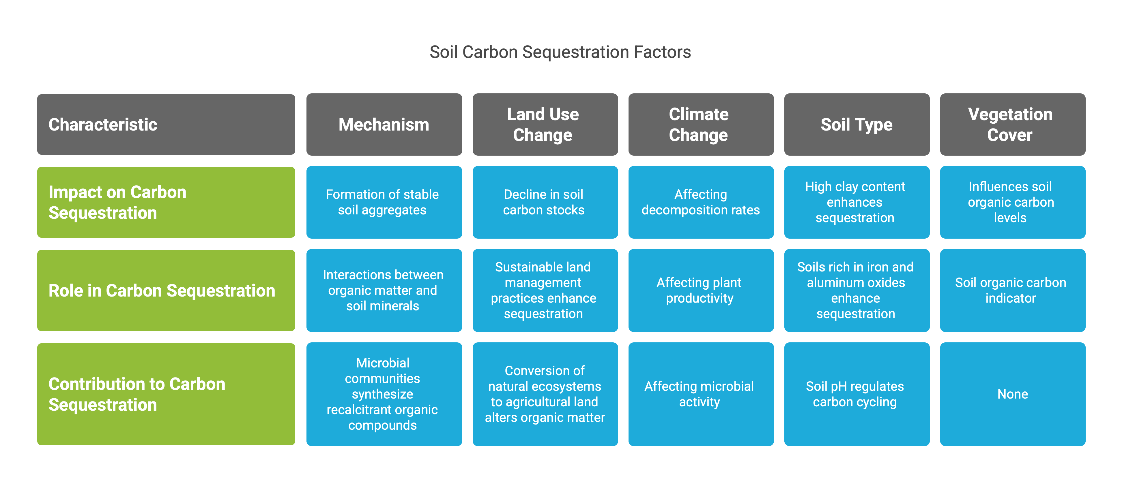
Chart 1. Soil carbon sequestration factors
Land use change has a substantial impact on carbon dynamics in soil, where converting peatland to agricultural land is expected to alter organic matter and C-biomass population (Munawaroh et al., 2022). Specifically, the conversion of natural ecosystems to agricultural land often results in a decline in soil carbon stocks due to the disruption of soil structure, increased soil erosion, and reduced inputs of organic matter. Conversely, the implementation of sustainable land management practices, such as reforestation and conservation tillage, can enhance soil carbon sequestration and restore degraded soils. Moreover, climate change, including alterations in temperature and precipitation patterns, can influence soil carbon dynamics by affecting decomposition rates, plant productivity, and microbial activity.
The role of soil in carbon sequestration is influenced by various soil types, each possessing unique physical, chemical, and biological properties that affect carbon storage capacity and dynamics. For instance, soils with high clay content tend to have greater potential for carbon sequestration due to the formation of stable organo-mineral complexes and the physical protection of organic matter within soil aggregates. Similarly, soils rich in iron and aluminum oxides can also enhance carbon sequestration through the formation of strong bonds with organic matter, reducing its susceptibility to decomposition. Additionally, soil pH plays a crucial role in regulating carbon cycling, with acidic soils generally exhibiting lower decomposition rates and greater carbon accumulation compared to alkaline soils. Vegetation cover plays a vital role in influencing soil organic carbon levels, contingent on the quantity, arrangement, and biodegradability of plant residues reintroduced into the soil (Saljnikov et al., 2013). Soil organic carbon serves as a crucial indicator of soil quality, impacting productivity in ecosystems.

6. Factors Influencing Soil Carbon Sequestration
- Land Management and Agricultural Practices:
Land management practices, including tillage, crop rotation, and fertilization, significantly influence soil carbon sequestration rates. Reduced tillage practices, such as no-till farming, can minimize soil disturbance, reduce erosion, and enhance carbon accumulation in the topsoil (Chan et al., 1992). Similarly, crop rotation and cover cropping can increase carbon inputs into the soil, improve soil structure, and promote microbial activity, leading to enhanced carbon sequestration. Furthermore, the application of organic amendments, such as compost and manure, can enhance soil fertility, increase carbon inputs, and improve soil physical properties, thereby promoting carbon sequestration (Yadav & Malanson, 2007). Incorporating plant litter into the soil can substantially affect its fertility, impacting the accessibility of nutrients and, consequently, influencing plant growth, variety, makeup, framework, and output (Hassan et al., 2021). Also, the carbon stored in the soil may face increased degradation due to global climate change (Rajan et al., 2019).
The ability of soil to function sustainably relies on various interacting factors, including its capacity to support plant life, facilitate the cycling of essential elements, and regulate the flow of water and energy (Badha et al., 2017).

7. Impact of Climate Change on Soil Carbon Sequestration
Climate change has the potential to significantly impact soil carbon sequestration processes, with rising temperatures and altered precipitation patterns affecting the balance between carbon inputs and outputs in soils. Changes in temperature and moisture regimes can influence the rate of decomposition of organic matter in soils, potentially leading to a release of stored carbon into the atmosphere. Land use change, such as agricultural expansion and deforestation, can exacerbate the impact of climate change on soil erosion, while reforestation, agricultural land abandonment, and soil conservation practices can potentially offset these effects (Eekhout & Vente, 2022). Moreover, soil management techniques, including conservation tillage, residue management, and crop rotation, play a crucial role in enhancing carbon sequestration while improving soil health and productivity.
Rising temperatures can accelerate the decomposition of soil organic matter, releasing carbon dioxide into the atmosphere and reducing the soil's capacity to store carbon. Changes in precipitation patterns, such as increased drought frequency or intensity, can also affect soil carbon sequestration by limiting plant growth and reducing the input of organic matter into the soil (Muchane et al., 2020). Climate change may influence soil aggregation and stability, which directly affects carbon storage, protection, and other soil functions, either directly or indirectly. Alterations in temperature and precipitation patterns can have a cascading effect on plant productivity, decomposition rates, and microbial activity, all of which influence the dynamics of soil carbon sequestration.
Land use changes, such as deforestation and agricultural expansion, can further exacerbate the impact of climate change on soil carbon sequestration. Deforestation, in particular, can result in a significant loss of soil carbon, as forests store large amounts of carbon in their biomass and soils (Mukhopadhyay et al., 2020). The replacement of rainforest with grasslands, for example, has been shown to increase surface temperature, decrease evapotranspiration and precipitation, and lead to a more prevalent dry season (Guo et al., 2021). Agricultural expansion can also lead to soil carbon loss, especially when intensive tillage practices are employed, which disrupt soil structure and accelerate organic matter decomposition. Soil erosion, exacerbated by climate change and unsustainable land management practices, further contributes to the depletion of soil carbon stocks. The impact of rainfall greatly contributes to soil erosion which leads to soil damage, where the eroded soil, especially on cropland, causes decreasing quality of physical, chemical, and biological properties of the soil (Herawati et al., 2018).
Fig 2.
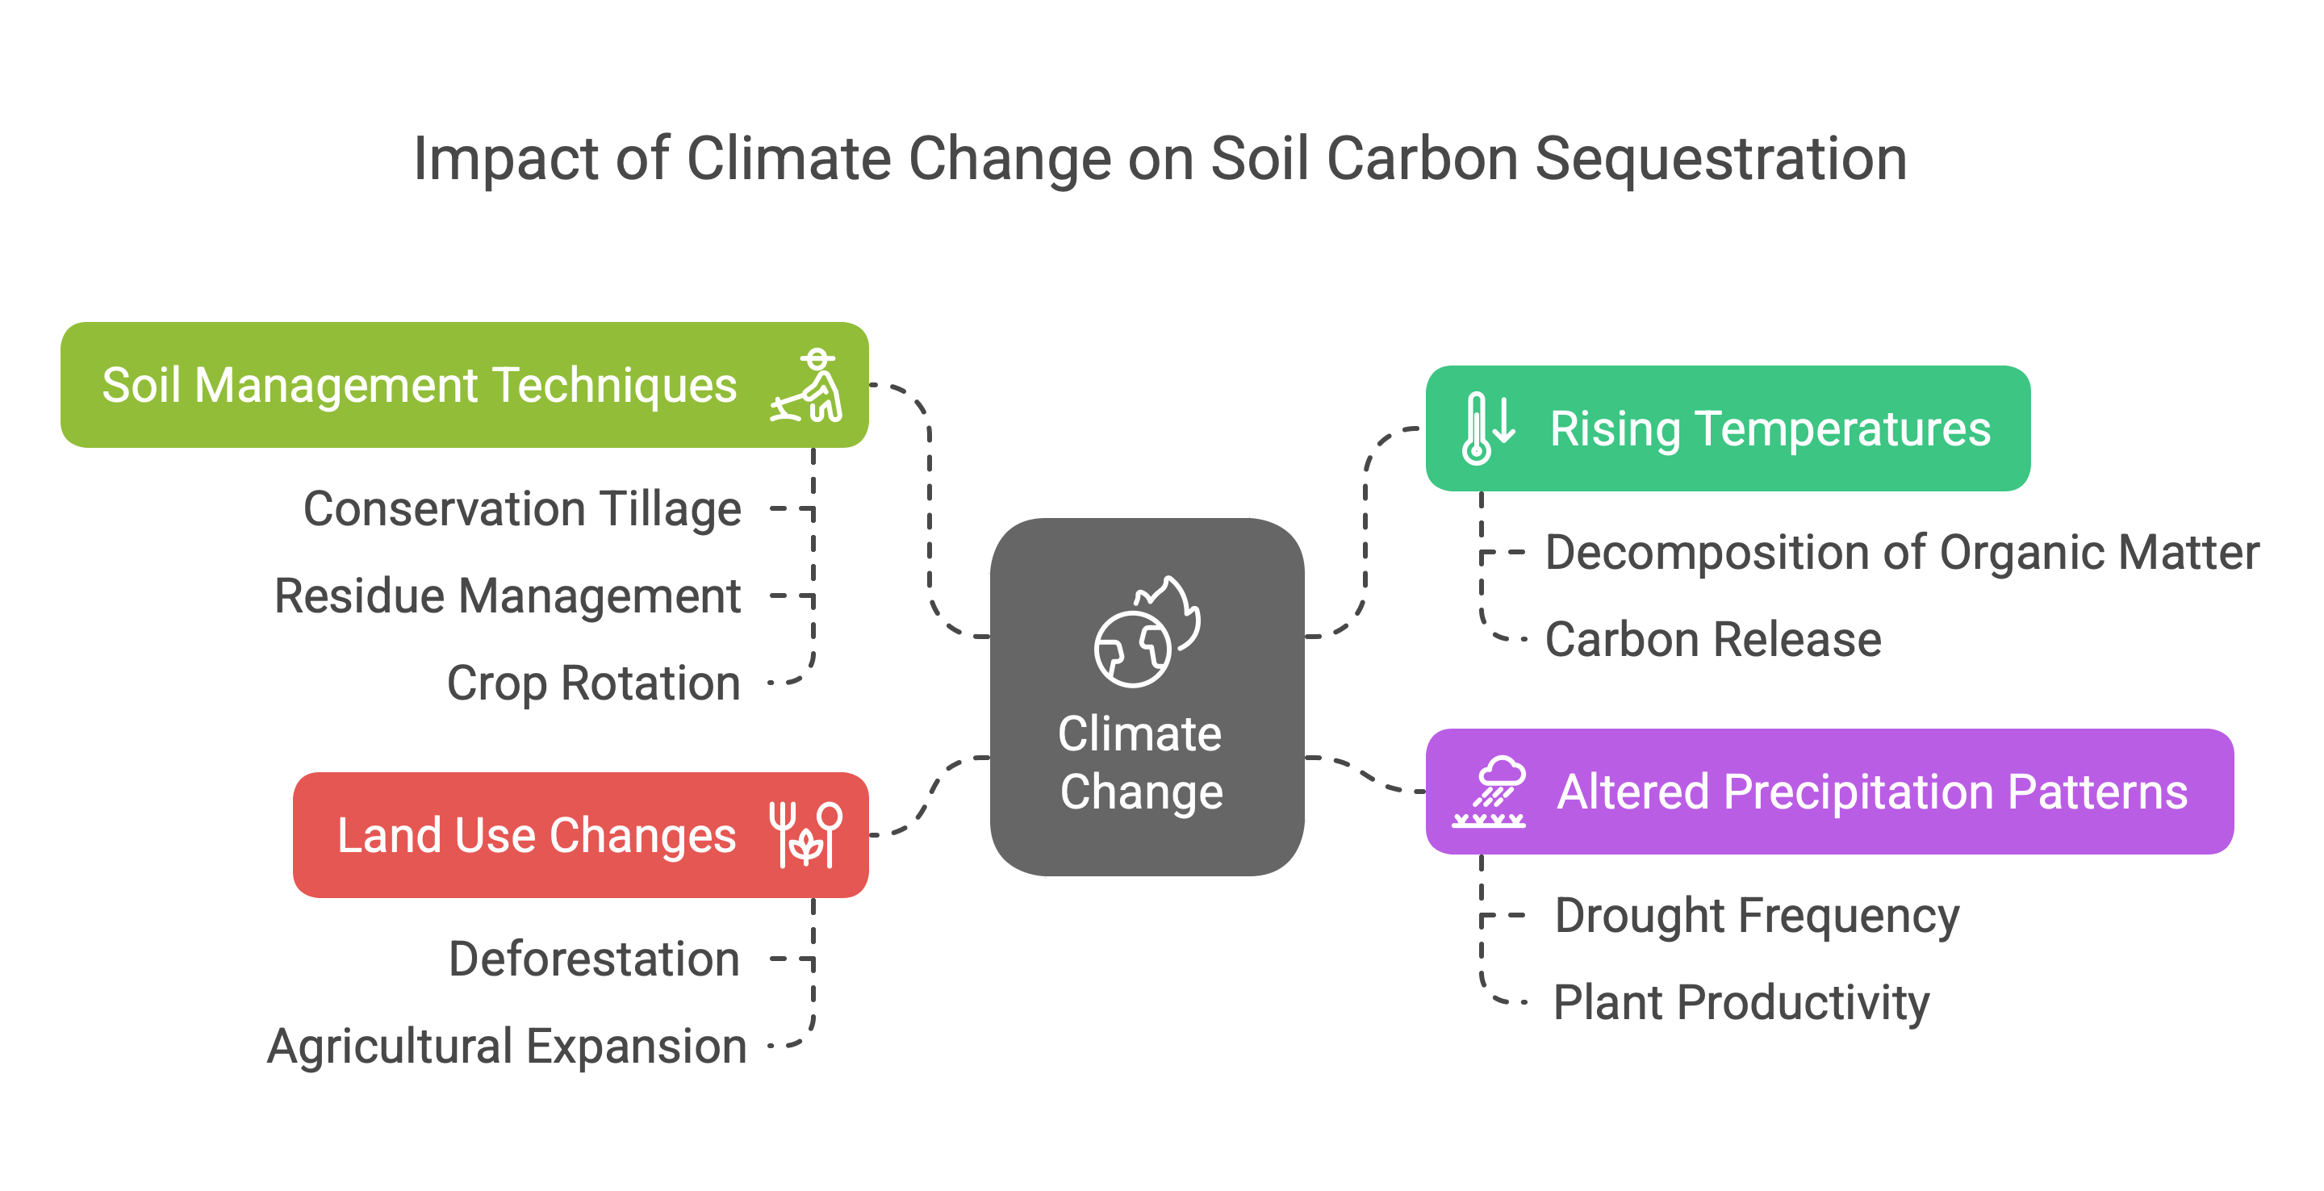
Conversely, reforestation, agricultural land abandonment, and soil conservation practices can potentially offset the negative impacts of climate change on soil carbon sequestration. Reforestation involves planting trees on degraded or deforested land, which can increase carbon sequestration in both the aboveground biomass and the soil. Soil conservation practices, such as reduced tillage, cover cropping, and contour farming, can help to improve soil structure, reduce erosion, and enhance carbon sequestration. These practices not only help to sequester carbon in soils but also provide a range of other benefits, such as improved water quality, enhanced biodiversity, and increased crop yields. These alternative pathways for climate change adaptation can also encourage adoption of conservation agriculture and reduce greenhouse gas emissions from agricultural activities while potentially improving yield.
The combined climate and carbon-cycle effects of large-scale deforestation have implications for climate change mitigation strategies (Bala et al., 2007). While reforestation and afforestation projects are often proposed as a means of sequestering carbon dioxide from the atmosphere, the biogeophysical effects of these projects, such as changes in albedo and evapotranspiration, can influence regional and global climate patterns (Portmann et al., 2022). Changes in land-use practices, like the conversion of forests to pastures, can also affect soil carbon levels, with some studies even showing an increase in soil carbon after the conversion from forest to pasture (Paul et al., 2010). The role of grazing land management in carbon sequestration is also a key consideration, as improved grazing practices can lead to increased carbon stocks in grazing land soils (Conant et al., 2016).
8. Soil Carbon Sequestration and Climate Change Mitigation
Soil carbon sequestration plays a crucial role in mitigating climate change by removing carbon dioxide from the atmosphere and storing it in the soil (Schwartz et al., 2020). Carbon sequestration is the process of capturing CO2 from the atmosphere or capturing anthropogenic CO2 from large-scale stationary sources like power plants before it is released to the atmosphere (Maiti et al., 2016). Soils have the potential to store vast amounts of carbon, making them a significant carbon sink that can help to offset greenhouse gas emissions from human activities. Increasing soil organic carbon stocks can improve soil health, enhance agricultural productivity, and reduce the concentration of greenhouse gases in the atmosphere (Lal, 2007). Carbon sequestration in soil is a method of removing carbon dioxide from the atmosphere and storing it in the soil. The soil's capacity to act as a carbon sink depends on various factors, including soil type, climate, land management practices, and vegetation cover. Certain ecosystems, like forests and wetland ecosystems, play a role in buffering extreme storms and flooding related to climate change (Cullman et al., 2003).
The ability of soils to sequester and store carbon is greatly influenced by land management practices, as agricultural lands in particular have often lost significant amounts of their original soil carbon due to intensive cultivation and other unsustainable practices. Strategies such as conservation tillage, cover cropping, crop rotation, and the application of organic amendments can promote carbon sequestration in agricultural soils and enhance their overall health and productivity (Carey et al., 2020). Peatland ecosystems, with their waterlogged conditions and slow decomposition rates, accumulate substantial amounts of organic matter over time, forming deep peat layers that act as long-term carbon stores (Hikmat et al., 2022). However, the carbon sequestration function of peatland ecosystems is threatened by drainage and land use change, which leads to the oxidation of organic matter and increased emission of greenhouse gases (Jaenicke et al., 2008). Restoring degraded peatlands can help reinstate their carbon sequestration capacity and mitigate climate change (Harenda et al., 2017) (Amesbury et al., 2019). In intact peatland ecosystems, oxygen deficiency resulting from high-water tables causes the formation of organic soils (Leifeld & Menichetti, 2018). Plant productivity exceeds decomposition in these ecosystems, leading to a slow, steady accumulation of carbon-rich organic matter (Amesbury et al., 2019). Peatlands, covering only about 3% of the Earth's land surface, store approximately twice the amount of carbon found in all forests (Mrotzek et al., 2020). When peatlands are drained for agriculture, forestry, or peat extraction, the organic matter decomposes, releasing large quantities of carbon dioxide into the atmosphere (Harenda et al., 2017).

9. Opportunities and Challenges
Enhancing soil carbon sequestration offers a multifaceted approach to climate change mitigation, presenting both opportunities and challenges that require careful consideration and strategic implementation. One of the most promising opportunities lies in the adoption of sustainable land management practices in agriculture. These practices can not only increase carbon sequestration but also improve soil health, enhance biodiversity, and increase crop yields. Implementing conservation tillage, cover cropping, and crop rotation can significantly enhance carbon sequestration in agricultural soils. Peatland restoration also presents a significant opportunity for climate change mitigation. By re-establishing water-saturated conditions, peatland restoration can promote the accumulation of new peat and restore the climate cooling carbon sink function.
Despite the potential benefits, enhancing soil carbon sequestration also faces a number of challenges. One major challenge is the complexity of soil carbon dynamics. Soil carbon sequestration is influenced by various factors, including soil type, climate, land management practices, and vegetation cover, making it difficult to accurately predict and measure carbon sequestration rates.
Fig 3.
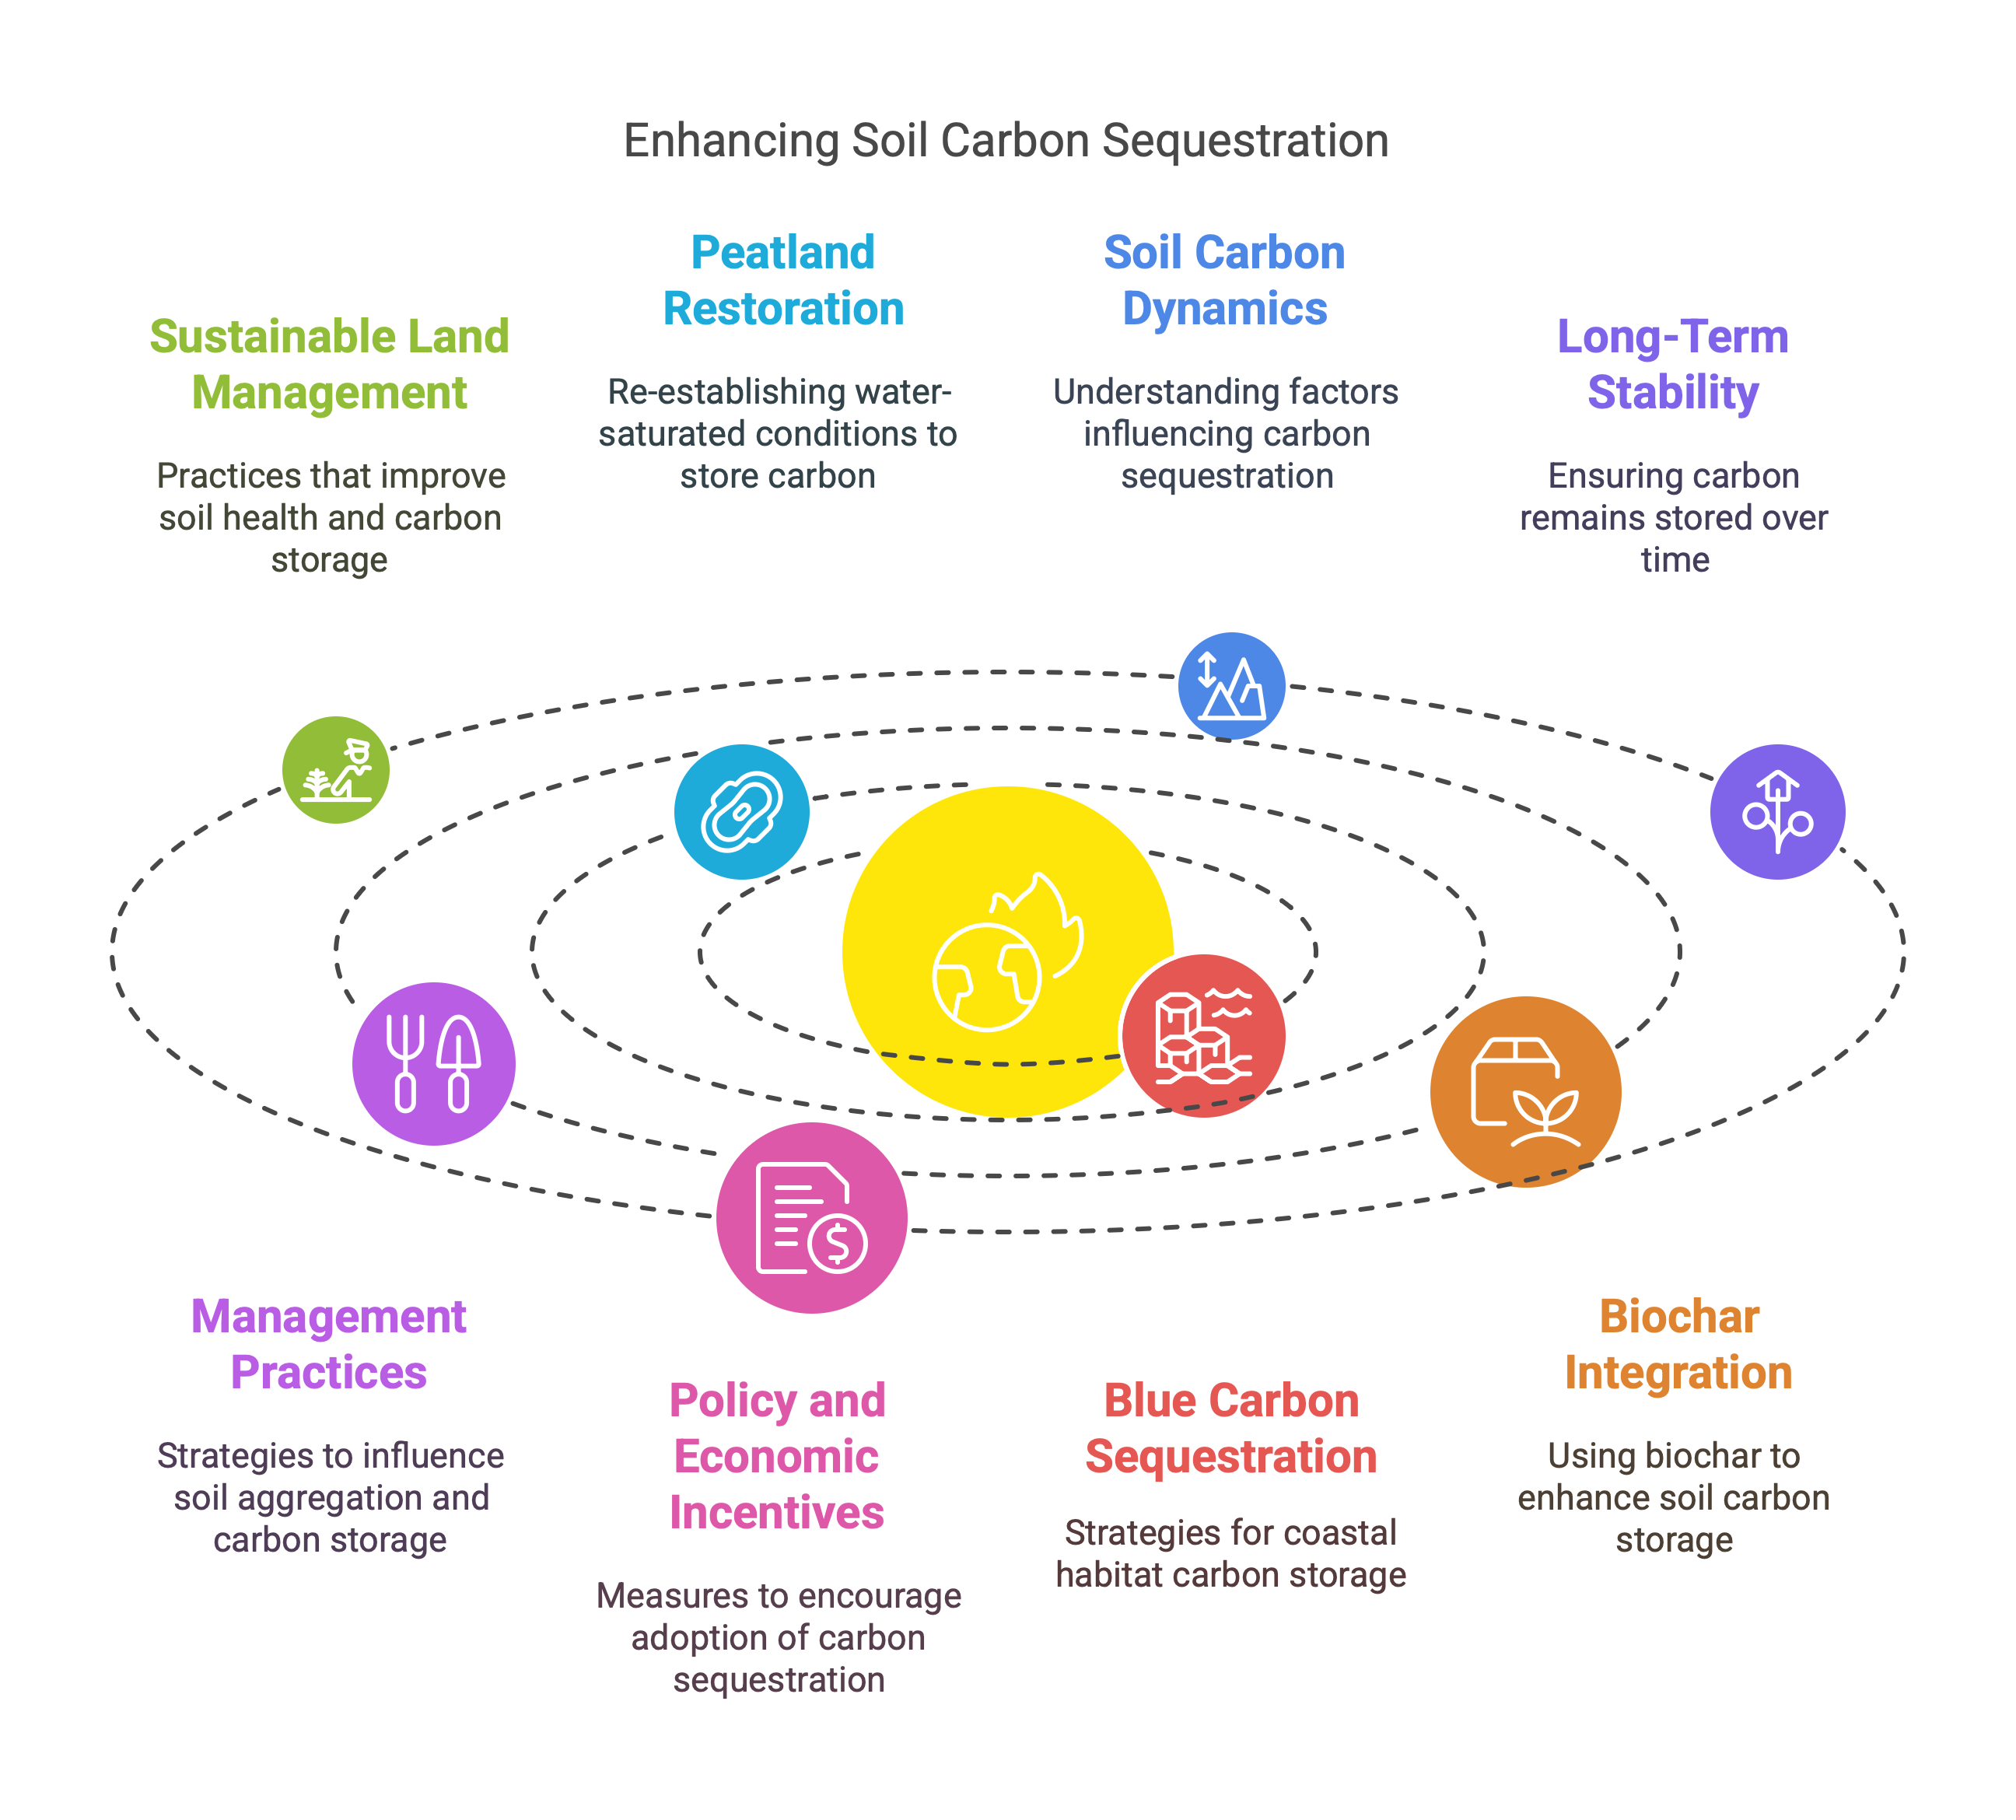
Additionally, the long-term stability of soil carbon is not always guaranteed. Changes in land use, climate, or management practices can lead to the release of previously sequestered carbon back into the atmosphere (Salim et al., 2021). Understanding how management practices influence soil aggregation, which is the binding of soil particles into stable clusters, is crucial for maximizing carbon storage potential. Furthermore, the implementation of soil carbon sequestration strategies often requires significant investments in new technologies, infrastructure, and training. Policy and economic incentives can play a crucial role in promoting the adoption of soil carbon sequestration practices. The process of carbon dioxide sequestration involves isolating carbon dioxide from the atmosphere for extended periods using physical, chemical, biological, or engineered processes (Pawde & Parekh, 2013).
To promote blue carbon sequestration, it is important to implement management strategies that consider the environmental variables that influence this process (Macreadie et al., 2017). It is also crucial to have precise measurement of changes in carbon stocks in coastal habitats through remote sensing techniques and machine learning algorithms. Biochar, a carbon-rich product derived from the pyrolysis of organic materials, has emerged as a promising tool for carbon sequestration and soil amendment (Senadheera et al., 2023). Integrating biochar into soil can enhance its capacity to store carbon, improve its physical and chemical properties, and promote plant growth (Resnik & Vallero, 2013).

Conclusion
The soil has great potential for carbon sequestration, which is a crucial component of global climate change mitigation strategies. Soils have the ability to absorb carbon dioxide from the atmosphere, which reduces the amount of greenhouse gases and improves soil health and fertility. To fully realize this potential, it is essential to implement integrated strategies that combine sustainable land management practices, technological advancements, and supportive policies.
Increasing carbon storage in soils through strategies like conservation tillage and cover cropping can mitigate climate change and improve soil health and agricultural productivity. The ocean, geological formations, and terrestrial ecosystems are viable places for carbon sequestration (Lal, 2009). Carbon sequestration technology is still not fully understood, and there is a dearth of thorough literature reviews on the various carbon sequestration choices. Therefore, policy and research priorities are developed without a thorough understanding of the state of scientific knowledge, effects, and policy trade-offs. Further research is needed to optimize carbon sequestration strategies and understand their long-term impacts on soil health, ecosystem function, and climate change mitigation. Also, attention should be given to the possible negative effects of carbon sequestration projects, such as land use change and the emission of other greenhouse gases. Furthermore, standardization of measurement, reporting, and verification protocols is essential to track progress and ensure the effectiveness of carbon sequestration efforts. Finally, carbon sequestration is a crucial strategy for mitigating climate change, and soils play a key role in this process. By implementing integrated strategies and investing in research and innovation, we can unlock the full potential of soil carbon sequestration and create a more sustainable and resilient future for all.

References
Alcántara, J. C., González, I., Pareta, M. M., & Vilaseca, F. (2020). Biocomposites from Rice Straw Nanofibers: Morphology, Thermal and Mechanical Properties. Materials, 13(9), 2138. https://doi.org/10.3390/ma13092138
Amelung, W., Bossio, D., Vries, W. de, Kögel‐Knabner, I., Lehmann, J., Amundson, R., Bol, R., Collins, C. D., Lal, R., Leifeld, J., Minasny, B., Pan, G., Paustian, K., Rumpel, C., Sanderman, J., Groenigen, J. W. van, Mooney, S., Wesemael, B. van, Wander, M. M., & Chabbi, A. (2020). Towards a global-scale soil climate mitigation strategy [Review of Towards a global-scale soil climate mitigation strategy]. Nature Communications, 11(1). Nature Portfolio. https://doi.org/10.1038/s41467-020-18887-7
Amesbury, M. J., Gallego‐Sala, A., & Loisel, J. (2019). Peatlands as prolific carbon sinks. Nature Geoscience, 12(11), 880. https://doi.org/10.1038/s41561-019-0455-y
Amundson, R., & Biardeau, L. (2018). Soil carbon sequestration is an elusive climate mitigation tool. Proceedings of the National Academy of Sciences, 115(46), 11652. https://doi.org/10.1073/pnas.1815901115
Araújo, A. S. F. de, Leite, L. F. C., Iwata, B. de F., Lira, M. A., Xavier, G. R., & Figueiredo, M. do V. B. (2011). Microbiological process in agroforestry systems. A review [Review of Microbiological process in agroforestry systems. A review]. Agronomy for Sustainable Development, 32(1), 215. Springer Science+Business Media. https://doi.org/10.1007/s13593-011-0026-0
Atia, M. A. M., Jiang, W., Sedeek, K., Butt, H., & Mahfouz, M. M. (2024). Crop bioengineering via gene editing: reshaping the future of agriculture. Plant Cell Reports, 43(4). https://doi.org/10.1007/s00299-024-03183-1
Badha, J. H., Capasso, J., Schindelbeck, R. R., & Bacon, A. R. (2017). Tools for Evaluating Soil Health. EDIS, 2017(3). https://doi.org/10.32473/edis-ss657-2017
Bala, G., Caldeira, K., Wickett, M., Phillips, T. J., Lobell, D. B., Delire, C., & Mirin, A. A. (2007). Combined climate and carbon-cycle effects of large-scale deforestation. Proceedings of the National Academy of Sciences, 104(16), 6550. https://doi.org/10.1073/pnas.0608998104
Bardgett, R. D., Freeman, C., & Ostle, N. (2008). Microbial contributions to climate change through carbon cycle feedbacks [Review of Microbial contributions to climate change through carbon cycle feedbacks]. The ISME Journal, 2(8), 805. Springer Nature. https://doi.org/10.1038/ismej.2008.58
Bellassen, V., & Luyssaert, S. (2014). Carbon sequestration: Managing forests in uncertain times. Nature, 506(7487), 153. https://doi.org/10.1038/506153a
Bhayal, D., Khaddar, V. K., Bhayal, L., Yadav, T. C., Bangar, K. S., & Singh, B. (2018). Effect of Sunhemp Green Manuring and Intercropping on Soil Properties. International Journal of Current Microbiology and Applied Sciences, 7(12), 371. https://doi.org/10.20546/ijcmas.2018.712.046
Brevik, E. C. (2013). The Potential Impact of Climate Change on Soil Properties and Processes and Corresponding Influence on Food Security. Agriculture, 3(3), 398. https://doi.org/10.3390/agriculture3030398
Carey, C. J., Gravuer, K., Gennet, S., Osleger, D. J., & Wood, S. A. (2020). Supporting evidence varies for rangeland management practices that seek to improve soil properties and forage production in California. California Agriculture, 74(2), 101. https://doi.org/10.3733/ca.2020a0015
Chan, K., Roberts, W., & Heenan, D. (1992). Organic carbon and associated soil properties of a red earth after 10 years of rotation under different stubble and tillage practices. Soil Research, 30(1), 71. https://doi.org/10.1071/sr9920071
Conant, R. T., Cerri, C. E. P., Osborne, B., & Paustian, K. (2016). Grassland management impacts on soil carbon stocks: a new synthesis [Review of Grassland management impacts on soil carbon stocks: a new synthesis]. Ecological Applications, 27(2), 662. Wiley. https://doi.org/10.1002/eap.1473
Cullman, G., Gibbs, J. P., Johnson, E. I. M., Laverty, M. F., Murphy, L., & Sterling, E. J. (2003). Why is Biodiversity Important? https://doi.org/10.5531/cbc.ncep.0007
Davidson, E. A., & Janssens, I. A. (2006). Temperature sensitivity of soil carbon decomposition and feedbacks to climate change [Review of Temperature sensitivity of soil carbon decomposition and feedbacks to climate change]. Nature, 440(7081), 165. Nature Portfolio. https://doi.org/10.1038/nature04514
Dollinger, J., & Jose, S. (2018). Agroforestry for soil health. Agroforestry Systems, 92(2), 213. https://doi.org/10.1007/s10457-018-0223-9
Dooley, S., & Treseder, K. K. (2011). The effect of fire on microbial biomass: a meta-analysis of field studies. Biogeochemistry, 109, 49. https://doi.org/10.1007/s10533-011-9633-8
Eekhout, J., & Vente, J. de. (2022). Global impact of climate change on soil erosion and potential for adaptation through soil conservation. Earth-Science Reviews, 226, 103921. https://doi.org/10.1016/j.earscirev.2022.103921
Efosa, O. P., Chukwuma, U., Stanley, E., & Robert, O. E. (2021). Relationship Between Soil Organic Matter and Some Physical Properties in Selected Soils of the Oil Palm Belt of Nigeria. Journal of Natural Sciences Research. https://doi.org/10.7176/jnsr/12-7-01
Fargione, J., Bassett, S., Boucher, T. M., Bridgham, S. D., Conant, R. T., Cook‐Patton, S. C., Ellis, P. W., Falcucci, A., Fourqurean, J. W., Gopalakrishna, T., Gu, H., Henderson, B., Hurteau, M. D., Kroeger, K. D., Kroeger, T., Lark, T. J., Leavitt, S. M., Lomax, G., McDonald, R. I., … Griscom, B. W. (2018). Natural climate solutions for the United States. Science Advances, 4(11). https://doi.org/10.1126/sciadv.aat1869
Gelybó, G., Tóth, E., Farkas, C., Horel, Á., Kasa, I. W., & Bakacsi, Z. (2018). Potential impacts of climate change on soil properties. Agrokémia És Talajtan, 67(1), 121. https://doi.org/10.1556/0088.2018.67.1.9
Georgiou, K., Koven, C. D., Wieder, W. R., Hartman, M. D., Riley, W. J., Pett‐Ridge, J., Bouskill, N., Abramoff, R., Slessarev, E., Ahlström, A., Parton, W. J., Pellegrini, A. F. A., Pierson, D., Sulman, B. N., Zhu, Q., & Jackson, R. B. (2024). Emergent temperature sensitivity of soil organic carbon driven by mineral associations. Nature Geoscience, 17(3), 205. https://doi.org/10.1038/s41561-024-01384-7
Guo, B., Subrahmanyam, M. V., Ai-guo, L., & Guang-zhe, L. (2021). Application of Remote Sensing Technology to Monitoring of Vegetation Recovery and Regional Precipitation in Wenchuan Earthquake Area: Case Study of Longxi River Basin. Sensors and Materials, 33(11), 3693. https://doi.org/10.18494/sam.2021.3337
Hamidov, A., Helming, K., Bellocchi, G., Bojar, W., Dalgaard, T., Ghaley, B. B., Hoffmann, C., Holman, I., Holzkämper, A., Krzeminska, D., Kværnø, S., Lehtonen, H., Niedrist, G., Øygarden, L., Reidsma, P., Roggero, P. P., Rusu, T., Santos, C., Seddaiu, G., … Schönhart, M. (2018). Impacts of climate change adaptation options on soil functions: A review of European case‐studies [Review of Impacts of climate change adaptation options on soil functions: A review of European case‐studies]. Land Degradation and Development, 29(8), 2378. Wiley. https://doi.org/10.1002/ldr.3006
Harenda, K. M., Lamentowicz, M., Samson, M., & Chojnicki, B. H. (2017). The Role of Peatlands and Their Carbon Storage Function in the Context of Climate Change. In GeoPlanet: earth and planetary sciences (p. 169). Springer International Publishing. https://doi.org/10.1007/978-3-319-71788-3_12
Hassan, N., Sher, K., Rab, A., Abdullah, I., Zeb, U., Naeem, I., Shuaib, M., Khan, H., Khan, W., & Khan, A. (2021). Effects and mechanism of plant litter on grassland ecosystem: A review [Review of Effects and mechanism of plant litter on grassland ecosystem: A review]. Acta Ecologica Sinica, 41(4), 341. Elsevier BV. https://doi.org/10.1016/j.chnaes.2021.02.006
Herawati, A., Suntoro, S., Widijanto, H., Pusponegoro, I. H., Sutopo, N. R., & Mujiyo, M. (2018). Soil degradation level under particular annual rainfall at Jenawi District– Karanganyar, Indonesia. IOP Conference Series Earth and Environmental Science, 129, 12010. https://doi.org/10.1088/1755-1315/129/1/012010
Hikmat, M., Yatno, E., & Heryanto, B. R. (2022). Potentials of peatlands for agriculture in Tanjung Jabung Barat Regency, Jambi Province. IOP Conference Series Earth and Environmental Science, 1025(1), 12035. https://doi.org/10.1088/1755-1315/1025/1/012035
Jaenicke, J., Rieley, J. O., Mott, C. J. B., Kimman, P., & Siegert, F. (2008). Determination of the amount of carbon stored in Indonesian peatlands. Geoderma, 147, 151. https://doi.org/10.1016/j.geoderma.2008.08.008
Katti, J., Gurumurthy, K. T., Ravikumar, D., & Vageesh, T. S. (2020). Carbon Dynamics under Different Land-Use Systems of Nandipura Mini-Watershed of Chikkamagaluru District, Karnataka, India. International Journal of Current Microbiology and Applied Sciences, 9(10), 3968. https://doi.org/10.20546/ijcmas.2020.910.456
Keenor, S. G., Rodrigues, A. F., Mao, L., Latawiec, A. E., Harwood, A. R., & Reid, B. J. (2021). Capturing a soil carbon economy. Royal Society Open Science, 8(4). https://doi.org/10.1098/rsos.202305
Kingra, P. K., Setia, R., Kaur, S., Kaur, J., Singh, S., Singh, S. P., Kukal, S. S., & Pateriya, B. (2018). ANALYSIS AND MAPPING OF SPATIO-TEMPORAL CLIMATE VARIABILITY IN PUNJAB USING CLASSICAL STATISTICS AND GEOSTATISTICS. MAUSAM, 69(1), 147. https://doi.org/10.54302/mausam.v69i1.246
Kobayashi, H. (2004). Climate change and future options for carbon sequestration. Foresight, 6(3), 153. https://doi.org/10.1108/14636680410547753
Koch, A., McBratney, A. B., Adams, M. A., Field, D. J., Hill, R. W., Crawford, J. W., Minasny, B., Lal, R., Abbott, L. K., O’Donnell, A. G., Angers, D. A., Baldock, J., Barbier, E. B., Binkley, D., Parton, W. J., Wall, D. H., Bird, M. I., Bouma, J., Chenu, C., … Zimmermann, M. (2013). Soil Security: Solving the Global Soil Crisis. Global Policy, 4(4), 434. https://doi.org/10.1111/1758-5899.12096
Kowalska, A., & Grobelak, A. (2020). Organic matter decomposition under warming climatic conditions. In Elsevier eBooks (p. 397). Elsevier BV. https://doi.org/10.1016/b978-0-12-818032-7.00014-x
Lal, R. (2007). Carbon sequestration [Review of Carbon sequestration]. Philosophical Transactions of the Royal Society B Biological Sciences, 363(1492), 815. Royal Society. https://doi.org/10.1098/rstb.2007.2185
Lal, R. (2008). Sequestration of atmospheric CO2 in global carbon pools. Energy & Environmental Science, 1(1), 86. https://doi.org/10.1039/b809492f
Lal, R. (2009). Sequestering Atmospheric Carbon Dioxide. Critical Reviews in Plant Sciences, 28(3), 90. https://doi.org/10.1080/07352680902782711
Lal, R. (2020). Soil organic matter and water retention. Agronomy Journal, 112(5), 3265. https://doi.org/10.1002/agj2.20282
Lal, R., Monger, C., Nave, L. E., & Smith, P. (2021). The role of soil in regulation of climate [Review of The role of soil in regulation of climate]. Philosophical Transactions of the Royal Society B Biological Sciences, 376(1834), 20210084. Royal Society. https://doi.org/10.1098/rstb.2021.0084
Leifeld, J., & Menichetti, L. (2018). The underappreciated potential of peatlands in global climate change mitigation strategies. Nature Communications, 9(1). https://doi.org/10.1038/s41467-018-03406-6
Léopold, A., Drouin, J., Drohnu, E., Kaplan, H., Wamejonengo, J., & Bouard, S. (2021). Fire-fallow agriculture as a sustainable cropping system for maintaining organic carbon in Maré Loyalty Island (New Caledonia, southwest Pacific). Regional Environmental Change, 21(4). https://doi.org/10.1007/s10113-021-01814-x
Li, C., Li, Z., Yang, M., Ma, B., & Wang, B. (2021). Grid-Scale Impact of Climate Change and Human Influence on Soil Erosion within East African Highlands (Kagera Basin). International Journal of Environmental Research and Public Health, 18(5), 2775. https://doi.org/10.3390/ijerph18052775
Loboguerrero, A. M., Campbell, B., Cooper, P. J. M., Hansen, J., Rosenstock, T. S., & Wollenberg, E. (2019). Food and Earth Systems: Priorities for Climate Change Adaptation and Mitigation for Agriculture and Food Systems. Sustainability, 11(5), 1372. https://doi.org/10.3390/su11051372
Luyssaert, S., Schulze, E., Börner, A., Knohl, A., Hessenmöller, D., Law, B. E., Ciais, P., & Grace, J. (2008). Old-growth forests as global carbon sinks. Nature, 455(7210), 213. https://doi.org/10.1038/nature07276
Macreadie, P. I., Nielsen, D. A., Kelleway, J. J., Atwood, T. B., Seymour, J. R., Petrou, K., Connolly, R. M., Thomson, A. C. G., Trevathan‐Tackett, S. M., & Ralph, P. J. (2017). Can we manage coastal ecosystems to sequester more blue carbon? [Review of Can we manage coastal ecosystems to sequester more blue carbon?]. Frontiers in Ecology and the Environment, 15(4), 206. Wiley. https://doi.org/10.1002/fee.1484
Maiti, R., Rodríguez, H. G., & Ivanova, N. S. (2016). Carbon capture, carbon sequestration and carbon fixation (p. 199). https://doi.org/10.1002/9781119104452.ch16
Malhi, Y., Franklin, J., Seddon, N., Solan, M., Turner, M. G., Field, C. B., & Knowlton­, N. (2020). Climate change and ecosystems: threats, opportunities and solutions. Philosophical Transactions of the Royal Society B Biological Sciences, 375(1794), 20190104. https://doi.org/10.1098/rstb.2019.0104
Mampitiya, L., Rozumbetov, K., Rathnayake, N., Erkudov, V. O., Esimbetov, A., Arachchi, S., Kantamaneni, K., Hoshino, Y., & Rathnayake, U. (2024). Artificial intelligence to predict soil temperatures by development of novel model. Scientific Reports, 14(1). https://doi.org/10.1038/s41598-024-60549-x
Mrotzek, A., Michaelis, D., Günther, A., Wrage, N., & Couwenberg, J. (2020). Mass Balances of a Drained and a Rewetted Peatland: on Former Losses and Recent Gains. Soil Systems, 4(1), 16. https://doi.org/10.3390/soilsystems4010016
Muchane, M. N., Sileshi, G. W., Gripenberg, S., Jonsson, M., Pumariño, L., & Barrios, E. (2020). Agroforestry boosts soil health in the humid and sub-humid tropics: A meta-analysis. Agriculture Ecosystems & Environment, 295, 106899. https://doi.org/10.1016/j.agee.2020.106899
Mukhopadhyay, R., Sarkar, B., Jat, H. S., Sharma, P. C., & Bolan, N. (2020). Soil salinity under climate change: Challenges for sustainable agriculture and food security [Review of Soil salinity under climate change: Challenges for sustainable agriculture and food security]. Journal of Environmental Management, 280, 111736. Elsevier BV. https://doi.org/10.1016/j.jenvman.2020.111736
Munawaroh, H., Rauf, A., Razali, Bintang, & Sabrina, T. (2022). Preliminary study on C-organic and C-microbial biomass of peatland in Toba highlands. IOP Conference Series Earth and Environmental Science, 1025(1), 12017. https://doi.org/10.1088/1755-1315/1025/1/012017
Nair, P. R. (2007). The coming of age of agroforestry. Journal of the Science of Food and Agriculture, 87(9), 1613. https://doi.org/10.1002/jsfa.2897
Nalluri, N., & Karri, V. R. (2023). Superior effect of nature based solutions in soil and water management for sustainable agriculture. Plant Science Today. https://doi.org/10.14719/pst.2159
Pallikonda, M. (2017). CLIMATE CHANGES AND ITS IMPACT ON AGRICULTURE OF NORTHERN TELANGANA ZONE. International Journal of Advanced Research, 5(12), 1737. https://doi.org/10.21474/ijar01/6142
Panchami, L. R., Gudi, N., & Patil, D. S. (2023). Sustainable agricultural practices in South Asia: A comprehensive review [Review of Sustainable agricultural practices in South Asia: A comprehensive review]. CABI Reviews. https://doi.org/10.1079/cabireviews.2023.0032
Parmesan, C. (2023). Terrestrial and Freshwater Ecosystems and Their Services. In Cambridge University Press eBooks (p. 197). Cambridge University Press. https://doi.org/10.1017/9781009325844.004
Paul, M., Catterall, C. P., Pollard, P., & Kanowski, J. (2010). Recovery of soil properties and functions in different rainforest restoration pathways. Forest Ecology and Management, 259(10), 2083. https://doi.org/10.1016/j.foreco.2010.02.019
Pawde, C., & Parekh, R. (2013). A Discussion of the HSE Aspects of Carbon Dioxide Sequestration. SPE Asia Pacific Oil and Gas Conference and Exhibition. https://doi.org/10.2118/165781-ms
Peichl, M., Arain, A. M., Moore, T. R., Brodeur, J., Khomik, M., Ullah, S., Restrepo‐Coupé, N., McLaren, J., & Pejam, M. R. (2014). Carbon and greenhouse gas balances in an age sequence of temperate pine plantations. Biogeosciences, 11(19), 5399. https://doi.org/10.5194/bg-11-5399-2014
Pérez‐Alonso, M., Guerrero‐Galán, C., Scholz, S. S., Kiba, T., Sakakibara, H., Ludwig‐Müller, J., Krapp, A., Oelmüller, R., Vicente‐Carbajosa, J., & Pollmann, S. (2020). Harnessing symbiotic plant–fungus interactions to unleash hidden forces from extreme plant ecosystems [Review of Harnessing symbiotic plant–fungus interactions to unleash hidden forces from extreme plant ecosystems]. Journal of Experimental Botany, 71(13), 3865. Oxford University Press. https://doi.org/10.1093/jxb/eraa040
Portmann, R., Beyerle, U., Davin, É. L., Fischer, E., Hertog, S. D., & Schemm, S. (2022). Global forestation and deforestation affect remote climate via adjusted atmosphere and ocean circulation. Nature Communications, 13(1). https://doi.org/10.1038/s41467-022-33279-9
Pralhad, B. S., Rajendran, P., Divya, M., Rajeswari, R., Thangamani, G., & Ramaha, C. (2020). Assessing the Effect of Different Agroforestry Practices on Soil Physico-chemical Properties and Microbial Activity. International Journal of Current Microbiology and Applied Sciences, 9(9), 2802. https://doi.org/10.20546/ijcmas.2020.912.335
Proietti, I., Frazzoli, C., & Mantovani, A. (2015). Exploiting Nutritional Value of Staple Foods in the World’s Semi-Arid Areas: Risks, Benefits, Challenges and Opportunities of Sorghum [Review of Exploiting Nutritional Value of Staple Foods in the World’s Semi-Arid Areas: Risks, Benefits, Challenges and Opportunities of Sorghum]. Healthcare, 3(2), 172. Multidisciplinary Digital Publishing Institute. https://doi.org/10.3390/healthcare3020172
Rahadiarta, I. K. V. S., Putra, I. D. N. N., & Suteja, Y. (2018). Simpanan Karbon Pada Padang Lamun di Kawasan Pantai Mengiat, Nusa Dua Bali. Journal of Marine and Aquatic Sciences, 5(1), 1. https://doi.org/10.24843/jmas.2019.v05.i01.p01
Rajan, K., Kumar, S., Dinesh, D., Raja, P., Bhatt, B. P., & Karan, D. (2019). Appraisal of Soil Potential to Store Organic Carbon in Different Land Uses under Old Alluvium of Indo- Gangetic Plains. International Journal of Current Microbiology and Applied Sciences, 8(3), 2089. https://doi.org/10.20546/ijcmas.2019.803.249
Raza, A., Razzaq, A., Mehmood, S. S., Zou, X., Zhang, X., Lv, Y., & Xu, J. (2019). Impact of Climate Change on Crops Adaptation and Strategies to Tackle Its Outcome: A Review [Review of Impact of Climate Change on Crops Adaptation and Strategies to Tackle Its Outcome: A Review]. Plants, 8(2), 34. Multidisciplinary Digital Publishing Institute. https://doi.org/10.3390/plants8020034
Resnik, D. B., & Vallero, D. A. (2013). Geoengineering: An Idea Whose Time Has Come? Journal of Earth Science & Climatic Change, 4(2). https://doi.org/10.4172/2157-7617.s1-001
Rodríguez, B. C., Zuazo, V. H. D., Soriano, M., Tejero, I. F. G., Ruíz, B. G., & Tavira, S. C. (2022). Conservation Agriculture as a Sustainable System for Soil Health: A Review [Review of Conservation Agriculture as a Sustainable System for Soil Health: A Review]. Soil Systems, 6(4), 87. Multidisciplinary Digital Publishing Institute. https://doi.org/10.3390/soilsystems6040087
Salim, A., Narendra, B. H., Lisnawati, Y., & Rachmat, H. H. (2021). Hydro-physical properties of agriculturally used peatlands in Liang Anggang Protected Forest, South Kalimantan, Indonesia. IOP Conference Series Earth and Environmental Science, 789(1), 12048. https://doi.org/10.1088/1755-1315/789/1/012048
Saljnikov, E., Čakmak, D., & Rahimgaliev, S. (2013). Soil Organic Matter Stability as Affected by Land Management in Steppe Ecosystems. In InTech eBooks. https://doi.org/10.5772/53557
Sanderman, J., & Amundson, R. (2003). Biogeochemistry of Decomposition and Detrital Processing. In Elsevier eBooks (p. 249). Elsevier BV. https://doi.org/10.1016/b0-08-043751-6/08131-7
Sanderman, J., Jodie, R., Wurst, M., Mary-Anne, Y., & Austin, J. (2015). Impacts of Rotational Grazing on Soil Carbon in Native Grass-Based Pastures in Southern Australia. PLoS ONE, 10(8). https://doi.org/10.1371/journal.pone.0136157
Sanz-Cobeña, A., Lassaletta, L., Aguilera, E., Prado, A. del, Garnier, J., Billen, G., Iglesias, A., Sánchez, B., Guardia, G., Ábalos, D., Plaza‐Bonilla, D., Puigdueta-Bartolomé, I., Moral, R., Galán, E., Arriaga, H., Merino, P., Infante‐Amate, J., Meijide, A., Pardo, G. O., … Smith, P. (2016). Strategies for greenhouse gas emissions mitigation in Mediterranean agriculture: A review [Review of Strategies for greenhouse gas emissions mitigation in Mediterranean agriculture: A review]. Agriculture Ecosystems & Environment, 238, 5. Elsevier BV. https://doi.org/10.1016/j.agee.2016.09.038
Schmitz, O. J., Wilmers, C. C., Leroux, S., Doughty, C. E., Atwood, T. B., Galetti, M., Davies, A. B., & Goetz, S. J. (2018). Animals and the zoogeochemistry of the carbon cycle [Review of Animals and the zoogeochemistry of the carbon cycle]. Science, 362(6419). American Association for the Advancement of Science. https://doi.org/10.1126/science.aar3213
Schwartz, N. B., Aide, T. M., Graesser, J., Grau, H. R., & Uriarte, M. (2020). Reversals of Reforestation Across Latin America Limit Climate Mitigation Potential of Tropical Forests. Frontiers in Forests and Global Change, 3. https://doi.org/10.3389/ffgc.2020.00085
Semeraro, T., Scarano, A., Leggieri, A., Calisi, A., & Caroli, M. D. (2023). Impact of Climate Change on Agroecosystems and Potential Adaptation Strategies. Land, 12(6), 1117. https://doi.org/10.3390/land12061117
Senadheera, S. S., Gupta, S., Kua, H. W., Hou, D., Kim, S., Tsang, D. C. W., & Ok, Y. S. (2023). Application of biochar in concrete – A review [Review of Application of biochar in concrete – A review]. Cement and Concrete Composites, 143, 105204. Elsevier BV. https://doi.org/10.1016/j.cemconcomp.2023.105204
Shahzad, M. F., Abdulai, A., & Issahaku, G. (2021). Adaptation Implications of Climate-Smart Agriculture in Rural Pakistan. Sustainability, 13(21), 11702. https://doi.org/10.3390/su132111702
Shanmugam, P. M., Sangeetha, S. P., Prabu, P. C., Varshini, S. V., Renukadevi, A., Ravisankar, N., Parasuraman, P., Parthipan, T., Satheeshkumar, N., Natarajan, S., & Gopi, M. (2024). Crop–livestock-integrated farming system: a strategy to achieve synergy between agricultural production, nutritional security, and environmental sustainability. Frontiers in Sustainable Food Systems, 8. https://doi.org/10.3389/fsufs.2024.1338299
Srivastava, R. K., Purohit, S., Alam, E., & Islam, M. (2024). Advancements in soil management: optimizing crop production through interdisciplinary approaches. Journal of Agriculture and Food Research, 101528. https://doi.org/10.1016/j.jafr.2024.101528
Thomas, N. W., James, E. J., & George, C. (2023). Water-related impacts on agriculture due to climate change: a review with reference to Kerala. [Review of Water-related impacts on agriculture due to climate change: a review with reference to Kerala.]. Sustainability Agri Food and Environmental Research, 10. Temuco Catholic University. https://doi.org/10.7770/safer-v10n1-art2560
Tripathi, A., Tripathi, D. K., Chauhan, D. K., Kumar, N., & Singh, G. S. (2015). Paradigms of climate change impacts on some major food sources of the world: A review on current knowledge and future prospects [Review of Paradigms of climate change impacts on some major food sources of the world: A review on current knowledge and future prospects]. Agriculture Ecosystems & Environment, 216, 356. Elsevier BV. https://doi.org/10.1016/j.agee.2015.09.034
Tubiello, F. N., Biancalani, R., Salvatore, M., Rossi, S., & Conchedda, G. (2016). A Worldwide Assessment of Greenhouse Gas Emissions from Drained Organic Soils. Sustainability, 8(4), 371. https://doi.org/10.3390/su8040371
Udawatta, R. P., Gantzer, C. J., & Jose, S. (2017). Agroforestry Practices and Soil Ecosystem Services. In Elsevier eBooks (p. 305). Elsevier BV. https://doi.org/10.1016/b978-0-12-805317-1.00014-2
Vose, J. M., Peterson, D. L., & Patel-Weynand, T. (2012). Effects of climatic variability and change on forest ecosystems: a comprehensive science synthesis for the U.S. https://doi.org/10.2737/pnw-gtr-870
Wilson, M., & Lovell, S. T. (2016). Agroforestry—The Next Step in Sustainable and Resilient Agriculture. Sustainability, 8(6), 574. https://doi.org/10.3390/su8060574
Yadav, V., & Malanson, G. P. (2007). Progress in soil organic matter research. Progress in Physical Geography Earth and Environment, 31(2), 131. https://doi.org/10.1177/0309133307076478
Yan, Y., Luo, Y., Zhou, X., & Chen, J. (2014). Sources of variation in simulated ecosystem carbon storage capacity from the 5th Climate Model Intercomparison Project (CMIP5). Tellus B, 66(1), 22568. https://doi.org/10.3402/tellusb.v66.22568
Zhang, K., Liu, Z., McCarl, B. A., & Fei, C. (2024). Enhancing Agricultural Soil Carbon Sequestration: A Review with Some Research Needs [Review of Enhancing Agricultural Soil Carbon Sequestration: A Review with Some Research Needs]. Climate, 12(10), 151. Multidisciplinary Digital Publishing Institute. https://doi.org/10.3390/cli12100151
Zomer, R. J., Neufeldt, H., Xu, J., Ahrends, A., Bossio, D., Trabucco, A., Noordwijk, M. van, & Wang, M. (2016). Global Tree Cover and Biomass Carbon on Agricultural Land: The contribution of agroforestry to global and national carbon budgets. Scientific Reports, 6(1). https://doi.org/10.1038/srep29987

