Original Research Article
Water quality of River Ganga and variation analysis of important water quality parameters for Real Time Water Quality Monitoring Systems (RTWQMS)

Abstract: The research paper has presented an overview of the online Real Time Water Quality Monitoring Stations (RTWQMS) of River Ganga and an analysis of the important water quality parameters. The data analysis is based on large datasets from 18 RTWQM stations set up on River Ganga in 2016. The data were analysed for five most important surface water quality parameters for nearly three years and compared with the notified primary water quality criteria for bathing in surface waters, which revealed progressive improvement in the water quality of River Ganga. A comparison of RTWQM data viz-a-viz laboratory analysed values was also done for critical parameters to determine variation in the RTWQMS. The variation of RTWQM data was found to be parameter-specific. The least variation was observed for Total Suspended Solids (TSS), and the highest variation was observed for Biological Oxygen Demand (BOD).
Keywords: India, Water Quality, River Ganga, Real Time Water Quality Monitoring Stations (RTWQMS), Data validation, Calibration, Dissolved Oxygen (DO).
Introduction:
The water quality of River Ganga is conventionally monitored by the State Pollution Control Boards (SPCBs) by taking grab samples at specified locations. At present, water quality is monitored at 112 locations on the nearly 2525 km long River Ganga by the 5 main Ganga State Pollution Control Boards on a bimonthly basis for general parameters. Samples are collected from the designated locations, preserved as per standard procedure, and provided in laboratories for analysis. The analysis in laboratories provides a snapshot of the prevalent conditions. Field parameters are analysed on the spot. There are nearly 65 water quality parameters that are analysed as per the desired frequency. Based on water quality analysis, river stretches are classified from Priority I (most polluted) to Priority VI (least polluted). However. Manual water quality monitoring –grab as well as composite- has the following limitations:
- Grab or composite samples do not represent the complete representativeness of aquatic systems, particularly for rivers, due to changes in river profile with time.
- There are also chances of a considerable gap between the collection of samples and analysis in laboratories.
- There is subjectivity in the collection, preservation, fixation, transportation, and analysis of samples. The correct analysis of samples depends upon an understanding of water quality as well as the qualifications of the persons entrusted.
- Sample analysis in laboratories involves the use of many chemicals, which are harmful to the surrounding environment. If not treated adequately before discharge from the laboratories, the chemicals may have a deleterious impact on the surrounding flora and fauna.
The sensor-based water quality monitoring system overcomes the above limitations to a large extent and provides continuous real-time data. Water quality sensors have evolved from the traditional lab-based sensors (e.g., potentiometric, conductometric, mass spectrometry, ion-sensitive electrodes, and amperometric sensors) to in-situ sensors capable of real-time measurement of water quality parameters on site (e.g., biosensors, fibre optic sensors, lab-on-a-chip sensors, electromagnetic wave sensors, fluorescence detection, and infrared sensors). These can measure various parameters such as temperature, pH, DO, TSS, TN, TP, COD, BOD, turbidity, conductivity, ammonium ion, nitrate, etc. Commencement of RTWQM stations gathered some momentum since 2008, with monitoring in the River Nile in Egypt (Khan et al. 2008). River Exploits in Newfoundland and Labrador in Canada (Zhang S., 2011), River Kolubara and River Tisa in Serbia (Harvey et al., 2011), and River Atoyac in Mexico (Mijović et al., 2012).
There is not much available scientific literature related to experiences in the implementation of the RTWQM project for surface water monitoring. The available information mainly focuses on the design of RTWQM systems and Wireless Sensor Networks (Hernandez et al., 2012; Neil Andre et al., 2016; Alexander T. Dumetella et al., 2019). In particular, the literature on experiences about water quality aspects and data purchase concepts is not available in journals, as per the author's understanding. The concept of a data purchase model in Real Time Water Quality Monitoring was undertaken for the first time in India by the Central Pollution Control Board (CPCB) in 2016, and a network of 36 Real Time Water Quality Monitoring (RTWQM) Stations was installed to provide continuous data under World Bank supported National Ganga River Basin Authority (NGRBA) Project. Of the 36 RTWQM stations set up on River Ganga, 18 stations were on the main stem of Ganga, 9 stations were on tributaries of River Ganga, and 9 stations were on drains (Table 1). Most of the RTWQM stations were installed to monitor the water quality of River Ganga in the State of Uttar Pradesh and West Bengal in the wake of a relatively higher pollution load. The stations commenced providing continuous real-time water quality data with effect from 11 March 2017. Though the project was for 5 years, it got a series of extensions and continued till August 2023. Up to 17 water quality parameters–each station having assigned a minimum of 6 parameters- were monitored by RTWQM stations. The data were provided on a real-time basis to the CPCB server.

Materials and Methodology
The RTWQM repository had quite a large volume of data that had been used only for internal purposes (i.e., within the various government institutions). A need was felt for analysis of the historical data and dissemination of the information, given the non-availability of information on RTWQMS data for river water quality.
The water quality measurement from RTWQM systems on the River Ganga involved the use of single or multi-parameter sensors. The system involved the use of a fully submersible UV and Visible (UV/Vis) spectrometer probe. The probe used was 647 mm long, 44 mm in diameter, and weighed 2.1 kg. The sensors generated a broadband picture of overall water quality. The contaminants in the water were detected as a deviation from the baseline or reference signal. Sensors were connected to the data logger, and data was transmitted to the server through telemetry. Electrode sensors were used for monitoring some of the parameters. The RTWQMS data was generated every two minutes and transferred on an hourly basis to the server. The five most important parameters -Dissolved Oxygen, Biological Oxygen Demand, pH, COD, and Ammonia were selected for the study of water quality.
The data analysis is based on hourly data received for each parameter for the period from March 2017 to December 2019. Data was generated in real time every 2 minutes. Thus, the data was obtained for calculating the average value for each station on an hourly basis for the stated duration. On average, 720 data points are accepted for one parameter every month. Thus, for a year, 12 x 720 data are supposed to be provided if a station is continuously functional. The RTWQM data set was arranged month-wise and year-wise based on a monthly average. Year-wise percentage availability of data for the water quality parameters is mentioned in Table 3 to indicate the representative sample size. Screening of water quality data was done based on observations, considering minimum and maximum values along with the stuck values. Outliers were removed based on plausibility values derived in-house. For data validation, a plausibility range was applied to filter out implausible or erroneous data.
Each site was physically visited for assessment of RTWQM stations. The RTWQM values were observed and noted (Pre-value) as displayed online. Thereafter, samples were taken from the river at each station as per schedule (every 14 days), just adjacent to the submerged sensor, to have the same matrix as measured by the RTWQM stations. The samples were analyzed on the spot with field instruments to assess the variation of measurement. The average value of data sets, after removing outliers, was compared with the standard for bathing. The variation analysis is based on RTWQM data displayed at Madhya Ganga Barrage (Station-code-UP 02) on River Ganga for the year 2019. To assess variation, RTWQMS values of important parameters such as DO, BOD, TSS, Turbidity, and Nitrate were compared with values obtained from water quality analysis carried out using handheld devices in the field. RTWQM stations are visited every 14 days to assess proper measurement and for the calibration of sensors. Data sets for at least 15 rounds of visits (hence 15 sets of analysis) were taken, and the variations were calculated. BOD and COD, which could not be measured in situ, were analysed in the laboratory as per standard methods. Besides, the laboratory value of samples was also used as an additional check for analysis carried out through handheld devices. The RTWQM sensors were calibrated after obtaining values from a handheld device or the laboratory when significant variations were noticed.
The value provided by each RTWQM station is calibrated at every 14-day interval, based on the result of water samples collected from the same site, where RTWQM sensors are installed and analysed by a certified handheld field instrument. The calibration is done if there are significant variations in the analysis or if there is a significant drift in measurement by the sensor. The purpose was to understand parameter-specific variation. RTWQM data indicated in the table is the instant (real-time) reading displayed at the time of collection of samples by the handheld devices. The author conducted several visits to oversee/witness the functioning of RTWQM systems and the calibration done by the representative of the Data Service Provider. Findings are presented in the results and discussion section.
Results and Discussion
The real-time water quality data obtained from RTWQM stations on the main stem of River Ganga were tabulated and graphically represented. The values, after eliminating redundancy and outliers, were compared with primary water quality criteria for bathing in surface waters, notified by the Central Pollution Control Board (Ministry of Environment, Forest & Climate Change) [Table 2]. The results are presented below:
Dissolved Oxygen (DO): Dissolved Oxygen is the most critical parameter in surface water systems (Riverine system). The dissolved oxygen reveals the changes that occur in the biological parameters due to aerobic or anaerobic phenomena and signifies the condition of the river/stream water for both aquatic as well as for human life. Primary Water Quality criteria for bathing as specified by the Central Pollution Control Board (Ministry of Environment, Forest & Climate Change) states that DO should be 5 mg/L or more in surface water. The minimum DO concentration of 5mg/L ensures reasonable freedom from oxygen-consuming organic pollution (Gupta N et al., 2017). The desirable DO for natural waters is in the range of 5–14.5 mg/L.
DO was found to comply with the primary water quality for bathing at all 18 locations for the entire duration of analysis (2017, 2018, and 2019). The overall range of DO for all the stations for the period March 2017 to December 2019 was found between 5.3 to 9.2 mg/L. The data analysis further revealed that the maximum level of DO was slightly lower, from 8.3 mg/L in 2017 to 8.22 mg/L in 2019. The number of DO values in 2019 was much higher as compared to values obtained in 2017 since the project commenced in March 2017. The minimum value of DO increased from 5.3 mg/L in 2017 to 5.62 mg/L in 2019, which indicated a marginal improvement in river water quality (Figure 1).
Biological Oxygen Demand (BOD): The Biological Oxygen Demand (BOD) reveals the amount of oxygen consumed by microorganisms in decomposing organic matter in stream water. The high value of BOD rapidly depletes oxygen in the stream. This means less oxygen is available to higher forms of aquatic life. Sources of BOD include leaves and woody debris, dead plants and animals, animal manure, effluents from pulp and paper mills, wastewater treatment plants, feedlots, and food-processing plants; failing septic systems; and urban stormwater runoff [8]. The bathing criteria for Biological Oxygen Demand in surface waters in India are 3mg/l or less. The BOD values were found to comply with the bathing criteria at 6 stations and non-compliant at 12 stations in the year 2017. The values were found in the range of 2.1 to 7.7 mg/L during the year 2017. The data revealed that it improved marginally in 2018, with compliance for bathing at 8 stations and non-compliance at 10 stations (improvement at 2 locations). There was further progressive improvement in the year 2019 as well (compliance at 11 stations and non-compliance at 7 stations). The maximum value of BOD was found to have reduced from 7.7 mg/L in 2017 to 5.53 mg/L in 2019. Its minimum value has also decreased from 2.8 mg/L in 2017 to 2.15 mg/L in 2019 (Figure 2).
Chemical Oxygen Demand (COD): Chemical Oxygen Demand (COD) is also a measure of the organic pollution present in the water. Like BOD, it is a measure of the oxygen demand exerted by organic matter when it is discharged into the water environment. A strong chemical oxidizing agent is used to ensure that virtually all organic matter within the sample is oxidized during the analysis. This includes some of those that may not be susceptible to bacterial decomposition. Some naturally occurring organic compounds, such as celluloses, fulvic acids, lignins, or many synthetic petrochemicals, are either non-decomposable or are degraded at a very slow rate by bacteria. For a given water sample, therefore, COD is always greater than BOD.
Chemical Oxygen Demand is not a specified parameter under bathing criteria for surface water, however, it is an important parameter for indicating surface water pollution as well as for Sewage Treatment Plants (STPs). The maximum value for COD significantly decreased from 44.9 mg/l in 2017 to 28.1 mg/l in 2019. However, its minimum value increased from 10.6 mg/l in 2017 to 14.2 mg/l in 2019 (Figure 4).
Ammonia (NH₄⁺): Ammonia occurs naturally in water bodies from the microbiological decomposition of nitrogenous compounds in organic matter. Fish and other aquatic organisms also excrete ammonia. It is also discharged into waterbodies by some industrial processes or the decomposition of domestic sewage. Natural (unpolluted) waters contain relatively small amounts of ammonia, usually less than 0.02 mg/L as N. The ammonia exists in aqueous solutions in two forms, ionised (NH₄⁺) and un-ionised (NH₃). The un-ionized fraction is toxic to freshwater fish even at very low concentrations. The relative proportions of ionized and un-ionized ammonia in water depend on temperature, pH, and, to a lesser extent, salinity. The concentration of un-ionised ammonia becomes greater with increasing temperatures and pH and decreasing salinity (Robertson et al., 2007). The RTWQM stations installed on the River Ganga measured the ionic form of ammonia (i.e., NH₄⁺).
Ammonia was found in the range of 0.3 to 3.4 mg/L. Most of the time, it remained under 1.0 mg/L, which shows that the water quality of the main stem of the river Ganga is satisfactory. The maximum value of Ammonia has reduced from 3.4 mg/L in 2017 to 1.4 mg/L in 2019. There has been no change in its minimum value, which stands at 0.3 mg/L in all three years (Figure 5). It is also important to note that the measurement conditions at Kachla Ghat, Badaun in UP, were not met all the time for the RTWQM sensor, hence, data for this location is not representative of Ammonia in the River. The station at this location was also under force majeure conditions due to the low water depth around the sensor. This is the reason for the abnormal ammonia levels shown for that particular station, while the handheld and laboratory values show satisfactory (low) ammonia levels.
Total Suspended Solids (TSS): Total suspended solids (TSS) in the water column are the particles that are larger than 2 microns. The size of the solids smaller than 2 microns is considered a dissolved solid. Most suspended solids are made up of inorganic materials, though bacteria and algae can also contribute to the total solids concentration. These solids include anything drifting or floating in the water, from sediment, silt, and sand to plankton and algae. Organic particles from decomposing materials can also contribute to the TSS concentration. As algae, plants, and animals decay, the decomposition process allows small organic particles to break away and enter the water column as suspended solids. Total suspended solids (TSS) are the main cause of turbidity. The most common and accurate method of measurement of suspended solids is by weight (Habash A., 2016).
The year-wise range (minimum and maximum) of DO, BOD, COD, pH, and NH₄-N, as well as the average value of these parameters, is given in Tables 4 and 5. Station-wise comparison of the most important water quality parameters for the period 2017- 2019, based on average RTWQM values, is provided in graphical representation from Figures 1 to 5.
pH (Bathing Criteria Complying Conditions-: 6.5 to 8.5)
pH was also found to comply at all 18 RTWQM stations on the main stem of River Ganga in the years 2017, 2018, and 2019. The pH was found in the range of 7.5 to 8.6.
Variation Analysis for RTWQM Station at Madhya Ganga Barrage, Uttar Pradesh
(UP02)

The value provided by each RTWQM station is calibrated at every 14-day interval, based on the result of water samples collected from the same spot where RTWQM sensors are installed and analysed by a certified handheld field instrument. The calibration is done if there are significant variations in the analysis or if there are significant drifts in the measurement by the sensor.
The purpose was to understand parameter-specific variation. RTWQM data indicated in the table is the instant (real-time) reading displayed at the time of collection of samples by the handheld devices.
Dissolved Oxygen (DO)
The minimum and maximum value for DO from the RTWQM station at UP02 was between 6.83 to 9.93 mg/L, whereas from a handheld device, the value is in the range of 6.42 to 9.66 mg/L. DO value analysed in the CPCB laboratory ranges from 6.34 to 10.44mg/L (Figure 6).
Variation in respect of DO is not much significant as the maximum deviation is only up to 13.84 %. Out of a set of 18 values, the handheld analysed value was found to be higher as compared to the RTWQM-derived average value for 2019 (except for 2 readings, which could be exceptions). This is further corroborated by the CPCB lab value, which was also higher compared to the RTWQM value.
Biochemical Oxygen Demand (BOD)
The comparative analysis revealed all three trend lines moving along with each other, except for the exception of initial RTWQM display value, which could be due to malfunctioning of the sensor or some material stuck on the sensor. The minimum and maximum value for BOD from the RTWQM station at UP02 was found to range from 1.12 to 14.24 mg/L, whereas the lab value provided by the Data Service Provider (DSP) is in the range of 1.08 to 3.1 mg/L. BOD value analysed in the CPCB laboratory ranges from 1 to 4.5 mg/L. The value indicated as 1.0 mg/L in the CPCB lab analysis report signifies the Below Detection Limit (BDL). The high value of 14.24 mg/L observed at the time of calibration can be ignored as an exception. The comparison of the BOD value from the RTWQM station with the value obtained from the handheld device does not reveal any significant variation (Figure 7).
Total Suspended Solids (TSS)
The minimum and maximum value from the RTWQM station at UP02 was found in the range of 22.89 to 379.02 mg/L, whereas, for handheld devices, the observed value is in the range of 4.0 to 453 mg/L. TSS value analysed in the CPCB laboratory ranges from 8 to 1097 mg/L. An extremely high variation has been found for TSS from UP02 as compared to handheld devices. However, if the trend lines are observed minutely, it shows that most of the time, the values almost coincide. The abnormal peaks are mostly in the rainy season (Figure 8).
Turbidity
The comparative study of turbidity presents the smoothest curve of all the parameters. The sudden rise in turbidity in the middle of the graph reveals the increased turbidity in the rainy season. The minimum and maximum value from the RTWQM station at UP02 was found to be in the range of 43.25 to 684.96 NTU, whereas, for handheld in-situ analysis, the value is in the range of 23.3 to 842 NTU. The laboratory value reveals the impact of time lag in turbidity analysis as it remains almost flat for the entire period. The situation reveals that, in general, the values provided by the RTWQM system are also nearly similar to the handheld device. However, extremely high variation has been recorded for turbidity compared with laboratory values (Figure 9).
Nitrate-Nitrogen (NO3-N)
The variation in nitrate also reveals the same pattern as observed in the case of turbidity. There is no significant deviation in the nitrate value measured by the RTWQM sensor, vis-à-vis the handheld device. The minimum and maximum value from the RTWQM station at UP02 was found to be in the range of 0.32 to 1.3mg/L, whereas for handheld values, the observed value was in the range of 0.3 to 1.1 mg/L. Nitrate-nitrogen value analysed in the laboratory ranges from 0.2 to 3.6 mg/L (Figure 10).
Conclusion and recommendations.
Analysis of a large volume of RTWQM data revealed that the water quality of River Ganga was found to comply with the specified Dissolved oxygen (DO) at all 18 locations. Dissolved oxygen (DO) is considered one of the most critical surface water quality parameters. The values of the other parameters, such as Biological Oxygen Demand (BOD), Chemical Oxygen Demand (COD), and ammonia, also revealed satisfactory water quality values except for a few instances of slightly high BOD. In 2017, 12 RTWQM locations showed high BOD values (non-compliant concerning primary water quality criteria of bathing for BOD <3mg/l); however, the number of non-compliant locations progressively decreased to 10 in 2018 and 07 in 2019. Thus, progressive improvement in water quality has been observed. There are 58 priority drains in the State of West Bengal stretch (the highest in the entire Ganga stretch), from which 7375 MLD of sewage (BOD load 241 TPD) is discharged into the River Ganga. This may be the reason behind the comparatively high BOD in the West Bengal stretch. The DO values, though found in compliance with the bathing criterion of >5mg/l, were also lower than the other RTWQM stations. There are 56 priority drains in Uttar Pradesh, of which 16 drains are in Kanpur itself, from which 2213 MLD of sewage (BOD load 107 TPD) are discharged into the River Ganga. This could be the reason for comparatively low DO (though complying) and high BOD at one of the RTWQM stations (i.e., Dhondhi Ghat, Kanpur) in Uttar Pradesh. The State Pollution Control Boards identified 1072 Grossly Polluting Industries (GPI) in the main stem of the River Ganga based on BOD load and potential to pollute the river.
The study revealed less than 10% variation for some parameters, such as TSS, conductivity, and nitrate, and greater than 10 % variation for parameters such as BOD, COD, and Turbidity. Significant variations in data provided by sensors and by other field-based / laboratory analytical methods are inevitable due to the following reasons:
Online RTWQMS has been proving an effective and fast water quality monitoring tool for surface water and industrial effluent monitoring, but lacks the reliability of data under different hydrological conditions. The RTWQMS is not a replacement for laboratory-based analysis, and the actions, based only on data supplied by the sensors, could prove erroneous if a proper validation protocol is not formed. The RTWQM data requires constant supervision by an experienced water quality specialist. It is important to distinguish the true outliers and pseudo-outliers in the continuous stream of data flow. Hence, the development of a robust statistical tool to screen out the outliers and erroneous data could be of immense help for the reliability of the data, apart from checking field conditions at regular intervals of time. Another recommendation is to ensure the timely calibration of sensor data, but that does not mean too often calibration. RTWQM sensors are designed based on a pre-set experimental algorithm, and sensor settings should not be disturbed without a thorough understanding of the field conditions and measurements. Calibration should be undertaken if there is a significant variation in values on repeated analysis in similar conditions. However, if the variations are significantly higher even after repeated calibration and there is a high drift in successive measurements, the sensors may be replaced.
Conflicts of Interest Declaration: The author declares no conflicts of interest with anyone as the manuscript has been written solely by the author.
Informed Consent Declaration: The Author hereby declares that NO generative AI technologies such as Large Language Models (ChatGPT, COPILOT, etc.) and text-to-image generators have been used during the writing or editing of manuscripts.
References:
- Khan et al (2008). A Real-Time Water Quality Monitoring Network and Water Quality Indices for River Nile. Published in International Water Research Association (IWRA) Proceedings in IWRA https://iwra.org/proceedings/congress/resource/abs894_article.pdf
- Zhang S, Zhang L. (2011). Water pollution monitoring system based on Zigbee wireless sensor network. 2011 International Conference on Electronics, Communications and Control (ICECC) 2011 (pp. 1775-1779).
- Harvey, R., Lye, L., & Khan, A. (2011). Recent Advances in The Analysis of Real-Time Water Quality Data Collected in Newfoundland and Labrador. Canadian Water Resources Journal/Revue Canadienne Des Resources Henriques, 36(4), 349-361.
- Mijović S, Palmar B. (2012). Water quality monitoring automation of rivers in Serbia. Facta universitatis-series: Working and Living Environmental Protection. 2012;9(1):1-0.
- Hernandez Ramirez AG, Martinez-Tavera E, Rodriguez-Espinosa PF, Mendoza-Pérez JA, Tabla Hernandez J, Escobedo-Urías DC, Jonathan MP, Sujitha SB (2019). Detection, provenance, and associated environmental risks of water quality pollutants during anomaly events in River Atoyac, Central Mexico: A real-time monitoring approach. Science of the Total Environment. 2019; 669:1019-32.
- Neil Andre Cloete, Reza Malakian, And Lakshmi Nair (2016), Design of Smart Sensors for Real-Time Water Quality Monitoring IEEE Access Digital Object Identifier 10.1109/ACCESS.2016.2592958.
- Alexander T. Dumetella, Michelle V. Napitane and Evelyn B. Taboada (2019). A system for monitoring water quality in a large aquatic area using wireless sensor network technology. Sustainable Environment Research. Available online https://doi.org/10.1186/s42834-019-0009-4.
- Gupta N, Pandey P, Hussain J. (2017). Effect of physicochemical and biological parameters on the quality of river water of Narmada, Madhya Pradesh, India. Water Science. 2017;31(1):11-23.
- Robertson GP, Groffman PM (2007). Nitrogen transformations. In Soil microbiology, ecology and biochemistry 2007 (pp. 341-364). Academic Press.
- Habash A. (2016), Using Real-Time Telemetry System for Assessing Water Quality and Improving Routine Monitoring. Ministry of Water Resources and Irrigation National Water Research Centre Drainage Research Institute.
----------------------------------xxxxxxxxxxxxx-------------------------------------------

Photographs, Tables and Figures referred in the Manuscript

Photographs of a few RTWQM Stations on River Ganga
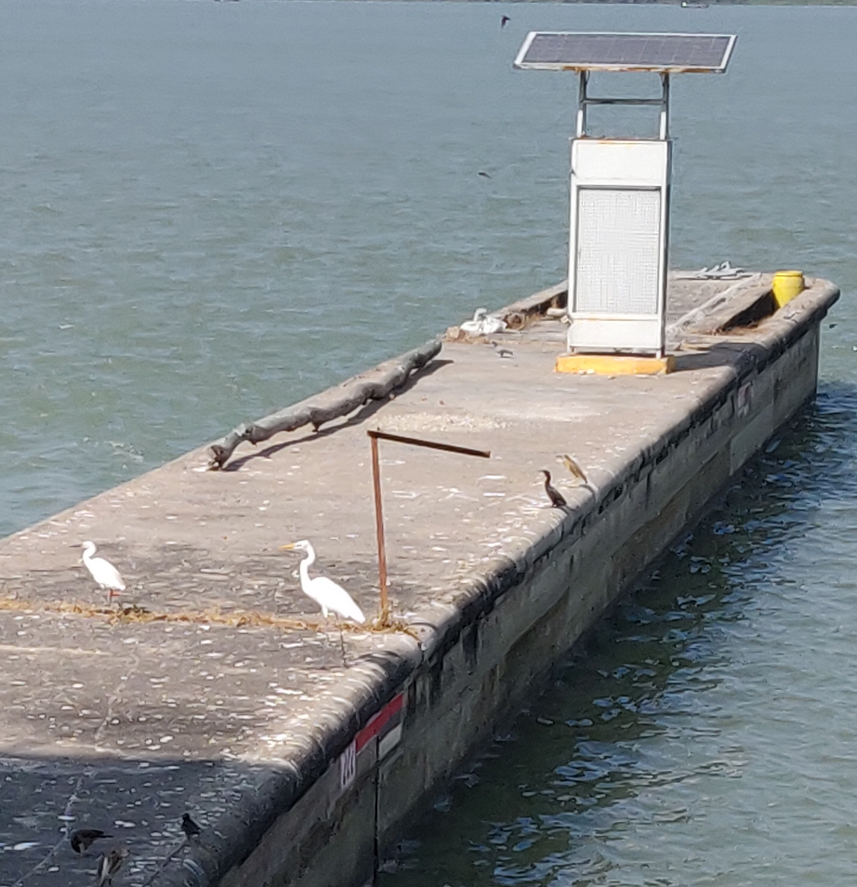  Pic 1. Madhya Ganga Barrage, Bijnore (U.P) | 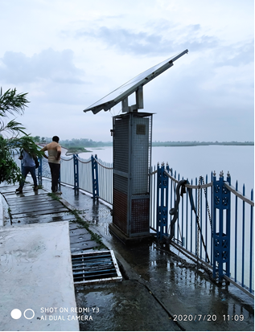  Pic 2. Barrage at Kanpur (UP19)
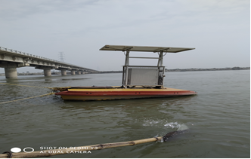  Pic 3. Bithoor Bridge, Kanpur (UP-18) | 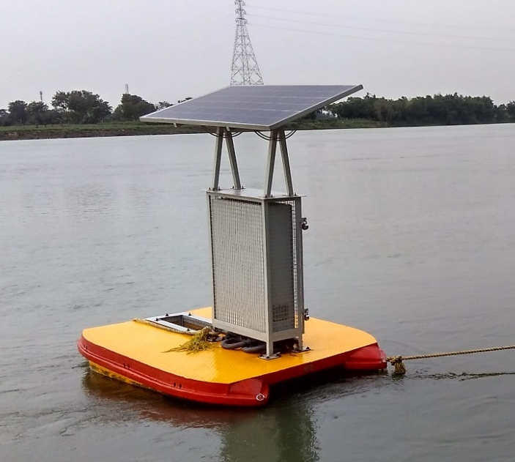  Pic 4. D/s of Murshidabad, West Bengal(WB11)

Table 1. Locations of 18 Real Time Water Quality Monitoring Station installed on River Ganga
S.No | State | Location | Lat | Long | Station code
1. | Uttar Pradesh | Madhya Ganga Barrage, Bijnore | 29.3732 | 78.0404 | UP-02
2. | Uttar Pradesh | Anupshahar Ghat | 28.3555 | 78.2717 | UP-06
3. | Uttar Pradesh | Narora Barrage, Narora | 28.1903 | 78.3953 | UP-08
4. | Uttar Pradesh | Kachla Ghat Bridge, Badaun | 27.9325 | 78.858 | UP-09
5. | Uttar Pradesh | Ghatiyaghat Bridge, Farrukhabad | 27.3987 | 79.6273 | UP-14
6. | Uttar Pradesh | Manimau Bridge (Mehendi Ghat ), Kannauj | 27.0111 | 79.9866 | UP-16
7. | Uttar Pradesh | Pariyal Bridge, Bithoor | 26.3658 | 80.1628 | UP-18
8. | Uttar Pradesh | Ganga Barrage Bridge, Kanpur | 26.3029 | 80.1859 | UP-19
9. | Uttar Pradesh | Shuklaganj Bridge, Kanpur | 26.2814 | 80.2237 | UP-26
10. | Uttar Pradesh | Deorighat (Maharajpur), Kanpur | 26.2242 | 80.2925 | UP-24
11. | Uttar Pradesh | Bridge at Ansi, Fatehpur | 26.326 | 80.5424 | UP-32
12. | Uttar Pradesh | Pontoon Bridge Sirsa, Allahabad ( Prayagraj) | 25.2678 | 82.093 | UP-40
13. | Uttar Pradesh | Chaudhary Charan Singh, Pump Canal, Ghazipur | 25.5374 | 83.1988 | UP-56
14. | West Bengal | Bridge at Behrampore, Behrampore | 24.0602 | 88.1468 | WB-10
15. | West Bengal | Bridge at d/s of Behrampore, Behrampore | 24.0373 | 88.1368 | WB-11
16. | West Bengal | Ghat at Srirampore, Behrampore | 22.4354 | 88.2135 | WB-21
17. | West Bengal | Intake Pumping station at Belgharia, Belgharia | 22.6709 | 88.3597 | WB-23
18. | West Bengal | Millennium Park_ Howrah Bridge, Howrah | 22.3495 | 88.2087 | WB-27

Table 2. Primary Water Quality Criteria for Bathing
Criteria | Justification
Faecal Coliform 500 (desirable)  MPN/100ml : 2500 (Max permissible)  Faecal Streptococci 100 (desirable)  MPN/100ml : 500 (Max. permissible) | To ensure low sewage contamination. Faecal coliform and faecal streptococci are considered as they reflect the bacterial pathogenicity.  The desirable and permissible limits are suggested to allow for fluctuation in environmental conditions such as seasonal changes, changes in flow conditions etc.
pH: Between 6.5-8.5 | The range provides protection of the skin and delicate organs like eyes, nose, and ears etc. which are directly exposed during outdoor bathing.
Dissolved Oxygen: 5 mg/l or more | The minimum dissolved oxygen concentration of 5 mg/l ensures reasonable freedom from oxygen consuming organic pollution. DO in water is necessary for preventing production of anaerobic gases (obnoxious gases) from sediments
Biochemical Oxygen Demand 3 mg/l or less 3 day, 27ºC: | The Biochemical Oxygen Demand of 3 mg/l or less of the water ensures reasonable freedom from oxygen demanding pollutants and prevent production of obnoxious gases.

Table 3. Percentage of Sample Size of 5 parameters for the year 2017-2019
Parameters | Percentage availability of data from RTWQM Stations
Parameters | 2017 | 2018 | 2019
COD | 93.8 | 90.0 | 88.1
BOD | 93.9 | 90.1 | 88.1
DO | 94.6 | 94.6 | 91.9
NH₄⁺ | 92.2 | 92.7 | 90.6
pH | 92.5 | 94.0 | 92.0

Table 4. Range of values for critical parameters displayed by RTWQM Stations
 | Year 2017 |  | Year 2018 |  | Year 2019
 | Min. | Max. | Min. | Max. | Min. | Max.
pH | 7.6 | 8.3 | 7.5 | 8.2 | 7.57 | 8.27
DO | 5.3 | 8.3 | 6 | 9.2 | 5.62 | 8.22
BOD | 2.8 | 7.7 | 1.3 | 6.5 | 2.15 | 5.53
COD | 10.6 | 44.9 | 10.4 | 35.8 | 14.2 | 28.1
NH₄+ | 0.4 | 3.4 | 0.3 | 3.2 | 0.3 | 1.4
Except pH, other values are in mg/L

Table 5. Number of complying and Non-complying stations based on DO, BOD and pH values of RTWQM system on main stem of River Ganga
 |  | Year 2017 |  | Year 2018 |  | Year 2019
Parameters | Criteria | Number of complying stations | Number of Non-complying stations | Number of complying stations | Number of Non-complying stations | Number of complying station | Number of Non-complying stations
pH | 6.5-8.5 | 18 | 0 | 18 | 0 | 18 | 0
DO | ≥ 5 mg/l | 18 | 0 | 18 | 0 | 18 | 0
BOD | ≤ 3 mg/l | 3 | 15 | 11 | 7 | 8 | 10

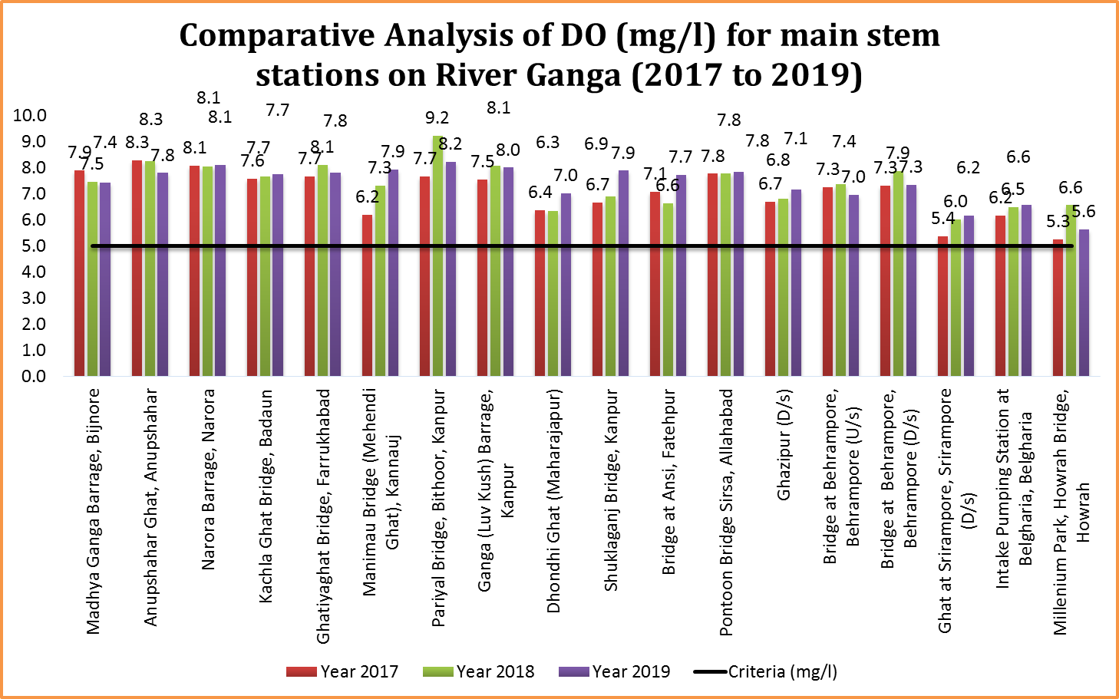

Figure 1. Comparative Analysis of DO (mg/l) for main stem stations on River Ganga (2017 to 2019)
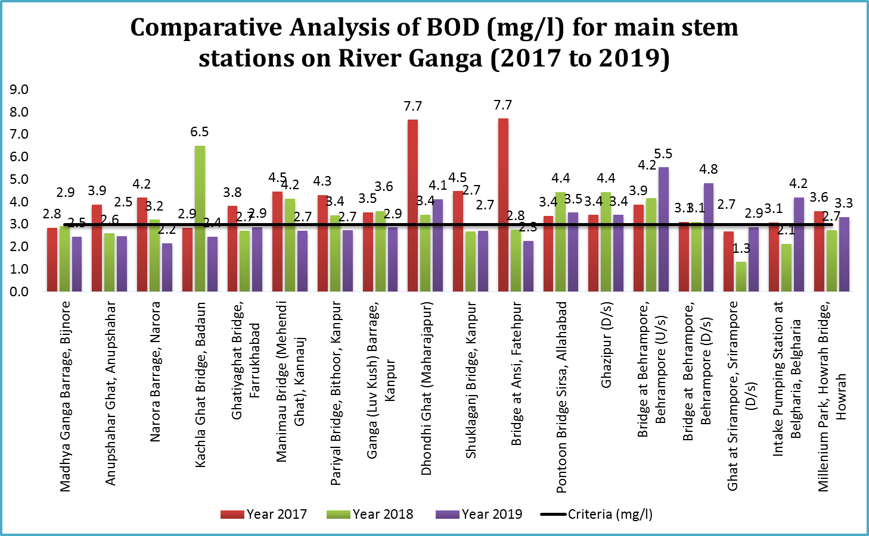
Figure 2. Comparative Analysis of BOD (mg/l) for main stem stations on River Ganga (2017 to 2019)

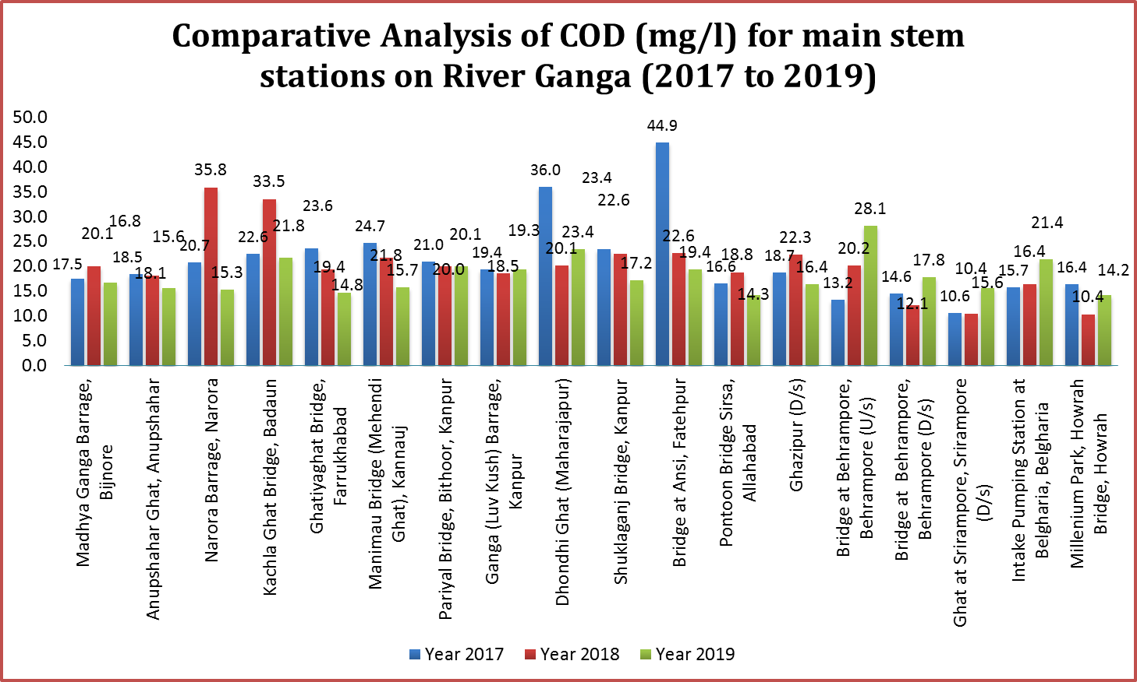

Figure 3. Comparative Analysis of COD (mg/l) for main stem stations on River Ganga (2017 to 2019)

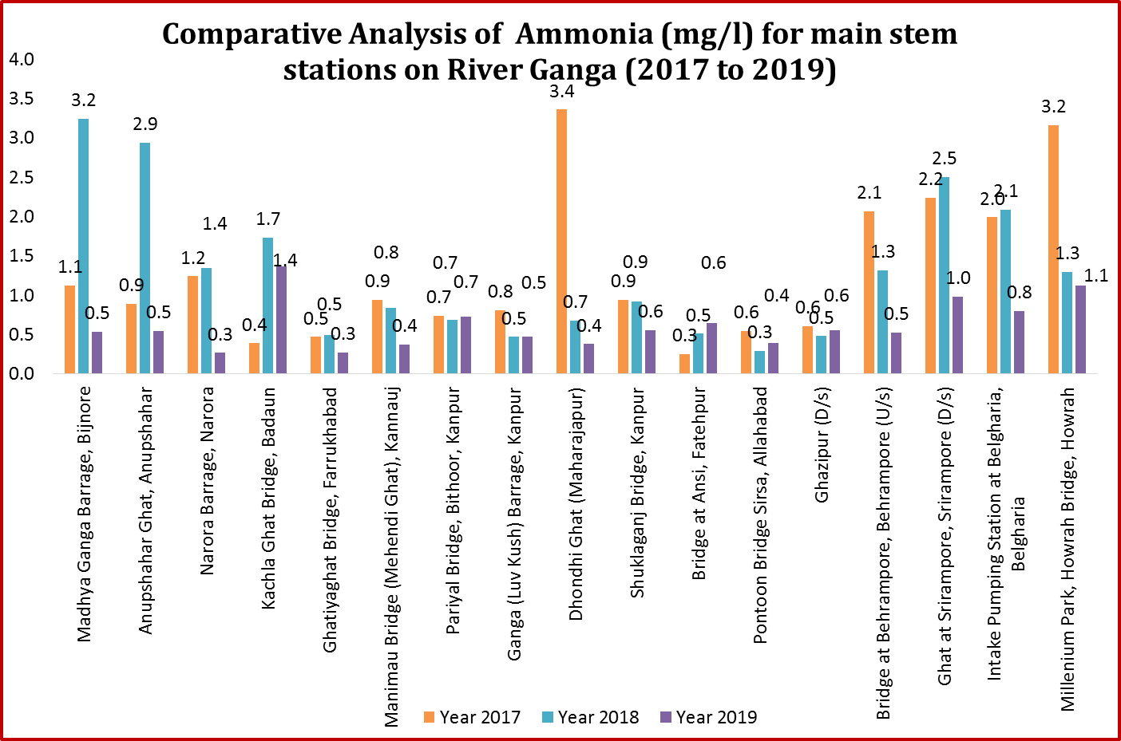
Figure 5. Comparative Analysis of Ammonia (mg/l) for main stem stations on River Ganga (2017 to 2019)

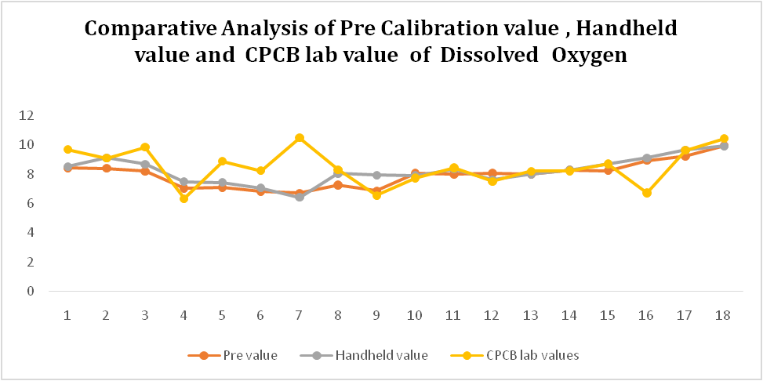
Figure 6. Comparative Analysis of Pre-value Calibration, Handheld Values, and Lab Values of Dissolved Oxygen (mg/L)

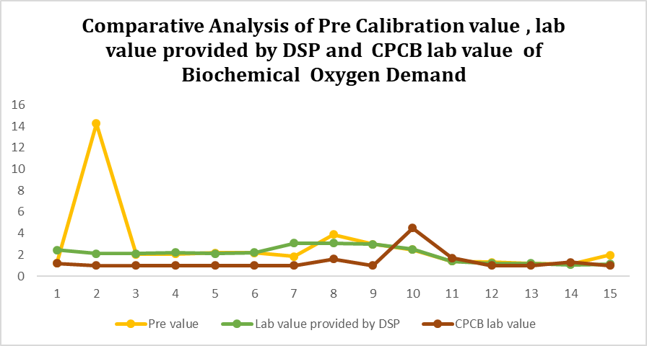
Figure 7. Comparative Analysis of Pre-value Calibration, lab value provided by DSP, and lab value of BOD (mg/L)

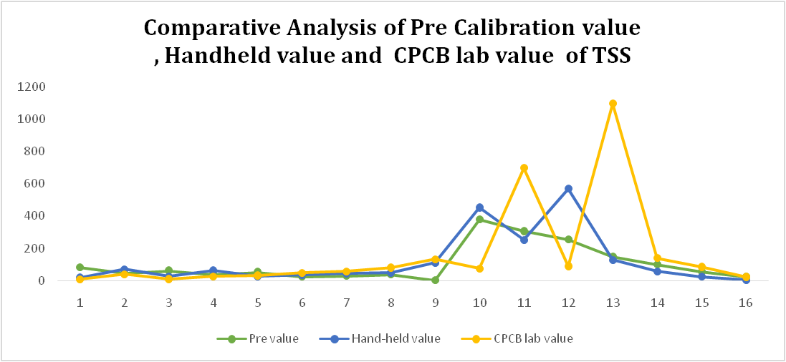
Figure 8. Comparative Analysis of Pre-value Calibration, Handheld Values and Lab Values of TSS (mg/L)

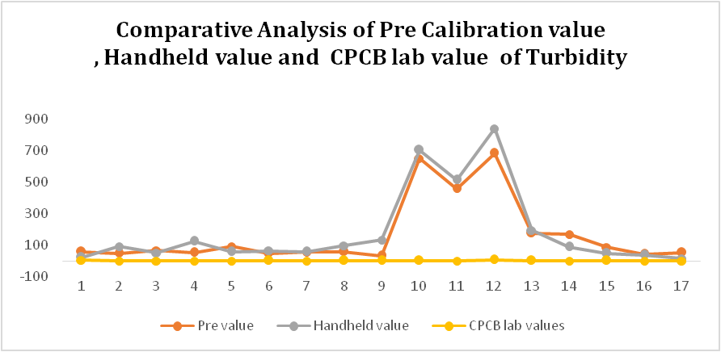

Figure 9. Comparative Analysis of Pre-Value Calibration, Handheld Values, and Lab Values of Turbidity (NTU)
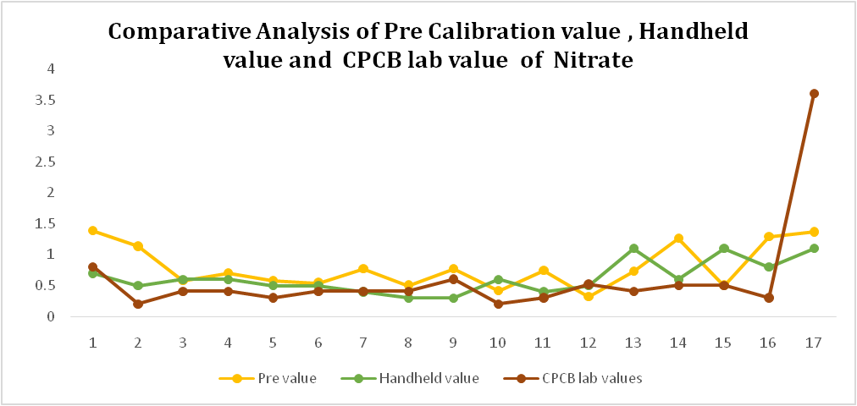
Figure 10. Comparative Analysis of Pre-Value Calibration, Handheld Values, and Lab Values of Nitrate (mg/L)

