Original Research Article

EFFECT OF HYDROPONICS ON GROWTH, YIELD ATTRIBUTES AND ROOT CHARACTERISTICS OF TOMATO (*Solanum lycopersicum* L.)

.

ABSTRACT

|  |
| --- |
| An investigation was performed to identify the best hydroponic system suitable for tomato cultivation at the College of Agriculture, Vellayani during 2022-2023. The present study was laid out in completely randomized design (CRD) with seven treatments and three replications. The study included the comparison of six different systems of hydroponics *viz*., nutrient film technique (NFT), deep flow technique (DFT), Ebb and flow system, deep water culture (DWC), drip system and wick system along with soil cultivation as control. Growth attributes such as number of branches and stem girth, recorded during 20 days after transplanting (DAT), 40 DAT, 60 DAT, and at the harvest stage, were found to be significantly higher in the ebb and flow system (T3). Furthermore, yield parameters like the length and diameter of the fruit, average fruit weight, and yield per plant were found to be superior for the hydroponic treatments rather than the soil cultivation. Among the hydroponic systems, ebb and flow (T3) recorded the higher average fruit weight (46.85 g) with maximum yield per plant (2.10 kg). The lowest fruit yield was observed in control treatment (T7) with 0.99 kg per plant. T3 also recorded the highest values of root parameters at the harvest stage of the crop. Maximum root volume (39.10 cm3) and root weight (28.67 g) were attained from T3. Among the different methods of hydroponics, ebb and flow was identified as the best method of hydroponics for tomato cultivation based on its growth, yield and root parameters. |

*Keywords: Hydroponics, Systems of hydroponics, Tomato, Yield, Root parameters*

1. INTRODUCTION

Current world is facing a lot of challenges including rapid urbanization, industrialization, and population growth which have resulted in reduction of cultivable land, depletion of water resources, and the unavailability of fresh and high-quality food. Here comes the importance of adopting modern agro-techniques like hydroponics. Hydroponics is the practice of growing plants in a nutrient solution with or without a soilless substrate such as perlite, rock wool, sand, gravel, coir, sawdust, *etc*. to provide physical support (Niu and Masabni, 2022).

Compared to traditional soil cultivation, hydroponic farming enables farmers to grow more food in a smaller area. It is possible to cultivate multiple crops at once using a hydroponic system. Depending on the needs of the plant, nutrients are provided in the form of a nutrient solution that contains a precise combination of the necessary ingredients for plant growth (Kumara *et al*., 2023). Better crop yields are achieved through the unique ability of this technique to accelerate root system growth and effectively absorb vital nutrients from the culture solution. Besides these, hydroponics consumes 60 per cent less fertilizer and saves 70–90 per cent more water, as water is re-circulated and reused (Prakash *et al.,* 2020). With its ability to maximize resource efficiency, enable year-round crop production, and enhance yields, hydroponics has the potential to revolutionize the way we grow food. By utilizing Hydroponics, we can optimize water, nutrients, and space, reducing waste and promoting sustainability (Rajaseger *et al.,* 2023).

Tomato (*Solanum lycopersicum* L.) is one of the extensively grown horticultural crops worldwide, where it is cultivated on a large scale as an annual vegetable crop and valued as a significant cash crop. Being one of the most cultivated vegetables with great acceptance in the market and compensating prices, tomatoes have been ranked as one of the most profitable vegetables for Indian farmers.

Adopting the technique of hydroponics promises to provide the solution to most of the existing hurdles in the agricultural production systems, especially for crops like tomato. Although hydroponics is widely accepted, the most suitable and cost-effective methods suitable for hydroponics are not clearly defined. Hence, the current study has been formulated to standardize the hydroponic method to maximize the growth and yield of tomato.

2. material and methods

Experiment was carried out in a rain shelter near the Instructional Farm, College of Agriculture, Vellayani during February 2022-June 2022. The experimental field was located between 80 25’ 41” N latitude, 760 59’ 14” E longitude and at an altitude of 29 m above the mean sea level. The semi determinate tomato variety Anagha which is released by Kerala Agricultural University was used for the present study.

**2.1 Treatment details**

The treatments included six types of hydroponic methods along with soil cultivation as control (Table 1). Treatments were laid out in Completely Randomized Design (CRD) with three replications.

**Table 1. Treatment details**

|  |  |
| --- | --- |
| T1 | Nutrient Film Technique (NFT) |
| T2 | Deep Flow Technique (DFT) |
| T3 | Ebb and flow system |
| T4 | Deep Water Culture (DWC) |
| T5 | Drip system |
| T6 | Wick system |
| T7 | Soil cultivation (control) |

**2.1 Fabrication of hydroponic systems**

Six types of hydroponic systems, *viz.*, nutrient film technique (NFT), deep flow technique (DFT), ebb and flow method, deep water culture (DWC), drip system, and Wick system, were fabricated inside the rain shelter. NFT and DFT systems were fabricated using 6 m long PVC pipes with a diameter of 4 inches. The pipes were drilled with 4-inch diameter holes, spaced 30 cm apart from each other, to accommodate 4-inch net pots. NFT system was fabricated by arranging the PVC pipes with 3% slope to contain a thin layer of nutrient solution (1-2 cm), whereas for DFT system, PVC pipes were arranged on a levelled surface holding the solution at a depth of 4-6 cm.

The ebb and flow system was built using a 6 m by 1.3 m brick grow bed lined with tarpaulin. Plastic pots filled with coco peat were placed inside, and a bell siphon was installed at a depth of 15 cm. A nutrient solution stored in a similarly sized tank (0.8 m deep) below the bed was pumped up using a 0.5 hp pump. The solution flooded the grow bed and then drained back into the tank via the bell siphon. A timer system was arranged to control the flow rate in common, an ON time of 15 minutes and an OFF time of 10 minutes were programmed.

DWC consisted of a rectangular reservoir with dimensions of 6 m in length, 1.3 m in width and 0.8 m in depth was lined with tarpaulin sheets and filled with nutrient solution. A floating platform made of thermocol with a thickness of 40 mm was placed on top of the solution. A separate aeration pump was inserted into the tank to provide adequate aeration to the plant roots. The drip system was set up with sand and disc filters, sub main pipe, laterals and emitters. 6 m long drip laterals were placed, and emitters were connected at 30 cm spacing. Plastic pots of 8 inches size filled with coco peat were planted with seedlings. PVC pipes of 4 inches in diameter were used and holes of 1 inch in size were drilled on them at a spacing of 30 cm apart. Wicks made of glass wool with 1 inch thickness were connected from the bottom of the pots to the PVC pipe filled with nutrient solution.

**2.2 Nutrient reservoir**

A 750 L tank was used as a container to store the freshly prepared nutrient solution, and it acted as a common source for all the treatments. It was placed 0.5 m above the ground surface to ensure the gravity flow of the solution for all the treatments, and the flow was controlled by valves. Another tank of 500 L capacity was buried at the tail end of the NFT and DFT systems to collect the solution and recirculate the same to the main tank via a pump.

**2.3 Nutrient solution management**

Hoagland solution was prepared according to Maynard and Hochmuth (2007), which was used for all the treatments. The composition and quantity of chemicals used are given in Table 2. pH and EC of the solutions were measured weekly and maintained in the range of 5.5-6.5 and 1.5-2.5 dS m-1, respectively. The pH of the solution was adjusted to the ideal range by adding H2SO4 or NaOH.

**Table 2. Preparation of Hoagland solution (Maynards and Hochmuth, 2007)**

|  |  |  |
| --- | --- | --- |
| **Chemicals used for Hoagland solution** | **Stock solution (g to make 1 L)** | **Final solution (ml to make 1 L)** |
| KNO3 | 101.1 | 5 |
| Ca(NO3)2.4H2O | 236.2 | 5 |
| KH2PO4 | 136.1 | 1 |
| MgSO4.7H2O | 246.5 | 2 |
| **Micronutrient solution** |  | 1 |
| a. Boric acid | 2.8 |  |
| b. Manganese chloride | 1.81 |  |
| c. Zinc sulphate | 0.22 |  |
| d. Copper sulphate | 0.08 |  |
| e. Molybdic acid | 0.02 |  |
| Fe – EDTA (0.5%) |  | 1 |

**2.5 Control treatment – soil cultivation**

One month old seedlings were transplanted in a net plot of 4.5 m × 2 m with a spacing of 60 cm×60 cm. Farmyard manure @ 20 t ha-1 was applied as basal during land preparation. The recommended fertilizer dose was 75:40:25 kg N:P2O5:K2O ha-1, supplied in the form of urea, rajphos and muriate of potash, respectively.

**2.6 Statistical analysis**

The data on observations made was statistically analyzed using the technique of analysis of variance (ANOVA) for the experiment laid out in CRD. The data were analyzed using the online tool GRAPES developed by Kerala Agricultural University (Gopinath *et al*., 2020). The significance was tested with the F test, and the critical difference at the 5 percent level was presented whenever the results were found to be significant.

3. results and discussion

**3.1 Effect of methods of hydroponics on growth attributes of tomato**

Growth attributes of tomato *viz*., number of branches per plant and stem girth were significantly influenced by hydroponic methods. Total number of plants produced was significantly higher in ebb and flow system at all the growth stages except for 20 DAT (Figure 1). At 40 DAT, T3 and T6 had similar number of branches (3.07 and 2.87, respectively). At 60 DAT, T3 had the highest branch count (4.80), followed by T6 (3.33), which had a comparable value with all the remaining treatments *viz*., T4 (2.73), T1 (2.67), T7 (2.67), T2 (2.53), and T5 (2.33). During the harvest stage, T3 had maximum number of branches (5.73), and was followed by T6 (4.40), which was on par with T4 (3.73).

**Fig. 1. Number of branches as influenced by different methods of hydroponics**

Stem girth was significantly influenced by the treatments at all the growth stages except at 20 DAT (Table 3). At 40 DAT, higher stem girth was observed in T3 (4.03), and it was on par with T6 (3.57). Similarly, at 60 DAT and at the harvest stage, T3 (4.23 and 4.73 respectively) had greater value of stem girth which was on par with T6 (4.07 and 4.57 respectively). Enhancement in growth attributes of tomato in the ebb and flow system (T3) might have been achieved by availing a better micro-climate resulted from alternate flooding and draining of planting media with nutrient rich solution to enhance the nutrient uptake. Increased number of branches with greater stem girth could also been contributed towards a higher total biomass of plants. Abu-Shahba *et al.* (2021) noticed that the growth attributes including biomass production of lettuce and spinach was significantly higher in hydroponic cultivation over traditional soil cultivation.

**Table 3. Stem girth of tomato as influenced by different methods of hydroponics (cm)**

|  |  |  |  |  |
| --- | --- | --- | --- | --- |
| **Treatments** | **20 DAT** | **40 DAT** | **60 DAT** | **Harvest** |
| T1- NFT | 1.97 ± 0.06 | 3.13 ± 0.21bc | 3.43 ± 0.21cd | 3.70 ± 0.20b |
| T2 - DFT | 2.20 ± 0.10 | 3.23 ± 0.15bc | 3.57 ± 0.32cd | 3.56 ± 0.42b |
| T3 - Ebb and flow | 2.30 ± 0.10 | 4.03 ± 0.61a | 4.23 ± 0.25a | 4.77 ± 0.25a |
| T4 - DWC | 2.13 ± 0.25 | 3.27 ± 0.25bc | 3.67 ± 0.23bc | 3.80 ± 0.26b |
| T5 - Drip | 2.03 ± 0.25 | 3.10 ± 0.20bc | 3.40 ± 0.20cd | 3.87 ± 0.15b |
| T6 - Wick | 2.23 ± 0.06 | 3.57 ± 0.29ab | 4.07 ± 0.21ab | 4.57 ± 0.25a |
| T7 - Control | 2.00 ± 0.17 | 2.93 ± 0.31c | 3.17 ± 0.25d | 4.00 ± 0.20b |
| F stat | 1.85 | 3.95* | 7.38** | 9.17** |
| p value | 0.16 | 0.02 | 0.00 | 0.00 |
| CD | NS | 0.56 | 0.42 | 0.46 |
| MSE | 0.03 | 0.10 | 0.06 | 0.07 |
| SE(m) | 0.09 | 0.19 | 0.14 | 0.15 |
| SE(d) | 0.13 | 0.26 | 0.2 | 0.21 |
| CV(%) | 7.62 | 9.65 | 6.63 | 6.45 |
| Cohen’s F | 0.89 | 1.30 | 1.78 | 1.98 |

Cell values are mean±SD; Treatments with the same letter grouping are not significantly different; * indicates significance at 5% level, ** indicates significance at 1% level.

**3.2 Effect of methods of hydroponics on root parameters of tomato**

The treatments were found to significantly affect the root parameters (Figure 2). The longer root was found in T6 (42.57 cm), followed by T3 (35.30 cm), which was in turn comparable to T4 (32.73 cm) and T5 (32.23 cm). Similarly, T3 recorded significantly greater root volume (39.1 cm3) and root weight (28.67 g), which was on par with T6 (38.4 cm3 and 27.47 g). Whereas, T7 recorded the shortest roots (20.86 cm) with lower root volume (16.93 cm³) and root weight (14.53 g) compared to other treatments.

Root aeration has a crucial role in maintaining a successful hydroponic system. Available oxygen in root zone is mainly determined by layout of the hydroponic system, frequency of water supply and the physical properties of the substrate (Schroeder and Lieth, 2004). Similarly, Yomo et al. (1998) also observed that among different methods of hydroponics used, ebb and flow system performed better and produced 7.1 to 9.6 times higher root fresh weight than NFT and DFT.

In the ebb and flow system, well-developed roots established with greater spread all over the media in response to alternate flooding and draining with the nutrient solution, might have produced maximum root volume and root weight, more than the root length. In the case of wick system, roots had to travel comparatively deeper to get the sufficient moisture and nutrients which might have increased its length rather than its volume and weight. Even under the condition of flooding, roots get proper strength, support and anchorage in the coco peat media (Reshma, 2016).

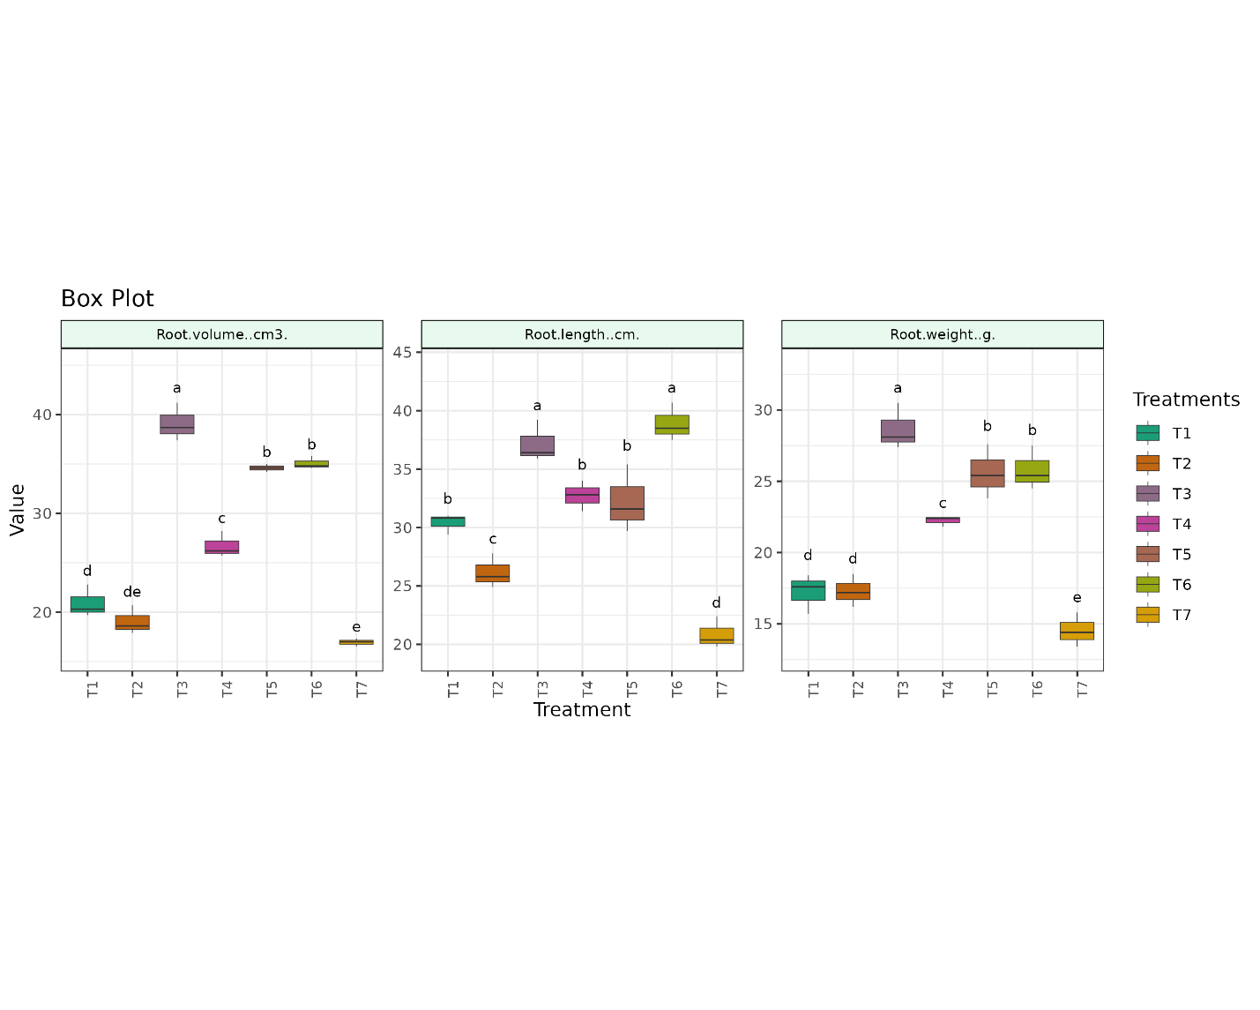

**Fig. 2. Root parameters as influenced by different methods of hydroponics**

**3.3 Effect of methods of hydroponics on yield attributes of tomato**

The treatments exerted a significant influence on the length and diameter of tomato fruit (Table 4). Longer fruits were obtained from T3 (4.17 cm), which was comparable with T6 (3.93 cm) and T4 (3.89 cm). T6 and T4 were also found to be on par with the remaining treatments. Fruit diameter was statistically higher in T3 (14.79 cm), which was on par with T6 (14.29 cm) and T5 (13.81 cm). Fruits of T7 had a lesser diameter (11.60 cm), statistically comparable to T1 (11.95 cm) and T2 (12.41 cm).Similarly,heavier fruits were produced from T3, which was significantly superior over other treatments with an average weight of 49.52 g. T3 was followed by T6 (44.93 g), which was on par with T2 (41.97 g) and T4 (41.52 g). T7 (35.43 g) had comparatively lighter fruits, which was on par with T5 (36.08 g).

The average fruit yield produced in T3 (49.52 g), which was significantly superior over other treatments. T3 was followed by T6 (44.93 g), which was comparable to T2 (41.97 g) and T4 (41.52 g). The soil cultivation (T7) recorded comparatively lighter fruits (35.43 g), which was on par with T5 (36.08 g). Hydroponic methods had significantly influenced the total yield of the plant (Figure 3). Maximum yield was recorded from T3 (2.10 kg plant-1), which was followed by T6 (1.56 kg plant-1). While, the lowest yield was reported from T7 (0.99 kg plant-1).

Superior yield attributes of hydroponic systems might be resulted from maintaining optimum quantity of nutrients in the solution, with easy availability of nutrients and water, and their efficient utilization. The results are in accordance with Maher *et al.* (2008) who opined that increased yield in soilless cultivation was probably associated with the conservation of moisture and improvement in micro-climate. Supply of adequate nutrition possibly might have led to the availability of nutrients to plants thereby causing an increase in yield components such as increase in fruit weight, length and girth of fruit, and ultimately to increased yield.

**Table 4. Yield attributes of tomato as influenced by different methods of hydroponics**

|  |  |  |  |
| --- | --- | --- | --- |
| **Treatments** | **Fruit Length (cm)** | **Fruit Diameter (cm)** | **Fruit Weight (g)** |
| T1- NFT | 3.57 ± 0.23b | 11.95 ± 0.42d | 39.13 ± 1.97d |
| T2 - DFT | 3.72 ± 0.09b | 12.41 ± 1.06cd | 41.97 ± 1.25c |
| T3 - Ebb and flow | 4.17 ± 0.17a | 14.79 ± 0.66a | 49.52 ± 1.51a |
| T4 - DWC | 3.89 ± 0.34ab | 13.40 ± 1.05bc | 41.52 ± 1.08cd |
| T5 - Drip | 3.76 ± 0.12b | 13.81 ± 0.47ab | 36.08 ± 1.59e |
| T6 - Wick | 3.93 ± 0.21ab | 14.29 ± 0.44ab | 44.93 ± 1.50b |
| T7 - Control | 3.57 ± 0.20b | 11.60 ± 0.80d | 35.43 ± 1.83e |
| F stat | 3.13* | 7.94** | 30.25** |
| p value | 0.04 | 0.00 | 0.00 |
| CD | 0.36 | 1.31 | 2.73 |
| MSE | 0.04 | 0.56 | 2.44 |
| SE(m) | 0.12 | 0.43 | 0.90 |
| SE(d) | 0.17 | 0.61 | 1.28 |
| CV(%) | 5.48 | 5.67 | 3.79 |
| Cohen’s F | 1.16 | 1.84 | 3.60 |

Cell values are mean±SD; Treatments with the same letter grouping are not significantly different; * indicates significance at 5% level, ** indicates significance at 1% level.

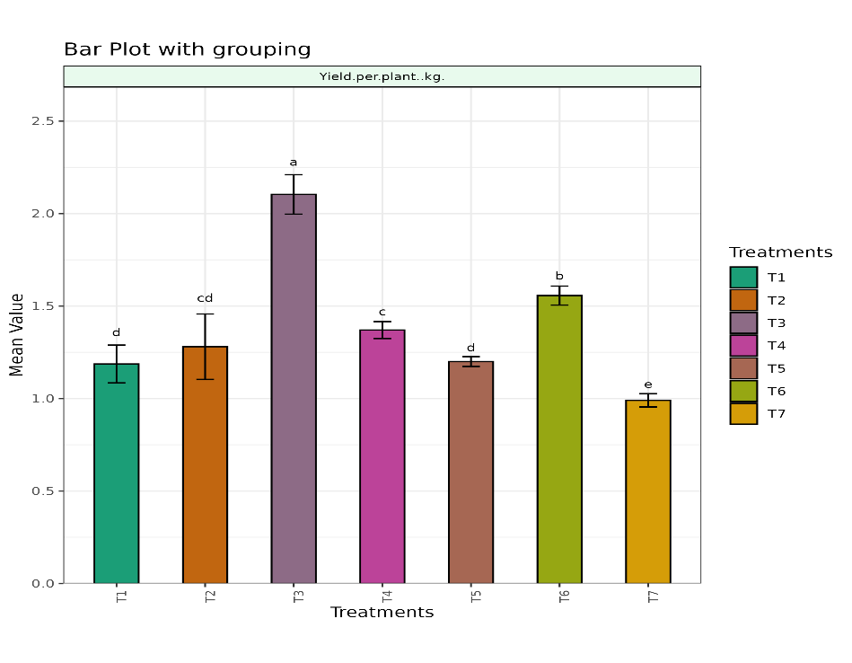

**Fig. 3. Tomato yield (kg plant-1) as influenced by different methods of hydroponics**

4. Conclusion

The growth and yield attributes, as well as the root parameters, of tomato were significantly higher in hydroponic treatments compared to soil cultivation. Among the various methods of hydroponics, the ebb and flow system exhibited superior performance for tomato cultivation yielding 2.10 kg per plant.

DISCLAIMER (ARTIFICIAL INTELLIGENCE)

Author(s) hereby declare that no generative ai technologies such as large language models (chatgpt, copilot, etc) and text-to-image generators have been used during writing or editing of this manuscript.

References

Abu-Shahba, M.S., Mansour, M.M., Mohamed, H.I., & Sofy, M.R. (2021). Comparative cultivation and biochemical analysis of iceberg lettuce grown in sand soil and hydroponics with or without microbubbles and macrobubbles. Journal of Soil Science and Plant Nutrition 21(1): 389-403.

Gopinath, P. P., Parsad, R., Joseph, B., & Adarsh, V. S. (2020). GRAPES: General Rshiny Based Analysis Platform Empowered by Statistics. https://www.kaugrapes.com/home. version 1.0.0. [DOI: 10.5281/](https://doi.org/10.5281/zenodo.4916978)zenodo.4923220

Kumara, V., Mohanaprakash, T. A., Fairooz, S., Jamal, K., & Babu, T. (2023). Experimental study on a reliable smart hydroponics system. In *Human Agro-Energy Optimization for Business and Industry* (pp. 27-45). IGI global.

Maher, M., Prasad, M., & Raviv, M. (2008). Organic soilless media components. In: Raviv, M., Lieth, J.H. (Eds.), Soilless culture: Theory and practice. Academic Press, San Diego, USA, pp. 459-504.

Maynard, D.N., & Hochmuth, G.J., (2007). Knott’s Handbook for Vegetable Growers, 5th ed. John Wiley & Sons Inc., Hoboken, NJ, pp. 68-93.

Niu, G., & Masabni, J. (2022). Hydroponics. In Plant factory basics, applications and advances Academic Press, 153-166.

Prakash, S., Singh, R., Kumari, A. R., & Srivastava, A. K. (2020). Role of Hydroponics towards Quality Vegetable Production: An Overview. International Journal of Current Microbiology and Applied Sciences, 10, 252-259.

Rajaseger, G., Chan, K. L., Tan, K. Y., Ramasamy, S., Khin, M. C., Amaladoss, A., & Haribhai, P. K. (2023). Hydroponics: current trends in sustainable crop production. *Bioinformation*, *19*(9), 925.

Reshma, T. (2016). Standardization of Hydroponics in tomato. M. Sc. (Ag.) Thesis, Kerala Agricultural University

Schroeder, F.G., & Lieth, J.H. (2004). Gas composition and oxygen supply in the root environment of substrates in closed hydroponic systems. Acta Horticulturae, 644: 299-305.

Yomo, T., Hasegawa, C., Minami, M., & Sugino, M. (1998). Production of medicinal plants by Hydroponics (part-4). Selection of hydroponic system suitable for growth of *Angelica acutiloba* Kitagawa. Journal of the Society for High Technology in Agriculture 10(3):156-160.