Interannual and seasonal variability of lightning flash density and related meteorological parameters from 2003 to 2014

ABSTRACT

This study primarily examines the annual and seasonal variations in lightning flash density and associated meteorological parameters from 2003 to 2014. The trends in lightning flash density are analyzed in relation to meteorological variables such as aerosol optical depth (AOD), relative humidity (Rh), effective cloud droplet size (CDZ), Ångström exponent, and wind patterns. The study focuses on Sri Lanka, covering the region between 5.5°–10.0°N latitude and 79.0°–82.0°E longitude. Additionally, the study explores the complex relationship between lightning activity and AOD. The findings reveal that lightning occurred on 710 days, accounting for approximately one-fifth of the total study period. When AOD values were between 0.6 and 0.7, the maximum lightning flash density (2.92 × 10⁻⁴ flashes/km²/day) was recorded. Both lightning and AOD and cloud droplet size and lightning flash rate density were found to be negatively correlated. Furthermore, variations in relative humidity were found to influence lightning activity, with relative humidity increasing as AOD increased, and vice versa. These results underscore the significance of aerosol concentration in modulating relative humidity, which in turn affects lightning intensity.

Keywords: Lightning, relative humidity, AOD, cloud droplet and correlation.

1. INTRODUCTION

Lightning is among the most hazardous extreme weather events, causing thousands of fatalities worldwide each year. Estimates suggest that between 6,000 and 24,000 deaths occur annually due to intense lightning activity (Cooper & Holle, 2019). Beyond its toll on human life, lightning also inflicts substantial economic damage. In 2021 alone, lightning-related incidents led to approximately $1.3 billion in damages across the United States (Krishna et al., 2023; Borden & Cutter, 2008). Apart from its destructive consequences, lightning plays a crucial role in atmospheric chemistry as the primary natural source of nitrogen oxides (Levy et al., 1996). These compounds significantly impact air quality and climate dynamics, making lightning prediction essential for both hazard mitigation and environmental protection. Lightning primarily occurs during thunderstorms, which develop under conditions of high atmospheric moisture and instability (Carey & Rutledge, 1996; Kamra & Ramesh Kumar, 2021). As a localized atmospheric phenomenon, lightning originates from electrical discharges within thunderstorms. These discharges, carrying immense electrical energy, result from the separation of positive and negative charges within clouds (Orville et al., 2001). In some cases, charge imbalances extend between clouds and the ground. Under stable atmospheric conditions, charge distributions remain undisturbed; however, in unstable conditions, charge separation intensifies, exerting pressure on the surrounding air and ultimately triggering powerful electrical discharges (Boccippio et al., 2000; Umakanth et al., 2022; Umakanth et al., 2020). Lightning manifests in two primary forms: intra-cloud lightning, where electrical charges interact within a single cloud, and cloud-to-ground lightning, which occurs when charges are exchanged between the Earth's surface and a thunderstorm cloud (Michalon et al., 1999; Singh et al., 2015; Williams, 2005; Lal et al., 2018).
Aerosols play a critical role in modulating lightning activity. Numerous studies have demonstrated that increased aerosol concentrations enhance lightning frequency, particularly in tropical regions (Williams et al., 2005; Christian et al., 2003; Williams & Stanfill, 2002; Rosenfeld, 1999; Tao et al., 2012; Fan et al., 2016; Li et al., 2016, 2017; Wang et al., 2018; Sekiguchi et al., 2006; Ramesh Kumar & Kamra, 2012; Zhang et al., 2007). Zhao et al. (2017) reported that higher aerosol levels contribute to cloud droplet formation, intensifying convective activity. Additionally, Wang (2005) emphasized the impact of topography on aerosol dispersion and precipitation patterns, while Lee et al. (2008) explored the correlation between aerosol concentrations and rainfall. Further research indicates that increasing aerosol concentrations reduce cloud droplet size, facilitating warm rain processes (Wang et al., 2011). Liu et al. (2020) demonstrated that aerosols influence vertical humidity and temperature profiles, fostering cloud ice formation and enhancing latent heat release, thereby strengthening deep convection. This process indirectly amplifies non-inductive lightning activity by intensifying thunderstorms. Lal et al. (2018) observed a positive correlation between aerosol concentrations and lightning activity. Jnanesh et al. (2022) underscored the role of relative humidity in regulating aerosol concentrations, particularly in unstable atmospheric conditions, which subsequently influence the lower cloud layers. Their research also showed that aerosols and lightning have a nonlinear relationship, with humidity serving as a key modulator. Zhang et al. (2022) examined aerosol effects over continental and marine regions, finding that while marine aerosols tend to suppress convection, continental aerosols enhance it. Their study further highlighted the impact of aerosols on cloud formation at varying altitudes and observed that increased maritime aerosol levels enhance the optical thickness of cirrus and anvil clouds.
Research has also linked high lightning activity over Sichuan to elevated aerosol concentrations (Zhao et al., 2020). Similarly, Singh et al. (2013) found that lightning flashes intensify in moist environments with increased atmospheric aerosol levels. Strong updrafts are associated with intense thunderstorms, whereas weaker updrafts promote rainfall activity. Additionally, winds significantly influence thunderstorm dynamics (Andreae et al., 2004; Ramesh Kumar & Kamra, 2013; Koren et al., 2005). Convective Available Potential Energy (CAPE) is a key dynamic parameter that governs updraft strength and plays a vital role in lightning occurrence. As CAPE quantifies atmospheric instability during humid convection processes, it serves as an effective predictor of lightning activity (Kilinc & Beringer, 2007). Kumar & Kamra (2012) demonstrated that clouds with high moisture content are strongly affected by elevated aerosol concentrations. Yuan and Qie (2008) studied South China and found a strong positive correlation between aerosol concentrations and effective cloud droplet radius. Additionally, aerosol transport can trigger local convection, influencing atmospheric stability (Emanuel, 1994). Other thermodynamic factors, including wind shear, stability indices, and humidity, also affect lightning occurrence (Eddy, 2018; MacGorman et al., 2018). Despite extensive research on thunderstorms and lightning, studies focusing on Sri Lanka remain limited. In this context, our study aims to investigate the interplay between lightning and various meteorological factors over the region. Specifically, we examine Sri Lanka to better understand the intricate relationships between lightning activity and atmospheric parameters, with a particular emphasis on the roles of humidity and aerosols on lightning occurrence days.

2. Data and Methodology
  - Study site

Fig.1 Study area map with sub-divisions over the Sri Lanka region.

Sri Lanka, a small island nation in southern Asia, is situated between 79°–82°E longitude and 5°–10°N latitude, covering approximately 65,610 square kilometers. With a population of nearly 21.8 million (Sri Lanka Socio-Economic Data 2020), it is among the most densely populated islands. Like the Indian subcontinent, Sri Lanka experiences four distinct seasons: the First Inter-Monsoon (March–April), Northeast Monsoon (December–February), Southwest Monsoon (May–September), and Second Inter-Monsoon (October–November). The Northeast Monsoon delivers an average annual rainfall of around 2,500 mm. The island exhibits both dry and humid climatic regions, with lightning activity occurring more frequently in moist areas than in arid zones (Alahacoon et al., 2021). The Western region, being the most densely populated, also records the highest frequency of lightning strikes (Maduranga, 2022). Among the four seasons, the First Inter-Monsoon (March–April) experiences the most lightning incidents, whereas the Northeast Monsoon (December–February) sees the fewest (Maduranga et al., 2019). Overall, lightning activity in Sri Lanka is strongly linked to the monsoon seasons. The study domain is depicted in Fig. 1.
2.2 DATA
The Tropical Rainfall Measuring Mission (TRMM) employs the Lightning Imaging Sensor (LIS) to monitor lightning activity, providing data with a 90% detection efficiency (Christian et al., 1999). LIS data, spanning from 2003 to 2014, was sourced fromhttps://ghrc.nsstc.nasa.gov/pub/lis/orbit_files/data/. For this study, TRMM precipitation (3A12) data with a 0.50° × 0.50° grid resolution was utilized. Data from the Moderate Resolution Imaging Spectroradiometer (MODIS) satellite dataset were used to determine the Aerosol Optical Depth (AOD), Cloud Top Temperature (CTT), and Cloud Droplet Size (CDZ) at a grid resolution of 10° x 10°. Relative humidity data with the same grid resolution was retrieved from the Atmospheric Infrared Sounder (AIRS) instrument. The AOD data from MODIS was analyzed in relation to lightning occurrence. To investigate this relationship, AOD values ranging from 0.1 to 0.7 were grouped into seven bins, each with an interval of 0.1. The corresponding AOD and lightning data for each bin were averaged to obtain a single mean value.

3. Results and discussion
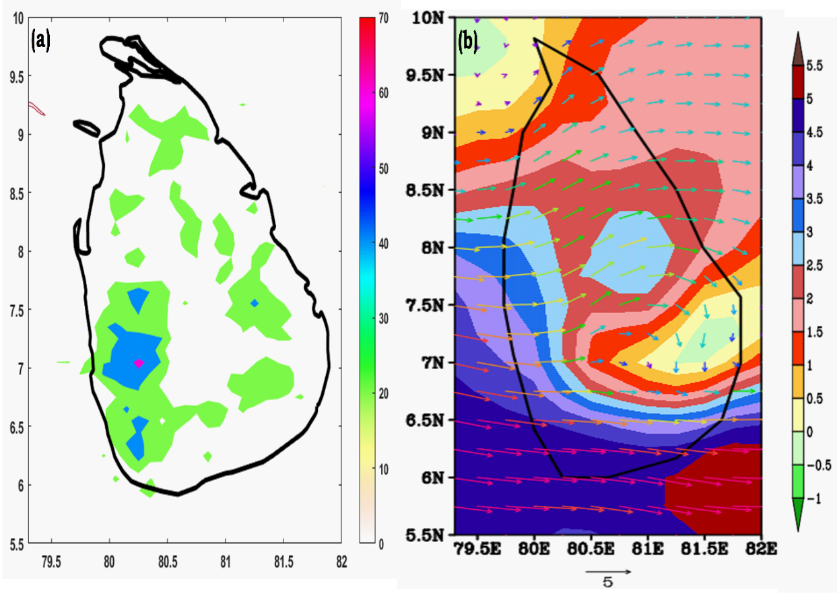
Fig.2 Mean Spatial distribution of (a). lightning, (b). zonal wind (shaded; units: m/s) with wind vectors (arrows; units: m/s) over Sri Lanka from 2003 to 2014.
The climatology of lightning flash rate density over Sri Lanka between 2003 and 2014 is shown in Fig. 2(a). About 40 to 50 lightning flashes per km² were observed annually in the western, Sabaragamuwa, and southern areas, while only 10 to 30 flashes per km² were recorded annually in the eastern, northern, and UVA regions. The mean zonal wind (shaded) and wind vectors (arrows) over the study region for the same period are shown in Fig. 2(b), where the size of the arrows indicates the wind speed in m/s. The western and southern regions of Sri Lanka were found to have high zonal wind speeds (~>3.8 m/s). Wind speeds ranged from 3 to 5 m/s in the northwestern, central, and Sabaragamuwa areas and from 1.5 to 2.5 m/s in the northwestern, north-central, eastern, and Trincomalee regions. The northern, UVA, and eastern regions recorded the lowest wind speeds (0.5–1.5 m/s). Intense convective activity is encouraged by the predominance of westerly winds across the study area, which is essential for moisture transport.
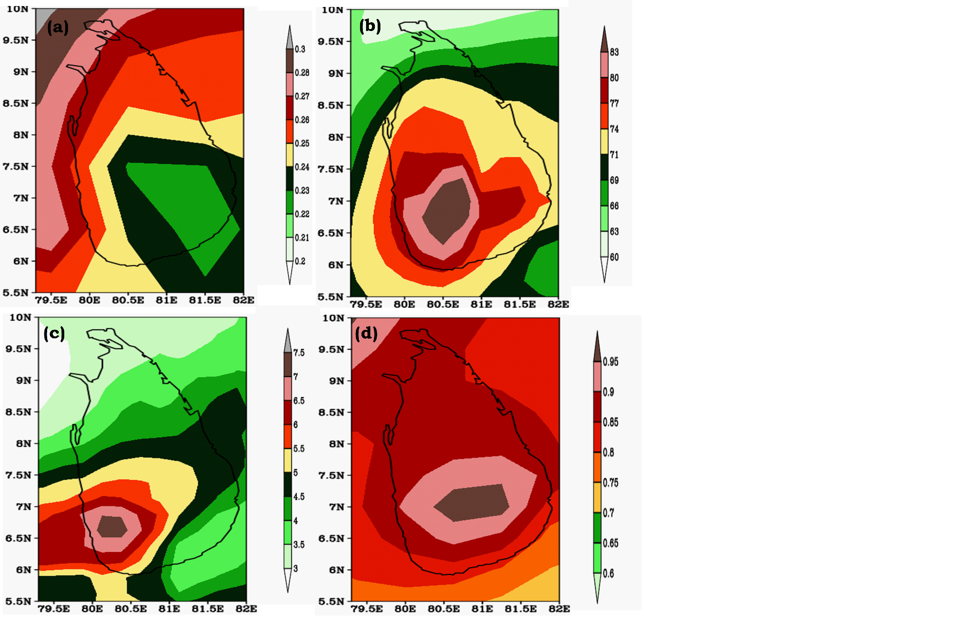
Fig.3 Spatial distribution of (a) AOD, (b) relative humidity, (c) rainfall, and (d) Ångström exponent over Sri Lanka from 2003 to 2014.
Fig. 3(a) presents the spatial distribution of mean Aerosol Optical Depth (AOD) over Sri Lanka from 2003 to 2014. The northern, northwestern, and north-central regions recorded AOD values between 0.25 and 0.28, while the UVA and eastern regions exhibited slightly lower values ranging from 0.22 to 0.24. Fig. 3(b) displays the distribution of relative humidity (RH). The western, Sabaragamuwa, UVA, eastern, and central regions experienced RH levels between 74% and 82%, whereas the northern, Trincomalee, and north-central regions recorded slightly lower values of 63%–71%. Notably, the central region showed RH values exceeding 83%, creating favorable conditions for intense convective activity. Fig. 3(c) illustrates the mean daily rainfall across Sri Lanka. The western, Sabaragamuwa, and central regions received between 5.5 and 7.5 mm/day, while the northern, northwestern, and north-central regions observed relatively lower rainfall amounts of 3–4.5 mm/day. Fig. 3(d) depicts the spatial variation of the Aerosol Ångström Exponent over Sri Lanka from 2003 to 2014. The western, Sabaragamuwa, UVA, eastern, and central regions exhibited values between 0.9 and 0.95, whereas the northern, Trincomalee, and north-central regions recorded slightly lower values of 0.8–0.9. The central region showed Ångström values exceeding 0.95, further indicating conditions conducive to severe convective activity.
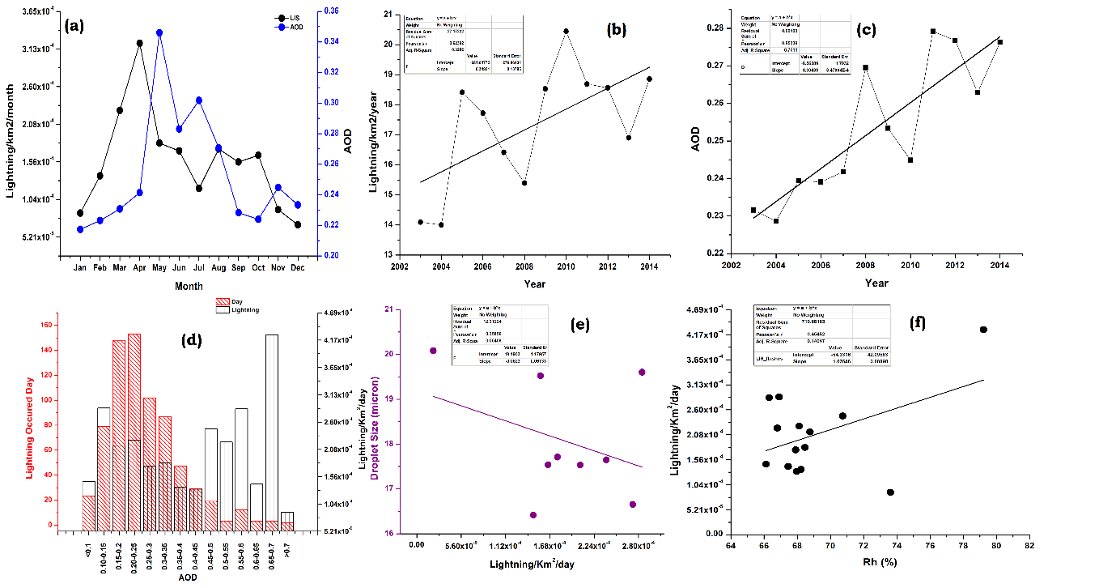
Fig.4 (a). Seasonal variations in lightning flash density and AOD, (b). Annual variations of lightning flash density, (c). Annual variations of AOD, (d). Lightning flash density and total number of lightning days, (e). Correlation between lightning and droplet size and (f). Correlation between relative humidity and lightning over Sri Lanka from 2003 to 2014.
Seasonal fluctuations in the average total number of lightning flashes and Aerosol Optical Depth (AOD) over the Sri Lankan region between 2003 and 2014 are shown in Fig. 4(a). According to the data, lightning activity increased beginning in January, peaked in April, and then began to decline in December. Significantly, the pre-monsoon season (March–May) has the highest lightning activity, with April recording the highest flash rate density (~3.13 × 10⁻⁴ flashes/km²/month). Between August and October, a secondary peak is seen, and throughout this time, the flash rate density gradually increases. The largest concentration of AOD is found in May, after which there is a gradual decrease until October, when the lowest value (~0.22) is seen. According to earlier research on the Indian subcontinent, these results are consistent (Kandalgaonkar et al., 2010; Lal et al., 2018).
Fig.4(b) illustrates the annual mean variations in lightning flash density over the region. A decline in lightning activity is observed between 2005 and 2008, following a sudden increase between 2004 and 2005. After 2008, lightning flash density rises again until 2010, after which a decreasing trend is evident from 2011 to 2014.
Fig.4(c) presents AOD variations over Sri Lanka from 2003 to 2014, showing an overall increasing trend that closely follows the observed rise in lightning activity. The data indicate a gradual increase in AOD between 2005 and 2008, with a sharp rise between 2007 and 2008, followed by a decline until 2010. From 2011 onward, AOD exhibits a renewed upward trend until 2014. Previous research suggests that aerosols significantly influence lightning activity, potentially enhancing its intensity (Lal & Pawar, 2011; Williams & Stanfill, 2002).
Between 2003 and 2014, lightning activity was observed over the Sri Lanka region for approximately 710 days (Fig. 4(d)). Fig.4(d) presents the number of lightning days, aerosol optical depth (AOD), and lightning flash density (flashes/km²/day). Both the frequency of lightning days and flash density exhibited a steady rising trend as AOD rose. Lightning struck 23 days with a flash density of 1.46 × 10⁻⁴ flashes/km²/day when AOD was less than 0.1. This frequency increased dramatically at AOD values between 0.15 and 0.20, with a flash density of 2.08 × 10⁻⁴ flashes/km²/day and 148 lightning days. With a peak flash density of 2.5 × 10⁻⁴ flashes/km²/day and a duration of 153 days, the maximum lightning activity was seen for AOD between 0.2 and 0.25. As the quantity of lightning days reduced, so did the flash density. Nonetheless, on 102, 87, 47, 29, and 19 days, comparatively high flash densities (>1.67 × 10⁻⁴ flashes/km²/day) were still noted; these correlate to AOD ranges of 0.25–0.3, 0.3–0.35, 0.35–0.4, 0.4–0.45, and 0.45–0.5, respectively. Interestingly, lightning activity continued for 15 days with a peak flash density of 2.71 × 10⁻⁴ flashes/km²/day when AOD was between 0.5 and 0.6. Significant variations in lightning activity were seen for AOD values greater than 0.5. When AOD was between 0.65 and 0.7, the maximum flash density, 4.17 × 10⁻⁴ flashes/km²/day, was seen; however, this peak was only present for three days. The number of lightning days decreased to just two when AOD surpassed 0.7, resulting in a lower flash density of 1.04 × 10⁻⁴ flashes/km²/day. According to these results, lightning activity does not grow steadily above an AOD of 0.5; rather, flash density varies between 2.08 × 10⁻⁵ and 2.92 × 10⁻⁴ flashes/km²/day. Both extremely high and low AOD levels correlate to lower flash densities, however higher AOD values are typically linked to increasing lightning activity. Lightning activity and cloud droplet size have a negative connection (~ -0.35), as shown in Fig. 4(e). Conversely, Fig.4(f) highlights a strong positive correlation (~0.45) between relative humidity and lightning. At AOD 0.55, a slight decrease in droplet size (16.5 µm) coincides with a drop in relative humidity (66%). Over the study period, the average lightning activity was 2.80 × 10⁻⁴ flashes/km²/day, indicating a relatively low frequency consistent with observed trends. Overall, our findings confirm an inverse relationship between cloud droplet size and lightning activity, supported by a strong negative correlation (r = -0.35), as illustrated in Fig.4(e).
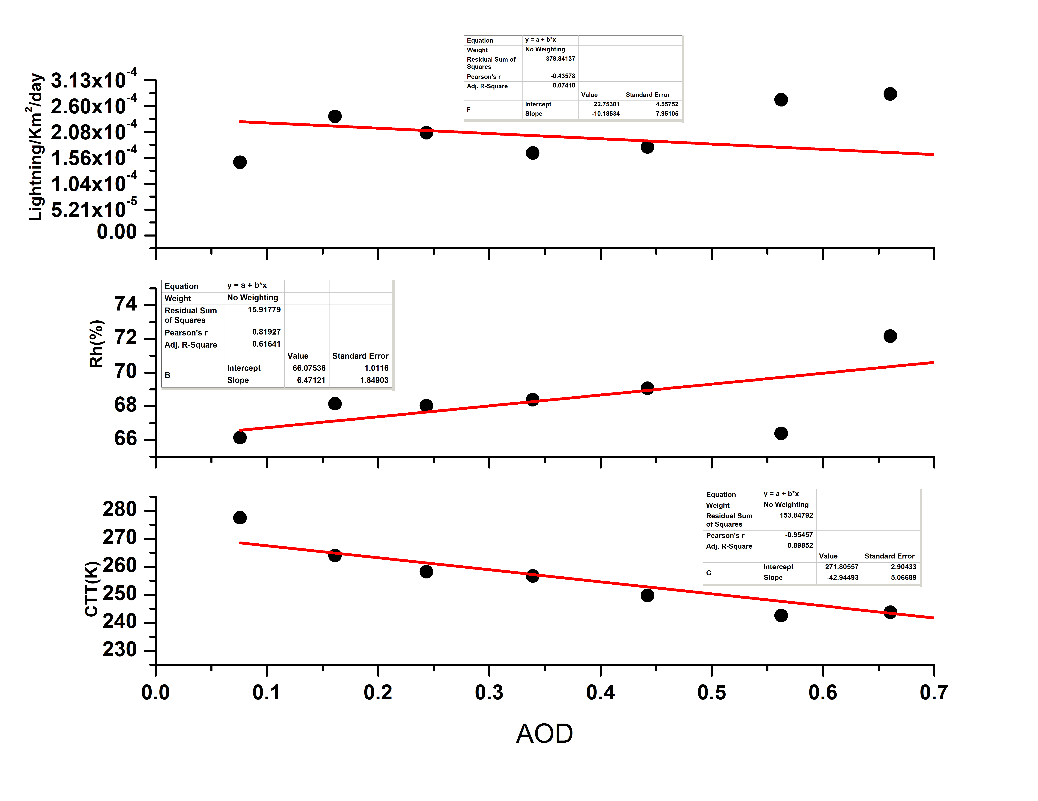
Fig.5 Relationship between lightning, relative humidity and cloud top temperature for different AOD levels over Sri Lanka from 2003 to 2014.

Fig.5 illustrates the relationship between lightning activity and AOD over the Sri Lankan region, showing the mean lightning flash density across different AOD bins. The results indicate a sharp increase in lightning activity between AOD values of 0.08 and 0.18, followed by a gradual decline beyond 0.18. Specifically, the lightning flash density starts at 1.3 × 10⁻⁴ flashes/km²/day for an AOD of 0.08, peaks at 2.5 × 10⁻⁴ flashes/km²/day at 0.18, and then declines significantly to 1.6 × 10⁻⁴ flashes/km²/day at an AOD of 0.45. Additionally, Fig.5 highlights the interplay between atmospheric relative humidity, AOD, and lightning activity. Over the Sri Lankan region, relative humidity increases as AOD rises (0.04–0.45), while lightning activity decreases. The correlation between AOD and lightning is negative (R = -0.43), though prior studies have reported both negative and positive relationships between aerosols and lightning (Koren et al., 2004, 2008; Li et al., 2017). Meanwhile, relative humidity and AOD exhibit a strong positive correlation (R = 0.81), suggesting that humidity plays a crucial role in modulating the impact of aerosols on lightning activity. Previous studies (Lal et al., 2013; Xiong et al., 2006) have also emphasized that aerosol-driven variations in lightning are more pronounced under high-humidity conditions. Furthermore, Fig.5 presents the correlation between Cloud Top Temperature (CTT) and AOD. CTT shows a strong negative correlation with AOD (R = -0.95). Notably, for AOD values up to 0.7, CTT exhibits a distinct downward trend, maintaining a correlation of approximately -0.95.

4. Conclusions
The impact of various meteorological parameters on lightning flash density over Sri Lanka was analyzed for the period 2003–2014. This study focuses on the region spanning 79°E to 82°E longitude and 5.5°N to 10°N latitude.
Key findings from this study include:
- Over the 2003–2014 period, lightning activity was observed on approximately 710 days, accounting for about one-fifth of the total days.
- The maximum lightning flash density of 2.92 × 10⁻⁴ flashes/km²/day was reported during a period of almost three days when the average daily Aerosol Optical Depth (AOD) varied between 0.65 and 0.7.
- When the average daily AOD was between 0.2 and 0.3, almost 35% of lightning days had a flash density below 2.08 × 10⁻⁴ flashes/km²/day.
- A clear trend indicates that AOD decreases as lightning activity declines, suggesting an inverse relationship.
- Overall, AOD and lightning exhibit a negative correlation (R = -0.43), whereas AOD and relative humidity show a stronger positive correlation (R = 0.81).
- A notable downward trend in Cloud Top Temperature (CTT) up to an AOD of 0.7 was observed. As AOD is increasing the CTT decreases (correlation ~95%).
A significant inverse correlation (R = -0.35) was observed between droplet size and lightning flash density. Although higher AOD values are generally linked to increased lightning activity, both exceptionally high and low AOD levels are associated with reduced lightning flash densities.

Ethics approval: This is not applicable.
Consent to participate: This is not applicable.
Consent to participate: The authors confirm that they have no conflicts of interest concerning the publication of this work.
Human and Animal Ethics: Not Applicable.
Consent for publication: All authors agree to the publication of the data and results presented in this work in Environmental Science and Pollution Research, granting others the right to access and utilize the published material with appropriate citation and acknowledgment.
Data availability: TRMM, MODIS and AIRS datasets are publicly accessible.

References
Alahacoon, N., Edirisinghe, M., & Ranagalage, M. (2021). Satellite-based meteorological and agricultural drought monitoring for agricultural sustainability in Sri Lanka. Sustainability, 13(6), 3427.
Andreae, M. O., Rosenfeld, D., Artaxo, P., Costa, A. A., Frank, G. P., Longo, K. M., & Silva-Dias, M. A. F. D. (2004). Smoking rain clouds over the Amazon. science, 303(5662), 1337-1342.
Boccippio, D. J., Goodman, S. J., & Heckman, S. (2000). Regional differences in tropical lightning distributions. Journal of Applied Meteorology, 39(12), 2231-2248.
Borden, K. A., & Cutter, S. L. (2008). Spatial patterns of natural hazards mortality in the United States. International journal of health geographics, 7, 1-13.
Carey, L. D., & Rutledge, S. A. (1996). A multiparameter radar case study of the microphysical and kinematic evolution of a lightning producing storm. Meteorology and Atmospheric Physics, 59, 33-64.
Christian, H. J. (1999) The lightning Imaging Sensor. Procedgs.11th IntI.conf. on Atmos. Elec.,Guntersville, AL, ICAE. 746–749.
Christian, H. J., Blakeslee, R. J., Boccippio, D. J., Boeck, W. L., Buechler, D. E., Driscoll, K. T., ... & Stewart, M. F. (2003). Global frequency and distribution of lightning as observed from space by the Optical Transient Detector. Journal of Geophysical Research: Atmospheres, 108(D1), ACL-4.
Cooper, M. A., & Holle, R. L. (2019). Reducing lightning injuries worldwide. New York: Springer International Publishing.
Eddy, A. (2018). Environmental conditions producing thunderstorms with anomalous vertical polarity of charge structure.
Emanuel, K. A. (1994) Atmospheric convection. Oxford University Press USA.
Fan, J., Wang, Y., Rosenfeld, D., & Liu, X. (2016). Review of aerosol–cloud interactions: Mechanisms, significance, and challenges. Journal of the Atmospheric Sciences, 73(11), 4221-4252.
Jnanesh, S. P., Lal, D. M., Gopalakrishnan, V., Ghude, S. D., Pawar, S. D., Tiwari, S., & Srivastava, M. K. (2022). Lightning characteristics over humid regions and arid regions and their association with aerosols over Northern India. Pure and Applied Geophysics, 179(4), 1403-1419.
Kamra, A. K., & Ramesh Kumar, P. (2021). Regional variability in lightning activity over South Asia. International Journal of Climatology, 41(1), 625-646.
Kandalgaonkar, S. S., Tinmaker, M. I. R., & Vani, G. (2010). A lightning climatology of Northeast India: 1998-2007. International Journal of Meteorology, 35(347), 89-98.
Koren, I., Kaufman, Y. J., Rosenfeld, D., Remer, L. A., & Rudich, Y. (2005). Aerosol invigoration and restructuring of Atlantic convective clouds. Geophysical Research Letters, 32(14).
Koren, I., Kaufman, Y. J., Remer, L. A., & Martins, J. V. (2004). Measurement of the effect of Amazon smoke on inhibition of cloud formation. Science, 303(5662), 1342-1345.
Koren, I., Martins, J. V., Remer, L. A., & Afargan, H. (2008). Smoke invigoration versus inhibition of clouds over the Amazon. science, 321(5891), 946-949.
Lal, D. M., & Pawar, S. D. (2011). Effect of urbanization on lightning over four metropolitan cities of India. Atmospheric Environment, 45(1), 191-196.
Lal, D. M., Ghude, S. D., Patil, S. D., Kulkarni, S. H., Jena, C., Tiwari, S., & Srivastava, M. K. (2012). Tropospheric ozone and aerosol long-term trends over the Indo-Gangetic Plain (IGP), India. Atmospheric Research, 116, 82-92.
Lal, D. M., Ghude, S. D., Mahakur, M., Waghmare, R. T., Tiwari, S., Srivastava, M. K., ... & Chate, D. M. (2018). Relationship between aerosol and lightning over Indo-Gangetic Plain (IGP), India. Climate Dynamics, 50, 3865-3884.
Lal, D. M., Patil, S. D., Singh, H. N., Ghude, S. D., Tiwari, S., & Srivastava, M. K. (2013). Influence of aerosol on clouds over the Indo-Gangetic Plain, India. Climate dynamics, 41, 601-612.
Lee, S. S., Donner, L. J., Phillips, V. T., & Ming, Y. (2008). The dependence of aerosol effects on clouds and precipitation on cloud‐system organization, shear and stability. Journal of Geophysical Research: Atmospheres, 113(D16).
Levy, H., Moxim, W. J., & Kasibhatla, P. S. (1996). A global three‐dimensional time‐dependent lightning source of tropospheric NOx. Journal of Geophysical Research: Atmospheres, 101(D17), 22911-22922.
Li, Z., Guo, J., Ding, A., Liao, H., Liu, J., Sun, Y., ... & Zhu, B. (2017). Aerosol and boundary-layer interactions and impact on air quality. National Science Review, 4(6), 810-833.
Li, Z., Lau, W. M., Ramanathan, V., Wu, G., Ding, Y., Manoj, M. G., ... & Brasseur, G. P. (2016). Aerosol and monsoon climate interactions over Asia. Reviews of geophysics, 54(4), 866-929.
Li, Z., Guo, J., Ding, A., Liao, H., Liu, J., Sun, Y., ... & Zhu, B. (2017). Aerosol and boundary-layer interactions and impact on air quality. National Science Review, 4(6), 810-833.
Liu, Z., Ciais, P., Deng, Z., Lei, R., Davis, S. J., Feng, S., ... & Schellnhuber, H. J. (2020). COVID-19 causes record decline in global CO2 emissions. arXiv preprint arXiv:2004.13614.
MacGorman, D. R., Eddy, A. J., Homeyer, C. R., & Williams, E. (2018, March). Environmental conditions producing thunderstorms with anomalous vertical polarity of charge structure. In Proceedings of the 25th International Lightning Detection Conference & 7th International Lightning Meteoroligy Conference.
Maduranga, U. G. D., Edirisinghe, M., Alahacoon, N., & Ranagalage, M. (2022). Spatiotemporal variability of lightning activity over the railway network in Sri Lanka with special attention to the proposed suburban railway electrification network. Infrastructures, 7(7), 92.
Maduranga, U. D., Edirisinghe, C. M., & Gamage, L. V. (2019). Spatiotemporal variability of lightning flash distribution over Sri Lanka. Int. Lett. Chem. Phys. Astron, 82, 1-13.
Michalon, N., Nassif, A., Saouri, T., Royer, J. F., & Pontikis, C. A. (1999). Contribution to the climatological study of lightning. Geophysical Research Letters, 26(20), 3097-3100.
Orville, R. E., Huffines, G., Nielsen‐Gammon, J., Zhang, R., Ely, B., Steiger, S., ... & Read, W. (2001). Enhancement of cloud‐to‐ground lightning over Houston, Texas. Geophysical Research Letters, 28(13), 2597-2600.
Penki, R. K., & Kamra, A. K. (2013). The lightning activity associated with the dry and moist convections in the Himalayan Regions. Journal of Geophysical Research: Atmospheres, 118(12), 6246-6258.
Kilinc, M., & Beringer, J. (2007). The spatial and temporal distribution of lightning strikes and their relationship with vegetation type, elevation, and fire scars in the Northern Territory. Journal of climate, 20(7), 1161-1173.
Krishna, R. P. M., Ganai, M., Tirkey, S., & Mukhopadhyay, P. (2023). Revised cloud processes to improve the simulation and prediction skill of Indian summer monsoon rainfall in climate forecast system model. Climate Dynamics, 61(5), 2189-2210.
Ramesh Kumar, P., & Kamra, A. K. (2012). The spatiotemporal variability of lightning activity in the Himalayan foothills. Journal of Geophysical Research: Atmospheres, 117(D24).
Ramesh, K. P., & Kamra, A. K. (2012). Land-sea contrast in lightning activity over the sea and peninsular regions of South/Southeast Asia. Atmospheric Research, 118, 52-67.
Rosenfeld, D. (1999). TRMM observed first direct evidence of smoke from forest fires inhibiting rainfall. Geophysical research letters, 26(20), 3105-3108.
Sekiguchi, M., Hayakawa, M., Nickolaenko, A. P., & Hobara, Y. (2006). Evidence on a link between the intensity of Schumann resonance and global surface temperature. In Annales Geophysicae (Vol. 24, No. 7, pp. 1809-1817). Göttingen, Germany: Copernicus Publications.
Siingh, D., Singh, R. P., Kumar, S., Dharmaraj, T., Singh, A. K., Singh, A. K., ... & Singh, S. (2015). Lightning and middle atmospheric discharges in the atmosphere. Journal of Atmospheric and Solar-Terrestrial Physics, 134, 78-101.
Michalon, N., Nassif, A., Saouri, T., Royer, J. F., & Pontikis, C. A. (1999). Contribution to the climatological study of lightning. Geophysical Research Letters, 26(20), 3097-3100.
Siingh, D., Kumar, P. R., Kulkarni, M. N., Singh, R. P., & Singh, A. K. (2013). Lightning, convective rain and solar activity—Over the South/Southeast Asia. Atmospheric Research, 120, 99-111.
Tao, W. K., Chen, J. P., Li, Z., Wang, C., & Zhang, C. (2012). Impact of aerosols on convective clouds and precipitation. Reviews of Geophysics, 50(2).
Umakanth, N., Kalyan, S. S. S., Satyanarayana, G. C., Gogineni, R., Nagarjuna, A., Naveen, R., ... & Rao, M. C. (2022). Increasing pre-monsoon rain days over four stations of Kerala, India. Acta Geophysica, 70(2), 963-978.
Umakanth, N., Satyanarayana, G. C., Simon, B., Rao, M. C., & Babu, N. R. (2020). Climatological analysis of lightning flashes over Kerala. In AIP conference proceedings (Vol. 2220, No. 1). AIP Publishing.
Wang, C. (2005). A modeling study of the response of tropical deep convection to the increase of cloud condensation nuclei concentration: 1. Dynamics and microphysics. Journal of Geophysical Research: Atmospheres, 110(D21).
Wang, Q., Li, Z., Guo, J., Zhao, C., & Cribb, M. (2018). The climate impact of aerosols on the lightning flash rate: is it detectable from long-term measurements?. Atmospheric Chemistry and Physics, 18(17), 12797-12816.
Wang, Y., Wan, Q., Meng, W., Liao, F., Tan, H., & Zhang, R. (2011). Long-term impacts of aerosols on precipitation and lightning over the Pearl River Delta megacity area in China. Atmospheric Chemistry and Physics, 11(23), 12421-12436.
Williams, E., & Stanfill, S. (2002). The physical origin of the land–ocean contrast in lightning activity. Comptes Rendus Physique, 3(10), 1277-1292.
Williams, E., Mushtak, V., Rosenfeld, D., Goodman, S., & Boccippio, D. (2005). Thermodynamic conditions favorable to superlative thunderstorm updraft, mixed phase microphysics and lightning flash rate. Atmospheric Research, 76(1-4), 288-306.
Williams, E. R. (2005). Lightning and climate: A review. Atmospheric research, 76(1-4), 272-287.
XIONG, Y. J., QIE, X. S., ZHOU, Y. J., YUAN, T., & ZHANG, T. L. (2006). Regional responses of lightning activities to relative humidity of the surface. Chinese journal of geophysics, 49(2), 311-318.
Yuan, T., & Qie, X. (2008). Study on lightning activity and precipitation characteristics before and after the onset of the South China Sea summer monsoon. Journal of Geophysical Research: Atmospheres, 113(D14).
Zhao, P., Zhou, Y., Xiao, H., Liu, J., Gao, J., & Ge, F. (2017). Total lightning flash activity response to aerosol over China area. Atmosphere, 8(2), 26.
Zhang, R., Li, G., Fan, J., Wu, D. L., & Molina, M. J. (2007). Intensification of Pacific storm track linked to Asian pollution. Proceedings of the National Academy of Sciences, 104(13), 5295-5299.
Zhang, H., Zhou, C., Wang, Z., Zhao, S., & Li, J. (2015). The influence of different black carbon and sulfate mixing methods on their optical and radiative properties. Journal of Quantitative Spectroscopy and Radiative Transfer, 161, 105-116.
Zhang, J., Zhao, B., Liu, X., Lin, G., Jiang, Z., Wu, C., & Zhao, X. (2022). Effects of different types of aerosols on deep convective clouds and anvil cirrus. Geophysical Research Letters, 49(19), e2022GL099478.

