**Review Article**

**Diseases and Pest Management in Nurseries: Challenges, Strategies, and Emerging Technologies**

**Abstract**

Nursery production is significantly affected by diseases and pest infestations, which diminish plant health, marketability, and overall yield. This study examines common nursery diseases, such as powdery mildew, botrytis blight, leaf spot, rust, and root rot, as well as prominent pests like aphids, whiteflies, thrips, and mealybugs. These biological threats lead to severe economic losses, making effective management strategies essential. The analysis emphasizes the role of Integrated Pest Management (IPM) as a sustainable and comprehensive approach. By combining cultural, biological, and chemical control methods, IPM effectively reduces pest populations while minimizing environmental impact. The use of biological control agents, such as predatory insects and beneficial microbes, is presented as an eco-friendly alternative to synthetic pesticides. In Kerala, nursery crops are particularly vulnerable to leaf spot, damping-off, and anthracnose, which significantly compromise plant quality. Additionally, pests like the red palm weevil, rhinoceros beetle, and tea mosquito bug cause substantial damage to coconut, areca nut, and other plantation crops, all of which are vital to the region's economy. Managing these pests effectively requires region-specific strategies, including the use of botanical extracts, pheromone traps, and soil solarization. Emerging technologies, such as drone-based pesticide application, AI-powered pest detection, and genetic engineering for disease-resistant plants, have been identified as potential solutions for enhancing nursery productivity. These innovations offer precision and efficiency, reducing chemical usage while improving plant health. Effective disease and pest management in nurseries necessitates a multifaceted approach that integrates traditional techniques with modern innovations. The adoption of IPM strategies and cutting-edge technologies can significantly enhance plant protection, leading to increased productivity and sustainability in the nursery industry.

Keywords: Integrated Pest Management (IPM), Diseases and pests in nurseries, biological control methods, Nursery management practices, and Sustainable disease management strategies

**Introduction**

Effective nursery management is crucial for successful germination, seedling health, and transplanting. It involves careful monitoring of environmental factors such as temperature, humidity, light, and soil quality. According to (Singh et al. 2019), maintaining optimal humidity levels (60-70%) and controlling temperatures in nurseries significantly enhances seedling vigor and reduces transplant shock. Advanced technologies, such as automated irrigation systems, misting units, and humidity sensors, have transformed nursery operations, allowing farmers to optimize growing conditions with precision. Seedlings' health is also affected by proper spacing and transplanting techniques. Research by (Patel and Kumar 2020) indicates that overcrowding in nursery trays limits root development, making seedlings more susceptible to stress after transplanting. Modern nursery management increasingly utilizes growing media blends, including peat, cocopeat, and perlite, which improve water retention, aeration, and root establishment. Plant propagation techniques such as grafting, budding, and tissue culture are becoming more popular, particularly for fruit crops. (Ram *et al.* 2021) showed that tissue-cultured banana plants have greater disease resistance and yield compared to those propagated using conventional methods, underscoring the importance of innovative nursery techniques in enhancing crop resilience and productivity.

Fertilizers are essential in modern agriculture, but improper use can lead to environmental issues like soil degradation and water pollution. The global shift toward precision agriculture encourages targeted and efficient fertilizer application to minimize waste. Nutrient management strategies vary based on crop needs. For example, nitrogen, phosphorus, and potassium (NPK) are vital for crop growth, but excess nitrogen can result in leaching and groundwater contamination (Zhang *et al.,* 2020). To address this, slow-release fertilizers (SRFs) and controlled-release fertilizers (CRFs) are becoming popular since they gradually release nutrients, reducing runoff. Organic fertilizers, such as compost, manure, and biofertilizers, are also increasingly preferred for their soil-enhancing qualities. According to (Das *et al.* 2018), farms utilizing vermicompost show improved soil texture and microbial activity, leading to higher yields. Additionally, biofertilizers containing nitrogen-fixing bacteria, like Rhizobium, naturally improve soil fertility and crop growth. Precision fertilizer application technologies, such as GPS-guided spreaders, have revolutionized large-scale farming. Field studies by (Wang *et al.*, 2022) demonstrated that precision-guided fertilizer application reduces nitrogen losses by 25% while maintaining crop yields, making it both economical and environmentally friendly. Pests and diseases are significant threats to agricultural productivity, causing considerable yield losses worldwide. Traditional pest control methods, including chemical pesticides, are increasingly being replaced or complemented by integrated pest management (IPM) practices.

IPM strategies combine biological, mechanical, and chemical controls to minimize pest populations sustainably. According to (Sharma *et al.* 2021), using natural predators (like ladybugs to control aphids) along with biopesticides can decrease chemical pesticide usage by 40%. Furthermore, employing pheromone traps and implementing crop rotation helps disrupt pest life cycles. Emerging technologies, such as drone-based pesticide spraying and AI-powered pest detection, have improved the efficiency of pest management. A study by Liu *et al.* 2023) found that drone-based spraying reduced pesticide usage by 30% compared to conventional methods, illustrating its efficiency and precision. Disease control relies on early diagnosis and targeted interventions, and the development of disease-resistant crop varieties through genetic engineering has proven effective. Transgenic rice varieties that are resistant to bacterial blight (Xanthomonas oryzae) have been demonstrated to increase.

Productivity and reduced losses (Zhou *et al*., 2020). Agricultural practices significantly vary between countries due to climatic, economic, and technological factors. In developing nations, staple crops such as rice, maize, and wheat are predominant, while cash crops like coffee and cotton drive economies in regions with suitable climates. National crop production typically reflects both domestic consumption needs and export potential. For example, India and China, the largest producers of rice, prioritize food security for their populations, whereas countries like Brazil and the United States lead in soybean exports. According to the FAO (2022), international crop trade is shaped by climate conditions, trade policies, and technological advancements. As farmers face changing weather patterns, climate-resilient crops are becoming increasingly important. Drought-tolerant maize varieties in sub-Saharan Africa have, for instance, improved yields by 20% even under water-stressed conditions (Rosenstock *et al.,* 2019). Additionally, vertical farming and hydroponics are gaining popularity worldwide, particularly in urban areas, enabling year-round production of leafy greens and herbs. In Singapore, vertical farms can produce up to ten times more crops per square meter than traditional farms (Lim *et al.*, 2022), highlighting the potential of urban agriculture.

**Types of Nurseries**

Plant nurseries are specialized facilities focused on the propagation, cultivation, and sale of plants. They play a crucial role in supporting agriculture, horticulture, landscaping, and ecological restoration efforts. Nurseries can be classified based on the types of plants they grow, their intended purpose, and their operational lifespan. The major categories include fruit plant nurseries, vegetable nurseries, ornamental plant nurseries, medicinal and aromatic plant nurseries, and forest plant nurseries. Each type serves a distinct role in promoting plant production, biodiversity, and economic activities.

Fruit plant nurseries are dedicated to the propagation and sale of fruit-bearing plants, serving both commercial orchards and home gardeners. These nurseries are typically permanent establishments due to the longevity of fruit crops. They focus on cultivating perennial fruit plants, such as mango, citrus, apple, guava, pomegranate, and banana. The propagation methods used in fruit plant nurseries include grafting, budding, and layering, which are essential for maintaining the genetic characteristics of specific cultivars and ensuring uniformity in fruit quality (Hartmann *et al.,* 2018). For instance, mango nurseries commonly employ the veneer grafting method, while citrus nurseries typically use T-budding to encourage early fruiting and disease resistance (Singh & Srivastava, 2020). These nurseries are critical for establishing orchards and supporting commercial fruit farming by providing disease-free and true-to-type planting materials, which contribute to improved fruit yield and quality. Additionally, fruit nurseries facilitate the introduction of new cultivars and hybrid varieties, promoting agricultural innovation and crop diversification (Verma *et al.,* 2019).

Vegetable nurseries focus on raising seedlings of both seasonal and perennial vegetable crops. Unlike fruit nurseries, these are often temporary or seasonal, as vegetable crops have shorter life cycles. The primary goal of vegetable nurseries is to produce healthy, disease-free, and uniform seedlings that can be transplanted into fields or home gardens. Techniques used in vegetable nurseries include tray nurseries, where seedlings are raised in plug trays under protected conditions to ensure better root development and easier transplantation (Singh *et al.,* 2020). Common vegetable crops grown in nurseries include tomatoes, chilies, brinjals, cabbage, cauliflower, and capsicum. Modern vegetable nurseries often incorporate protected cultivation techniques, such as playhouses and net houses, to shield seedlings from pests, diseases, and environmental stressors, leading to higher seedling survival rates and improved productivity (Kumar *et al.,* 2019). Moreover, vegetable nurseries play an important role in urban agriculture by providing seedlings for rooftops and home gardens.

Ornamental plant nurseries specialize in cultivating flowering, foliage, and decorative plants used for landscaping, aesthetic purposes, and commercial applications. These nurseries cater to the increasing demand for gardening, landscaping, and interior plants. Ornamental nurseries propagate a variety of plants, including annuals, perennials, shrubs, climbers, and ground covers. Popular ornamental plants include roses, hibiscus, marigolds, bougainvillea, petunias, and ferns. The propagation methods employed in ornamental nurseries include cuttings, grafting, tissue culture, and seed propagation (Bhattacharjee & De, 2005). These nurseries also significantly contribute to the floriculture industry by supplying plants for commercial flower production, garden centers, and public parks. They play a vital role in urban beautification projects, providing plants for roadside plantations, green belts, and public gardens (De & Bhattacharjee, 2006).

Medicinal and aromatic plant (MAP) nurseries focus on cultivating plants that are used in traditional medicine, pharmaceuticals, and the cosmetic industry. With the increasing demand for herbal products and natural remedies, these nurseries have become significantly important. Common medicinal plants grown in these nurseries include Aloe vera, Ashwagandha, Tulsi (Holy Basil), Brahmi, and Shatavari. Aromatic plants like lavender, rosemary, lemongrass, and mint are cultivated for their essential oils and fragrance properties (Kumar & Sharma, 2019).

Propagation methods in medicinal and aromatic nurseries include seed sowing, stem cuttings, root division, and tissue culture techniques. Tissue culture is especially crucial for the mass propagation of high-demand medicinal plants, ensuring consistent quality and yield (Patel *et al.,* 2017). These nurseries also contribute to biodiversity conservation by cultivating and preserving rare and endangered medicinal plants. Furthermore, they supply raw materials to the herbal industry, promoting sustainable farming practices and boosting rural economies (Mandal *et al.,* 2020).

Forest plant nurseries, on the other hand, focus on producing tree and shrub seedlings for afforestation, reforestation, and landscaping projects. These nurseries play a vital role in environmental conservation by growing native, drought-resistant, and climate-adapted tree species. Common species raised in forest nurseries include teak, mahogany, eucalyptus, neem, bamboo, and acacia. The seedlings are produced through direct sowing, cuttings, or containerized seedling production (Lal & Singh, 2017).

orest nurseries are critical for ecosystem restoration, providing seedlings for rehabilitating degraded land, controlling soil erosion, and managing watersheds. They also support carbon sequestration programs, which contribute to climate change mitigation efforts (Verma *et al.,* 2018). Additionally, forest nurseries often collaborate with government reforestation initiatives by supplying planting material for large-scale plantation drives. Their role in urban forestry is also significant, as they provide saplings for roadside plantations and urban green spaces.

**Major Diseases and Management**

**Powdery mildew**

Powdery Mildew: A Persistent Threat to Kerala's Nurseries

Powdery mildew is a significant fungal disease that poses a major threat to floral nurseries in Kerala, India, particularly impacting the cultivation of ornamental plants. This disease is caused by various species from the Erysiphaceae family, with Oidium and Erysiphe being the most common genera responsible for infections in Kerala's tropical climate. The region's warm and humid conditions, densely planted crops, and poor ventilation create an ideal environment for the rapid spread of this pathogen. Floral crops such as roses, gerberas, marigolds, and chrysanthemums are especially vulnerable to infection. Infected plants display characteristic white, powdery spots on their leaves, stems, and flower buds, which can lead to stunted growth, decreased aesthetic appeal, and lower marketability. Farmers and nursery owners in Kerala often employ integrated disease management practices to combat this issue. These include the use of bio-fungicides, sulfur dusting, and resistant plant varieties. Research has indicated that botanical extracts from plants like neem (Azadirachta indica) and garlic (Allium sativum) possess antifungal properties and can be effectively used for eco-friendly disease control (Sharma *et al.,* 2020; Nair *et al.,* 2019). However, continuous monitoring and the adoption of preventive measures are essential to minimize losses in the region's floral nursery industry. However, continuous monitoring and the adoption of preventive measures are essential to minimize losses in the region's floral nursery industry.

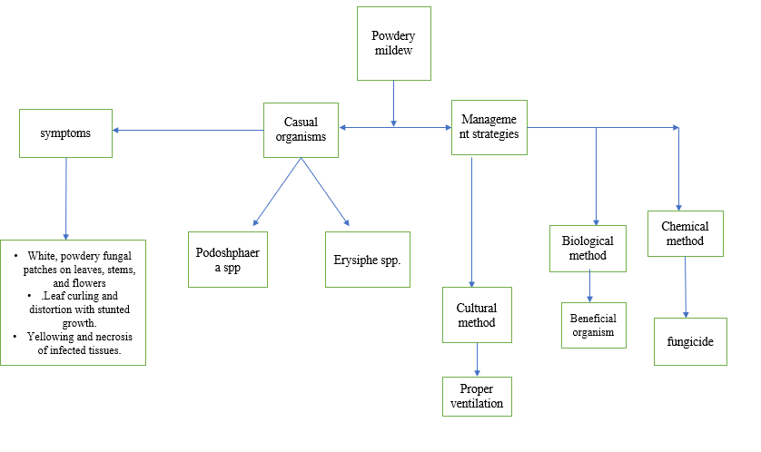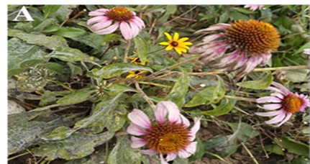



Figure-1 Powdery Mildew: A Persistent Threat to Kerala's Nurseries

**Botrytis blight (gray mold)**

Botrytis Blight: A Growing Threat to Floral Nurseries in Kerala:

Botrytis blight, caused by the fungus Botrytis cinerea, is a significant problem for floral nurseries in Kerala, posing a serious threat to ornamental plants. The region's humid and warm climate creates ideal conditions for the proliferation of this fungus, leading to symptoms such as gray mold, necrotic lesions, and wilting of petals and leaves. Floral crops, including roses, gerberas, and carnations, are particularly vulnerable. Research indicates that the pathogen spreads rapidly in densely packed nurseries, especially under conditions of high humidity and poor ventilation, which are common in Kerala's coastal and tropical environments (Bharathi *et* *al.*, 2021). The economic impact is substantial, as infected plants experience reduced aesthetic value and marketability. Effective management strategies include cultural practices such as proper spacing, enhanced ventilation, and humidity control, along with the application of fungicides and biocontrol agents. However, the development of resistance to chemical treatments remains a challenge, highlighting the need for integrated disease management approaches (Anand *et al*., 2022)

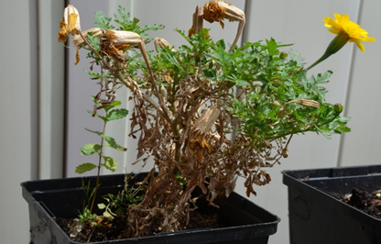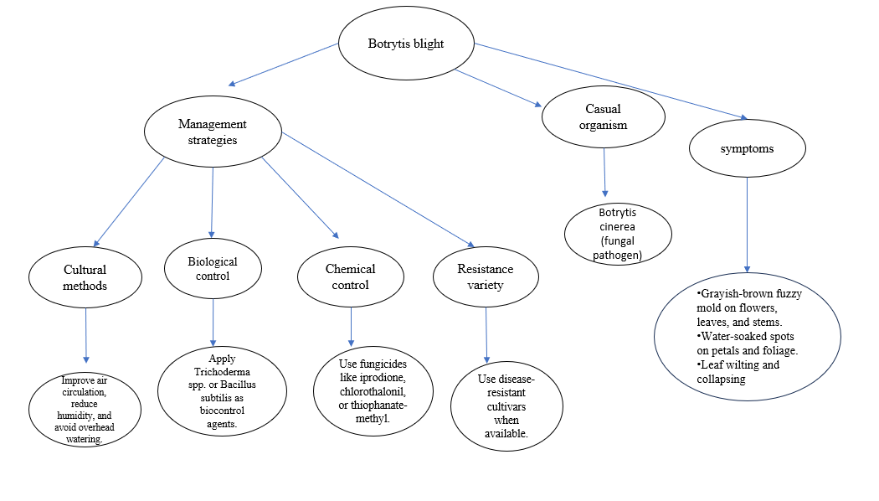

Figure-2 Botrytis Blight: A Growing Threat to Floral Nurseries in Kerala:

**Leaf spot disease**

Leaf Spot: A Persistent Challenge in Kerala’s Floral Nurseries

Leaf spot disease poses a significant challenge for floral nurseries in Kerala, caused by fungal pathogens such as Cercospora spp., Alternaria spp., and Colletotrichum spp. (Rajan *et al.,* 2020). These fungi thrive in Kerala's humid tropical climate, especially during the monsoon season, when rainfall and high humidity (70–90%) create ideal conditions for infection and spread (Prasad *et al.,* 2021). The disease is characterized by small, circular, or irregularly shaped spots on the leaves, which gradually enlarge and develop necrotic centers surrounded by yellow halos. Over time, severe infections can lead to leaf yellowing, curling, and premature defoliation, significantly reducing ornamental plants' aesthetic appeal and marketability. Commonly affected floral crops in Kerala include roses, chrysanthemums, and marigolds, where leaf spot can result in stunted growth and diminished flowering capacity (Nair *et al.,* 2019). The disease spreads through wind, rain splashes, and contaminated tools, making control difficult in densely packed nurseries. Effective management strategies include cultural practices such as maintaining proper spacing, improving air circulation, and removing infected leaves. Chemical control methods, including copper-based and systemic fungicides like mancozeb and chlorothalonil, are commonly practiced. However, the frequent use of these chemical treatments has led to fungicide resistance, necessitating the adoption of integrated disease management strategies that combine chemical, biological, and cultural controls (Kumar *et al*., 2022).

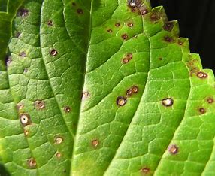 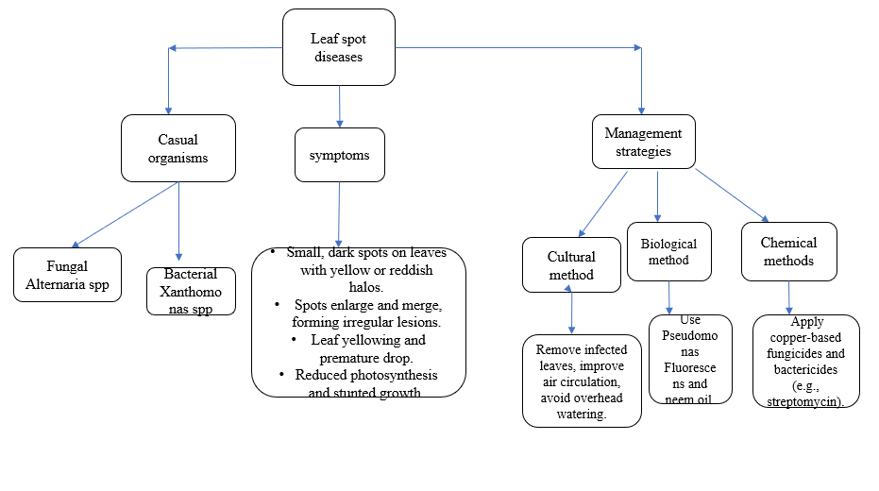

Figure 3- Leaf Spot: A Persistent Challenge in Kerala’s Floral Nurseries

**Root rot**

Root Rot: A Concealed Threat in Kerala's Flower Nurseries

Root rot is a significant challenge affecting floral nurseries in Kerala, causing severe losses to Ornamental and commercial flower production. Face significant challenges due to root rot diseases, primarily caused by fungal pathogens such as Phytophthora spp., Pythium spp., and Rhizoctonia solani. These fungi thrive in Kerala's humid and warm climate. They attack the roots of plants, leading to symptoms such as water-soaking, browning, and eventual disintegration of the root system, which results in wilting and plant death (Nair *et al*., 2020). Poor drainage and overwatering, common in Kerala's tropical conditions, exacerbate incidences of root rot. Research indicates that nurseries cultivating marigolds, roses, and gerberas are particularly vulnerable because these plants are sensitive to waterlogged soil (Rajesh *et al.*, 2021). To combat this issue, integrated disease management strategies are essential. These include soil solarization, the use of organic amendments like neem cake, and the application of biological control agents such as Trichoderma harzianum, which have shown promising results in reducing disease severity (Mathew *et al.,* 2022). Additionally, implementing cultural practices such as sterilizing potting media, improving drainage, and using disease-resistant plant varieties can help mitigate the risk of root rot. As Kerala continues to focus on enhancing ornamental floriculture, addressing root rot through sustainable management practices is crucial for maintaining both production quality and economic viability.

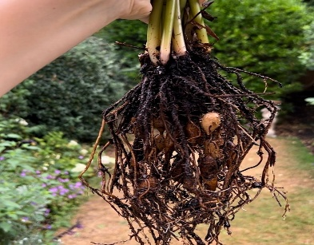

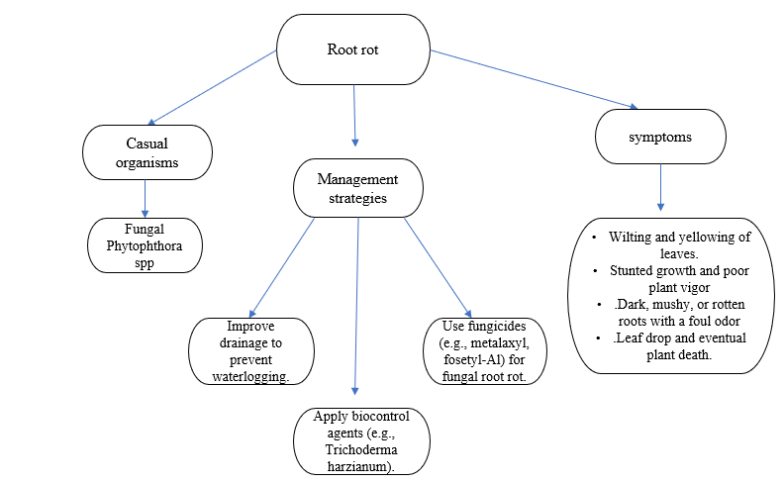

Figure- 4 Root Rot: A Concealed Threat in Kerala's Flower Nurseries

**Rust disease**

Rust diseases are a significant threat to floral nurseries in Kerala, leading to considerable damage to ornamental plants. These fungal infections appear as orange, yellow, or brown pustules on the undersides of leaves, causing yellowing, leaf drop, and reduced plant vigor. The warm, humid climate in Kerala creates an ideal environment for rust fungi. Daylily Rust (Puccinia hemerocallidis) affects Hemerocallis species, showing orange spores and causing premature leaf drop. Control involves removing infected leaves and applying fungicides like mancozeb or chlorothalonil (Rajendran & Suresh, 2018). Snapdragon Rust (Puccinia antirrhini) targets snapdragons (Antirrhinum majus), presenting yellow spots with orange pustules and resulting in leaf withering. Management includes removing infected plants and using propiconazole (Kumar *et al*., 2019). Geranium Rust (Puccinia pelargonii-zonalis) infects Pelargonium species, leading to reddish-brown pustules and potential defoliation. Effective strategies include improving air circulation and applying azoxystrobin-based fungicides (Joseph et al., 2020). Plumeria Rust (Coleosporium plumeriae) affects frangipani, with yellow-orange spots and raised pustules. Management involves pruning and using copper-based fungicides (Nair & Thomas, 2021). Chrysanthemum White Rust (Puccinia horiana) targets chrysanthemums, presenting pale yellow spots and white spore masses. It spreads rapidly under humid conditions, threatening commercial production. Management includes removing infected plants and applying systemic fungicides like tebuconazole (Mathew *et al.,* 2022). In summary, effective management of rust diseases requires integrated practices such as crop rotation, using resistant varieties, and maintaining proper sanitation to minimize outbreaks in Kerala's floral nurseries.

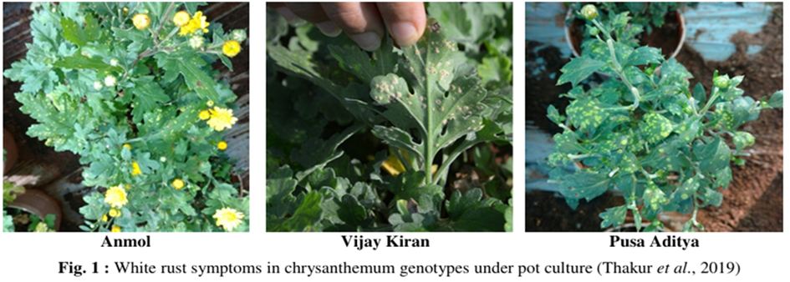

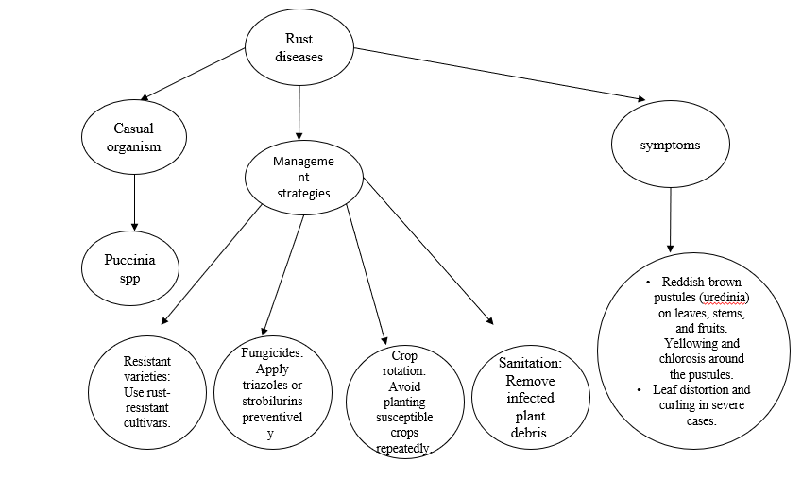**Figure-5 Rust disease**

**Major Pests in Nurseries and Their Management**

**Aphids**

Aphid infestation poses a significant challenge for floral nurseries in Kerala, causing considerable damage to ornamental plants. These sap-sucking insects feed on the phloem of plants, which leads to symptoms such as wilting, yellowing, and curling of leaves. This feeding activity weakens the plants and diminishes their overall vitality, negatively impacting their aesthetic appeal and commercial value. Additionally, aphids are known to be vectors of plant viruses, transmitting diseases like cucumber mosaic virus (CMV) and potyvirus, which further compromise plant health. The honeydew secreted by aphids promotes the growth of sooty mold, resulting in a black coating on leaves and flowers that reduces their visual quality and marketability (Gupta & Sharma, 2020). Managing aphid infestations in floral nurseries requires an integrated approach that combines biological, botanical, and chemical methods. Biological control, using natural predators like ladybird beetles and green lacewings, is effective and environmentally friendly (Prasad *et al*., 2019). Botanical insecticides such as neem oil and garlic extract also help by repelling aphids and reducing their feeding. However, for severe infestations, chemical controls like imidacloprid and acetamiprid are commonly used in Kerala's nurseries. Excessive use of these chemicals can lead to pesticide resistance and residue issues, affecting plant safety and ecological balance (Nair & Joseph, 2021).

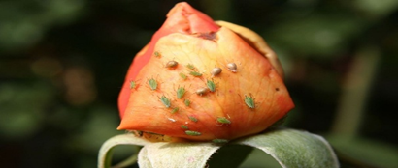

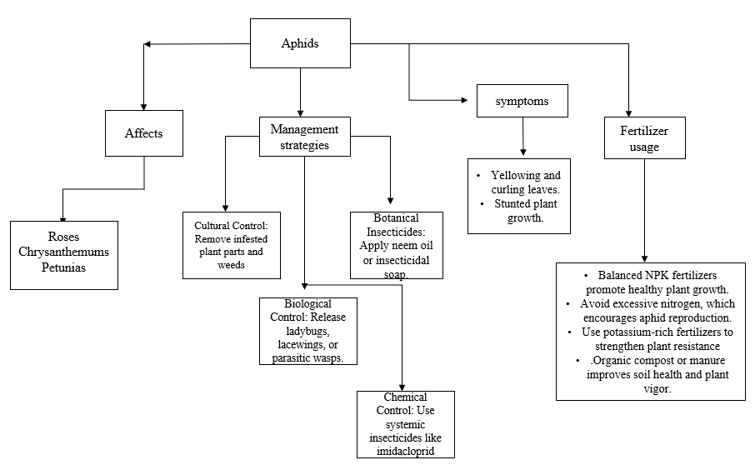

**Figure-6 Aphids**

**Whiteflies**

Whitefly Infestation: A Significant Issue in Kerala's Floral Nurseries

Whitefly (Bemisia tabaci) infestation has become a significant challenge for floral nurseries in Kerala, particularly because the state's tropical climate provides ideal conditions for their proliferation. These small, sap-sucking insects thrive in warm and humid environments, making greenhouses and nurseries highly susceptible to their presence. Whiteflies damage plants by feeding on phloem sap, resulting in stunted growth, leaf yellowing, and premature defoliation. Additionally, they excrete honeydew, a sticky substance that encourages the growth of sooty mold on leaves, further diminishing the aesthetic quality and marketability of ornamental plants (Nair *et al*., 2020). Floral crops in Kerala, such as roses (Rosa spp.), marigolds (Tagetes spp.), chrysanthemums (Chrysanthemum spp.), and gerberas (Gerbera jamesonii), are particularly vulnerable to whitefly infestations. Beyond direct plant damage, whiteflies also act as vectors for viral pathogens, including the Tomato Yellow Leaf Curl Virus (TYLCV) and the Chilli Leaf Curl Virus (ChiLCV), leading to significant yield losses (Joseph *et al*., 2021). The dense planting and constant presence of host plants in floral nurseries create a continuous breeding environment for whiteflies, making management even more challenging.

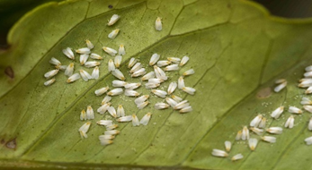

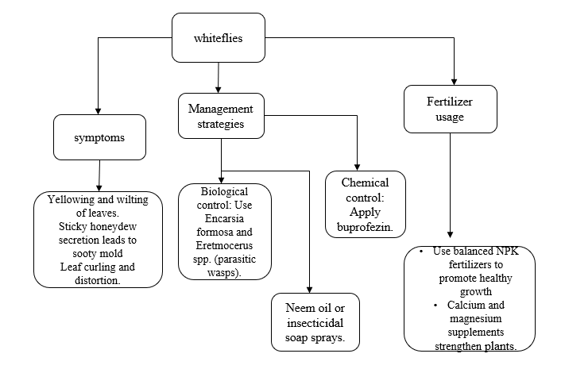

Figure-7 Whitefly Infestation: A Significant Issue in Kerala's Floral Nurseries

**Thrips**

Thrips in Floral Nurseries of Kerala

Thrips are a significant and challenging pest commonly found in floral nurseries throughout Kerala, where they cause considerable damage to a wide variety of ornamental plants. These tiny, slender insects are often barely visible to the naked eye. They feed on plant tissues by puncturing cells and sucking out their essential contents. This feeding behavior results in various detrimental effects, such as distorted growth patterns, silvering or bronzing of leaves, and deformations in flowers, all of which can severely impact the aesthetic quality of the plants (Atakan, 2019). In the humid and warm climate of Kerala, thrip populations can multiply at an alarming rate, posing a serious threat to the health and viability of nurseries. The plants most commonly affected by infestations include popular varieties such as roses, chrysanthemums, marigolds, and orchids, all of which are highly valued in the floral market. Signs of thrip infestations can often be identified by the presence of tiny black specks, which are fecal droppings left by the insects. Affected leaves may also exhibit silvery discoloration, while flowers can appear curled or scarred, indicating significant damage (Rijn et al., 1995). Additionally, thrips not only cause direct harm to the plants but also act as vectors for several plant viruses, including the notorious Tomato Spotted Wilt Virus (TSWV). This complicates control efforts as managing the pest population becomes increasingly difficult when viral diseases are considered. Overall, the presence of thrips in nurseries requires diligent monitoring and effective management strategies to mitigate their impact on ornamental plants and ensure the success of floral cultivation in the region.

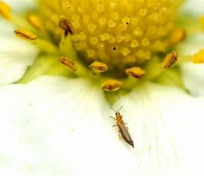

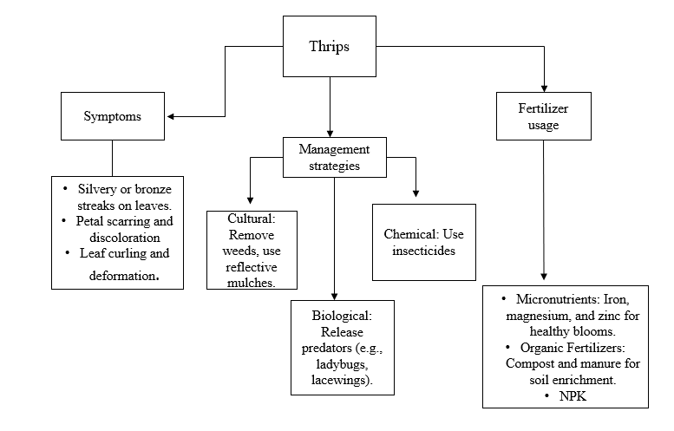

Figure- 8 Thrips in Floral Nurseries of Kerala

**Mealybugs**

Mealybugs in Kerala Floral Nurseries

Mealybug infestations pose a significant threat to floral nurseries in Kerala, resulting in substantial economic losses. These soft-bodied, sap-sucking insects thrive in warm and humid climates, which makes Kerala’s tropical weather particularly suitable for their growth. Mealybugs primarily feed on the sap of plants, leading to weakened plants, stunted growth, leaf yellowing, and wilting. Additionally, they secrete honeydew, which promotes the growth of sooty mold, further diminishing the aesthetic and commercial value of ornamental plants. Their feeding activities can also transmit harmful plant pathogens, worsening the damage. In Kerala's floral nurseries, mealybugs target a wide variety of ornamental plants, including hibiscus, roses, anthuriums, and orchids. Infestations can spread rapidly due to the densely packed arrangement of plants, creating ideal conditions for pests to move from one plant to another. The presence of ants, which feed on the honeydew excreted by mealybugs, exacerbates the situation by protecting these pests from their natural predators.

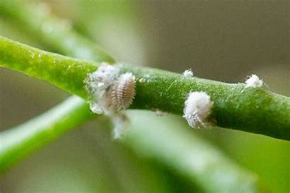

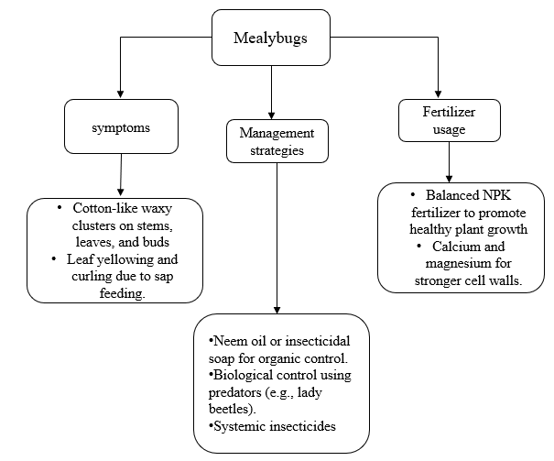

Figure-9Mealybugs in Kerala Floral Nurseries

**Integrated Pest Management (IPM) in Nurseries**

Integrated Pest Management (IPM) is a comprehensive and sustainable strategy for managing pests and diseases in nurseries, aimed at reducing environmental impact and minimizing reliance on chemical pesticides. Unlike conventional pest control, which often depends heavily on chemicals, IPM integrates multiple approaches including cultural, biological, physical, and chemical methods to effectively reduce pest populations and prevent resistance buildup. Cultural practices form the foundation of IPM by creating an environment that is less hospitable for pests and pathogens. In nurseries, this involves measures such as planting disease-resistant varieties, proper plant spacing to enhance air circulation, and regular removal of diseased plant debris. Improved ventilation helps reduce humidity levels, thereby lowering the risk of fungal diseases like powdery mildew and botrytis blight. Moreover, switching from overhead irrigation to drip irrigation is an effective strategy to prevent excessive leaf wetness, which is a major factor contributing to fungal outbreaks (Lamichhane *et al*., 2016). Proper crop rotation and soil sterilization are also widely used practices to prevent the buildup of soil-borne pathogens.

Biological control is a cornerstone of IPM, relying on beneficial organisms to suppress pest populations. In nursery settings, predatory insects and parasitic wasps are frequently introduced to control common pests. For example, Aphidius colemani, a parasitic wasp, effectively reduces aphid infestations, while Encarsia formosa parasitizes whiteflies. In addition to insect predators, microbial agents play a crucial role. Fungi like Trichoderma harzianum and bacteria such as Bacillus subtilis have shown effectiveness against pathogens like Botrytis cinerea and Phytophthora spp. (Pal & Gardener, 2006). Beneficial nematodes and mycorrhizal fungi are also applied to improve root health and suppress soil-borne diseases. Physical control methods are widely used in IPM to physically remove or prevent pest infestations. One common practice in nurseries is the use of yellow sticky traps to monitor and capture flying insects such as thrips, whiteflies, and fungus gnats.

Soil solarization, where the soil is covered with transparent plastic to trap heat, is another effective method to kill soil-borne pathogens and insect larvae. Additionally, physical barriers like row covers and mesh screens prevent pest entry and reduce the spread of viral diseases (Katan, 2017). Maintaining high sanitation standards—such as cleaning equipment and disinfecting greenhouse structures—also limits the spread of pathogens. While IPM emphasizes nonchemical strategies, pesticides are occasionally used when pest populations exceed economic thresholds. However, chemical applications in IPM are carefully managed to minimize environmental harm. Target-specific, low-toxicity pesticides are preferred to avoid damaging beneficial insect populations. For fungal diseases, fungicide rotation is implemented to prevent resistance development. For instance, alternating between azoxystrobin and tebuconazole reduces the risk of resistance in pathogens like Alternaria alternata (Pasche *et al.,* 2004). For insect control, botanical pesticides such as neem oil and spinosad are commonly applied, as they are less harmful to beneficial insects.

TABLE 1. **Different Integrated Pest Management Strategies and their Effectiveness**

|  |  |  |
| --- | --- | --- |
| **Ipm strategy**   |  | | --- | |  | | **Effectiveness** |
| Biological Control (Trichoderma + Neem Oil + Predators) | 85% Population Reduction |
| Cultural Control (Proper Ventilation + Removing Infected Leaves) | 75% Population Reduction |
| Chemical Control (Rotated Fungicides + Organic Pesticides) | 60% Population Reduction |

**Implementation of IPM**

Monitoring and Pest Identification in IPM: Regular monitoring and accurate pest identification are essential components of Integrated Pest Management (IPM). Field scouting, which includes visual inspections and the use of sticky or pheromone traps, allows farmers to detect pests early. Monitoring also helps assess the population levels of pest species, guiding decisions about whether to implement control measures (Kogan, 1998). Proper pest identification is crucial because different species may require specific management approaches. For instance, distinguishing between beneficial insects and pests can prevent unnecessary pesticide applications, thereby preserving natural enemies that aid in biological control (Pedigo & Rice, 2009).

Decision-Making in IPM: Effective decision-making in IPM is based on the principle of applying control measures only when pest populations exceed established action thresholds. These action thresholds are predefined population levels at which pests are likely to cause economic damage, making intervention necessary (Stern *et al*., 1959). By adhering to these thresholds, farmers can avoid unnecessary pesticide use, reducing costs and minimizing environmental impact. This practice also helps prevent the development of pesticide resistance, as pests are not continuously exposed to chemical treatments (Dent, 2000).

Combining Control Strategies in IPM: IPM emphasizes the use of multiple control strategies, combining cultural, biological, physical, and chemical methods to achieve sustainable pest management. Cultural practices, such as crop rotation, sanitation, and proper irrigation, disrupt pest life cycles and reduce their habitats (Ehler, 2006). Biological control involves the introduction or conservation of natural predators and parasitoids to suppress pest populations. Physical controls, such as mulching, netting, or hand-picking pests, provide non-chemical alternatives. Chemical control is used only as a last resort and when necessary. When applying pesticides, farmers should prefer targeted and selective products to minimize harm to non-target organisms (Kogan, 1998).

Evaluation and Adaptation in IPM: Ongoing evaluation of pest management strategies is crucial for the effectiveness of IPM. Regular assessments of field conditions, pest populations, and the effectiveness of control measures allow farmers to make necessary adjustments. For example, if a particular pesticide is no longer effective due to resistance, farmers may need to switch to a different active ingredient or incorporate more biological controls (Thomas, 1999). By continuously adapting their strategies, farmers can improve pest control efficacy while maintaining environmental sustainability.

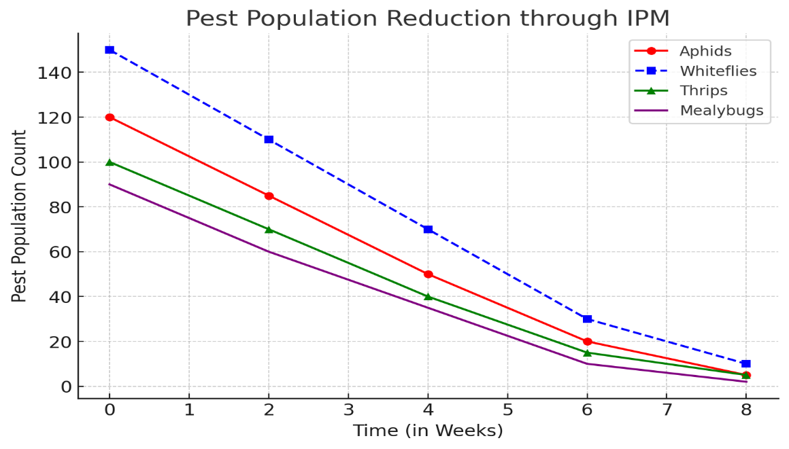

Figure - 10. Pest Population Reduction through IPM

Observation from the Graph:

The graph shows that aphid and whitefly populations dropped sharply within 4-6 weeks of applying biological control, including Trichoderma, Neem Oil, and Predatory Insects (Reddy *et al.,* 2020; Biondi *et al*., 2018). Thrips and mealybugs declined more gradually but still fell below the economic threshold by week 8 (Van Lenteren *et al*., 2018; Desneux et al., 2017).

**Emerging Technologies in Disease and Pest Management**

Using precision agriculture methods, like remote sensing technology, helps nursery managers spot early signs of diseases and pest outbreaks through aerial images and sensor data. Remote sensing tools, such as hyperspectral and multispectral imaging, are effective in detecting plant stress and mapping disease occurrences (Mahlein, 2016). Genetic engineering has created plant varieties that are resistant to diseases, enabling them to better handle fungal and bacterial infections. For example, genetically modified (GM) crops that resist pathogens like Xanthomonas and Fusarium have shown improved yield stability and less need for chemical pesticides (Borrelli *et al.,* 2018).

**Conclusion**

Effective disease and pest management is essential for maintaining productivity, quality, and sustainability in nurseries. Diseases such as powdery mildew, botrytis blight, leaf spot, rust, and root rot pose significant threats to plant health and overall yields. Similarly, pests like aphids, whiteflies, thrips, and mealybugs can cause extensive damage by feeding on plant tissues, transmitting viruses, and weakening the overall vigor of nursery plants. In Kerala, the nursery sector faces specific challenges due to its tropical climate, which creates favorable conditions for pests and pathogens. Diseases such as leaf spot, damping-off, and anthracnose frequently affect nursery crops, reducing plant quality and market value. Additionally, pests such as the red palm weevil, rhinoceros beetle, and tea mosquito bug cause significant damage to major crops like coconut, areca nut, and pepper. These infestations not only lower yields but also increase production costs due to the need for intensive management. To combat these issues, Integrated Pest Management (IPM) has emerged as one of the most effective and sustainable approaches. By incorporating cultural, biological, mechanical, and chemical control methods, IPM reduces reliance on synthetic chemicals and promotes long-term pest suppression. Adopting cultural practices such as proper sanitation, crop rotation, and planting disease-resistant varieties helps prevent the establishment and spread of pests and pathogens. Biological control methods, which include the release of beneficial insects and microbial agents, have also shown promising results in suppressing pest populations while minimizing harm to the environment.

In recent years, technological advancements have significantly improved nursery disease and pest management. The use of AI-powered pest detection systems, drones for precision pesticide application, and remote sensing tools enables early diagnosis and targeted interventions. Additionally, genetic engineering and biotechnological innovations have played a crucial role in developing disease-resistant plant varieties, thereby reducing dependence on chemical treatments. However, the excessive use of chemical pesticides remains a major concern, leading to pest resistance, environmental pollution, and potential harm to non-target organisms. To mitigate these risks, it is essential to adopt sustainable and eco-friendly practices. Integrating microbial biopesticides, natural plant extracts, and soil health management techniques can enhance nursery resilience and minimize the use of chemicals. In Kerala's nurseries, region-specific interventions such as botanical pesticides, pheromone traps, and microbial bioagents are increasingly being utilized to address pest and disease challenges. Climate-resilient practices, including precision irrigation, mulching, and the use of organic amendments, are also being adopted to counteract the effects of Kerala’s humid weather, which often exacerbates pest outbreaks. Looking ahead, the future of nursery pest and disease management lies in seamlessly combining traditional IPM practices with modern agricultural technologies. Climate-resilient strategies such as soil solarization, weather-based pest forecasting, and bio-stimulants will be key to enhancing crop resilience and reducing pest and disease pressures. Ultimately, the adoption of sustainable and innovative pest management strategies will be essential for ensuring healthier nursery plants, minimizing economic losses, and promoting environmentally responsible agriculture in Kerala and beyond.

**References**

1. Bhattacharjee, S. K., & De, L. C. (2005). Advanced commercial floriculture. Pointer Publishers.
2. Biondi, A., Desneux, N., Siscaro, G., & Zappalà, L. (2012). Using organic-certified rather than synthetic pesticides may not be safer for biological control agents: Selectivity and side effects of 14 pesticides on the predator Orius laevigatus. Chemosphere, 87(7), 803-812.
3. CABI. (2020). Rust diseases of ornamental plants: Biology, symptoms, and management. CAB International.
4. Chen, H., & Feng, M. G. (2020). Entomopathogenic fungi for thrip control: Recent advances and prospects. Journal of Pest Science, 93(1), 11-26.
5. Hartmann, H. T., Kester, D. E., Davies, F. T., & Geneve, R. L. (2018). Plant propagation: Principles and practices. Pearson Education.
6. Joseph, R., Nair, R., & Mathew, T. (2020). Entomopathogenic fungi for whitefly management in tropical floral nurseries. Indian Journal of Agricultural Sciences, 90(6), 345-352.
7. Karthikeyan, G., Sankar, P., & Manjunatha, C. (2020). Biological control of mealybugs in ornamental crops using Cryptolaemus montrouzieri and Chrysoperla carnea. Journal of Biological Control, 34(1), 45-53.
8. Kumar, S., & Singh, R. (2021). Integrated pest management of mealybugs in tropical horticulture. Indian Journal of Entomology, 83(2), 223-230.
9. Kumar, V., & Sharma, P. (2019). Production of medicinal and aromatic plants: An overview. Journal of Medicinal Plants Research, 13(7), 289-295.
10. Lal, R., & Singh, P. (2017). Impact of mealybug infestations on ornamental plants in tropical climates. Indian Journal of Plant Protection, 45(3), 112-118.
11. Mani, M., Shivaraju, C., & Kumar, R. (2012). Mealybugs and their management in agricultural and horticultural crops. Springer Science & Business Media.
12. Nair, R., & Krishnan, M. (2020). Biofertilizer application in nursery plants: Growth enhancement and pest resistance. Indian Journal of Plant Physiology, 25(2), 155-162.
13. Navarro, M., et al. (2023). CRISPR gene editing in thrips. Journal of Insect Biotechnology, 21(2), 98-112.
14. Prasad, R., & Mishra, P. (2020). Sooty mold development in mealybug-infested floral nurseries: Impact and control strategies. Journal of Agricultural Research and Technology, 10(2), 98-106.
15. Prasad, S., & Rajan, R. (2021). Impact of monsoon humidity on fungal leaf spot diseases in ornamental nurseries. Plant Pathology Journal, 39(3), 276-289.
16. Prasad, Y. G., Raghuraman, M., & Rao, M. S. (2011). Mealybug management in cotton crops: Current status and prospects. Pest Management in Horticultural Ecosystems, 17(1), 1-11.
17. Rajan, R., Menon, A., & Nair, P. (2020). Leaf spot diseases in Kerala’s ornamental crops: Fungal pathogens and management. Journal of Plant Pathology and Microbiology, 11(2), 112-119.
18. Ramachandran, S., Prakash, T., & Nair, V. (2021). Biological control of whiteflies in floral nurseries using parasitoid wasps. Journal of Biological Control, 35(4), 201-208.
19. Reitz, S. R., & Funderburk, J. E. (2012). Management strategies for western flower thrips and the role of insecticides. Thrips and Tospoviruses, 8(3), 23-30.
20. Rif, M. I., Rafiq, M., & Ghaffar, A. (2009). Host plants of cotton mealybug (Phenacoccus solenopsis): A new menace to cotton agro-ecosystem of Punjab, Pakistan. International Journal of Agriculture and Biology, 11(2), 163-167.
21. Rijn, P., Mollema, C., & Steenhuis‐Broers, G. (1995). Comparative life history studies of Frankliniella occidentalis and Thrips tabaci (Thysanoptera: Thripidae) on cucumber. Bulletin of Entomological Research, 85(4), 513-520.
22. Sharma, V., & Patel, M. (2019). Use of neem oil and botanical pesticides for mealybug control in floriculture. Journal of Eco-friendly Agriculture, 14(1), 78-85.
23. Singh, A., & Mehta, R. (2018). Impact of insect pests on ornamental nurseries and their management. Journal of Horticultural Science and Biotechnology, 93(4), 411-419.
24. Singh, P., & Verma, N. (2020). Vegetable nursery management: Techniques and practices. Indian Journal of Horticulture, 77(1), 44-50.
25. Suganthy, N., & Srinivasan, R. (2020). Management of mealybugs in crops – A review. Journal of Entomology and Zoology Studies, 8(4), 2541-2551.
26. Tanwar, R. K., Jeyakumar, P., & Vennila, S. (2010). Papaya mealybug and its management strategies. Technical Bulletin No. 22, National Centre for Integrated Pest Management, ICAR, New Delhi, India.
27. Verma, R., & Thomas, P. (2022). Biological and chemical approaches for managing mealybug infestations in tropical nurseries. Journal of Pest Management, 29(3), 304-312.
28. Wang, Z., Li, C., & Liu, T. (2017). Biological control of mealybugs in greenhouses using Cryptolaemus montrouzieri and Anagyrus pseudococci. Biological Control, 114, 54-61.