Review Article
Mitigating Aquatic Toxicity Through the Use of Aquatic Plants

Highlights:
Role of Aquatic Plants in Pollution Mitigation: The study focuses on aquatic plants like Lemna gibba and Eichhornia crassipes which play a significant role in reducing water pollution by detoxifying or metabolizing harmful chemicals, thus aiding in the restoration of water quality.
Phytoremediation Techniques for Aquatic Environments: The review discusses techniques such as phytoremediation, phytoextraction, and hemofiltration that leverage plant roots to absorb, concentrate, and neutralize heavy metals, toxicants, and other pollutants in both terrestrial and aquatic settings.
Algal Turf Scrubbers (ATS) and Organic Pollutant Removal: Filamentous algae in ATS systems effectively extract organic pollutants and nutrients from water, enhancing the purification process in contaminated aquatic systems.
Constructed Wetlands as Natural Wastewater Treatment Systems: Constructed wetlands mimic natural wetland ecosystems by using plant species like Typha and Phragmites to treat wastewater and sustainably manage pollution.
Potential for Natural, Sustainable Wastewater Management: The study emphasizes the potential of using aquatic plants and engineered ecosystems to naturally, cost-effectively, and sustainably manage wastewater, reducing reliance on chemical treatments.

Abstract
Aquatic ecosystems are increasingly threatened by pesticides, industrial chemicals, and urban runoff. These toxicants accumulate in water bodies, affecting biodiversity. Aquatic plants play a crucial role in mitigating this pollution. Species like Lemna gibba detoxify phenolic compounds, while Eichhornia crassipes metabolize PCP, making them effective in wastewater treatment. Techniques like phytoremediation (using aquatic plants to cure the contaminated plant bodies), phytoextraction (uptake the heavy metals and toxic elements by roots of plants), rhizofilteration (absorbs the contaminants by the roots in the highly toxic aqueous ecosystem) perform in both aquatic and terrestrial, algal turf scrubber (ATS) removal of organic pollutants and concentrated nutrients by using filamentous algae, constructed wetlands which are the copies of wetlands to treat the natural wetlands by using aquatic plant species like Typha spp., Phragmites spp., etc. There are so many aquatic plant species that have a natural ability to absorb or break down the toxic elements and metabolites in aquatic environments. The study focuses on how, using these plants may reduce the toxicity of aquatic ecosystems and allow wastewater management to be done naturally and effectively.

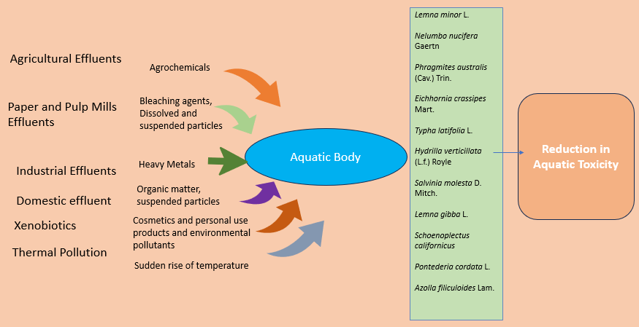
Graphical Abstract
Keywords: Aquatic toxicity, phytoremediation, toxicity-reducing plants, wastewater treatment, bioindicators
Introduction
The aquatic ecosystem is an important part of our environment. Where important plant species and aquatic animals are alive. The aquatic ecosystem is a water-based environment where living and non–living things survive and interact with each other. Both biotic and abiotic factors live together in an aquatic environment. The constituents of the aquatic ecosystem are categorized into two:
- Biotic components - Producers (Phytoplankton), Consumers (Zooplanktons, large fishes, Sharks, etc.) and Decomposers (Microbes and Detritus)
- Abiotic components - Water, Lights, Nutrients, Substrates, Temperatures, rocks, etc.
Aquatic ecosystems are like freshwater ecosystems, marine ecosystems, wetlands, etc. Plants like Spirulina, duckweed, red algae, chlorella, water hyssop, etc. are important medicinal plants. Some smaller organisms are evidence and indicators of aquatic health and those are analyzed by Transmission Electron Microscopy (TEM) such as picoplankton, nanoplankton, cyanobacteria, cyanophyte, etc.^{[1]} (Leppard and Munawar 1992). Aquatic toxicity refers to increased nutrient concentration or toxic chemicals in an aquatic ecosystem. It affects the reproductive health, growth, and immunity of aquatic organisms and also affects the food chain, loss of biodiversity, degradation of water quality, disturbance of nutrient and mineral concentration in aquatic ecosystems, etc.^{[2]} (Kooijman and Bedaux 1996). There are various chemicals like pesticides, herbicides, fertilizers, and heavy metals like zinc, cadmium, iron, etc. mainly cause aquatic toxicity.
  - Main causes of aquatic toxicity
The main role of xenobiotics for cause aquatic toxicity like drugs, various industrial chemicals, pesticides, oils, etc. About 250 chemicals are found in pulp and paper mill effluents^{[3]} (Ali and Sreekrishnan 2001). Industrial wastes and pesticides from crop fields cause damage to aquatic plants and animals and increase the oxygen demands in aquatic ecosystems. Trace elements like copper, cadmium, mercury, chromium, and arsenic can disrupt aquatic animals’ homeostasis. Heavy metals are causing damage to aquatic life by affecting signalling properties, nervous systems, and digestive functions^{[4]} (Kolarova and Napiórkowski 2021). Some various substances and compounds cause aquatic toxicity and affect aquatic life (Fig. 1 here).
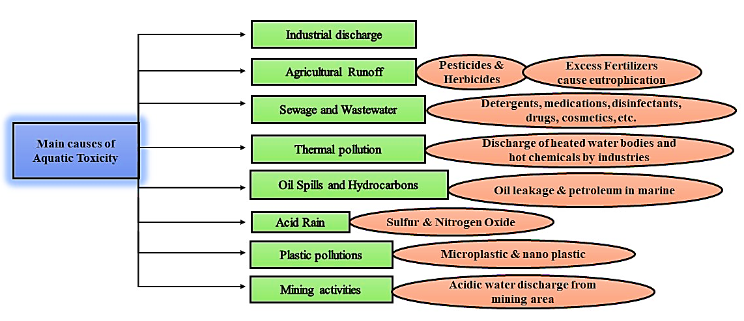
Fig. 1: Major causes of aquatic toxicity
Herbicides and pesticides are shown to have harmful impacts on aquatic life. Impacts such as disturbance in the mineral concentration of the marine ecosystem, bioaccumulation, and biomagnification, affecting the algae that are the primary producers of the aquatic ecosystem, hampering the nutrient fixing and cycling microbes and small plants^{[5]} (Kumar et al. 2021). The most affecting herbicides and pesticides in aquatic ecosystems are listed in (Table 1 here).
  - Biological indicators and testing methods for analysis of aquatic toxicity
Some essential aquatic plants and microorganisms like bacteria, protozoa, and fungi act as monitors or indicators of aquatic toxicity, that are sensitive to chemicals or may be present in chemicals. Biological indicators describe the abiotic and biotic reactions in any ecosystem^{[6]} (Zaghloul et al. 2020). Biological indicators detect and can scale the pollutants in an aquatic ecosystem. Amphibians, algae, fungi, and lower groups of aquatic plants are the best indicators of aquatic toxicity. A reduction in the growth of algae and a decrease in the growth rate of fish indicates the toxic substances in the water. Abnormal growth of larvae, reduction in egg rate, and changes in fish swimming patterns represent the aquatic toxic level^{[7]} (Lenhardt et al. 2015). Biochemical markers like enzymatic activities, hormonal changes, and other biochemical parameters are exposed to toxicity. Inhibition of acetylcholinesterase enzymatic activity indicates carbamate pesticide compound toxicity^{[8]} (Lionetto et al. 2013). Cytochrome P450s enzymes present in the liver of fishes change the metabolic activities due to the bioaccumulation of polychlorobiphenyl (PCB). Organic contamination in water affects the enzymatic actions of the liver in fishes and it’s an indicator of aquatic toxicity^{[9]} (Koenig et al. 2012).
There are some testing tools and methods for analysis of the toxicity rate in aquatic ecosystems. Acute Toxicity Test determines the immediate effect of substances on aquatic organisms like fishes, toads, algae, etc. This test resulted in the death rate and survival rate of aquatic organisms. The Chronic Toxicity Test is also slightly similar to the Acute Toxicity Test where it is a long-term exposure, determining the toxicity rate by effect of substances over an extended period^{[10]} (Bhardwaj and Gupta 2012). Using various types of living organisms to test the toxicity level. Tests are like algal growth test, which measure and examine the growth of algal and Daphnia Immobilization Tests, where Daphnia magna is common water fleas plankton belonging to Phyllopoda, examine the responses and behavioural effects of this plankton indicate the toxicity^{[11]} (Chevalier et al. 2015). Daphnia magna is highly sensitive to heavy metals. Various aquatic plant species act as an indicator of toxic substances through the response of the plants and they play a vital role in reducing the toxicity (Table 2 here).
Various physiological changes of aquatic plant species are the indicators or responses towards the toxic substances in aquatic ecosystems. Some basic physiological effects are chlorophyll content reductions, changes in biomass content, discoloration, folding of leaves, etc. These factors can analyze the toxicity levels in aquatic ecosystems^{[12]} (Batista et al. 2017). Lipid membrane peroxidation is a mechanism of reduction of oxidative degradation of lipids in cell membranes due to toxicity. The generation of ROS that reacts with the polyunsaturated fatty acids in the membrane forms a chain reaction of lipid peroxyl radicals. This chain reaction continues until antioxidants neutralize it. If the antioxidant defense system is excessive, lipid peroxidation occurs, leading to cell damage^{[13]} (Girotti 1985).
- Mechanism of reduction of aquatic toxicity
Aquatic plants play major roles in the reduction of toxic substances in the aquatic ecosystem. Plants absorb heavy metals or toxic substances and degrade or detoxify the toxic substances. Aquatic plants have the ability and potential to absorb the nutrient in excess amounts. The different types of mechanisms are:
  - Phytodegradation
The phytodegradation mechanism also called phytoremediation or Phyto transformation, is plants uptake pollutants or contaminants and can modify them. Eichhornia crassipes Mart., Lemna minor L., Pistia stratiotes L., and Scirpus spp. are most commonly used in the phytoremediation process, this process has the potential to enhance natural microbial stimulations and natural additives^{[14]} (Kristanti and Hadibarata 2023). Eichhornia crassipes Mart. grow rapidly and produce biomass in larger amounts. It is an absorbent for inorganic wastes and heavy metals. E. crassipes Mart. used as effective wastewater treatment technology for the treatment of contaminated water^{[15]} (Lima and Asencios 2021). Phytodegradation is an important ecological service contribution to sustainability and a healthy aquatic ecosystem. Polycyclic Aromatic Hydrocarbons are toxic group that rapidly spreads pollutants in the environment and aquatic ecosystem. L. minor L. has the potential to absorb these contaminants and degrade them. This toxicity can damage the photosynthetic pigments^{[16]} (Zazouli et al. 2023). P. stratiotes L., E. crassipes Mart. and L. minora L. are effectively detoxifying plants that can degrade and absorb the textile dyes like Cibacron Blue FR, DB 201, Moxilon Blue GRL, etc. are tolerated by these plants and decolorize the dyes. The enzymatic actions in roots of mainly E. crassipes Mart. and L. minor L. decolorizes the textile dyes. Enzymes like peroxidase, tyrosinase, and azo reductase can decolorize the toxic dyes^{[17]} (Ekanayake et al. 2021).
  - Phytoextraction
Phytoextraction is also called as phytoaccumulation. This method cleans the polluted water and also enhances the ecological value and aesthetic ecosystem. Where hyperaccumulator plant species absorb the heavy metals and pollutants substances and store them in leaves, stems or leaves. Hyperaccumulator species are like Salvinia molesta D. Mitch., Cabomba aquatica Aubl., Hydrilla verticillata (L.f.) Royle and L.minor L. accumulate high concentrations of heavy metals, organochlorine pesticides, PAHs, and other pollutants and store them in root areas and leaves^{[18]} (Mânzatu et al. 2015). A floating aquatic plant Limnobium laevigatum (Humb. & Bonpl.) is a hyperaccumulator plant significantly effective in waste water treatment. L. laevigatum (Humb. & Bonpl.) absorbs heavy metals like Pb, Cr, Zn, and Ni, then accumulates the on the roots and leaves region. This plant accumulates heavy metals at roots in high concentrations as compared to leaves, where Zn and Ni are mostly accumulated in leaves^{[19]} (Arán et al. 2017). Swollen duckweed Lemna gibba Linn. and Lemna aequinoctialia Welw. Have the potential to accumulate or extract heavy metals like Cd, Ni, Pd, etc. i.e. industrial wastes or municipal effluents. Lemna gibba L. produces high biomass, which reduces heavy metal concentration in which Ni concentration is high compared to other metals in these plants^{[20]} (Bokhari et al. 2015).
  - Phyto stabilization
Phyto stabilization is another form of phytoremediation, where plants stabilize the contaminants in water or soil and prevent it from spreading. Plants absorb, immobilize, and accumulate pollutants and improve aquatic health. Root growth and transpiration processes immobilize pollutants by creating an aerobic environment in the rhizosphere and controlling erosion. Aquatic plants can tolerate high levels of pollutants has monitor the concentration of metalloids^{[21]} (Bolan et al. 2011). A floating macrophyte Ludwigia adscendens L. has the phytoremediation potential to remove heavy metals from contaminated aquatic ecosystems. The roots are attributed to accumulating high concentrations of metals like Ni, Cd, Zn, Cu, Fe, Mn, and Al seasonally. The chlorophyll b and carotenoid content in the leaf area significantly reduce the contaminants and toxicity in water bodies^{[22]} (Galal et al. 2020). Canna indica L., Eichhornia crassipes Mart., Typha latifolia L., etc., hydroponics plant species roots accumulate high quantities of metals in their roots and other tissues. Canna indica L. and P. stratiotes L. show a high accumulation of metals. Mostly Zn and Cd heavy metals are absorbed by the roots of aquatic plant species^{[23]} (Sricoth et al. 2018). The commonly used plant species are Phragmites australis (Cav.) Trin., which produces large amounts of biomass, L. minor L. reduces soil erosion and also stabilizes the contaminated sediments, etc., and many more plant species which reduce the mobility of contaminants by root systems.
  - Phytovolatilization
The root systems of aquatic plants absorb the contaminants or toxic chemicals and release them into the atmosphere through their leaves as a volatile compound. Particularly dealing with selenium, mercury, and other organic toxins. Pollutants are translocated to leaves through the vascular systems and released into the atmosphere through the stomata of leaves^{[24]} (Limmer and Burken 2016). Pteris vittate L. is a hyperaccumulator plant species used for phytoextraction and phytovolatilization. Recently discovered, P. vittate L. can accumulate volatile arsenic substances which can cause toxicity. A larger concentration of Arsenic contaminants can cause excessive toxicity^{[25]} (Sakakibara et al. 2010). Phytovolatilization is also called Phyto sequestration. Four common accumulator plants such as Salvinia, Lemna minora L., P. stratiotes L. and Eichhornia crassipes Mart. having great potential in absorbing heavy metals by roots and translocating them to the aerial parts of the plants. The toxic elements are stored in the vacuoles of plant cells, later vacuole expel out from the plant cell with the toxic elements^{[26]} (Pang et al. 2023). Oryza sativa L. has the potential for volatilization. Accumulation of metabolites and metal ions in leaves and leaf sheath, then volatile the toxics. Rice plants volatile bromophenols and bromoanisoles from the hydroponic solutions^{[27]} (Zhang et al. 2020).
  - Rhizofiltration
Rhizofiltration is a form of phytoremediation, where plants degrade, destroy, stabilize, and remove the contaminants mainly by roots. Hydroponically growing plant species have substantial root system uptake, the contaminants accumulate with the root surface or other plant tissues and then form insoluble compounds that are less harmful. Once the root system absorbs the contaminants then harvest the plant expels it out from the aquatic ecosystem^{[28]} (Kristanti et al. 2021). Plant biomass for removing the contaminants that contain heavy metals, chemicals, and toxic elements. Carex pendula Huds. an accumulator plant species growing at hyper clay soil, river banks, wetlands, and beside streams. This plant is best for lead-containing wastewater treatment^{[29]} (Yadav et al. 2011). Major pollutants like heavy metals such as Cu, Pb, Ni, arsenic, Zn and non–metallic xenobiotics concentration mostly affect the water quality. There commonly available plants Eichhornia crassipes Mart., Pistia stratiotes L. and Azolla filiculoides Lam. Reduces the contaminants from water bodies also interact with the microbes. The roots of these plants release organic acids malic acid and citric acid which degrade and react with the concentrated metals, then absorb or adsorb the pollutants. Pistia stratiotes L. is a hyperaccumulator of fluoride. These plants are good for removing and detoxifying xenobiotic pollutants^{[30]} (Banerjee et al. 2022) (Fig. 2 here).
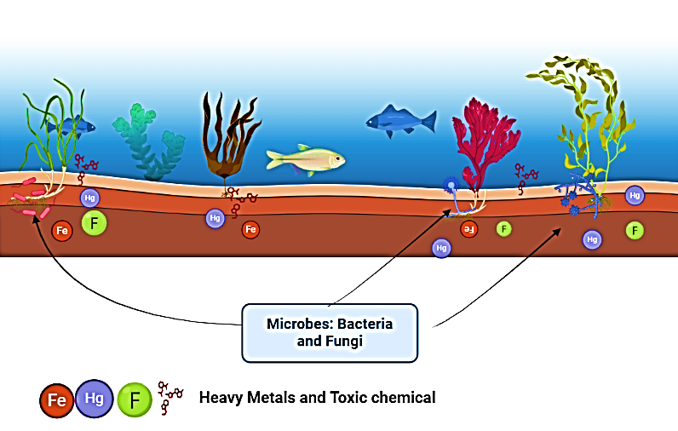
Fig. 2: Microbes are interacting with the aquatic plants and degrade the toxic chemicals and heavy metals
  - Rhizodegradation
Rhizodegradation is also known as the Phyto stimulation and plant–assisted bioremediation. Plant roots release various organic compounds such as amino acids, sugars, and other enzymes in the rhizosphere and these organic compounds provide nutrition to the microbes. Bacteria and fungus are like Pseudomonas putida, Bacillus subtilis, Rhizobium leguminosarum, Azospirillum brasilense, Sphingomonas paucimobilis effective to PAHs degradation. Fungi like Aspergillus niger, Penicillum chrysogenum, Phanerochaete cryososporium, Trichoderma harzianum, and many more microbes degrade the organic compounds, pesticides and herbicides toxicity^{[31, 32]} (Kumar et al. 2020; Ramírez et al. 2023). Ibuprofen is exposed to xenobiotics and causes abiotic stress formed by excessive production of ROI. ROI is the toxic by-products that play key roles during stress response and cell signaling. Ibuprofen can inhibit the growth of plants and algae, reduce the mobility of aquatic animals, and reduce the growth rate of fish. Typha spp. can absorb the toxic metals and elements in aquatic environments breaking down into simpler forms by enzymatic digestion and evaporating through leaves through a transpiration mechanism. There are so many aquatic plant species that are consumed and absorb the toxic compound and break into simpler forms. In 24 hours about 60 – 70% of IB got removed^{[33]} (Dordio et al. 2011) (Fig. 3). Various agrochemicals such as organophosphate, carbamate, organochlorine and many more cause environmental pollution which later mixes with water bodies resulting in aquatic toxicity. Plant-based green technologies remove the agrochemicals. Aquatic plant species like Spirodela oligorrhiza (Kurz.), L. minora L., etc can degrade and break the toxic chemicals^{[34]} (Dhir 2020) (Fig. 3 here).
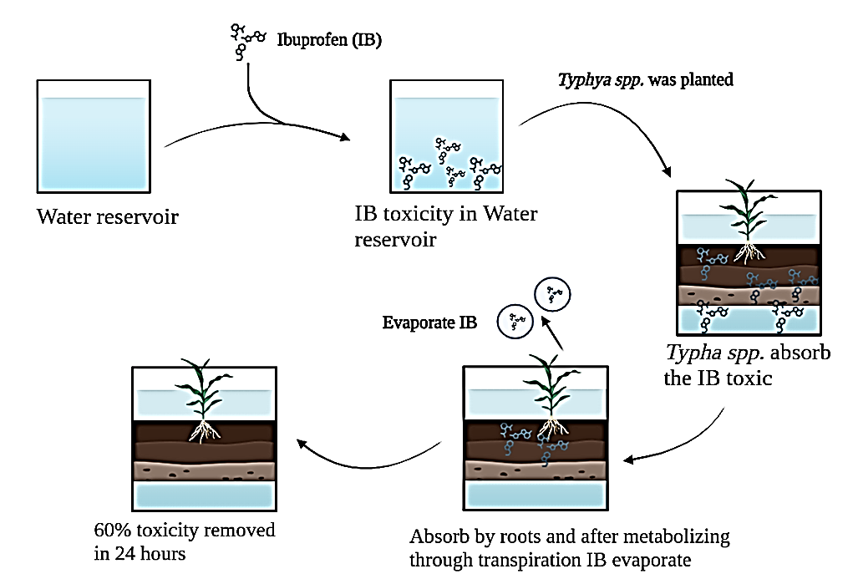
Fig. 3: Typha spp. reducing the ibuprofen toxicity
There are so many processes of Phyto remediation that can remove, absorb, volatile, degrade, and filtrate the toxic chemicals in aquatic ecosystems. The aquatic plants are used as a green technology for wastewater treatments.
- Challenges faced by green– technology-based wastewater treatment and reduction of aquatic toxicity
There are several challenges faced during the treatment of pollutants and contaminants by aquatic plant species or by green technologies. Some processes like degasification, filtration, reverse osmosis, flocculation, adsorption, absorption, sedimentation, coagulation, etc., methodologies are carried out by aquatic plants that reduce toxicity^{[35]} (Saravanan et al. 2021). Many green technologies are still in research and development may not be efficient for application for reduction in toxicity. Some most effective chemicals from pesticides and pharmaceutical products can cause severe damage to the aquatic ecosystem like organochlorine, antibiotics, PCBs, PFCs, carbamate pesticides etc., that may or may not be removed by green technologies. Where microfluidics (MFs) and advanced green technologies can reduce aquatic toxicity^{[36, 37]} (Weaver et al. 2022; Johnson 2012). Choosing the right aquatic plant species for green – technologies is also an important challenge for the treatment of toxic aquatic ecosystems. Maintain and properly take care of the plants to improve the health of the aquatic ecosystem. Managing the biomass production by aquatic plants during the wastewater is also an important challenge. Pyrolysis and torrefaction technologies modify and convert biomass into valuable products like oils, biochar, and syngas^{[38]} (Qambrani et al. 2017).
Climate change and seasonal variation affect the aquatic plant’s growth which reduces the effectiveness of plant species. Difunctional green – technologies can cause more damage to the aquatic ecosystem and affect other aquatic species^{[39]} (Ali et al. 2022). Selecting cost-effective green technologies for removing toxicity at low cost produces high biomass and purifies the water bodies in larger quantities. Implication and securing funding for green technologies projects can be challenging for green technologies for the production of valuable products^{[40]} (Fig. 4) (Wicker et al. 2021). Acceptance and social challenges also matter most for using green – technologies-based wastewater treatment. Society or governments are sometimes unable to accept these kinds of technologies because of the cost and risk of defaulting on technologies. Approval for these technologies is also a big deal involving long-term testing, sustainability testing, monitoring, enforcement, and ensuring the green – technologies are operated effectively and maintained properly^{[41]} (Söderholm 2020). Finding the loops and gaps is operated and implication green technologies. Study the long-term impacts and utilization of green technologies. Collaboration challenges with engineers, scientists, investors, policymakers and stakeholders for effective implementation of technologies^{[41]} (Söderholm 2020). There are various challenges for addressing, financial incentives, research and advancement technologies for successful of green – technology-based wastewater treatment (Fig. 4 here).
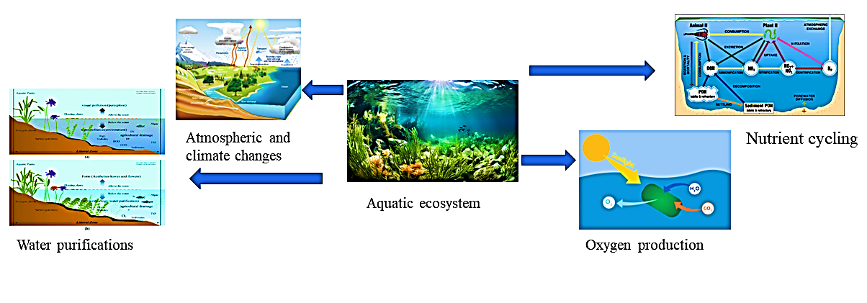TAB
Fig. 4: How aquatic ecosystems interact with climate, atmosphere, nutrient cycling, oxygen production, and water purification
- Recent research findings on reduction of aquatic toxicity and green – technologies-based wastewater treatment
Nowadays environmental pollution is an important issue that needs to be solved. There are various technologies, innovations, and research have been conducted to overcome or reduce the pollution rate. Aquatic pollution and toxicity cause several diseases in all types of organisms. So, it’s necessary to research and innovate in the field of aquatic toxicity. Macrophytes and aquatic plant species are effective to reduction in toxicity level of aquatic ecosystems. Info disruption is caused by natural contaminants and a wide range of anthropogenic. It is the disturbance in info chemicals from pharmaceutical products, pesticides, metals, industrial products, etc., biotic interact with the other organisms in the aquatic ecosystem. Duckweed, cattails, and water hyacinth can degrade and absorb the metals and all types info chemicals and detoxify the ecosystem^{[42]} (Gross 2022).
Emerging contaminants affect the aquatic environments, where microplastics are the major emerging contaminants that can also carry other pollutants. Macrophytes can interact with the microplastics and degrade them by growing biofilms or trapping them within the biomass. The interaction reduces the availability of toxicity for aquatic organisms^{[43]} (Zhang et al. 2023). Microplastic in aquatic ecosystems is a major problem all over the world, that causes serious damage to aquatic animals, plants, humans, and the whole aquatic ecosystem. Under UV, microplastics break down into simpler molecules and mix with water bodies. Plant species are like Lemna minor L., various algae, Phragmites australis (Cav.) Trin., Eichhornia crassipes Mart., Typha spp., etc. many species are absorbing the microplastic and degenerate or volatile the toxic molecules^{[44]} (Bhan et al. 2024). These plants also interact with beneficial microbes that degrade the microplastic.
China’s urban water infrastructure aims to framework Green House Gas emissions associated with wastewater treatments and water purification. These approaches can reduce emissions and sustainable wastewater treatments. Wastewater treatment prevents the emission of methane and nitric oxide^{[45]} (Zhang et al. 2021). The wastewater treatment occurs in three essential stages Primary stage (Physical – Chemical), Secondary (Biological stage), and Tertiary (Advanced physical – Chemical Stage). The motive is the discharge of wastewater from the water bodies. Membrane Bioreactors (MBRs)that perform the membrane filtration and remove the contaminants with high efficiency. The chemical energy present in wastewater can be recovered by anaerobic digestion in the form of biogas^{[46]} (Ugrina and Milojković 2024).
Recent research using advanced materials like cellulose nanomaterials and graphene oxide nanosheets for treatment and advancement of wastewater treatment. These materials and processes increase the efficiency of the filtration system and the degradation of contaminants. Graphene oxide nanosheets immobilize the laccase, which is a colour dye that affects the aquatic ecosystem. Cellulose nanomaterials are sustainable technologies for wastewater treatment^{[47]} (Kumar et al. 2022).
Conclusion
Aquatic toxicity is mainly caused due to pesticides, pharmaceutical products, industrial chemicals, and microplastics. After mixing these contaminants the water gets wasted or unable to use and affects the aquatic ecosystems. It is necessary to treat wastewater to make it useable and conserve of aquatic ecosystem. There are various mechanisms such as phytoremediation, construction of wetlands to treat the wastewater, green – technologies-based wastewater treatment, and microbial toxicity reduction technologies by using bioreactors to reduce the toxicity level. There are several processes of phytoremediation, where aquatic plant species perform the reduction of aquatic toxicity such as phytodegradation, Phyto stabilization, phytoextraction, phytovolatilization, rhizodegradation, etc., various types of processes carried out by aquatic plants to improve the health of the aquatic ecosystem. The most commonly used aquatic plants are Phragmites australis (Cav.) Trin., Eichhornia crassipes Mart., Salvinia, Lemna minora L., Pistia stratiotes L., Hydrilla verticillata (Lf) Royle, etc. This sustainable eco-friendly solution of wastewater or aquatic toxicity treatment helps to mitigate pollution and also improve the health and resilience of biodiversity and the ecosystem.

COMPETING INTERESTS DISCLAIMER:
Authors have declared that they have no known competing financial interests OR non-financial interests OR personal relationships that could have appeared to influence the work reported in this paper.
References
- Ali, Huda Hilo, Mohamed IA Fayed, and Israa Ibrahim Lazim. "Use of aquatic plants in removing pollutants and treating the wastewater: A review." J Glob Innov Agric Sci 10 (2022): 61-70. doi: 10.22194/JGIAS/10.985
- Ali, Muna, and T. R. Sreekrishnan. "Aquatic toxicity from pulp and paper mill effluents: a review." Advances in environmental research 5, no. 2 (2001): 175-196. doi: 10.1016/S1093-0191(00)00055-1
- Anderson, Julie C., Sarah C. Marteinson, and Ryan S. Prosser. "Prioritization of pesticides for assessment of risk to aquatic ecosystems in Canada and identification of knowledge gaps." Reviews of Environmental Contamination and Toxicology Volume 259 (2021): 171-231. doi: 10.1007/398_2021_81
- Arán, Daniela Silvina, Carlos Alfredo Harguinteguy, Alicia Fernandez-Cirelli, and María Luisa Pignata. "Phytoextraction of Pb, Cr, Ni, and Zn using the aquatic plant Limnobium laevigatum and its potential use in the treatment of wastewater." Environmental Science and Pollution Research 24 (2017): 18295-18308. doi: 10.1007/s11356-017-9464-9
- Banerjee, Aditya, and Aryadeep Roychoudhury. "Assessing the rhizofiltration potential of three aquatic plants exposed to fluoride and multiple heavy metal polluted water." Vegetos 35, no. 4 (2022): 1158-1164. doi: 10.1007/s42535-022-00405-3
- Batista, Adriana A., Jorge AG Santos, Marcela R. Bomfim, Flávia M. Moreira, Emylly F. Leal, and Joseane N. da Conceição. "Induced changes in the growth of four plant species due to lead toxicity." Revista Brasileira de Engenharia Agrícola e Ambiental 21, no. 5 (2017): 327-332. doi: 10.1590/1807-1929/agriambi.v21n5p327-332
- Bhan, C., N. Kumar, and V. Elangovan. "Microplastics pollution in the rivers, its source, and impact on aquatic life: a review." International Journal of Environmental Science and Technology (2024): 1-16. doi: 10.1007/s13762-024-05846-8
- Bhardwaj, S., and Deepika Gupta. "Study of acute, sub acute and chronic toxicity test." International Journal of Advanced Research in Pharmaceutical & Bio Sciences 1, no. 3 (2012): 103-130. doi: 10.1590/1807-1929/agriambi.v21n5p327-332
- Bokhari, Syeda Huma, Muhammad Mahmood-Ul-Hassan, and Munir Ahmad. "Phytoextraction of Ni, Pb and, Cd by duckweeds." International journal of phytoremediation 21, no. 8 (2019): 799-806. doi: 10.1080/15226514.2019.1566882
- Bolan, Nanthi S., Jin Hee Park, Brett Robinson, Ravi Naidu, and Keun Young Huh. "Phytostabilization: a green approach to contaminant containment." Advances in agronomy 112 (2011): 145-204. doi: 10.1016/B978-0-12-385538-1.00004-4
- Chevalier, Julie, Elodie Harscoët, Merlin Keller, Pascal Pandard, Jérôme Cachot, and Matthias Grote. "Exploration of Daphnia behavioral effect profiles induced by a broad range of toxicants with different modes of action." Environmental toxicology and chemistry 34, no. 8 (2015): 1760-1769. doi: 10.1002/etc.2979
- De Laet, Chloe, Théodora Matringe, Eddy Petit, and Claude Grison. "Eichhornia crassipes: a powerful bio-indicator for water pollution by emerging pollutants." Scientific reports 9, no. 1 (2019): 7326. doi: 10.1038/s41598-019-43769-4
- Deng, Xianbao, Dong Yang, Heng Sun, Juan Liu, Heyun Song, Yaqian Xiong, Yunmeng Wang et al. "Time-course analysis and transcriptomic identification of key response strategies of Nelumbo nucifera to complete submergence." Horticulture Research 9 (2022): uhac001. doi: 10.1093/hr/uhac001
- Dhir, Bhupinder. "Green technologies for the removal of agrochemicals by aquatic plants." In Agrochemicals detection, treatment and remediation, pp. 569-591. Butterworth-Heinemann, 2020. doi: 10.1016/B978-0-08-103017-2.00021-0
- Dordio, Ana, Raquel Ferro, Dora Teixeira, Alfredo J. Palace, Ana P. Pinto, and Cristina MB Dias. "Study on the use of Typha spp. for the phytotreatment of water contaminated with ibuprofen." International Journal of Environmental and Analytical Chemistry 91, no. 7-8 (2011): 654-667. doi: 10.1080/03067311003782708
- Ekanayake, Manavi Sulakkana, Dhanushka Udayanga, Isuru Wijesekara, and Pathmalal Manage. "Phytoremediation of synthetic textile dyes: biosorption and enzymatic degradation involved in efficient dye decolorization by Eichhornia crassipes (Mart.) Solms and Pistia stratiotes L." Environmental Science and Pollution Research 28 (2021): 20476-20486. doi: 10.1007/s11356-020-11699-8
- Galal, Tarek M., Yassin M. Al-Sodany, and Hatim M. Al-Yasi. "Phytostabilization as a phytoremediation strategy for mitigating water pollutants by the floating macrophyte Ludwigia stolonifera (Guill. & Perr.) PH Raven." International journal of phytoremediation 22, no. 4 (2020): 373-382. doi: 10.1080/15226514.2019.1663487
- Girotti, Albert W. "Mechanisms of lipid peroxidation." Journal of free radicals in biology & medicine 1, no. 2 (1985): 87-95.doi: 10.1016/0748-5514(85)90011-X
- Gross, Elisabeth M. "Aquatic chemical ecology meets ecotoxicology." Aquatic Ecology 56, no. 2 (2022): 493-511. doi: 10.1007/s10452-021-09938-2
- Guerrero Ramírez, José Roberto, Lizbeth Alejandra Ibarra Muñoz, Nagamani Balagurusamy, José Ernesto Frías Ramírez, Leticia Alfaro Hernández, and Javier Carrillo Campos. "Microbiology and biochemistry of pesticides biodegradation." International Journal of Molecular Sciences 24, no. 21 (2023): 15969. doi: 10.3390/ijms242115969
- Harguinteguy, Carlos A., Daniela S. Arán, Gustavo L. Gudiño, and Matías Peñaflor. "Capacity of Schoenoplectus californicus to remove and tolerate copper, lead, and zinc in constructed wetland systems using simulated wastewater." Journal of Environmental Engineering 149, no. 10 (2023): 04023069. doi: 10.1061/JOEEDU.EEENG-7334
- Hassanzadeh, Mahsa, Rahmat Zarkami, and Roghayeh Sadeghi. "Uptake and accumulation of heavy metals by water body and Azolla filiculoides in the Anzali wetland." Applied Water Science 11, no. 6 (2021): 91. doi: 10.1007/s13201-021-01428-y
- Johnson, P. A. "Agricultural and pharmaceutical chemicals." In Clean Technology and the Environment, pp. 199-235. Dordrecht: Springer Netherlands, 2012. doi: 10.1007/978-94-011-1312-0_7
- Lima, Herbert de P., and Yvan JO Asencios. "Eichhornia crassipes (Mart.) Solms (natural or carbonized) as biosorbent to remove pollutants in water." SN Applied Sciences 3 (2021): 1-18. doi: 10.1007/s42452-021-04736-9
- Khudhur, Shelan Mustafa, Yahya Ahmed Shekha, and Y. Ahmed Shekha. "Histopathological and biochemical biomarker response of mussel, Unio pictorum, to carbamate pesticide carbaryl: A laboratory study." Indian J Ani Res 1157 (2019): 1-5. doi: 10.18805/ijar.B-1157
- Klink, Agnieszka, Ludmiła Polechońska, Aurelia Cegłowska, and Andrzej Stankiewicz. "Typha latifolia (broadleaf cattail) as bioindicator of different types of pollution in aquatic ecosystems—application of self-organizing feature map (neural network)." Environmental Science and Pollution Research 23 (2016): 14078-14086. doi: 10.1007/s11356-016-6581-9
- Koenig, Samuel, Pilar Fernández, and Montserrat Solé. "Differences in cytochrome P450 enzyme activities between fish and crustacea: relationship with the bioaccumulation patterns of polychlorobiphenyls (PCBs)." Aquatic toxicology 108 (2012): 11-17. doi: 10.1016/j.aquatox.2011.10.016
- Kolarova, Nikola, and Paweł Napiórkowski. "Trace elements in aquatic environment. Origin, distribution, assessment and toxicity effect for the aquatic biota." Ecohydrology & Hydrobiology 21, no. 4 (2021): 655-668. doi: 10.1016/j.ecohyd.2021.02.002
- Kooijman, S. A. L. M., and Jacques JM Bedaux. "The analysis of aquatic toxicity data." (1996).
- Kristanti, Risky Ayu, and Tony Hadibarata. "Phytoremediation of contaminated water using aquatic plants, its mechanism and enhancement." Current Opinion in Environmental Science & Health 32 (2023): 100451. doi: 10.1016/j.coesh.2023.100451
- Kristanti, Risky Ayu, Wei Jie Ngu, Adhi Yuniarto, and Tony Hadibarata. "Rhizofiltration for removal of inorganic and organic pollutants in groundwater: a review." Biointerface Res. Appl. Chem 11 (2021): 12326-12347. doi: 10.33263/BRIAC114.1232612347
- Kumar, Arvind, Sruchi Devi, Himanshu Agrawal, Simranjeet Singh, and Joginder Singh. "Rhizoremediation: a unique plant microbiome association of biodegradation." Plant microbe symbiosis (2020): 203-220. doi: 10.1007/978-3-030-36248-5_11
- Kumar, M. Iniya, G. Boopathi, and S. Karthikeyan. "Advanced Green Technologies for Wastewater Treatment and Remediation." In Encyclopedia of Green Materials, pp. 1-13. Singapore: Springer Nature Singapore, 2022. doi: 10.1007/978-981-16-4921-9_49-1
- Kumar, Rahul, Mahipal Singh Sankhla, Rajeev Kumar, and Swaroop S. Sonone. "Impact of pesticide toxicity in aquatic environment." Biointerface Research in Applied Chemistry 11, no. 3 (2021): 10131-10140. doi: 10.33263/BRIAC113.1013110140
- Lajmanovich, Rafael C., Andrés M. Attademo, María F. Simoniello, Gisela L. Poletta, Celina M. Junges, Paola M. Peltzer, Paula Grenón, and Mariana C. Cabagna-Zenklusen. "Harmful effects of the dermal intake of commercial formulations containing chlorpyrifos, 2, 4-D, and glyphosate on the common toad Rhinella arenarum (Anura: Bufonidae)." Water, Air, & Soil Pollution 226 (2015): 1-12. doi: 10.1007/s11270-015-2695-9
- Lenhardt, Mirjana, Vesna Poleksić, Branka Vuković-Gačić, Božidar Rašković, Karolina Sunjog, Stoimir Kolarević, Ivan Jarić, and Zoran Gačić. "Integrated use of different fish related parameters to assess the status of water bodies." Slov Vet Res 52, no. 1 (2015): 5-13.
- Leppard, Gary G., and Mohiuddin Munawar. "The ultrastructural indicators of aquatic ecosystem health." Journal of Aquatic Ecosystem Health 1 (1992): 309-317. doi: 10.1007/BF00044172
- Li, Shiyou, Ping Wang, Zushang Su, Emily Lozano, Olivia LaMaster, Jason B. Grogan, Yuhui Weng, Thomas Decker, John Findeisen, and Monica McGarrity. "Endocide-induced abnormal growth forms of invasive Giant Salvinia (Salvinia molesta)." Scientific Reports 8, no. 1 (2018): 8006. doi: 10.1038/s41598-018-25986-5
- Li, Yan, Xi Qi, Jianpan Xin, Chu Zhao, and Runan Tian. "Physiological responses and algae inhibition of Pontederia cordata to simulated eutrophication and acid rain co-pollution." Ecological Processes 12, no. 1 (2023): 55. doi: 10.1186/s13717-023-00467-4
- Limmer, Matt, and Joel Burken. "Phytovolatilization of organic contaminants." Environmental Science & Technology 50, no. 13 (2016): 6632-6643. doi: 10.1021/acs.est.5b04113
- Lionetto, Maria Giulia, Roberto Caricato, Antonio Calisi, Maria Elena Giordano, and Trifone Schettino. "Acetylcholinesterase as a biomarker in environmental and occupational medicine: new insights and future perspectives." BioMed research international 2013, no. 1 (2013): 321213. doi: 10.1155/2013/321213
- Mânzatu, Carmen, Boldizsár Nagy, Alessio Ceccarini, Renato Iannelli, Stefania Giannarelli, and Cornelia Majdik. "Laboratory tests for the phytoextraction of heavy metals from polluted harbor sediments using aquatic plants." Marine pollution bulletin 101, no. 2 (2015): 605-611. doi: 10.1016/j.marpolbul.2015.10.045
- Nugnes, Roberta, Chiara Russo, Elena Orlo, Margherita Lavorgna, and Marina Isidori. "Imidacloprid: Comparative toxicity, DNA damage, ROS production and risk assessment for aquatic non-target organisms." Environmental Pollution 316 (2023): 120682. doi: 10.1016/j.envpol.2022.120682
- Pang, Yean Ling, Yen Ying Quek, Steven Lim, and Siew Hoong Shuit. "Review on phytoremediation potential of floating aquatic plants for heavy metals: a promising approach." Sustainability 15, no. 2 (2023): 1290. doi: 10.3390/su15021290
- Pasricha Sarin, Lakshmi, K. Sowjanya Sree, Károly Bóka, Áron Keresztes, Jörg Fuchs, Akhilesh K. Tyagi, Jitendra Paul Khurana, and Klaus-Juergen Appenroth. "Characterisation of a spontaneous mutant of Lemna gibba G3 (Lemnaceae)." Plants 12, no. 13 (2023): 2525. doi: 10.3390/plants12132525
- Qambrani, Naveed Ahmed, Md Mukhlesur Rahman, Seunggun Won, Soomin Shim, and Changsix Ra. "Biochar properties and eco-friendly applications for climate change mitigation, waste management, and wastewater treatment: A review." Renewable and Sustainable Energy Reviews 79 (2017): 255-273. doi: 10.1016/j.rser.2017.05.057
- Radić, Sandra, Draženka Stipaničev, Petra Cvjetko, Ivanka Lovrenčić Mikelić, Marija Marijanović Rajčić, Siniša Širac, Branka Pevalek-Kozlina, and Mirjana Pavlica. "Ecotoxicological assessment of industrial effluent using duckweed (Lemna minor L.) as a test organism." Ecotoxicology 19 (2010): 216-222. doi: 10.1007/s10646-009-0408-0
- Sakakibara, Masayuki, Aya Watanabe, Masahiro Inoue, Sakae Sano, and Toshikazu Kaise. "Phytoextraction and phytovolatilization of arsenic from As-contaminated soils by Pteris vittata." In Proceedings of the annual international conference on soils, sediments, water and energy, vol. 12, no. 1, p. 26. 2010.
- Saravanan, A., P. Senthil Kumar, S. Jeevanantham, S. Karishma, B. Tajsabreen, P. R. Yaashikaa, and B. Reshma. "Effective water/wastewater treatment methodologies for toxic pollutants removal: Processes and applications towards sustainable development." Chemosphere 280 (2021): 130595. doi: 10.1016/j.chemosphere.2021.130595
- Söderholm, Patrik. "The green economy transition: the challenges of technological change for sustainability." Sustainable Earth 3, no. 1 (2020): 6. doi: 10.1186/s42055-020-00029-y
- Solomon, Keith R., James A. Carr, Louis H. Du Preez, John P. Giesy, Ronald J. Kendall, Ernest E. Smith, and Glen J. Van Der Kraak. "Effects of atrazine on fish, amphibians, and aquatic reptiles: a critical review." Critical reviews in toxicology 38, no. 9 (2008): 721-772. doi: 10.1080/10408440802116496
- Sricoth, Theeta, Weeradej Meeinkuirt, Patompong Saengwilai, John Pichtel, and Puntaree Taeprayoon. "Aquatic plants for phytostabilization of cadmium and zinc in hydroponic experiments." Environmental Science and Pollution Research 25 (2018): 14964-14976. doi: 10.1007/s11356-018-1714-y
- Tresnakova, Nikola, Alzbeta Stara, and Josef Velisek. "Effects of glyphosate and its metabolite AMPA on aquatic organisms." Applied Sciences 11, no. 19 (2021): 9004. doi: 10.3390/app11199004
- Ugrina, Marin, and Jelena Milojković. "Advances in Wastewater Treatment, 2024." Energies 17, no. 6 (2024): 1400. doi: 10.3390/en17061400
- Weaver, Edward, Collette O’Hagan, and Dimitrios A. Lamprou. "The sustainability of emerging technologies for use in pharmaceutical manufacturing." Expert Opinion on Drug Delivery 19, no. 7 (2022): 861-872. doi: 10.1080/17425247.2022.2093857
- Wicker, Rebecca J., Gopalakrishnan Kumar, Eakalak Khan, and Amit Bhatnagar. "Emergent green technologies for cost-effective valorization of microalgal biomass to renewable fuel products under a biorefinery scheme." Chemical Engineering Journal 415 (2021): 128932. doi: 10.1016/j.cej.2021.128932
- Xu, S. Z., Y. X. Wang, Y. D. Wang, Y. J. Zhao, and Y. Gao. "Seasonal influence of reed (Phragmites australis) and lotus (Nelumbo nucifera) on urban wetland of Yi River." Appl Ecol Environ Res 17 (2019): 7891-7900. doi: I: 10.15666/aeer/1704_78917900
- Yadav, Brijesh K., Maarten A. Siebel, and Johan JA van Bruggen. "Rhizofiltration of a heavy metal (lead) containing wastewater using the wetland plant Carex pendula." CLEAN–Soil, Air, Water 39, no. 5 (2011): 467-474. doi: 10.1002/clen.201000385
- Zaghloul, Alaa, Mohamed Saber, Samir Gadow, and Fikry Awad. "Biological indicators for pollution detection in terrestrial and aquatic ecosystems." Bulletin of the National Research Centre 44, no. 1 (2020): 1-11. doi: 10.1186/s42269-020-00385-x
- Zazouli, Mohammad Ali, Somayeh Asghari, Roshanak Tarrahi, Seyed Yahya Salehi Lisar, Esmaeil Babanezhad, and Nafise Dashtban. "The potential of common duckweed (Lemna minor) in phytoremediation of phenanthrene and pyrene." Environmental Engineering Research 28, no. 1 (2023). doi: 10.4491/eer.2021.592
- Zhang, Heran, Nan Shen, Yafeng Li, Cheng Hu, and Peng Yuan. "Source, transport, and toxicity of emerging contaminants in aquatic environments: A review on recent studies." Environmental Science and Pollution Research 30, no. 58 (2023): 121420-121437. doi: 10.1007/s11356-023-30869-y
- Zhang, Qing, Wenqian Kong, Linfeng Wei, Yingjun Wang, Yadan Luo, Pu Wang, Jiyan Liu, Jerald L. Schnoor, and Guibin Jiang. "Uptake, phytovolatilization, and interconversion of 2, 4-dibromophenol and 2, 4-dibromoanisole in rice plants." Environment international 142 (2020): 105888. doi: 10.1016/j.envint.2020.105888
- Zhang, Qian, Kate Smith, Xu Zhao, Xinkai Jin, Shuya Wang, Junjie Shen, and Zhiyong Jason Ren. "Greenhouse gas emissions associated with urban water infrastructure: What we have learnt from China's practice." Wiley Interdisciplinary Reviews: Water 8, no. 4 (2021): e1529. doi: 10.1002/wat2.1529
- Zhong, Guidi, Zhonghua Wu, Jun Yin, and Lulu Chai. "Responses of Hydrilla verticillata (Lf) Royle and Vallisneria natans (Lour.) Hara to glyphosate exposure." Chemosphere 193 (2018): 385-393. doi: 10.1016/j.chemosphere.2017.10.173
- Ramírez, R.; Medina, R.; Fernández-González, A.J.; Garcia-Rodiguez, F.M.; Villadas, P.J.; Rosso, J.A.; Fernandez-Lopez, M.; Del Panno, M.T. Exploring the Effect of Composting Technologies on the Recovery of Hydrocarbon-Contaminated Soil Post Chemical Oxidative Treatment. Appl. Soil Ecol. 2023, 150, 130459. DOI: 10.1016/j.apsoil.2019.103459.

Table 1: Most agrochemicals that have affected the aquatic ecosystems and cause aquatic toxicity and damage the aquatic life
Sl.no | Herbicides & pesticides | Cause damages | Structures | References
1 | Glyphosate | Affects fishes’ health like haematological, biochemical change and histopathological changes | 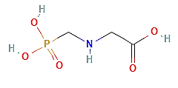 | (Tresnakova et al., 2021)
2 | DDT | Eutrophication, reduce reproductive rate and damage egg cell and fish cell | 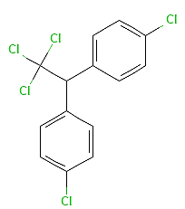 | (Anderson et al., 2021)
3 | Atrazine | Cause hypoxia, destroy endocrine system of fish, hormonal disruption of fishes and block ETC of PS II in plants. | 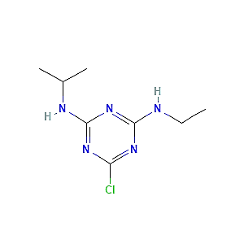 | (Solomon et al., 2008)
4 | 2,4 – D | DNA damage, induced mutation in aquatic organisms, | 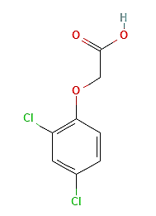 | (Lajmanovich et al., 2015)
5 | Chlorpyrifos | Oxidative DNA damage, plasma damage in toads, immunological depression, and neurotoxicity. | 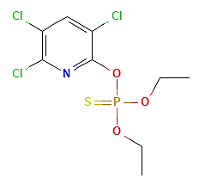 | (Lajmanovich et al., 2015)
6 | Carbaryl | Epithelial tissue and gills damage, hypoplasia, pycnotic changes in nuclei | 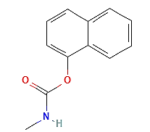 | (Khudhur et al., 2019)
7 | Imidacloprid | Algal DNA damage, genomic toxicity, ROS production | 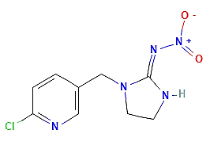 | (Nugnes et al., 2023)

Table 2 – Aquatic plants as biomarkers for aquatic toxicity
Sl. No | Aquatic plants | Family | Indicator responses | References
1 | Lemna minor L. | Araceae | Growth inhibition, peroxidase activity, lipid peroxidation level, DNA modification | (Radić et al., 2010)
2 | Nelumbo nucifera Gaertn. | Nelumbonaceae | Plant height, reduction in leaves number, changes in chlorophyll contain | (Deng et al., 2022) (Xu et al., 2019)
3 | Phragmites australis (Cav.) Trin. | Poaceae | Changes in chlorophyll contains, pH changes in reed water area, ammonia contain increase in reed area. | (Xu et al., 2019)
4 | Eichhornia crassipes Mart. | Pontederiaceae | Bioaccumulation, changes in community, excessive growth | (Laet et al., 2019)
5 | Typha latifolia L. | Typhaceae | Bioaccumulation, leaves colour change | (Klink et al., 2016)
6 | Hydrilla verticillata (L.f.) Royle | Hydrocharitaceae | Change in leaf structure, change in growth patterns, leaves colour changes | (Zhong et al., 2018)
7 | Salvinia molesta D. Mitch. | Salviniaceae | Abnormal growth, leaves are quickly fold, trichome damage | (Li et al., 2018)
8 | Lemna gibba L. | Araceae | Decreases in carotenoids, decrease in peroxidation level, higher dry weight, root enlarge | (Sarin et al., 2023)
9 | Schoenoplectus californicus (C. A. Mey) | Cyperaceae | Roots and shoot elongated more, formation of lipid membrane peroxidation | (Harguinteguy et al., 2023)
10 | Pontederia cordata L. | Pontederiaceae | Inhibition of growth, reduce the Chla content, short plant | (Li et al., 2023)
11 | Azolla filiculoides Lam. | Salviniaceae | Population got decreased, discolouration, stunted growth, changes in morphological structure. | (Hassanzadeh et al., 2021)

