**Effect of Storage on Value-Added Products Developed from Composite Flour of Acacia and Banana**

**Abstract**

The work assessed the impact of storage on value-added biscuits and *sev* prepared from composite flour made of Acacia and raw banana flour. Composite flours were employed to replace wheat flour partially in different proportions, and Type-I formulation (20% composite flour) was found to be the most acceptable based on sensory characteristics. Storage trials for 30 days evaluated lipase activity, peroxide value, and total microbial count. The findings showed that Type-I products showed much lower lipase activity (0.17–1.14 µmol/g in biscuits; 0.34–1.16 µmol/g in *sev*I) and peroxide values (1.13–2.20 meq/kg in biscuits; 1.36–3.13 meq/kg in *sev*I) than controls. Microbial growth was well within safe levels in Type-I samples (1.36 log cfu/g in biscuits; 1.23 log cfu/g in *sev*I on day 30) and much lower than in the control samples. The increased oxidative and microbial stability in the value-added foods was due to the inherent antioxidant and antimicrobial activities of Acacia and banana flours. The results justify the potential utilization of such composite flours in functional food products with enhanced shelf stability.

1. **Introduction**

Traditional foods have a distinct texture and taste, making them an important part of people's diets across countries. Snack foods make up a large portion of traditional foods. According to Webster's New Ninth Collegiate Dictionary (1985), the noun "snack" (first used in 1757) refers to a "light meal, foods eaten between regular meals, food suitable for snacking" and the verb snack means "to eat a snack." According to Kulkarni (1992), snacks made from locally accessible raw ingredients evolved as a way to break up monotony in diets. Traditional Indian cuisine consists of cereal, lentils, and vegetables (Waghray and Gulla, 2010).

*Acacia nilotica* is also known as the Babul, Kikar, or Indian gum Arabic tree. It belongs to the Leguminosae-Mimosoideae family and can be found all throughout India. It is a significant multipurpose tree, with almost every part used to treat an ailment. Because of their potential benefits for a number of chronic illnesses, the scientific community and consumers have shown a strong interest in bioactive compounds such as antioxidants (Revathi *et al.,*2017). Synthetic antioxidants are often utilised in the food processing industry to extend product shelf life while also promoting them as healthy meals. However, high doses of these synthetic antioxidants have been demonstrated to be toxic rather than beneficial to health. Some are known to cause cancer and other negative health effects. These effects can be avoided by replacing them with natural antioxidants found in Acacia nilotica. Almost all of its ingredients are used in pharmaceuticals and have been found to have numerous health benefits, including anti-inflammatory, anti-diabetic, antihypertensive, and in vitro anticancer properties (Saggu *et al.,*2015; Majumder *et al.,*2021). Overall, *Acacia nilotica* pods could be a useful functional component due to their nutritional value, processing functionality, and potential health advantages. However, acacia pods are bitter, rendering them unsuitable for value addition. To boost Acacia nilotica's market potential in the food industry, it is necessary to find a suitable vehicle that can provide a food matrix to mask the bitterness of acacia while also possessing product development attributes.

Mature banana pulp is abundant in iron, potassium, and vitamin A, but low in protein and fat (Adeniji *et al.,* 2006). Ripe banana flour is perfect for food preparations that require great solubility, sweetness, and energy density. content. Zhang *et al.* (2005) and Mohapatra *et al.* (2010) investigated and described the physical properties of fresh bananas and their components, including banana starch. They are wealthy. They are rich in vitamin B6, fibre, vitamin C, magnesium, and potassium. Bananas are high in vitamins and minerals, with each large serving providing 123 I.U. of vitamin A. According to Vasudha and Misra (2013), bananas are a healthful fruit that can improve the taste of food.

Value-addition involves transforming a raw commodity into a high-quality finished product. Value-added refers to enhancing a commodity with time, place, and shape to cater to consumer preferences. Value-added means anticipating consumer needs, delivering them on time and in the right place (Parimita and Puneet, 2015). Value addition in food items leads to greater quality, safer, and more nutrient-dense goods that meet various requirements (Pant and Chinwan, 2014).

**2 Materials and Methods**

**2.1 Development of value-added food products**

Value-added food products were developed using composite flour formulations to enhance the nutritional profile, functionality, and market potential of the final products, such as biscuits and sev.

**2.1.1 Biscuit**

Value-added biscuits were made by replacing wheat flour partially with composite flour in various ratios. The control sample was 100 g of wheat flour, and the treatment formulas replaced 20 g (T-I), 30 g (T-II), and 40 g (T-III) of wheat flour with composite flour. All the preparations consisted of 40 g ghee, 60 g sugar, 40 mL milk, one teaspoon ammonium bicarbonate, and an amount of sodium bicarbonate equal to a pinch. Flours were first sieved for removing impurities. Ghee and sugar were creamed together, and then baking powder, sodium bicarbonate, ammonium bicarbonate, and respective flour mixtures were added. The batter was mixed well and milk was gradually added to create a soft dough. The dough was rolled into sheets of about ½ inch thickness and biscuit shapes were cut out. The biscuits were baked in the oven at 160°C until they turned light brown.

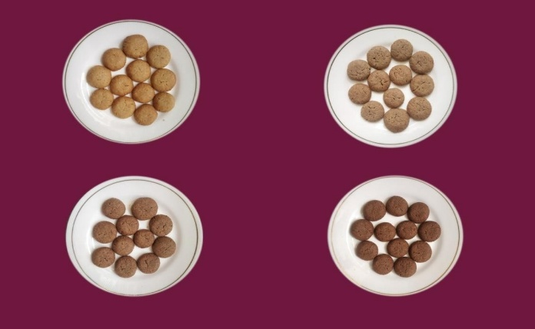

**Control**

**T-I**

**T-II**

**T-III**

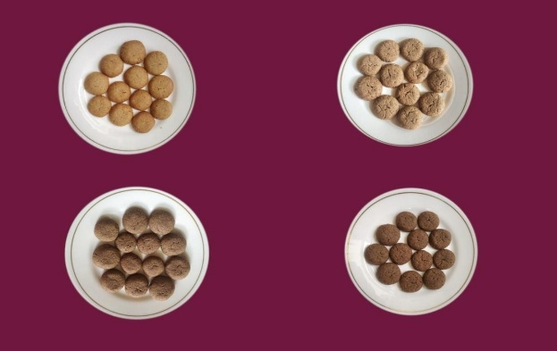**Plate 1: 30:70 Composite flour supplemented biscuits**

**Control**

**T-I**

**T-II**

**T-III**

**Plate 2: 50:50 Composite flour supplemented biscuits**

***2.1.2 Sev***

In order to assess the usability of composite flour in snack food, *sevI*-type extruded biscuits were made with the following wheat flour-composite flour replacement ratios:

**Process:** A typical recipe consisted of wheat flour (or its mixture), Bengal gram flour, salt, spices (ajwain, turmeric, chili powder), and water. The mixture was kneaded to a semi-soft state to make the dough. The dough was processed through a *sevI* press having a fine-holed plate, and extrudates were fried in refined vegetable oil at 170–180°C until golden brown. The fried foods were brought to room temperature and stored in food-grade polyethylene pouches for subsequent analysis.

Control: Wheat flour (100%)

Type-I: Composite flour: Wheat flour (20:80)

Type-II: Composite flour: Wheat flour (30:70)

Type-III: Composite flour: Wheat flour (40:60)

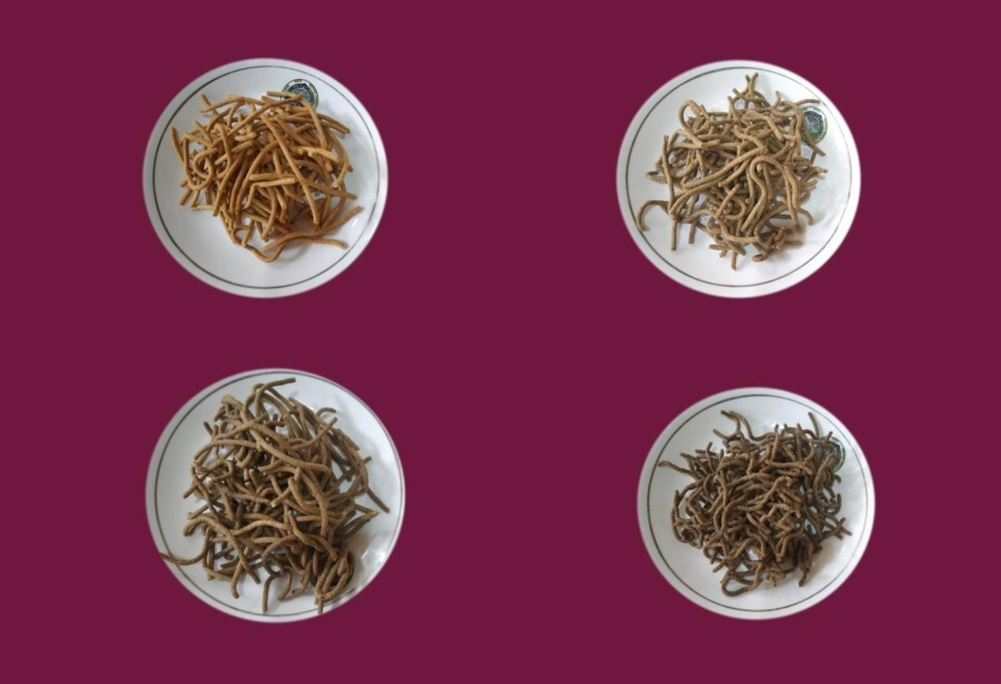

**Control**

**T-I**

**T-II**

**T-III**

**Plate 3: 30:70 Composite flour supplemented *sev***

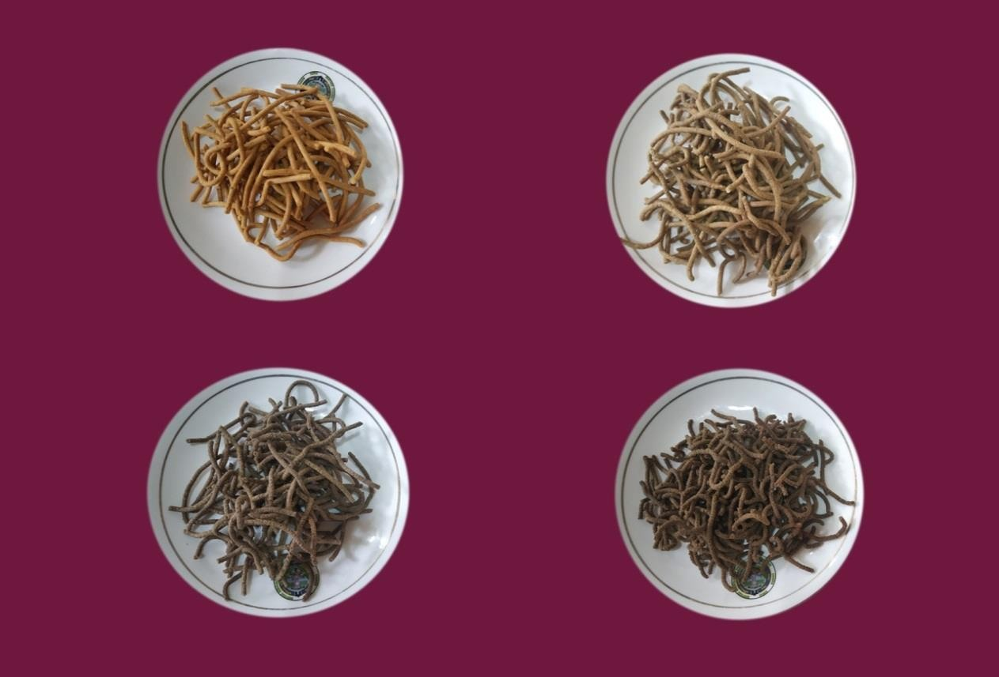

**Control**

**T-I**

**T-II**

**T-III**

**Plate 4: 50:50 Composite flour supplemented *sev***

**2.2 Lipase Activity**

Lipase activity was determined based on the titration of free fatty acids released from triacylglycerols, following the method of Verduin *et al*. (1973).

**2.2.1 Substrate Preparation:**

A 50 mM phosphate buffer (Na₂HPO₄/NaH₂PO₄, pH 7.0) was prepared. The substrate emulsion was made by homogenizing 40 g of sample with 60 mL of 5% gum Arabic solution. A total of 50 mL of this emulsion was mixed with 45 mL of the buffer solution.

**2.2.2 Enzymatic Activity Assay:**

To 9.5 mL of the prepared substrate, 0.5 mL of crude enzyme extract was added. The mixture was incubated at 28°C for 1 hour in a shaker. Free fatty acids released were titrated with 50 mM NaOH until the pH reached 9. One unit of lipase activity was defined as the amount of enzyme that releases 11 μmol of fatty acids per hour at 28°C.

**2.2.3 Total Microbial Count**

Total microbial burden was approximated on Plate Count Agar (PCA) medium made up of (g/L): peptone 5.0, yeast extract 2.5, dextrose 1.0, and agar 20.0 in 1000 mL distilled water. The medium was autoclaved at 121.6°C (15 psi) for 15 minutes, and glassware was sterilized using a hot air oven at 160°C for 2 hours (Clark, 1965).

For the purpose of analysis, 1 g of sample was homogenized in 9 mL of sterile distilled water to give a 10⁻¹ dilution. The serial dilutions (10⁻² and 10⁻³) were made likewise. From each of the dilutions (10⁻¹, 10⁻², 10⁻³), 1 mL was plated onto sterile Petri plates with PCA medium. The plates were incubated at 30 ± 2°C for 24–48 hours. Colony-forming units (cfu/g) were determined by the formula:

CFU/g = Number of colonies × dilution factor × 10

**2.3 Peroxide value**

Peroxide value of stored samples (0, 15, and 30 days) was measured in accordance with AOAC (2000). A 5 g sample was shaken with 30 mL acetic acid–chloroform (3:2, v/v) in a conical flask and swirled until dissolved. Then, 0.5 mL saturated potassium iodide was added and reaction mixture was left to react for 1 minute with shaking at intervals. Next, 30 mL distilled water was added, and the solution was titrated with 0.01 N sodium thiosulphate until the color faded. Following the addition of 0.05 mL starch solution as indicator, titration was continued until the blue color disappeared. A blank was run in a similar manner. The peroxide value was calculated in milliequivalents of peroxide per kilogram of sample (meq/kg).

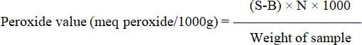

Where,

B = Volume (ml) of Na2S2O3 used for titration of blank S = Volume (ml) of Na2S2O3 used for titration of sample N = Normality of Na2S2O3 solution

**2.4 Statistical analysis**

The data were statistically analysed using standard procedures (Sheoran and Pannu 1999). The data was analysed using ANOVA and the 't' test, and the level of significance was set at (p≤0.05).

1. **Results**
   1. **Lipase Activity Trends**

The lipase activity trends were analyzed to evaluate the enzymatic potential related to lipid hydrolysis in the composite flour samples, providing insights into their stability, shelf life, and possible metabolic effects.

**3.1.1 Biscuit**

The lipase activity of control biscuits varied from 1.57 to 5.33µmol/g during 0 to 30 days of storage. In type-I biscuit the lipase activity from 0 to 30th day of storage ranged from 0.17 to 1.14 µmol/g. Type-I biscuit had minimum content of lipase activity as compared to control (Table 1).

***3.1.2 Sev***

Control *sev* lipase activity ranged from 1.37 to 4.67µmol/g during storage (0-30 days). Lipase activity in type-I biscuits ranged between 0.34 and 1.16 µmol/g from the first to 30th day of storage. Type-I *sev* had the lowest level of lipase activity when compared to the control (Table 1).

**Table 1: Lipase activity (µmol/g) of value-added product during storage**

|  |  |  |  |  |  |
| --- | --- | --- | --- | --- | --- |
| **Storage Period (day)** | **0** | **7** | **15** | **30** | **CD(p**≤**0.05)** |
| **Biscuit** | | | | | |
| Control W.F (100%) | Nil | 1.57±0.07 | 3.27±0.08 | 5.33±0.12 | 0.39 |
| T-I | Nil | 0.17±0.04 | 0.53±0.20 | 1.14±0.01 | 0.45 |
| *Sev*I | | | | | |
| Control BGF (100%) | Nil | 1.37±0.12 | 3.22±0.04 | 4.67±0.07 | 0.23 |
| T-I | Nil | 0.34±0.16 | 0.84±0.05 | 1.16±0.024 | 0.45 |

* 1. **Peroxide value**

Peroxide value was measured to assess the extent of lipid oxidation in the samples, indicating the freshness and oxidative stability of the composite flour during storage.

**3.2.1 Biscuit**

Peroxide value content of control biscuits increased significantly (p≤0.05) during storage. Peroxide value of control ranged from 1.80 to 3.40 meq peroxide/1000g. In type-I biscuit peroxide value from 0 to 30th day of storage ranged from 1.13 to 2.20 meq peroxide/1000g. Type-I biscuit had minimum content of peroxide value as compared to control (Table 2)

***3.2.2 Sev***

Peroxide value of control *sev* ranged from 2.23 to 5.76 meq peroxide/1000g, respectively. Type-I *sev* showed significantly **(**p≤0.05) lower peroxide value 1.36 to 3.13 meq peroxide/1000g, throughout storage period as compared to control *sev* (Table 2).

**Table 2: effect of storage period on peroxide value (meg peroxide/1000g) of stored value-added products**

|  |  |  |  |  |  |
| --- | --- | --- | --- | --- | --- |
| **Storage Period (day)** | **0** | **7** | **15** | **30** | **CD(p**≤**0.05)** |
| **Biscuit** | | | | | |
| Control W.F (100%) | Nil | 1.80±0.05 | 2.63±0.08 | 3.40±0.32 | 0.75 |
| T-I | Nil | 1.13±0.03 | 1.72±0.05 | 2.20±0.05 | 0.22 |
| *Sev*I | | | | | |
| Control BGF (100%) | Nil | 2.23±0.08 | 3.93±0.08 | 5.76±0.06 | 0.35 |
| T-I | Nil | 1.36±0.12 | 2.13±0.14 | 3.13±0.26 | 0.60 |

* 1. **Total microbial count**

The total microbial count of the composite flour samples was assessed to determine the level of microbial contamination and to evaluate the microbiological safety and shelf life of the developed products. Results indicated the effectiveness of processing and storage conditions in controlling microbial growth.

**3.3.1 Biscuit**

The total microbial count of control biscuits increased significantly (p≤0.05) during storage. Total microbial count of control biscuits varied from 3.20 to 5.86 log cfu/g during 0 to 30 days of storage. In type-I biscuit the total microbial count from 0 to 30th day of storage ranged from nil to 1.36 log cfu/g. Type-I biscuit had minimum content of microbial count as compared to control (Table 3).

***3.3.2Sev***

The total microbial count of control *sev*I varied from 3.13 to 5.70 log cfu/g during 0 to 30 days of storage. Total microbial count of type-I *sev*I ranged from nil to 1.23 log cfu/g, respectively. The total microbial count from 0 to 30th day of storage in Type-I *sev*I had minimum as compared to control (Table 3).

**Table 3. Microbial analysis (log cfu/g) of developed value-added products during storage**

|  |  |  |  |  |  |
| --- | --- | --- | --- | --- | --- |
| **Storage Period (day)** | **0** | **7** | **15** | **30** | **CD(p**≤**0.05)** |
| **Biscuit** | | | | | |
| Control W.F (100%) | Nil | 3.20±0.00 | 3.56±0.03 | 5.86±0.57 | 1.34 |
| T-I | Nil | Nil | 0.50±0.20 | 1.36±0.33 | 0.81 |
| *Sev*I | | | | | |
| Control BGF (100%) | Nil | 3.13±0.03 | 3.63±0.14 | 5.70±0.11 | 0.51 |
| T-I | Nil | Nil | 0.66±0.12 | 1.23±0.08 | 0.76 |

**4 Discussion**

The most acceptable products (Type-I biscuits and *sev*I) were used for shelf-life parameter evaluation with a storage period of 0 to 30 days.

**4.1 Lipase Activity**

Lipase activity for Type-I biscuits varied between 0.17 to 1.14 µmol/g, and for Type-I *sev*I, it varied between 0.34 to 1.16 µmol/g during the storage period. The rise in lipase activity with time suggests the hydrolytic breakdown of lipids, which is a normal process during storage. Both Type-I biscuits and *sev*I, however, showed considerably lower lipase activity than the control samples. This diminished activity can be linked to the occurrence of bioactive compounds in Acacia flour that are found to inactivate lipolytic enzymes.

**4.2 Peroxide Value**

The peroxide value, a measure of the primary lipid oxidation, rose considerably (p ≤ 0.05) in all products under storage. The peroxide value varied from 1.13 to 2.20 meq peroxide/1000 g in Type-I biscuits and from 1.36 to 3.13 meq peroxide/1000 g in Type-I *sev*I from day 0 to day 30 of storage. Interestingly, the two products both contained much lower peroxide values than their respective controls, indicating increased oxidative stability. This is a result of the secondary metabolites present in Acacia flour, which are antioxidants and antibacterials.

Upadhyay *et al*. (2017) have also indicated that cookies made from herbal powders of plant-based materials and low in cost could serve as immune-stimulating functional foods. The antimicrobial property of Acacia nilotica was evidenced by Oladosu *et al*. (2013), who proved its efficacy against pathogenic microorganisms. Hafez (2012) has also noted that cakes fortified with sweet marjoram contained lower peroxide values upon storage than control, affirming the enhancing effect of natural antioxidants on product shelf life.

**4.3 Total Microbial Count**

The overall microbial population of biscuits and *sev* enhanced considerably (p ≤ 0.05) within the storage duration. Yet, microbial growth in Type-I biscuits and *sev* was still below the control level throughout 30 days. The microbial load was still below the safe consumption level for cookies of less than 1×10⁴ cfu/g, as suggested by Banusha and Vasantharuba (2014). This proves that the products were microbiologically safe for use even after storage for one month.

Similar results were obtained by Komal and Kaur (2019), who proved that the addition of banana blossom powder at 20% considerably enhanced the shelf life of bakery foods. This endorses the efficiency of adding functional plant food ingredients in order to promote microbial stability and increase the storage life of foods.

**5 Conclusion.**

The use of composite flour from Acacia and raw banana in biscuits and *sev*I had a significant effect on the storage stability. Type-I products (substitution with 20% composite flour) had the best results with respect to lipase activity, peroxide value, and microbial count during 30 days of storage. These products had reduced lipid hydrolysis and oxidation and improved microbial stability than respective controls. This enhancement is due to the presence of bioactive components with antioxidant and antimicrobial activities in the composite flour. The research hence lays down that Acacia and banana composite flours can be efficiently used in the development of functional snacks with extended shelf life, providing both nutritional and preservative benefits. These results have significant implications for the food processing industry in manufacturing healthier, longer-life value-added foods.

**6 References**

Adeniji, T. A., Sanni, L. O., Barimalaa, I. S., & Hart, A. D. (2006). Determination of micronutrients and colour variability among new plantain and banana hybrids flours. *World Journal. Chemistry*, *1*(1), 23-27.

AOAC. (2000) Official Methods of Analysis. 16th Ed. Association of Official Analytical chemists. Arlyngton, Virginia, USA.

Banusha, S. and Vasantharuba, S. (2014). Preparation of Wheat-Malted Flour Blend Biscuit and Evaluation of its Quality Characteristics. *American Eurasian Journal of Agricultural and Environmental Science*, 14(5): 459-463.

Clark, F. E. (1965). Agar‐plate method for total microbial count. *Methods of Soil Analysis: Part 2 Chemical and Microbiological Properties*, *9*, 1460-1466.

Hafez, A. A. (2012). Physico-chemical and sensory properties of cakes supplemented with different concentration of marjoram. *Australian Journal of Basic and Applied Sciences.* 6 (13): 463-470

Komal and Kaur P. (2019). Development of Value-Added Product and Evaluation of Banana Blossom Incorporated Nut Chocolate. *International Journal of Trend in Scientific Research and Development*, **3**(5): 1930-1931.

Kulkarni, A. P. (1992). Food quality control and processing. Eating on the run. *Food Laboratory News*, *8*(2), 10-13.

Majumder, D., Nath, P., Debnath, R., & Maiti, D. (2021). Understanding the complicated relationship between antioxidants and carcinogenesis. *Journal of Biochemical and Molecular Toxicology*, *35*(2), e22643.

Mohapatra, D., Mishra, S., & Sutar, N. (2010). Banana and its by-product utilisation: an overview.

Oladosu, P., Isu, N. R., Ibrahim, K., Okolo, P., & Oladepo, D. K. (2013). Time kill-kinetics antibacterial study of *Acacia* nilotica. *African Journal of Microbiology Res*, ***7***(46), 5248-5252.

Pant, S., & Chinwan, D. (2014). Value addition of food products. *Int. J. Eng. Sci. Res*, *4*(12), 946-949.

Parimita, E., & Puneet, E. (2015). Development of fruit bar by using apple and banana pulp supplemented with omega-3 fatty acid. *International Journal of Engineering Studies and Technical Approach*, *1*(2), 27-35.

Revathi, S., Govindarajan, R. K., Rameshkumar, N., Hakkim, F. L., Mohammed, A. B., Krishnan, M., & Kayalvizhi, N. (2017). Anti-cancer, anti-microbial and anti-oxidant properties of Acacia nilotica and their chemical profiling. *Biocatalysis and Agricultural Biotechnology*, *11*, 322-329.

Saggu, S., & Sundaravalli., A. (2016). Development and Evaluation of Value-Added Iron Rich Spirulina Millet Mix Flour. *International Journal of Science and Research,* 2319-7064.

Sheoran, O.P. & Pannu, R.S. (1999) Statistical Package for agricultural workers. “O.P. Stat” College of Agriculture, Kaul, CCS Haryana Agricultural University, Hisar. India.

Upadhyay, S., Khan, S., Tiwari, R., Kumar, S., Kohli, D. and Rautela, I. (2017). Nutritional and Sensory Evaluation of Herbal Cookies. *International Journal of Food Science and Nutrition*, **2**(6): 156-160.

Vasudha, S., & Mishra, H. N. (2013). Non dairy probiotic beverages. *International Food Research Journal*, *20*(1).

Verduin, P. A., Punt, J. M. H. M., & Kreutzer, H. H. (1973). Studies on the determination of lipase activity. *Clinica Chimica Acta*, *46*(1), 11-19.

Waghray, K., & Gulla, S. (2010). Butylated hydroxyanisole (BHA) to maximize the oxidative stability of snacks: A case study with *sevI* and boondi. *Journal of Human Ecology*, *32*(2), 97-99.

Zhang, P., Whistler, R. L., BeMiller, J. N., & Hamaker, B. R. (2005). Banana starch: production, physicochemical properties, and digestibility—a review. Carbohydrate polymers, 59(4), 443- 458.