Review Article
Clove (Syzygium aromaticum): A Champion Spice with Multiple Industrial Applications
Abstract
Clove (Syzygium aromaticum), an aromatic spice known for its therapeutic and culinary value, has emerged as a significant subject of scientific inquiry due to its broad range of bioactive compounds and diverse industrial applications. This review provides a comprehensive overview of the chemical composition of clove essential oil (CEO), its biological activities, and its utilization across multiple industries. The chemical profile of CEO is dominated by eugenol, along with other important constituents such as Eugenol, β-caryophyllene, eugenyl acetate, and α-humulene, which collectively contribute to its pharmacological efficacy. Clove exhibits a variety of biological activities, including strong antioxidant potential, which helps in combating oxidative stress; notable antimicrobial effects against bacteria, fungi, and viruses; anti-inflammatory activity through inhibition of pro-inflammatory mediators; cytotoxic effects with promising anticancer properties; and anti-hypertensive action, likely mediated through vascular relaxation and calcium channel modulation. In addition to its therapeutic value, clove finds widespread application in the food, pharmaceutical, cosmetic, agricultural, and tobacco industries due to its preservative, flavouring, medicinal, and aromatic properties.
This review reveals that Clove, and its essential oil serve as natural, and multifunctional resource with significant potential for further development in both therapeutic and industrial sectors.
Keywords: Syzygium aromaticum, clove, eugenol, industrial applications, essential oils, antimicrobial, pharmaceutical, cosmetics, food industry etc.
Introduction
Clove (Syzygium aromaticum), a valued spice from the Myrtaceae family, has long been utilized both as a natural preservative and in traditional medicine due to its notable antioxidant and antimicrobial effects. The genus Syzygium represents the largest group within the Myrtaceae family, consisting of approximately 1,200 to 1,800 species of flowering plants. These species are predominantly found across tropical and subtropical regions, including parts of Asia, Africa, Madagascar, and various Pacific and Oceanic islands (Cock & Cheesman 2018). The clove plant, an evergreen tree that can reach a height from ten to twenty meters (Bhowmik et al., 2012). The clove tree yields three distinct types of essential oils: clove stem oil (extracted from flower stalks), clove leaf oil (derived from the leaves), and clove bud oil (obtained from the flower buds), with clove bud oil being the most utilized. Essential oils derived from aromatic plants like clove are abundant in diverse natural compounds. These bioactive constituents are widely applied across the pharmaceutical, cosmetic, health, and food industries due to their beneficial biological activities (Majidiyan et al., 2022).
Clove essential oil (CEO) has long been valued for its therapeutic properties, particularly in promoting wound and burn healing, as well as alleviating dental infections and toothaches (Batiha et al., 2020). Clove essential oil has also been widely recognized for its diverse bioactive properties, with research supporting its antiviral, antibacterial, antifungal, and strong antioxidant capabilities, among others (Refaey et al., 2023; Roy et al., 2022; Kaur et al., 2019). The therapeutic potential of clove essential oil (CEO) in managing various health conditions is largely linked to its rich chemical composition. Eugenol, which typically constitutes over 50% of the oil, is recognized as the primary active component. Other notable constituents include β-caryophyllene (ranging from 5-15%), along with smaller quantities of α-caryophyllene (also known as α-humulene) and acetyl eugenol (Liñán-Atero et al., 2024; Alanazi et al., 2022).
A variety of treatment approaches-such as mastectomy, chemotherapy, radiotherapy, conventional allopathic medicine, and Ayurvedic therapies-are continually being investigated for managing breast cancer. However, many of these methods are associated with significant side effects that can severely impact patients' quality of life. This has sparked a growing interest in identifying alternative therapies that are both effective and cause minimal adverse effects. Drawing inspiration from ancient medical practices where herbal remedies were commonly used, modern researchers are increasingly exploring plant-based treatments. Many plants are rich in essential oils, flavonoids, and aromatic compounds, which have demonstrated potential in combating diseases like breast cancer. Natural sources such as ginger, garlic, clove, green tea, cabbage, broccoli, and others have shown promising antiproliferative and anti-carcinogenic activities in various studies (Rani & Jena 2021).
Chemical constituents of Clove Essential Oil (CEO)
Clove essential oil (CEO), derived from Syzygium aromaticum, has been widely utilized in traditional medicine and the food industry, largely due to its rich composition of bioactive compounds. Various extraction techniques have been applied to obtain CEO, each influencing the final chemical profile of the oil (Ramadan 2022). The chemical constituents identified in CEO extracted through supercritical fluid extraction (SFE), hydro distillation (HD), and steam distillation (SD). In all cases, the oils were obtained from clove flower buds and analysed via gas chromatography-mass spectrometry (GC-MS). Across these methods, a total of 13 compounds were detected, with SFE yielding the greatest compound diversity. Eugenol consistently emerged as the dominant component, comprising 55.28% of the SFE extract, followed by (E)-β-caryophyllene (20.97%) and α-humulene (7.08%). Similarly, eugenol was found to be the primary constituent in oils extracted via HD and SD, with concentrations ranging between 82.16% and 97.80%, consistent with findings from another research. For instance, Kennouche et al., (2015) reported that eugenol was the principal compound in CEO extracted via HD, microwave-assisted extraction (MAE), and microwave steam distillation (MSD), with levels reaching up to 71.84%. Supporting this, a study by de Oliveira et al., (2016) on CEO obtained through SFE found the following major components: eugenol (66.9%), β-caryophyllene (24.8%), α-humulene (3.1%), and eugenol acetate (2.7%).
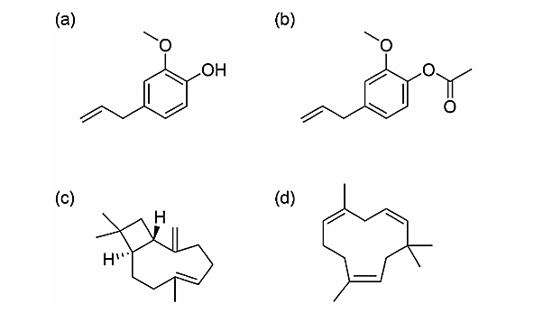
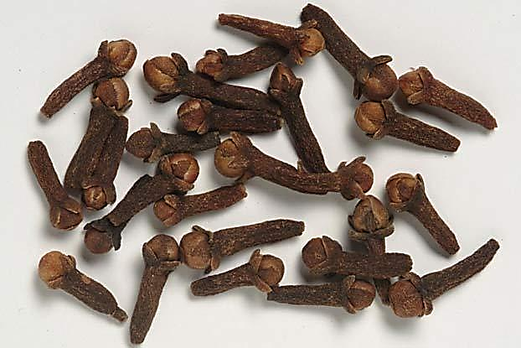
Eugenol
Eugenol acetate
(E)-β-caryophyllene
α-humulene
Clove spice buds

Fig. 1: Main Chemical compounds of clove essential oil (CEO)

Biological activities
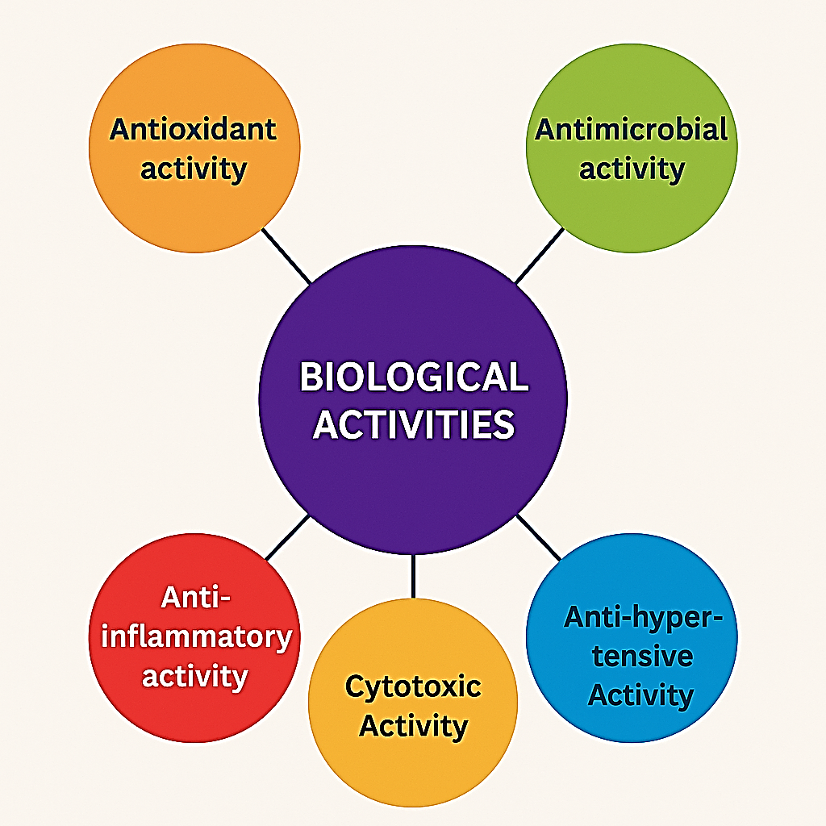
Clove has long been recognized as a valuable medicinal plant, with its therapeutic properties rooted in centuries of traditional use and supported by numerous scientific investigations. The following sections provide an overview of the key biological activities associated with clove and its primary active compound, eugenol, as documented in various research studies.

Fig.2: Biological Activities of Clove Essential oil (CEO)
Antioxidant activity
Clove buds, known for their aromatic properties, offer significant health benefits due to their strong antioxidant activity. This antioxidant nature helps in reducing oxidative stress within the body by limiting oxidation reactions and thereby decreasing the formation of harmful free radicals (Gülçin et al., 2012). During normal metabolic processes, a portion of the oxygen consumed by cells is converted into reactive oxygen species (ROS), such as hydrogen peroxide and hydroxyl radicals. These reactive compounds can damage cellular structures and contribute to various health disorders. While the body synthesizes some antioxidants naturally, others are obtained through dietary sources. Notably, clove contains key aromatic compounds like eugenol and eugenyl acetate, both of which have been identified as major contributors to its antioxidant capacity (Kasai et al., 2015). In a study conducted by Shan et al., (2005) phenolic compounds in 26 different spices were identified and measured using high-performance liquid chromatography (HPLC), followed by evaluation of their antioxidant capacity through the ABTS assay. The findings demonstrated a strong positive relationship between the total polyphenol content and antioxidant activity of the spices. Among the samples analysed, clove buds exhibited the highest levels of both antioxidant activity and polyphenol concentration, with values recorded at approximately 168.66 mmol Trolox equivalents per 100 grams of dry weight and 14.38 grams of gallic acid equivalents per 100 grams of dry weight, respectively.
Antimicrobial activity
The antimicrobial potential of clove has been demonstrated against a variety of bacterial and fungal species. In a study by Sofia et al., (2007)., the antimicrobial effects of several Indian spices-including mint, cinnamon, mustard, ginger, garlic, and clove—were evaluated, highlighting clove's notable effectiveness. Clove essential oil (CEO) is widely recognized for its strong antimicrobial activity against numerous pathogenic bacteria. This antibacterial effectiveness is largely attributed to its high concentration of eugenol. Acting as a bactericidal compound, CEO has shown the ability to inhibit common foodborne pathogens, including Staphylococcus aureus, Escherichia coli, Listeria monocytogenes, and Salmonella Typhimurium (Halder et al., 2012; Radünz et al., 2019). Bai et al., (2023) investigated the antibacterial activity and mechanism of action of clove essential oil (CEO) against common foodborne pathogens. The study revealed that CEO was effective against both Gram-positive bacteria, such as Staphylococcus aureus, and Gram-negative strains, including Escherichia coli. This antibacterial action is primarily linked to the lipophilic nature of CEO, which allows it to integrate with the lipid components of bacterial cell membranes, thereby disrupting membrane integrity and increasing permeability.
Anti-inflammatory activity
Inflammation is a vital biological response to injury or harmful environmental stimuli, but when persistent, it contributes significantly to the onset and progression of chronic diseases such as rheumatoid arthritis, diabetes, and cancer (Zhong & Shi 2019). Clove, being a natural source of bioactive phytochemicals and generally considered safe, has been extensively studied for its anti-inflammatory potential. Research has shown that clove and its primary constituents can effectively reduce inflammation and swelling at various sites in the body. Eugenol, the main active compound in clove, plays a crucial role by modulating immune responses and influencing key signalling pathways involved in the inflammatory process (Widowati et al., 2015). Clove essential oil (CEO) is renowned for its analgesic and anti-inflammatory properties. Traditionally, it has been utilized in aromatherapy to alleviate ailments such as headaches, joint discomfort, toothaches, and for its antiseptic qualities in oral care (Banerjee et al., 2020).

Cytotoxic Activity
The human body comprises a vast array of cells at various stages of development, continually undergoing division and proliferation to meet the metabolic demands of the organism (de Oliveira Prata da Silva et al., 2022). The human body employs tightly regulated mechanisms to control cellular growth and induce programmed cell death when necessary. However, when these regulatory processes are disrupted, cells may exhibit abnormal behaviours, such as uncontrolled proliferation, which can contribute to tumour formation (Kulesz-Martin et al., 2018). Clove buds (Syzygium aromaticum) have been utilized in traditional Ayurvedic medicine for their potential therapeutic properties, including their use in managing cancer. While conventional treatments such as chemotherapy, radiation therapy, bone marrow transplants, and surgery are commonly employed, they often come with significant side effects that can impact patients' quality of life. These adverse effects underscore the need for alternative approaches to cancer treatment. Consequently, there is a growing interest in exploring natural resources, like clove buds, that may offer effective anticancer properties with minimal side effects and resistance (Reddy et al., 2003).
Anti-hypertensive Activity
Historically, both aromatherapy and clove essential oil (CEO) have been used to manage ailments such as headaches, joint discomfort, dental pain, and oral hygiene issues. Clove oil and its active compound, eugenol, are known for their safety, affordability, and effectiveness as pain relievers. Numerous studies have highlighted the analgesic effects of eugenol across different pain models (Haro-González et al., 2021). Khalilzadeh et al., (2016) reported that the pain-relieving effects of clove essential oil (CEO) are linked to the involvement of both the opioidergic and cholinergic systems. Its effectiveness in relieving acute corneal pain appears to rely heavily on cholinergic mechanisms. Eugenol, a key component of CEO, demonstrates both analgesic and local anaesthetic properties, which may stem from its capacity to block voltage-gated sodium (Na⁺) and calcium (Ca²⁺) channels, as well as activate transient receptor potential vanilloid 1 (TRPV1) receptor. Interestingly, the pain-relief action of CEO and eugenol shares similarities with that of lidocaine.
Industrial Applications of Clove spice
Clove spice (Syzygium aromaticum) has found extensive application across various industries owing to its rich phytochemical profile, particularly its high eugenol content. In the food industry, clove is widely used as a flavouring agent in baked goods, sauces, confectioneries, and beverages, imparting a distinct aromatic taste (Ahmed et al., 2021; Li et al., 2020). Moreover, due to its strong antimicrobial and antioxidant properties, clove functions as a natural preservative, contributing to the shelf-life extension of various food products. In the pharmaceutical sector, both clove and its essential oil have been incorporated into numerous formulations for their analgesic, antiseptic, and anti-inflammatory effects (Kang & Song, 2019). Eugenol is frequently used in dental preparations for pain relief and as a local antiseptic in the treatment of oral infections. Clove is also a common ingredient in syrups, lozenges, and topical ointments targeting respiratory and dermatological conditions. The cosmetic and personal care industry utilizes clove oil for its fragrance in perfumes, soaps, and lotions, as well as for its antibacterial and soothing effects in oral care products such as toothpastes and mouthwashes. Additionally, in the agricultural sector, clove oil is employed as a natural pesticide and insect repellent, offering an environmentally friendly alternative to synthetic agrochemicals. Aromatherapy practices also leverage the therapeutic properties of clove essential oil for stress relief, muscle relaxation, and mild pain management. Furthermore, in the tobacco industry, clove is used to enhance the flavour profile of certain products, most notably in the production of clove cigarettes (kreteks). These diverse industrial applications highlight the economic and functional significance of clove spice beyond its traditional culinary use. The table 1 depicted the industrial applications of Clove essential oil (CEO) compounds in various industries.
Table 1. Industrial Applications of Clove Essential Oil (CEO) compounds in various industries
Industry | Application | Key Bioactive Compounds | References
Food Industry | Natural preservative in baked goods and dairy products; extends shelf life; antimicrobial agent against foodborne pathogens like Escherichia coli and Staphylococcus aureus. | Eugenol, β-Caryophyllene | Haro-González et al., 2021
Pharmaceuticals | Ingredient in dental care products for its analgesic and antiseptic properties; used in treatments for respiratory and gastrointestinal infections. | Eugenol, Eugenol acetate, β-Caryophyllene, α-humulene | Ulanowska & Olas 2021
Pharmaceuticals | Effectiveness for treatment and prophylaxis of vaginal candidiasis | Eugenol and Carvacrol | Chami et al.2004
Pharmaceuticals | Anti-inflammatory properties against skin inflammation | Eugenol derivatives | Maurya et al.2020
Cosmetics | Incorporated in perfumes, soaps, and creams for its fragrance and antimicrobial properties. | Eugenol, β-Caryophyllene | Silva et al., 2024
Agriculture | Used as a natural pesticide and fungicide; protects crops and stored grains from microbial contamination. | Eugenol, α-humulene | Ulanowska & Olas 2021
Packaging | Incorporated into bioactive films for food packaging; imparts antioxidant and antimicrobial properties to packaging materials. | Eugenol | Bibow & Oleszek (2024)

Concluding Remarks with Future Perspectives
Clove (Syzygium aromaticum) stands out as a multifunctional spice with a rich phytochemical profile and a wide array of biological activities, including antioxidant, antimicrobial, anti-inflammatory, cytotoxic, and anti-hypertensive effects. Its essential oil, particularly due to its high eugenol content, offers significant potential for therapeutic applications. Furthermore, clove’s versatility has led to its integration into numerous industries, including food, pharmaceuticals, cosmetics and agriculture. Despite the widespread use and high consumption of clove essential oil (CEO), considerable research gaps remain. Additional studies are required to better understand the specific roles of its major constituents in various biological mechanisms, which could support their potential application in the treatment of diverse diseases. Overall, this review highlights clove as a valuable natural resource with promising prospects for future research and industrial innovation.
References
- Ahmed, L. I., Ibrahim, N., Abdel-Salam, A. B., & Fahim, K. M. (2021). Potential application of ginger, clove and thyme essential oils to improve soft cheese microbial safety and sensory characteristics. Food Bioscience, 42, 101177.
- Alanazi, A. K., Alqasmi, M. H., Alrouji, M., Kuriri, F. A., Almuhanna, Y., Joseph, B., & Asad, M. (2022). Antibacterial activity of Syzygium aromaticum (clove) bud oil and its interaction with imipenem in controlling wound infections in rats caused by methicillin-resistant Staphylococcus aureus. Molecules, 27(23), 8551.
- Bai, J., Li, J., Chen, Z., Bai, X., Yang, Z., Wang, Z., & Yang, Y. (2023). Antibacterial activity and mechanism of clove essential oil against foodborne pathogens. Lwt, 173, 114249.
- Banerjee, K., Madhyastha, H., Sandur, R., NT, M., & Thiagarajan, P. (2020). Anti-inflammatory and wound healing potential of a clove oil emulsion. Colloids and Surfaces B: Biointerfaces, 193, 111102.
- Bhowmik, D., Kumar, K. S., Yadav, A., Srivastava, S., Paswan, S., & Dutta, A. S. (2012). Recent trends in Indian traditional herbs Syzygium aromaticum and its health benefits. Journal of Pharmacognosy and Phytochemistry, 1(1), 13-22.
- Bibow, A., & Oleszek, W. (2024). Essential oils as potential natural antioxidants, antimicrobial, and antifungal agents in active food packaging. Antibiotics, 13(12), 1168.
- Chami, F., Chami, N., Bennis, S., Trouillas, J., & Remmal, A. (2004). Evaluation of carvacrol and eugenol as prophylaxis and treatment of vaginal candidiasis in an immunosuppressed rat model. Journal of antimicrobial chemotherapy, 54(5), 909-914.
- Cock, I. E., & Cheesman, M. A. T. T. H. E. W. (2018). Plants of the genus Syzygium (Myrtaceae): A review on ethnobotany, medicinal properties and phytochemistry. Bioactive compounds of medicinal plants: Properties and potential for human health, 35-84.
- de Oliveira Prata da Silva, M. G., de Farias Ramos, I. N., de Matos, C. H. C., de Oliveira, M. S., Khayat, A. S., Cruz, J. N., & de Aguiar Andrade, E. H. (2022). An Overview of Essential Oil Anticancer Activity. Essential Oils: Applications and Trends in Food Science and Technology, 391-413.
- de Oliveira, M. S., da Costa, W. A., Pereira, D. S., Botelho, J. R. S., de Alencar Menezes, T. O., de Aguiar Andrade, E. H., ... & de Carvalho Junior, R. N. (2016). Chemical composition and phytotoxic activity of clove (Syzygium aromaticum) essential oil obtained with supercritical CO2. The Journal of Supercritical Fluids, 118, 185-193.
- El-Saber Batiha, G., Alkazmi, L. M., Wasef, L. G., Beshbishy, A. M., Nadwa, E. H., & Rashwan, E. K. (2020). Syzygium aromaticum L.(Myrtaceae): traditional uses, bioactive chemical constituents, pharmacological and toxicological activities. Biomolecules, 10(2), 202.
- Gülçin I, M. Elmastaş, H.Y. Aboul-Enein. Antioxidant activity of clove oil-A powerful antioxidant source. Arab J Chem 2012; 5(4): 489-499
- Halder, S., Mehta, A. K., Mediratta, P. K., & Sharma, K. K. (2012). Acute effect of essential oil of Eugenia caryophyllata on cognition and pain in mice. Naunyn-Schmiedeberg's archives of pharmacology, 385, 587-593.
- Haro-González, J. N., Castillo-Herrera, G. A., Martínez-Velázquez, M., & Espinosa-Andrews, H. (2021). Clove essential oil (Syzygium aromaticum L. Myrtaceae): Extraction, chemical composition, food applications, and essential bioactivity for human health. Molecules, 26(21), 6387.
- Kang, J. H., & Song, K. B. (2019). Characterization of Job's tears (Coix lachryma-jobi L.) starch films incorporated with clove bud essential oil and their antioxidant effects on pork belly during storage. Lwt, 111, 711-718.
- Kasai, H., M.Shirao, & M.Ikegami-Kawai, (2015). Analysis of volatile compounds of clove (syzygium aromaticum) buds as influenced by growth phase and investigation of antioxidant activity of clove extracts. Flavour and Fragrance Journal, 31(2), 178–184.
- Kaur, K., Kaushal, S., & Rani, R. (2019). Chemical composition, antioxidant and antifungal potential of clove (Syzygium aromaticum) essential oil, its major compound and its derivatives. Journal of Essential Oil Bearing Plants, 22(5), 1195-1217.
- Kennouche, A., Benkaci-Ali, F., Scholl, G., & Eppe, G. (2015). Chemical composition and antimicrobial activity of the essential oil of Eugenia caryophyllata cloves extracted by conventional and microwave techniques. Journal of Biologically Active Products from Nature, 5(1), 1-11.
- Khalilzadeh, E., Hazrati, R., & Saiah, G. V. (2016). Effects of topical and systemic administration of Eugenia caryophyllata buds essential oil on corneal anesthesia and analgesia. Research in pharmaceutical sciences, 11(4), 293-302.
- Kulesz-Martin, M., Ouyang, X., Barling, A., Gallegos, J. R., Liu, Y., & Medler, T. (2018). Multistage carcinogenesis: cell and animal models. In Comprehensive Toxicology, Third Edition: Volume 1-15 (pp. V7-11). Elsevier.
- Li, K., Zhang, M., Bhandari, B., Xu, J., & Yang, C. (2020). Improving storage quality of refrigerated steamed buns by mung bean starch composite coating enriched with nano‐emulsified essential oils. Journal of Food Process Engineering, 43(9), e13475.
- Liñán-Atero, R., Aghababaei, F., García, S. R., Hasiri, Z., Ziogkas, D., Moreno, A., & Hadidi, M. (2024). Clove essential oil: Chemical profile, biological activities, encapsulation strategies, and food applications. Antioxidants, 13(4), 488.
- Majidiyan, N., Hadidi, M., Azadikhah, D., & Moreno, A. (2022). Protein complex nanoparticles reinforced with industrial hemp essential oil: Characterization and application for shelf-life extension of Rainbow trout fillets. Food Chemistry: X, 13, 100202.
- Maurya, A. K., Agarwal, K., Gupta, A. C., Saxena, A., Nooreen, Z., Tandon, S., ... & Bawankule, D. U. (2020). Synthesis of eugenol derivatives and its anti-inflammatory activity against skin inflammation. Natural product research, 34(2), 251-260.
- Radünz, M., da Trindade, M. L. M., Camargo, T. M., Radünz, A. L., Borges, C. D., Gandra, E. A., & Helbig, E. (2019). Antimicrobial and antioxidant activity of unencapsulated and encapsulated clove (Syzygium aromaticum, L.) essential oil. Food chemistry, 276, 180-186.
- Ramadan, M. F. (Ed.). (2022). Clove (Syzygium aromaticum): Chemistry, Functionality and Applications. Academic Press.
- Rani, R., & Jena, M. K. (2021). Clove (Syzygiumaromaticum): Beneficial effects on human health: A review. Plant Archives, 21(1), 1967-1972.
- Reddy, L. A. L. I. N. I., Odhav, B., & Bhoola, K. D. (2003). Natural products for cancer prevention: a global perspective. Pharmacology & therapeutics, 99(1), 1-13.
- Refaey, M. S., Fayed, M. A., Kutkat, O., Moatasim, Y., Tolba, N. S., Anis, A., ... & El-Badawy, M. F. (2023). Bio-guided chemical characterization and nano-formulation studies of selected edible volatile oils with potential antibacterial and anti-SARS-CoV-2 activities. Arabian Journal of Chemistry, 16(7), 104813.
- Roy, S., Priyadarshi, R., & Rhim, J. W. (2022). Gelatin/agar-based multifunctional film integrated with copper-doped zinc oxide nanoparticles and clove essential oil Pickering emulsion for enhancing the shelf life of pork meat. Food Research International, 160, 111690.
- Shan, B., Cai, Y. Z., Sun, M., & Corke, H. (2005). Antioxidant capacity of 26 spice extracts and characterization of their phenolic constituents. Journal of agricultural and food chemistry, 53(20), 7749-7759.
- Silva, M. V., de Lima, A. D. C. A., Silva, M. G., Caetano, V. F., de Andrade, M. F., da Silva, R. G. C., ... & Vinhas, G. M. (2024). Clove essential oil and eugenol: A review of their significance and uses. Food Bioscience, 105112.
- Sofia, P. K., Prasad, R., Vijay, V. K., & Srivastava, A. K. (2007). Evaluation of antibacterial activity of Indian spices against common foodborne pathogens. International Journal of Food Science and Technology, 42(8), 910-915.
- Ulanowska, M., & Olas, B. (2021). Biological properties and prospects for the application of eugenol—a review. International journal of molecular sciences, 22(7), 3671.
- Widowati, W., D.Rusmana, Elisabeth, M.Elisabeth, Fauziah, N.Fauziah, &, M.Maesaroh,(2015). Inhibition of Inflammatory Agent Production by Ethanol Extract and Eugenol of Syzygium aromaticum (L.) Flower Bud (Clove) in LPS-Stimulated Raw 264.7 Cells. Research Journal of Medicinal Plant, 9(6), 264–274.
- Zhong, J., & Shi, G. (2019). Regulation of inflammation in chronic disease. Frontiers in Immunology, 10, 737.

